
Module Name: Professional Career Development

Module Code: BMBS4005

Student Name: MUHAMMAD NOUMAN

Student Number: 2536635

Lecturer: JEMMA SMITH

Deadline: Monday 26th October 2026 23.59PM

AI Acknowledgement
(This section is compulsory for all students.)
I acknowledge the use of [AI tool name] ([AI tool URL]) on [date] to support [state purpose – e.g. research / proofreading / none].
Prompt(s) used (if applicable):

I confirm that I have not presented any AI-generated text as my own work. I confirm that I have retained copies of drafts, notes, and resources used before and after the use of AI tools.

Contents
Element 1: Career Sector Investigation 1
1.1 My Chosen Sector or Business Area 1
1.2 Sector / Business Area Research 1
1.3 Skills, Qualities and Attributes Valued by Employers 1
1.4 Current Trends Affecting the Sector 1
1.5 Personal Career Fit 2
Element 2: Skills Audit and Professional Development Plan 2
2.1 Personal SWOT Analysis 2
2.2 Emotional Intelligence and Professional Behaviour 3
2.3 Applying Theories or Models 3
2.4 SMART Development Goal 4
Element 3: Recruitment Application Pack 4
3.1 Selected Job Role 4
3.2 Tailored Curriculum Vitae (CV) 5
MUHAMMAD NOUMAN 6
PROFESSIONAL SUMMARY 6
CORE COMPETENCIES 6
Food Preparation & Kitchen Operations 6
Hospitality, Service & Safety 6
WORK EXPERIENCE 6
EDUCATION & QUALIFICATIONS 6
CertHE in Business Skills 6
Higher Secondary School Certificate (HSSC) 6
CERTIFICATIONS & PROFESSIONAL QUALIFICATIONS 7
3.3 Cover Letter 7
3.4 LinkedIn Profile 7
3.5 Application Rationale 8
Reference List 9

Element 1: Career Sector Investigation

1.1 My Chosen Sector or Business Area
With aiming on high number burger sale and grill operations I chose hospitality and fast food restaurant management sector(RMS). While working as waiter, front of the desk, assistance chef and sous chef in Abo Ali takeaway Restaurant and The Philly Grill I have develop widespread operation skill in high volume food preparation communication skills customer service and team leadership. My dream/objective is to promote into senior kitchen management and ultimately as head chef in my chosen sector.

1.2 Sector / Business Area Research
The economy of UK significantly dependent on fast food takeaways and restaurant. The fast-food takeaways and restaurants is famous for their fast-food preparation services and food delivery (Government, 2023) For the food delivery most of the shop use third party apps like Just eat, Uber eats and Deliveroo (Caddy, 2025). Food safety regulation HACCP, taking care of Allergens, Inventory check (FIFO) and waste management are the key elements to gain success in this sector. (Agency, 2025)

1.3 Skills, Qualities and Attributes Valued by Employers
Employer/management skills and equipment’s are the two main factors valued by Employers. Skills without equipment’s and equipment’s without skilled workers are useless for any organisation and employer.
- Food safety and Hygiene: Food safety and hygiene is the compulsory component for food preparation for any employee. Level two and level three are courses offer by UK government for the worker in the food industry. (Agency, 2025)
- Fast paced kitchen: Preparing high quality food under pressure, during rush hours with fast pace and taking care of hygiene is always first priority of employer. (Trought, 2017)
- Team management: Dividing workload of the kitchen, grooming of junior chef and maintaining high moral under pressure are valued by the employers. (Michael Armstrong, 2026)
- Waste management: Maintaining the portion size, keeping track of inventory and using the remaining items without compromising on the quality influence the employer. (Cameron, 2021)

1.4 Current Trends Affecting the Sector
Following are the some trends that are affecting the food business in current period.
- Modernization and third party apps: Using of third party apps e.g. Uber, Just eat and Deliveroo in modern kitchen reduce the delivery and food preparation time. Using these new technologies (displays) made it easy to organize the orders in modern kitchens. Due to displays no paper waste (Slips). (Caddy, 2025)
- Increase in Expenses: Inflation and increase in prices of raw products, it is very important to keep track of kitchen expenses and stock controlling. (WRAP, 2026)
- Laws and Regulations: According to the government law providing food safety (HACCP) and Allergens information is compulsory. (Agency, 2025) (Government, 2023)

1.5 Personal Career Fit
My experience in this sector gives me all the relative experience according to the needs of those restaurant and takeaways. During working in Abo Ali takeaway and The Philly Grill I got experience how to use grill, taking orders, customer service, food preparation, inventory control, keeping records and food hygiene. Currently I am working in the Philly grill and learning new skill like team leading. For the future I need to be the master in digital administration and adopting the new skills of modern world to be successful.

Element 2: Skills Audit and Professional Development Plan

2.1 Personal SWOT Analysis
STRENGTHS  • Experience on grill and handling orders  • Sous chef at Abo Ali and The Philly Grill  • Food safety and HACCP Level 2 Certificate (Agency, 2025)  • Keep calm during rush and busy hours  • Communication with team | WEAKNESSES / AREAS FOR DEVELOPMENT  • Team leading  • Working on digital/modern platform  • Need more experience in report writing
OPPORTUNITIES  • My CertHE degree can help me learning management.  • Getting Sous chef in reputed organization  • To get more Hospitality management certification. | THREATS / CHALLENGES  • Increase in prices of raw products  • Competition in fast food industry  • Tax from the government

SWOT Summary:
My strength are managing kitchen, taking order, food preparation with high quality and hygiene standard even though if its busy or quite. Keeping every food preparation area nicely clean. Listening to colleagues for ideas and taking customers feedback. I am working on my team leading skills for the future and learning about digital and modern software’s and tools require for these industries (Cottrell, 2021). My previous jobs at The Philly Grill and Abo Ali restaurant and takeaway gave me strong background in kitchen and my current degree from UWTSD can support me in get new jobs in hospitality and business management field in the future. Inflation and Taxation and hight competition in the market are high threats to the fast food industry.

2.2 Emotional Intelligence and Professional Behaviour
Emotional intelligence is very important in kitchen environment. Leader emotional state can influence the whole team directly and some times indirectly. Keeping calm and staying positive is very important for a leader and every colleague to reduce mistakes in the kitchen environment. (Goleman, 2020) During working at Abo Ali and the Philly Grill I learned how to control my emotions while working in group and solo. With clear communication and understanding with team I always delivered an outstanding service to the customers. (Wilson, 2016)

2.3 Applying Theories or Models
Followings are the two Theories/Models I have used for this assessment to explain how I used these theories in my workplace
Gibb’s Reflective Cycle: (Gibb's, 1988) I used Gibb’s Reflective Cycle to improve my work style e.g. “Once in the Philly Grill during rush hour the order got delayed I personally examine the situation and point out the mistake and in the next shift I changed the work pattern due to that the services efficiency increased by 10%”.
Johari Window: (Window, 1955)Taking feedbacks from customers and colleagues I learned how to improve my work efficiency and learn how to deliver my service more better.

2.4 SMART Development Goal
Specific | Digital Skills and Stock controlling.
Measurable | Get certification of stock management with 80% or higher grades.
Achievable | Giving extra time to learn digital skills from University official portals such as “Digi Skills” and “LinkedIn Learning” .
Relevant | To understand and control the stock and inventory management as sous chef
Time-bound | To complete before end of this term.

Element 3: Recruitment Application Pack

3.1 Selected Job Role
Job Title | Sous Chef
Organization | Fat Hippo Restaurant Ltd
Location | Cardiff, Wales, UK
Where the vacancy was found | Indeed
Job Role URL | https://uk.indeed.com/viewjob?jk=fb82aeb061e7e6f4

3.2 Tailored Curriculum Vitae (CV)

MUHAMMAD NOUMAN
Cardiff | 1234567890 | 2536635@student.uwtsd.ac.uk
Status: Eligible to work in the UK | Licence: Full UK Driving Licence

PROFESSIONAL SUMMARY

Hardworking, experience chef and kitchen manager who has experience of managing grill and handling a takeaway. Has got experience from previous jobs at Abo Ali and The Philly Grill in Food Safety (HACCP), stock controlling and working with team/group. Currently studying CertHE Business Skills at UWTSD to get more experience in managing staff and make improvement.

CORE COMPETENCIES

Food Preparation & Kitchen Operations
- Experience in grill food
- Working in busy atmosphere
- Kitchen tools handling
- Menu planning

Hospitality, Service & Safety
- Level 2 Food Hygiene & HACCP Standards
- Fast pace working experience
- Stock Rotation (FIFO) & Inventory Checks
- Cleaning each station neat and clean

WORK EXPERIENCE

Grill Chef / Kitchen Team Member — The Philly Grill, Cardiff, UK Jan 2025 – Present
- Food Preparation & Grill Management: Preparing and managing grill food, burgers, kebabs, rice and other starters.
- Hygiene & Safety Compliance: Holding Level 2 Food Safety and Hygiene Certification
- Order Fulfillment & Workflow: Experience in fast pace and busy kitchen environment, communication with team and nice work flow.
- Inventory & Stock Rotation: Checking inventory and stock rotation rules, First in First out (FIFO).
Grill Chef / Food Service Assistant — Abo Ali Takeaway & Restaurant, Cardiff, UK Sep 2023 – Dec 2024
- Kitchen Operations: Worked and managed busy kitchen at Abo Ali, preparing high volume of orders in given timeframe.
- Customer & Front-of-House Support: Presented good quality food to the satisfactory level of customers and always kept the high standards of hygiene .
- Stock Intake & Station Setup: Placed and organized delivery stock and confirmed the freshness and quality.
- Teamwork & Adaptability: Worked with group and team in collaboration in fast pace environment.

EDUCATION & QUALIFICATIONS

CertHE in Business Skills
University of Wales Trinity Saint David, Cardiff, UK

Higher Secondary School Certificate (HSSC)
Orbit College, Swabi, PK
Apr 2026 – Present Graduated 2022

CERTIFICATIONS & PROFESSIONAL QUALIFICATIONS

- Level 2 Food Hygiene & Safety Certificate: Comprehensive knowledge of food safety, cross-contamination prevention, and hygiene protocols.
- Full UK Driving Licence: Clean driving record
- UK Work Authorization: Entitlement to work full-time in the UK.

3.3 Cover Letter

Muhammad Nouman
Cardiff, Wales, UK
Nouman@gmail.com
1234567890
24/10/2026

HR Manager Fat Hippo Cardiff
Subject: Application for position Sous Chef
Dear hiring manager,
I applying for the position of sous chef at Fat Hippo Cardiff. I have all the experience which required for this position at Fat Hippo. My previous jobs at Abo Ali and The Philly Grill give me a strong background in kitchen and managerial experience.
The fast pace Fat Hippo kitchen environment and my previous jobs experience are most likely same which make me competent for this role. I always worked in busy environment and kept high standard of food and hygiene. I got experience in stock inventory and stock rotation and understand how to minimize the waste. Time management and communication with team is very important to me for consistent workplace. I am committed to follow the head chef and guide the junior chef at Fat Hippo. Thank you.
Kind regards.

3.4 LinkedIn Profile
.

LinkedIn Profile URL | https://www.linkedin.com/in/muhammad-nouman-b4ba9640a/
Professional Headline | Experienced sous chef
Evidence / Screenshot | 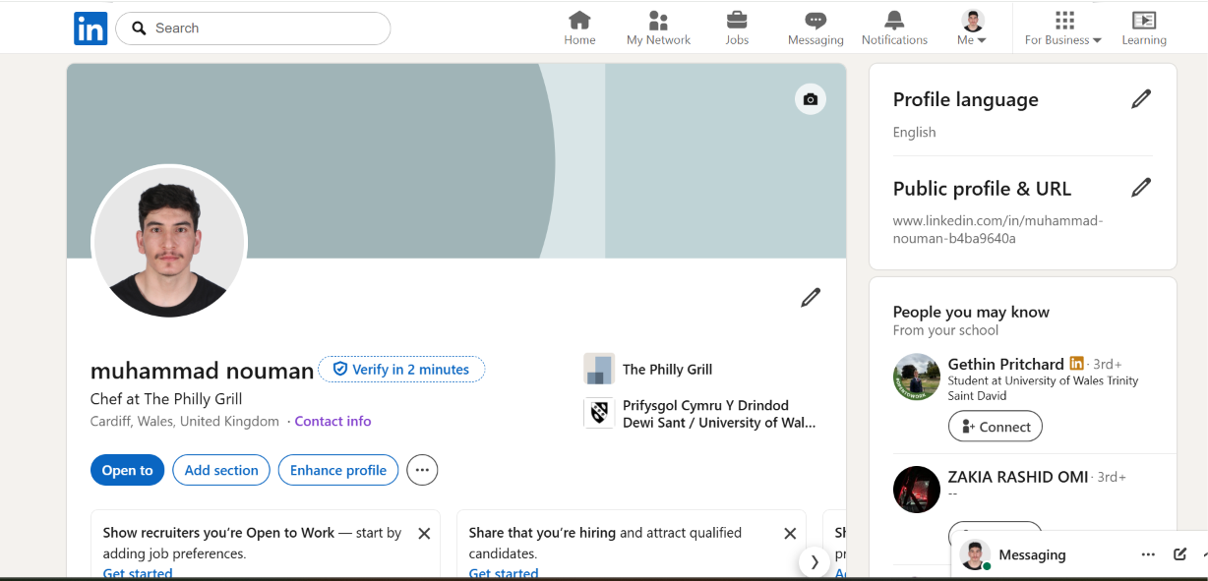

3.5 Application Rationale
The application has been written for the requirements of sous chef position at Fat Hippo Cardiff Ltd. After consideration the job advertised following are the three main factors has been considered.
Grill Experience: The Philly Grill and Abo Ali experience in grill food has been prompted to prove that I can work in high pace and busy kitchen environment with quality and in required timeframe.
Managing/Leading Kitchen: I got experience in working with head chef and training junior chefs
Rules & Regulations and Stock awareness: I got level 2 food safety certification, and I have expertise in controlling stock and reducing the waste.

My CV and cover has been written in simply and professional way although my LinkedIn and Indeed profile has the evidence of work experience and education career.

References
Agency, F. S., 2025. Food Standard Agency. s.l.:Food Standard Agency.
Caddy, T., 2025. UK Fast Food Restaurants Market Report 2025, s.l.: Mintel.
Cameron, S., 2021. Business Student's Handbook, The: Skills For Study and Employment. 07 ed. s.l.: Pearson (20 January 2021) © 2021.
Cottrell, S., 2021. Personal Development and Employability. s.l.:Bloomsbury Publishing.
Gibb's, G., 1988. Gibbs’ Reflective Cycle. s.l.:s.n.
Goleman, D., 2020. Emotional Intelligence. 01 ed. s.l.:Bloomsbury Publishing.
Government, U., 2023. Economic Contribution of the UK Hospitality Industry, s.l.: s.n.
Michael Armstrong, S. T., 2026. Armstrong's Handbook of Human Resource Management Practice. 17 ed. s.l.:s.n.
Michael Armstrong, S. T., 2026. Armstrong's Handbook of Human Resource Management Practice. 17 ed. s.l.:s.n.
Trought, F., 2017. Brilliant Employability Skills: How To Stand Out From The Crowd In The Graduate Job Market. 02 ed. s.l.:Pearson (27 March 2017) © 2018.
Wilson, L., 2016. Soft Skills in the Workplace. s.l.:s.n.
Window, J., 1955. Johari Window, s.l.: s.n.
WRAP, 2026. Waste and Resources Action Programme: Hospitality and Food Service Action Plan. Banbury: WRAP, s.l.: s.n.

