Project Planning, Monitoring and Control
Student Name:
Omar Aldossari
Lecturer:
Juan Ferriz Papi

Date:
01/05/2018

TABLE OF CONTENTS
TABLE OF CONTENTS i
LIST OF FIGURES ii
LIST OF TABLES ii
1 INTRODUCTION 1
1.1 Project Description 1
1.2 Learning Outcomes 2
1.3 Aims and Objectives 2
2 CONSTRUCTION LOGISTICS PLAN 1
2.1 Introduction 1
2.2 Construction Programme 1
2.2.1 Preconstruction works 2
2.2.2 Excavation works 3
2.2.3 Building substructure works 3
2.2.4 Building superstructure, roof structure works, finishes, external works and site handover 4
REFERENCES 8

LIST OF FIGURES
Figure 1: Site location of the proposed commercial block 1
Figure 2: Site logistics plan for excavation phase 3
Figure 3: Site logistics plan for substructure works phase 4
Figure 4: Site logistics plan for superstructure works phase 5
Figure 5: Site utilization plan with facilities, equipment and plants (Jarrell, 2014) 6
Figure 6: Building logistics centre (Matouzko, 2015) 6

LIST OF TABLES
Table 1: Construction programme 2

INTRODUCTION

Project Description
A proposed commercial building block is to be constructed and the property development is made up of 2 underground floors, sub-block A with five storeys, sub-block B with seven storeys, sub-block C eleven storeys and sub-block D with fifteen floors. Consequently, the heights of the different sub-blocks vary in height. Figure 1 shows the project site location of the proposed commercial building block. Moreover, the arrangement of the sub-blocks A, B, C and D on the site is shown in Figure 1. The site is bordered by existing commercial developments, Strand road and Quay Parade (A4067) road.
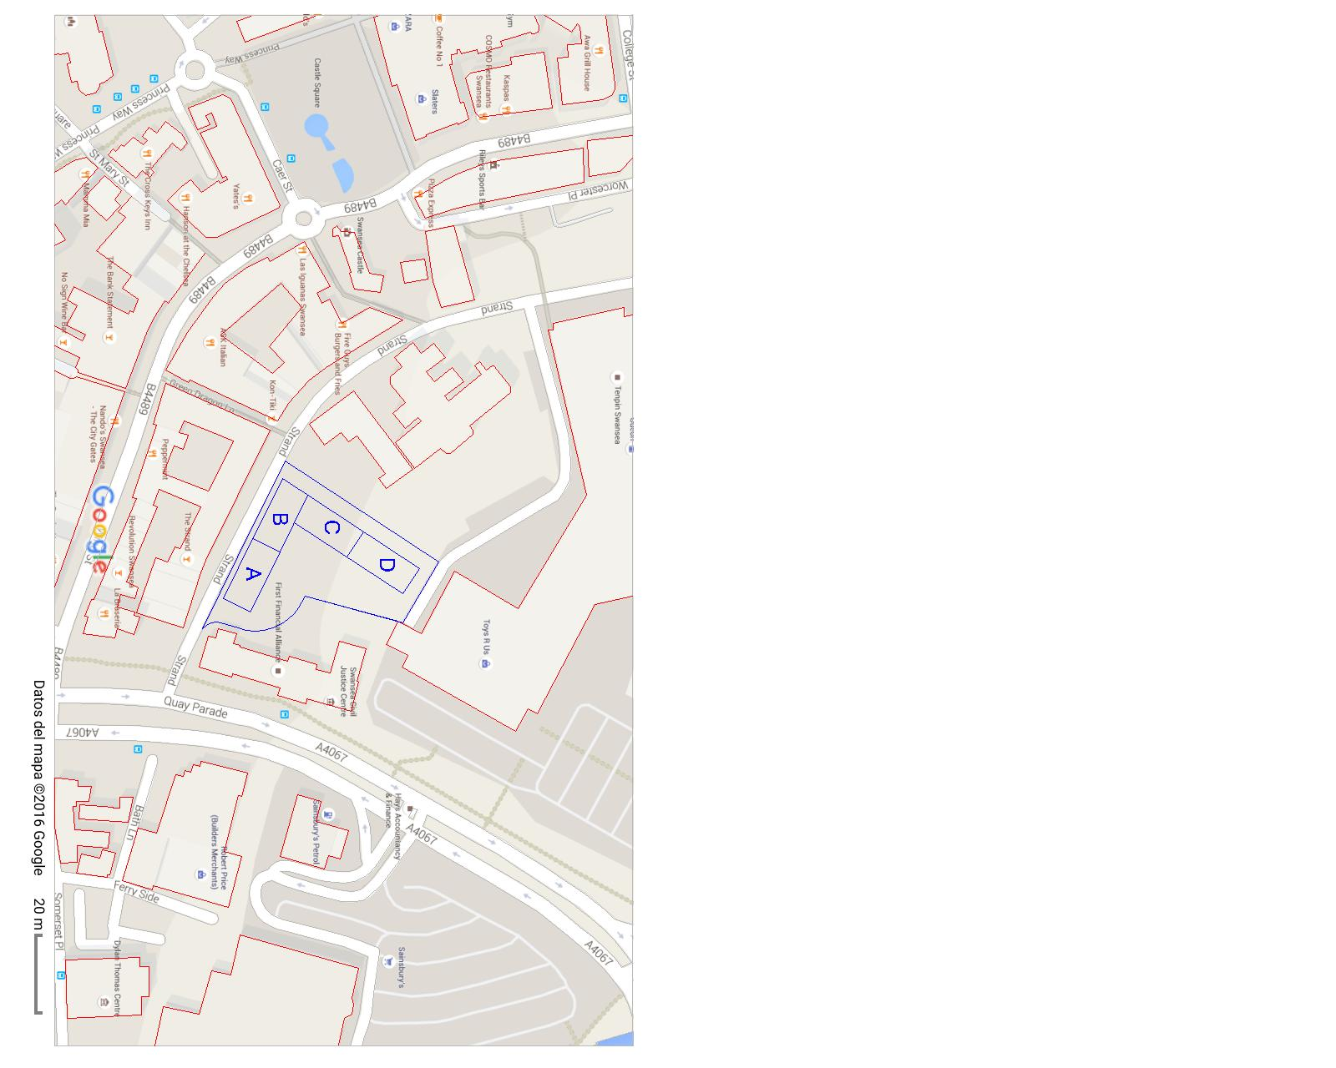
Figure 1: Site location of the proposed commercial block
The project is at the inception stage and scheduling of the project for the planning of the following aspects is required; earthworks, foundation, underground floors, superstructure, top roof and external walls. The proposed commercial building is to have a plinth area of approximately 2,000 m² and each of the 4 blocks A, B, C and D will have a reinforced concrete slab with an area of 500 m². The site geology is made up of a mixture of sand, lime and clay. A raft foundation is proposed for construction of the commercial development.

Learning Outcomes
The case study on project planning, management and control is aimed at equipping learners with skills on evaluating alternative planning monitoring and control techniques and choosing the best technique for the project development. Specifically, several planning practices are to be used in different complex construction situations, and to carry out detailed investigations on various construction techniques. Consequently, a Gantt chart will be produced to schedule construction works and determine the resource allocation and duration of the projects.

Aims and Objectives
The main objective of the coursework is the description of the site logistics for the construction of the different activities and structural elements of the commercial building block. The specific objectives include the presentation and discussion of the site plan layout for: services, plant, cranes, offices, facilities, storage and waste. Moreover, the resources required for each stage and the necessary changes to the site plan layout will also be described.

CONSTRUCTION LOGISTICS PLAN

Introduction
Local county or city councils in most developed countries require the preparation of a construction logistics plan on and off-site for approval before construction commences. The construction logistics plan will manage materials delivery to site and manage the movement of workers, equipment and vehicles on site. Moreover, site logistics plan is intended for supply chain management and delivery of materials on site. The associated benefits of a site logistics plan on complex construction projects include timely delivery of the project, cost savings, reduced risks and accidents on site, environment-friendly construction etc. The site logistics plan is usually prepared by the contractor and approved by the project manager before the commencement of construction. The logistics plan is then submitted to the local authorities for approval of the construction phase. In large and complex projects, a logistics manager may be appointed to oversee the site logistics at the project site location for the different phases of construction. However, the current project will utilise the contractor’s staff in the management of the site logistics plan. The preparation of the site logistics plan was guided by project management guidelines and case studies of projects conducted in the past (Turner, 2008; Fisher, 2012; AH, 2016; Panfilova, 2017).

Construction Programme
The construction of the commercial block building is anticipated to take 663 days from the inception stage, site preparation phase, site handover, construction phase and final completion of the works and handing over to the client. The project began on the 1st October 2017 and the estimated completion date is 17th April 2019. The construction programme is detailed in the Gantt chart attached in the APPENDICES section.
The construction works for the commercial building can be categorised into the major stages summarised in Table 1. The construction programme or scheduled work plan summarises the construction activities, the resources and the duration of each construction phase or stage.

Table 1: Construction programme
Construction phase | Construction activities | Resources | Duration
Preconstruction works | Drawing approvals, survey for existing services. | Consultants, project manager | 1/10/2017 - 7/10/2017
Excavation works | Surveying & setting out, approval for Setting out, mass excavation to the required depth, base excavations. | Project manager, consultants, site gang,  site engineer, excavator. | 1/10/2017 - 24/10/2017
Substructure works | Basement floor column blinding, rebars, formwork, concrete casting etc. | Project manager, consultants, concreting team, site engineer, concrete mixer, concrete pump etc. | 24/10/2017- 7/12/2017
Superstructure works, finishes, external works & site handover | Columns, beams & slabs formwork, reinforcement, concreting for all floors and roof slab. Walling, plaster and painting; tiling, doors & windows; electrical & plumbing fittings & fixings; basement backfilling, cabro laying; perimeter wall & gate; roofing finishes, staircase and passages finishes; water tanks, water tanks, boreholes, generator and fire hydrant system; external lighting; site clearing of construction wastes & site handover. | Project manager, consultants, concreting team, foremen, plaster team, tiling team, site engineer, concrete mixer, concrete pump etc. | 9/1/2018 - 13/11/2019

Preconstruction works
This phase involved acquiring the necessary approvals from the local authorities and was undertaken between 1st October 2017 and 7th October 2017 for a total duration of 14 days. The approvals included but are not limited to architectural drawings approval, structural drawings approval, site logistics plan approval, public health approval, occupational health and safety approval, environmental management plan approval, etc. The approvals were required before the construction phase of the building begun. The preconstruction works could also include mapping out existing services such as gas, electricity, water, internet cables, and water pipelines on the site or around the boundary. The service providers were then consulted and diversion or relocation of the services and utilities undertaken to avoid damages to the infrastructure during construction and thus interruption of services to neighbours. Moreover, the stage was also necessary for urban planning purposes to ensure the property development conformed to all the planning regulations. Also, identification of the existing services through survey works enabled the developers not to interfere with the routes of the services which if not identified early can lead to expensive corrective measures in future and may also interfere with future expansion or extension works for the services. This stage of the building works did not need management of site logistics because most of the activities were conducted off-site and preceded the actual construction of the building.

Excavation works
The excavation works stage for the development of the commercial building block was preceded by setting out the boundaries for the plinth area of the commercial building block. Thereafter, mass excavation works commenced ensuring the required foundation depth and the two basement floors are accommodated in the construction works. The proposed site logistics plan for movement of vehicles, storage of materials and disposal of wastes is shown in Figure 2. The central portion labelled 1 will be used for storage of excavated soil at the start. Tipper trucks will then access the site from Strand road then waste soil is loaded onto the trucks, and then exit the site through Quay Palace road for disposal of wastes at landfills.
1
Figure 2: Site logistics plan for excavation phase

Building substructure works
The substructure works for the building development was undertaken to enable construction of the 2 basement floors. Consequently, the work involved blinding works for the column bases, base slab formwork, laying basement slab and column reinforcement, concrete casting and construction of retaining walls. The work was carried out between 24th October 2017 and 7th December 2017 for a total duration of 16 days.
Due to the constraint space on site, a crane will be permanently stationed for the duration of the construction of the substructure and superstructure. This is shown in the construction logistics plan shown in Figure 3. The central portion labelled 1 will serve as the storage area for materials as well as have offices for project staff and changing rooms for workers. The area labelled 2 will be the location of the crane and other plants. Site planning will be undertaken to ensure the equipment are properly positioned for proper functioning and safety of the workers. Figure 3 shows the route planning of the vehicles to encourage a seamless flow of vehicles to avoid congestion on site and access roads to the site.
1
2
Figure 3: Site logistics plan for substructure works phase

Building superstructure, roof structure works, finishes, external works and site handover
The superstructure works involve the construction works for the ground floor, 5 floors in sub-block A, 7 floors in sub-block B, 11 floors in sub-block C, 15 floors in sub-block D and the roof structures for sub-blocks A, B, C and D. Moreover, finishes and external works were also carried out concurrently with some of the superstructure worksIn summary, the work involved formwork and concreting works for beams, columns, and slabs for all the floors and roof slabs, and the finishes and external works. The work was carried out between 4th December 2017 and 13th November 2019 for a total duration of 609 days. The superstructure will take the longest time for construction and thus the need to come up with a proper site utilization plan to avoid unnecessary delays in completion of the project due to poor planning. Construction site plan best practices were used in drawing a plan for this phase of the project to ensure the site logistics are optimized (Jarrell, 2014; Matouzko, 2015). The construction logistics plan involved the management of the materials, equipment, and the site plan optimization (Jarrell, 2014). In certain instances, a static site logistics plan was adopted, and in others, a dynamic approach was used to ensure proper utilization of space on the site. The standard site logistics plan used for the construction of the blocks is shown in Figure 4. The crane at location 2 was permanently located on site to help with lifting heavy equipment and construction materials to different floors.
1
2
Figure 4: Site logistics plan for superstructure works phase
However, the construction logistics plan was both dynamic and static in nature. However, in the case of construction of the sub-blocks in phases, the location of temporary facilities such as site offices could vary and be located say on the site for sub-blocks A, B, or C when sub-block D is under construction. Figure 5 shows other common components of a construction logistics plan such as a mobile site office, vehicles, plants and equipment.

Figure 5: Site utilization plan with facilities, equipment and plants (Jarrell, 2014)
The vice versa is also true when construction began with the other sub-blocks. The construction logistics techniques utilised in the project are discussed briefly in the next section.

Construction logistics techniques
Construction Consolidation Centre (CCC) or a building logistics centre will operate as a warehouse where construction materials will be stored off-site before deliveries of the materials is brought to the site (Matouzko, 2015). Figure 6 shows a typical building logistics centre where in the case of the commercial building block where materials such as cement, sand and ballast will be delivered. Based on need, trucks would then deliver the required materials for construction of the different floors while materials that need for disposal are carried to the building logistics centre by the same truck on the return trip. The same cycle is followed until construction is completed.
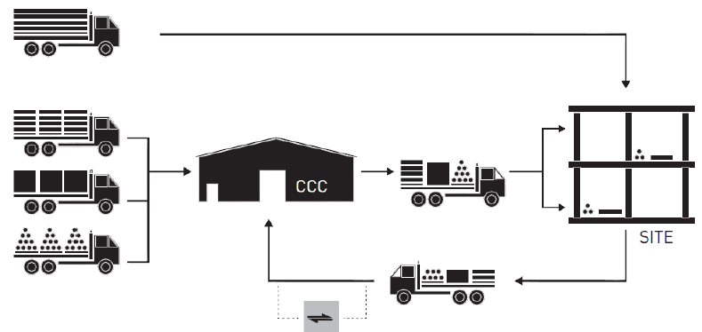
Figure 6: Building logistics centre (Matouzko, 2015)
Just-in-time delivery (JIT) will also be adopted will also be conducted for materials such as pre-mixed concrete in trucks that have scheduled delivery times. This eliminates the need for large storage sites for materials and avoids delays in the construction programme (Matouzko, 2015).
The use of pre-fabricated elements such as rebars eliminates the need for having welders on site for cutting the rebars in the required lengths and shapes. It also avoids utilization of space on site as a storage yard for materials.
Information and Communication Technology (ICT) Systems were also used for fleet tracking of the delivery trucks to ensure proper management of the material deliveries. The materials used on site were also monitored using software thus eliminating wastage of resources for the project.

REFERENCES
AH 2016. Redevelopment of Stamford bridge grounds outline construction logistics plan. Available: https://www.rbkc.gov.uk/idoxWAM/doc/Other-1745969.pdf?extension=.pdf&id=1745969&location=VOLUME2&contentType=application/pdf&pageCount=1.
Fisher, J.A. 2012. Senior Thesis Proposal.
Jarrell, W. 2014. Construction Site Utilization Planning Best Practices.
Matouzko, Y. 2015. Efficient Construction Logistics, A case study of an Office Block Project.
Panfilova, M. 2017. The construction stages of the six-storey residential building in Saint-Petersburg.
Turner, J.R. 2008. Handbook of project-based management. McGraw-Hill Professional Publishing.

