Jonathon Atter
Numbers count ECIE5002
Numeracy, Pedagogy, and online resouce

Content
Element 1…………………………………………………………………………. P2-4
Reference List 1…………………………………………………………………P5
Element 2…………………………………………………………………………. P6-8
Reference List 2…………………………………………………………………P9
Information Sheet……………………………………………………………. P10
Reference List 3………………………………………………………………. P11
Evaluation………………………………………………………………………. P12-14
References list 4………………………………………………………………. P14-15
Reflection…………………………………………………………………………P16-18
Reference List 5……………………………………………………………….P18

2 Numeracy, work and life

Why is good numeracy important and why do we need numeracy at all? You are probably already thinking of many needs for numeracy but here are few reasons why numeracy is important. Money, money, money, I think it’s safe to say that we all like money and we most certainly need numeracy skills to count our money and be able to save money for the future. In every job you’ll need at least basic maths skills or maths qualifications to secure the job, this is why mathematics is labelled as a core subject in secondary schools.
Before starting my research into why good numeracy was important, I was fully aware that numeracy was important to the country but wasn’t aware of why many people in the United Kingdom were failing in their numeracy skills as adults and the importance of it. “Millions of adults in the UK could be missing out on the benefits of improved numeracy skills due to a failure to appreciate their importance in everyday life” (Kingscollage, 2019).
“It’s estimated that the cost of poor numeracy in the UK is £20.2billion to our economy each year” (Le May, 2021). With the United Kingdom losing billions each year this to me is clearly a massive political issue that needs to be addressed
If good and effective numeracy is not applied to people from a young age then they will develop into adults with poor numeracy skills and this will impact on their social lives and will decrease their life chances of being able to secure a notable job within society. Adults unable to obtain these jobs will then have to resort to claiming benefits off the government thus adding more pressure on the finances of the United Kingdom. According to a yougov online poll in 2014 “showing that over a third of adults (36%) feel they have sometimes been held back by poor maths skills in some aspects of their lives” (National numeracy, 2014).

The results of poor numeracy are costing the United Kingdom billions of pounds and some adults believing that they are being held back by their poor numeracy skills. This clearly shows the importance of good numeracy is key to helping the country with its economical finances and with cost of living rises since the nation has left the lockdowns from the pandemic and with the war between Russia and Ukraine which has affected the fuel price in the United Kingdom.
3
With these ever-rising cost the importance of obtaining and having good numeracy skills for working out household bills and possessing the ability to save money through these skills is key to manging the everyday cost of living.
There are many different ways to learn from college courses, online courses for beginners and they are not just offering to teach maths but they mostly offering numeracy life skills.
I was absolutely over the moon to discover that the BBC GCSE Bitesize was now offering advice on household finance from utility bills, mortgages, national insurance and tax, and how to budget.
“Rhys has just finished his degree and has got a job that pays £2,110 a month. His monthly income after tax is £1,800. Here are his monthly outgoings for the month:” (BBC, n.d).

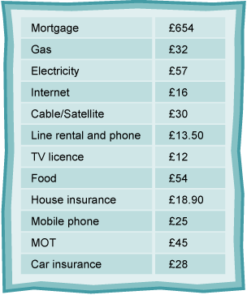
(BBC, n.d)
I just wish that this resource information and guidance when studying for my GCSE then maybe I would have been able to save and sort out my finances and wouldn’t be struggling today. With these numeracy skills being offered to the next generation and showing them the importance of good numeracy then hopefully the future will be better for the country and its finances.

4
I commenced this blog by asking the question why is good numeracy important and why do we need numeracy at all? I have shown that good numeracy is a key foundation for all people in managing their everyday living and their access to the workplace. So, we have seen that poor numeracy can affect people at all levels in society and can have a knock-on effect on the finances of the country. Perhaps the answer lies in reviewing the way the current mathematical curriculum is delivered in our primary and secondary school settings in order to give our children a better life chance thus, enhancing the economy at the same time and reducing the twenty billion lost each year to poor numeracy.

5
BBC, (n.d). Household Finance-WJEC
Available at https://www.bbc.co.uk/bitesize/guides/z8rhfrd/revision/3
(Accessed: 27th February 2023).
Kings collage, London (2019) Research reveals how poor maths skills are holding the UK back.
Available at https://www.kcl.ac.uk/news/research-reveals-how-poor-maths-skills-are-holding-the-uk-back
(Accessed: 27th February 2023).
Le May, M (2021). The importance of tackling poor numeracy in the UK.
Available at https://www.linkedin.com/pulse/importance-tackling-poor-numeracy-uk-malcolm-le-may
(Accessed: 27th February 2023).
National Numeracy, (2014). Poor adult numeracy could cost the uk economy £20 billion a year
Available at https://www.nationalnumeracy.org.uk/news/poor-adult-numeracy-could-cost-uk-economy-ps20-billion-year
(Accessed: 27th February 2023)

6 The Online Pedagogy

Schools! Numeracy! How does a school develop the numeracy skills in their pupils? Has teaching of numeracy changed over the years? Or did it have to change in the last few years due to the impact of the coronavirus with schools, teachers and pupils being confined to their houses. This transition from the classroom to online blended learning may have been a difficult one but according to the British broadcasting corporation for the 4 years 60%plus pupils were achieving A to C grades in their GCSE.
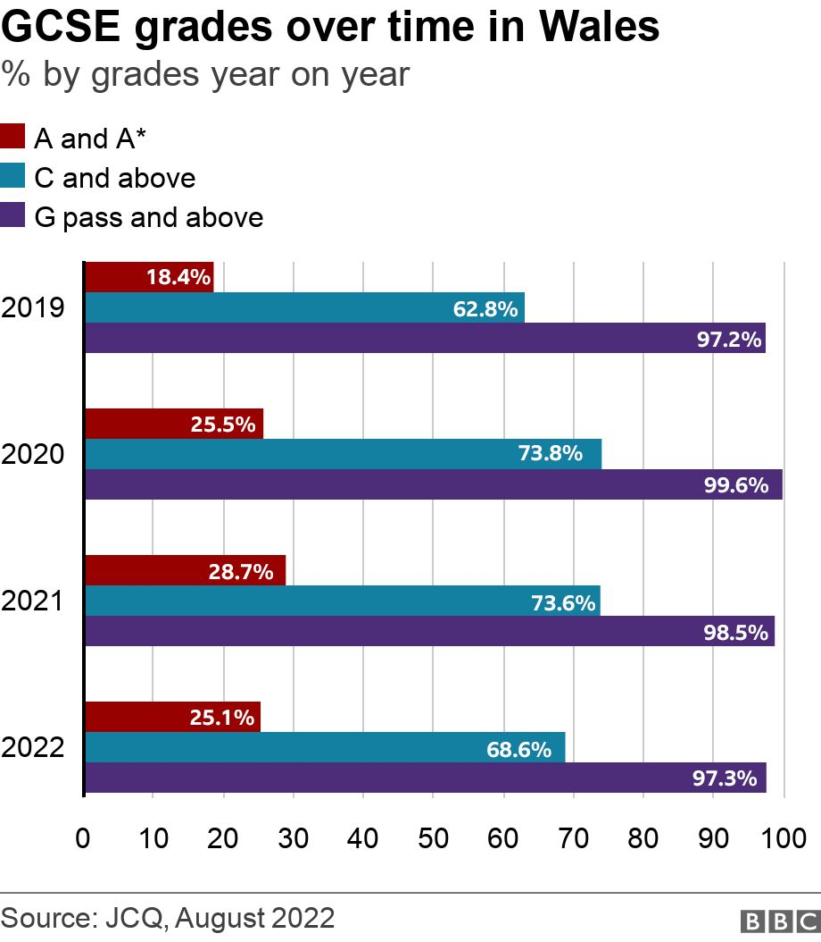
(BBC, 2022).
The above table is from the British broadcasting corporation and this table shows that the percentage of C grades and above has increased during the lockdown years. As you can also see from the table in 2022 the results have started to decrease once again, is this due to the return of pupils to the classroom from online learning?
7
The roles of schools to develop pupils’ numeracy skills has always been vastly important, but during the pandemic and the lockdowns teachers had to change and introduce new form of online for pedagogy. This gives the teacher scope to set work outside the structured lesson and proved online videos for the pupil to watch in their own time and comfort at home. As some pupils may feel unable to watch and intake the information from the video in the classroom setting. The spaciousness of their own home maybe the right environment they need to concentrate. “Space provides interactive scripts, shared resources and points of intersection for teachers and learners. It has physical, social, temporal, experiential (and possibly virtual) dimensions and designing methodologies around different places (school, classroom, out-of-school, online)” (Nind, et al., 2016, pp. 209-210)
The blended learning of Numeracy to myself seems like mixture of different teaching techniques. “As its name suggests, blended learning involves multiple teaching pedagogies mashed into one. There is a mixture of online learning and teacher-led classes” Ashley, (n.d).
The use of the online programme Mymaths can be used by the teacher to set different types structured online mathematical work tailored for the specific student to complete.

Was the world already preparing itself for the world of online technology learning and the new online teaching of pedagogy? “Changes in society, student expectations, and technology were already motivating university and college faculty and instructors to rethink pedagogy and teaching methods before the pandemic” (Teachonline, 2020). If we are to believe the statement from Teachonline then the key role of our schools to be able to develop pupils numeracy skills in order to keep moving with the times and adapt to the four pedagogy’s of online learning.
- Flipped Classroom
- Collaborative learning
- Open sauce educational resource
- Blended learning

8
According to the Welsh Government document national-literacy and numeracy-programme a strategic action plan quotes “Estyn’s 2014–2015 annual report stated that in good secondary schools “the Literacy and Numeracy Framework has encouraged staff to see the links between subject areas and prompted them to share good practice across departments within and between schools” (Welsh Government, n.d) The Welsh government outline in 2014-2015 that they wanted to encourage schools to share good practice and hope it is my wish that they will share the practice of blended learning as blended learning for me is a mixture of past pedagogy techniques and the new online teaching of pedagogy’s. “design that prove to be effective may then be communicated and shared between teachers or archived” (Beetham, et al., 2007). for reuse on future occasions. We as humans to teach the next generation and develop their numeracy skills we need to look to the past, but also at the same time we can’t live in the past and need to be looking towards. It is my belief that the school’s role is developing the numeracy skills of our pupils is take what they have learned from teaching during the pandemic and use tools like google classroom to set work and upload mathematical videos as well as uploading to the google classroom each and every lesson once the lesson has been taught, this will give the student the chance to have a refresh of the lessons and be able to understand in a comfortable environment.
In conclusion, I am in favour of a blended learning and a new technology approach being used and implemented but schools need to be careful using this technology. There many different types of schools across the country with different pupils from many different backgrounds. Children will learn in different ways and for some learning online and for others, they will learn best from a school environment because there are children who will procrastinate and need the everyday school structure to learn. It may be that in order to facilitate numeracy learning that schools need to be flexible and think outside the box because one size does not fit all.

9

Ashley, (n.d) 4 online teaching pedagogies to teach online
Available at https://blog.heyhi.sg/online-teaching-pedagogy-teach-effectively/
(Accessed: 24th February 2023).

BBC, (2022), GCSE Results: Wales’ top grades drop but improvement on 2019.
Avaible at https://www.bbc.co.uk/news/uk-wales-62660790
(Accessed: 24th February 2023).
Beetham, H., Sharpe, R. (2007) Rethinking Pedagogy for a digital age
(p, 104). (Accessed: 24th February 2023).

Teachonline, (2020), A New pedagogy is emerging… and online is a contributing factor.
Available at https://teachonline.ca/tools-trends/how-teach-online-student-success/new-pedagogy-emerging-and-online-learning-key-contributing-factor
(Accessed: 24th February 2023).
Nind, M., Curtin, A., Hall,K. (2016), Research methods for pedagogy
(pp,209-210). (Acccesed: 24th February 2023).
Welsh Government, (n.d) document national-literacy and numeracy-programme a strategic action plan
Available at https://www.gov.wales/sites/default/files/publications/2018-11/national-literacy-and-numeracy-programme-a-strategic-action-plan.pdf
(Accessed: 24th February 2023)

10
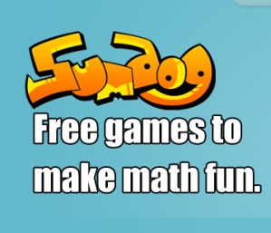
Sumdog is a mixture of fun mathematical game that can be accessed via www.sumdog.com or by downloading the free app. Sumdog allows children primary schools age up to 14 years of age. Sumdogs games are fun and interactive, it takes away the anxiety that children may have about learning mathematics as the games can be set at a beginner’s levels. “They also keep students engaged because they are tailored to their ability level and so the questions adapt to ensure an appropriate level of challenge is set” (Dabell, 2023).
This Photo by Unknown Author is licensed under CC BY-SA-NC
Sumdog is fully accessible from many electronic devices such as desktop computers, laptops, tablets, and smartphones. As sumdog has many ways to log onto the website. Thus, giving pupils access at home or in the classroom. The sumdog resource is tool for the teachers as it helps them to set specific tasks and skills for the pupils to attempt and gives the teacher the ability to track the pupils progress. Sumdog also has a feature which allows pupils to compete against other pupils from another class and even pupils in other schools. These contest are set at pupils ability as this will give a fair chance for every pupil to win. Parents can sign up to sumdog and track the progress of the child and what they are learning, the parent is also able to play games with they child online or via the sumdog app.

The variety of games on offer by sumdog will keep pupils’ attention. Through offering this variety of multiple games pupils are less likely to lose interest. Maths for children can be the scariest subject of all with all the different mathematical methods but by using maths in games it becomes fun and they learn the skills of maths through video games which most children love to play. “Children love games, and they love video games more” (Srivastava, 2017). This resource is great help to children with ALN as it helps them learn maths is a fun and calm way and removes the pressure and the stress they suffer in the classroom.

Once pupils have registered with sumdog there are three simple steps for sumdog to understand their level of ability.
Step 1: Pupil to click on their task list
Step 2: To select the maths diagnostic from the task list.
Step 3: Start the maths diagnostic.

11

Dabell, (2023) Every day is a school day
Available at:
https://johndabell.com/2022/02/03/resource-review-sumdog/
(Accessed: 14th February 2023).

Srivastava, (2017) everything about sumdog how-to, review, pro’s & con’s
Available at: https://www.techgyd.com/sumdog-review/32384/
(Accessed: 15th February 2023).

12

Evaluation of resource

The Sumdog is a free online website and app that teaches numeracy to children from the age range of five to fourteen years old, with a variety of mathematical games but also has a premium subscription package. In this evaluation it will be weighed up whether Sumdog is an average effective resource or is it top of the bill when it comes to developing the youths’ mathematic skills or does it fall a mile short of helping them attain the dependable skills they need. Sumdog has over 30 single and multiplayer problem-solving games. According to Piaget’s four stage of cognitive development skills this is the age range for children to be developing problem solving skills. “During this stage, Adolescents display independent problem-solving skills, and are able to understand abstract ideas such puns, proverbs, metaphors, analogies, philosophy and maths”(Bajwa, n.d). has virtual coins and 3d avatar, house, and garden for children to personalise. When the children first register with Sumdog a diagnosis is undertaken to assess the ability level of the child and then Sumdog can set the level difficulty accordingly.
Sumdog does sound like an attractive concept of online gaming with a mathematical theme for enhancing children’s numeracy skills levels through fun and exciting games and rewards.
Sumdog gives free accessibility for pupils, parents, and teachers giving the teachers and parents the ability to create student login. There is a premier package available at a reasonable price, but with school and parents’ budgets being so tight since the United Kingdom came out of the covid-19 lockdown pandemic, Sumdog may find a lack of customers willing to pay for the premier accounts. The only thing extra the premier account subscription offers is low stake testing, overview of pupil’s results, spelling and grammar practise.
Teachers and parents can reward their children for hard work by giving them coins they can spend in the store. This enables them to purchase virtual furniture for their Sumdog house and clothes for their Sumdog avatar.

13
The teacher is given the power to award a certificate as a reward for work completed, which the pupil can print once received. The children’s work is positively rewarded which encourages them as they continue in their work. Theorist B.F Skinner believed that “The reward is a reinforcing stimulus” (Mcleod,2023). Another feature of Sumdog for the teacher/parents is the pupil tracker, which allows the teacher to track the pupil’s progression. “Sumdog is efficient for teachers and parents too to keep track of kids progress” (Srivastava, 2017).
Sumdog offers a variety of well thought out fun and entertaining mathematical games to keep pupils engaged and have them coming back again as they can compete against classmates and other pupil from many schools.
However, as this resource relies on modern technology work, once that technology doesn’t work it halts the learning. If the school or the parents’ internet isn’t working the pupil is unable to access to resource and their learning is hindered.
Error code BB3742FC is an error code that can occur when a group of pupil’s log into Sumdog while using the same network connection. Some school’s antivirus could also block the accesses of Sumdog website. Technology is a great tool and has its usefulness but a downside may be that pupils rely on it to much. “With too much use of modern technological devices and gadgets in the classrooms to study, students completely depend on them” (Adil, 2022). The pupils will not be sitting their maths GCSE exam via an online technology game, so is the world heading for a massive fall when using resources like Sumdog or is Sumdog the way of the future? Are all GCSE exams going be undertaken through the means of electronic devices during the examination. In the distant future this may be the case but for now technology resources like Sumdog have too many missing elements to be a fully working and fruitful resources to help pupils with their numeracy. The concept of Sumdog is a fantastic idea but it just doesn’t hit the high note when being applied.
On the Sumdog website it has set up a year-by-year curriculum starting from year 1 pupils to year 9. They have really done their homework when it comes to testing and aligning the games to meet the pupils at different age groups.

14
“Sumdog exactly matches the curriculum points in the Programme of Study for Mathematics, making it even easier to quickly set practice work and assessments” (Sumdog, n.d). With Sumdog matching the curriculum programme of mathematics and also they have worked closely with a team of experienced teachers helping them produce an entertaining, fun resource and teaching the curriculum at the same time which is really impressive and a challenge to undertake. “The Sumdog curriculum team has worked closely with a team of experienced teachers” (Sumdog, n.d).
Yes! Sumdog as stated has worked closely with experienced teachers and is following the curriculum, which is clearly stated on their website, but unfortunately, they don’t make it crystal clear for their users which curriculum they are aligning themselves with. For a teacher in the United Kingdom it would be foolish to waste a vital part of their budget on a resource and not be fully aware of what counts curriculum is being laid before their pupils.
A massive downside to Sumdog is it’s not a very inclusive site and app as the only language available is English and this has been the case for many years now. “The site is currently in English, but we hope it’ll have multiple language translations in future” (Kidslox, 2018). Sumdog is only available in 8 countries. Just to highlight that the United Kingdom and the United States of America are two countries that have accessed Sumdog and they consist of a vast variety of multeity lingual languages and the fact that these languages are being ignored lets this numeracy resource down. Yes! Mathematics and numeracy are a form of language themselves, but if the parent or pupil are unable to access to site due to a lack of understanding of the English language then Sumdog has failed them. As a numeracy resource Sumdog has been supporting children with their maths for nearly three decades now, so to last for so many years the children are developing their numeracy skills through Sumdogs’ fun and interactive 2d and 3d games. According to insider.co.uk “Scottish education technology company Sumdog has been sold to Swedish rival eEducation Albert” (Walker, 2023). With this information from the insider website maybe just maybe the sumdog website and app will soon be available in many different languages in the not-so-distant future.

15

Adil, M, (2022). Top ten reasons why modern technology is bad for students in education.
Available at https://adilblogger.com/reasons-modern-technology-bad-education/
(Accessed: 22nd February 2023).
Bajwa, (n.d) Development of cognitive skills; Piaget’s theory
Available at https://blog.cognifit.com/development-cognitive-skills/
(Accessed: 22nd February 2023).
Kidslox, (2018) Sumdog review
Available at https://origin.kidslox.com/guide-to/sumdog-review/
(Accessed: 21st February 2023).
Mcleod, S (2023) Operant conditioning: what it is, how it works, and examples
Available at https://simplypsychology.org/operant-conditioning.html#:~:text=Skinner%20in%20his%20theory%20of,reward%20is%20a%20reinforcing%20stimulus.
(Accessed: 22nd February 2023).
Srivastava, (2017) everything about sumdog how-to, review, pro’s & con’s
Available at https://www.techgyd.com/sumdog-review/32384/
(Accessed: 21st February 2023).
Sumdog (n.d) Maths Curriculum
Available at https://www.sumdog.com/en/teachers/curriculum/maths/
(Accessed: 22nd February 2023).

Sumdog (n.d) Maths Curriculum
Available at: https://www.sumdog.com/en/teachers/curriculum/maths/
16
(Accessed: 22nd February 2023).
Walker, (2023) Scottish education technology firm sold to Swedish rival
Available at https://www.insider.co.uk/news/scottish-education-technology-firm-sold-26461330 (Accessed: 21st February 2023).

Reflection
Number count! That’s the title of this assignment and could there be any more of a daunting title for an assignment as many people have had an unsatisfactory encounter with mathematics and numeracy. As for myself at first, I was terrified of the assignment, but also ready to undertake a maths challenge. As a child the thought of being in a maths lesson and learning through the different mathematical units in school wasn’t an issue for me, as I enjoyed the different types a problem that maths can throw at you. What was alarming for me was at the first lecture I wasn’t hundred percent confident that I could step up to an assignment at level five. In the lectures I was struggling to understand how these different types of theory’s could be connected to numeracy however I was determined to research and attempted to complete the assignment to the best of my ability. After now completing the module, I realise that my fears were founded in my presumptions of numeracy but as I delved into the subject material, I realised that it wasn’t an unachievable assignment to complete. I maybe still not completely be there yet when it come down to the critical thinking and linking my conclusions together.
As I worked my way through blog one my understanding and knowledge increased. It made me think of how much of an impact numeracy has on my life and the life of other people living in the United Kingdom. It was quite shocking to realise that poor numeracy skills had a devastating impact on the country’s economy and forcing the United Kingdom to losing billions of pounds each year. As there is a vast ocean of information on numeracy and I only had a word count six hundred words there was so much I wish that could have been added.

17
For the second blog I was introduced to the word pedagogy and now I would like to think I am pronouncing it correctly, but most likely its being pronounced in the same way as the many Welsh words I know. So, my pronunciation is most probably completely incorrect. As within both blogs I have tried to writs in an engaging style, but I feel that I have still not found what is my style. Once I discover my style my future blogs will hopefully be much more engaging and be able to draw the reader in and show them the opinion I am trying to express. The key to any blog in my opinion is to draw the reader in right from the word go and if this is not achieved, the reader will be lost for the rest of the blog.
“Your introduction sells the read. If your introduction doesn’t motivate readers to make that all-important scroll down, you lose them” (Drennan, 2021).
As I take the time to reflect on my chosen resource, I would definitely choose a different resource as I found it extremely difficult to find references to help explain the point of view I was trying to portray. The idea I had behind choosing Sumdog was that it’s been around for a while, but it still fits into the new modern world of technology which I strongly believe is the way forward for the educational system and as children enjoy online games I thought that online educational fun games would be ideal. “Online games are certainly one way of doing this and Sumdog could be the very hook you are looking for” Teachprimary, n.d).
I have realised this belief by working in a professional educational setting for over a decade and I have seen the advancement of online technology over the years. “Machine technology is also in the forefront of educational advancement, allowing students the opportunity to utilize robotics and artificial intelligence in ways previously not imagined even 10 years ago” (Statti, 2020). So, with the ever advancement of technology and the new world that these pupils are going to be living in I thought that Sumdog would be ideal for my chosen resource.
Unfortunately, I encountered an issue with Sumdog when I was preparing to make the video as my school setting have now stopped using Sumdog. This now is only available for pupils who are in the Schools’ Accelerate Programme and are unable to take part in any type of video due to safeguarding issues. As for my final edition of the video there is so much more material that could be added to it, but as the account I used was a freshly added account it was impossible to
18
show Sumdog at its finest showing the specific work that Teachers have set, test scores and the progression of the child being shown. Since it was a new students account it made the video feel empty and bare, with an only a limited amount of information to shown. If I was able to access an account that had been running for some time, then even in a three-minute video I would be able to show a much in-depth video of the resource.

When it came time to write the evaluation, I feel that the evaluation I have given of the Sumdog resource was fair and impartial weighing up both pros and cons for the resource until the very end when I gave my concluding thought and expressed my opinion on the matter.
To conclude my reflection, I think that my critical evaluation needs to be upgraded for the next module, but I have now had a taste of level five and the only way can be onward and upwards improving my academic knowledge and skills.
Drennan, G (2021) 7 Tips to write a great blog post introduction Available at
https://contentmarketinginstitute.com/articles/tips-write-blog-post-introduction/#:~:text=Your%20introduction%20sells%20the%20read,the%20attention%20those%20efforts%20deserve. (Accessed: 4th March 2023).
Statti,A Torres, K (2020) The advancement of technology in schools and universities/
Available at https://www.tandfonline.com/doi/full/10.1080/0161956X.2020.1745591
(Accessed: 4th March 2023).
Teachprimary, (n.d) Sumdog product review
Available at https://www.teachprimary.com/hot_products/view/sumdog-product-review
(Accessed: 6th March 2023).

