Crusades : First Commentary

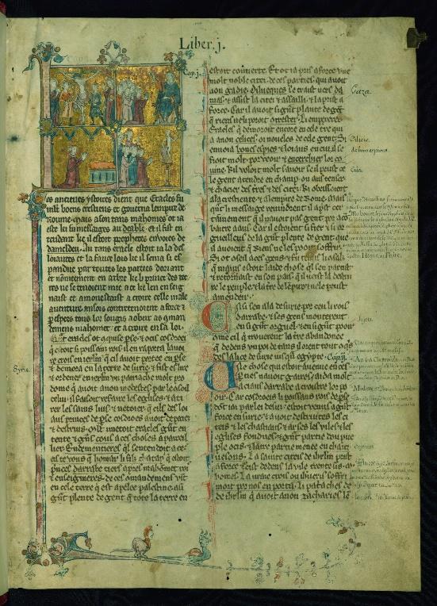
Walters Ms.W.137.William of Tyre’s Histoire D’Outre Mer

The manuscript page illustrated above is found in a copy of William of Tyre’s Histoire d’Outre Mer (History of overseas) which is housed in The Walters Art Gallery in Baltimore. This manuscript was completed in the latter part of thirteenth century and is described as being written in ink on medium parchment. William of Tyre is described as a diplomat, an intellectual tutor and historian. He was born in the Kingdom of Jerusalem 1130, studied in Paris and returned to Jerusalem to tutor the king’s son, becoming Archbishop of Tyre 1175-1186. He is mostly known as an eminent historian and his Historia of which this manuscript is one, was written between 1170 and 1184, using many classical and scriptural references. His work was very popular in France in the latter part of the thirteenth century and was extensively copied over the next few centuries.
The volume of which this image belongs was written in Old French and the images within the whole manuscript are thought to have been illustrated by four different artists. Initials to a text were often illustrated within a manuscript and were originally known as ‘ystoires’ or ‘histoires’ but later were known as historiated initials with the subject of the text being illustrated, usually by a master craftsman after the text had been written by a scribe. The initial in this case is an L which also extends down the page to include the page of text. This image appears at the beginning of the volume and sets the scene for the crusades with four images on a background of gold and bordered with gothic type flowers at the corners of the images.

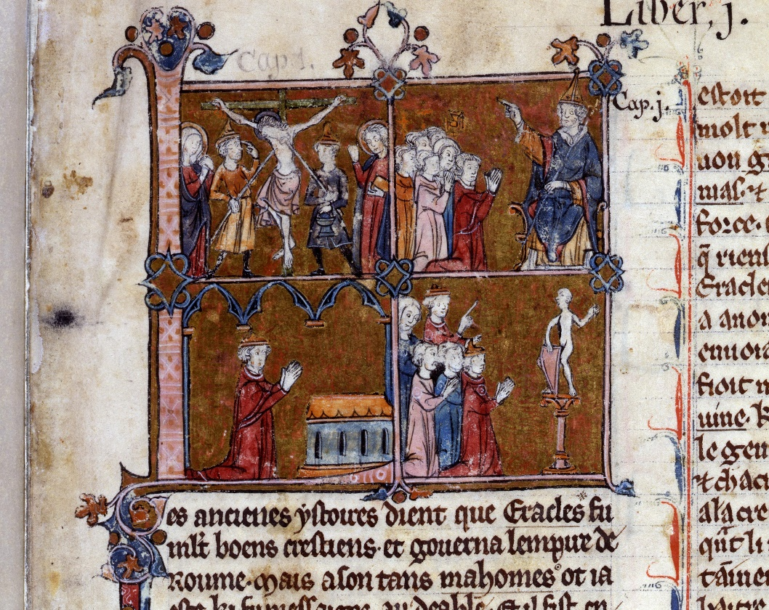

The four images illustrated are of Jesus on the cross, Pope Urban II preaching to the masses, Muslims worshipping idols and a pilgrim praying at the Holy Sepulchre. These images are four of the motivations which encouraged the people in Europe to take to the crusade although Jean Flori has written of many more, aiding brethren in the east ,Christian pilgrims suffering in the east, desecration of the churches, fighting a righteous war, the reward of plenary indulgencies and forgiveness of sins to name but a few.

Christ on the Cross
Probably meant to be the main motivation, with many verses from the bible being quoted and used to inspire and stimulate the populus, for example ‘If any man will come after me, let him deny himself and take up his cross and follow me’ (Matthew 16:24). The cross was a visual symbol which was given to all crusaders as a sign of their vow of commitment to the crusade and to be worn until their vows had been fulfilled. They were physical and personal tokens, often used as talismans for protection. After the loss of the “true cross” in 1187, propaganda was saturated with references of the cross and by the mid thirteenth century, ‘Taking the cross ‘was a phrase used as shorthand for going on a crusade. By the third crusade 1187-92, it was used as a symbol or banner of Christ’s suffering and the offering of redemption.

Pope Urban II’s Speech at Clermont
Although no original texts have survived, there are several chronicles reporting Pope Urban’s speech for example from Fulcher of Chartres , Robert the Monk and in the Gesta Francorum. Pope Urban II, who had been touring throughout France delivered a speech in a field at Clermont, calling on people to march to free the Christians in the East and to liberate the Holy Sepulchre from Islamic Rule. It is thought that he may have had a crusade in mind for several years and that he had discussed plans with Adhemar of le Puy and Raymond of St Giles prior to his speech after which Adhemar of Le Puy was the first to take the vow, which Riley- Smith feels gave ‘the impression of a piece of deliberate theatre.’ With Peter the Hermit having already commenced organising the peoples crusade and thirty six bishops having taken vows prior to the speech, this seems to corroborate this fact. The Pope’s message was preached throughout Europe by bishops so that his call for a holy war which soon became known as a ‘most holy war’ spread to the common people.

Worshipping of Idols by Muslims
Urban II preached that the city of Jerusalem was being desecrated by the Muslims stating ‘they destroy the alters, after having defiled them with their uncleanness’ and that the Muslims were a despised and base race who worshiped demons. Much was made of this in some chronicles as a valid reason to take the cross although Marcus Bull feels that the people’s response was not so concentrated on a hatred of Islam but with other factors playing a part. War against the enemies of God in order to win back the heavenly kingdom would have perhaps been a more accurate motivation but difficult to illustrate on a manuscript.

Praying of Pilgrim at Holy Sepulchre
The religious culture of Christianity had been considered by many to have centred around the Holy Sepulchre and Jerusalem where Christ had lived and died. The knowledge of the Holy Sepulchre was widely known throughout Christendom from repeated stories and through scriptures and felt to be the ultimate place to pilgrimage and to have a Christian experience. Although there were better communication routes with Europe, it still meant that mainly only the rich were able to travel but the crusades allowed all social classes to make the trip with endorsement from the Pope (only Pope’s had the authority to call a crusade). The crusades were proposed as a form of pilgrimage as there was a wide fear of sin and its consequences after death. It could even be said that guilt was encouraged in order for communities to be convinced that by embarking on a pilgrimage or in this case a crusade, their sins would be forgiven and their souls accepted into heaven. It seems that the call for the first crusade was preached at a time the lay person was convinced that their salvation would only happen following some form of positive action.
The image in William of Tyne’s history of the crusades, although does not depict all the reasons behind the crusades, illustrates some of the main motivations of those called to the cross and as this is the first page of his chronicle, it sets the scene for the rest of the manuscript.

BIBLIOGRAPHY

Flori, Jean, Medievalists.net, Ideology And Motivations In The First Crusade ,2005, https://www.medievalists.net/2011/07/ideology-and-motivations-in-the-first-crusade/ [accessed 02 March 2024].

Halsall, Paul/Fordham University, Internet Medieval Sourcebook (1996), www.https://sourcebooks.fordham.edu/sbook1k.asp [accessed 02 March 2024].

Harthan, John, Illuminated Manuscripts, (London: Her Majesty’s stationary office.1981).

Riley-Smith, Jonathan, The Oxford Illustrated History Of The Crusades, (United States: Oxford University Press, 1995).

Strack, Georg, ‘The Sermon Of Urban ii In Clermont And The Tradition Of Papal Oratory’, Medievalists.net,(2013), < https://www.medievalists.net/2013/09/the-sermon-of-urban-ii-in-clermont-and-the-tradition-of-papal-oratory/> [accessed 02 March 2024].

Tyerman, Christopher, The World Of The Crusades, (New Haven and London: Yale University Press,2019).
Walters Art Museum, The Digital Walters, https://www.thedigitalwalters.org/Data/WaltersManuscripts/html/W137/description.html > [accessed 02 March 2024].
Walters Art Museum, William of Tyre, <https://www.art.thewalters.org/browse/creator/william-of-tyre/> [accessed 02 March 2024].

Walters Art Museum, William of Tyre, <https://www.art.thewalters.org/browse/creator/william-of-tyre/> [accessed 02 March 2024].
Walters Art Museum, The Digital Walters, https://www.thedigitalwalters.org/Data/WaltersManuscripts/html/W137/description.html > [accessed 02 March 2024].
Christopher Tyerman, The World Of The Crusades, (New Haven and London: Yale University Press,2019), p.108.
Walters, The Digital Walters.
John Harthan, Illuminated Manuscripts, (London: Her Majesty’s stationary office.1981), p. 9.
Jonathan Riley-Smith, The Oxford Illustrated History Of The Crusades, (United States: Oxford University Press, 1995), p.44.
Jean Flori, ‘Ideology And Motivations In The First Crusade’ , Medievalists.net,(2005), https://www.medievalists.net/2011/07/ideology-and-motivations-in-the-first-crusade/ [accessed 02 March 2024].
Riley- Smith, The Oxford Illustrated History, p.68.
Ibid.
Tyerman, The World Of The Crusades, p.6.
Georg Strack, ‘The Sermon Of Urban ii In Clermont And The Tradition Of Papal Oratory’, Medievalists.net,(2013), < https://www.medievalists.net/2013/09/the-sermon-of-urban-ii-in-clermont-and-the-tradition-of-papal-oratory/> [accessed 02 March 2024].
Riley- Smith, The Oxford Illustrated History, p.1.
Ibid.
Flori, 2005.
Paul Halsall/Fordham University, Internet Medieval Sourcebook, Urban II: Speech at Clermont 1095 Robert the Monk version (1996), < https://www.sourcebooks.fordham.edu/source/urban2a.asp> [accessed 02 March 2024].
Paul Halsall/Fordham University, Internet Medieval Sourcebook, Urban II: Speech at Council of Clermont, 1095, according to Fulcher of Chartres (1996) https://www.sourcebooks.fordham.edu/source/urban2-fulcher.asp [accessed 02 March 2024]
Riley- Smith, The Oxford Illustrated History, p.17.
Tyerman, p.xxiii.
Ibid.
Riley- Smith, The Oxford Illustrated History, p.25-26.

