Module Code: BMSK5005
Assignment Title: Workplace culture and its impact on the organizational performance
Module Lectures: Dr. Isaiah Oino
Student Name: Firon Miah
Student ID: 1605305

Table of Contents
Introduction 3
1. Discussing the impact of external forces on the Tesco Plc 4
1.1 SWOT analysis of Tesco Plc 4
1.2 PEST analysis of Tesco Plc 6
2. Discussing the formal and informal relationship between departments and people of the Tesco PLC. 8
2.1 formal communication between departments and people of Tesco Plc 8
2.2 Informal communication between departments and people of Tesco Plc 9
3. Discussing Organisational culture, ethos and values of Tesco Plc 9
4. Corporate social and environmental responsibility of the Tesco Plc 12
4.1 Corporate social responsibility of the Tesco Plc 12
4.2 Environmental responsibility of the Tesco Plc 14
5. Discussing culture of sustainability of the Tesco Plc 14
6. Ethical standards, values and policies of Tesco Plc 15
7. Discussing the Communication channel of Tesco Plc which are used for sharing information 17
8. Discussing the barriers of the effective functioning of Tesco Plc and the methods of overcoming those 17
8.1 Barriers to the effective functioning of Tesco Plc 17
8.2 Method of overcoming barriers of effective functioning 18
Conclusion 19
References 20

Introduction
From the beginning of a business organisation, it’s quite important for them to nourish a standard organisational culture. The workplace culture has a great influence on the organisational performance. According to (Pilar Rodrigues, 2016), the performance of the employees in their workplace is influenced by around 87%. So, without any doubt, it can be said that establishing an optimum workplace culture is very important for any business organisation. A strong or solid culture greatly affects the conduct of the individuals from an association than a feeble culture, which has ambiguous and conflicting rules. There are so many ways that can follow by the business organisation to establish a positive workplace culture. Campbell and Kitson, (2013) argued that give the benefit of the doubt, speak well to others, practice generosity of spirit, look at what works, show appreciation, etc. are the key ways to establish a good workplace culture.

1. Discussing the impact of external forces on the Tesco Plc
Along with the internal analysis, the external analysis is another crucial sector of analysis that needs to take into consideration in order to take any strategic decision. In the following section, the external analysis of Tesco Plc is conducted by using SWOT and PEST analysis.

1.1 SWOT analysis of Tesco Plc
This SWOT examination surveys Tesco Plc, an international retailing company and prearrangement of retail market that normally offer food as well as non-food items in nations universally all over the world in numerous organisations, including a vast online trade location. In this examination, the organisation's qualities, failings, openings and jeopardies will be inspected in detail to survey what Tesco Plc can do going ahead with its business methodology and the brand commitment (Mosola, 2012).
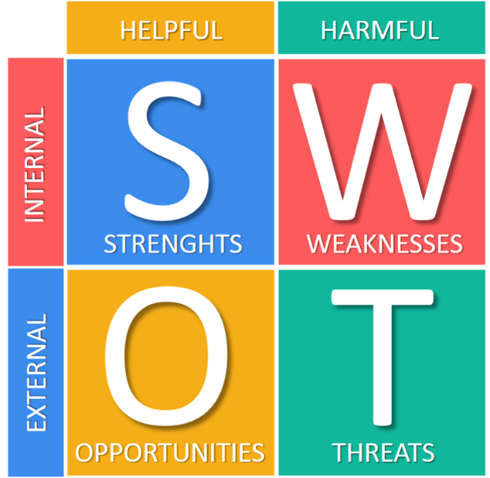
Figure 1: SWOT analysis of Tesco Plc
Source: (Booth and Melling, 2017)
Strength- Tesco Plc has recently owned various rewards for its overall retail brilliance, consumer administration, and over-all shopping knowledge. So, It’s regarded as one of the largest as well as most gainful grocery store designs on the business, which plentiful competitors have endeavoured to reproduction. Apart from that Tesco Plc has enough cash reserves and a widespread assortment of property in its own portfolio yet unactualized, which may give a strong money related position to atmosphere an extensive variety of budgetary cycles (Meyer and Allen, 2014). It has extensive trademark value in its own brand name with universal recognition and esteem for what it leftovers for as far-off as quality, determination, and well management.
Weakness- Some subsidiaries of Tesco Plc aren’t working as well as they are quite powerless against to definite outside elements. For example, Tesco's Finance advantage levels were inimically influenced in the midst of the progressing credit crisis and directly can't ricochet once again from this overall event (Leigh, 2014). The buyers may not be interested to buy a similar number of things distinguished as having less additional money and the retailer has not adjusted its stock and decision, surrendering it with an awesome cost of stock. The retailer is significantly dependent on the UK and Europe for its arrangements and has not put the vitality and resources in working up substitute markets where it works (Kearns, 2012).
Opportunities- There are open entryways for key partnerships with various associations and regarded brands to offer more things or attract more purchasers in certain goal markets. In the locales where Tesco Plc may neglect to meet desires, there could be a few chances of joint ventures in which the area association can help with factual looking over and showcase learning to improve execution in those areas. There is a basic opportunity to create online searching for Tesco Plc and furthermore offer its home movement organization to more domains. Under-developing markets still hold diverse open entryways for few certain retail sorts out that Tesco Plc starting at now offers.
Threat- Financial subsidence as well as loan difficulties will keep on an undermining bit of the general business and advantage in zones basically for far and wide, reducing the number along with the size of purchases made by the buyers. Forceful threats are starting from other overall retail organizations who that may have the ability to offer low costs and more noticeable variety and have more settled overall supply frameworks to move the items speedier than Tesco Plc in light of the way that they are more inventive and know how to use advancement simply more reasonable.The increasing price tendency of imported materials also a great threat for the Tesco Plc to conduct business activities favourably (Hopp, 2011). The treat of workers regarding expanded wages as well as rewards far and wide enhance to Tesco Plc's cost premise that moreover increase its valuing methodology. The government controls as well as political obstacles are likewise enhance Tesco Plc to move fast to the innovative directions.
Strength | Weakness
- Diversification strategy  - Product choice  - Market share  - Enough cash reservation  - Brand value  - Long-standing history | - Pay £129m fine over an accounting scandal  - Reliance on the UK market  - Buyout  - Debt deduction  - Price competition
Opportunity | Threat
- Well diversification  - Overseas market  - Online presence  - Strong portfolio  - Offer free parking  - Station area hub | - BREXIT  - Low-cost rivals  - Wek pound  - International expansion  - Financial downturn  - Out of town centre shopping
Table-1: Summary of the SWOT analysis of Tesco Plc

1.2 PEST analysis of Tesco Plc
PEST analysis is applied as a measure of the supplementary area in order to resolve Tesco Plc's long-term collective and social patterns. The PEST system underneath examinations the forceful and flighty ailment in which Tesco Plc mechanisms by recognizing the influences that usually have the furthermost consequence on the Tesco's overall execution:
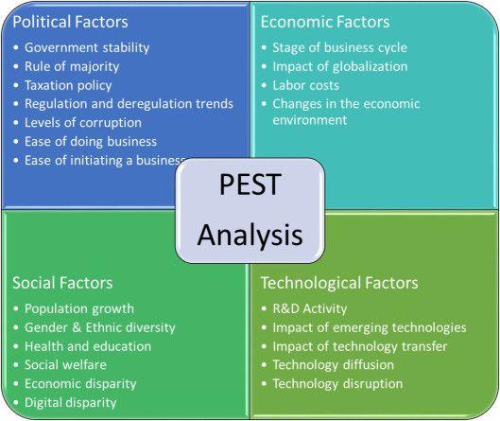
Figure 2: Pest analysis of Tesco Plc
Source: (Tesco plc and the Co-operative Group (CWS) Limited, 2016)

Political: The government impose employment legislation to encourage retailers in order to provide flexible, higher paid, central based job opportunities. Tesco appreciates that their business extraordinarily influences by the work and people lifestyle there as when they open the new store they roundaboutly destroying distinctive occupations in the overall retail industry, for instance, standard stores and those shops are constrained to cut costs to battle with Tesco plc(Gupta, 2012).
China's acceptance to the World Tread Organisation (WTO) has forward-looking a free stream of outside business by removing all tread barriers towards the Western retail institutions, together with Tesco, to strong a pathway into the sphere's most useful market incorporating more than around 1.5 billion customers. In 2009, a deal was sanctioned by the Tesco Plc to set up a deliberate preparation of the joint venture for the upgrading of the supermarket run centres in the China.
The government of the UK also takes a step towards the free trade agreement with the rest of the world. Drenching of 10 more countries into the EU occurred in the 2004 progressing trade amongst the Western and Eastern European nations. This has specified Tesco plc to additionally grow its retail arrange over the Europe Countries. But after BREXIT in 2016 many companies in the UK like Tesco Plc who operated their business activities in the EU countries.
Economic: Tesco Plc is giving watchful thought to the fiscal factors as this crucial factor particularly impacts the acquiring conduct of their customers. Notwithstanding the way that the UK economy was reported formally under financial subsidence in later 2008, the organization's huge reducing in credit costs restricted further risings in joblessness in the midst of 2009. In this manner, the burning through power of purchasers is extending reliably in light of the way that the buyers are increasingly sure about their present cash related situation (Campbell and Kitson, 2013). In any case, there is as yet a huge amount of budgetary trouble inferring that purchasers are presumably going to spend less on premium and in addition extravagance things, joining organics and arranged orchestrated meals, which will ominously impact the quantity of offers and also edge.
Socio-cultural: A socio-economic survey throughout the UK shows that there is the more retired person in the UK than the children. So, this sort of messages may unfavourable for the Tesco Plc as ageing people tend to eat less. And the ageing people are less interested to shop more compare to the young generation (Worthington and Britton, 2012). Despite the fact that internet proficiency level drops past 65 years of age a very long time inside the masses, it has by the by been foreseen that the developing people would find online shopping more supportive. Regardless, little movements are believed to be inadequate and expensive.
Technological: Development is essential for the production network of the Tesco Plc. The retailers like Tesco Plc make inventory network organization structures with a particular true objective to accomplish high grounds and enhance cost profitability. The best upper hand is those that are difficult to impersonate by contenders. These are reflected in the inside abilities of the affiliation. For example, web innovation improved Tesco's movement advantage since purchasers can pick their favored wine through the online request on their cell phone.
The development of technology provides several opportunities to the Tesco Plc. From those opportunities, two common scopes are the introduction of online shopping and self-service checkout points. The self-service checkout system provides ease to the customers as well as help to cut labour cost.

2. Discussing the formal and informal relationship between departments and people of the Tesco PLC.

2.1 formal communication between departments and people of Tesco Plc
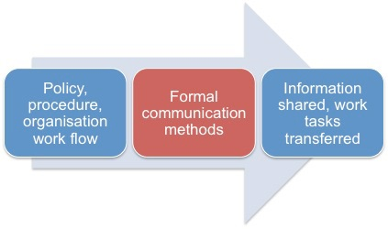
Figure 3: Method of Tesco's formal communication
Source: (Randell and Pilar Rodrigues, 2016)
In the Tesco Plc, the practice of formal communication prevails and they strictly maintain those in order to conduct daily business activities in an optimal way. The formal communication that Tesco’s departments conducted with the people are like a composed expected set of responsibilities that points of interest someone's obligations, his compensation rate, and the standards of the organization when he begins another activity. The exhortation of money or cash owing, a solicitation to an occasion that requests that employee affirm regardless of whether he will go to, a composed notice that is hand conveyed to someone's home or office, a bank articulation that gives data about his or her account, etc. are the ways of formal communication from different department conducted in the Tesco Plc.
Apart from that the procurement department of Tesco Plc issue an invitation to delicate for work. The business messages from one department to another department are transferring through electronic mail. Addressing associates or customers at a formal meeting, or having a formal dialogue with the employees of Tesco is another way to conduct communication.

2.2 Informal communication between departments and people of Tesco Plc
Along with a formal set of communication Tesco Plc also use some sort of informal method of communication in order to communicate with the people. The methods of informal communication are grapevine, influence, team building, etc. in some cases Tesco Plc uses the technique of grapevine in order to spread the information among the employees. All things considered, Tesco Plc may attempt to avert grapevine gossipy tidbits by imparting official data as right on time as could be expected under the circumstances (Mosola, 2012). Through influencing the employees by the influencing skill and social network the executives of the Tesco Plc also established communication with the people. Building a team is another method of informal communication that frequently followed by the management of Tesco’s different departments’ executive with the people. The executives from a different small team and provide order to those team leaders to execute the order.

3. Discussing Organisational culture, ethos and values of Tesco Plc
The management, as well as employees of Tesco Plc, tried both professionally and personally to establish an organisational culture. They believe in their functions that may enhance the performance of the organisation. To help the best working environment culture, Tesco Plc has made impeccable, splendid, top notch workplaces for their representatives where they can foresee coming to work each day (Leigh, 2014). Tesco Plc maintains a positive situation and strong streets of correspondence and support with their power structure. Moreover, they have some great occasions together, too, with various events, trips and recreational open entryways reliably. This culture invigorates life alter in Tesco's agents, and in addition produces sound social associations and a sentiment of the system between their colleagues. The workers of Tesco Plc appreciate coming to work, and they appreciate cooperating.
Culture in work-group characteristics- Tesco Plc has conducted their business in China and in China, they are bound to practice some local culture that they don’t use to. China places awesome implication on distinct relationship. The Chinese executives may at first essence more force on enriching social and relational relations, which is known as guanxi, before going into business or legally binding relationship (Hopp, 2011). Conversely, western world, for example, Tesco administrator, interestingly, may ask their get-together people to pick up from each other to revolve around embraced instead of on social and social relations and to collect the sureness required for dominating execution. They do not consider setting up singular relationship is on a very basic level related with the work.
Cultural in Motivation system- As indicated by Leung (2014), the technique for circulating pay to propel workers may likewise rely upon social qualities. Pay for execution in western organisations like Tesco, and pay value in Chinese organisations. Like other companies, Tesco Plc uses financial support as a technique to motivate the employees.
Culture in Decision-making- Individualistic Western directors inclines toward settling on decisions independently or surrendering to their supervisors rather than advising with others. The western division has a low power isolate culture, and they regard singular reasonableness and place stock in decentralization and drew in underlings (Gupta, 2012). However, the situation in China is to some degree convoluted. A couple of experts prescribe that decisions are typically participatory in collectivistic-high power isolate countries. Diverse investigators trust that agents in those countries should instantly recognize decisions passed on by their managers, and even contradict interest in essential authority because of their unquestioning attitudes toward their chairmen.

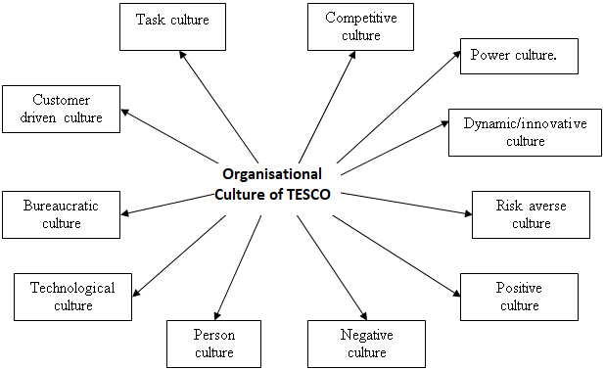
Figure 4: Organisational culture of Tesco Plc
Source: (Britton, 2012)
Power culture: This type of culture believes that being nearer to the focal point of an association implies Tesco Plc can have more impact on the business and consequently can manage. Others won't have quite a bit of a say in the association and accordingly, there are few standards and directions in the power culture (Campbell and Kitson, 2013). This kind of culture relies upon employees of Tesco Plc instead of gatherings. Individual communication with each employee and managers is a key trademark in this culture.
Role culture: Frequently alluded to as the bureaucracy, Coordination is from the best and employment positions are focal. Such a culture makes an exceptionally organized, stable organisation with exact sets of expectations, and depends on a solitary item. The practice of democracy among the management in the Tesco Plc is widely practised. In the Tesco Plc, the subordinate employees also can participate in decision-making activities. The business decision is supposed to execute by the lower or middle-level management. So, the upper-level management of Tesco Plc shares the strategic decision with the lower or middle-level management so that they can eagerly participate to execute the strategic decision.
Task culture- This is the place the association's qualities are identified with work or undertaking. It is typically connected with a little group approach. It demonstrates a system association participating to convey a venture. People are engaged with autonomy and control over their work (Booysen, 2017). Such an association is adaptable and versatile, and the way of life stresses ability and thoughts and includes consistent group critical thinking and counsel. In the Tesco Plc, the individuals are empowered with control as well as power over their work. The subordinates of Tesco are empowered with taking an important strategic business decision.
Competitive culture: Nowadays the competition in the business organisation is in the peak position. Each and every sector there is a range of competition and it’s quite tough to endure. So, in order to endure in the competitive trade world, it’s important to implement the innovative strategic decision to take a competitive advantage.
Innovative culture: Innovation in a business organisation is highly desirable. In the same way as several others organisations, Tesco is influenced in each season and in addition condition and bunches of staff botches. Tesco needs are to present an advancement that can extend its direction, and Tesco swaps the workforce into the PC innovation (Worthington and Britton, 2012).
The Tesco administration considered that our administrations will low level because of the absence of staff, anyway void spaces could be loaded with the assistance of PC innovation and in addition productive execution. The client's conduct has been changed because of the PCs. So self-look at and web-based requesting is the piece of the innovation which Tesco is utilizing productively.
Customer-driven culture- The customers are one of the most important factors that any business organisation need to take into consideration. In the Tesco Plc, they took every single strategic decision by considering the benefits of the customers (Randell, et al, 2016). For example, recently when they inaugurated an online shopping and the delivery system they at first ensure the protection of the rights of the buyers’. That means Tesco plc always concern about the timely delivery, quality control of the delivered products, return conditions, etc.
Tesco is considered as such affiliation which have encountered major flexible social and social changes in the past along similar lines (Rae, 2014). Through my discretionary research, I have found material showing Tesco's flourishing associated with its adjustment in those fields. Tesco is one of the greatest retailers of drinks and nourishment around the globe. Arranged in the United Kingdom as far back as 1920, it needs to date expanded itself into a couple of countries over the EU and furthermore in Asia. It offers more or less 40,000 sustenance and non-sustenance things through its wide arrangement of 2318 stores and its online administration of Tesco.com.

4. Corporate social and environmental responsibility of the Tesco Plc

4.1 Corporate social responsibility of the Tesco Plc
Tesco Plc supporting local communities through performing several activities. Some of the supporting activities of Tesco plc are community champions, donations, 20% top up, British Red Cross partnership, etc. As diplomats for Tesco within their territory, their 500 Communal Champions effort to agreement that they are an unusual fellow citizen that carries a veritable advantage to their neighboring network. Presumptuous a operational part in the origins their communities and customers think about (Booysen, 2017).
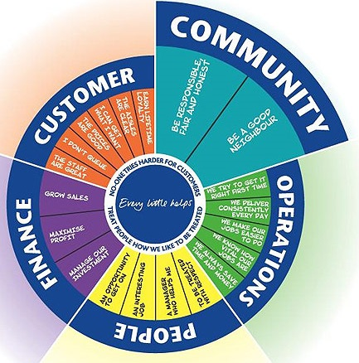

Figure 5: CSR of Tesco Plc
Source: (Gupta, 2012)
Every store of Tesco Plc holds a Community spending plan to assist bolster with demands for nearby fundraising. To be considered for the donation please keep in touch with the Community Champion at your closest store and anyone who has a financial crisis are eligible to apply for the assistance. Tesco plc gets a high volume of solicitations, so they may need to confine the sum gave. Tragically they can't support occasions or people. Tesco Plc is glad for their long history of British Red Cross partnership. Since the start of their organisation, together with their associates and customers in UK, and they have given over around £10.8 million pounds to the British Red Cross. This cash has given essential help to crises in UK and also philanthropic work in abroad calamities. All Tesco associates can spread over for the replenishment of 20% on their own fundraising. The Tesco Plc consequently top-up associate fundraising for their Countrywide Charity Partner and UK's Cancer Research which is known as the Race for life.

4.2 Environmental responsibility of the Tesco Plc
Tesco Plc is a high concern about the maintenance of environmental safety. Some of the initiatives executed by the Tesco Plc are recycled materials, water and energy conservation, green computing, digitalization, recycling, teleconferencing, etc.
The metal suppliers of Tesco Plc furnish them with items that incorporate certain measures of reused material. Tesco's aluminium sheet and tempered steel contain some post-purchaser and post-mechanical reused metal. Also, any piece of metal created by Tesco's assembling procedure is reused. They guarantee that their office supplies are fabricated utilizing reused material, and their Office-produced paper squander is reused. Indeed, in 2011 Tesco Plc reused more than 4600 pounds of office paper, sparing 39 trees, 16000 gallons of water, 9440 kilowatt long stretches of power and averting more than 1300 pounds of contamination from being discharged into the climate. Tesco requires their arranging and janitorial organisations to utilize earth agreeable items at all of their workplaces (Arvinen and Perkins, 2013).

5. Discussing culture of sustainability of the Tesco Plc
Organisational culture is a preparation of communal suppositions, qualities and convictions that represents how persons behave in an institutions. An association with a positive culture empowers workers to acquire and advance in their employment and professions. An association with a moral culture bounces a culture that progresses ethical conduct amongst the entities from the institutions. The unethical behaviour is any movement by an individual from an association that does not fit in with the benchmarks set by the way of life of that association.
Two parts of the culture of an association decide whether the culture of an association is positive and ethical; the content and strength of the culture. A strong or solid culture greatly affects the conduct of the individuals from an association than a feeble culture, which has ambiguous and conflicting rules (Rae, 2014).
Positive organisational cultures that do energize moral conduct customarily have three qualities in common. These organisational cultures of Tesco Plc are ordinarily high in hazard resistance, low in forcefulness and worried about the strategies that are utilized to accomplish hierarchical objectives. Ethical and positive cultures of Tesco Plc have guidelines and limits that energize development by their individuals and demoralize uncontrolled rivalry and a win-no matter what way to deal with accomplishing organisational desired goals. Positive organisational cultures that do energize moral conduct customarily have three qualities in common. These organisational cultures are ordinarily high in hazard resistance, low in forcefulness and worried about the strategies that are utilized to accomplish hierarchical objectives. Supervisors of associations with ethical and positive cultures attempt to enable their representatives to figure out how to wind up better at their employment and are worried about how objectives are accomplished by the individuals from their association; they don't just spotlight on the outcomes (Mosola, 2012).

6. Ethical standards, values and policies of Tesco Plc
Tesco Plc has several ethical policies to covers different areas. Some of the ethical policies are delineated in the following-
Tesco's human rights program is a key component of their guarantee to purchase and sell their products mindfully. The customers of Tesco Plc need to realize that all that they purchase is created in not too bad conditions, and everybody included is dealt with recently. Tesco Plc is devoted to maintaining human rights and totally reinforce the United Nation (UN) Universal Declaration of the Human Rights, the ILO Core Conventions and the UN Guiding Principles on Business and Human Rights. They are furthermore devoted to reporting every now and again on their work to keep up human rights in their supply chains (Meyer and Allen, 2014).
The human rights work of Tesco Plc is inspired by Giles Bolton, Group Accountable Sourcing Director who has reported to the Jason Terry, CPO who is responsible for thing sourcing in general retail associations. On an ordinary commence, relates in Tesco's obtaining bunches supervise supplier and site associations, and good necessities with the assistance of Accountable Sourcing Managers. All United Kingdom Technical Managers, Buying Managers and Procurement Managers are needed to go to inside Accountable Sourcing preparing.
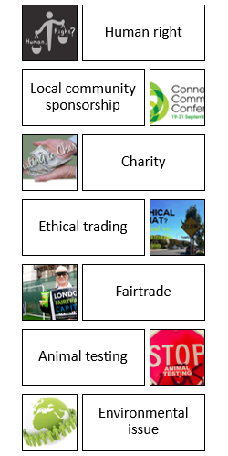
Figure 6: Ethical activities conducted by Tesco Plc
Source: (Gupta, 2012)
One of the officials of Tesco Plc said that 'we don't commission or complete testing on the animals for restorative, pharmaceutical or family unit items. Where animal testing is required by law for nourishment wellbeing purposes, we require that these are completed in accordance with the appropriate direction.' The animal testing is required by law that means for new drugs, they expect providers to limit dependence on the animal’s preliminaries and embrace the most noteworthy moral and welfare benchmarks (Booth and Melling, 2017). Be that as it may, the organisation was likewise offering non-possess mark items made by organisations which were specifically associated with testing their items on the animals at the season of composing. Tesco got Ethical Consumer's moderate rating for its Animal Testing approach.
Green computing alludes to the fabricate, design, utilize, and disposition of IT related hardware, for example, PCs, servers, screens, laser printer, storing gadgets, and arrangements supervision and communications outlines in a naturally well-disposed way. Tesco Plc utilizes energy Star screens, work areas, PCs, laser printer, and different gadgets. Such gadgets shut down to a low power state when not being used diminishing vitality by 60-70 percent, and run cooler, enduring longer. Tesco Plc urges representatives to shut down all IT related gear toward the finish of every day to stay away from control draws when the hardware isn't being utilized. The Tesco Plc recently established a solar panel to support additional power.

7. Discussing the Communication channel of Tesco Plc which are used for sharing information
Face to face sharing of information is the most secure and most proficient strategy for data sharing. In Tesco Plc, everybody can share their data and make inquiries. This enables them to find the solutions they require without waiting. One issue with up close and personal data sharing is that occasionally it isn't conceivable or sparing to meet eye to eye. On the off chance that someone needs to impart data to another one in Manchester and the first person are in Edinburg, it is exceedingly impossible that Tesco will send that person to Manchester only for the face to face meeting (Mosola, 2012).
Tesco’s departments conducted with the people are like a composed expected set of responsibilities that points of interest someone's obligations, his compensation rate, and the standards of the organization when he begins another activity. The exhortation of money or cash owing, a solicitation to an occasion that requests that employee affirm regardless of whether he will go to, a composed notice that is hand conveyed to someone's home or office, a bank articulation that gives data about his or her account, etc. are the ways of formal communication from different department conducted in the Tesco Plc. The official phone calls are another way to communicate with the people by the sales and executives department of Tesco Plc. Addressing associates or customers at a formal meeting, or having a formal dialogue with the employees of Tesco is another way to conduct communication.

8. Discussing the barriers of the effective functioning of Tesco Plc and the methods of overcoming those

8.1 Barriers to the effective functioning of Tesco Plc
Poor communication, unclear goal, lack of management involvement, ego problem, etc are the most common factors that responsible for creating barriers of the effective functioning. Fruitful communication that stimuluses powerful collaboration flinches with the overall enthusiasm to share as well as tune in (Allen, 2014). The respect and hearing should be well-regarded at all levels in an association, commencement with highest management and offering into the manner in which every office is run. Customary email refreshes are precious to make beyond any doubt that all and sundry on someone's group identifies what they have to recognize when they usually have to recognize it.
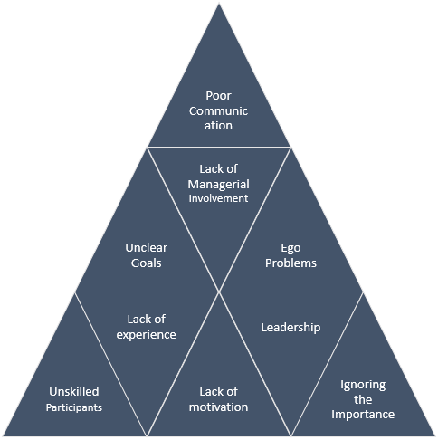
Figure 7: Barriers of the effective functioning of Tesco Plc
Source: (Leigh, 2014)
Administrators make gatherings of qualified staff people remembering the ultimate objective to complete destined assignments or errands. Nevertheless, when the director can't watch a chance to be related with the gathering's execution of its commitments, the ability to make a demeanor of intense joint effort is crippled. Each gathering needs a pioneer, and when the pioneer is missing to allocate obligation and go about as an advantage for partners, by then the gathering won't have the ability to suitably make. Check in with your groups consistently by means of email, through telephone calls or face to face to talk about advance toward objectives or difficulties workers are experiencing.

8.2 Method of overcoming barriers of effective functioning
Following are the ways they can overcome barriers of effective functioning:
- One of the main ways to overcome the barriers of the effective functioning is to share information as much as you have. Sharing information with the group regarding concerning why their exertion is so critical to the organization. 'Each Individual need to be aware of everything'-says the CEO of Tesco Plc.
- The better guidelines always welcome to overcome the barriers of the effective functioning. The team manager needs to have a clear idea about the project and along with that, he ought to provide proper guidelines to the team members in order to complete the task effectively.
- The task needs to have the characteristics of viability as some task are unachievable. So, the project manager or team leader needs to assess the tasks whether those are achieved able or not. It’s also important for the manager to help people to touch the challenge.
- Formation performs that let the projects group understanding about their test imprudently. Consider the policies employed by administrators in the Tesco Plc' marketing and sales department at what time they as of getting on tested retailer groups to form new beliefs for sustaining customer's purposes in order to surprise the customers.

Conclusion
The workplace culture has a great impact on the organisational performance. Basically, the performance of the employees in an organisation largely depends on the culture, environment, ethical practices, etc. of their workplace (Allen, 2014). Tesco Plc is one of the largest retailers in the UK those who maintain all the standards regarding ethical issues and standard culture. Tesco utilizes this way to deal with taking above activities to contribute towards the community. Some scholar recommended that if individuals take after this rule it will bring about optimum good. As a result of the commitment, Tesco made products and services as per the preference of the customers. So, the customers are more upbeat to shop in Tesco in light of the fact that they can augment their own self-enthusiasm towards the general public.

References
Arvinen-Muondo, R. and Perkins, S. (2013). Organisational behaviour. London: Kogan Page.
Booth, A. and Melling, J. (2017). Managing the Modern Workplace. Florence: Taylor and Francis.
Booysen, M. (2017). The influence of the external environment on the internal environment of small businesses.
Campbell, R. and Kitson, A. (2013). The ethical organisation. Basingstoke: Palgrave Macmillan.
Garber, P. (2011). Conducting workplace investigations. Amherst, MA: HRD Press.
Gupta, S. (2012). Lability of mood and stressors in the internal and external environment. International Clinical Psychopharmacology, 28, p.e37.
Hopp, H. (2011). Internal and external factors that affect business performance. Internal and external factors that affect business performance, 1(3), pp.238-264.
Kearns, P. (2012). Measuring and managing employee performance. London: Financial Times/Prentice Hall.
Leigh, A. (2014). Ethical leadership.
Meyer, J. and Allen, N. (2014). Commitment in the workplace. Thousand Oaks, Calif.: Sage Publications.
Mosola, B. (2012). Employees' perception of ethical behaviour in business.
Rae, I. (2014). Overseas business culture. [Place of publication not identified]: Palgrave Macmillan.
Randell, G. and Pilar Rodrigues, M. (2016). Managerial ethical behaviour. Bradford: University of Bradford, Management Centre.
Tesco plc and the Co-operative Group (CWS) Limited. (2016). [London]: Stationery Office.
Worthington, I. and Britton, C. (2012). The business environment.

