Construction Materials
Date Completed: 2022V
Word Count:
Luke Hunt

Prepared for: Allan Nantel

Contents
1.0 Summary 2
2.0 Introduction 2
2.1 – The Gherkin 2
3.0 Finding 3
3.1 – Historical Background 3
3.2 – Original Design Planning 4
3.2 - Construction Method 6
3.3 – Steel Frame resistance to Environmental conditions 8
3.4 – Steel Production Process and its Social and Ecological Impacts 11
3.5 – Positive Attributes of Steel Frames in comparison to Concrete Frames 13
3.6 – Steel Frame Wind Loading Properties 14
4.0 Conclusion 19
5.0 References 20

Summary
Steel framed construction is the most commonly used material in construction today and used to meet the demands of the ever-growing city skylines across the globe. There are impacts in consideration of social and environmental sustainability of this material as there is with all materials, and it is therefore crucial to pinpoint whether the benefits out way the limitations of this. This study aims to compare this to other materials and an existing building that is made from steel frame in order to justify an argument for steel framed structures.

2.0 Introduction

2.1 – The Gherkin
30 St Mary Axe, more widely known as The Gherkin, as seen in the image below, is a steel framed structure that has become one of London’s most widely recognised landmarks, primarily due to its incredibly distinctive design that has been comfortably situated as part of London’s skyline view. The primary reason for producing a case study on this ‘mathematically and geometrically’ (Freiberger, 2007) sound building is because I feel that there is much more to the skyscraper than its design, and to fundamentally provide details, including the history of the building and analysis of its materials in order to gauge the overall impact in consideration of social and environmental sustainability of the site, its materials, and the surrounding area.
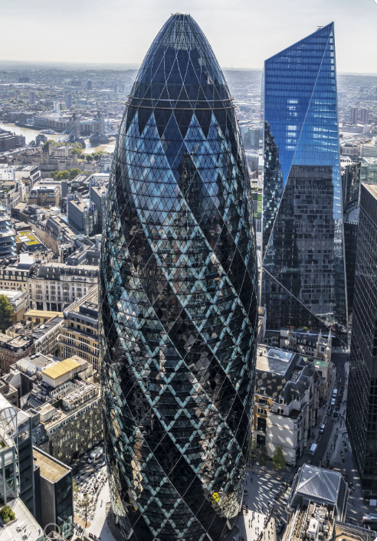

Figure 1: (Shiggwe, 2019)

Finding

3.1 – Historical Background
Prior to the Gherkin’s construction in 2001, the Baltic Exchange Building, built in 1903 stood in its place as a Shipbrokers that dealt with shipping freight and data across the globe (Maritime Manual, 2021). In 1992, there was a terrorist attack instigated by the IRA which led to the detonation of explosives near the Baltic Exchange, completely destroying the building and the surrounding area (Barty-King, 1977). It was left derelict for 6 years, with the intent of it being restored by English Heritage, however commercial interests interceded (Top Site Tours, 2022). The decision was then made, after some public resentment, for the building to be demolished. Below is an image of the Baltic Exchange Building prior to 1992.
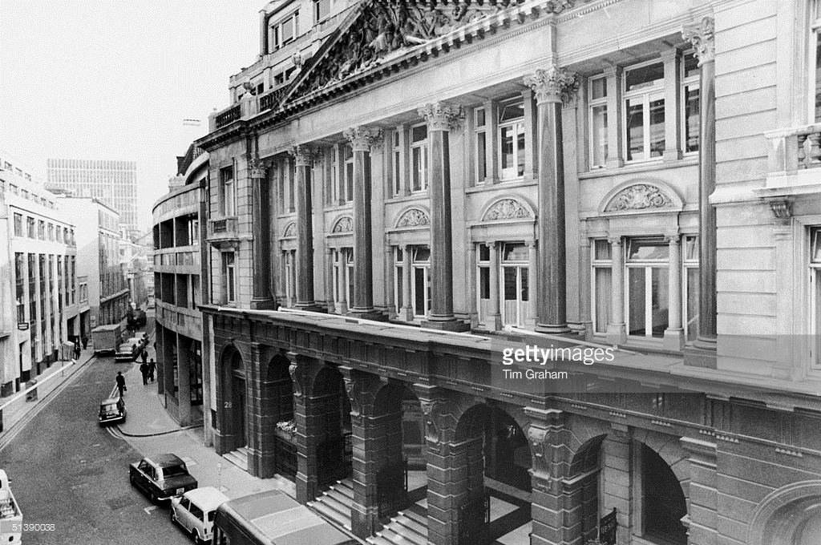

Figure 2: Baltic Exchange Building, London: pre-1992
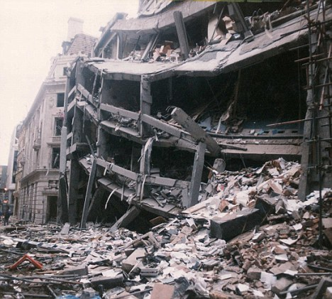

Figure 3: Baltic Exchange Building London: 1992 (Slideshare, 2015)

This led to a debate about what should be put on the site and whether the medieval streets of Canary Wharf should be dominated by a skyscraper and was concluded with the steel framed structure of 30 St Mary Axe, The Gherkin.

3.2 – Original Design Planning
Prior to the construction of the Gherkin, there were plans in place for a building twice the size to be constructed, a feat of engineering, a symbol of the capital, dominating not only the city but London itself as stated by English Heritage (ianVisits, 2015). It was planned to be a 1265 ft, almost see-through masterpiece. Below is a skyline view of London with the Millennium Tower in place of the Gherkin as a representation.
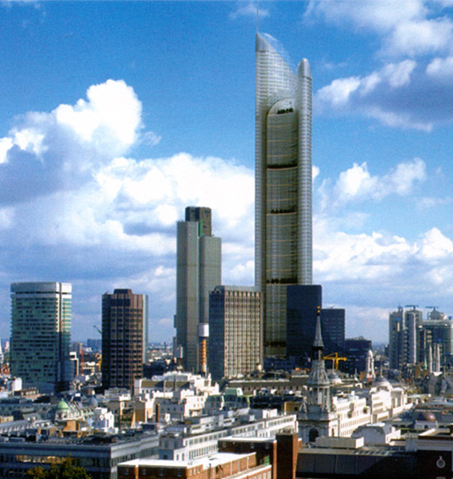

Figure 4: London Millennium Tower (ianVisits, 2015)

This was however, rejected because of two social considerations surrounding the location of the building and the height of the building. The first being that St Paul’s Dome, being of significant importance in the heritage of London, would have been obstructed by the view of the tower in certain lines of sight around the city (Top Site Tours, 2022). As stated by the City of London (City of London, 2022) , St Paul’s Cathedral along with other landmarks are protected by planning controls. The second being that with Heathrow Airport being so close to the city, there was concern that this would be a threat to aircraft taking off and landing (ianVisits, 2015). An attempt was then made to shorten the building but was again rejected. Both of these social factors were considered more important thus cancelling the project completely.
Following this, the land was sold to Swiss Re who hired Foster and Partners to build a skyscraper, where the Gherkin was then approved for construction. Below are some images showing the potential designs for the site and the evolution of design from Millennium Tower to The Gherkin.

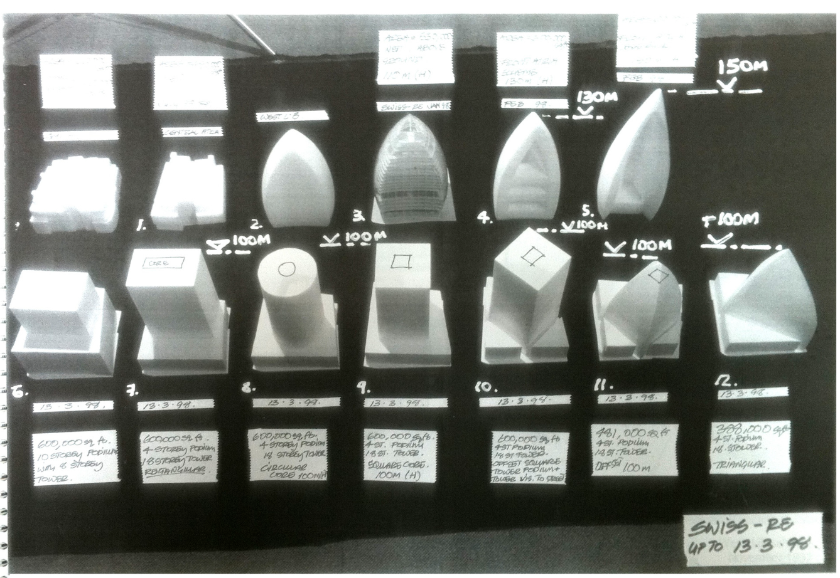
Figure 5: Foster and Partners 1998 (archdaily, 2013)
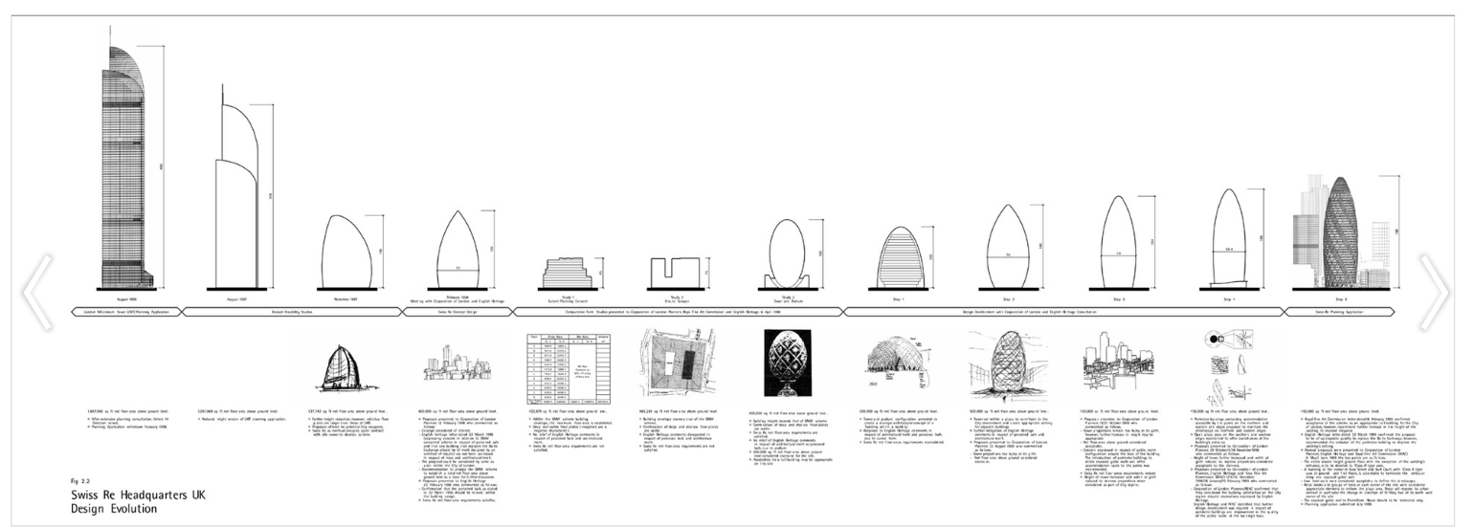
Figure 6: Foster and Partners 2000 (archdaily, 2013)

It can be argued then, that in terms of social and environmental sustainability, the rejections of the previous designs were fundamental to the construction of the Gherkin. This is because the social sustainability limited specific design factors, ensuring that other, historical buildings were not affected in sight view, but also that the design became part of the city’s view rather than sitting out of place. Furthermore, the smaller design would have cost less and taken less time to complete, thus, producing less disruption on a day-to-day basis of the construction.

3.2 - Construction Method
Foundation: The foundation of the steel framed structure consists of 333 concrete piles. Due to specific site restrictions, the rigidity of space on site and need for a monolithic foundation type, it was imperative that everything was achieved in one day.
General Structure: The Gherkin is constructed of steel frame. The steel is pre-cast in a factory to acute pression and then shipped off to site, normally when needed to move onto the next stage. Each column or beam should perfectly connect to the steel before it, generating an efficient and quick erection process.
The Gherkin was built using two fundamental structures to provide absolute stability and load bearing capacities. These are Diagrid - used for the main structure to ‘resist horizontal and gravity loads and the Core – used to ‘resist gravity loads’ as shown in the image below: (Slideshare, 2015)
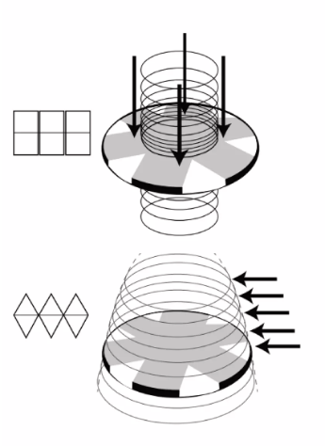

Figure 7: Horizontal and Gravity Loads (Slideshare, 2015)

Structural System: The diagrid method as described by The Contractor – Building Ideas the diagrid consists of many diagonal pieces, angled according to the buildings height is formed to create a framework of triangles to combine gravity and lateral support, making the building strong and stiff – brilliant for a complex and geometric steel design (The Contractor: Building Ideas, n.d.). An example is shown below:
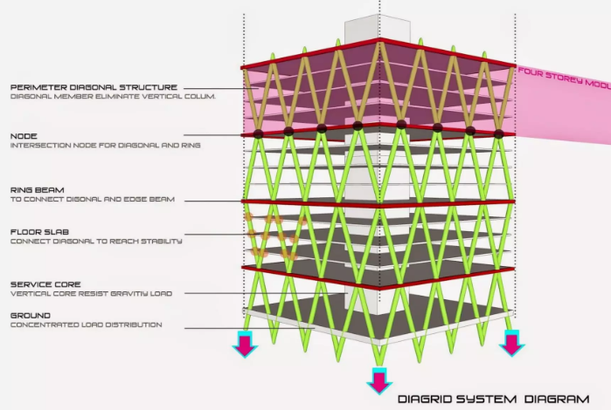

Figure 8: Diagrid System (Slideshare, 2015)

Social and Environmental Impacts: Pouring the foundations in one day would have been difficult. In terms of social sustainability, it might have caused disruption on the roads due to continuous flow of concrete trucks however, it would’ve have enabled the project to develop to the next stage more rapidly.
Having the steel frame pre-cast in a factory prior to going on site allows for absolute precision when fixing it together. It also reduces any waste that would otherwise occur, where it can be incorporated back into the recycling operation. This improves the environmental considerations hugely – more recycled metal means less production. Socially, this would generate jobs as there would be an endless recycling process of steel. However, it could be argued that there is more steel being made than is being recycled, suggesting that there wouldn’t be any reduction in overall environmental implications in the long term.
The diagrid system is crucial to the development of steel frames because of its ability to provide, stiffer, stronger, safer, more complex, more easily adaptive, less need for shear resisting elements and lighter buildings (Devine Civil, 2018). Environmentally, this reduces the overall material use, and provides a margin of error should it need to be adapted.
Types of Load bearing capacities:
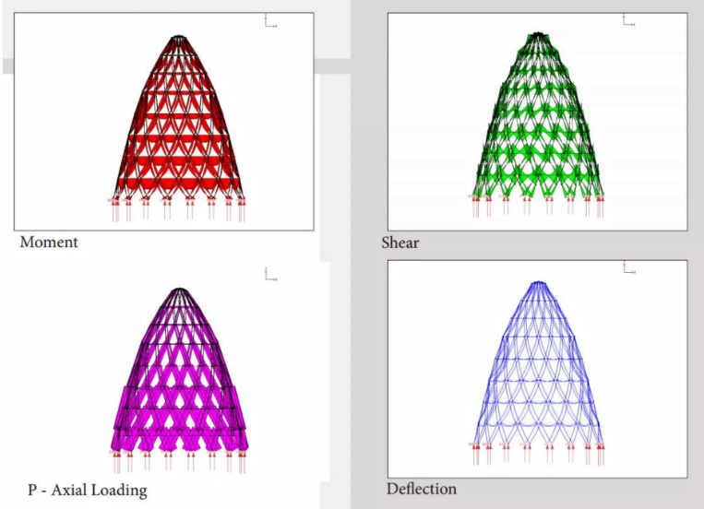
Figure 9: Load Bearing Capacities (Slideshare, 2015)

3.3 – Steel Frame resistance to Environmental conditions
It is difficult to give steel a precise lifespan in terms of climatic resistance due to the vast number of factors that can affect it. When designing a building out of steel, it is crucial to investigate the sites environmental conditions in order to provide a steel that is durable enough and resistant to the surrounding climate, thus making sure that the right tests have been undertaken to build out failure and build in resistance.
The UK has always had a fairly predictable weather pattern in terms of seasons, which allows a building to have built in qualities to withstand the extremes. However, in recent years the climate has changed, and the weather is becoming more unpredictable. This includes higher temperatures in the summer and stronger storms and winds in the winter.
The Gherkin is situated in London which is seen to have slightly differing weather patterns to the rest of the UK. The reason for this is because it is closer to continental Europe. This means that the warmer and more humid south-east winds move towards London increasing temperatures. Furthermore, the low-pressure systems of the Atlantic do not reach London, thus reducing ‘cloud, wind and rain’ (MyLondon, 2022). In the winter, London experiences colder temperatures but not to the extent of the rest of the UK. Below is an annual rainfall and temperature graph in London.

Month | Average High  (F / C) | Average Low  (F / C) | Rainfall  (mm)
January | 48 / 9 | 41 / 6 | 52
February | 48 / 9 | 41 / 5 | 39
March | 54 / 12 | 43 / 6 | 35
April | 59 / 15 | 45 / 7 | 43
May | 64 / 18 | 50 / 10 | 50
June | 70 / 21 | 55 / 13 | 43
July | 73 / 23 | 59 / 15 | 41
August | 73 / 23 | 59 / 15 | 48
September | 68 / 20 | 55 / 13 | 49
October | 61 / 16 | 50 / 10 | 71
November | 54 / 12 | 45 / 7 | 63
December | 48 / 9 | 41 / 5 | 53

Figure 10: Annual rainfall and temperature graph (London Perfect, n.d.)

Steel has a natural resistance to many of the natural elements that it faces as a structure. Some of which include corrosion, mold, vermin, and dimensional stability (Building Using Steel, n.d.). Please
Type of Resistance | Prevention
Corrosion | - ‘Properly designed and constructed steel structures provide long-term durability.  - Laboratory and field exposure tests on steel structures built to industry standard practices demonstrate excellent service life.  - Barrier coatings are readily available to coat the steel surface and isolate it from water and oxygen.  - When further protection is needed, zinc is available to provide sacrificial protection as well as barrier protection.  - When there are severe exposure conditions, such as industrial atmospheres and marine atmospheres, higher-performance coatings are available. (Building Using Steel, n.d.)’
Mold | - ‘Steel framing is resistant to mold since it is inorganic and does not provide a food source for mold to grow.  - Ventilation is efficiently built into a steel-framed design, and energy efficiency is maintained or increased due to steel’s inorganic properties. (Building Using Steel, n.d.)’
Vermin | - Steel framing is not vulnerable to termites since it is inorganic and does not provide a food source for them.  - Cold-formed steel is one of the recognized methods for compliance with the termite-resistant construction requirements of the International Residential Code.  - Cold-formed steel provides a healthy building with no off-gassing from chemical termite treatments or pressure-treated lumber.  - Termite damage is rarely covered by insurance. Building with steel allows owners to avoid costly problems later. (Building Using Steel, n.d.)’
Dimensional Stability | - ‘When considering framing systems, the dimensional stability of the framing materials must be given careful consideration before and during the design and construction process.  - Unintended structural movement can have expensive and potentially disastrous consequences on structural, mechanical, and finish systems.  - Steel structures provide long-term, consistent performance.  - Steel does not expand or contract with moisture content.  - Steel does not warp, split, crack or creep.  - Steel is isotropic, meaning it has the same dimensional properties in all directions. Since there is no “grain,” the strength of steel is the same up and down, side-to-side, and in all loading directions.  - Using steel not only solves issues with structural movement due to changes in moisture content or humidity but eliminates or greatly reduces other moisture related issues such as rot and mold. (Building Using Steel, n.d.)’

However, just like any other material, when exposed to the environment without protection, its durability can diminish, although not by nearly as much. This is why investigating the surrounding climate and environment of a building site is crucial, as it allows for resistance to be built into the design, which maintains its full durability and climatic resistance, when built. (Building Using Steel, n.d.)

3.4 – Steel Production Process and its Social and Ecological Impacts

Production Process of Steel: (FrontMet, 2022)
1st | ‘Taconite rock is blown up to expose and loosen crude Iron ore.
2nd | The rock is ground into a powder and the iron ore is separated using powerful magnets.
3rd | The ore is formed and heated into marble sized pellets.
4th | From bituminous coal, coke is created to fuel the iron making furnaces.
5th | Coal is crushed and sealed into an airtight furnace where it is heated to high temperatures and is the removed as solid carbon fuel.
6th | The fuel and pellets mix together in the furnaces, using limestone to remove any impurities.
7th | A continuous blast of super-heated air combusts the coke, changing raw materials into molten iron.
8th | Recycled steel scrap is dumped into oxygen furnaces and added to hot iron.
9th | High purity oxygen is the blown into this mix, turning molten iron into molten steel.
10th | The steel can then be poured into a ladle which allows the steel to flow through a funnel and into moulds where the highly formable material can take shape.
11th | The steel is commonly cast into long slabs where they can, once dried, be stacked up ready for further processing, which will determine more specified characteristics.
12th | The steel is re-heated and rolled into thinner and more malleable sheets than can be rolled up into coils, ready for use.
13th | The final step provides specials finishes and surface textures for its required specification, i.e., dunked into acid to provide a resistance to corrosion etc.’

Steel is a remarkable material for the contemporary forms of construction and is a plentiful resource that can be used for many years to come, due to it durability, resistance, and stability. Although it provides many great qualities within society, and the construction industry, the process into making steel is not environmentally friendly.
Mining for the primary source of taconite requires large areas of ground. The topsoil is removed until taconite is exposed, where small holes are then dug and filled with explosives, dismantling the rock ready to be taken away (Act for Libraries , n.d.). In terms of environmental and ecological impact, this is not considered acceptable. Such forms of mining can introduce large quantities of water use; air, land, water, and soil pollution; Degradation of surrounding land; Destruction of animal habits; Loss of biodiversity; Disturbance of gases i.e., methane and carbon dioxide; Use of fossil fuels for energy etc (Better Meets Reality, 2022). Coinciding with this is the use of machinery and energy used on site.
Further down the process line is the production of coke, which is baked coal that eventually turns into carbon, and is used for smelting iron ore and steel. Although effective and in high demand, this requires continuous coal mining (Similar environmental implication as mentioned above) and coal burning which creates flying ash, and sulphur dioxide which contributes to major air pollution (Charlton & Jenrick Ltd, 2021).
The primary biproduct of steel production is slag. This is a collection build-up of minerals originating from the raw materials. If disposed of inaccurately i.e., landfills it could cause contamination and other various forms of waste disposal problem. However, it is more commonly used within many industries to “prevent landfill waste, and reduce carbon dioxide emissions, and help preserve natural resources.” (POSCO Newsroom, 2016).
Predominantly, in terms of ecology, air pollution is the main concern and as proven, has both short- and long-term health effects, not only on humans, but the surrounding wildlife and environment. There are many stages within the steel production process that partake in climate implications, but at each of these stages, there is potential for improvement.
The argument pertains that although environmentally, the production of steel is not acceptable, however it is crucial to recognise that there is improvement occurring to reduce this. In addition to this, the social impacts far out way the environmental impacts, especially if environmental control and restoration is heavily monitored and controlled. Thousands of jobs are created just from the steel making process, along with the jobs created by construction that needs steel. This material thus generates a huge economic benefit which can be used to our advantage.

3.5 – Positive Attributes of Steel Frames in comparison to Concrete Frames
 | Steel | Concrete
Ease of Assembly | ‘Structural steel doesn’t have the same time issues associated with it as reinforced concrete. They can be erected as soon as they are delivered, and they can be formed into any shape required with the use of bolts or welding’ (Masteel, 2018). | ‘The constructability of a material refers to how easy it is to be used in general construction tasks. Reinforced concrete takes one to two days to set once it has been poured out, and then it requires additional curing over a period of 28 days. This extended period considerably increases the time taken to construct a structure. In some cases, the concrete can be pre-cast into the required form to save time’ (Masteel, 2018).
Positive Aspects with regards to services provisions | Steel has the potential to span much greater distances than concrete with small sections. Alongside this is the possibility of providing openings within the steel frame. This allows for all the services provisions to be integrated into the building quickly and efficiently and can be hidden from view. It also allows the building to be designed in any way without affecting the positioning of the service provisions. | It is far more difficult to provide services provisions in a concrete frame as you have to build around the concrete.
Ease of Adaption to building shape and use | Steel structures provides lots of space within to adapt and change the layout or even use of the building to provide the necessary means. | This limits the adaption and design of a building because the concrete is fixed, once in place, it cannot be changed.

3.6 – Steel Frame Wind Loading Properties
Steel frame properties in wind loading: Based on the carbon content of steel, and the range of stress and/or strain it is under, you can have a variation on how well steels properties are displayed. This allows for the frame to have specific properties built into it based on the build and its surrounding environment. Please refer to the appendix
Tensile properties | 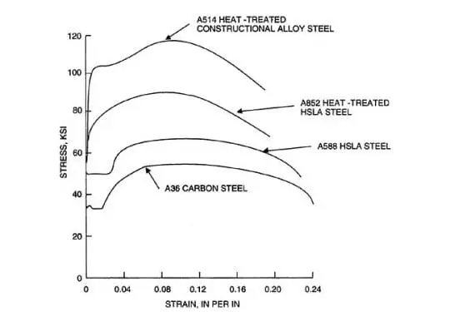  There are different categories of steel structures which can be used in the construction of steel buildings. Typical stress strain curves for various classes of structural steel, which are derived from steel tensile test. The initial part of the curve represents steel elastic limit. In this range, steel structure deformation is not permanent, and the steel regain its original shape upon the removal of the load. As the load on the steel is increased, it would yield at a certain point after which plastic range will be reached. The yield point is the point at which steel specimen reach 0.002 strain under the effect of specific stress.
Shear properties | ‘Shear strength of steel structure is specified at the failure under shear stress, and it is about 0.57 times yield stress of structural steel. Regarding elastic shear modulus, it is expressed as the ratio of shear stress to shear strain in elastic range of steel structure’.
Hardness | ‘Hardness is the measure of ability of steel structure to withstand inelastic deformation’.
Creep | ‘Creep is gradual variation of strain of steel structure under constant stress. It occurs due to the influence of constant stress and the effect of fire. Creep property is insignificant for structural steel frame design and construction apart from the case in which the effect of fire should be taken into consideration’.
Relaxation | ‘It is a step-by-step reduction of structural steel under a constant stress. Usually, yield strength of steel structure increases around 5% over stress relieved strain and the steel structure would suffer from plastic elongation which around 0.01’ (The Constructor, n.d.).
Fatigue | ‘Fatigue is the failure of steel structure due to crack initiation and development under the influence of cyclic loading’ (The Constructor, n.d.).

Remedied wind loading design: The Gherkin was designed with precision accuracy and efficiency to remedy the wind loading capacities of the structure, incorporating each aspect of the building to enhance its functionality. Crucially, the site was analysed to find the dominant direction of the wind to ensure that the building is structurally cable of withstanding the load. Below is a graph that indicates this:
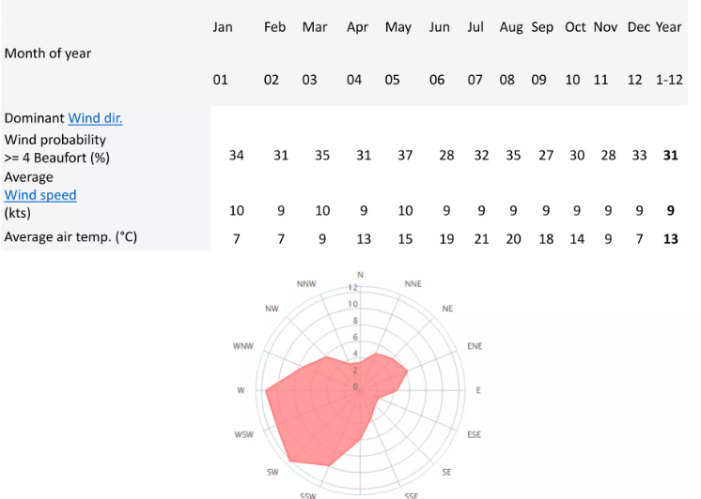
Figure 11: Dominant Wind Direction (Slideshare, 2015)

A primary consideration of the buildings shape was the surrounding buildings. This is because of their rectangular nature, making it difficult for wind to flow smoothly around the buildings. The Gherkin is aerodynamic which reduces the deflection of the wind, providing a ‘comfortable environment at ground level’ (Slideshare, 2015). The aerodynamics provide a path for the wind reducing the overall ‘buffeting, reduced vibrations and diminished fluttering’ (Slideshare, 2015). The image below shows this:
Whilst diverting the wind around the building smoothly, it is also effective in ventilating it, by allowing wind to pass through and around it. This is truly environmentally sustainable as it takes little to no energy to ventilate and heat the building. It also provides a socially comfortable environment with the natural lighting and continuous ventilation.
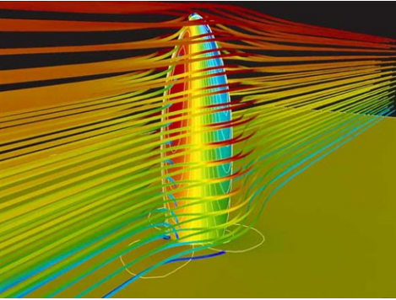
Figure 12: Aerodynamics of the Gherkin (Slideshare, 2015)

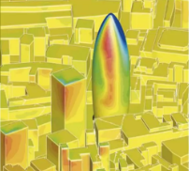
Figure 13:Dominant Wind Direction (Slideshare, 2015)

4.0 Conclusion
After a thorough analysis of this topic, I believe that this steel structure fundamentally demonstrates the pinnacle of what is capable in the contemporary era. There is now the possibility to design a building with resistance to elements and build in any margins for error, such as expansion and contraction within the metal. Furthermore, with the readily available option of pre-casting, there can be a significant reduction in waste but also an improvement in the environmental consideration of the steel. In terms of social sustainability, the whole process, from mining iron to constructing a building, there is a possibility for huge economic growth. Steel production is not the cleanest process, but there is potential for improvement, working with the environment rather than against it.

5.0 References
Act for Libraries , n.d. Mining Taconite. [Online]
Available at: http://www.actforlibraries.org/mining-taconite/
[Accessed 14th November 2022].
archdaily, 2013. The Gherkin: How London’s Famous Tower Leveraged Risk and Became an Icon (Part 2). [Online]
Available at: https://www.archdaily.com/447205/the-gherkin-how-london-s-famous-tower-leveraged-risk-and-became-an-icon-part-2
[Accessed 27th November 2022].
Barty-King, H., 1977. The Baltic Exchange. s.l.:Hutchinson.
Better Meets Reality, 2022. The Potential Negative Effects Of Mining On The Environment, Animals & Humans. [Online]
Available at: https://bettermeetsreality.com/mining-negative-effects-problems-environment-animals-humans-solutions/
[Accessed 14th November 2022].
Charlton & Jenrick Ltd, 2021. Why is Burning Coal Bad?. [Online]
Available at: https://www.charltonandjenrick.co.uk/news/2021/08/why-is-burning-coal-bad/
[Accessed 16th November 2022].
City of London, 2022. Protected views and tall buildings. [Online]
Available at: https://www.cityoflondon.gov.uk/services/planning/planning-policy/protected-views-and-tall-buildings
[Accessed 26th November 2022].
FrontMet, 2022. Steel: From start to finish. [Online]
Available at: https://www.frontmet.com/project-details/steel-from-start-to-finish/
[Accessed 13 November 2022].
ianVisits, 2015. Unbuilt London: The Millennium Tower. [Online]
Available at: https://www.ianvisits.co.uk/articles/unbuilt-london-the-millennium-tower-16036/
[Accessed 28th November 2022].
Maritime Manual, 2021. What is Baltic Exchange?. [Online]
Available at: https://www.maritimemanual.com/what-is-baltic-exchange/
[Accessed 27th November 2022].
POSCO Newsroom, 2016. Steel Slag: The Incredible, Upcycable Byproduct of Steelmaking. [Online]
Available at: https://newsroom.posco.com/en/steel-slag-the-incredible-upcycable-byproduct-of-steelmaking/
[Accessed 16th November 2022].
Slideshare, 2015. The Gherkin: Case Study. [Online]
Available at: https://www.slideshare.net/VikramBengani/the-gherkin-case-study
[Accessed 29th November 2022].
Top Site Tours, 2022. The Gherkin: History of London's Newest Iconic Building. [Online]
Available at: https://www.londontopsightstours.com/the-gherkin-history-of-londons-newest-iconic-building/
[Accessed 27th November 2022].
Visit London, n.d. The Gherkin. [Online]
Available at: https://www.visitlondon.com/things-to-do/place/951036-gherkin
[Accessed 26th November 2022].

6.0 Appendices

