
Certificate in higher education business skills
LCLM4006 enterprise and entrepreneur
Task 1 individual written business plan
Chung lai Johnny wan
Vanesa brenkacova
2440610

Executive Summary
EcoEvent UK is a proposed Sustainable Event Planning and Management company that delivers professionally managed, environmentally friendly events for individuals, businesses and community organisations based in the UK. The company will adapt to the increasing demand for memorable events that cause a minimum amount of waste. It will offer a range of services, at the heart of which are planning services for weddings and private events, corporate events, networking events, community events and full event coordination. EcoEvent UK will stand out by its sustainable event-management model, which will include professional event planning, the use of re-usable décor, digital invitations, reductions in waste, recycling, sustainable catering options and working with local suppliers. This will give them a unique USP – a professionally managed event that combines sustainability with quality and customer experience. The business will cater for the majority of the customer base that takes their green values seriously: couples, SMEs and organisations who are looking for a reliable event-management company. Customers will be directed via a professionally designed website, social-media marketing, digital content, referrals and partnerships with venues and local event suppliers. Initial start-up expenses of around £15,000 will cover business establishment, insurance, website development, branding, marketing, software and equipment, and initial operating costs. The ultimate goal of EcoEvent UK is to build a recognisable sustainable-event brand and look to gradually grow this service across the UK.

Table of Contents
Executive Summary 2
1. Overview of the Business Idea 4
1.1 Business Concept and Services 4
1.2 Target Customers and USP 4
1.3 Sustainability and Community Support 4
1.4 Legal Format 4
1.5 Management Structure 5
2. Market Research 5
2.1 UK Market Context 5
2.2 PESTEL Analysis 5
2.3 Competition 6
3. Marketing Communications 7
3.1 Target Market and Positioning 7
3.2 Digital and Social Media Strategy 7
3.3 Promotional Strategy 8
3.4 Partnerships and Customer Acquisition 8
4. Financials 9
4.1 Funding Requirement 9
4.2 Funding Sources and Justification 9
4.3 First-Month Startup Expenses 9
4.4 Financial Considerations 10
5.References 11
6.Appendix 13

1. Overview of the Business Idea

1.1 Business Concept and Services
EcoEvent UK is a proposed UK business that will plan and manage professional and environmentally friendly events, that will plan and manage professional and environmentally responsible events. The business will be based in Birmingham city centre and serve customers across the UK.The business will manage the planning of its projects from conception and budget to venue and supplier coordination to day-of-event management (Thomas and Stephens, 2022). It will begin with weddings, corporate events, networking events, and private celebrations. EcoEvent UK will minimise time, coordination pressures, and risks to customers, as well as ensuring consistency, by offering an integrated service. The idea is a marriage of professional convenience and sustainability, and provides a unique proposition for the entrepreneur. The assessment guide specifies that the business idea should include an offering, USP, and sustainability/community support.

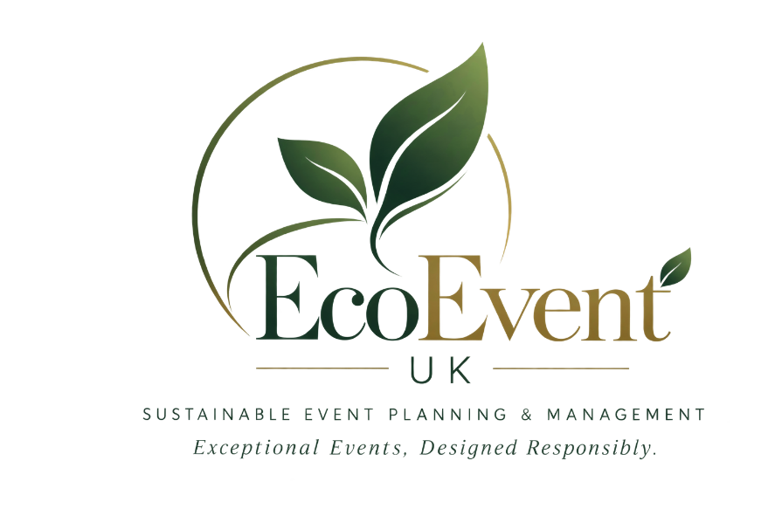
Figure 1:EcoEvent UK
Source: (Myself,2026)

1.2 Target Customers and USP
EcoEvent UK will appeal to couples with an eco-friendly sensibility, SMEs, corporate clients, and community groups who want advice on event management. The USP will be sustainable event management without sacrificing quality, creativity, and customer experience (Srinivasan, 2018). This positioning separates the venture from others, with responsible event practices being a fundamental element of the service and not viewed as an added value. Value creation can be enhanced across business relationships by stakeholder-focused sustainability (Orefice and Nyarko, 2020).

1.3 Sustainability and Community Support
Sustainability will be incorporated by using reusable décor and equipment, digital invitations, reducing waste, recycling, sustainable catering, and local suppliers. Moreover, the business will employ local part-time event workers, consequently promoting local economic involvement. The practices of these programs reflect sustainability goals in action for their purchasing and operations, meeting the assessment criteria for an environmental and/or community-support element.

1.4 Legal Format
EcoEvent UK will be a private company limited by shares Ltd.. A private limited company is a separate legal entity from its owners. However, the liability of the shareholders will not exceed the amount they invested, and it also helps to finance and invest in the future (Afridi, 2025).

1.5 Management Structure
The company will be run by a Founder/Managing Director who will be responsible for strategy and key clients, assisted by an Event Coordinator, Marketing/Social Media Officer, and Finance/Admin function. Event staff will be hired on a freelance basis as needed, allowing the business to grow alongside the event needs.
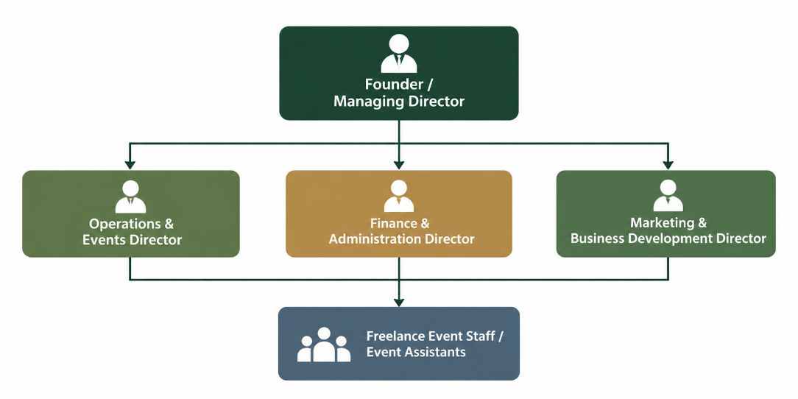
Figure 2: Managerial Structure of EcoEvent UK
Source: (Myself, 2026)

2. Market Research

2.1 UK Market Context
EcoEvent UK joins the events market. According to the Events Industry Forum, there are outdoor events accounting for the biggest share of the UK events industry, at a value of £61.6 billion (UK Parliament, 2026). The ONS data illustrates the wider economic activity around events, including how major events can impact consumer spending locally, as per Appendix A (ONS, 2026). This provides a chance for specialist planners who can bring together professional delivery and sustainability.

2.2 PESTEL Analysis
 | Analysis and implications for EcoEvent UK
  Factor
Political | The UK government offers tax relief on some energy -efficiently equipment.This could help EcoEvent UK reduce costs when investing in eligible sustainable technology  EcoEvent can research whether any relevant tax reliefs allowance apply to the equipment to help reduce cost (GOV.UK)
Economic | Inflation may increase venue, catering, transport and equipment costs. UK CPIH inflation was 3.1% in July 2026 (ONS, 2026). EcoEvent UK to negotiate supplier rates, flexible packages, and contingency budgets to safeguard margins.
Social | Users are demanding experiences that reflect social and environmental values. Event selection can have a positive impact on sustainability, and community-based procurement can help build relationships.EcoEvent UK should communicate responsible practices transparently rather than relying on unverified “green” claims.
Technological | Digital channels are effective customer acquirers and effective event communicators. UK adults reported spending an average of 4.5 hours online each day in 2025, and Instagram and TikTok were relevant to younger adults (Jackson, 2025). Social media visualisation, online booking and digital invitations are a way to help EcoEvent UK be more effective and convenient.
Environmental | Events generate emissions, waste and resource use; academic research shows impacts throughout the event life cycle (Cavallin Toscani et al 2022). EcoEvent UK can achieve this by providing re-usable decor, waste prevention, recycling, local sourcing, and sustainable catering and by embedding environmental management into the delivery of services.
Legal | Event organisers are responsible for complying with legal requirements. Events involving alcohol, regulated entertainment or late-night refreshments may require a Temporary Event Notice in England and Wales. At the time of delivery, EcoEvent UK should ensure that venues have licences, event permissions, insurance, and supplier responsibilities for the event.
Table 1: PESTEL Analysis
Source : (Compiled by Myself)

2.3 Competition
Competitor | Main Focus | Sustainability | Implication for EcoEvent UK
Lee & Klein Events | Event planning and management, mainly in London | Eco-friendly event planning | EcoEvent UK can serve a wider UK customer base.
Zentive Agency | Corporate events, venue sourcing and management | Sustainability and carbon measurement | EcoEvent UK can combine sustainability with personalised event design.
Event Experience | UK corporate event planning | Sustainable event delivery | EcoEvent UK can target private, SME and community clients as well.
EcoEvent UK | Weddings, private, corporate and community events | Reusable materials, waste reduction, recycling and local sourcing | Differentiates through accessible sustainable planning and personalised service.
Table 2: Competitor Analysis
Source: (Myself, 2026)

3. Marketing Communications

3.1 Target Market and Positioning
EcoEvent UK will focus on the eco-conscious couple, SMEs, corporate and community organisations looking for professionally managed, memorable, and responsible events. Users will appreciate user-friendliness, innovative design, coordination, and a lower environmental footprint. EcoEvent UK will be a more approachable sustainable event-management expert, with the message: “Exceptional events designed responsibly.” This positioning links customer experience with measurable sustainable practices.

3.2 Digital and Social Media Strategy

Figure 3: Digital and Social Media Strategy
Source: (Myself, 2026)
Digital communication is going to be a key method of customer acquisition as UK adults spend an average of 4.5 hours online each day, and 89% of all adult internet users use social media (Jackson, 2025).Instagram will feature event photography, transformations of décor and client stories; TikTok will share the behind-the-scenes details of event planning and sustainability advice; Facebook will provide local community involvement and advertising. The focus of LinkedIn will be on the SMEs and corporate decision-makers. A website will offer service packages, portfolios, enquiries and booking details, and Google Business Profile will enhance local search visibility. Email marketing will help to nurture enquiries, share offers and drum in referrals.

3.3 Promotional Strategy
A launch campaign will be created with the help of an “Eco Celebration” portfolio, showcasing the appeal of events that have a negative impact on waste. Case-style posts, planning tips, and testimonials from clients will form part of content marketing. Great customer service and incentives to partner businesses will make it more likely that customers will recommend the service (Nadda, Dadwal and Roya, 2017). Seasonal demand can be generated for wedding, Christmas functions and corporate events. Performance will be tracked on paid social ads based on enquiries, conversion rate and customer-acquisition cost (CAC).

3.4 Partnerships and Customer Acquisition
EcoEvent UK will create relationships with local businesses, florists, caterers, photographers, hotels, and wedding venues that provide referrals. Other client networks can be found in corporate and community organisations (Jarrah, 2015). Such collaborations can boost the number of referrals, build trustworthiness, and lessen the need for advertising. The assessment guide explicitly asks to explore digital platforms and how digital technology can attract customers.

4. Financials

4.1 Funding Requirement
EcoEvent UK will need to start out with £15k in up-front investment. This figure is derived from the first-month start-up budget below and will leave it with adequate funds for legal establishment, digital infrastructure, insurance, marketing, and sustainable event equipment and contingency for working capital. The funding model has been drawn up to prevent the business from having too much up-front investment and to enable it to deliver its first events professionally.

4.2 Funding Sources and Justification
The funding will include a £7500 Start Up Loan from the Government (that is, a loan backed by the Government) and a £7500 contribution by the founder(s). Founder investment shows commitment and preserves control of the equity, and external financing will expand the working capital without equity dilution. This is a scale of borrowing which is relevant to a new venture, as the loans are offered by UK Start Up Loans at £500 to £25,000 and have fixed interest and repayment terms (GOV.UK, 2025).

4.3 First-Month Startup Expenses
Expense | Estimated Cost
Companies House registration | £100
Website, domain and hosting | £1,200
Branding and marketing materials | £900
Launch advertising | £1,500
Sustainable event décor/equipment | £3,000
Business/event insurance | £800
Software and subscriptions | £500
Office/admin and communications | £600
Initial supplier deposits | £4,000
Contingency reserve | £2,400
Total | £15,000
Table 3: Start-up Expenses
Source: (Myself, 2026)
The registration fee is based on the current Companies House online incorporation fee of £100. The budget for the website is proportional to that of a professionally created small-business site, and the equipment and supplier budget will provide capacity to provide initial events. The insurance provided by a contingency reserve is a cash-flow cushion against unforeseen expenses in the first phase of development and market entry.

4.4 Financial Considerations
EcoEvent UK will manage costs by negotiating with suppliers, deposits, and flexible freelance staffing. It will be important to carefully manage cash flows as the venue, catering and supplier costs may come before customer balances are received (Orefice and Nyarko, 2020). The company can grow without a significant jump in fixed costs and financial risk by hiring freelancers and outsourcing work as demand grows.

5.References
Afridi, A. (2025). Corporate liability and the concept of limited liability. International Journal of Law and Policy, 3(10), pp.37–57. DOI:10.59022/ijlp.386
GOV.UK (2025). Apply for a start up loan for your business. [online] GOV.UK. Available at: https://www.gov.uk/apply-start-up-loan.
Jackson, M. (2025). Ofcom finds UK adults now spend over 4.5 hours online each day. [online] ISPreview UK. Available at: https://www.ispreview.co.uk/index.php/2025/12/ofcom-finds-uk-adults-now-spend-over-4-5-hours-online-each-day.html.

Jarrah, M.A. (2015). Evaluation of electronic customer knowledge mediating by electronic customer attraction on electronic customer Acquisition. International Journal of Customer Relationship Marketing and Management, 6(3), pp.33–47.

Cavallin Toscani A Macchion L stoppato A and Vineli A ( 2022) “How to assess events environmental impacts a uniform life cycle approach .
Nadda, V., Dadwal, S. and Roya, R. (2017). Promotional strategies and new service opportunities in emerging economies. IGI Global.
ONS (2026). Consumer price inflation, UK. [online] Ons.gov.uk. Available at: https://www.ons.gov.uk/economy/inflationandpriceindices/bulletins/consumerpriceinflation/august2026.Orefice, C. and Nyarko, N. (2020). Sustainable value creation in event ecosystems – a business models perspective. Journal of Sustainable Tourism, pp.1–16. Doi:10.1080/09669582.2020.1843045.
Reading Borough Council (2024). Reading events greener following pilot scheme | reading borough council.
news. [online] Reading Borough Council News. Available at: https://media.reading.gov.uk/news/reading-events-greener-following-pilot-scheme.
Srinivasan, R. (2018). Marketing success formula. Notion Press.
Thomas, K. and Stephens, S. (2022). Understanding the management theory in event management. [online] ResearchGate. Available at: https://www.researchgate.net/publication/351229536_Understanding_the_Management_Theory_in_Event_Management.
UK Parliament (2026). Business events. [online] Parliament.uk. Available at: https://publications.parliament.uk/pa/cm5902/cmselect/cmcumeds/335/report.html.

6.Appendix
Appendix: Consumer price inflation rates



