
Design for X Project



Executive Summary
STUDENT NUMBER- 2117931
July 8, 2024
University of Wales Trinity Saint David

This report is split into two tasks, task one is about the redesigning of a robot gripper, as a manufacturing company would like to increase production to 1000+ units per week to mass production, the initial design has been given however it could be changed to aid in increasing production in the manufacturing process. Task two for this report is about addictive manufacturing and redesigning a component using Design For Addictive Manufacturing, and using the generative tool. Creating a component that can be manufactured using an Additive Manufacturing Process.

Table of Contents
Executive Summary 0
Table of Contents 2
Introduction 4
Task 1 – Robot Gripper Redesign 5
Design Process 5
The Problem 5
Design specification 6
Design For Manufacturing (DFM) 6
Design For Assembly (DFA) 7
Design Efficiency 7
Research 8
Mechanical gripper 8
Potential Costs To Produce 11
Machining Costs 11
Selection Criteria Of Grippers 12
Quality Function Deployment 13
Developing Alternative Ideas 14
Choosing Alternatives 17
Choosing A Solution 17
Model Of New Idea 18
Evaluation Of Idea 19
Task 2 – Design for Additive Manufacturing 21
Design For Manufacturing (DFM) 21
Design For Additive Manufacturing (DfAM) 21
Additive Manufacturing For Component Consolidation 22
Additive Manufacturing Processes 22
Support Structures In Additive Manufacturing 22
Post – Processing in Additive Manufacturing 23
Internal Structures (Lattice or Cellular) 23
Topology Optimisation 24
Generative Design 24
Difference Between Topology and Generative Design 24
Component 25
Initial Design 26
Stress Constraints 27
Generative Design 1 – Tough 2000 28
Generative Design 2 - PEKK 29
Generative Design 3 - PA11 – Nylon – HP 11 -30 30
Generative Design 3 – Aluminium AlSi10Mg 31
Evaluation 32
References 33
Bibliography 37
Appendices 41
Design specification 41
Additive Manufacturing Processes 42
QFD 44

Introduction

This report is about a robotic tooling manufacturer who would like a review of one of their mechanical grippers. The manufacturer has been producing the gripper in small volumes, but the company would like to change to mass produce this part. The components will be initially looked at with the possibility of changing the design and assembly process. the company has suggested to increase production volumes to 1000+ units per week. The gripper will be analysed looking at the design efficiency and manufacturing process. Items which maybe considered in this report of the mechanical gripper may be a design specification and the chosen method for manufacturing. Different methods of potential designs could be looked at and evaluated against the new design concept, different analysis techniques could be used on the new design also taking into account the product life cycle and environmental factors.

Task 1 – Robot Gripper Redesign
To begin this report the design process will be looked at initially, once the initial design process is looked at then the expansion, into the different parts of the design process will be completed.

Design Process
There are basic fundamentals that are part of a design process
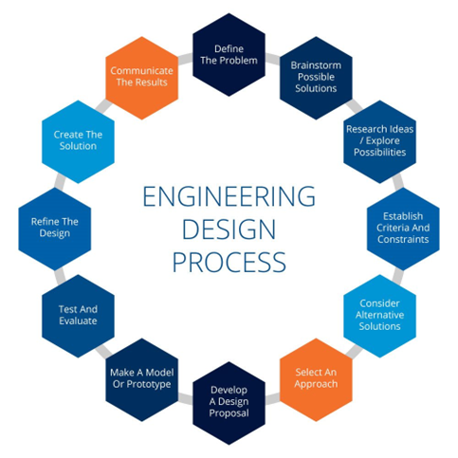
- The Problem
- The Design Specification
- Research
- Developing alternatives
- Choosing alternatives
- Choosing a solution
- Models and prototypes
- Testing and evaluating
- Manufacturing and production

Figure 1 Engineering design process (TWI, No date b)

The Problem

A robotic tooling manufacturer wants a review of their mechanical gripper. The gripper has been produced in small volumes but the company wants the components and assembly redesigned for mass production of 1000+ units per week. The company has an initial design but further work is required to optimize the design efficiency and manufacturing of the gripper.

Design specification

Initially a design specification should be written, this is a list of prompts that will help the understanding of the requirements to fit the brief, the prompts can vary between pricing, customer interaction, and aesthetics to name a few (Nollie, No Date). For this task see appendix for the design specification.

Design For Manufacturing (DFM)

Design for manufacturing is the optimisation of a part or component to create it cheaper and more efficiently (TWI, No Date). In the product design stage, the design of the product is thought about so that it can manufactured efficiently, it is easier to spend time getting the design right at this stage to reduce manufacturing costs and adjustments in the future and hopefully prevent mistakes (TWI, No Date). If the product can be easily manufactured by not having complicated assembles, specialist machines will not be required. If standardisation of parts and reducing the number of parts are applied then this can lead to taking less time to manufacture, if the amount of parts required is reduced, less storage is required and from these factors costs will reduce. Toyota Production Systems use the word MUDA – meaning waste. This can be used to highlight different forms of waste in a manufacturing process the acronym ‘TIMWOOD’ can be used to remember the key points below (Kanban tool, No date).
Transport – Moving products that are not required.
Inventory – Products that are in stock either finished or ready for processing.
Motion – People or equipment more than required.
Waiting – Waiting for the next production step.
Overproduction – Production ahead of demand.
Overprocessing – Creating extra activities from poor designs.
Defects – Inspecting and fixing defects.
(Kanban tool, No date).
By designing a product that reduces the MUDA according to Toyota production systems, this will reduce overall manufacturing costs and the future production costs as well.

Design For Assembly (DFA)

Design for assembly is a sub topic of DFM and focusses on designing a product to ease the assembly process. This can be done by reducing the number of components, ease of alignment and accessibility, not requiring the need for specialist equipment, reducing labour costs and time of assembly (Jiga, 2023). Instead of having lots of individual parts, make them whole (Rapid Direct, 2021). Parts could be assembled by not requiring tools, not requiring orientating, access through one direction through the top of the component. Securing the component together can be done in several ways without the use of fasteners. A component could be fixed together by the use of bolts, with the need of the bolt, washer, and nuts required, more parts and the need to secure together of the two faces, if the design was changed to screw moulded pillars a single screw could be used to screw the component together which aligns and secures into the moulded pillar. The part count for this design would reduce and also the need to only fix together on one face. This design has the potential to have the parts reduced down further and potentially have its assembly speed up by not having a screw assembly but by having snap together components (Jiga, 2023) this is also suggested by (Rapid Direct, 2021) that snap fits do not require tools and can make assembling easier. Though if the product requires service then this snap fixing will have to be able to withstand being taking apart and put back together again (Jiga, 2023). The use of uniform parts will also speed up the assembly process, if screws are required, if all screws are uniform in size and shape, then the error of putting the wrong screw in the wrong hole will be removed, if all the screws have the same size head and are the same type of screw then the production team can all use the tool to assemble the product (Rapid Direct, 2021). Also the use of modular designs will help in the assembly process if the parts to make up the component can be made up of smaller units containing pre-assembled components, then this eases the assembly process, it also means that if there are parts to repair then the small modules can be taken out and replaced (Rapid Direct, 2021). By making unique parts for a position, it enables parts to only be fitted in a certain way meaning that parts cannot be wrongly fitted together(Rapid Direct, 2021). A simple design also reduces the need for multiple parts as apposed to a complex design it also helps the production team by making it less complex and can then reduce production costs.

Design Efficiency
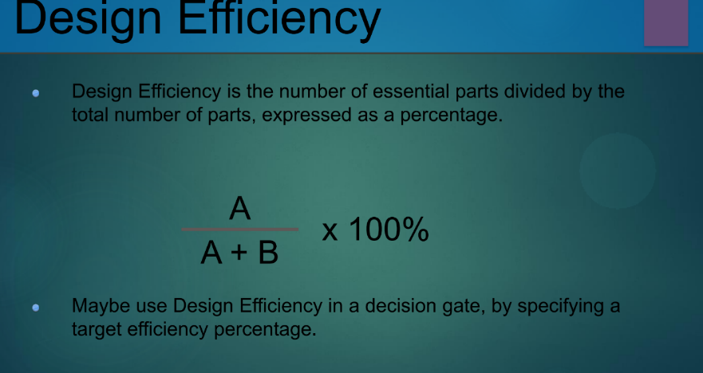
Using the calculation in the figure 2 this calculation can be used to determine how efficient the component is.
Figure 2 Design Efficiency calculation (Morgan, No Date a)

Research
By referring to the design specification, research can be carried out on a variety of different things
- A look at different design techniques
- Material costs
- Potential costs to produce
- Material life span
- Material properties – durability, strength, weight
- Material disposal
- What can the gripper be used on

Mechanical gripper
A mechanical gripper serves as a hand on the end of a robotic arm or automation system, designed for grasping, holding, manipulating, gripping and releasing objects (Dorna robotics, 2023). There are numerous types of gripper on the market such as parallel jaw grippers, vacuum grippers, finger grippers, pneumatic grippers, electromagnetic grippers, hydraulic gripper. For this task parallel jaw will be looked at. Parallel jaw grippers, comprise of two jaws moving parallel to each other, useful for grasping objects of diverse shapes and sizes, delicately handling small components or a secure grip of large components (Dorna robotics, 2023).
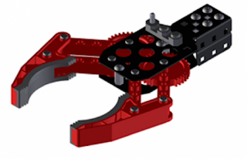
Different Designs
Initial visual thoughts- either metal or plastic, with rubber grippers, looks to be made of several parts and screws.
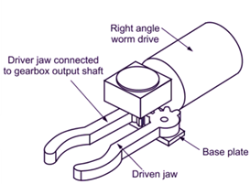
Initial visual thoughts – relatively simple design not many parts or screws.

Figure 3 Robot gripper (Austin, 2016) Figure 4 Robot gripper (Electrical Workbook, 2021)
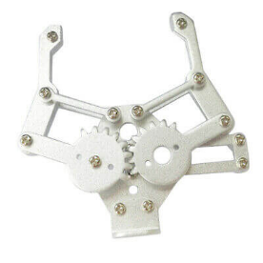
Initial visual thoughts – open design, good for accessibility, simple design, with several screws.
Figure 5 Mechanical Metal Gripper for Robot Mechanical Claw Robotic Arm Manipulator (Electronics Hub, No date)
Material costs
Grippers can be made of several different types of materials
Aluminium- lightweight, durable, corrosion resistant, can withstand high temperatures, commonly used in gripper construction.
Stainless steel – durable, corrosion resistant, suitable for the use in the food and beverage industry.
Plastic – lightweight, cost-effective, suitable for picking up delicate objects.
(Pact Automation, No date)
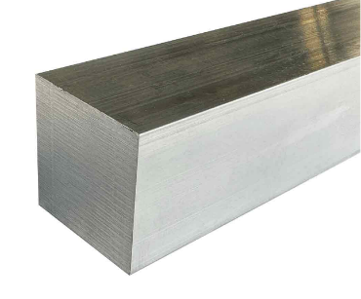
Aluminium –
Grade – 6082
Size – 50.8mm square bar
Length – 1000mm
Weight – 7.03kg
Price - £67.30 ex VAT
(Aluminium warehouse, No Date a) Figure 6 square bar (Aluminium warehouse, No Date a)
Structural grade aluminium- highest strength alloy in the 6000 series. Good machinability. Good corrosion resistance and mechanical properties. (Aluminium warehouse, No Date a)
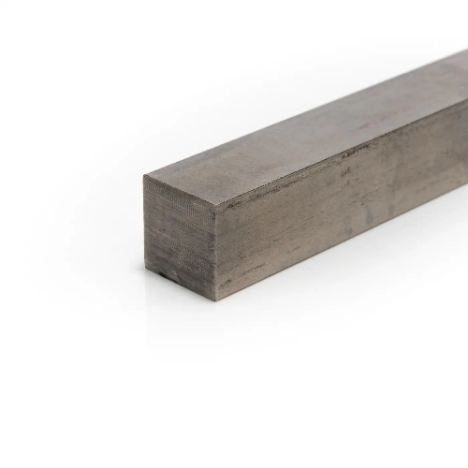
Aluminium is the most abundant metallic element on earth and has a life span of 40 years for building and over 80 years for window frames. It is easy to cast, machine and shape. It can also be recycled and reused without the loss of material quality it can be recycled and reused in every step of its lifecycle, saving CO2 emissions by preventing the use of primary metal (Metals Warehouse, 2021).
Stainless steel –
Grade – 316
Size – 50mm square bar
Length – 1000mm
Weight – 19.8kg
Price - £280.23 ex VAT Figure 7 Stainless steel square bar (Metals4U, No date)
316 Stainless Steel is suitable when corrosion resistance is important in both atmospheric and seawater environments. Can be welded together. (Aluminium warehouse, No Date b) Stainless steel has a life span of over fifty years, and is used in many applications especially as it is easy to sterilise. It is also 100% recyclable. (Metals Warehouse, 2021).

Carbon steel -
Grade – S275JR
Size – 50mm square bar
Length – 1000mm
Weight – 20kg
Price - £313.98 ex VAT

PTFE –
Extruded virgin
Size – 50mm round bar
Length – 1000mm
Weight – 2.16(g/cm3) / 2160kg/m3
Price - £123.10 ex VAT
(Plastock, No date a)
PTFE rod is used in a variety of industries, including aerospace, electrical, and automotive. It is suitable for billeting, precision grinding and CNC turning (Plastock, No date a).
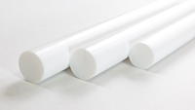
Figure 8 PTFE rod (CS Hyde Company, No date)

Polycarbonate-
Grade - Engineering Grade Extruded Clear Rod
Size – 50mm round bar
Length – 1000mm
Weight – 1.2(g/cm3) / 1200kg/m3
Price - £75.65 ex VAT
(Plastock, No date b)

Potential Costs To Produce
Researching a mechanical gripper online the below was found. The cost is £7.79 to purchase. An important point to consider is that this is the purchase price and not manufacturing cost, this part, may have been mass produced and so material to produce it may have been bought in bulk and then either by casting or machining the parts produced. The parts would have then been assembled together with the screws.
Aluminum Mechanical Robotic Claw Gripper For Arduino Medium Servo MG995 SG5010
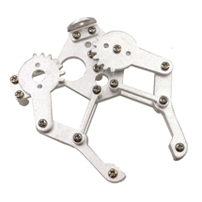
Cost £7.79
Figure 9 Mechanical Robotic Claw (Ebay, No date)

Machining Costs
When designing parts for machining three factors will affect the cost of the part-
- Design – will affect the technology required
- Material – will affect the parts price
- Quantity – machining parts in bulk will help reduce costs.
CNC machining is a subtractive machining technology, physically cutting to remove material from a solid block of material. Costs can vary from £10 - £21 per hour in China and around £30 per hour in the UK. The main driving factors of cost are labour, time and energy (Smoothy, 2024).

Selection Criteria Of Grippers
An important consideration on selection of a gripper is the gripping force. The force that is exserted from the gripper should be sufficient to hold the object but not too strong that it damages the object. Depending on what the gripper will be picking up, the objects size and shape, will depend on the grippers size (Pact Automation, No date). The material of the claw part of the gripper will also have to be considered, does the gripper require to have rubber tips so it protects the object from damage. If the object was made from a metal and the gripper was also made of metal. There could be the possibility of cross contamination from metal to metal.

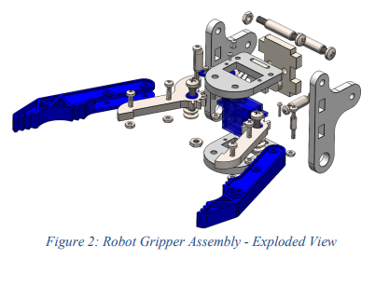
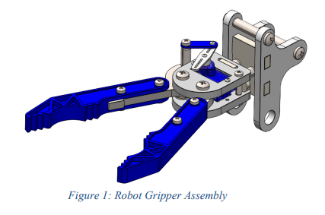

Figure 10 Robot Gripper Assembly Figure 11 Robot Gripper Assembly – Exploded View

(Morgan, No Date b)

Quality Function Deployment
Quality function deployment (QFD) is a method for gathering customer requirements and turning them into products or services. From listening to the customer needs and wants it can then determine what product features or services to create to meet the demands of the customer. This method is supposed to supplement the current design process, it can show the best features to build to improve customer satisfaction (Nguyen. S, 2023). The result of using this method has the potential to produce products that are more likely to satisfy your customers.
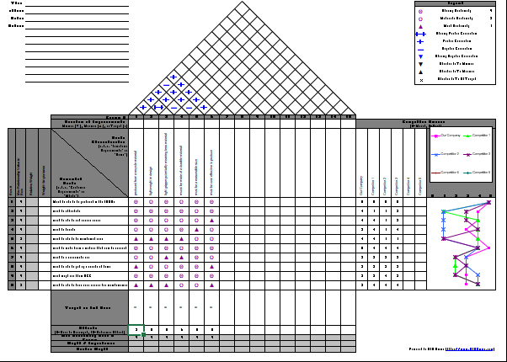
See appendix for full view Figure 12 (Morgan, No Date c )

Developing Alternative Ideas

Existing Idea
Figure 13 (Morgan, No Date b)
Initial thoughts from the original design would be:
Remove/reduce the number screws
Make it one unit so there is less parts
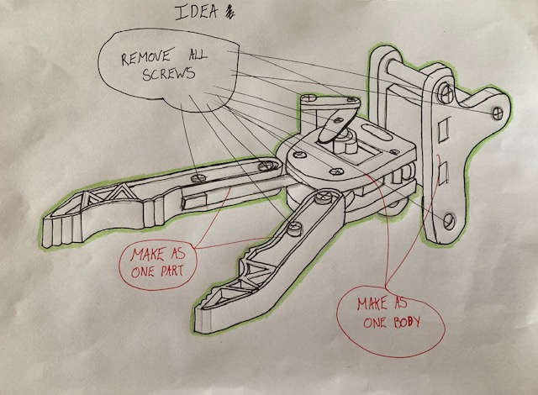

Figure 14 Edited version of (Morgan, No Date b)
Design Idea 1

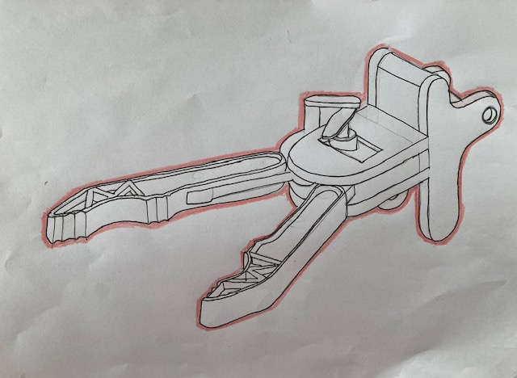
Figure 15 Edited version of (Morgan, No Date b)

Design could look like the above
By removing the screws and making it one unit the unit however the unit would be fixed in place and being a gripper the arms should be able to move. So this idea would have to be altered.

Design Idea 2

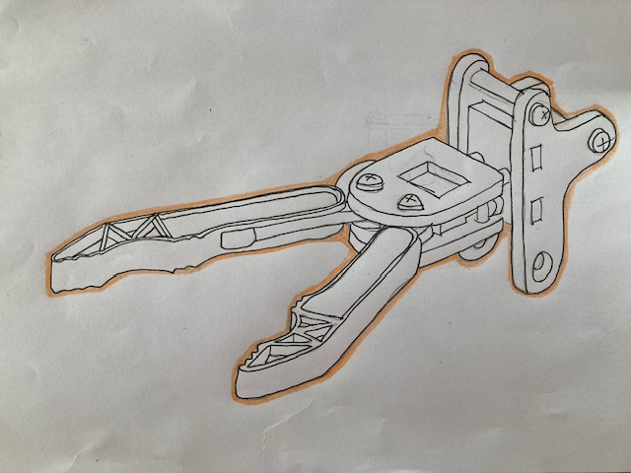
Figure 16 Edited version of (Morgan, No Date b)

This idea is a combination of the initial design, with the idea of reducing the number of screws and making the unit one whole unit.

Choosing Alternatives
Existing Design-
This design could do with improvement as it is made up of several parts and there are several screws holding it all together. It does allow for it to be taken apart if parts require changing however to assemble this component will take time as items will have to put in one by one and then secured together using screws, the screws are also different lengths which means that screws will have its place and cannot be mixed up as they will either be the wrong length to secure together or the will not fit in the hole as it is the wrong screw diameter. With having different size screws slows down assemble as the right screw has to go in the right hole but also the tool to secure the screw into place will have to change depending on the screw size. Down time can then come in changing of tool sizes. If the screws are not all the same type as well this will mean more tool changing not just in size but in type of tool.
Design 1
All screws have been removed on this design and made up as one unit. With the possibility this could be cast or made from addictive manufacturing. However the gripper arms have to be able to move and as one unit will not function properly. So although assembly of this part will be faster it will not function properly.
Design 2
This idea being a combination of making the unit whole and reducing the number of screws. The gripper arms will potentially wear or break over time so the two screws that secure the gripper arms are in place so they can be removed and the gripper arms replaced.
The rest of the unit can be made up as a whole unit reducing the number of screws required. It only requires 2 more screws which will attach the gripper body to the robot arm. These two screws also allows the removable of the whole unit if this becomes damaged.
If all 4 screws in this design are kept uniform with the same head type and length then this becomes a standard part and so it wont matter which screw goes where and the tools required to put the component together will be just 1 type, reducing time lost in tool changes and money to buy different tool types.

Choosing A Solution

The solution which will be chosen will be Design 2 as it is a combination of reducing screws, making the unit whole, it also allows for the gripper arms to be replaced, it allows the main body to be replaced from the robot arm, the screws in this design will be a uniform and standardised part so they can be fitted into any screw hole and can be fitted via one tool. To manufacture this unit will take less time to assemble than the initial component whilst also maintaining its function as a gripper.

Model Of New Idea

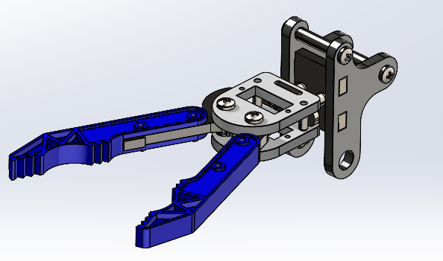

Figure 16 Edited version of (Morgan, No Date b)

Evaluation Of Idea

This design comprises a few different design factors to the existing design, the screws have been reduced down to 4 these screws will be used to secure to robot arm and also allow the arms to move and allow for them to be replaced if they become worn or damaged. The screws are now uniform and standardised so it does not matter which hole the screws go into as they are all the same length and the same type of screw, meaning only 1 tool will be required, rather than different types and different sizes of tools.
The main body of this design could also be made up in one unit which could be done by casting or by additive manufacturing. With the main body being attached to the robot arm via screws this allows the main body to be replaced if required fairly easily. With the reduction in screws the component should now take less time to manufacture than the initial component. Looking at the design specification which states:

Must be able to be made in mass production 1000+ units per week –
with the reduction in screws which will speed up manufacturing time this will improve the chances of producing 1000+ units per week
Must be affordable to produce – depending on which material is used to manufacture this component will determine this but if the component was to be from aluminium for a square bar 1000mm in length would cost £67.30 (Aluminium warehouse, No Date a) while stainless steel bar of the same size and length would cost £280.23 so a lot cheaper per length
Must be able to last years- Life span of 40 years for building and over 80 years for window frames.
Must be Durable- with aluminium having a life span between 40-80 years and being used for a variety of purposes one could say that yes it is durable.
Must have easy maintenance- with the addition of the 4 screws this allows the gripper arms to be replaced or the replacement of the unit body from the robot arm
Must have be made from a material that can be easily disposed or recycled - It can also be recycled and reused without the loss of material quality it can be recycled and reused in every step of its lifecycle, saving CO2 emissions by preventing the use of primary metal (Metals Warehouse, 2021).
Product must be a reasonable size- the component has been modified from its original design and so should meet this requirement of being a reasonable size.
Must be designed so it could be used on a variety of components- this gripper could be used on a variety of different components it has not been design for only picking up a certain item in a certain way.
Must be easy to transport- with the product being lighwieght and a reasonable size this aids in helping it being able to be transported easily
Product can not weigh too much- Weight of a length of aluminium 1000mm x 50mm square bar – 7.03kg (Aluminium warehouse, No Date a)
Weight of a length of stainless steel 1000mm x 50mm square bar - 19.8kg (Aluminium warehouse,No Date b) so aluminium weighs 12.77kg less than stainless steel for the same size length of square bar.
The overall design could be looked at again to make further improvements, maybe the screws could be changed to pins to reduce the need for tools being used to secure components.

Task 2 – Design for Additive Manufacturing

Introduction
For this section, the task was to redesign a component of choice using Design for Additive Manufacturing (DfAM) tools/ principles and apply the concepts of DfAM to the design. A appropriate Addidtive Manufacturing (AM) process and material should be chosen for the design and justification should be given of the selections. Working in the engineering industry it is important that tools are stored correctly and so a bracket for a shelf unit will be designed and so the following report will be for wall bracket design.

Design For Manufacturing (DFM)

Design for manufacturing is a product design principle that focuses on producing a improved design at a lower cost by improving the selection of material and manufacturing processes. The product should then be easier to manufacture and take less time to produce. DFM helps to give new ideas to product design to benefit all involved. With such advanced technology, it is now possible to create designs, which can be simulated and then produced fast and at low cost with advanced manufacturing techniques (Sild.S , 2021).

Design For Additive Manufacturing (DfAM)
Design for additive manufacturing is one of the subsidies of DFM. DfAM is the ability to produce designs from 3D printing. 3D printing is quite different from traditional manufacturing techniques. Once a model has been designed a 3D printer builds the part up layer by layer eventually creating the full component. This technique is different from subtractive manufacturing where material is machined away to create a part, or a part is made via injection moulding (Sculpteo, No Date).
As 3D printing is built up of many layers it is able to produce shapes that would possibly not be produced from subtractive manufacturing techniques and also from casting as to produce the mould may be difficult. There are several 3D printers on the market that can be used to produce different components, Fused Deposition Modelling (FDM) which uses a plastic filament, and resin, which uses liquid resin cured by light. Metal additive manufacturing can also be used to produce components. This manufacturing technique works by fusing metal particles using high temperatures from lasers or electron beams to create metal objects. Other techniques uses binders or polymer to bond metal particles together, the part then go through a de-binding process to remove excess binder and onto a sintering process to fuse the metal particles into the final part. Materials such as stainless steel, aluminium and titanium are commonly used to create prototypes and functional items (Nexa3D, 2024)

Additive Manufacturing For Component Consolidation

In a normal product assembly several components would be made and then brought together for assembly. However with addictive manufacturing these components could all be manufactured as a single unit, even if the shape and layout is very complex (SyBridge technologies, 2019). By having one consolidating unit this will reduce the assembly process of assembling several different parts together. Not only will this reduce physically assembling the different parts, but manufacturing or buying these parts will no longer be required, storing of these parts ready for assembly will then not be required either, this will reduce handling costs, also when assembling quality control may have to take place at several steps and this step would then be removed as well, by not relying on external sources for parts also can help the manufacturing process, if the supplier increases their costs of a part, this may affect the business profit margins and so the business may then have to increase its product price, if the external supplier cant deliver parts on time this may cause delays in the assembly process, so by having the part made with AM this then reduces the risk of relaying on the external supplier (SyBridge technologies, 2019). Often the more complex the part the higher the cost, for AM the part cost does not increase. If the complexity of the part is due to being lightweight for having less material which usually would have to have a mould created. As AM uses a build up layer by layer complex shapes can be achieved to use less material (SyBridge technologies, 2019). Additive Manufacturing can potentially give an improved product to by being able to create parts that are lighter in weight but still maintaining its strength (SyBridge technologies, 2019).

Additive Manufacturing Processes

There are several different processes in Additive manufacturing each use a different process and materials to build objects (Engineering Product design, 2024 b). See appendix for Additive manufacturing process.

Support Structures In Additive Manufacturing
Support structures in additive manufacturing can play an essential role as they act as a scaffold, to prevent objects from collapsing or shifting and can provide extra stability for them. Without them parts could bend or collapse. By keeping the object secure and in place this can aid and help improve accuracy of the process (Schloder, M ,2022)

Post – Processing in Additive Manufacturing
Once a object has finished being produced the post processing can be undertaken this may involve the removal of support structures or excess material on the build. The post processing steps required to be taken are dependent on the technology used, the material used and the intended final use of the printed part (Post Process, 2022)

Internal Structures (Lattice or Cellular)

Additive Manufacturing has the ability to create a variety of shapes, with this it is possible that objects can be created using different structures such as lattice structures. These structures reduce the objects mass which means less material used but still keeping its strength. Common lattice structures are :
Surface-based lattices – lattices that are generated from trigonometric equations. (Altair, 2022).
Strut lattices – structures that consist of a series of rod-like forms that are connected in different orientations to form the different unit cells of the lattice. (Altair, 2022).
Planar-based lattices – structures created as a periodic pattern in a 2D plane and then extruded in a single direction to create the 3D structure. (Altair, 2022).

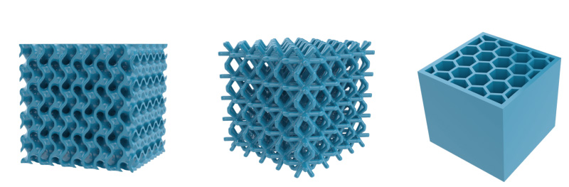

Figure 17 On the left, surface-based lattices In the centre, we have a strut-based lattice and on the right, we see a planar lattice (Altair, 2022).

Topology Optimisation
Using the rules defined by the designer in a given 3D geometrical design space, topology optimizes material layout and structure. Taking into account external forces, load conditions, boundary conditions, material properties it tries to increase part performance. It is often used at the design stage to increase stiffness to weight ratio. The designs generated from Topology optimisation are often difficult to manufacture using standard techniques but with the use of additive manufacturing these designs are able to be created (Engineering Product design, 2021).

Generative Design
Using predefined criteria set by the designers, generative design is an advanced, algorithm-driven process, which creates a wide array of designs. It is able to generate complex designs, reducing material used whilst also maintaining the strength and specification of the component. It has changed many industries, such as engineering, automotive, aerospace, health care and construction (Autodesk, No Date).

Difference Between Topology and Generative Design
The difference between topology and generative design is that topology optimisation looks at material distribution within a space for structural efficiency while generative design generates multiple solutions taking into account, functionality, manufacturing and cost (Autodesk, No Date). Topology optimisation would require a design model from the user, along with other inputs such as external forces, constraints, and material properties. While generative design uses topology optimization but takes the process further by removing the need for an initial model. The model can be created by taking the inputs such as design space, forces and constraints, it then creates multiple designs for the engineer to evaluate (Engineering Product design, 2021).

Component
Working in the engineering industry it is important that tools are stored correctly and so a bracket for a shelfing unit will be designed. The bracket must be able to hold a downward force of 10KG. A safety factor of 2 was applied to the component. A simple right angle bracket was designed with two holes to accept screws for securing the bracket into the wall and another hole for securing the shelf to the bracket. The initial design could have been built out of a variety of materials. One material that it could have built from could have been carbon steel. The bracket could have been made from 10mm carbon steel plate with 5mm plate welded onto the 10mm and holes could have been into the steel plate to accept the screws.

Initial Design

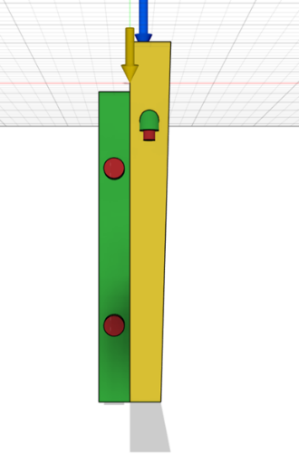
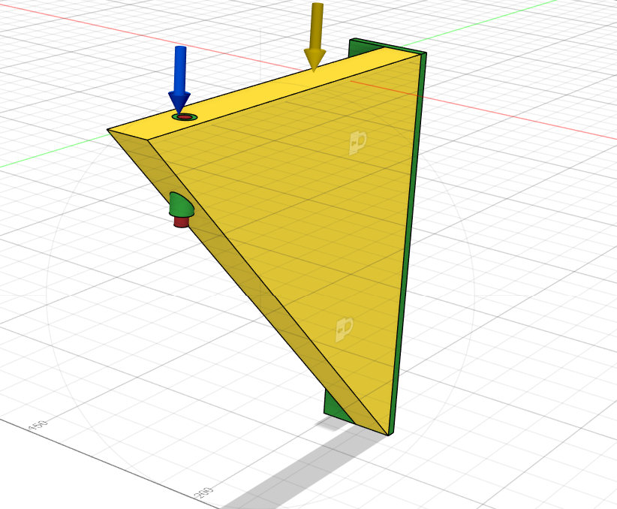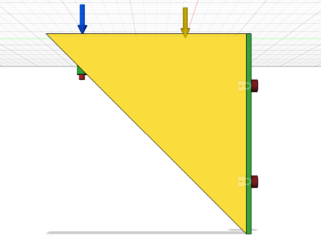
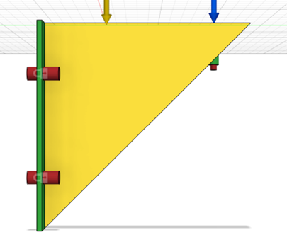

Holes for securing bracket to wall and securing shelf

Figure 17 design on (Autodesk, No date)

Above is the initial design of a shelf bracket designed to hold 10kg of downward force. Designed with the safety factor of 2 in the design. There are 3 holes in the bracket two for securing the bracket into the wall and one for securing the shelf to the bracket to ensure that the shelf is not loose. The brackets dimensions are 200mm X 200mm. This bracket has the potential to be made from a variety of materials. Using standard fabrication techniques this bracket could be made carbon steel with a welded joint from the 10mm plate to the 5mm plate and the holes drilled in the desired locations. This design was put through generative design software, which then produces lots of different designs but still within the constraints of holding 10kg with the safety factor of 2 and still having three holes for securing to wall and securing shelf. This bracket also has the potential to not require any support structure for the additive manufacturing.

Stress Constraints
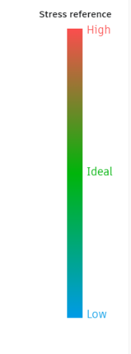
This stress reference chart shows the colours of the stress on the component. Red being high stress and blue being low stress. One of the software’s settings allows the user to see where the stress constraints would be on the bracket.

Figure 18 Stress constraints (Autodesk, No Date)

Generative Design 1 – Tough 2000
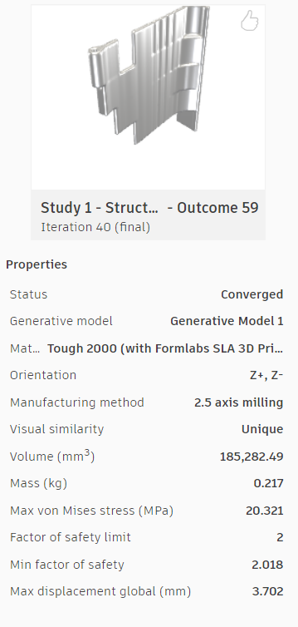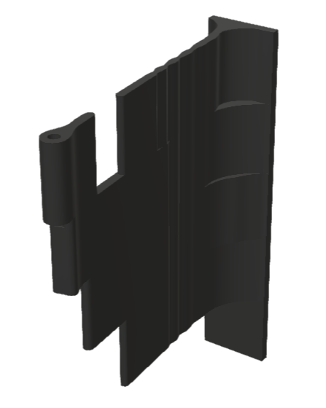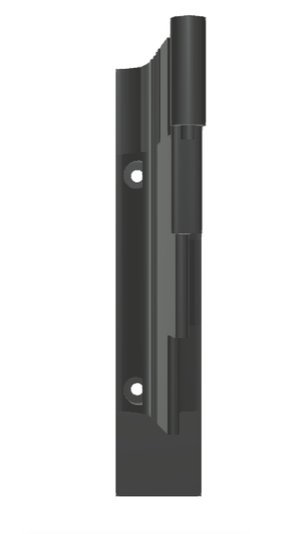
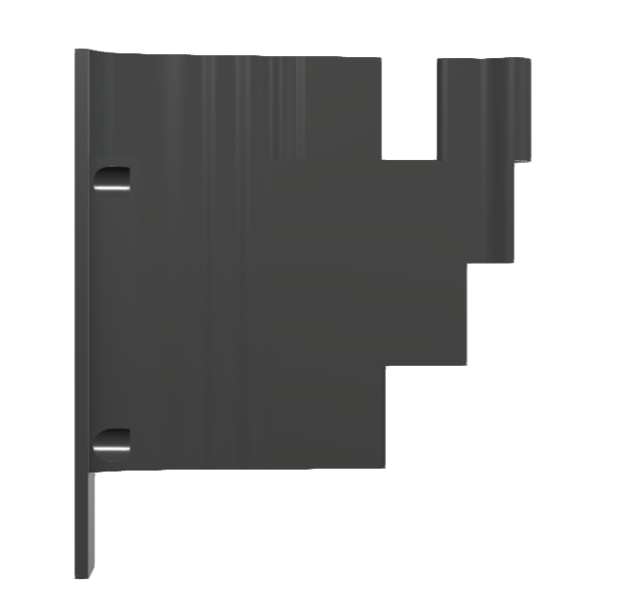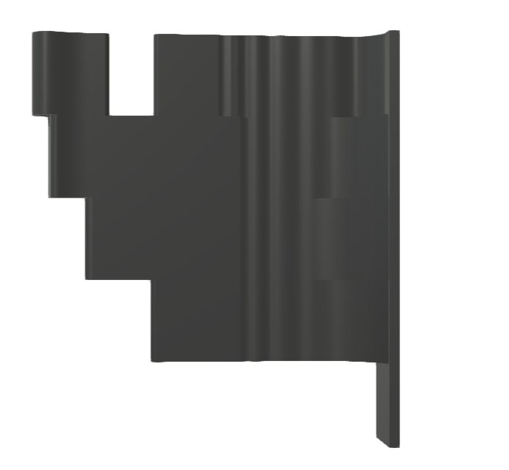
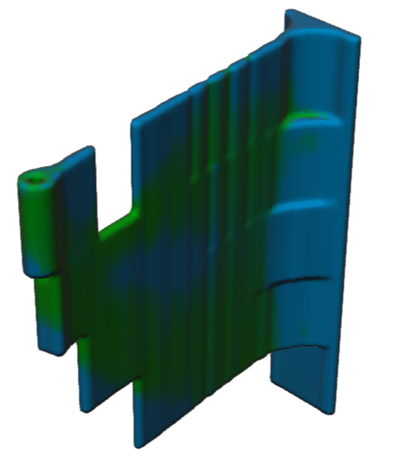
Design 1 – made from Tough 2000, when using tough 2000 resin it is suggested it is used with supports and avoid printing directly on the build platform as the print will be difficult to remove form the build platform. (Formlabs, No Date) the bracket as slimmed down but as kept a similar shape.
Looking at the stress constraints on the left it is in the ideal to low category of stress.
Figure 19 Generative design design on (Autodesk, No date)

Generative Design 2 - PEKK

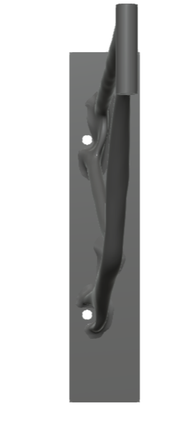
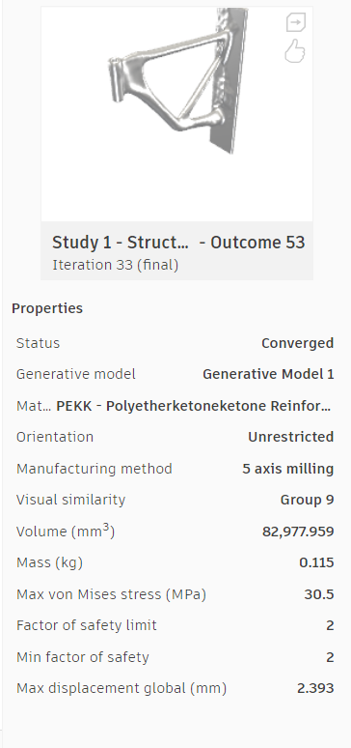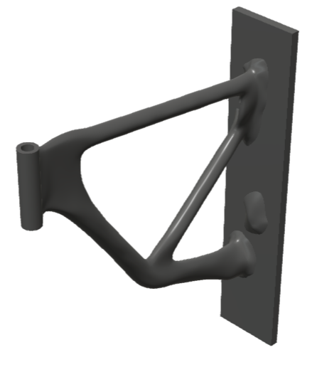
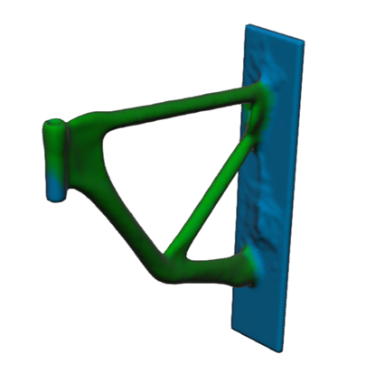
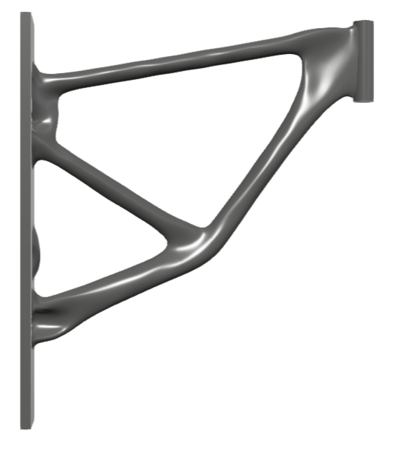

Figure 20 Generative Design on (Autodesk, No date)

Design 2 made from PEKK (Polyetherketoneketone) is a high- performance polymer, it offers exceptional resistance to extreme environments such as aerospace and oil exploration (Arkema, No Date) a lot of the material has been taken away for this bracket producing a very lightweight component, but still meeting the criteria of being able to support the 10KG. The stress constraint of the bracket again is within the ideal to low range.

Generative Design 3 - PA11 – Nylon – HP 11 -30

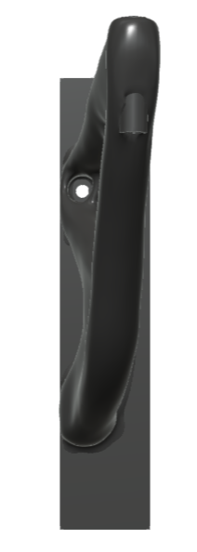
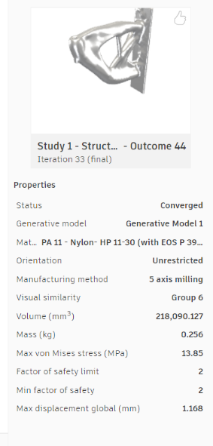
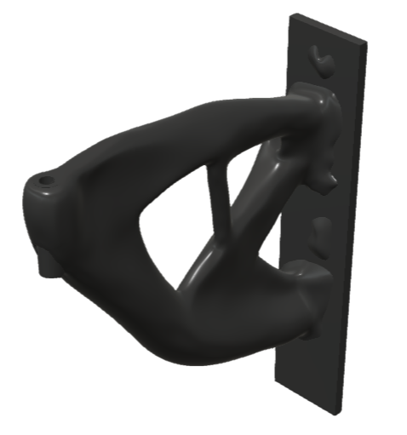

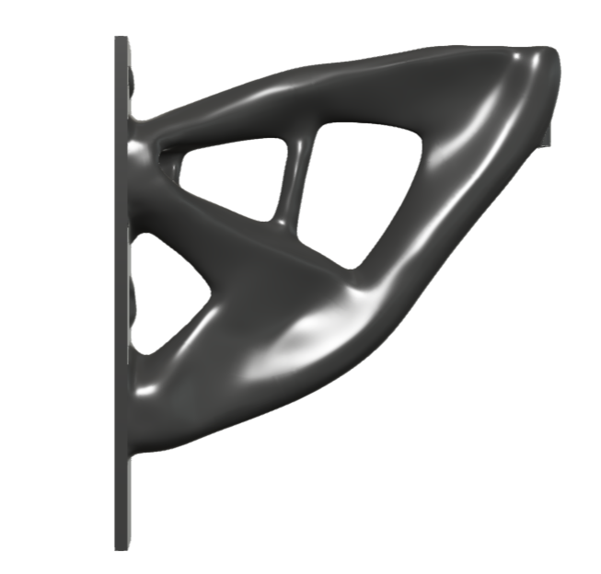
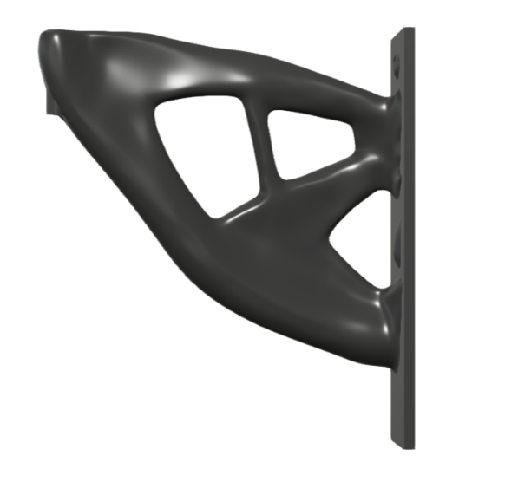
Design 3 made from PA11 – Nylon – HP 11 -30 is high performance plastic polyamide made from 100% renewable castor beans. The additive manufactured parts are just as strong, flexible and durable as moulded parts and PA11 is also heat resistant and is suited for highly technical applications (EOS, No Date). This design although plenty of material has been taken away the design is chunky compared to other designs. PA11 is over double the weight of PEKK.

Figure 21 Generative Design on (Autodesk, No date)

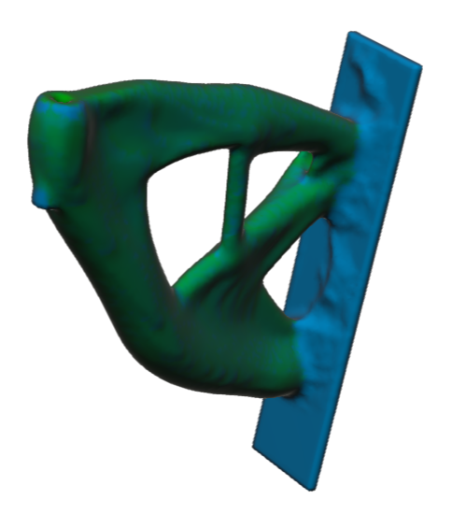

Generative Design 3 – Aluminium AlSi10Mg
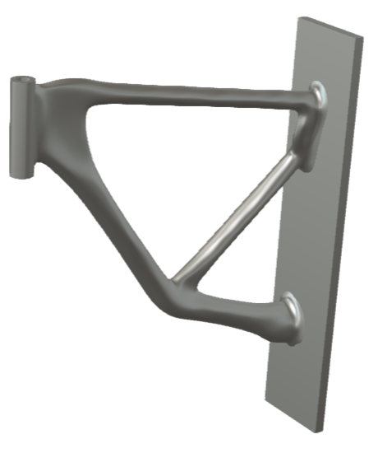
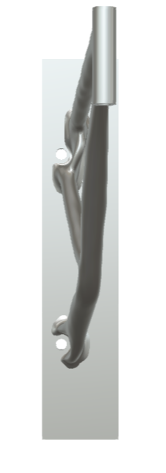
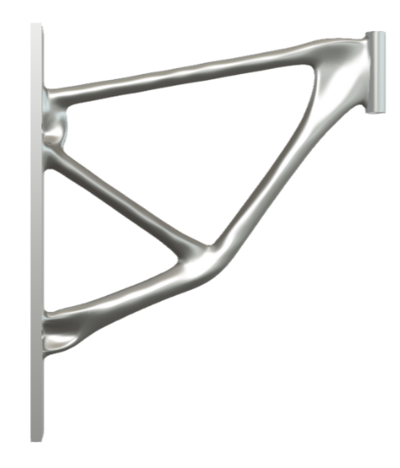
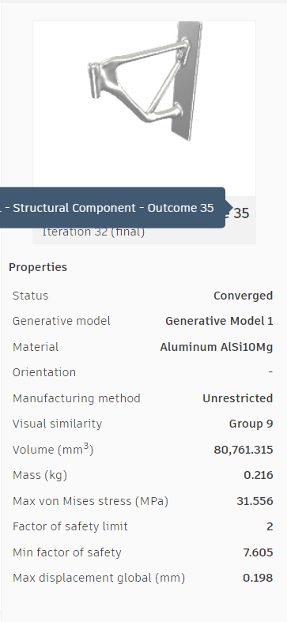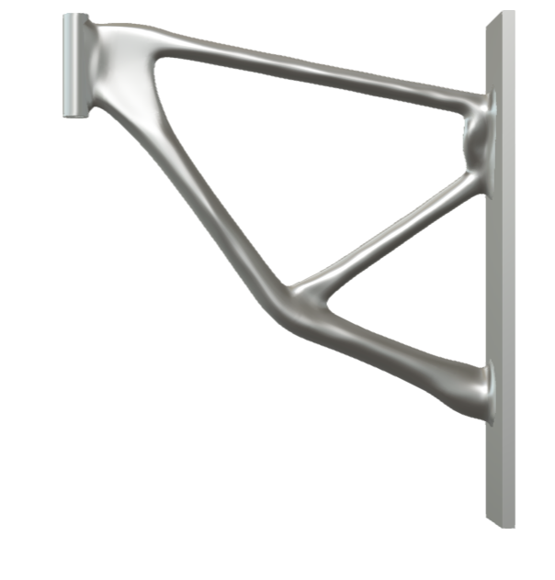

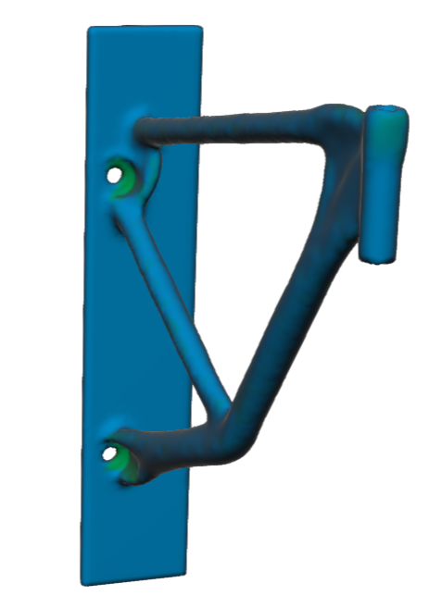
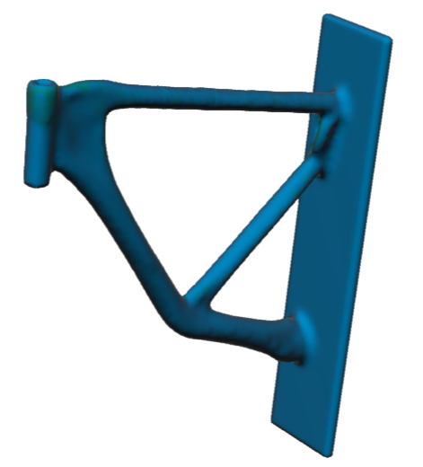

Figure 22 Generative Design on (Autodesk, No date)

Design 3 made from Aluminium AlSi10Mg is a alloy that combines light weight and good mechanical properties, such as strength and hardness, heat treatments can be applied to modify properties to increase ductility and conductivity it also has a high corrosion resistance. (EOS, No Date b) this design again has a lot of the original material taken away and only a small structure is left. Looking at the stress constraints it is on the low to ideal scale.

Evaluation
To choose a design from the four different generative designs above there could be several factors which influence the decision, the aesthetics of the piece, the cost of material, the availability of material, the weight could all be factors to consider. The aluminium design however aesthetically looks good, aluminium is lightweight, it can be recycled, it meets the requirements of the specification, aluminium is an available source of material, the cost to purchase aluminium is a reasonable cost. Aluminium would also hold up in a workshop environment. Others my decide on other materials for various reasons but aluminium would be able to do the job required. The additive manufacturing machines available are also compatible with aluminium.

References

Aluminium warehouse,(No Date a) ‘50.8mm (2") Aluminium Square Bar’ Available at: https://www.aluminiumwarehouse.co.uk/collections/aluminium-square-bar/products/2-in-x-2-in-aluminium-square-bar Accessed on: 30th June 2024
Aluminium warehouse,(No Date b) ‘50mm 316 Stainless Steel Square Bar’ Available at: https://www.aluminiumwarehouse.co.uk/collections/stainless-steel-square-bar/products/50-mm-x-50-mm-316l-stainless-steel-square-bar Accessed on: 30th June 2024
Arkema, (No Date) ‘PEKK Polyetherketoneketone’ Available at: https://www.arkema.com/global/en/products/product-families/pekk-kepstan/ Accessed on: 21st July 2024
Austin, (2016) ‘New robot gripper is gentle and strong at the same time’ Available at: https://instabog.blogspot.com/2016/02/new-robot-gripper-is-gentle-and-strong.html Accessed on: 30th June 2024
Autodesk, (No Date) ‘Generative design: Streamlining iteration and innovation’ Available at: https://www.autodesk.com/design-make/emerging-tech/generative-design#:~:text=Generative%20design%20is%20an%20advanced%2C%20algorithm-driven%20process%2C%20sometimes,meet%20predefined%20criteria%20set%20by%20engineers%20or%20designers. Accessed on: 15th July 2024
Autodesk, (No date) ‘Autodesk fusion 360’ Available at: https://www.autodesk.com/products/fusion-360/personal Accessed on: 22nd July 2024
CS Hyde Company, (No date) ‘PTFE rod’ Available at: https://catalog.cshyde.com/viewitems/all-categories-ptfe-sheets-rods-and-rectangles/ptfe-rod Accessed on: 13th July 2024
Dorna robotics, (2023) ‘Types Of Robot Grippers And Their Applications’ Available at: https://dorna.ai/blog/types-of-grippers-for-robots/ Accessed on: 30th June 2024
Ebay, (No date) ‘Aluminum Mechanical Robotic Claw Gripper For Arduino Medium Servo MG995 SG5010’ Available at: https://www.ebay.co.uk/itm/364836608079?var=0&mkevt=1&mkcid=1&mkrid=710-53481-19255-0&campid=5338590836&toolid=10044&customid=0e15a73baf3b16818327c1ba12956d9 Accessed on: 30th June 2024
Electrical Workbook, (2021) ‘What Is A Robot Gripper? Definition & Types’ Available at: https://electricalworkbook.com/robot-gripper/ Accessed on: 30th June 2024
Electronics Hub, (No date) ‘Mechanical Metal Gripper for Robot Mechanical Claw Robotic Arm Manipulator’ Available at: https://electronicshub.pk/product/mechanical-metal-gripper-for-robot-mechanical-claw/ Accessed on: 30th June 2024
Engineering Product design, (2021 a) ‘Introduction to Topology Optimization’ Available at: https://engineeringproductdesign.com/knowledge-base/topology-optimization/ Accessed on: 15th July 2024

Engineering Product design, (2024 b) ‘Additive Manufacturing’ Available at: https://engineeringproductdesign.com/knowledge-base/additive-manufacturing-processes/ Accessed on: 20th July 2024
EOS, (No Date a) ‘Ductile Polymers’ Available at: https://www.eos.info/en-us/polymer-solutions/polymer-materials/ductile Accessed on: 21st July 2024
EOS, (No Date b) ‘EOS Aluminium AlSi10Mg’ Available at: https://www.eos.info/en-us/metal-solutions/metal-materials/data-sheets/mds-eos-aluminium-alsi10mg Accessed on: 21st July 2024
Formlabs, (No Date) ‘Using Tough 2000 Resin’ Available at: https://support.formlabs.com/s/article/Using-Tough-Resin?language=en_US#printing Accessed on: 21st July 2024
Jiga, (2023). ‘Design for Assembly: Principles, Application and Guidelines’ Available at: https://jiga.io/articles/design-for-assembly-principles-applications-guidelines/ Accessed on: 30th June 2024
Kanban tool, (No date). ‘What is Muda?’ Available at: https://kanbantool.com/kanban-guide/what-is-muda Accessed on: 29th June 2024
Metals Warehouse, (2021). ‘THE LIFESPAN AND RECYCLABILITY OF ALUMINIUM AND STAINLESS STEEL’ Available at: https://www.metalswarehouse.co.uk/lifespan-recyclability-aluminium-steel/#:~:text=Aluminium%20is%20the%20most%20abundant%20metallic%20element%20on,building%20and%20over%2080%20years%20for%20window%20frames. Accessed on 30th June 2024
Metals4U, (No date) ‘Stainless Steel Square Bars’ Available at: https://www.metals4u.co.uk/materials/stainless-steel/stainless-steel-square Accessed on: 13th July 2024
Morgan, R, (No Date a) ‘Design for X’ (Powerpoint Presentation) Available at: Mechanical Engineering, UWTSD
(Morgan, R , No Date b) ‘Gripper’ Available at: Mechanical Engineering Microsoft teams Robot Gripper Files, UWTSD
(Morgan, No Date c ) ‘QFD’ Available at: Mechanical Engineering Microsoft teams, QFD template, UWTSD
Nexa3D, (2024) ‘Metal 3D Printing Guide: What It Is & How It Works [2024]’ Available at: https://nexa3d.com/blog/metal-3d-printing/ Accessed on: 14th July 2024
Nguyen. S, (2023) ‘What is quality function deployment (QFD)? Phases, example’ Available at: https://blog.logrocket.com/product-management/quality-function-deployment-qfd-example-phases/ Accessed on: 14th July 2024
Nollie, (No Date) ‘Understanding a Design Specification and How To Use One’ Available at: https://nolliedesign.com/understanding-a-design-specification-and-how-to-use-one/ Accessed on: 16th June 2024
Pact Automation, (No date) ‘GRIPPERS: TYPES, MATERIALS, AND SELECTION CRITERIA’ Available at: https://pactautomation.com/2023/03/06/grippers-types-materials-and-selection-criteria/#:~:text=The%20materials%20used%20in%20grippers%2C%20such%20as%20rubber%2C,features%20that%20make%20them%20suited%20for%20specific%20applications. Accessed on 30th June 2024
Plastock, (No date) ‘PTFE Extruded Virgin White Rod’ Available at: https://www.plastock.co.uk/products/ptfe-extruded-virgin-white-rod Accessed on: 30th June 2024
Plastock, (No date b) ‘Polycarbonate Engineering Grade Extruded Clear Rod’ Available at: https://www.plastock.co.uk/products/polycarbonate-engineering-grade-extruded-clear-rod?variant=37506482536614 Accessed on: 30th June 2024
Post Process,(2022) ‘What is Post-Processing in Additive Manufacturing?’ Available at: https://www.postprocess.com/2022/09/what-is-post-processing-in-additive-manufacturing/ Accessed on: 21st July 2024
Rapid Direct, (2021) ‘Design for Assembly and its Use in Product Manufacturing’ Available at: https://www.rapiddirect.com/blog/design-for-assembly/#:~:text=While%20screws%20may%20be%20necessary%20in%20some%20cases%2C,do%20not%20require%20tools%20and%20make%20assembling%20easier. Accessed on: 13th July 2024
Schloder, M ,(2022) ‘Additive Manufacturing Support Structures: What You Need to Know’ Available at: https://www.alphaprecisionpm.com/blog/additive-manufacturing-support-structures#:~:text=Support%20structures%20in%20AM%20act%20as%20a%20scaffold%2C,printing%20process%20by%20keeping%20the%20object%20in%20place. Accessed on: 21st July 2024
Sculpteo, (No Date) ‘Design for Additive Manufacturing: Everything you need to know’ Available at: https://www.sculpteo.com/en/3d-learning-hub/3d-printing-business/design-for-additive-manufacturing/ Accessed on: 13th July 2024
Sild.S , (2021) ‘Design For Manufacturing’ Available at: https://fractory.com/design-for-manufacturing-dfm/ Accessed on: 13th July 2024
Smoothy, L. (2024) ‘How much does CNC machining cost?’ Available at: https://get-it-made.co.uk/resources/how-much-does-cnc-machining-cost#:~:text=CNC%20machining%20per%20hour%20can%20vary%20from%20%C2%A310,will%20cost%20are%20the%20design%2C%20material%20and%20quantity. Accessed on: 30th June 2024
SyBridge technologies, (2019) ‘Rethinking Part Consolidation With Additive Manufacturing’ Available at: https://sybridge.com/rethinking-part-consolidation-with-additive-manufacturing/#:~:text=When%20thinking%20about%20part%20consolidation%20with%20AM%2C%20the,approach%20to%20analyzing%20the%20parts%20to%20be%20consolidated. Accessed on: 14th July 2024
Taber.M, (2021). ‘What is Design for Manufacturing (DFM)?’ Available at: https://www.ptc.com/en/blogs/plm/what-is-design-for-manufacturing Accessed on: 30th June 2024
TWI, (No Date a). ‘WHAT IS DESIGN FOR MANUFACTURING (DFM)?’ Available at: https://www.twi-global.com/technical-knowledge/faqs/faq-what-is-design-for-manufacture-dfm Accessed on: 29th June 2024
TWI (No date b) ‘WHAT IS THE ENGINEERING DESIGN PROCESS?’ Available at: https://www.twi-global.com/technical-knowledge/faqs/engineering-design-process Accessed on: 30th June 2024

Bibliography

Aluminium warehouse,(No Date a) ‘50.8mm (2") Aluminium Square Bar’ Available at: https://www.aluminiumwarehouse.co.uk/collections/aluminium-square-bar/products/2-in-x-2-in-aluminium-square-bar Accessed on: 30th June 2024
Aluminium warehouse,(No Date b) ‘50mm 316 Stainless Steel Square Bar’ Available at: https://www.aluminiumwarehouse.co.uk/collections/stainless-steel-square-bar/products/50-mm-x-50-mm-316l-stainless-steel-square-bar Accessed on: 30th June 2024
Arkema, (No Date) ‘PEKK Polyetherketoneketone’ Available at: https://www.arkema.com/global/en/products/product-families/pekk-kepstan/ Accessed on: 21st July 2024
Austin, (2016) ‘New robot gripper is gentle and strong at the same time’ Available at: https://instabog.blogspot.com/2016/02/new-robot-gripper-is-gentle-and-strong.html Accessed on: 30th June 2024
Autodesk, (No Date) ‘Generative design: Streamlining iteration and innovation’ Available at: https://www.autodesk.com/design-make/emerging-tech/generative-design#:~:text=Generative%20design%20is%20an%20advanced%2C%20algorithm-driven%20process%2C%20sometimes,meet%20predefined%20criteria%20set%20by%20engineers%20or%20designers. Accessed on: 15th July 2024
CS Hyde Company, (No date) ‘PTFE rod’ Available at: https://catalog.cshyde.com/viewitems/all-categories-ptfe-sheets-rods-and-rectangles/ptfe-rod Accessed on: 13th July 2024
Dorna robotics, (2023) ‘Types Of Robot Grippers And Their Applications’ Available at: https://dorna.ai/blog/types-of-grippers-for-robots/ Accessed on: 30th June 2024
Ebay, (No date) ‘Aluminum Mechanical Robotic Claw Gripper For Arduino Medium Servo MG995 SG5010’ Available at: https://www.ebay.co.uk/itm/364836608079?var=0&mkevt=1&mkcid=1&mkrid=710-53481-19255-0&campid=5338590836&toolid=10044&customid=0e15a73baf3b16818327c1ba12956d9 Accessed on: 30th June 2024
Electrical Workbook, (2021) ‘What Is A Robot Gripper? Definition & Types’ Available at: https://electricalworkbook.com/robot-gripper/ Accessed on: 30th June 2024
Electronics Hub, (No date) ‘Mechanical Metal Gripper for Robot Mechanical Claw Robotic Arm Manipulator’ Available at: https://electronicshub.pk/product/mechanical-metal-gripper-for-robot-mechanical-claw/ Accessed on: 30th June 2024
Engineering Product design, (2021 a) ‘Introduction to Topology Optimization’ Available at: https://engineeringproductdesign.com/knowledge-base/topology-optimization/ Accessed on: 15th July 2024

Engineering Product design, (2024 b) ‘Additive Manufacturing’ Available at: https://engineeringproductdesign.com/knowledge-base/additive-manufacturing-processes/ Accessed on: 20th July 2024
EOS, (No Date a) ‘Ductile Polymers’ Available at: https://www.eos.info/en-us/polymer-solutions/polymer-materials/ductile Accessed on: 21st July 2024
EOS, (No Date b) ‘EOS Aluminium AlSi10Mg’ Available at: https://www.eos.info/en-us/metal-solutions/metal-materials/data-sheets/mds-eos-aluminium-alsi10mg Accessed on: 21st July 2024
Formlabs, (No Date) ‘Using Tough 2000 Resin’ Available at: https://support.formlabs.com/s/article/Using-Tough-Resin?language=en_US#printing Accessed on: 21st July 2024
Holishevska.A (2024) ‘HOW TO WRITE THE DESIGN SPECIFICATION? [QUICK GUIDE]’ Available at: https://rewisoft.com/blog/how-to-write-the-design-specifications-quick-guide/ Accessed on: 18th June 2024

Jiga, (2023). ‘Design for Assembly: Principles, Application and Guidelines’ Available at: https://jiga.io/articles/design-for-assembly-principles-applications-guidelines/ Accessed on: 30th June 2024
Kanban tool, (No date). ‘What is Muda?’ Available at: https://kanbantool.com/kanban-guide/what-is-muda Accessed on: 29th June 2024
Metals Warehouse, (2021). ‘THE LIFESPAN AND RECYCLABILITY OF ALUMINIUM AND STAINLESS STEEL’ Available at: https://www.metalswarehouse.co.uk/lifespan-recyclability-aluminium-steel/#:~:text=Aluminium%20is%20the%20most%20abundant%20metallic%20element%20on,building%20and%20over%2080%20years%20for%20window%20frames. Accessed on 30th June 2024
Metals4U, (No date) ‘Stainless Steel Square Bars’ Available at: https://www.metals4u.co.uk/materials/stainless-steel/stainless-steel-square Accessed on: 13th July 2024
Morgan, R, (No Date a) ‘Design for X’ (Powerpoint Presentation) Available at: Mechanical Engineering, UWTSD
(Morgan, R , No Date b) ‘Gripper’ Available at: Mechanical Engineering Microsoft teams Robot Gripper Files, UWTSD
(Morgan, No Date c ) ‘QFD’ Available at: Mechanical Engineering Microsoft teams, QFD template, UWTSD
Nexa3D, (2024) ‘Metal 3D Printing Guide: What It Is & How It Works [2024]’ Available at: https://nexa3d.com/blog/metal-3d-printing/ Accessed on: 14th July 2024
Nguyen. S, (2023) ‘What is quality function deployment (QFD)? Phases, example’ Available at: https://blog.logrocket.com/product-management/quality-function-deployment-qfd-example-phases/ Accessed on: 14th July 2024
Nollie, (No Date) ‘Understanding a Design Specification and How To Use One’ Available at: https://nolliedesign.com/understanding-a-design-specification-and-how-to-use-one/ Accessed on: 16th June 2024

Pact Automation, (No date) ‘GRIPPERS: TYPES, MATERIALS, AND SELECTION CRITERIA’ Available at: https://pactautomation.com/2023/03/06/grippers-types-materials-and-selection-criteria/#:~:text=The%20materials%20used%20in%20grippers%2C%20such%20as%20rubber%2C,features%20that%20make%20them%20suited%20for%20specific%20applications. Accessed on 30th June 2024
Plastock, (No date) ‘PTFE Extruded Virgin White Rod’ Available at: https://www.plastock.co.uk/products/ptfe-extruded-virgin-white-rod Accessed on: 30th June 2024
Plastock, (No date b) ‘Polycarbonate Engineering Grade Extruded Clear Rod’ Available at: https://www.plastock.co.uk/products/polycarbonate-engineering-grade-extruded-clear-rod?variant=37506482536614 Accessed on: 30th June 2024
Post Process,(2022) ‘What is Post-Processing in Additive Manufacturing?’ Available at: https://www.postprocess.com/2022/09/what-is-post-processing-in-additive-manufacturing/ Accessed on: 21st July 2024
Rapid Direct, (2021) ‘Design for Assembly and its Use in Product Manufacturing’ Available at: https://www.rapiddirect.com/blog/design-for-assembly/#:~:text=While%20screws%20may%20be%20necessary%20in%20some%20cases%2C,do%20not%20require%20tools%20and%20make%20assembling%20easier. Accessed on: 13th July 2024
Schloder, M ,(2022) ‘Additive Manufacturing Support Structures: What You Need to Know’ Available at: https://www.alphaprecisionpm.com/blog/additive-manufacturing-support-structures#:~:text=Support%20structures%20in%20AM%20act%20as%20a%20scaffold%2C,printing%20process%20by%20keeping%20the%20object%20in%20place. Accessed on: 21st July 2024
Sculpteo, (No Date) ‘Design for Additive Manufacturing: Everything you need to know’ Available at: https://www.sculpteo.com/en/3d-learning-hub/3d-printing-business/design-for-additive-manufacturing/ Accessed on: 13th July 2024
Sild.S , (2021) ‘Design For Manufacturing’ Available at: https://fractory.com/design-for-manufacturing-dfm/ Accessed on: 13th July 2024
Smoothy, L. (2024) ‘How much does CNC machining cost?’ Available at: https://get-it-made.co.uk/resources/how-much-does-cnc-machining-cost#:~:text=CNC%20machining%20per%20hour%20can%20vary%20from%20%C2%A310,will%20cost%20are%20the%20design%2C%20material%20and%20quantity. Accessed on: 30th June 2024
SyBridge technologies, (2019) ‘Rethinking Part Consolidation With Additive Manufacturing’ Available at: https://sybridge.com/rethinking-part-consolidation-with-additive-manufacturing/#:~:text=When%20thinking%20about%20part%20consolidation%20with%20AM%2C%20the,approach%20to%20analyzing%20the%20parts%20to%20be%20consolidated. Accessed on: 14th July 2024
Taber.M, (2021). ‘What is Design for Manufacturing (DFM)?’ Available at: https://www.ptc.com/en/blogs/plm/what-is-design-for-manufacturing Accessed on: 30th June 2024
TWI, (No Date a). ‘WHAT IS DESIGN FOR MANUFACTURING (DFM)?’ Available at: https://www.twi-global.com/technical-knowledge/faqs/faq-what-is-design-for-manufacture-dfm Accessed on: 29th June 2024
TWI (No date b) ‘WHAT IS THE ENGINEERING DESIGN PROCESS?’ Available at: https://www.twi-global.com/technical-knowledge/faqs/engineering-design-process Accessed on: 30th June 2024
Universal robots, 2020 ‘Types of Grippers Used in Manufacturing | Universal Robots’ Available at: https://www.universal-robots.com/blog/types-of-grippers-used-in-manufacturing/ Accessed on 30th June 2024

Appendices

Design specification
Proposed project: Mechanical Gripper
Performance requirement | Design requirement | Design specification
Must be able to be made in mass production 1000+ units per week | Should be able to be assembled easily | Limit the number of components
Must be affordable to produce | Keep material costs to a minimum | Find a material that is affordable
Must be affordable to produce | Keep the number of parts to a minimum | Design so parts are minimal
Must be able to last years | Should be made from quality material | Find a material that will last for 3+ years
Must be Durable | Should be made from a durable material | Material should be able to flex and last 3+ years
Must have easy maintenance | Easy access for maintenance | Don’t hide components under unnecessary parts
Must have easy maintenance | Easy maintenance to replace parts | Design with limit components so less components can go wrong
Must have be made from a material than can be easily disposed or recycled | Design with a material that can be disposed or recycled | Research on disposal of material
Product must be a reasonable size | Should be a reasonable size to pick up object | Work out what it could be gripping and design size around that.
Must be designed so it could be used on a variety of components | Pick a suitable material and size of conponent | Research what grippers can be used for
Must be easy to transport | Must be small and lightweight | Less than 5kg
Product can not weigh too much | Lightweight material required | Rubber/ plastic less than 3Kg  Light weight metals

Additive Manufacturing Processes

The different processes for additive manufacturing are:
• Vat photo-polymerisation
This process uses Photopolymerization, to create objects by exposing them to ultraviolet light. Materials undergo a chemical reaction and become solid. Only plastics can be printed using these technologies. It is commonly used in dentistry and jewelley. (Engineering Product design, 2024 b).
• Material Extrusion
This process uses a continuous thermoplastic or composite material filament to construct 3D parts. The filament of thermoplastic is fed through a heated nozzle before being deposited layer by layer to create the object. (Engineering Product design, 2024 b).

• Material Jetting
This process is similar to standard inkjet printers, where the material droplets are deposited layer by layer to create a three-dimensional object. Once a layer is complete, it is cured by ultraviolet light.
(Engineering Product design, 2024 b).

• Binder Jetting
The process deposits binding liquid to join the powder material to form a 3D object. The process does not employ heat during the process to fuse the material together making it suitable for a range of materials. The process alternates layers of bonding liquid and build material to form the object. (Engineering Product design, 2024 b).
• Powder bed fusion
This process uses a laser to melt and fuse the powder material to form the object. This process can be broken down into the following:
Multi-Jet Fusion
Direct metal laser sintering
Electron beam melting, Selective heat sintering
Selective laser melting
Selective laser sintering
(Engineering Product design, 2024 b).

• Directed energy deposition
This process uses thermal energy such as a laser, electron beam, plasma arc to melt and fuse the material as they are deposited to create the object. Similar to a welding process but very finely detailed, building up the part layer by layer. (Engineering Product design, 2024 b).

• Sheet lamination.
This process uses sheets of material by stacking them and laminating them using either adhesive or ultrasonic welding. Once the object is built the unwanted areas of the sections are removed layer by layer. This process can be broken down into:

Ultrasonic Additive Manufacturing
Selective Deposition Lamination
Laminated Object Manufacturing
(Engineering Product design, 2024 b).

QFD


