Assignment 2 Menu
Engineering (Practical Task)
BA International Hotel Management

Table of Contents
PART 1: Restaurant Concept 3
Introduction : 3
Restaurant concept: 3
Target audience : 3
Conclusion : 4
PART 2: Menu Design 4
References : 8

PART 1: Restaurant Concept

Introduction :
The developing assignment aims to open a new Which will be established under the Trinity hotel chain in the Uk. The adoption restaurant concept is because of people's demands these days. People like to take a different variety of the menu and focus on developing target audiences. This brand is focusing on manu designing along with developing the pricing strategy as well as going to develop an understanding of the dietary values in the right way.

Restaurant concept:
The main aim of the restaurant concept is to focus on developing a huge variety of menus and giving an excellent dining experience with elegant ambiences along with authentic food quality. The restaurant is going to be decorated with overall themes and the dining place will have a different service style, cuisine and music. This new restaurant will be focusing on table services along with quick delivery. They are focusing on takeaway style also. The critical determination of the giving preferences of the customer perceives and experiences in the right way (Revel, 2022).

Target audience :
Segmentation: The segmentations of the new hotel process focus on demographic and psychographic segmentations and focus on the development of the organisations. This demographic section focuses on the various personal attributes such as the gender of the people, marital status, ethnicity and occupations in the right way( Iofrida et al. 2022). The psychographic segmentation focuses on the stylish along with the luxurious hotel in the right way.
Targeting: The main target is moderate to high-income families in the age group of 15-45. The main targeting of the new restaurant focuses on each group for enhancing the business profitability in the right way. The main reason for targeting young and middle age people is because they have higher demand to go to restaurants (Soni et al. 2022).
Positioning: Organisations can develop their positioning by giving higher offers and discounts on festive sessions effectively. Positioning can be done by providing healthy products in a lively and engaging environment in the restaurant. More social media promotion will be beneficial for promoting in the market. ( (Yulianto, and Suhaimi, 2020).

The reason behind the menu choice: The new restaurant is trying to provide nutritious products with authentic tests because the consumers of the modern day are more health aware. Consumers are focusing on their health condition and order food as per their dietary needs (Nutrition, 2023). Today maximum females are aware of their favourable attitude both taste and healthfulness in an effective way.

Conclusion :
The new restaurant is going to offer different types of food. Being part of the Trinity hotel chain, they have a huge responsibility to maintain the brand positioning in the right way. They are focusing on the particular target audiences to engrave their business effectively.

PART 2: Menu Design

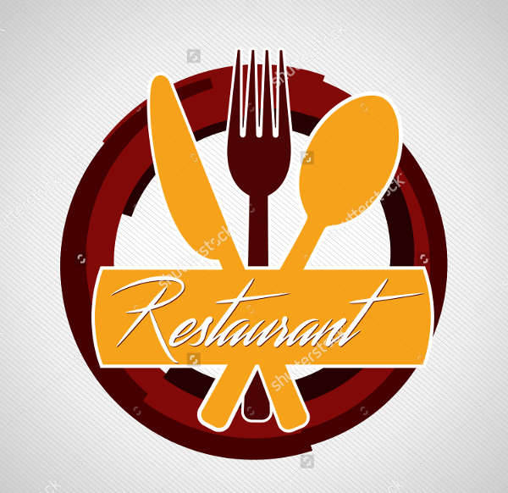

Menu
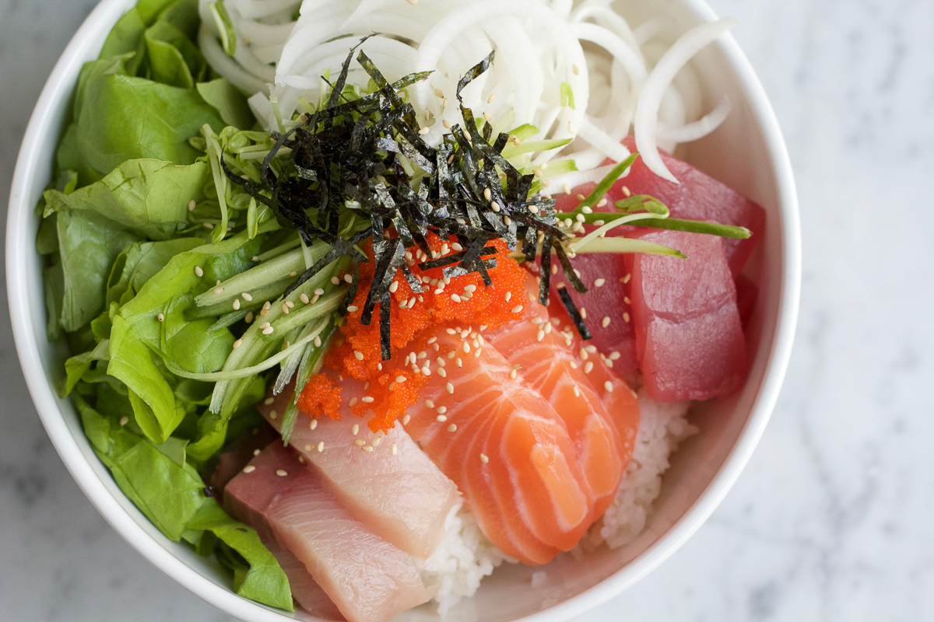
Gluten free item
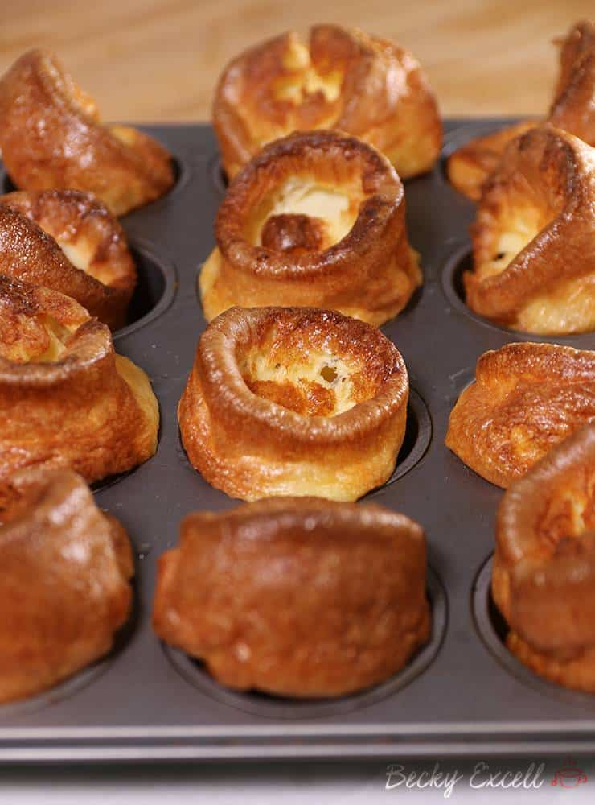

- Gluten-free Yorkshire puddings (corn flour, milk cooking oil and egg) £12.95

- Jerk-seasoned chicken pilaf ( Chicken, onion, green chilli) £34.95

- Beef Stew with Mashed Plantains ( pork lard and boneless beef, onion and oregano) £29.75

Snakes
Main courses

- Korean kimbap ( sesame oil. grain rice. Scallion, sirloin)- £18.45
- Puy lentils ( parsley shottots, lentils, tomato)- £17.95
- Japanese Sashimi and Rice ( seafood such as raw salmon, chilled poached and, raw tuna with rice) - £19.95
- Falafel with Tahini ( Parley, garlic, chickpeas, flour )- £23.1

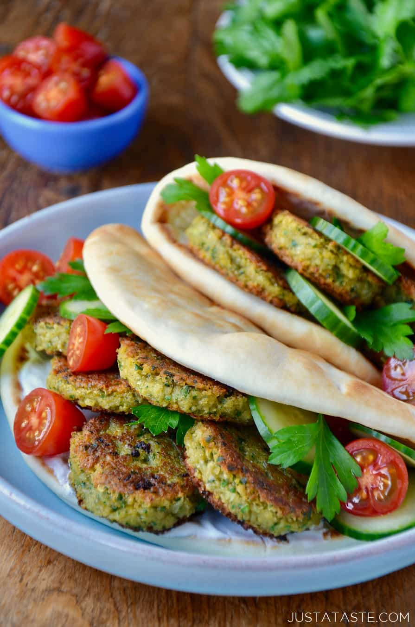

- Jarzynowa Sałatka _ (Vegetable Salad) £24.85
- Kapusta z Grochem - (Cabbage and Split Peas) £20.91
- Zupa Grzybowa – (Mushroom and cheese) £28.74
- Piernik – ( Ginger potato and bread) £14.65
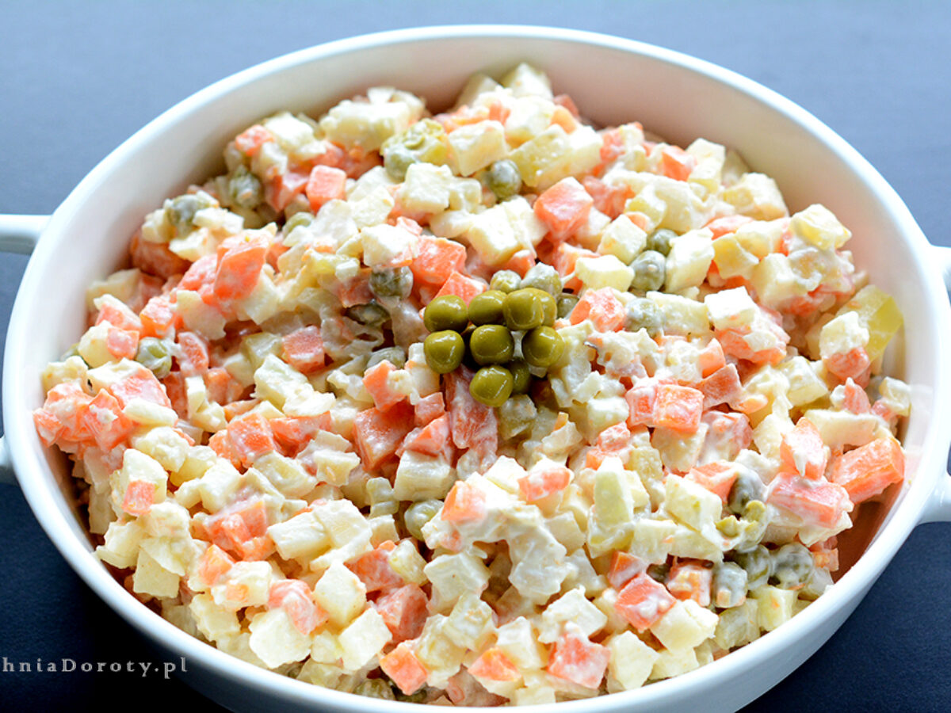

Mocktail

- Virgin mojito ( Usual rum ) £ 15.70

- Gin-free G&T ( cardamom, mint, cloves, chamomile, and rosemary ) £14.70

- Negroni mocktail ( Orange, grape juice, aromatic spices) £17.60

- Sidecar mocktail ( marmalade, honey, tea) £19.10

- Faux fizz ( pear, apricot and rosemary) £13.10

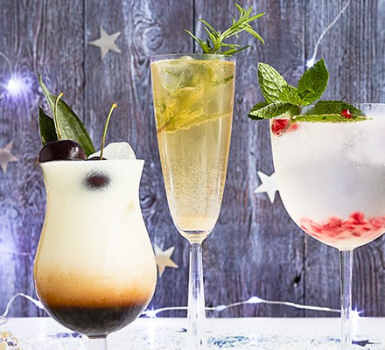
- Sernik – (Polish Cheesecake)
- Kutia –( Wheat-flour and Honey Dessert)
- Patisserie Chocolate ( milk, chocolate) £24.95
- Strawberry fool ( Strawberry and cream) £21.95
- Knickerbocker Glory ( vanilla ice cream and raspberry sauce) £20.10

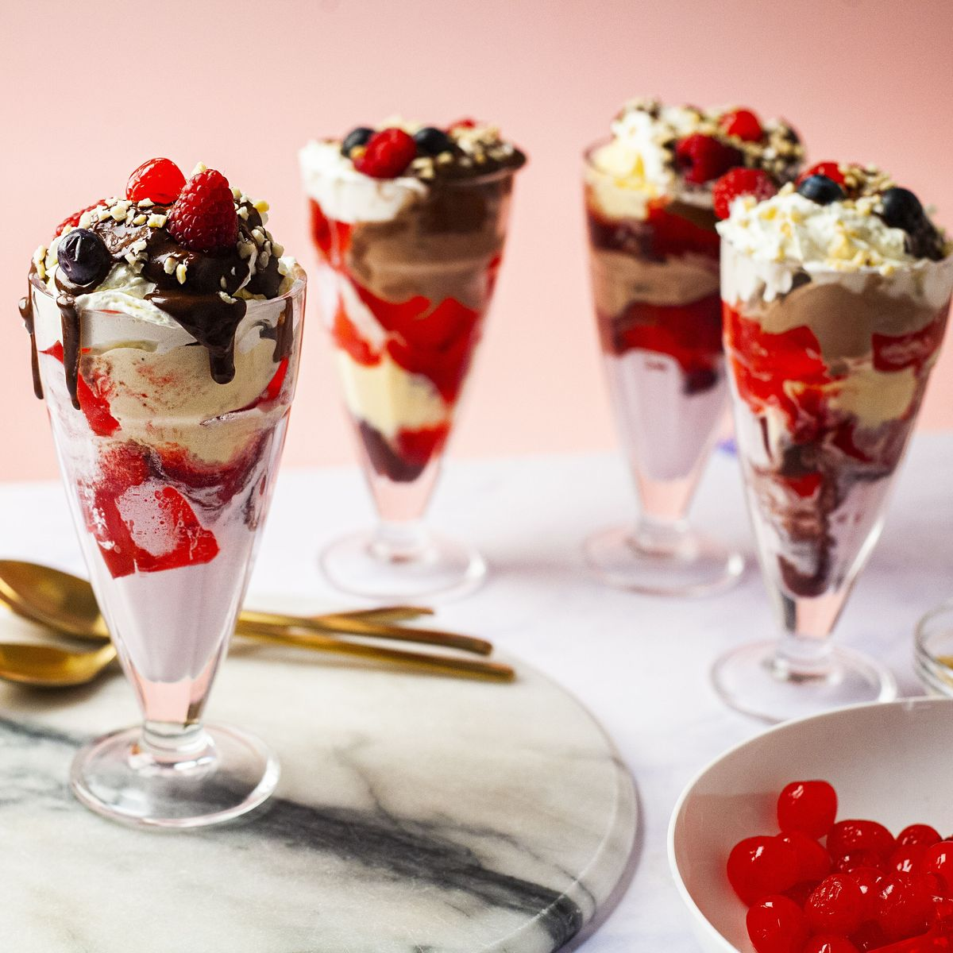

Food and Beverage Selection: The menu of the restaurant has a different variety of products. All food and Beverages have been selected for having enough nutrients. This brand focuses on the dietary values of the products along with focusing on the personal hygiene of the employees. Before selecting the menus, the proper nutritive analysis has been done effectively. The beverage products contain higher fruits which helps to attract a higher number of consumers.
Pricing Strategy: I like to fix competitive pricing strategies because I will prefer the food quality of my hotel to the restaurant. The price setting is based on the other competitor's prices in the market but the offer will be available for the best customer of the restaurant (Symson, 2023).
Nutrition and Special Dietary Requirements:
Different types of protein such as sea products protein, and animal protein has been included in the menus. The menu of the food item has enough unsaturated fatty acid which is beneficial for the human body. The enough amount of vegetables and fruits available in the menu planning are good sources of dietary fibre, minerals and vitamins. The overall menu planning has been done to meet individual daily needs (Hsph, 2021). Before menu planning higher calorie products, high fat-enriched products and higher sodium-enriched products were not added to the menu. The new restaurant will focus on the cooking technique and cooking temperature to maintain the nutritive values effectively.
Menu Layout and Design: Our menu layout and design focuses on brainstorming and all kinds of food and beverages will be served overwhelmingly. The menu design is based on the a La Carte menu in which prices of each item are mentioned in the menu card separately and all main ingredients' names are mentioned ( Binwise, 2023).
Sustainability and Seasonality:
Seafood and mushroom are available as ingredients so those who tend allergies can take other products. Maximum products are free from allergens and harsh chemicals. All of the products are fresh products and raw materials will come from the trustable vendor. all seasonal fruits and vegetables which are locally available I will prefer to use. Mindful resources will be established to reduce the damage to raw or cooked products (Ucf.edu, 2023). The organisation focuses on the food and safety act 2004 carefully during preparing food, transporting, storing and serving to the consumer effectively (Chambers, 2021).

References :
Revel (2022) Restaurant Concepts & Ideas: Why They Are Important, Revel System Blog. Available at: https:/.revelsystems.com/choosing-restaurant-concept (Accessed: 08 June 2023).
Hsph, (2021)Vegetables and fruits. The Nutrition Source. Available at: https://www.hsph.harvard.edu/nutritionsource/what-should-you-eat/vegetables-and-fruits/# (Accessed: 08 June 2023).
Symson, (2023). Competitive pricing strategy - Symson Hyperlearn with Dynamic Pricing - Optimise your Margin. Available at: https://www.symson.com/pricing-strategies/all-about-competitive-pricing-strategy#:~:text. (Accessed: 08 June 2023).
Ucf.edu, (2022) Sustainability in hospitality: How industry leaders can help. UCF Online. Available at: https://www.ucf.edu/online/hospitality/news/sustainability-in-hospitality-why-it-is-important-and-how-industry-leaders-can-help/#(Accessed: 08 June 2023).
Chambers, S.P. (2021) The Food Safety Act explained: Food Safety Act Summary, St Pauls Chambers. Available at: https://www.stpaulschambers.com/food-safety-act-explained/(Accessed: 08 June 2023).
Binwise, (2023). Types of the menu: 5 types of menus to use in your restaurant Complete Bar Inventory Software System. Available at: https://home.binwise.com/types-of-menu#:~:text=price%20a%20menu (Accessed: 08 June 2023).
Yulianto, H. and Suhaimi, H., 2020, October. Business Coaching: Implementation of Service Quality and Social Media Promotion Improvement in Indonesian MSMEs' Restaurants. In Proceedings of the 2nd International Conference of Business, Accounting and Economics, ICBAE 2020, 5-6 August 2020, Purwokerto, Indonesia.
Iofrida, N., De Luca, A.I., Zanchini, R., D'amico, M., Ferretti, M., Gulisano, G. and Di Vita, G., 2022. Italians' behaviour when dining out: Main drivers for restaurant selection and customers segmentation. International Journal of Gastronomy and Food Science, 28, p.100518.

Soni, G.N., Kaushik, T. and Hussain, S., 2022. Demographic or Psychographic Hotel Segmentation? The Emerging Market of Domestic Women Business Travellers. Atna Journal of Tourism Studies, 17(2).
Nutrition, (2023). British Nutrition Foundation Survey reveals 62% of Britons have altered their diet to get healthier. British Nutrition Foundation. Available at: https://www.nutrition.org.uk/news/2021/british-nutrition-foundation-survey-reveals-62-of-britons-have-altered-their-diet-to-get-healthier-in-the-past-year. (Accessed: 08 June 2023).

