Systems Engineering – Systems Thinking Design Report

Author: Joseph S Rula (2317963)
University of Wales Trinity Saint David
Course Code: ACDA5022
Instructor: Mr Dave Holley
Due: 1500Hrs 4th May 2026

Contents
Table of Abbreviations 3
Table of Figures 3
Table of Tables 4
Abstract 5
1.0 Introduction: 5
2.0 Systems Engineering Toolkit 5
2.1 Key Customer Requirements 5
2.2 Rationalisation of Requirements 6
2.3 Required Functionality 6
2.4 Use Case 7
2.5 QFD 01 7
3.0 Concept Generation and Design Choices 8
3.1 Function Means Analysis 8
3.2 Concept Generation 8
3.3 System Pugh 9
3.4 Functional Metrics Analysis 9
3.5 Design Failure Mode and Effects Analysis 10
4.0 QFD 02 11
4.1 P-Diagram 12
4.2 Prime “What Why” Table 13
4.3 Control Factors Chart 14
4.4 Noise Factors Chart 14
5.0 Manufacturing 15
5.1 Requirements Set Manufacturer 15
5.2 Process Map 15
5.3 Manufacturing QFD01 16
5.4 Process Importances Chart 16
5.5 Process Function Means Analysis 17
5.6 Manufacturing QFD02 17
5.7 Function Means Importance 18
5.8 Process Pugh 18
5.9 QFD03 19
5.10 Technique Importances Chart 20
5.11 QFD04 20
5.12 QFD04 Importances Chart 21
5.13 Waste and Manufacture to Disposal System 21
6.0 Conclusion 21
7.0 Reflection 22
8.0 References 22
Appendix A 22

Table of Abbreviations
Abbreviation | Description
SE | Systems Engineering
OME | Ordnance, Munitions and Explosives
QFD | Quality Function Deployment
T&E | Testing and Evaluation
DFMEA | Design Failure Mode and Effects Analysis
SOP | Standard Operating Procedures
RPN | Risk Priority Number
LiPo | Lithium Polymer
PFMA | Process Function Means Analysis
SQEP | Significantly Qualified Experienced Personnel
MTDS | Manufacture to Disposal System

Table of Figures
Figure | Description
1 | List of Given Customer Requirements.
2 | Design QFD01 Functional Importance Graph
3 | Graphed Functional Metrics.
4 | Graphed Importance of Components and/or Sub-systems from QFD02.
5 | P-Diagram.
6 | Control Factors Graph.
7 | Noise Factors Graph.
8 | Manufacturing Requirements Flow Chart.
9 | Process Importances Chart
10 | Function Means Importance.
11 | Technique Importance Chart.
12 | QFD 4 Table.
13 | QFD4 Importances Chart.

Table of Tables
Table | Description
1 | Customer and Stakeholder Requirements.
2 | Rationalised Requirements with Graph.
3 | Required Functionality Table.
4 | QFD1 Table
5 | Generic Function Means Analysis
6 | System Pugh Comparing the 4 concepts as well as the standard solution of personnel with a metal detector.
7 | Functional Metrics Table.
8 | Graphed Functional Metrics
9 | DFMEA for Shaped Charge Release System on Drone.
10 | Design QFD02 Table
11 | Prime/What/Why Table
12 | Requirements Set Manufacturer.
13 | Manufacturing QFD01
14 | Process Function Means Analysis
15 | Manufacturing QFD2.
16 | Process Pugh.
17 | QFD3.
18 | Mine clearance T&E Table.
19 | Functional Importance Graph.

Abstract
This assignment covers the systems engineering approach taken by design group 4 and how the usage of the systems engineering toolkit including quality function deployment tables influenced the direction of the solution taken to develop a drone mounted searching and a partner drone with shaped charge deployment sub-systems to meet customer requirements whilst also adhering to safety standards, regulations and manufacturing requirements.

1.0 Introduction:
This assignment covers the overview of the Systems Engineering (SE) approach taken by Group 4 consisting of several Ordnance, Munitions and Explosives (OME) students for a case study for the development of a mine clearance system for the safe transport of medical/humanitarian aid through a steep walled desert pass. Other requirements include, keeping involved and uninvolved persons safe from the operations, safely marking the path for transit, and keeping costs to a reasonable level. Operational restrictions prevent the implementation of some concepts due to the desert conditions, threat from hostile factors and logistical issues.

2.0 Systems Engineering Toolkit
The Quality Function Deployment (QFD) design book, part of the SE toolkit, contains several tools to take key customer requirements and turn them into a product or process that meets the customers’ needs and expectations. This is done by gathering the requirements, prioritising them before turning them into explicit product or process specifications. [1 ][2]

2.1 Key Customer Requirements
Figure 1 – List of Given Customer Requirements.
The Groups first step was to list, identify and understand the customer’s requirements, to ensure that the direction the assignment was headed in was aligned with these requirements. These requirements were then added to by members of the Group who were acting as stakeholders for R&D, Manufacturing, and Safety. The additional requirements were not included in the following Pairwise comparison.
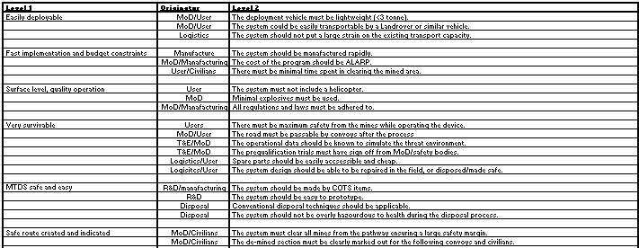
Table 2 - Customer and Stakeholder Requirements.

2.2 Rationalisation of Requirements
To better understand these requirements, a pairwise comparison is undertaken. Comparing the requirements together to judge their relative importance allows for the better focusing of the group’s finite time and resources on critical aspects of product. This was conducted on the given customer requirements to avoid complexity that would have been expressed in later QFD tables.
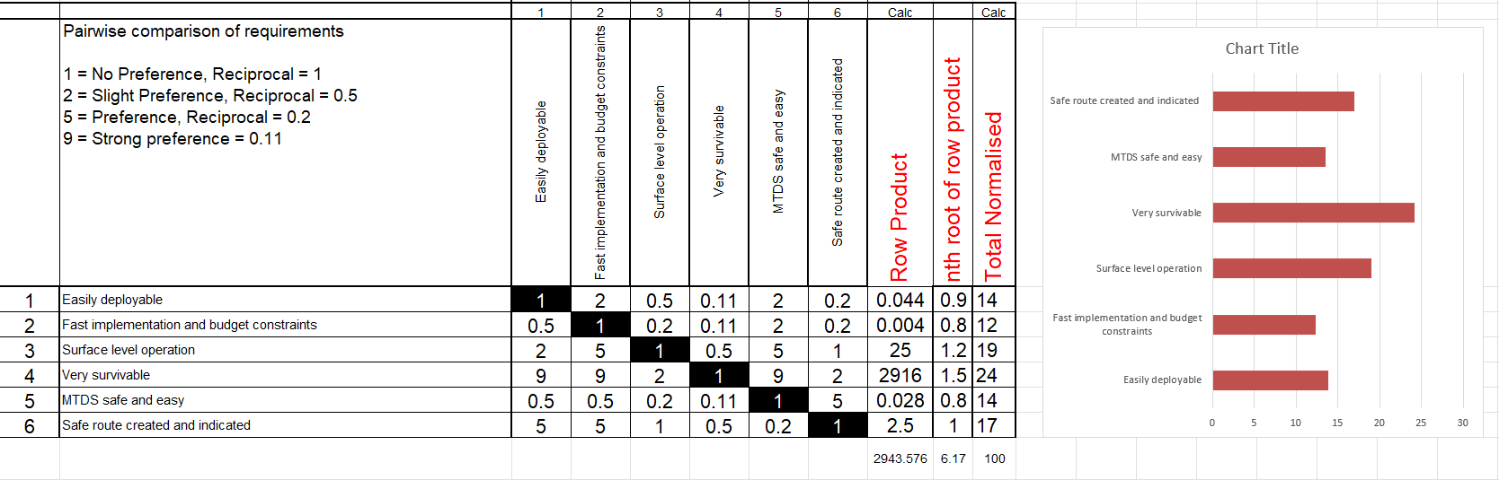
Table 3 - Rationalised Requirements with Graph.

2.3 Required Functionality
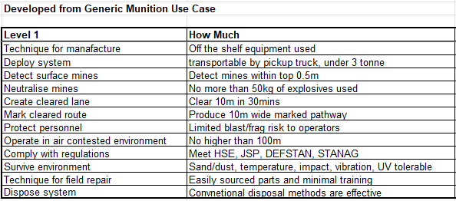
Table 4 - Required Functionality Table.
Defining the required functionality of the stakeholder’s requirements is required to create clarity and reduce risks of missing targets due to ambiguity in the requirements. Other requirements are unspoken but are expected, that the product must comply with regulations to be used. Specifying which regulations must be adhered to influence the choices made during the design and manufacturing process.

2.4 Use Case
From the above the group’s use case was identified:
- Clearance team arrives at the desert walled pass in a light vehicle.
- The team deploys the clearance system.
- The route ahead is scanned for potential mine threats.
- A suspected mine is detected and its location confirmed.
- The threat is neutralised.
- The area is re-scanned to confirm the mine has been cleared.
- A safe lane is marked through the cleared section.

2.5 QFD 01
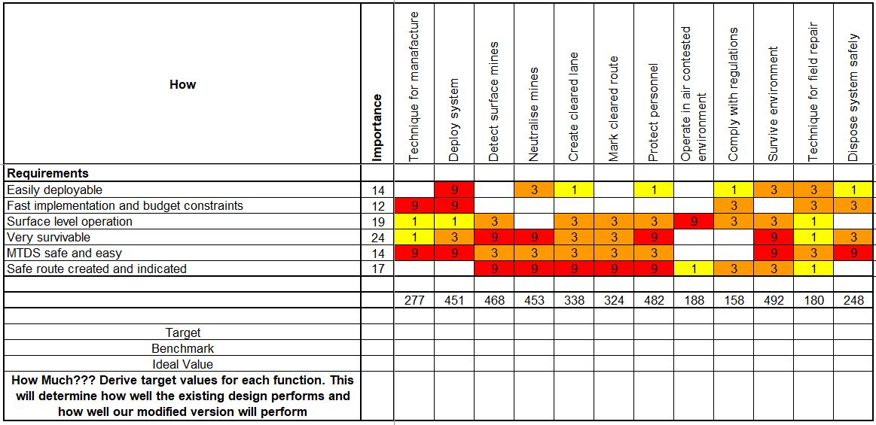
Table 5 - QFD01 Table
Taking the customer requirements and their importances and comparing them to the Level 1 requirements from the required functionality table, to obtain the functional importances, as displayed below in the following graph. As can be seen there are 5 main critical importances; Survive the Desert Environment, Protect Personnel, Detect Surface Mines, Neutralise Mines, and the Fast Deployment of the System.
The importance of completing the QFD01 comparison is to gain an understanding on which parts of the functionality of the system will achieve the customer requirements. Now that the group knows what the system must do, concepts can be generated for designs that can be put forth.

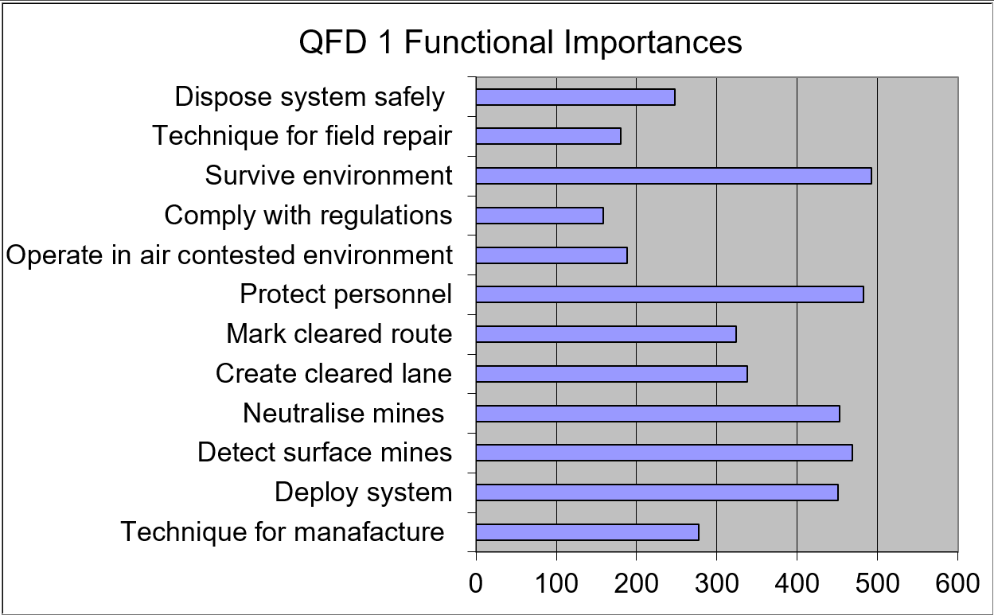
Figure 2 - Design QFD01 Functional Importance Graph

3.0 Concept Generation and Design Choices

3.1 Function Means Analysis
The Function Means Analysis (FMA) table is a list of every possible way, the means, to achieve the required function, and then compare them against another to judge which options would be best to pair together and be incorporated into the design.
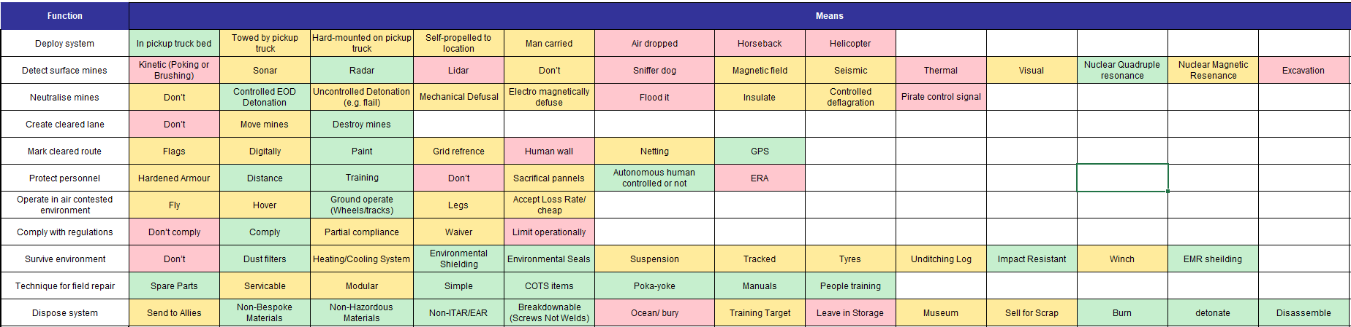
Table 6 - Generic Function Means Analysis

3.2 Concept Generation
From discussions within Group 4, 4 concepts were generated that we wished to spend some time on to judge their efficacy in achieving the required function.
The 4 concepts generated were;
- A truck mounted flail in a similar manner to those mounted on tanks.
- A Plow system to dig up buried mines and push them aside.
- Tumbleweed design to roll through the mined area setting off any mines.
- A drone system to detect, mark and then either defuse or destroy the mines.
As well as the existing solution of personnel walking slowly through the minefield with metal detectors.

3.3 System Pugh
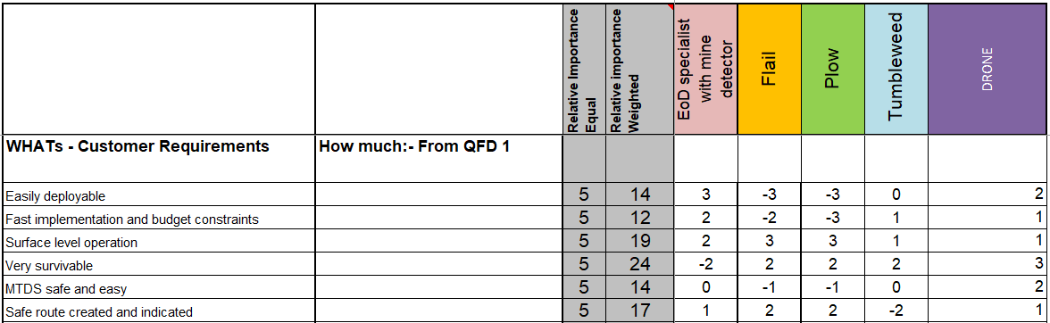
Table 7 - System Pugh Comparing the 4 concepts as well as the standard solution of personnel with a metal detector.
The System Pugh table allows for the comparison between concept solutions, where each solution is compared against one another and ranked on their abilities to complete the customer requirements.
Due to the usage the System Pugh, it became evident to group 4 that some of the proposed concepts had to be left behind due to them not meeting the customer requirements.
Other factors also influenced the selection, the maximum weight limit prevented the usage of the flail and the Plow system, the possibility of detonation or the intentional detonation of the mine system, would pose a significant hazard to the operating personnel and the unarmoured nature of the carrier vehicle, Toyota or Land Rover would require the addition of protection to its essential systems and its occupants. This together with the mine defeat mechanism would exceed the weight limit of 3 tonnes.
The tumbleweed design to be rolled through the mined area clearing a path, was interesting on paper, but would only be suitable for the passive clearance of a large flat open area, as it rolls around in the wind. None of which suit the tight narrow desert pass, the customer presented the group with.
Resultantly the concept that would be going forth was the drone system.

3.4 Functional Metrics Analysis
The functional metrics analysis is the turning of customer requirements into product performance targets that can be measured against to judge the quality of the product to be completed by Testing and Evaluation (T&E) showing the order of importance and which trials are crucial for the mine systems development.
From this analysis the most important targets that should be met are that the mine neutralisation trials, deployment time/setup, and environmental survivability trials.
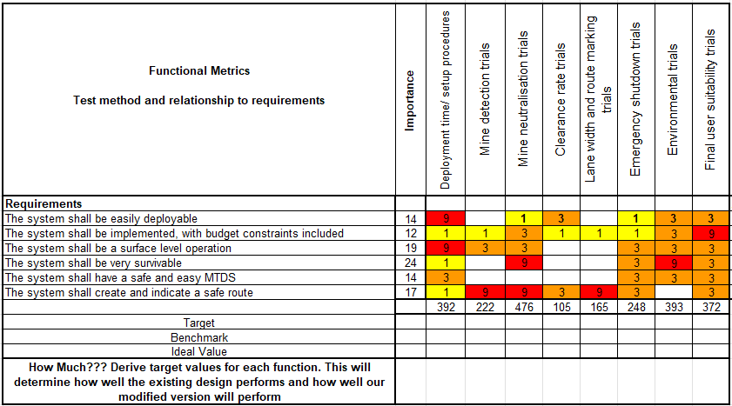
Table 8 - Functional Metrics Table.
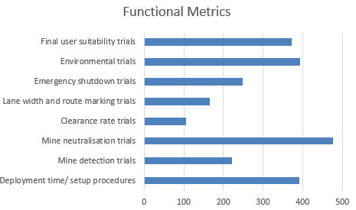
Figure 3 - Graphed Functional Metrics.

3.5 Design Failure Mode and Effects Analysis
The R&D team conducted a Design Failure Mode and Effects Analysis (DFMEA) on several areas, highlighted in Table 9 is the DFMEA for the release mechanism on the drone concept. The DFMEA anticipates possible failure modes for mechanisms before they are incorporated into the final design, allowing for the implementation of prevention modes or detection activities to be incorporated into the standard operating procedures (SOP) and Maintenance Schedules.
The release mechanism for the drone was identified to have 2 potential failure types, the shaped charge does not get released from the drone when intended, or the shaped charge may release at an unintended time. These were addressed with potential effects, and severities. Either the system fails to function properly and must be retrieved, or the system activates unintentionally in a position that may not be safe. Prevention methods were listed, the possible occurrence. And then how the scenario may be detected before or when it occurs. The numbers allocated were multiplied together to get the Risk Priority Number (RPN) and the higher the RPN the higher the risk identified and measured must be taken to prevent the risk. In this scenario too high a voltage, and leaking seals were identified. Implementing better quality seals and the relatively stable voltage offered by commercial Lithium Polymer (LiPo) batteries, are deemed adequate. [4]
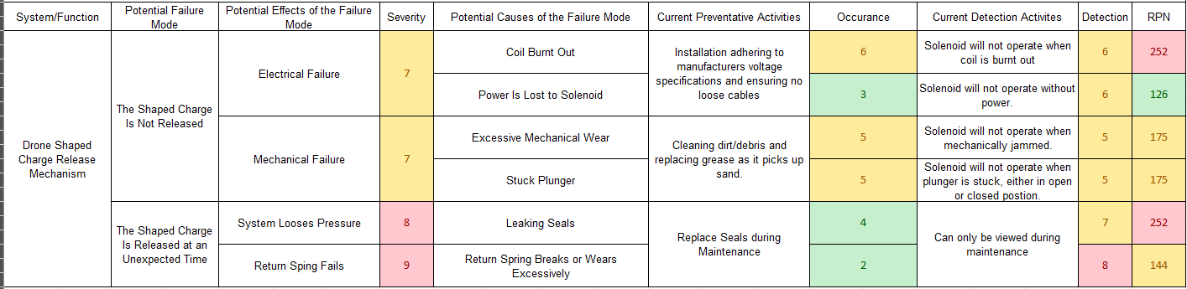
Table 9 - DFMEA for Shaped Charge Release System on Drone.

4.0 QFD 02
After the group had defined the customer requirements, rationalised the requirements, technical requirements defined, and a concept had been identified. The usage of QFD2 allows for the rationalisation of the concept as an overall system, into sub-systems and component parts. The matrix and how numbers appear to bunch into areas, highlight related sub-systems or components, the higher the number of those groupings signify the importance of those sub-systems as well.
Highlighted important areas and sub-systems are;
- Shaped Charge carrying system on the drone
- The mines are defeated by the shaped charge.
- The drone systems can move around the minefield unthreatened by MANPADs.
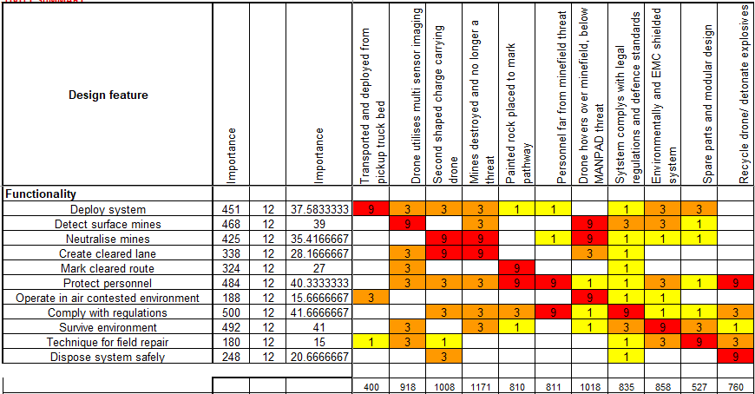
Table 10 – Design QFD02 Table
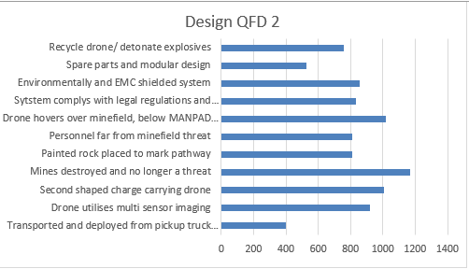
Figure 4 – Graphed Importance of Components and/or Sub-systems from QFD02.

4.1 P-Diagram
The Parameter Diagram (P-Diagram) is a tool used to easily show inputs, outputs, controls and noises to a system or sub-system, This
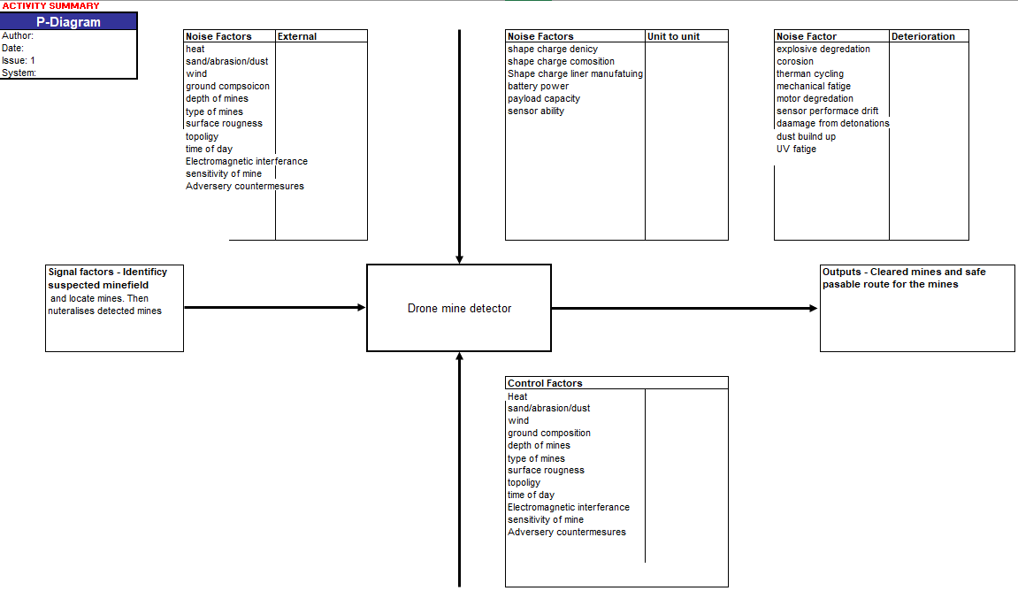
Figure 5 - P-Diagram.

4.2 Prime “What Why” Table
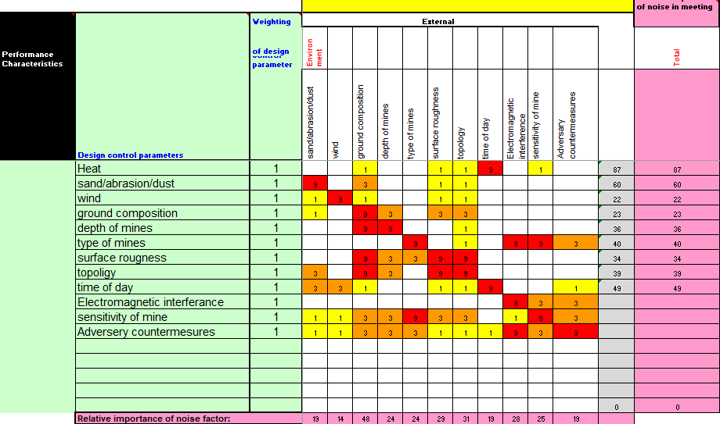
Table 11 - Prime/What/Why Table
A prime/what/why table shows the system as three segments: prime; the systems core functionality. What, the actions the system must do to accomplish the core functionality. Why, the reasoning for the action, such as, it being the customers key requirement.

4.3 Control Factors Chart
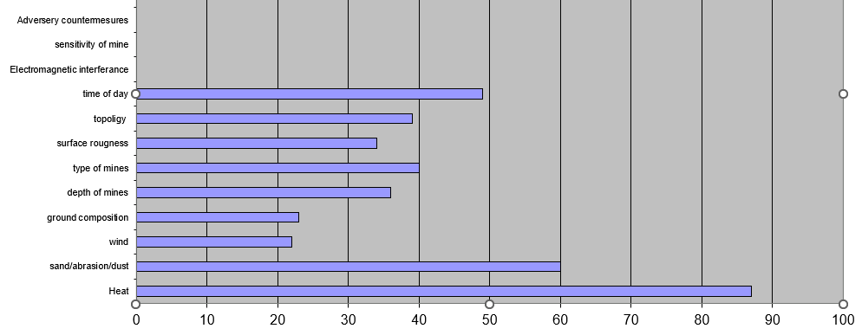
Figure 6 - Control Factors Graph.
Graphed in figure 5, are the control factors from the Prime/What/Why table on which factors have the greatest effect on the system, in this case. The temperature and the mechanical wear posed by sand and dust are the greatest factors.

4.4 Noise Factors Chart
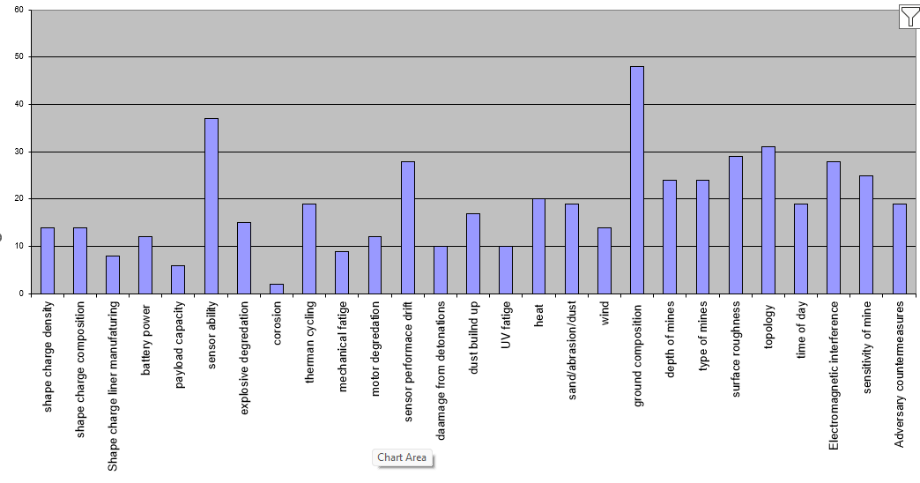
Figure 7 - Noise Factors Graph.
Graphed in figure 6, are the noise factors that are impossible or extremely difficult to design out of the system, and as a result must be designed to accommodate the noises. The largest noises identified were the ground composition, where differences in earth density, materials or presence of metallic objects such as shrapnel would affect the detection rate of the system.

5.0 Manufacturing

5.1 Requirements Set Manufacturer
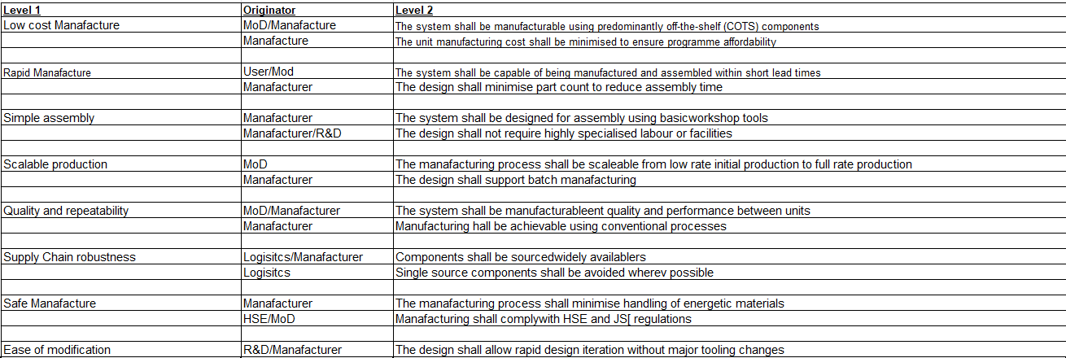
Table 12 - Requirements Set Manufacturer.
Manufacturers also have their own requirements alongside the customer, designs and systems must be feasible to be manufactured. As well as the regulatory requirements posed by organisations such as the MoD, NATO, or the HSE.
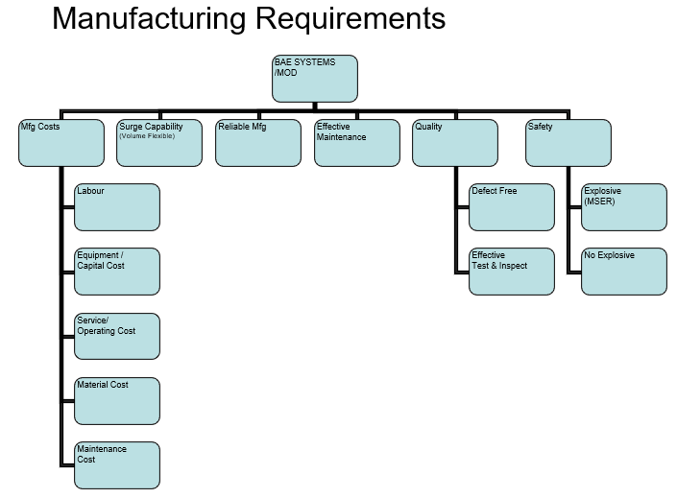
Figure 8 - Manufacturing Requirements Flow Chart.

5.2 Process Map
Next the Process Team identifies a process map for the manufacturing processes to create sub-systems. To manufacture the shaped charge, the following processes were identified;
- Mix Powdered Explosives into Compound, with other ingredients.
- Inspect prior to pressing for contaminants.
- Load into die, and press.
- Eject pressed shaped charge and inspect.
- Load shaped charge into casing and place on top liner.
- Inspect tolerances.
- Pack into transportation boxes.

5.3 Manufacturing QFD01
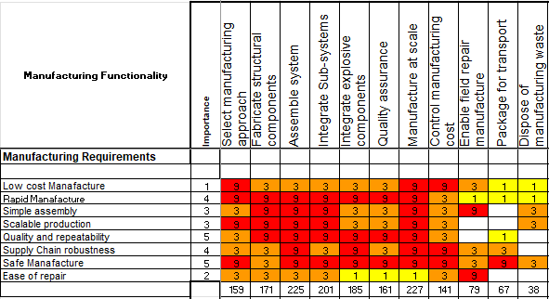
Table 13 - Manufacturing QFD01

5.4 Process Importances Chart
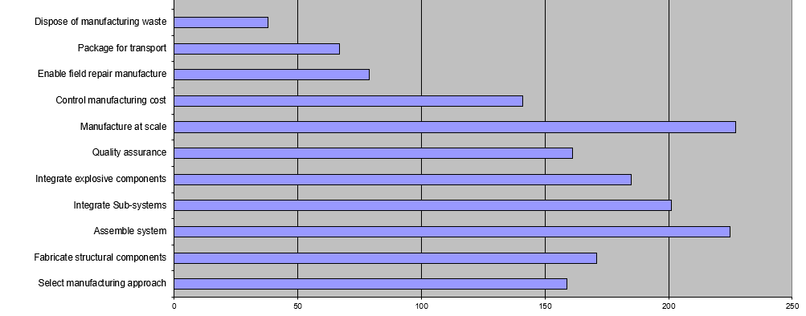
Figure 9 - Process Importances Chart
The Manufacturing QFD1 performed by the Manufacturing Team, details the manufacturing requirements and their relative importance to another. The top 3 most important requirements from the manufacturing team are; To manufacture at scale, to assemble the system, and to integrate sub-systems.

5.5 Process Function Means Analysis
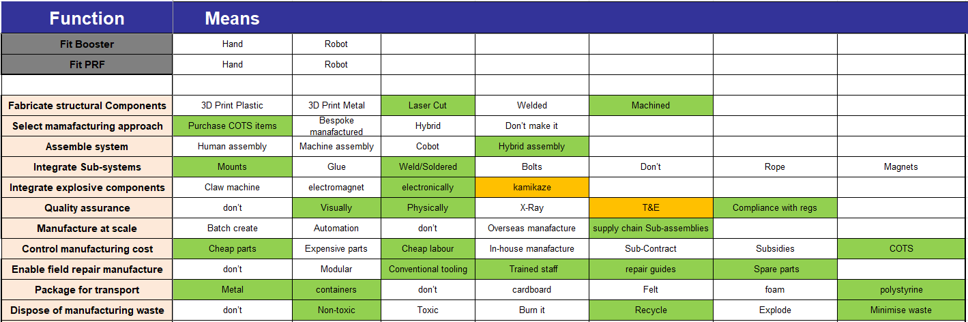
Table 14 - Process Function Means Analysis
The Process Function Means Analysis (PFMA), like the FMA, is a brainstorm of all possible ways to accomplish the identified functions required to building the system, these means are then compared to each other and a method is determined.
For the drone-based system that was chosen as the concept. Purchasing them as COTS items, and fabricating the hardpoints internally with laser cut and machined components was deemed optimal.
Disposal options were also considered here, as to reduce the waste from manufacturing and recycle where possible, using non-toxic components where possible.

5.6 Manufacturing QFD02
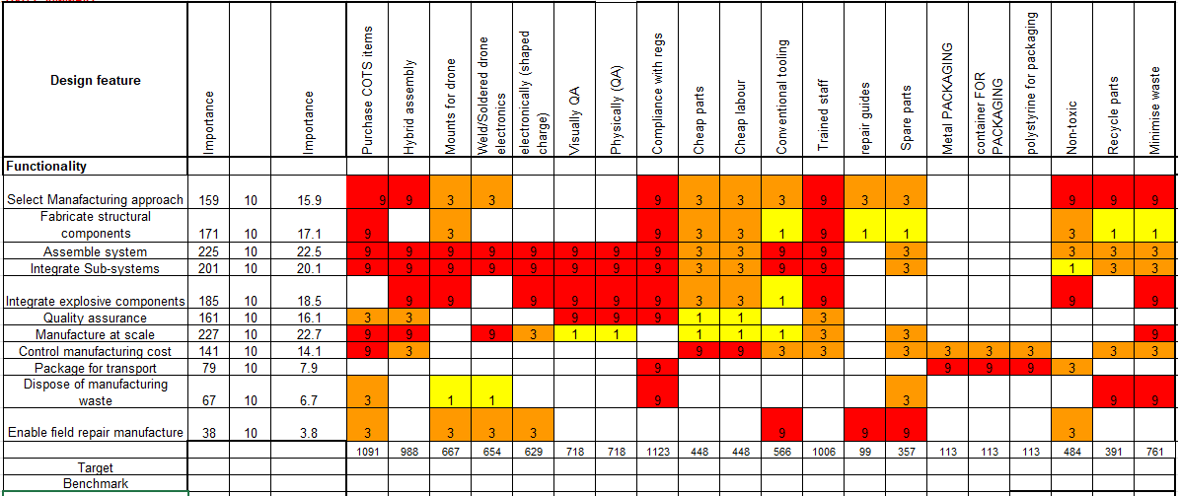
Table 15 - Manufacturing QFD2.
Using the QFD2 table again, but for the purposes of manufacturing allows for the assessment of the importance of each of the manufacturing techniques to achieving the manufacturing requirements outlined in manufacturing qfd01.

5.7 Function Means Importance
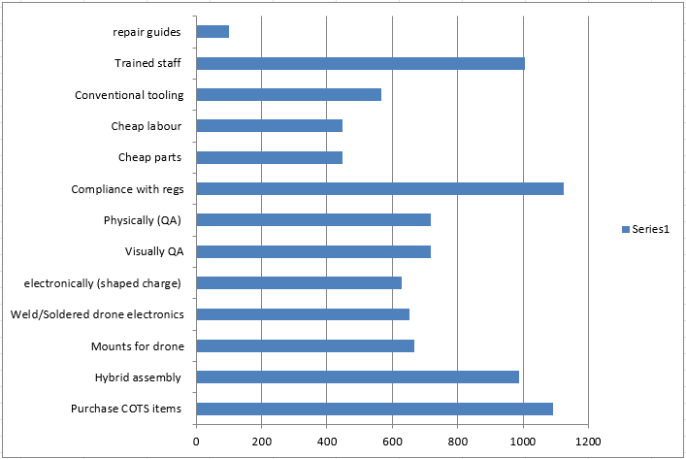
Figure 11 – Function Means Importance.
Shown in figure 10, is the graphed output of manufacturing QFD2, 4 requirements are significantly more important than the rest. Compliance with regulations, The usage of COTS items, Significant Qualified Experienced Personal (SQEP), and Hybrid Assembly techniques, such as using laser cut and machined components.

5.8 Process Pugh
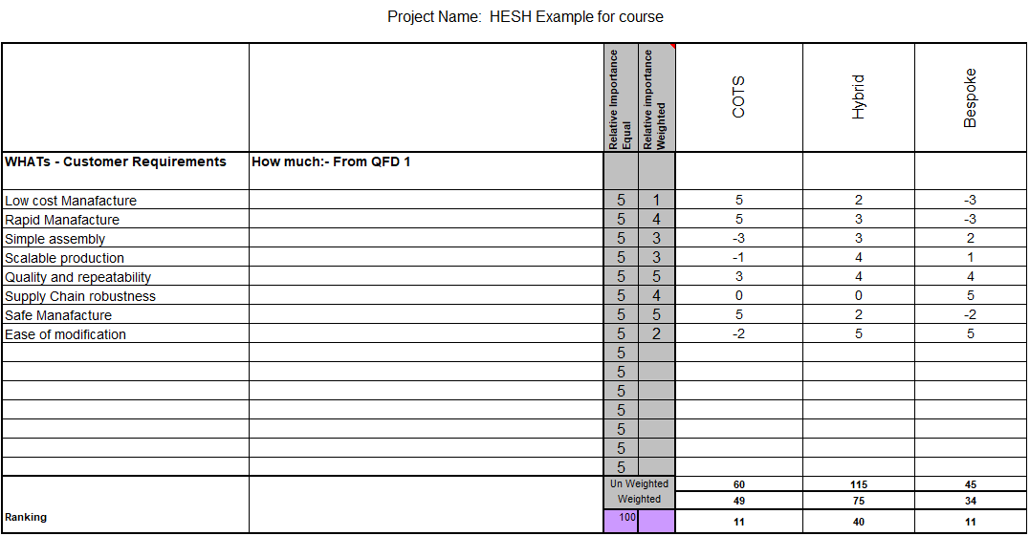
Table 16 - Process Pugh.
The Pugh table is used again this time for the comparison of manufacturing techniques.
The System Pugh table allows for the comparison between concept solutions, where each solution is compared against one another and ranked on their abilities to complete the customer requirements.
COTS items and Hybrid assembly techniques were identified to be preferential over making bespoke items specifically for the drone based system, manufacturing components such as flight controllers or motors when existing suppliers can produce these components and sub-systems in bulk is preferential.

5.9 QFD03
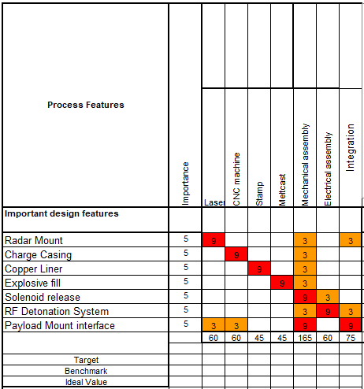
Table 17 - QFD3.
The usage of QFD3 takes the requirements developed from the previous QFDs and takes the important design features and compare them to the manufacturing techniques identified.
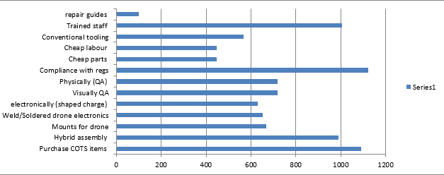
Figure 12 - Graph of QFD3.

5.10 Technique Importances Chart
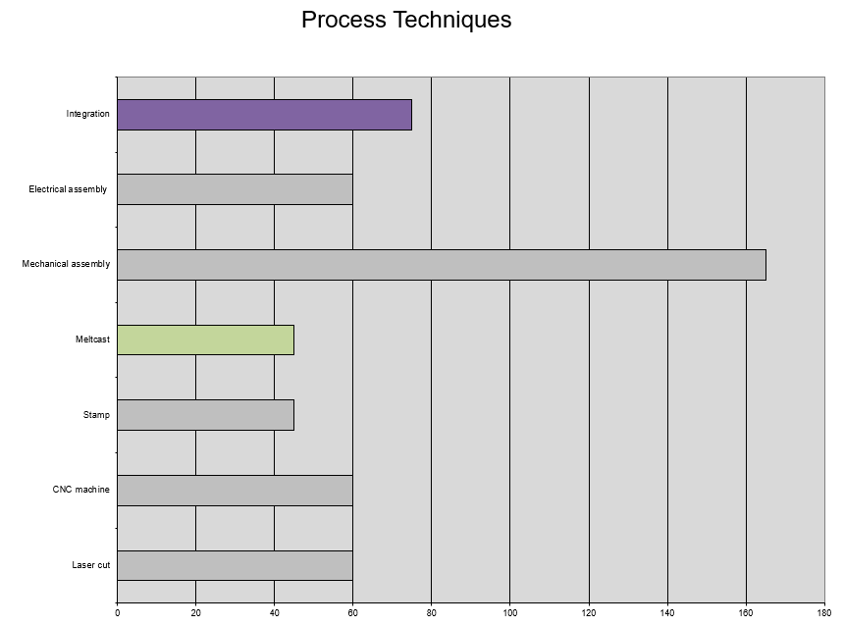
Figure 13 - Technique Importance Chart.
The graphed output of the technique importances, shows the importances of the manufacturing techniques. Mechanical Assembly outweighs the second next most important manufacturing techniques bay greater than a ratio of 2:1.

5.11 QFD04
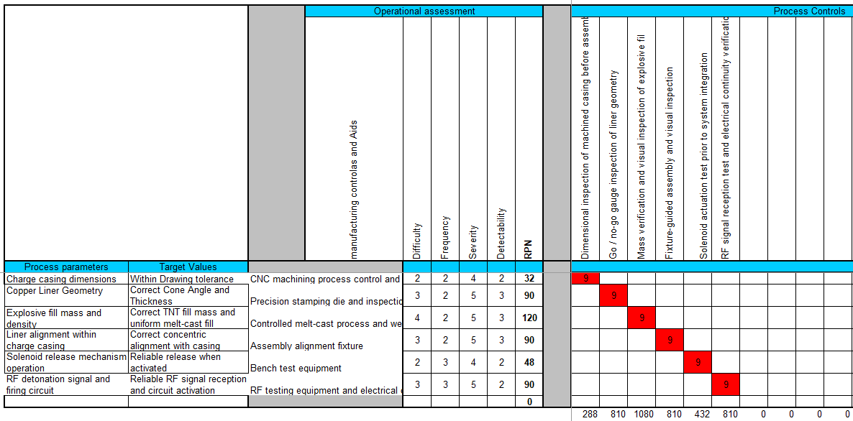
Figure 14 - QFD 4 Table.
QFD4 turns the process requirement outcome from QFD3 into target values, controls and tolerances. So that when the drone system is put into full scale production, every drone produced, and every shaped charge to be used on the drone are identical and operate the same way every time reliably. These targets, controls and tolerances allow for the product to meet customer needs and requirements routinely.

5.12 QFD04 Importances Chart
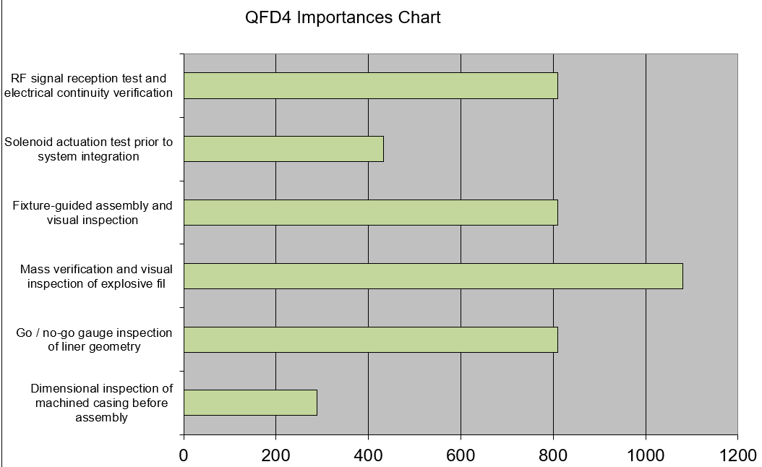
Figure 15 - QFD4 Importances Chart.
The QFD4 importances chart shows the ranked importances of controls and inspections for quality control. Lower risk areas such as perfect tolerances on a casing or solenoid activation have very little impact on the final product, as they either add no value to the final product and are a waste on resources, or can be replaced easily and cheaply for like systems. Whereas for higher risk areas, where mistakes can be costly or with explosive fills, potentially causing dangerous outcomes, the safety and reliability gain by spending more time with Quality control checks on that aspect are considerably worth it.

5.13 Waste and Manufacture to Disposal System
A manufacture to disposal system (MTDS) considers the way materials and components will be handled at the end of life. For the drone carrier systems detailed at their end of life, they will need to be stripped of proprietary or secret hardware and software, where they then can be disposed of as e-waste through the Disposal Services Authority, an approved disposal agency by the MoD.
Where explosive shaped charges that reach their end of life are to be disposed of by burning at an MoD contracted site as per the Defence Code of Practice 104.

6.0 Conclusion
In conclusion the systems engineering toolkit greatly benefited the team as it structured their approach to the customer requirements they were given. It allowed the involvement of all the team members for their ideas, concepts and approaches to the requirements, and they were then able to be judged impartially and only the best solutions were to be adopted into the final concept.

7.0 Reflection
Some flaws were noted with the team’s approach to the systems engineering toolkit, generally most team members were greatly unfamiliar with the toolkit and did not know the full application of each tool, and as a result most were underused to their full capabilities. Regardless, despite unfamiliarity with the design book, a concept was identified and fleshed out to a significant enough degree to give a presentation on the topic.

8.0 References
[1] B. E. Goldberg, K. Everhart, R. Stevens, N. Babbitt, P. Clemens, and L. Stout, “System engineering toolbox for design-oriented engineers,” ntrs.nasa.gov, vol. 1, Dec. 1994, Available: https://ntrs.nasa.gov/citations/19950012517
[2] “What is Quality Function Deployment (QFD)? | ASQ,” Asq.org, 2026. https://asq.org/quality-resources/qfd-quality-function-deployment?srsltid=AfmBOor2I4zNeVq0kjWUm6ePyVM5kmAo8CS6Hl2tyDXVPOhjF_pGGhk1 (accessed May 03, 2026).
[3] C. Montgomery, “What Is DFMEA?,” Ansys.com, Jul. 15, 2019. https://www.ansys.com/blog/what-is-dfmea (accessed May 03, 2026).
[4] J. Shepard, “The difference between lithium ion and lithium polymer batteries,” Battery Power Tips, Jun. 30, 2021. https://www.batterypowertips.com/difference-between-lithium-ion-lithium-polymer-batteries-faq/ (accessed May 03, 2026).

Appendix A
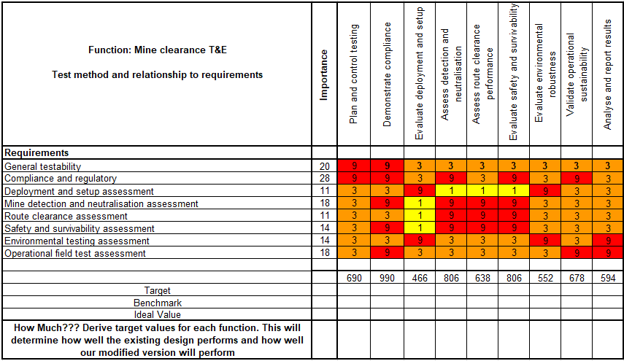
Table 18 - Mine clearance T&E Table.
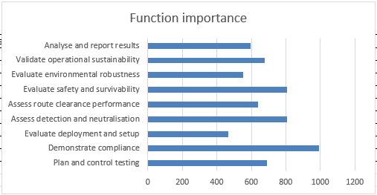
Table 19 - Functional Importance Graph.

