

UNIVERSITY OF WALES TRINITY SAINT DAVID

GLOBAL BUSINESS ENVIRONMENT (LCBB4005)

ASSESSMENT 1

LECTURER – DR. NADEEM MIRZA

STUDENT NAME – TSONYO TODOROV

STUDENT ID-2021609

TASK 1

BUSINESS ENVIRONMENT ANALISYS OF CHINA

Table of Content
Introduction p.3
Globalization p.3
IKEA’s Globalization……………………………………………………………………………………p.4
China’s Economic Condition p.4
Application of theories p.5
PESTEL Analysis pp.5-7
Five Forces Model pp.8-9
Hofstede’s Cultural Framework pp.9-11
Opportunities & Challenges p.11
Barriers to Enter the Market p.12
Strategy Recommendation p.12
Conclusion p.13
Reference list pp.14-15

Table of Figures
Figure1: China Economy (Vaswani, 2020)………………………………………………………….p.4
Figure2:PESTEL Analysis (source-https://www.edrawmax.com/article/china-pestel-analysis.html) …………………………………………...................................................................p.5

Introduction
Economic development has traditionally been measured by productive capacity. More significantly, a growing economy will boost its people's buying power, advancing society. China's 1.34 billion people have helped it prosper economically since the 1980s. China, known for its closed-door policy and poverty, has now evolved. Since 1978, China has become one of the world's fastest-growing economies and the biggest developing country (Ajami, 2020). CNN Money reports that the country has the second world's most populous economy with a GDP of 7.8 trillion U.S. dollars. This has lifted over 400 million Chinese citizens out of one-dollar-a-day poverty. The government's strict pandemic measures, the severe property fall, and cooling expansion will hamper development this year. Stronger infrastructural boost should help. Persistent Covid-19 limitations and a worsening property crisis are downside risks, while U.S. tariff rollbacks are positive risks. Focus Economics panelists projected 4.4% GDP growth in 2022, down 0.3 percent from the previous. The panel predicts 5.2% GDP growth in 2023. Thus, this study will explain China’s business environment and challenges related to this environment.
Globalization
Globalization is the process of interconnecting enterprises, people, and governments of other nations. Since neighboring nations are a source of production and sales for home companies, globalization will bring all economies closer together. Globalization has impacted international commerce, which includes sales, investments, and transportation connecting a number of different countries. Globalization improves technology, making worldwide communication simpler for businesspeople. Global-enterprises are affected by China developing economy, whether we want to or not. That although China is really a huge market, it must deal with global commercial changes. Thus, company managers and decision-makers must comprehend business environment analysis to survive and thrive in their respective marketplaces. However, many decision-makers fail to grasp or assess the business environment and make poor business judgments. Failure in decision-making may hurt firm’s profitability, growth, and competitiveness, sometimes forcing them to close (Choo et al., 2021).

IKEA’s Globalization
Furniture, kitchenware, bathroom items, and other home goods are all sold by the private, global firm IKEA. The company is one of the biggest international furniture merchants in the world, and it was established in Sweden in 1943. IKEA began its journey of worldwide growth from Northern Europe to other areas of the world after it had reached a stable stage of development. IKEA now operates 445 shops, 271 of which are in Europe and the remaining 82 in Asia (Chen, 2021). The company owns retail centers in 54 different nations and regions. With the continuing expansion of the organization internationally, supply and demand will also grow. Therefore, the company must expand its manufacturing facilities and retail stores as well. IKEA is also present in China and this is a great opportunity for them to expand their production line in the country furthermore.
China’s economic condition
China became the world's second biggest economy after decades of rapid expansion. China's nominal GDP rose from USD 214 billion in 1978 to USD 9.2 trillion 35 years later. State-owned firms dominate China's socialist market economy. Open-market supply and demand govern the state-owned industry. It is described as market capitalism. China has the world's second-largest economy by nominal GDP and the largest by PPP. Its economy grew 10% annually over three decades (Geert Hofstede, Gert Jan Hofstede and Minkov, 2010). China's nominal GDP in 2016 was $11.4 trillion, with $8,260 per capita. It employs 807 million. 40.6% work in services, 29.9% in industry (Capobianco et al., 2021), and 29.5% in agriculture.

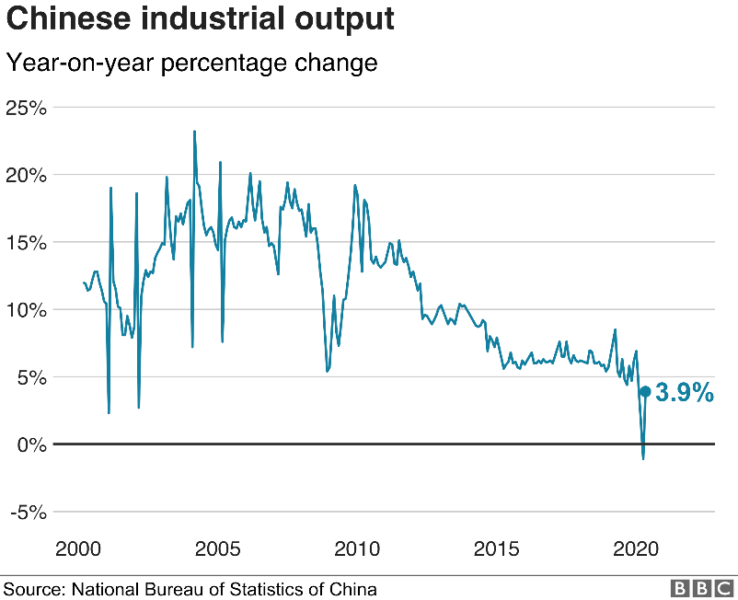
Figure 1: China Economy (Vaswani, 2020)
Application of theories
PESTEL analysis, Five Forces Model & Hofstede study requires knowledge of the country's history and economy. With 1.39B people, China is a superpower. Its fast economic expansion makes it a popular business location. China's cheap manufacturing cost and huge profit margin attract numerous enterprises. China dominates IT investment abroad. The country has 14.72 trillion USD GDP (2020).

1.PESTEL Analysis
China's low-cost workforce and business climate have traditionally attracted investors. It boosted the economy. It's a strong nation. Politics, economics, society, technology, environment, and legislation may impact their business location ranking. PESTEL analysis China can identify potential threats:

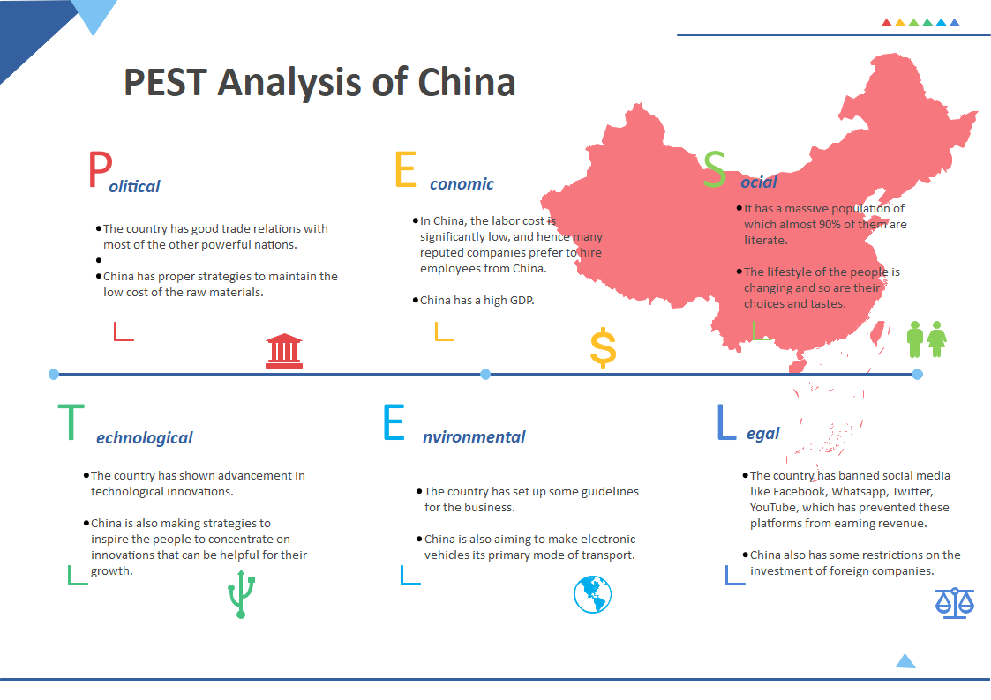
Figure 2: PESTEL Analysis (https://www.edrawmax.com/article/china-pestel-analysis.html)
1.1 Political Factors
Any nation's politics effect its industries. Thus, China needs political stability to provide organizations an optimal atmosphere. Politics may affect China:
- China manages raw material costs well. Low labor costs make investors an attractive business decision.
- Government plans and subsidizes enterprises. E-commerce is promoted by the Chinese government.
1.2 Economic Factors
Growth is correlated with economic health. China has grown economically. It's good for company investment (D Anthony Miles, 2011). PESTEL analysis China shows how economic considerations affect development:
- Many reputable firms utilize Chinese workers due to reduced labor costs. This nation also has cheap, experienced workers.
- China has high GDP. Thus, the country's population have more buying power. Investors like China's market.
- China has strong inflation and rising house prices. It may hinder future economic development.
1.3 Social Factors
- Any nation's economy and industry are influenced by its culture. Sociological variables affect national growth:
- Its enormous population is over 90% literate. Thus, the company may hire skilled workers cheaper. High population lowers labor expenses.
- People's preferences and lifestyles change. Businesses are seeing social behavior and purchase habits shift as the urban lifestyle spreads.
- Internet users are growing fast. Internet availability increases e-commerce use. It makes the nation ideal for e-commerce startups.

1.4 Technological Factors
Technology and business are intertwined. Technology increases manufacturing capacity and company income. PESTEL analysis China can demonstrate how technology boosts growth:
- The nation has advanced technologically. It altered manufacturing and distribution. Baidu and Alibaba, global tech titans, can help firms boost sales.
- China is also encouraging individuals to focus on growth-promoting inventions. These rules may help local and multinational enterprises improve output.
- E-commerce is popular in the nation due to superior technology.

1.5 Environmental Factors
Ecology may indirectly effect nation development. China has urbanized due to fast expansion in recent decades (Luo, He and Hu, 2021). China's environmental challenges include:
- The nation regulates commerce. It ensures manufacturing environmental norms. It may raise manufacturing costs and lower profits.
- China wants to use electric cars too. The automobile manufacturer may benefit from including it.
- The country's large manufacturers need technological advancement. It lowers production costs and emissions.
1.6 Legal Factors
Company operations may be affected by legal circumstances. China's business-promoting laws:
- The nation has outlawed Facebook, WhatsApp, Twitter, and YouTube, preventing them from making money (Li, Negnevitsky and Wang, 2020).
- China likewise restricts international investment. It may reduce foreign investment in the country.
- The nation is drafting e-commerce legislation, which is problematic. The state's taxes and IP regulations don't verify the seller-buyer online contract. E-commerce sites may face higher transaction risks.

2. Five Forces Model
Retail titans rule the sector. Retail giants compete in several categories. Retailers compete on price, location, store format and inventory mix, size, atmosphere, and customer image. Michael Porter Five Forces analyzes China's retail market's competitiveness (Li, 2020).
2.1 Threat of New Entrants
In the early years of economic reform, foreigners were not allowed to shop in China's retail sector. The market was controlled solely by state- and collective-owned businesses. Despite performing poorly, they felt protected from new competitors because of the severe admittance requirements. The Chinese central government gave new retailers a lot of support. Without network externalities, retailers can simply contact their consumers. As a result, shops multiplied. A series of rules were recently put in place by the Chinese central government to regulate and promote the expansion of retailing, allowing for scale expansion and the restructuring of cross-sector, cross-regional, and cross-ownership assets by competing firms.
2.2 Threat of Substitutes
Wet and street marketplaces in China are retail shop replacements. Wet markets are huge and enclosed, with counter-service sections, whereas street markets offer fresh food by independent merchants with modest booths. Both are filthy, crowded, and loud. Fresher food and lower prices make supermarket chains and street markets competitive. Thus, wet markets and pedestrian marketplaces first replace retail businesses. As people's living standards rise, retail businesses, cozy atmosphere, vast selection, and excellent service are drawing more consumers.
2.3 Supplier’s Negotiation Power
After China entered the WTO, retailer-supplier ties, as China have grown in importance. Retail-outlets are the most essential distribution channels due of retailing's growth potential. Manufacturers provide retailers most. China has several middle and small suppliers. The fittest endure fierce competition. Suppliers have little influence on merchants. As the retail business grows, many merchants are expanding their operational and buying sizes. Thus, such merchants make up a large amount of supplier’s revenues, and continual high-volume purchases are essential to their survival. Thus, suppliers will have minimal negotiating power.

2.4 Bargaining power of Buyers
Buyers may negotiate merchant earnings like suppliers. Most store-based retail businesses have a set price, but purchasers have some negotiating power since they may buy from a rival. The quantity of merchants accessible to clients affects their power.
China's GDP growth boosts family earnings and spending. Rapid economic development is predicted to increase Chinese consumption. This boosts Chinese retail. As incomes rise, more individuals want better lifestyles. Car ownership and better mobility allow consumers to buy at distant retail outlets. After China joined WTO, reduced import charges and tariffs have increased sales of high-quality consumption items in local markets as more middle-class consumers can buy them.
2.5 Industry Rivalry
This factor is poor due to the fact that China's market is extensively regulated, which reduces competition. Since China has few domestic and foreign competition, this element is the weakest. As we shall see, China's monopoly and enormous market share indicate that it faces little to no competition from existing or emerging competitors. Lastly, China does not have to worry about industry competition because to the enormous market size and rapid subscriber development. China is serious about expanding the Chinese market to multinational corporations, especially in the telecom sector. As stated, future changes need China's departure from its previous commercial model, which it is currently pursuing.

3.Hofstede’s Cultural Framework

The Hofstede method assesses the influence of social norms and attitudes as well as cultural values on workplace behavior. The now-famous framework was created by psychologist Dr. Geert Hofstede while he was employed by IBM and was based on a survey of more than 100,000 people in 50 different countries.

3.1 Small vs. Large Power Distance
Chinese culture is paternalistic and has a cultural split between the high and lower classes. These make's China's corporate climate obedient to leadership. Compared to the West, China has a considerable power gap. Chinese culture is hierarchical, therefore lower-level workers often communicate hierarchically with their bosses (Luo, He and Hu, 2021).
3.2 Individualism vs. Collectivism
A culture's emphasis on group membership against individualism is this dimension. This dimension has low individuality because Chinese business favors the collective well above individual and encourages group-think and conduct. Chinese prefer family connections above individual friendships and value collective loyalty over individualism. Most Chinese companies prefer to remain with their suppliers and vendors rather than attempt new ones. China has a low Individualism Dimension (IDV) score due to its focus on loyalty and a collectivist network of links (Peschel, 2020).
3.3 Masculinity vs. Femininity
Society's support of the conventional male labor paradigm. China is paternalistic, yet it doesn't follow the typical work-life paradigm. However, many women work in industry and commerce, which is similar to the West because women are regarded equally. Chinese culture's focus on the Yin and Yang, or masculine and feminine, has eliminated many gender preconceptions and prejudices.

3.4 Weak vs. Strong uncertainty avoidance
Like the preceding dimension, China's rating is deceptive. Free countries with low long-term orientation accept workplace uncertainty and ambiguity. Poor scores can imply low control. China, despite its economic liberalization, controls its people. Employees require strong supervision rather than making snap judgments at work (Waters, 2013).

3.5 Long-term vs. short-term orientation
Chinese people frequently think long term rather than short term. The country aspires to be a powerhouse therefore it plans widely and far in advance. The slower business tempo in China must be budgeted for by Western businesses. Because of their intense sense of historical pride, Chinese people tend to have a longer perspective on time than Westerners. This explains Chinese long-term thinking.
3.6 Indulgence vs. Restraint or Aggressiveness
Chinese culture discourages overt hostility therefore they tend to be restrained. Chinese men and women are not as different as in other Asian nations. Chinese society is less open than Western societies.
Opportunities & Challenges
China has two significant opportunities: enhancing the service industry and promoting urban migration.
- China can improve the service industry and urban migration.
- Service-based firms may thrive as the agriculture sector declines and more people relocate to cities. This is crucial as agribusiness and manufacture were China's top sectors until recently (Song, Sun and Jin, 2017).
- First, folks must relocate to cities. Without farmland, people are moving to cities for jobs. 55% of urban migrants are 40 or younger. 18% are 50+.
Chinese suffer from unfavorable views. The country is seen as a totalitarian state by foreigners. The one-child policy doesn't enhance attitudes. China's air quality is poor. Thus, many people wear masks when they walk outside. China's cheap labor is a strength, but foreigners worry about industrial worker abuse and ask how anybody can live on such poor hourly earnings. Many individuals may see Chinese security camera incidents online. Commenters complain about China's safety standards (Wang and Wang, 2020), from broken elevators to hit-and-runs. Some say it's advisable to escape rather than aid a guy in China after an accident since the Chinese citizen at responsibility may have to care for the wounded party for life. Many folks are put off by online forum murmurs and rumors. However, China doesn't seem to care about how other nations view them. China seldom reacts to issues with Japan and South Korea, so this isn't unusual. Trade between these three nations is hampered by their disputes over corporate power of the East China Sea (Zhang et al., 2020).
Barriers to Enter the Market
Many multinational companies have expanded to China due to weak western economic development. Traditional Chinese expansion may be expensive and time-consuming. Foreign enterprises entering the Chinese market may also face changes in international relations, local preferences, and restrictions. Therefore, business experts propose partnering with local corporate and human resources specialists to avoid China market entrance hurdles and enter successfully. Global political changes make growing into China the hardest. Many foreign nations rely on domestic supply chains due to rising trade rivalry. West and Asia Pacific region nations compete to recruit enterprises for global growth. Competition has also altered consumer-business interactions. Buyers increasingly consider the whole supplier chain. Global enterprises also struggle to employ and assess customer preferences.
Strategy Recommendation
In the next wave of the struggle for Chinese markets, Multinationals should consider using a mix of the methods outlined below in order to prevail against Chinese competitors on the rise.
Consolidate industries: Chinese industries are fragmented. Fragmentation will impair economies of scale, excess capacity and price competitiveness will continue, and even fundamentally good enterprises will struggle to achieve appropriate returns. Given China's acquisition limitations, firms have struggled to address this issue until late. China acquires 5% of foreign direct investment. However, industry consolidation opportunities are emerging. Kodak pioneered a 1998 arrangement with the Chinese government would acquire three significant state-owned photography firms and merge them into a controlling shareholder with its current operations. In October 2003, Kodak purchased a 20% stake in Lucky Film Corp., China's biggest film maker, for $4.2 billion (U.S.) and new filmmaking technology.
Simplify distribution: Multinationals were formerly barred from direct distribution and retailing. Due to legislative restrictions on core sales and distribution, Canon has forced to utilize its Hong Kong headquarters to serve China. However, China's WTO membership removes these prohibitions, allowing multinationals to simplify their networks. Building specialized distribution networks as the Chinese does helps smooth the supply chain, reach closer to consumers, and improve marketing and communications via the point of sale.
Consolidate industries and simplify distribution is an appropriate approach for businesses in China. Also firms may seek to join hands with some of the Chinese organizations or enterprises in order for their business to be successful.
Conclusion
Any firm seeks to maximize profit with limited resources. Thus, company decision-makers are under pressure to create effective business strategies to meet organizational goals. Therefore, managers examine their company environment using PESTLE and SWOT Analysis. Thus, managers may make predictions about the future evolution of environmental elements that might affect a commercial company's performance and build a feasible plan. However, a periodic strategy assessment and updating system are necessary. In conclusion, strategic analysis tools like PESTEL analysis, SWOT analysis and other methods will assist business executives and decision-makers in identifying environmental factors, evaluating their influences, and developing a strategy to mitigate or take advantage of them in order to enhance the performance of the company successful.

Reference list
- Ajami, R. (2020). Globalization, the Challenge of COVID-19 and Oil Price Uncertainty. Journal of Asia-Pacific Business, pp.1–3. doi:10.1080/10599231.2020.1745046.
- Capobianco, N., Basile, V., Loia, F. and Vona, R. (2021). Toward a Sustainable Decommissioning of Offshore Platforms in the Oil and Gas Industry: A PESTLE Analysis. Sustainability, 13(11), p.6266. doi:10.3390/su13116266.
- Chen C., (2021). IKEA's Development Path in China. International Journal of Frontiers in Sociology, 3(18); doi:10.25236/IJFS.2021.031801.
- Choo, E., Yie, I., Constantia, N., Tham, S. and Ping (2021). International Journal of Multidisciplinary Research in Social Science Cultural Crash between the Merger of Daimler-Benz and Chrysler: Applying Hofstede Analysis. [online] Available at: http://ijmrss.in/uploads/vol_2_is_2/6-Choo%20Eern%20Yie.pdf.
- D Anthony Miles (2011). Risk factors and business models: understanding the five forces of entrpreneurial risk and the causes of business failure. Boca Raton: Dissertation.com.
- EdrawMax, Detailed PESTEL Analysis of China. [online] Available at: https://www.edrawmax.com/article/china-pestel-analysis.html. [Accessed 18 Nov. 2022].
- Geert Hofstede, Gert Jan Hofstede and Minkov, M. (2010). Cultures and organizations: software of the mind: intercultural cooperation and its importance for survival. New York; London: Mcgraw-Hill.
- Ji-Feng, L., A-Lun, G., Zhong-Yu, M., Cheng-Long, Z. and Zhen-Qing, S. (2019). Economic development, energy demand, and carbon emission prospects of China’s provinces during the 14th Five-Year Plan period: Application of CMRCGE model. Advances in Climate Change Research. doi:10.1016/j.accre.2019.09.003.
- Li, C., Negnevitsky, M. and Wang, X. (2020). Prospective assessment of methanol vehicles in China using FANP-SWOT analysis. Transport Policy, 96, pp.60–75. doi:10.1016/j.tranpol.2020.06.010.
- Li, T. (2020). A SWOT analysis of China’s air cargo sector in the context of COVID-19 pandemic. Journal of Air Transport Management, 88, p.101875. doi:10.1016/j.jairtraman.2020.101875.
- Luo, Z., He, J. and Hu, S. (2021). Driving force model to evaluate China’s photovoltaic industry: Historical and future trends. Journal of Cleaner Production, 311, p.127637. doi:10.1016/j.jclepro.2021.127637.
- Peschel, M.M. (2020). Developing China’s Private Hospital Sector: A Holistic Analysis of Feasibility and Success Rate through Cooperation with German Companies. [online] opus4.kobv.de. Available at: https://opus4.kobv.de/opus4-hwr/frontdoor/index/index/docId/2282 [Accessed 18 Nov. 2022].
- Song, J., Sun, Y. and Jin, L. (2017). PESTEL analysis of the development of the waste-to-energy incineration industry in China. Renewable and Sustainable Energy Reviews, [online] 80, pp.276–289. doi:10.1016/j.rser.2017.05.066.
- Vaswani K. (2020). How bad are China’s economic woes? [online] Available at: https://www.bbc.co.uk/news/business-52754782 [Accessed 16 Nov. 2022].
- Wang, J. and Wang, Z. (2020). Strengths, Weaknesses, Opportunities and Threats (SWOT) Analysis of China’s Prevention and Control Strategy for the COVID-19 Epidemic. International Journal of Environmental Research and Public Health, 17(7), p.2235. doi:10.3390/ijerph17072235.
- Waters, M. (2013). Globalization. London: Routledge.
- Zhang, P., Yang, D., Zhang, Y., Li, Y., Liu, Y., Cen, Y., Zhang, W., Geng, W., Rong, T., Liu, Y. and Shao, J. (2020). Re-examining the drive forces of China’s industrial wastewater pollution based on GWR model at provincial level. Journal of Cleaner Production, [online] 262, p.121309. doi:10.1016/j.jclepro.2020.121309.

