

Module Code and Title: LCLM5002 DEVELOPING AND MANAGING INDIVIDUALS AND TEAMS

Lecturer: Mudassar Hasan, Amer Kareem

Assessment title: Component 2- Individual Report

Student Name: Aminat Jimoh
Student Number:
Executive Summary
This report gives an analysis of the HR challenges in the present which ASDA is facing in Project Future, their transformation plan to autonomous HR and Technology level. It explores the effect which technology adoption, talent acquisition and retention, as well as inclusion, diversity and equity (DEI) have on organisation performance, employee affinity and sustainability. This report aims to critically discuss existing HR practices, such as the use of digital HR systems, workforce analysis, strategic workforce planning, employer brand, employee engagement, inclusive recruitment, employee development and leadership, and their strengths and weaknesses within the framework of the organisation ASDA. It also examines how important the role of the Departmental Managers is in this area in order to lead and take responsibility for these practices, communicate effectively, monitor behaviours and engage in an organisational culture that embraces everyone. The last few recommendations put forward by the report are ongoing workforce development, integrated workforce management and increased managerial responsibility which ASDA must incorporate to ensure their sustainable performance whilst fulfilling the objectives of Project Future.

Table of Contents
Introduction 4
Explanation of Key Factors 4
Adapting to Technological Advancements 4
Talent Acquisition and Retention 4
Diversity, Equity and Inclusion (DEI) 5
Evaluation of Contemporary HR Practices 6
Digital HR Systems and Workforce Analytics 6
Employer Branding and Strategic Workforce Planning 6
Employee Engagement, Inclusive Recruitment and Leadership Development 7
Critical Evaluation of Managerial Implementation 8
Recommendations 9
Conclusion 10
References 11

Introduction
This report will examine the problems of HRM that ASDA is facing today as part of its Project Future large scale transformation and examine them critically. The report builds on and synthesises the outcomes of Component 1 exploring the impact of technological development, recruitment and retention of talent, and Diversity, Equity and Inclusion (DEI) on organisational performance, employee engagement, long term sustainability. It also examines current HR practices and managerial action needed to successfully employ such practices in ASDA's changing business environment.

Explanation of Key Factors

Adapting to Technological Advancements
By being focused by their Project Future, ASDA is undergoing a massive transformation of their employers' focus as it is basically a change in the way their operational and technological systems are exploited by Walmart, and a change to business independent systems (ASDA, 2024). This change is not only about buying new technology; it's also about educating users on how to use a new digital platform and reconceptualizing and digitizing processes to integrate new functions into businesses. This programme has helped develop a demand for digital skills around organisation change and business as usual. Therefore, technological advancement isn't just an IT motion however an action plan human resource management challenge which needs ongoing personnel advancement (Naoum, Szakadáti and Balogh, 2026).
Due to advances in technology, the World Economic Forum predicted that about 39% of all the jobs that currently exist will need employees to learn new skills by 2030 (World Economic Forum, 2025). Therefore, ASDA should continuously train their employees to decrease the resistance to change, maximize the employee's performance and raise their confidence. It may lead to decrease in productivity, higher risk of implementation as well as poor service quality for the customers leading to poor organisational performance and sustainability if skill of man-power is not matched with technological innovation (Naoum, Szakadáti and Balogh, 2026).

Talent Acquisition and Retention
More challenging, however, is the need to recruit highly skilled workers who can master complex technological and organisational changes that has intensified for ASDA as part of project Future (Mendonça, 2024). Strong recruitment begins by systematically analysing a job, creating a job description and person specification along with structured selection criteria that will enable selection of candidates who are technically competent and have the appropriate change leadership skills. But recruiting is not enough as well as retaining experienced workers will help maintain knowledge within the organisation and minimise the impact on other workers in the transition process. Despite the many advances and exciting potential of AI, Labour shortages and skills gaps remain an issue for employers in the UK, with the Chartered Institute of Personnel and Development (CIPD) finding it something of a concern (CIPD, 2026). This implies that ASDA should also design strategic recruitment and career development programs with additional learning experiences and wellbeing programs to further develop organisational commitment (CIPD, 2026).

Diversity, Equity and Inclusion (DEI)
Diversity, Equity and Inclusion are integral drivers of effective organisational change strategies and key to doing this well are collaboration, innovation and equality in employment practices. A competency-based, structured interview for Component 1 coupled with non-unconscious biased selection of staff as ASDA recruits Project Future staff, means having a principled approach towards the nature of the interview and selection of staff (Sindhu and Bansal, 2025). Organisations with diverse leadership outperform and out-innovate the ones with less diverse leadership teams (McKinsey & Company, 2023).
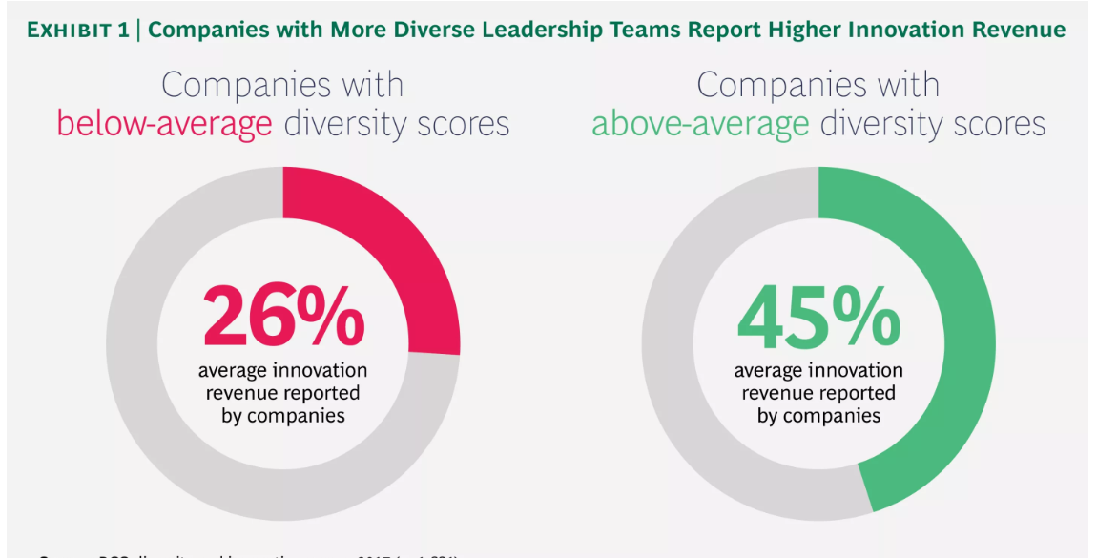
Figure 1: Why diversity is important
(Source: Lorenzo et al., 2018)
A cross-cultural recruitment process enables ASDA to create an organisation that embraces diversity in culture and values, increase employees' engagement and enhance the brands value (Sehgal and Raut, 2025). Also, diversity within the workforce proves to be a strong relationship between that diversity and creating an inclusive staff that can adapt and make decisions in the face of changing customer needs as there is ASDA's diverse customers too (Ellul and Friggieri, 2025). The effect of DEI on dimensions such as operational resilience, sustainability, and an engaged workforce with diverse representation at Project Future, for a workforce to be innovative and adaptable; these are just a few of the results of DEI (Ellul and Friggieri, 2025).

Evaluation of Contemporary HR Practices

Digital HR Systems and Workforce Analytics
ASDA needs to put in place modern digital HR tools based on workforce analytics to improve strategic choices (Service Now, 2025). The discussion in component 1 demonstrated that there is need to have new systems in operation in the organisation and recruit specialist staff to help the organisation implement the technological revolution following demerger from Walmart. The organisation, needs to come up with new operational systems and hire specialist employees that will help implement the technological revolution after the demerger from Walmart. HR information systems now have the ability to track the capacity of a workforce, recruitment indicators, employee productivity and training needs and therefore enable HR managers to preemptively act to address future skills shortages instead of reacting to them (Service Now, 2025).
Workforce analytics also provides evidence for making decisions, including predictions for workforce turnover/absenteeism, workforce learning outcomes, and an intervention plan. Yet, the impact of digital HR systems is reliant on reliable data quality and acceptance and managerial ability to understand analytical insights (Hossain, Ikbal and Rahman, 2025). Without the core digital literacy skills, or if lack of core skills is rectified to invest in training but none of its digital components is, there simply will be all the numbers and there will be all the details but nothing of any strategic significance to the organisations can happen (McKinsey & Company, 2023).

Employer Branding and Strategic Workforce Planning
In today's HR context, employer branding and strategic workforce planning is a good idea for ASDA's high demand for workers who have digital knowledge, project management skills and skills to be a good leader of change, since the company can be categorized into the Service sector (Rahman, 2026). In the HR context of today, it is a good idea to add to ASDA's high requirement of staff having digital knowledge, project management skills, and skills in the aspect of leadership of changes, to be included in the Service sector (John and Hajam, 2024). In Component 1, structured job analysis and person specifications identified and recruitment advertising campaigns to target the correct job seekers for Project Future targeted.
Based on these practices, employer branding provides an opportunity to connect to job-seekers' values, career prospects and willingness to be the first employer to provide and HMG to be the first to adopt, thus differentiating ASDA in an increasingly competitive job market (Koski, 2020). Furthermore, strategic workforce planning helps with recruitment and has a predictive quality as it can be used to anticipate the need for an organisation's workforce based on its goals and objectives rather than simply when a job is available (John and Hajam, 2024). However, without compromising on employee-to-employer prospects, employer branding is not enough to ensure winning in recruiting when there is little career advancement and the culture of the organisation is not uniform (McKinsey & Company, 2023).

Employee Engagement, Inclusive Recruitment and Leadership Development
During transformation, organisations build up their strength by employee engagement strategies, inclusive recruitment processes and leadership development initiatives (Atiku, Naunyango and Oladejo, 2024). Structured, competency and behaviour-based interviews (as requested in Component 1) have been introduced whereby a view of candidate performance is determined against a set of consistent criteria, rather than the subjective view of the interviewer. Newer methods of recruitment - that embrace a wider range of people beyond the traditional outlet – open the door to new talent and help to minimize unconscious bias, which in turn foster innovation and decision-making within an organization (Mahajan, 2024). At the same time, leadership development training helps departmental leaders with the relevant attributes, such as employee changing habits, communication and coaching skills, needed for the continuity of employee motivation during the process of technical transformation. Additional initiatives by teams to engage these staff members by providing continuous development and training, acknowledging achievements through reward schemes and development paths help achieve succession planning (Ingale, 2025).
These practices, however, can only be instituted and maintained with the ongoing oversight and investment of management and organization. They are recruiting into the culture and being inclusive in recruitment isn't sufficient in all cases, or wast a strategy which will work if the leader isn't modelling behaviours for inclusion. Thus, to maintain the sustainability of these 'new' HR practices so they lead to improvements in organisational performance, employee engagement and future-oriented business survivability, ASDA needs to incorporate "accountability" with the leaders for the HR practices, "feedback" from the employees and “measurable” performance indicators (Mahajan, 2024).

Critical Evaluation of Managerial Implementation
Managers within the departments have been responsible for making the strategic objectives into consistent operational measures throughout ASDA's Project Future. With a critical role between the senior leaders and the front-line staff, managers are tasked to make sure digital transformation, talent management and DEI policies become part of the day-to-day business (Solis, 2024). Thus, leaders must hold accountable, ensure good communication and transparency, maintain performance monitoring, foster a collaborative organisational approach and proactively manage challenges to the implementation process (Valtonen and Holopainen, 2025).
Accountability is critical as managers have first-hand touch with employees' commitment towards organization change. As well as contributing to achieving the operational objectives, managers are expected to exhibit desired behaviours; support employee development; and ensure that HR policies are consistently followed by employees (Basu, 2024). Measuring employees' commitment, retention and learning completion and/or diversity results should be added to managers' measurement of Accountability, not financial (Pai, Jaiswal and Jaiswal, 2024). It allows learning to be reinforced of the need for people management as well as business performance for effective change (Pai, Jaiswal and Jaiswal, 2024).
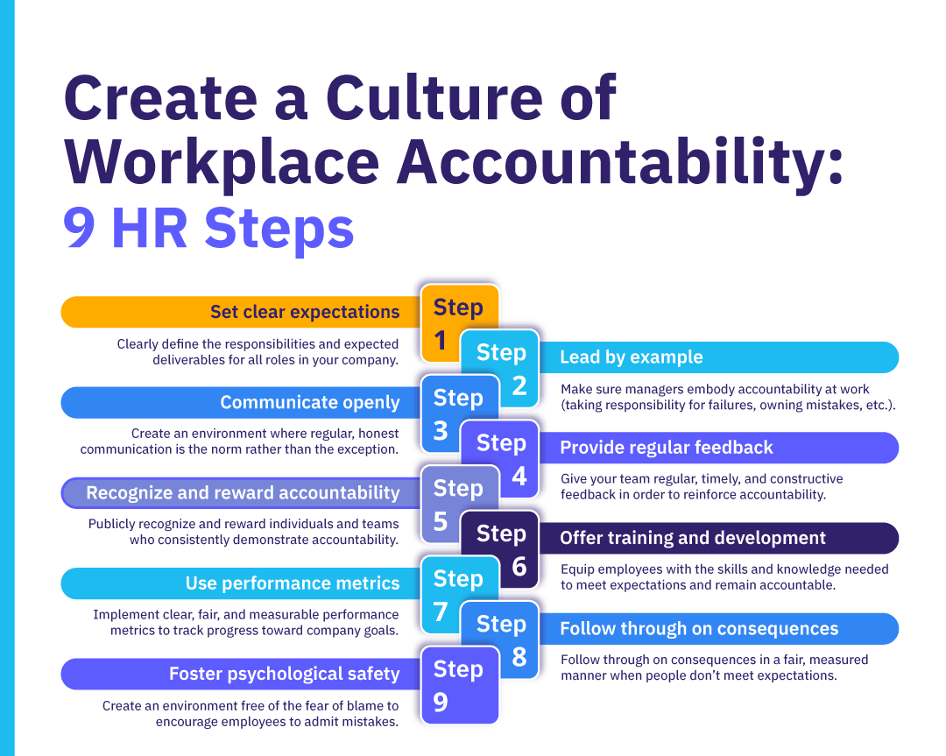
Figure 2: Workplace accountability
(Source: Lombard, 2025)
With technology change comes uncertainty and resistance, which inevitably means there must be effective communication (Lombard, 2025). Try to communicate with employees in an open and clear manner as to what Project Future is, why it is being implemented and what will be gained from it, and encourage associates to be a part of the project by participating in it (Valtonen and Holopainen, 2025). Through regular team meetings, feedback and digital communication, managers can resolve issues in time, reducing the possibility of any misunderstandings and improving staff trust. However, without a reactive response by managers that is meaningful and one which is clearly demonstrated to management, it would be difficult to implement any changes in leadership within the organisation (Saranya et al., 2026).
Managers will be able to gain awareness over time on the effectiveness of working practices used and whether or not they are achieving an agreed success. There are a range of tools that can yield evidence such as workforce analytics, Employee Engagement surveys, retention rate, training completion rate, diversity metrics, etc., that can be beneficial in mapping the need for gaps in implementation, and can provide evidence on time to assist in taking action (Saranya et al., 2026). However, just looking at the numbers can leave out of the equation employee experiences and culture.
Last but not least, organisational culture plays a significant role in determining the successful implementation. The culture of trust, working together, learning together and inclusion should be established by managers to make the employees comfortable with the new technologies and working method (Joseph, 2024). There's also a lack of readiness to change and unease with numbers which is a major constraint, and inconsistent managerial behaviour. Specific leadership development initiatives, ongoing skills development, and employee participation in decision making and the recognition of positive behaviour change can help address these challenges (Hooker, 2025). Departmental managers will be able to ensure that ASDA contemporary HR practices are effectively put in place, holding managers accountable for communicating with, monitoring and reporting back to the HR team, which should lead to improved organisational performance, employee engagement and the successful delivery of Project Future (Hooker, 2025).

Recommendations
Digital Capability: ASDA should further develop the capability of its workforce by providing on-going digital training backed by workforce analytics to capture any skills gaps arising and ensuring their organisation is ready to take advantage of Project Future (Lee and Hammant, 2022).
Talent Management: LLP is closely linked to the employer brand process and the organisation should have a proper course of career development, learning and succession planning to attract quality candidates to the organisation and retaining the employees and increasing the long-term succession planning (Valtonen and Holopainen, 2025).
Managerial Accountability: Departmental managers' effectiveness/substance of their recent performance should be reviewed on an acceptable measure of Employee Engagement, Diversity, Training & Performance that would show compliance with current HR practice, enhance the organisation's culture and facilitate fulfilment of project Future's goals (Lee and Hammant, 2022).

Conclusion
The analysis comprehensively shows that the implementation of Project Future demands that ASDA integrate its people strategy with the technological change by means of integrated HR practices. Implementing digital HR systems, strategic workforce planning, implementing employee engagement programs, and ensuring inclusive recruitment practices all contribute to enhancing organizational capacity. They all need to be led by accountable leaders, communicated consistently, tracked for results and supported by an organisation who values learning, working together and being inclusive.

References
ASDA (2024). Project Future: Driving Asda’s Transformation. [online] Corporate. Available at: https://corporate.asda.com/20240925/project-future-driving-asdas-transformation [Accessed 1 Aug. 2026].
Atiku, S.O., Naunyango, K.A.I. and Oladejo, O.M. (2024). Inclusive leadership and employee engagement as critical drivers of sustainability in telecommunication companies. Administrative sciences, 14(6), pp.126–126.
Basu, R. (2024). The Importance Of HR Policies On Employee Performance, Employee Engagement And Employee Motivation In Various Organizations. Educational Administration: Theory and Practice, 30(5), pp.4272–4279.
CIPD (2026). AI and technology | Factsheets. [online] Available at: https://www.cipd.org/uk/knowledge/factsheets/ai-technology/#ai-and-technology-terms-defined [Accessed 2 Aug. 2026].
Ellul, D.B. and Friggieri, J. (2025). A thriving future through diversity, equity, and inclusion for resilient and innovative communities. IntechOpen eBooks. [online] doi:10.5772/intechopen.1008368.
Hooker, A.M. (2025). The Lived Experiences of Imposter Syndrome Among Women of Color Professors in Higher Education. ScholarWorks.
Hossain, Q., Ikbal, Md.Z. and Rahman, M.M. (2025). A meta data-driven decision support in human capital management: Reviewing HRIS and predictive analytics integration. ASRC Procedia: Global Perspectives in Science and Scholarship, [online] 1(01), pp.215–246. doi:10.63125/xgew7q22.
Ingale, A. (2025). Succession planning and leadership development are important in creating a talent pipeline within human resource management. SSRN Electronic Journal.
John, A.S. and Hajam, A.A. (2024). Leveraging predictive analytics for enhancing employee engagement and optimizing workforce planning: A data-driven HR management approach. International Journal of Innovation in Management, Economics and Social Sciences, 4(4), pp.33–41. doi:10.59615/ijimes.4.4.33.
Joseph, E. (2024). Resilient infrastructure and inclusive culture in the era of remote work. IGI Global, pp.276–299.
Koski, K. (2020). Employer Branding on Social Media – the Impact on Job Seekers’ Behaviour in the 2020s. Theseus.fi. [online] doi: http://www.theseus.fi/handle/10024/870856.
Lee, C. and Hammant, C. (2022). Corporate social and community-oriented support by UK food retailers: a documentary review and typology of actions towards community wellbeing. Perspectives in Public Health, 143(4), p.175791392210953.
Lombard, N. (2025). Accountability in the workplace: Your 9-step guide to creating a culture of accountability. [online] AIHR. Available at: https://www.aihr.com/blog/accountability-in-the-workplace/ [Accessed 2 Aug. 2026].
Lorenzo, R., Voigt, N., Tsusaka, M. and Krentz, M. (2018). How diverse leadership teams boost innovation. [online] BCG Global. Available at: https://www.bcg.com/publications/2018/how-diverse-leadership-teams-boost-innovation [Accessed 2 Aug. 2026].
Mahajan, D. (2024). Leadership decision-making in innovation management.
McKinsey & Company (2023). Diversity matters even more: the case for holistic impact. [online] McKinsey & Company. Available at: https://www.mckinsey.com/featured-insights/diversity-and-inclusion/diversity-matters-even-more-the-case-for-holistic-impact [Accessed 2 Aug. 2026].
Mendonça, L.B. (2024). The Impact of Green Human Resource Management Practices on Environmental and Economic Performance in the UK Retail Sector: The Human Resource Perspective - NORMA@NCI Library. Ncirl.ie. [online] doi: https://norma.ncirl.ie/7706/1/lisabrendamendonca.pdf.
Naoum, R.F., Szakadáti, T. and Balogh, G. (2026). Artificial intelligence (AI) in human resource management (HRM): A systematic review of its dual impact on diversity, equity, and inclusion (DEI). Management Review Quarterly.
Pai, A.S., Jaiswal, S. and Jaiswal, A.K. (2024). A comprehensive review of food safety culture in the food industry: leadership, organizational commitment, and multicultural dynamics. Foods, 13(24), p.4078.
Rahman, M. (2026). Changing nature of HRM practices at work: Exploring the role of e-HRM in creating employer branding in the UK. Journal of Organizational Change Management, pp.1–19. doi:10.1108/jocm-12-2024-0845.
Saranya, S., Antony, N., George, G., Sasikala, K. and Thomas, M.R. (2026). Beyond surveys: a study on metrics and tools in employee engagement analytics. Studies in Systems, Decision and Control, pp.493–503. doi:10.1007/978-3-031-99470-8_51.
Sehgal, A. and Raut, S. (2025). Strategic Collaboration-Boosting Business Success Through Marketing. Improving Business Through Marketing, Cross-Cultural Management, and Public Relations, [online] pp.239–278. doi:10.4018/979-8-3373-1544-7.ch009.
Service Now (2025). AI transformation and the future of work. [online] Available at: https://www.servicenow.com/uk/executive-circle/article/retail-transformation.html [Accessed 2 Aug. 2026].
Sindhu, J. and Bansal, P. (2025). Driving sustainability through diversity, equity, and inclusion: a strategic business imperative. Strategic Blueprint for Viksit Bharat 2047, pp.31–36. doi:10.64171/jsrd.4.s1.31-36.
Solis, V. (2024). Driving Organizational Transformation: Empowering Middle Managers to Prioritize Diversity, Equity, and Inclusion Within the Healthcare Sector. University of Southern California.
Valtonen, A. and Holopainen, M. (2025). Mitigating employee resistance and achieving well-being in digital transformation. Information Technology & People, [online] 38(8), pp.42–72. doi:10.1108/itp-05-2024-0701.
World Economic Forum (2025). Future of Jobs Report 2025: 78 Million New Job Opportunities by 2030 but Urgent Upskilling Needed to Prepare Workforces. [online] World Economic Forum. Available at: https://www.weforum.org/press/2025/01/future-of-jobs-report-2025-78-million-new-job-opportunities-by-2030-but-urgent-upskilling-needed-to-prepare-workforces/ [Accessed 2 Aug. 2026].

