Gweithgareddau Activities

Gweithgaredd 1
Sut mae’r tywydd heddiw? Mae hi’n heulog heddiw.
How is the weather today?

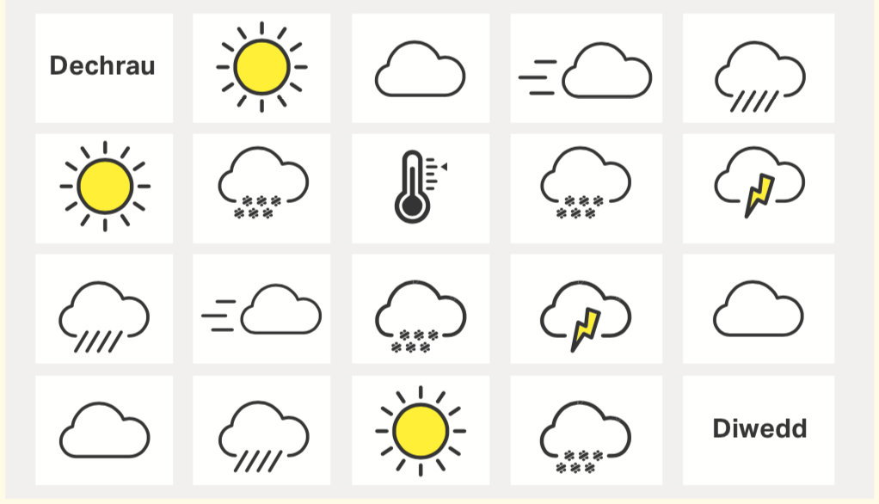

Gweithgredd 2
Meddyliwch am berson rydych chi’n adnabod a llenwch y bylchau.
Think of someone you know and complete the gaps.

Dyma ................... Mae e’n dod o .....................
Mae e’n hoffi.......................... Mae e’n gallu ........................
Mae e’n mynd i ....................... bob penwythnos.

Dyma .................... Mae hi’n dod o .....................
Mae hi’n hoffi ......................... Mae hi’n gallu.......................
Mae hi’n mynd i ...................... bob penwythnos.

Gweithgaredd 3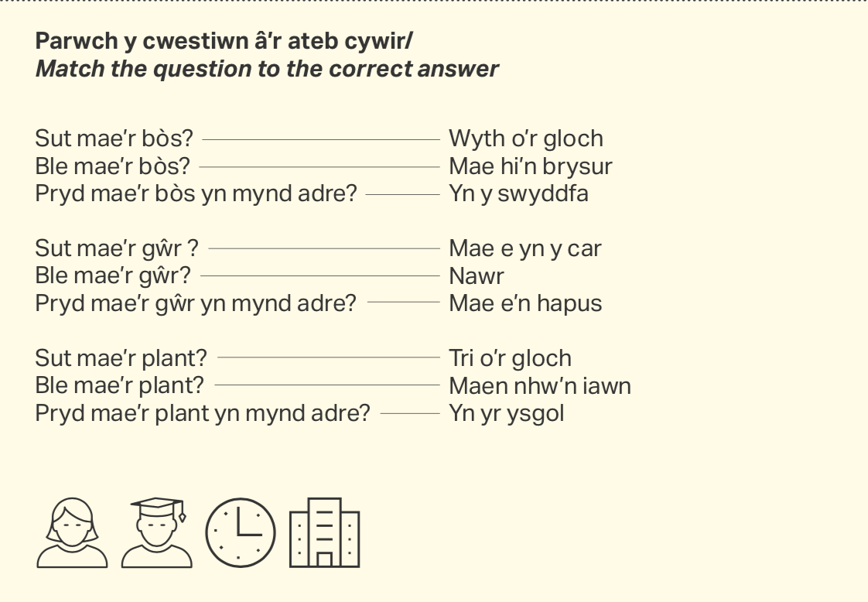

Gweithgaredd 4
Ysgrifennwch y rhifau:
Write the numbers:
38 .......................................... 27...........................................

54 .......................................... 19 ..........................................

61 ......................................... 75 ...........................................

46 ......................................... 83 ............................................

100 ....................................... 92 ...........................................

Gweithgaredd 5
Sut mae’r tywydd yn...
How is the weather in....
- Siberia.....................................................................
- Y Sahara ..................................................................
- De Affrica .................................................................
- Yr Alban ..................................................................
- Yr Amason ..............................................................


Gweithgaredd 6
Disgrifiwch Gareth a’r teulu Jones. Dilynwch y patrwm.
Describe Gareth and the Jones family. Follow the pattern.

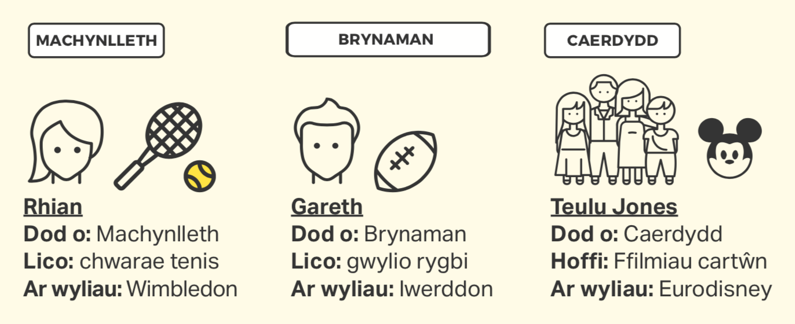

Dyma Rhian. Mae hi’n dod o Fachynlleth yn wreiddiol. Mae hi’n hoffi chwarae tenis. Mae hi’n mynd i Wimbledon ar wyliau.

Dyma Gareth. ........................................................................

.............................................................................................

Dyma’r teulu Jones. ...............................................................

..............................................................................................

Gweithgaredd 5
Sut mae’r tywydd yn...
How is the weather in....
- Siberia.....................................................................
- Y Sahara ..................................................................
- De Affrica .................................................................
- Yr Alban ..................................................................
- Yr Amason ..............................................................

Gweithgaredd

