

Graduate Diploma Professional Police Practice

LEVEL 6 - 40 Credits

Workbook title: Competency Based Workbook 2 (DHEP)

(SOUTH WALES POLICE, GWENT POLICE AND UWTSD)

Learner name: Alexandra NETHELL

Learner’s University Registration Number:
1922442

FACULTY OF BUSINESS AND MANAGEMENT
PUBLIC SERVICE PROGRAMME

Module title: Policing in the Workplace 3 (DHEP) - BMPP6001D

Competency Based Workbook 2 - Learner Workbook

Guidance:

- Your workbook must contain items 1 - 5 below (in the order given).
- You should use the pro-forma to insert your text within each section.
- Note that this module has 2 components with each weighted at 50% of the overall 100% marks total.
- You should upload your completed document as a saved pdf file of this workbook; if this is not possible then a Word Doc file is acceptable. Do not send a scanned file from a photocopier, an apple.dot file, or a Microsoft publisher file as Turnitin will not be able to assess them, despite you being able to upload them.

Contents

Component 1  50% | Area of Professional Practice | Word count
Task 1 | Maintaining Professional  Standards  Leadership and Team-working  Wellbeing and Resilience | 2164/2000
Task 2 | Vulnerability and Risk  Evidence-based policing | 2149/2000
Task 3 | O.C.P | 2000  equivalent
Task 4 | CHOOSE ONLY 1 OF THESE 'ADVANCED LEARNING AREA’ OPTIONS. IT SHOULD BE ONE THAT HAS BEEN AGREED WITH THE FORCE TO STUDY IN YEAR 2. | All options are 2000 words
Task 4  Option 1  Option 2  Option 3  Option 4  Option 5 | Response Policing  Policing Communities  Road Policing  Information and Intelligence  Conducting Investigations | 2135/2000
Task 5 | Personal study/learning plan | 2000
 | Bibliography

Task 1

Relevant areas of the National Policing Curriculum: Understanding the role of a constable, maintaining Professional Standards, Leadership and Team-working, Wellbeing and Resilience

Critically evaluate theories of team dynamics as a means of developing team cohesion (reasons why some teams cannot function, theories and models relating to team dynamics, ways to improve team cohesion) and to what extent group dynamics are shaped by wider organisational cultural norms.

Consider why inter-personal conflict can occur within a team and outline what strategies can be adopted to enhance individual and team performance.

Consider how team dynamics within the police service can result in failing to comply with professional standards requirements demonstrating an understanding of organisational justice in a policing context (Code of Ethics, policies, procedures, protocols, or legislation).

2000 words (+/- 10%: include your actual word count at the end of each section)

ANSWER:

In this essay, I will be analysing the different models of team dynamics. I will be looking at how officers implement team dynamics and how we deal with interpersonal conflict. The areas to be reflected on for this will be in how we maintain professional standards on duty and the leadership role. There will also be incorporation of response policing during the Covid-19 pandemic and its effect on policing and interpersonal dynamics. I will be using Borton’s reflection model to discuss and review incidents as it will help to review what has happened, what was the significance of it and what will I do next time (Borton, 1970). The team dynamic frameworks I will be looking at are the Tuckman Team Model, DiSC, GRIP and the Lencioni Model. I will also include the theories of team roles.

Firstly, what is required for successful team dynamics? TenBoer states that team cohesion is needed for a successful outcome of a project “Team cohesion happens when a team remains united while working to achieve a common goal” (TenBoer, 2021). Team cohesion is needed to allow team dynamic models to function, as everyone needs to work towards a common goal and not focus on the success of themselves. This mentality is essential for success in team dynamics in the police because it focuses on a successful outcome of an incident.

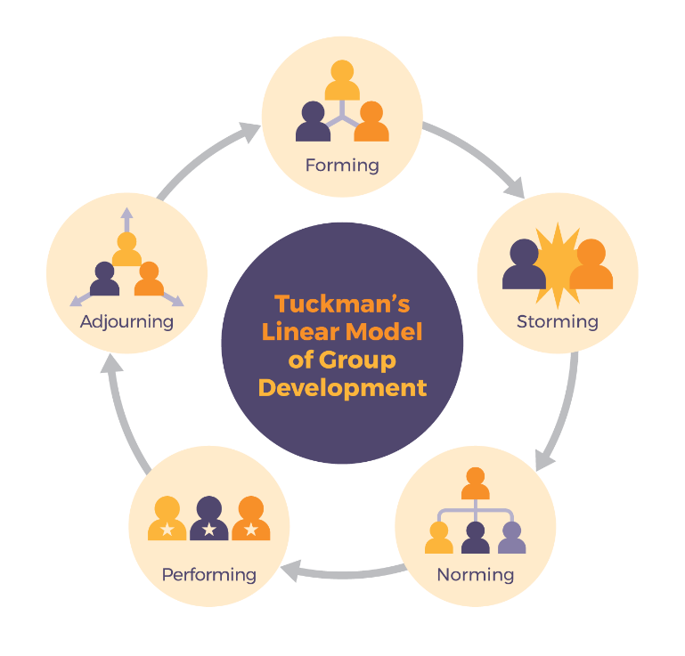
There are various models of team dynamics that can apply to how police officers work with each other. Suzane Last discusses the various methods and one which applies to police team work is the Tuckman Team Model. This highlights 5 points of team work which is forming, storming, norming, performing and adjourning and that individuals are able to go back a step in order to improve the dynamic (Last, 2021). This applies to the police as the forming stage is when new pears are introduced into the group dynamic, new connections are made and expectations are established among everyone. The storming stage is when conflict arises between colleagues and everyone works out their strengths and weaknesses. This applies to probationary police officers as they are new to the job and must work with senior officers with many years of experience who have different methods of dealing with incidents compared to what probationers are taught in training. The norming stage is achieved when colleagues have passed their conflicts and know how to work with each other’s strengths and weaknesses. Performing is achieved after colleagues in a team have reached a collaborative stage with each other and can smoothly work through projects with each other. Finally, the adjourning stage is when team members go their separate ways (West Chester University, 2020).

Figure 1: “Tuckman’s Linear Model of group development”, in Communication for Business Professionals - Canadian Edition [Online]. eCampus Ontario, 2018.

This team dynamic is unconsciously applied in the police. For example, as a probationary police officer I was sent to a different team in a different sector, thus re-setting Tuckman’s model for me as I had to complete the forming stage again. After roughly 6-8 months of forming, I could move onto the storming stage with my colleagues. One example of this is when I attended a domestic incident with a senior officer. At the time, the senior officer knew I was not confident in my communication skills and decided to speak with the victim while I did the updates, as I was better at updating incidents, thus working to my strength. Following on from this, the senior officer helped me improve my communication skills by allowing me to take the lead when speaking with victims which built my confidence in this area. This allowed me to achieve the norming stage. After this, I moved onto the performing stage within a short few months. Myself and my team could go to other incidents and delegate duties out evenly as we all could do them to the standard that is required. The newer stage of the model, adjourning, has also taken place on my team with a senior officer retiring from duty. When he left, he took a lot of police knowledge with him which did affect the team dynamic for a period. However, a new officer was added to the team shortly after and the Tuckman cycle was started again. Therefore, Tuckman’s model is useful in team dynamics and in the police as it is a continuous developing cycle, which requires individuals to communicate with each other and work out their strength and weaknesses to achieve a common goal and successful outcome.

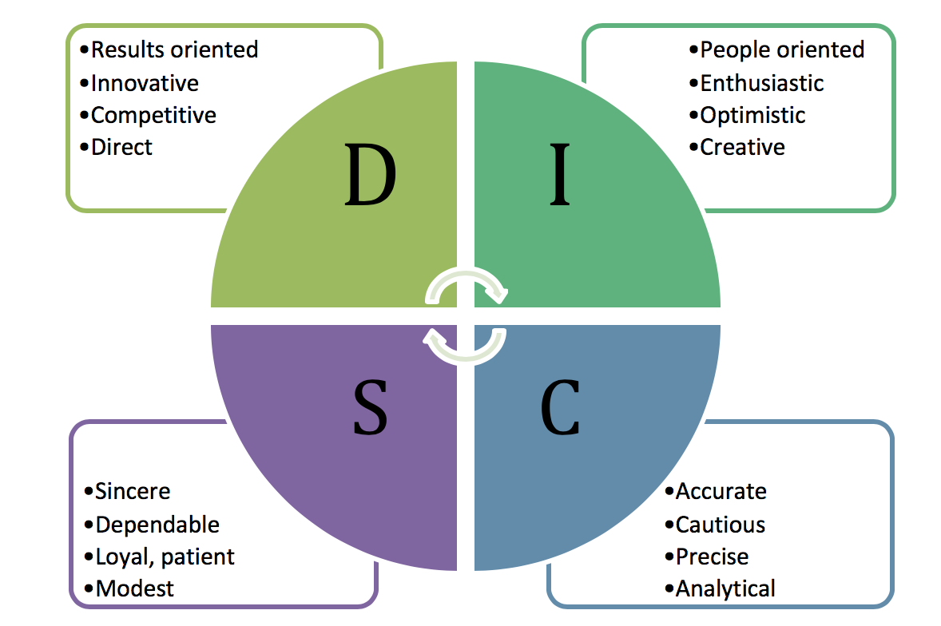
Moving onto the DiSC model, which was founded by William Marston in 1928, this helps with conflict management within the team and works to identify 4 common traits in individuals and how to work with them. These are Dominance, Influence/Inspiring, Steadiness/Supportive and Compliance/Conscientiousness (DiSC Profile, 2022).
Figure 2: DiSC Model, https://pressbooks.bccampus.ca/technicalwriting/chapter/understandingteamdynamics/#footnote-1135-3

The DiSC model allows for individuals to identify their key characteristics and using them as a strength in their place of work and allows the team to see how they can best collaborate with each other (MindTools, 2019). One benefit of identifying and implementing this model to the police team dynamic is that it allows individuals to play to their strengths when dealing with others in the team and incidents. However, using this model on police teams can lead to an imbalance of characteristics and one may find that there are more Dominant and Inspiring individuals on the team, and lacking ones with the Steadiness and Compliance characteristics. Also, another disadvantage of this model in the police team dynamic is that in order to be a competent officer, you need to have all 4 traits and yes, one of these traits may be more pronounced in an individual but officers should be able to adapt to certain incidents. I would also argue that individuals are multifaceted than this DiSC model would identify with more than just one of these 4 points (MindTools, 2019).

Another model that can be applied to the police team dynamic and team cohesion is the GRIP model, developed by Richard Beckhard in 1972 (Last, 2021). While used among sports athletes and sports teams, this model can also be applied to police dynamcis. It involves 4 points which are Goals, Roles, Interpersonal and Processes (Chapman, 2022).

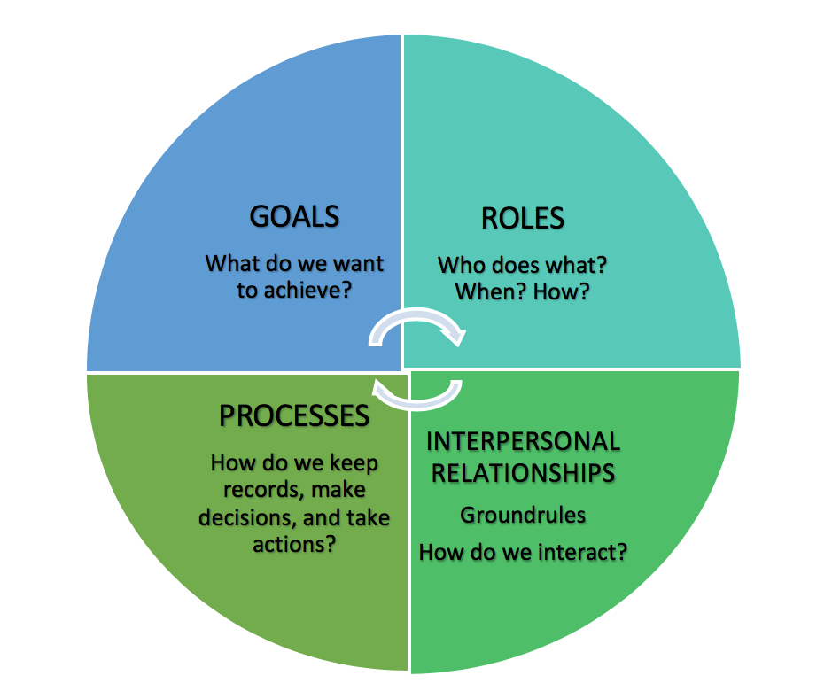
Figure 3: GRIP Model, https://pressbooks.bccampus.ca/technicalwriting/chapter/understandingteamdynamics/#footnote-1135-3
Each of these points requires good communication between the team members and leaders in order to achieve successful outcomes. For example, when I attended a concern call about drugs use with members of the public, I attended with a male colleague. The suspects were known drug users. We established our roles early on, in that he would be the one to communicate with the females identified in using the drugs as I had not had experience in this area of policing. While he interacted with the suspects and explained the reason for our presence, I would be the one to conduct a Stop Search on them under Section 23 Misuses of Drugs Act 1971 (Misuse of Drugs Act, 1971). After the search was conducted and nothing was found, everything was documented on our bodyworn cameras and our electronic pocket notebook. The action we decided to take was simply to give words of advice to the females who had been suspected of using drugs, such as dealing is illegal however if they are struggling with an addiction, they should seek help at DYFODOL and if they were going to inject drugs to use clean needles. They were understanding of officers attendance and were compliant as they had many dealings with police in the past, so they appreciated our calm and composed attitude. By subconsciously using the GRIP model, we were able to achieve the goal of investigating what had taken place. Also, the suspects were treated with dignity and respect and officers were able to achieve a better outcome with the search as a result of calm and effective communication.

Therefore, the GRIP model works better among police team dynamics than the DiSC model as its main function is to establish a team members role and actions within a situation and what outcome they wish to achieve, rather than focusing on an individual’s characteristic. Along with the Tuckman model, both models allow for team cohesion and any interpersonal conflict among the team to be worked on. As noted by Keyton in their group research “An important premise of Bandura’s conceptualization is that behaviours can be taught, learned, and improved. Like all communication behaviours, communication in organizations is socially learned (e.g., mentoring, shadowing, vicarious learning)” (Keyton, et al., 2013). This can be applied to all the models mentioned as it proves individuals attitude in the work place can be adjusted while team cohesion and interpersonal conflict is being established. Many behaviours and attitudes in the police team dynamic are taught through mentoring and hands-on learning.
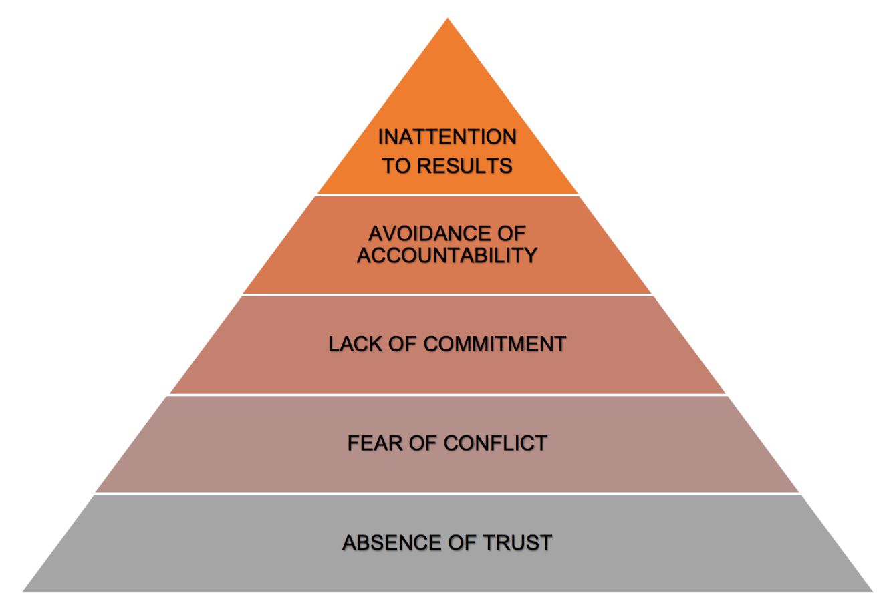
One model that looks at the dysfunction of a team is the Lencioni model. Lencioni in his 2005 research established a triangle of how dysfunction within a team begins and how it culminates into inattention with results (Lencioni, 2005). These 5 points are what affect team dynamics and lead to a break down in the environment people work in. The 5 points are Lack of trust, Fear of conflict, Lack of commitment, Avoidance of accountability and Inattention to results (Last, 2021).
Figure 4: Lecioni's 5 Dysfunctions of a Team, https://pressbooks.bccampus.ca/technicalwriting/chapter/understandingteamdynamics/#footnote-1135-8

It is clear to see from the diagram that interpersonal conflict occurs mainly when there is a lack of trust between colleagues and supervisors. All of these stages lead to an inattention to results, which in the case of police officers, leads to a lack of trust and confidence the public has in the force. An example of where interpersonal conflict has happened in the police force was with the Covid-19 pandemic. Throughout the last 2 year, Covid-19 has played a significant role throughout this time and has significantly changed the way officers have had to strategies and work with the public and the force. The pandemic had such a significant impact on the public’s life and required a higher demand for officers to maintain order, new legislation had to be brought in to enable officers to police the regulations correctly. The Coronovirus Act was established to provide a clear and concise legislation to govern the public’s movements during lockdown, defining who could go where and what care could be provided (Coronvirus Act, 2020).
Stott in his online article, summarises as “police officers were asked to take on a new, and for many unfamiliar, role of public health worker, at the same time as being tasked with enforcing a constantly evolving set of laws and guidelines” (Stott, 2020). This new demand and pressure on a force can cause significant mentality changes and how officers deal with incidents. Bishop notes this “Indeed, police misconduct has been associated with increases in organisational stressors of this kind” (Bishopp, 2016). The added stress and pressure to preform according to force policy and increasing the demand on response officers has indeed proven Lecioni’s model. Kyprianides notes “Especially in trying times, if police officers are to remain committed and loyal to the organisation it is important they identify and agree with organisational goals, mission and values.” (Kyprianides, et al., 2021). This is simply trusting the team and leadership you have, which is relevant with any workplace. However, due to higher demand, stressful work environment and a constant public eye on police forces, it can be difficult to remain committed to organisational goals, when those in a leadership and supervisory role do not support struggling constables, thus leading to Lencioni’s model. This is why officers are reminded of the Code of Ethics, as this guidance will remind officers of their duty and how they are expected to behave professionally as officers are there to serve the public (College of Policing, 2014).
Moving on from the models, I now want to briefly highlight the team roles. Peter Honey’s team role involves 5 different categories: leader, challenger, doer, thinker and supporter (University of Exeter, 2022). These roles can be linked to the DiSC model, however Honey’s roles can be fluid and they interlink with others on the team. This provides a far better team cohesion than the rigid categories of the DiSC model.

To conclude, after looking at the different team dynamic models that can be used in the police force, the Tuckman model is by far the most relevant and the best one when establishing one’s place within the team. Keeping Lencioni’s dysfunction of a team as reminder is also essential for officers of how interpersonal conflict can break down the team dynamics. Honey’s team role is better suited for the police dynamic than the DiSC model as it is more fluid and not as rigid as the structure of DiSC. Also, by using Borton’s reflective model, I have been able to apply my own experience when using these models during incidents and with establishing team dynamics.

WORD COUNT: 2164

Task 2

Relevant areas of the National Policing Curriculum:
Vulnerability and Risk, Evidence-based policing

You must choose a policing incident in which you played a significant role with a victim of crime or anti-social behaviour and reflect on what happened.

Give a brief description of the incident including social and legislative contexts and any relevant cultural, ethnicity and language issues.

Critically evaluate the appropriateness of different approaches (by professionals and the police) in supporting or managing vulnerable people or people at risk of harm.

Explore what works in relation to tackling repeat victimisation and repeat offending. Consider the use of evidence-based policing.

2000 words (+/- 10%: include your actual word count at the end of each section)

ANSWER:

In this essay, I will be discussing an incident I attended in which there was a high factor of vulnerability and risk to the victim and what evidence based policing was used during the investigation. The incident to be discussed was a domestic violence incident which led to a lengthy investigation, with protection measures placed on the victim.
In the Home Office review of Domestic Homicides and Suspected Victim Suicides During the Covid-19 Pandemic 2020-2021, they noted that while a percentage of domestic homicides and suspected victim suicides were known to police officers, there was a higher number of these victims that had been known to partner agencies and other services, such as MARAC, Social Services and mental health teams (Bates, et al., 2021, pp. 77-78). This suggests that there is a hesitancy for victims to report their abusers to police for fear of repercussions. As Jacobson’s research highlights, victims can form what they call a “trauma bond” with their abusers (Jacobson, 2018). This again can make it more difficult for victims to come and report the abusers to police. Therefore, when officers attend calls it is crucial to utilise bodyworn video in order to correctly document the situation and try their best to get a statement. In these situations, we are victim focused, not victim led.
So, what qualifies someone to be a victim? The College of Policing defines a vulnerable person “because of their situation or circumstances, they are unable to take care of or protect themselves, or others, from harm or exploitation” (College of Policing, 2018a). This is the key statement officers must remember when going to any call, as the calls and crime we deal with always include a vulnerable person. This applies mainly to those in situations of domestic violence, county lines and neglect. The National Action Plan from the National Police Chiefs Council provides officers with areas to identify and work with to protect vulnerable people:
“The National Action Plan is aimed at supporting police forces to deliver 7 identified key themes that have specific actions:
- Early Intervention and Prevention
- Protecting, Supporting, Safeguarding and Managing Risk
- Information, Intelligence, Data Collection and Management Information
- Effective Investigation and Outcomes
- Leadership
- Learning and Development
- Communications”
(College of Policing, 2018b)
The plan also provides what they call the “overarching principles”:
- Recognising and responding to vulnerability requires partners to work together effectively
- The concept of vulnerability encompasses the person and their circumstances
- Responding to vulnerability includes empowering people to seek their own support networks
- Prioritising prevention reduces harm and demand
- To be better at recognising and responding to vulnerability requires a change in culture within and across service providers
(College of Policing, 2018b)
Using these guides, officers can correctly take positive action for those who have been in vulnerable situations.
For early intervention, I attended a call in which a victim had called about a situation of domestic violence with their partner. This was not the first call the victim had made to police regarding their partner about domestic violence and I knew from attending previous calls that after the victim had called police, they were reluctant or would not engage at all when officers arrived. The victim was a very difficult person to engage with each time when they were by themselves and away from their partner.
When myself and a male police officer arrived, I went and spoke to the victim who had fled to a neighbour’s house after making this call. My colleague spoke with the home owners as they were witnesses. I informed the victim that we would be using bodycamera as this was a domestic violence incident and disclosures needed to be recorded. Instantly, the victim went silent and said they did not want to talk about it and were leaving. My colleague came in and tried to sway them, again explaining the necessity for the discussion with bodycamera. The victim was not engaging and walked off. I followed and had a discussion with the victim and eventually convinced them to provide a statement, given the level of domestic assault that had taken place. The victim had disclosed that they had been punched to the face and they had suffered a mild bruise to the cheek. The early intervention here would be me choosing to follow the victim to get a statement to place safeguarding measures for them.
In Schaap’s discussion Police trust-building strategies. A socio-institutional, comparative approach, they mention that “What they also shared was that efforts were pushed by specific policy or professional actors who were reasoning from particular ‘rationalised myths’ about how good, legitimate, trustworthy police work should look.” (Schaap, 2021, p. 319) how different forces used their policies to highlight the positive side of engaging with officers and how it would greatly help victims. By explaining force policy and the law to victims, we can engage and communicate better with them and they understand why we have early intervention and prevention.
How I went about protecting the victim was firstly by arresting the suspect for domestic assault. South Wales Police policy is to safe guard victims of domestic violence and to take positive action. I judged the arrest t be necessary due the victim and suspect living in the same house and that the victim did not have any of their belongings or house and car keys, when they snuck out. Once the suspect was arrested, they were taken to custody and processed. I stayed and dealt with the victim by giving supporting words for their actions in disclosing the assaults to police. The next step was to obtain a positive statement from the victim which would support their case and arrest of the suspect.
One way I ensured future safeguarding and managing risk for the victim was to include in the statement that they wanted to apply for a restraining order against the suspect, which would then be considered by the Crown Prosecution Service when the file went to them for review. By offering the victim a restraining order, it ensured future safeguarding for them and would lessen the demand on police if one was granted. This is proven by Kothari’s research on domestic violence calls in the USA. Once protection orders were put in place for the victims, the number of calls for police from the victims drastically dropped and victims has more confidence when engaging with the police (Kothari, et al., 2012, pp. 2852-2862). This demonstrates the positive outcome safeguarding provides for victims and while this research is based in the USA, it can be applied to the UK and safeguarding for victims here.
Another way to ensure safeguarding is that officers must submit a Public Protection Notification for all domestic violence incidents we go to. In my officer’s observations, I deemed the victim high risk and requested contact be made by our Domestic Violence Unit for further support. I also advised that the victim was open to support from other agencies which they would qualify for. A Victim Referral Form was also created for the victim to have support from other police agencies. I also gave the victim a referral card for the Live Fear Free Line, which helps with Stalking, Harassment and Violence Against Women in Wales. These collaborating safeguarding agencies would be able to support the victim further with any emotional or psychological trauma the victim had gone though. This would then leave time for officers to conduct a thorough investigation and collect any evidence for the investigation. This would lead to the multi-agency support unit being notified.
I also offered Claire’s Law to the victim and explained that as they were in a domestic violence relationship, they could apply for it and see the previous history, if there was any, on the suspect. I explained the process to them and that officers would be in contact regarding the information but they would not be allowed to tell anyone else the information due to data protection (Home Office, 2021).
For the investigation, information and intelligence were gathered from previous occurrences reported to officers and warning markers/PNC reports the suspect had on them, which was for previous domestic violence offences. By researching the history and warning markers for the suspect, and seeing the information and intelligence available on him, I could assess the situation to greater degree. Innes discusses in their paper that effective engagement helps build the “gut feeling” officers have with “Everything the patrol officer does in this mode is ‘‘enculturated’’/that is, attuned to, working with and creating understandings inflected by experience, constructive interpretation of constrained information and the relevance criteria laid down by current understandings of the police mission in that locale” (Innes, 2016, p. 139).
By obtaining a statement and having bodyworn of the disclosure, I could prepare for the interview effectively and be made aware of all the evidence presented to me. The suspect had a no comment interview and then a case file had to be compiled for Crown Service Prosecutions for a decision to be made.
As the victim withdraw their statement, the Crown Service Prosecutions decided to deem the case with no further action. This was due to evidential difficulties due to the injury amounting to common assault and the victim withdrawing their statement. (Crown Service Prosecutions, 2021). Despite this decision, early police intervention in this matter helped the victim to leave the suspect as they finally saw what the relationship was like.
The victim of this incident clearly did not want to speak to any male police officer and my experience from 2 previous calls with the victim and looking at the calls the victim had made in the past, there was a pattern of them shutting down and avoiding officers after making calls. As stated previously, officers informed the victim that they would be recorded on bodyworn video, which they were not comfortable with and walked off. I decided to take the lead and follow the victim on their brief walk, to which I started to communicate with them and got them to stop and begin to engage with me again. They requested that I not have the camera on them and so I moved my bodycam to the other side of my vest and informed the victim it was still recorded but they were content with that. Eventually after discussing what had happened to the victim, I could get them to provide a statement. Again, using the National Decision Model (College of Policing, 2013) to reassess the situation, I decided it was best for me to take the lead with dealing with the victim.
From this incident, I have learned that early engagement is crucial, especially with incident like domestic violence. If I was to develop with this moving forward, it would be to recognise when to offer Claire’s Law, and implement it earlier when there are signs of domestic violence in calls I attend. Development between agencies is also crucial, such as Notko highlights in their paper that officers need to fully understand the domestic violence incident to effectively offer the correct safeguarding and support the victim needs (Notko, et al., 2021, p. 7). Communication is key to any incident and it is only through engagement and effective communication with the people we deal with that we can achieve a positive outcome. Reflecting on this incident, I would say the use of multi-agency approach was the most useful form of safeguarding for the victim.
To support vulnerable people in these domestic violence situations, the police collaborate with different agencies. One’s such as Women’s Aid and MARAC offer a safe space for victims of domestic violence to engage and communicate their experiences and current issues. In Salter’s paper, he discusses the establishment of MARAC in Cardiff and the collaboration between police, domestic violence units, social services, child services, housing and health. He notes that the success of this collaboration between agencies meant it was adopted by other forces and was at the time being adopted by the New South Wales police force in Australia (Salter, 2014, p. 8). Being able to reflect on previous years, MARAC’s involvement with victims has proven that the multi-agency approach does work to safeguard them (if the victims are willing to listen and engage). There may be difficulty with some victims of domestic violence due to a trauma bond, as Jacobson discusses in their research (Jacobson, 2018). However, through multi-agency intervention, the police are able to offer some for of support, safeguarding and reprieve from the domestic violence victims experience.
To conclude this essay, by using the 7 key points stated above, officers are able to effectively assess high risk situations and the vulnerability of individuals in them. As Innes states “Everything done in this mode is consistent with qualitative research” (Innes, 2016, p. 139). That experience on the beat and engaging with communities helps to build rapport but also it improves an officers skills in how they communicate with different people. It develops our “gut feeling” of when something is wrong with situations we attend and like the incident above, pursuing the victim to simply have a discussion with them helped to progress this matter further and for the victim to finally leave the suspect, even though the decision by Crown Service Prosecutions was to have no further action. Managing vulnerability with the people we deal with also requires officers to engage with other partner agencies, but also they need to inform police forces of any concerns they have when dealing with vulnerable people too. MARAC has played a significant role in how the police collaborate with other agencies to help victims of domestic abuse.

WORD COUNT: 2149

Task 3
Recognition and confirmation of progress on the Occupational Competency Portfolio (OCP).

By signing the section below, you are acknowledging your continuing progress on O.C.P.
This is recognised by the university as work that is fully supporting this module BMPP 6001D; Policing in the Workplace 3 and in signing it will be equivalent to 2000 words.

Confirmation of the progress on the Occupational Competency Portfolio (OCP).

I confirm that I am progressing with the Occupational Competency Portfolio (OCP) in accordance to the regulations.

Signed: Alexandra Nethell (Learner – electronic signature accepted.)

Date: 25/01/2022

Task 4

This is a reminder that this TASK 4 section is an opportunity for you to answer one question which should be relevant to the “advanced learning” area that you have chosen. The advanced learning lecture that you choose to attend will assist you in answering this task.

Choose 1 of these 5 options to answer

(Note for officers who have an interest in becoming a detective and wish to specialise in this role, you MUST choose option 5)

  - Response Policing.
  - Policing Communities.
  - Road Policing.
  - Information and Intelligence.
  - Conducting Investigations.

TASK 4 Option 3

Relevant areas of the National Policing Curriculum:

Road Policing

You should choose a serious collision that you have been involved in that was of a complex nature, in which you played a significant role in providing a response.

Task 4 Option 3:

Critically evaluate the evidence base for dealing with serious roads incidents and strategies that could be implemented to reduce the likelihood of it reoccurring.

2000 words (+/- 10%: include your actual word count at the end of each section)

Answer:

In this essay, I will discuss Roads Policing and I will be critically evaluating evidence based policing for dealing with road incidents and what strategies have been used to minimise risk and improve road safety for drivers, passengers and pedestrians. I will specifically be looking at an incident I attended in which an intoxicated driver had two passengers in their vehicle and the collision had caused a serious incident. There will also be a discussion on drink/drug driving and young adults’ involvement in this.

To begin, the College of Policing defines a roads policing officers as “the roads policing constable prevents loss of life and injury on the roads by preventing, investigating and prosecuting offences through intelligence led policing” (College of Policing, 2022). A police constable’s role in response also incorporates this and at some point, response constables must attend and deal with a road traffic collision.

Road Safety Wales publish statists for road traffic collisions in Wales and what percentages were fatal, seriously injured or slightly injured:
“In 2020, police forces in Wales recorded a total of 2,864 road accidents involving personal injury, which resulted in 3,692 casualties. 22% of the reported road accidents resulted in at least one KSI casualty.
- Of these, 72 people were killed (2%), 747 were seriously injured (20 %) and 2,873 were slightly injured (78%)
- Males were more likely than females to be casualties, accounting for 62% of all casualties and 72% of all people killed or seriously injured in Wales in 2020.”
(Road Safety Wales, 2021)
It must be noted that the information compiled for this period was conducted during 2020, when the pandemic and lockdown were in effect. There was a lengthy period where there were fewer vehicles on the road compared to the previous year, and thus less collisions had occurred. However, these statistics are specifically for Wales which is relevant to my discussion, compared to the statistic provided by the Home Office, which compares data from both England and Wales.
Collisions usually involve a vehicle of some kind, which Blackstone’s define as “a mechanically propelled vehicle, or anything (whether or not it is a vehicle) that has been, but has ceased to be, a mechanically propelled vehicle” (Professor Bryant & Bryant, 2020, p. 424). This definition is key in identifying the different types of road vehicles the public use and whatever offence it applies to. In Blackstone’s handbook, it provides 4 categories of collisions, those being:

- Damage only
- Non-Reportable Damage Only (NRDO)
- Person Injured (PI)
- Killed or Seriously Injured (KSI)
(Professor Bryant & Bryant, 2020, p. 460)

The incident I attended was referred to as a KSI - Killed or Seriously Injured. Myself and my colleague were the first on scene from the police force. Ambulance and Fire service were already attending to the injured. Given the situation, I implemented the National Decision Model (College of Policing, 2013), ACE-CARD (Professor Bryant & Bryant, 2020, p. 462) and CLEAR keep traffic moving (College of Policing, 2015).
On arrival at the scene, ambulance and fire service were already in attendance and the road had been closed off. A small vehicle had gone off road and become wedged between a high wall and an electric pole. The pole had become dislodged, but was kept in place due to the positioning of the car. There were live electric cables on the road that had come off the pole. There were also witnesses and many bystanders around the scene. Officers needed to establish who was in the vehicle, who had been injured and who the driver was. Three people were involved in the collision and were from the vehicle that was wedged. One passenger and the driver suffered mild injuries, while the front seat passenger was in a life-threatening situation.

Assessing the situation, it was determined that traffic officers were needed as the road traffic collision had resulted in life threatening and life changing injuries for the three people who had been involved in the RTC. The vehicle had dislodged the pole from the pavement, but due the vehicle being wedges between the wall and pole, the vehicles placement was holding the electric pole in place. The electric cables had come loose and were live on the ground; it was also heavily raining that day.

The main risk here was the threat to life for the three-people involved in the RTC. Ambulance crew were working on them and the risk, and there was also risk with the witnesses who were out to see what had happened. Officers had to keep the area clear and safe from the cables, while also preserving the scene in the rain.

The main power and policy to consider here was to arrest the driver after they had been treated for the injury. They were to be arrested under the Road Traffic Act 1988 for Section 2 Dangerous Driving and Section 5 Driving Under the Influence (Road Traffic Act, 1988). Officers would have to wait to see if the driver would have to be arrested for Section 1 Death by Dangerous Driving due to one passenger being in critical condition and needed to be transported immediately.

Here, the CLEAR keep traffic moving (College of Policing, 2015) where we had highway, vehicle recovery, police, fire and rescue and ambulance all working together to save life and limb, preserve the scene for the necessary amount of time, repair what could be repaired and then re-open the road when it was safe to do so. Western power was also contacted to turn the power off to the pole to reduce the risk of electrocution due to the live wire and weather conditions.

Another review of the scene suggested that the road would have to remain closed until the vehicle could be removed safely and the electric pole would have to be taken down and replaced with a new one.

Using the ACE-CARD method of Approach, Caution, Examine, Casualties, Ambulance (Fire & Rescue and other services), Remove, Detailed (investigation), (Professor Bryant & Bryant, 2020, p. 462) officers could conduct a very efficient investigation in the limited time they had while they were there. While the situation was very stressful, especially with limited number of police officers who could attend the scene, by using ACE-CARD and the National Decision model, officers could prioritise the incident as efficiently as possible. These method and collaborations between services greatly helped in conducting and efficient evidence based policing of the scene and would be necessary for when the SIO arrived to take over.

It was then necessary to breathalyse the driver on scene, as per Section 5 of the Road Traffic Act 1988 (Road Traffic Act, 1988). The driver blew over the limit of 35. A drug swab was also taken and the driver tested positive for cocaine. The driver admitted to driving under the influence to officers. This positive result and admission was crucial for the evidence based aspect of the investigation, as officers had clear evidence of drugs in the driver system from the scene and the driver’s admission on bodyworn camera. As the driver was also injured, they were to be taken to hospital and treated. Here, to act and follow traffic law, an officer had to accompany the driver as they were to be detained after they had been deemed fit to leave by a doctor.

This reminded me of Dalton’s paper in which they discuss with a group of young adults their awareness of the law surrounding drink and drug driving and the consequences that come with it. The focus group are aware that drink driving is a very serious offence which can cause life altering consequences for them. However, when asked about driving under the influence of cannabis, they were aware that more people in their age group (17-24 years old) where driving while under the influence of a drug, suggesting that the perception of driving while under the influence of cannabis is more acceptable than drink driving (Danto, et al., 2003, pp. 50-60). This study was conducted in 2003, when driving under the influence of cannabis had not been implemented under Section 5A (until 2015), however it is still a relevant discussion today. Many young adults believe there is less of a stigma driving while under the influence of drugs than drink driving. However, the Department for transport provides statistics on KSI (specifically drivers killed while under the influence of drugs and alcohol), and it shows the latest year, being 2018, there were 235 drivers killed while under the influence of drugs compared to 200 while under the influence of alcohol (Department for Transport, 2021). At this time, there is very little research on young adults’ attitudes and perception towards drink driving. Therefore, it is difficult to confirm from an academic research point of view this is how young adults perceive their actions if they were to drive while under the influence of drink/drugs. However, by policing incidents such as the above, there is a disregard for driving under the influence of drugs and the consequences that follow, compared to drink driving. With the incident above, it is clear that these young offenders see no issue with driving under the influence of alcohol or drugs.

Moving on from the drug offence, as this collision resulted in a KSI, the injured party had to be rushed to the nearest hospital that could treat their injuries; this being the Heath in Cardiff. The hospital was quite a distance away and time was key here for the KSI passenger. In Partheeban research, they suggested that “medical facilities should be made available to the accident victim by providing medical centres on highways at regular intervals” (Partheeban , et al., 2008, p. 6). While Partheeban’s research is based on RTCs in Chenai, India, this can be applied in Wales. As discussed above, while the number of RTCs and KSI’s had decreased between the period of 2020-2021 in Wales, this was due to lockdown. Now that Wales has come out of lockdown and there is more traffic on the roads there will be a noticeable increase of RTC’s on the road. The Home Office has already seen a 10% increase of traffic on the road for England and Wales between January to June 2021, compared to the previous year (Department for Transport, 2021). Having regular medical check points along major roads would help to decrease the waiting time for medical treatment by the ambulance service.

As a result of driving under the influence and casualties involved, one strategy the government has done is to change the Highway Code (Highway Code, 2022). This is in relation to cyclists, pedestrian and equestrians, which places them as a priority when using the road or highway. However, this change only came into effect at the end of January 2022 and it is too soon to tell the impact this has had, either positive or negative, on road safety. Highlighting this change however, demonstrates that collaborations between the police, government and aiding services to collate data and analyse RTC incidents does bring about change for road safety. This is one example of where evidence based policing working with partner agencies to share statistics has helped to implement change with the law. The number of road cyclists have greatly increased in recent years and so have road related deaths with them. The statistics from the Department for Transport reported that in 2020, there were 141 cyclist deaths in relation to collision with vehicles. This had increased from 2019, in which the number was 100. Interestingly, there is a higher percentage of male cyclist who were KSI, with it being 83% (Department for Transport, 2021). However, the percentage is higher as there are more male cyclists on the road than there are female, when we consider recreational and work related cycling.
Another strategy to be used on road safety is to educate on driving under the influence and the consequences it entails. The THINK! Campaign is one resource freely available for road users. On their website, they note that “Male drivers aged 17-24 are over-represented in drink drive related road casualties. They’re also less likely than the wider population to perceive drink driving as risky or unacceptable” (Department for Transport, 2021). This demonstrates a psychological attitude towards driving under the influence and that young adults, especially male, do not seem to manage risk as well as one would expect. A strategy South Wales Police traffic run is a drink drive awareness time, in which officers run a campaign to bring awareness to the dangers of drunk driving and the impact it has on victims’ families.
To conclude, when officers attend road traffic collisions, they should immediately implement the National Decision Model and ACE-CARD to assess the scene and deal with victims, suspects and witnesses effectively. There is a clear need for officers to investigate collisions correctly and then share the results with partner agencies and local governments to help improve statistics and implement road safety changes, such as the recent changes to the Highway Code. Driving under the influence is a big issue, especially among young adult males. There is still an attitude “yes, I was high but at least I wasn’t drunk”, suggesting that young adults view drink driving worse than driving while under the influence of drugs such as cannabis.

WORD COUNT: 2135

Task 5

Personal Study programme / Individual Learning Plan

The first learning outcome identified in the accompanying module descriptor (BMPP 6001D) asks that you formulate and implement a personal study programme to further enhance the development of your professional police practice. A template has been added for an ‘Individual Learning Plan’ that you can use for this task.

This task differs from the PDP that you have completed in your previous workbook in that this learning plan allows you to assess what level you believe you are in key knowledge, skills, and experience against where you believe you (and the force) consider you should be – now and in the coming 6 to 12 months of your placement. This should then be used to target future development need.

2000 words equivalent. Please note that this is not the actual number of words used in completing the table, the count reflects the thought and research behind it.

ANSWER:

Knowledge, Skills and Experience Assessment

 | REQUIRED |  |  | RATING |  |  | DEVELOPMENT NEED
KNOWLEDGE | Low  1-4 | Med  5-7 | High  8-10 | Low  1-4 | Med  5-7 | High  8-10 | At this time and in the next coming months, I would say the required knowledge is between 8-10, as I am now coming to the end of my second year.  My currently rate myself at a 6/7 in knowledge, as I am still uncertain on how to handle new situations I go to. However, I am confident in them when I go to calls. One hindrance has been having my Hub attachment cancelled and scheduled at a later date. I have not had the opportunity to learn how to make case files properly and therefore my knowledge in this area is lacking. I improving this by asking other team members for help when I have case files and phoning the Hub when I need further assistance, until I am able to do my attachment.
SKILLS | Low  1-4 | Med  5-7 | High  8-10 | Low  1-4 | Med  5-7 | High  8-10 | I would say the force expects us to be at 7-10 now, when it comes to skill and applying them to response calls.  I feel my skills, such as communication and engagement with people is at this level that response requires, between 7-8, as I am attending a lot of calls. I have also benefitted from the team I have been on since being placed in Neath. My team are full of seasoned officers who have also had the experience of working on different departments in their time. I have learnt a lot from them and my skills when dealing with calls have greatly improved by learning from them.
EXPERIENCE | Low  1-4 | Med  5-7 | High  8-10 | Low  1-4 | Med  5-7 | High  8-10 | I believe the force requires our experience to be between 5-7, as we are still only a year and half through our probationary period.  I feel that my experience is at the top end, at a 7 and I am confident when dealing with most calls as I have experienced a lot in my short time on response.  I have been tasked with things that not many people do on response, such as a Superintendents Bail Application. I was also lucky on my CID attachment to witness an investigation into 2 counts of knife point robbery, and be able to witness the investigation, interview and charging decision for it. This experience really helped to improve my investigation skills and I have taken what I have learned from it and implemented it on response.

Bibliography
The bibliography should only include sources referenced within the workbook using the Harvard referencing system. Information about referencing in written assignments and how to avoid plagiarism can be found on Moodle. It is important that you are aware of the importance of ensuring that the work submitted is your original work.

Bibliography
Adlam, R., 1998. Developing ethics education for police leaders and managers: action research and critical reflection for curriculum and personal development. Educational Action Research, 6(1), pp. 131-151.

Bates, L., Hoeger, K., Stoneman, M.-J. & Whitaker, A., 2021. Domestic Homicides and Suspected Victim Suicides During the Covid-19 Pandemic 2020-2021. [Online]
Available at: https://assets.publishing.service.gov.uk/government/uploads/system/uploads/attachment_data/file/1013128/Domestic_homicides_and_suspected_victim_suicides_during_the_Covid-19_Pandemic_2020-2021.pdf
[Accessed 15 Jan 2022].

Bishopp, S. W. J. &. P. N., 2016. General strain and police misconduct: the role of organizational influence.. Policing: An International Journal, 39(4), pp. 635-651.

Borton, T., 1970. Reach, Touch and Teach. London: Hutchinson.
Chapman, A., 2022. What is the GRPI Model?. [Online]
Available at: https://www.businessballs.com/leading-teams/the-grpi-model/
[Accessed 4 April 2022].

College of Policing, 2013. National Decision Model. [Online]
Available at: https://www.app.college.police.uk/app-content/national-decision-model/the-national-decision-model/
[Accessed 15 January 2022].

College of Policing, 2014. Code of Ethics. [Online]
Available at: https://assets.college.police.uk/s3fs-public/2021-02/code_of_ethics.pdf
[Accessed 15 January 2022].

College of Policing, 2015. CLEAR keeping traffic moving. [Online]
Available at: https://library.college.police.uk/docs/APPREF/CLEAR-Leaflet-April-2015.pdf
[Accessed 20 January 2022].

College of Policing, 2018a. Evaluation of vulnerability training for frontline police officers and staff. [Online]
Available at: https://whatworks.college.police.uk/Research/Documents/Vulnerability_training_eval.pdf
[Accessed 15 January 2020].
College of Policing, 2018b. National Vulnerability Action Plan 2018-2021. [Online]
Available at: https://www.npcc.police.uk/documents/crime/2018/National%20Vulnerability%20Action%20Plan_18_21.pdf
[Accessed 15 January 2022].

College of Policing, 2020. Understanding the Law. [Online]
Available at: https://www.college.police.uk/guidance/covid-19/understanding-law
[Accessed 15 January 2022].

College of Policing, 2022. Roads Policing Constable. [Online]
Available at: The Roads Policing Constable prevents loss of life and injury on the roads by preventing, investigating and prosecuting offences through intelligence led policing.
[Accessed 20 January 2022].

Coronvirus Act (2020).
Crown Service Prosecutions, 2021. How we make a decision on what to do in your case. [Online]
Available at: https://www.cps.gov.uk/rasso-guide/how-we-make-decision-what-do-your-case-0
[Accessed 15 January 2022].

Danto, K., Misselke, L., Bacon, R. & Done, J., 2003. Attitudes of young people toward driving after smoking cannabis or after drinking alcohol. Health Education Journal, 62(1), pp. 50-60.

Department for Transport, 2021. Developing drug driving statistics: initial feasibility study. [Online]
Available at: https://www.gov.uk/government/statistics/developing-drug-driving-statistics/developing-drug-driving-statistics-initial-feasibility-study
[Accessed 05 March 2022].

Department for Transport, 2021. Pint Block 2021. [Online]
Available at: https://www.think.gov.uk/campaign/pintblock2021/
[Accessed 05 March 2022].

Department for Transport, 2021. Reported road casualties in Great Britain, provisional estimates: year ending June 2021. [Online]
Available at: https://www.gov.uk/government/statistics/reported-road-casualties-in-great-britain-provisional-estimates-year-ending-june-2021/reported-road-casualties-in-great-britain-provisional-estimates-year-ending-june-2021
[Accessed 05 March 2022].

Department for Transport, 2021. Reported road casualties in Great Britain: pedal cycle factsheet, 2020. [Online]
Available at: https://www.gov.uk/government/statistics/reported-road-casualties-great-britain-pedal-cyclist-factsheet-2020/reported-road-casualties-in-great-britain-pedal-cycle-factsheet-2020
[Accessed 10 March 2022].
DiSC Profile, 2022. History of DiSC. [Online]
Available at: https://www.discprofile.com/what-is-disc/history-of-disc
[Accessed 4 April 2022].

Highway Code, 2022. Home Office. [Online]
Available at: https://www.gov.uk/government/news/the-highway-code-8-changes-you-need-to-know-from-29-january-2022
[Accessed 20 January 2022].

Home Office, 2021. Domestic Violence Disclosure Scheme factsheet. [Online]
Available at: https://www.gov.uk/government/publications/domestic-abuse-bill-2020-factsheets/domestic-violence-disclosure-scheme-factsheet
[Accessed 15 January 2022].

Innes, N. &. F. M., 2016. Reassurance Policing, Community Policing and Measuring Police Performance. Policing & Society, 16(2).

Jacobson, S., 2018. What is Trauma Bonding? Is It Keeping You In a Bad Relationship?. [Online]
Available at: https://www.harleytherapy.co.uk/counselling/what-is-trauma-bonding.htm
[Accessed 2022 February 2022].

Keyton, J. et al., 2013. Investigating Verbal Workplace Communication Behaviors. Journal of Business Communication, 50(2), p. 152–169.

Kothari, C. et al., 2012. Protection Orders Protect Against Assault and Injury: A Longitudinal Study of Police-Involved Women Victims of Intimate Partner Violence. Journal of Interpersonal Violence, 27(14), pp. 2845-2868.

Kyprianides, A. et al., 2021. Policing the COVID-19 pandemic: police officer well-being and commitment to democratic modes of policing. Policing and Society, pp. 1-18.

Last, S., 2021. Technical Writing Essentials. [Online]
Available at: https://pressbooks.bccampus.ca/technicalwriting/chapter/understandingteamdynamics/
[Accessed 4 April 2022].

Lencioni, P., 2005. Five Dysfunctions of a Team. New York: John Wiley and Sons Inc.

MindTools, 2019. Understanding People's Personal Styles. [Online]
Available at: https://www.mindtools.com/pages/article/newCDV_92.htm
[Accessed 4 April 2022].

Misuse of Drugs Act, 1971. Misuse of Drugs Act. [Online]
Available at: https://www.legislation.gov.uk/ukpga/1971/38/section/23
[Accessed 5 April 2022].

Newton, T., 1998. The place of ethics in investigative interviewing by police officers. The Howard Journal, Volume 1, pp. 52-69.

Notko, M. et al., 2021. Intervening in domestic violence: interprofessional collaboration among social and health care professionals and the police. Journal of Interprofessional Care, pp. 1-9.

Partheeban , P., Arunbabu, E. & Hemamalini, R. R., 2008. Road accident cost prediction model using systems dynamics approach. Transport, 23(1), pp. 55-66.

Professor Bryant, R. & Bryant, S. eds., 2020. Blackstone's Handbook for Policing Students. 14 ed. Oxford: Oxfrod University Press.

Road Safety Wales, 2021. Reported Road Casualties Wales, 2020. [Online]
Available at: https://gov.wales/sites/default/files/statistics-and-research/2021-09/reported-road-casualties-2020-881.pdf
[Accessed 15 January 2022].

Road Traffic Act, 1988. Home Office Legislation. [Online]
Available at: https://www.legislation.gov.uk/ukpga/1991/40/section/1
[Accessed 20 January 2022].

Salau, T. A. O., Adeyefa, . A. O. & Oke, S. A., 2004. Vehicle speed control using road bumps. Transport, 19(3), pp. 130-136.

Salter, M., 2014. Multi-Perpetrator Domestic Violence. TRAUMA, VIOLENCE, & ABUSE, 15(2), pp. 102-112.

Schaap, D., 2021. Police trust-building strategies. A socio- institutional, comparative
approach. Policing and Society, 31(3), pp. 304-320.

Stott, C., 2020. The challenges of change: policing, legitimacy and the liberalisation of government guidance.. [Online]
Available at: https://policinginsight.com/features/analysis/the-challenges-of-change-policing-legitimacy-and-the-liberalisation-of-government-guidance/
[Accessed 15 January 2022].

TenBoer, K., 2021. Team Cohesion in the workplace. [Online]
Available at: https://www.russelltobin.com/culture/team-cohesion-in-the-workplace/
[Accessed 5 April 2022].

University of Exeter, 2022. Team Roles. [Online]
Available at: https://studyhub.fxplus.ac.uk/study-guides/teams-groupwork/activities/team-roles
[Accessed 7 April 2022].

West Chester University, 2020. TUCKMAN'S STAGES OF GROUP DEVELOPMENT. [Online]
Available at: https://www.wcupa.edu/coral/tuckmanStagesGroupDelvelopment.aspx
[Accessed 5 April 2022].

