Hotel trinity  LUNCH menu  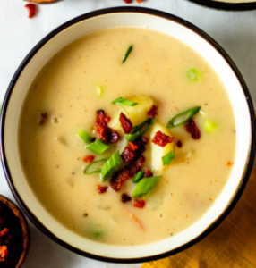  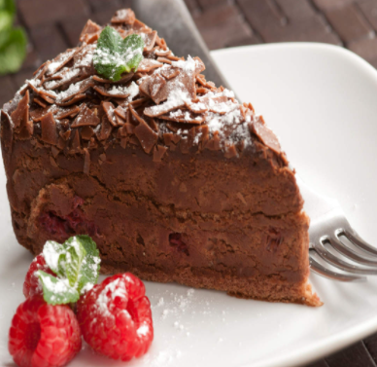  DRINKS  Wines  Di Maria Prosecco…£17.50  Finca Monica Tempranillo, Rioja…£8.99  Moutard House Champagne…£32.00  Jack Duggan Chardonnay…£7.17  Moet & Chandon Brut Champagne…£42.00  Aotearoa Pinked Sauvignon Blanc…£9.00  Beer  Corona…£3.20  Peroni…£3.20  WKD Blue…£3.20  Cobra…£4.00  Budweiser…£3.20  Bulmers Cider…£3.90  Soft Drunks  Schweppes…£1.50  Coca Cola…£2.00  Orange or Passion Juice…£2.00 | MAINS  Jumbo Shrimp….£9.00  Popcorn Shrimp…£10.00  Bam bam Shrimp…£10.00  Served with Caesar Salad  Salmon Pie…£5.00  Topped with creamy mash  Salmon Fillet…£6.00  Served with hollandaise sauce  Grilled Salmon…£7.00  Catfish…£6.00  Lobster…£13.00  All served with crisp Caesar salad  DESSERT  Chocolate Fudge Cake…£3.50  Carrot Cake…£3.50  Rice Pudding…£3.50  

