

Postgraduate/Distance Learning
Assignment coversheet & feedback form

THIS SHEET MUST BE THE FIRST PAGE OF THE ASSIGNMENT YOU ARE SUBMITTING (DO NOT SEND AS A SEPARATE FILE)

For completion by the student:
Student Name: Sara El Bizri

Student University Email: 1805674@student.uwtsd.ac.uk
Module code: HPCA7019  Module title: Sacred Skies | Student ID number:  1805674 |  |  | Educational support needs:  Yes/No
Assignment title: Essay based on a Sky Journal

Assignment due date: 19/3/2021
This assignment is for the 1st 2nd 3rd 4th 5th 6th module of the degree
I confirm that this is my original work and that I have adhered to the University policy on plagiarism.
Signed ……Sara El Bizri………………………………………………………
Email submission:if you are submitting this form via email, please tick this box □
(as a substitute for your signature) to confirm that you agree to the above declaration.
Assignment Mark
1st Marker’s Provisional mark
2nd Marker’s/Moderator’s provisional mark
External Examiner’s mark (if relevant)
Final Mark

NB. All marks are provisional until confirmed by the Final Examination Board.

For completion by Marker 1 :
Comments:

Marker’s signature: |  |  | Date:
For completion by Marker 2/Moderator:

Comments:

Marker’s Signature: |  | Date:
External Examiner’s comments (if relevant)

External Examiner’s Signature: |  | Date:

University of Wales Trinity Saint David
Faculty of Humanities and the Performing Arts
MA Cultural Astronomy and Astrology
Module: Researching Contemporary Cosmologies

Essay based on a Sky Journal

INTRODUCTION
This paper explores the relationship of sky with humans via perceptions and thoughts based on sky reflections on different surfaces around us whether it was water, buildings, or landscapes in Italy and in Lebanon. However, the aim of my observations is to examine the abstract meaning of the reflection of the sky and link it to personal perceptions through a phenomenological approach based on reflexivity. To my luck , the observation takes place in the winter of February where there is a lot of rain in both Italy and in Lebanon, Hence the observation will mainly be about the reflection of the sky on puddles of water due to the rainy season.
ACADEMIC RATIONALE
In this essay, the mechanism of understanding or experiencing living with the sky is through the action of observing, reflecting, and documenting. An example of this is in Henry Thoreau’s ‘Walden and Civil Disobedience’, where he promotes the philosophy of individualism and love of nature. In his book he writes his observations along Walden Lake in Massachusetts, going into detail about what each element in nature represents to him. An example is the reflection of the sky on Walden Lake, ‘ A lake like this is never smoother than at such a time and the clear portion of the air above it being shallow and darkened by clouds, the water, full of light and reflections, becomes a lower heaven itself so much the more important’. Another example, is Christopher Sturm’s ‘Reflections For Everyday of the Year on the Works of God’, where he dwells in to the art of observing nature and reflects it upon himself in the form of lessons and emotions. He documents in one of his observations that ‘this sky is void of intelligence. It is a stranger to its own beauty, while I, who am mere clay, molded by a divine hand, am endowed with sense and reason. Hence, according to both scholars, I intend to focus on the mechanism of observing, reflecting and documenting different perceptions that could come to mind in the form of ideas or sensations.
Literature Review
According to Christopher Tilley , in his book ‘ A Phenomenology of Landscape’, ‘The key issue in any phenomenological approach is the manner in which people experience and understand the world.’ I have reflected upon this idea in my essay and have exposed myself to several experiences that connect with the idea of the sky, for according to Tilly, humans should interact and have physical experiences with the world to be able to develop a certain understanding or even a feeling. ‘To be human is both to create this distance between the self and that which is beyond and to attempt to bridge this distance through a variety of means - through perception (seeing, hearing, touching), bodily actions and movements, and intentionality, emotion and awareness residing in systems of belief and decision-making, remembrance and evaluation.’ However, Tim Ingold talks about a set of associations connected with the sky in his chapter ‘Reach for the Stars’ in the book ‘ The Imagined Sky’, by stressing on the importance of phenomenology to shift ones perception into uncovering these associations and understanding what is sky. As for Ada Blair, she also have talked about the relationship of humans with the sky in her book ‘Sark in the Dark’, she targets the importance and benefits the sky has on humans by doing a survey on the people of Sark. Nevertheless, I’ve also taken inspiration from Thoreau and Stum’s reflected perceptions of nature and the sky upon themselves while documenting their observations when in contact with the outside world. For Stum states, ‘How reasonable that we should sometimes turn our eyes from foreign subjects to ourselves.’
METHODOLOGY
This project was developed according to a phenomenological approach and reflexive considerations throughout the observation period. The methodology was influenced by Tilly’s ‘A phenomenology of landscape’ where he argues that ‘Phenomenology involves the understanding and description of things as they are experiences by a subject’. Hence, I will be experiencing my surroundings through taking daily walks around my neighborhood in Italy that I have lived in for two and a half years now. I will be observing the reflection of the sky as a visual image and as a source of light on different mediums around me, such as streets, landscapes, glass, buildings and so on. However, my reflexive considerations were according to a process called ‘intuitive inquiry’ in which Rosemary Andersson and William Braud have explained by stating that it is vital when doing research to interview one’s self and write about it to follow up on the reflexive considerations taking place throughout the research process. Thus, I will be writing down my observations in my sky journal every time I go for a walk for a month starting from Feb. 1. 2021 along with taking pictures .
Reflective considerations
I am a Lebanese Female, yet I didn’t spend a lot of time in Lebanon, but I have spent the past two and a half years in Italy. I am 26 years old and I’ve always been interested in Astronomy, and anything related to the sky, it has always grounded me throughout my life no matter where I am in the world. However, I am also an architectural engineer and a landscape architect, I am always working on building experiences for people whether it was in buildings or in landscapes. Thus, I am very attentive to the idea of experience and exploration and I tend to indulge with this concept in my sky journal.

FINDINGS:
Based on my sky journal I have categorized my findings into three themes that deal with personal perceptions and self-reflections and participation with the sky.
Perception

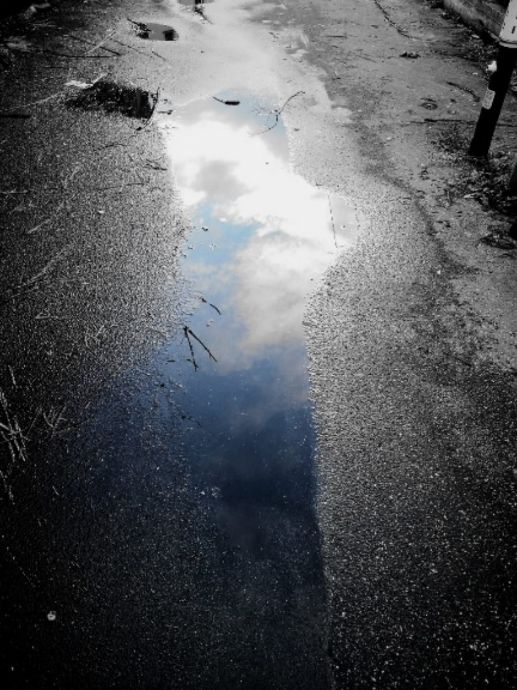
On Feb. 3, 2021 I decided to finally go for a walk after it has been raining nonstop for the past few days. While walking I saw clouds right under my feet, it was a water puddle reflecting the sky, yet I did not see water, I only saw a deep blue sky with white clouds right under me as seen in fig. 1. And I wrote in my journal ‘I feel like walking on the sky and in the sky, I feel like I am a part of the sky. I do not have a definition, I am not a bird nor a human, I’m just existing, I’m just feeling alive with the sky’. while stepping out of the water puddle it seemed like I am now back in the dimension of reality, I could almost swear it was all real, I did not just perceive the sky, I felt it too. However, Tim Ingold has argued that ‘the sky is luminous, but to perceive the sky is not to perceive its luminosity. If light delivers the sky to our perception, but then vanishes, does not the sky vanish with it?’
Figure 1 Reflection of the sky on a water puddle on the street. 03.02.21. Photo By: Sara El Bizri.

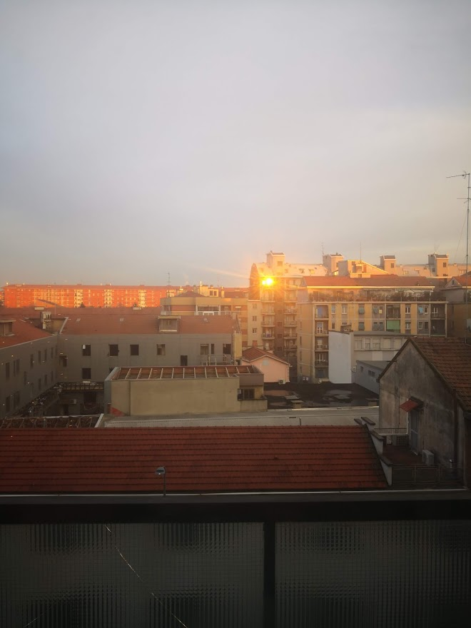
on Feb. 9, 2021 I was sitting in my room in Milan working, when all of a sudden, I see a golden light shine right on the wall in front of me. I was delighted to realize that it’s the reflection of the sunset, it wasn’t something familiar to me because the sun never reflected on that specific angle before as seen in fig.2. I also didn’t get the chance to see sunsets in Milan since there was no sea near me, and buildings were high. I enjoyed the sun’s visit, such a delightful guest, we had some conversations and I wrote in my journal ‘I missed you sunset, I haven’t seen you for more than a year now, I needed your daily reminders telling me that everything will be okay, that I have survived today, and that tomorrow will be another new day, I wasn’t totally okay but I never forgot what you’ve taught me and I kept going.’ It was minutes and my guest has left the room. It was an emotional moment, it’s as Sturm have discussed that ‘the pleasure of the senses, how soon are we deprived of them! we scarcely begin to enjoy them before they disappear! At sun - rise we are often cheerful and content; before it sets, we are plunged in distress and sorrow.’
Figure 2 reflected sunset from distant windows. 09.02.21. Photo by: Sara El Bizri

Self-Reflection
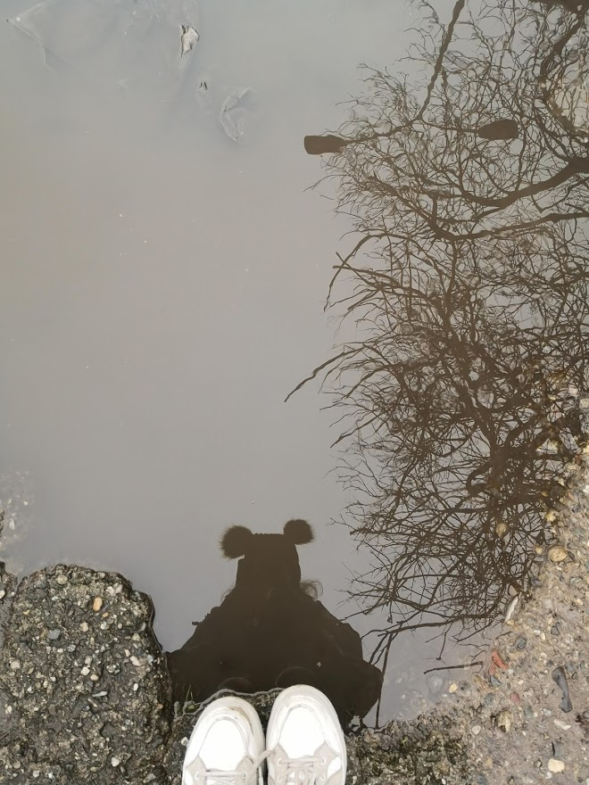
Figure 3 Self-Reflection on a puddle of water. 12.02.21 Photo by: Sara El Bizri
Feb. 12. 2021 was a cloudy day, the sky was colorless, and so were the water puddles. There was no light, no reflection, I felt like the world was empty, with nothing to see. It is as Ingold puts it ‘Are we not left, on a cloudless day, with precisely nothing: mere emptiness, save for the ghost of a sun that does not shine, turning shimmering day into starless night?’ I approached the water as seen in fig. 3, I in doubt of seeing anything that matters, and I saw myself, my own reflection. In a second I had a thousand ideas and sensations jumping in my head, and so I wrote in my journal, ‘I matter, I am enough.’ I connected the issue with what Ada Blair have concluded in her book ‘Sark in the Dark’, where one of her conclusions was ‘You’re made of stardust and if you can get your head around that you’re part of something amazing.’ I felt like even though the sky was visually absent it was still there sending me messages , connecting with me, grounding and healing me.

Participation
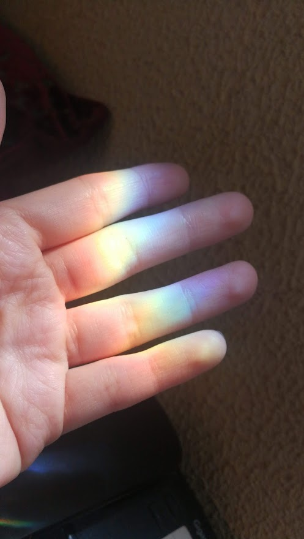
On Feb. 15 2021, I left Italy and have moved to Lebanon. It was a tough week, and I couldn’t go for walks. I was feeling a bit down and overwhelmed. However, on Feb. 21 I was sitting in my room next to the window and I saw the sun have reflected a rainbow next to me and so I reached and touched it as seen in fig. 4. I don’t know why exactly it felt so magical, maybe because in the back of my head I knew that rainbows represented bridges that connect earth to heaven according to Greek mythologies. However, This wasn’t the first time I’ve tried to touch a rainbow, I was always so enthusiastic to run towards a reflected rainbow and try to touch or participate and be part of this phenomenon, yet I’ve never thought about the reason of why it excites me so much, but I would always be happy to just be part of the sky in some way. Nevertheless, even when I was absent from my daily walks that were intended to be interactions with the sky, I felt that the sky has reached out to me again. It was ironic because my goal was to go for walks and search for the sky on whatever reflected surface I can find, yet the sky was the one which was always finding me. It seemed like a message sent to me by a ray of light to remind me yet again that I am not alone, that I matter, and that even if something is not physically visible, it doesn’t mean it’s not there. For according to Ingold, light is a messenger delivering right to our perception.
Figure 4 touching the reflection of light when a rainbow was formed. 21.02.21 Photo by : Sara El Bizri
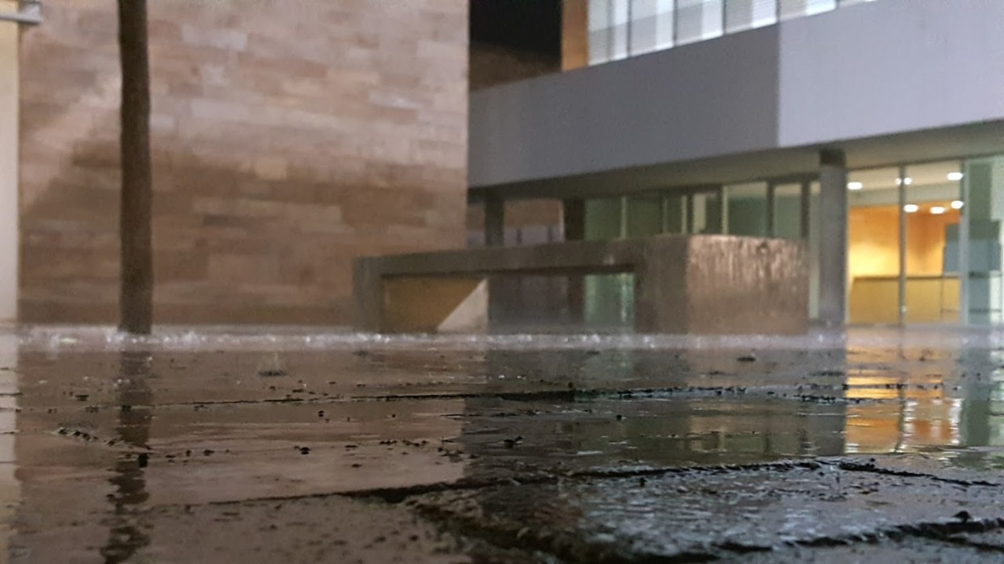
Figure 5 Observing the rain fall on puddles of water. 26.02.21 Photo by: Sara El Bizri
On Feb. 26 I went out with some friends to a place nearby, it was cloudy with dark grey clouds. I didn’t think I’ll see anything special on this day. However, after some time it started raining, while everyone went inside, I decided that I wanted to watch the raindrops fall on the puddles of water and take some pictures as fig.5 . While standing under the rain I was just focusing on observing the rain drops on the puddles of water and I didn’t pay any attention to the raindrops falling on me. when I started getting wet, the idea occurred to me, that as the droplets of rain touch my skin, I am in in contact with what is being sent from the heavens. it wasn’t just about perceiving the reflection of the sky on water, it was about experiencing being a part of what the sky has to present and perceiving that in a certain way. For how I see it, this time it wasn’t just a visual connection it was also a physical connection that I have felt on my skin and perceived in my mind as a message that the sky is so close to us, it is even touching us, we just have to pay attention. It is also as Stump sees it, ‘ Rain may properly be termed a present from heaven.’

CONCLUSION

To conclude, the paper’s aim was to explore the relationship of the sky with humans via perceptions and through sky reflections on certain surfaces such as water puddles. However, while I was in search of sky reflections to connect with the sky, what happened was that it was the sky that actually found me. I’ve been so focused on searching for visual representations of the sky while I learned that I forgot the most important sense which is feeling. The experience of doing observations according to a phenomenological approach has helped me build an interpretation based on my experiences that took a turn I never expected. The sky has surprised me every single time through rain, rainbows, self-reflective lessons, and unexpected reflections. I was so naïve to think that I have to go to a certain place to witness a connection with the sky, while in reality what happened was that the sky came to me, it has literally touched me, it showed me that it is there everywhere and has presented me with gifts in the form lessons and sensations that show our deep connection with the sky at anytime and anyplace.

Bibliography:
Primary sources
Observing sky reflections / Sky Journal
Secondary sources
Blair Ada, Sark in the Dark, 3 edn (UK: Sophia Centre Press, 2016).

Thoreau Henry, Walden and Civil Disobedience (Signet, 2012).

Tilley Christopher, A Phenomenology of Landscape (Oxford: Berg Publishers, 1994).

Lane Belden, Landscapes of the Sacred: geography and narrative in American spirituality (USA: The Johns Hopkins university press , 2002).

Ingold Tim , 'Reach for the Stars! Light, Vision and the Atmosphere ', in The Imagines Sky , ed. by Darrelyn Gunzburg (UK: Equinox Publishing , 2016)

Sturm Christopher, Reflections for Everyday in the Year on the Works of God , 1 edn (UK : John M'Gowan, great windmill street ).

Anderson Rosemarie & Braud William , Transforming Self and Others Through Research (USA: State University of New York Press , 2011).

Lee Raymond & Fraser Alistair, The Rainbow Bridge: Rainbows in Art, Myth, and Science (China: The Pennsylvania State University Press, 2001).

Henry David Thoreau, Walden and Civil Disobedience (Signet, 2012) p. 61
Henry David Thoreau, Walden and Civil Disobedience, p. 61
Christopher Sturm, Reflections for Everyday in the Year on the Works of God, 1 edn (UK : John M'Gowan, great windmill street ) p. 33
Christopher Tilley, A Phenomenology of Landscape (Oxford: Berg Publishers, 1994). P.11
Christopher Tilley, A Phenomenology of Landscape (Oxford: Berg Publishers, 1994) p. 12
Tim Ingold, 'Reach for the Stars! Light, Vision and the Atmosphere ', in The Imagines Sky, ed. by Darrelyn Gunzburg (UK: Equinox Publishing, 2016) p. 17
Christopher Sturm, Reflections for Everyday in the Year on the Works of God , 1 edn (UK : John M'Gowan, great windmill street ) p.38
Christopher Tilley, A Phenomenology of Landscape (Oxford: Berg Publishers, 1994 )p.12
Resemarie Anderson & William Braud, Transforming Self and Others Through Research (USA: State University of New York Press, 2011). p. 180
Tim Ingold, 'Reach for the Stars! Light, Vision and the Atmosphere ', in The Imagines Sky, ed. by Darrelyn Gunzburg (UK: Equinox Publishing, 2016) p. 238
Christopher Sturm , Reflections for Everyday in the Year on the Works of God, 1 edn (UK : John M'Gowan, great windmill street ) p. 105
Tim Ingold , 'Reach for the Stars! Light, Vision and the Atmosphere ', in The Imagines Sky , ed. by Darrelyn Gunzburg (UK: Equinox Publishing , 2016) p. 238
Ada Blair, Sark in the Dark, 3 edn (UK: Sophia Centre Press, 2016). p. 117
Raymond Lee & Alistair Fraser, The Rainbow Bridge: Rainbows in Art, Myth, and Science (China: The Pennsylvania State University Press, 2001) p. 21
Tim Ingold , 'Reach for the Stars! Light, Vision and the Atmosphere ', in The Imagines Sky , ed. by Darrelyn Gunzburg (UK: Equinox Publishing , 2016) p.237
Christopher Sturm , Reflections for Everyday in the Year on the Works of God , 1 edn (UK : John M'Gowan, great windmill street ) p. 223

