

Name: Jamuthra Srikumar
Student Number:2310736
Module: LCLM6001
Lecturer: Ibrahim Rufai

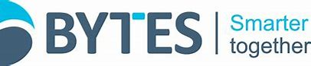

STRATEGIC MANAGEMENT FOR BUSINESS
LCLM 6001

EXECUTIVE SUMMARY
BYTES software solutions is UK based SME providing IT solutions to the business development from micro to corporate levels. They approach business investors to build a sustainable future and create long term value for BYTES and its stakeholders in a responsible manner. Through their commitment to sustainable business practices and activities.
In this assignment explains about BYTES services, products and business models. You can understand about their business, how they provide their services to the customers and how can you approach them to know about more.
My research of BYTES PESTEL give you an idea of BYTES competitors and how they are different from them to satisfy their customers.
Using Ansoff matrix, Porters generic matrix and Mendelow’s matrix models to clarify BYTES business models.
After the study of BYTES, I have recommended short-, medium- and long-term timelines.

INTRODUCTION
BYTES software solutions is one of the world class IT solutions providers in the UK. BYTES established in 1982, as a small computer shop and now employs more than 700 employees across the country including Northern Ireland. BYTES has its headquarters in UK and has grown continuously and wisely to adopt the latest technology. They are helping hundreds of top brands to transform grow and adopt to changing technology landscape. Bytes empower and inspire our people to fulfil their potential, so they can help our customers make smarter buying decisions and meet their business objectives through technology. Bytes passionate about their employees, vendors and customers. They act with integrity in all times. They work with diversity and respect their ethics and culture. As a sustainable business, they take cognisance of socio-economic and environmental landscape, the regulatory environment in which they operate and the legitimate needs and interests of stakeholders. This context is considered in the determination of risks and opportunities, as well as value drivers and material matter that are housed within their sustainability framework.
According to United Nations Development Environmental Aims (Goals) BYTES commended with United Nations seven environmental goals which are explained detailly in their CSR policies and allow them to be sharing their goals with their customers, colleagues and communities. Their goals are No to poverty, no hunger, considering everyone’s health and well-being, providing quality education, maintaining gender equality, focusing on economic growth and decent work ethics, finally climate action. They provide financial support to UN SDGs of seven projects they are No poverty, zero hunger, good health and well-being, quality education, gender equality. Decent work and economic growth and climate action.
Low carbon action plan with carbon reduction targets. Supply chain engagement.
Bytes committed to take efforts of embedding a culture which reflects the diverse communities in which they conduct business, and which provides equal opportunity and support for all to use their experience and skills to contribute to promoting an inclusive environment.
Bytes understand their workforce according to their culture and BYTES respect their values and ethics.

MISSSION VISION AND OBJECTIVES
Bytes has solid vision of their services. They provide best of breed technologies into action at this point security becomes a business enabler not an everyday distraction. Bytes portfolios fulfil every single aspect of information security and risk management from initial assessment through to programme planning, hands on deployment and round the clock support. Also, BYTES concentrate cloud migration, communications, -Microsoft office 365 discovery workshop, Adobe creative suite 5.5, check point R77 release. Recently BYTES introduced Websense Triton Risk vision.
BYTES mission mainly focuses cloud services, security blind spots and Microsoft premier support. Also, BYTES goal driven change of hybrid infrastructure and public cloud to discover the capabilities of stakeholders at anywhere and anytime. BYTES digital tools will help NHS workers focus on frontline care. They provide Microsoft products at a reduced cost and contract with NHS can explore opportunities to introduce new innovative technology overs coming years.
BYTES offer software advisory service that compasses all aspects of software Asset Management, licensing consultancy, hybrid and cloud solutions, learning and services. When you reach BYTES, you feel that your future is are on safe hands. BYTES software solutions respect their customers ethics, values, professionalism. BYTES values to being passionate their employees, vendors and customers. BYTES always act with integrity. They work together and collaborate across teams. They are kind and respectful to all people and all of the time. (www.bytes.co.uk)

PESTEL analysis of BYTES.

At this era especially modern technology is ruling the world inch by inch. Technology is interlaced with every aspect of business, understanding the countless influences shaping a company. BYTES software solutions is fundamental for investors and industry entrepreneurs alike. A PESTLE analysis of BYTES in the UK explains several key external factors which influence their operations.
Political factors:
- Government information technology policies - government’s digital transformation of all areas. It is beneficial for BYTES and stable in their business.
- Data privacy policies – According to GDPR adheres to these policies are critical to maintaining customer privacy and trust.
- Tax policy – It has been impacted by changes in the UK corporation tax rates, such as the increase from 19% to 25%.

Economic factors:
- Inflation and interest rates: Inflation is the most important factor to affect the business and high interest rates positively impacted their profit before tax also high interest rate is additional income for the company.
- Customers spend: Unsteadiness of economy will lead the existing customers to invest in IT needs with the public sector showing strong growth in invoiced income.
- Economic environment: Economic uncertainty has been led to some clients delaying projects and impact on decision making.

Social factors
- Skills and expertise: the need for greater employee expertise in emerging technologies like AI, cloud and cybersecurity is a key consideration and BYTES invests in personal development and career progression to meet this need. Diversity of their workforce leads to improve their performance and innovation.
- Corporate culture and reputation: BYTES emphasizes a strong internal culture, diversity and inclusion and employee wellbeing which has helped it rank highly in GREAT PLACE TO WORK surveys and maintain strong staff retention.
- Ethical Consumerism and ESG: There’s a growing emphasis on environmental, social and governance (ESG) considerations and ethical practices which BYTES addresses through its sustainability and human rights policies.
Technological Factors
- Cybercrime risk: The raising of cybercrime is most challenging, and BYTES handle it very well to focus on cybersecurity solutions. It is a key area of demand for BYTES’ customers.
- Technological evolution: The fast face of technological growth (AI, cloud computing and cyber security) drives demand for BYTES’ services but also requires continuous adaption and investment in new solutions and staff training.
- Vendor Dynamics: When partner incentive programs make changes by major vendors like Microsoft can impact BYTES’ operating profit and sales structure, requiring business adjustments.
Legal Factors
- Employment laws: BYTES must follow and aware to local labour laws, health and safety regulations and national wages increases in the United Kingdom.
- Data protection policies: Compliance with regulations like GDPR is important, given the sensitive nature of data storge and consumer rights in the technological sector.
- Regulatory Compliance: Loyalty to the regulatory frameworks of government and public sector contracts is crucial for maintaining its position on key IT frameworks.
Environmental Factors
- resource management: Considerations around sustainable resources, supply chain management and ethical sourcing are becoming more important to customers and stakeholders.
- Sustainability CSR: BYTES allies its corporate social responsibility policy with UN sustainable Development Goals and considers this in its operations. There are increasing expectations for businesses to manage their environmental footprint.
(Authorised and regulated by the Financial Conduct Authority)

Strategic analysis
Strategic growth direction
BYTES software solutions, a UK based SME, should pursue a verticalized SaaS growth model to achieve sustainable long-term success. This involves shifting to subscription-based services, developing industry specific features and forming strategic partnerships. The model combines elements from Ansoff’s product and market development and porters differentiation and focus strategies.
Key Advantages: predictable recurring income, stronger customer loyalty, scalable operations through partnerships and competitive edge from domain specific expertise.

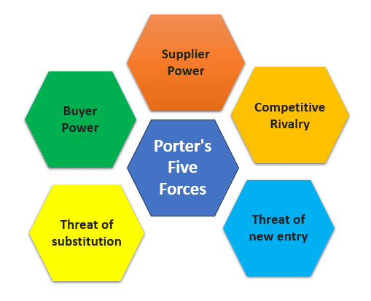

Ansoff Style
How BYTES implement Ansoff Matrix to make a growth of their business.
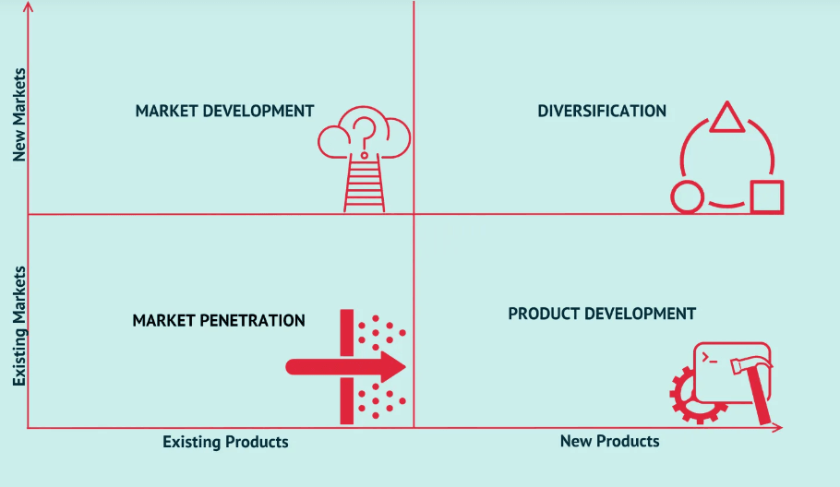

(Ansoff H I, (1957). Strategies for Diversification, Harvard Business Review, (Vol. 35 Issue 5, Sep/Oct). p113-124)

According to Ansoff, market penetration grow share in existing markets; upsell current customers, increase ROI and reduce churn.
Product development build new modules, add integrations or analytics features, create managed services.
Market Development target new verticals ( eg: finance, healthcare, retail) or new geographies (Europe, Asia or America)
Diversifications create adjacent products (developer tools CI/CD services) or acquire a micro startup.

Also, Porter’s Generic explains how differentiation offer unique IP (proprietary algorithms, UX and integrations) superior customer support.
Cost leadership (niche) streamline delivery to offer lower cost solutions or fixed fee packages.
Focus specialise in a vertical (for example – compliance heavy sectors) or SME segment.

Other practical SME routes
Move to Saas/ Subscription (if not already) for recurring revenue.
Product-led growth: Freemium/trial self-serve paid

Managed services/ outcome- based contracts for higher ARPU
Partnerships and channel sales (resellers, consultancies)
Platform play/ APIs become the data/integration layer others build on.

Recommended new strategy (short statement)
Adopt a verticalized Saas platform with subscription pricing + strong customer success and strategic partnerships (product led distribution)
Why it is sustainable?
- Recurring revenue improves cash predictability and valuation.
- Vertical focus reduces competitive noise and allows charging premium for tailored solutions and compliance expertise.
- Customer success + PLG lowers acquisition cost (virality, referrals) and reduces churn.
- Partnerships accelerate scale without proportionate headcount increases.
- Technical moat: integrations, data models and domain specific templates create switching costs.

How it maps to models
Ansoff Matrix: Product development + market development (deepen product, move into verticals).
Porters Generic: Differentiation + Focus
Bowman: Move to value for money differentiated offering (higher perceived value through vertical fit + outcomes)

High level rollouts
- Choose 1-2 target verticals (healthcare, compliance, fintech SME)
- Build vertical templates/ features and compliance models.
- Launch a tiered SaaS pricing (free trial SME tier Enterprise)
- Hire or assign 1-2 customer success reps.
- Form 3 key partnerships (consultancies, integration partners and marketplaces).

Stake holder Analysis
BYTE’s stakeholders differ in influence and expectation. Founders, investors, and regulators have high power and interest, employees and customers have medium power but high interest, partners have medium influence. Using Mendelow’s Matrix Byte should manage high power groups closely and maintain good relationships with others. The RACI framework ensures accountability for new strategy execution.
Role | Responsible | Accountable | Consulted | Informed
CEO | √ | √
Product Head | √ |  | √
Sales Head | √ |  | √
Legal Advisor |  |  | √
Employees |  |  |  | √

Key stakeholders and typical expectations
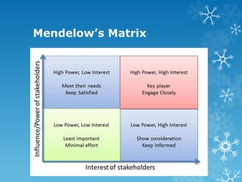
Mendelow Matrix explains how stakeholders’ strategy works

- Founders or owners’ growth, margin, exit optionality and control. (High power, High interest)
- Employees/ Developers job security, career growth and product clarity. (Medium – high power, high interest)
- Customers (current and target) reliability, value for money, fast support, compliance. (High interest, medium power individually; collectively)
- Investors/ Lenders ROI, steady growth, governance. (High power, medium interest day to day)
- Partners/Resellers clear margins, reliable product and enablement. (Medium power medium interest)
- Vendors/ cloud providers steady contracts, predictable usage. (Low medium power)
- Regulators (UK ICO, sector-specific) compliance with data/security rules. (High power for regulated verticals)
- Community/users (dev community) documentation, transparency, roadmap. (Low power, medium interest)

Mendelow’s Matrix (quick mapping& engagement strategy)
High power/High interest (Manage Closely): Founders, Key customers, Investors, Regulators consult, report, involve in major decisions.
High power/Low interest (Keep satisfied): Employees, smaller customers, dev community regular updates, training, community forums.
Low power/ Low interest (monitor): General public, distant suppliers.

Actionable takeaway: treat a few anchor customers and regulators as co design partners when verticalizing. That reduces adoption friction and regulatory risk.

Recommendations
Key strategic recommendations and implementation plans (with SME realities)
I will give prioritised recommendations with short, medium and long timelines and mitigations for SME constraints.
Short term recommendations
Move to or optimise SAAS subscription model.
Why I recommend it? Because it will be a predictable revenue. Also easy to scale and higher Lifetime value (LTV). Bytes can implement it for short term up to 6months. They must keep on eye on the following:
- Audit current product for multi-tenant readiness and security.
- Design tiered pricing and trial/ freemium offering.
- Add billing and subscription tooling (stripe and GoCardless)
KPIs: monthly recurring revenue, annual recurring revenue
LTV: Customer acquisition cost and churn percentage
Resources: dev time (medium), billing integration and legal (low)
Risks and mitigations: Security and compliance gaps run penetration test and implement system and organization controls and independent sales organisation.
Controls: Pricing too high pilot with a few customers.
Recommendation 2 – Verticalize: pick 1-2 niches and build domain features. Why it is recommendable for BYTES. BYTES pick a niche where they can be seen as specialist and charge premium. (can implement up to 9 months)
BYTES could
- select verticals based on existing customers and market size.
- Deliver 3 vertical templates and 1 compliance module.
- Create vertical case studies.
KPIs: Annual recurring revenue per vertical, win rate in vertical Request for Proposal (RFP) and net revenue retention.
Resources: product with SME consultant(medium), marketing collateral (low).
Risks: Choosing wrong vertical mitigate by customer interviews, pilot projects.

Recommendation 3
Invest in customer success and onboarding
It will reduce churn but increases expansion revenue.
Define onboarding flows, create success playbooks and hire 1CSM.
Implement of customer health scoring.
KPIs: Time to value, churn rate, expansion revenue percentage
Resources: Low med (one headcount initially)
Risks: Cost of hire start with fractional/outsourced CSM.

Recommendation 4
Adopt product-led growth (PLG) and marketing Operations
It will help to find the cheaper customer acquisition and virality.
- Free trial or freemium with clear upgrade prompts
- Build in app messaging, analytics and simple referral flows.
KPIs: Activation rate, trial paid conversion and CAC
Resources: Dev for instrumentation (low – med), marketing expertise (low)
Risks: Low conversion run A/B tests, adjust onboarding.

Recommendation 5
Build strategic partnerships
Fast reach to customers and credibility. (recommended 3 to 12 months)
Target 3 partner types: consultancies, integration partners, SAAS marketplaces
Create partner program (margins, enablement, Cosell playbook)
KPIs: revenue via partners, number of active partners and partners – sourced leads.
Resources: Partnerships lead time. (Med)
Risks: Partner churn offer clear incentives and joint success metrics.

Recommendation 6
Regulatory requirements and trust in B2B sales.
Actions (ongoing):
Quarterly security reviews, backups, disaster recovery plan. If targeting regulated verticals, get relevant certifications (e.g: - GDPR readiness and cyber essentials)
KPIs: Incidents, uptime and audit results.
Resources: Security consultant (as needed), dev time (med).
Risks: Certification costs prioritise must have ones first.

Recommendation 7
Funding and cash flow strategy
Growth needs capital: SMEs must balance dilution or cost.
Actions: Build 12-18 months financial runway plan tied to milestones (MRR targets).
Consider growth paths: revenue funded growth, soft loans or strategic investor (if scaling fast)
KPIs: runway months, burn rate and CAC payback.
Risks: Over raising or dilution prefer milestone-based tranches.

Practical roadmap (implementation cadence)
0-3 months (quick wins): Pricing tiers, trial flow, hire 1 CSM, pick verticals, begin partner outreach.
3-9 months (Build and test): Deliver vertical templates, go to market pilots with 2 customers, launch partner program and tighten security.
9-18 months (Scale): Expand verticals, scale partnerships, optimise PLG funnels, measure ARR growth and CAC cashback.

Final practical tips:
Start lean: prototype vertical features as configurable templates reuse core code.
Use contractors or partners for non-core work (compliance, marketing) to avoid fixed overhead.
Measure ruthlessly: pick 5 KPIs (MRR, Churn, CAC, LTV, TTV) and review weekly/ biweekly.
Keep customers in the loop: co build with 2-3 anchor customers to de risk product fit.
Documents decisions: Short one pager for each strategic bet (why, cost, success, metric, exit criteria).

Bytes create a lot of job opportunities for IT people. Will list out some of them
Information Technology | Information systems
Hardware engineers | Data Analyst & scientist
Computer programmers | Database administrator
Technicians (field Service) | Software engineers
IT support specialists and consultants | System analyst
ICT helpdesk technicians | Software designer

Conclusion
Bytes use ethical standards in all areas to sustainable their business in modern world. They adopt the latest technology to develop their customers to face the competitive business environment. It is necessity that defines a company’s long-term success. Adhering to ethical principles not only mitigate risks and negative consequences but also fosters mutual respect, trust, and honesty which play a crucial role in maintaining a healthy relationship between a company and its clients. AI usage in business processes, using algorithms, protecting data, ensuring fairness and creating accountability mechanisms are all essential aspects as successfully and safely. Also, social media platforms will be handling very carefully and keep maintain the cyber security system to avoid data breaching. Then only customers and stakeholders to build trust in the company. BYTES adopt the latest and upcoming changes as much as possible to satisfy their stakeholders. Their concern about carbon reduction and educational scholarship should be appreciated.

References
White, C., 2017. Strategic management. Bloomsbury Publishing.
Saloner, G., Shepard, A. and Podolny, J., 2005. Strategic management. John Wiley & Sons.
Parnell, J.A., 2013. Strategic management. Sage.
Lynch, R., 2021. Strategic management. Sage.
Henry, A., 2021. Understanding strategic management. Oxford University Press.
Martinet, A.C., 2010. Strategic planning, strategic management, strategic foresight: The seminal work of H. Igor Ansoff. Technological Forecasting and Social Change, 77(9), pp.1485-1487.
Gurcaylilar-Yenidogan, T. and Aksoy, S., 2018. Applying Ansoff’s growth strategy matrix to innovation classification. International Journal of Innovation Management, 22(04), p.1850039.
Islami, X., Mustafa, N. and Topuzovska Latkovikj, M., 2020. Linking Porter’s generic strategies to firm performance. Future Business Journal, 6(1), p.3.
www.bytes.co.uk
O'brien, J.A. and Marakas, G.M., 2006. Management information systems (Vol. 6). New York, NY, USA:: McGraw-Hill Irwin.
Apsilyam, N.M., Shamsudinova, L.R. and Ashrapova, L.U., 2025. ETHICAL ASPECTS OF USING AI IN BUSINESS. INTERNATIONAL SCIENTIFIC-ELECTRONIC JOURNAL “PIONEERING STUDIES AND THEORIES”, 1(3), pp.22-27.
Christopher Hodges Professor of Justice Systems, and Fellow of Wolfson College, University of Oxford1.
Issa, T., Issa, T., Hardin-Ramanan, S., Abu-Salih, B., Maketo, L., Balapumi, R., Nau, S.Z. and Ahmud-Boodoo, R.H., 2023. Management Information Systems: Harnessing Technologies for Business & Society. SAGE Publications Limited.
Passino Jr, J.H. and Severance, D.G., 1990. Harnessing the Potential of Information Technology for Support of the New Global Organization. Human Resource Management, 29(1).
Ghelani, D., 2022. Cyber security, cyber threats, implications and future perspectives: A Review. Authorea Preprints.
Act, D.P., 1998. Data protection act. London Station Off, 5.

