Therapy Assistant Practitioner:
Demonstrating Practice Logbook



This logbook was completed by:

Mentor’s name: ………Heather Baker………………………… Mentor’s signature: ………H.Baker……………… Date: ………………

Learner’s name: ………Samantha Alozie…………………………. Learners’ signature: ……Samantha Alozie………… Date: ………17/02/26……….

The content page includes a list of evidence to be collected as part of your portfolio:

- Log of supporting documents: | Details to include (including criteria): | Date of completion: | Mentors signature: | Appendix / page
- An observation of your practice | A supporting document from your mentor of your compliance with person centred practice (1.2 & 4.3). | 17/02/26 | H. Baker | Appendix 1 / Page 3
- Evidence of reading and learning related to role | A minimum of 2 examples of your engagement with researching and learning on topics related to your role (8.4). | 17/02/26 | H. Baker | Appendix 2 /Page 4
- Log of a wide range of assessments. | A minimum of three anonymised assessments completed by you, demonstrating a range of skills and tools (1.2). | 17/02/26 | H. Baker | Appendix 3 /Pages 5-12
- Copy of a recent Personal Development Appraisal Review (PDAR). | A copy of the most recent PDAR document completed with supervisor / mentor (8.1 & 8.3). | 17/02/26 | H. Baker | Appendix 4 / Pages 13-14
- Copies of your recent supervision records. | A minimum of two supervision records, demonstrating attendance and contribution to supervision and agreement to actions (4.2). | 17/02/26 | H. Baker | Appendix 5/ Pages 15-18
- A copy of a risk assessments you have undertaken | A formal or informal risk assessment that you have completed. This can be a case note entry, DATIX, incident report or an assessment completed due to risks (such as a falls risk assessment) (4.3) | 17/02/26 | H. Baker | Appendix 6 /Pages 19-20
- Examples of any training you have participated in or delivered | A minimum of five examples of evidence that you attended or delivered training within the last 12 months (8.4). | 17/02/26 | H.Baker | Appendix 7 / Pages 21- 23
- Evidence of your compliance with mandatory training | A minimum of 5 examples of your mandatory training compliance over the past 12 month (4.1). | 17/02/26 | H.Baker | Appendix 8 /Page 24
***The following pages are where you can start to include your evidence:
Appendix 1 (to be completed by your mentor) - Supporting document:
Give a brief description of your relationship with the learner and a typical activity that you have overseen the learner complete:
For the past two and a half years I have supported Samantha in my role as her clinical, managerial, and wellbeing supervisor. I completed Samanthas induction when she started this new post and have observed her in many different situations with and without clients as part of her role. I have observed Samantha completing phone calls to make appointments, physical equipment assessments including ordering of equipment. I have observed Samantha deliver individual anxiety management sessions with a client who was unable to tolerate the Functioning with Anxiety group and this work involved educating about the flight and flight response, use of a breathing exercise and collaboratively planning appropriate goals with this client. I have observed Samantha lead initial assessments and completed the required documentation and also witnessed her completion of Single Observation records. I have observed Samantha deal with many difficult situations where clients we have been working with have experienced complex issues, been in crises and have challenged staff regarding this. I have observed Samantha in group sessions where she has led specific sessions/tasks and activities appropriately, competently and confidently. In all observations and within our ongoing working relationship Samantha has always demonstrated a professional, calm, and enthusiastic approach to her work.

Does the learner demonstrate the following performance in their day to day practice: | - Yes | - No | - N/A | Signature
- Person-Centred Practice
- Actively listens to patients/carers to understand goals and concerns | √ |  |  | H. Baker
- Adapts communication style to meet patient needs (such as cognitive, language, sensory) | √ |  |  | H. Baker
- Respects patient dignity, respect, and personal preferences | √ |  |  | H. Baker.
- Involves patients in decision making and provides clear explanations | √ |  |  | H. Baker
2. Professionalism & Accountability
- Arrives prepared, punctual, and appropriately presented for the clinical task. | √ |  |  | H. Baker
- Follows organisational policies, procedures, and scope of practice | √ |  |  | H. Baker
- Accurately reports and escalates clinical concerns to qualified therapists | √ |  |  | H. Baker
- Accepts responsibility for actions and learns from feedback | √ |  |  | H. Baker
- Maintains appropriate boundaries and therapeutic relationships | √ |  |  | H. Baker
3. Safe & Competent Clinical Practice
- Delivers treatment sessions as prescribed by supervising clinicians | √ |  |  | H. Baker
- Demonstrates safe handling, mobility, and equipment use | √ |  |  | H. Baker
- Uses standardized assessments correctly and ethically | √ |  |  | H. Baker
- Identifies and reports risks (falls, safeguarding, deterioration, environmental hazards) | √ |  |  | H. Baker
- Documents interventions and outcomes accurately and timely | √ |  |  | H. Baker

Evidence of Reading and Research (2 examples) Appendix 2 page 5

Title of reading: Person-Centred Care in Mental Health: Principles and Practice (NHS guidance / OT professional literature)
Summary of learning:
I explored the principles of person-centred practice specifically within mental health care. This reading reinforced the importance of active listening, collaborative goal-setting, and respecting individual differences when planning and delivering interventions. It emphasised tailoring communication for people with cognitive, sensory, or emotional needs, and highlighted how shared decision-making improves patient engagement and therapeutic outcomes.
How this supports my role:
The learning has strengthened my ability to adapt communication styles, involve patients more meaningfully in their care, and ensure interventions align with their goals and personal values. This directly links to competencies 1.2 and 4.3.
Research on Risk Assessment in Mental Health Settings
Title of reading: Understanding and Applying Clinical Risk Assessment in Mental Health (local policy / professional guidance)
Summary of learning:
I reviewed guidance on identifying and responding to risks such as self-neglect, falls, safeguarding concerns, and environmental hazards. The reading covered structured risk assessment tools, documentation requirements, and escalation procedures. It also highlighted the importance of recognising early indicators of deterioration and acting promptly.
How this supports my role:
This learning has improved my confidence in recognising and reporting risks during patient interactions, documenting clearly, and working within service protocols. This supports competencies 4.3 and safe clinical practice.

Evidence of 3 assessments. Appendix 3 pages 6/12
BUS PRACTICE SKILLS

NAME: MRS B  DOB:  PARIS ID:  ADDRESS:  CARE MANAGER: | KEY  0 – UNABLE TO COMPLETE TASK (WITH PROMPTING / SUPPORT)  1 – COMPLETED TASK WITH THREE OR MORE PROMPTS / MAXIMUM  SUPPORT  2 - COMPLETED TASK WITH TWO PROMPTS / MODERATE SUPPORT  3 - COMPLETED TASK WITH ONE PROMPT / MINIMAL SUPPORT  4 – COMPLETED TASK INDEPENDENTLY (WITH NO PROMPTING/ SUPPORT)

DATE OF ASSESSMENT / 02/06/25  INTERVENTION: | Bus Practice
TASKS | PERFORMANCE

PLANNING
Choose suitable journey for abilities | 1
Able to plan route | 2
Flexibility in trying different routes | 0
Able to read / follow bus time table | 0
Remembers money / bus pass etc | 3
Wears appropriate clothing | 4

USING TRANSPORT
Able to locate bus stop | 3
Able to follow route / signs | 3

COGNITIVE
Concentration | 4

Summary
Mrs B was met at the bus station and did not appear anxious and wanted to go outside to use her vape and led the way out of the station independently. Mrs B then led the way to ask at the kiosk where and what time the bus to Crest was. Mrs B was then able to lead the way to the stop she needed to be on. Mrs B then did say on the bus there is no way I can return on my own I will fall asleep. Reassurance given that Mrs B was doing very well and to focus on the positives. Mrs B was able to tell OT Tech where we get off the bus and pressed the bell to get off. Mrs B then showed the way to walk to the centra and used the crossings safely. Mrs B completed this task with minimal prompting and appeared to have the knowledge needed to get the correct bus and appeared confident.

SIGNED: S.Alozie OT Tech

Assessment of a home visit. Case note.

Mr M consented to visit and let OT Tech Samantha Alozie and the student in to his property
Mr M started by saying sorry for attending group. There was a strong smell of alcohol. Mr M stated he is drinking increasingly and is not getting much sleep so his days and nights are all mixing up .
Mr M stated that he feels the Functioning with anxiety group is not for him as he feels his anxiety is different and is mainly around alcohol and not having any social interaction. Discussed with Mr M that in the group everyone has different levels of anxiety as the weeks progress we talk about this, but Mr M said it’s just not the right time with my drinking
Discussed with Mr M about the Newydd referral and to expect all call from them to arrange an assessment. Mr M stated he was worried he would fail and drink again as he did when he was discharged from his last admission but in discussion with Mr M OT Tech explained he was in hospital for his mental heal not for the drinking so didn’t get the support with the drinking as he would if supported by Newydd and Barod. Mr M was slurry in speak and said he only had 3 hours sleep and has been topping up drinking.
Agreed that Sian Draper OT would call Mr M on her return to work to arrange a visit and discuss a new plan. Mr M said he had no concerns on keeping himself safe and no thoughts around self-harm.
Plan - Sian Draper to call Mr M to arrange visit . OT tech to chase up Baron and Newyyd referral.

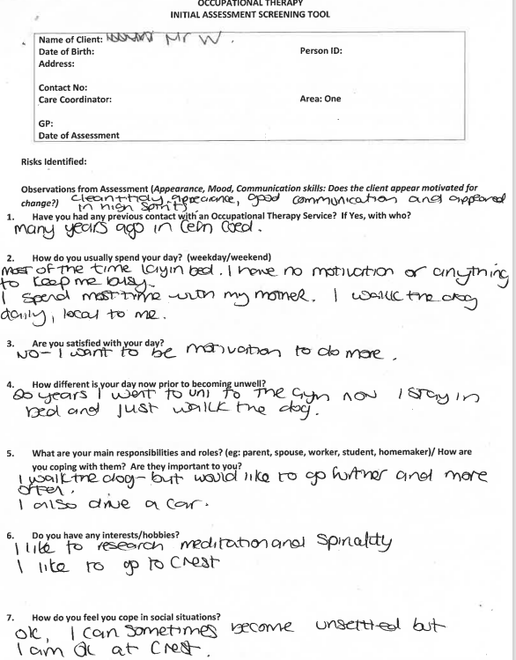
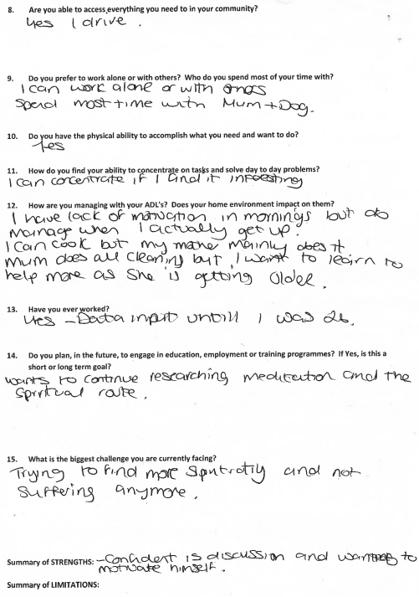
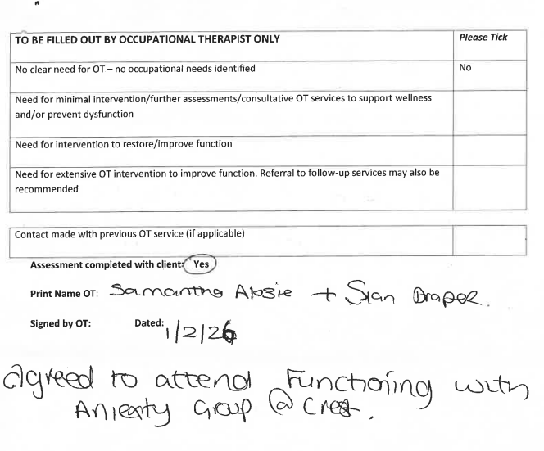
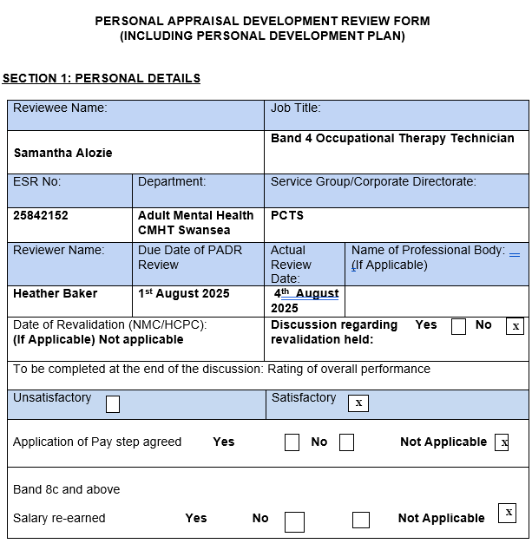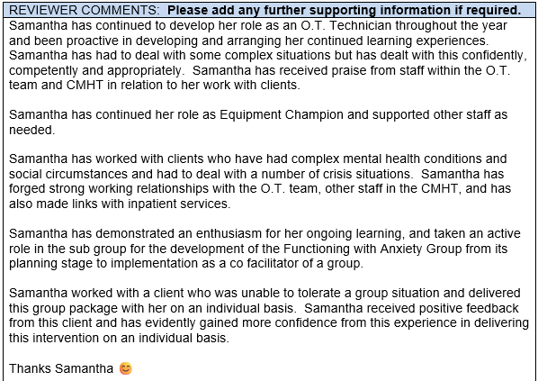
Evidence of personal appraisal development plan.
Appendix 4 pages 13/14

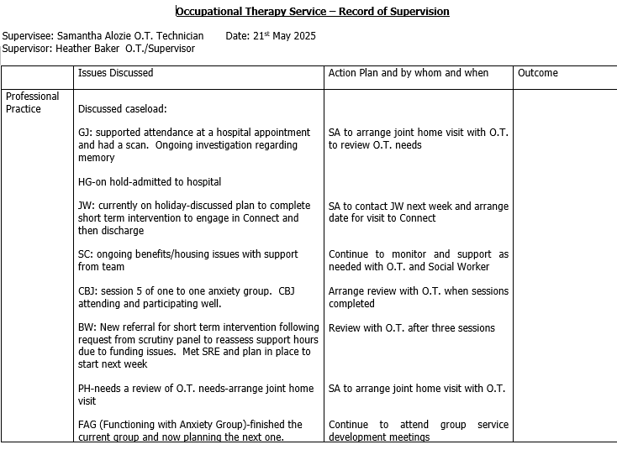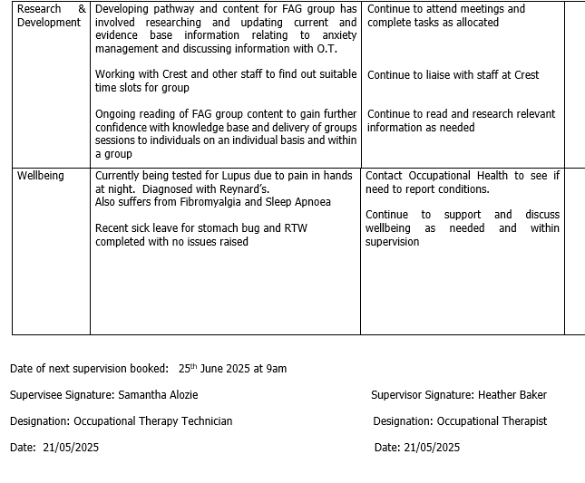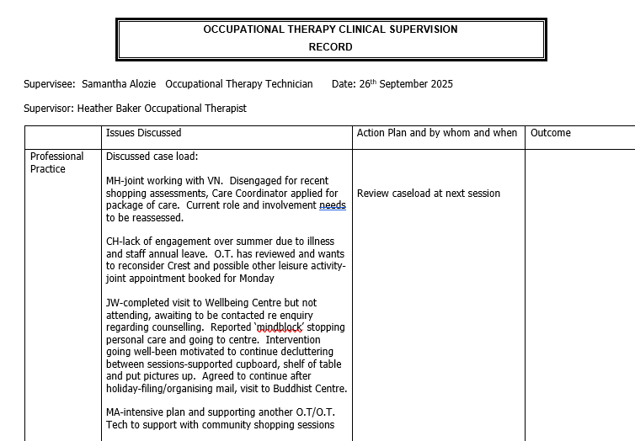
Evidence of 2 supervisions.
Appendix 5 pages 15/18
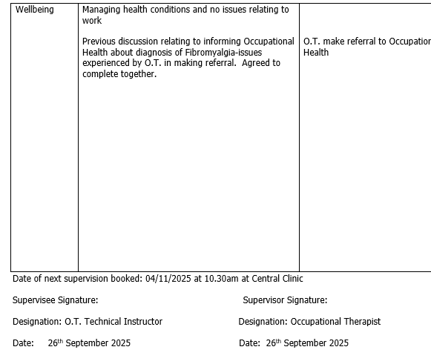

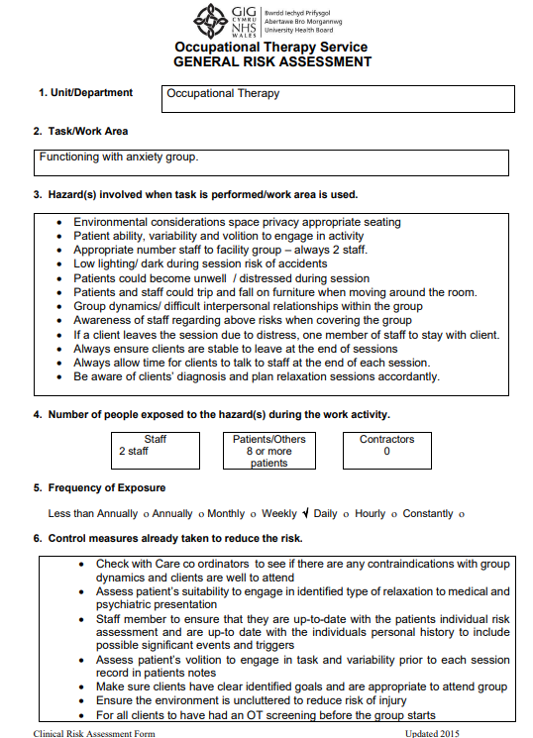
Evidence of Risk assessment.
Appendix 6 pages 19/20
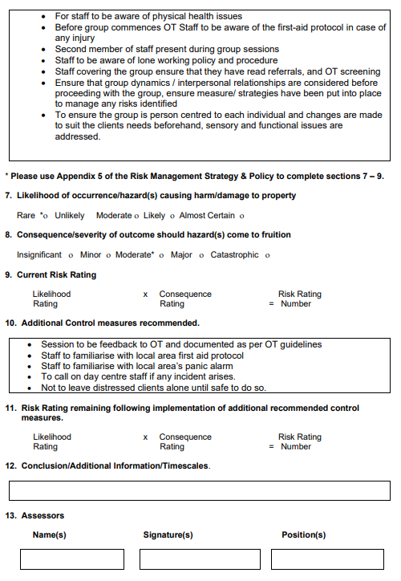Samantha Alozie SAlozie OT Tech
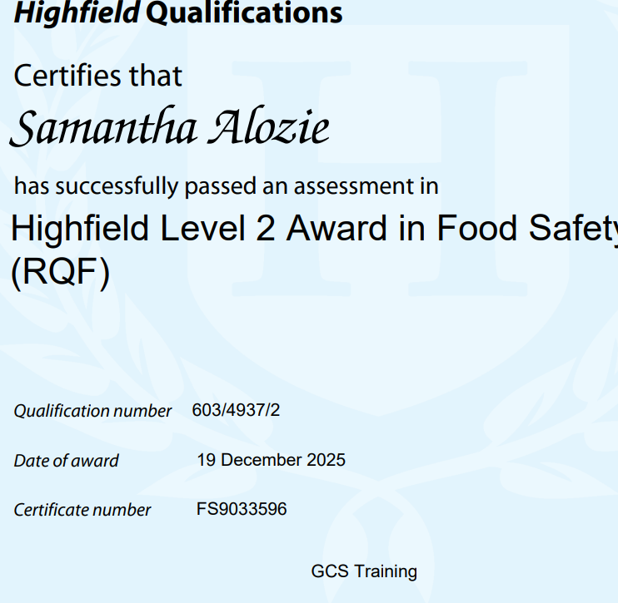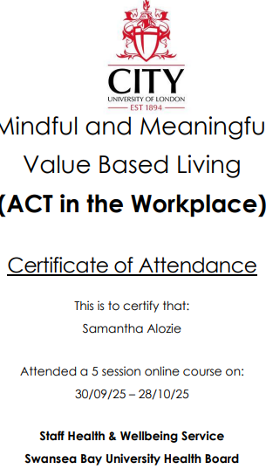
Evidence of training.
Appendix 7 pages 21/23



