Module Name: Contemporary Themes in the Hotel
and Hospitality Sector
Module Code: BMIH6001
Student Name: Abdul Mannan
Student Id: 2009122

Table of Contents
1 Importance of IoT technology for the hospitality sector of UK 3
2. Background of the hospitality sector of the UK 3
3. Use of IOT in the hospitality industry of the UK 4
4. Impact of IoT on the hospitality industry 5
5. Theories for the implementation of IOT in hotels 6
6. Application of IOT in the housekeeping of UK hospitality sector 7
7. Impact of IOT in housekeeping 8
8. Recommendations for the management of IOT in UK hospitality sector 9
9. Recommendations for the management of IoT in housekeeping 9
10. Conclusion 10
Slides……………………………………………………………………………………………11
References……………………………………………………………………………………….17

1 Importance of IoT technology for the hospitality sector of UK
- The Internet of Things (IoT) has become a very important part of the hospitality industry of the UK.
- IoT enables sensors, track room occupancy for better resource management.
- IoT also helps to monitor time equipment and it also ensures maintenance and reduces the work time of the employees.
This IoT technology helps the hospitality sectors to enhance their efficiency and guest experiences (Infante-Moro et al., 2021). This includes smart devices like thermo, thermostats and lights which optimise energy usage and have a low cost. Guests benefit from personalised services through the connected devices, like in room tables for controls.

2. Background of the hospitality sector of the UK
- The hospitality sector of the UK includes hotels, restaurants, and tourism services.
- The UK’s hospitality sector plays a very important role in their economy to provide jobs and boost the local businesses.
- The hospitality industry of the UK is mainly focused on customer satisfaction (Tektelic, 2022).
Hospitality sector of the UK is known for their historical, landmarks and cultural attractions. This plays a pivotal role in the country's overall economy. The sector of the UK is utilising mode trends and embracing advanced technology to enhance their customer experiences.

3. Use of IOT in the hospitality industry of the UK
- The hospitality industry of the UK is using the Internet of Things (IoT) to enhance their customer service and efficiency.
- This not only benefits tourists but helps businesses understand and provide for customer needs.
- IoT is transforming the tourism and hospitality sector in the UK by introducing cashless transactions, and proactive support.
Safety is a priority in hospitality, contributing to surveillance tracking systems of IoT an hotel can enhance their security. Advanced sensors help hotels to clean rooms more efficiently, which saves money and prevents issues. IoT enables better control over room temperature and entertainment settings which provides personalised experiences for the guest of the hotels (MEWS, 2022).

4. Impact of IoT on the hospitality industry
- IoT has both positive and negative impacts on the UK hospitality industry.
- Relying too much on this tech can lead to disruptions if there are network or technical problems.
- Connecting devices in the IoT world can risk customer data through cybersecurity issues.
- On a positive note, hotels can save their costs and energy by using smart devices like lights and thermostats that automatically adjust.
The customers enjoy a better experience with personalised features such as smart TVs and voice-activated assistants with the help of IoT(AQUA LIBRACO, 2022). It is also expensive to make different IoT devices work together in hotels. Privacy becomes a concern as these devices collect lots of information about guests. In summary, while IoT can help hotels and restaurants save money, provide better experiences, and operate more efficiently, it also brings risks like cybersecurity threats, privacy concerns, and technical challenges. Creating a balance is crucial for the hospitality industry to make the most of IoT benefits while managing its downsides.

5. Theories for the implementation of IOT in hotels
- In the housekeeping area of hotels utilising Lewin's Change management theory is very beneficial for improvement.
- Housekeeping in hotels can also implement IoT through Herberg’s Two Factor Theory.
- Herberg’s Two Factor Theory focuses on both hygiene and motivational factors of the employees
- By implementing these theories, the workplace management can be improved and that the staff can also be motivated.
Firstly, it is very important to initiate the change by introducing IoT to the housekeeping staff (Mercan et al., 2020). The application of Lewin's Change Management theory includes a clear plan to enhance the entire housekeeping service. For example, equipping housekeeping carts with smart sensors, it will help to track inventory. This will also be helpful in timely restocking of the cleaning supplies. Implementing smart locks and adjusting lighting systems based on the room occupancy can help to reduce energy consumption.
The application of Two-factor theory will ensure the motivation and efficiency of the employees so that they can work with the new technologies. The employees will get motivated as they will get growth opportunities and proper training on IoT. The satisfaction of the employees can help the hotel to maintain a well equipped and comfortable environment for the customers.

6. Application of IOT in the housekeeping of UK hospitality sector
- In the hospitality sector of the UK, IoT helps to enhance housekeeping by implementing smart devices.
- Mobile apps empower staff to manage tasks efficiently, like receiving time alerts for room turnovers.
- Implementation of the smart IoT devices promotes sustainable practices in housekeeping.
IoT includes an automated sensor, monitor room occupancy, smart locking system, voice control customer service and many more (Nadkarni et al., 2020). By implementing devices such as smart bean signals, it can help to optimise waste management. IoT also enables cleaning tools, track, usage and maintenance. This will help to ensure timely replacements of the bins. This connectivity can help to enhance the operational efficiency and the guest experiences

7. Impact of IOT in housekeeping
- In the hospitality sector of the UK, IoT has both positive and negative impacts.
- IOT enables housekeeping tools, like smart cleaning devices and inventory management systems.
- IOT poses a risk of technical glitches, which can disrupt the operations.
The positive side is that IOT devices like smart lights and energy efficient appliances enhance resource management. Automatic cleaning devices help employees by reducing their work and saving their time (Mercan et al., 2021). IoT innovations enhance the work efficiency and the satisfaction of the guests. However, IoT also increases some concerns, like too much dependency on smart devices. Smart devices also collect personal information, which can potentially expose the customers to cyber threats. It is very important to create a balance between the usage of the IOT.

8. Recommendations for the management of IOT in UK hospitality sector
- The hotels need strong cybersecurity to protect customer data through IoT.
- They should also invest in employee training to enhance the operational efficiency (Pelet et al., 2021).
The hotels need to make a proper plan by selecting scalable and interoperable IOT solutions. Implementing clear privacy policies to address concerns about guest information is also very important.

9. Recommendations for the management of IoT in housekeeping
- Ensure secure connectivity to protect guest privacy (Chopra et al., 2022).
- Use smart sensors for real-time monitoring of room occupancy and resource needs.
The hotels can provide staff training for IoT device usage. Regular update and maintain IoT systems is required for optimal performance. The hotels must implement automated cleaning schedules based on occupancy data.

10. Conclusion
- In conclusion, IoT helps to enhance efficiency and guest experiences.
- It brings many valuable improvements to the UK hospitality industry.
- Careful planning, employee training, and maintaining updated systems are key to a successful integration of IoT in the UK hospitality sector.
IOT offers benefits like energy savings and personalised services, It also poses challenges such as cybersecurity risks and privacy concerns.

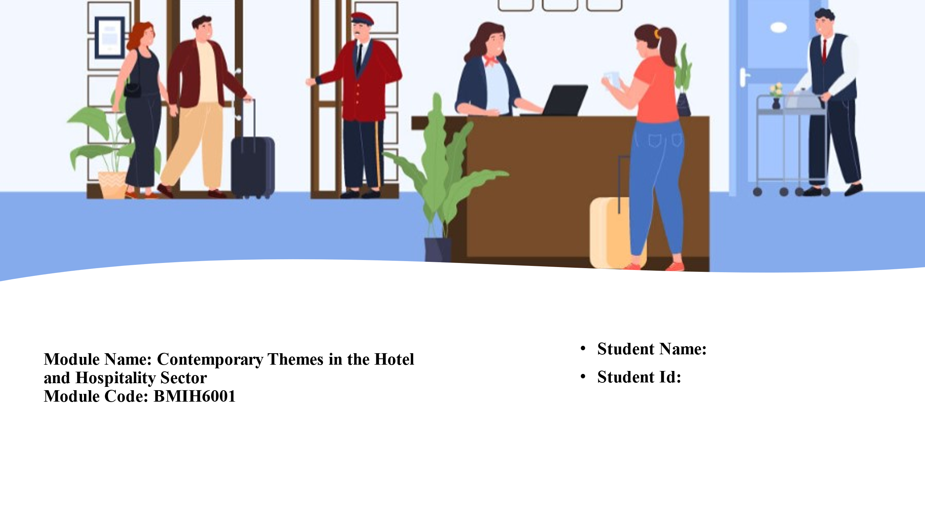

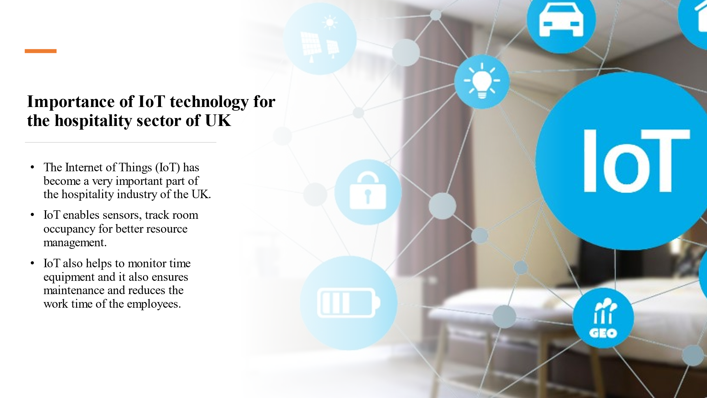



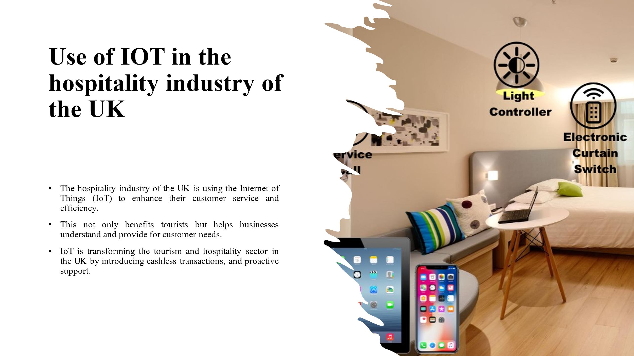

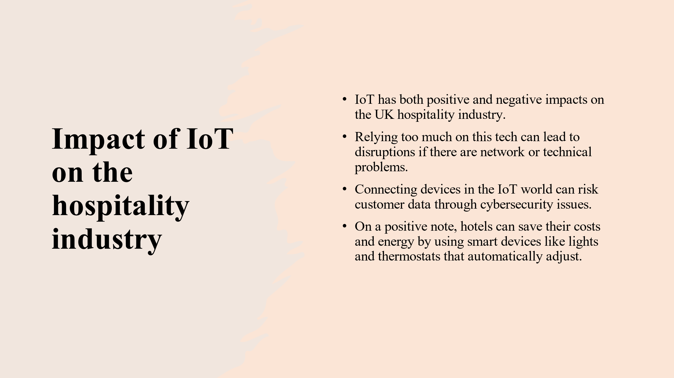

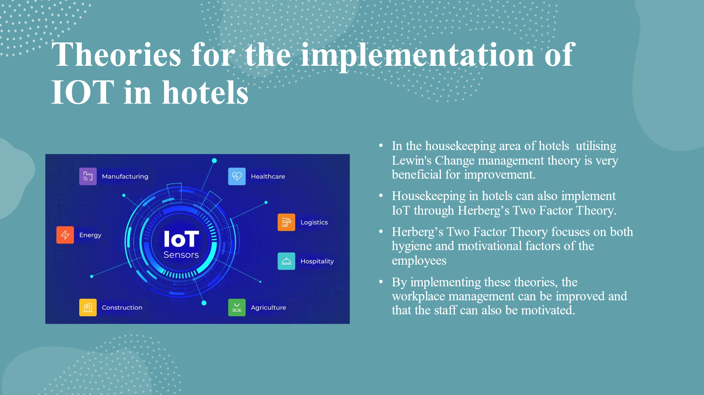

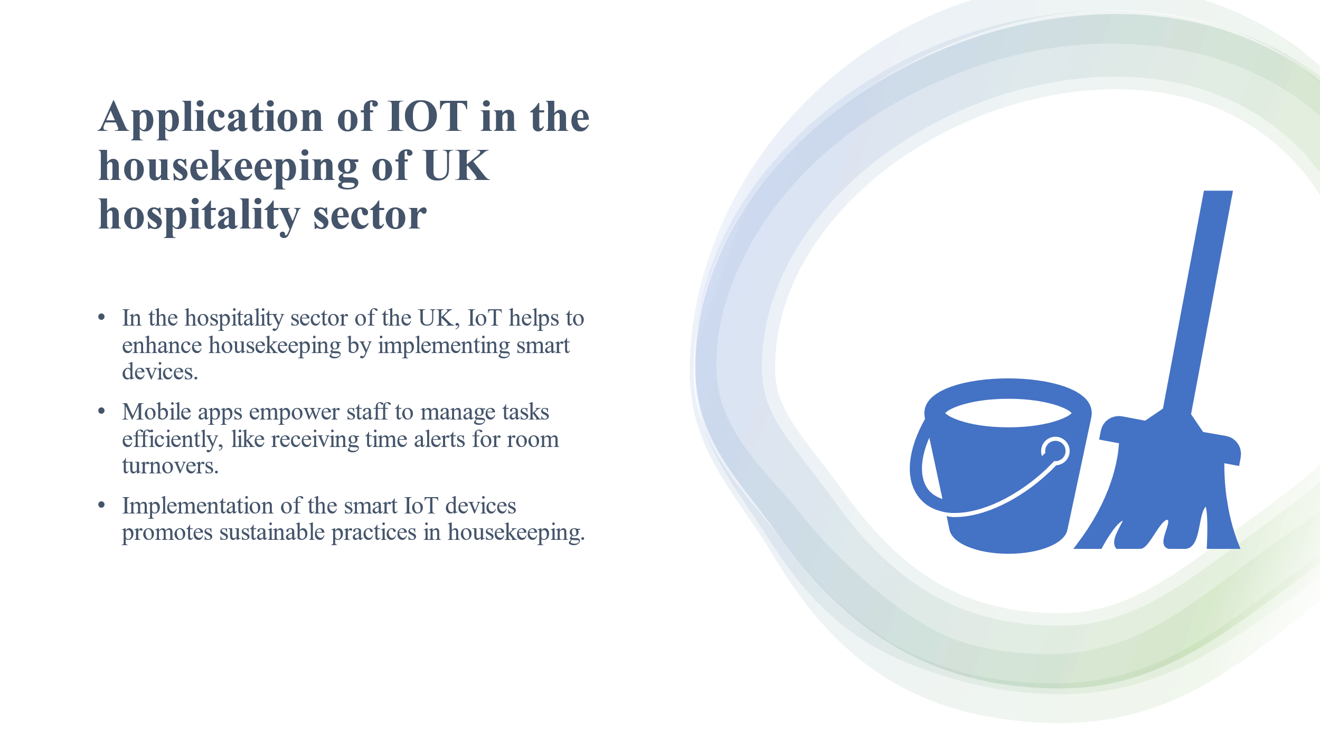

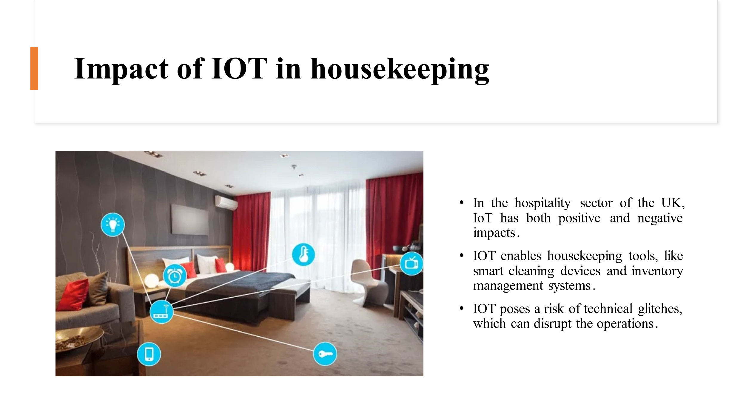

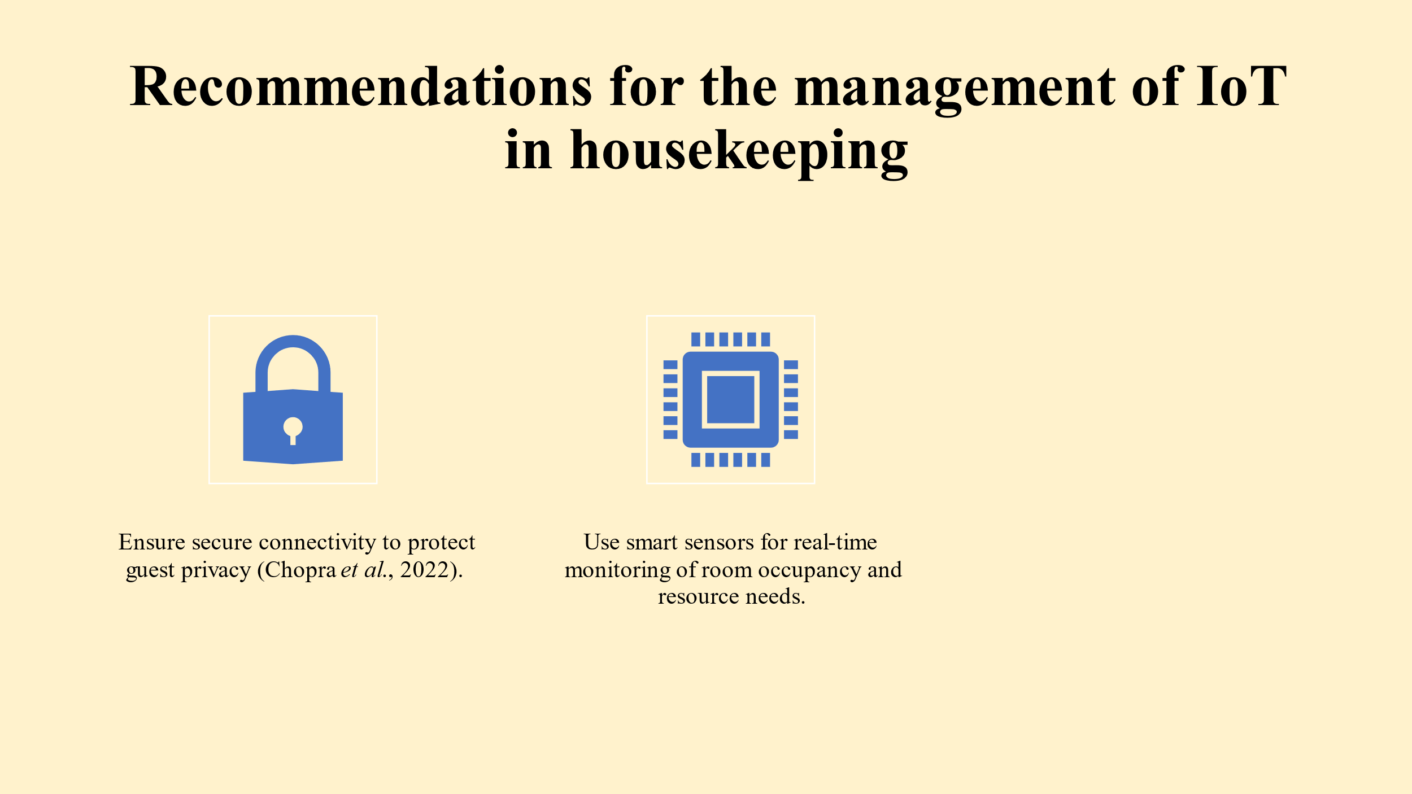

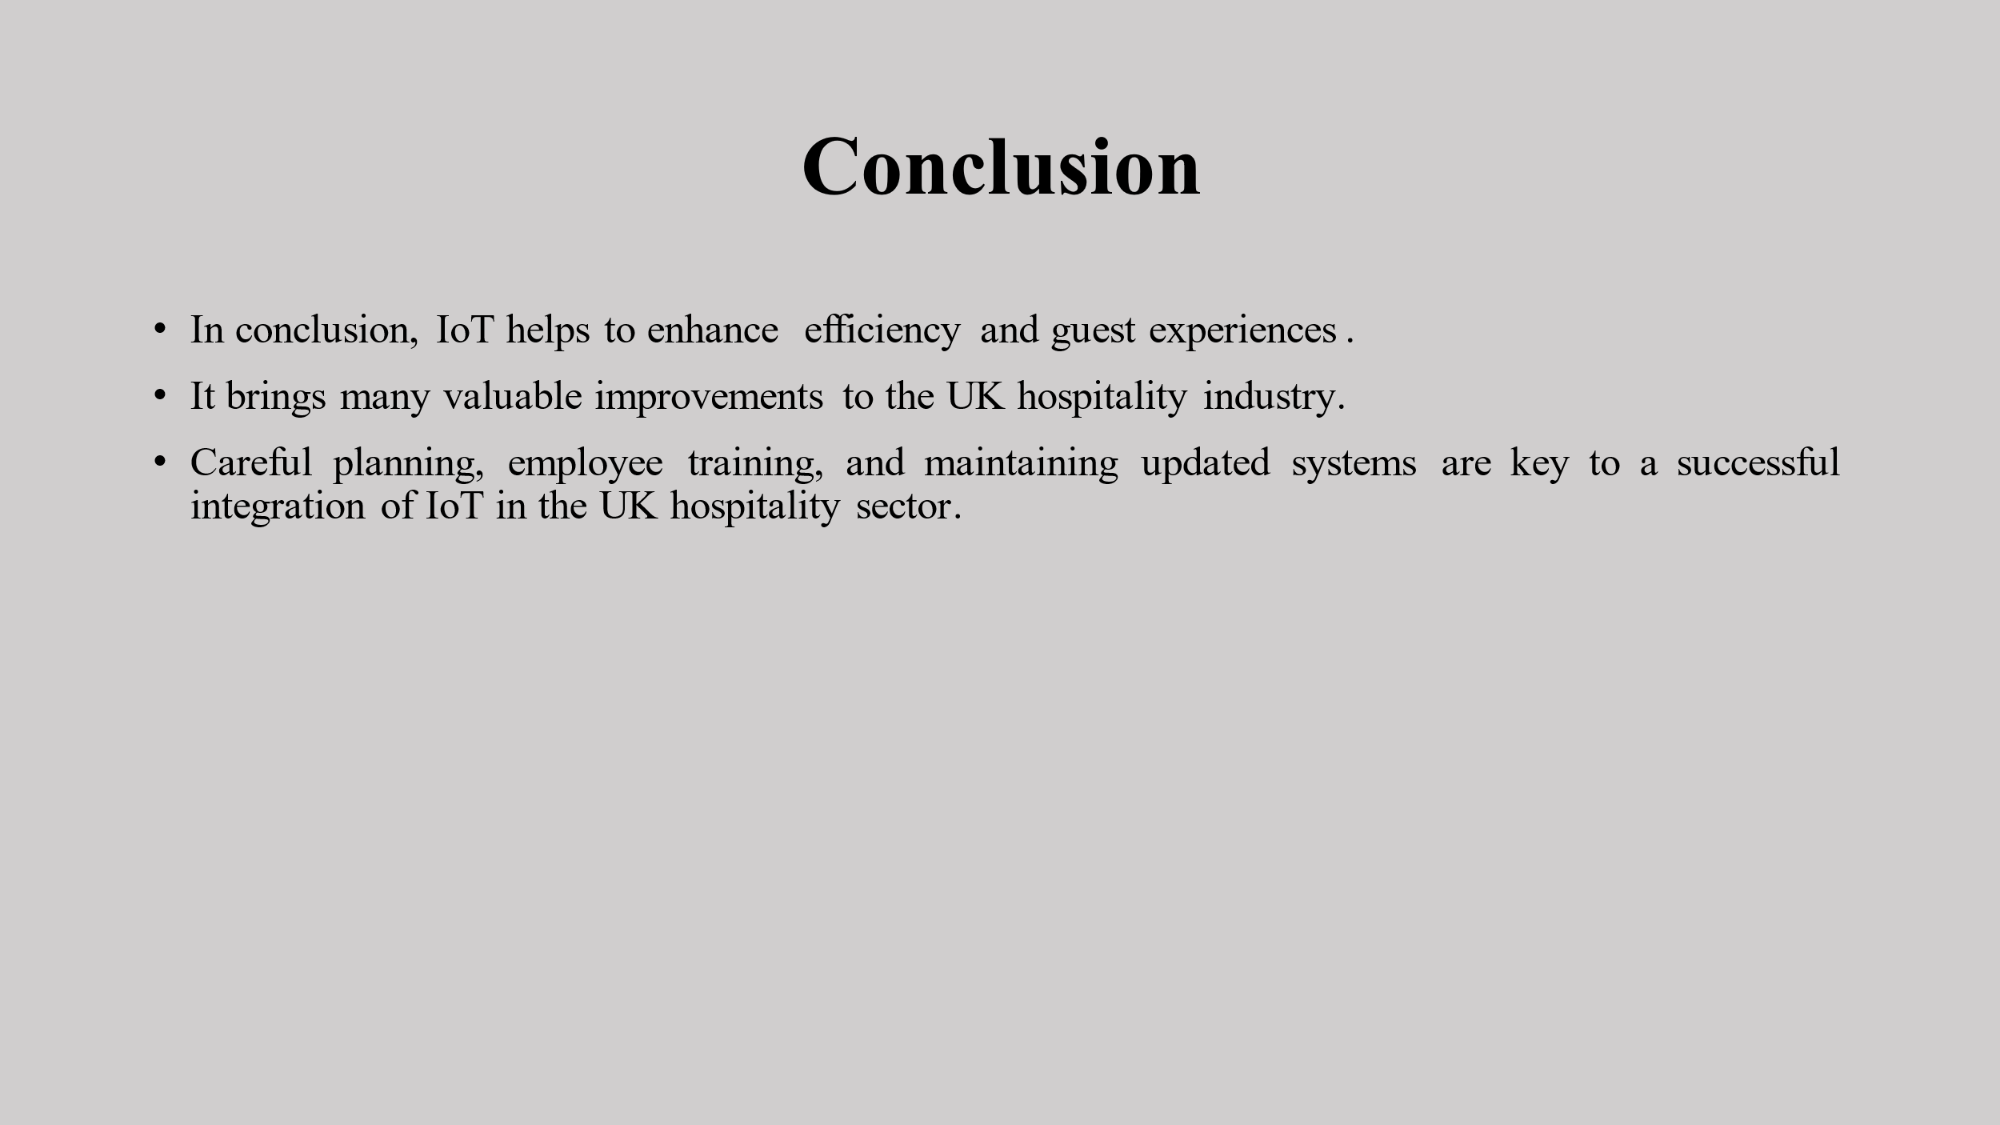

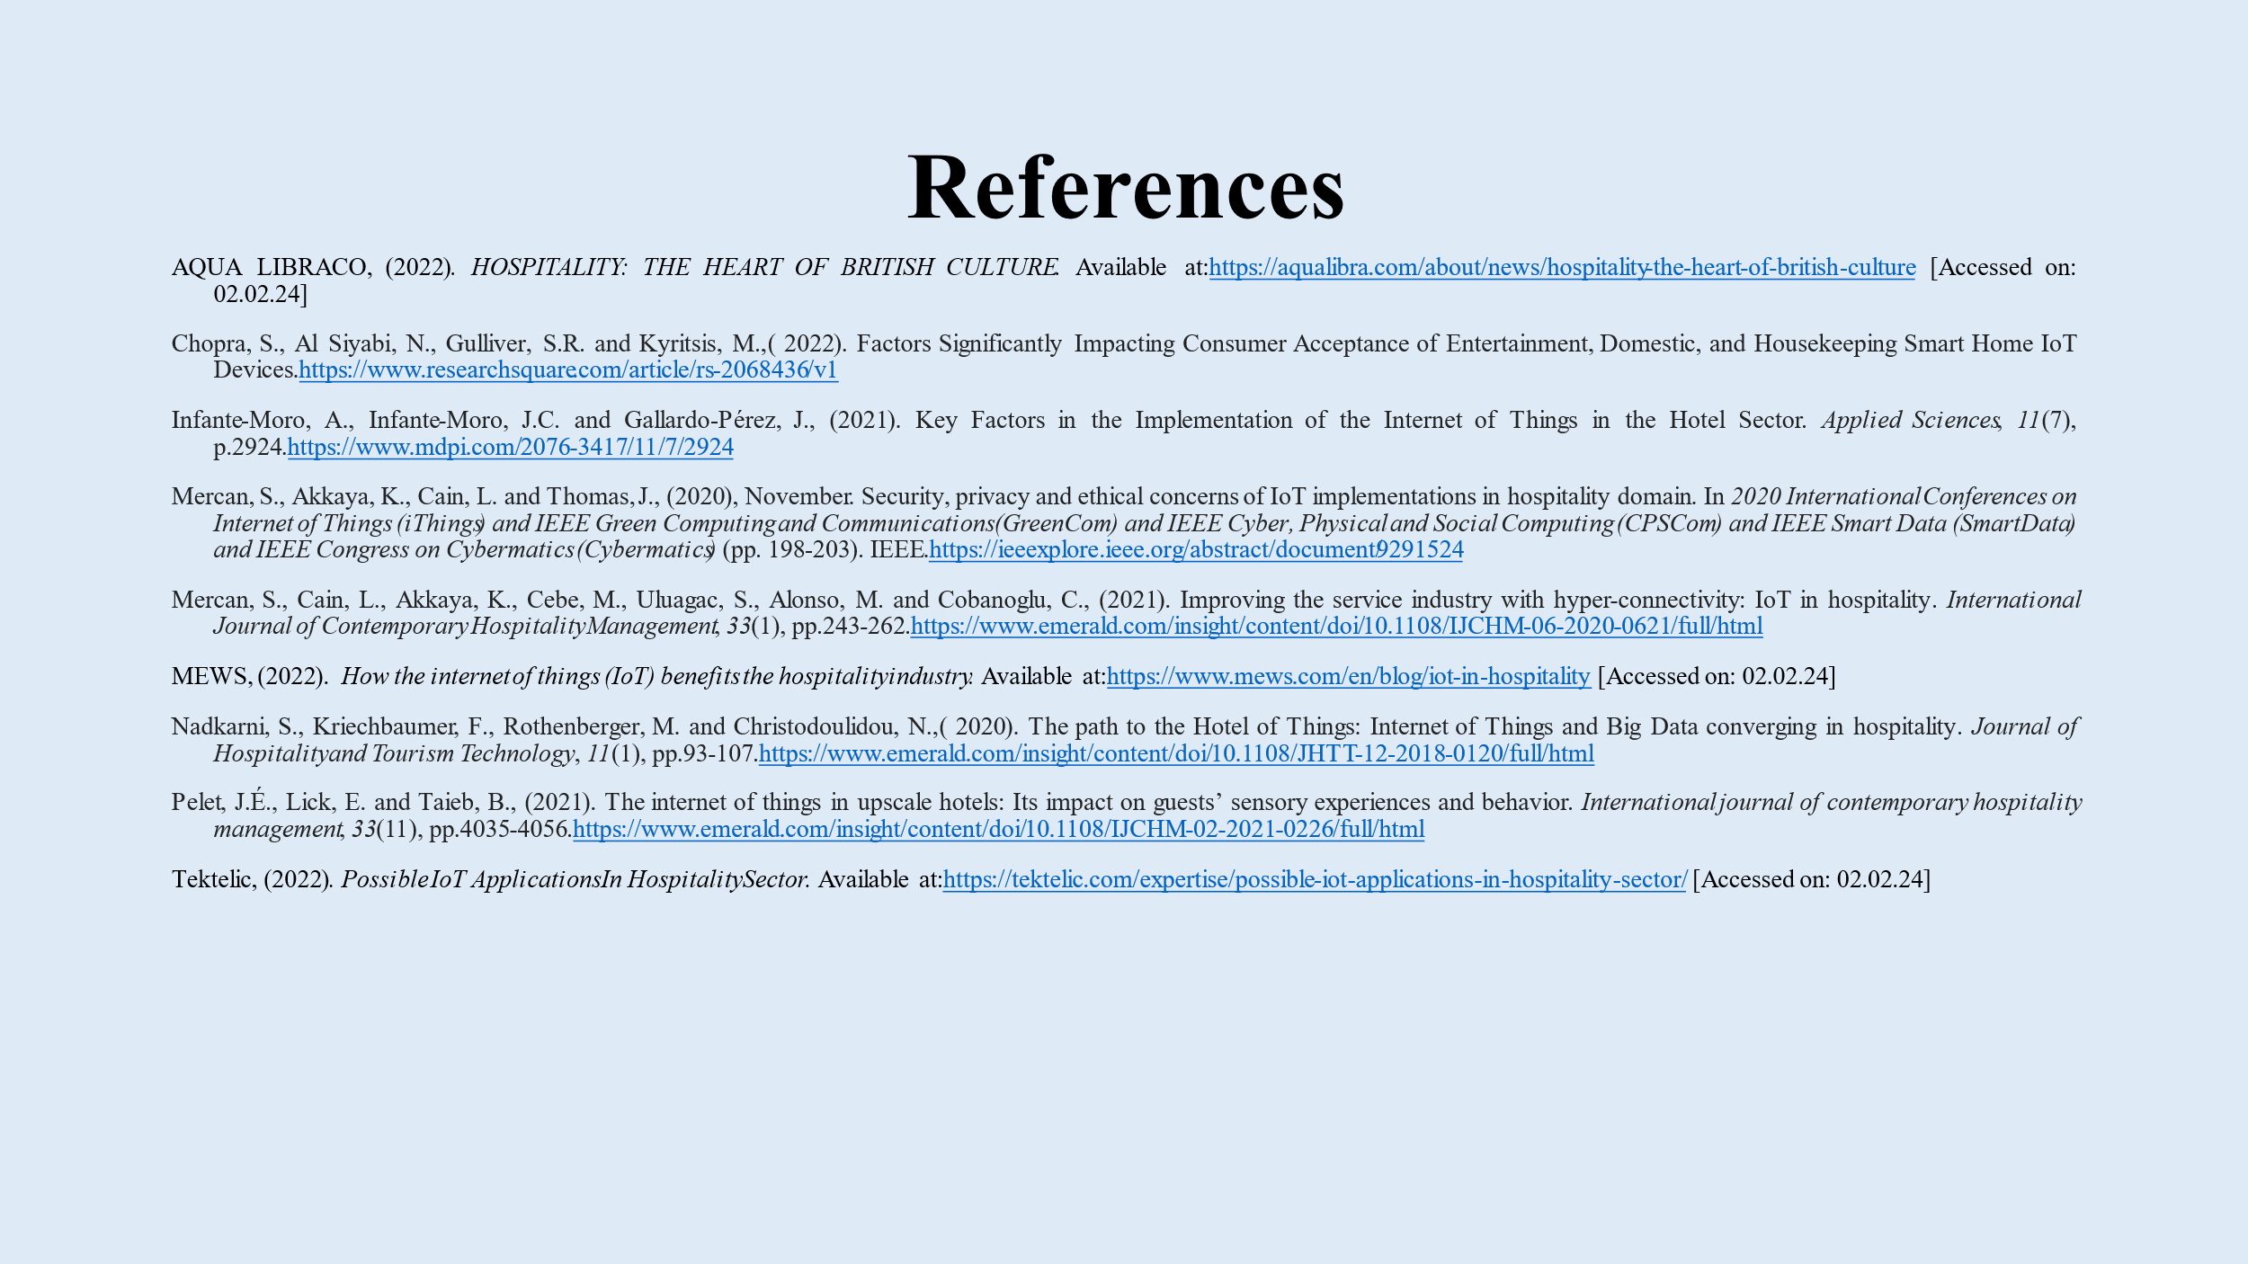

References
AQUA LIBRACO, (2022). HOSPITALITY: THE HEART OF BRITISH CULTURE. Available at:https://aqualibra.com/about/news/hospitality-the-heart-of-british-culture [Accessed on: 02.02.24]
Chopra, S., Al Siyabi, N., Gulliver, S.R. and Kyritsis, M.,( 2022). Factors Significantly Impacting Consumer Acceptance of Entertainment, Domestic, and Housekeeping Smart Home IoT Devices.https://www.researchsquare.com/article/rs-2068436/v1
Infante-Moro, A., Infante-Moro, J.C. and Gallardo-Pérez, J., 2021. Key Factors in the Implementation of the Internet of Things in the Hotel Sector. Applied Sciences, 11(7), p.2924.https://www.mdpi.com/2076-3417/11/7/2924
Mercan, S., Akkaya, K., Cain, L. and Thomas, J., (2020), November. Security, privacy and ethical concerns of IoT implementations in hospitality domain. In 2020 International Conferences on Internet of Things (iThings) and IEEE Green Computing and Communications (GreenCom) and IEEE Cyber, Physical and Social Computing (CPSCom) and IEEE Smart Data (SmartData) and IEEE Congress on Cybermatics (Cybermatics) (pp. 198-203). IEEE.https://ieeexplore.ieee.org/abstract/document/9291524
Mercan, S., Cain, L., Akkaya, K., Cebe, M., Uluagac, S., Alonso, M. and Cobanoglu, C., (2021). Improving the service industry with hyper-connectivity: IoT in hospitality. International Journal of Contemporary Hospitality Management, 33(1), pp.243-262.https://www.emerald.com/insight/content/doi/10.1108/IJCHM-06-2020-0621/full/html
MEWS, (2022). How the internet of things (IoT) benefits the hospitality industry. Available at:https://www.mews.com/en/blog/iot-in-hospitality [Accessed on: 02.02.24]
Nadkarni, S., Kriechbaumer, F., Rothenberger, M. and Christodoulidou, N.,( 2020). The path to the Hotel of Things: Internet of Things and Big Data converging in hospitality. Journal of Hospitality and Tourism Technology, 11(1), pp.93-107.https://www.emerald.com/insight/content/doi/10.1108/JHTT-12-2018-0120/full/html
Pelet, J.É., Lick, E. and Taieb, B., (2021). The internet of things in upscale hotels: Its impact on guests’ sensory experiences and behavior. International journal of contemporary hospitality management, 33(11), pp.4035-4056.https://www.emerald.com/insight/content/doi/10.1108/IJCHM-02-2021-0226/full/html
Tektelic, (2022). Possible IoT Applications In Hospitality Sector. Available at:https://tektelic.com/expertise/possible-iot-applications-in-hospitality-sector/ [Accessed on: 02.02.24]

