BSc (Hons) Computing Portfolio

Design and Evaluation of Wireless Sensor Networks

ACCB5004

Wireless Networks and Simulation

Julie Millard

P150865

Lecturer: Simon Downes

Table of Content
Abstract 4
Introduction: Part One. The function of modulation in a communication system. 4
Research and Evaluation of Modulation Schemes 4
Amplitude 4
Frequency 4
Phase 4
How the concepts and principles of computer network simulations relate to communication systems? 5
1 Noise 5
1.1 Internal Noise 5
1.2 External Noise 5
2 Latency 5
3 Jitter 5
Quadrature Phase Shift Keying (QPSK) Modulation Technique 5
QPSK Block Build 6
Conclusion 7
Introduction: Part Two Wireless Sensor Network Design for a Small Smart Farm. 7
Assumptions 7
Farm Layout: 7
Old Tahoe 8
Modulation Technique 8
Latency 8
Delay 8
Jitter 8
Packet Loss 9
Throughput 9
Rayleigh Fading 9
Pathloss 9
Sink Node 9
Advanced Encryption Standard Encryption 9
Experiment Baseline 0 to 11 Rayleigh Pathloss 9
Conclusion 10
Appendix 11
Bibliography 12

Table of Figures
Figure 1: Carrier Wave and Modulated Signals [5] 5
Figure 2: Phase [12] 5
Figure 3:Phase Modulated Wave [4] 6
Figure 4: QPSK Wave Form[27] 7
Figure 5: QPSK Phase Shift in Degrees [27] 7
Figure 6: QPSK and OKPSK Waveform [26] 7
Figure 7: QPSK Block Build 7
Figure 8:Signal to Noise Ratio from 0 - 100 per cent 8
Figure 9:Signal to Noise Ratio from 0 - 100 per cent 8
Figure 10: Signal to Noise Ratio 40 per cent 8
Figure 11: Layout of Farm in Netsim also in appendix 8
Figure 12: Farm for Visualization [40] 9
Figure 13: Farm Layout 9
Figure 14: Close up of Backbone 9
Figure 15: Advanced Encryption Standard Design [44] 10
Figure 16: Average Packets Generated, Received and the Throughput at 0 Rayleigh Pathloss 10
Figure 17: Throughput 0-5 pathloss Rayleigh 11
Figure 18: Average Packets Generated, Received and the Throughput at 11 Rayleigh Pathloss 11
Figure 19: Throughput Graph 11
Figure 20: Delay Graph 11
Figure 21: Farm Network Layout 12

Abstract
The following report includes two experiments. The first experiment covered modulation communication systems and focused on Quadrature Phase Shift Keying and using this method to simulate the effects of noise on a network using Simulink to calculate the Bit Error Rate. It was found that introducing noise into the network did not produce the expected result of distorted signal. The second experiment consisted of utilizing NetSim to create a network for a small smart farm. The outcome of this experiment did not reflect the expected correlation between Rayleigh Fading and throughput but found that delay and throughput were related.

Introduction: Part One. The function of modulation in a communication system.
The technique of carrying digital data over analogue waveforms is known as digital modulation. There are three distinct characteristics to a carrier wave, also known as a sinusoidal wave. They are phase, amplitude and frequency. Altering one of these characteristics changes the modulation technique and these altered techniques are called phase shift keying, amplitude shift keying and frequency shift keying. Once the modulation has taken place and the digital data has been transmitted, the instrument receiving the information must demodulate the signal extracting the original digital data [1]–[3]. Modulation strengthens the signal, allowing the signal to travel a greater distance [4].
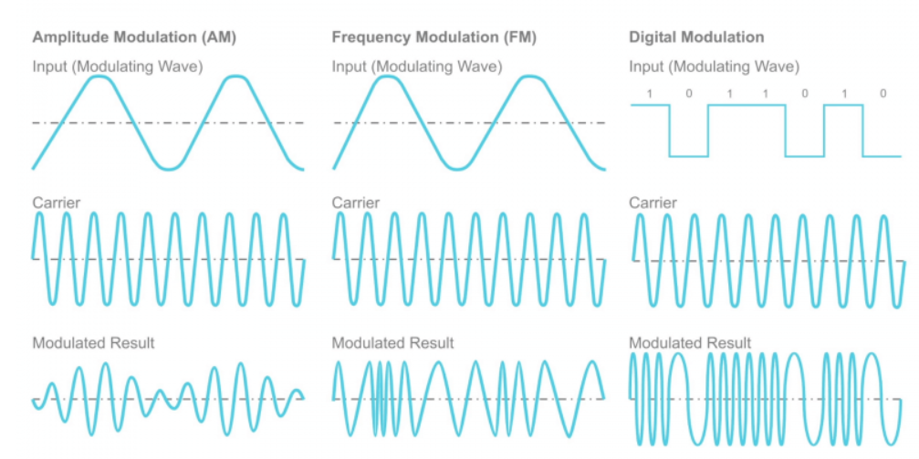
Figure 1: Carrier Wave and Modulated Signals [5]

Research and Evaluation of Modulation Schemes
Binary Phase Shift Keying allows digital data to be transmitted over analogue waveforms at the rate of one bit per symbol, while Quadrature Phase Shift Keying allows twice as much data transmitted over the same bandwidth. Quadrature Amplitude Modulation is a more complicated method and uses both phase and amplitude modulation to achieve an even higher rate of data transmission [5]–[8].

Amplitude
Amplitude of a wave can be described as movement from lowest point to highest point of a wave cycle.[9], [10]

Frequency
Wave frequency is described as how often a complete wave passes through a given space in a given time. Frequency of waves is usually counted in number of waves per second, or hertz per second [11].

Phase
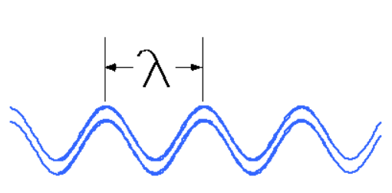
Figure 2: Phase [12]
Fig two is a phase which is the distance from one peak of a signal to the next.
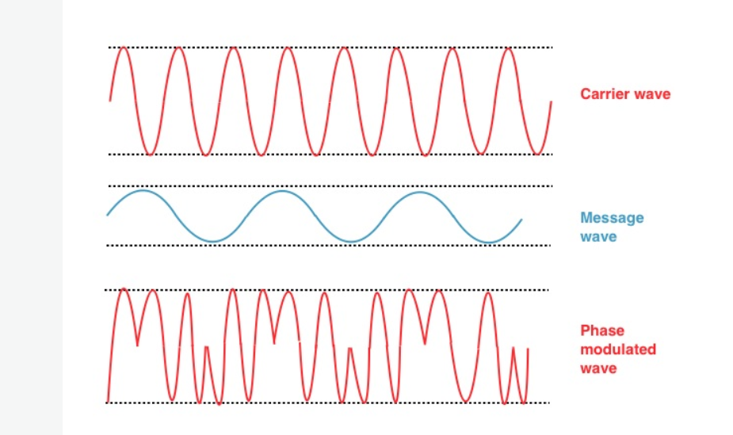Figure 3:Phase Modulated Wave [4]

How the concepts and principles of computer network simulations relate to communication systems?
Computer network simulation software facilitates realistic results to be obtained without the expensive outlay required to test in a real-life scenario. It allows for challenges to be explored, the outcomes analysed, evaluated and implemented [13]–[15]. Thus, permitting projects to proceed in a more expedient manor. Simulation software is also useful as a teaching aid, giving fundamental hands-on experience, allowing students to explore different procedures without damaging networks. When this is applied to communication systems it allows the user to implement simulations based on bit error rate (BER) which measures the amount of bits transmitted against the amount of bits received [16], throughput, the amount of data processed in a given time [17], Signal to Noise Ratio (SNR)

1 Noise
When data is transmitted over the airwaves, it is accompanied by other forms of energy. It is this other energy that is defined as noise. Noise is broken down into two different types: Internal Noise and External Noise.

1.1 Internal Noise
Internal Noise can be categorised as Shot Noise, which is produced randomly by electron movement, Transit Time Noise, produced during transmission by charge carriers, and Thermal Noise. As Thermal Noise has a spectral density that is uniform, it is also known as White Noise and is generated by electrons affected by thermal motion inside resistors.

1.2 External Noise
External Noise can be categorised as Man Made Noise, which uses a broad range of frequencies and is transmitted akin to radio waves. It is produced by electrical items such as computer systems or fluorescent lighting. Other sources include Extra-terrestrial Noise, which is generated, as the name suggests, in outer space, and Atmospheric Noise. Atmospheric Noise is naturally occurring electricity that is usually discharged during electrical storms. It is random in nature and is not limited to one frequency [18]–[20].

2 Latency
Latency in computer networks is the amount of time a packet of data takes to travel over a network. It is usually measured in milliseconds. The higher the milliseconds, the higher the latency. Low latency is an indication of an efficient network [21]–[23].

3 Jitter
Jitter is when data being transferred over a network has minute delays between packet transmissions. This can occur for many reasons, including congestion, signal interference or collisions on the network [24], [25].

Quadrature Phase Shift Keying (QPSK) Modulation Technique
QPSK modulation technique was chosen as Simulink is limited to the use of QPSK. Technically it uses OQPSK which is QPSK, but the signal is offset [26].
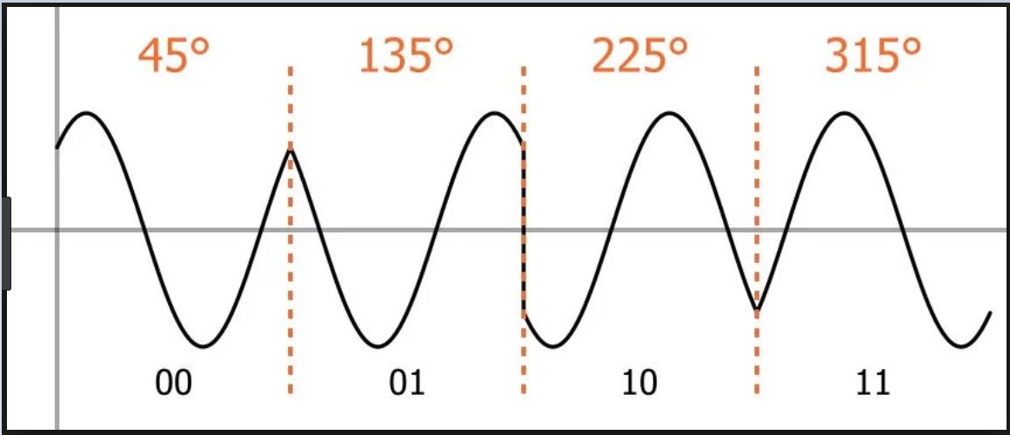
Figure 4: QPSK Wave Form[27]

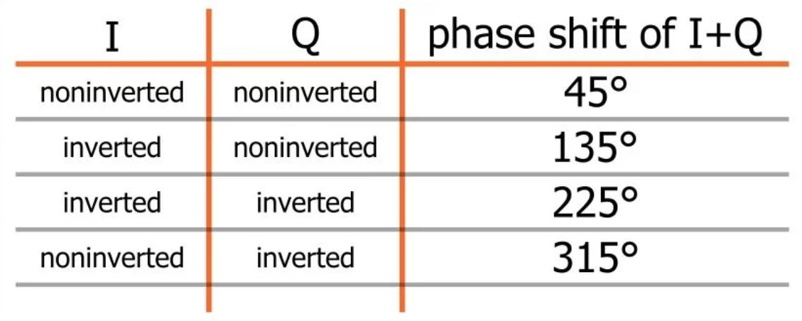
Figure 5: QPSK Phase Shift in Degrees [27]

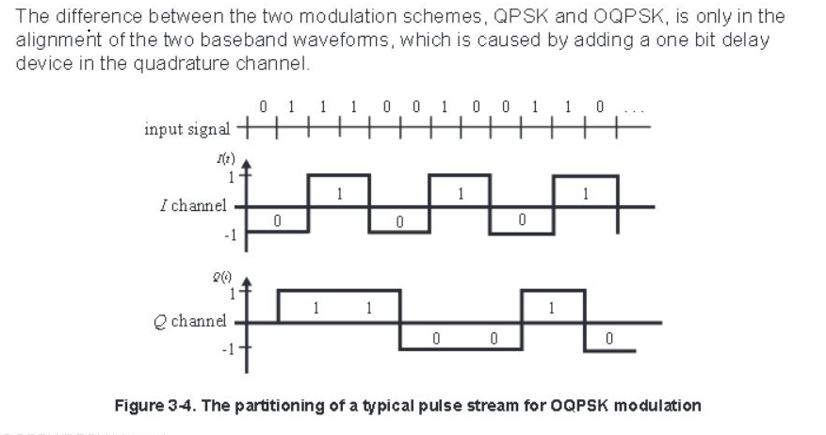
Figure 6: QPSK and OKPSK Waveform [26]
As shown in Fig five, the difference between
“QPSK and OQPSK is the delay in the quadrature channel” [26].
There are 360 degrees to a complete waveform cycle. A phase is effectively defined as:
“The position of a point in time (instant) on a waveform cycle” [28].
When a signal is modulated, the carrier-wave timing is moved - phased. Signals sent on the same frequency at different times are known as leading phase and lagging phase. As shown in Fig 4. The phase shift is always 90-degree increments. This is known as quadrature phase shift keying. The phase can also be 180 degrees (90 x 2), when this occurs it is considered to be in ‘phase opposition’ [28]–[32].

QPSK Block Build
To build the QPSK block a random integer generator was used and was set to a number value of four. This was connected to an integer to bit converter through a MUX, allowing the binary values to be split. The next part was to connect two unipolar to bipolar converters using 0, M-1 where M is the M-ary number [33]. The sine and cosine waves were offset by 180 degrees. This was joined to the sum block which joins the signals back together. A gaussian filter was added to remove the noise and the process was reversed [34]–[39]. As shown in Fig seven below.
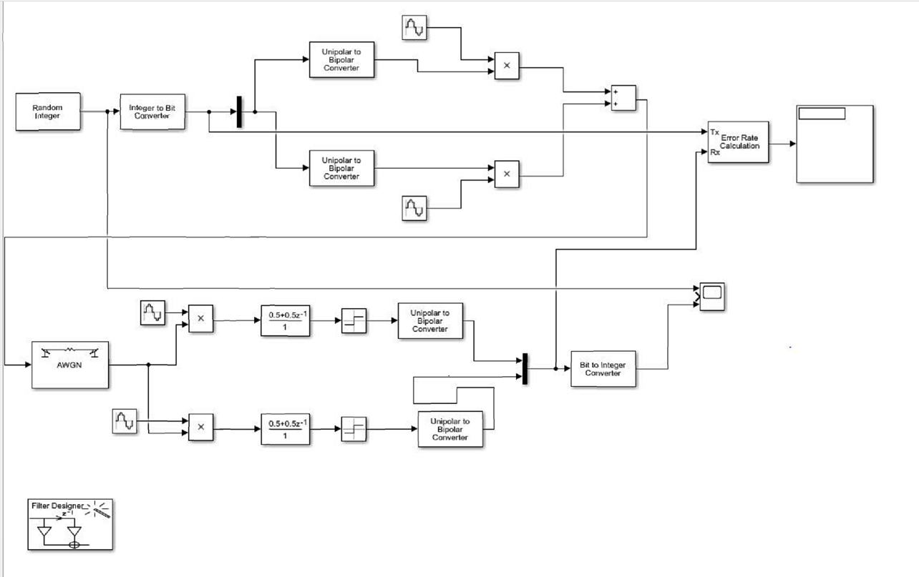
Figure 7: QPSK Block Build

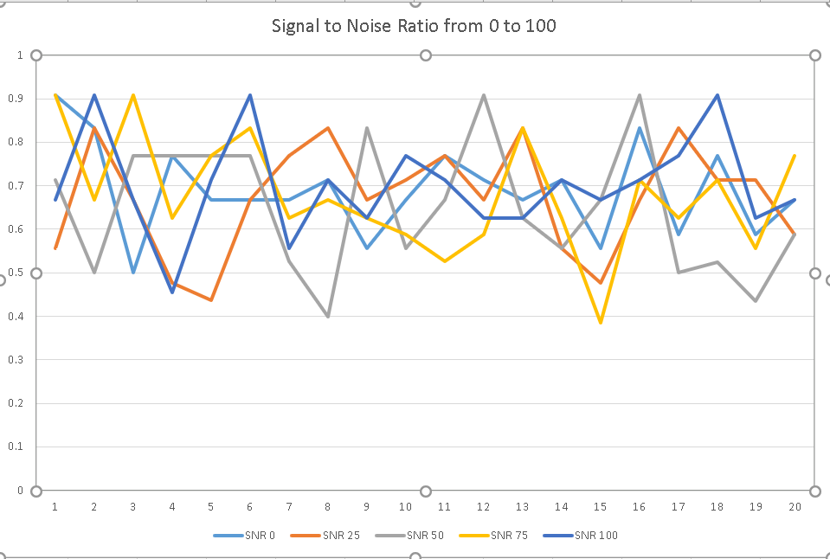
Figure 8:Signal to Noise Ratio from 0 - 100 per cent
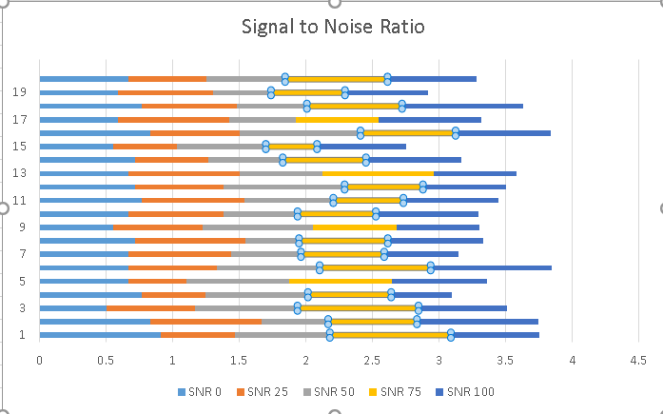
Figure 9:Signal to Noise Ratio from 0 - 100 per cent
Fig eight and nine shown above is the signal to noise ratio from zero to one hundred per cent.
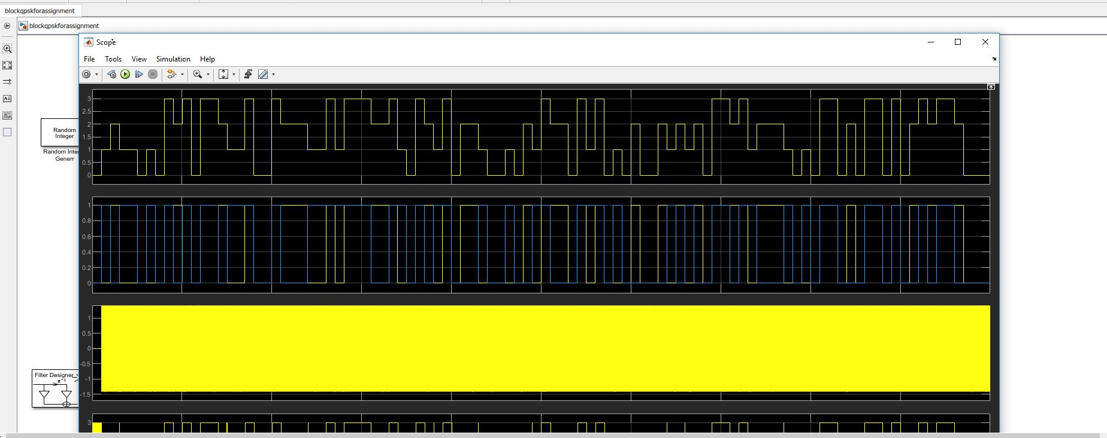
Figure 10: Signal to Noise Ratio 40 per cent
Fig ten above shows the output of a sinusoidal wave with a signal to noise ratio set to forty per cent.

Conclusion
The author expected to see a steady increase in the distortion of the information as more noise was introduced. The information gathered did not show this to be the case.

Introduction: Part Two Wireless Sensor Network Design for a Small Smart Farm.
As the Internet of Things (IoT) becomes more widely used farms are now able to take advantage of this technology to help increase productivity. Netsim was used to simulate a smart farm and an experiment was run to show how the farm would work.

Assumptions
It is assumed that all relevant security measures have been carried out on the router, switch, access points and nodes. The farmer’s office computer is directly connected to the server, along with printer and any other office equipment required. There is a firewall in place. Due to the time restriction placed on the use of Netsim, (Netsim not being available for Easter break) the experiments were run five times. The background map was originally utilized but it kept moving so it was removed.

Farm Layout:
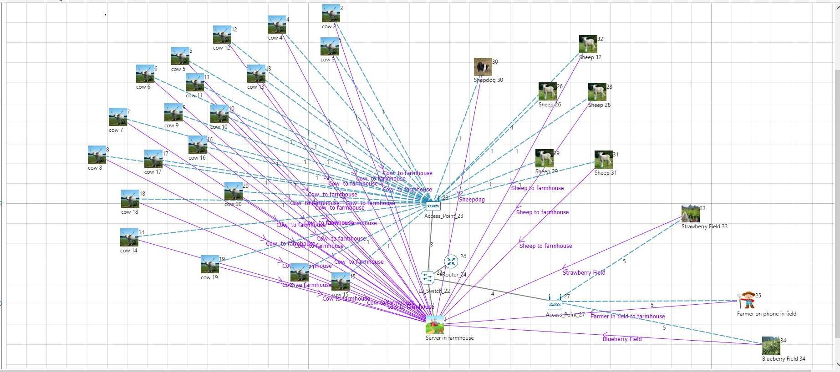
Figure 11: Layout of Farm in Netsim also in appendix
Fig eleven shows a farm layout in NetSim. The layout is 500 meters by 500 meters. It has 20 nodes for cows, 5 nodes for sheep, a node for a sheepdog, 2 nodes for fruit fields and a node for the farmer while outside. The nodes connect to access points. The farmer has an access point that is used by himself and the fruit fields. The sensors in the fruit fields send data three times per day, so the farmer has better access to the home server as there is very little traffic on this part of the network.
Sensors in the fields track the soil temperature and water saturation, these would be set to transmit gathered data periodically. This would mean short bursts of concentrated activity to the access point. The sensors on the animals would be set to allow continuous dataflow. This could cause data collision and packet loss.
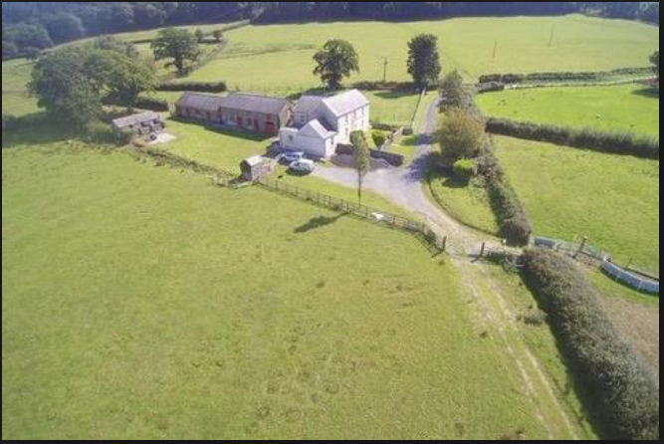
Figure 12: Farm for Visualization [40]
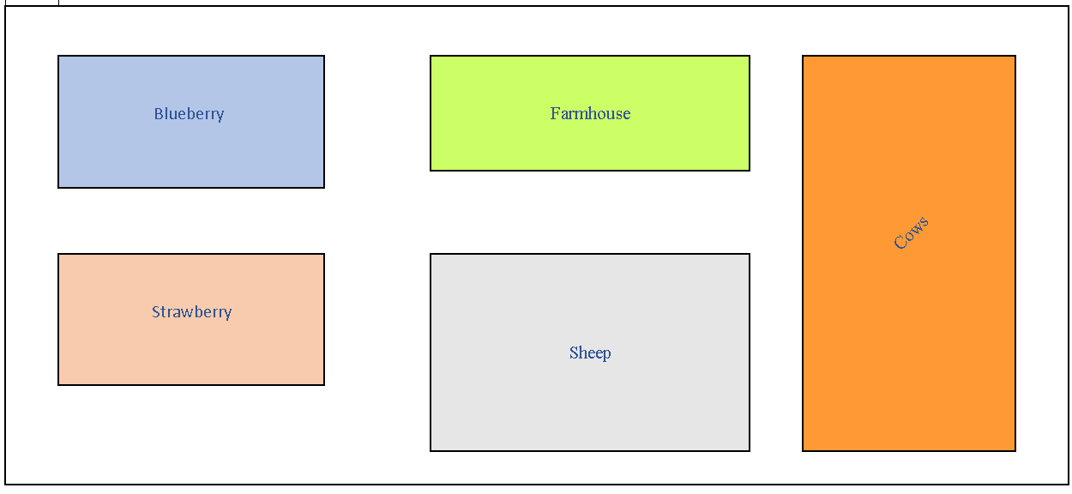
Figure 13: Farm Layout

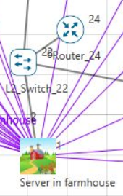
Figure 14: Close up of Backbone
Fig fourteen above shows the server connected to a switch which is in turn connected to a router. In the farmhouse the office would have a computer connected to the server.

Old Tahoe
The transmission control protocol (TCP) used in the above simulation was Old Tahoe. It uses congestion avoidance and a slow start [40].

Modulation Technique
As NetSim uses O-QPSK (Offset quadrature phase shift keying), This is the modulation technique used. To transmit the signal, it utilizes four separate values of the phase [41].

Latency
As mentioned in part one (2) latency is the interval between receiving instructions to transmit and actually transmitting information [42].

Delay
Like latency, delay is also connected to the amount of time it takes for data to be transmitted and received over a network.

Jitter
As previously mentioned in part one (3) jitter is delays in transmission. As the delays vary, packets of information can arrive at their destination out of sequence. In some instances, such as audio or video, this would result in packet loss causing a distortion of the information received [42].

Packet Loss
Packet loss occurs for many reasons such as collision of data on a network, or low signal strength. This can result in lower quality audio or video, or missing information [43], [44].

Throughput
The amount of information that is passed from source to destination in a specific amount of time is known as throughput [45].

Rayleigh Fading
Rayleigh fading was used and is a representation of signal amplitude variation as experienced by the receiver based on a statistical model. It takes place when the line of sight between a receiver and transmitter is obstructed. This can be due to scattering, refraction or reflection of particles in the atmosphere[41], [46].

Pathloss
Degradation of a signal caused by conditions in the atmosphere is called pathloss [41].

Sink Node
When data is sent over a network, the destination node is known as a sink node. It is where all the data is collected. The energy consumption of the network will be impacted by the positioning of the sink node [47], [48].

Advanced Encryption Standard Encryption
Advanced Encryption Standard (AES) encryption was used in this simulation. It consists of AES-128,192 and AES-256 block ciphers to encrypt and decrypt information. The sender and receiver use the same key for encryption and decryption [43].
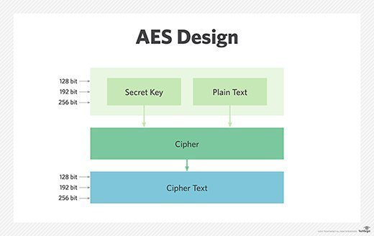
Figure 15: Advanced Encryption Standard Design [43]

Experiment Baseline 0 to 11 Rayleigh Pathloss
Tests were run with no pathloss and the information was analysed against introduced pathloss at varied degrees of 5, 7, 9 and 11 Rayleigh pathloss.
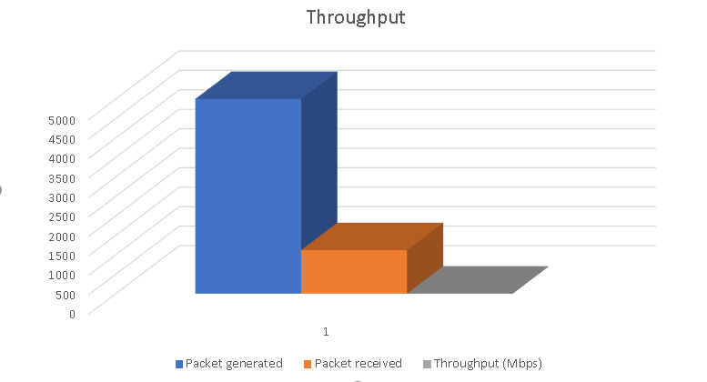
Figure 16: Average Packets Generated, Received and the Throughput at 0 Rayleigh Pathloss
Fig sixteen above shows the average packets generated at 0 pathloss were 4998.3, out of which only 1116.7 packets reached the destination. The average payload (bytes) sent was 7297512.592 with only 1630333.33 bytes received. The average throughput was 0.1304 megabits per second with an average 38102532.98 microsecond delay. So, we can see that even at 0 pathloss the layout of the farm network is not conducive to receiving information.
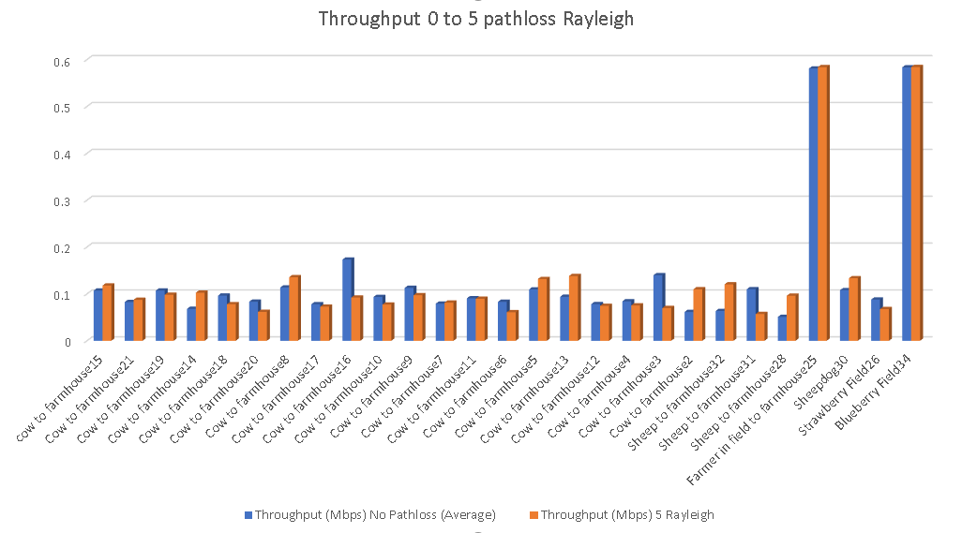
Figure 17: Throughput 0-5 pathloss Rayleigh
The 0-5 Rayleigh pathloss graph Fig seventeen shows as expected with 0 pathloss the throughput was on average better than at pathloss 5 Rayleigh. Where the throughput was greater at Rayleigh 5 pathloss it appears, there were packet collisions in neighbouring nodes.
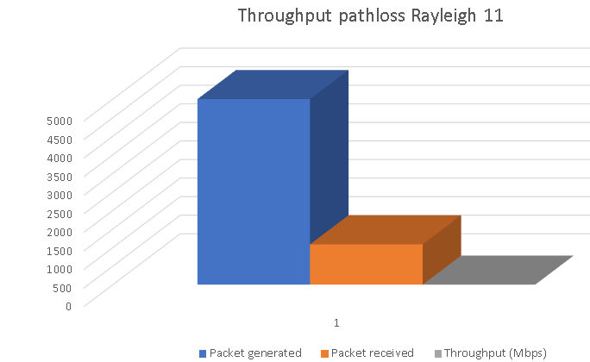
Figure 18: Average Packets Generated, Received and the Throughput at 11 Rayleigh Pathloss
As shown in Fig eighteen above, the average throughput for Rayleigh 11 pathloss looks the same as the 0 Rayleigh pathloss.
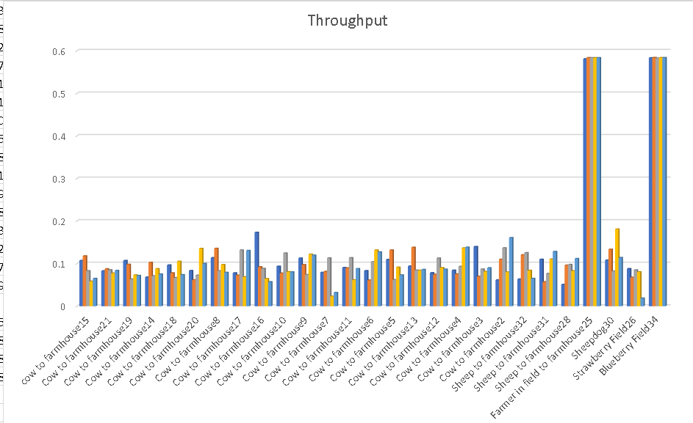Figure 19: Throughput Graph
In the above graph, Fig nineteen, the farmer and the blueberry field have almost the same throughput at all the levels of pathloss, whereas the strawberry field, which is connected to the same access point does not fare as well on any of the pathloss. This could be because the farmer and the blueberry field sensors are closer to the access point.
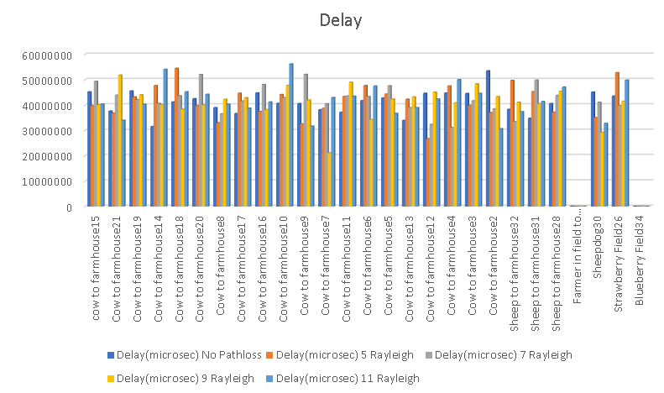Figure 20: Delay Graph
When looking at the delay graph, Fig twenty, it becomes clear that the reason the farmer and the blueberry field are having better results is because there is very little delay involved at any of the pathloss values.

Conclusion
Further experiments need to be conducted before the information collected can be analysed in-depth. The results show that with no path loss there is a significant amount of data that is not reaching the destination. When Rayleigh fading was introduced there was very little if any difference in the throughput. What did make a difference was the amount of traffic on the network. The network that had only three sensors had significantly more throughput. The delay on the strawberry network is mirrored by the lack of throughput received. It would be advantageous to have more access points available to the network to lessen the volume of traffic. This in turn would help with the throughput and delay.

Appendix

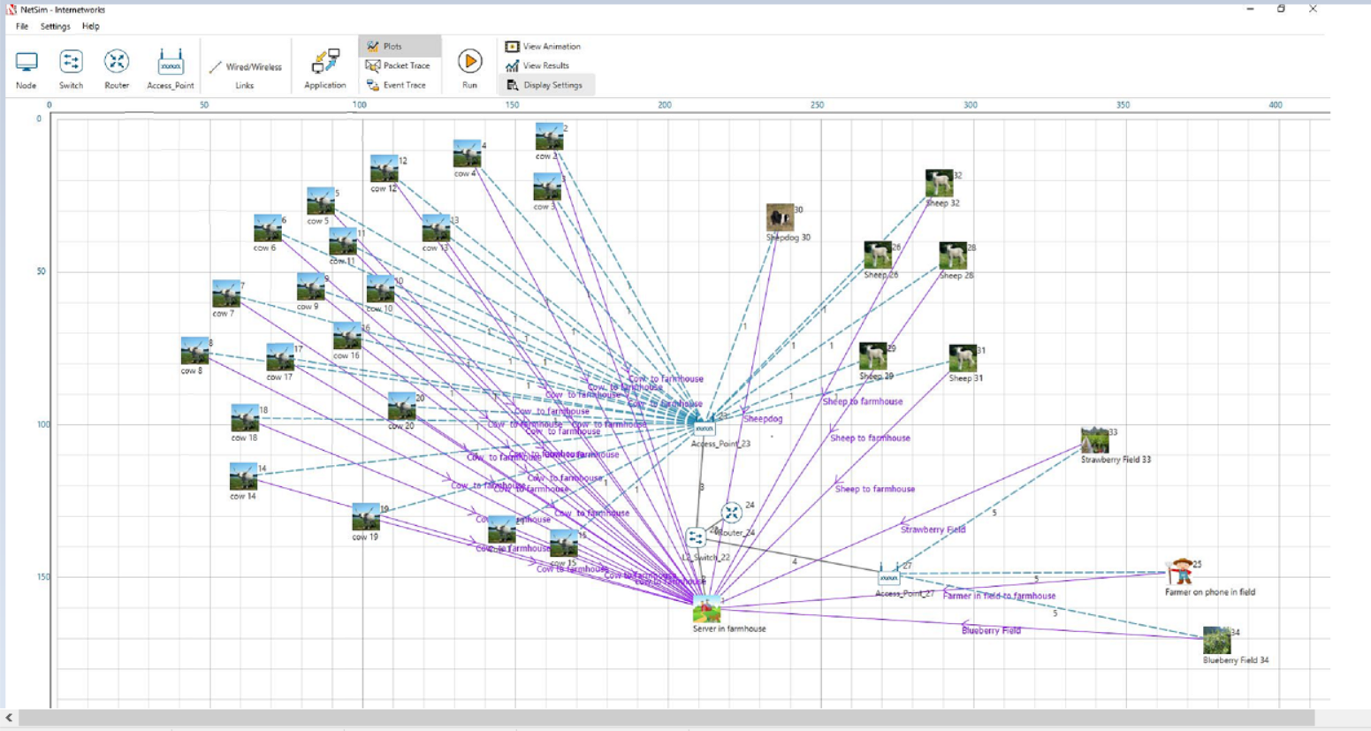
Figure 21: Farm Network Layout

Bibliography
[1] techopedia, “What is Modulation? - Definition from Techopedia,” 2019. [Online]. Available: https://www.techopedia.com/definition/8409/modulation. [Accessed: 27-Mar-2019].
[2] edgefix.in, “What is Modulation? Different Types of Modulation Techniques,” 2019. [Online]. Available: https://www.edgefx.in/types-of-modulation-techniques-with-applications/. [Accessed: 27-Mar-2019].
[3] “Modulation Schemes: Moving Digital Data With Analog Signals | EE Times,” 1997. [Online]. Available: https://www.eetimes.com/document.asp?doc_id=1255090. [Accessed: 03-Apr-2019].
[4] T. Point, “Modulation Graphical,” 2018. [Online]. Available: https://www.tutorialspoint.com/communication/modulation_graphical.asp. [Accessed: 03-Apr-2019].
[5] D. Noordhof, Ian, “How does modulation work? | Tait Radio Academy,” 2019. [Online]. Available: https://www.taitradioacademy.com/topic/how-does-modulation-work-1-1/. [Accessed: 03-Apr-2019].
[6] electronicsnotes, “What is QAM: Quadrature Amplitude Modulation | Electronics Notes,” 2019. [Online]. Available: https://www.electronics-notes.com/articles/radio/modulation/quadrature-amplitude-modulation-what-is-qam-basics.php. [Accessed: 08-Apr-2019].
[7] T. Agarwal, “What is Modulation? Different Types of Modulation Techniques,” 2014. [Online]. Available: https://www.edgefx.in/types-of-modulation-techniques-with-applications/. [Accessed: 27-Mar-2019].
[8] tutorialspoint, “Digital Communication Quadrature Phase Shift Keying,” 2019. [Online]. Available: https://www.tutorialspoint.com/digital_communication/digital_communication_quadrature_phase_shift_keying.htm?fbclid=IwAR24Y9rld9E9pUdS0Sggx4qPIOTh7ib_ROnRFhgtTxMj7DCm-OsffejWlys. [Accessed: 27-Mar-2019].
[9] W. Davis, Andrew, “Modulation Schemes: Moving Digital Data With Analog Signals | EE Times,” 2019. [Online]. Available: https://www.eetimes.com/document.asp?doc_id=1255090#.
[10] “The Anatomy of a Wave,” 2019. [Online]. Available: https://www.physicsclassroom.com/class/waves/Lesson-2/The-Anatomy-of-a-Wave. [Accessed: 17-May-2019].
[11] techopedia, “What is Wireless Communications? - Definition from Techopedia,” 2019. [Online]. Available: https://www.techopedia.com/definition/10062/wireless-communications. [Accessed: 27-Mar-2019].
[12] “Wave Properties: wavelengths and phase shifts.” [Online]. Available: http://ww2010.atmos.uiuc.edu/(Gh)/guides/rs/rad/basics/wv.rxml. [Accessed: 17-May-2019].
[13] C. Frenz, “Possibilities and limitations of computer simulation,” IEEE Potentials, vol. 26, no. 2, pp. 30–33, Mar. 2007.
[14] M. Xiannog, “When is Simulation the Appropriate Tool?,” 2018. [Online]. Available: https://www.eg.bucknell.edu/~xmeng/Course/CS6337/Note/master/node2.html. [Accessed: 08-Apr-2019].
[15] E. Malec, “The Benefits of Using Computer Simulation Models to Support Decision-Making,” Springer, Cham, 2018, pp. 205–214.
[16] M. Rouse, “What is bit error rate (BER)? - Definition from WhatIs.com,” 2019. [Online]. Available: https://whatis.techtarget.com/definition/bit-error-rate-BER. [Accessed: 08-Apr-2019].
[17] E. TechTerms, “Throughput Definition,” 2019. [Online]. Available: https://techterms.com/definition/throughput. [Accessed: 08-Apr-2019].
[18] Farlex, “Extraterrestrial noise | Article about extraterrestrial noise by The Free Dictionary,” 2019. [Online]. Available: https://encyclopedia2.thefreedictionary.com/extraterrestrial+noise. [Accessed: 18-Apr-2019].
[19] F. Leferink, “Man-Made Noise In Our Living Environments.” .
[20] R. Hasan, “What is noise in communication system? - Quora,” 2018. [Online]. Available: https://www.quora.com/What-is-noise-in-communication-system. [Accessed: 18-Apr-2019].
[21] Comparitech, “Latency vs Throughput - Understanding the Difference | Comparitech,” 2019. [Online]. Available: https://www.comparitech.com/net-admin/latency-vs-throughput/. [Accessed: 19-Apr-2019].
[22] E. SAS, “What is network latency (and how do you use a latency calculator to calculate throughput)?,” 2019. [Online]. Available: https://www.sas.co.uk/blog/what-is-network-latency-how-do-you-use-a-latency-calculator-to-calculate-throughput. [Accessed: 19-Apr-2019].
[23] Bellevue Linux, “Latency Definition,” 2005. [Online]. Available: http://www.linfo.org/latency.html. [Accessed: 19-Apr-2019].
[24] TechTerm, “Jitter Definition,” 2019. [Online]. Available: https://techterms.com/definition/jitter. [Accessed: 19-Apr-2019].
[25] V. Popeskic, “What is Jitter in Networking?,” 2016. [Online]. Available: https://howdoesinternetwork.com/2013/jitter. [Accessed: 19-Apr-2019].
[26] LABVOLT.COM, “Unit 3 — OQPSK QPSK/OQPSK/DPSK Manual FACET by Lab-Volt 33 Generation and Demodulation of OQPSK Signal.”
[27] Keim.Robert, “Understanding Quadrature Phase Shift Keying (QPSK) Modulation,” 2016. [Online]. Available: https://www.allaboutcircuits.com/technical-articles/quadrature-phase-shift-keying-qpsk-modulation/. [Accessed: 03-Apr-2019].
[28] M. Rouse, “What is phase? - Definition from WhatIs.com,” 2019. [Online]. Available: https://whatis.techtarget.com/definition/phase. [Accessed: 14-Apr-2019].
[29] Keim Robert, “Understanding Quadrature Phase Shift Keying (QPSK) Modulation,” 2016. [Online]. Available: https://www.allaboutcircuits.com/technical-articles/quadrature-phase-shift-keying-qpsk-modulation/. [Accessed: 27-Mar-2019].
[30] “Principles of Communication Modulation.” [Online]. Available: https://www.tutorialspoint.com/principles_of_communication/principles_of_communication_modulation.htm. [Accessed: 06-Mar-2019].
[31] L. Hanzo, W. T. Webb, and T. Keller, “Single-and Multi-carrier Quadrature Amplitude Modulation: Principles and Applications for Personal Communications, WLANs and Broadcasting,” 1999.
[32] M. Rouse, “What is staggered quadrature phase-shift keying? - Definition from WhatIs.com,” 2007. [Online]. Available: https://searchnetworking.techtarget.com/definition/staggered-quadrature-phase-shift-keying. [Accessed: 14-Apr-2019].
[33] Matlab, “Generate integers randomly distributed in specified range - Simulink - MathWorks United Kingdom,” 2019. [Online]. Available: https://uk.mathworks.com/help/comm/ref/randomintegergenerator.html. [Accessed: 17-May-2019].
[34] “QAM and QPSK: Aim.”
[35] Engineering Made EAsy, “QPSK- QPSK Generation and Detection - QPSK Block Diagram (Quadrature Phase Shift Keying) - YouTube.” [Online]. Available: https://www.youtube.com/watch?v=L0KIHbUXF_Y. [Accessed: 17-May-2019].
[36] “full-text.”
[37] “QPSK modulation and Demodulation – GaussianWaves,” 2019. [Online]. Available: https://www.gaussianwaves.com/2010/10/qpsk-modulation-and-demodulation-2/. [Accessed: 17-May-2019].
[38] “QPSK MODULATION AND DEMODULATION QPSK Modulation.”
[39] Tutorialspoint, “Digital Communication Quadrature Phase Shift Keying,” 2019. [Online]. Available: https://www.tutorialspoint.com/digital_communication/digital_communication_quadrature_phase_shift_keying.htm. [Accessed: 17-May-2019].
[40] R. Unnikrishnan, S. R. Devi, R. Ramesh, A. Rajesh, and A. Varma, “A comprehensive analysis of TCP congestion control schemes in wireless mesh networks,” in 2017 International Conference on Intelligent Computing, Instrumentation and Control Technologies (ICICICT), 2017, pp. 247–251.
[41] “NetSim User Manual Contents.”
[42] “Network Latency, Jitter, &amp; Packet Loss – SingleComm,” 2019. [Online]. Available: https://help.singlecomm.com/hc/en-us/articles/115003427168-Network-Latency-Jitter-Packet-Loss. [Accessed: 17-May-2019].
[43] M. Rouse, “What is Advanced Encryption Standard (AES)? - Definition from WhatIs.com,” 2014. [Online]. Available: https://searchsecurity.techtarget.com/definition/Advanced-Encryption-Standard. [Accessed: 17-May-2019].
[44] S. Cooper, “How to Fix Packet Loss - Learn Common Causes &amp; Simple Solutions,” 2019. [Online]. Available: https://www.comparitech.com/net-admin/minimize-packet-loss/. [Accessed: 18-May-2019].
[45] M. Rouse and J. Burke, “What is throughput? - Definition from WhatIs.com,” TechTarget, 2019. [Online]. Available: https://searchnetworking.techtarget.com/definition/throughput. [Accessed: 18-May-2019].
[46] Editors of Encyclopedia Britannica, “Rayleigh scattering | physics | Britannica.com,” Encyclopædia Britannica, inc., 2018. [Online]. Available: https://www.britannica.com/science/Rayleigh-scattering. [Accessed: 18-May-2019].
[47] W. M. Aioffi, G. R. Mateus, and F. P. Quintão, “Optimization issues and Algorithms for Wireless Sensor Networks with Mobile Sink.”
[48] H. Kim, Y. Seok, N. Choi, Y. Choi, and T. Kwon, “Optimal Multi-sink Positioning and Energy-Efficient Routing in Wireless Sensor Networks,” Springer, Berlin, Heidelberg, 2005, pp. 264–274.

marking criteria and Student FEEDBACK

This section details the assessment criteria. The extent to which these are demonstrated by you determines your mark. The marks available for each criterion are shown. Lecturers will use the space provided to comment on the achievement of the task(s), including those areas in which you have performed well and areas that would benefit from development/improvement.

Common Assessment Criteria Applied (Assignment 1) | Marks available | Marks  awarded
1. Research-informed Literature
Extent of research and/or own reading, selection of credible sources, application of appropriate referencing conventions.
A good number of resources utilised throughout the report making justifications and analysis simple, a number of diverse sources from journals and conferences. Task one is very well discussed and shows the authors knowledge this flows through to the second task. (Grade mark: 86.67%) | 15 | 13
2. Knowledge and Understanding of Subject
Extent of knowledge and understanding of concepts and underlying principles associated with the discipline.
Good knowledge of Modulation and MatLab software is shown within the report, it is evident you understand the subject. The conclusion on task one could be longer as you have done in task two. Overall the knowledge shown is more than sufficient to produce both simulations. (Grade mark: 86.67%) | 15 | 13
3. Analysis
Analysis, evaluation and synthesis; logic, argument and judgement; analytical reflection; organisation of ideas and evidence
The analysis in task one prior to the conclusion is excellent the only area for improvement would be the conclusion. Further to this the conclusion on task two demonstrates the necessary findings, its also backed up by the understanding of the WSN. (Grade mark: 73.33%) | 30 | 22
4. Practical Application and Deployment
Deployment of methods, materials, tools and techniques; application of concepts; formulation of innovative and creative solutions to solve problems.
The practical solution for MatLab is advanced and the testing shows knowledge of the necessary elements required for the assignment. NetSim implementation shows the required elements to deploy a WSN, the evidenced testing is allows you to give a conclusion in task two. (Grade mark: 82.86%) | 35 | 29
5. Skills for Professional Practice
Attributes in professional practice: individual and collaborative working; deployment of appropriate media; presentation and organisation.
The use of the IEEE structure is good and only has minor errors (see comments). The overall appearance looks okay and the relevant IEEE referencing is utilised. (Grade mark: 80.00%) | 5 | 4

Assignment Mark (Assessment marks are subject to ratification at the Exam Board. These comments and marks are to give feedback on module work and are for guidance only until they are confirmed. ) | Late Submission Penalties (tick if appropriate) |  | 81%
 | Up to four weeks late |  | 81%
 | First Attempt? |  | 81%

