


University of Wales Trinity St David
School of Engineering

Physical Science of Materials
ACMA 4001

Richard Jacob Pulman
220260
7/5/2024

Task 1: Prepare and discuss simple extraction chemical equations relating to the production of pig iron (Blast Furnace) and steel (Basic Oxygen Route). Also explain the process with the help of useful diagrams.
Pig Iron
The manufacturing of pig iron is conducted via a blast furnace and the materials are: iron or and coke. However fluxes are also used in order to help extract contaminants. The mixture of all the components is known as a “burden”
Blast Furnace design.
The average blast furnace is cylindrical in shape and has refractory lining on the inside. Then, hot air is blown through a water cooling system, this system is known as “tuyeres” in the lower part of the furnace known as the “bosh”. Near the floor of the furnace, there will be several openings that are usually refined with clay which can then be opened to tap out any molten iron, then above that there are additional openings known as skimmers to collect and remove an waste material, colloquially known as “slag”. On the average blast furnace, a bell system is used at the top of the furnace, this allows the gas to remain trapped while simultaneously charging the furnace with the materials; iron ore, coke and flux.
Top gas is the gas that escapes from the top of the furnace and mostly contains Nitrogen (N), despite the fact that Nitrogen has a low heating value, it is usually used to pre heat the air entering the furnace through a device known as a “Cowper”.
In order to create the ideal environment for the manufacturing of pig iron, the air is preheated to 800 degrees Celsius, pushed through the tuyeres into the furnace at approximately 1.6 bar (23.206 psi) (https://www.interstahl.com, n.d.)
Diagram of a bell blast furnace (https://www.metallics.org/pig-iron-bf.html, n.d.)
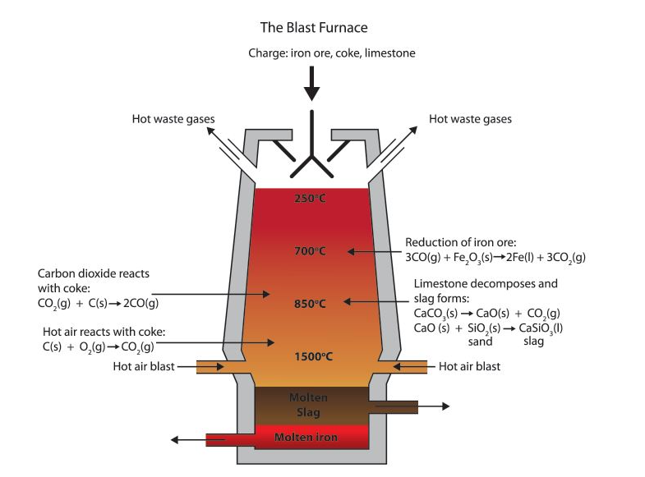

Manufacturing Steel via BOP (basic oxygen process)
Basic oxygen process, or “BOP” is method to manufacture steel from pig iron. Pure oxygen is blown into the furnace containing scrap and iron. The oxygen initiates a series of explosion or exothermic reactions including the oxidisation of impurities such as ; carbon, manganese, phosphorus, and silicon.
Top-Blown Basic Oxygen process and design.
The average top-blown basic oxygen furnace is a vertical, cylindrical container with a closed bottom and an upper cone, where the water- cooled rod (or lance) is raised and lowered. The contained is then lined with a refractory lining and then mounted on to trunnions. The purpose of the trunnions is to allow it to be tilted and for charging and tapping liquid steel.
The typical charge consists of:
- 70/75 % molten blast furnace iron which contains approximately 4 % carbon.
- 25-30% such as scrap metal and lime, along with other materials than can act as fluxes.

The rod is then lowered into the container and oxygen is injected to the bath at extremely high velocity, the flow rates can exceed 800 cubic meters or 28,000 cubic feet. The oxygen is usually blown for approximately 20 mins, depending on how much carbon is needed within the steel. The steel is then removed into a pot at temperatures approximately 1600 degrees Celsius. (https://www.britannica.com/technology/basic-oxygen-process, n.d.)
Diagram of BOP (britannica , 1999)

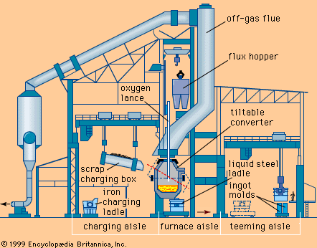

Chemical equations
Pig Iron
The chemical equation for pig iron is as follows.
$$Fe_2O_+ 3CO ->2Fe + 3CO_2$$
- Fe_2O_3 represents iron (III) oxide, also known as black iron and is the main component for iron ore.
- 3CO represents the three molecules of carbon monoxide which is formed when coke is burned.
- 3CO_2 represents the molecules of carbon dioxide which is released as a byproduct.
BOP (Basic Oxygen Process)
The chemical equation for the BOP is as follows.
$$Fe + C +0_2->FeO +CO$$
- Fe represents the molten iron obtained from pig iron or direct reduced iron.
- C represents the carbon present in the molten iron
- O_2 represents the oxygen blown into the iron
- FeO represents the iron oxide formed as a result of the oxygen reaction
- CO represents the carbon monoxide which is created during the process.
(britannica , 1999)

Task 2
Carbon is added to iron to make steel which has very good mechanical properties. Briefly explain why carbon and not any other elements could be used for this purpose. What is the usefulness of atomic structure of carbon in this regard?
The purpose of adding carbon to steel is to change its properties such as hardness and improve strength. Once the carbon is added to the iron it forms a solution with the crystal lattice structure, this is known as solid solution strengthening. The small carbon atoms then fit into the larger iron atoms making the crystal lattice stronger.
the atomic structure of steel is very important to its usefulness . by dictating the amount of carbon added to the iron, manufacturers can make a wide range of steel types with different properties depending on what they are used for. The carbon atoms modify the crystal lattice
(Crystal lattice is a 3 dimensional symmetrical structure of atoms, molecules, and ions also known as constituent particle inside a crystalline solid. It is defined as a geometrical arrangement of atoms, ions and molecules of the crystalline solid as points in space (Byjus.com , n.d.)
This in tern makes the iron more rigid which provides greater strength and hardness, which allows it to be heat treated to achieve specific properties and also contributes to its wear resistance.
Other Elements
Carbon is the primary alloying element used to manufacture steel due to unique ability to impact the materials properties due to the crystal lattice structure altering the mechanical properties. Other materials would not configure as well as carbon does with the iron.
However, other elements can be used to create steel for certain jobs, for example; Chrome (Cr) while not only aesthetically pleasing for applications such as “alloy wheels” can also be used for bearing manufacturing. Even though it is harder than stainless and can last longer, it does not function well in high temperatures, anything 120 degrees Celsius and the bearing undergoes huge deformation and load is reduced. (Xu, 2020).

Task 3:
Compare ferrous metal electrical and thermal conductivity properties with non-ferrous metals, semi-conductors, and insulators. Illustrate your answer with the help of useful applications for each case.

Ferrous metals
In regards to thermal and electrical conductivity, primary ferrous metals, such as steels and iron are poor conductors of heat and electricity as the crystalline structure of steel and iron hinders the flow of electrons which results in lowering conductivity.
While ferrous metals are not useful in thermal and electrical conductivity they are extensively used in structure due to their high tensile strength and durability for example; bridges, buildings, automotive components and manufacturing machinery
Non-Ferrous Metals
The thermal and electrical conductivity with non ferrous metals, such as silver, copper and aluminium, is far superior than that of non-ferrous metals. Copper in particular is on the best conductors of electricity due to having a large amount of free electrons within its atomic structure (Byjus.com , n.d.)
Since non ferrous metals have excellent thermal and electrical properties, they are used in a wide range of applications such as; power generation, transmission systems and electrical wiring. Aluminium is also an excellent thermal conductor and is used in the aerospace and automotive industries. (Byjus.com, n.d.)

Semi- conductors
The two main materials used for semiconductors and germanium and silicon, the latter of which is the most used. The electrical conductivity of these two materials are rather unique as they fall between conductors and insulators, the reason why they are so good for these applications is because of the high electron mobility (wafer world , n.d.) (electron mobility, or mobility, relates to the drift velocity of electrons to their applied electric field (chem europe , n.d.)
Semiconductors are used in most modern electronics, as they form the basis of semiconductor devices such as diodes integrated circuits and transistors.
(diodes are electrical components that allows the flow off current in one direction (Britannica, n.d.). however, the control of electrical conductivity in semiconductors allows the for the growth of optoelectronic devices, solar cells and sensors. (Optoelectronic devices are electrical-to-optical or optical-to-electrical transducers, or instruments that use such devices in their operation. (electronics, n.d.)

Insulators
Insulators such as plastics, ceramics and glass are very poor with thermal and electrical conductivity as they block the flow of both heat and electricity due to the brittle atomic structure.
Insulators are used in fields such as electrical safety as they can isolate both electrical and thermal reactions where necessary. They are also used in electrical cables for electronics such as phone chargers, and power distribution systems.
They also have thermal applications, such as insulating materials within the construction industry and insulating electrical components.

Task 4:
Prepare a simple material selection table for plain carbon steels (Low carbon steel, medium carbon steel and high carbon steel) highlighting the basic mechanical (Young’s modulus, Yield strength and Ultimate tensile strength) and physical properties (Thermal conductivity, specific heat capacity, density etc.) of these metals.
Below is a material selection table for carbon steels, ranging from low to high carbon.
Property | Low Carbon Steel | Medium Carbon Steel | High Carbon Steel
Chemical Composition | 0.05%-0.30% C  <0.05% Mn | 0.30-0.60% C  <0.30% Mn | 0.60%-1.00%  0.60% Mn
Youngs Modulus (GPa) | 200-210 | 200-210 | 200-210
Yield Strength (MPa) | 250-350 | 350-500 | 500-800
Ultimate tensile strength (MPa) | 400-550 | 550-700 | 700-1000
Thermal conductivity (W/m.K) | 45-55 | 45-55 | 45-55
Specific Heat capacity (J/Kg.K) | 450-490 | 450-490 | 450-490
Density (g/cm3) | 7.85 | 7.85 | 7.85
Hardness (Brinell scale) | 120-170 | 170-230 | 230-270
Electrical conductivity (%) | 5 | 5 | 5

The variables within the above table may vary depending on the manufacturing process and the alloying elements. But it shows a fairly accurate approximation.
- (MatWeb, n.d.)
- (MatWeb, MatWeb , n.d.)
- (MatWeb, Matweb , n.d.)
- Chat GPT

Task 5:
Why do you think steel is so useful material? Have we exhausted all the potential of steel in terms of its applications or there are more mysteries about steel which we still not aware of? Discuss in the light of your research findings.
Steel is a very useful material for the following reasons.
- Sustainability- it is very abundant within the earth’s surface and is recyclable which reduces the need for raw materials, which therefore makes is cheap.
- Corrosion resistance- It can also be coated to resist corrosion, via galvanisation which prolongs its performance in certain environments and longevity.
- Strength and durability- Steel has a high tensile strength which allows it to withstand heavy loads and harsh environmental conditions. It also has excellent durability which allows for long term use.
- Versatility- steel can be machined, shaped, welded, formed and fabricated into different forms and structures to meet diverse construction and engineering needs.
- Cost effectiveness- Due to steels sustainability, it offers a favourable balance between cost and effectiveness within construction and engineering.
Due to the reasons listed above, steels potential is far from exhausted; ongoing research and development continue to show how versatile this material is. From sustainable production methods to advanced alloys, there are more mysteries within the realm of steel that engineers and researchers are exploring which ensures that steel is a key material in shaping the future of various industries.

References
(Britannica, n.d.)
(Byjus.com , n.d.)
(MatWeb, MatWeb , n.d.)
(MatWeb, Matweb , n.d.) (MatWeb, Table showing low carbon steels, n.d.)
(Xu, 2020)
(britannica , 1999)
(chem europe , n.d.)
(gpt, 2024 )
(https://www.metallics.org/pig-iron-bf.html, n.d.)
(https://www.fedsteel.com/insights/how-does-coke-and-coal-play-into-steel-making/, n.d.)
(https://www.interstahl.com/en/wiki/pig-iron-production/, n.d.)

