BSC HND Applied Computing Computer Architecture and Operating Systems Windows OS and Linux OS Batch Scripting

David Julian Rapado RAP11801722
  - 20 May 2023

Table of Contents
Introduction 3
Use of CLI commands in Linux [5] 12
The use of batch scripts in Windows [6] 20
The use of Bash Scripts in Linux OS 23
References 27

Introduction

An operating system (OS) is the program that loads as soon as your computer is turned on. It’s an essential layer of software that manages and controls the computer and enables the hardware and other software applications to work seamlessly. The OS provides a range of functions like application management, Key functions like memory management, file system organization, device management, network management, and security. [1]

Key functions of a general Operation system

General operating systems offer a wide range of key functions that enable with efficient resource allocation of handle on a wide range of hardware, enabling a user to run one or more tasks simultaneously. A general-purpose OS can be installed on several desktops and laptops, and can run applications from accounting systems to databases.
Here are some of the main key functions of a general OS
Memory Management
The operating system manages the main memory resources (main memory is made up of an array of bytes) these bytes are utilized in the allocation of available RAM to allocate memory to keep track of how much memory each program has.
Process management (multiprogramming)
The OS keeps track of the status of processes. It handles the extraction of multiple processes concurrently this is called (traffic control). It also de-allocates a process when a process is no longer required.
File management
An OS has a filing system to facilitate file storage in directories for easy of navigation and use. These directories may contain other files. The OS carries out a file managing activity keeping track of files and making sure the user can access files, this is called a file system drive.
Device Management
The OS manages and keep track of all the devices and allows them to connect to the system and communicate via their respective drivers. This includes things like printers, network cards, storage devices. Device management ensures efficient device utilization. [2]

User Interface (GUIs)
An OS provides a user-friendly interface between the user and computer
Hardware. This interface takes the form of a graphical user interface or more commonly known as (GUIs) allowing the user to interact with applications using visual elements, like windows, icons, menus and pointers from a mouse.

Network management
The OS provides network connectivity communication between computers on a network. They also provide protocols and services for data transmission, routing and addressing. Network management also covers interfacing, configuring networks and network security by providing firewalls and other security measures.

The Use of CLI commands in Windows [3] [4]
To access Windows OS command prompt, you must use the program directory. The search bar is the bottom left-hand corner (next to the Windows icon) and type in cmd in the search bar. See fig
Fig 1
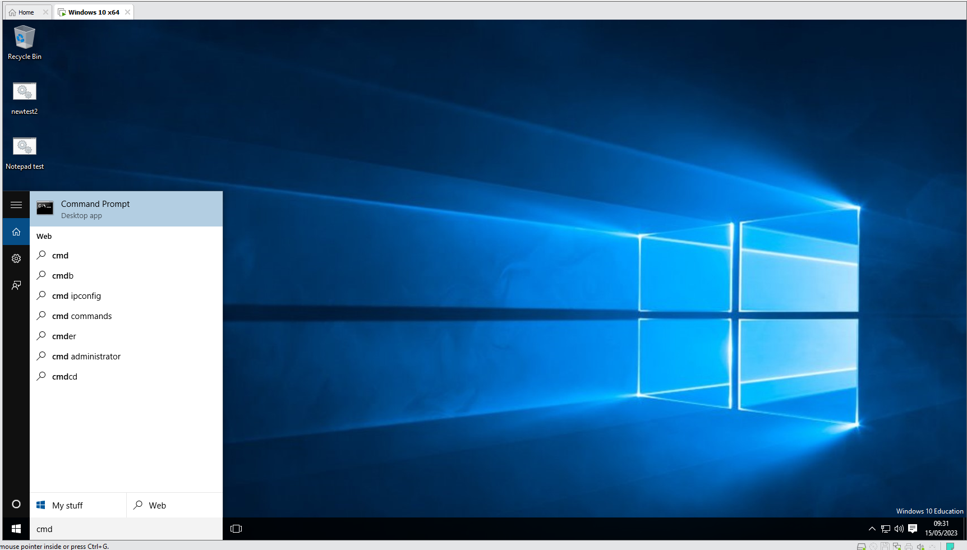

Next click on command prompt and it will take you to a screen like this see fig 2
Fig 2
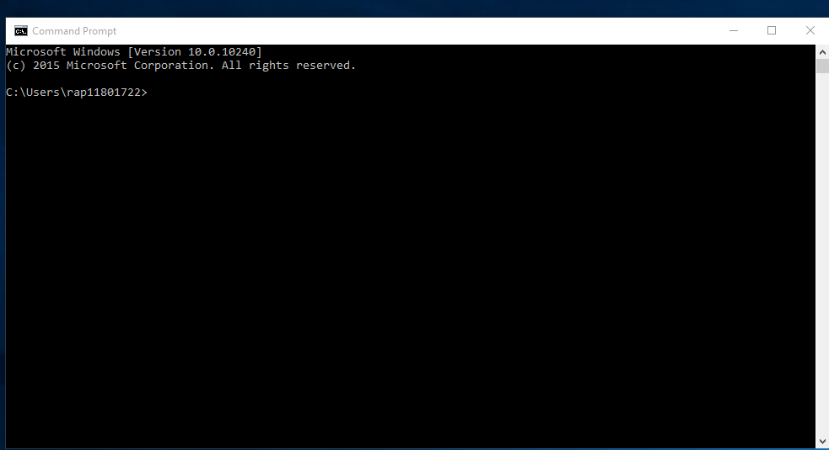
Then you need to type in the command prompt cd Desktop this should then take you to your desktop and it should look like this. See fig 3
Fig 3

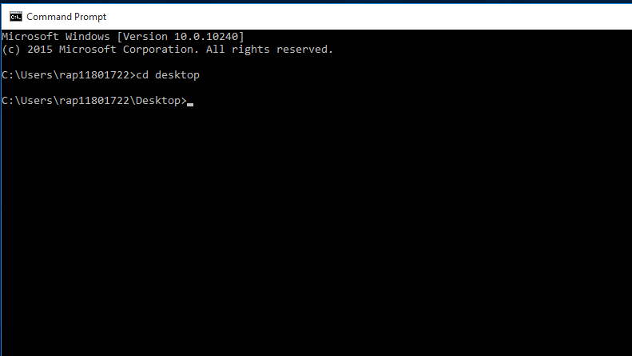

Next creating a folder using CLI. Now usually you would just right-click on a random area of your screen and select the” New folder” option from the drop-down menu. But when using CLI its different.
First, open up your CLI see (fig 1, Fig2, fig 3)
Next you need to create a directory for your new folder so type in mkdir < name_of_your_folder>
Now Press Enter
And if it worked correctly it should look like this see fig 4
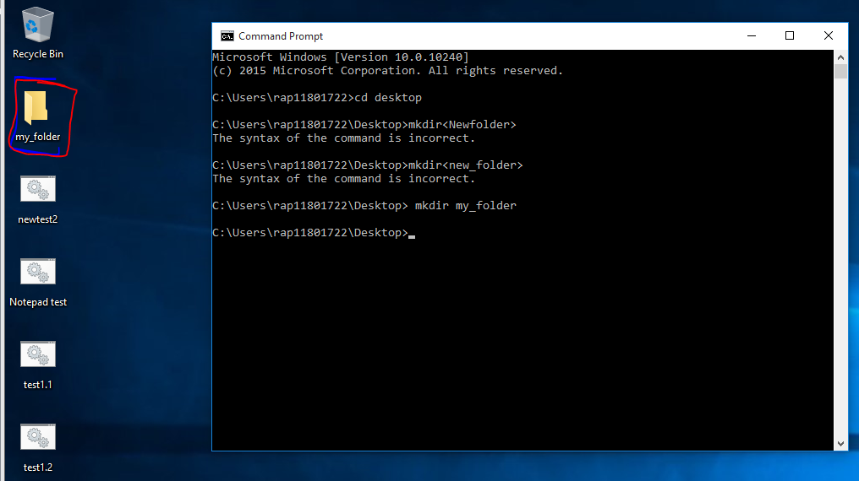
Fig 4

You should see a new folder appear on your desktop like the one highlighted in fig 4.
You can name your folder whatever you like.
Next if you want to delete a folder, open up a new command prompt and follow
And then type in this command rmdir/s < name_of_your_ folder>
You should be then prompted with an are you sure message with a (Y/N) see fig 5

Fig 5
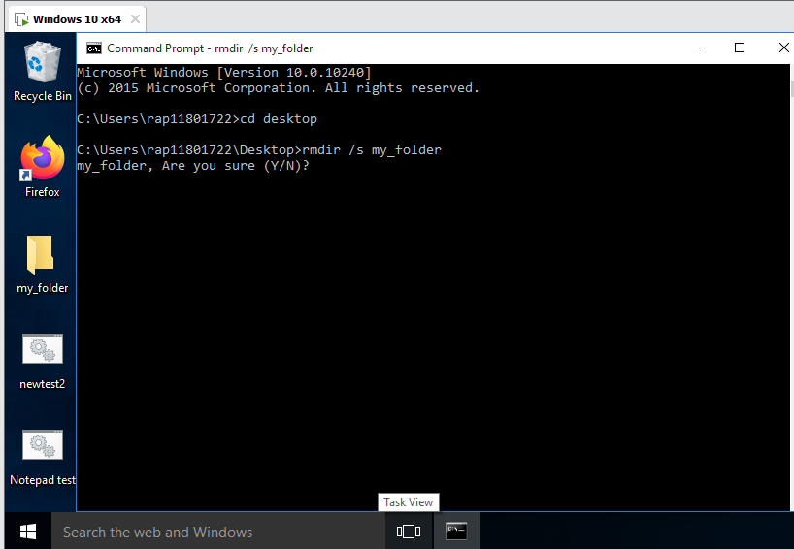

So, in this case we do want to delete the file so we will select Y and then press enter
Notice how the my_folder file icon on my desktop has disappeared I have circled in red to show where it used to be. see fig 6

Fig 6
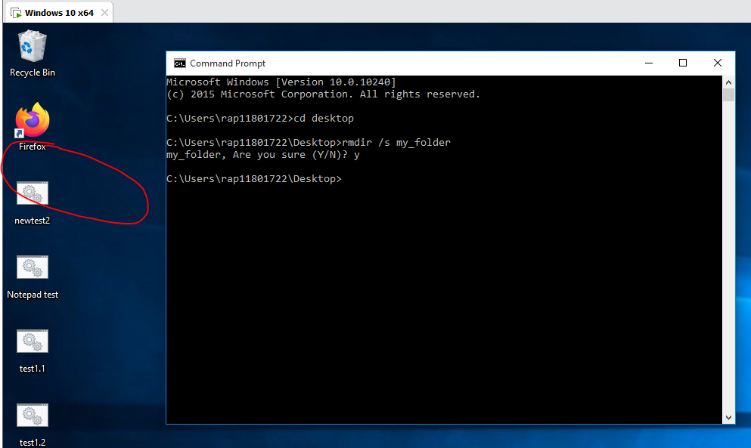

Adding a new user to your PC using Command lines
First open up the command prompt screen as seen fig 1
Then right-click on command prompt to open up the drop-down menu
Click on Run as administrator see fig 7
Fig 7
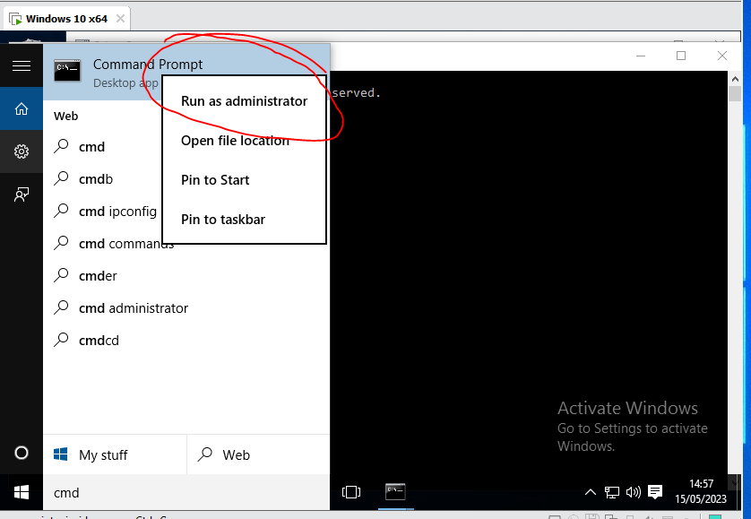

You will then be asked if you want to make changes to the device
Click yes see fig 8
Fig 8
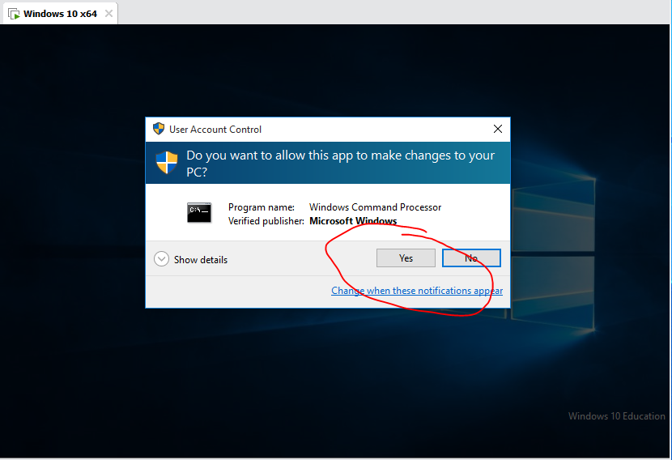
Once you click Yes to change settings on the device you will get a new screen called
Administrator Command Prompt screen, now to “add a user” type this net user <username password> /add
for this example, I have used net user David Test123 /add see fig 9

Fig 9
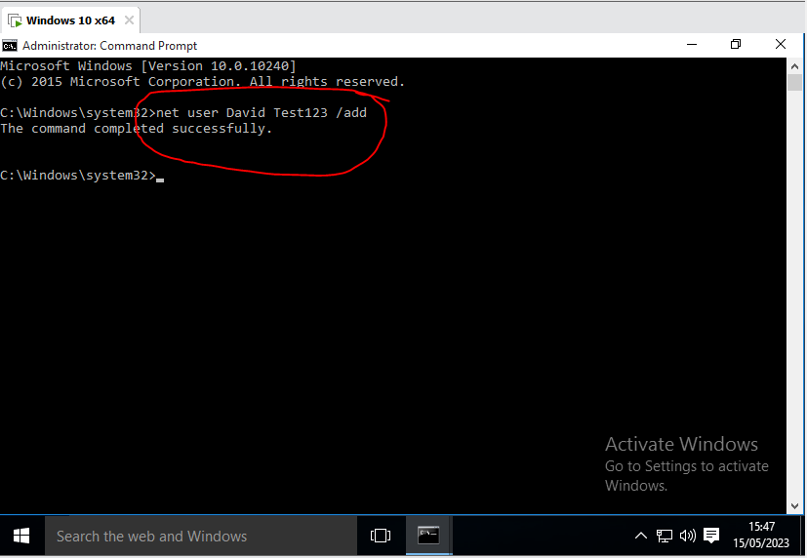

When you hit enter you will also get a message “The command completed successfully”. This means the user has been added Now you need to give that new user permissions for this example David is going to be the administrator of this account. So, this new command needs to be typed in
net localgroup administrators David /add
then press enter see Fig 10

Fig 10
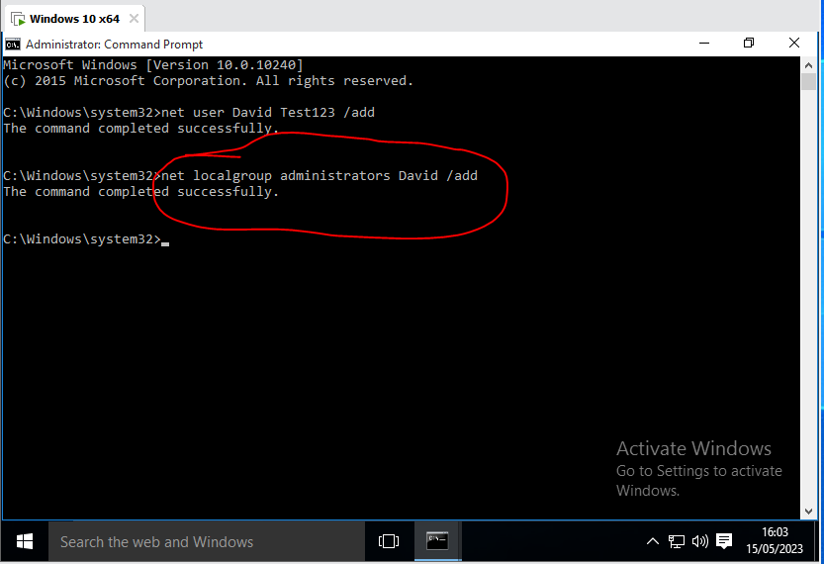

David is now the Administrator of the group.

Use of CLI commands in Linux [5]
First thing you need to do is open the terminal and type in lower case the command ls
This will list all the files and working directories see fig 1
Fig 1

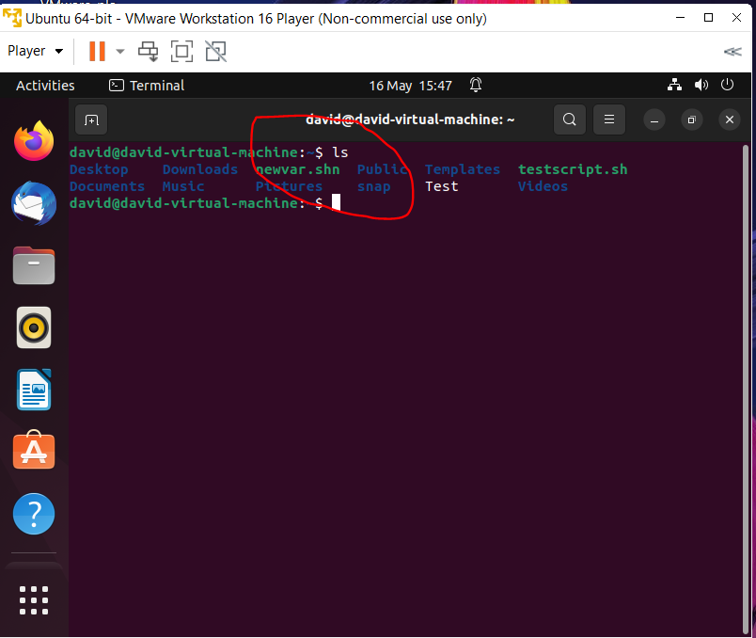

Now the next step is you need to print out the working directories using the command
line type pwd see Fig 2

Fig 2

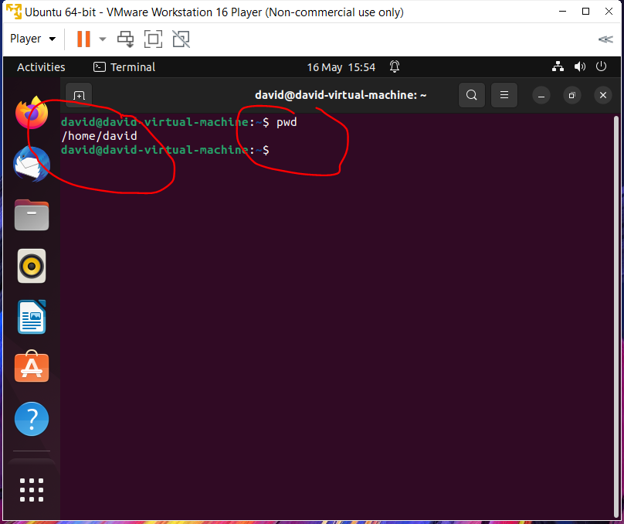

Now that you can see the directories you can change it from /home/david
To do this you will need to use the change directory command by typing in
cd ./Desktop (linux is case sensitive remember) see fig 3

Fig 3

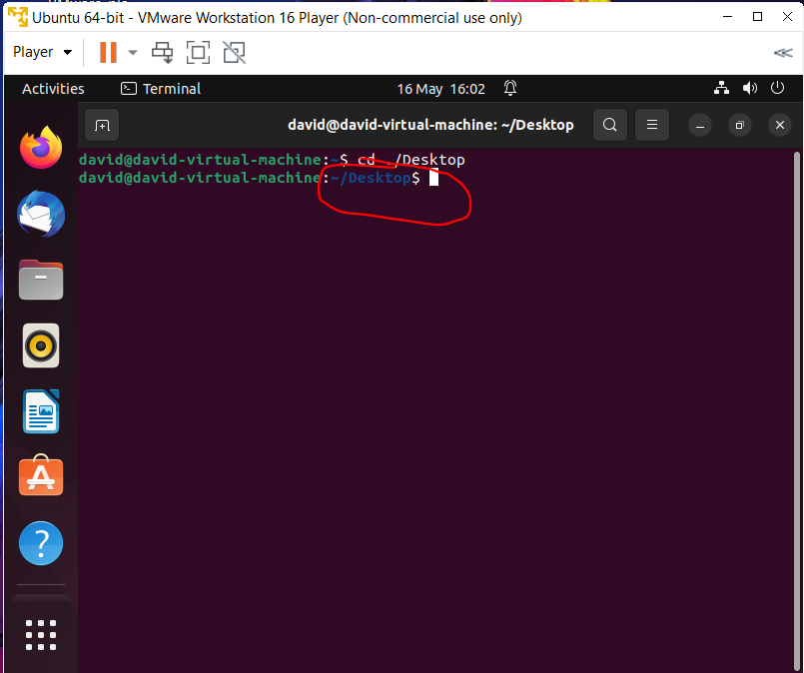

Now that you have created a new directory call Desktop, you are now going to make a folder for the desktop by typing the command line mkdir julian this will then create a folder on the desktop see fig 4

Fig 4

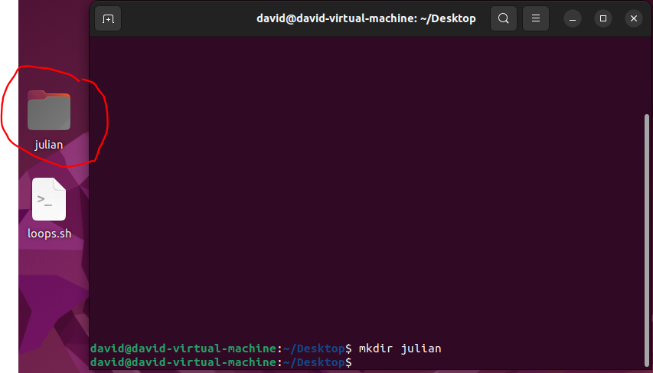

Now if you need to remove a file you can use the command line
Type rm -r /home /username/Directory/folder/ ( as you can see in the screenshot I of used home/david/Desktop/julian/) you can substitute in with whatever you want. this will remove the folder from the desktop see fig 5

Fig 5

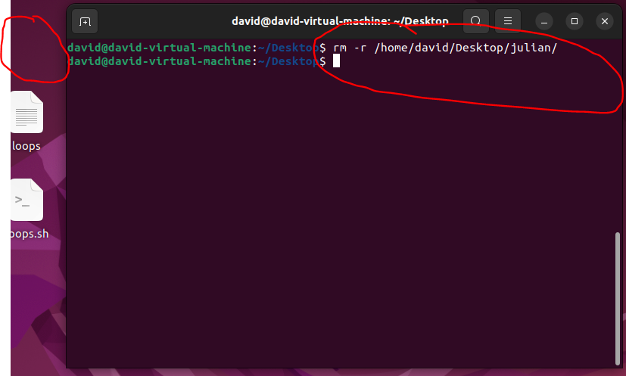

The next command Line I want to demonstrate reading a file from your desktop
To execute this command you must type cat./<filename>
This command displays the contents of the file in the terminal as you can see the contents of the loops file is now displayed in the terminal see fig 6

Fig 6
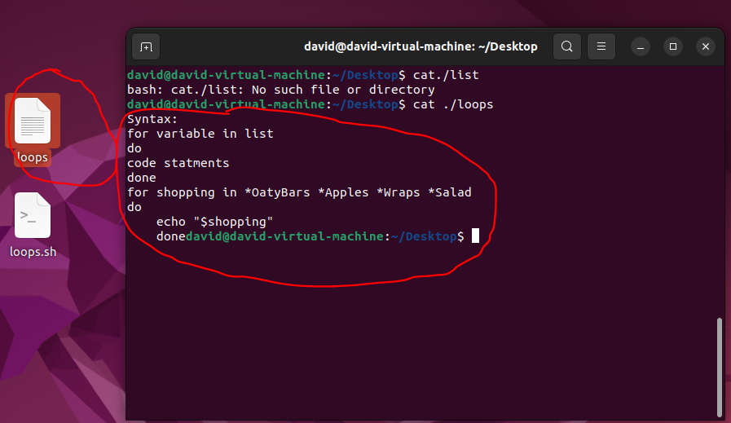

This next command creates an empty file on the desktop by using the command line
Touch <filename> see fig 7
Fig 7
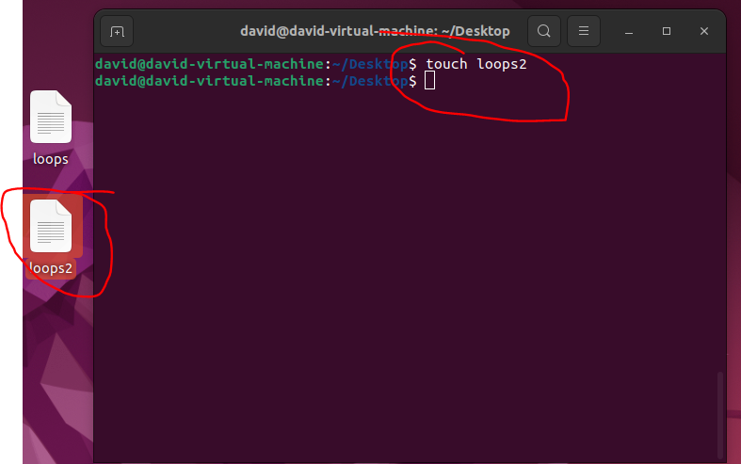

This next command line is used to move files and place them in a new folder. In this screenshot mv ./loops ./dumpfolder/ was typed see fig 8

Fig 8

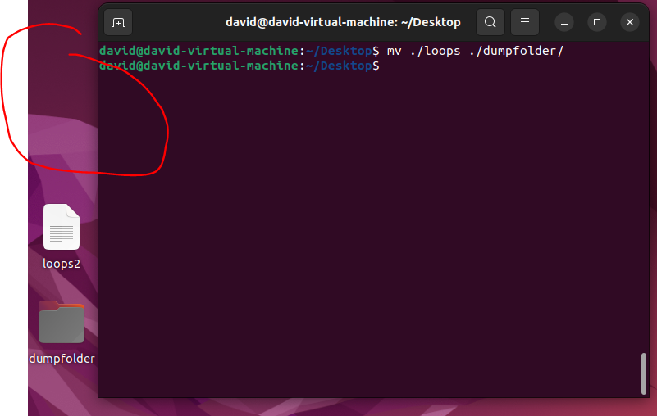

This is another basic command line that is used to bring up a calendar that can bring up any year or date that is input in in the example the entire year for 2024 was input. To get the calendar up you must type cal 2024 see fig 9

Fig 9
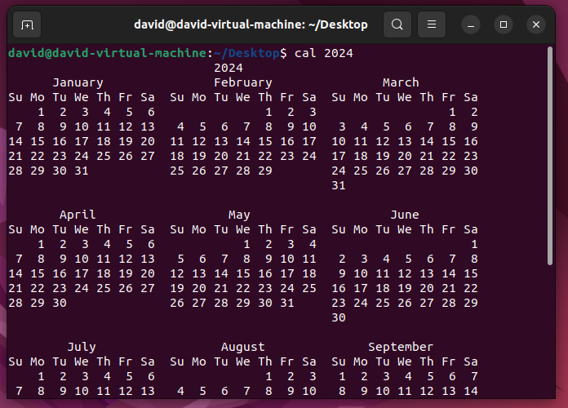

The use of batch scripts in Windows [6]

This introduction to Batch scripting on Windows aims to provide overview of basic batch scripting and to demonstrate their use in Windows OS. In the next few pages, you will see a syntax example of a basic script along with instructions and screenshots on it’s uses. Batch scripting is a powerful tool to aid Software developers. Because the scripts are executed in a sequential manner, it can help the user save time. As it allows the user to automate repetitive tasks on servers and their local machines.

Creating a batch script
There are two ways to create a batch script the first is to open up your command window see fig 10
Fig 10

The other way is to open up a text editor (in this case Notepad++) and write start writing the code in there see fig 12
Fig 12
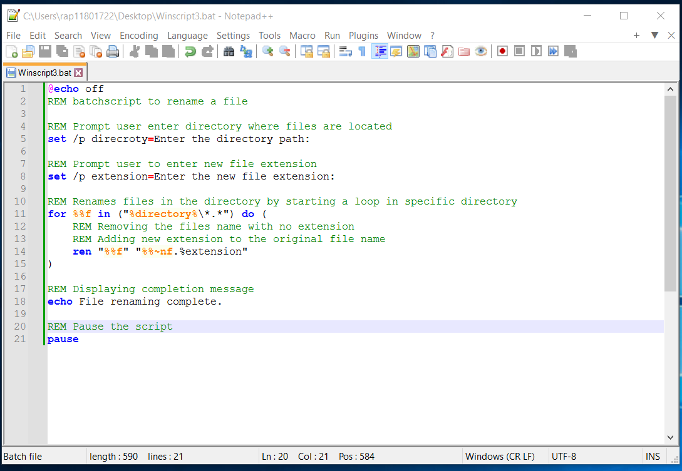
If you are going to do it this way, make sure you save your file with a .bat extension
The reason you add the .bat is so that instead of opening program and running a .exe file, it reads the series of commands contained in the batch file and opens it up that way.

Breaking the code down line by line
In this example we are looking at a batch scrip written to change the names of file in a directory.
Line 1 @echo off : This is on the start of almost every batch file. It’s to tell the screen not to display anything. As a default Windows will echo (print screen)
Line 2 REM : This is one way to indicate comments in batch script. Telling the user what the scripts task is
Line 3 empty
Line 4 REM : This is another comment, Asking the user to enter the directory name that the file is located in.

Line 5 set /p: This command captures the user input and allocate it in a variable called directory, this is then displayed as a prompt.
Line 6 empty
Line 7 REM : Another comment explaining the next part of the code
Line 8 set /p This command captures the input and assigns it to the extension variable.
Line 9 empty
Line 10 REM Another comment on the next line being a loop targeting all files in a specific directory.
Line 11 for %%f in (“%directory%\*.*”) this is the code to start the loop in target directory
Line 12 REM theses two comments explain what happens in the loop comment explaining ~n modifier
Line 13 REM Another comment explain the new file extension added to the original file name.
Line 14 REN “%%f”~nf.%extension%” this is the end of the loop
Line 15 End of the loop
Line 16 empty
Line 17 REM comment displaying output message to console.
Line 18 echo displaying message File renaming complete
Line19 empty
Line 20 Pause command pauses the script execution allowing the user to review the output before prompt window closes.

The use of Bash Scripts in Linux OS

Bash scripts in Linux are similar to Batch scripts in in Windows, in the same sense that they both are files that contain a sequence of commands that are executed line by line allowing the user to perform repetitive actions efficiently. In this section of the report, we will explore a basic script for a password generator, with step-by-step instructions and screenshots for a better understanding.

Step 1 creating a bash script
When you first create a bash script, you must open a text editor in this example Nano was used. Open with nano Script_pass.sh See fig 13
Fig 13
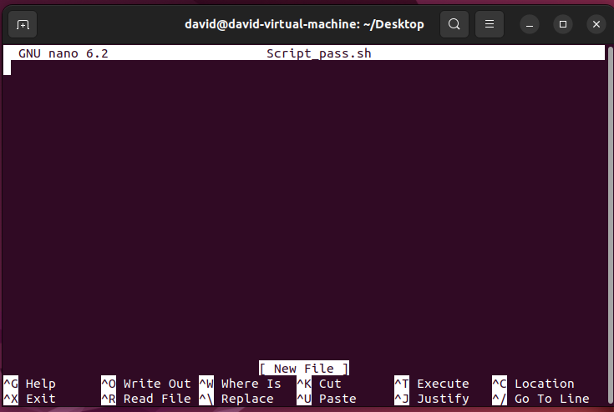

Step 2 Writing the script
Once the text editor has opened, you can begin to write the script
First you must always start with the shebang #!/bin/bash, this is interpreted by the kernel that the file is executable and will be allowed to run with a script file to program.
See Fig 14
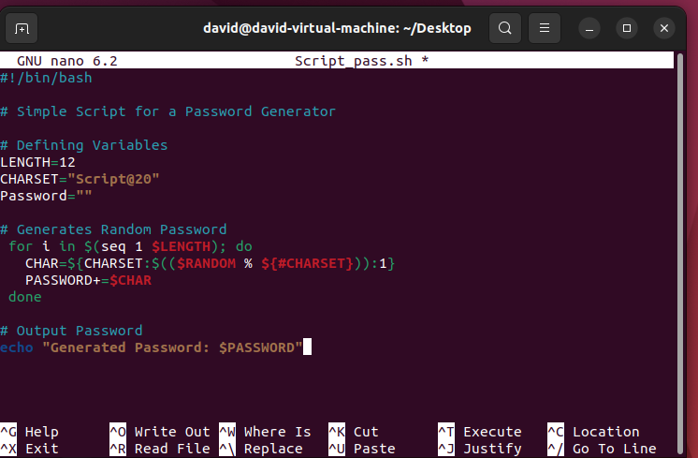

In the script you can see several of # symbol. This is used in bash as a way to make a comment about the code. Also, there are three variables LENGTH, was set at 12 for the script but you could modify that value and set it to your desired length. The next variable is CHARSET, this variable defines the characters used in the password, this includes uppercase and lowercase. And the next one is PASSWORD; this variable will store the password generated. There is also a for loop that generates the password randomly and when that has completed it’s loop there is an echo command to output the result to the display.

Step 3 saving the script and making it executable.
Once the script has been written, you must save it before it’s able to Run. To save it you must press CTRL +X and follow the screen prompts. Once it’s saved you can then try and run the script by typing chmod +x script_pass.sh see Fig 15
Fig 15
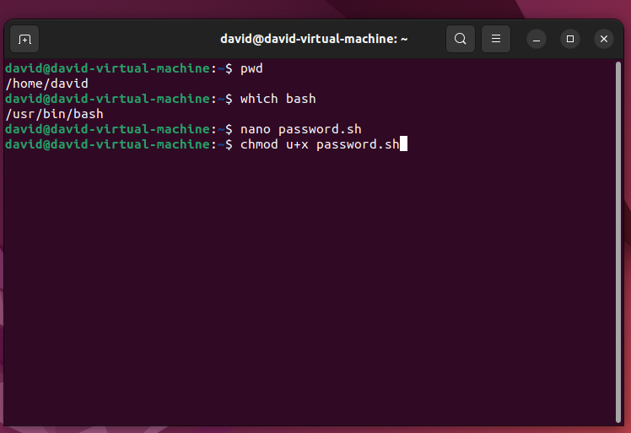

Step 4 Observing the output
In this next screenshot here is the output from the script see fig 16
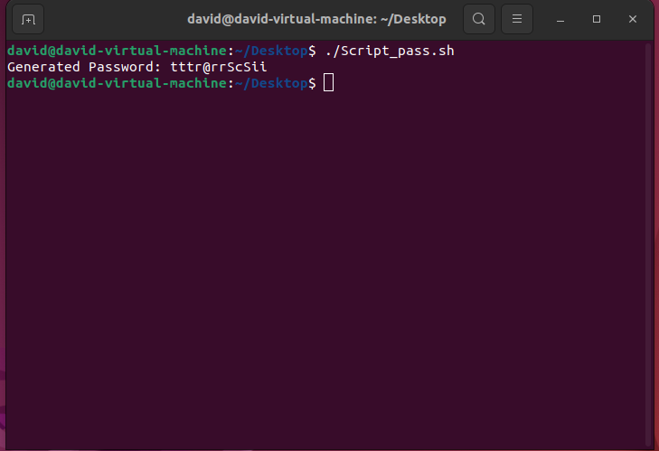

References

[1] | “BBC Bitesize computer systems,” [Online]. Available: https://www.bbc.co.uk/bitesize/guides/z7qqmsg/revision/2. [Accessed 29 April 2023].
[2] | “geekforgeeks.org,” [Online]. Available: https://www.geeksforgeeks.org/functions-of-operating-system/. [Accessed 17 May 2023].
[3] | M. Obadoni, “freecodecamp.org,” September 2022. [Online]. Available: https://www.freecodecamp.org/news/how-to-use-the-cli-beginner-guide/. [Accessed 16 May 2023].
[4] | N. Levine, “wikihow to do anything,” 6th April 2023. [Online]. Available: https://www.wikihow.com/Create-and-Delete-Files-and-Directories-from-Windows-Command-Prompt. [Accessed 14th May 2023].
[5] | N. Levine, “wiki how to do anything,” 6th April 2023. [Online]. Available: https://www.wikihow.com/Create-and-Delete-Files-and-Directories-from-Windows-Command-Prompt. [Accessed 16 May 2023].
[6] | “tutorialspoint,” [Online]. Available: https://www.tutorialspoint.com/batch_script/batch_script_files.htm. [Accessed 16 May 2023].
[7] | “seobility.net,” [Online]. Available: https://www.seobility.net/en/wiki/Batch_Scripting. [Accessed 16 May 2023].
[8] | Z. Hiria, “freecodecamp.org Bash Scripting for begginers,” 20 March 2023. [Online]. Available: https://www.freecodecamp.org/news/bash-scripting-tutorial-linux-shell-script-and-command-line-for-beginners/. [Accessed 19 May 2023].

