

MODULE CODE: Digital Skills for Personal Development and Business Growth BMSW4008

ASSESSMENT COMPONENT: PORTFOLIO

STUDENT NAME: Kareem Hamoudeh

STUDENT NUMBER: 2530272

LECTURER: Philippa Fitzgerald
DATE: 15/03/2026

Relevance and Importance Of Microsoft Excel :
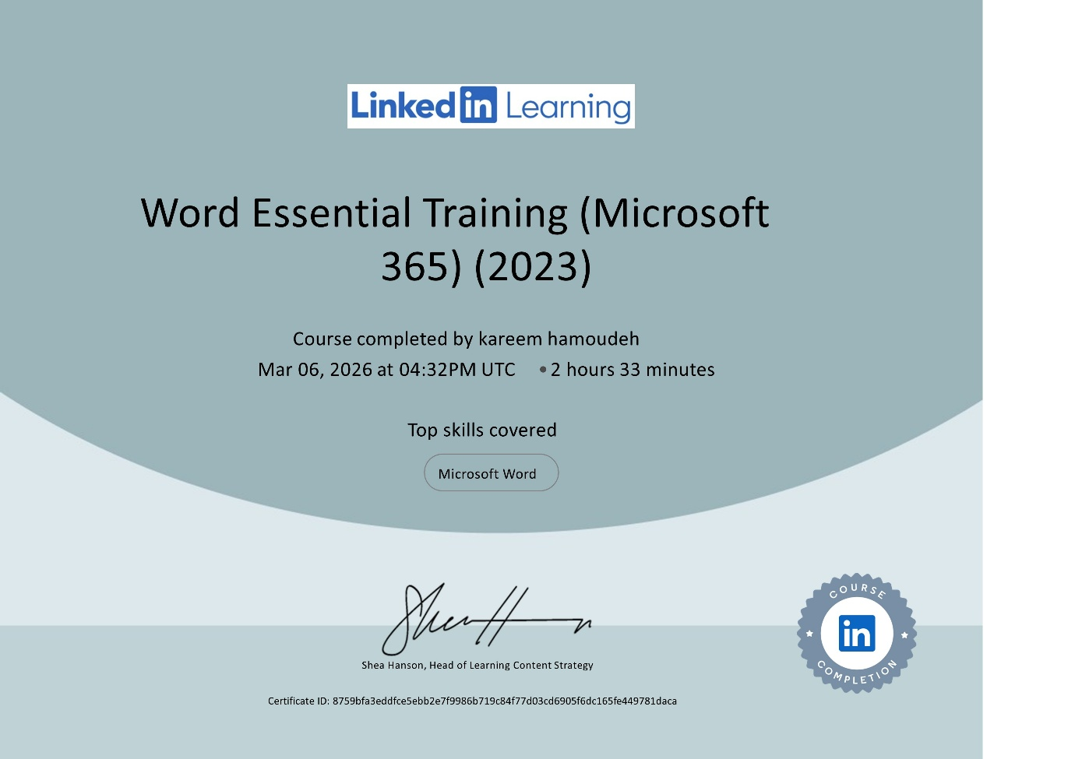

Introduction
Microsoft Excel is a multipurpose software tool broadly used for systematising, examining, and analysing data professionally. Its tabular construction, consisting of rows and columns, permits operators to supply large datasets and achieve controls via built-in formulas and functions such as SUM, AVERAGE, and COUNT (Microsoft, 2024). Excel is chiefly valuable for personal and household monetary organisation, allowing individuals to path revenue, expenditures, and savings transversely categories like rent, utilities, and entertainment (Business Insider, 2024). By compounding numerical analysis with conception tools like charts and graphs, Excel delivers clear visions that sustenance knowledgeable monetary policymaking and planned preparation.
Main Body
Microsoft Excel is an influential tool that assists you in establishing and examining data, permitting operators to establish large amounts of information into tables decided in rows and columns. This construction permits operators to effortlessly achieve and monitor monetary information. For instance, categories such as home, transportation, daily living, health, and entertaining can be rummaged through to examine household expenditures. Such classifications brand it easier to sort, filter, and analyse data evocatively. Excel delivers formulas and functions such as SUM, AVERAGE, and COUNT, which abridge complex numerical analysis by mechanically calculating them (Microsoft, 2024). In practical monetary tracking, a household income and spending spreadsheet can assist you compute total income and total expenditures and equate different expenditure groups to comprehend monetary performance. Also, large datasets can be effortlessly achieved; for instance, over 850 self-submitted entries record Microsoft employees' salaries, bonuses, and stock awards (Walkenbach, 2024). This data analysis displays how modest pay rules support Microsoft in enticing top AI engineers and researchers.
Microsoft Excel is also extensively rummage-sale for planning and monetary organisation, where individuals and governments can path revenue and expenditures in clear tables (Business Insider, 2024). By recording categories such as salary, rent, food, conveyance, utilities, and entertainment in Excel, operators can simply track where their money is being consumed. Formulas can mechanically compute total expenditures, which protects time and decreases calculation errors. Excel can also be rummage-sale to equivalence deliberate budgets and real expenditures, which assistances assess monetary habits and brand changes where prices are high. At a similar period, Microsoft is contributing a multi-million dollar bid to entice Meta's AI talent and has presented new salary rules to safeguard a modest advantage (Microsoft, 2023). The company has cut thousands of employees this year, even though it has assured to retain headcount flat, representing that hiring plans are continuing.
Another significant purpose of Microsoft Excel is to sustenance monetary preparation over automatic calculations. Excel can promptly compute the enduring poise for a given period—for instance, a month—consuming formulas like income minus total expenses, which assist operators comprehend their savings or overspending. Business Insider examined closely 300 entries, sent in from the US by self-identified software engineers, to control the income ranges and averages for different levels and groups (Business Insider, 2023). This information is typically communal voluntarily and namelessly by Microsoft employees, which endorses the salary slide, but it is not official or complete information. It is cooler for users to uphold individual economic regulators when they frequently inform their monetary information. The approximately 850 entries out of the company's 228,000 staff are just a small sample (PwC, 2023). This type of planning tool is particularly valuable for students, families, and small businesses, who need a simple and real way to achieve money and plan for upcoming expenditures.
Microsoft Excel also delivers influential reporting and data imagining landscapes that assist operators in current information obviously and effortlessly. In Excel, you can change numerical data into a visual format consuming a variety of charts, such as pie charts, bar charts, and line graphs, creating it easier to comprehend complex information (Microsoft, 2024). For instance, in a household income and spending spreadsheet, a pie chart can display what percentage of revenue is spent on rent, food, or conveyance, and a bar chart can assistance equivalence total income and total expenditures. Yet, if staff with higher salaries or senior positions share less information in such a spreadsheet, the salary range may appear lower than the total workforce. These visual reports permit operators to rapidly comprehend monetary patterns and assistance brand precise monetary valuations (Knaflic, 2023). At a similar period, Microsoft is hastening the step of novelty by familiarising with new skill stacks and new ways of working, bringing present platforms at scale, while building the next generation to unceasingly make worth for clients and partners.
Microsoft Excel validates many significant Excel services with a domestic revenue and spending spreadsheet. Economic information is chronicled obviously and precisely, consuming well-organised data tables in spreadsheets. Formulas like SUM and subtraction can be rummage-sale to mechanically compute total revenue and lasting poises (Microsoft, 2023). In calculation, charts like pie charts, bar charts, and line graphs visually show contrasts of different expenditure groups and income, altering raw data into expressive information. Consuming these features, Excel assists operators in organising economic records, examining expenditure habits, and brand well-versed choices (McKinsey & Company, 2024). At the similar period, the influence of AI is creating small businesses more industrious, multinational corporations more modest, non-profit groups more actual, and governments more competent, refining healthcare and education consequences. Over-controlled planning, regular analysis, and conception, Excel remnants an vital digital ability for both personal and expert exists.
Conclusion
In conclusion, Microsoft Excel is a vital tool for handling, examining, and imagining financial data, serving operators to switch over household or structural budgets (Microsoft, 2024). Its mixture of structured tables, formulas like SUM and AVERAGE, and conception tools such as charts allows clear trailing of income, expenditures, and investments, subsidiary informed monetary choices (McKinsey & Company, 2024). Outside of personal finance, Excel’s competencies spread to examining large datasets, classifying drifts, and refining structural competence. By abridging complex calculations and giving data visually, Excel authorises students, families, and businesses to successfully strategise, monitor presentations, and attain economic constancy in today’s data-driven world.
References
Business Insider (2023) Tech salary transparency: Microsoft engineers share compensation data. Available at: https://www.businessinsider.com/tech-salary-transparency-microsoft-engineer-pay-data-2023
Business Insider (2024) Microsoft salary data reveals how much the company pays software engineers, product managers, and other roles. Available at: https://www.businessinsider.com/microsoft-salary-data-software-engineer-pay-2024
Knaflic, C.N. (2023). Storytelling with Data: Let’s Practice!. Hoboken: Wiley. Available at: https://www.wiley.com/en-us/Storytelling+with+Data%3A+Let%27s+Practice%21-p-9781119774838
McKinsey & Company (2024) The economic potential of generative AI: The next productivity frontier. Available at: https://www.mckinsey.com/capabilities/quantumblack/our-insights/the-economic-potential-of-generative-ai-the-next-productivity-frontier
Microsoft (2023). Use Excel to create and manage budgets. Available at: https://support.microsoft.com/en-us/office/manage-your-household-budget-in-excel
Microsoft (2024). Create a chart from start to finish in Excel. Available at: https://support.microsoft.com/en-us/office/create-a-chart-from-start-to-finish-in-excel-0baf399e-c4c8-4c0a-9a30-73e2f4c6f4f4
Microsoft (2024) Overview of Microsoft Excel. Available at: https://support.microsoft.com/en-us/excel
PwC (2023) Financial planning and budgeting in the digital age. Available at: https://www.pwc.com/gx/en/services/consulting/digital-finance.html
Walkenbach, J. (2024) Excel 2024 Bible. Indianapolis: Wiley. Available at: https://www.wiley.com/en-us/Excel+2024+Bible-p-9781394218171

Task 4
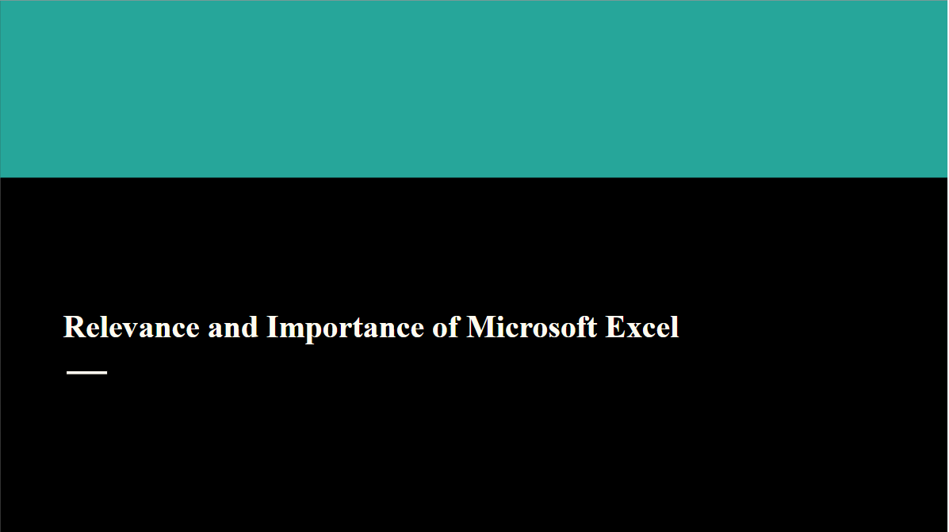
Slide 1: What I Learned About Excel Skills
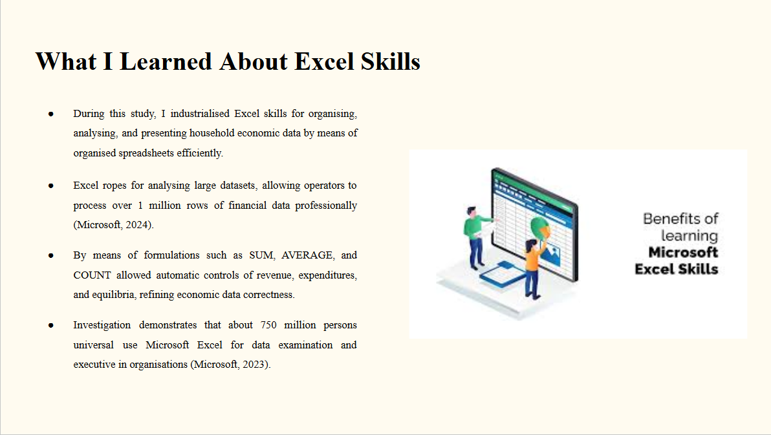
Speaker Notes
In this slide, I illustrated numerous significant Excel services connected to organising, analysing and giving economic data. I erudite how spreadsheets let operators to construct data obviously and perform controls mechanically by means of formulas. These purposes recover competence and correctness when employed with financial info. I also erudite that Excel is extensively used internationally for data analysis and journalism. Sympathetic, these services have aided me in realising the rank of Excel in together moot work and expert surroundings.
Slide 2: How I Applied Excel Skills
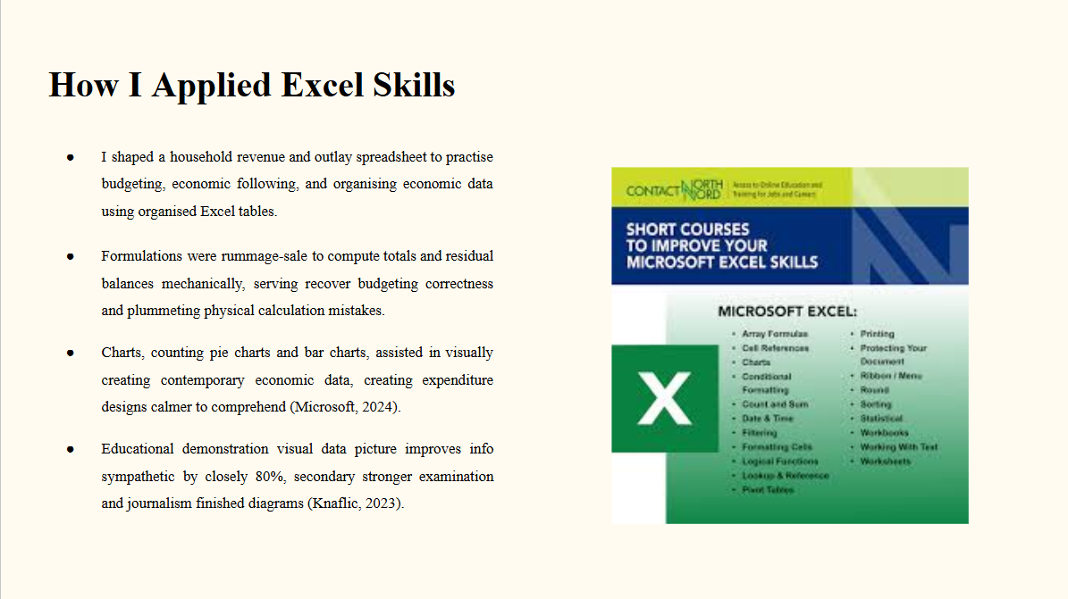
Speaker Notes
To apply the Excel skills I learned, I shaped a spreadsheet that followed household revenue and expenditures. The worksheet comprised groups such as rent, food, conveyance and values. I used formulations to calculate sums and residual equilibria mechanically. I also shaped diagrams to visually current expenditure designs. These visualisations aided make economic data calmer to comprehend. This movement aided me in practising planning and established how Excel can provision economic preparation and data analysis.
Slide 3: How I Will Use These Skills in the Future
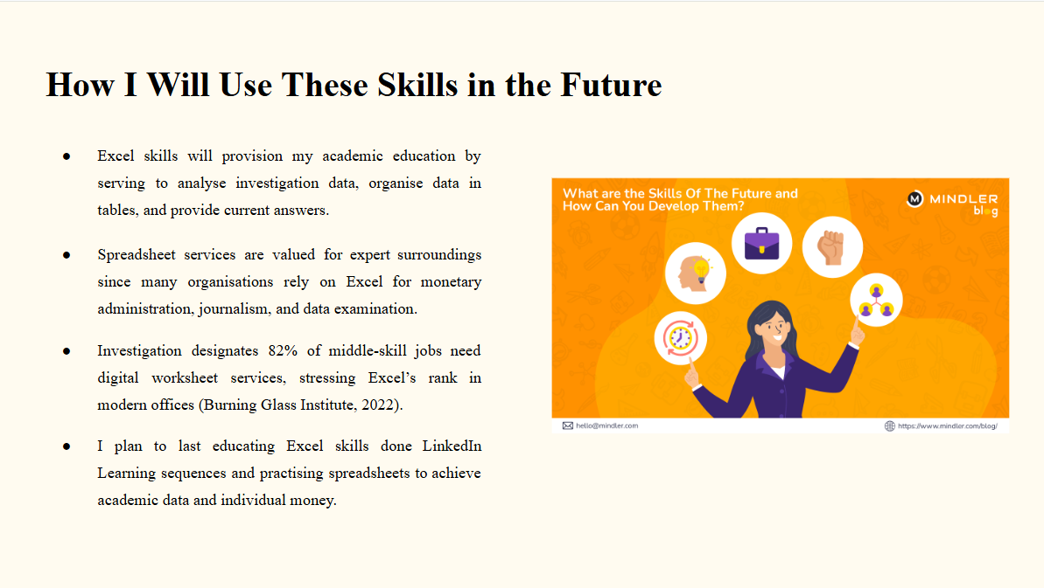
Speaker Notes
In the upcoming, I plan to learn by means of Excel for both academic effort and expert growth. Excel will help me organise investigation data, do examination and current info obviously in projects and intelligence. Many bosses also need spreadsheet skills for planning, economic examination and journalism tasks. Through ongoing to practise Excel and comprehensive online exercise sequences, I will reinforce my digital services and recover my aptitude to work efficiently with data.
References
Burning Glass Institute (2022). The digital skills revolution and the future of work. Available at: https://www.burningglassinstitute.org (Accessed: 10 March 2026).
Knaflic, C.N. (2023). Storytelling with Data: Let’s Practice! Hoboken: John Wiley & Sons.
McKinsey & Company (2024). The economic potential of generative AI: The next productivity frontier. Available at: https://www.mckinsey.com/capabilities/quantumblack/our-insights/the-economic-potential-of-generative-ai-the-next-productivity-frontier (Accessed: 10 March 2026).
Microsoft (2023). Microsoft company facts and statistics. Available at: https://news.microsoft.com/facts-about-microsoft (Accessed: 10 March 2026).
Microsoft (2024). Overview of Microsoft Excel. Available at: https://support.microsoft.com/en-us/excel (Accessed: 10 March 2026).
Walkenbach, J. (2024). Excel 2024 Bible. Indianapolis: John Wiley & Sons.

