

Report on: Strategic Evaluation of BYD's Passenger Electric Vehicle Business in the European Market: A Strategic Management Consultancy Report for the Board of Directors

Student Name: B M A RAHMAN
Student ID: 2526730

Programme: Master of Business Administration
Module Name: Strategic Management
Module Code: LCMB7003

Lecturer’s Name: Hoang Nguyen

Work Count: 5325

Submission Date: 12 August 2026

Acknowledgement of AI Tool Use
I acknowledge using AI tools for purposes of permitted research, explanation, proofreading as outlined in the Guidelines for Using AI in Research at the UWTSD (February 2026).
ChatGPT (https://chatgpt.com/) was used to support research, explain strategic management concepts and frameworks, and proofread the assignment.
Perplexity AI (https://www.perplexity.ai/) and Google Gemini (https://gemini.google.com/) were used to support research and understanding of BYD, the European EV market and relevant strategic issues.
Grammarly (https://www.grammarly.com/) was used for grammar, spelling, clarity and proofreading.
QuillBot (https://quillbot.com/) was used to improve the wording and readability of selected passages.
I certify that I have not submitted AI-generated content as my own work. I know that the content of this assignment, any analysis, arguments and conclusions are the ultimate responsibility of me.

Table of Contents
1. Introduction 6
2. Organisational Context and Overview 7
3.0 External and Internal Strategic Analysis 8
3.1 External Environment Analysis 8
Political 9
Economic 10
Social 10
Technological 10
Environmental 10
Legal 10
3.2 Industry Structure Analysis Using Porter's Five Forces 11
3.3 External Strategic Implications 13
3.4 Internal Environment Analysis 13
3.5 Strategic Diagnosis 15
4. Comprehensive and Holistic Evaluation 16
4.1 Corporate Social Responsibility (CSR) 16
4.2 Balanced Scorecard 18
5. Strategic Choices and Implementation 20
5.1 Strategic Alternatives 20
5.2 Strategic Alternatives Evaluation 21
Porter's Generic Strategies 21
Ansoff Matrix 22
BCG Matrix 23
5.3 Recommended Strategy and Implementation 25
Recommended Strategy 25
Implementation Roadmap (2026-2030) 25
Implementation Challenges 26
Risk Mitigation Strategies 26
Key Performance Indicators (KPIs) 26
Section 2 28
Reflective Account 28
Description 28
Feelings 29
Evaluation 29
Analysis 29
Conclusion 30
Action Plan 30
References 31

Table 1: PESTEL Analysis of BYD's Passenger Electric Vehicle Business in the European Market 11
Table 2: VRIO Analysis of BYD's Strategic Resources 14
Table 3: Balanced Scorecard for BYD's Passenger Electric Vehicle Business in the European Market 19
Table 4: Strategic Alternatives for BYD's Passenger Electric Vehicle Business in the European Market 21
Table 5: SAFe Evaluation Matrix 25
Table 6: Implementation Roadmap for BYD's European Localisation Strategy (2026-2030) 27

Figure 1: Strategic Framework of the Consultancy Report 7
Figure 2: BYD's strategic evolution and expansion into the European market 8
Figure 3:Porter's Five Forces analysis of BYD's passenger electric vehicle business in the European market 12
Figure 4: SWOT matrix of BYD's passenger electric vehicle business in the European market 16
Figure 5: Alignment of BYD's CSR strategy with business objectives 17
Figure 6: Porter's Generic Strategies 22
Figure 7: Ansoff Matrix 23
Figure 8: BCG Matrix 24
Figure 9: Gibbs' Reflective Cycle applied to the strategic management consultancy report 28

Introduction
In the fast-evolving landscape of the European automotive industry, the market for passenger electric vehicles (PEV) has emerged as one of the most pivotal and strategically important segments globally, underscored by the growing consumer demand for sustainable transportation options, technological advancements, and the introduction of new regulations. However, as competition becomes fiercer, manufacturers need to continually adjust their strategies in order to maintain competitive advantage and to be responsive to the changes that occur across the market (Porter, 1985; Johnson, Scholes and Whittington, 2020). By leveraging a vertically integrated business model, advanced battery technology and an expanding product range, BYD Company Limited has extended its footprint in Europe among the emerging global competitors.
This report assesses the strategic landscape of BYD's business in the passenger EV sector from a strategic management consultant's point of view, as advising the Board of Directors. The analysis uses existing strategic management frameworks to evaluate the external environment, internal capacities, competitors, corporate social responsibility (CSR) and strategic performance of the company. The report proposes various strategic choices and directions and analyzes them based on the available evidence and information, and then concludes with the most appropriate strategic direction and implementation option to reinforce BYD's future competitive position in the European passenger EV market.
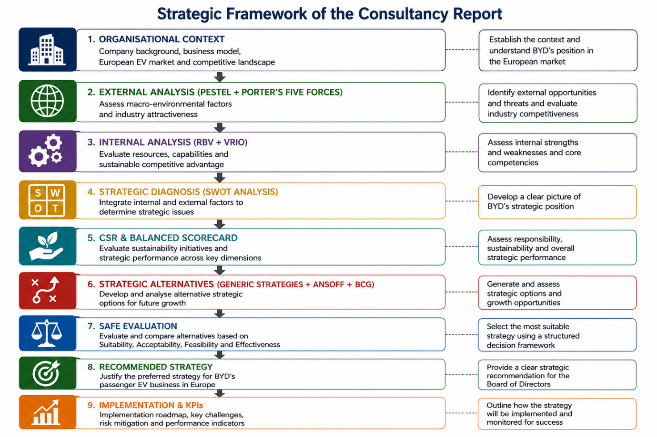
Figure 1: Strategic Framework of the Consultancy Report

Organisational Context and Overview
BYD Company Limited was established in 1995 in Shenzhen, China, and started making rechargeable batteries before it got into the auto business by acquiring Xi'an Qinchuan Automobile in 2003. The company has consistently been a leader in developing new energy vehicle technology over the last two decades, combining innovation in battery technology, vehicle production, semiconductors, and energy storage systems (BYD, 2024). The shift is part of BYD's long-term strategy to embrace technological advancements and eco-friendly transportation solutions.
BYD's vision is to be a global leader in sustainable technology and intelligent mobility, and its mission is to cool the earth by 1°C by providing clean transportation solutions to lower the carbon emissions. The company has a vertically integrated business model which allows the company to manage certain key points of the value chain such as battery production, electric powertrain development, semiconductor manufacture, and vehicle assembly. This integration improves operational efficiency, decreases supply chain risks, and enables constant product innovation, especially by using new technologies like the Blade Battery (BYD, 2024).
The European passenger EV market is a strategic growth market with its ambitious climate policies, tough regulations on emissions, widespread charging infrastructure, and consumer demand for ZEVs. Europe is one of the world's biggest and most competitive markets for EV sales, with long-term decarbonisation goals (International Energy Agency (IEA), 2024) to back them up.
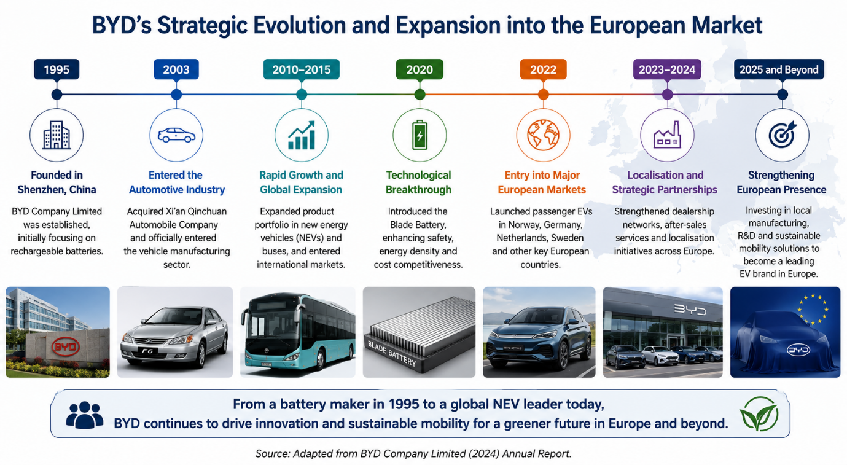
In this competitive market, BYD faces competition from other market players such as Tesla, Volkswagen Group, BMW, Mercedes-Benz, Renault Group, Stellantis, Hyundai, Kia, Volvo, and MG. Despite having a brand that is well recognised and a solid network of dealerships, BYD is quickly enhancing its footprint in Europe through a growing lineup of vehicles, strategic alliances with dealerships, and localization programs. As a result, BYD has become a major competitor in the European EV sector, and is seen as being an innovator, competing on technology, product quality and value, and increasing its market share in the region (Porter, 1985; Johnson, Scholes and Whittington, 2020).
Figure 2: BYD's strategic evolution and expansion into the European market
(Adapted from BYD, 2024).

3.0 External and Internal Strategic Analysis

3.1 External Environment Analysis
A PESTLE is a tool that can be used to present a structured evaluation of the macro-environmental factors that affect the planning of an organisations strategy and competitive performance (Johnson, Scholes and Whittington, 2020). The European market offers a lot of growth prospects and political, economic, social, technological, environmental and legal changes create strategic risk for BYD's passenger electric vehicle (EV) business.
Figure 3: PESTLE Framework - Macro Environment

Political
As the European Union (EU) is moving towards a low-carbon mobility, political factors have become more and more relevant, due to the European Green Deal and the plan of ending the production of new internal combustion engine vehicles by 2035. In addition, these policies set the stage for a more favourable long-term demand for EVs, but the EU's recent investigations on the subsidies provided by China for EVs and the new battery electric vehicle tariffs have led to more regulatory uncertainty and cost pressures for EV manufacturers like BYD (European Commission, 2024).

Economic
The performance of the markets is also affected by the economic situation. Several European economies have seen a reduction in consumer purchasing power due to economic growth pressures, rising interest rates and inflation, however, on-going government incentives and investments in charging infrastructure is driving EV uptake. Furthermore, if the production cost of batteries decreases, they will become more affordable, thereby enhancing their market growth in the long run (International Energy Agency (IEA), 2024).

Social
Market opportunities are further entrenched by social factors. This surge in environmental awareness, the acceptance of sustainable transport by consumers as well as the increasing demand for technologically advanced vehicles, has boosted the trend towards electric mobility. However, the general access to charging infrastructure, driving distance and resale value are issues that have not yet convinced certain groups of consumers (IEA, 2024).

Technological
One of BYD's greatest assets is its technological innovation. On-going investment in battery, intelligent driving systems, digital connectivity and manufacturing automation improves the quality of products and operational efficiency. Specifically, BYD's patented Blade Battery technology helps to enhance product differentiation and safety and cost competitiveness (BYD, 2024).

Environmental
Carbon reduction and sustainable manufacture are priorities as both governments and businesses and consumers are mindful of environmental issues. BYD's focus on zero emission vehicles and clean energy technologies fits well with the European sustainability goals, but the drive for higher expectations for battery recycling, responsible sourcing of raw materials, and lifecycle emissions, calls for ongoing environmental innovation.

Legal
Lastly, Law is an opportunity and constraint. Stringent EU vehicle safety, battery and data protection and environmental laws and regulations must be met for market entry. At the same time, changing trade policies and localisation demands give BYD more incentives to increase production and supply chain in Europe, which lowers the risk of regulatory factors on the horizon and enhances the company's long-term competitiveness (European Commission, 2024).
Overall, the external environment poses favorable conditions for the long-term growth of BYD, but it is crucial that the company reliably adjusts to the changing requirements of the regulatory, technological and competitive environment.
Table 1: PESTEL Analysis of BYD's Passenger Electric Vehicle Business in the European Market
Factor | Key Issues | Strategic Implication for BYD
Political | EU Green Deal; 2035 ICE phase-out; EU tariffs on Chinese EVs | Opportunity through policy support but higher trade-related costs
Economic | Inflation; interest rates; charging infrastructure investment; declining battery costs | Short-term demand pressure, positive long-term growth
Social | Sustainability awareness; EV acceptance; range anxiety | Increasing demand but continued consumer education needed
Technological | Blade Battery; intelligent driving; digital connectivity; automation | Supports differentiation and cost leadership
Environmental | Carbon neutrality; battery recycling; sustainable sourcing | Reinforces BYD's sustainability positioning
Legal | EU safety regulations; Battery Regulation; GDPR; trade policies | Requires compliance and supports localisation strategy
Source: Adapted from Johnson, Scholes and Whittington (2020); European Commission (2024); BYD (2024); IEA (2024).

3.2 Industry Structure Analysis Using Porter's Five Forces
Once the PESTEL analysis is done, Porter's Five Forces framework is a structured analysis to consider the competitive forces that affect a company's position in a market segment (Porter, 1980). The overall level of competition is extremely high, a fact that can be attributed to the fierce competition in the market between established manufacturers like Tesla, Volkswagen Group, BMW, Mercedes-Benz, Renault Group, Stellantis, Hyundai, Kia, Volvo and MG. BYD must maintain technological differentiation and operational efficiency for continuous innovation, aggressive pricing and fast product development.
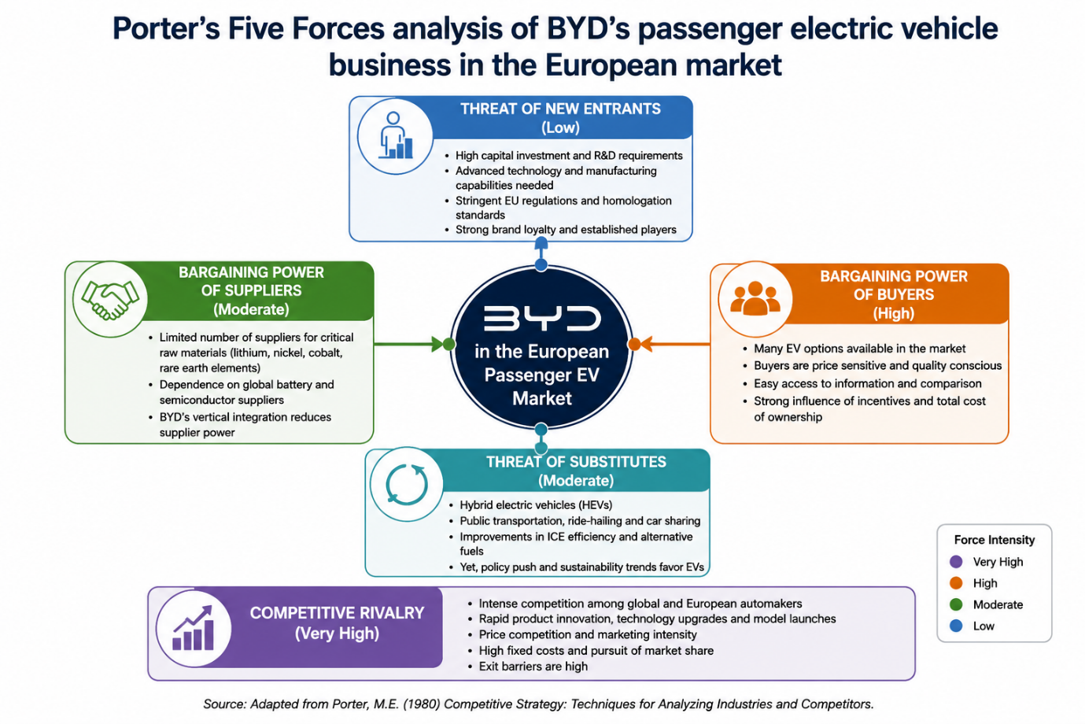
Figure 3:Porter's Five Forces analysis of BYD's passenger electric vehicle business in the European market
(Adapted from Porter, 1980).
New entrants have limited potential because of the high investment needed, technological sophistication, regulatory approvals and consumer satisfaction with the brand in the auto industry. The power of suppliers is, however, moderate as critical raw materials such as lithium and rare earth elements are still only a handful of suppliers worldwide. This risk is somewhat reduced because BYD has a vertically integrated supply chain, in which it manufactures key components and batteries itself (BYD, 2024).
European consumers have many options for EVs, and they are able to easily compare prices, quality and technological features, giving them high bargaining power. Likewise, the risk of substitution is moderate as alternative ways of mobility are provided by hybrid vehicles, public transport, and shared mobility.
Overall, the European passenger EV industry is appealing, but requires ongoing innovation, cost competitiveness, and adaptation. With its technological capabilities and vertical integration, BYD's competitive position is strengthened, but continued growth in the market will depend on the company's ability to differentiate and localise itself in Europe (Porter, 1980; Johnson, Scholes and Whittington, 2020).

3.3 External Strategic Implications
The external analysis shows that the market in Europe where BYD is doing business has lots of long-term growth potential, as there is a favorable climate for the adoption of EVs, technological progress, and climate policies. But the increasing level of competition, changing trade rules, and regulations require strategic swiftness. By strengthening localisation, maintaining technological innovation and utilising vertical integration, BYD can enhance its competitive position and buffer external risks while seizing opportunities in the new markets in the future (Porter, 1980; European Commission, 2024; IEA, 2024).

3.4 Internal Environment Analysis
Market opportunities are a function of the external environment but sustainable competitive advantage is a function of the internal resources and capabilities of an organisation. The Resource-Based View (RBV) suggests that companies can outperform their rivals when they acquire valuable, rare, inimitable, and well-organised resources which competitors do not possess, or acquire with difficulty (Barney, 1991; Wernerfelt, 1984). Therefore, the assessment of BYD's internal environment is a way of gaining an understanding of its competitive advantage in the European passenger EV market.
One of the most important strategic assets of BYD is its vertically integrated business model that includes producing battery power, semiconductors and the development and manufacturing of electric powertrain systems and vehicles. Being able to manage critical parts of its value chain means that BYD can minimize supply chain disruptions, maximize cost efficiency, and shorten product development times (BYD, 2024). The ability proved to be particularly useful during the recent global semiconductor shortage, as the company kept production relatively constant, compared with some well-known automotive companies.
Another key organisational advantage is the ability to innovate. Research and development are a key investment focus for BYD, where they are bettering battery performance, intelligent driving systems and digital vehicle technologies. The Blade Battery, a proprietary technology, has been a key competitive advantage, delivering enhanced safety, energy density, durability, and manufacturing efficiency, thereby boosting product quality and customer trust (BYD, 2024). The rapidly changing preferences of European consumers, coupled with the progressive environmental standards in Europe, are other factors that continually spur BYD to innovate.
Considering VRIO, BYD's vertical integration in manufacturing system, high-tech battery manufacturing and solid R&D strength have met the conditions of being valuable and hard to imitate. Moreover, the organization is designed to leverage these resources in a coordinated manner, continuously innovate and expand worldwide to provide value to sustainable competitive advantage (Barney, 1991). The international growth is supported by financial resources and manufacturing scale, but it is not as uncommon as given the other global automotive manufacturers also have the financial resources to invest and manufacturing scale.
However, there are several flaws within the system. BYD is still relatively unknown and trusted by customers in some European markets compared to well-known European manufacturers. It's also less well developed than incumbent competitors in terms of its dealership and after-sales service network, which may impact the brand's customer experience and customer loyalty over the long term. Secondly, the speed of international expansion demands significant investment in manufacturing, localisation, talent development and regulatory processes, which puts pressure on the organisation and finances.
In general, BYD has a solid strategic resource portfolio and organisational capacity, which is conducive to sustainable competitive advantage. However, achieving the best possible outcomes will be reliant on building brand equity, boosting local activity and ongoing investment in innovation to solidify its competitive edge in the European passenger EV segment.
Table 2: VRIO Analysis of BYD's Strategic Resources
Strategic Resource/Capability | Valuable | Rare | Inimitable | Organised | Competitive Implication
Vertical Integration | ✓ | ✓ | ✓ | ✓ | Sustained Competitive Advantage
Blade Battery Technology | ✓ | ✓ | ✓ | ✓ | Sustained Competitive Advantage
R&D Capability | ✓ | Moderate | Moderate | ✓ | Temporary to Sustained Advantage
Manufacturing Scale | ✓ | ✗ | ✗ | ✓ | Competitive Parity
Financial Resources | ✓ | ✗ | ✗ | ✓ | Competitive Parity
Brand Reputation in Europe | Moderate | ✗ | ✗ | Moderate | Competitive Disadvantage / Improvement Opportunity

3.5 Strategic Diagnosis
The results of the external and internal analysis in the SWOT framework are combined to determine the strategic position of BYD in the European passenger EV market (Gürel and Tat, 2017). The key advantages that BYD possesses are its vertically integrated business model, its innovative Blade Battery technology, its robust research and development efforts, and its cost-efficient production processes, which are the foundations of sustainable competitive advantage (Barney, 1991; BYD, 2024). There are, however, some weaknesses within the company, primarily weak brand identification, a young after sales service network and the difficulty of fast international expansion.
On the external side, Europe is moving towards low carbon mobility, supportive climate policies, growing charging infrastructure and consumer demand for EVs, offering strong growth opportunities (IEA, 2024). On the other hand, the market expansion is at risk due to higher industry competition, changing EU trade standards regarding Chinese EVs, and strict regulations (European Commission, 2024).
In conclusion, the SWOT analysis suggests that BYD has a strong potential to capitalize on the growing EV market in Europe, given its technological advantages and value chain integration. Despite this, future success will rely on building brand equity, speeding up the localisation, and developing customer services, but also on a continuous innovation process in order to meet the competitive and regulatory challenges (Johnson, Scholes and Whittington, 2020).

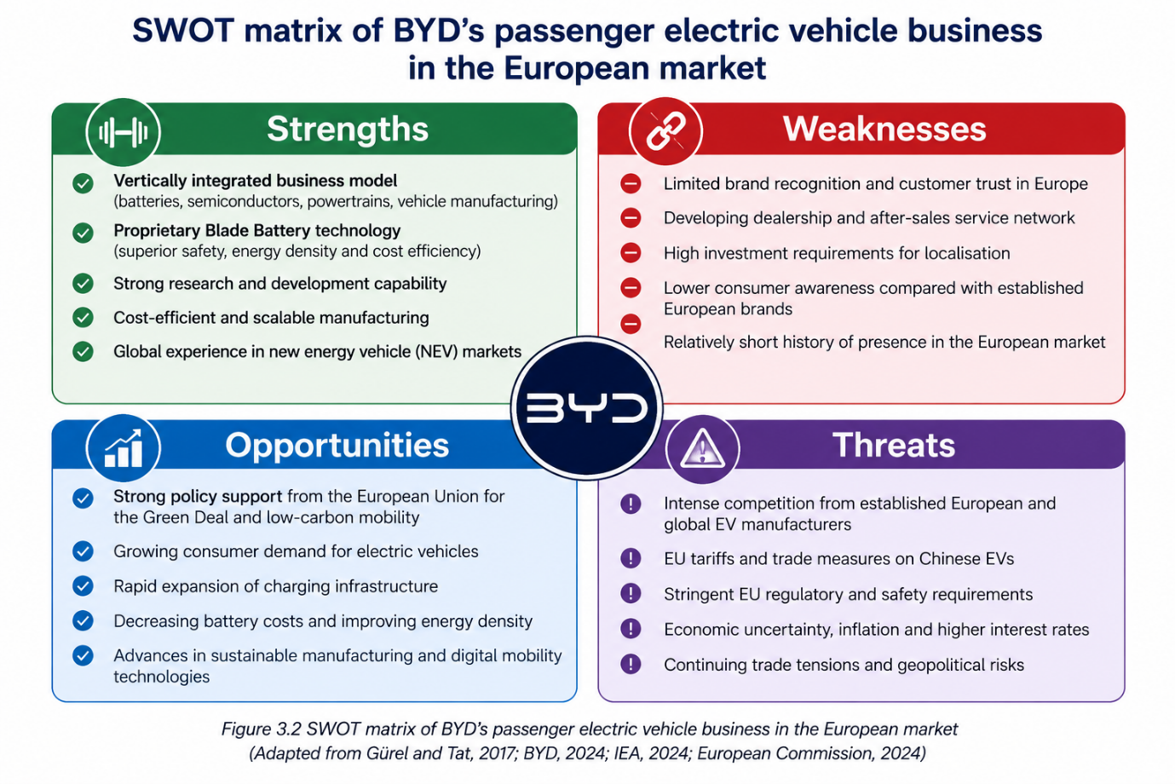
Figure 4: SWOT matrix of BYD's passenger electric vehicle business in the European market
(Adapted from Gürel and Tat, 2017; BYD, 2024; IEA, 2024, European Commission, 2024).

Comprehensive and Holistic Evaluation

Corporate Social Responsibility (CSR)
Corporate Social Responsibility (CSR) is a strategic concept which involves the organisation to generate long term value through its economic, environmental and social responsibility (Carroll, 1991). BYD's CSR is aligned with its corporate vision of “cool the Earth by 1°C”, making sustainability a social responsibility and a competitive advantage for the company. BYD's plans for CSR are not just implemented as a separate project, but are deeply integrated into its core business strategy of environmental innovation. They involve the creation of zero-emission passenger electric vehicles, battery technologies, and renewable energy solutions aimed at decarbonising the world (BYD, 2024).
Carbon reduction is one of BYD's priorities in the field of environment, including the mobilization of the car, energy-saving production processes, the recycling of batteries and ongoing investments in green technologies. The projects are in line with the EU sustainability program and boost the company's credibility in the European passenger EV segment. In terms of social aspects, BYD invests in employee development, occupational health and safety, responsible supply chain management, and community involvement; and governance frameworks focus on ethical business practices, regulatory compliance, and transparent corporate reporting (BYD, 2024).
Strategically, BYD's CSR initiatives align with the company's business goals, helping to build a positive reputation, ensure compliance with regulations, appeal to eco-conscious customers, and foster trust among stakeholders. This alignment is based on the concept of creating shared value: projects that benefit the society while also providing long term business value (Porter and Kramer, 2011). However, it will be essential to keep investing in supply chain transparency, responsible sourcing of battery materials and localisation efforts to meet growing stakeholder demand and changing environmental laws if expansion into Europe is to be continued. In summary, BYD's CSR strategy is well aligned with its long-term growth strategy and enhances its competitive edge in the European passenger EV market.
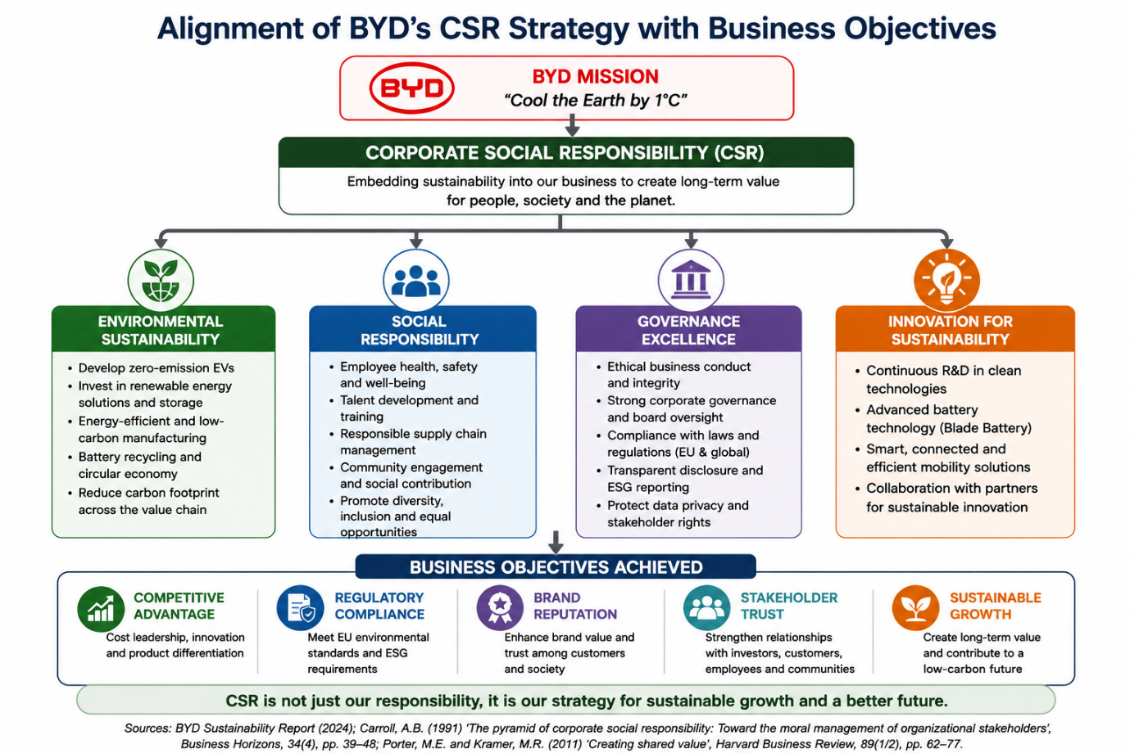
Figure 5: Alignment of BYD's CSR strategy with business objectives
(Adapted from Carroll, 1991; Porter and Kramer, 2011; BYD, 2024).

4.2 Balanced Scorecard
The Balanced Score Card (BSC) is a tool that breaks down an organisation's strategy into measurable goals and objectives by linking together four interdependent perspectives: financial, customer, internal business process, and learning and growth (Kaplan and Norton, 1992). The BSC offers a real-world solution to BYD's mission of sustainable mobility and strategic approach to the European mass-market passenger EV market.
In terms of business model, BYD's focus is to build sustainable business growth and profitability, as well as gain market presence in Europe. The key performance indicators (KPIs) used are European EV sales growth, operating margin, market share and return on invested capital. Strategies like localisation of manufacturing, supply chain optimisation and investment in manufacturing hubs can lower costs, boost the operational resilience, and drive long-term value for shareholders (BYD, 2024).
The Customer perspective is about increasing brand awareness, customer satisfaction and market penetration. Some of the KPIs that are relevant will be customer satisfaction scores, brand awareness, vehicle delivery performance, and repeat purchase intentions. To accomplish these goals, BYD needs to further strengthen its network of dealerships, refine its after-sales support, and boost its digital marketing and customer engagement efforts, whilst continuing to focus on the safety, quality and technological leadership of its passenger EV lineup.
As for the internal business process view, BYD's goals are to enhance the efficiency of their operations, product quality and innovation capability. Production efficiency, battery quality, product development cycle time, and reliability of the supply chain are some indicators of performance. Operational excellence and compliance with evolving European regulatory requirements will be further bolstered by continual investment in advanced manufacturing technologies, quality management systems and sustainable manufacturing practices.
Last but not least, the learning and growth focus is on the organizational capabilities that need to be developed in order to hold a competitive advantage over time. Research and development intensity, employee training hours, innovation output and talent retention are some of the appropriate KPIs. Focus on workforce development, strengthening digital capability, cross-cultural management and consistent technological innovation are key to supporting future growth as strategic initiatives.
Overall, the Balanced Scorecard provides a clear indication that BYD's mission and strategic goals can be measured. The company can foster a balance of financial performance, customer value, operational excellence and organisational learning to enhance strategic execution and to maintain its competitive edge in the European passenger EV market (Kaplan and Norton, 1992; Johnson, Scholes and Whittington, 2020).
Table 3: Balanced Scorecard for BYD's Passenger Electric Vehicle Business in the European Market
Perspective | Strategic Objective | Key Performance Indicators (KPIs) | Target | Strategic Initiatives
Financial | Increase profitability and European market share | Revenue growth, operating margin, market share, ROIC | Sustainable annual growth | Localise production, optimise supply chain, expand manufacturing capacity
Customer | Enhance customer satisfaction and brand loyalty | Customer satisfaction, brand awareness, repeat purchase rate, delivery performance | Improve customer retention | Expand dealerships, strengthen after-sales service, improve digital engagement
Internal Business Processes | Improve operational efficiency and innovation | Production efficiency, battery quality, product development cycle time, supply chain reliability | Shorter development cycles and higher quality | Advanced manufacturing, quality management, sustainable operations
Learning and Growth | Develop organisational capability and innovation | R&D intensity, employee training, innovation output, talent retention | Continuous capability improvement | Invest in R&D, employee development, digital skills, cross-cultural leadership
Source: Adapted from Kaplan and Norton (1992); BYD (2024).

Strategic Choices and Implementation

Strategic Alternatives
Following external and internal analysis, three strategic options are identified to boost BYD's market position in the European passenger EV market. The first approach is a Premium Differentiation strategy with technological innovation, based on the use of advanced batteries, intelligent driving systems, high quality products and high added value in the customer experience. This approach would help strengthen BYD's innovative positioning and would also help to advance premium value creation in a competitive market landscape.
The second is a European Localisation Strategy, which involves increasing manufacturing capacity, partnerships with supply chain, dealership networks and after sales services in Europe. European Commission (2024) indicated that localisation would benefit from the reduction of exposure to trade barriers, regulatory uncertainty and increase customer trust, operational resilience, and responsiveness to local market requirements.
The third is an Integrated Mobility and Energy Ecosystem Strategy, which amplifies BYD's competitive edge in the passenger car industry by bringing to the market EV, battery storage, charging infrastructure and renewable energy solutions. Through this, BYD will be able to produce value for its customers in the long term and reinforce strategic differentiation, taking advantage of its diversified technological capacities (BYD, 2024).
While each option presents certain benefits, it is important to systematically evaluate their respective impacts within the framework of the SAFe and determine the option that best suits BYD's resources, expectations and long-term growth goals (Johnson, Scholes and Whittington, 2020).

Table 4: Strategic Alternatives for BYD's Passenger Electric Vehicle Business in the European Market
Strategic Alternative | Strategic Focus | Key Benefits | Potential Challenges
Option 1: Premium Differentiation Strategy | Technology leadership, product quality, intelligent features | Strong brand positioning, customer loyalty, premium value creation | High R&D investment and intense innovation competition
Option 2: European Localisation Strategy | Local manufacturing, supply chain, dealerships, after-sales services | Reduced tariff exposure, improved customer trust, regulatory alignment | Significant capital investment and execution complexity
Option 3: Integrated Mobility & Energy Ecosystem Strategy | EVs integrated with charging, battery storage, and renewable energy solutions | Diversified revenue streams, ecosystem lock-in, long-term differentiation | Market adoption uncertainty and coordination across multiple business units
Source: Adapted from Johnson, Scholes and Whittington (2020); European Commission (2024); BYD (2024).

5.2 Strategic Alternatives Evaluation

Porter's Generic Strategies
The proposed strategic alternatives were screened with complementary strategic management frameworks to determine the strategic direction that would best suit BYD's passenger electric vehicle (EV) business in the European market. Based on Porter's Generic Strategies, BYD would be best suited to choose a differentiation strategy with cost efficiency. It has a proprietary Blade Battery technology, a powerful research and development capacity, and vertically integrated production, which can be used to differentiate products with better technology, safety, and quality, and ensure competitive prices (Porter, 1985; BYD, 2024).
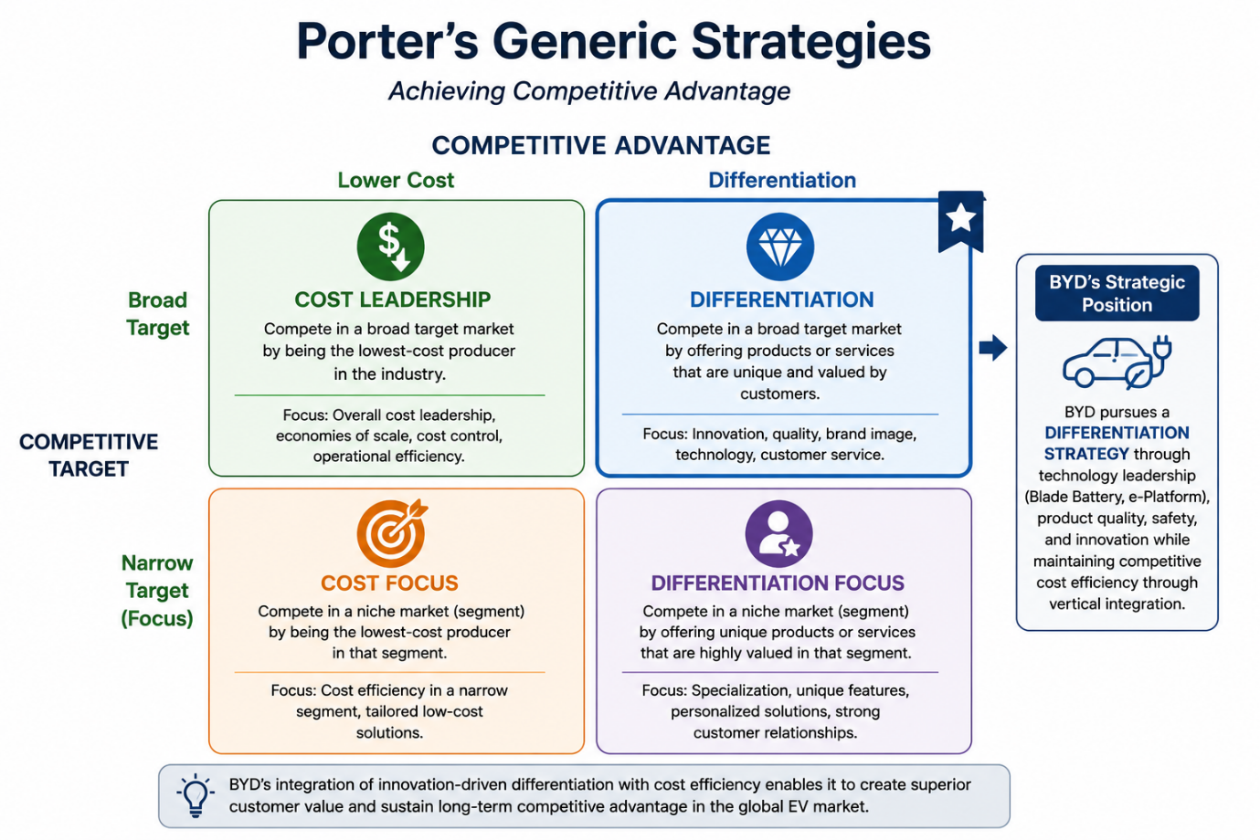
Figure 6: Porter's Generic Strategies

Ansoff Matrix
Using Ansoff's Matrix, market development is the preferred growth strategy for BYD, which involves growing the current passenger EV offerings in Europe by continuing to localise its products, expand its dealer network and improve customer services. The continuous innovation in battery technology and intelligent mobility solutions are also still relevant to product development and ensure long-term competitiveness (Ansoff, 1957).
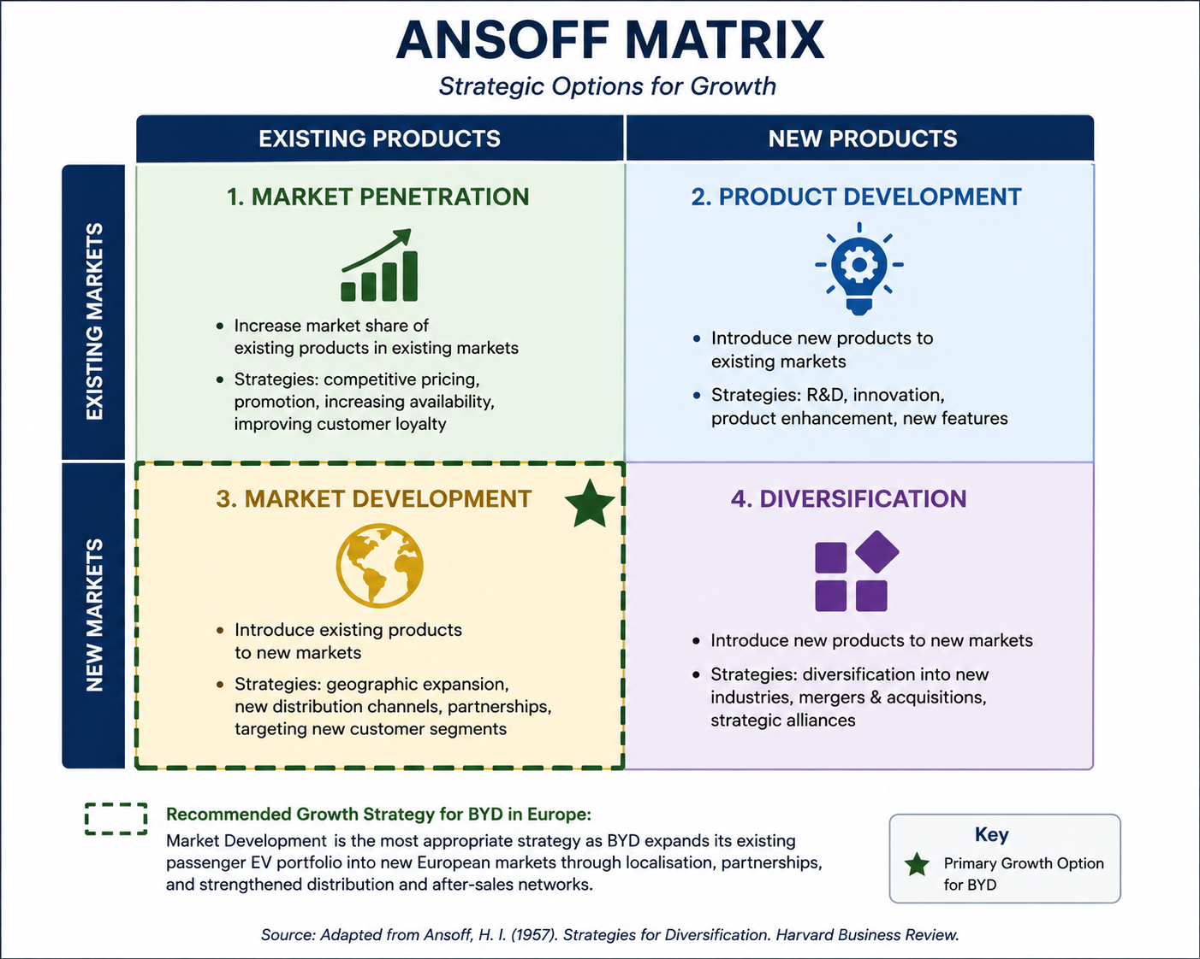
Figure 7: Ansoff Matrix
(Adapted from Ansoff, H.I (1957). Strategies for Diversification. Harvard Business Review.)

BCG Matrix
The BCG Matrix can be used to assess BYD's passenger EV business as a Star, due to its high growth potential in the fast-growing European EV market and growing market share. The need for ongoing investment in manufacturing capacity, innovation, and brand building to build market share and future profitability is a Star business priority (Henderson, 1970).
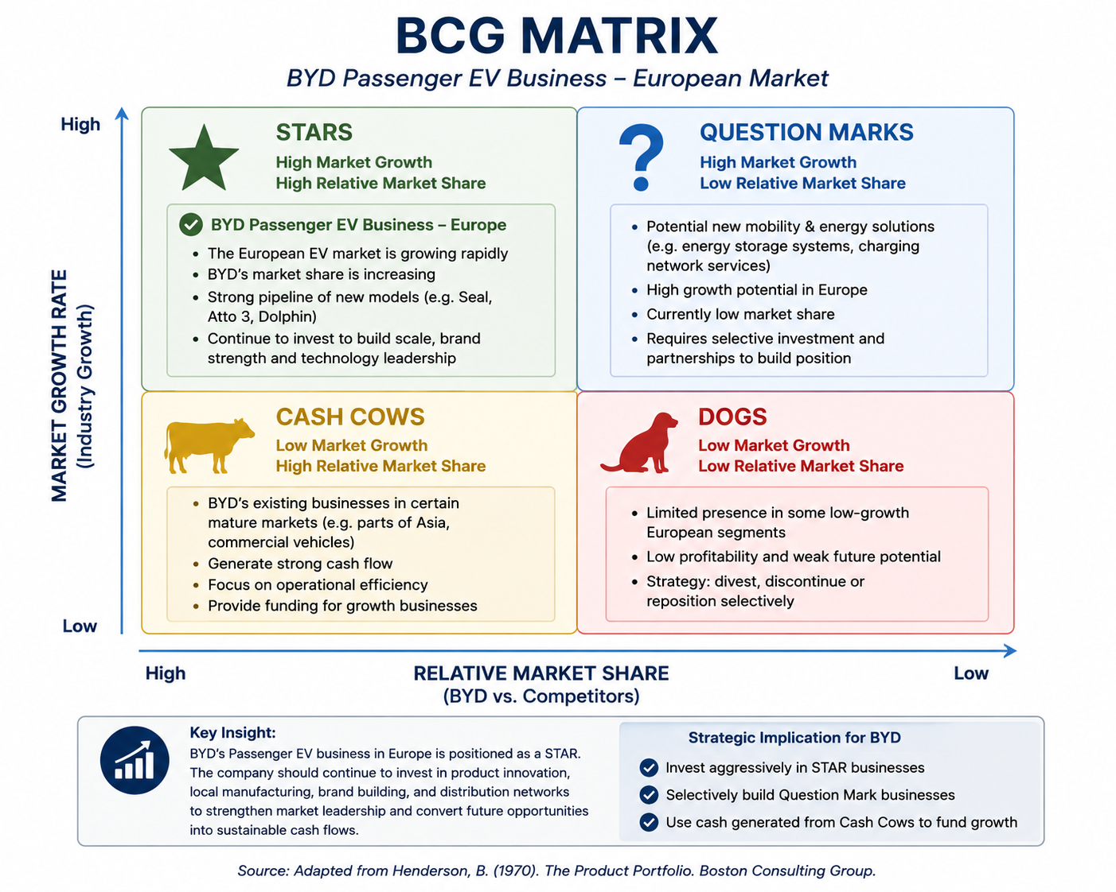
Figure 8: BCG Matrix
(Adapted from Henderson, B. (1970). The Product Portfolio. Boston Consulting Group.)
Finally, the three strategic alternatives were analysed with the help of the framework of SAFe (Johnson, Scholes and Whittington, 2020). The European Localisation Strategy shows the best overall performance, whereas the Premium Differentiation Strategy capitalizes on the core strengths of the technology of BYD, and the Integrated Mobility and Energy Ecosystem Strategy has a great long-term potential. Its integration into the external analysis had addressed regulatory and competitive concerns, had been welcomed by stakeholders due to its ability to foster customer trust and regional collaboration, and it was deemed feasible based on BYD's financial capabilities, manufacturing experience, and current European expansion efforts (European Commission, 2024; BYD, 2024).

Table 5: SAFe Evaluation Matrix
Strategic Alternative | Suitability | Acceptability | Feasibility | Overall Assessment
Premium Differentiation Strategy | High | High | Moderate | Strong
European Localisation Strategy | Very High | Very High | High | Recommended
Integrated Mobility & Energy Ecosystem Strategy | High | Moderate | Moderate | Long-term Opportunity
Source: Adapted from Porter (1985); Ansoff (1957); Henderson (1970); Johnson, Scholes and Whittington (2020)
In summary, the integrated evaluation suggests that a European Localisation Strategy coupled with technological differentiation in the long term is likely to prove to be the best strategy to secure BYD's competitive edge and sustain the company's long-term growth in the European passenger EV market.

Recommended Strategy and Implementation

Recommended Strategy
Integrated strategic evaluation reveals that the most suitable strategic option for BYD's business of passenger electric vehicles is the European localisation strategy aided by continuous technological differentiation. Manufacturing, supply chains, dealership networks and after-sales services will be more local, which will increase the regulatory compliance, decrease the exposure to trade barriers, increase the customer's confidence and increase the operational resilience. Meanwhile, the ongoing development of battery technology and intelligent vehicle systems will further solidify BYD's competitive edge and continue to drive the company's success in the European market (Johnson, Scholes and Whittington, 2020; BYD, 2024).

Implementation Roadmap (2026-2030)
The implementation should be in stages. BYD needs to further strengthen partnerships at the local level, build up the dealership and service network, and further localise procurement and assembly in 2026-2027. During 2028-2029, the company needs to ramp up production facilities, allocate resources for research and development partnerships in Europe and improve the supply chain integration. In 2030, BYD will further establish its market position by constantly innovating, improving customer experience and achieving operational excellence.

Implementation Challenges
European Commission, 2024, identifies regulatory uncertainty, growing competition from well-established European manufacturers, high capital investment needs, complexity of supply chains and the need to ensure product quality throughout multiple European markets as key challenges.

Risk Mitigation Strategies
These challenges can be alleviated by supplier diversification, strategic partnerships with European suppliers, active regulatory participation, investing in employee capacity building, and establishing effective quality and enterprise risk management processes. Ongoing market surveillance will further enhance organisational resilience, as will flexibly resource allocation (Hill, Schilling and Jones, 2021).

Key Performance Indicators (KPIs)
There are a number of measurable indicators that can be used to monitor the implementation of a successful strategy, such as the following: European market share, annual EV sales growth, customer satisfaction, localisation ratio, operating margin, dealership and service network expansion, battery production efficiency, R&D investment intensity. Through regular performance reviews with these KPIs, the Board of Directors will be able to assess the strategic progress and make timely changes to maintain their competitive advantage (Kaplan and Norton, 1992).

Table 6: Implementation Roadmap for BYD's European Localisation Strategy (2026-2030)

Phase | Timeline | Key Activities | Key Challenges | Risk Mitigation | Primary KPIs
Phase 1 | 2026-2027 | Expand local partnerships, dealerships, after-sales services, and procurement | Regulatory compliance, market entry barriers | Regulatory engagement, strategic alliances | Dealer network growth, localisation ratio, customer satisfaction
Phase 2 | 2028-2029 | Scale manufacturing, strengthen European R&D, optimise supply chain | Capital investment, supply chain complexity | Supplier diversification, quality management | Production efficiency, operating margin, EV sales growth
Phase 3 | 2030 | Consolidate market leadership through innovation and customer experience | Intensified competition, technological change | Continuous innovation, performance review, flexible resource allocation | Market share, R&D intensity, customer retention

Section 2

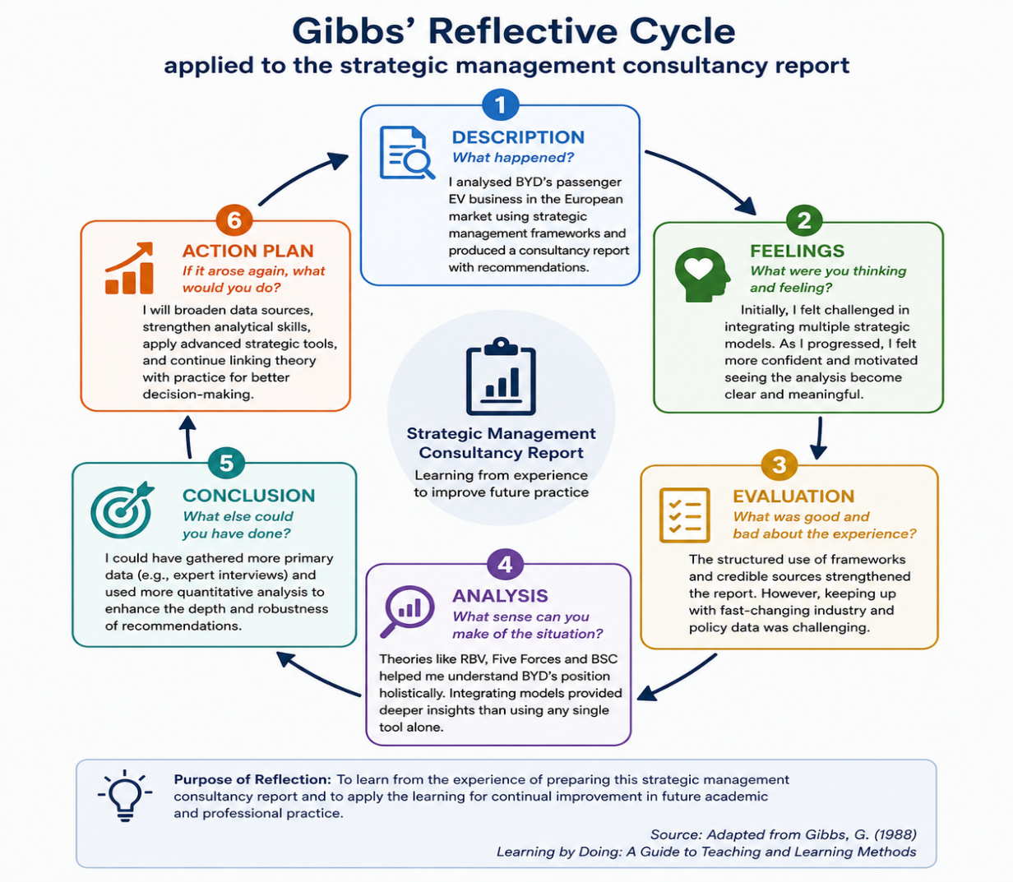
Reflective Account
Figure 9: Gibbs' Reflective Cycle applied to the strategic management consultancy report
(Adapted from Gibbs, 1988).

Description
A strategic management consultancy report was undertaken to assess BYD's business of the passenger electric vehicles in Europe and to use theories and frameworks of strategic management to a real organisation. The research process included searching for academic journal articles, strategic management documents, industry documents, company publications and policy documents from reputable sources such as the European Commission, the International Energy Agency (IEA) and BYD annual reports. The analysis involved a process of gathering information across a number of viewpoints to assess the external environment, the capabilities within BYD, the strategic positioning of BYD, the corporate social responsibility, performance management of BYD and any future strategic options. The report ended with a strategic recommendation and an implementation roadmap with the backing of the recognised strategic management frameworks.

Feelings
Initially, I was confident of the understanding of strategic management models for individuals but less confident on how to combine them in a coherent report as a consultant. At first, it was difficult to differentiate between the descriptive use of the frameworks and critical strategic evaluation. During the course of the research, I developed an increased belief in the ability to link theory to current industry developments, especially in the rapidly changing European Electric Vehicle market. Having finished, I gained an appreciation of how at the same time organisations can have capabilities, external pressures and stakeholders' expectations that all influence strategic decisions.

Evaluation
I was not only using complementary strategic frameworks in a systematic way, but I also didn't use a single analytical model. The PESTEL analysis, Porter's Five Forces, VRIO, SWOT, the Balanced Scorecard, Ansoff Matrix, BCG Matrix and SAFe framework gave a comprehensive view of BYD's strategic situation. The analysis was also enhanced by the use of recent academic literature and industry and government sources, which helped to build the credibility of the analysis. I was aware, however, that the industry is very dynamic and faces challenges when using analysis because of the rapid changes in regulations, technology and competition. Therefore, the use of up-to-date and trustworthy evidence was crucial in the entire research process.

Analysis
Gibbs' reflective model was used to prompt me to analyse and critique the role of strategic management theories in relation to each other (Gibbs 1988). For instance, PESTEL analysis highlighted the opportunities and threats in the macro-environment, and Porter's Five Forces analysis clarified the nature of the competition in the industry due to the external factors. The Resource Based View and VRIO framework showed that not only is it important that these opportunities are available externally but it is also important that the organisation has the right capabilities to make use of them (Barney, 1991). In addition, the Balanced Scorecard showed how strategic objectives could be expressed in terms of measurable organisational performance and the SAFe framework helped the organisation to be able to compare different strategic options objectively before being able to recommend the European Localisation Strategy (Kaplan and Norton, 1992; Johnson, Scholes and Whittington, 2020). This experience really helped me to realize that there is a need to understand multiple theories and not just one and use them together in order to have a successful strategic management.
The assignment also provided an additional development of some transferable skills. Independent research helped develop the skills of recognising reliable academic sources and critically analysing divergent opinions. By focusing on BYD's market development strategies in Europe, I gained valuable insights into international business strategy, sustainability, and competitive positioning. The creation of figures, strategic matrices and consultancy-type recommendations further strengthened my professional communication skills by structuring complex information in a comprehensible manner for senior decision makers.

Conclusion
Overall, this was an excellent consultancy project to complete as it greatly enhanced my understanding of strategic management in practice. I acquired more skills in critically analysing strategic issues, consolidating evidence from varied sources and making recommendations based on existing strategic frameworks. Therefore, the assignment has shown that a successful formulation of strategy requires balancing of organisational capacity with external environmental factors, and taking account of stakeholder expectation and sustainability of the strategy.

Action Plan
For future academic research and professional practice, I plan to build my analytical skills by reading more of the current, peer-reviewed literature and using more quantitative, up-to-date evidence in the evaluation of strategies. I also intend to build up my expertise in advanced data analysis, business intelligence and performance measurement to aid in evidence-based decision-making. Last, I will keep developing my capacity to apply theory to practical application and make meaningful recommendations for a range of consultancy work, which will continue to be academically sound, timely and relevant to the ever-changing business world.

References
Ansoff, H.I. (1957) ‘Strategies for diversification’, Harvard Business Review, 35(5), pp. 113-124.
Barney, J. (1991) ‘Firm resources and sustained competitive advantage’, Journal of Management, 17(1), pp. 99-120.
BYD Company Limited (2024) Annual report 2024. Shenzhen: BYD Company Limited.
BYD Company Limited (2024) Brand concept. Available at: https://www.bydglobal.com/en/BrandConcept.html (Accessed: 29 July 2026).
BYD Company Limited (2024) About BYD. Available at: https://www.byd.com/en/about-byd (Accessed: 29 July 2026).
Carroll, A.B. (1991) ‘The pyramid of corporate social responsibility: Toward the moral management of organisational stakeholders’, Business Horizons, 34(4), pp. 39-48.
European Commission (2024) Commission imposes countervailing duties on imports of battery electric vehicles from China. Available at: https://trade.ec.europa.eu/ (Accessed: 29 July 2026).
Gibbs, G. (1988) Learning by doing: A guide to teaching and learning methods. Oxford: Oxford Polytechnic.
Grant, R.M. (2022) Contemporary strategy analysis. 11th ed. Hoboken, NJ: John Wiley & Sons.
Gürel, E. and Tat, M. (2017) ‘SWOT analysis: A theoretical review’, The Journal of International Social Research, 10(51), pp. 994-1006.
Henderson, B.D. (1970) The product portfolio. Boston, MA: Boston Consulting Group.
Hill, C.W.L., Schilling, M.A. and Jones, G.R. (2021) Strategic management: Theory and cases: An integrated approach. 14th ed. Boston, MA: Cengage Learning.
International Energy Agency (2024) Global EV outlook 2024. Paris: International Energy Agency.
Johnson, G., Scholes, K. and Whittington, R. (2020) Exploring strategy. 12th ed. Harlow: Pearson.
Kaplan, R.S. and Norton, D.P. (1992) ‘The balanced scorecard - Measures that drive performance’, Harvard Business Review, 70(1), pp. 71-79.
Porter, M.E. (1980) Competitive strategy: Techniques for analyzing industries and competitors. New York: Free Press.
Porter, M.E. (1985) Competitive advantage: Creating and sustaining superior performance. New York: Free Press.
Porter, M.E. and Kramer, M.R. (2011) ‘Creating shared value’, Harvard Business Review, 89(1–2), pp. 62-77.

