

MODULE CODE: Digital Skills for Personal Development and Business Growth BMSW4008

ASSESSMENT COMPONENT: PORTFOLIO

STUDENT NAME: Lydia George

STUDENT NUMBER: 2516475

LECTURER: Philippa Fitzgerald

DATE:12.12.2025

I confirm that I have not presented any AI generated materials as my own work.
I confirm that I have copies of my drafts, notes, and other resources I used, which I may be asked to provide in evidence.

Contents
- Task 1 4
- Assessment of Digital Skills 4
References 6
- Task 2 7
- LinkedIn Learning Certificates for Office365 7
- Task 3 9
- Essay on Relevance of Excel in professional and personal life. 9
References 10
- Task 4 11
- 7 Minute Reflective Presentation 11

Task 1

Assessment of Digital Skills
I completed JISC assessment and my strengths and areas for improvement are identified.
Image 1
Screen shot of your JISC report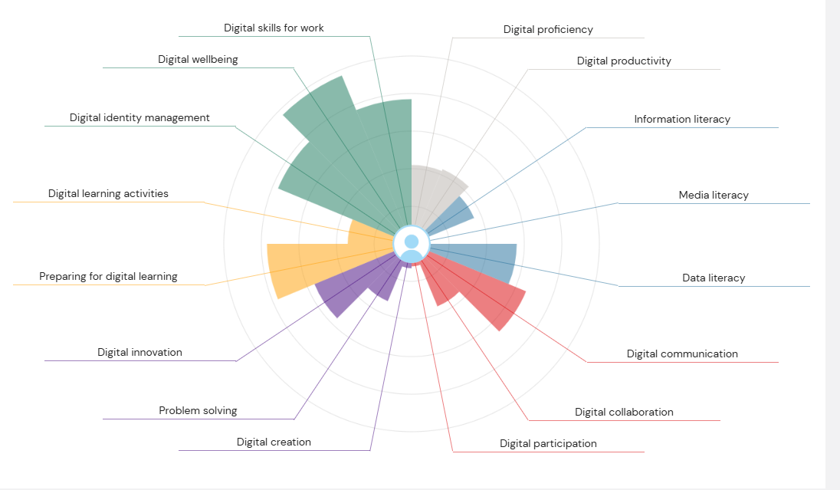

Digital skills are abilities we develop to operate devices such as computers, smartphone, laptops, tablets as well as the use of the internet effectively for google search and social medias. Wyk (2023) states that “rapid advancements in technology have had a significant impact on teaching and learning” and this I on going These skills have become very essential both in ones personal and professional lives .According to Bejakovic et al,(2020) highlighted that ,"digital technology becomes more integrated into the daily life and production in many economic sectors, digital literacy becomes of critical importance for the majority of employees" . Having a strong foundation of this skill not only improve productivity but it enables individuals to adapt changes technology brings .

My JISC tool result was completed at the start of the semester (2025) with this it identified both my strengths and areas that need improving according to JISC (2023) this an assessment for “developing strong digital capabilities helps individuals to thrive in a technology-rich environment, enhancing both learning and employability”.My strongest areas aware digital skills and digital wellbeing . Digital wellbeing is a skill i use to in a very balanced way whilst digital tools involve using tools and software in daily tasks . In my professional life i use various Microsoft Word, excel, powerpoint , and outlook for emails, teams regularly for meeting Covid changed our ways of interactions , data update for circulation and distribution , including presentations. These skills have helped me stay organised , and communicate effectively to colleagues and outside organisations . and work effectively with confidence . These skills have also supported me in my journey to academic work by allowing me to research for my course work , plan , take notes during lectures and submit assignments confidently.

My JISC results also help me identify my weaker areas as digital participation and media literacy. I feel i have none I don’t have much practise in these skills as i don't use them , but i am willing to learn and improve this by enrolling in short courses online to improve my knowledge and skill in this area . Digital participation this is bout taking part in online communication and team work, while media literacy focuses on understanding and information. I believe i might already use these some of these skills without realising it , for instance searching for information on line or reading articles for my course work and my professional work. Technology keeps developing , with new programmes and names is constant revolution , it is very important for me to acquire this knowledge and build my confidence in the areas of weakness for me to be able to use these tools effectively, properly in the future , according to the world economic forum(2023) it states “digital skills are no longer optional they are critical to accessing better jobs and adapting to the changing nature of work”.
Overall, completing the JISC tool has helped me understand my digital strengths and areas that need improvement. It has encouraged me to reflect on how I use technology in my studies and professional life. I now feel more confident about developing my digital skills further and using different tools to support my learning. As technology continues to evolve, I recognise the importance of keeping up to date so I can work efficiently and confidently in the future.

References
- Bejakovic, P. and Mrnjavac, Ž. (2020), The importance of digital literacy on the labour market.
- Fenech RM & Zammit Lucianne (2025), Empowering responsible digital citizens: insights from Maltese Personal, Social and Career Development (PSCD) teachers on the impact of technology on students’ wellbeing and curriculum relevance. https://doi-org.ezproxy.uwtsd.ac.uk/10.1080/02643944.2025.2500367
- JISC (2023) Building digital capability: The six elements of digital capability. https://digitalcapability.jisc.ac.uk (Accessed: 9 November 2025).
- World Economic Forum (2023) The Future of Jobs Report https://www.weforum.org/reports/future-of-jobs-report-2023 (Accessed: 9 November 2025).
- Wyk Van Michael, (2023) Intech Open ,Technology in Learning.

Task 2

LinkedIn Learning Certificates for Office365
I completed the LinkedIn Learning courses for Microsoft Word, Excel, and PowerPoint. Having done mock practise during lectures on these courses , this has helped me build on my existing digital skills and gain more confidence in using different tools for both academic and professional purposes.

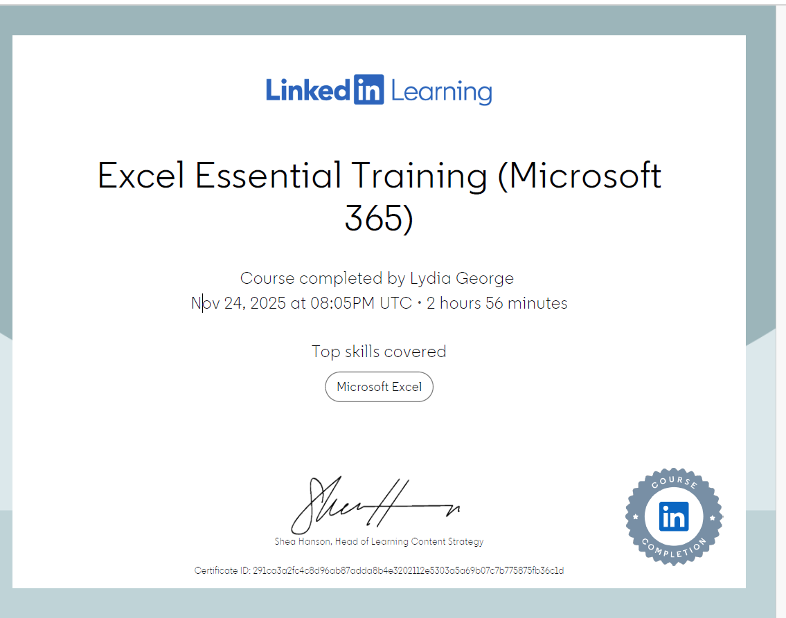

Task 3

Essay on Relevance of Excel in professional and personal life.
Microsoft Excel is a software program that forms part of the Microsoft 365 package, alongside other applications such as PowerPoint, Outlook, Word, and Teams. It is mainly used to organise, calculate, and analyse data through spreadsheets, formulas, and charts. As technology continues to develop, there is always new knowledge to gain and new ways to use digital tools effectively. According to Weathers et al. (2024), “with the growing importance of marketing analytics, there is a need to understand how to effectively develop analytics-related skills in students to prepare them for the workforce,” which highlights the increasing relevance of Excel and similar programs for the future workplace.
In this essay, I will discuss how Microsoft Excel, as a spreadsheet tool, can be used for data analysis, budgeting, reporting, and decision-making. Excel can also be applied for creating invoices, income statements, data reports, calendars, and to-do lists for better organisation. Each of these areas shows how Excel benefits not only students but also a wide range of industries, helping users make more informed choices in their work and daily lives, as quoted by Harvard Business review (2023) saying “Excel remains one of the most widely used analytical tools across industries”.

Microsoft Excel helps me see patterns and structure clearly, and it allows me to put the ideas that were in my head onto a spreadsheet in an organised way. Excel gives me a balanced outlook of the data and helps me create a positive forecast for looking ahead. According to Wallace et al. (2023), “data analysis refers to the process of examining, organising, and interpreting data to uncover hidden patterns, relationships or insights that can support decision-making and predictions.” One tool I use often is the SUM formula, which helps me add a whole set of data quickly using shortcut methods. I also divide between cells to compare profit and loss, and this helps me track numbers and percentages. If some cells are not quite 100%, I know improvement is needed, and I aim for a guiding range between 80–95% on the next data report which I can share with the team as according to Trimmer (2025) says ‘’excel can enable better decision-making and bring people together through shared and easily accessed information’’. This shows how Excel helps me analyse weekly data, make comparisons, and plan better for the upcoming week. raw data into useful knowledge and to make decisions in a more practical way.

In my life never thought excel can be used to tracking household income and expenditure , as I am used to the old fashioned way by pen to paper and calculator. The lecture about excel of the use of formulas was a refresher for me as I do use excel in work setting but I will now be using this in my personal life as I see the benefits it brings and are important according to Burns et al (2022) they say ‘’ there is an abundance of education technology that are worth using’’ as excel is one of them.

Overall in a working capacity I do see the benefits of excel as this gives accurate data and identifies area that needs improving. By looking at numbers and percentages from previous weeks, problems can easily be spotted and understand where may be going wrong. This will allow plans to be discussed early , with aim of making improvements before the next data is uploaded into excel. Having this level of detail not only will it support better decision making ,but it will also build and grow my confidence in managing information in both academic setting and everyday budgeting. This helps to know the importance of technologies as according to Cottrell (2024) she identifies that ‘’universities and colleges now routinely incorporate digital technologies into all aspects of the course’’, as students will held results to succeed in the future.

Embedded excel

References
- Burns, T and Sinifield, S (2022), Essential study skills, The complete guide to success at university 5th edition.
- Cottrell, S (2024) , The study skills handbook 6th edition.
- Harvard Business Review (2023) – “Excel remains one of the most widely used analytical tools across industries.”
- JISC (2023) – digital capability and data literacy
- linkedin.com (Firm) ,( 2022) Excel Essential Training (Microsoft 35) (Speaker Dennis Taylor)
Excel Essential Training (Microsoft 365).

- Trimmer,S (2025) , Building dashboard and tools with excel and power bi to elevate both non-techy colleagues and data driven decision making.
SIGUCCS '25: Proceedings of the 2025 ACM SIGUCCS Annual Conference
Page 28
https://doi-org.ezproxy.uwtsd.ac.uk/10.1145/3675229.3712533
Published: 06 April 2025

- Wallace M, Poulopoulos, Vassilis, Antoniou, Angeliki, López-Nores, Martín,(2023) Big Data and Cognitive Computing , Basel Vol. 7, Iss. 1, (2023): 14. DOI:10.3390/bdcc7010014.

- Weathers, D., Swain, S.D (2024) A scaffolded learning approach to increasing student comfort with Microsoft Excel. J Market Anal 12, 198–208 (2024). https://doi.org/10.1057/s41270-024-00306-1

Task 4

7 Minute Reflective Presentation
Embed PowerPoint

