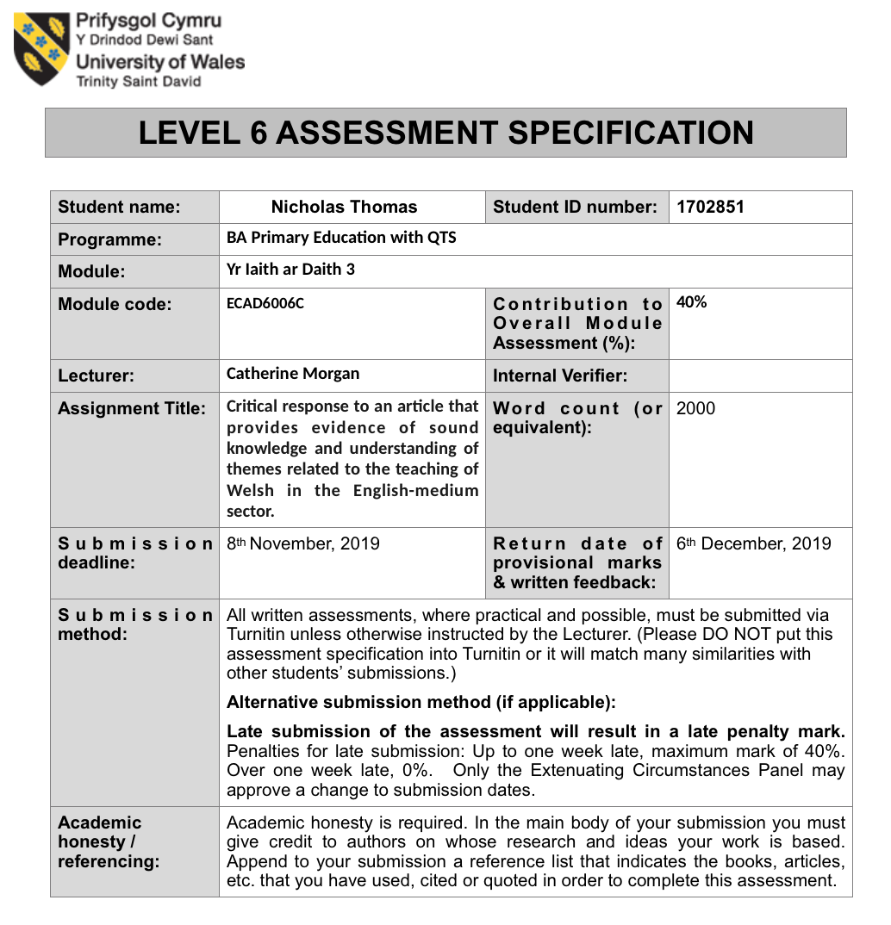
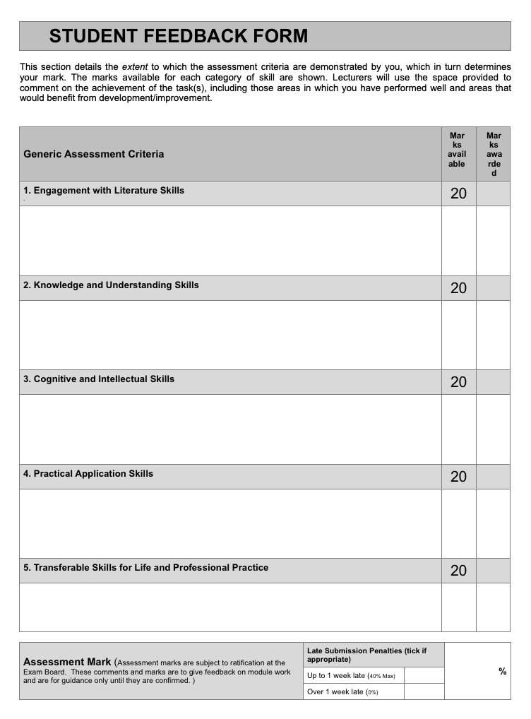

Critical response to an article that provides evidence of sound knowledge and understanding of themes related to the teaching of Welsh in the English-medium sector.

During this piece the writer aims to critically analyse the article ‘Non-Native English Students Learning in English: Reviewing and Reflecting on the Research’, written by Allan B.I. Bernardo and Marianne Jennifer M. Gaerlan. The articles title states clearly the intent of the writing. The review and reflection of research into Non-native speakers learning in English, it does not define what specific area of research it is reviewing. The learning of English as a second language is widely researched. The authors would find it difficult to review in depth all the areas of language learning.
In brief the article reviews and reflects on research conducted around Bilingual Philippine students who are tasked with undertaking activities in different psycholinguistic approaches. The students are learning English as a second language and are referred to as bilingual throughout the article. One issue is the statement made in the article within the introduction, noting that this article is not focused on how these students learn English; instead it focuses on how these students learn the content in a range of non-language focused subjects. This means that the research is implied to take place in settings where the students are capable of performing tasks in their non native language. Additionally this raises questions on the standard of the students bilingualism, and the difficulty in grouping or standardising bilingualism (Diller, 1970) The article was written in 2011, this makes it nine years old. While this in itself should not make the article outdated, the research within the article ranges from 1991-2010, this would mean there has been many years of possible updated research that itself may outdate the article.
Allan B.I. Bernardo is a distinguished lecturer of psychology who’s research focuses on poly-cultural and intercultural relations in Asian countries. The second author, a colleague of Bernardo at the University De Le Salle in the Philippines when this article was written, is Marianne Jennifer M. Gaerlan a faculty member of the English and applied linguistics department. The two authors would both appear to be in an informed position on the area of learning English for non-native speakers as well as experienced writers. The intended audience of the article is English second language teachers and English as an additional language teachers. The authors of the article offer some suggestions towards these practitioners to assist them in their teachings.
One main issue to be addressed is the use of the term ‘Bilingual’. Its use to describe the students within the research can complicate the analysis of the data and results. Being bilingual is a complex subject that is difficult to define accurately (Baker, 2011; Diller, 1970) and many writers are at opposition as to what would classify someone as bilingual. Valdés and Figueroa (1994) claim that bilingualism is the act of knowing two languages, this is ambiguous and could mean a large percentage of people are classed as bilingual. Diebold (1964) also believes in a low threshold for bilingualism where simply knowing a few words or phrases in another language makes one bilingual. If this was the accepted standard for bilingualism then that would mean that 19% of Wales would be classed as bilingual (Welsh Government, 2018). At the other end of the spectrum is Oestreicher (1974) who believes that there must be complete mastery of both languages in order to call yourself bilingual. This would possibly be too difficult of an outcome to achieve as there is very few people that could claim mastery of two languages, which would include its use in all situations. This would hugely reduce the number of ‘Bilinguals’ in an environment (Baker,2011; Baetens Beardsmore, 1986). If the students in the research were this class of bilinguals it may alter the results and findings. According to national statistic polls only 11% of Welsh citizens classes themselves and fluent in both Welsh and English (Welsh Government, 2018), this would mean that according to Oestreicher only 11% of Wales would be bilingual (Welsh-English). The variance in the numbers of bilinguals will further affect policy and statistics. The Cymraeg 2050: A million Welsh speakers document (Welsh Government, 2017b) published by aims to achieve 20% Welsh speakers depending on the accepted threshold of bilingualism this could be achieved sooner or much later. This variance would also affect how the research in this article comperes to Welsh education. Where the balance may be is somewhere in the middle according to Bloomfield (1933) and Grosjean (2008) place bilingualism as the ability to use both languages in their daily life, or with native like control. This categorisation of bilingualism may seem to be the best middle ground on a complex subject but it does still come with difficulties. The use of the term ‘native-like control’ (Bloomfield, 1933) is vague.What would be needed for one to be considered ‘native-like’, would the control require an accent or the application of slang terms in daily use. Diller (1970) mentions two forms of bilinguals that may run alongside the above mentioned categorisations, compound and coordinate learners. These definitions further muddy the waters of bilingualism. A native like use of the language would place the user in the coordinate learner category where they have learned the two languages separately in different contexts, whilst compound bilinguals will learn a second language using the first language as a dependent. Brooks (1964) claims that if a person is a compound bilingual they will never be a true bilingual. This would mean that a child who grows up with two languages at home would be a compound learner and not truly bilingual. These contradicting theories and definitions show the complexity and problematic use of the term ‘Bilingual’ and how varied its definitions may be.
The learning of a second language according to Baker (2011) is for one of two reasons, elective and circumstantial. Elective is where a learner learns a second language for monetary, societal, or educational needs, they are often learned in a classroom setting and produces a low chance of the mother language being replaced. Circumstantial learning is where a person must learn a language to function within a society such as some migrants who travel to countries where they do not speak the language. This learning can sometimes cause the mother language to suffer. The learning of English in the Philippines and Welsh in Wales would be elective, a person is not required to learn either language to survive in their respective countries. It is a choice. The article states that although there is no true need to learn English there are many pressures to learn. It is a requirement for high paying jobs, an entry requirement for many large universities, and there are social pressures due to the admiration of English speakers (Bernardo, A.B.I. & Gaerlan, M.J.M., 2011) . This is not necessarily the case in Wales, the governments plan for 50 million speakers by 2050 (Welsh Gov, 2017a) states the limited use of Welsh in the workplace with only 14% of staff using Welsh in the workplace. This shows that the use of Welsh in the workplace is not currently of high importance and is not seen by employers as valuable. The action plan states the intention of raising the use of Welsh within the workplace which in turn will also increase the prestige of Welsh within the workplace. This increase in prestige could bring the want and desire to learn Welsh to the levels of English in the Philippines.
Welsh in Education: action plan 2017-21 states the importance of using real concrete experiences to aid learning, ‘opportunities for children and young people to use their Welsh in various contexts’ (Welsh Gov, 2017b p22) . This would imply that teaching a second language through lessons on non language based subjects would be beneficial to the development of that second language. This pairs up with the research within the article where students learn non-language based subjects through English (their non-native language) as to improve their use of the language in daily use.
One issue with the methods used in the Philippines is to what level of bilingualism the students in the research have attained, as mentioned above the term bilingual is very difficult to define and as such the use of it within the article creates a vagueness. We cannot determine from the article alone what standard of English the students can use and this would affect the suggestions given. If the students are adept at English then that may be comparable to the 16% of Welsh speakers we have in Wales or the 22% in Welsh medium education (Welsh Government, 2018). In this scenario the education systems are very similar with non-language subjects being taught through a second language. Although Welsh may not be considered a second language for some students, it is the minority language just as English is in the Philippines. The research conducted in this article could be used in this instance, to defend the use of Welsh as the teaching language in non-language based subjects. Where this research may be most useful is if the bilinguals in the study have limited second language skills. This would then compare to the large majority of learners in Wales, the over 70% whom learn primarily in English with Welsh specific lessons (Welsh Government, 2018). The research in this article shows that learning through a second language does not hinder the learning of a non-language subject and in some instances can give better recall of information. The research aligns with the goals and ideals set out by both the Welsh Government (2017a, 2017b) and Prof. Donaldson (2015), where learners should be given opportunities to experience learning in real life scenarios. These real world learning experiences are, according to Professor Donaldson in ‘Successful Futures’(2015), instrumental to good learning and understanding. The possible increase in use from the suggestions outlined by the article, Welsh Government, and Prof. Donaldson could create an environment conducive of the goals set out in the Cymraeg 2050: A million Welsh speakers document (Welsh Gov, 2017a).
With regards to the results, the article notes that learning is the ability to use information in complex ways (understanding) but the studies show that the students were recorded as being better at complex mathematical problems that relied on understanding more than recall when tested in their native language, the students also noted that they would translate the problems to their native tongue to aid them. This would categorise them as a compound bilingual where the speaker uses the native language to scaffold the second. And again according to Brooks (1964) they will never be a true bilingual. The students did perform better in the recall tasks that were taught and tested through English but that is explained as an effect of learning in English. If the goals of the lessons are to make a learner bilingual then these methods may not be satisfactory and the learners will never become true coordinate bilinguals (Brooks,1964; Oestricher, 1974), but if the goal is to produce learners who can effectively communicate and function in two languages then this method may be productive. Michał B. Paradowski and Aleksandra Bator. (2018) write that there are many benefits to learning bilingually in eduction and the mixture of first language at home and second language produces effective language development of both the first and second language.
To compare the two situations of the Philippines and Wales is difficult, there are so many differences in the two systems and environments that assuming a method that works well in the Philippines will translate to Wales and also be productive is troublesome. There are large differences in reasons for learning the languages, with the high admiration and desirability of English in higher education and the workforce in the Philippines compared to the low use of Welsh in the workforce. The Philippine government has placed a huge emphasis on high quality teaching of English. A report by Florencio Fianza (2017) of the Manila Standard notes the recent( at the time of publishing) push for English to become the mandatory language in schools. The last of four bills filed to the Philippine House of Representatives was pushed forward by a former president,Gloria Macapagal-Arroyo. This report highlights a belief by some high ranking government employees that English medium Education is a must for producing high quality English speakers. The Welsh government are aiming promoting similar beliefs as noted in the goals of Cymraeg 2050: A million Welsh speakers document (2017a)
If the Welsh government are able to create an environment where Welsh is seen as valuable and sought after as English is in the Philippines then the method of fully Welsh medium education may work. This is no guarantee though as Michał B. Paradowski and Aleksandra Bator. (2018) write that there are no perfect fits to bilingual development and must be tailored to fit as with most education, learners of a second language may have completely different backgrounds and may have no family link to the second language. If the desire to learn Welsh increases then the possibility of learners whose families are not Welsh speaking will be entered into Welsh medium education, these learners will require a tailored educational experience (Paradowski and Bator, 2018). There is clearly no easy solution to improving the use and speakers or the Welsh language but through the successes of the Philippines the improvement and increase in the admiration and desirability of the language across business and higher education may be a good starting point.
WORDCOUNT- 2,250

References-
Bernardo, A.B.I. & Gaerlan, M.J.M. (2011) Non-Native English Students Learning in English: Reviewing and Reﬂecting on the Research. In Jaidey, R., Sadorra, M.L.C., Wong, J.O., Lee, M.C. & Lorente, M.C. (eds.) Global perspectives, local initiatives: Reflections and practices in ELT. National University of Singapore, CELC, pp.1-9.
Antoniou, K., Grohmann, K. K., Kambanaros, M., and N. Katsos. (2016) The Effect of Childhood Bidialectalism and Multilingualism on Executive Control. Cognition 149: 18–30.
BAETENS BEARDSMORE, H. (1986). Bilingualism: basic principles. Clevedon, Tieto.
Baker, C. (2011) Foundations of Bilingual Education and Bilingualism, 5th Edition. Clevedon: Multilingual Matters.
Bloomfield, L. (1933) Language. New York: Holt, Rinehart, and Winston.
Brooks, N. (1964) Language and Language Learning. New York
Diebold, A. R. (1964). Incipient bilingualism.
Diller, K. (1970) “Compound” and “Coordinate” Bilingualism: A Conceptual Artifact, Word, 26:2, 254-261, DOI: 10.1080/00437956.1970.11435596
Donaldson, G. (2015). Successful Futures: Independent review of curriculum and assessment arrangements in Wales. Caerdydd: Llywodraeth Cenedlaethol Cymru
Fianza, F. (2017) Duty calls Available at: http://manilastandard.net/opinion/columns/duty-calls-by-florencio-fianza/235741/english-speaking.html [Accessed on 25/10/19]
Grosjean, F. (2008) Studying Bilinguals. Oxford: Oxford University Press.
Oestreicher, J. P. (1974) ‘The early teaching of modern language, education and culture’. Review of the Council for Cultural Cooperation of the Council of Europe 24: 9-16
Paradowski, M. and Bator, A. (2018) Perceived effectiveness of language acquisition in the process of multilingual upbringing by parents of different nationalities. International Journal of Bilingual Education and Bilingualism 21:6, pages 647-665.
Valdés, G., & Figueroa, R. A. (1994). Second language learning. Bilingualism and testing: A special case of bias. Westport, CT, US: Ablex Publishing.
Welsh Government (2017a) Cymraeg 2050: A million Welsh speakers. Cardiff
Welsh Government (2017b) Welsh in education: Action plan 2017-21. Cardiff
Welsh Government (2018) National Survey for Wales: Headline results, April 2017 – March 2018. Available at: https://gov.wales/sites/default/files/statistics-and-research/2019-01/national-survey-wales-headline-results-2017-18.pdf [Accessed on 25/10/19]

