Module: Understanding and Engaging in the Customer Experience
Code: BMSW 5103
Assignment Title: Acritical Perspective of ASDA in relation to its CRM, Ethics, Sustainability and Quality Policies and Operations
Student: Ubaidullah Shameem
Number: 1711708
Lecturer: Dr Olu Adegbite
Submission deadline: Report – 13/03/2020
Task one

Executive summary

This report is about investigation of Customer Experience on Ethical and Sustainability in Asda and other supermarkets and in the whole business sector. The report also looked at Customer Relationship Management, Quality and Quality Management and how to improve them. at the end of the report recommendations are given to Asda for future improvement.

Contents
Executive summary 2
Introduction: 4
Customer Relationship Management (CRM) and Customer Experience Management. 4
Customer relationship cycle 5
What is Ethical: 5
Marketing Ethics: 5
Importance of Marketing Ethics: 6
Areas of Marketing Ethics 6
Ethical Norms and Rules: 7
Some of the Ethical and Unethical examples in the Business sector 7
Sustainability: 7
Sustainable Marketing: 8
Importance of Sustainable Marketing: 8
Asda 8
Ethical and Sustainable practices of Asda: 8
Tesco Ethical and Sustainability policies: 9
Task two: 10
What is Quality: 10
How to Manage Quality: 10
Total Quality Management (TQM): 11
Importance of Quality Marketing: 11
Deming Theories of Quality: 12
Deming Cycle: 12
Deming 14 point for plan for Quality Management: 13
Juran’s Theory of Quality: 14
Quality Trilogy: 14
Juran’s Quality Planning Road Map: 14
Crosby’s Cost of Quality: 15
Quality Models used by Asda to improve its Quality and customer Relationship Management: 15
Task Three: 16
Conclusion and Recommendations: 16
Reference: 17

Introduction:
This report will highlight the customer experience of Ethical and Sustainability in Asda and other supermarkets, with examples, as well as finding the impact of Ethical and Sustainability on customer relationship Management.
The report will also explain how an organisation improves its customer relationship management by using many quality models and theories. At the end of the report recommendations will be given to improve customer relationship management.

Customer Relationship Management (CRM) and Customer Experience Management.
Customer Relationship Management is about managing detailed information about individual customers and carefully managing customer touch points to maximise customer loyalty.
CRM is also known as continuous Relationship Marketing, customer Relationship Marketing and customer Relationship Management (Armstrong et al, 2017).
CRM record what a company knows about a specific customer. Every detail of his or her history of service requests, product returns, and inquiries, as well as other things.
Customer experience data captures customers’ subjective thoughts about a particular company.

Customer relationship cycle
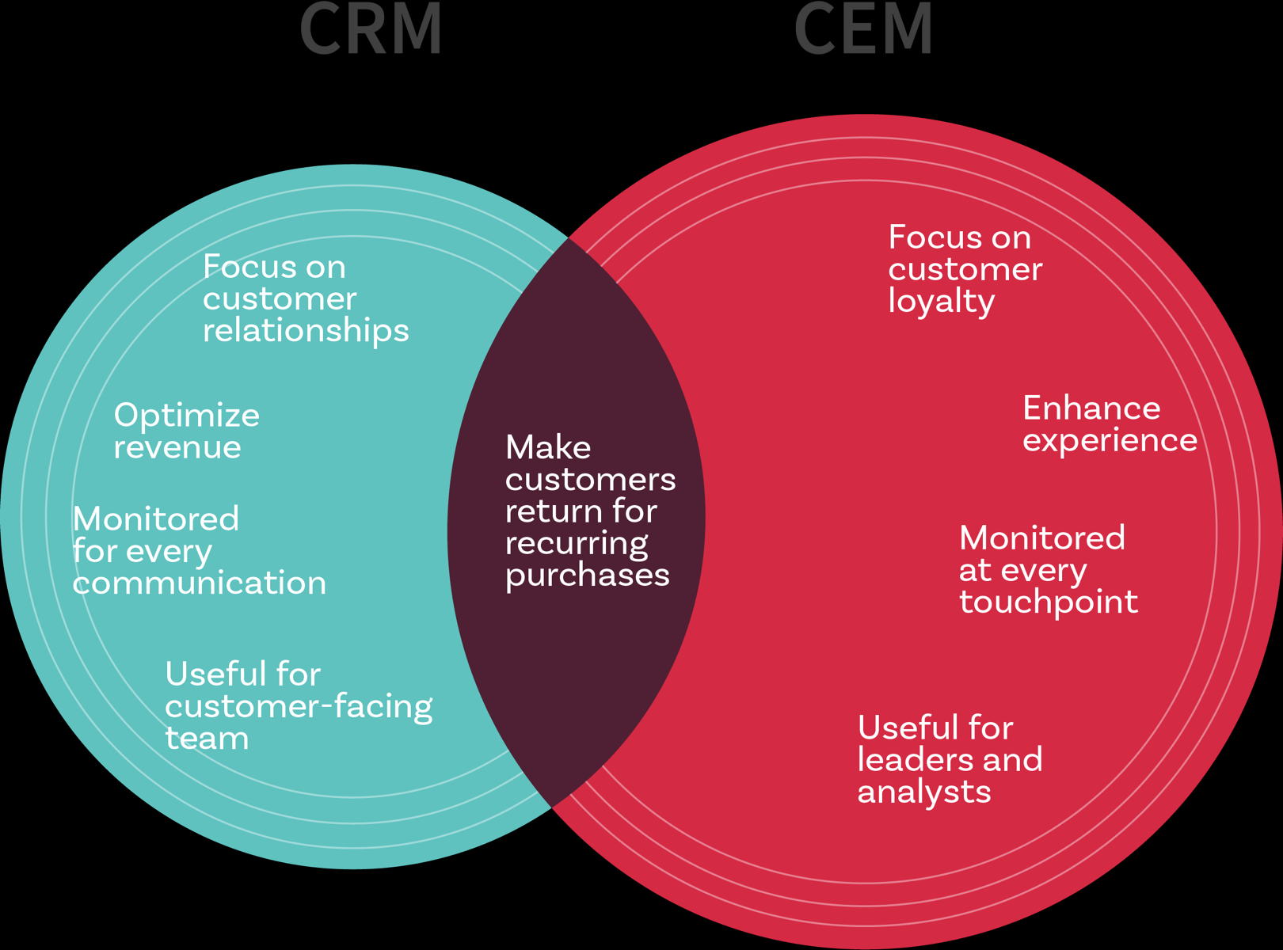
Source: Medium.com
Today every business is more interested on how to build long term relationships with their customer, promising them that they can fulfil their long-term needs. Therefore, companies make every effort to satisfy the needs of important customers as dissatisfied customers will not return.
According to Lemon and Verhoef (2016), customer experience is a multidimensional construct focusing on a customer’s cognitive, emotional, behavioural, sensorial, and social responses to a firm’s offerings during the customer’s entire purchase journey.

What is Ethical:
Ethical is what is good for individuals and society and is also described as moral philosophy. According to Cambridge Dictionary (2020), ethic is the study of what is morally right and wrong, or a set of beliefs about what is morally right and wrong.

Marketing Ethics:
Marketing Ethics are moral codes of conducts which are acceptable in the marketplace, what is morally right and what is wrong in marketing. According to CIM (2016), Marketing Ethics is ‘the moral principles that govern behaviour or the conducting of an activity’. Its importance is valuable to the continuing existence of business.

Importance of Marketing Ethics:
Marketing Ethics is important so companies can win the trust and loyalty of its customers, as customers want such products which are genuine and authentic as advertised by the company. Therefore, every company should be honest, fair and responsible in all of their advertising, selling and dealings. These are vital for the survival of the company, as unethical behaviour will lead to mistrust to the customer and this may lead to company failure.
However, maintaining balance between making profit and meeting customers’ expectations is sometimes challenging, because companies want to make profit at the same time to fulfil the needs of customers so they exercise unethical behaviour. For example, to make clothing in UK it would cost more but to make it from Asia it would cost less because they use cheap labour and sometimes child labour such as Topshop and Primark (Independent News, 2018), so they can pay less but sell with higher price, though paying less and using children is unethical.
Areas of Marketing Ethics:
Marketing Ethics can be found in many areas such as product advertising. When companies advertise a product, they hide some information or provide an insufficient amount which misleads or advertises unsafe products. They are aware that this is not illegal, however this is unethical, as Fruen reported in The Sun News Paper (2016), on how Supermarkets mislead shoppers including Asda, Morrison, Sainsbury’s and Tesco. Tesco and Sainsbury for example, mentioned in their package ‘’Duck and orange pate Slice’’, However, the main ingredient here is actually pork fat not Duck and orange. As in Tesco, not only is their label misleading but the Duck picture in the package is also misleading. Similarly, in Asda, the Salmon fillet packet weight is mentioned as 400g, but the actual fish weight is 360g and 40g is Ice.
Promotion: To provide items which promote companies such as shirts, hats and beer to college students.
Pricing: There are four areas where pricing is believed to be unethical and illegal such as deceptive pricing, unfair pricing, price discrimination and price fixing.

Ethical Norms and Rules:
There are some rules which every marketer should follow in order to make good relationships with the customers and stakeholders. Among them the core values are:
Honesty: Be truthful in all situation and all times. Deliver what they promise.
Fairness: The marketers should be fair when they sell any product or in their advertising. They should not give false information nor should they deceive.
Respect: They should treat everyone equally regardless of their gender, race, colour and ethnicity.
Responsibility: They are responsible to accept consequences of marketing decision and strategies.
There are laws and consumers rights which are available to protect the customers from unethical practise by the business. These laws allow consumers basic rights in the marketplace.
Some of the Ethical and Unethical examples in the Business sector:
- It is ethical to pay at least minimum wages to the employees by following the government laws and regulations as paying less than minimum wage is unethical.
- Practising equality and diversity in business is ethical, whereas treating employees differently based on their colour and religion is unethical.
- Companies should not deceive consumers by reducing the size of the products and contents.
- Marketing to children is unethical as well as marketing beer to college students and also giving promotional items such as shirts and hats etc.
- Price fixing whether it be Horizontal price fixing or vertical price fixing is unethical.
- Product testing on animals or inadequate testing to reveal concern.

Sustainability:
According to Cambridge Dictionary (2020), sustainability is the Quality of being able to continue over a period of time.
Sustainability is meeting the needs of the present without compromising the ability of future generations to meet their needs.

Sustainable Marketing:
Sustainable marketing is to meet consumers’ needs as well as thinking of future generations to meet their needs. Generally, there are three areas to sustainability: Environmental, Economic and Social.

Importance of Sustainable Marketing:
The world population is growing faster than ever before, consumers needs are also growing. Consumers are more interested in environmental issues, social issues and economic growth. Global climate is changing, temperatures are rising, ice is melting, sea levels have increased by 3.6mm every year between 2005 and 2015 (BBC,2020), people are more concerned about the future, how the future generation can benefit economically, socially and environmentally. Consumers want to buy from a company who take these issues in to account. Therefore, sustainable Marketing is important. As a result, many companies are now adopting sustainability in their marketing strategy.
In the UK, big supermarkets such as Tesco, Asda, Morrisons and other supermarkets have launched sustainability to attract customers.

Asda
Asda was founded in 1949 and it headquarter is in Leeds west Yorkshire. Asda is the second largest supermarket in UK with the market share of 15.4% (BBC, 2019). Asda was merged with the world-famous company Walmart in 1999. Currently Asda has 631 stores with 165,000 employees working in (Asda,2020). Asda claims that it is Britain’s lowest priced Supermarket.

Ethical and Sustainable practices of Asda:
Some of the examples of Asda on their sustainable marketing are as follows:
- According to Asda (2020), Asda has distributed more than 10 million meals working with FareShare for more than six years.
- In 2018 Asda worked in partnership with FareShare and the anti-poverty charity Trust to help 1 million people out of poverty. They call it “Asda Fight Hunger Create Change”.

- Asda stated that workers across the supply chain are properly looked after, treated equally and fairly. However, according to Mail on Sunday (Bright, 2017), an investigation found that they paid low wage to the Bangladeshi workers so they were not able to support their families.
- Asda says that they have removed plastic from 180 product ranges and removed single use plastic items from their home offices, stores, depots and cafes. They removed single use carrier bags from online Grocery and in store. This will save 375 million carrier bags from production each year. As part of sustainability, Asda is opening a sustainability store in Leeds where customers can refill their own container with food such as rice, pasta, tea and coffee as well as Kellogg’s cereals such as coco pops, rice Krispies and PG Tips Tea. In addition to refill station, there will be a ‘’naked florist’’ plastic free flowers and loose products such as cucumber and mushroom without plastic packaging. This move is to reduce plastic waste as Asda is committed to reduce plastic by 15% by 2021 and 100% recyclable by 2025 (BBC, 2020).

- Since 2015 all Palm Oils in Asda’s products are Roundtable on Sustainable Palm Oil (RSPO) standards. However, Ethical Consumer Research Association Ltd, (2020) found that more than half were certified by Book and Claim, the lowest level of certification.
- The Cocoa that Asda uses in Asda Milk, Dark, White Whole nut and fruit and in chocolate Bars is Rainforest Alliance Mass Balance certified.
- Asda claims that they pay an equal amount to male and female employees. However, in 2017, 9,500 women claimed that they were paid less compared to their male colleagues, despite the fact that their work was the same (Ethical Consumer Research Association,2020).

From the above examples it can be said that Asda is not fully ethical, as some of its practices contradicts with the reality.

Tesco Ethical and Sustainability policies:
Tesco has similar policies like Asda, such as providing good health and safety, working hours, equal pay, no child labour, no discrimination and human right issues. However, Tesco was fined £8 million for environmental and safety offence (Helen et al, 2017) when a petrol filling station in Haslingden leaked and 23,500 litres of petrol was lost from the fuel tank and fuel entered in sewers and the River Irwell.

Tesco says that they are the founding member of Ethical trading initiative since 1998 and their suppliers follow the Ethical Trading rules and Regulations and supply goods that is good for the business and consumers (Tesco, 2020). However, in 2013, they advertised beef meat in their burgers but the burgers actually contained horse meat. It was known on 15 January 2013, when horse DNA was found in frozen beef burgers which goes to British supermarkets such as Tesco, Asda and other Supermarkets (BBC, 2013).
Tesco was rated the best Ethical Consumers in 2019 for its supply chain Management as they mentioned in their website under ‘’ our Approach to Human Rights’’ under Modern Slavery Statement 2018/19 and Supplier Code of Conduct. However, Ethical Consumer Research Association have found that one of Tesco’s suppliers were using slave labour and they were paid as little as 50p a day for working on firms, rubbish Recycling centre and poultry factories (Ethical Consumer Research Association Ltd, 2020).

Task two:
In this task different quality models and theories will be discussed to see what quality models Asda is using to improve its products, services and Customer Relationship Management.

What is Quality:
Quality means how good something is contrasted with other comparative things. According to Pryor, et al, (1998, p. 2.3):
“Quality refers to the extent to which processes, products, services, and relationships are free from defects, constraints, and items which do not add value for the customer.”
Quality needs to be managed always for customer loyalty, as well as meeting customer expectations and reduce cost and wastage.

How to Manage Quality:
Quality can be achieved by Quality Assurance and through Strategic Approach.
Quality Assurance is a method of finding out mistakes and defects of manufactured products and correcting the defects before reaching to the customers. Also, Quality can be managed through Strategic approach by implementing a strategic planning process to analyse and evaluate the needs of customers to find the best approach to fulfil the needs.
In addition to this, Quality can be managed by adopting the Quality Models that Quality Gurus have introduced such as Edwards Deming, Joseph Juran, Philip B Crosby and Kaoru Ishikawa.
Other ways of managing Quality includes:
- Conformance: How good the product or service to meet customers’ expectations is.
- Reliability: How reliable the product is.
- Special Features: products have extra facilities, for examples, some cars have Apple car Play/ Android Auto, Heated Steering Wheel and Automatic Emergency Breaking.
- Durability: Products last as long as it should.
- Performance: Everything is fine and works well.
- Serviceability: Company provides service after sale.
Quality can also be managed by Quality Certification such as ISO 9000 which international Standard on Quality assurance and ISO 14000 on international standards for assessing for company’s environmental performance.

Total Quality Management (TQM):
A system of the organisation based on the principle that everyone in an organization is in a continual effort to improve quality and achieve customer satisfaction.
Total Quality Management deals with finding out what customers want, design products that meet customers’ expectations, keep track of the results and also solve problems.

Importance of Quality Marketing:
Maintaining Quality is important in business to get customer satisfaction and loyalty. Customers do not choose products just based on price but on quality too. In fact, many customers are willing to pay more for products or services if the quality is good. Poor quality products may result in more spending or may lead to loss of business or reduce productivity.
For example, Toyota and Lexus recalled its 44,000 customers of 2019 and 2020 model car owner over engine cracks (Consumer Report,2020). Similarly, Volkswagen, Hotpoint and Indesit have also recalled their customers over their products fault (BBC,2019).
There are many quality models and theories which are available to improve quality of products and services. However, the most well-known are:
- Deming (Deming’s Cycle, Deming 14 points, etc)
- Juran (the Quality Trilogy and the Quality Planning Roadmap)
- Crosby (Crosby's Cost of Quality, four Absolutes of Quality Management)

Deming Theories of Quality:
William Edwards Deming is an American lecturer, professor, engineer and a management consultant. He believes that higher quality leads to higher productivity and higher productivity leads to long term competitive strength. If the quality is better with lower price, a company can perform better in the business sector and create more jobs (Monnappa,2019)
Deming quality focuses on identifying the products faults, examining the causes, correcting the cause and recording the effect of the corrections. He thinks that this would cost less in the long-run rather than doing it now and fix it later.
Deming has introduced four repeated steps for continues quality improvement process and product. This is called the Deming Cycle, also known as Shewhart cycle or PDCA (Deming,1986). The four steps are:
- Plan a change or test
- Do it. Conducting the change or test.
- Check it. Look at the effect of it.
- Act on what was learned from the test.

Deming Cycle:
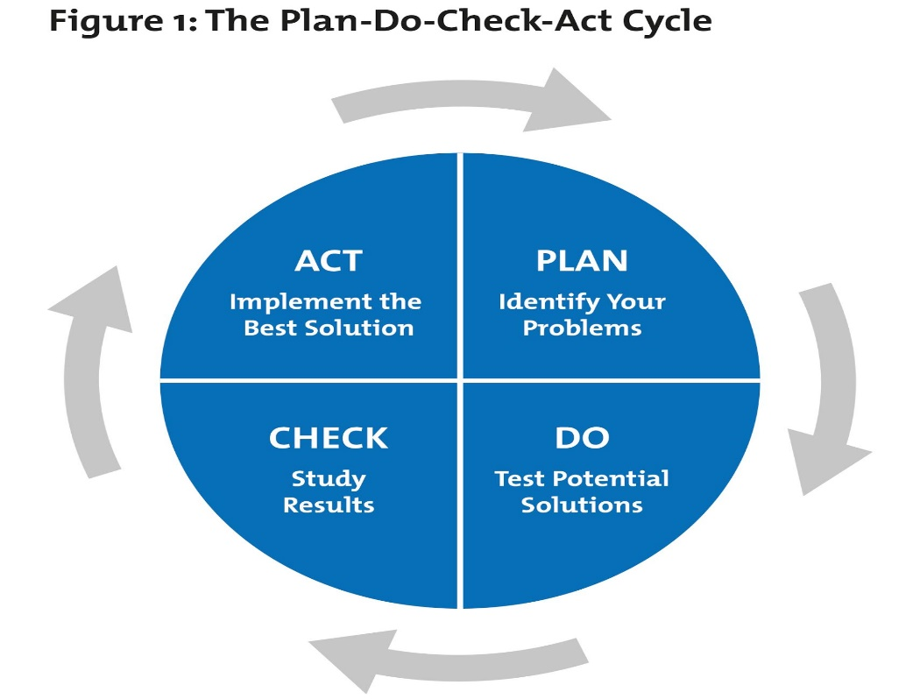

Source: Mind tools.com

Deming has introduced 14 points for the business to improve its products, quality and services to become competitive in the market and provide jobs. They are as follows:
- Create constancy of purpose to improve products and services.
- Implement the new philosophy
- Do not continue inspection, require evidence.
- Improve the quality of supplies.
- Always try to improve products and services.
- Provide training and educate employees.
- Supervisors must help employees.
- Drive out fear.
- Remove boundaries among the staff areas.
- Eliminate the use of slogans.
- Abolish the numerical goals that was created for the workplace.
- Let employees be proud of their work.
- Encourage employees to do training and gain more knowledge for improvement.
- Encourage senior management to strive toward these goals.

Deming 14 point for plan for Quality Management:
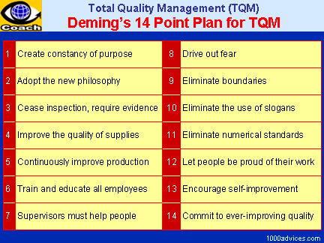
Source: 1000 advicess.com

Juran’s Theory of Quality:
Dr Joseph Moses Juran was a Romanian born American engineer and a management consultant specialised in quality management. He was one of the experts on quality in the world.
Juran's ideas can be used to set up a traditional quality system, also to help Strategic Quality Management. In addition to other things, Juran's philosophy includes the Quality Trilogy and the Quality Planning Roadmap.

Quality Trilogy:
Quality Trilogy is an improvement cycle which reduces the cost of poor quality by implementing three process such as Quality planning, quality control and quality improvement (Juran,1974).
Quality planning: Companies should produce such products and services that can meet customer’s needs. To meet customer needs, companies must know who the customers are and what products and features they need. Therefore, design and manage systems that can provide good quality.
Quality Control: How planned ideas should be implemented and controlled.
Quality Improvement: Whatever data is found from quality control, should be examined, implemented and improved.
Quality planning must be integrated into every aspect of the organization's work, such as strategic plans; product, service and process designs; operations; and delivery to the customers.

Juran’s Quality Planning Road Map:
The quality planning Roadmap is used for products and Process Development.
There are 9 steps which should be implemented to improve the quality, product and services:
- Identify the customers, because customers will be affected by the products. There are two types of customers:
- Internal are those who are part of the company and influence by the company’s activities.
- External customers are those who are not part of company but influence by the company’s activities.
- Determine the customer’s needs.
- Translate these needs into technical procedures.
- Develop a product that can respond to those needs.
- Improve the products features so it can satisfy the needs of the product as well as company’s needs.
- Develop a process which is able to produce the product.
- Improvement of the process.
- Prove that process can produce under operating conditions.
- Transfer the process to operation (Stefanatos, 2000).

Crosby’s Cost of Quality:
Philip Bayard Crosby was an Author and businessman who contributed to management theory and quality management practices.
Crosby (1979) philosophy states that organizations should concentrate on customers’ requirements and prevent products from defects and faults. His theory was “Doing it Right the First Time”, if there is a problem in the quality. He supports his basic theories about quality in Four Absolutes of Quality Management and basic Elements of improvement. The four Absolutes Quality Management are as follows:
- Quality means conformance to requirements, not goodness.
- The system for causing quality is prevention, not appraisal.
- The performance standard must be zero defects, not "that's close enough."
- The measurement of quality is the price of nonconformance, not indexes.

To implement the suitable Quality model, organisations need to consider some elements of strategic management such as SWOT Analysis, mission, vision, core values, goals and objectives, strategy formulation, strategy development, measurement, control etc.

Quality Models used by Asda to improve its Quality and customer Relationship Management:
Based on Asda’s aim and objectives it can be said that Asda uses Juran’s Quality improvement Model, as Asda’s aim is to offer goods with low price because Uk supermarkets are more competitive now. This helps companies to keep their price down and attract customers as people shop where they think they can buy goods with low prices and save money. Asda’s aim is to make goods and services more affordable for everyone. Furthermore, to satisfy customer with its goods and services, Asda’s staff check prices locally on a weekly basis.
Quality Assurance is practiced in all level of Asda and all employees are firm to provide best services to their customers. Asda also exercise with Quality Control where machine test is carried out during the production development. There is a checking in every stage of production in the organisation (Asda Quality Management, 2017).

Task Three:

Conclusion and Recommendations:
Researcher have investigated the Customer Experience on Ethical and Sustainability in Asda and other supermarket and in the whole business sector and found out that many supermarkets are not fully Ethical and sustainable as they claim. Asda particularly, one of the largest supermarkets in the UK, they also practiced unethical behaviour time to time such as Horse meat scandal in 2013, Palm oil allegation in 2017 and treating its supply chain workers less, as well as using child labour.
The report also looked at Customer Relationship Management and how this can be improved. Furthermore, the report also demonstrated Quality and Total Quality Management and how to improve it by using different Quality Models such as Deming, Juran and Crosby Quality Models.
Based on investigation and findings, the researcher is recommending few points for Asda’s future improvement:
- Asda need to be more Ethical and Sustainable as this is important for good Customer Relationships and trust, as well as improves productivities.
- Asda can introduce schemes such as buy and test foods to attract customers like Tesco have ‘’Free Fruits for Kids Scheme’’ where kids can have fruits while their parents do their shopping (Tesco, 2019). This would encourage them to visit Tesco more as well as having healthy food.
- Asda need to improve its products Quality more, as some believe due to its low price.

Reference:
Asda, (2020). Better Planet. Available at: https://www.asda.com/creating-change-for-better/better-planet ( Accessed on 2/03/20)
Armstrong, G. Kotler, P. and Opresnik M. O. (2017). Marketing: An Introduction, 13th Edition, Pearson.
Avantika, M. (2019). Pioneers of Project Management: Deming vs Juran vs Crosby. Article. Available at: https://www.simplilearn.com/deming-vs-juran-vs-crosby-comparison-article (Accessed on 1/3/20)
Asda, (2020). Company Facts. Available at: https://corporate.asda.com/our-story/company-facts. (Accessed on 01/03/20)
Asda, (2017). Quality Management. Available at: https://www.asdatech.com/aboutuss.php?id=45. (Accessed on 27/02/20)
BBC, (2020) What is climate change? A really simple guide. Available at: https://www.bbc.co.uk/news/science-environment-24021772. (Accessed on 4/3/20)
Bright. E. (2017) Tesco, Aldi and Asda accused of paying poverty wages to Bangladeshi workers. Available at : https://www.thegrocer.co.uk/supermarkets/tesco-aldi-and-asda-accused-of-exploiting-bangladeshi-workers/557778.article. (Accessed on 4/03/20)
BBC, (2019). Washing machine recall: Whirlpool 'sorry' for website problems. Available at: https://www.bbc.co.uk/news/business-50834927. (Accessed on 6/03/20)
BBC, (2019). Asda overtakes Sainsbury's to become second largest supermarket. Available at: https://www.bbc.co.uk/news/business-47784817. (Accessed on 6/03/20)
BBC News, (2020). Asda trials refills at 'sustainability store'. Available at: https://www.bbc.co.uk/news/business-51132164. (Accessed on 25/02/20)
BBC News, (2013). Horsemeat scandal: Withdrawn products and test results. Available at: https://www.bbc.co.uk/news/world-21412590 (Accessed on 08/03/20)
Consumer Report, (2020. Toyota and Lexus Recall Cars to Replace Engines. Available at : https://www.consumerreports.org/car-recalls-defects/toyota-lexus-recall-replace-engine-avalon-camry-rav4-es/. (Accessed on 09/03/20)
Cambridge university Press, (2020). Ethics. Available at : https://dictionary.cambridge.org/dictionary/english/ethics. (Accessed on 10/03/20)
Cambridge University Press, (2020). Sustainability. Available at : https://dictionary.cambridge.org/dictionary/english/sustainability.( Accessed on 11/03/20)
Crosby, P.B. (1979). Quality Is Free, McGraw-Hill, New York, NY.
Deming, W. E. (1986). “Out of the Crisis.” MIT Center for Advanced Engineering Study. Cambridge, MA
Deming, W. Edwards (2000). Out of the crisis (1. MIT Press ed.). Cambridge, Mass.: MIT Press. p. 88. ISBN 0262541157.
Ethical Consumer Research Association Ltd, (2020). Company profile, Asda Group. Available at : https://www.ethicalconsumer.org/company-profile/asda-group-ltd. ( Accessed on 07/03/20)
Ethical Consumer Research Association Ltd, (2020). Tesco PLC. Available at: https://www.ethicalconsumer.org/company-profile/tesco-plc. (Accessed on 28/02/20)
Helen, B, et al. (2020). UK: Tesco Fined £8 Million For Environmental and Safety Offences. Available at : https://www.mondaq.com/uk/Environment/620872/Tesco-Fined-8-Million-For-Environmental-And-Safety-Offences. (Accessed on 11/03/20)
Independent news, (2018), TOPSHOP AND PRIMARK COULD BE HIRING CHILDREN AGED 14 IN SUPPLY FACTORIES. Available at : https://www.independent.co.uk/life-style/fashion/child-labour-primark-topshop-sustainable-fashion-industry-m-and-s-select-committee-parliament-a8654026.html. ( Accessed on 02/03/20)
Juran, J.M. (1974). Juran’s Quality Handbook. New York. McGraw Hill Companies. Sixth Edition. Available at: http://qpr.buaa.edu.cn/__local/4/D4/C0/81CC8D81E1AE0E0518FBECD1CB2_F5D24D52_50DBCF.pdf. (Accessed on 8/03/20)
Lemon, K. N. and Vehoef, P. C. (2016), “Understanding Customer Experience Throughout the Customer Journey,” Journal of Marketing, 80(6),69-96.
Stefanatos, S. (2000). Total Quality, ed. EAP, Greece
Tesco, (2019). Tesco gives out 100 million pieces of free fruit to kids. Available at: https://www.tescoplc.com/news/2019/100-million-free-fruit/ (Accessed on 11/03/20)
The Chartered Institute of Marketing (CIM), (2016), What is ethical Marketing. Available at: https://exchange.cim.co.uk/blog/what-is-ethical-marketing/. (Accessed on 9/3/20)
The Sun News Paper, (2016). The Great Food Level Con. How supermarkets including Morrisons, Tesco and Asda are ‘misleading shoppers with questionable labels. Available at: https://www.thesun.co.uk/news/1299427/how-supermarkets-including- morrisons-tesco-and-asda-sainsburys-are-misleading-shoppers-with-questionable-labels/. (Accessed on 3/03/20)
Tesco, (2019). Our approach to human rights. Available at : https://www.tescoplc.com/sustainability/downloads/our-approach-to-human-rights/. (Accessed on 8/03/20)

