Early years practitioners:
A guide to transitions.

Source: Transitions in Care - CIHR (cihr-irsc.gc.ca)

Contents

Introduction To Transitions Page 3

The Role of The Adults Page 4

The Needs of The Child Page 7

Partnerships Page 10

Interventions Page 12

Proposed Outcomes Page 13

Reference List Page 14

Aims

The aim of this handbook is to help guide practitioners through a transitional period at any stage in an early year’s setting. This handbook will look at the subheadings set out in the context page and touch upon various theories by recognised professionals.

What are transitions?

Cornwall council (2022) states that ‘the term ‘transition’ is used to describe the life changes that a child or young person may go through’. Every child will pass through these stages every day. Even though this is a common occurrence, each child will react different to each transition as they come across them. They may also react differently to the same transitions. It solely depends on how the child is feeling at that moment in time and other surrounding factors.

The most common transitional moves include:
- Moving from class to class
- From a nursery setting to Primary School
- From Primary School to Comprehensive School
- From Comprehensive School to College.

Some children will not even notice these transitions, some however, may struggle with even the simplest of transitions, such as, coming into class from break or moving from play to learning or quiet time. These types of transitions are what is called ‘horizontal’ transitions. They are simply movement or change to a child’s usual routine. ‘Vertical transitions are a little bit more intrusive. This is where, for example, a child first starts in a school or nursery setting for the first time.

When transitioning from one setting to another, it is vitally important that it is as smooth as possible and placing the child’s needs at the centre of every decision that is made and each step that is agreed. One of the simplest ways of ensuring the child’s needs are at the centre is referring to Maslow’s Hierarchy of Needs chart. This will ensure that the child’s needs are met whilst conducting the transition. A child being able to cope with transitions should not define them so this handbook should assist anyone looking for support to aid a child in need.

What is the role of the adult during transitions?

The adult during transitions must ensure that they always conduct themselves in a professional way. The adult helping the child through any type of transition should always be someone that the child knows and is familiar with so that they have someone to turn to should they feel scared or worried about anything. The adult must approachable and fair so that the child can openly come to them should they need help or support. The adult must form an appropriate relationship with the children that they look after to ensure that they are able to provide the children with the best possible care whilst they are in their setting. Being the child’s key worker would be beneficial during transitions as the key worker will already have a bond with the child and their family to ensure the transition is as smooth and as comfortable as possible.
A child will form different relationships with each adult that they form a relationship with. They will form one of four attachment styles.
- Anxious Ambivalent
- Anxious-Avoidant
- Fearful Avoidant - insecure
- Secure
Anxious Ambivalent attachment is where a child suffers with low self-esteem, clinginess, or a strong fear of rejection from the adult. This is due to the inconsistent actions, and this could be owing to an adult not reacting on time, every time, when a child needed help or support. Signs of Anxious Ambivalent attachment in children can be seen in the form of a child being upset or angry and unwilling to let the adult leave. When the adult has left the child may present itself by having a ‘temper tantrum’. This may last for a few second, minutes or until the adult returns. When the adult returns, they may start to cling to their caregiver again to feel safe again. However, even though the adult has now returned, and the child is back in the arms of their caregiver, the child may not want any affection from the adult since the adult has just left them, and they are not happy about it.
Anxious Avoidant attachment usually develops within the first 18 months of a child’s life. If the child has this type of attachment, then the child’s caregiver could have been emotional or physically unavailable to them during this period. Mothers with mental health issues such as postnatal depression could result in the mother ‘rejecting’ their child because they themselves do not feel safe to look after the child. They may shout when the baby is crying and leave them for extended periods before attempting to sooth them. This could also be a result of poor education in what a child wants or needs and not being able to read the cues that the baby is giving them. It could also be a direct result of how they themselves were parented and what advice they have been given from the people supporting them. A child that has an anxious-avoidant attachment with their parent quickly learns that looking to their adult or help and support is a pointless exercise and will slowly learn to try and do things by themselves because they know that if they do ask for help, they will not get what they need. This can show to others as a fiercely independent child but unfortunately, this might not be the case. It could also come through as frustration when a task cannot be completed. The child will appear frustrated because it cannot do the task but still will not ask an adult for help because they feel that nobody will help them anyway.
Fearful Avoidant - insecure attachment is where the basic need of the child is not met. The Attachment Project (2022) states that;
“The child learns indirectly that he or she can rely on, and thus, trust other people. A secure and stable attachment is formed. In some cases, however, the child perceives that his or her needs are not met and that the caregivers are not emotionally available or responsive when the child seeks their attention, affection, or support. As a result, the child is unable to form a secure bond.”
The more that a child is ignored, the more damage is being done to the attachment and relationship between parent and child that may not be able to be fixed and the child will take that attachment style through to adulthood. This may also affect the other relationships that they have further on in life. This attachment style is more commonly seen in children who have experienced neglect or physical abuse and affects around 7% of the population shows in a study by Olivia Guy-Evans (2022). Signs that a child has a fear avoidant, or an insecure attachment, are, but not limited to:
- Poor self-regulation of emotions
- Fidgety behaviours
- No sense of personal boundaries
- Difficulty trusting others
- Hypervigilance

The role of the adult is simply to observe each child and to adapt the way that they work to ensure that each child has the help and support that they need regardless of what attachment style they possess and without bias. Practitioners need to be able to identify key signs of each attachment style and adapt accordingly. Practitioners have a duty of care to each child in their settling so practitioners must ensure that regular training is undertaken to ensure that they are up to date with Government Legislation and in-house policies and procedures.

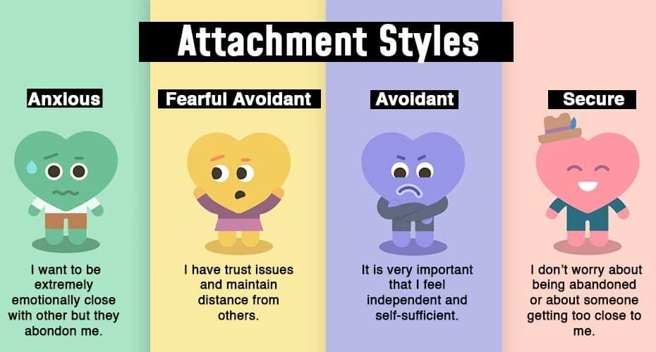
Source: 4 Types Of Attachment Styles (mind.help)

How can we recognise the needs of the child?

Below is a diagram of the Hierarchy of Needs chart.
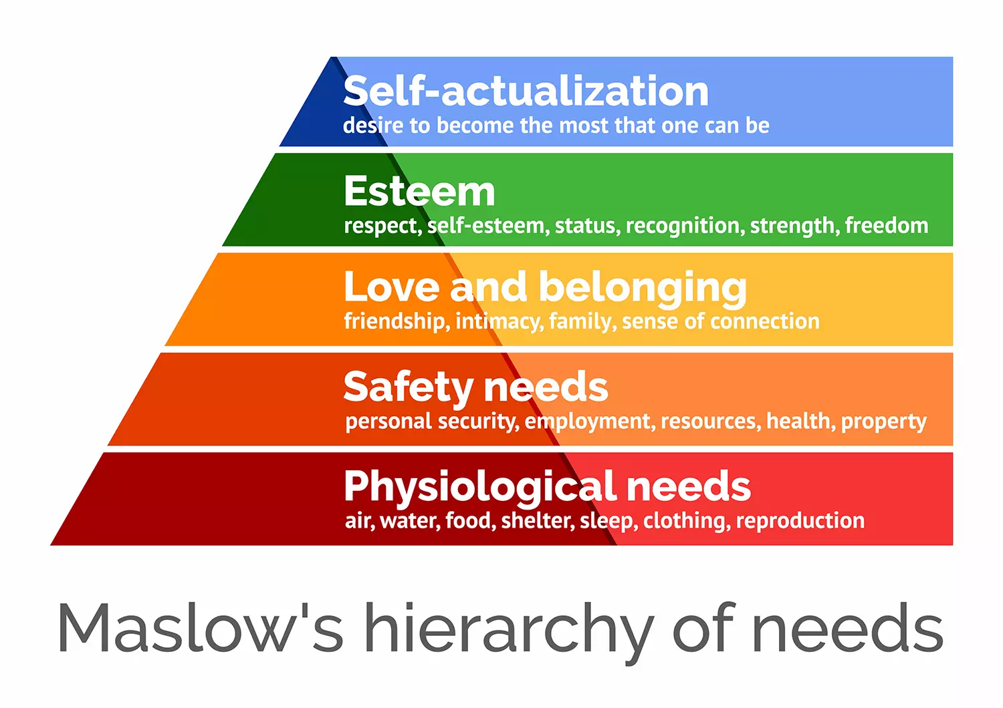
Source: Maslow's Hierarchy of Needs - Simply Psychology
As Maslow (1943) has set out above, before the child can climb the hierarchy pyramid, the needs must have been met for the stage that they are currently on. Physiological needs are the fundaments of everyday survival. Air, food, water, shelter, sleep, and clothing is what every child requires to be able to function, be fit and healthy and free from harm or abuse. For the child to climb the pyramid everybody in the child’s life must be supporting the child with their needs. Parents must support the child with air, food, and water whilst they are in their care but when a child goes into any other setting and becomes the responsibility of someone else, for example, a teacher or support worker, then they become responsible for ensuring these needs are met. If the needs are not being met, for example, if a child continually comes into a setting wearing dirty and damp clothing, this must be reported to a senior member of staff as this could be signs of abuse and neglect at home. If this is happening, then it is likely that the child’s physiological needs are not being met. During transitions, practitioners must ensure that the needs of the child does not waiver, children must be safe, warm, given food and water and all other needs met. If this cannot happen, then the practitioner must explore other options for the transition.

How can we support the needs of the child?

Practitioners have a duty of care to ensure that children are safe and free from harm, as stated in Article 19 (UNCRC 1989). By ensuring that the children are safe and free from harm, the practitioner is meeting the child’s needs and the practitioner is giving them the opportunity to climb the hierarchy pyramid in the setting that they are in. By ensuring these needs are met, it will also highlight any problematic behaviours, attachment issues, and any failing care needs that the child may be enduring. Buckinghamshire Council states that:
‘A strong emotional environment is a place where children feel safe, cared for and relaxed and are physically, mentally, and emotionally healthy. Children need to form a close bond and a trusting relationship with a Key Person who must ensure that their care and learning is tailored to meet their individual needs. All adults must tune in to children’s interests and interact with them to support and extend their learning and development, jointly engaging in problem-solving and sustained shared thinking’.
Buckinghamshire Council have also said that “Children thrive best in an inclusive environment based on mutual respect, where their uniqueness is valued”. (Buckinghamshire Council, 2022, Positive Relationships and Key Person | Early Years (buckscc.gov.uk)). If all children are treated this way, then practitioners of any statues will get the best out of the children with which they are working. The children will start to form bonds with the adults that oversee their care each day and will start to divulge any issues or concerns that they may have. If a practitioner feels that there is a possibility of child abuse occurring, they must refer to their organisations whistleblowing policies and ensure that all steps are taken to ensure that the child remains safe whilst in their care. A practitioner may be required to gather further information from the child so must do this in a sensitive manner and ensuring that the child does not get too upset speaking about it. If they do, then the practitioner must distract the child and come away from the subject.
If, whilst all of this is happening, the child is required to change rooms, or a setting all together, then the needs of the child must come to the forefront. A practitioner must ensure to go at a pace that is suitable for the child, and not the adult, and ensure to be hypersensitive to the child’s emotional needs. Transitions can be scary for children so having this in mind, practitioners must move slowly to ensure the child is coping with the changes.


Source: How Do You Define a Special Needs Child? | HealthyPlace

Partnerships Page 10

Why are partnerships important during transitions?
The GOV.UK states that ‘Research shows that involving parents and carers in their children’s learning is the most important factor in enabling some children to do well regardless of background.’
The role of the practitioner during transitions is ensuring that all lines of communication remain open and transparent. This is done by forming partnerships before the transitions begin so that the practitioner knows the child and their family, and the child and their family knows the practitioner. Becoming a key working within a setting gives the practitioner the added advantage when working with children because it gives them the opportunity to work closely with the children in their care. Settings can have a vast amount of childing that they support so having key workers ensures that the setting stays personally in touch with the children and their families whilst they are in their care. Fitzgerald, D (page 74) states:
‘For many parents, early years practitioners may be the first group of people associated with education that they have contact with. It is likely that some children may take longer to integrate into the setting, engage actively in the opportunities available and interact with the other children and adults. This can present challenges for parents, as they may blame themselves for any difficulties, begin to question whether their child has a special need or feel apprehensive about discussing this with practitioners.’
Being the first person that they meet, the practitioner must over come barriers with the parents to ensure that the parent feels at ease to leave their child in the setting. As stated above, this may be their first setting that the child will go to so they will feel apprehensive about the thought of leaving their child with ‘strangers’. In some instances, this may be a second, or third, placement so ensuring that the practitioner is open, kind, and honest, will set them in good stead to form an honest and open relationship with the parents. If the parents show that they have a trusting relationship with the practitioner, this will help the child see that the practitioner is also someone that they can trust so this will aid their transition process.
How can practitioners best support partnerships with parents and children?
Practitioners can best support the partnerships between themselves and the families by ensuring they are putting the child’s needs at the centre of everything they do. The child centred approach as described by Victoria State Government as:
‘When your service takes a child-centred approach, this means it:
- plans and designs all aspects of the service to meet the individual needs and abilities of every child
- gives all children the same opportunity to access and participate in all parts of the service
- adjusts and tailors’ activities towards all children's unique needs
- includes the child, their family and support team in decision making
- makes the 'child's voice' and preferences a priority
- reflects and seeks feedback from all involved.’

During transitions, children’s emotions may be heightened so communication between the practitioner, setting and the parents is paramount. There are various ways in which a setting can communicate with parents throughout the day to keep them up to date on how their child is feeling. This could be allowing the parent to read the key notes from the day, having an extensive handover and providing them with all the information that they need to gauge how their child has been through the day and how they may be feeling. It could also be given video evidence of their child during the transition so that the parent can see how their child is playing and reacting during their transition.
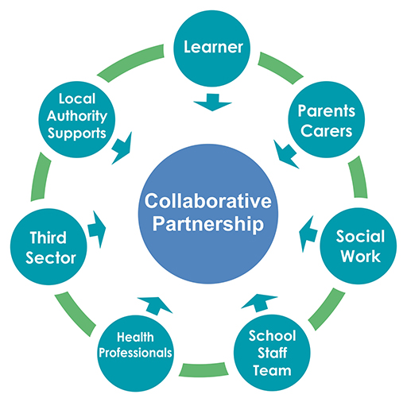

Source: 6 Collaborative partnership working: View as single page (open.edu)

Interventions Page 12

By placing the child in the centre of everything they do, they must ensure that they are also keeping their family incorporated in this too. There are many ways of keeping parents in the loop regarding what the child does during their stay in any setting. Such as, stay and play sessions – where parents are invited into the setting for a set time so that the parent can interact and play with the child and see how their day is laid out. Welcome books also help the parent know what is going on in the setting if the parent is unable to stay and see what goes on for themselves. This book must be regularly updated and personal to the child. Home visits are extremely beneficial. By completing a home visit, you will get to meet the child and their family in a familiar surrounding for the child. By meeting, speaking, and playing with the child in their own surroundings will create a connection with the child so when the child comes into the setting, they will see the practitioner and will see a familiar face.



Source: Welcome Rainbow Nursery Sign (smartbuyschoolsigns.co.uk)

Proposed Outcomes Page 13

Using information and evidence provided by the theorists mentioned in this handbook such as Maslow(1943), Fitzgerald (2004) and UNICEF(1949), the practitioner should be better equipped with the knowledge and skills to help any child through both vertical and horizontal transitions. Using methods such as visual timetables and home visits to get to know the children and their families and putting the child’s needs at the forefront of their transitions to ensure their needs are still being met.
The child is the most important person during the transition and if the practitioner is respectful and makes sure they are going at the child’s pace they are more likely to see a successful and short transition. If the practitioner tries to rush the child or make them do a task that they have trouble settling with this will hinder the progress of the transition and it may take the child longer to settle. Each child is an individual and should be treated as such for them to be able to settle and feel comfortable in the setting.


Source: The Every Child Matters Agenda - Your Guide to BESD (google.com)

Reference List Page 14

Buckinghamshire Council, 2022, Positive Relationships and Key Person | Early Years (buckscc.gov.uk)
Cornwall Council. Transitions between school phases and preparation for adulthood. Available at: https://www.cornwall.gov.uk/schools-and-education/special-educational-needs/transitions/ (accessed on 27th November 2022)
Fitzgerald, D. (2004) Parent partnership in the Early Years. London: Continuum.
GOV.UK (2022), Report Child Abuse. Available at: Report child abuse - GOV.UK (www.gov.uk)
Guy-Evans, O (2022). Simply Psychology. Fearful Avoidant Attachment: How it develops and how to cope. Available at: Fearful Avoidant Attachment Style - Simply Psychology (accessed on 30th November 2022)
Open Learn Create. Children’s Transitions. Available at: https://www.open.edu/openlearncreate/mod/oucontent/view.php?id=79794&section=3#:~:text=Horizontal%20transitions%20occur%20on%20a,(a%20change%20in%20routine) (accessed on 27th November 2022)
The Attachment Project. Anxious Attachment: Causes and Symptoms. Available at: https://www.attachmentproject.com/blog/anxious-attachment/ (accessed on 27th November 2022)
The Attachment Project. How does Anxious Ambivalent attachment develop in children? Available at: https://www.attachmentproject.com/blog/anxious-ambivalent-attachment-in-children/ (accessed on 27th November 2022)
The Attachment Project. How does Anxious Avoidant Attachment Develop in Children? Available at: https://www.attachmentproject.com/blog/anxious-avoidant-attachment-in-children/ (accessed on 27th November 2022)
The importance of child-centred approaches at OSHC (2021) Department of Education and Training Victoria. Available at: https://www.education.vic.gov.au/school/teachers/profdev/Pages/child-centred-approaches-oshc.aspx (Accessed: December 3, 2022).
UNICEF. Our Rights (1989). Available at: Our-rights_UNCRC.pdf (unicef.org.uk) (accessed on 3rd December 2022)

