
Project Management Plan For
A Smart Campus Digital
Transformation System

Module: Project Management
Module code: LCBB6006
Student name: Adrian Mocanu
Student ID: 2243469
Lecturer name: Dr. Said Usman

Table of Contents
1. INTRODUCTION 3
2. AIM, OBJECTIVES & SCOPE 3
3. PROJECT DELIVERABLES 4
4. WORK BREAKDOWN STRUCTURE (WBS) 4
5. ACTIVITIES, MILESTONES & TIMELINE 5
6. RESOURCE PLANNING 6
7. PROJECT MANAGEMENT METHODOLOGY 6
8. RISK AND LIMITATIONS 7
9. CONCLUSION 8
10. REFERENCES 9

List of Figures
Figure 1: Work Breakdown Structure 6
Figure 2: Schedule Table 7
Figure 3: Gantt Chart 8
Figure 4: Network Diagram 8

1. INTRODUCTION
Project management is a structured field, it's the utilization of information, skills, tools and techniques for project tasks in order to fulfill defined project goals within limits of time, cost and scope. PMBOK and PRINCE2 are examples of frameworks that make governance, process and lifecycle-based delivery a key priority, in order to make project delivery consistent and controlled in project environments (Ali, 2024). This project is aimed at improving the efficiency of the institutions and introducing a Smart Campus Digital Transformation System with the help of Student attendance system, Internet of Things, and Centralised student information system. The main goal of this project is to make the operations of a Higher Learning Institute more efficient, accurate and user friendly. In an organizational setting, the project is a sign of the trend of digitalization in academic institutions seeking modernisation in delivering their services. A project lifecycle is a series of phases that can be used to implement a project (initiation, planning, execution, monitoring, and closure). High interdependencies, uncertainty and complexity of the stakeholder network in such complex digital projects makes it important to conduct these projects in a structured way.

2. AIM, OBJECTIVES & SCOPE
Smart Campus Digital Transformation System project aims to develop and deploy an overall digital solution that would boost the operational efficiency and improve the accuracy of the data, modernize key academic and administrative processes in the higher education institution. The project will be implemented within a time frame of roughly 6 months to streamline attendance monitoring, allow real-time attendance and data management and facilitate the operation of campuses with the help of the Internet of Things. The main goals are to adopt an AI solution for attendance, to cut down on administrative burden by 40% or more and ensure that student data is as accurate as possible (aiming for 95%), with the aim of making the information more reliable to help with informed decisions and institutional reporting. The project is supposed to include the development of an AI-based attendance system, a centralised student administration system and the use of IoT technologies, which allow to make the campus smart from the scope point of view (Tyagi, Gupta and Mehndiratta, 2024). It doesn't contain financial management systems or external network integration with the university as it would add to the feasibility and lead to the project boundaries being out of control. Defining the scope is very important to ensure that there is no scope creep, efficient use of the project resources and timely delivery of the project's deliverables. It is essential to have a perfect project management and project deliverables without any restrictions and goals.

3. PROJECT DELIVERABLES
The Smart Campus Digital Transformation System project's work is crucial for enhancing the user experience and the efficiency of the institution, and the development of the attendance tracking system, the centralised student database and the mobile application interface are all important deliverables. The functional outputs of the project are the basic outputs of the project that are directly related to the expectations of the project stakeholders, including the academic staff's, students' and administration departments' stakeholders. The main outputs include installation of the IoT sensors to gather real-time data under various scenarios in the campus, project documentation, and testing reports with detailed information to ensure the system is reliable, meets standards, and is easy to maintain. The value-added distinction between primary deliverables and supporting deliverables is one of the most important in project management as it helps to set priorities, resource allocations and successful projects (Kerzner, 2017). All the deliverables are defined in relation to the needs of the stakeholders, including the need for accurate attendance and easy access to data, and improved digital infrastructure. The alignment is to guarantee that the project outputs are technically feasible, value added and aligned with the institutional project objectives (operational and strategic).

4. WORK BREAKDOWN STRUCTURE (WBS)
A Work Breakdown Structure (WBS) is one of the key project management tools that is used to break down a project into hierarchical, manageable and manageable components. It helps to break the scope of the project down into smaller parts and so provides greater clarity, ownership and management of the project. In the Smart Campus Digital Transformation System, the WBS is structured and designed using the top down approach as we do in PMBOK scope management and structured planning (Higgins, 2023). At the level 1 the project will be defined as the Smart Campus Project and will be the overall deliverable. This is broken down into the key project phases and recognises the same phases of the project lifecycle as in a normal project (ie. level 2). All these stages have been broken down into specific actions under Level 3 which help the AI system function, including coding the system, setting up the database and integration with APIs. This hierarchical organization will help in determining the ownership, sequence and dependency of tasks.
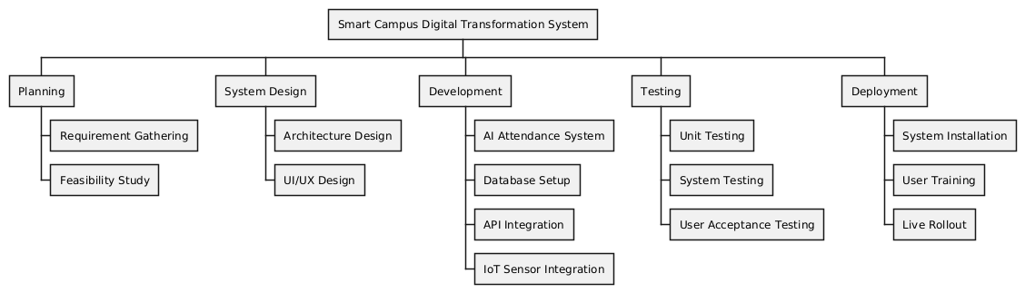
Figure 1: Work Breakdown Structure
This logic of decomposition is key because it allows them to effectively allocate the resources, improve the level of project visibility and reduce the complexity and scale of a digital transformation project by breaking it down into measurable and manageable parts.

5. ACTIVITIES, MILESTONES & TIMELINE
The project Smart Campus Digital Transformation System contains activities, which are planned to be carried out in a specific order or within the project lifecycle to guarantee a controlled project execution and efficient delivery. Requirements Gathering: This is the first step in understanding the needs of the stakeholders and documenting the requirements, which should be aligned to the project goals and objectives of the institution (Umar and Lano, 2024). This is followed by system design, where the general architecture of the system, data flow and technical requirements are identified, which is then followed by the development blueprint being created. The coding phase includes the implementation of the actual AI based attendance system, centralised database and integration into IoT. The testing process validates the reliability, system accuracy and performance of the system by conducting structured testing procedures after the development process. Lastly, the deployment phase enables implementing the system in the real campus setting and introducing the users to the system.
Important thresholds are defined to follow up on the work and on time delivery. These include M1 - get approval for project; M2 - system design is complete; M3 - prototype develops; M4 - testing is complete; and M5 - final deployment of the system. The milestones are identified as important checkpoints to assess the project progress and manage it accordingly.
The project time is around 16 weeks, there are well-defined durations and dependencies for the tasks. Planning involves coming before design, design involves working through the development completion, development involves with successful testing and deployment comes after successful testing (Kruachottikul et al., 2023). This sequence dependence is an important reminder of the importance of the links between the risks of each phase of the project, and how one phase delay can impact the next, and ultimately the success of the project.
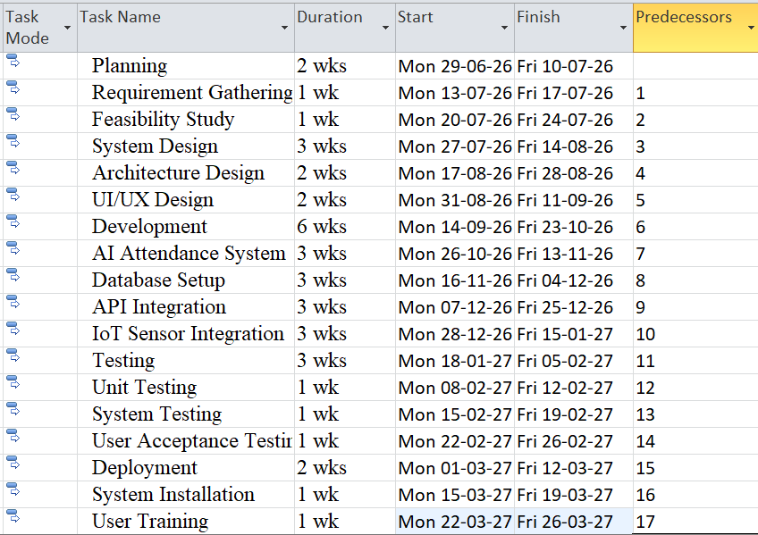
Figure 2: Schedule Table
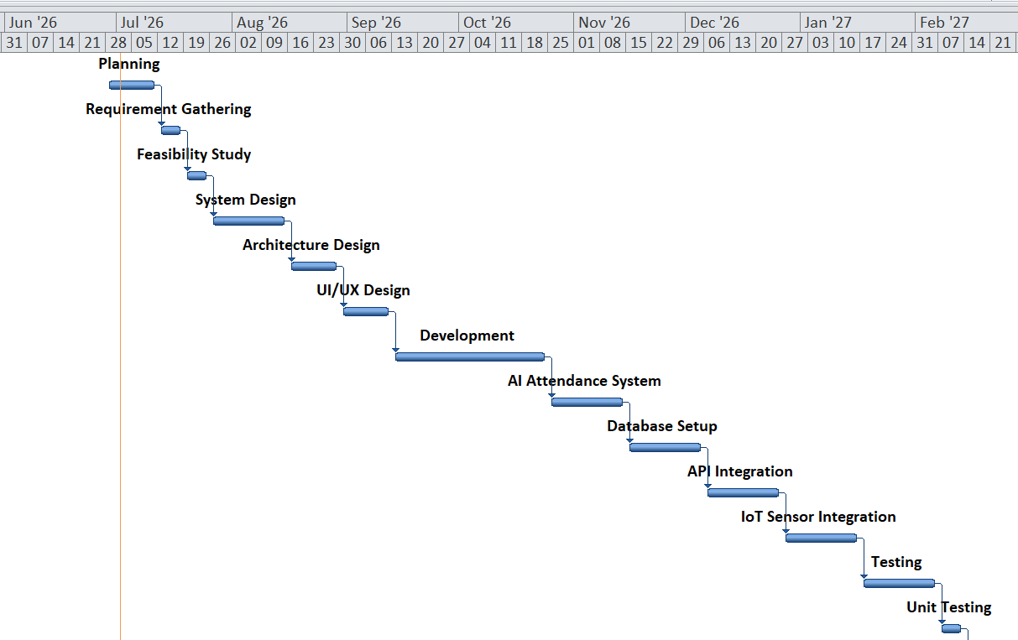
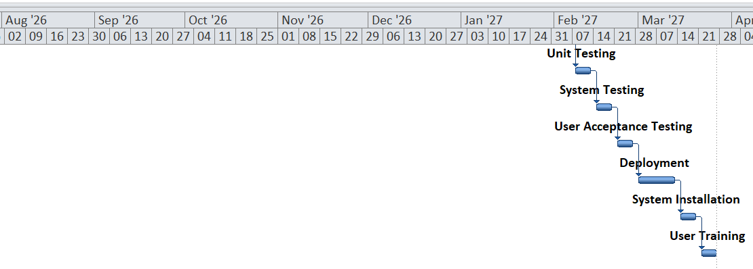
Figure 3: Gantt Chart
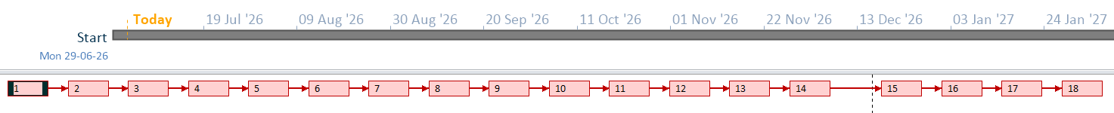
Figure 4: Network Diagram

6. RESOURCE PLANNING
The Smart Campus Digital Transformation System's resource planning is a process of systematically assigning human, material and financial resources to the project, ensuring that the project can be executed efficiently and delivered successfully (Hashim, Tlemsani and Matthews, 2022). Human resource requirements of the project include hiring a Project Manager who will be responsible for governance and coordination, Software Developers to design and develop the various components of the system, UI/UX (User Interface/User Experience) Designer who will be responsible for ensuring usability and accessibility features of the mobile and web platform, Data Analyst to oversee analysis and insights, and QA Testers for reliability and conducting structured tests on the system. Each position has specific responsibilities for parts of a project's life cycle, which will help to provide a balanced workload and technical coverage.
Technical and development aspects of the project include using cloud technology (AWS or Azure) for scalable deployment, programming languages (Python, Java) for system development, IoT sensors to collect data in real-time in different contexts of the campus, and powerful database systems that can be used for securely and efficiently storing and retrieving data (Rao and Medina, 2024). It is not mandatory, but in reality a major part of the project environment where finances dictate the scope of work and availability of resources, it is very important.
When it comes to effective allocation of resources, budget, time and skill constraints should be considered as well, along with the constraints mentioned above. In project environment compromises between cost and quality are always a given and if not planned well, can impact the project timelines, the performance of the system, and delivery success in general.

7. PROJECT MANAGEMENT METHODOLOGY
The selection of a project management methodology is crucial to the successful implementation of the Smart Campus Digital Transformation System, as every one of them has its own strengths and weaknesses in terms of the complexity, uncertainty and involvement of the projects.
In a Waterfall approach to modelling, each phase of the modelling process (requirements, design, implementation, testing and deployment) is completed one at a time and the process is linear. It's appropriate for projects with definite and stable requirements (Mazhindu, 2025). It may, however, be rigid and not so flexible, which could be a problem in an evolving digital world, where the needs of the stakeholders may evolve during the project.
In contrast, with Agile there is an incremental and iterative development process, and the development is carried out in short cycles, called sprints. It involves continuous and frequent interactions with stakeholders as well as several iterations and adaptation to changing needs. This is particularly beneficial for the Smart Campus project as needs and requirements of users can evolve during the project lifecycle such as when it comes to tracking attendance or integrating IoT.
Structured governance frameworks that are based around the stages of control, documentation and accountability are offered in PRINCE2 and PMBOK. Both PRINCE2 and PMBOK have their own roles, business justification and controlled project stages, as well as knowledge-based frameworks with regard to integration, scope, time, cost, and risk management processes. They are especially useful for monitoring the risks and project management of large-scale institutional projects.
The Waterfall method is quite structured and predictable, but not flexible; the Agile method is flexible and adaptable, but may lack predictability in terms of timelines; and PRINCE2 provides a good amount of governance, but can be documentation-heavy and bureaucratic. The Smart Campus project therefore is most suited to Agile, as it has constantly changing requirements, and is very dependent on cycles of stakeholder feedback (Nworuh et al., 2025). Waterfall can be paired with Agile which can be used to offer governance and control mechanisms, but is not as suitable as PRINCE2, because it is not as flexible and adaptable to change. Combined, the flexibility and supervision are maintained in complex digital transformation projects.

8. RISK AND LIMITATIONS
However, if not disposed of well, the Smart Campus Digital Transformation System is subjected to several types of risks that can lead to the failure of a project to be successful. The technical risks encompass system failures, software bugs, as well as compatibility issues between AI modules, databases, and IoT gadgets, that could cause lower system reliability or downtime. Time-related risks can occur because of delays in development activities, especially if there are relationships in the development phases, such as between design, coding and testing activities, which can lengthen the project schedule (Xie et al., 2023). There is also the risk of budgets being exceeded – any unforeseen costs with the cloud infrastructure, software tools, or hardware procurement could easily result in a budget blowout. Also, when staff and students do not embrace and adopt the change from traditional systems to digital systems, this poses risks to the overall systems' effectiveness.
To minimize these risks, a recommended way is to develop with an Agile Iterative method that provides opportunities to make improvements during development and potential problem areas can be identified from the outset. The defects need to be identified as early as possible and quality assurance need to be provided at all the stages of development through regular testing (Srinivas, Mandaloju and Nadimpalli, 2024). Furthermore, there should be backup system and data redundancy system that would minimize the chances of a system failure so as to not affect the business continuity.

9. CONCLUSION
In conclusion, the Smart Campus Digital Transformation System project provides a blueprint for implementing the necessary changes to improve the efficiency of the institutions, using AI, IoT and centralised data management systems. All project activities are controlled and measurable throughout the project lifecycle by having a project plan which clearly states project objectives, expected project outcomes, Work Break Structure, project timeline and project resources and budgets. The major activities will be broken down into smaller activities using structured project management methods, such as WBS, Milestones and Time line scheduling will be valuable to help clarify, coordinate and control.
There is also a range of suitable project management methodologies (e.g. Agile & PRINCE2/PMBOK Government Principles) which add flexibility and control and accountability. To sum up, good planning, monitoring and stakeholder management is a key component in the implementation of this project. When implemented correctly, these organized approaches have a good chance of achieving the goals of the project and the project's scope, cost and time constraints.

10. REFERENCES
Ali, A. (2024). Investigating project management practices in public sector organisations of a less developed country. figshare. [online] doi:https://doi.org/10.25439/rmt.27576747.
Hashim, M.A., Tlemsani, I. and Matthews, R.D. (2022). A sustainable University: Digital Transformation and Beyond. Education and Information Technologies, 27. doi:https://doi.org/10.1007/s10639-022-10968-y.
Higgins, A. (2023). An explorative analysis of effective project management of research and research-related projects within a newly formed multi-campus Technology University /. research.thea.ie. [online] Available at: https://research.thea.ie/handle/20.500.12065/4699.
Kerzner, H. (2017). Project management: a Systems Approach to planning, scheduling, and Controlling. 12th ed. John Wiley & Sons, Inc.
Kruachottikul, P., Dumrongvute, P., Tea-makorn, P., Kittikowit, S. and Amrapala, A. (2023). New product development process and case studies for deep-tech academic research to commercialization. Journal of Innovation and Entrepreneurship, 12(1). doi:https://doi.org/10.1186/s13731-023-00311-1.
Mazhindu, D.T. (2025). Analysing the Benefits and Drawbacks of Waterfall Model in Software Development Projects at Steward Bank, Zimbabwe. 125.165. [online] doi:http://localhost:8080/xmlui/handle/123456789/4608.
Nworuh, G.E., Ebiringa, O.T., Asiegbu, B.C. and Echeme, I.I. (2025). An Agile Stakeholder Interface Management Framework for University Infrastructure Projects in Nigeria. Deleted Journal, [online] 20(1), pp.290–313. doi:https://doi.org/10.62154/ajmbr.2025.020.01026.
Rao, A.R. and Medina, A.E. (2024). Designing an internet of things laboratory to improve student understanding of secure IoT systems. Internet of things and cyber-physical systems, 4, pp.154–166. doi:https://doi.org/10.1016/j.iotcps.2023.10.002.
Srinivas, N., Mandaloju, N. and Nadimpalli, S.V. (2024). Leveraging Automation in Software Quality Assurance: Enhancing Defect Detection and Improving Efficiency. International Journal of Acta Informatica , [online] 3(1), pp.112–124. Available at: https://www.yuktabpublisher.com/index.php/IJAI/article/view/211.
Tyagi, S., Gupta, V. and Mehndiratta, V. (2024). Building Smart Campuses: Integrating AI in Higher Education. pp.399–431. doi:https://doi.org/10.1007/978-981-97-6790-8_15.
Umar, M.A. and Lano, K. (2024). Advances in automated support for requirements engineering: a systematic literature review. Requirements engineering (London. Print). doi:https://doi.org/10.1007/s00766-023-00411-0.
Xie, H., Hong, Y., Xin, M., Brilakis, I. and Shi, O. (2023). Identification and analysis of communication barriers for construction projects with time uncertainties. Engineering, Construction and Architectural Management. doi:https://doi.org/10.1108/ecam-07-2022-0669.

