
Image 1 (Grace-Martin, 2022)

Changemakers: Statistics

Ioan Jeffries | UWTSD

Question 1
The Gower Ornithological Society have collected the following data on the weights of individual robins during the spring and autumn months. A statistical test needs to be carried out to determine whether or not the weights of the birds are different. The data has been provided (Figure 1).
Spring |  | Autumn
Individual | Weight (g) | Individual | Weight (g)
1 | 20 | 1 | 22
2 | 18 | 2 | 20
3 | 15 | 3 | 19
4 | 19 | 4 | 23
5 | 20 | 5 | 21
6 | 20 | 6 | 17
7 | 21 | 7 | 22
8 | 20 | 8 | 20
9 | 16 | 9 | 23
10 | 15 | 10 | 21
11 | 16 | 11 | 19
12 | 15 | 12 | 17
13 | 19 | 13 | 24
14 | 18 | 14 | 19
15 | 21 | 15 | 23
Figure 1 Gower Ornithological Society data on robins weights during the seasons
The most appropriate test to be carried out for this specific data set would be a paired sample T test. This is because a paired-sample T-test will show whether there is a statistically significant difference in the mean score of parallel 2 data sets. By inputting the data into SPSS and performing a paired-sample T-test, the results are produced (Figure 2)
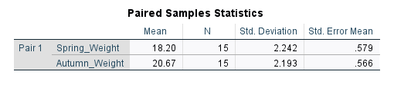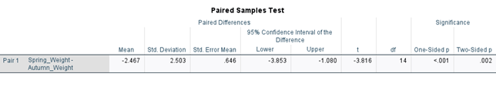
Figure 2 Paired sample T-test results

The significance value at the end of the row on the paired samples test is below 0.05. This is the probability value and so this means there is a 95% confidence interval ranging from -3.853 to -1.080. Looking at the Paired Samples Statistics table (Figure 2), it shows the mean of both data sets. As can be seen, the mean spring weight is 18.2g and the autumn weights is 20.67g. Indicating that the birds are heavier during the autumn months by 2.47g on average. This result aligns with recent scientific literature as this was discussed within a paper published in 2020 about migration and feeding habits of the European robin (Ktitorov et al., 2020).

Question 2
The local authority has been collecting data on Molinia plants and how effective they are in the success of attracting rare butterfly species (Figure 3). A statistical test needs to be carried out to determine whether there is a difference between the 3 sites.
Site A | Site B | Site C
38 | 22 | 14
47 | 19 | 26
39 | 8 | 11
25 | 23 | 18
42 | 31 | 5
Figure 3 Data collected on Molinia plants
The most appropriate statistical test to be used in this case is a one-way analysis of variance or Anova. This is used to analyse whether there is a significant statistical difference between the means of 2 or more data sets. This will be useful when examining the data on Molinia plants as there are 3 sites that need to be compared to determine which site has the most plants. These were the results after putting the data into SPSS (Figure 4).
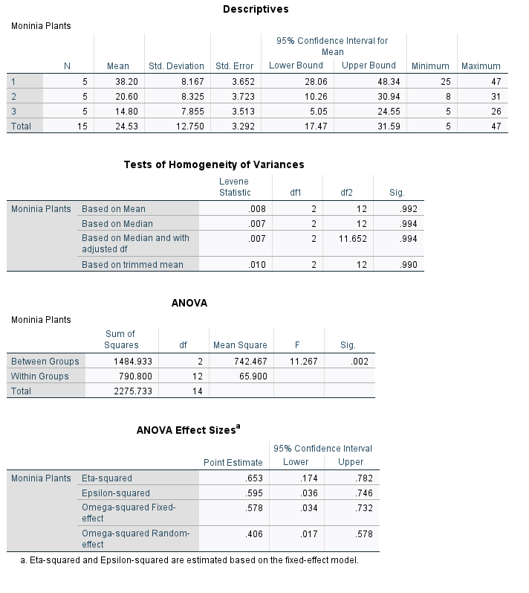
Figure 4 Results of ANOVA test
In the Descriptives table (Figure 4), the mean for each site is shown. Site 1 is significantly higher than the other 2 sites. This indicates that there are more Molinia plants at site 1 that the other 2. Looking at the ANOVA table the final column shows the significance. The value is 0.002 which means that there is a significant difference in the data. The conclusion that can be drawn from the data indicates that site 1 his the highest number of Molinia plants and therefore has the best chance of attracting the rare butterflies. The idea that Molinia plants attract different species of butterfly including rare varieties is supported by scientific literature (Schlegel and Hofstetter, 2021).

Question 3
Natural Resources Wales (NRW) have collected data on some potential solutions to flooding and need to determine if there is a difference between the 2 options. The data (Figure 5) is the results taken from local farmers and residents to see which option they would prefer.
 | Farmers (1) | Residents (2) | Total
Gabion Baskets to slow water (1) | 23 | 13 | 36
Planting more trees to absorb water (2) | 15 | 37 | 52
Bunding to form a wall (3) | 28 | 26 | 54
Total | 66 | 76 | 142
Figure 5 NRW survey data on flood prevention methods
In order to determine whether or not there is a difference a statistical test must be performed. In this instance the test that is most appropriate is a Chi-Squared test. This test is used to test if there is a relationship between 2 categorial variables (Pallant, 2020). In the output tables (Figure 6), the farmers are classed as owners 1 and the residents are owners 2.
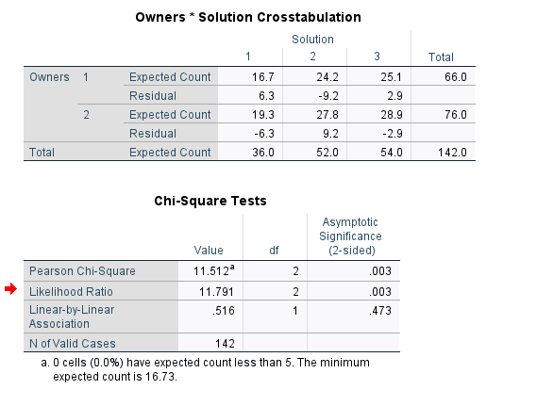
Figure 6 Chi-Square test results
Looking at the “Owners * Solution Crosstabulation” table, it has the expected counts and the residual counts for each. The expected count is what would be expected if there was no association. As can be seen they differ significantly indicating that there is a significant difference. This is also shown in the “Chi-Squared Tests” table. The Asymptotic significance is 0.003, this shows that the results are statistically significant and backs the alternate hypothesis that there is a difference between the opinions of farmers and the residents.

Question 4
A lecturer has a hypothesis that a student’s milk intake has an effect on their scores in a test due to the calcium. In order to test this, the students daily calcium was taken alongside their test scores, and the results were noted down (Figure 7).
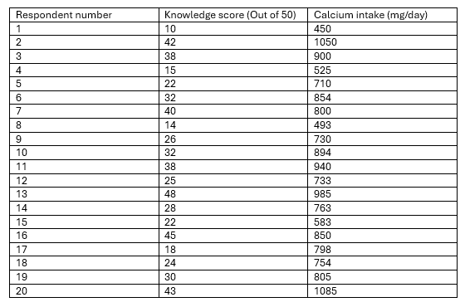
Figure 7 Data collected by lecturer on student test results and amount of calcium consumed
In order to conclude whether there is a correlation between the two, the most appropriate test is a Pearson correlation test. This compares the results and determines whether or not there is a correlation with up to 99% confidence (Field, 2013). These were the results SPSS produced (Figure 8);
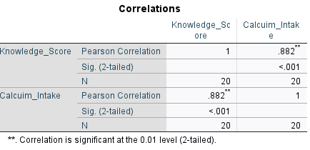
Figure 8 Results Produced
The results show that the Pearson correlation has a score on 0.882. This indicates that the data has a 99% significance for correlation. It can also be seen that the correlation between the knowledge score and the calcium intake is the same
Using these results a graph can be plotted to better visualise the correlation and using a line of best fit, predictions can be made using the line of best fit.
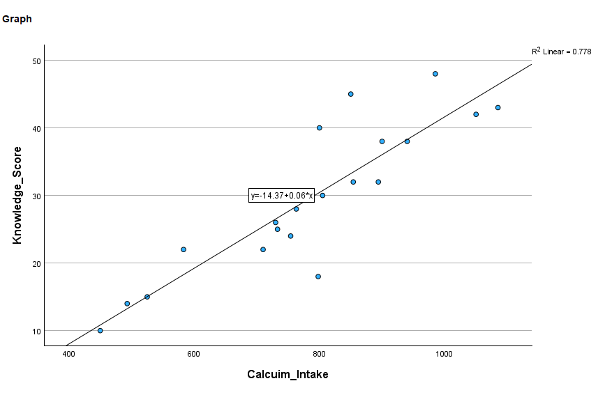
Figure 9 Graph showing the correlation between the calcium intake and the test results
This data concludes that there is a strong correlation between the amount of calcium these students had and the test scores they achieved.

References
Field, A. (2013). Discovering statistics using IBM SPSS statistics : and sex and drugs and rock ‘n’ roll. 4th ed ed. Sage.
Grace-Martin, K. (2022). Getting Started with SPSS Syntax. [online] The Analysis Factor. Available at: https://www.theanalysisfactor.com/spss-syntax-101/.
Ktitorov, P., Bulyuk, V., Leoke, D. and Kulikova, O. (2020). Meteorological factors affecting refueling of European Robin (Erithacus rubecula) during migrations. International journal of biometeorology, [online] 65(2), pp.291–299. doi:https://doi.org/10.1007/s00484-020-02031-7.
Pallant, J. (2020). SPSS survival manual a step by step guide to data analysis using IBM SPSS Julie Pallant. 7th ed ed. McGraw-Hill Education.
Schlegel, J. and Hofstetter, A. (2021). Butterflies of fragmented wet grassland in Western European lowland forests: Effects of vegetation, connectivity and plot size. [online] Science Direct. Available at: https://www-sciencedirect-com.ezproxy.uwtsd.ac.uk/science/article/pii/S1146609X20301831 [Accessed 4 Apr. 2025].

