University of Wales Trinity Saint David
Wales Institute of Science & Art

Application of Computer Aided Engineering Processes
Structural Design and Fluid Analysis / ACHA6010

Rhys Ewin
2004294
Date (12/2023)
Contents
1 Introduction 2
1.1 Development of CAE 2
1.2 Present CAE 2
1.3 Report Objectives 2
2 Literature review 3
2.1 Topology Optimisation 3
2.2 Integrating CAD and CAE 3
2.3 Boundary conditions 3
3 Methodology 5
3.1 Validation cases 6
3.1.1 Bimetallic strip 6
3.1.2 Cantilever UDL 7
3.1.3 Mesh influence 7
3.1.4 Thermal validation 8
3.2 Topology study 8
4 Results/Analysis 9
4.1 Rigid dynamics 9
4.2 Steady State Thermal 10
4.3 Static Structural 10
4.4 Optimisation of piston design 11
4.4.1 First iteration 11
4.4.2 Second iteration 13
5 Conclusion 15
6 References 16

Introduction

Development of CAE
Computer-Aided Engineering (CAE) has been used by engineers since the 1960’s since the original CAD programs were developed. The 1970’s introduced Finite Element Analysis (FEA) which realised the potential of using computational mathematics to provide solutions for complex structural engineering problems; simulating structures and adjustable environmental conditions led to more comprehensive evaluation of designs. 1980 brought the invention of Computer-Aided Manufacturing (CAM) which increased the necessity of CAD and FEA for businesses, in turn, it also provided a spark in rapid development of the industry. The 1990’s and 2000’s delivered 3D CAD, and cloud-based servers, exponentially advancing the growth and scalability of computerised engineering, integration into other industries also began. (Frackiewicz, 2023)

Present CAE
Currently CAE development could be said to be driven by artificial intelligence systems and machine learning, this is leading to rapid changes in the usage of CAE, continuing the trend of innovation in the industry. (Frackiewicz, 2023) At present, humans are still the catalyst in engineering design, computers are used as a tool to increase efficiency and potentially provide alternative ideas. Complexity in design occurs when CAD models must be converted for CAE analysis, it is said up to 80% of the design process can be spent completing these tasks that a computer cannot automatically accomplish. (Wang, et al., 2023)

Report Objectives
This report aims to consider, explore and evaluate the inherent positives and negatives within the computer-influenced engineering systems available, backing-up referenced information with case studies performed using ANSYS Workbench.
In the world of engineering, CAE has never been more influential than it currently is; a necessity in many ways, mainly utilised in the mass manufacturing, design and optimisation processes with the ability to use iterative topology to adapt designs based on set criteria at the click of a button.

Literature review
A foundational literature review has been crafted to enhance comprehension regarding the utilization of existing systems and to substantiate assertions articulated in the conclusion. This review aims to provide a comprehensive overview of the current state of the field, drawing upon relevant scholarly works to bolster and validate the key findings and conclusions presented in the research. The incorporation of existing literature not only contributes to the credibility of the study but also contextualizes the research within the broader scholarly discourse, offering a well-rounded perspective on the subject matter.

Topology Optimisation
Topology optimisation (TO) usage in modern CAE requires human-aided design (HAD) to obtain reasonable results. Iterative topology optimisation (ITO) strives to reduce excess material in a design, this comes with inherent problems regarding the design of components as the ITO doesn’t take into consideration the geometric requirements with respect to human interaction. Complex geometries exude the largest design discrepancies and reducing the effect garnered by ITO utilisation remains a difficult task in the modern day. (Wang, et al., 2023)

One way in which TO is managed for complex designs is to embed the design into a regular domain mesh providing the topology study with as much information as possible about the geometric conditions of the design. (Wang, et al., 2023)
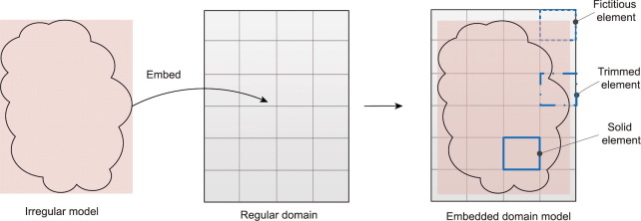
Figure 1 - Illustration of an embedded domain model (Wang, Y. et al., 2023)
Gradient-based TO has been commonly used to optimise material placement in iterative design, however, most designs are nonlinear and provide problems when using the gradient-based method to constantly update the design variables. (Brown, et al., 2022) Machine-learning has been trialled in producing more efficient methods of ITO, using a data-driven approach to machine-learn the load conditions with respect to the dimensional space available, an efficient TO model can be developed to provide initial conditions for the future iterative steps in design. (Ulu, Zhang and Kara, 2015)

Integrating CAD and CAE
As analysis usually occurs after the design process of a product, the engineers usually have time to run simulations of obvious and basic solutions to problems experienced initially. Integrating the design and analysis would reduce this inherent time-based limitation. In turn, the idea of integrating the entire design process will help to shorten development time of the product, allowing more design variants and manufacturing processes to be evaluated delivering a fully explored product at the end of manufacturing. As well as, in the long run reducing cost to companies as the optimum solution to the problems will more likely be discovered. (Kagan & Fischer, 2000)

Boundary conditions
A unique method for determining boundary conditions involves conducting simulations in reverse. By modelling the component at its maximum deflection and calculating the forces required to restore it to its original shape, one can identify the maximum forces the component can withstand without prior knowledge of the boundary conditions. This approach considers all forces involved in returning the model to its standard state, providing insights into the component's maximum load capacity. (Krishan & Aggarwal, 2012)

When running analysis of components, it is crucial to explore what the object interacts with and consider any conditions experienced which will impact the original component. In the case of a piston, the combustion chamber will experience thermal expansion therefore allowing the piston free room along the side. In this sense, it should be considered whether the piston material will expand at the same rate in order to allow proper mating of components. (Xu., et al., 2011)

In the case study covered in this report, the combustion pressure acting on the crown of the piston is added as a pressure load, the kinematic study is ran using the joint loads of the assembly and the maximum forces exported. The thermal conditions of the piston are related to each individual area of the piston, and the deformation and stress levels are calculated using a combination of all boundary factors.

Also considered in boundary conditions is the influence of the mesh sizing, a mesh study can be completed to garner information as to where the increase of mesh size doesn’t result in any higher degree of accuracy that is reasonable regarding computational time required. Finding the point at which the increase in nodes doesn’t relate to a difference in results can be plotted to provide visualisation of this procedure. (Leap CFD Team, 2012)

Methodology
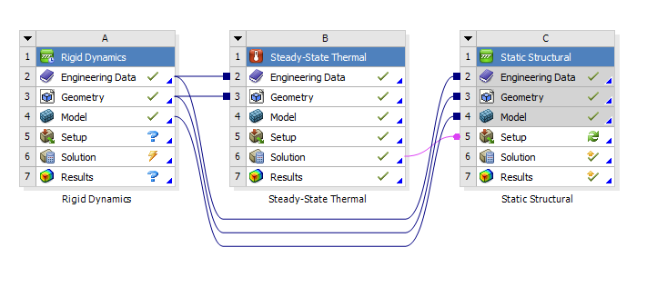
Figure 2 - ANSYS Workflow for a fully linked dynamics study.
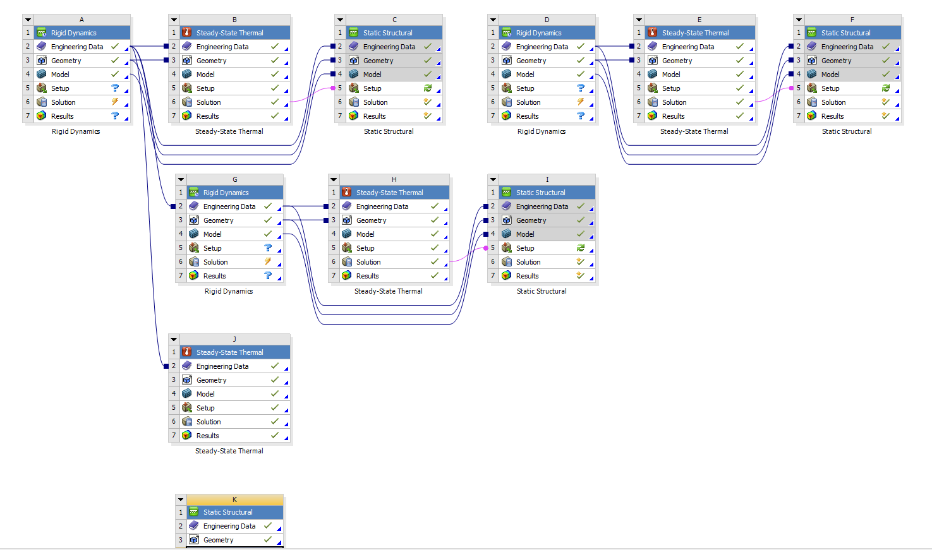
Figure 3 - ANSYS Workflow, multiple iterations and validation cases
ANSYS Workbench has been used to run fully linked dynamic simulation analysis on a piston case study under realistic environmental conditions including thermal loading, pressure and kinematic progression. The above figure shows the interface of ANSYS and how multiple different simulation methods can be integrated to provide overall results for the study.

In the case of the fully linked system, it began with a rigid dynamics study to find the maximum kinematic forces experienced by the piston, these results have to be exported for one time step and loaded into a static structural study. Before the static structural study is completed, a steady-state thermal test is carried out to find the thermal loading of the piston so the static structural results which are then calculated, are more accurate.

Validation cases
Initially, validation studies must be completed to provide results for easily understood or mathematically validated cases. The point of this is to provide understanding that ANSYS can delivers accurate results when tasked with a more complex simulation, such as the piston.

Bimetallic strip
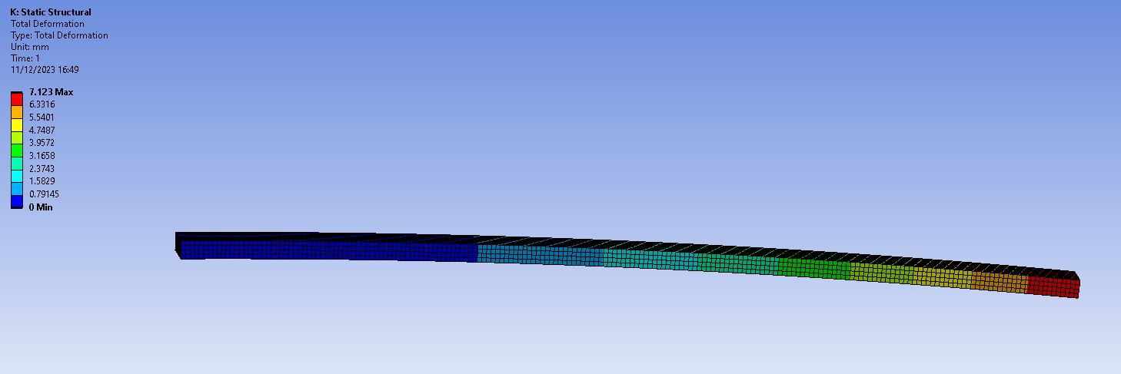
Figure 4 - Bimetallic strip 0.5mm mesh validation case
When generating the total deformation of a bimetallic strip of copper and invar, at a temperature of 100° + ambient temperature, it is possible to use the results as a way of calculating the accuracy of the simulation. The total deformation is simulated to be 7.123mm, when calculating this case study by hand it is found to be 7.049mm, this shows an accuracy of 98.95% when a mesh size of 0.5mm is used.

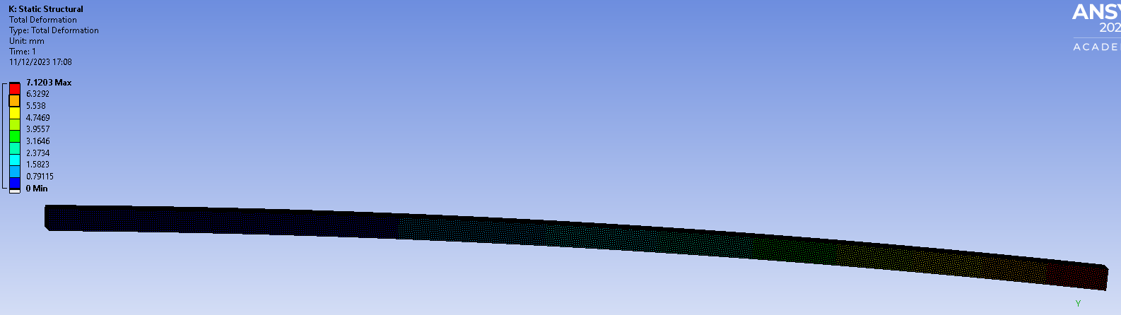
Figure 5 - Bimetallic strip with 0.1mm mesh
The results found with the finer mesh were more accurate, with a maximum total deformation of 7.1203mm which is an accuracy of 98.99%. An increase in accuracy of 0.04% over the original meshing size.

Cantilever UDL
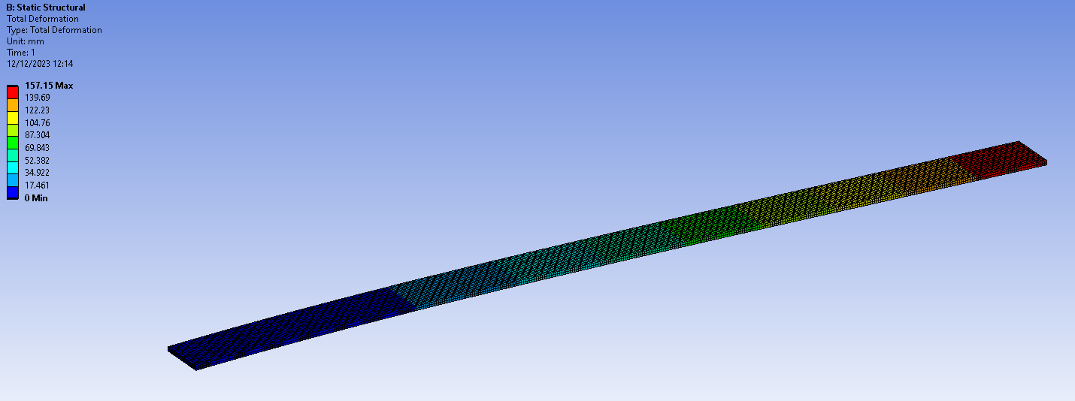
Figure 6 - Cantilever UDL ANSYS Workbench
In this case, of a cantilever beam with a universally distributed load (UDL), meaning it is fixed at one end with a constant pressure acting across the top surface. The maximum result is 157.15mm of deformation, the result was expected to be 157.143mm, this shows a difference of 0.00445% which is an acceptable percentage error.

Mesh influence
The mesh size used directly impacts the results as a smaller mesh size allows for more accurate readings across the geometry, however, smaller meshing means the time taken to run the simulation and analysis increases. Computing power is important when running simulations, more complex designs for important models in harsh environmental conditions such as a piston need to be understood as much as possible as they are crucial to the performance of systems and can directly influence the public in terms of safety.

In the case study of the bimetallic strip, a mesh of 0.5mm element sizing was originally used to find results of total deformation. When the 80% decrease of mesh sizing to 0.1mm element sizing was used, the results simulated were found to be 0.04% more accurate. The problem with this increase in accuracy is the time taken to find these results increased drastically.

Thermal validation
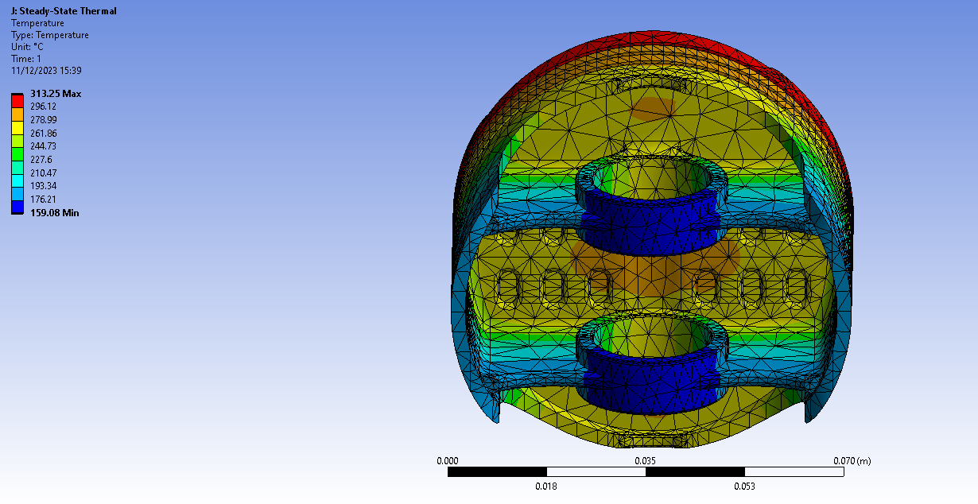
Figure 7 - Iteration 2 solo thermal study
This study was of the second iteration of piston design without the influence of the full assembly; therefore, no rigid dynamics testing was completed prior to the thermal study. When looking at the image above and comparing with the thermal results from the fully linked second iteration study, it is clear that the rigid dynamics kinematic loading has an affect on the outcome of the thermal loading. The maximum temperature experienced is much higher with the standalone thermal testing, the minimum temperatures are relatively consistent, however the spread of the thermal loading shows minor differences, these differences are discussed later.

Topology study
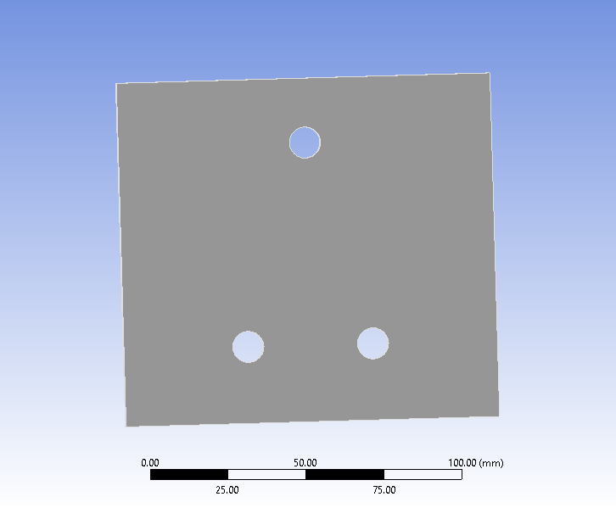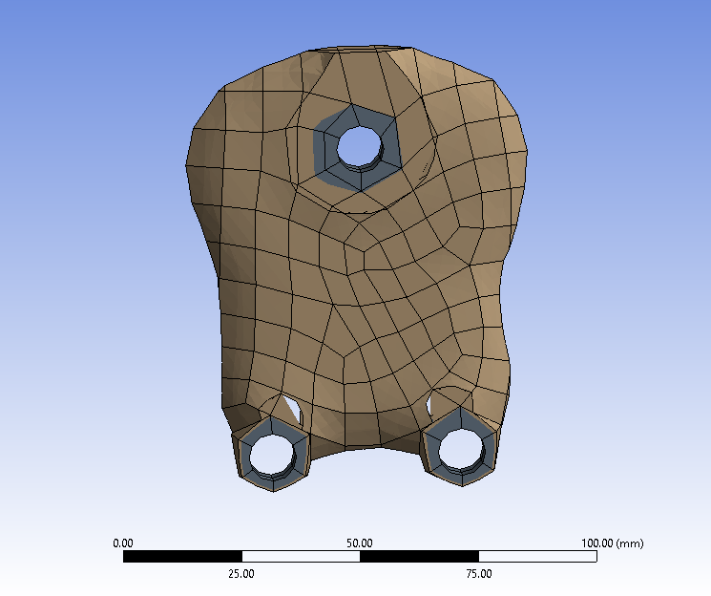
Figure 8 - Topology optimisation study, before (left) and after (right)
Given boundary conditions and optimisation objectives, there can be optimisation simulated to iteratively improve the geometric design of models. In this case a plate was used with a bearing load in the top single hole and cylindrical supports through each of the other two holes. The requirement was set to removal of 50% of mass whilst reducing or keeping the stress on the plate the same, the result pictured was the 12th iteration simulated.

Results/Analysis

Rigid dynamics
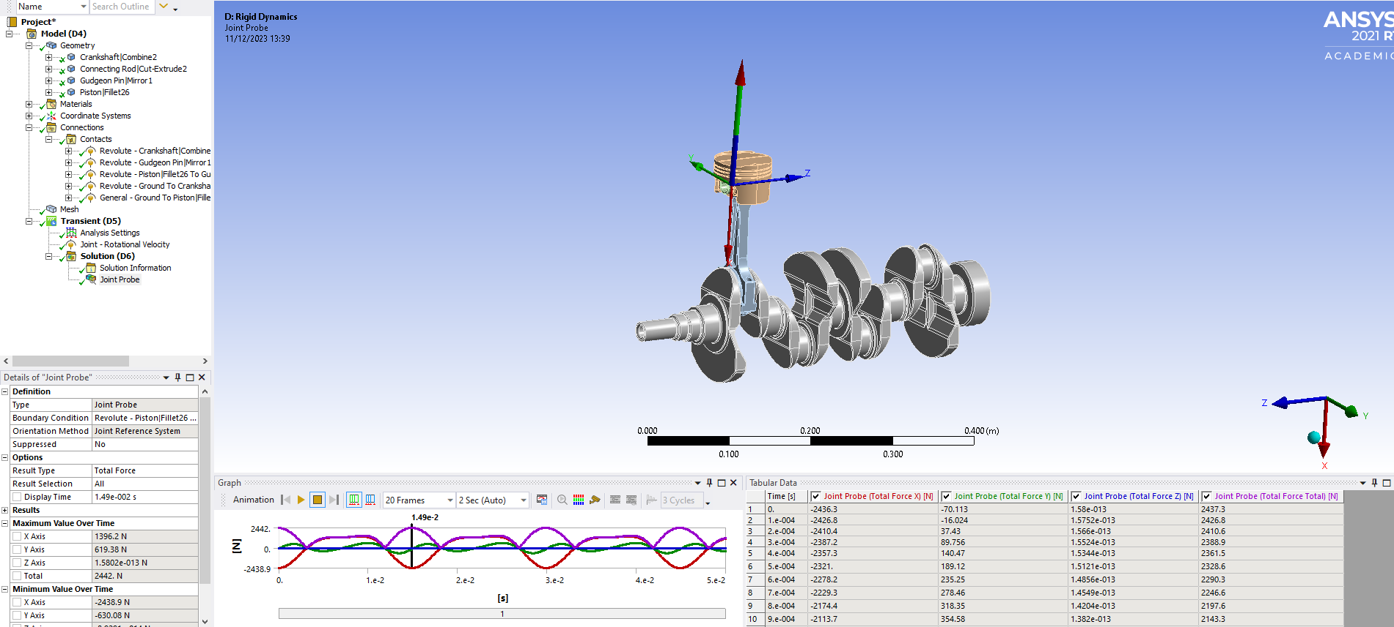
Figure 9 - Rigid Dynamics ANSYS Workbench
To complete this study, the assembly must be imported to ANSYS from the CAD software of choice. All contacts must be reassigned to have the assembly perform as realistically as possible, meaning the user must input joints of different capabilities to achieve results that are relevant. In complex cases of modelling and analysis, this is a time-consuming step and requires user knowledge of the systems kinematics, it could be difficult and expensive to find engineers capable of modelling, analysing and understanding requirements for unique case studies, adding to the cost of using FEA, CAE and CAD.

The rigid dynamics study delivers transient results as it is conducted over multiple time steps, therefore when it is exported for use in a static structural analysis, the maximum loading scenario is exported at one time step. In this case the forces were examined for the joint between the gudgeon pin and the piston, whilst using the crankshaft to ground joint as the driving force of the assembly, with a rotational velocity of 4000rpm.

Steady State Thermal
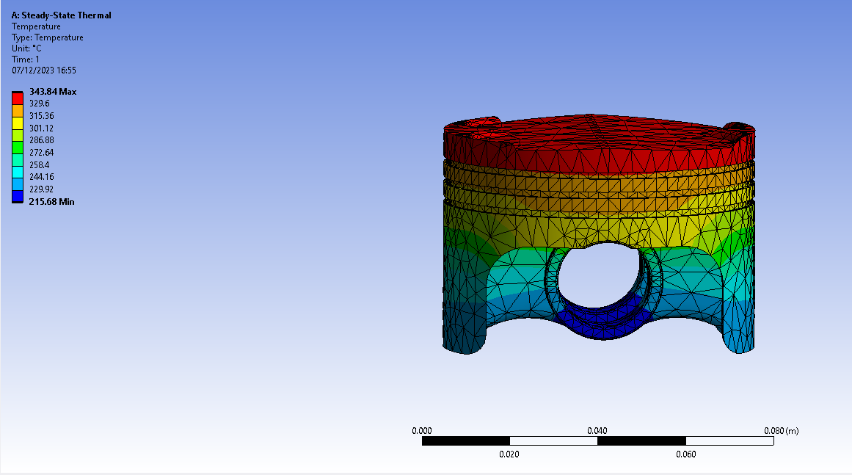
Figure 10 - Thermal testing stock piston
Thermal testing necessitates the application of conventional thermal loading conditions to the model input in ANSYS, aiming to replicate the environmental circumstances surrounding the model. The thermal capability of the piston plays a crucial role, exerting a direct influence on the model's limitations concerning stress resistance, deformation, and kinematics. Engineers must possess a precise understanding of the product's conditions to ensure a realistic simulation, as each outcome from one study inherently affects the subsequent ones in linked systems.

Static Structural
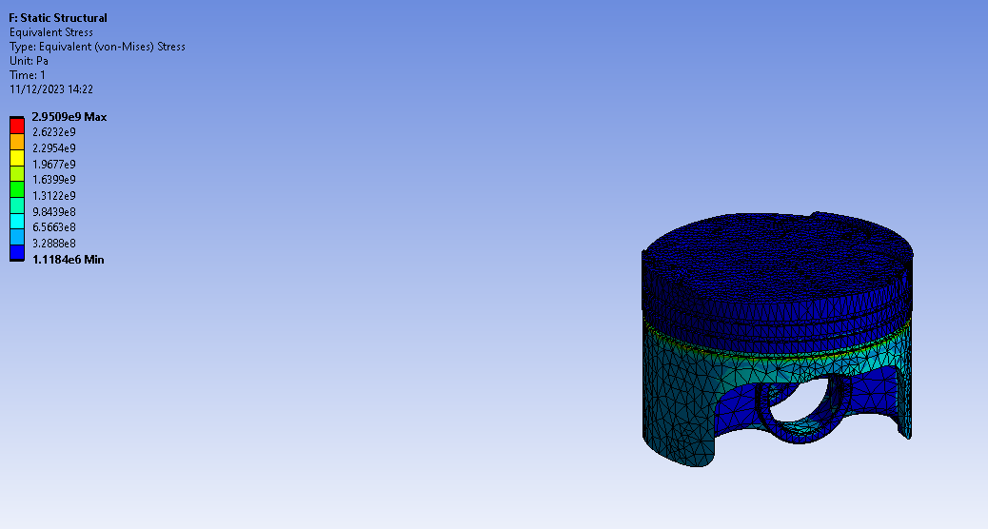
Figure 11 - Equivalent stress of stock piston
In the realm of internal combustion engine (ICE) pistons, static structural testing takes on paramount importance. This process involves subjecting the piston to stationary loading conditions within ANSYS, allowing engineers to scrutinize its response under static forces. The piston's capacity to endure these forces significantly influences critical factors, including stress resistance, deformation, and overall structural robustness. For a realistic simulation that accurately reflects the piston's performance, engineers must possess a nuanced understanding of the specific conditions governing its operation. The insights gained from static structural testing lay the groundwork for subsequent analyses, ensuring the piston's reliability, durability, and optimal design within the intricate dynamics of an internal combustion engine.

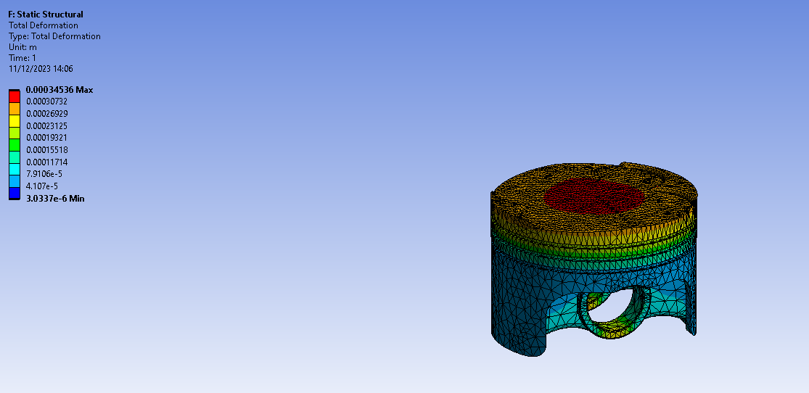
Figure 12 - Total deformation stock piston

Optimisation of piston design
Connecting studies enables the seamless propagation of updated results across analyses. Nevertheless, challenges arise when revisiting earlier outcomes in downstream studies, necessitating the restart of the entire study to generate new values at the analysis's conclusion. This intricacy can make the swift modification of conditions time-consuming, underscoring the need for meticulous precision during the initial configuration of the analysis. Subsequent to adjusting piston dimensions, additional testing was conducted to identify opportunities for enhancing the assembly's performance.

Initial design parameters were to reduce the overall mass of the piston, decrease the height, and make sure the deformation and stress doesn’t increase. Removing the correct parts of the piston for material reduction is important, maintaining or improving upon the original structural integrity of the piston and decreasing the overall temperature must be the main priority. Reducing the skirt height can lead to unbalancing the piston in the combustion chamber, the side walls can have material removed but the diameter must remain the same in order to prevent leaking of gases, there is also the possibility of piston slap which is when the piston is running too cold and can rock in the chamber. (Bagul & Tripathi, 2015) (JE Auto, 2023)
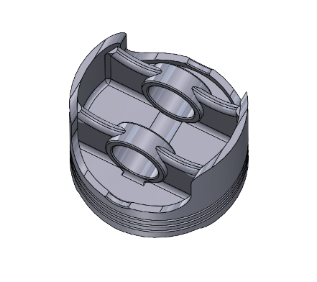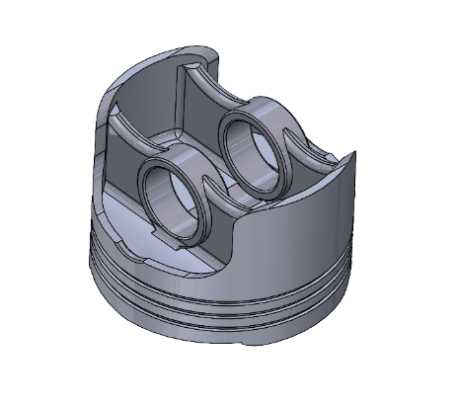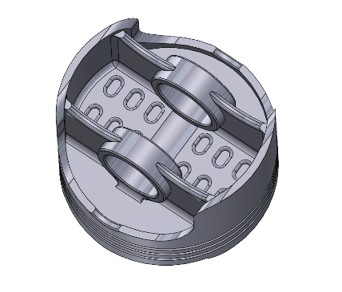
Figure 13 - Piston design iterations. Stock design (left), iteration 1 (middle), iteration 2 (right) Solidworks 2023.

First iteration
0.5mm removed from side wall (inside), reduced height of piston by removing 1.5mm from bottom of skirts.

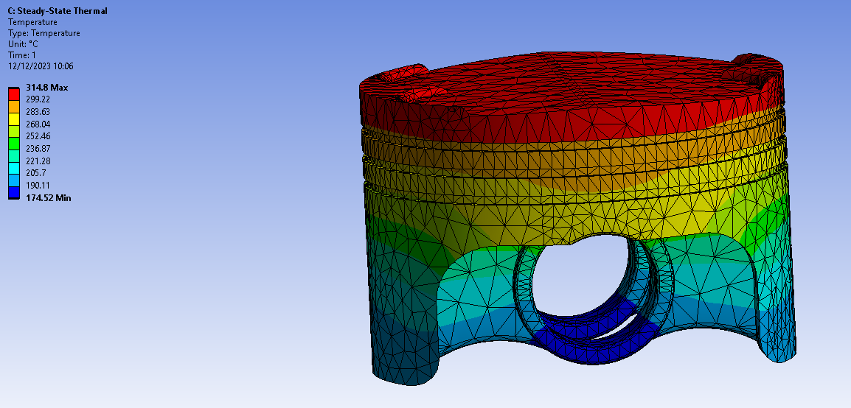
Figure 14 - Thermal study of piston iteration 1
The first iteration reduces the maximum temperature of the piston drastically, whilst also massively reducing the thermal loading where the gudgeon pin is placed inside the assembly. This will reduce the friction between parts and prolong the life of the assembly.

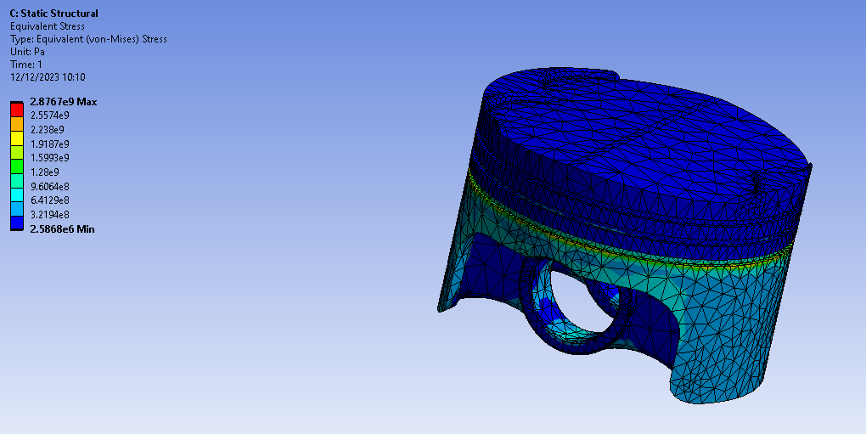
Figure 15 - Stress of piston iteration 1
Reduction of stress experienced from the stock iteration.

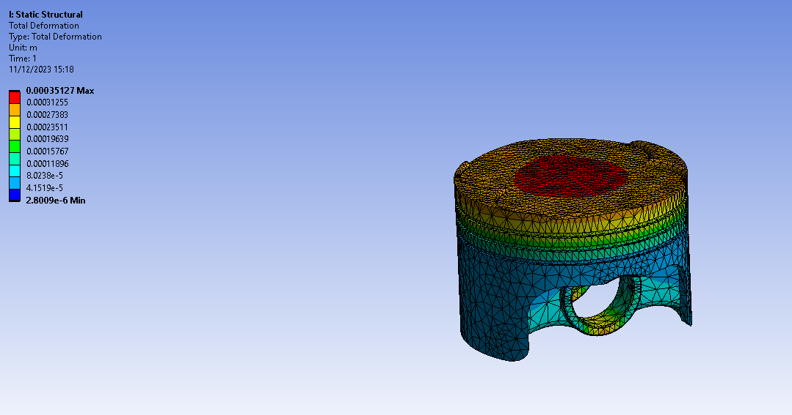
Figure 16 - Total deformation of piston iteration 1
The total deformation has actually increased very slightly in terms of maximum values from the stock piston.

Second iteration
Added more grooves to the underside of the piston to reduce mass, removed a further 1.5mm from piston length in the same method as the first iteration, due to this, reduced the fillet radius by 1mm on the underside of the supports connecting side wall to gudgeon pin holders. Reduced the width of the supports from 5mm to 3mm.

Results shown that the minimum temperature is 159.08° whereas the stock piston experienced 170.62° showing that the removal of mass on the underside of the piston decreased the overall temperature of the piston, this in turn will allow the piston to handle more stress and wear the component slower. (Pomeroy, 1922)

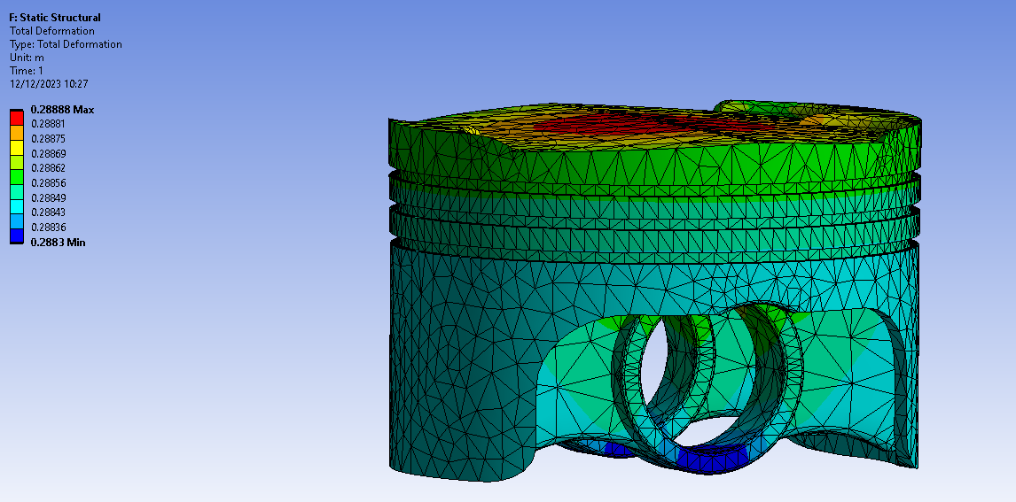
Figure 17 - Total deformation of piston iteration 2
The second iteration shows a much lower deformation (units are in meters) meaning the improvements made in regard to reducing mass to improve the life of the piston and increase the stress resistance have worked.

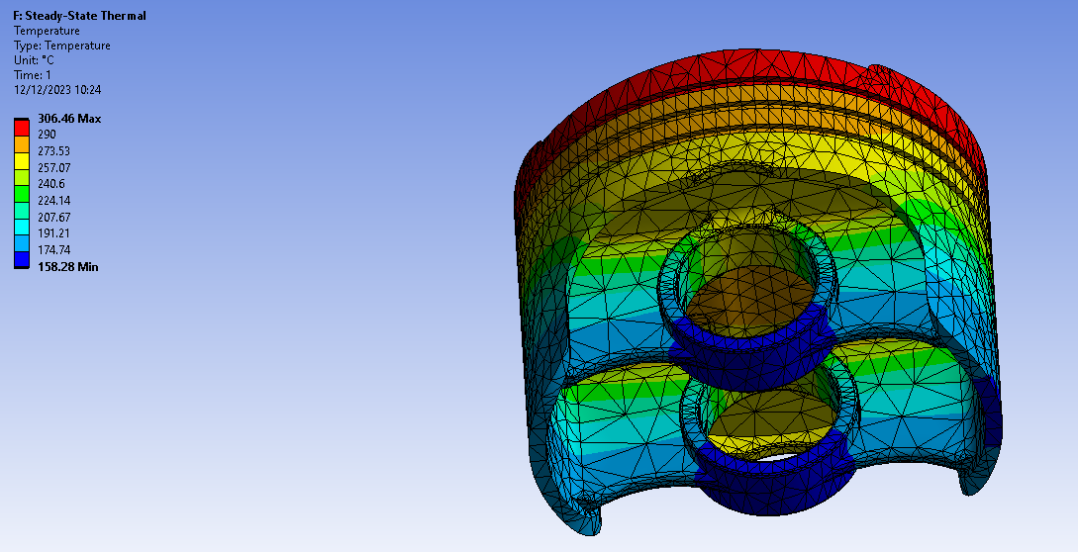
Figure 18 - Thermal study of piston iteration 2
The fully linked system shows unbalanced thermal loading on the bottom of the skirt, this could be an indication of piston slap meaning the improvements made to the piston will not be suitable in practice, displaying one of the main uses of CAE – discovering future problems before they arise in a safe and inexpensive way.

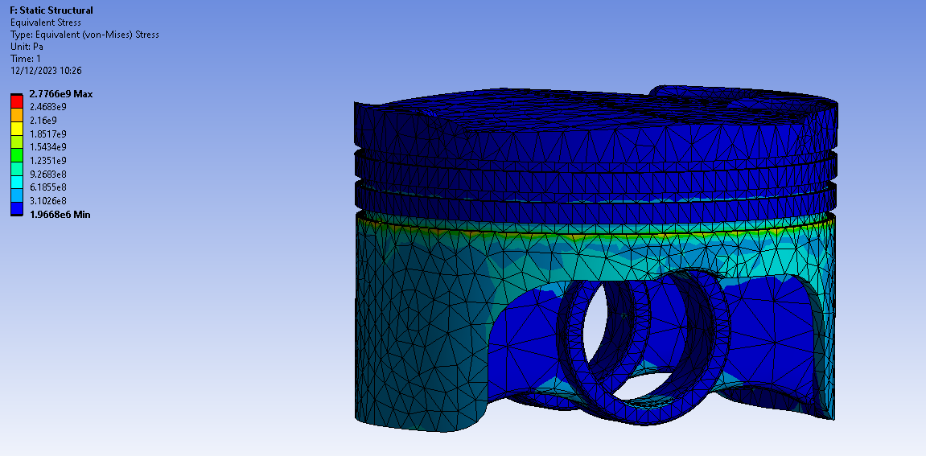
Figure 19 - Stress of piston iteration 2
The maximum stress experienced has reduced throughout each iteration of design. Performing analysis on iterations of models provides plenty of information in the manufacturing process of the product. However, the effectiveness of these modifications depends on various factors, including the specific design changes made, the material properties, and the operating conditions of the assembly. Additionally, in the case of a piston, the interplay of thermal, mechanical, and lubrication factors in an engine assembly is complex, and changes in one aspect may have cascading effects on others.

It's essential to validate these design changes through thorough analysis, simulation, and, ideally, experimental testing to ensure that the intended improvements are achieved without introducing unintended consequences. The success of such modifications also relies on a comprehensive understanding of the entire system and the specific goals of the design changes.

Conclusion
CAE, as a tool, offers extensive benefits to engineers by enabling result collection without the necessity of acquiring machinery, tools, or materials. This approach allows for the thorough theoretical analysis of entire products, enabling manufacturers to implement necessary changes before engaging in real-life testing. The integration of AI further enhances the capabilities of CAE, promising faster and more precise analyses with reduced reliance on human intervention.

A key advantage of Computer-Aided Engineering (CAE) lies in its ability to provide visual representations of results. When CAE calculations are performed, the graphical visualization of outcomes offers engineers an ergonomic and immediate understanding of test variations. The efficiency of comparing results is enhanced, as engineers can quickly assess graphs that highlight the positives and negatives of each study.

However, a notable limitation of CAE emerges when there is a need to alter the geometry of fully linked systems. This requirement necessitates the complete redoing of simulations, turning the iterative optimization of complex geometries—such as pistons—into a time-consuming process. Each simulation involves multiple physical studies that must be executed in tandem; failure to do so compromises the reliability of the overall results, introducing challenges in maintaining accuracy throughout the iterative optimization process.

References

- Bagul, V. and Tripathi, V. (2015) ‘Design optimization of piston of IC engine for weight reduction’ International Journal of Engineering Sciences. 8(3) 165-172.
- Brown, N.K. et al. (2022) ‘Deep reinforcement learning for engineering design through topology optimization of elementally discretized design domains’, Materials & design, 218(C), pp. 110672-. Available at: https://doi.org/10.1016/j.matdes.2022.110672.
- Frąckiewicz, M. (2023). The Evolution of Computer-aided Engineering: A Historical Perspective. [online] TS2 SPACE. Available at: https://ts2.space/en/the-evolution-of-computer-aided-engineering-a-historical-perspective/#gsc.tab=0 [Accessed 5 Dec. 2023].
- JE Auto (2023) What is Piston Slap and False Knock? Accessed: 11/12/2023. Available at: https://www.jepistons.com/je-auto-blog/what-is-piston-slap-and-false-knock/
- Kagan, P. and Fischer, A. (2000) ‘Integrated mechanically based CAE system using B-Spline finite elements’, Computer aided design, 32(8), pp. 539–552. Available at: https://doi.org/10.1016/S0010-4485(00)00041-5.
- Krishan, K and Aggarwal, M.L. (2012) ‘A finite element approach for analysis of a multi leaf spring using CAE tools’ Research Journal of Recent Sciences. 1(2) 92-96.
- Leap CFD Team. (2012) Tips & Tricks: Convergence and mesh independence study. Accessed: 12/12/2023 Available at: https://www.computationalfluiddynamics.com.au/convergence-and-mesh-independent-study/
- Pomeroy, L.H. (1922) ‘Advantages of light-weight reciprocating parts’, SAE Technical Paper Series [Preprint]. doi:10.4271/220044.
- Ulu, E., Zhang, R. and Kara, L.B. (2015). A data-driven investigation and estimation of optimal topologies under variable loading configurations. Computer Methods in Biomechanics and Biomedical Engineering: Imaging & Visualization, 4(2), pp.61–72. doi:https://doi.org/10.1080/21681163.2015.1030775.
- Wang, Y. et al. (2023) ‘From Computer-Aided Design (CAD) Toward Human-Aided Design (HAD): An Isogeometric Topology Optimization Approach’, Engineering (Beijing, China), 22, pp. 94–105. Available at: https://doi.org/10.1016/j.eng.2022.07.013.
- Xu, T. et al. (2011) ‘An Advanced and Comprehensive CAE Approach of Piston Dynamics Studies for Piston Optimal and Robust Design’, SAE International Journal of Engines, 4(1), pp. 2087–2099. Available at: https://doi.org/10.4271/2011-01-1404.

