
Zero-base Budgeting

[Date]

Name: Md Taslim Olid
ID: 2027984
Module Title: Financial Management for the Hotel Industry
Module Code: BMIH5007

Executive Summary
Developing a financial plan and sticking to it is critical not just in the business arena but also in one's private life. In this report, the importance of budgeting, different budgeting methods and how budgeting control can support sustainability have been presented. Budgets are necessary in order to accurately estimate resources and make the most of them. With the assistance of an effective financial planning strategy, the organization's goals can be moved forward. In this regard, as well as in every other, the benefit of developing and sticking to a budget is immeasurable. The four most common ways to create a budget statement are the incremental budgeting method, the activity-based budgeting method, the value proposition method, and the zero-based budgeting method. It is necessary for businesses to use the strategy that yields the greatest results for them. If the amount of money brought in by clients is more or equal to the amount of money spent, then the budget is deemed to be sustainable. Adopting a budget that can be maintained eternally is a guaranteed method to help an organization operate successfully in the long term, and it is one of the most important things an organization can do.

Table of Contents
Executive Summary 2
1. Introduction 4
2. Importance of Budgeting 4
3. Different Budgeting Techniques 5
3.1 Incremental Budgeting 5
3.2 Activity Based Budgeting 6
3.3 Value Proposition Budgeting 6
3.4 Zero Based Budgeting 6
4. The Way Budgeting Controls Support Sustainability 7
5.0 Conclusion 8
Budget Calculations 9
References 10

1. Introduction
There has to be close coordination between everyone involved in the budgeting process at any given business. Costs and budgeting go hand in hand. Economic concerns have grown in significance throughout time. This means that many businesses do not follow the recommended budgeting process, which often incorporates some financial factors automatically. Budgeting is a very vital process for any business. In today's world, budgeting may be approached from several perspectives (CFI, 2022). In business, the best method is the one that works for them. Funding for initiatives now takes into account their demonstrated value and relevance. This method is sometimes referred to as "zero-based budgeting." Instead of relying on past data, budgeting tools are used to maximize efficiency and meet operational needs. To adapt to the needs of the ever-evolving global economy, more and more individuals are adopting this method of budgeting. This report will reflect why budgeting is important, how to make a budget in different ways, and why it's important to think about long-term sustainability when making a budget (Becker et al., 2016).

2. Analysis of Grand hotel budget planner
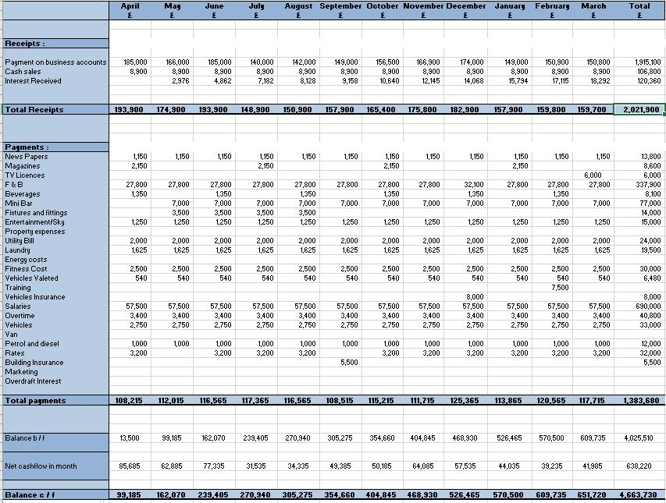
Figure 1: Grand hotel budget
Source: Own calculation
According to the data presented in the section of this budget that came before it, the months of April and June were the ones that brought in the most revenue for The Grand Hotel. This was due to the fact that during those months, more money was paid out on business accounts. July was the month that brought in the least amount of money, and this was due to the fact that there was the smallest amount of money received from company accounts during that month. The total amount of money that was brought into the business accounts of the company during the period covered by the accounting period was 1915100 pounds. The cash sales remained consistent throughout all the months, whereas the interest received varied from one month to the next.
There was a total of 138,3680 pounds worth of payments made according to the budget. The payments were at their highest during the month of December, while they were at their lowest during the first month. December was the month that saw the largest payments made. The hotel spent the least amount of money possible on its building insurance while spending the most on salaries for its employees. The hotel spent its money on numerous transactions that took place in the payments sector. Among the other expenses, the ones associated with the food and beverages, the mini bar, the vehicles, and the rates stood out as particularly significant. The highest amount of net cash was brought in during the first month, while the smallest amount was brought in during the seventh month. The fact that the hotel had an overall net cash flow for the time period of 638,220 pounds lends credence to the optimistic forecast for the establishment. Every single month saw a rise in the net amount of cash that was brought in. It indicates that the hotel will continue to be profitable in the future. The management was able to implement the budget without any problems at all. The hotel was able to keep its costs to a bare minimum while at the same time increasing the amount of money it brought in. This, in the end, ensured that the hotel made a profit.

3. Importance of Budgeting
The term "budgeting" refers to the procedure of creating and managing a plan to limit monetary outflows and maximize incoming resources over a certain time frame. Budgeting is an important skill for business owners, administrators, and managers to have if they want their companies and teams to do well. For these five reasons, it's clear that businesses need a budget (BIB, 2022).
- Ensures the availability of resources
Budgeting's major purpose is to make sure there are enough funds for an organization to achieve its objectives. With careful financial planning, you may save money or allocate it more wisely to projects and teams.
- Supports Goal-Setting and Progress Reporting Internally
For a firm, budgeting entails estimating how much money will be needed to meet goals. Budgeting may be used to set business and group financial goals. This is excellent practice even without an activity-based budget. Your financial goals should dictate the rest of the fiscal selections. The goals and expenses are linked. Budgeting informs employees of performance and the next period's goals. In this way, budgeting supports in setting goals and to understand the real performance of the organization (Anessi-Pessina et al., 2016).
- Benefits of Project Prioritization
Prioritizing projects and initiatives is a natural outcome of developing a budget. You should evaluate the possible returns on investment for each project, the degree to which each project matches the organization's values, and the potential influence on its overall financial objectives. When prioritizing jobs and significant projects, the value proposition budgeting approach may help establish and justify the worth of each line item (Asogwa and Etim, 2017).
- Opportunities to Obtain
Funds It is crucial to keep detailed financial records if you work for a company or want to seek outside investors. Current, historical, and projected financial performance are highly valued by investors when considering whether to support a firm. Documentation indicating planned and actual spending from previous periods may be used to demonstrate the ability to manage corporate finances, allocate resources, and make modifications as needed (Lidia, 2014). Some possible investors might want to look at your current budget to see how well you've been planning for the future.
- Offers an Adaptable Strategy
A budget illustrates how much money should be generated and spent if everything goes as planned. Business is unpredictable. Factors outside our control might affect the income or objectives. The 2020 COVID-19 pandemic can be contemplated. Travel restrictions, lockdowns, and other protective measures have unforeseen economic consequences. Executives reworked budgets quickly but wisely to account for large losses and safety issues. Executives are reworking their budgeting practices to make pivoting simpler (Rossi, 2015). McKinsey pointed out that organizations are moving toward zero-based budgeting to figure out how little money they need to stay in business.

4. Different Budgeting Techniques

4.1 Incremental Budgeting
An incremental budget is one that is constructed by utilizing the existing period's budget or performance level as a starting point and then making small, incremental adjustments. As a rule of thumb, this is done by using the funds allotted the previous year and making necessary adjustments to account for inflation. Commonly, incremental budgets use inflation as an adjustment element (Yan, 2016). Some companies examine each budget line item's adjustment elements differently. Unlike the zero-based budget, each expense is not analysed and rationalized but simply modified for the next month. In incremental budgets, spending and income are still reviewed. Because they're simpler to approach, minor budget modifications are often overlooked. This is not true, and the preceding period's budget modifications should be carefully considered. The main difference is that expenses aren't looked at and justified. Instead, it's assumed that all company spending is legal and necessary (Wildavsky, 2017).

4.2 Activity Based Budgeting
A budgeting system known as activity-based budgeting is one in which every action that results in a cost is recorded and analysed in order to identify areas in which efficiency may be improved. Following the completion of a cost analysis, one will be able to formulate a financial plan based on the results (Mohammadipour, 2014). Because it requires extra computations, activity-based budgeting provides a more complete method of financial planning than standard budgeting. This kind of budgeting isn't just about keeping track of spending or adjusting numbers based on inflation or other relevant events. Instead, its main goals are to cut costs and make things run more smoothly. As an example, suppose that a corporation decides that it wants to generate $100,000,000 in sales. To achieve the sales goal, the organization must first ascertain what steps need to be followed and then calculate the associated expenses (Mahal and Hossain, 2015).

4.3 Value Proposition Budgeting
Value proposition budgeting requires the planner to think about the following points:
- For what purpose is this sum allocated in the spending plan?
- Is there value for the buyer, the worker, or the stakeholder in this product?
- Is it financially worthwhile to purchase this item? Is there any other justification for the expense if not?
A value proposition budgeting mentality is necessary in order to guarantee that all of the budgeted expenses benefit the company. Both zero-based budgeting and value proposition budgeting aim to cut down on wasteful spending, but value proposition budgeting is more specific than zero-based budgeting (Divvy, 2022).

4.4 Zero Based Budgeting
When using a budgeting method based on zero, each expenditure has to have a justification. The practice of analyzing a company's expenditure and consumption by beginning with "zero" is known as "zero-based budgeting." Costs are categorized and analyzed based on previous performance as well as current expectations (Sachik, 2018). This enables management to allocate funds according to current requirements rather than those based on levels from the past. This approach to budgeting was first developed in the 1970s by Peter Phrr. Under the zero-based budgeting system, managers are obligated to provide justification for their operations because the budget won't be granted until company management can verify them. The job of managers has to be acknowledged. Zero-based budgeting would eliminate unwarranted expenditures and efforts. When compared to other budgeting methods, including the progressive technique, the zero-based budgeting approach has a higher chance of fully using available resources (Marcel, 2014).
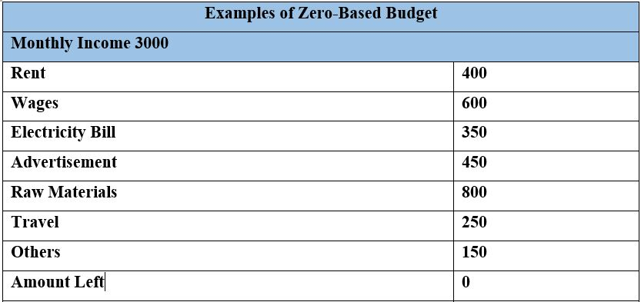
Figure-1: Example of zero-based budgeting (Nimtrakoon and Tayles, 2015)

5. The Way Budgeting Controls Support Sustainability
Sustainability in the budget is achieved when client revenues are more than or equal to expenditures. It might take into account either historical data or projections for future earnings and expenditures (Robinson, 2016). The budget can only be managed effectively if individual managers are given authority over their own departments' budgets. In order to ensure that all funds were used appropriately, managers compared actual expenditures to those projected in the budget. The budget for the future is then adjusted so that it matches the original projections. Corporations are private, for-profit businesses. If they can't make a profit, they won't survive. Decisions are significantly impacted by anticipation and foresight. Incorporating such assumptions and forecasts into a scenario helps shape the outcome. If monetary data is included in a scenario, then a corresponding budget has been created (Emerling and Wojcik-Jurkiewicz, 2018). Creating a budget is similar to putting together a financial simulator for a company. Budgeting is a vital tool in the framework of prudent financial management for sustainable development. Budgeting may also be used to ensure that the firm is making the most of its money and other resources. The budgets of different companies and regions reflect a wide range of spending habits. The budgeting practices of several sectors, including manufacturing, distribution, aviation, building, and hospitality, vary widely from one another. Consequently, if the company's management is committed to sustainability, strict budgeting may help (Ditillo and Lisi, 2016.).

6.0 Conclusion
Creating a budget is essential not just in business but also in one's personal life. Budgets allow for accurate resource estimation and optimal use. The organization's objectives may be advanced with the aid of an efficient budgeting plan. The value of budgeting is incalculable, in this and every other way (Posner and Fantone, 2015). Incremental budgeting, activity-based budgeting, value proposition, and zero-based budgeting are the four most prevalent approaches to creating a financial plan. Companies need to use the method that works best for them. The budget is considered sustainable if client revenues are more than or equal to expenditures. Adopting a budget that can be kept up indefinitely is a sure way to help an organization do well in the long run (Botín and Vergara, 2015).

Budget Calculations
Here are some examples of how a well-established hotel with a zero-based budget may operate for one month (Wijethilake et al., 2017).

References
- Anessi-Pessina, E., Barbera, C., Sicilia, M. and Steccolini, I., 2016. Public sector budgeting: a European review of accounting and public management journals. Accounting, Auditing & Accountability Journal.
- Asogwa, I.E. and Etim, O.E., 2017. Traditional Budgeting in Today's Business Environment. Journal of Applied Finance and Banking, 7(3), p.111.
- Becker, S.D., Mahlendorf, M.D., Schäffer, U. and Thaten, M., 2016. Budgeting in times of economic crisis. Contemporary Accounting Research, 33(4), pp.1489-1517.
- Botín, J.A. and Vergara, M.A., 2015. A cost management model for economic sustainability and continuos improvement of mining operations. Resources Policy, 46, pp.212-218.
- Business Insights Blog (BIB). 2022. Why Is Budgeting Important in Business? 5 Reasons. [online] Available at: <https://online.hbs.edu/blog/post/importance-of-budgeting-in-business> [Accessed 13 October 2022].
- Corporate Finance Institute. 2022. Types of Budgets. [online] Available at: <https://corporatefinanceinstitute.com/resources/knowledge/accounting/types-of-budgets-budgeting-methods/> [Accessed 12 October 2022].
- Ditillo, A. and Lisi, I.E., 2016. Exploring sustainability control systems' integration: The relevance of sustainability orientation. Journal of Management Accounting Research, 28(2), pp.125-148.
- Divvy. 2022. Value Proposition Budgeting | Divvy. [online] Available at: <https://getdivvy.com/learn/value-proposition-budgeting/> [Accessed 13 October 2022].
- Emerling, I. and Wojcik-Jurkiewicz, M., 2018. The risk associated with the replacement of traditional budget with performance budgeting in the public finance sector management. Ekonomicko-manazerske spektrum, 12(1), pp.55-63.
- Lidia, T.G., 2014. Difficulties of the budgeting process and factors leading to the decision to implement this management tool. Procedia Economics and Finance, 15, pp.466-473.
- Mahal, I. and Hossain, A., 2015. Activity-based costing (ABC)–an effective tool for better management. Research Journal of Finance and Accounting, 6(4), pp.66-74.
- Marcel, M., 2014. Budgeting for fiscal space and government performance beyond the great recession. OECD Journal on Budgeting, 13(2), pp.9-47.
- Mohammadipour, R., 2014. A study on the effect of performance based budgeting using activity based cost method. Management Science Letters, 4(1), pp.145-148.
- Nimtrakoon, S. and Tayles, M., 2015. Explaining management accounting practices and strategy in Thailand: A selection approach using cluster analysis. Journal of Accounting in Emerging Economies, 5(3), pp.269-298.
- Posner, P.L. and Fantone, D.M., 2015. Performance budgeting: prospects for sustainability. In Performance Management and Budgeting (pp. 106-127). Routledge.
- Robinson, M., 2016. Budget reform before and after the global financial crisis. OECD Journal on Budgeting, 16(1), pp.29-63.
- Rossi, M., 2015. The use of capital budgeting techniques: an outlook from Italy. International journal of management practice, 8(1), pp.43-56.
- Schick, A., 2018. Budgeting for results: recent developments in five industrialized countries. Performance-based budgeting, pp.129-146.
- Wijethilake, C., Munir, R. and Appuhami, R., 2017. Strategic responses to institutional pressures for sustainability: The role of management control systems. Accounting, Auditing & Accountability Journal.
- Wildavsky, A., 2017. Budgeting and governing. Routledge.
- Yan, B., 2016. Cycle-Based Budgeting Toolkit: A Primer. Online Submission.

