

Design of Class Attendance System Using
Face Recognition

by
Han Zhengyuan

Supervisor: Renuga Jayakumar

Project submitted as part of the requirements for the award of MSc 12

September 2022

DECLARATION

I, Han Zhengyuan declare that I am the sole author of this Project; that all references cited have been consulted; that I have conducted all work of which this is a record, and that the finished work lies within the prescribed word limits.

This work has not previously been accepted as part of any other degree submission.

Signed : Han Zhengyuan

Date : 07/09/2022

FORM OF CONSENT

I, Han Zhengyuan hereby consent that my Project, submitted in candidature for the M.Sc. Data Science and Analytics degree, if successful, may be made available for inter-library loan or photocopying (subject to the law of copyright), and that the title and abstract may be made available to outside organisations.

Signed : Han Zhengyuan

Date : 07/09/2022

Content
1. Introduction 1
1.1 Background 1
1.2 Design objectives 3
1.3 Design structure 4
2. Literature Review 5
2.1 Reasons for design a class attendance system using face recognition 5
2.2 The current state of face recognition research 10
2.3 The principle and process of face recognition 13
2.4 The choice of face detection algorithm 15
2.5 The process of feature extraction 18
2.6 The choice of face recognition algorithm 20
3. Methods 25
3.1 Software Frame and Functional Frame Design of the System 25
3.2 Development tool for class attendance system 29
3.3 Design of Database 30
4. Design and Implementation 33
4.1 The face recognition process used in this system 33
4.2 Implementation of face recognition 38
4.3 System test 41
5. Results and Evaluation 43
5.1 System operating interface 43
5.2 Discussion on face recognition result 46
5.3 Evaluation on System Implementation Process 47
6. Conclusion and Recommendations 48
6.1 Summary of the dissertation 48
6.2 Future enhancement 49
7. Reference list 50

Figure 1. Various biometric images [8]. 6
Figure 2. Primary stages in the history of face recognition [21]. 12
Figure 3. Face recognition principal block diagram. 15
Figure 4. Model structure [26]. 23
Figure 5. Structure frame diagram. 28
Figure 6. OpenFace’s project structure [46]. 36
Figure 7. OpenFace’s affine transformation [46]. 37
Figure 8. Face detection part of the code. 39
Figure 9. Face recognition part of the code. 40
Figure 10. System main interface. 44
Figure 11. Students’ personal information collection. 45
Figure 12. Train and Load Model. 45
Figure 13. The main interface after completing the attendance. 46

Table 1. Application areas of face recognition methods [9]. 7
Table 2. Student personal information storage format. 31
Table 3. Attendance information record storage format. 32
Table 4. Student personal information collection module test. 41
Table 5. Attendance module test (main interface). 43

Abstract

Face has been one of the main biometric traits, the analysis of the human face and facial behaviour is an interdisciplinary research area involving psychology, neuroscience, and engineering. Application areas of face recognition methods are very wide, involving areas such as Security and Health, Law Enforcement, Entertainment, Education and Marketing. As part of human feature recognition, face recognition is different from other human feature recognition in that face recognition is totally non-intrusive and does not carry any health risks. Therefore, the class attendance system based on face recognition also came into being, which made up for the current paper/manual attendance system, such as student distraction issues and inefficiencies.

With face recognition technology as the core, this paper designs and implements a face recognition attendance system for classroom use. The article first analyses the research overview of face recognition, and analyses the rationality and efficiency of using the face recognition attendance system in view of the problems existing in the traditional attendance management system. Analysed the related technologies of face recognition, designed the corresponding implementation plan, clarified the software framework and functional modules of the attendance system based on face recognition technology, and finally realized the interface design and function of the attendance system based on face recognition. test. The system achieves the purpose of detecting and identifying faces and recording attendance records. It can identify the identity information of students, then record and count the attendance of students, and can complete the entry and modification of student information, as well as the query and statistics of attendance information. The main part of the face recognition attendance system designed in this dissertation is completed by the scheme of OpenCV+ResNet+FaceNet+MySQL. First, use OpenCV to open the camera, detect the face in real time, and then apply the ResNet face detection algorithm to find the face coordinates. Then the face correction algorithm is applied to correct the face. Then use the face recognition algorithm FaceNet to perform feature extraction on pure face images to realize face recognition. Then use SVM to implement the classification task of 128-dimensional vectors of each face. Finally, the MySQL database is used to manage the information to achieve a complete attendance effect.

Key Words: Face recognition; Attendance system; Software development

1. Introduction
This chapter provides an introduction to the background of the design; design objectives and design structure.

1.1 Background
Is this the person who he or she claims to be? and other identity-related inquiries. "Has this applicant previously visited here?" Organizations in the financial services, healthcare, e-commerce, telecommunications, and government ask this question millions of times every day. Because of this, an increasing number of businesses are looking to automated identity authentication systems to boost operating effectiveness, increase customer satisfaction, and conserve valuable resources [1]. In response, the scientific community put forth the concept of "Biometrics," or the identification of people based on their physiological or behavioural characteristics [2].

The Greek words bios (life) and metrics are where the term "biometric" originates (measure). It is common knowledge that people intuitively recognize one another based on physical traits like voice, gait, and face. Recognizing humans based on their physical characteristics became increasingly interesting in emerging technology applications because today's applications require reliable verification schemes to confirm an individual's identity [3]. Traditional methods of identifying a person depend on what they have (a physical key, an ID card, etc.) or what they know (a secret password, etc.). These techniques have some drawbacks. Passwords can be forgotten, keys can be lost, and ID cards can be forged. However, an individual’s biological traits cannot be misplaced, forgotten, stolen or forged [4].

The term "biometric identification" describes the process of recognizing a person by his or her distinctive physiological and/or behavioural characteristics (biometric identifiers). It links or disaffiliates a person with a predetermined identity or identities based on who they are or what they do. Biometric identifiers are inherently more trustworthy and capable than knowledge-based and token-based techniques in differentiating between an authorized person and a fraudulent impostor because many physiological or behavioural characteristics are unique to each person. So, what biological measurements qualify to be a biometric? Anil K. Jain's said that any human physiological and/or behavioural characteristic can be used as a biometric characteristic as long as it satisfies the following requirements [5]:
- Universality: each person should have the characteristic.
- Distinctiveness: any two persons should be sufficiently different in terms of the characteristic.
- Permanence: the characteristic should be sufficiently invariant (with respect to the matching criterion) over a period of time.
- Collectability: the characteristic can be measured quantitatively.

Face has been one of the main biometric traits, the analysis of the human face and facial behavior is an interdisciplinary research area involving psychology, neuroscience, and engineering. Face recognition is born in this context. It is easy for humans to recognize faces. As long as they are familiar with the facial contours and features of a certain person, when the face of this person appears again, it can be accurately recognized. People want to give machines the same ability, the ability to recognize faces.

Face recognition belongs to the intersection of computer vision and pattern recognition and is widely used in various disciplines. Face recognition methods are very wide, involving areas such as Security and Health, Law Enforcement, Entertainment, Education and Marketing. Among them, Face Recognition technology finds major applications in the field of education to efficiently automate and manage the attendance system. As the number of students enrolling to university increases every year, maintaining the attendance and records of thousands of students is a major concern in the education sector [6]. Empirical evidence has shown that there is a significant correlation between students' attendances and their academic performance. There was also a claim stated that the students who have poor attendance records will generally link to poor retention. This is also agreed by Mazza and Dimitrova where they both claimed that the students' attendances on the course may indicate their behavior towards the subject where it can be used to judge their tendency and commitment to the course [7].

Although face recognition has long been applied to life, its development is not perfect, and there are still many problems to be solved. On the one hand, among the various factors that affect the recognition rate, environmental factors and shooting angles are the most important: in different light intensities, different backgrounds and different shooting angles, it is possible to recognize the same face Different results may also be found for different faces; on the other hand, face recognition involves the privacy and security issues of the public, and the network transmission of face images collected by cameras may lead to leakage of user privacy. . In order to solve these defects, it is necessary to continuously explore new methods and other related scientific means for face recognition, so as to improve face recognition technology.

The face recognition attendance system is a relatively advanced attendance software system at present. It is a product designed based on biometric identification technology combined with database technology, and is used in enterprises, schools and other commercial occasions. But there are some problems with the current paper/manual attendance system, such as student distraction issues and inefficiencies. As a result, it is necessary to design a classroom attendance system to solve the problem of classroom attendance.

1.2 Design objectives
Based on face recognition, this paper uses ResNet-SSD as the face detection model and FaceNet as the face recognition model. A classroom attendance system is designed and implemented, which can be applied to the school's daily teaching. The system function can not only realize face attendance, but also provide the function of querying students' basic information and attendance records by connecting to the database. It mainly involves algorithm selection, code implementation, platform training and visual interface design.

1.3 Design structure
This dissertation then has five chapters. They are Literature Review, Methods, Design and Implementation, Results and Evaluation and Conclusion. Specifically, this dissertation is the first to justify the study in Literature Review. Second, the software environment and tools for development were determined in Methods. Thirdly, the design and implementation process of the system is introduced in detail in Design and Implementation and tested. Then the designed system operation results are discussed and analysed in Results and Evaluation. Finally, the entire dissertation is summarized in Conclusion.

2. Literature Review
This chapter provides some focused and critical opinions about: Reasons for design a class attendance system using face recognition; The current state of face recognition research; The principle and process of face recognition; The choice of face detection algorithm; The process of feature extraction and The choice of face recognition algorithm.

2.1 Reasons for design a class attendance system using face recognition
Biometric traits are the special attributes on which the biometric recognition system is developed. Face, palm print, iris, retina, fingerprint, voice, signature, gait, hand geometry, handwriting, ECG, brain print and keystroke dynamics are the various examples of biometric traits which include biological, physiological and behavioural aspects. Physical characteristics of a person include their fingerprint, hand and palm geometry, iris, ear, facial pattern, deoxyribonucleic acid (DNA), retina, palm vein, and finger vein identification. Because of qualities like collectability, uniqueness, permanence, and affordability for achieving verification and identification, these traits are widely accepted. A person's gait, keystroke, signature, handwriting, and speech are examples of behavioural traits, which are characteristics that describe their personality and behaviour. Their images are shown in Figure 1 [8].
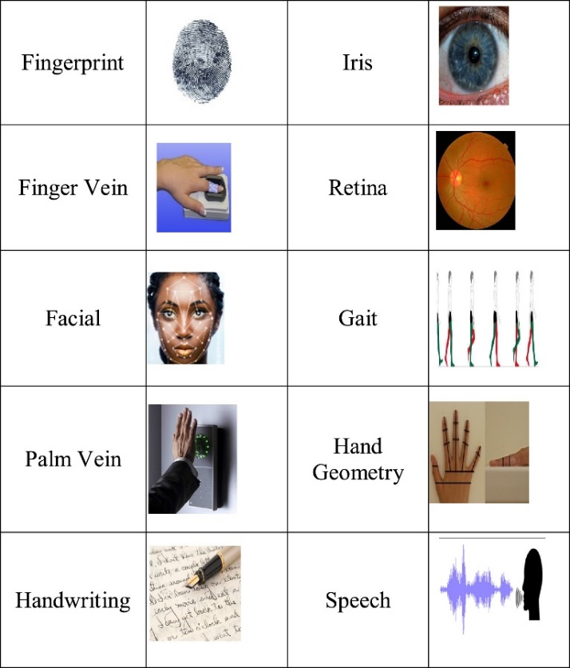

Figure 1. Various biometric images [8].

One of the most important biometric characteristics has been the face, which has numerous applications in the fields of security and law enforcement, health, education, marketing, finance, entertainment, and human-computer interaction. A person's face contains data about their identity, age, gender, race, and various facial expressions that convey their emotions and mental states. The analysis of the human face and facial behaviour is an interdisciplinary research area involving psychology, neuroscience, and engineering. The main application areas and specific applications related to these areas are listed in Table 1 [9]. Face recognition involves analysing facial characteristics. It is a computer program that automatically recognizes or authenticates a person from a digital image or a video frame obtained from a video source. One method for doing this is as simple as analysing specific facial features from the image and the facial database [10]. Face recognition, one of the most significant biometric methods, has the advantage of being passive and natural compared to other biometric methods that depend on subjects cooperating, like fingerprint and iris recognition. A system must be able to identify or recognize an uncooperative face in an uncontrolled environment and arbitrary situation without the subject's knowledge in order to take advantage of face recognition's non-intrusive nature [11].
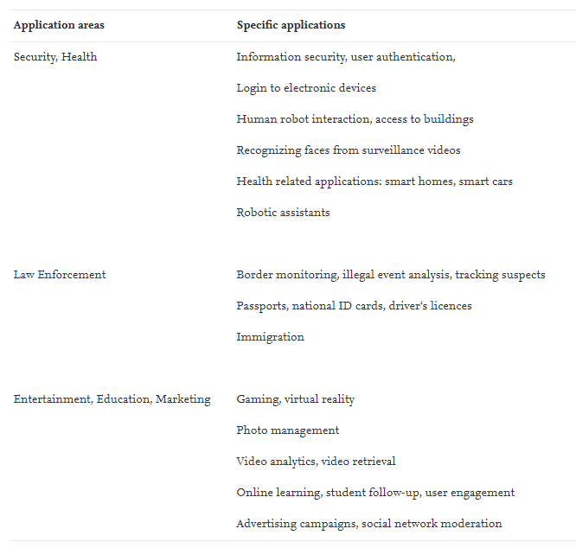

Table 1. Application areas of face recognition methods [9].

Data collection generally is difficult for other biometrics since methods relying on hands and fingers may become useless if the epidermal tissue is harmed in any manner (i.e., bruised or cracked). Identification via the iris or retina is expensive and extremely sensitive to body motion. Voice recognition is sensitive to acoustic variations on a phone line or in a tape recording as well as background noise in public locations. It is possible to alter or falsify signatures. However, a few cheap fixed cameras can be used to quickly capture facial photos. Noise and small differences in orientation, scale, and illumination can be compensated for by effective face recognition algorithms and proper image pre-processing. Last but not least, technologies that require several users to share the same equipment in order to collect biological data may expose the user to contamination from other users' pathogens and pollutants. Face recognition, on the other hand, poses no such health dangers and is completely non-intrusive [12]. Face recognition is one of the extra advantages. Databases make it easy, convenient, and a mature technology to store templates. Additionally, cameras and other existing image capture equipment can be employed [13].

On the other hand, Face recognition isn’t perfect and faces challenges to perform under certain conditions. For example, Face recognition doesn’t work effectively in bad/weak lighting, sunglasses/sunshades, lengthy hair, or other objects partly covering the subject’s face. And it hasn't much effective for low resolution images. Another serious drawback is that many systems are usually less efficient if facial expressions vary. Even a big grin/laugh can render the system’s performance less effectively.

In the above papers, we can find that face recognition is a subcategory of biometrics, and it can be said to be the most important category. Through Table 1, it can be found that application areas of face recognition methods are very wide, involving areas such as Security and Health, Law Enforcement, Entertainment, Education and Marketing. These areas are areas that often appear in people's daily lives and cover a very large number of people. That means there are many places and opportunities for facial recognition to come into play. This is enough to prove that face recognition as part of research is very valuable and promising.

Of course, facial recognition is not perfect. Of course, there will be problems when it is used in people's current life. Through Figure 1, it can be found that there are at least ten types of biometrics. Existence is reasonable, which proves that face recognition must have advantages and disadvantages compared with other biometrics. This means that if an individual needs to use biometrics, his best option is to weigh the pros and cons of the situation and make the choice that best suits the individual.

As mentioned in the above literature, face recognition involves the Education area. I am still a student as the actual researcher of this dissertation. This means that I am very familiar with the field of Education. This means that it is reasonable for this dissertation to choose face recognition as part of the research and apply it to the field of Education. In addition to this, the above literature also mentions that face recognition also has convenience and Matured technology. And the existing image capturing devices i.e., cameras can be used. As a student, I independently developed a project, and I actually needed the technology needed for the project to be convenient and mature. Because my own ability is limited and face recognition just meets this need. And if only the camera needs to be called as the device in the actual face recognition, then the development cost and difficulty are not high. To sum up, it is feasible to design a system using face recognition technology in this dissertation plan.

The majority of institutions use the attendance system to track students' punctuality. Student attendance systems typically come in two flavours: manual attendance systems and automated attendance systems. The manual attendance method in use today, however, has significant difficulties. The most typical method of keeping track of students' attendance in a classroom is to require them to manually sign an attendance sheet that is typically circulated around the room as the lecturer is giving the lesson. Using such a system has a lot of drawbacks. For instance, instructors with big classes can discover that the trouble of having the attendance sheet moved around the room and the manual signing of attendance by students is difficult and will likely distract them from teaching and gaining the students' entire attention [14]. Additionally, some students sign attendance by proxy despite never attending class. Some professors mark attendance by calling out names one by one, although this process takes a long time. Another issue is that some students arrive late for class, particularly in morning classes. Additionally, it could be quite distracting for both lecturers and students to open and close the door during a lecture. As a result, the manual attendance mechanism is unreliable and not guaranteed [15].

On the other side, the automated attendance system might provide some advantages to the faculty, or at the very least, it might make the staff's administrative workload less onerous. Particularly for attendance systems that use human face recognition technology, these systems frequently entail the process of collecting important elements from any facial images of students taken as they enter the classroom or when everyone has taken their seats. When it successfully recognizes a student, it moves on to automatically mark that student's attendance [16].

From the above literature, it can be found that attendance is very important in the field of education, because attendance can directly determine students' learning attitude. It is hard to believe that a student with a bad attitude towards learning has good academic performance. But there are some problems with the current paper/manual attendance system, such as student distraction issues and inefficiencies. As a result, it is necessary to design a classroom attendance system to solve the problem of classroom attendance. It is also mentioned in the above literature that face Recognition technology finds major application in the field of education to efficiently automate and manage the attendance system. And attendance systems using face recognition technology can also reduce the administrative burden of school staff. Then, this dissertation plan designs a classroom attendance system based on face recognition to solve the above problems.

2.2 The current state of face recognition research
Face recognition has a long history in computer vision, dating all the way back to Bledsoe's work in the 1960s [17]. Kanade is likely responsible for the initial attempts at automatic face identification using a vector of geometrical features in 1973 [18]. A collection of 16 features was generated using a reliable feature detector (constructed from straightforward modules utilized in a backtracking technique). Some of the parameters were found to be ineffectual by analysis of the inter and intra class variances, resulting in a vector with less dimension. Using two photographs per person—one for reference and one for testing—algorithm Kanade's was able to identify each person in a database of 20 different people with a top performance of 75% accuracy. These procedures are based on face characteristics. A different strategy approaches the recognition issue from a broad perspective. Instead of extracting the feature of the nose, mouth, or eyes separately, it directly extracts the statistical characterisation using the statistical approach out of the full training sample photos. This method uses holistic feature extraction for facial photos. Principal Component Analysis is the method used in the second strategy that is most well-known (PCA). Both face representation and face recognition have made substantial use of PCA, a potent method for condensing a large set of correlated variables into a smaller number of uncorrelated components. Applying the PCA technique to face recognition, Turk and Pentland developed a well-known Eigenfaces method, where the eigenfaces correspond to the eigenvectors associated with the largest eigenvalues of the face covariance matrix. Face detection and recognition are then performed in the smaller space defined by the eigenfaces, which significantly decreases the dimensionality of the original space [19]. Both face representation and face recognition have made substantial use of PCA, a potent method for condensing a large set of correlated variables into a smaller number of uncorrelated components. Applying the PCA technique to face recognition, Turk and Pentland developed a well-known Eigenfaces method, where the eigenfaces correspond to the eigenvectors associated with the largest eigenvalues of the face covariance matrix. Face detection and recognition are then performed in the smaller space defined by the eigenfaces, which significantly decreases the dimensionality of the original space [19].

Face recognition technology is achieving more and more as new techniques keep emerging in the industry. The Defense Advanced Research Projects Agency (DARPA) created the Face recognition technology (FERET) initiative in 1998 to spur industry and academia to advance research on this subject. This program gave the globe access to a huge, difficult database made up of 2400 photos for 850 individuals. In order to promote and advance face recognition technology for use in supporting current facial recognition projects, the Face Recognition Grand Challenge (FRGC) competition was established in 2005. In 2011, everything accelerated due to deep learning, a machine learning method based on artificial neural networks. The computer selects the points to be compared: it learns better when it supplies more images. In 2014, Facebook knew how to recognize faces due to its internal algorithm, Deepface. The social network claims that its method approaches the performance of the human eye near to 97%. Part of the most significant historical stages that have contributed to the advancement of face recognition technology is shown in Figure 2 [21].
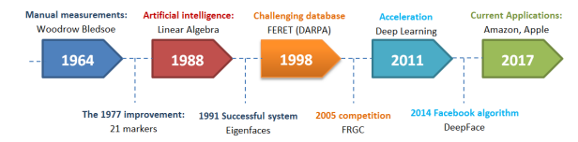

Figure 2. Primary stages in the history of face recognition [21].

Today, with much fanfare, Apple unveiled its Face ID product for the iPhone X in the Fall of 2017 [22]. Digital animations like Samsung's memoji and Apple's animoji improve facial recognition technologies' ability to recognize all human faces [23]. Uber using Microsoft’s Cognitive Face API to verify their drivers and C-Span using Amazon’s Rekognition service to index their videos by who is speaking or who is on camera [24]. MasterCard opened a new face recogniser app called as the selfie app which enables the user to confirm the payment using their mobile camera [25]. Google proposes a face recognition algorithm called FaceNet, and the method of CNN and triplet loss mining is proposed. On the LFW dataset, the accuracy rate is 0.9963, and on the YouTube Faces DB dataset, the accuracy rate is 0.9512 [26].

According to the above literature, it can be found that the application of face recognition is very extensive, and the key point is that almost all technology giants have stepped into the field of face recognition and applied it to their products. Moreover, there are many algorithms for face recognition. Since each company has its own scientific researchers, it is often difficult for people to distinguish and choose the appropriate face recognition algorithm in practical applications. If people want to choose a face recognition algorithm for actual project development, the first thing people have to do is to study what kind of face recognition algorithm is suitable for their development, and whether there is a certain feasibility.

2.3 The principle and process of face recognition
It is determined above that this dissertation is to design a classroom attendance system based on face recognition. Then the top priority is to choose a suitable face recognition algorithm suitable for classroom attendance. At first, it needs to understand the principles and process of face recognition. As mentioned above, the use of human face information to identify the particularity of human identity, and the technology to determine personal identity in this way is face recognition technology. Face recognition in a broad sense includes related technologies for building a face recognition system. It includes face detection, face position, identity recognition, image pre-processing, etc. Face detection algorithm is to find out the coordinate system of all faces in one image. This is the process of scanning the entire image to determine whether the candidate area is a face. The output of the face coordinate system can be square, rectangular, etc. The face position is the coordinate position of the face feature in the face detection coordinate system [27].

However, this dissertation is more inclined to study the application of face recognition in this system. It means that more attention should be paid to the specific process of face recognition. Three basic steps are used to develop a robust face recognition system: (1) face detection, (2) feature extraction, and (3) face recognition. The face detection step is used to detect and locate the human face image obtained by the system. The feature extraction step is employed to extract the feature vectors for any human face located in the first step. Finally, the face recognition step includes the features extracted from the human face in order to compare it with all template face databases to decide the human face identity [28].

Specifically, the stages involved in the Face Recognition process are face detection, pre-processing of the face image, extraction of facial features and lastly feature classification. The system is made to confirm the presence of a face in an image or video at the first stage, called face detection. The image is pre-processed to acquire the region of interest and enhance the image quality after the face has been detected. The pre-processing method known as normalization involves transforming and mapping multiple scales of facial photographs into a single scale. Another pre-processing method is face alignment, which involves locating the fiducial points such the mouth, eyes, chin, and nose. Although it continues to be difficult and an open problem in unrestricted contexts, this method is thought to improve the facial recognition system. Another pre-processing technique that is underutilized in literature is image enhancement. Its main goal in this regard is to create an improved version of the original face image, which should boost the face recognition system's overall performance. The face recognition system model's next step, feature extraction, aims to reduce the number of resources needed to describe a sizable set of data. Additionally, a feature vector that adequately describes the face from the face image is recovered, with the aim of reducing noise and irrelevant information included in the original face image. The classification phase is the last. In recent years, using categorization methods like the convolutional neural network has been more and more preferred to using machine learning algorithms (CNN). Identification and authentication of facial pictures are both necessary for the feature classification stage that results in the recognition of face images. While authentication occurs when a face is compared with another to confirm the required identity, identification compares a face image with other face images to be able to identify the face among other possibilities. In both scenarios, face images of known individuals are registered in the system known as a gallery. After that, face images which are used as probes can either be the registered or unregistered individuals used for the identification or recognition task [29].

It can be found from the above literature that face recognition is a broad concept, and different scholars have different definitions of it. This does not mean that these scholars have made inaccurate judgments or even incorrect research. The reason for the different definitions is actually because different scholars have different methods of applying face recognition. In fact, face recognition is more of a tool used by people, and it plays different roles in the hands of different people. For the classroom attendance system designed by this dissertation, this dissertation is more inclined to regard face recognition as a complete process. In this way, the final result can be obtained according to step-by-step analysis in this process. The specific process is shown in Figure 3:
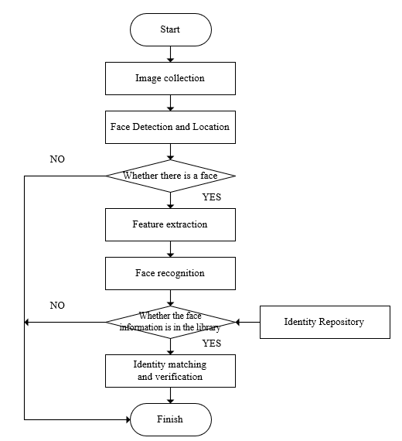

Figure 3. Face recognition principal block diagram.

2.4 The choice of face detection algorithm
Through the face recognition principle and process introduced in the previous chapter, it can be seen that the system first needs a specific understanding of face detection. Face detection is the step stone to all facial analysis algorithms, including face alignment, face modelling, face relighting, face recognition, face verification/authentication, head pose tracking, facial expression tracking/recognition, gender/age recognition, and many more. So, computers can understand the face clearly, after that they begin to truly understand people's thoughts and intentions. Given a digital image, the primary goal of face detection is to determine whether or not there are any faces in the image. This appears as a trivial task for human beings, but it is a very challenging task for computers, and has been one of the top research topics studied in the past few decades. The difficulty associated with face detection can be attributed to many variations in scale, location, orientation (in-plane rotation), pose (out-of-plane rotation), facial expression, lighting conditions, occlusions, etc [30].

There are many methods of face detection, which are roughly divided into feature-based methods, template matching-based methods and statistical learning-based methods. Feature-based methods approaches are based on the extraction of the local features of a face, such as the shapes of the eyes, mouth and nose. These methods suffer from the unpredictability in facial appearance and environmental conditions, e.g., head pose, when a profile image is compared with a frontal image [31]. Template matching-based method is a technique that uses a template to search and find in an image the best match of this template. There are different matching methods to perform the template matching technique. This work uses the Normalized Cross-Correlation method that remains a viable choice for some if not all applications [32]. The disadvantage of this scheme is that it does not have good robustness, and it is difficult to locate dynamic images. This is because the template used in it comes from a human setting. In order to solve this problem, researchers such as A. Yullie designed a detection method. This detection method sets an elastic template to transform various facial organs of the human face and convert each feature into parameters [33]. Since this method is based on global facial features, it has higher accuracy and better reliability, but the disadvantage of this algorithm is that it takes a long time to complete the calculation. The learning-based methods depend on special statistical learning algorithms, such as SVM (Support Vector Machine), Neural Network and Bayesian [34]. It also means that the methods rely on learning algorithms to automatically obtain feature representation from local images, which includes DeCAF, R-CNNa, OverFeata, SPPNeta, Network-in-networka, GoogLeNeta, VGGNeta, DeepID-Neta [35]. Methods based on statistical learning can ensure the stability of detection and have good robustness.

Many face detection algorithms have been introduced above. So how to choose the appropriate algorithm according to the system planned to develop in this dissertation is a key point. For face detection, it is the application of prior knowledge, so that the computer has the ability to recognize faces, non-faces, etc. In the process of designing the face recognition attendance system, there are three main factors affecting the selection of the face detection algorithm:
- Accuracy of face detection. The selected face detection algorithm has a higher accuracy rate.
- Detection of real-time requirements. In order to make the system requirements conform to the actual operation requirements, the selected algorithm has a relatively fast detection speed.
- The computational complexity of facial features. For complex face features, it will affect the detection speed, so the face feature calculation of this algorithm is relatively simple.

Based on the above considerations, this system applies OpenCV's ResNet-SSD algorithm to the face detection implementation part. ResNet (Residual Neural Network) was proposed by four Chinese including Kaiming He from Microsoft Research Institute. By using ResNet Unit, a 152-layer neural network was successfully trained and won the championship in the ILSVRC2015 competition, with an error rate of 3.57% on top5, while the number of parameters is lower than that of VGGNet, the effect is very prominent [36]. SSD, the full name of Single Shot MultiBox Detector, is a target detection algorithm proposed by Wei Liu at ECCV 2016. Up to now, it is one of the main detection frameworks. It has obvious speed advantages compared to Faster RCNN and obvious advantages compared to YOLO. mAP advantage (but has been surpassed by YOLO9000 of CVPR 2017) [37]. The SSD algorithm is a target detection method based on deep learning, which can be applied to face detection. OpenCV began to introduce a face detector based on deep learning after version 3.3, and the current implementation is based on the SSD algorithm. The advantage of choosing this algorithm is that the trained model can be obtained from the OpenCV project on GitHub to achieve real-time and stable detection, and there is no need to retrain the model in many application scenarios. This is a great convenience for developers and saves a lot of time. Moreover, the SSD algorithm works very well in the application of face detection. Although the speed cannot reach the real-time performance of other cascaded detectors, the accuracy and model generalization ability are very ideal.

2.5 The process of feature extraction
After studying face detection, this dissertation performs image pre-processing. After pre-processing the face data input to the recognition network, the quality of the face map can be improved, and the recognition accuracy can be guaranteed after the image quality is improved. So pre-processing is a must for face recognition. There are three common pre-processing methods, one is image grayscale processing, one is histogram equalization processing, and the other is image normalization processing. These processing methods are described below.

Image grayscale refers to the process of grayscale color face image. Color-to-grayscale conversion methods perform dimension reduction operation by typically transforming the RGB tristimulus values ​​(R, G, B) ∈ R3 to intensity values ​​(I) ∈ R1 [38]. The processed image contains only three-channel color information and pixel information. The color and brightness data of the image need to be determined in combination with the three-channel situation. In the process of processing, the color image needs to be calculated. Since the calculation is carried out on different channels, the amount of calculation is very large. In order to simplify the operation process and reduce the operation time, it is necessary to convert the three channels of the image.

Histogram equalization is a method of pre-processing the image. After pre-processing the image by histogram equalization, the quality of the image will be improved by [39]. The main function is to enhance the contrast in the image. All operations are implemented based on image histogram. After the image has high contrast, it can have a clearer performance, and through this method, the brightness on the image can be better distributed. The collection of face images will be carried out in different environments. One of the biggest uncertainties is the illumination. Due to the different illuminations, different image quality effects will be brought about. In some cases, the contrast of the image is insufficient, resulting in insufficient image clarity. In this case, it can be processed in this way, and the processed images can be used for network training.

Image normalization aims at designing face representations with robustness to pose and expression variations [40]. In the process of convolutional neural network training, it is necessary to pay attention to its training time and convergence speed. These two indicators will be affected by many factors. The factors that affect the convergence speed include the activation function and the complexity of the network structure. Of course, different input data will also lead to different convergence rates, mainly due to the distribution of input data. If the input data is distributed at one end of the function or exhibits two-level differentiation, then the network training will have the problem of gradient disappearance. In this case, the network cannot complete the training, or the training time is prolonged. In order to avoid this problem, the data needs to be pre-processed, and the specific method is to control the size of the data within a range of 0 to 1. The normalization method of maximum and minimum is usually used, as shown in the following formula:
$$norm=\frac{x_{i}-m\dot{i}n\left(x\right)}{\max\left(x\right)-\min\left(x\right)}$$
Another normalization method is called Z-score normalization, and the transformation formula is as follows:
$$norm=\frac{x-u}{σ}$$
After processing in this way, the distribution of the data can satisfy a normal distribution with a mean of 0 and a standard deviation of 1.

2.6 The choice of face recognition algorithm
The next step is to choose a suitable face recognition algorithm. First, it needs to understand the classification of face recognition algorithms. Face recognition technology can be traced back to the 18th century, Galton in the “Nature” published an article based on facial information for identification. In the magazine he explored the possibility of using the face as a feature for identification. Later, with the development of computer technology, corresponding face recognition algorithms began to appear. Generally speaking, face recognition algorithms are divided into methods based on geometric features, methods based on subspace analysis, methods based on template matching and methods based on neural networks.

Facial geometric feature-based method is the earliest method to realize face recognition. The specific content and object of this method is mainly based on the human body. It is necessary to describe some set parameters of human facial organs, including the height of the bridge of the nose, some features and sizes of eyes and eyebrows, as well as some set scenes and conditions between some distances (Generally speaking, geometric distance refers to the distance and included angle between feature points) [41]. Different faces have different facial features, which are embodied in the differences in the size, contour, shape and distribution of various organs of the face. Personal characteristic information can be obtained by combining different characteristic information. This method is to identify geometric information in these features as the basic feature points. The distance data between each feature point is combined to obtain the corresponding feature vector. This set of vectors can be compared with the information in the database. Compare and finally complete the identification. The advantage of this method is that the principle is simple, the amount of stored data is not large, and the data is not easily disturbed by the environment. The disadvantage is that various data are greatly affected by human expressions.

The principle of face analysis method based on subspace is to perform certain processing on the image data of the face and then obtain corresponding information in the subspace. The processing method can be nonlinear space transformation or linear space transformation. In this way, the dimensionality reduction process is realized, and finally the separability between classes is highlighted. Researchers such as Sirovich and Kirby first adopted the principal component analysis method in face recognition. This method requires the use of PCA technology to complete the spatial dimensionality reduction processing [42]. The Eigenface technology proposed by Turk and Pentland mentioned above is a typical representative. From a practical point of view, good correlation is still guaranteed between images regardless of lighting. When it comes to PCA, LDA is naturally involved, and this method can achieve intra-class separation while ensuring the maximum dispersion between classes.

The method based on template matching is to compare the image samples to be recognized with all the patterns in the database, and find the method that is most similar to face [43]. It is one of the methods for matching based on face texture, grayscale features, etc. For this method, there are two types of template selection. One is a relatively simple template selection method, that is, the face is regarded as an ellipse, so that the face detection problem is transformed into the problem of ellipse detection in the image. The second is to describe the human face through small templates such as eyes and nose. However, in the process of extracting the above-mentioned small templates, different feature contours must be utilized. However, it is difficult to extract these contours, and the previous edge-based extraction methods are very difficult, which increases the difficulty of extracting corresponding feature points. In order to extract the feature points required for face recognition, people use the elastic template method to extract the features.

The method of face recognition based on neural networks is to apply face recognition to various neural networks. For artificial neural networks, as one of the mathematical models, its characteristics are similar to the brain nerves connected to each other, so it is called a neural network. The neural network has a certain self-learning ability. By inputting different image samples and inputting their corresponding recognition results, the neural network can use the self-learning function to recognize these similar images [44]. The recognition method based on neural networks can obtain laws related to face recognition that cannot be obtained by other recognition, so as to express them invisibly. Convolutional Neural Network (CNN) mostly uses algorithms in image and face recognition. CNN is a kind of artificial neural network that employs convolution methodology to extract the features from the input data to increase the number of features. CNN was first proposed by LeCun and was first applied in handwriting recognition. His network was the origin of much of the recent architecture, and a true inspiration for many scientists in the field. Krizhevsky, Sutskever and Hinton achieved the best results when they published their work in the ImageNet Competition. It is widely regarded as one of the most influential publications in computer vision and showed that CNNs outperform recognition performances compared to handcrafted based methods. With computational power of Graphical Processing Units (GPUs), CNN has achieved remarkable cutting-edge results over a number of areas, including image recognition, scene recognition, semantic segmentation, and edge detection [45].

Many face recognition algorithms have been introduced above. So how to choose the appropriate algorithm according to the system planned to develop in this dissertation is a key point. For face recognition algorithms, there are many types. Combined with specific needs, it can refer to the following factors to select a face recognition algorithm:
- One is the recognition rate. Under the condition that the recognition efficiency is guaranteed, the higher the recognition rate, the better the algorithm.
- The second is the robustness of the algorithm. Because the illumination and so on affect the face image, the robustness of the selected algorithm is better.
- The third is to identify the time. For the recognition time, it and the recognition rate are conflicting definitions. The algorithm with a high recognition rate is more complicated, and its recognition time will be longer.

Based on the above considerations, this system applies OpenFace's open-source Inception-based FaceNet pre-training model to the face detection implementation part. Due to space limitations, the introduction and selection reasons for OpenFace's open-source Inception-based FaceNet algorithm will be elaborated in the later chapter. This section only focuses on why this dissertation chose this algorithm. FaceNet is an algorithm based on neural networks. As mentioned above, Google proposes a face recognition algorithm called FaceNet, and the method of CNN and triplet loss mining is proposed. On the LFW dataset, the accuracy rate is 0.9963, and on the YouTube Faces DB dataset, the accuracy rate is 0.9512. The Model structure of FaceNet is shown in Figure 4:
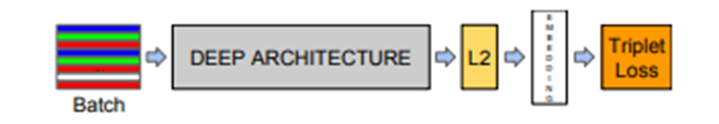

Figure 4. Model structure [26].

FaceNet's network consists of a batch input layer and a deep CNN followed by L2 normalization, which results in the face embedding. Face embedding encodes a face into a 128-dimensional vector, then calculate the distance and use the threshold to determine whether the two face photos belong to the same individual ("Direct" learning of face vectors for distance calculations via Triple Loss). The main idea of FaceNet is to map face images to a multi-dimensional space, and express the similarity of faces through spatial distance. The spatial distance of the same face image is relatively small, and the spatial distance of different face images is relatively large. In this way, face recognition can be realized through spatial mapping of face images. The final result of FaceNet can obtain the feature vector of the face data, and then calculate the Euclidean distance of the feature vector between the two pictures, which can directly represent the difference between the two pictures.

Face recognition can be used for many different applications, but not all face recognition libraries are equal in accuracy and performance, and most state-of-the-art face recognition systems are proprietary black boxes. Perhaps the most prominent is called OpenFace that provides FaceNet models built and trained using the PyTorch deep learning framework [46]. OpenFace is a deep learning facial recognition model developed by Brandon Amos, Bartosz Ludwiczuk, and Mahadev Satyanarayanan. OpenFace is an open-source library that rivals the performance and accuracy of proprietary models. It provides face recognition models with state-of-the-art face recognition accuracy levels equivalent to enterprise-grade ones like Google FaceNet or Facebook DeepFace. In addition to being open source, OpenFace has a special benefit that the development of the model is mainly focused on real-time face recognition on mobile devices, so the model can be trained with high accuracy with very little data [47].

At this point, this dissertation has completed a literature review, analysed face recognition in detail and proved the legitimacy of choosing face recognition. At the same time, the application of the algorithm has also been studied, which has laid the foundation for the specific design below.

3. Methods
This chapter provides some specific methods about: Software Frame and Functional Frame Design of the System; Development tool for class attendance system and Design of Database

3.1 Software Frame and Functional Frame Design of the System
Most of the functions of this system can be completed by relying on ordinary computers, and directly using the camera that comes with the computer to achieve the function of checking students' attendance. Generally speaking, the design architecture of software mainly covers two categories, the multi-layer system structure method and the client-server method.

Many extra-large programs can be divided into several sub-object programs, and each sub-program has its own fixed logic and related functions. Even subroutines can continue to be split to generate a larger number of subroutines with more detailed functions, which are included in higher-level subroutines and appear as a collection of lower-level subroutines. For this kind of program structure, it is generally called a multi-layer system structure. In the program system, the 4-layer structure is the most common, which is divided into the following four layers:
- Business logic layer (also called domain layer)
- Presentation layer (also called UI layer)
- Data access layer (also called persistence layer)
- Application layer (also called service layer)
Application Environment:
- E-commerce web application
- Common desktop applications
It has the following advantages:
- Simple structure, easy to understand and develop;
- The goal is very easy to design, and the program development can be specifically distributed according to the developer's ability, level and the difference of the achievement unit;
- The program system is independent of its subprograms, and each unit and each subprogram can be independently detected, which can easily simulate other units or subprograms, so as to facilitate the debugging of the interface.
Correspondingly, this development method also has its shortcomings:
- The maintainability is not good. If the design background has changed, or there have been a series of changes in functional requirements, it is generally very cumbersome and time-consuming and energy-consuming when it is required to reorganize the materials or make changes to the code.
- The design is poorly functional and very cumbersome. Especially when it is required to adjust a small piece of code, it is often necessary to build and design the entire program again, which makes it difficult to continue the design of software program changes;
- The system upgrade is too complicated. When the corresponding software is required to be upgraded, in some cases, it may be required to temporarily stop all services before configuring;
- The program expansion function is poor. If the user requests a sudden increase, the code must be modified from the relevant functional subprograms step by step. Since each functional module and the corresponding program in the program are interconnected and restricted, the expansion of the entire architecture becomes very difficult.

The client-server model mainly consists of two modules: one module is the main server, and the other module is many sub-clients. In this mode, the response of the server component comes from the request of each client component, and provides corresponding services based on different requirements, and the server can complete the monitoring, communication and processing of corresponding service applications of many clients at the same time. Application Environment:
- Insurance and financial online applications, email clients, real-time pages, and Internet data sharing carriers.
- Application of mobile APP and other applications
- Use of online programs, etc.

This client-server architecture is commonly referred to as a cloud architecture. Since the multi-layer structure has defects in program concurrency and program expansion, the cloud structure can handle it effectively. It has huge advantages in scalability. The key point is that the information obtained from the cloud structure is stored in a memory information module that can be copied and stored in the system. Since the central information base in the multi-layer structure is not used during storage, the impact on the scalability is avoided, and the scalability of the program is greatly increased. In addition, the processing units with special functions are encapsulated into specific processing units. When functions need to be added, new processing units are re-established; when they need to be reduced, the extra processing units are removed.

The software of this system is more focused on the application of multi-layer system structure. At the same time, some database and model update access operations adopt the client-server mode, which will be better. Therefore, in software design, this system combines the advantages of two aspects. The architecture design of this system is shown in Figure 5, which is divided into UI operation layer, application function layer, internal logic layer and data interface layer.
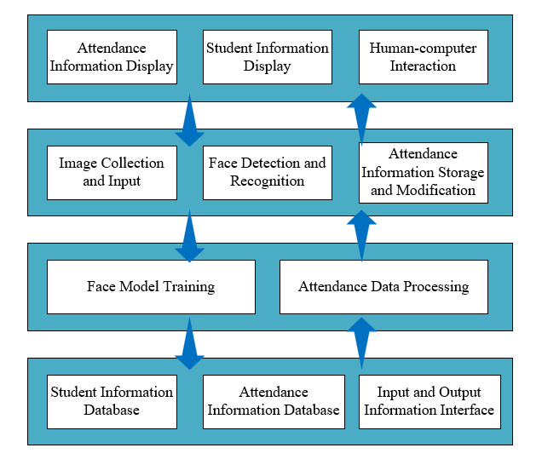

Figure 5. Structure frame diagram.

As can be seen from Figure 5, the UI operation layer is used to display student information and attendance information, while providing a concise human-computer interaction interface. The application function layer is responsible for completing the operations of interacting with users, such as image acquisition, face detection and recognition, and storage and modification of attendance information. The internal logic layer is the background of the system, which is mainly responsible for the training of the model and the processing of attendance data, completing the business logic, and realizing the bridge between the user and the database. The database interface layer provides storage services for student information and attendance information, and provides corresponding interfaces. The functions of the class attendance system designed by this dissertation mainly cover the following aspects: (1) Input of face information and basic information. Collect face images of students, and enter basic information such as name, gender, class, birthday, etc. into the database. (2) The operation of the administrator. Administrators can not only add new students, but also view the personal information and attendance records of all students, and can add, modify, and delete basic user information. (3) Data training module. When initializing the system or entering a new face, the face image is trained through the FaceNet network model to complete the registration of student face information. (4) Reading of attendance records. After the model is trained, the administrator can perform attendance operations. After that, the main interface will display the student's attendance status.

3.2 Development tool for class attendance system
- Python
Python is one of the top 3 most popular and fastest growing programming languages today. It is a multipurpose, high-level, object-oriented, interactive, interpreted and very user-friendly programming language. The most important advantages of Python for this dissertation are:
- Python is open source and free. Open source, also known as open source, means that all users can see the source code. Users use Python to develop or publish their own programs without paying any fees or worrying about copyright issues. Even for commercial use, Python is free.
- Interactive mode is a feature of the Python shell that provides immediate feedback on every statement a developer enters on the console. Python has a simple coding style that is easy to capture with a little knowledge and the right tools.
- More importantly, many libraries and software depend on python, and even many algorithms and models can only be run with python-based packages.

Based on the above reasons, the class attendance system designed by this dissertation is developed in python language.
- Computer Vision Library OpenCV
OpenCV (Open-Source Computer Vision Library) is an open-source computer vision library that can be used for computer vision, machine learning and other graphics processing algorithm implementation. It is released under the BSD license, so it can be used completely free for academic research and commercial environments, so that customers can easily apply to their own product requirements and rewrite the code to achieve the corresponding functions. It has Java, C++ and Python interfaces, and provides support for iOS, Android, Windows, MacOS and Linux system environments. OpenCV has huge uses in face recognition, image recognition and other fields, so its application is very common.
- PyQT interface design
Commonly used GUI (graphical operation interface) based on python language mainly include: Tkinter that comes with the python toolkit, PyQT tool that includes QT, and wxPython tool that includes wxWidgets. Tkinter belongs to a part of python, calls the TCL/TK interface, and is a cross-platform script GUI. Its advantage is that it is friendly to python and has a good adaptability to cross-platform operation. The disadvantage is that the support for documentation is not good enough, the update efficiency of the version is low, and the maintainability is poor. wxPython is an excellent GUI graphics library under the Python language. It has the advantages of a complete functional system and very good support for python. However, its interface calls are very complicated and the performance of the windows system is not good. PyQT is also a QT packaging tool for python. The functions and classes are quite sufficient. Based on the support of QT, the operation and design of the interface are roughly the same as those of QT. In terms of GUI design, this system chooses to use PyQT, which is friendly to python and has rich documentation, for GUI design, and uses the easy-to-use Qt Designer tool for interface design.

3.3 Design of Database
Databases commonly used on desktops and mobile applications include MySQL, SQLite, SQL server and other databases. MySQL is one of the most common open-source free relational databases, with a very fast access rate, capable of supporting multi-client multi-threaded operations, and capable of accommodating large amounts of data. The disadvantage is that there is no stored program function, and the use of the default IP port is prone to security risks, and it cannot provide transaction, sub-lookup, and view functions. SQLite is a lightweight database system, similar to Access. In application, SQLite has no limited use, and is a truly free database. Compared with MySQL, it is more lightweight, has almost no configuration cost, and is easy to maintain. The disadvantage is that the concurrency is not high, the performance is not good when the amount of data is relatively large, and the writing speed is slow. Due to MySQL is a kind of relational database management system, which is a very popular database at present. It improves the efficiency of data management by storing information in various tables. In addition, MySQL also includes interfaces of various programming languages such as Java, Python, C++, and C, which can facilitate and reasonably manage and query information. The system chooses the widely used MySQL database as the storage system for student information and attendance records to complete various complicated storage tasks. After the student's attendance data is punched through the face recognition attendance system, the obtained student attendance date, location and attendance status are entered, and then the obtained information is stored in the database. In addition to MySQL, Navicat for MySQL, a visual database management tool, is also used in this system to manage the database, so that users can understand the relationship between data and the positioning of content more clearly and conveniently. The information stored in the database is stored in two ways:
- The first is the basic information of the student, covering ID, name, class, gender, birthday and other information. Among them, the ID is the most important, because the query statement is the function of retrieving personal information through the ID keyword. This information usually does not change and is stored in the database for a long time. The storage format is shown in Table 2:
ID | Name | Class | Sex | Birthday
10 | MESSI | 2022001 | Male | 19870624
11 | CR7 | 2022001 | Male | 19850205
12 | HAN | 2022002 | Male | 19990202
Table 2. Student personal information storage format.

- The second category is attendance information, which mainly includes information such as ID, name, time, class, and attendance status. Among them, Description shows the specific situation of student attendance. According to the attendance time set by the user, it is divided into three cases: absenteeism, late and normal. The storage format is shown in Table 3:
ID | Name | Class | Time | Description
12 | HAN | 2022002 | 2022-09-03 14:36:09 | Absenteeism
12 | HAN | 2022002 | 2022-09-03 19:55:18 | Normal
12 | HAN | 2022002 | 2022-09-03 20:54:46 | Late
Table 3. Attendance information record storage format.

At this point, this dissertation has completed the introduction of Methods and analysed the design basis of the system in detail. It lays the foundation for the specific design below.

4. Design and Implementation
This chapter provides some focused and critical opinions about: The face recognition process used in this system; Implementation of face recognition and System test.

4.1 The face recognition process used in this system
The system designed by this dissertation refers to the project in GitHub: https://github.com/datamonday/Face-Recognition-Class-Attendance-System. It is developed on the basis of this project, and the program code and actual functions have been modified.

The main part of the face recognition attendance system designed in this dissertation is completed by the scheme of OpenCV+ResNet+FaceNet+MySQL. First, use OpenCV to open the camera, detect the face in real time, and then apply the ResNet face detection algorithm to find the face coordinates. Then the face correction algorithm is applied to correct the face. Then use the face recognition algorithm FaceNet to perform feature extraction on pure face images to realize face recognition. Then use SVM to implement the classification task of 128-dimensional vectors of each face. Finally, the MySQL database is used to manage the information to achieve a complete attendance effect.

As mentioned above, this system uses the OpenCV's ResNet-SSD algorithm. The backbone network of the SSD face detector implemented by OpenCV is ResNet-10, which currently provides two trained models, one based on the deep learning framework Caffe training, and the other based on TensorFlow training.

Both Caffe and TensorFlow are deep learning training frameworks. Caffe is an efficient and high-performance deep learning framework that has been widely used by researchers around the world. Its developer is Jia Yangqing, a well-known scholar who graduated from UC Berkely and is now employed by Google. Caffe effectively used fast convolutional networks in MATLAB, and then transferred it to platforms such as C, C++, etc. Caffe is suitable for deep learning research, especially for image processing. But with audio, time series related fields such as information category and text, but it is not very good. In addition, Caffe chose the Python language as its application programming interface. The specific advantages of Caffe are reflected in:
- Adapt to image processing and feedforward networks;
- Adapt to fine-tuning the existing network;
- The model can be trained without writing code;
- The Python-based interface is very friendly.
Its defects are as follows:
- It requires writing a new GPU layer, which will use C++/CUDA;
- It does not apply to recurrent networks;
- It cannot be expanded, and the structure is more complicated;
- Not available for commercial support;
- Poor support for text-to-speech models.

TensorFlow is an open-source machine learning library that is used in various types of machine learning, especially in perception targets and semantic understanding of languages. It was developed by Google Brain and became open source in November 2015. TensorFlow will form the corresponding operation graph, and can achieve the purpose of automatic derivation. Automatic derivation has far-reaching significance, that is, it is more convenient to directly carry out the calculation and deduction of the backpropagation network. In addition, in Google's software ecosystem, such operational graphs can also be used in the high-intensity computing of Google Brain. In Google's deep learning solution, TensorFlow is considered an important component. TensorFlow has huge advantages:
- Computational graph abstraction;
- The compilation time is short;
- Visualization adopts Tensor Board;
- Excellent overall architecture and high code quality;
- Supports deep model and data parallelism.
Its defects:
- Compared with other frameworks, the speed is slower;
- When the training batch is reloaded, it will jump, jump from C/C++ to Python and then jump back, resulting in time-consuming;
- It is difficult to implement tooling;
- In large software projects, dynamic types are more prone to errors.

Combining the advantages and disadvantages of the above two frameworks, the system designed in this dissertation uses the model trained by the deep learning framework Caffe. Because Caffe is suitable for processing images and Caffe chooses Python language as its application programming interface, and this system is developed using python language. The running speed of TensorFlow is relatively slow and does not meet the above requirements for the face detection algorithm. In the actual face recognition process, the process of face detection will be directly presented in the following Implement.

After designing face detection, the system mainly focuses on designing the face recognition algorithm. In the previous chapter, this dissertation briefly introduced OpenFace's open-source Inception-based FaceNet algorithm. On this basis, it is necessary to study this algorithm clearly for better practical development. OpenFace's project structure is proposed in the paper written by the designer: OpenFace: A general-purpose face recognition library with mobile applications. It is based on the above article FaceNet: A Unified Embedding for Face Recognition and Clustering, as shown in Figure 6:
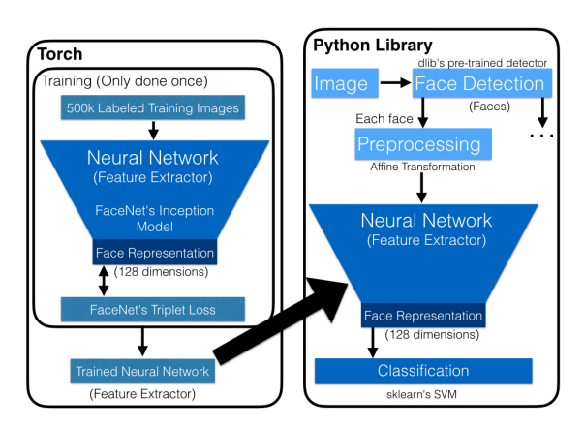

Figure 6. OpenFace’s project structure [46].

This system provides great accuracy with quick training and prediction times; therefore, the paper also employs OpenCV for computer vision primitives. A collection of bounding boxes around the faces in an image—which may be in various positions and lighting situations—is returned by the face detection component. Faces may be looking in different directions or under varying lighting conditions, which could be a problem if the bounding boxes are used as the neural network's only input. With a large training dataset, FaceNet is able to manage this, but for its smaller dataset, a heuristic is to shrink the input space by normalizing the faces such that their eyes, noses, and mouths appear in comparable places in each image. A current area of study in computer vision is face normalization. Many contemporary methods, like DeepFace, convert the face into a 3D model to give the impression that the face is staring directly at the camera. To align the eyes and nose for the neural network input, OpenFace uses a straightforward 2D affine transformation. Figure 7 demonstrates the normalization of faces by the affine transformation:
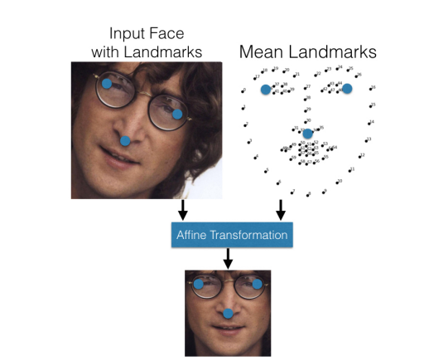

Figure 7. OpenFace’s affine transformation [46].

As shown in Figure 7, the transformation is based on large blue landmarks. The system gives an input face, the affine transformation makes the eye corners and nose close to the mean locations. The affine transformation also resizes and crops the image to the edges of the landmarks so the input image to the neural network is 96 × 96 pixels.

Once the faces are affine transformed by OpenCV, all faces are pointing in the same direction, they are fed into a trained neural network for one forward pass. That is to say, the system uses the pre-trained FaceNet face recognition model to generate the Embedding vector. Because the amount of data is small, the system directly puts the Embedding of all the pictures into an array. The system is then used to feed the images into a neural network trained on Torch. In this step, a single forward pass is performed on the neural network to obtain a 128-dimensional representation (facial features) for prediction. OpenFace uses FaceNet’s triplet loss as defined in above chapter so the network provides an embedding on the unit hypersphere and Euclidean distance represents similarity. These low-dimensional face representations are then used for classification or clustering.

The system can then proceed to apply the face recognition algorithm. First load the face embedding and encode the labels. The model for accepting face 128-d embeddings is then trained, which then produces the actual face recognition. Finally write the actual face recognition model to disk and send the label encoder to disk.

Therefore, the support vector machine (SVM) is used in this system to realize the task of classifying 128-dimensional vectors of each face. In OpenFace’s article, OpenFace classification uses a linear SVM with a regularization weight of 1, which consistently performs the same or better than other regularization weights. In this dissertation, system uses SVM for face recognition because SVM is implemented using the SVC API provided by scikit-learn, and this example conforms to this feature.

4.2 Implementation of face recognition
For the attendance system of face recognition, the function of face detection needs to be completed first. In the methods of the previous chapter, it was mentioned that the ResNet-SSD pre-training model provided by OpenCV should be used to complete the detection. And the model has been selected as a model trained based on the deep learning framework Caffe. Then it need to get the model file and configuration file first, and the system loads the serialized face detector directly from the disk. Then loop the frames from the video file stream and grab the frames directly from the threaded video stream. Then load the image through OpenCV's detector, resize the frame to make it 900 pixels wide (while maintaining the aspect ratio), and grab the image dimensions. A blob is then constructed from the image, scaled to a 300 x 300 x 3-pixel image, which is to fit the ResNet-SSD input size. OpenCV's deep learning-based face detector is then applied to locate faces in the input image. Make sure to find at least one face, and compute the (x,y) coordinates of the face bounding box. Extract the face ROI and get the ROI dimensions, construct a blob for the face ROI, and then pass the blob through the face embedding model to obtain a 128-d quantification of the face. Finally passed to ResNet-SSD to detect faces. After completing these operations, the system will initialize a list, adding the person's name and the corresponding face embedding to their respective lists to save the recognized faces. Part of the code is as follows:
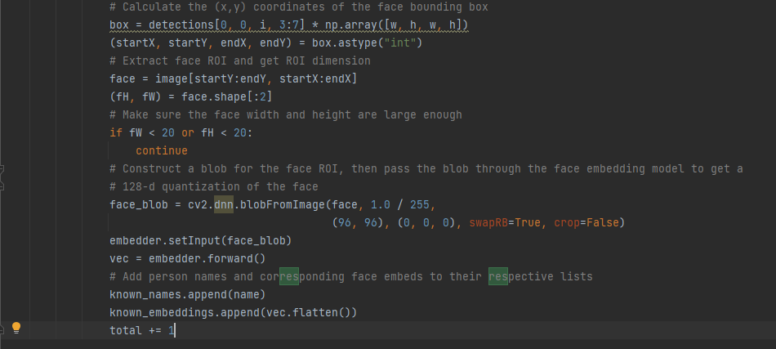

Figure 8. Face detection part of the code.

After the face is detected, it enters the face recognition link, that is, how to distinguish and identify various face images. When training the classifier, it is required to use a certain number of images as the training set to train the classifier. A good training set should cover all kinds of situations where faces change. For example, if only positive faces (like diploma images) need to be recognized, then only the training set images need to have positive faces. When the face in the image to be recognized is upward or sideways, it is necessary to ensure that there are also face images in the training set with similar situations, otherwise the face recognition algorithm may be difficult to complete the recognition of such face images. Again, this applies to other situations, such as facial expressions (faces in the training set Always with a smile, while the face in the test set does not smile) or the direction of the light (the bright light is on the left side of the face in the test set, but on the right side in the training set), in such cases, the face Recognition algorithms will be difficult to implement. The face pre-processing will reduce the impact of these aspects, but it cannot be completely avoided. Especially when the face orientations are not the same. Because the face orientations in the image are different, the positioning of all the feature points in the face will be quite different, which further increases the difficulty of face recognition.

After completing face detection, the system assumes that each image has only one face and finds the bounding box with the highest probability. Then calculate the (x,y) coordinates of the face bounding box and extract the face ROI and get the ROI dimension. A blob is then constructed for the face ROI, which is passed through the face embedding model to obtain a 128-d quantification of the face. Train a model to accept face 128-d embeddings, which then produce actual face recognition. Finally write the actual face recognition model to disk and send the label encoder to disk. Part of the code is as follows:
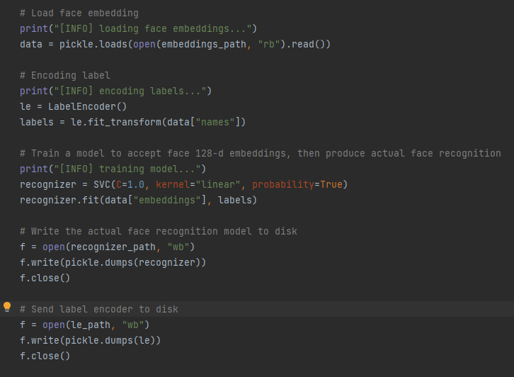

Figure 9. Face recognition part of the code.

Finally, the system uses SVM to classify the face vectors. Where prediction is a vector, the first dimension of its shape is the number of IDs in the face database, and returns a list of classification probabilities. Take the index with the highest probability and get the predicted probability. Then find the person's name (ID) through the index j and convert it to the real name before one-hot encoding, that is, the folder name of the face dataset, that is, the value of the ID field in the database. Then count the number of times each face is detected. And draw the bounding box of the face along with the associated probabilities. Finally construct the face bounding box and display the output frame.

4.3 System test
Before the official use of the class face recognition attendance system, it is necessary to carry out specific tests on the functional units of the system, so as to find out the problems existing in each part of the unit during the use process, and correct them as soon as possible to improve the performance of the system. The functional module test of the whole system mainly includes the test of two modules, the student's personal information collection module and the attendance module.
- Student Personal Information Collection Module Test. Test the function of updating faces and other information of new students, whether the operation results of input interface and collecting face and student information are accurate, etc. The test results are shown in Table 4:
Test session | Expected output | Actual results
Access the Face Recognition Information Collect interface | Display the Face Recognition Information Collect interface | The test results match the design requirements
Click the "Start Collect" button to collect students' faces | Display live image and start recording | The test results match the design requirements
Inquire about the basic information of students based on students’ ID | Display the basic information of students | The test results match the design requirements
Inquire about the face count of students based on students’ ID | Display the face count of students | The test results match the design requirements
Modify the basic information of students | Display the basic information of the modified student | The test results match the design requirements

Table 4. Student personal information collection module test.

- Attendance module. Perform face recognition attendance on students to test whether the recognition results are accurate and whether the attendance information of students can be displayed normally. The test results are shown in Table 3:
Test session | Expected output | Actual results
Access the main interface | Display the main interface | The test results match the design requirements
Query the initial attendance information of students | Display the initial attendance information of students (all leave and don’t real arrive status) | The test results match the design requirements
Train and load the model | Display the training process on PyCharm to prove that the model is successfully trained | The test results match the design requirements
Turn on the camera, set attendance time and start attendance | Display Tips: Attendance Success | The test results match the design requirements
Perform face recognition | Dynamically display face recognition accuracy on the camera's interface | The test results match the design requirements
Make the attendance status normal attendance by setting the attendance time | The number of people actually arrived in the upper right corner has changed from 0 to 1, and the Leave status bar in the middle right has no sign-in name. | The test results match the design requirements
Make the attendance status late attendance by setting the attendance time | The number of people actually arrived in the upper right corner has changed from 0 to 1, the Leave status bar in the middle right d has no sign-in name, and the name of the sign-in appears in the Late status bar. | The test results match the design requirements
Make the attendance status absenteeism attendance by setting the attendance time | The number of people actually arrived in the upper right corner has changed from 0 to 1. | The test results match the design requirements

Table 5. Attendance module test (main interface).

5. Results and Evaluation
This chapter provides some specific methods about: System operating interface; Discussion on face recognition result; Evaluation on System Implementation Process and Future enhancement.

5.1 System operating interface
Enter the main interface of the system, the main interface is shown in Figure 10:
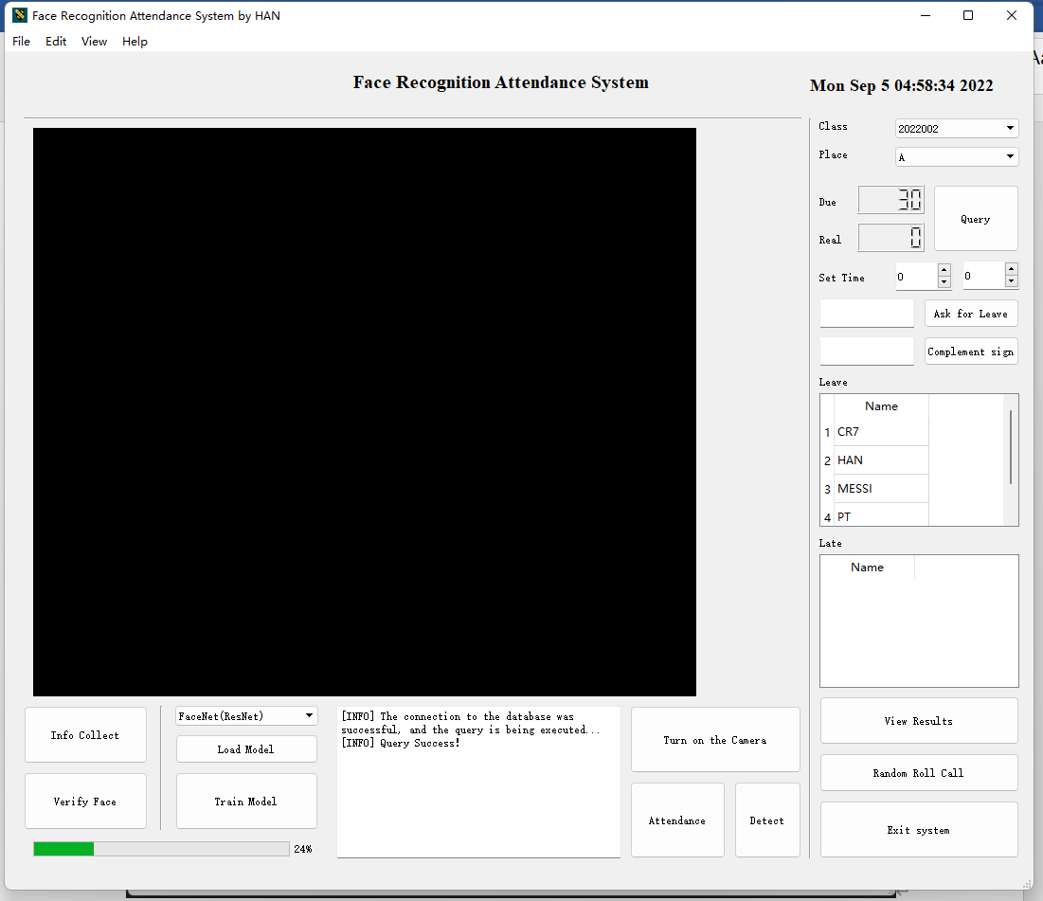

Figure 10. System main interface.

As can be seen from the Figure 10, on the main interface, users can realize some functions by clicking buttons, such as displaying the current attendance status of all students. Then, the user first performs the student's information entry operation. Click the "Info Collect" button on the interface to log in to the student personal information entry page, which is shown in Figure 11.
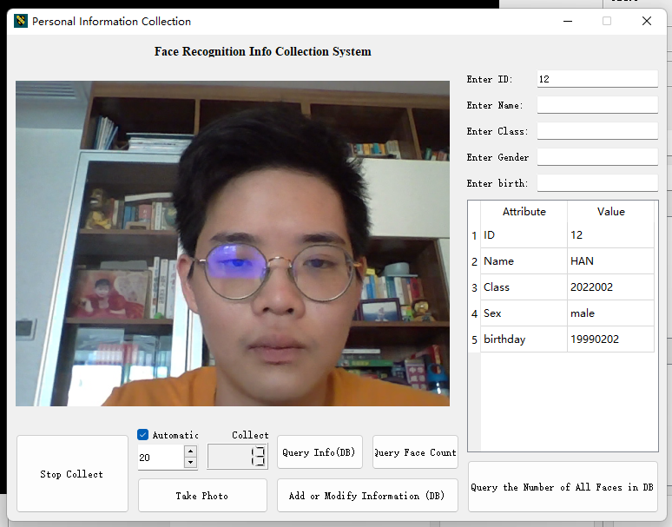

Figure 11. Students’ personal information collection.

As shown in Figure 11, face information can be collected by taking pictures on this page. First click the "Take Photo" button, the camera will automatically open to capture student pictures, and save the pictures in a local folder. In addition, users can also query and modify students' personal information and face information on this page.

After completing the information collection, return to the main interface. The user can click the "Train Model" button to retrain the face recognition model, and click the "Load Model" button to apply the trained model, as shown in Figure 12:
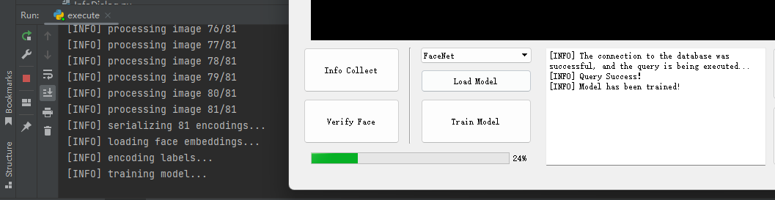

Figure 12. Train and Load Model.

As can be seen from Figure 12, the newly trained face recognition model is obtained by serializing 83 images. Among them, there are 81 newly entered faces. After the model is loaded, face recognition and attendance functions can be performed. First click the "Turn on the camera" button, align the face with the camera, and the recognized face will be automatically framed. Then set the attendance time and click the "Attendance" button to start face recognition, which is shown in Figure 13.
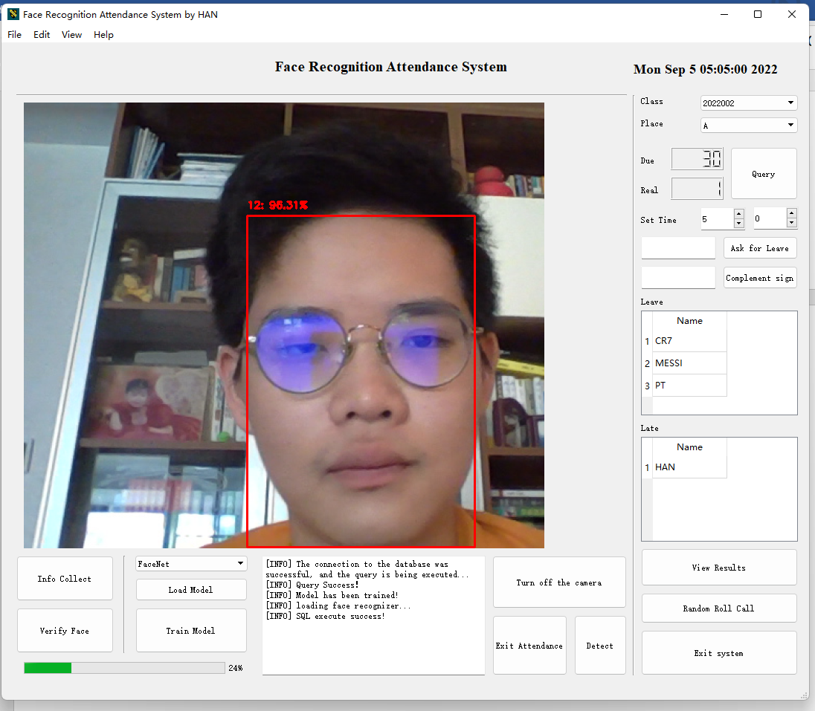

Figure 13. The main interface after completing the attendance.

The main interface after completing the attendance is shown in Figure 13, in which the face recognition screen dynamically displays the matching accuracy. In the application of the newly trained face recognition model, the accuracy rate given by the system is about 95%. The attendance status of students is determined by the attendance time set before attendance. The figure shows the late state, and the student has changed from the Leave list to the Late list. At the same time, the number of responders at the top has changed from 0 to 1, which means that the student's attendance is successful. Other cases will be described in detail in the following system test chapters.

5.2 Discussion on face recognition result
The system can observe the dynamic face recognition accuracy rate on the main interface after completing the attendance. In the model designed above, the system collected 83 pictures, of which 81 were the identified person. When looking at the screen at a good angle, the accuracy rate can stabilize to more than 95% after a period of observation. This is basically close to the accuracy (95.12%) of the FaceNet algorithm introduced in the previous Literature Review in YouTube Faces and DB datasets. It proves that the system has a good effect on the accuracy of face recognition. A combination of ResNet-SSD as a face detection method and FaceNet as a face recognition method is feasible. And other functions of the system design, such as attendance management and student information management, the function realization of this system has all met expectations.

However, when the angle of the face looking at the screen is not so ideal or even when the face does not completely appear on the screen, the accuracy rate will begin to drop, and the lowest will drop to about 90%. Therefore, when the actual user asks the students to face the camera, they should straighten the orientation of the camera, and try to capture images in an environment with better light conditions. When the position and size of the face displayed in the real-time detection screen of the camera window are correct and the image is clear, it is better to take several pictures from different angles when taking pictures. Increase the change of face details and illumination level, which can improve the quality of the data set, improve the robustness of the training model, and prevent subtle changes in the face that the model cannot recognize.

Overall, the design of the system is what I expected, and I am also excited and satisfied with the functionality it implements. Of course, there is still a lot of room for improvement in this system. If I can do it again, I will add some features to make the system more attractive.

5.3 Evaluation on System Implementation Process
The core of the class face recognition attendance system designed by this dissertation is face recognition technology. The face recognition algorithm used by FaceNet for this dissertation was determined at the beginning. However, in the actual operation of the programming project, it is found that the generalized FaceNet framework is not fully suitable for class face recognition. In other words, the direct application of FaceNet is not cost-effective. In this case, the OpenFace open-source Inception-based FaceNet algorithm was finally used in the project. It provides pre-trained models that can be trained directly in the system, and provides ideas that are more suitable for the purpose of this system than the original FaceNet. Therefore, after modifying the algorithm, the actual process of system face recognition is greatly simplified.

In general, this dissertation's algorithm modification is good and has merits. Because the algorithm of OpenFace itself is based on the FaceNet algorithm, but some fine-tuning is carried out on the basis of FaceNet. This means that the entire face recognition process is not affected, which can be verified in the ideas of the methods above. Then, the decision to choose OpenFace's open-source Inception-based FaceNet algorithm as the core part of face recognition is basically correct.

6. Conclusion and Recommendations

6.1 Summary of the dissertation
Attendance is indispensable in the school's human affairs, and the use of face recognition technology to help classroom managers with attendance has unique technical advantages. Although face recognition technology is widely used, computer recognition of faces will be affected by many external factors, which makes face recognition technology a hugely challenging research direction.

With face recognition technology as the core, this paper designs and implements a face recognition attendance system for classroom use. The article first analyses the research overview of face recognition, and analyses the rationality and efficiency of using the face recognition attendance system in view of the problems existing in the traditional attendance management system. Analysed the related technologies of face recognition, designed the corresponding implementation plan, clarified the software framework and functional modules of the attendance system based on face recognition technology, and finally realized the interface design and function of the attendance system based on face recognition. The system achieves the purpose of detecting and identifying faces and recording attendance records. It can identify the identity information of students, then record and count the attendance of students, and can complete the entry and modification of student information, as well as the query and statistics of attendance information.

The main part of the face recognition attendance system designed in this dissertation is completed by the scheme of OpenCV+ResNet+FaceNet+MySQL. First, use OpenCV to open the camera, detect the face in real time, and then apply the ResNet face detection algorithm to find the face coordinates. Then the face correction algorithm is applied to correct the face. Then use the face recognition algorithm FaceNet to perform feature extraction on pure face images to realize face recognition. Then use SVM to implement the classification task of 128- dimensional vectors of each face. Finally, the MySQL database is used to manage the information to achieve a complete attendance effect. In addition, the system covers the following technologies:
- MySQL database is used to store student data and attendance information;
- The ResNet-SSD pre-training model provided by OpenCV is used for face detection;
- OpenFace open-source Inception-based FaceNet pre-training model for face recognition;
- Python and PyQT as programming and GUI design platform tools.

6.2 Future enhancement
Because a large number of camera devices (especially fewer in attendance) are not RGBD cameras with depth-of-field information, it is impossible to determine whether the current face image is a real person or a human face. The original intention of this system was to design a function to verify the face, and to verify whether the recognized person is a real person by blinking or shaking his head. However, due to the time factor, the system does not have enough time to develop a complete and adaptable functional module of the system. My ability and energy are limited, so I did not realize this part of the expected function. But in my free time in the future, I still taste positively and heartily to realize the original intention.

In addition, the software interface design of this system is simplistic and the functions are not perfect. In addition, the face detection speed algorithm in the attendance module is not fast enough, and can only achieve single-person recognition. Based on the above situation, in the future work, this system strives to optimize the GUI page design and enrich the functions of the attendance system. It is also necessary to improve the recognition efficiency and realize the attendance of multiple people at the same time.

7. Reference list
[1] A. Jain, L. Hong, and S. Pankanti, "Biometric identification," Communications of the ACM, vol. 43, no. 2, pp. 90-98, 2000.

[2] J. Unar, W. C. Seng, and A. Abbasi, "A review of biometric technology along with trends and prospects," Pattern recognition, vol. 47, no. 8, pp. 2673-2688, 2014

[3] K. Delac and M. Grgic, "A survey of biometric recognition methods," in Proceedings. Elmar-2004. 46th International Symposium on Electronics in Marine, 2004: IEEE, pp. 184-193.

[4] R. Jafri and H. R. Arabnia, "A survey of face recognition techniques," journal of information processing systems, vol. 5, no. 2, pp. 41-68, 2009.

[5] A. K. Jain, A. Ross, and S. Prabhakar, "An introduction to biometric recognition," IEEE Transactions on circuits and systems for video technology, vol. 14, no. 1, pp. 4-20, 2004.

[6] E. Rekha and P. Ramaprasad, "An efficient automated attendance management system based on Eigen Face recognition," in 2017 7th International Conference on Cloud Computing, Data Science & Engineering-Confluence, 2017: IEEE, pp. 605-608.

[7] U. A. Patel and S. Priya, "Development of a student attendance management system using RFID and face recognition: a review," International Journal of Advance Research in Computer Science and Management Studies, vol. 2, no. 8, pp. 109-119, 2014.

[8] S. Dargan and M. Kumar, "A comprehensive survey on the biometric recognition systems based on physiological and behavioral modalities," Expert Systems with Applications, vol. 143, p. 113114, 2020.

[9] M. Taskiran, N. Kahraman, and C. E. Erdem, "Face recognition: Past, present and future (a review)," Digital Signal Processing, vol. 106, p. 102809, 2020.

[10] R. Saini and N. Rana, "Comparison of various biometric methods," International Journal of Advances in Science and Technology, vol. 2, no. 1, pp. 24-30, 2014.

[11] X. Zhang and Y. Gao, "Face recognition across pose: A review," Pattern recognition, vol. 42, no. 11, pp. 2876-2896, 2009.

[12] R. Jafri and H. R. Arabnia, "A survey of face recognition techniques," journal of information processing systems, vol. 5, no. 2, pp. 41-68, 2009.

[13] T. Sabhanayagam, V. P. Venkatesan, and K. Senthamaraikannan, "A comprehensive survey on various biometric systems," International Journal of Applied Engineering Research, vol. 13, no. 5, pp. 2276-2297, 2018.

[14] M. Kassim, H. Mazlan, N. Zaini, and M. K. Salleh, "Web-based student attendance system using RFID technology," in 2012 IEEE Control and System Graduate Research Colloquium, 2012: IEEE, pp. 213-218.

[15] O. A. R. Salim, R. F. Olanrewaju, and W. A. Balogun, "Class attendance management system using face recognition," in 2018 7th International conference on computer and communication engineering (ICCCE), 2018: IEEE, pp. 93-98.

[16] S. Lukas, A. R. Mitra, R. I. Desanti, and D. Krisnadi, "Student attendance system in classroom using face recognition technique," in 2016 International Conference on Information and Communication Technology Convergence (ICTC), 2016: IEEE, pp. 1032-1035.

[17] B. Moghaddam, T. Jebara, and A. Pentland, "Bayesian face recognition," Pattern recognition, vol. 33, no. 11, pp. 1771-1782, 2000.

[18] R. Brunelli and T. Poggio, "Face recognition through geometrical features," in European Conference on Computer Vision, 1992: Springer, pp. 792-800.

[19] C. Liu, "Gabor-based kernel PCA with fractional power polynomial models for face recognition," IEEE transactions on pattern analysis and machine intelligence, vol. 26, no. 5, pp. 572-581, 2004.

[20] A. K. Jain, B. Klare, and U. Park, "Face recognition: Some challenges in forensics," in 2011 IEEE International Conference on Automatic Face & Gesture Recognition (FG), 2011: IEEE, pp. 726-733.

[21] I. Adjabi, A. Ouahabi, A. Benzaoui, and A. Taleb-Ahmed, "Past, present, and future of face recognition: A review," Electronics, vol. 9, no. 8, p. 1188, 2020.

[22] B. RichardWebster, S. Y. Kwon, C. Clarizio, S. E. Anthony, and W. J. Scheirer, "Visual psychophysics for making face recognition algorithms more explainable," in Proceedings of the European conference on computer vision (ECCV), 2018, pp. 252-270.

[23] L. Stark, "Facial recognition is the plutonium of AI," XRDS: Crossroads, The ACM Magazine for Students, vol. 25, no. 3, pp. 50-55, 2019.

[24] V. Mohanty, D. Thames, S. Mehta, and K. Luther, "Photo sleuth: Combining human expertise and face recognition to identify historical portraits," in Proceedings of the 24th International Conference on Intelligent User Interfaces, 2019, pp. 547-557.

[25] H. Tiwari, S. Goyal, R. Agrawal, and M. Pawar, "Live Attendance System via Face Recognition," International Journal for Research in Applied Science & Engineering Technology (IJRASET) Volume, vol. 6, 2018.

[26] F. Schroff, D. Kalenichenko, and J. Philbin, "Facenet: A unified embedding for face recognition and clustering," in Proceedings of the IEEE conference on computer vision and pattern recognition, 2015, pp. 815-823.

[27] L. Li, X. Mu, S. Li, and H. Peng, "A review of face recognition technology," IEEE access, vol. 8, pp. 139110-139120, 2020.

[28] Y. Kortli, M. Jridi, A. Al Falou, and M. Atri, "Face recognition systems: A survey," Sensors, vol. 20, no. 2, p. 342, 2020.

[29] M. O. Oloyede, G. P. Hancke, and H. C. Myburgh, "A review on face recognition systems: recent approaches and challenges," Multimedia Tools and Applications, vol. 79, no. 37, pp. 27891-27922, 2020.

[30] A. Kumar, A. Kaur, and M. Kumar, "Face detection techniques: a review," Artificial Intelligence Review, vol. 52, no. 2, pp. 927-948, 2019.

[31] N. A. Shnain, Z. M. Hussain, and S. F. Lu, "A feature-based structural measure: an image similarity measure for face recognition," Applied Sciences, vol. 7, no. 8, p. 786, 2017.

[32] R. F. Ribeiro, J. M. Fernandes, and A. J. Neves, "Face detection on infrared thermal image," Signal, p. 45, 2017.

[33] A. L. Yuille, "Deformable templates for face recognition," Journal of cognitive neuroscience, vol. 3, no. 1, pp. 59-70, 1991.

[34] J. Yan, X. Zhang, Z. Lei, and S. Z. Li, "Face detection by structural models," Image and Vision Computing, vol. 32, no. 10, pp. 790-799, 2014.

[35] Y. Li, S. Wang, Q. Tian, and X. Ding, "Feature representation for statistical-learning-based object detection: A review," Pattern Recognition, vol. 48, no. 11, pp. 3542-3559, 2015.

[36] K. He, X. Zhang, S. Ren, and J. Sun, "Identity mappings in deep residual networks," in European conference on computer vision, 2016: Springer, pp. 630-645.

[37] W. Liu et al., "Ssd: Single shot multibox detector," in European conference on computer vision, 2016: Springer, pp. 21-37.

[38] A. Güneş, H. Kalkan, and E. Durmuş, "Optimizing the color-to-grayscale conversion for image classification," Signal, Image and Video Processing, vol. 10, no. 5, pp. 853-860, 2016.

[39] G. Yue and L. Lu, "Face recognition based on histogram equalization and convolution neural network," in 2018 10th International Conference on Intelligent Human-Machine Systems and Cybernetics (IHMSC), 2018, vol. 1: IEEE, pp. 336-339.

[40] X. Zhu, Z. Lei, J. Yan, D. Yi, and S. Z. Li, "High-fidelity pose and expression normalization for face recognition in the wild," in Proceedings of the IEEE conference on computer vision and pattern recognition, 2015, pp. 787-796.

[41] H. Wang and L. Guo, "Research on face recognition based on deep learning," in 2021 3rd International Conference on Artificial Intelligence and Advanced Manufacture (AIAM), 2021: IEEE, pp. 540-546.

[42] L. Sirovich and M. Kirby, "Low-dimensional procedure for the characterization of human faces," Josa a, vol. 4, no. 3, pp. 519-524, 1987.

[43] I. William, E. H. Rachmawanto, H. A. Santoso, and C. A. Sari, "Face recognition using facenet (survey, performance test, and comparison)," in 2019 fourth international conference on informatics and computing (ICIC), 2019: IEEE, pp. 1-6.

[44] M. Liao and X. Gu, "Face recognition based on dictionary learning and subspace learning," Digital Signal Processing, vol. 90, pp. 110-124, 2019.

[45] M. Coşkun, A. Uçar, Ö. Yildirim, and Y. Demir, "Face recognition based on convolutional neural network," in 2017 International Conference on Modern Electrical and Energy Systems (MEES), 2017: IEEE, pp. 376-379.

[46] B. Amos, B. Ludwiczuk, and M. Satyanarayanan, "Openface: A general-purpose face recognition library with mobile applications," CMU School of Computer Science, vol. 6, no. 2, p. 20, 2016.

[47] B. RichardWebster, S. Y. Kwon, C. Clarizio, S. E. Anthony, and W. J. Scheirer, "Visual psychophysics for making face recognition algorithms more explainable," in Proceedings of the European conference on computer vision (ECCV), 2018, pp. 252-270.

