Lecturers name: Joanna Walsh
Students’ name and student numbers: Lucian Scobioala(1907758); Cosmina Andreea Babuta(1907090); Kacper Zaleski(1818719); Raynel Dors(1908587); Bernard Amoako(1909476); Edit Bona(1909474).

Effective Team Work and Communication

Introduction (Lucian Scobioala 1907758)
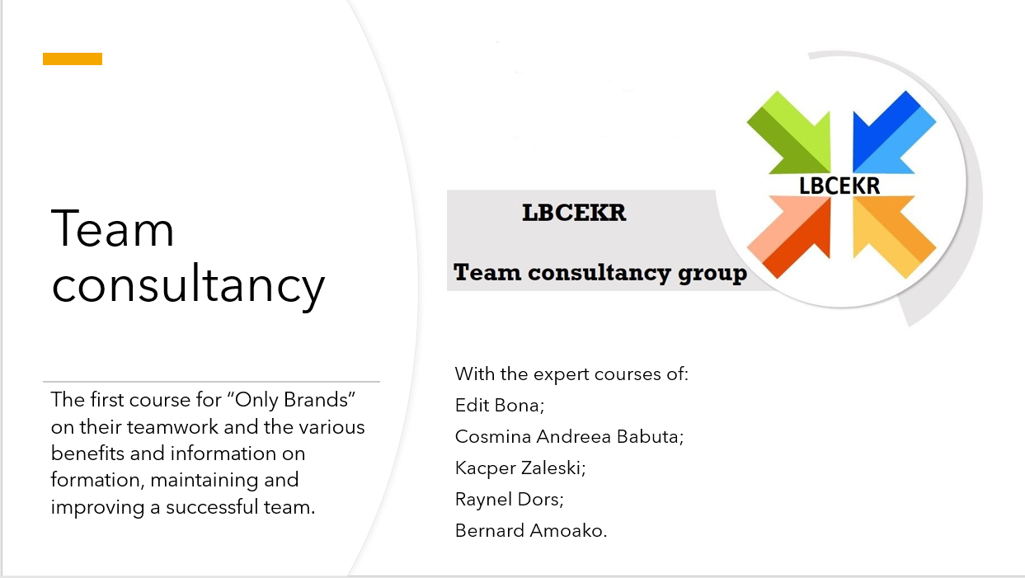
Good afternoon managers of “Only Brands”, my name is Lucian and I am here to tell you about the great future of your company, for should you implement the strategies, theories and advice of the experts that follow after me, the company you manage will surely profit extensively.
We know that you are a relatively new player on the market with an innovative strategy to sales, but a strategy alone is not enough to truly be able to compete with the big players that are the national and international chains of retailers, and in order for your strategy to work at all in an efficient manner, you need us to train you in the art of teamwork, and make you evolve from simple managers to great leaders for your teams.
But before that, let me tell you about LBCEKR, our team consultancy group. It is formed of 6 members including myself, Bernard, Cosmina, Edit, Kacper and Raynel, whose first letters of their names and who are all knowledgeable in the field of team development and successful teamwork.
We will guide each of you through a particular part of the subject, from more information about the benefits of working in a team to successful team development. They will teach you about team roles and their importance in forming a team as well as the stages that a team develops in, finalizing in managing conflict in an existing team, all of these including the theories of Belbin, Tuckman, Thompson and Leigh (Belbin 1981), (Tuckman 1965), (Thompson and Leigh 2008).
We shall then start with Edit, who will tell us about the benefits of teamworking. Please come forwards.

Benefits of Team Working (Edit Bona 1909474)
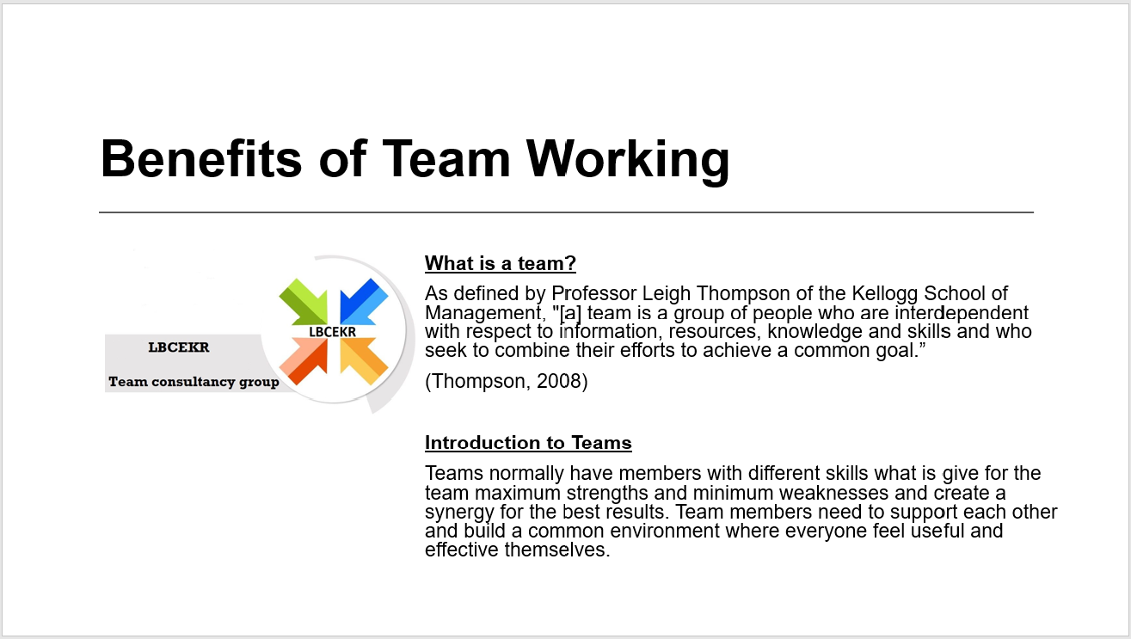
Good afternoon ladies and gentlemen. It’s a pleasure to welcome you today. Let me introduce myself. I’m Edit Bona from the LBCEKR consultancy group and the subject of my presentation is the benefits of team working. Today I would like to give you an overview of how effect a good teamwork for your business and your profit. The first part of my presentation I would like to talk about what is a team.
"[a] team is a group of people who are interdependent with respect to information, resources, knowledge and skills and who seek to combine their efforts to achieve a common goal.” Teams normally have members with different skills who give for the team maximum strengths and minimum weaknesses and create a synergy for the best results. Team members need to support each other and build a common environment where everyone feels useful and effective themselves.
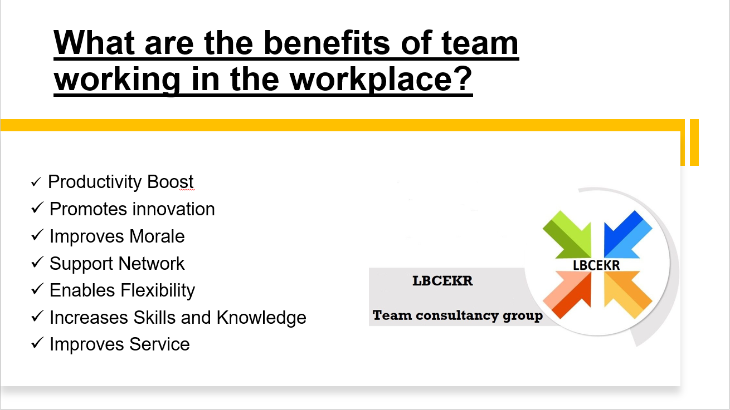
The second part of my presentation I would like to talk about 7 important points which will help you to understand the benefits of good team working.
The first point is the productivity boost where the team members share equally the workload and tasks depends of each of them strengths and skills. This way of division of labour effectively increases the productivity because every person in the team do in which they are the best.
The second point is the improves morale when the team members get their tasks by what is their best skills, they not just work each other better but with pleasure too. Each of the members feels appreciation and belongs somewhere.
The third point is the promotes innovation where the members of team work on the problems by creative and practical solutions.
The fourth point is the support network where the members of the team feel comfortable and they can express themselves freely. This create a trustworthy environment where they can try new possibilities without fear because they are helping and supporting each other.
The fifth point is the enables flexibility where the members get cross training and they can cover each other tasks if necessary. This does not disturb the project and gives more flexibility.
The sixth point is the increases skills and knowledge which continuously develops the team members under the common work.
The seventh point is the improves service because a good teamwork gives a valuable experience for the customers which increases the business success too.
These 7 points above show great how important a good teamwork if you want your business success. I hope you find useful this presentation and thank you for your attention. Next is Successful team development.

Successful team development (Cosmina Andreea Babuta 1907090)
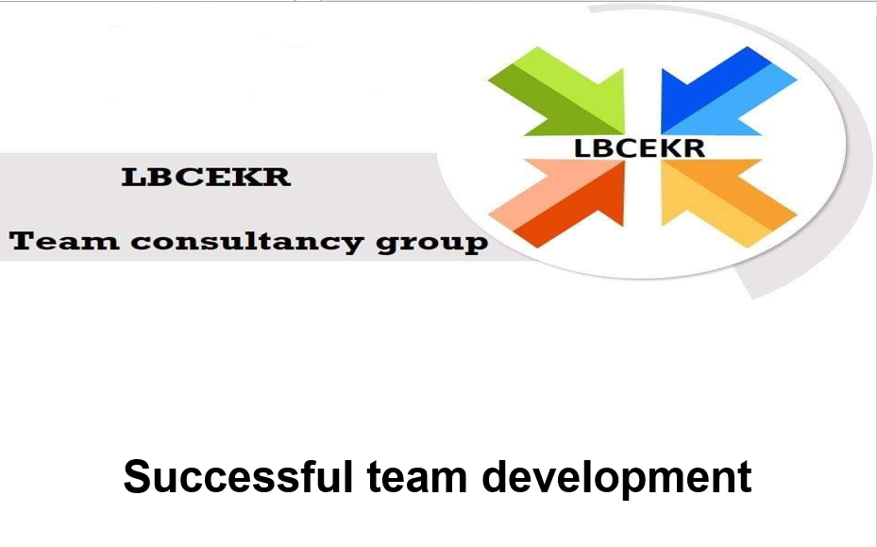
Just by bringing members together in order to complete individual tasks does not mean that is going to be a successful team (Salas, Stag and Burke, 2004). To develop an effective team, we have to manage both individual members work and how they work with each other.
The biggest role in a successful organisation is played by an effective team. Stanford University developed a study which showed that when individuals are treated as team members or partners their motivation increases.
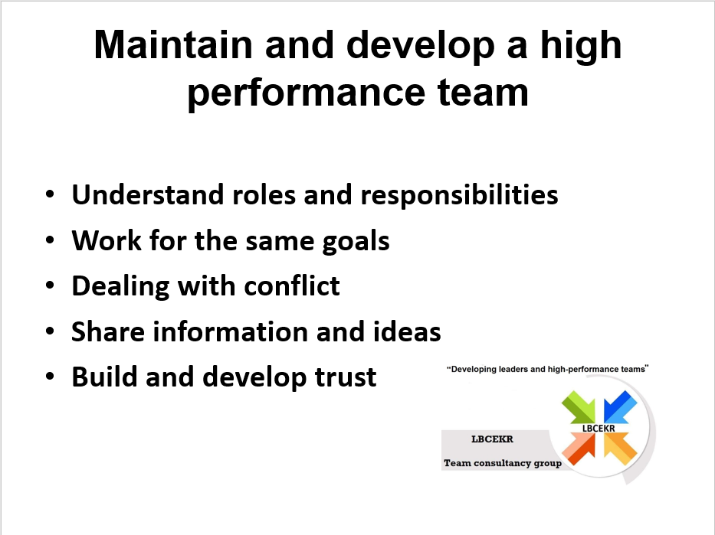Developing an effective team is a complex process and as leaders we have to take in consideration some steps for a strong and successful group of individuals.
- Understand roles and responsibilities
According to Belbin (1981) there are two important factors we have to consider when building a team: the knowledge that an individual has in order to be part of a group and the skills and abilities that the member brings to a task.
- Work for the same goals
Team members should be devoted to the team’s aims. This commitment could be reflected on their effort and sacrifice for the team and that will create a chain when all members will input their effort to sustain the team.
Business logo, name, job titles, uniform all those elements will influence the idea of a group with same objectives (Griffiths, B.A. and Dunham, E.B., 2015).

- Dealing with conflict
As leaders we have to create a set of rules that need to be clear to all team members, also the results of breaching the code to be well known by them.
Avoiding conflict could be easy if we consider all factors that could lead to unpleasant scenarios.
- Share information and ideas
Successful teams will continuously share ideas and knowledge, support each other to achieve great results.
- Build and develop trust
This is the key point in maintaining a successful team and keep it focused on the goals.
According to a research report conducted by Reina consultancy building, when trust is present, team members will deliver their best, together, efficiently. They will gravitate around same goals and will support each other.
Thank you for your attention, please welcome Kacper who will talk about the various team roles.

Team Roles (Kacper Zaleski 1818719)
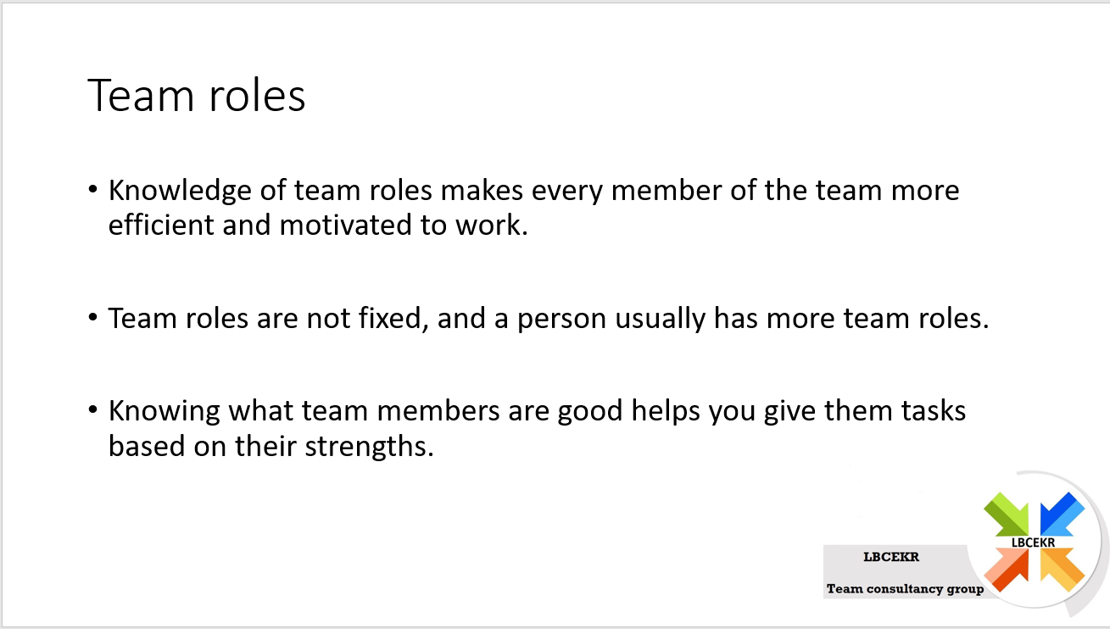
Hello, my name is Kacper Zaleski and I am an expert on team roles I’m here to help you to understand a few points.
First of all, I will explain to you what team roles are and how you can divide them between your employee.
Team roles - according to the theory developed by Meredith Belbin, this is an individual tendency to depend on behaviour, cooperation and building relationships with other people (Belbin 1981).
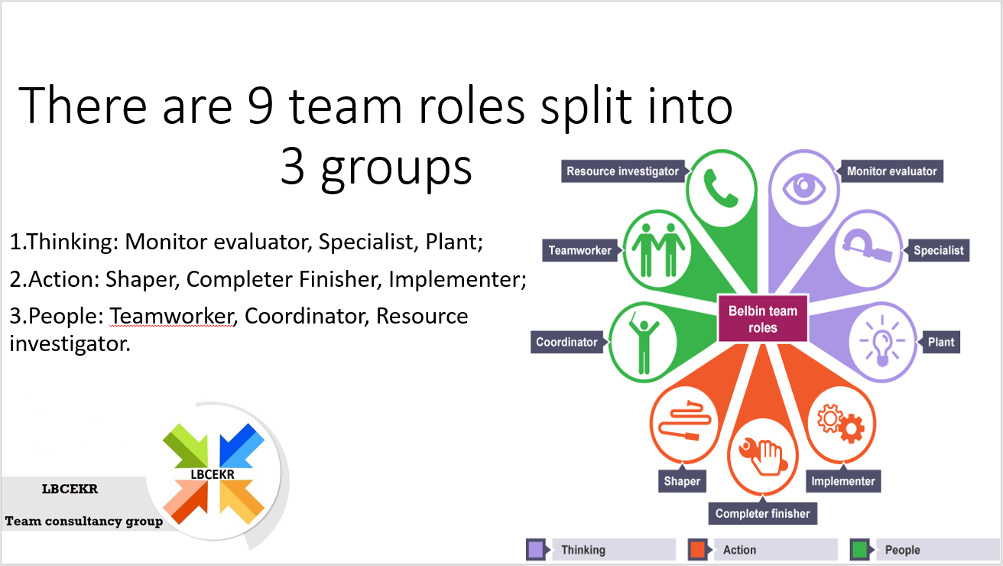
There are nine team roles which we can split in three groups.
1.Thinking: Monitor evaluator, Specialist, Plant.
2.Action: Shaper, Completer Finisher, Implementer
3.People: Team worker, Coordinator, Resource investigator.
If you want to make your teams work with high efficiency and quality management, you have to find nine Belbin team roles in the company. That does not mean nine different people because probably most of the employees working in your company will have two or three Belbin skills in which they will be feel comfortable. Each of role has a strengths and weaknesses. If you want to create your dream team first of all you have to know what your goals is and establish which steps you have to make. People which using Belbin’s method have better understanding their strengths, they have better communication as a team. To find who in your team is good in, for example say making decisions in critical moments or who is working good under the pressure its only one good way to check it: you need to give them a questionnaire which is easy to download from the Belbin website , after that do not forget about feedback, the feedback should be shared by your workers between management and all of staff. If you will do everything step by step what I wrote higher up team from your dreams will come to reality. I wish you all the best if you will have any more questions fell free to ask me by email or contact our consultancy.
After me, Raynel will be speaking about the stages of team development.

Stages of team development (Raynel Dors 1908587)
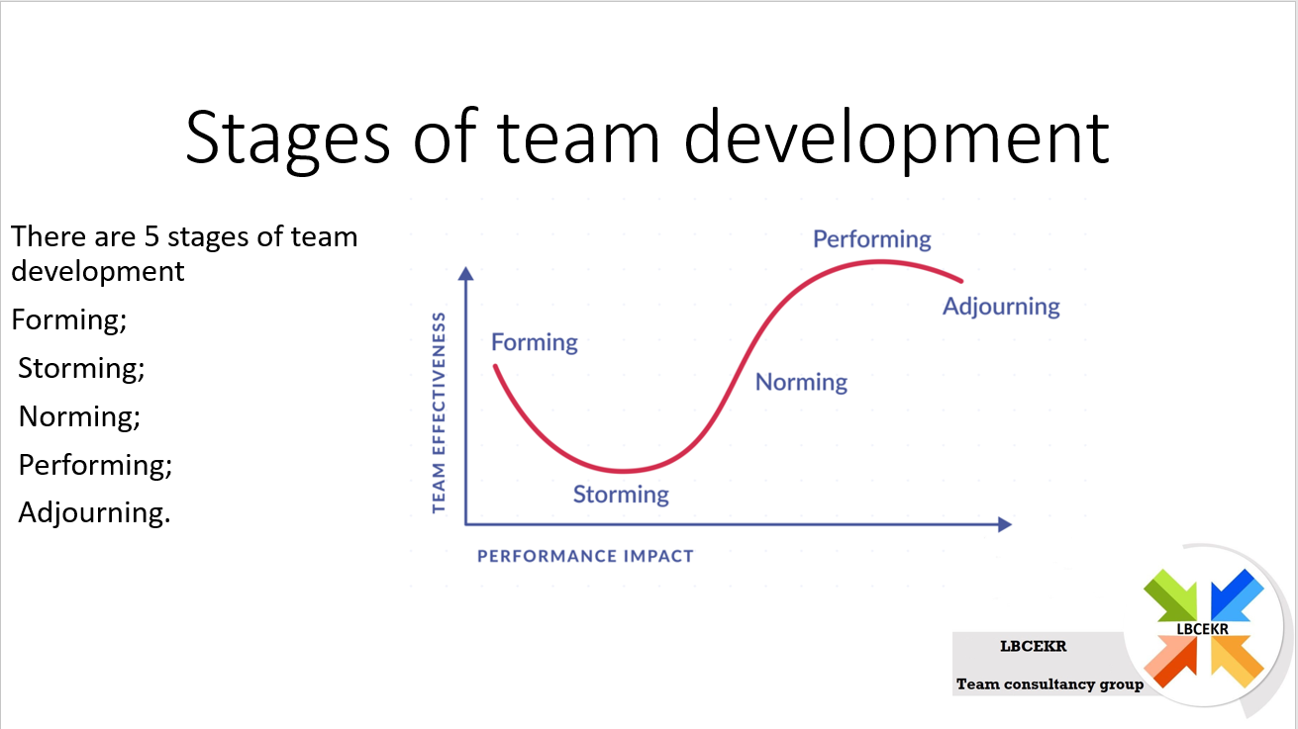
Hello everyone, I will speak to you managers about Tuckman stages of team development, which there are 5 stages: Forming, Storming, Norming, Performing and Adjourning (Tuckman, 1965).
Forming
As a stage developer I think we need a strong relationship with our team members to know how we can be on the same direction and understanding and mindset. If we Create a connection where we treat each other with respect and supporting each other, we will be succeeding in our goals. We will go through challenges and get a lot of opportunities to reach to higher level.

Storming
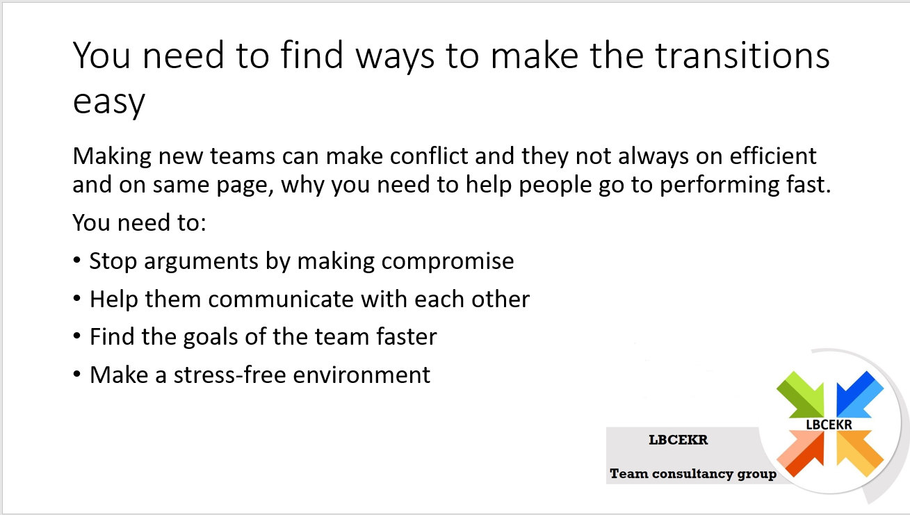
As team we have to correct our self when a team member has different opinion reach to hour goals. What is the right or the Better option for the company? If we get in an Argument we have to solve immediately if that happens between team members. We work and we stay solid to not reach to our breaking points.
Trust must be built by knowing each other well and having peace and not attacking each other from their culture or religion.

Norming
Rules are made for every team member no one is bigger than other one. Team members becoming good work partners. We think as one and you as a team member for all. We as team are responsible for our mistakes and makes us stronger. We discuss and coming with a solution if we can’t solve a problem.

Performing
Everything goals reached by working as strong team no mistakes can be making easily. We love the job what we are doing. Our customers are very satisfied with us by performance good customer services. We can find our self in every situation and makes a team stress free.

Adjourning
Team members job is always done on time to more work and be a step forward. It makes easier to have more important and difficult task done. When as team we are thinking like that is always easier come with more ideas to make more sales finding more connections and making a business bigger. A toast is always welcomed in great news of success when a have reached big number of the businesses.
Next will be speaking Bernard about managing conflict.

MANAGING CONFLICTS (Bernard Amoako 1909476)
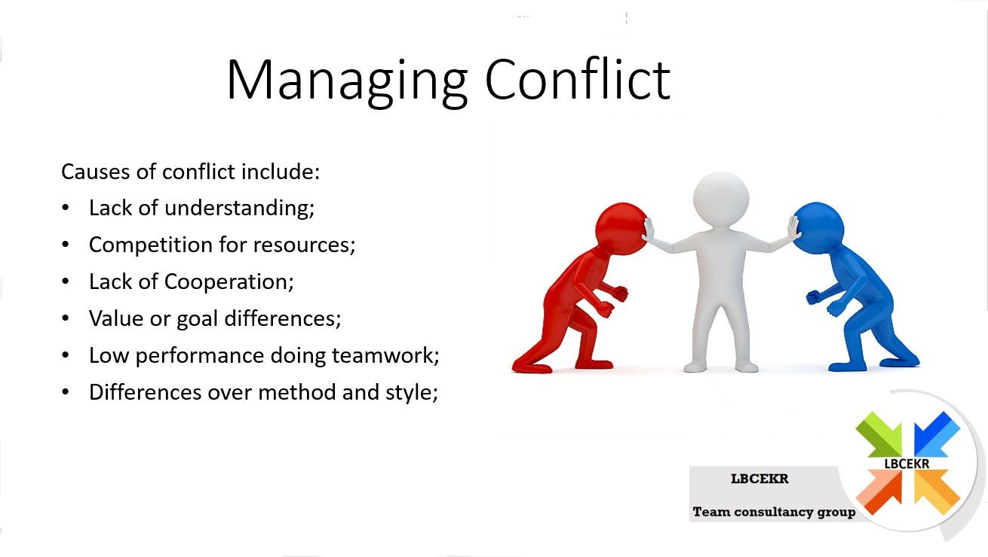
Conflict is when two or more people or parties disagree or have divergent views it could happen between employees Department managers into a large extent group of people in a city in conflict management during teamwork there is a need to place some emphasis on the causes of conflict drawing teamwork few of these may include:
- Lack of understanding
- competition for resources
- lack of Corporation
- value or go differences
- Low performance doing teamwork
- differences over method and style

It should also be noted that conflict can recede or evolve, results in harm or good, require intervention, can be highly petty, rational or even sometimes misguided.
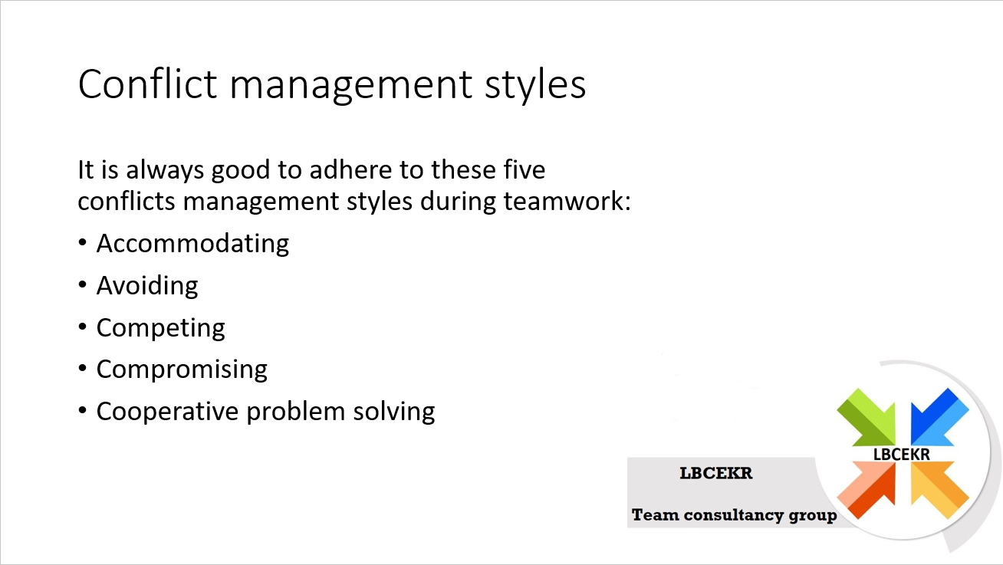
Managing teamwork conflicts
It is always good to adhere to these five conflicts management styles during teamwork
- Accommodating
- Avoiding
- Competing
- Compromising
- Cooperative problem solving

People have different viewpoints, and under the right set of circumstances, these differences escalate to conflicts. how to handle conflicts determines whether it works to the team advantage or contributes to its failure
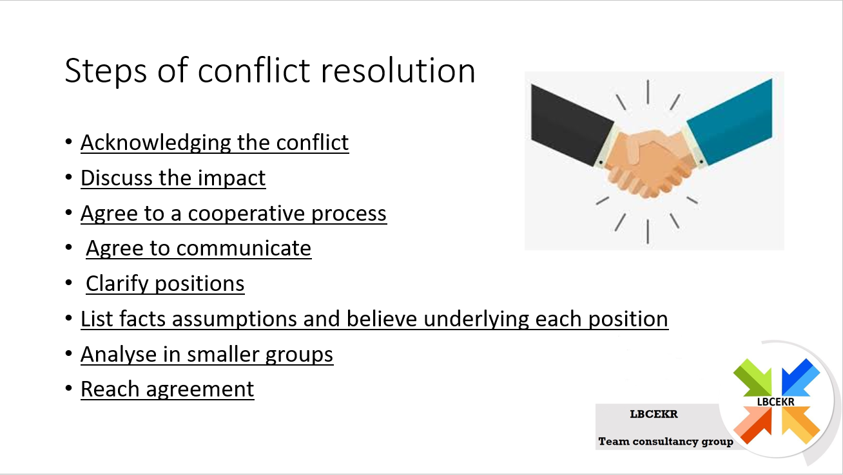
In managing conflict there is a need to also observe these:

Acknowledging the conflict
There is a need to acknowledge a conflict before it can be managed. If you are concerned about the conflict of your team, discussed it with other members. Once the team recognises the issue it can start the process of being managed.

Discuss the impact
As a team there is a need to discuss the impact the conflict is having on team dynamics and performance.

Agree to a cooperative process
Everyone involved must agree to corporate in resolving the conflict.

Agree to communicate
The most important thing throughout the management is to keep the communication open. The people involved need to talk about the issues and discussed their strong feelings.

Clarify positions
What about the conflict or disagreement, it's important to clarify people’s position. Whether there are obvious functions within the team who support a particular option, approach or ideas, or each team member who's their own unique view, it position needs to be clearly identified in articulated by those involved. This step alone can go a long way to resolve the conflict, as it helps the team see the fact more objectively and with less emotion.

List facts assumptions and believe underlying each position
What does a group, or person believe? What do they value? What information are they using as a basis for this belief? what decision-making criteria and processes have they employed?

Analyse in smaller groups
Bring the team into smaller groups, separating people are in alliance. In this smaller groups analyse and dissect each position, and the associated fact, assumptions and beliefs.
Which facts and assumptions are true? what are the more important to the outcome? is there additional objective information that needs to be brought into the discussion to clarify points of uncertainty or contention? is Addison a analysis or evaluate required?

Reach agreement
Now that's all patches understand the others’ positions, the team must decide what decision or course of action to take. Will the fact and assumptions considered it's easier to see the best of action and reach agreement

Conclusion (Lucian Scobioala 1907758)
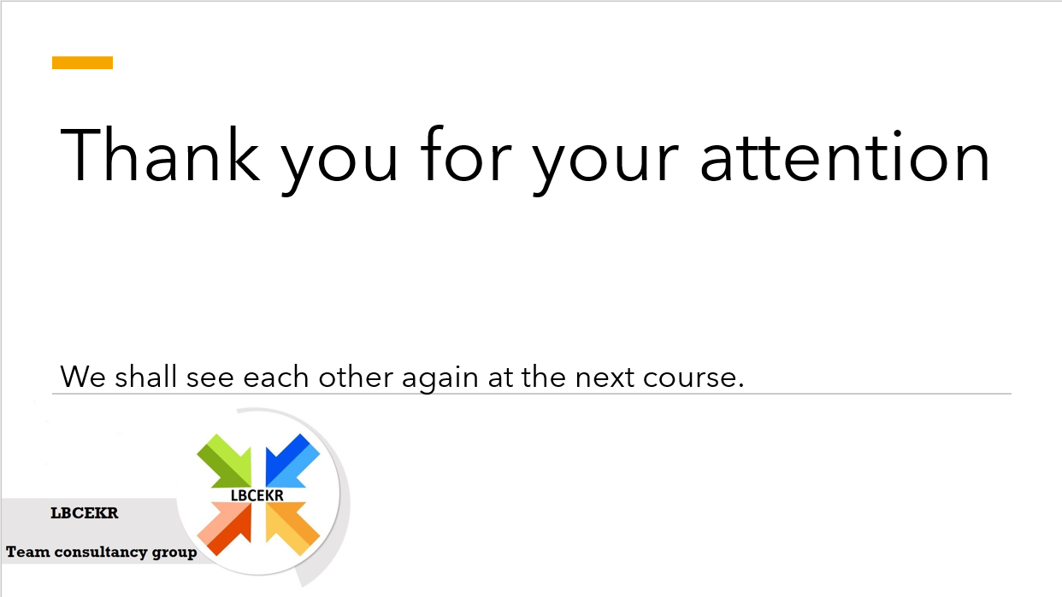
We shall conclude our presentation with this, let us thank our experts for their time and dedication, I hope you all learnt a lot from them, but don’t forget to review this information as well, and in order to fully implement successful team development, one session is not enough, so we shall see you again very soon. Do please talk with the teams you are responsible for as well to gauge their reactions, as asking good questions is important for good leadership as well(Coffrey et all, 1993), and tell us about them and their opinions on the subject, so that we can help you with the specific cases that you face. If you have any questions about any of the subjects, feel free to ask about them from our experts, or if you have any questions about our sources or company you may ask me. Thank you for your attention, we shall see you on the next training session where I will be speaking about emotional intelligence, the Johari window (Luft and Ingham 1955), and its’ influence on teamwork, have a good day and work hard for “Only Brands”.

References

Belbin, R.M. (1981) Management Teams: Why they succeed or Fail. London: Heinemann.
Coffrey J. R., Jones L., Kowalkowski A., Browne J. (1993) “Asking Effective Questions: An Important Leadership Role to Support Quality Improvement” The Joint Commission Journal on Quality Improvement , 19(10), pp. 454-464.
Crowley, M., Payne, J.C. and Kennedy, (2014) Economic and Industrial Democracy, Vol. 35
Luft, J.; Ingham, H. (1955). "The Johari window, a graphic model of interpersonal awareness". Proceedings of the Western Training Laboratory in Group Development.
Maund, A. Schriek, M. and Tinkler, P. (2017). Certificate in Higher Education: Skills for the Workplace Student Yearbook. Sage Publications
Peter Morgan (2017) The business student’s guide to study and employability, London, Sage Publication.
Thompson, Leigh (2008) Making the team: a guide for managers. 3rd edn. Pearson/Prentice Hall.
Tuckman B. W (1965). "Developmental sequence in small groups". Psychological Bulletin, 63(6), pp. 384–399.

