A CRITICAL ANALYSIS OF CSR WITHIN THE UK SUPERMARKET SECTOR: CASE STUDY OF ALDI

By Matthew Rothwell
P150153

Supervised by Dr. Caroline Jawad

Submitted in part fulfilment of the requirements of the degree of BA (Hons) Business Management


DECLARATION

This work has not previously been accepted in substance for any degree and is not being concurrently submitted in candidature for any degree.

Signed……………………………………………

Date………………………………………………

STATEMENT 1

This dissertation is being submitted in partial fulfilment of the requirements for the degree of BA.

Signed…………………………………………….

Date………………………………………………

STATEMENT 2

This dissertation is the result of my own independent work/investigation, except where otherwise stated.

Other sources are acknowledged by footnotes giving explicit references. A bibliography is appended.

Signed……………………………………………

Date………………………………………………

STATEMENT 3

I hereby give consent for my dissertation, if accepted, to be available for photocopying and for interlibrary loan, and for the title and summary to be made available to outside organisations.

Signed………………………………………………

Date…………………………………………………

STATEMENT 4

I hereby give consent for my dissertation, if accepted, to be available on the university’s IT system to those who have consent to use the system.

Signed………………………………………………

Date…………………………………………………

Acknowledgements

Abstract

This dissertation was undertaken in part fulfilment of an undergraduate bachelor’s degree in Business Management, and conduct a critical analysis of CSR with the UK supermarket sector, with a case study of Aldi.
A broad literature review of CSR, CSR theory and CSR principles and practices of Aldi was undertaken by the researcher. And????
The outcomes of the literature review were then used to develop and construct the researcher’s primary data collection method. An online survey was circulated among the researcher’s peers and potential possible participants online. The researcher gathered 141 responses, detailing the views and opinions of basic supermarket preferences, the understanding of CSR and finally the awareness of Aldi’s policies and practices.
The main findings were as follows: that Aldi have improved the CSR operations within the business yet have failed to communicate these effectively with consumers and potential consumers; personal incomes has a direct effect of the choice of preferred supermarket; Aldi have a middle rank among the potential competitors yet Aldi have shown improvement within its policies and practices.
The findings of this research suggest that Aldi are operating in aspects in CSR defined way, yet there could be improvements moving forward. With the improvement there is room for mass improvement of communication from Aldi on its commitments and achievements to the general public. This improved commutation could be a boost of awareness and may yield more potential consumers of the Aldi brand and products.

Table of Contents

List of Figures

Appendices

1.0 Chapter One - Introduction

1.1 Background

Leach (2016) states within the Gather report, indicates a sizeable flaw in the collective CSR outputs of the UK’s supermarkets: “There is a need to have stronger and more coherent story at the heart of each report to successfully link the report together.” Aldi UK have released a CSR report (Appendix 1) within this report there are an array of different CSR principles, practices and innovations. Aldi’s history can be briefly summarised as the following (Aldi website, History, 2019);
1913 – Anna Albrecht opens a small grocery store in Essen, Germany.
1930s – The Great Depression hits, effecting the business performance. This leads to a numerous of idea to push for lower prices and incentives for customers to retain their custom.
1946 – Karl & Theo Albrecht take over the business.
1961 – With over 300 stores, the brothers decide to split the business into Nord and Sud.
1962 – The Aldi name was formed by the shorting of Albrecht (Al) alongside discount (di),
1990 – Aldi Sud enters the UK supermarket sector.

1.2Rationale

CSR is defined as a term of reference and a countermeasure to various issues beyond corporations’ economic, technical, and legal requirements (Lee and Lee 2019). Thus interrelating with the fact that CSR is becoming more significant within the UK supermarket industry within the practices and cultures of the businesses within the sector. This is due to developments and changes to the real value of the CSR to the consumers and customer, Meijer and Schuyt (2005) state that consumers are reluctant to obtain products due to the low corporate social performance of producers and the retailers which sell the products. It is apparent that there is a requirement of further investigation, with the growth of the German supermarket chain Aldi, it would be a relevant case study.

1.3 Research statement

Due to the outline of Leach in 2016, there is a need for further development of each individual CSR report released by UK supermarkets. Aldi have released one report in 2017 (Appendix 1). The researcher wants to analyses the practices and policies, with the addition of primary research to understand the overall CSR commitments of Aldi.

1.3 Aims and Objectives

The aim of this study is to critically analyse CSR policies and practices within Aldi. The objectives are as follows:
- To conduct an extensive literature review examining CSR and CSR policies and practices at Aldi.

- To evaluate CSR policies and practices at Aldi by conducting a survey of supermarket shoppers.

- To synthesise extant literature and primary research to make recommendations for Aldi in the UK, to achieve a greater understanding and awareness from consumers of Aldi’s principles and practices.

1.4 Research

The researcher will carry out an online survey using the online formatting software which allows the creation of surveys Google Docs. This will distributed online to potential participants who conduct shopping trips and are a consumer of the UK supermarket industry. This data collection method is appropriate to the research, and holds the advantage of gathering a vast amount of data in a high economical manner (Saunders, et al., 2009). The use of a survey will enable the researcher have a reach to wider amount of participants, who will hopefully engage with the question in a manner to develop an understanding of the data.
The ensuing chapter will look at the Aldi CSR report (Appendix 1) and previous academic literature regarding CSR, CSR principles and practices within Aldi’s operations, and will be used to support the results and study conducted by the researcher.

2.0 Chapter Two – Literature Review

2.1 Introduction

This chapter aims to address the first research objective of this thesis:
- To conduct an extensive literature review examining CSR and CSR policies and practices at Aldi.
Using a vast range of sources that include the Aldi CSR report (Appendix 1), Aldi Principles (Appendix 2), alongside relevant literature, this literature examination will support and form the base of the methodology, which will allow the researcher to perform a data collection. This chapter will firstly define an outline vital terminology within the relevant literature, and include an update overview of the CSR policies and practices within Aldi’s operations.
It will then discuss key academic views regarding CSR, highlight models that can be related to CSR to allow the development of a deeper understanding.

2.2 Introduction to CSR

Currently, it seems that corporate social responsibility is largely accepted practice
and continues to be promulgated by management scholars and business leaders. For
example, at companies such as Novartis, corporate citizenship or corporate social
responsibility is stated as a top priority (Novartis 2005). As a corporation, Novartis seeks
to act the same way as responsible and conscientious individuals would act in their
community. They claim to do everything they can to operate in a manner that is
sustainable economically, socially, and environmentally in the best interest of long-term
success for their enterprise. The cornerstones of the stated commitment at Novartis to
corporate citizenship are active engagement in society in areas where they are competent,
helping where help is most needed, and establishing and implementing transparent,
ethical corporate standards and policies.
Currently, it seems that corporate social responsibility is largely accepted practice
and continues to be promulgated by management scholars and business leaders. For
example, at companies such as Novartis, corporate citizenship or corporate social
responsibility is stated as a top priority (Novartis 2005). As a corporation, Novartis seeks
to act the same way as responsible and conscientious individuals would act in their
community. They claim to do everything they can to operate in a manner that is
sustainable economically, socially, and environmentally in the best interest of long-term
success for their enterprise. The cornerstones of the stated commitment at Novartis to
corporate citizenship are active engagement in society in areas where they are competent,
helping where help is most needed, and establishing and implementing transparent,
ethical corporate standards and policies.
Currently, it seems that corporate social responsibility is largely accepted practice
and continues to be promulgated by management scholars and business leaders. For
example, at companies such as Novartis, corporate citizenship or corporate social
responsibility is stated as a top priority (Novartis 2005). As a corporation, Novartis seeks
to act the same way as responsible and conscientious individuals would act in their
community. They claim to do everything they can to operate in a manner that is
sustainable economically, socially, and environmentally in the best interest of long-term
success for their enterprise. The cornerstones of the stated commitment at Novartis to
corporate citizenship are active engagement in society in areas where they are competent,
helping where help is most needed, and establishing and implementing transparent,
ethical corporate standards and policies.
Currently, it seems that corporate social responsibility is largely accepted practice and continues to be promulgated by management scholars and business leaders (David, 2006).
Even though CSR development can be referred back to the 1950s, just recently has the concept gained popularity and turned out to be a significant element of a business strategy (Babiak & Trendafilova 2010). Carrigan and Attalla state in 2011 that in the current period when environmental and social awareness among consumers and customers is at highest point it has ever been, discovering the lowest price point does not always matter to the majority of consumers, in its place they assume and desire corporations to function in a way which can be referred to as socially responsible (Sampada, 2014). This awareness in the increase of the customer’s consciousness is due to the wanting of transparency with businesses. This development has led to the new era of consumers who are savvier than previous generations. This current era have a ‘default’ setting of scepticism, which then leads on the businesses requirement of building a trusting relationship (Craven, 2015).
Dahlsrud (2006) states that there have been abundant exertions to define a clear and unbiased definition of CSR, but there is still not an overall general definition of CSR. Dahlsrud (2006) also states that presently there is no standard recognised explanation for CSR, this is partly linked to the overwhelming quantity of definitions.
With the previous statement there is still some major uncertainty surrounding how to actually define CSR, this is due to the fact that definitions which are put forward are normally biased towards the specific aspects and interests of the individual presenting the definition.

Many companies are paying greater attention to CSR to obtain a
sustainable and strategic advantage in very competitive market conditions. CSR is defined as a term of reference and a countermeasure to various issues beyond corporations’ economic, technical, and legal requirements (Lee and Lee 2019). It enables corporations to accomplish not only traditional economic incomes but also social outcomes.

Dahlsrud (2006) summarises the overall wealth of the attempts to define CSR and delivers a momentous problem: if opposing definitions have separating biases, individuals will think of CSR contrarily therefore preventing industrious arrangements. As an outcome of the problem within the corporate and academic sphere, there has been doubt surrounding the debate around the definition of CSR and how it can be correctly implemented within business.
Aldi have stated that their CSR definition which they use as a value within the Aldi Corporate Responsibility Policy (CR Policy, 2017) that it defines it as a ‘core value of 'responsibility'. It summarizes our commitments to 'people and planet' and guides the day-to-day actions of all our employees and business partners.’

2.3 CSR and sustainable development relationship

CSR is usually betrayed as an "umbrella term under which manageability is one angle" (Knowles, 2014). Additional scholars contend that the "two terms can appear to be compatible" (Salt, 2012). Herrmann (2004) underpins this by including that a well-actualized and firmly upheld CSR approach is critical to feasible advancement.
Knowles (2014) perceives that CSR can be broken down to the three 'p's' (planet, people and profit) and that CSR alludes to organizations' obligation to act morally and think about their effects on the overall environment everywhere; that does not really include manageability. Bowd et al. (2006) observed stakeholder and management perspectives of CSR in retail which will be further discussed within the following section of this chapter. Confino and Drummond (2010) trust that CSR solely is not sufficient to make a reasonable world, depicting that another branch of business is starting to rise, naming the new shape, feasible business. They include that a practical business acts to accomplish short, medium and long-term achievement, which means they are fruitful today and essentially tomorrow also.
See paper 4 of Appendix, it is a foreword of the report yet it states the organisations which Aldi join and commit to in relation to sustainability. It is stated ‘Together with the Global Compact, the e Sustainable Development Goals form the basis for the further development of our sustainability strategy.’ This is a clear indication that Aldi have a long term plan for sustainable development within the business.
Aldi conducted a ‘Materiality analysis’ (see pages 17-20 of appendix 1) within this analysis Aldi nominated the topics to be included in Aldi’s CR Report grounded on Aldi stakeholders' expectations, Aldi’s impact current or potential, and Aldi’s general belief as expressed in our CR Principles. This analysis was carried out by ‘internal sustainability experts’ (Appendix 1, page 19). This reference of sustainability experts carrying out an internal analysis basing on the CR report, shows another direct relationship between both sustainability and CSR. ‘We asked our stakeholders to rate the importance they attach to various sustainability-related topics’ (Appendix 1, page 19) this question is requiring stakeholders to highlight which sustainability-related topics they are aware of and also rate them, is another strong development of the relationship, as the wording could have been used under a branch of CSR but chosen as sustainability.
Aldi held interviews with external experts for the supply chain field of action to highlight vital suggestions regarding the ongoing development of Aldi’s CSR strategy. ‘The multitude of challenges faced throughout our supply chains continue to provide potential for optimisation. We deem an ever stronger integration of sustainability requirements into our other business processes (Appendix 1, page 22).’ This is an obvious sign that Aldi link sustainable business practices to CSR.
Aldi have presented their CSR initiatives in aspects of energy usage and reduction, with also material input. With these reductions along the supply chain as a whole it can be considered that there are vast cost savings which may be attainable. Miles and Covin (2000) report that uninterrupted enhancements, decreasing lawsuit expenditures, inferior insurance, and lower energy costs belong to the main asset direction of corporations wanting to minimize their environmental impact.
The use of such an analysis to determine Stakeholder views and values for the CSR report but use sustainability as frequently as Aldi have done, shows to that within the Aldi business strategy, principles there is a crossing of both sustainability and CSR. This give the clear indication that Aldi have made sustainability a branch of their CSR reporting, values and responsibility. This overview is summed up by the sustainable goals within the actual CSR report (Appendix 1, page 33).

2.4 Theoretical models of CSR

There are numerous theoretical models representing contrasting opinions of CSR. Moreover an analysis of the theory proves that CSR discourse wavers between two standpoints: potential usefulness and applicability of CSR (Jamali & Mirshak, 2006). These models will be linked directly with Aldi and its practices and policies.

2.4.1 Carroll’s CSR Pyramid

Carroll theorises a four-part hierarchy structure, which was then structured into a pyramid model (See figure 1), which dictates what is necessary for a business to be considered as socially responsible (Carroll and Buchhotlz, 1999, pp. 37-38).
Carroll’s pyramid facilitated the creation of businesses to centre and considerate on CSR. This involves that economic responsibilities yield superiority above ethical and legal responsibilities. The pyramid makes available an outline for expressive analysis that endeavours for universality in the model. At the bottom of the model there is ‘Economic responsibility’, which fundamentally refers to gaining capital. At the third level there is ‘legal responsibility’, and this requires obeying the law due to the fact that ‘law is societies’ list of right and wrong’. ‘Ethical responsibilities’, at the second level of the pyramid, necessitate the corporation to perform in a way which is “right, just and fair” while “avoiding harm”. At the top of the pyramid there is ‘Philanthropic responsibilities’, which means to be a ‘good corporate citizen’, via ‘contributing resources to the community, in order to improve the quality of life’ (Carroll and Buchholtz, 1999, pp. 37-38).
Aldi has released information regarding all of these aspects shown in the figure below, this information can be fully examined online (Aldi Online). The link between Aldi and Carroll’s can be observed due to multiple reasons. As the two pyramids below show the original table alongside an example table of Aldi’s practices within the different aspects.

Aldi has released information regarding all of these aspects shown in the figure below, this information can be fully examined on the Aldi website. The link between Aldi and Carroll’s can be observed due to multiple reasons.

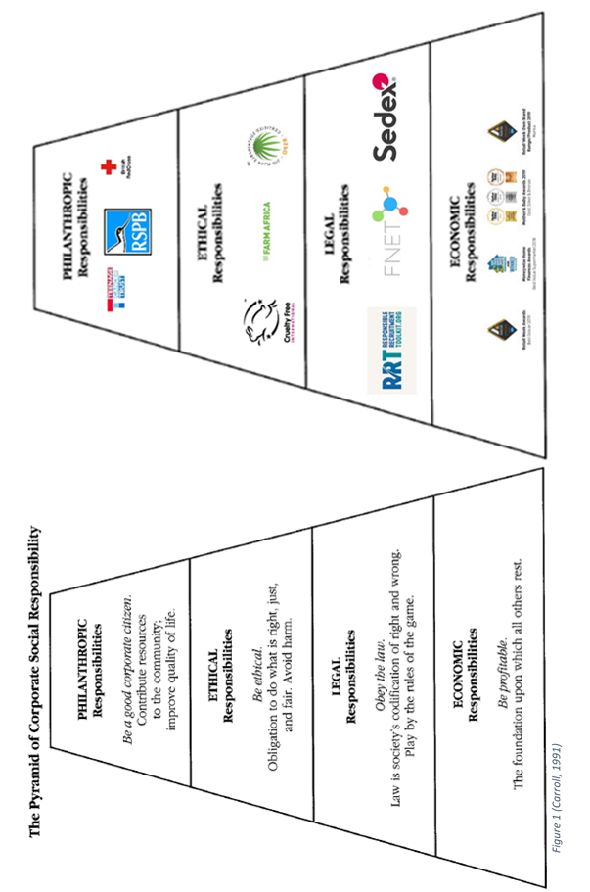

Firstly, as the bottom of the model is economic responsibility. Carroll (1991) states organizations were built to perform as economic units designed to offer products and services to the society surrounding them. As Aldi have won multiple awards due to value for money, these can be seen with the base of the second pyramid. The notion of the profit motive has been transfigured into an idea of maximization of profits, and this value has been strong since socially responsible firms try to increase profits, whilst trying to improve the welfare of other stakeholders (Beltratti, 2005). Aldi have maximised the potential profits and have accomplished the welfare of consumers by having a price point which has been accredited for its value for money. Jones et al. (2005, 2007) concluded that operational business imperatives, economic viability, and CSR assure long-term growth and financial safety for stakeholders.
Sander van Luit (2006) states ‘ALDI was known as a cheap store where only poor people did their weekly buying.’ Yet in recent years Aldi have been rising up the UK supermarket ranks. As Kantar Worldpanel states, sales at Aldi were up 12.4% year on year during a period of 12 weeks in 2017. This sales then increased the market share of Aldi by 0.6%, giving it a 6.2% market share and putting it just ahead of the Co-op on 6% (Vizard, 2017). Aldi won the 2018 MoneyWise Home Finance Award. This award is credited to businesses who provide essential services in Britain. The winner of this award is selected by surveying thousands of readers; the categories they select from value for money and customer service (MoneyWise Award, Aldi 2018).
Moving up the pyramid, the next section is legal responsibilities. Aldi have tried to link their own supply chain with government regulations and laws at the same time by implementing their own standards. Aldi identify that standards in the supply chain may not firstly reach those set out in Aldi’s Social Standards in Production (Monitoring Suppliers, 2019). In cases which go against these strict social standards within the supply chain, Aldi is committed to working with suppliers to achieve the standards.
Thirdly in the pyramid, there is ethical reasonability. This entails corporate codes of conduct for establishments of production have become a vital means of regulating work in retailers’ global supply chains (Blowfield, 1999; Barrientos, 2000; Jenkins, 2002). Within Aldi’s chain of supply and product sourcing (See Appendix 1 pages 37, 42 and 86) there are links with ethical sourcing of products. Throughout the CSR report there are multiple links to certifications, associations and standards, all of these accreditations show the ethically business practices in which Aldi are involved in.
Hosmer (1994) argues that companies who recognize and ethically resolve moral problems will be trusted by the stakeholders. Aldi have a system of which when a supplier breaks the strict requirements Aldi set which are then certified through third parties (see Apendix 1, page 14) there is a table relating to the supply chain within Aldi. The table points at the Social Monitoring Programme (SMP) which is implemented to monitor the supply chain process from production to selling point of products.
Within the CR report Aldi highlight the environmental aspects of the business (See appendix 1, page 16) this table show Aldi’s current practices and goals. ‘Throughout our global supply chains, we assume responsibility for promoting fair working conditions and environmental compliance’ (Aldi CR Report, 2007)
Finally the top of the model is Philanthropic responsibilities. The definition of philanthropy has been approached differently by scholars, who disagree about the significant defining features of philanthropy (Van Til 1990; Sulek 2010). The meaning of the term has changed over times, according to the different context structures (Ilchman et al. 1998).
‘ALDI is part of the community. To us, responsibility means making a positive contribution to the community by applying our skills and resources beyond our core business operations. The objective of our community activities is to deliver a sustainable societal impact. This will be achieved by engaging in long-term partnerships with charitable organisations and focusing on key issues and target groups’ (See Appendix 1, page 60).
Aldi have been working closely with a number charities and local organisations to help those in need within society. With Aldi working alongside the likes of Teenage Cancer trust raising three million pounds so far, Farm Africa supporting farmer’s rights and pay and the Red Cross helping during home crisis’s (See Aldi website 2019 finder, charity-partnerships).
Aldi have a lot of partnerships, associations and certifications the following chat will place these in the respective sections. This allows the basic understanding of Aldi’s principles in different relation the pyramid. All these different organisations, awards and partnerships can be found on the Aldi website (2019)

2.5 Stakeholder theory
Edward Freeman is generally accredited for the expansion of stakeholder theory. This theory has since then gathered value in business and society operations, and it has been considered by administrators and scholars due to its realism (Jamali, 2008). Stakeholder theory is frequently understood as “a necessary process in the operationalisation of corporate social responsibility” (Matten, Crane, & Chapple, 2003).
Freeman subsequentially made a CSR theory, basing it on the stakeholder theory, where he argued ‘the interests of the stockholders, should not outweigh the importance of other stakeholders’ (Bowie and Werhane, 2005, p. 25).
Stakeholders are regard as individuals or collective clusters, which are interested in practical and functional characteristics of corporate actions according to Donaldson & Preston (1995). Stakeholders are then recognised by their interests in the company, depending on the possibility of the corporation to have relevant functional awareness of them. Donaldson & Preston (1995) propose informative visual illustration linking the input-output model of organisations in contradiction of the stakeholder model. The input-output model as shown in the figure below has been adapted to Aldi’s system.

Figure 2 (Donaldson & Preston, 1995)
This figure shows that consumers, representatives and providers are delineated as contributions of the business, which at that point changes into the yields to serve the client. This input-output model in relation to Aldi highlights the input of certain aspects have a direct route towards the customers. Aldi as a business have to systematically have inputs into the business operations which cause effects on the outputs.
Aldi rely on input of employees to make sure that the business runs effectively in 2016 Aldi held an Employee survey which was about employee thoughts, improvements and issues (Training & Development Aldi, 2019). Suppliers are obviously a key element of the model due to the actually products that Aldi consumers require in relation to available options in the Aldi options.

2.5.1 Advantages of stakeholder theory
Stakeholder theory proposes numerous points of interest to associations. At the point when appropriately connected with amid the basic leadership process partners can offer profitable info, improve results and manufacture accord (Ryckman, 2015). A vital standpoint made by Ryckman (2015) is that including partners with a remarkable understanding of various problems may prompt expanded straightforwardness, which can help basic leadership and help in structure trust between partners.
Kurucz et al (2008) expand the benefits of stakeholder theory; according to them, to partner the board is a way of accomplishing supremacy that will empower supported development of monetary incentive through, as an example, cost and hazard decrease, representative or client dependability, increasingly good behaviour from controllers, and the obtaining of notoriety and authenticity.

2.5.2 Disadvantages of Stakeholder theory
In a general sense, the main issue in the improvement of the stakeholder theory has been perplexity as regards its inclination and reason. In this instance, the theory is utilized, unequivocally or certainly, for enlightening aims (Donaldson and Preston, 1995). Brenner and Cochran (1991) introduce a 'stakeholder theory of the firm' in order to reach two outcomes: to depict how associations work and to help foresee hierarchical conduct. Then they balance this with various 'theory of the firm' without addressing whether in truth the speculations have equivalent purposes. Donaldson and Preston (1995) clarify that the contrasting speculations have distinctive purposes and accordingly unique legitimacy criteria and distinctive ramifications.
King (2006) contends that numerous researchers have issues with stakeholder theory, with some contending that partner hypothesis needs particularity, and in this way can't be operationalised in a manner that permits logical examination. In the meantime others imply the way that this theory delives no basic leadership standard, that could be a satisfactorily manage corporate administration. Felin (2006) concludes that the theory does not have any established offers, which are implausible perspectives on how activities work and on a very basic level overlooks what is really important of the need to organise, the need to think about expenses and that's just the beginning.

2.6 The Triple Bottom Line

John Elkington created the triple bottom line (TBL), which consists of three P’s: profit, people, planet. The TBL surpassed the universal benefits, degree of cost-effectiveness and investor incentive to combine natural and social measurements (Hall and Slaper, 2011). The three P's speak on the social, ecological and money related components of execution within the TBL.
The issue surrounding the TBL is estimating its effectiveness, considering that each measurement does not possess a typical value of estimation. There are supporters who believe that adapting all components of the TBL would give the advantage of a typical unit of estimation (Hall and Slaper, 2011).
Tyson (2010) claims that the importance of TBL is at its highest point, like never before. For it has acquired consideration because it is a fascinating test to business pioneers to all the while please speculators. Leaving the planet somewhat superior to anything you discovered it while as yet making benefit, if conceivable, can prompt increasingly productive and fruitful business all things considered a mission can convey more prominent proficiency and sparkle advancement.
The lack of an all-inclusive standard strategy for estimating the TBL can still be considered a quality due to the fact that the client is able to change the system to the requirements. In that sense, TBL has the reach to be an expansive aspect, if one considers, for example, estimating impacts crosswise over huge geographic limits (Hall and Slaper, 2011).

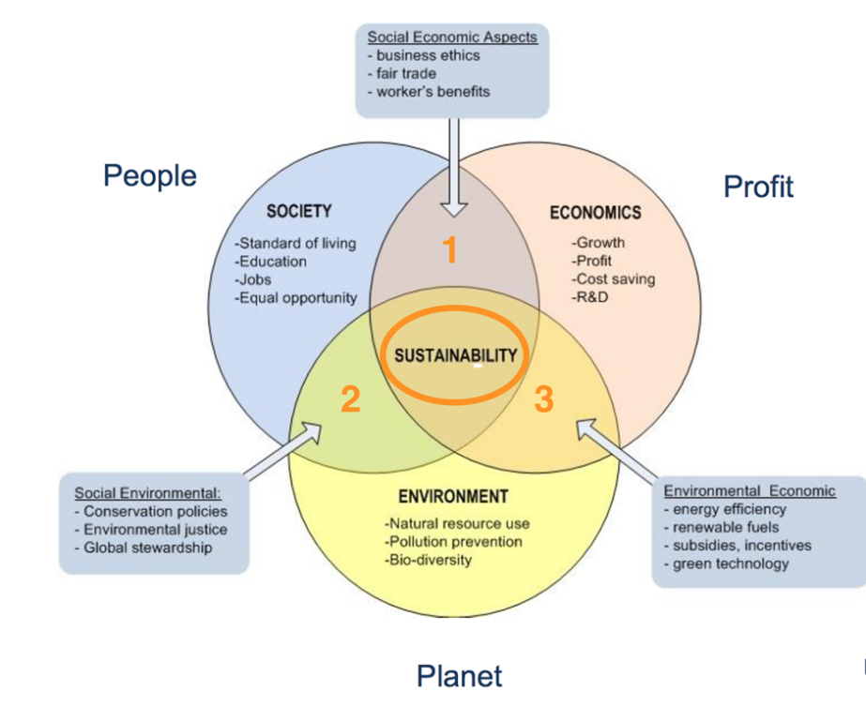

Profit,
People and Planet aims to measure the financial, social and environmental performance of a business over a period of time. In relation to Aldi, the TBL can be applied as a theory which can allow the development of understanding of Aldi aspects. Using the TBL as a measurement tool of progress in line with goals and aims across such a broad business, it can be key to understand the development and the progression required.
Aldi have reported on the key figures (See Appendix 1, pages 77-100) the aspects that are reported on range from sales, employees and environmental figures. Using selected key performance indicators (KPIs) in the areas of Company, Customers, Supply chain, People, Community, and Environment, Aldi have provided and covered data on the effectiveness of their internal and external actions whilst highlighting progression in areas and also in other areas where further action is still required. Together with the materiality analysis conducted within the scope of the International Corporate Responsibility Report 2017, selected KPIs for the reporting year 2017 were verified by the auditing firm KPMG AG.
Profit
The element of profit is somewhat an alternative to traditional financial methods. It consists of external economic advantage for society. An example of this could be employing autochthonous individuals and accessing local suppliers; these two aspects would improve the local economy.
With the data being limited within the report to the net sales (See Appendix 1, page 79) of the whole Aldi South group, it doesn’t allow an in-depth structure of the UK accounts within the public domain. Yet Aldi UK release yearly profits compared to the year before which is then passed on the media for example, ‘For the year to Dec. 31 2017 Aldi UK and Ireland made an operating profit of 265.9 million pounds ($346.4 million), up 26 percent from 211.3 million pounds made in 2016, on sales up 16.4 percent to 10.18 billion pounds.’ (Reuters, 2018)

People
The wider community is an aspect of society, which surrounds an organization. An organization should contribute to the community within its vicinity with projects, educational services and improving health; Aldi states this in detail under ‘Community focus’ (See Appendix 1, page 21). In the case of Aldi there are also the employees, which must ensure the following aspects: working hours, minimum wage levels, no discriminations, health and safety.
Aldi released the figures (See Appendix 1, pages 90-93) in relation to employees, with detailed analysis based on gender, age and position, showing an understanding of its own employees.

Planet
The awareness of pollution and the green house gasses within the remit of the public eye link directly to organisations’ environmental operations. Aldi as an organisation have to monitor the following aspects: waste management, sustainability, natural resources and ethical consumption (See Appendix 1, pages 14, 20, 21).

Benefits of Measuring the Triple Bottom Line

The businesses which start being more aware of the social and environmental situation, can easier stop using activities that creates pollution. For, due to the fact that they could start to weigh the results of their choices on both the societies and the environment, they could eventually decide to preserve the society and the surroundings. This attitude could positively effect the whole society in the long run.
Reputation – By achieving CSR aims and by carrying out a policy following CSR ideals, the organisation would experience an improvement of its reputation in the public eye. Among the high variety of positive consequences, guaranteed by choosing this kind of attitude towards the environment, there is the favour of the costumers and of other society that would promote the success of the abovementioned organisation.
Recruitment and Retention of Talent – According to some scholars (e.g. Hall and Slaper, 2011) the choice of a CSR policy brings also a numerous amount of employees who would want to work for that company. The company would then recruit the most talented workers and let them stay in the group.
Increased Productivity – By reducing wasted products and by utilising sustainable practices, the company would improve the production of good and save many costs.
New Market Potential – New markets could be open up if the company will pursue the CSR initiatives.

2.6.1 Criticisms of The Triple Bottom Line

While a company may express economical facets, e.g. salaries, incomes and costs, it is hard to enumerate social and environmental features. The choice of a business to protect the environment, for example via the practice of recycling, does not make simple to discern the impact it has. The adoption of a compliance approach is usually made by the companies that embrace the TBL; these companies state that they are committed to environment-sound activities.
The main problem created by the TBL is the possibility of creating conflict between the social-environmental positivity actions and the fact that a business’s management usually points to make the most out of the returns to the stakeholders. For the benefits of the CSR conduct would emerge over the long term, alas having a short-term negative impact on profits; if one considers that the majority of stakeholders are more oriented to the short-term profits than to long-term results, it is easy to see where the conflict could be.
Marketing Tool – Sometimes the CSR initiatives do not have real targets in order to improve the performances of the organisation; for these initiatives come across as marketing tools. In the case of an organisation wanting just to appear to be monitoring the TBL instead of doing it properly, it would be only a waste of resources.
Objectives Lost – Even though the TBL has the potential to improve productivity, it is not enough; other important objectives could be in fact lost.
Lack of Understanding – The TBL is still a misunderstood and complex tool. As a consequence, there could be a great waste of resources.
No Precise Measurement – The lack of a specific measurement for the three elements above can make it difficult to quantify and control performance.

2.7 CSR issues in Retail

According to Anselmsson and Johansson (2007) there are few universal attitudes-based scopes for CSR standing which then can be translated into the supermarket sector. These dimensions are human responsibility, environmental responsibility, product responsibility.
The first scope is environmental responsibility, which for a company means to yield eco-friendly, green, and non-dangerous goods. It suggests that a high number of environmental policies exists, and that goods-wrapping is recyclable.
The second scope is human responsibility. It can be defined as company arrangements with suppliers who should comply to laws and regulations within breeding and farming of animals, whilst also upholding safe and fair working environments and work-place atmospheres for the people who work for them.
The third scope is product responsibility. According to this last point, all products should have document, which specify a multiple array of aspects: e.g. origin, ‘ingredients’, declaration of intent. Organisations should also assume liability for their products. CSR’s policies and practices have a direct effect on consumers’ desire to buy CSR-oriented products. A central characteristic of extended producer responsibility (EPR) policies is that they put a certain number of responsibility for a product's end-of-life environmental impacts on the original producer and seller of that product (Walls, M. 2006).

A study carried out by Lee et al. (2009) on CSR attitudes of 100 retailers results in the following conclusion: researchers believe that there is a lack of communication coming from firms conveying the organisations’ social responsibilities to the rest of the society. The companies researched believe that the sole demographic within the operation comprises of stakeholders and investors of the economic community. Thus, economic principles would be of most interest. It would appear more appealing to the consumer if the organisation endorsed philanthropic principles, which would contribute to the organisation’s social responsibility reputation. In the study conducted by Lee et al. (2009), retailer’s social agendas were tracked by ecological plans, which encompassed aspects such as: community support, local charity, health awareness projects.
A supply chain is comprised of all the businesses and individual contributors involved in creating a product, from raw materials to finished merchandise (Farfan, B. 2018) . Aldi supply chain has been developed and built over the years that the business has been in operation a key example of this is the Roach Brothers, which have supplied Aldi since 1996 (Roach Bros Aldi, 2019). Within the retail sector, there is one key element, namely the supply chains, which is usually spread across the world. Towards the lower regions of the chain, there is less control from the entail business which leads to a greater danger of the use of children within the work force, health concerns and issues with any working conditions. Aldi have implemented a Women’s Empowerment Project in Ethiopia to support women who worked within the Aldi flower supply and have developed the working environment.
Mega-retailers pose a potential threat due to the fact that they may hold a stronger bargaining power (Grundy, T. 2006) and may exploit native farmers, manufacturers, and the environment. This then leads organisations to becoming engaged with enterprises, for example Ethical Trading Initiative or “Fair Trade” to avoid diverse kinds of negative phenomena (Jones et al., 2005). Aldi have a close link with fair trade; this can be seen on the Aldi’s Carroll’s pyramid showed before. Also Aldi are working with Rainforest Alliance (See Appendix 1, page 30).
The sustainability reports produced by the worlds’ leading stores have been reviewed and analysed by Jones et al. (2010). This review established that apparent conflicts were being published within the public domain and are subsequent from daily business practices. E.g. retailer’s necessity to evaluate the ecological expenses of sourcing produces and flowers from unindustrial countries, and the community welfares for customers. The study interrogated the definition of sustainability given by retailers, as they are often to “congest” an array of objectives into the sustainability policy, whilst these constitute the companies’ competitiveness and growth obligations. These companies’ often base the sustainability policies for the purposes of encouragement and to pursue growth. Jones at al. (2011) conclude the study with the notion that UK’s retailers commonly advertise a weak approach to sustainability, and the communication of aims is vital to stimulate potential consumers.

Guercini and Runfola (2009) offered a notion of ‘traceability’. With this word they imply the creation and distribution of data about goods and manufacturing developments beside the supply chain, from the business, passing to the business associations, up to the final destination, namely the customers. There are two different styles of traceability: the first is to act as if it was a instrument for enforcement of organisational regulations (as the organisation may not be willing or able to part information with consumers); the second is to use traceability as marketing tool for the growth of the business, which allows the awareness of the knowledge of the origin and manufacturing conditions, in which products have been made. Aldi’s notion of traceability has been called into question, yet they do publish their CSR reports and report on the positive aspects of business operations. On the other hand there have been many cases which products have been recalled for production conditions and risks to consumers. Walthew in 2016 states that Aldi have committed to partnerships with suppliers which are long-term; these relationship are founded on trust. The recent recalls of products suggests that this trusting relationship needs to be more regulated. There are obvious issues if products have to be recalled for production conditions concerns, these recall can also be added to by the horse meat scandal. The horse meat scandal was across the supermarket industry in Europe, Aldi was directly effect as horse meat was found in beef products (Huffington Post, 2013).

2.8 Supermarket ethical ranking

The Gather report as previously referenced to features the over-long nature of some CSR proclamations, and the way that at the heart numerous CSR activities interface back to the money related suitability of the business. Shaw and Shaw (2019) state here is a hidden accentuation on keeping up supply chains so client deal can be kept up, or on lessening vitality use, so the fuel or power bill can be limited. There is additionally an absence of any globally acknowledged basic standard of CSR, which enables each organisation to distribute what it picks, what give it the most green credit and, in all the abundant detail given by the bigger partnerships, any oversight will be difficult to spot.
The Good Shopping Guide is an organisation which compares and accesses the ethical aspects of multiple different industries. The GSG believe that supermarkets are very suitable to the majority of the British population, which have easy and regular access to them (GSG 2019).
The researcher will use the table and ethical rating given by this organisation as a basis for the discussion in Chaper 5.
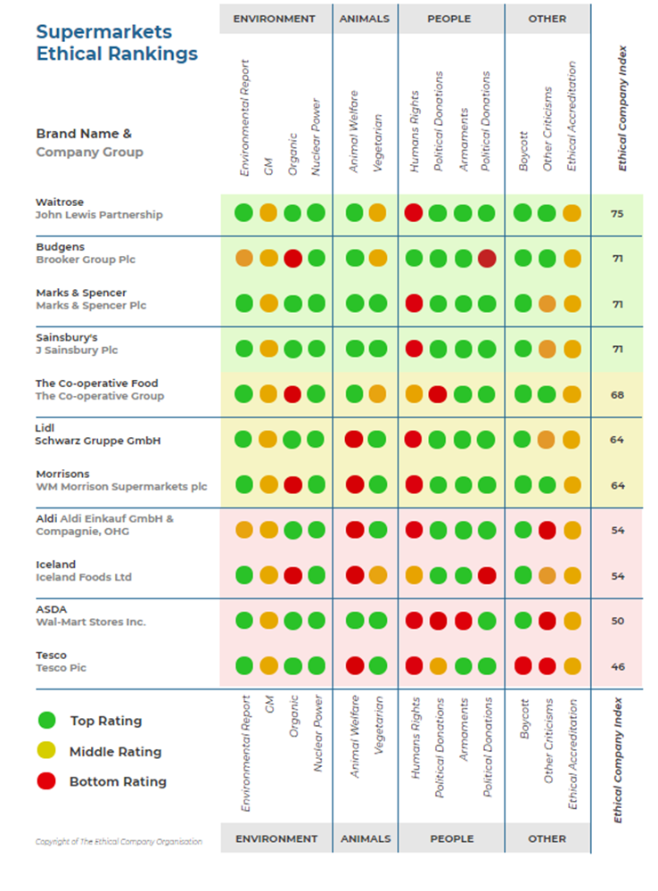

2.9 Conclusion

This literature review aimed to fulfil the primary research objective of this dissertation:
- To conduct an extensive literature review examining CSR and CSR policies and practices at Aldi.
This has been achieved to allow the researcher to develop a methodology on how to approach the data collection aspect of this thesis. It has given the researcher the foundations required to conduct data collection and the reasons to do so.

3.0 Chapter Three - Methodology

3.1 Introduction

This chapter will offer a summary and a justification of the research methodology employed in this thesis. Saunders et al. (2009) created a research planning process, called the ‘Research Onion’. The objective below was achieved within this chapter by the most appropriate choices in relation to the ‘Research Onion’:

- To evaluate CSR policies and practices at Aldi by conducting a survey of supermarket shoppers.

Primary research will be carried out in the form of surveys to consider the views of consumers in the supermarket sector in relation to consumer values towards CSR.

The use of a vast range of sources, that include the Aldi CSR report (Appendix 1), Aldi Principles (Appendix 2), alongside the research conducted and purposed within this methodology, will form a greater understanding about participants views on Aldi’s CSR stance and will make recommendations for how these principles can be improved to advance.

3.2 The Research Onion and Research Definition.

The researcher has selected a primary research method, that is the previously mentioned ‘Research Onion’, theorised by Saunders, et al. (2009), that will be implemented to recognise and rationalise the research strategy. This strategy will consist of the following aspects: data analysis techniques and data collection methods.
Research is a principle which can be outlined in the following way: a course of action, which holds the traits of organisation and systematism. It follows a direction which is logically guided by the usage of data, with the aim of investigating the put forth test or question (Punch 2016). Saunders, et al. (2009, p.9) define research as ‘something that people undertake in order to find out things in a systematic way, thereby increasing their knowledge’.
Ghauri & Gronhaug (2005) also attempt to define research, by affirming that it is built upon foundations of relationships and beliefs, which are both logical and opposed. The end goal of research, according to them, is to define, explain, understand, criticise, and/or analyse the data collected.

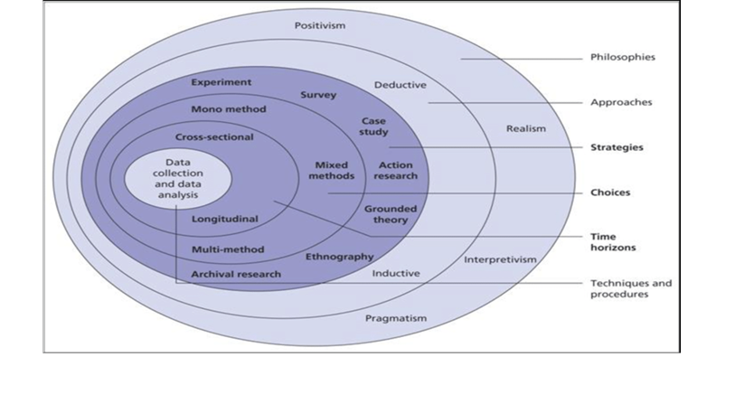
Figure 1 'Research Onion' Saunders, et al., (2009)
In the Figure 3.1, it can be visualised the concepts and sections within the Research Onion. There are multiple layers, highlighted are the aspects the researcher has chosen to use. By implementing this theory, it is basic to recognize a research strategy as deliberated by Saunders, et al., (2009). The researcher gains a directional guidance to be followed in the process of the research.
Saunders, et al. (2009) theory makes available the following options: attitudes, methods, policies, selections, time horizons, that can be conducted to give the research assistance in gaining entry to the optimum context of data.

3.3 Research Approach and Purpose

Saunders et al (2009) state that a deductive approach shapes the qualitative research process, which build upon on an existing grounded theory. Whilst the researcher acknowledges that there is an element of qualitative research using the CSR report (Appendix 1), the researcher is aware that the research will be appropriate in the form of an inductive approach. This kind of approach utilises research questions in a form of a survey to thin the overall focus of the study, in this case CSR is a broad range of differencing aspects. The inductive method embraces an investigation of potential configurations and recurring actions and then cultivates an overall theory as a result.

The researcher will use the inductive approach’s methods to allow change within the investigation; Bryman (2011) states that intensified adaptability, within the inductive approach, is possible. The previous observation gave the researcher insight into the reasonability of the plans to gather data, which is vital to the exploration, and subsequentially formed a conclusion from examining the CSR Report (Appendix 1). Within this research there was not any hypothesis or theories to which the researcher had to develop the conclusion around.
Exploratory research was detected as the most appropriate sort of research. Studies of this kind are significant methods for highlighting a overall sense of what is taking place and attaining perceptions of the research. This style of investigation is supportive in obtaining a precise issue. These investigations are adaptable enabling the examination to adjust the course of the research if required (Bryman, 2011).
This exploratory examination was reasonable as the researcher expected to pick up a comprehension into the branch of knowledge. Besides, there were two strategies for information gathering utilized.

3.4 Primary and Secondary Research

The process of gathering data first hand is referred to as primary research, which is specifically made according to the investigation. Secondary data is a collection of previous studies and other sources. Studies of research nature can comprise of both of these two types of data or can take use them individually (Schindler, 2014).
For this thesis, the researcher has acknowledged that both primary and secondary research is required. The necessity of the secondary research is highlighted by the mass content of the Aldi CSR report (See Appendix 1); this relevant literature will supply the structure to inform and guide the primary research.

3.5 Research Strategy and Data collection methods

The researcher establishes that there are two recognised research strategy: qualitative and quantitative.
Studies which endorse quantitative research analyse information that is mathematical. On the other hand, qualitative research investigates data in the method of a written format (Wilson 2010). Quantitative method is unbiased and emphasises determining actions, while qualitative methods are precise. Gathering quantitative and qualitative data can be done in many ways.
Surveys were conducted as primary research in order to gather the information needed for this research. Surveys are made of queries put towards a participant who has agreed to undergo the questionnaire. With the researcher having control over the format of the questions, there is a lack of control over the participants’ answers due to the fact that these answers are fixed or structured in way which is more flexible (Schindler, 2014).
The researches chooses the best strategy of primary research which enables to accomplish the objectives (Saunders et al., 2009), according to the properties and time available. A deep analysis of literature is vital to describe and explore the research. Therefore, this thesis utilises surveys due to the fact that it is a suitable method to achieve the aim and objective of the thesis.

3.6 Chosen Paradigm

Sections that researchers make are an outcome from a premise of two principle ideal models of social research. The two principles are called ‘positivist paradigm (closed)’ and ‘interpretivist paradigm (open)’ (Denscombe, 2014, p. 2). The researcher selected the latter of the two, due to the fact that it empowers the possibility to scan for principles that individuals use to understand social circumstances (Cameron et al., 2009, p. 57). This type of research forms areas of knowledge into individuals’ convictions and experiences. The methodology of this thesis suits this exploration as it utilizes quantitative information (Denscombe, 2014) yet the use of literature as a replacement to any qualitative data will enable the deemed appropriate paradigm.
Vast majority of the questions will involve quantitative analysis however, the open-ended questions will be evaluated qualitatively.

3.7 Survey Design

In this survey there are twenty five questions in total, with a completion time of roughly eight minutes. The categories of the questions are the following: participant demographics, supermarket shopping habits, supermarket opinion, understanding of CSR, knowledge of Aldi CSR. From the answers, the researcher obtained qualitative data via participants’ responses; this collection allows wider quantitative information analysis. Therefore the survey format enabled the storing and analysis of the data in an efficient manner for the researcher.

3.8 Research Sample

According to Saunders et al. (2009) the research is depending on a sample, which is reliable and reachable; therefore, it is not probable to gather information from the wider population. The word sample can be defined as a subdivision in relation to the population.
Saunders et al. (2009) continues by suggesting that opportunity sampling is a variation of sampling, which can be defined as a non-profitability method. Following on from this, the researcher has selected an appropriate and suitable method which is the previously mentioned ‘opportunity sampling method’.
Those who participated in the data collection providing data for the researcher, found the survey online within the reach of the researcher’s social media reach. The researcher didn’t have direct access to the company, due to privacy reasons and also the researcher wanted an unbiased opinion. The main reason for using the general public and supermarket consumers in general as a sample is for the unbiased view and opinion, this allowed the information to be reliable.
The resources for this study, which are reliable and accessible, are somewhat limited due to the fact that Aldi CSR reporting has not been an ongoing practice for a large quantity of years, and the business were not willing to engage with a formal interview. Subsequentially the researcher acknowledged the need of participants for the research, which then will be within the public domain. This requirement then lead to the use of non-probability sampling which is a technique utilised where there is no apparent sample frame.
The number of responses were limited due to the time constraint on this research. The minimum of surveys to be completed by participants was one hundred. If there was not a time constraint on the research, there would have been a possibility to carry out an interview which would have offered consideration towards additional data.

3.9 Time Horizon

The use of a cross sectional method instead of a longitudinal method was within the researcher’s remit. To understand the choice made by the researcher, it is vital to define what these methods mean. Longitudinal is ‘commonly’ employed in researches that consist of a long time frame, with annual data collection (Horn., 2012).
On the other hand cross sectional method is needed to answer research questions or to fill gaps within past researches. According to Saunders et al. (2009) this format requires the data to be collected over a number of days, weeks or months. Due to the time constraint on this project, the time horizon selected above was the best suitable to the research and the context of the research undertaken. It’s more suitable to a shorter time frame due to the collection research method.

3.10 Data Analysis

The surveys were collected and stored using the secure Google Docs system, which allows the researcher to clearly see the data in different formats; charts, graphs and a spreadsheet.
The researcher will use two main analysis techniques. On one hand a cross analysis, which allows the research to gain further insight by forming an overall summary. For Veal (2005) affirms that this type of summary lends itself to be employed to obtain deep looks into tendencies and patterns, and then will form the foundation for future statistical comparisons. Secondly the use of a keyword search will provide access to understand the wording used constantly within the CSR report (Appendix 1).

3.11 Pilot Survey

Before the final distribution of the survey, there was a trial of the survey amid colleagues to guarantee the stability and to gather opinions on improvements and areas of strength.
Daniel & Sam (2011) suggest that a trial of the survey should be carried out on a smaller scale before the certified distribution because it indicates to the researcher of any potential issues and subsequentially allows final alterations.
An undertaking of a pilot survey is somewhat vital because this data collection method (survey) will not allow respondents to request explanations of unclear elements (Thomas, 2003).
The complete survey can be seen within Appendix 3.

3.12 Reliability & Validity

Research-based reports, such as this one, should have valid and credible results and findings, which then should be able to undergo scrutiny. Sanders et al. (2009) state that to guarantee reliability and to minimize the chance of attaining inappropriate result is based on the two elements surrounding research design, which are: reliability and validity. These facets are vital of conducting research. Bryman (2011) recognizes that reliability is based on the possibility of the information gathered is repetitive.
Validity is reliant on the veracity of the final deductions made after the research. Kirk and Miller (1986) deliberate how significant is that the overall thesis would be considered as a valid, reliable and correct piece of academic literature. The literature review was the foundation of the understanding, which the researcher then used to design the survey. Kirk & Miller (1986) add to the previous point that questions should be unbiased and reviewed by an experienced dissertation supervisor, to ensure that no errors would be included; the researcher has done both of these points.
Designing the survey questions and the format was taken under extreme nature, this is due to the researcher not wanting to cause biases.
Remaining unbiased was one of the researcher’s main concern and focuses on ensuring that the surveys were completed with a simplistic fashion designed to allow the participant answer at their own will. Before the distribution of the surveys, the researcher and dissertation supervisor operated in a cohesive manner to make sure that the survey was in line with the previous criteria in relation to the aspects of reliability and validity; thus eliminating the possibility of participant error and invalid answers (Denscombe, 2014).

3.13 Limitations

The primary research within this thesis a limited time frame, which restricted different areas of possible research. The first restricted area was the sample, due to the fact that it would not be a representation of the entire retail sectors and the consumers; for the reach of the researchers’ distribution was constricted by the time frame. Saunders (2007) elaborates further on this by stating that the researcher’s aim and research would give a possible insight into the questioned industry, whilst maintaining no biases.
Secondly, the constraints did not enable the researcher to conduct primary research among a vast quantity of potential demographics. The willingness of respondents was also another limitation due to the fact that some potential participants within the demographics would not participate in the survey. Denscombe (2014) classifies an approach which is known as a “fairly self-contained’; the researcher implements this approach. Case studies have sometimes be criticised due to the fact that assumptions are usually regularly implemented; with this approach there may be benefits. The implementation of the case study approach within a thesis of this size and scale develops the researcher’s flexibility and method of defining, cultivating, and testing a theory.

3.14 Ethical Considerations

Within the research proposal of this thesis, an ethic form was completed (See Appendix 6). The ethic form guaranteed that all ethical reflections and deliberations were discussed before the start of the research (Horn, 2012). In this case of research there is a minimal risk of potential ethical hazards. Consideration was made about the vulnerable population, which may be reached by the distribution of the survey. Therefore, participants would be voluntary and over the age of eighteen, with all data collected stored anonymously and protected by password systems to gain access to a computer and the relevant software (Google Docs).

3.15 Summary

Within this methodology, the researcher had underlined the requirement and the necessity of using quantitative and qualitative research approaches, which will permit to obtain an enhanced knowledge and access to the data of the research topic (Denscombe, 2014). By conducting surveys with open members of the public the research can collect primary data from consumers of the UK supermarket industry.
The next chapter reviews the data collected by the survey to form a data analysis. The aim of Chapter 4 is to understand the results of the participants from the survey and an overview on Aldi’s released CSR reports using keyword searches.

4.0 Chapter 4 - Data analysis and findings

4.1 Introduction

The primary research conducted by the researcher will be shown, expressed and analysed within this chapter. The research consisted of a survey, which was distributed online, that regards CSR and Aldi. The sample was made of 141 participants. The overall analysis of this primary research data will include an oversight of the data provided by the participants.

The following results will be analysed, correlated and interpreted by the researcher in order to complete following objectives of the dissertation:
- To evaluate CSR policies and practices at Aldi by conducting a survey of supermarket shoppers.

- To synthesise extant literature and primary research to make recommendations for Aldi in the UK, to achieve a greater understanding and awareness from consumers of Aldi’s principles and practices.

Please note that the data will be presented within the format of a percentage (number of participants) for the benefit of the researcher to indicate the results and for the use of cross-referencing.
The survey can be formatted into four general sections that will accomplish different purposes for the research: Questions 1, 2, 3 and 4 are used to understand the overall and different demographics of participants; questions 5, 6, 7, 9, 10, 11 and 12 are to discover the general supermarket shopping habits, choices and basic opinions of general statements; questions 8 and 13 are to establish the understanding and awareness of which the participants have of CSR; and questions 14, 15, 16, 17, 18, 19, 20, 21, 22, 23, 24 and 25 focus on Aldi and the awareness of its CSR practices and principles, and the participants views this will allow the researcher to evaluate the effectiveness of these principles.
Due to the large quantity of questions, the researcher only shown only a number of the charts and graphs which are directly relatable to the direction of the research (See the others within appendix 4) . The researcher has also briefly analysed the results in certain cases there will be more information in Appendix 5 this in-depth analysis isn’t for every question just for the results which related and will be key to understand the overall survey and outcomes.

4.2 Data Analysis – Survey

4.2.1 Basic Demographics

4.2.1.1 Gender of participants
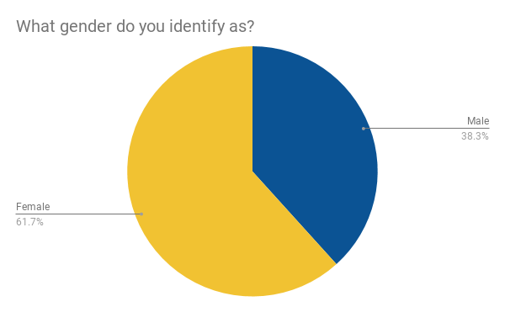
As the table indicates there were 87 female participants and 54 male participants. (See Appendix 5 for more detail).

4.2.1.2 Age of participants
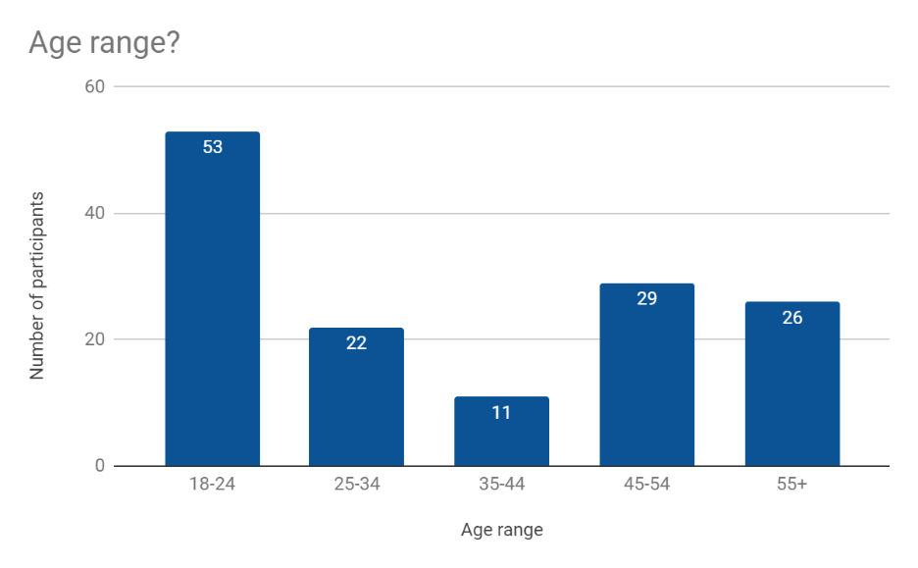

This chart shows the age ranges of participants, 18-24 was the highest age range in relation to number of participants, it is 38% of the participants. (See Appendix 5 for more detail).

4.2.1.3 Educational background of participants

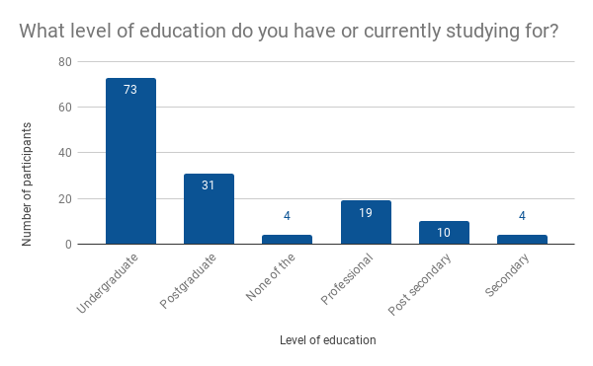

This pie charts highlights to the researcher that just over half of the participants have or are currently an undergraduate education. (See Appendix 5 for more detail).

4.2.1.4 Personal income of participants
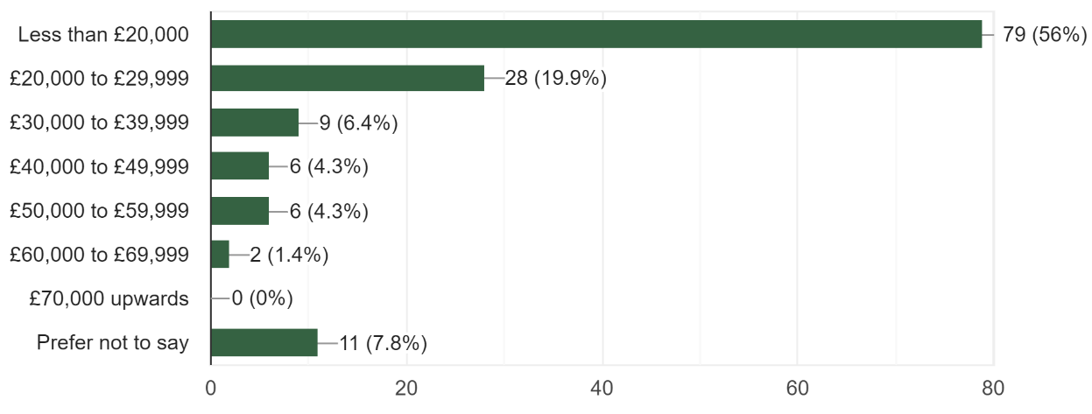
This chart indicates to the researcher that the biggest percentage of age is 1-24 at 38%, 52% of the participants are studying an undergraduate or have one , 56% of the income is less than £20,000. (See Appendix 5 for more detail).

4.2.1.5 Demographics conclusion

Considerable analysis of the demographics data collected can be found in Appendix 5. Here is an overview of the main demographic findings.
Firstly, this data will be linked with other questions later on due the importance of awareness, knowledge and understanding, with the previous analysis of age, the researcher can base further findings with the finding of these questions (See Appendix 5).
Secondly, this demographic data highlights that there is a underlining link, from the researcher’s reach with the survey, as the researcher matches aspects of the higher percentage of outcomes.

4.2.2 General Supermarkets
Shopping habits allow the researcher to investigate which supermarket the participants take their custom to, this can also be crossed reference with the basic demographics from example the personal income (See Appendix 5 for more detail).

4.2.2.1 Shopping frequency
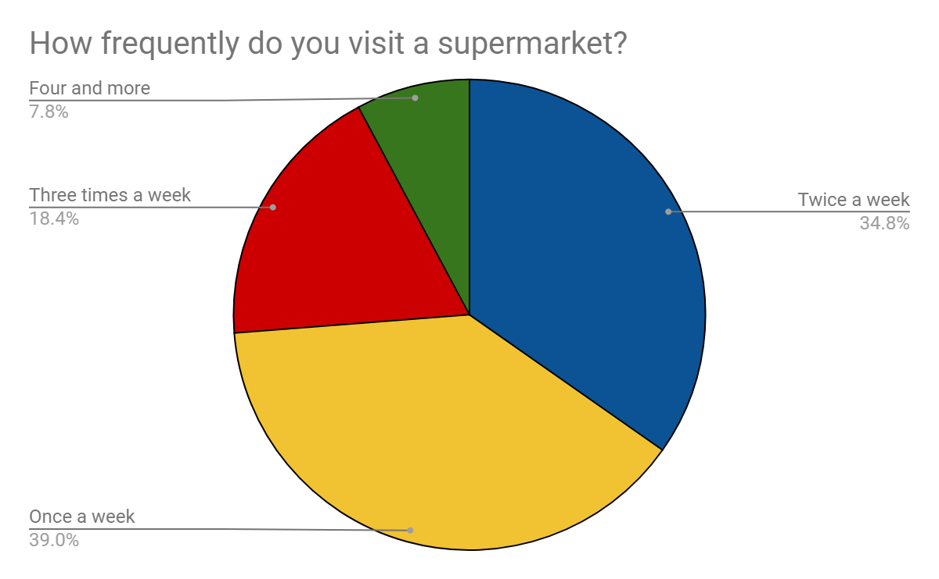

This data collected indicates to the researcher that the participants shopped mainly, once a week 39% and twice a week 34.8%.

4.2.2.2 Supermarkets visited

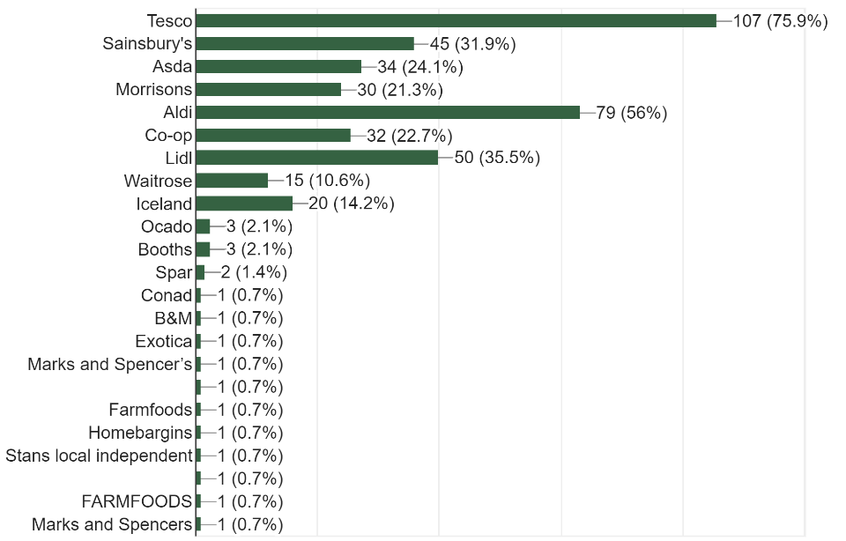
The researcher has collected the data and put it in the following table due to the figures above not combing participants’ additions together.
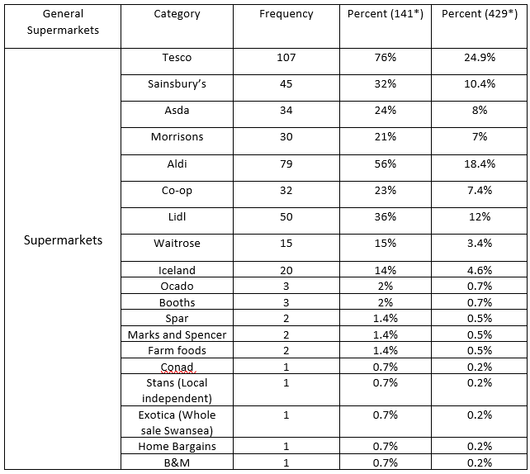
Percent (141*) – This column is the percent of the 141 participants who chose the option. (Example 76% of the participants selected Tesco).
Percent (429*) - This column is the percent of the overall count of sections made.
To understand this chart in detail the researcher is going to base some of the analysis with previous data, the income of the participants is key to the choice to where they shop. This is due to the available expenditure, 56% of the participants have a personal income of £20,000 or less. This is then shown by the popularity of the like of Aldi and Lidl both of which are known as ‘discount’ supermarkets (Thompson, et al. 2012).

4.2.2.3 Preferred supermarket
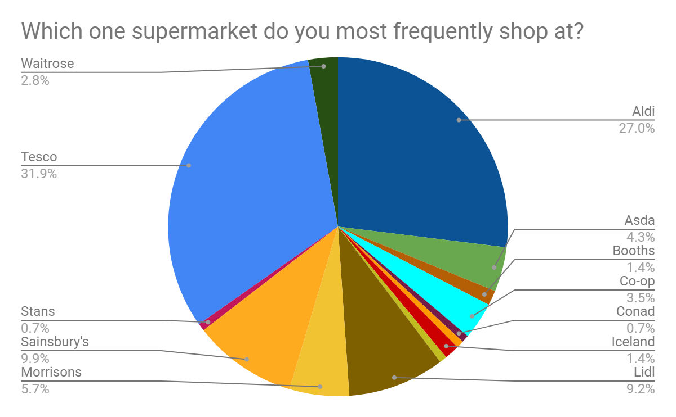
This chart highlights to the researcher the overall preferred supermarkets to the participants, it is clear that both Tesco (31.2%) and Aldi (27%) are the two most preferred supermarkets. (See Appendix 5 for more detail)
The researcher put the first supermarkets in the order of the current supermarket rankings to show how this demographic compares to the overall market share.
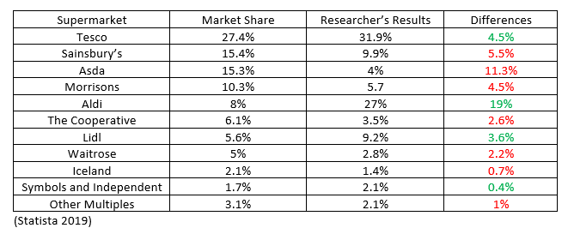
This table shows the difference in the market share and the participant’s choice of preferred supermarket. The colours are the results of comparing both columns and the difference, more is green and less is red.

4.2.2.4 Factors involved with supermarket choice

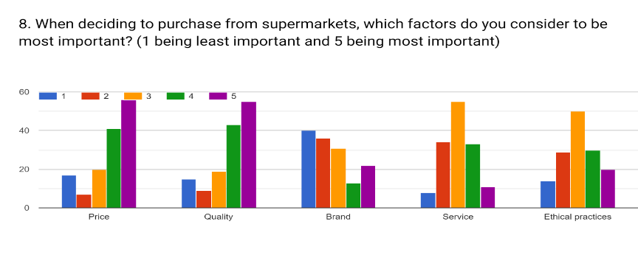
1 – Least important, 5 – Most important
This bar chart highlights multiple aspects of choice, the researcher has seperated below each section. This data is more accessible when it’s been broken down into subsections (See Appendix 5 for more detail).
The overview of the data is that participants feel that the most important factors are price and quality, this can be related to the preferred supermarket section (4.2.2.3) as Aldi represents the lower price point and quality, and in addition Tesco.

4.2.3 CSR concept
The researcher was interested to see what the open public what think CSR meant, or the understanding which people had of it. It was an open question within the survey to allow participants have open input.

4.2.3.1 Participant definitions of CSR
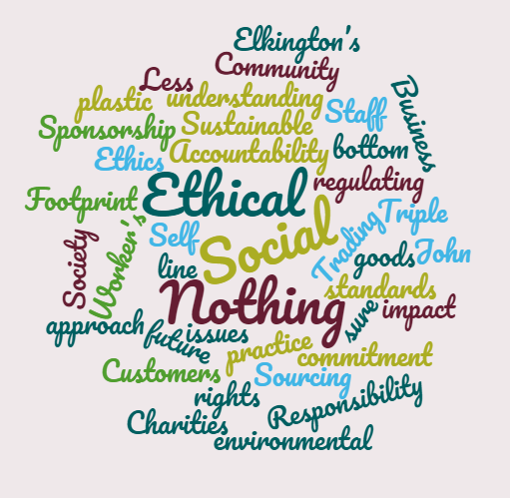
This is a representation of the open answers the researcher received from the participants of their understanding of the concept of CSR. 42 of the participants were either one of the following: No understanding, Nothing, N/A, Unsure, No idea, question mark.

4.2.3.2 CSR Reporting awareness

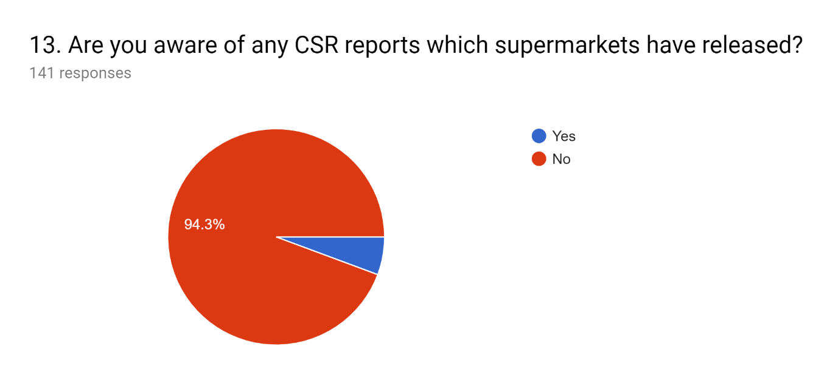

4.2.4 Aldi Section
Within this part of the data analysis the researcher will investigate the result of the questions within the Aldi section of the survey.

4.2.4.1 Awareness of the CSR aspects of Aldi's business practices
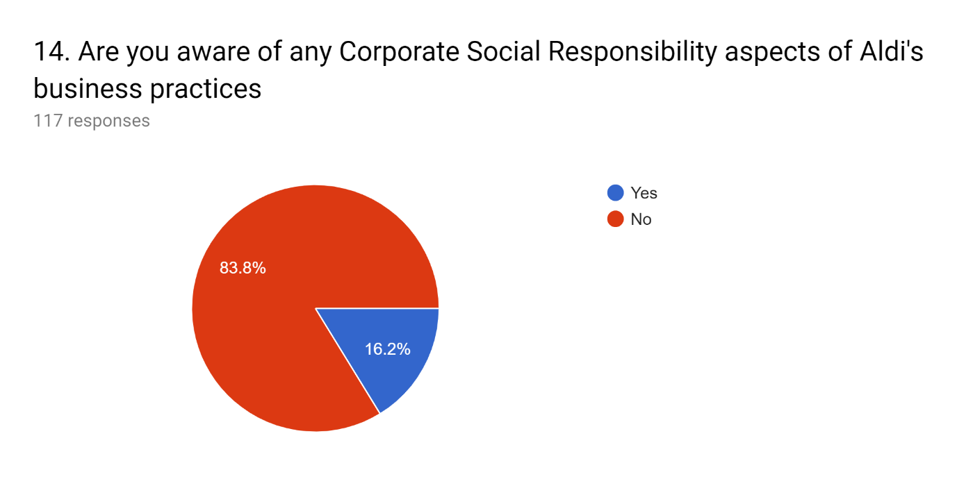

The aims and objectives of the research is to investigate the CSR practices of Aldi and evaluate them, and this negative awareness of the practices is a huge stumbling block. The fact that 83% of participants are unaware and linking it with the fact that 27% (4.2.2.3) chose Aldi as a preferred supermarket highlights the following statements.
- CSR aspects of supermarkets are not known widely.
- Aldi customers are unaware of the practices of Aldi.
(See Appendix 5 for more detail)

4.2.4.2 Aldi operational manner
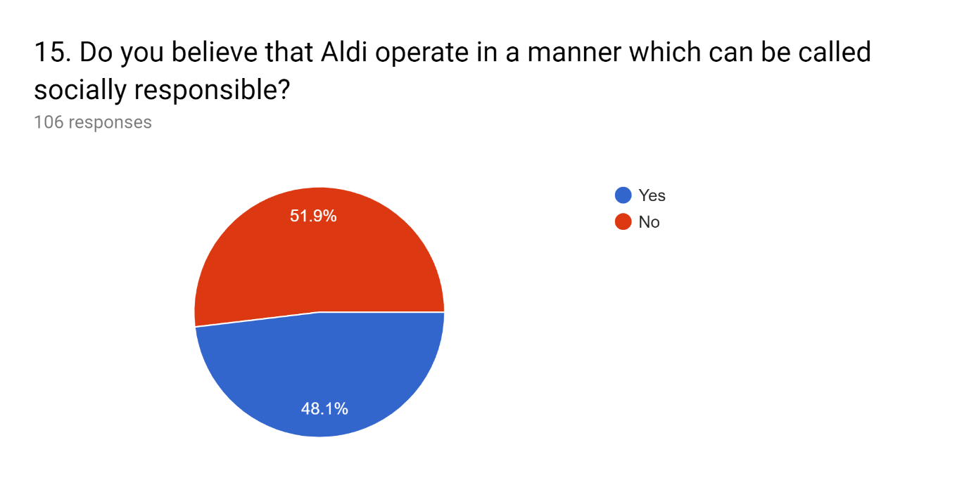

The researcher was to the highlight that 35 participants didn’t select an answer which can be presumed that they didn’t know the manner in which Aldi operate. This indicates that people are aware of the manner in which Aldi operate, on the other hand 44 participants believe that they don’t operate in a socially responsible way, this is linked to Aldi charitable commitments (4.2.4.9).

4.2.4.3 Awareness of Aldi's charitable commitments
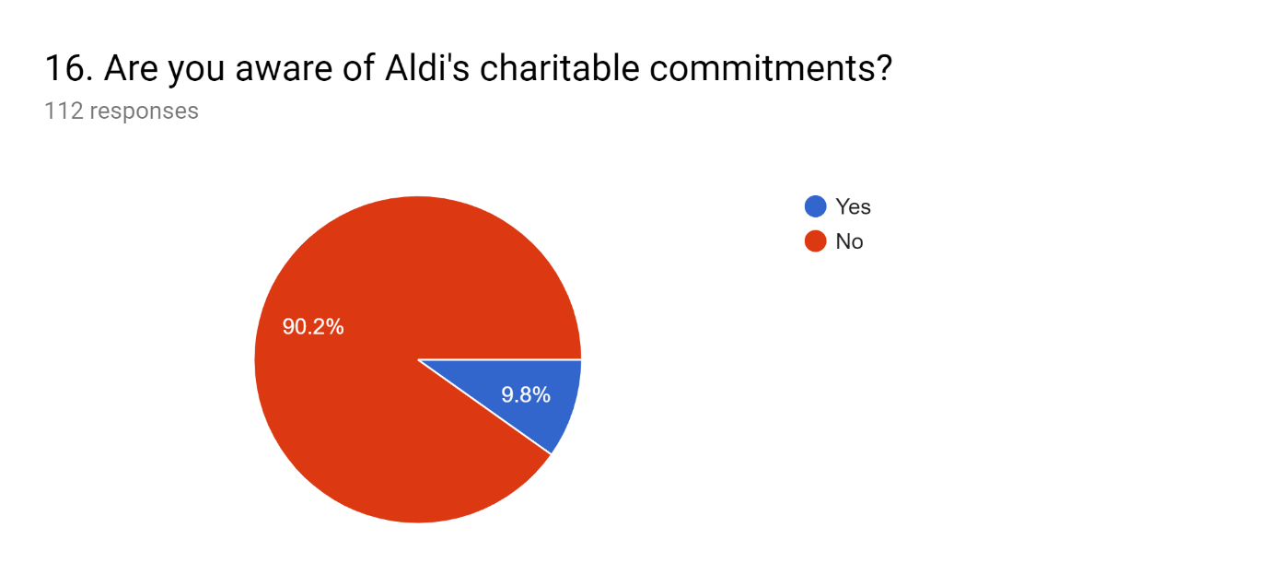
This chart above highlights that the vast majority of the participants are unaware of the charitable commitments of Aldi.

4.2.4.4 Awareness of any environmental commitments which have been published by Aldi

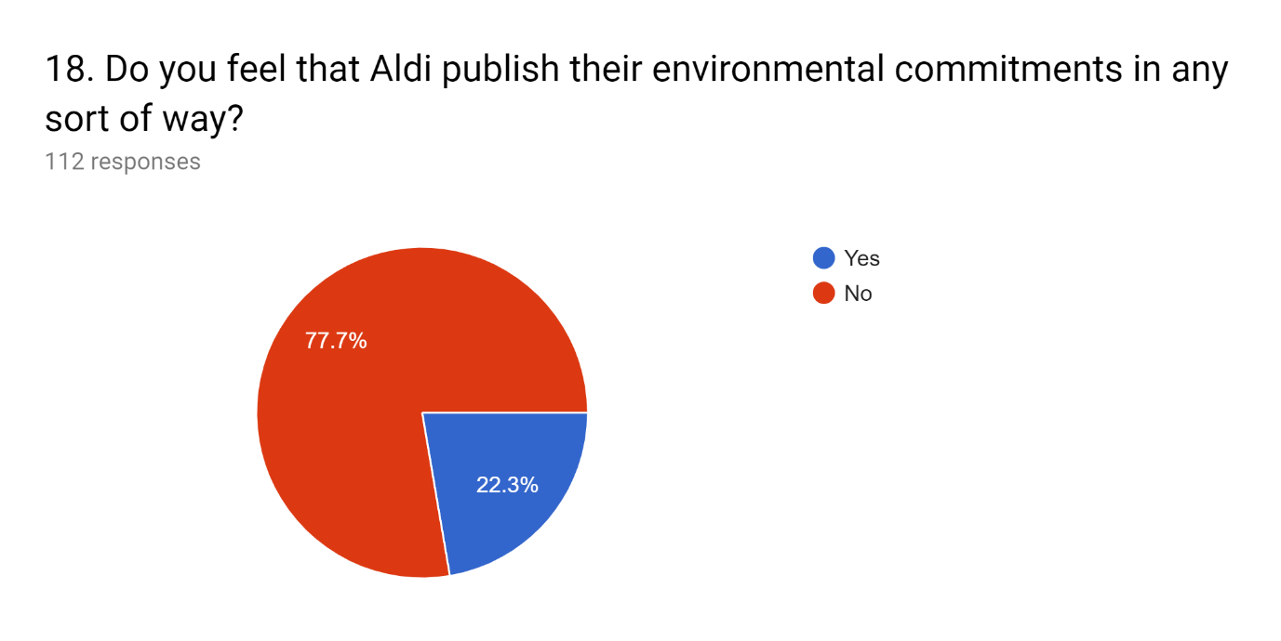

The researcher ask this question in direct relation to the CSR report and awareness of it, the fact that only 112 out of the 141, could lead to misrepresentation. Yet the researcher makes to it clear that 78% of those who answer are unaware of any published documents, posters, online new and reports.

4.2.4.5 Awareness within the Aldi supply chain
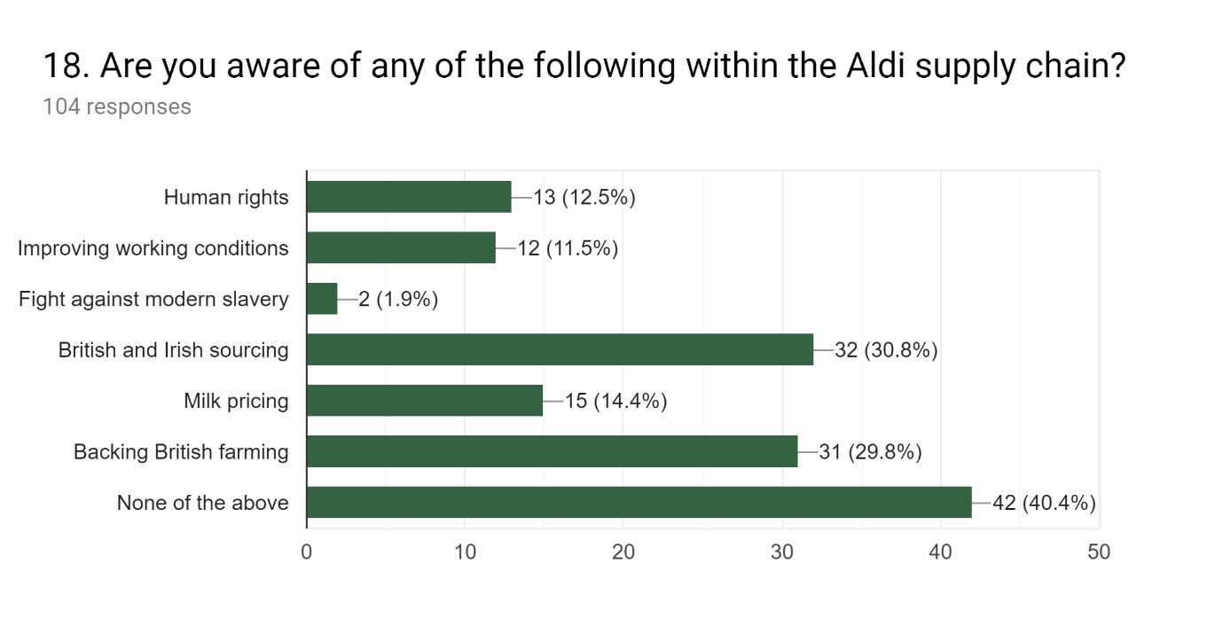
This chart highlights that 40.4% of the participants are unaware of any of sections within the Aldi supply chain, yet 30.8 and 29.8% are aware of sourcing and farming, which shows Aldi have advertised this in such a way that some of the participants are aware of it.

4.2.4.6 Aldi statements application to participants
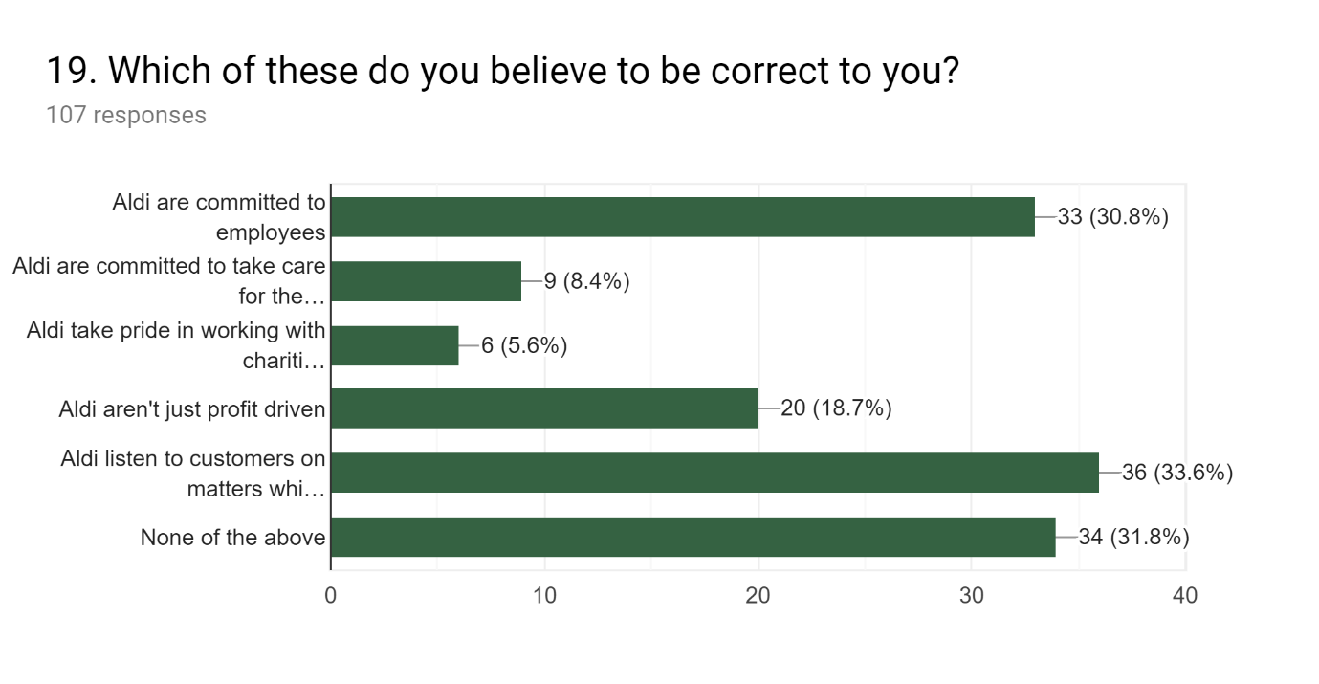
This chart demonstrates a multiple aspects to the researcher, firstly 31.8% of the participants selected none of the above which is a large percentage of the overall percentage. Secondly 30.8% believe that Aldi are committed to employees and 33.6% believe Aldi listen to customers on matters which regard responsibility.

4.2.4.7 Rating Aldi CSR practices
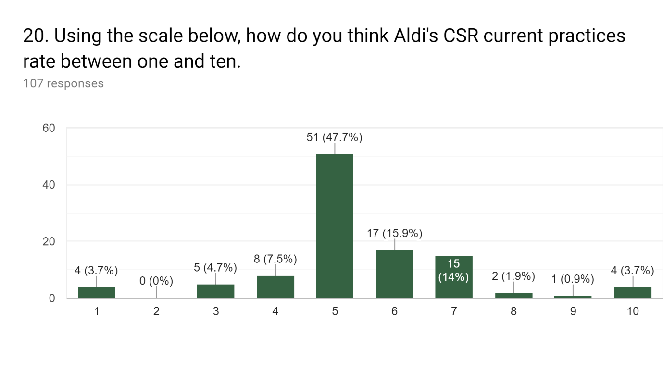
This chart highlights that 47.7% of the respondents think Aldi’s current practices rate in the middle of the range, 29.9% believe that their current practices are past the middle ground are more of a 6/7 out of 10.

4.2.4.8 Awareness of Aldi statements
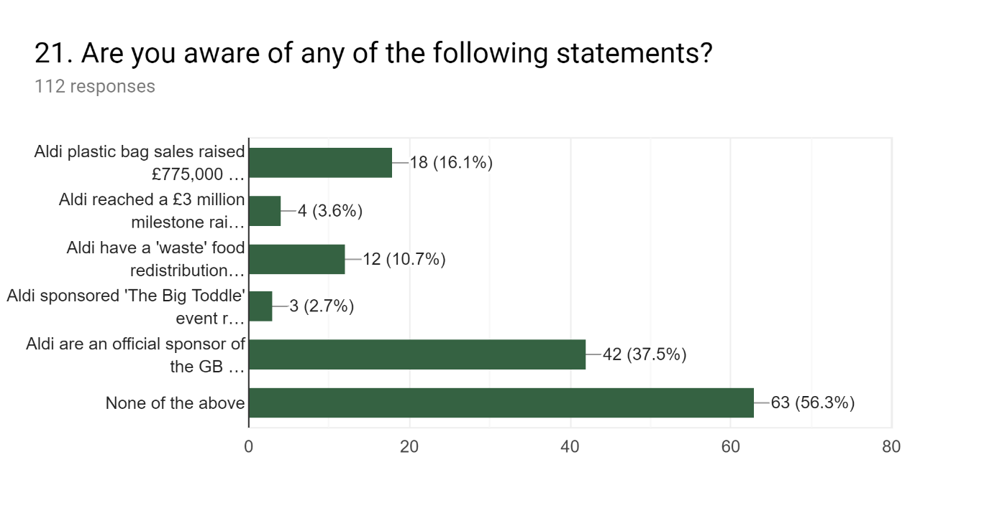
This chart highlights that 56.3% of the participants are unaware of any of the statements, the main statement which participants recognised was that Aldi are the official sponsor of team GB with 37.5%. Yet the massive fund raising for Teenage Cancer trust was only known by 4 participants, this is a massive indication of not publishing this achievement correctly.

4.3 Survey conclusion

The overall outcome of this data collection and the previous analysis is that participants are mainly unware of the Aldi CSR policies and practices. This will be discussed further within Chapter 5.

4.4 Data Analysis – Literature

In this section of the analysis the researcher decided in investigate the Aldi CSR report (Appendix 1) for the reasons which are highlighted in Chapter 2, this analysis allows the researcher to highlight data which can be used to base foundations on.

Key words in relation to CSR

The researcher ran an organic search which Hemann and Burbary state is a search of pages ‘that are tied to a specific keyword.’
Researcher has decided one of the data analysis elements will consist of the use of ‘key’ words associated with CSR, to develop an understanding regarding Aldi’s wording and actual usage of these words.
Word | Amount of times used
CSR | 1
CR | 171
Environment | 79
Susainable(ility) | 92
Energy | 30
Green | 41
Responsible(ity) | 61
Emission(s) | 85
Waste | 41
Community | 38
People | 39
Well-being | 8
Supply chain | 62

For the actual context of the report the usage of these words is quite low in compared to expectation, this could be to do the difference of understanding the concept of CSR. It could be the researcher’s over estimate of what the word count would be.
This could be related to the fact that Aldi could be aware of the issue of consumers not being aware of academic definitions of CSR, and the branches it covers. This could be proven by the survey sections based on awareness of CSR reports (4.2.3.2 and 4.2.4.5 for example).

5.0 Chapter Five – Discussion

The following chapter has the aim to address the third objective of this thesis:
3. To synthesise extant literature and primary research to make recommendations for Aldi in the UK, to achieve a greater understanding and awareness from consumers of Aldi’s principles and practices.
The results of the online survey will be studied and analysed further, also combined and compared to the literature deliberated in Chapter 2, together with the CSR report (Appendix 1).

5.1 Main Findings

5.1.1 Low income expenditure in discount supermarkets

The researcher understands that the question on educational background, can be a ‘proxy’ for the income of a participant. It is argued that the educational level gives an impression of the respondent’s income, or more generally its socio-economic status (Dobronte, 2013). At the micro level the agents and units of interest are typically individuals and households and activities of interest are economically productive activity, consumption activity, saving and capital accumulation. (Jenkinson, 1998)
As stated in chapter 2 and in relation to the overall direction of this research, Aldi are a ‘discount’ supermarket, this is stated within its own name ‘Albrecht Discount’. The income is vitally important for later analysis (Supermarket preference). The following section of the participants; age, education and income, can all be interlinked. The biggest percentage of age is 1-24 at 38%, 52% of the participants are studying an undergraduate or have one , 56% of the income is less than £20,000. These elements put together highlight to the researcher the following observations, firstly that there could be the possibility that there are a quantity of students and recent students who are on a low income which effects the shopping habits due to lack of personal expenditure. Finally, the fact that over half (56%) of the participants earn less than £20,000 has a direct effect on the shopping habits. Lautiainen (2015) states ‘The income level affects what consumers can afford and the perspective towards money’
This finding literally points at the spending of low income household’s towards price related factors (4.2.2.4) it has been noted that participants believe priced is very important when choosing which supermarkets to shop at.

5.1.2 Aldi CSR principles

As stated in the aims and objectives the researcher was going to analyse the CSR practices undertaken by Aldi. The researcher is aware that the CSR report (Appendix 1) will be biased due to the fact it is written by Aldi for Aldi, yet there are some independent audits within the report, yet Aldi could leave out sections which reflect negatively. The researcher will discuss section by section and highlight the positive aspects and areas for more insight which Aldi may have not included due to reasons, in Chapter 2 there is a chart highlighting Aldi’s rank with areas of weakness this will be used as a guidance. The table is colour coded, green for top rating, amber for the middle rating and red for bottom rating.
Environment
Environmental reporting this on the table was an amber score which the researcher has developed the reasoning as that the reporting format and process has only been introduced recently as the data given by Aldi in the CSR report is the past three years, which could highlight the neglect of reporting in the past.
Genetically modified section was given an amber rating, yet so were the other supermarkets on the list, this could be to the fact there may not be good or bad practices undertaken by the supermarkets.
Organic was given the top rating and within the CSR report (Appendix 1, page 86) there are huge indications of the progression which Aldi have undertaken to improve organic sourcing. Fish sourcing for example the percentage of sales of certified aquaculture products is one of huge progression, 38.25% in 2015, 55.68 in 2016, and 64.38% in 2017.
Nuclear Power was given the top rating this is then interlinked with the CSR report yet again, with the topic of refrigeration (See Appendix 1, page 68) Aldi have implemented ‘efficient technology, electronic controls, and continuous monitoring of electricity consumption help us to save both costs and energy and thereby avoid unnecessary emissions.’
Animals
Animal Welfare this was given a bottom rating yet Aldi have got certification from recognized animal welfare organisations in Chapter 2. This could demonstrate that Aldi have issues which haven’t be resolved within its supply chain or this rating was done without the knowledge of the ethic within the supply chain of Aldi.
Vegetarian section of Aldi ethic was given a top rating this is down to the large amount of products Aldi have introduced which are an vegetarian, this is can be related due to the maximisation of profits.
People
Human rights this section was given a bottom rating yet Aldi report great improvements within its supply chain with auditing system into the human working conditions. Yet there is no date on the table, Aldi improvements could have been a result of this information are error within its supply chain.
Political Donations was given a top rating, this could be related to the philanthropic aspects of Aldi’s business, all the money it’s raised for different charities etc.
Armaments this section was given a top rating due to the fact Aldi aren’t involved with this ethical area of operation.

Other
Boycott this is the Ethical Company Organisation’s opinion whether to boycott Aldi or other supermarkets on this list, Aldi have a top rating so the organisation does not recommend boycotting Aldi for ethical practice issues.
Other Criticisms this was given the bottom rating, these criticisms aren’t stated yet the researcher wants to express what these could be by reviewing the survey and literature.
Firstly the fact that respondents to the survey highlight that they believe Aldi over use plastic on packaging and should introduce bio-degradable bags, these areas are possible areas of criticism. Secondly Aldi haven’t been reporting before 2014/2015 this is made apparent with the key figure section and the dates shown on the comparison tables or this could be that Aldi were operating in such a manner which wasn’t a good standard compared to current operations. Finally as stated this table ranking could have been before the improvements implemented by Aldi, so it’s outdated to what Aldi have changed.
Ethical Accreditation, Aldi was given an amber rating of 54 which shows the improvement of areas, yet as the researcher highlighted the Aldi CSR report states multiple aspects of improvements in area this table suggests Aldi struggle with ethical.

5.1.3 Unawareness of Aldi CSR commitments and practices

One of the main findings of the survey is the overall lack of knowledge towards Aldi and its CSR practices. It is highlighted among the first related question towards the awareness of any CSR reports published by any supermarkets which 94.3% of the participants we not aware of any. This was the first indicator to the researcher that the participants may not be aware of any Aldi’s operations, commitments and principles. This is then followed by multiple questions were the participants were unaware of the practices, the researcher does take into account that not everyone who was answering the Aldi section shopped there due to the fact that the data collected previously on supermarket shopped at.
With this in mind the researcher has developed the understanding that even if the participants do not shop at Aldi there should be some basic understanding of its practices. Yet throughout the questions related to the awareness of Aldi CSR operations participants were unaware, yet Aldi advertise these on section of the website (Aldi Website 2019)) it is not the first thing that people will see when they go on the website.
This whole issue of participants can be directly related to the following statements:
- Aldi don’t see the reason in advertising CSR achievements and operations
- Aldi are unaware of the lack of knowledge among the consumers
- CSR is not what Aldi are focusing on as a business
These statements can be broken down;
Firstly, Aldi don’t see the reason in advertising CSR achievements and operations, this could be related to the consumer of the Aldi brand and idea. The income related to the shopping habits understood by this researcher does not represent the whole population it is only a sample but Hymann (2019) states ‘The supermarket is as strong with affluent people as it is with people on low incomes’. This could be due to special buys and the wider range of priced products, from basic to specially selected ranges. Aldi are a supermarket with prices which are overall much lower than the likes of Tesco, Sainsbury’s and Co-op, this is then lead on the adverts which are produced, comparing prices. The Aldi direction has amassed consumer which have changed shopping habits for lower prices even if they can’t get the brands they are accustomed to.

Secondly, Aldi are unware of the lack of knowledge among the consumers this statement is in direct relation to the survey which highlighted the multiple aspects which participants were unaware of. This could be down to the previous statement that Aldi aren’t interested in the consumer understanding due to the price point. The researcher believes that Aldi are committed to the community around to due to the quaintly of money raised for Teenage Cancer Trust, this highlights that Aldi do care about its CSR principles. The question is whether Aldi understand the lack of knowledge or whether they care if consumers know, but as a modern day consumer. Epstein-Reeves states in 2010 that ‘More than 88% of consumers think companies should try to achieve their business goals while improving society and the environment’ and in addition he continues to state ‘83% of consumers think companies should support charities and non-profits with financial donations.’ Due to the these statements it could be that Aldi are publishing their CSR commitments and achievements in the wrong channels where consumers won’t look into, it could be Aldi should do a wide range of adverts across different channels available to increase consumer awareness.

Finally, CSR is not what Aldi are focusing on as a business this statement interlinks to comments made previously about Aldi’s focus on price point. CSR can be a costly thing to implemented for example the audits which Aldi carried out internally and externally must have had costing towards it, the change of the production of a product, these two elements are basic understanding of Aldi’s progression which can be seen with the CSR report (See Appendix 1).
There are reason how CSR when implemented correctly can reduce costs over a period of time. Rangan, et al (2015) state ‘Thus they may—but don’t always—increase revenue, decrease costs, or both. Examples include sustainability initiatives that reduce resource use, waste, or emissions, which may in turn reduce costs; and investments in employee working conditions, health care, or education, which may enhance productivity, retention, and company reputation.’ This could be an outcome with further reduces the price point of products or yields a greater income. This could put the question forward, whether Aldi are in this for the ‘greater good’ or profit driven, the survey has a question with a link to this theory. 18.7% of participants believe Aldi aren’t just profit driven, this gives the researcher the insight that 81.3% believe that Aldi are just profit driven.

6.0 Chapter Six – Conclusion

This final chapter of the thesis contains the following closing discussion of CSR polices and practices of Aldi, and conclusion of opinion for the participants of the survey. This chapter also contains a discussion of each individual objectives with an analysis on the completion of the objectives. The limitations of the study will be investigated and measured, as these limitations will the be followed by the recommendations for further study within the field of research.

6.1 Summary of Main findings

The analysis of the quantitative data collected alongside the literature available in the form of Aldi CSR report (Appendix 1) revealed multiple stimulating and relevant findings to underpin the literature adjoining this topic area. Firstly, it is perceived a correlation between personal income and the choice of preferred supermarket, this is demonstrated within the results and the discussion. As the researcher distinguished that the participants of the survey based the ethical factor towards the choice of supermarket after the price and quality of the products, this highlights the consumer behaviour.
Secondly, the comparison of Aldi principles and practices to the table in Chapter 2, demonstrated the weaknesses within the Aldi operations with the literature from Chapter 2 it allows a wider understanding. The researcher raised issues with the use of the table to compare off due to the possible date of release, Aldi have only recently implemented the CSR principles and obviously over the years improved aspects of the operations within the practices and polices this is shown throughout the progression of data (See Appendix 1, pages 77-100).
The data collection and analysis highlighted the main finding of the research with is the lack of awareness among the participants of CSR, and mainly Aldi’s practices and principles. This is highlighted in direct questions in the survey and the combination of the data, which is then discussed proves to the researcher that there is a massive issue and concern on the part of Aldi. This is due to the fact that Aldi have implemented and improved aspects of the business operations over the past few years to benefit themselves and the wider community, environment surrounding the business, yet have not communicated these achievements in the right manner.

6.2 Aims and Objectives

6.2.1 Objective 1

- To conduct an extensive literature review examining CSR and CSR policies and practices at Aldi.

This first objective was accomplished in this thesis by the researcher via Chapter 2: it was used the Aldi CSR report (Appendix 1), and a vast range of articles, journals, webpages and text books. These previous academic literature and supporting literature developed a detailed summary of the subject area for this research. The researcher established a suitable foundation for this thesis with a well-informed direction of study, by the following sections being implemented: an overview of related theory of CSR and CSR models, Aldi’s CSR policies and practices and issues of CSR within supermarkets.

6.2.2 Objective 2

- To evaluate CSR policies and practices at Aldi by conducting a survey of supermarket shoppers.
The second objective stated above was completed by the circulation of the online survey which rendered 141 responses from participants, who were consumers of the UK supermarket industry. Chapter 2 enabled the researcher to develop an appropriate methodology with was considered and assembled in Chapter 3. The results of the survey were analysed within Chapter 4, and a critique of the results was conducted within Chapter 5.

6.2.3 Objective 3

- To synthesise extant literature and primary research to make recommendations for Aldi in the UK, to achieve a greater understanding and awareness from consumers of Aldi’s principles and practices.

Chapter 5 was where this third and finally objective was conducted and finalized. Chapter 5 contained the findings of the research, which were discussed in relation to the overall evaluation of the literature and the main findings of the survey. This discussion provided the researcher with a basis which could be used for the implications of the researcher for organisations, alongside recommendations for further study. These two elements are discussed in the sections below.

6.3 Implications of research

The findings of this research have multiple implications for both academia and the supermarket industry in the UK, mainly Aldi, the wish to implement CSR policies and practices within its business operations. It supports current literature and provides an additional approach to a case study regarding CSR in Aldi, but it also highlights the areas of weakness and improvements for such principles and policies. This understanding suggests that if Aldi fix these issues and make consumers more aware of the CSR policies and practices within its operations then it could be an advantage point over its competitors to go alongside the price point advantage which they currently hold.
The findings have all indicated the limited efficacy of understanding and knowledge of CSR within consumers. Therefore it has been highlighted that low income will be a factor on the choice of supermarkets this is a factor which picked over ethical practices as more important to the participants of the survey. Going forward it will be vital for Aldi to commutate the CSR principles and practices in operation for the growth of awareness among existing consumer and possible potential consumers, who may decide to shop at Aldi due to its operations.

6.4 Limitations

The limitations of this research can be directly related to the issues raised within the methodology: time frame, sample size and collection type.
Firstly, the time frame of research was a limitation due to the fact that the researcher could not conducted a prolonged primary research, which could have included an interview or focus groups. These aspects would then provide the researcher a more in-depth analysis and understanding of the subject area.
Secondly, the sample size; this aspect of the primary research was an underlining limitation as the demographic sample was not an overall sample which could have been accomplished with the use of paper surveys and sharing the online survey across different online platforms to research as many people as possible,
Thirdly, the method of approach; the research used a mono-method of primary research which provided only quantitative data. This method was satisfactory in the terms of reaching the overall aim and the objectives of this thesis, for it did provide an insight and reliable data; yet it was limiting within certain aspects.
Finally, the complex nature of the subject area of research. CSR is a vast topic area as stated in Chapter 2 with the array of different and conflicting definitions. This may be a vital limitation in this researcher as the survey highlighted the lack of aware of CSR, and CSR within Aldi’s practices and polices
A key limitation of the research was the use of a mono-method approach, this allowed the collection of only quantitative date. This was adequate to reach the aims and objectives of the dissertation and provided both interesting and reliable data. Alongside the use of the CSR report produced by Aldi there was no qualitative data collected for example an interview. The nature of the survey may have had an impact of the respondents understanding of the question put forward to them, despite the researcher’s efforts to design and format the survey in a clear and concise manner. This understanding could then be seen that the participant’s responses may be based on a misunderstanding or a lack of knowledge on the topic area.

6.5 Recommendations for future research

The recommendations for future research can be based off the limitations and outcome of this research. The sole use of a survey could lead to the future advancement by using interviews and other methods of primary research. The addition of an alternative method would allow a wider and larger analysis of the data alongside a deeper analysis of the CSR report (Appendix 1) would provide a deeper understanding and knowledge with this case of Aldi.
Stated previously in the limitations, the distribution of the primary research could be improved and attain a larger representation of the population, which would allow further application of theory and literature.

Finally, this research focused on the CSR operations of supermarkets, directly Aldi and surveyed participants on their opinions. It would be interesting to conduct further research on the other side, from the perspective of the supermarkets fulfilling the demand of implementing CSR operations and practices. This would allow the development of understanding both sides of CSR within the supermarket industry, the consumer and the business.

7.0 Chapter 7 – Bibliography and References

A.Kolk (2010) Trajectories of sustainability reporting by MNCs Journal of World Business, 45 (4), pp. 367-374
Aldi Community 2019 https://www.aldi.co.uk/about-aldi/corporate-responsibility/communities
Aldi CR Report, 2017 page 45 https://cr.aldisouthgroup.com/sites/default/files/2018-07/ALDI%20SOUTH%20Group%20CR%20Report%202017_0.pdf
Aldi Energy Efficiency 2019 https://www.aldi.co.uk/about-aldi/corporate-responsibility/environment/energy-and-transport-efficiency
Aldi Group History 2010, Company Histor ://www.fundinguniverse.com/company-histories/aldi-group-history/
Aldi Plastic Pledge 2019 https://www.aldi.co.uk/about-aldi/corporate-responsibility/resources-for-our-products/product-packaging-and-waste
Aldi Roach Bros, 2019 https://www.aldi.co.uk/meet-our-suppliers/roach-bros
Aldi website (2019) https://www.aldi.co.uk/awards
Aldi website, History, 2019 - https://www.aldirecruitment.co.uk/about-us/
Aldi WEEE 2019 https://www.aldi.co.uk/customer-services/weee
Aldi Welfare Policies 2018 https://www.aldi.co.uk/about-aldi/corporate-responsibility/resources-for-our-products/animal-testing-and-welfare
Alstete, Jeffrey & Halpern, David. (2006). DIVERGENT OPINIONS OF THE PROPER ROLE OF CORPORATE SOCIAL RESPONSIBILITY IN TWENTY-FIRST CENTURY AMERICA.
Ariola, M. M., 2006. Principles and Methods of Research. Philippines: Rex Bookstore.
Baker, M. (2015). Corporate social responsibility - What does it mean? Retrieved from Mallen Baker: http://www.mallenbaker.net/csr/definition.php
Barrientos S. Globalisation and ethical trade: assessing the implications for development, Journal of International Development , 2000, vol. 12 (pg. 559-570)
Beltratti, A. (2005) Geneva Pap Risk Insur Issues Pract 30: 373. https://doi.org/10.1057/palgrave.gpp.2510035
Blowfield M. Ethical trade: a review of developments and issues, Third World Quarterly , 1999, vol. 20 (pg. 753-770)
Bowd, R., Bowd, L., Harris P. (2006) Communicating corporate social responsibility: an exploratory case study of a major UK retail centre. Journal of Public Affairs, Vol. 6, pp. 147- 155.
Bowie N., Werhane P. 2005, pg.25. Management Ethics. Oxford: Blackwell.
Brenner, S., & Cochran, P. (1991). The stakeholder theory of the firm: Implications for business and society theory and research. Annual Meeting of the International Association for Business and Society. Sundance, UT.
Bryman, A. &. B. E., 2011. Business research methods. 3rd ed. Oxford : Business research methods.
Cameron et al., 2009. Business Research Methods A practical Approach. London: Charterted Institue of Personnel and Development.
Carroll (1991) The pyramid of corporate social responsibility: Toward the moral management of organizational stakeholders
Carroll, A. B. (1979). A three-dimensional conceptual model of corporate performance. The Academy of Management Review.
Carroll, A.B. and Buchholtz, A. (1999) Business and Society: Ethics and stakeholder management. 4th edition. Cincinnati, OH: South-Western College Pub, pp.37-85.
Christopher Thompson, Graham Clarke, Martin Clarke & John Stillwell (2012) Modelling the future opportunities for deep discount food retailing in the UK, The International Review of Retail, Distribution and Consumer Research, 22:2, 143-170,
Coffey A., A. P., 1996. Making sense of Qualitative Data. 1st ed. London: Sage Publications
Collis, H. &. H. R., 2009. Business research : a practical guide for undergraduate and postgraduate students. 3rd ed. Basingstoke: Palgrave Macmillan.
Confino, J., & Drummond, J. (2010). Why CSR is not enough to create a sustainable world. The Guardian.
CR Policy , Aldi, 2017 https://corporate.aldi.us/fileadmin/fm-dam/Corporate_Responsibility2/CR_Policy/ALDI_Corporate_Responsibility_Policy.pdf
Craven, R. (2015). Let's Be Real: Why Transparency in Business Should Be the Norm. Retrieved from Entrepreneur: http://www.entrepreneur.com/article/244474
Crispin Jenkinson, 'Measuring Health Status and Quality of Life' 1998, Question Bank Topic Commentary on Health, http://qb.soc.surrey.ac.uk/topics/health/jenkinson.htm [The Question Bank is an ESRC funded Internet social survey resource based in the Department of Sociology, University of Surrey.]
Cruelty Free International 2018 https://www.crueltyfreeinternational.org/what-we-do/breaking-news/aldi-leaps-2018-cruelty-free-certification
Dahlsrud, A. (2006). How Corporate Social Responsibility is Defined: an Analysis of 37 Definitions. Corporate Social Responsibility and Environmental Management, 15(1).
Daniel, P. S. & Sam, A. G., 2011. Research Methodology. 1st ed. New Dehli: Gyan Publishing House.
Denscombe, M., 2014. The Good Research Guide. 5th ed. Berkshire: McGraw-Hill Education.
Dobronte, 2013 https://www.checkmarket.com/blog/socio-demographics-online-surveys/
Donaldson, T., & Preston, L. E. (1995). The Stakeholder Theory of the Corporation: Concepts, Evidence, and Implications. The Academy Of Management Review, 201(1).
Epstein-Reeves 2010 - https://www.forbes.com/sites/csr/2010/12/15/new-study-consumers-demand-companies-implement-csr-programs/#7e3ae21b65c7
European Commission. (2011). A renewed EU strategy 2011-14 for Corporate Social Responsibility. Brussels: European Commission
Farm Animal Welfare Council 2018 https://www.gov.uk/government/groups/farm-animal-welfare-committee-fawc
Faucheux S, & Nicolaï I 1998, ‘Environmental technological change and governance in sustainable development policy’, Ecological Economics, vol. 27, pp. 243-256.
FIP Evaluation, 2019 https://www.sustainablefish.org/Programs/Science/FIP-Evaluation-Program
Ghauri, P. & Gronhaug, K., 2005. Research Methods in Business Studies: A Practical Guide. 3rd ed. Harlow: Financial Times Prentice Hall.
Glück J. Bluck S. (2013). The MORE life experience model: A theory of the development of personal wisdom. In Ferrari M. Weststrate N. M. (Eds.), The scientific study of personal wisdom: From contemplative traditions to neuroscience (pp. 75–98). New York: Springer.
Greenpeace, 2015 https://www.greenpeace.org.uk/what-we-do/oceans/tuna/league-table/
Guo, X., Xiao, G. and Zhang, F., 2017. Effect of consumer awareness on corporate social responsibility under asymmetric information. Available at SSRN 3039862.
Hall, T. J., & Slaper, T. F. (2011). The Triple Bottom Line: What Is It and How Does It Work? Indiana Business Review.
Hall, T. J., & Slaper, T. F. (2011). The Triple Bottom Line: What Is It and How Does It Work? Indiana Business Review.
Hart, C. &. H. C., 2005. Doing your masters dissertation : realizing your potential as a social scientist. London : Sage .
Hemann, C. and Burbary, K., 2013. Digital marketing analytics: Making sense of consumer data in a digital world. Page 25. Pearson Education.
Herrmann, K. K. (2004). Corporate Social Responsibility and Sustainable Development: the European Union Initiative as a Case Study. Indiana Journal of Global Legal Studies, 11(2).
Holme, R., & Watts, P. (2000). Corporate Social Responsibility: Making Good Business Sense. Geneva: World Business Council for Sustainable Development.
Horn., R., 2012. Researching and Writing Dissertations A complete guide for business and management students. 2nd ed. London: Chartered Institute of Personal Development .
Horn., R., 2012. Researching and Writing Dissertations A complete guide for business and management students. 2nd ed. London: Chartered Institute of Personal Development .
Hosmer, Larue Tone (1994). Strategic planning as if ethics mattered. Strategic Management Journal, 15, 17-34
Huiffington Post 2013 https://www.huffingtonpost.co.uk/2013/01/16/horse-meat-supermarket-burgers_n_2484997.html?guccounter=1&guce_referrer=aHR0cHM6Ly93d3cuZ29vZ2xlLmNvbS8&guce_referrer_sig=AQAAAIu0GPYMkcn8Y4w44vckE2Wt3fy86LdGELgUa-rm6WMVf5vxCSJ6NxcH3BF1gC7WD-yvwL0K9Al005V4JTywbPPW-mMWjGckp9rWXnEMiTAyATV1B4_DgomV7uQ-HHYiatAEyZljEd2zbl1R_j-LUk1r8nJDOOJCI37k2ijiV0Q-
Hymann (2019) - https://www.theguardian.com/business/2019/mar/05/long-read-aldi-discount-supermarket-changed-britain-shopping
Ilchman, W. F., Katz, S., & Queen, E. L. (1998). Introduction. In W. F. Ilchman, S. Katz, & E. L. Queen (Eds.), Philanthropy in the world’s traditions. Bloomington/Indianapolis: Indiana University Press
Jamali, D. (2008). A Stakeholder Approach to Corporate Social Responsibility: A Fresh Perspective into Theory and Practice. Journal of Business Ethics.
Jamali, D., & Mirshak, R. (2006). Corporate Social Responsibility (CSR): Theory and Practice in a Developing Country Context. Journal of Business Ethics.
Jenkins R. Jenkins R, Pearson R, Seyfang G. The political economy of codes of conduct, Corporate Responsibility and Labour Rights: Codes of Conduct in the Global Economy , 2002London and SterlingEarthscan(pg. 13-30)
Jones, P., Comfort, D. Hillier, D. (2005) Corporate social responsibility and the UK's top ten retailers. International Journal of Retail & Distribution Management, Vol. 33, No. 11/12, pp. 882-893.
Jones, P., Comfort, D., Hillier, D. (2007) What's in store? Retail marketing and corporate social responsibility. Marketing Intelligence & Planning, Vol. 25, No. 1, pp. 17-30.
K Babiak, S Trendafilova. (2010). CSR and Environmental Responsibility: Motives and Pressures to Adopt Green Management Practices
King, B. (2006). what’s wrong with stakeholder theory? Retrieved from orgtheory.net: https://orgtheory.wordpress.com/2006/08/03/whats-wrong-with-stakeholder-theory/
Kirk, J. & Miller, M., 1986. Reliability and Validity in Qualitative Research. London: Sage
Knowles, V. (2014). What’s the difference between CSR and sustainability? Retrieved from 2 Degrees: https://www.2degreesnetwork.com/groups/2degreescommunity/resources/whats-difference-between-csr-and-sustainability/
Kurucz, E. C., Colbert, B. A., & Wheeler, D. (2008). The Business Case For Corporate Social Responsibility. In A. Crane, A. McWilliams, D. Matten, J. Moon, & D. Seigel, The Oxford Handbook on Corporate Social Responsibility. Oxford: Oxford University Press.
Lautiainen, T. (2015). Factors affecting consumers’ buying decision in the selection of a coffee brand. Degree Thesis, Saimaa University of Applied Sciences.
Laville (2018) https://www.theguardian.com/environment/2018/nov/15/supermarkets-plastic-bags-still-produce-thousands-tonnes-greenpeace
Leborg, C. (2012). What are the main advantages of the stakeholders theory? Retrieved from Quora: http://www.quora.com/What-are-the-main-advantages-of-the-stakeholderstheory
M Carrigan, A Attalla (2011) - Journal of consumer marketing
Matt Gunn 2017 https://www.supplychaindigital.com/scm/comment-secret-making-customers-care-about-supply-chain
Matten, D., Crane, A., & Chapple, W. (2003). Behind the Mask: Revealing the True Face of Corporate Citizenship. Journal of Business Ethics.
McQuerrey, L. (2015). The Advantages of Transparency in Business. Retrieved from Small Business Chron: http://smallbusiness.chron.com/advantages-transparency-business-75933.html
McWilliams, A., & Siegel, D. (2001). Corporate social responsibility: a theory of the firm perspective. The Academy of Management Review, 26.
Meijer, M.-M., Schuyt, T. (2005) Corporate social performance as a bottom line for consumers. Business and Society, Vol. 44, No. 4, pp. 442-461.
Miles, M.P., Covin, J.G. (2000) Environmental marketing: A source of reputational, competitive, and financial advantage. Journal of Business Ethics, Vol. 23, pp. 299-311.
MoneyWise Award, Aldi 2018 https://www.aldi.co.uk/moneywise-awards
Monitoring Suppliers, 2019 https://www.aldi.co.uk/about-aldi/corporate-responsibility/monitoring-our-suppliers
MSC 2018 https://www.msc.org/media-centre/press-releases/aldi-swims-ahead-of-british-supermarkets-in-sustainable-seafood
Pechey, R. and Monsivais, P., 2015. Supermarket choice, shopping behavior, socioeconomic status, and food purchases. American journal of preventive medicine, 49(6), pp.868-877.
PKN, 2014 http://www.packagingnews.com.au/news/aldi-shows-where-its-tuna-came-from
Punch, K., 2016. Developing Effective Research Proposals. London: Sage.
Rangan, K., Chase, L. and Karim, S., 2015. The truth about CSR. Harvard Business Review, 93(1/2), pp.40-49.
Reuters, 2018 https://uk.reuters.com/article/aldi-uk-results/aldi-uk-reports-first-profit-rise-in-four-years-idUKL8N1WH0P0
Roach Brothers Aldi, 2019 https://www.aldi.co.uk/meet-our-suppliers/roach-bros
Salt. (2012). Six differences between CSR and Sustainability. Retrieved from Salt Communications: http://www.salt-communications.com/blog/2012/10/differences/
Sampada, M. (2014). CORPORATE SOCIAL RESPONSIBILITY - A study of key features, benefits, criticism and the various initiatives. International Research Journal of Management Sociology and Humanity, 5(1)
Sander van Luit (2006) Corporate culture: Putting Aldi in a scientific context
Saunders et al., 2009. Research methods for business students. Essex: Pearson Education Limited.
Saunders et al., 2009. Research methods for business students. Essex: Pearson Education Limited.
Saunders, M., Lewis, P. & Thornhill, A., 2009. Research Methods for Business Students. London: Pearson Educational.
Schindler, P. &. C. D., 2014. Business research methods.. 12th ed. New York: McGraw-Hill Education .
Seafood Source 2010 https://www.seafoodsource.com/news/environment-sustainability/aldi-partners-with-sfp
Sean Si (2017) - https://qeryz.com/blog/importance-demographic-questions/
Statista 2019 https://www.statista.com/statistics/280208/grocery-market-share-in-the-united-kingdom-uk/
Staudinger U. M. Glück J. (2011). Psychological wisdom research: Commonalities and differences in a growing field. Annual Review of Psychology , 62, 215–241.
Sternberg R. J. (2005). Older but not wiser? The relationship between age and wisdom. Ageing International , 30, 5–26.
Sulek, M. (2010). On the modern meaning of philanthropy. Nonprofit and Voluntary Sector Quarterly, 39, 193–212.
Sustainable brands (2016) https://sustainablebrands.com/read/marketing-and-comms/consumers-aren-t-reading-csr-reports-here-s-what-you-can-do-about-it
Team GB, 2019 https://www.teamgb.com/news/team-gb-extends-aldi-partnership-to-2025
Thomas, R. M., 2003. Blending Qualitative and Quantitative Research Methods in Theses and Dissertations. California: Corwin Press.
Training & Development Aldi, 2019 https://www.aldi.co.uk/about-aldi/corporate-responsibility/people/training-and-development
Tyson, M. (2010). Why the Triple Bottom Line Matters More Than Ever. Retrieved from GreenBiz: http://www.greenbiz.com/blog/2010/01/08/why-triple-bottom-line-mattersmore-ever
Van Marrewijk, M. (2003). Concepts and Definitions of CSR and Corporate Sustainability: Between Agency and Communion. Journal of Business Ethics, 44
Van Til, J. (1990). Defining philanthropy. In J. Van Til & Associates (Eds.), Critical issues in American philanthropy. San Francisco: Jossey Bass
Varadarajan, P.R. and Menon, A., 1988. Cause-related marketing: A coalignment of marketing strategy and corporate philanthropy. Journal of marketing, 52(3), pp.58-74
Veal, A. J., 2005. Business Research Methods: A Managerial Approach. 5th ed. Frenchs Forest: Pearson Education Australia.
Vizard, 2017 https://www.marketingweek.com/2017/02/07/aldi-fifth-largest-supermarket/
Vorhaus, J., Duckworth, K., Budge, D. and Feinstein, L., 2008. The social and personal benefits of learning: A summary of key research findings.
Walthew,A 2016 https://realbusiness.co.uk/aldis-product-recall-is-an-example-of-why-firms-need-to-foster-relationship-with-supply-chain/
Weiss, A. R. (2006). Cracks in the Foundation of Stakeholder Theory. Retrieved from http://www.management.ac.nz/: http://www.management.ac.nz/ejrot/Vol1_1/weiss.pd
Widrich, L. (2013). Why transparency is your biggest untapped competitive advantage .Retrieved from Fast Company: http://www.fastcompany.com/3012787/dialed/whytransparency-is-your-biggest-untapped-competitive-advantage
Wolcott, H., 1994. Transforming Qualitative Data; Description, analysis and interpretation. 1st ed. Thousand Oaks CA.: Sage.
Shaw, H.J. and Shaw, J.J., 2019. Corporate Social Responsibility, Social Justice and the Global Food Supply Chain: Towards an Ethical Food Policy for Sustainable Supermarkets. Routledge.
Good Shopping Guide - https://thegoodshoppingguide.com/supermarkets

