

Certificate of Higher Education in Skills for the Workplace

Task 2
Professional career development report

Student name: Andreea Ciorascu
Student ID:2121532

Module name: Professional Career Development
Module code: (BMSW4005_LON)
Lecturer name: Rita Ukachi-Lois

Table of Contents
Introduction 3
A personal reflection on the role play: Recruitment and Selection - Applying Gibbs learning cycle. 3
Skills and knowledge which contributes toward working effectively 5
My personal strengths and areas for further development 5
SWOT ANALYSIS 5
PERSONAL DEVELOPMENT PLAN 7
My short - medium – long-term targets for the development of my own professional career plan (using Specific, Measurable, Agreed, Realistic, Time-bound –SMART targets) 9
Conclusion 11
References: 11
Appendix 13

Introduction
Following is a report in which I detail my strategy for achieving professional success in my chosen sector. Using Gibb's reflective cycle, I will present a reflective account of the role-play that we participated. This article is about one of my long-term professional goals, which is to become a teacher. In it, I discuss the kinds of information and abilities that are necessary for filling that job. The present state of my strengths and weaknesses are broken down into specific categories, and a strategy for my further growth that includes SMART targets has been laid out for me to follow.

A personal reflection on the role play: Recruitment and Selection - Applying Gibbs learning cycle.
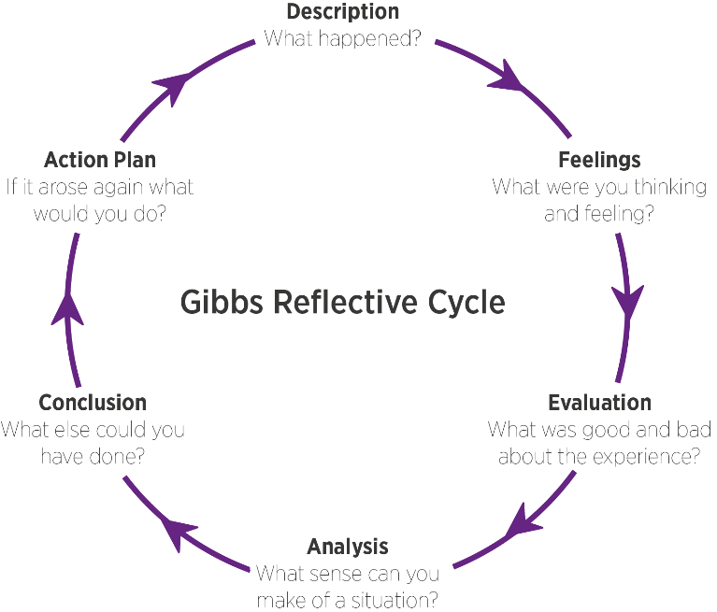

Figure: Gibbs Model
(Source: Gibbs, 1998)
As a novel form of education, I found roleplaying to be very beneficial, and I thoroughly enjoyed the lessons I learned in class. My newfound knowledge of interviews has equipped me to handle any future interviews with poise and skill. To better prepare for the demands of the real world of work in the days and weeks ahead, I may use a Gibbs model analysis to undertake an in-depth personal appraisal of my strengths and weaknesses.
The Gibbs model includes a statement of the issue at hand, an appraisal of how the individual feels about it, an evaluation, an examination of the context, a conclusion, and a set of recommendations for moving forward (Adeani, Febriani and Syafryadin, 2020).
This is a reflection on my personal experiences.
Description:
According to the Gibbs reflective cycle the first part is about explaining the experience in the form of a description. The description part demands an elaborate explanation of the whole scenario of the role-play interview session appropriately. During the roleplay interview session, I had to play both the parts of an interviewer and an interviewee. First of all, I was at the end of an interview and had to ask myself an appropriate question my teammate. Further, during the second session of role-play, I played the part of an interviewee and performed appropriately. The whole experience gave me a wholesome idea of how a real interview should be. The experience was enriching for me. I came across a glimpse of a real-time interview session and I sure hope this will help me out with cracking a real-life interview in the upcoming days.
Feelings:
The whole interview session experience was overwhelming for me. I felt different emotions during different parts of the interview. I feel like I was a better inter interviewee rather than an interviewer. I answered nicely to the interview questions whereas, the answers of my friend being an interviewee in the first round were not satisfactory to me. Although I felt like I was over-excited during my interview. I felt like I was talking too much. Still, I believe I did not do badly, rather I played my part pretty nicely.
Evaluation:
During the evaluation part, I am to evaluate my actions during the session. I can understand now that as an interviewer I could not make suitable questions. I should have made more appropriate and job-oriented questions. I asked my a few fairly simple questions to my friend, but my friend played well. He asked me strong subjective questions that were really tricky. I need to understand the subtle art of being a good interviewer as well.
Analysis:
During the roleplay, I learned that I am truly passionate about teaching. I am good at answering complex questions with confidence. I think I should not have acted over excited as an interviewer and interviewee. This probably will put a negative impression on me during a real interview session. In order to look confident in a real-time interview session, I must work better on my expressions and must act calm and composed.
Conclusion
In conclusion it can be said that the interview roleplay session has provided me with the dos and don'ts of an interview. With the help of this knowledge gathering, I will be able to perform effectively in the upcoming real-life teaching interview session precisely.
Action plan:

Skills | How to achieve | Timespan
Gathering subjective knowledge | By learning about my subject more. | 1 year
Managing time | Setting up the timetable for different tasks | 3 months
Learn to make smart interview questions | Observe the classmates regarding how they are making mock interview questions. Further, I can seek help from the teacher as well. | 6 months
Learn skills to handle children | Take some training sessions from education institutions regarding teaching and managing children | 2 years
gathering confidence | Practice via more such kind of mock interview sessions | 6 months

Skills and knowledge which contributes toward working effectively
Thanks to my background and training, I am well-suited for this field. I'm nervous, but I believe this experience will help me become a more dedicated student in pursuit of my career goals. But the fact that I am committed and hard-working is encouraging for my career.

My personal strengths and areas for further development

SWOT ANALYSIS
In the context of business, "SWOT" stands for "strengths, weaknesses, opportunities, and threats" that might be identified via some kind of strategic planning or management (Benzaghta et al., 2021).
SWOT ANALYSIS

STRENGHTS  - I have a keen interest in technology so, I love to spend my time on day-to-day upgrading technology.  - I am quite good at taking wise decisions for my team, so leadership is my thing.  - I am a self-regulating person, my mental state never depends on any external factors.  - I always criticise my work for better results and also it is a process of double-checking my work.  - I am aware of my appearance and communication skill and I take care of every single minute detail of myself.  - I have a very strong base in my field which is a huge confidence booster. | Weakness  - I am not so good at putting my work all together in a given time which causes many unwanted adverse situations in my day-to-day life  - I am a bit introverted so sometimes it's hard to communicate with people  - Sometimes I am not a good listener because of stress I become so impenitent.  - I am a very short-tempered person, when situations get out of hand I start panicking.  - Being a lazy person is one of my biggest obstacles it hinders my daily work which causes harm.  - I have disrupted my sleep schedule so weakening up late at night is common practice,  - Handling people and guiding them is one of my weak points.
OPPORTUNITIES  - Being a technology lover it will be very easy for me to communicate with future generations of children.  - Being a good leader I will be able to teach children more about leadership.  - My students will adopt my self-independent nature from me and it will be very helpful for them in future.  - In my teaching career self criticising will lead to self-discipline which will make me a good teacher.  - My strength of noticing every single minute detail can bring a lot of opportunities.  - A depth of knowledge in my field will help me to teach my student to precisely and passionately. | THREATS  - Not being able to manage my time will cause harm to my teaching career.  - Being an introvert it will be sometimes hard for me to communicate and express my opinion clearly to my students.  - I am not a good listener which sometimes will lead to miscommunication with my students  - Being a short-tempered person it will be hard for me to deal with adverse situations  - My laziness may bring a bad impression of me to my students and they may also come up with lots of excuses.  - The distributed sleeping patterns and being tired all the time may cause a lack of energy during classes.

PERSONAL DEVELOPMENT PLAN
Planning for one's own improvement and progress is known as "personal development planning," and it may be carried out in the context of one's professional life, academic pursuits, interpersonal connections, or a general feeling of well-being (Tymms, 2018).
NAME |  | Target Job/career  Example: Teacher, Manager, Business Person

TIME PERIOD | From: | To:

What Skills do I need to achieve my goal?

SKILLS | How Will I achieve this skill | What resources or support will I need? | What can prevent me from achieving my goals  :(unemployment, illness) | How long should it take
Time Management Skills | It will very tempting of getting a reward after particular work which is why it is very helpful to finish all the work in a given time. | A good to-do list will help me to track my all works and end of the day I will manage to estimate my improvements.  Various time reminders like mobile clocks etc will help to remind me and aware of time | Being lazy will prevent me from achieving my goals.  Weakening up late at night will hinder my work efficiency and it will be a huge obstacle in my work life. | 21 days
Communication Skills | Talking to more people of different age groups as well with people from different regions with different cultures will help me to become freer and more spontaneous.  Joining social clubs will also have a great impact on my communication skills. | As talking to random people with random ethics and morality on the internet will a great resource for achieving my goal. Reading journals of my interest will also help me in this process. | Being too shy it will prevent me to start conversations with people it ends up in the uncomfortable small talk. Not being confident enough in myself and limiting my abilities hampers my communication skills. | 8-9 months
Listening Ability | Joining more debate clubs will build an ability in me to listen to other people's opinions. Socialization is a major key to building my listening abilities. | Listing to podcasts from various people all around the world will be a great resource. Reading non-frictional books about self-improvements may also neutralize this problem. | Being more arrogant with my decisions and maintaining a rigid mindset will affect my building this skill. Being more restricted by my own morals and values will lead to harm to my process of developing this skill | 3-4 months
Anger Management | Meditation on a daily basis will help me to calm down, Be less reactive to external situations and control my own thoughts will help me in developing this process | Reading more spiritual books and developing my own personality in the template of spirituality is important in order to manage my anger issue. Doing certain pranayama’s may also help in this process, | Unwanted adverse situations have a negative impact on this process And being surrounded by arrogant people will also retrograde my results. | 1-2 years
Physical Fitness | Daily exercise of 30-60min can bring lots of change in my mentality and body and it will help me to be more active and fit. A good diet plan and exercise will be key factors to improve my fitness to the highest level. | Exercise in a good gym near my locality is a huge resource to put the body in good shape and in physical fitness. Following the doctor's advice and checking my body every month will help me to complete my skill. | A lazy lifestyle with no job in it will reduce my chances to achieve my goal. Not being able to sleep for 7-8 hours daily will be a huge obstacle for me. Eating fast foods on daily basis will prevent me from achieving my goal. | 1-2 years
People-handling skills | Doing more social work and being a leader will help me massively to improve my people-handling skills. Organising huge events or gatherings will also help me to achieve this skill | Working with various event management organisations will be a great asset to achieve this skill. | Living with impatient people and constantly handling toxic people can disrupt people handling skills. | 6 months

My short - medium – long-term targets for the development of my own professional career plan (using Specific, Measurable, Agreed, Realistic, Time-bound –SMART targets)

Short-term plan (3 -6 months)
Specific | In order to acquire a more in-depth comprehension of the Technologies and to speak more comfortably and naturally in the programming language. This will make it easier for me to connect with the younger children in my class.
Measurable | To further my skills in information technology and communication by pursuing appropriate certification.
Agreed | I have decided that getting in shape over the next three months is essential to my future prosperity, therefore I have made it my mission to do so.
Realistic | To ground me in realism and explore strategies for working with a variety of student types.
Time-Bound | 15/02/2023
Medium-term plan (1-2 years)
Specific | Studying child psychology and teaching should help me become a better educator.
Measurable | Teaching in the local community schools will help me get hands-on experience if handling the students in class.
Agreed | My terrible procrastination and social media addictions. Time management is essential if I am to arrive at class on time and set a good example for my students.
Realistic | I want to put my knowledge and abilities to the test, so I'm going to try to schedule as many classes as I can.
Time-Bound | 10/02/2024
Long-term plan (2-5 years)
Specific | My ultimate professional objective is to head up a prestigious UK university. If I can improve my university's educational system, more of my students will have a chance to demonstrate their talents.
Measurable | I want to become a student teacher; I want my students to follow my wisdom and inspire by the work I am doing.
Agreed | I want to retain my career as a director of an educational institution for the foreseeable future. I want to establish a name for myself in the education ministry to help UK education at another level.
Realistic | I want to be a good teacher who has a great love for his student and colleagues.
Time-Bound | 10/10/2025

Conclusion
Self-development is a top priority for me. I give a lot of thought to who I am, and I want the fact that I try to be a good person to be one of my distinguishing traits. Right now, I have a long list of things I need to work on, and some of them are rather difficult. If I want to succeed in life, I realise I have a lot of work to do. To put it simply, I am a really motivated person. I am confident in my ability to stay the course and complete my goals, and I know I can always count on the love and encouragement of my friends and family. In order to progress, I need to hone my skills more. Whatever may come my way, I swear to myself that I will never deviate from the path of righteousness.

References:
Adeani, I.S., Febriani, R.B. and Syafryadin, S., 2020. USING GIBBS’REFLECTIVE CYCLE IN MAKING REFLECTIONS OF LITERARY ANALYSIS. Indonesian EFL Journal, 6(2), pp.139-148.
Benzaghta, M.A., Elwalda, A., Mousa, M.M., Erkan, I. and Rahman, M., 2021. SWOT analysis applications: An integrative literature review. Journal of Global Business Insights, 6(1), pp.55-73.
Gibbs, G. (1988) Learning by Doing: A guide to teaching and learning methods. Further Education Unit. Oxford Polytechnic: Oxford.
Tymms, M., 2018. Implementing educational innovations: A staff perspective of personal development planning. Research in Post-Compulsory Education, 23(4), pp.463-478.

Appendix
The questions asked as interviewers in the role play

1.Why did you choose this nursing profession?
2. How do you deal with the challenging patient in your workplace?
3. How did you manage the working pressure?
4. How is your experience in the nursing field?
5. How do you identify patients who need better care?

