

Fundamentals of Construction Technology
Site Investigation Report
Joseph Murnane

Contents
Introduction Page 2
Site Details Page 2
Site History Page 3
Geological Appraisal Page 4
Building Regulations Page 5
Foundation Types Page 6
Bibliography Page 8

Introduction

I am a junior construction professional and I have been asked to carry out a full site investigation report on the proposed restaurant and ice-cream parlour (managers apartment included). The overall aim of the investigation will be to work out the best foundation type for the restaurant and parlour. I am going to be carrying out a desktop study of everything I need to know about the area the restaurant is going to be built up in. Throughout this report I will be digging into the factors regarding the site’s location such as the soil type, the history of the site, the type of building that will be constructed there and the structures loading. When all this information has been received, I will then have enough knowledge to decide on what foundation type is best suited for this specific project while taking into consideration the potential risks that come with building on the site. The site analysis is going to be vital to the project as going straight to site to carry out an investigation may be problematic due to a hidden historical factor that can be found by carrying out some archival studies on the local area and other nearby buildings.



Site Details

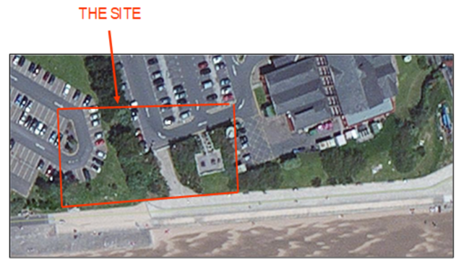
The site for this project is in Swansea next to the Marriot Hotel along the waterfront. The site I am investigating is in the South-West corner of the Marriot Hotel car park and reaches right down to the shore as shown in this boundary of the site. The current use of this site is for a part of the Marriot Hotels carpark, a part of the county council carpark and a public footpath. The areas that are covered in grass and bushes are like small hills so in order to transfer this present land use into the proposed land use, a lot of soil will have to be removed in order to level the ground to build the restaurant and ice cream parlour successfully. After investigating the visual contents of the site, I then looked at possible access areas for lorries to make deliveries during the construction phase of the project. There is an easy access and exit route for lorries to complete their deliveries as efficiently as possible as the site is in a car park. Access to the car parks will be granted by both Marriot Hotel and the county council as they are in a joint agreement to open the new restaurant.

Site History
When carrying out a site investigation, it is important that you look deeper than what you can see when just casting your eye over the site. By this I mean that it is vital to know what used to exist in this location a long time ago before what is currently occupying the land. For example, if there used to be industrial buildings in this area then there could be industrial waste that may have contaminated the land. This is the reason it is so important to have a history check on this location as the industrial revolution was massive in Swansea.
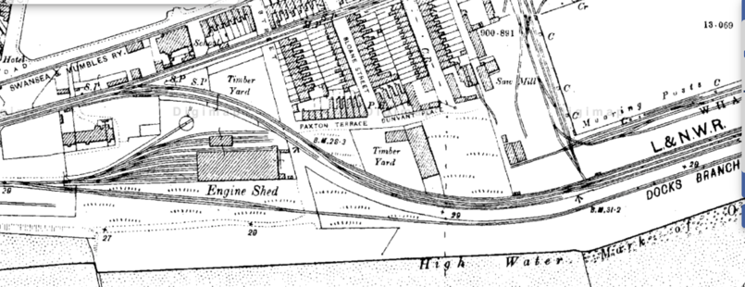
https://digimap.edina.ac.uk/roam/map/historic
After carrying out a desktop study of the history of the site, I managed to find a map of the area dated back to the 1890s. As you can clearly see, the previous use of this area was for a railway line that ran through Swansea and Mumbles along the waterfront. The railway line ran for at least 150 years before being closed in January 1960. Therefore, there must have been a large amount of waste produced from the operations during the time. Waste from the trains could be from the wear and tear of the track leading to repairing the track or the initial manufacturing of the railway causing chemicals to get into the ground. Not only was there a railway line running through the site, the maps from the 1950s also show that there was an engine shed in the area for the railway and there was also a wagon repair works factory. The work that went on in these buildings most likely consisted of all hands-on work with some of it being done with heavy machinery. This could also add chemicals into the ground causing contamination of the soil. Another thing with these buildings is when they were knocked down and removed, some of their remains could still be in the substructure causing issues when preparing the site. Another extremely important thing to note about the history of Swansea is the industrial boom that took place in the 1850s. During the industrial revolution Swansea become one of the biggest suppliers of copper and coal due to the mining in all the valleys. Swansea was the place that all the coal and copper would be transported to before it was shipped out from the docks. This is the reason that it is likely for industrial chemicals to be in the area.

Geological Appraisal
It is important to carry out a geological study in order to work out what foundation type to use for the building and to know if it is safe to construct anything in this area. When carrying out the geological survey I looked at the strength of the ground, the potential deformation of the ground and the hydraulic characteristics. During the industrial revolution in the 18th and 19th century, Swansea was a huge world supplier for copper and coal with the Swansea docks being a shipping area for all the mined materials. Our site is located near the docks, meaning that the ground in the area could be contaminated from the industrial revolution.
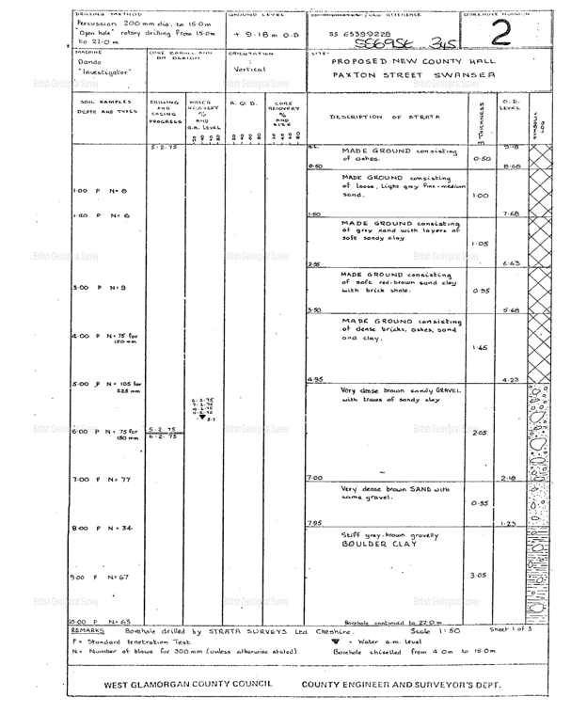
After researching more into the geology of the site I managed to find myself a borehole survey on the British Geological survey website for the County Hall building which is located right next door to the site. As stated on this borehole survey, the bore hole drilling was completed in 1975 and was done to a depth of 22 metres. Boring is a method used to examine the surfaces beneath the ground level that are obviously not visible to us. As you can see, at the first level of strata below ground level there is loose light grey sand, which wouldn’t be very safe building foundations on given the movement that will occur under stress. Below this, the next strata is made up of soft red-brown sand clay with brick shales which is a lot stronger surface than the one above. As you go further into the ground you find that the strata is becoming more and more solid and it seems that this ground is a suitable ground to build the ice cream parlour, restaurant, and apartment on top of while also following the building regs with regards to the overall safety of the structure.
http://scans.bgs.ac.uk/sobi_scans/boreholes/370246/images/10677923.html

After my desktop study of the history of this sites area, I must note that it is vitally important for the geotechnical surveyor allocated to this site to carry out a contaminated ground survey. The reason this is so important for this site is because all the work that has gone on in this area over just the last 200 years ranging from the railway manufacturing, the trains running and the industrial revolution. This would be especially dangerous for ground workers who will be exposed to hazardous materials and contaminated soil that could harm them. Not only this, the chemicals in the area could effect the restaurant and Ice cream parlour from being safe even when the construction is complete.

Building Regulations

Every single time a new building is constructed it must pass the building regulations in order for it to be allowed to stay standing. With this project there are some approved documents that are more difficult to follow due to the potential geological problems that it may face. For this reason, I am going to highlight a few building regulations below and why it is vitally important to consider them throughout the entirety of the project.

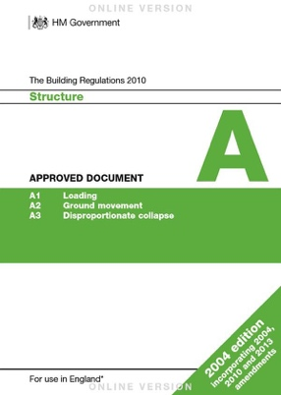
The first approved document I am going to mention is the ‘approved document A’ which is about structure. This document goes into detail about the structural safety and the stability of the building making sure that there are no chances of the building collapsing, sinking or failing. After looking into the borehole survey of the ground that the project is to be built on, it has come clear that sinking and collapsing is important as the ground it is going to be built on is not very solid or strong. The way to prevent this is all in the choice of foundation that is used.

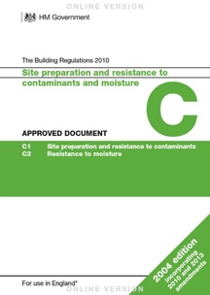
Another approved document that needs to be highlighted is the ‘approved document C’ about site preparation and resistance to contaminates and moisture. This approved document is in place to protect new buildings from any water and moisture
from making its way into the structure. The reason I have decided to highlight this approved document is because of the location of the site being right on the waterfront meaning that the building will be open to a lot of poor weather conditions.

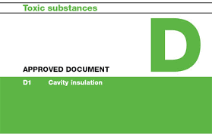
The final approved document that I am going to bring attention to is ‘approved document D’ which is about toxic substances. The document provides guidance on keeping the health and safety of the building to a high standard by preventing any toxic chemicals from entering the through the building. The reason I am reporting this approved document as an important document to keep in mind is because of the environmental trouble this area has faced in its history from the industrial revolution and the mumbles railway line.

Potential foundation types

I am now going to look into the possibilities of each foundation type to see which is the best option to go with for this particular project. It is important to consider both the location of the site and the potential geological problems that I have previously listed.

The first foundation type I am going to look at is strip foundation. Strip foundation is a method that is very commonly used for 2 storey houses and other 2 storey buildings whether that is by normal concrete strips or reinforced concrete strips dependant on if reinforcement is required to be able to support heavy loadings. The problem with using strip foundation on this project is that strip foundations are a shallow type of foundation, meaning that it will be loaded on to soil with a poor loading capacity. This could lead to the sinking of the structure into the ground leading to levels being off and even more potential disasters.

The next foundation type I am going to discuss is the pad foundations. This foundation type is easy to construct as they do not require as much excavation of the subsoil. Another positive of pad foundations is that they can be designed as shallow foundations or deep foundations, completely dependant on the bearing capacity of the ground below. The only problem with this is that the bearing capacity of the ground below is not strong enough to take the load coming straight through the columns down onto the soil. This would again run the risk of sinking in the loose sand below as the pad foundation is designed to add extra loading in areas where it is needed pushing the ground materials to failure.

Another foundation type I am going to look into using is pile foundations. Pile foundations are a deep method of foundations that are constructed using reinforced concrete or steel. In this project steel piles won’t be required as it is only going to be a two-storey building. The piles are designed to transfer the loads of the buildings down through weak strata such as the loose sand in this project onto the stronger, more compact strata beneath.

The final foundation type I will be bringing to the table is raft foundations. Raft foundations are shallow foundations, similarly to the strip and pad foundations. Raft foundations spread across the whole bed of the proposed building like a bed but they are not very deep. This means that it requires less excavation than other foundation types because it is so shallow. The difference between this shallow foundation type and the other foundation types is that the raft foundation is well suited to low capacity soils such as sand because the loads from the superstructure are distributed across the whole area of the building.
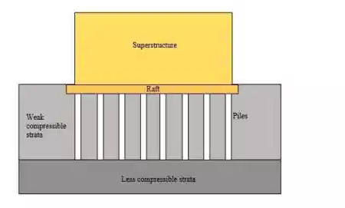
In conclusion, the foundation I would go with is a raft and pile foundation as shown in the foundation detail on the right. I feel that this foundation type is the best choice because the top level of strata is loose sand which is weak and compressive which would risk sinkage. This foundation allows us to be able to drill down with the piles in order to find stronger ground in order to take the pressure off the loose sand. Once the piles have
https://theconstructor.org/geotechnical/raft-foundations-types-advantages/7184/

Fitted, the raft foundation can then be placed on top to provide the superstructure with a stable level, whilst also successfully distributed the load of the superstructure evenly across the soil beneath the pile foundations. This is the best choice of foundation in my opinion because it will help succeed in following the ‘approved document A’ of the building regulations by giving the building the structural strength, stability and an incredibly decreased risk of sinkage in the substructure.

Bibliography

https://digimap.edina.ac.uk/roam/map/historic

http://www.swanseamuseum.co.uk/swansea-a-brief-history/industry

https://www.wales-info.co.uk/country/article/2523/history-of-swansea

http://mapapps2.bgs.ac.uk/geoindex/home.html?layer=BGSBoreholes&_ga=2.84136668.491353477.1641483306-2009305433.1641483306

http://scans.bgs.ac.uk/sobi_scans/boreholes/370246/images/10677923.html

https://www.gov.uk/government/collections/approved-documents#approved-documents

https://theconstructor.org/geotechnical/raft-foundations-types-advantages/7184/

https://www.designingbuildings.co.uk/wiki/Strip_foundation

https://www.designingbuildings.co.uk/wiki/Pad_foundation

