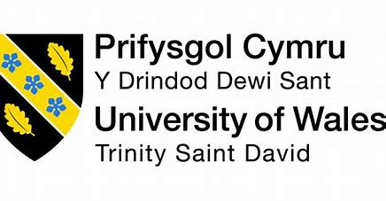
Entrepreneurship

Assessment 1

LCBB5001

Module Lecturer: Nishi Ramsurrun

Student name: Sandrina Rangelova

Student number: 1917133

Contents
Introduction 2
Entrepreneur KSB Knowledge, Skills and Behaviour and personal SWOT analysis 2
Opportunities 5
Threats 5
PESTEL analysis 5
Conclusion 8
References 10

Introduction
Entrepreneurship is defined as the process by which individuals pursue opportunities without regard to resources, they currently control for the purpose of exploiting future goods and services (Bibliu.com, 2022) This is person who starts and runs a business or enterprise, especially one that is considered high-risk. Individuals who are considered entrepreneurs are often passionate about their businesses and have a strong desire to succeed. They are usually innovative and take risks to achieve their goals. Knowledge of risk management practices is important. Many different skills, behaviors, and traits can be associated with entrepreneurs. Some of the most important ones include:

Entrepreneur KSB Knowledge, Skills and Behaviour and personal SWOT analysis
A desire to succeed
This is the most essential quality of an entrepreneur. Individuals who are successful in business are often driven by a powerful desire to achieve their goals. I am a dedicated person, who knows what want. I am hard working and manage my risk. This strength can help me to run a successful business. When I came to England, I did not speak any English. I was motivated and passionate to go to university and gain new knowledge. I started a course and after 3 years I accomplished it. My hard work and assuming risks help me to achieve success.
Innovation and communication
Entrepreneurs are often innovative and creative. They can produce new ideas and find new ways to solve problems. This allows them to create unique products or services that can be successful in the marketplace. I love to communicate with other people, share opinions and learn from them. This is the way my creativity is formed. I like to see what other people are doing and use this knowledge to create something new. This is the way how creativity work. When I start a new course, for example, I am thinking about how I can use this knowledge and create a unique product.
Risk-taking
Many entrepreneurs are willing to take risks to achieve their goals. They are not afraid of failure and are willing to try new things to achieve success. This can sometimes lead to them making mistakes, but it also allows them to learn from their experiences and become better at what they do. I am willing to take risks to achieve success. I take moderate risks and am not afraid to take advantage of opportunities in front of me. During my education, I launched a marketing campaign, analyzed my weaknesses, saw my mistakes, and decided to change the niche I was working on. I have invested my capital and am currently continuing to educate myself and work hard to achieve success.
Detail-oriented
Individuals are those who pay close attention to the small details of a task or project. People usually describe me as a detailed oriented person. I am organized and methodical in my work, and I want to be sure that all the details are taken care of before moving on to the next step. This can be a strength in many situations, especially when accuracy is important.
However, detail-oriented individuals can sometimes become bogged down in the details and fail to see the big picture. This can make them seem inflexible and unyielding, and it can also lead to them missing important deadlines. For this reason, detail-oriented individuals often need to work with others who are more flexible and who can help them see the big picture.
I worked in a factory, and my duty was to monitor the quality of the production. As I saw every single flaw, I became confused about what was acceptable and what was not, and as a result, I had to quit my job. In this situation, this strength becomes a threat.
Multi-tasking
Being able to juggle several tasks or projects at once, is another important strength for entrepreneurs. This is because entrepreneurs often must wear many hats and juggle many different responsibilities. Being able to multi-task efficiently can help entrepreneurs stay organized and on top of all their duties. This is my engine. When I multitask, I am more motivated, manage my time better, and stay focused. In my daily life, I often must deal with many tasks. I have two children that take up a lot of my time. At the same time, I study and work on courses and projects related to my current education. Completing these tasks keeps me moving forward and finding my place as a successful entrepreneur.
Individuals who are adaptable, willing to take risks, and tenacious are more likely to become entrepreneurs and succeed. A good entrepreneur possesses many positive personality traits that set them apart from the average person.

Weaknesses
I can be too passionate about my work and can become easily emotionally attached to my projects. Also, I can be too trusting of people and can get taken advantage of. I can be too optimistic about my chances of success.
My other weakness is my English language which affects my communication and writing skills. I have a lot of difficulties understanding what people say or explain to me. This can be problematic since this leads to bad decisions that could negatively affect my business. I will continue to educate myself and when I have more time, I will start an English course. This will help me to be more confident in any area of my life and entrepreneurial career.
One of my biggest weaknesses is that I am very impatient. This can cause problems because I can get easily frustrated if things are not going the way I want them to. For example, if I am trying to learn something new and it is taking longer as required, I can get impatient and give up. I am currently working to turn this weakness into a strength by effectively managing my time such as prioritizing my task by following the Eisenhower time management techniques. I am attending a meditation course that teaches me to be more patient.

Opportunities
My degree gives me knowledge and opportunities that increase my chance of success and development. With every module I study, I have a real chance to turn it into my future profession. I became interested in investing in the stock market and creating marketing campaigns. There are many opportunities for investing in the stock market and marketing. For instance, investors can buy stocks representing a company's ownership share or purchase mutual funds that invest in many different stores. Marketing professionals can create campaigns to promote products and services to potential customers. Additionally, many online resources provide information and tools for the stock market and marketing research. Many of the firms traded on the NASDAQ (the largest U.S. stock market with 3,100companies listed), such as Apple, Zynga, Facebook, and Amgen are commonly thought of as entrepreneurial firms. (Bibliu.com, 2022)
The stock market and marketing offer many opportunities for those who are willing to do the research and put in the effort. With careful planning and execution, investors and marketing professionals can achieve success.

Threats
Changes in technology
Modern technologies could make my products or services obsolete. As technology advances, it is essential to consider how the product connects and depends on technology

Natural Disasters
A hurricane, earthquake, or another natural disaster can damage your property or disrupt your business. In times of climate change, it is important to consider this factor.

PESTEL analysis
PESTEL is an acronym for Political, Economic, Social, Technology, Environmental, and Legal factors. These factors are important in understanding the macro-environmental factors that can affect a business. (Investopedia, 2022)
Political factors
The United Kingdom's long and complicated history has resulted in a diverse political landscape that is also greatly influenced by the public. For example, referendums and lobbying operate as powerful forces within the UK political landscape. The UK has a strong economy and is one of the world's leading financial centers. It is also home to some of the world's largest companies, such as HSBC, BP, and Shell. The country has a highly skilled workforce and is known for its innovation and entrepreneurship. The United Kingdom is a founding and permanent member of the United Nations and wields major influence over global economic, cultural, military, scientific, and political affairs. The UK's withdrawal from the EU (Brexit) has resulted in many political debates. Some analysts think that it has caused immense chaos because is such an important member of the EU while others see it as an opportunity for the country to grow. For example, the UK will no longer have to contribute to the EU budget, and it will be free to set its trade deals with other countries. Also, the UK will no longer be bound by EU rules and regulations, which some people believe are too restrictive.
Political factors -negative side
The BBC (2020) reports that the country's relations with some authoritarian regimes have been met with criticism, and its recent rise in violence and crime has caused serious concerns.
Economic factors
The UK is a desirable business destination for innumerable reasons: it has a service-based economy with a prominent financial sector, being the fifth largest world economy, and its currency ranked sixth most traded. It is also members of several powerful organization such as the Commonwealth of Nations, G8, G20, NATO etc., which strengthens their support system.
The country's economy is struggling because of the global lockdowns in 2020 and 2021, with many businesses failing as a result. This has caused one of the deepest recessions in UK history. The GDP contracted by 11.3% in 2020 and is expected to contract by 5.9% in 2021. The unemployment rate rose to 7.5% in 2020 and is expected to rise; however, long-term prospects are positive, with an annual growth rate of 1.5% forecast between 2021 and 2025 driven by the service sector and manufacturing industries.
The UK sees a trade surplus with its main trading partners, the United States, Germany, France, and China. This is due to numerous wealthy individuals and organizations from around the globe investing in several types of businesses situated within the UK, such as sports teams, real estate holdings, innovative technology companies, grocery stores chains.
One great benefit is that every year, the National Living Wage increases--this proves extremely helpful to those who do not earn much revenue.
PwC (2022) reports that the corporation tax rate for company profits will rise 5% from the current 19% to 25% for the budget year beginning April 1st, 2023. The UK's top exports include cars, gas tribune, gold and crude petroleum which are mostly sent to countries such as USA, Germany China, Netherlands and France.
The finance sector is vital to the United Kingdom economy. It significantly contributes to Gross Domestic Product (GPD), with London being a major player in this industry. Additionally, it employs over two million people throughout England in related sectors such as accounting and law.
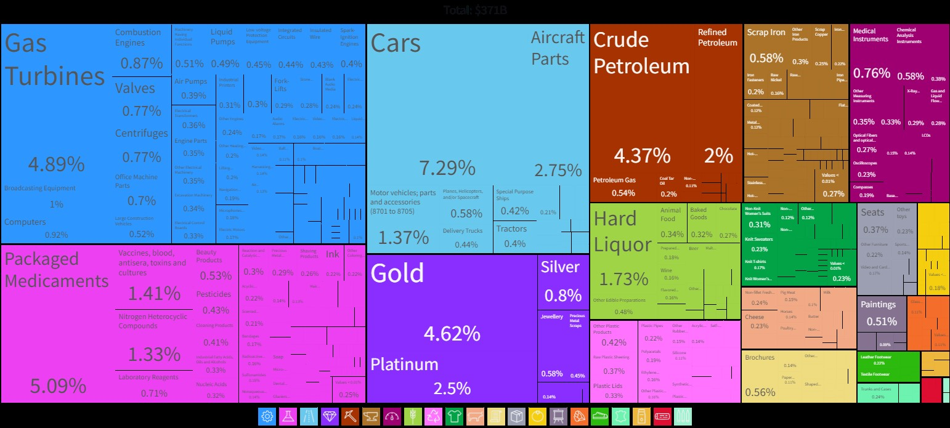
UK export 2020
(OEC - The Observatory of Economic Complexity, 2020)

Negative sides
The economy is still struggling to recover from the 2008/2009 recession, and inflation has reached 10.096% as of September 2022. This inflated rate is due in part to the influx of migrants seeking free public services and financial aid.

Social factors
The UK's population is continuing to grow, with more births than deaths each year. It is expected that the population will reach 74 million by 2039. With a large consumer market and dense population, the UK is an attractive place for businesses to operate. UK citizens have a high standard of living. UK is one of the top 10 countries with the most educated population according to world rankings. However, it should be noted that costs for higher education and general living are increasing.
The UK's population is now very multicultural, and companies have started to change their products and markets to reflect this. However, there are still many opportunities for organisations to explore.

Negative sides
There are social unrest and economic factors to consider in the UK such as a high dependency ratio, the cost of education, and an aging population. In 2046, 23% of the population will be elderly (defined as 65 or older), compared to only 16% in 2018. This shift presents both opportunities and challenges for businesses.
Technological factors
The United Kingdom's advanced infrastructure provides businesses with many opportunities. The UK is also one of the most technologically savvy countries, which makes London an ideal hub for entrepreneurs. The internet provides many opportunities for people in the UK to connect with others, work online, and find new consumers through digital marketing and social media platforms.
The technology sector is integral to the UK economy. Quality innovation skills come from expertise in science and IT, effective laws about intellectual property, and plenty of internal competition to stimulate growth. The availability of innovative technologies has also created opportunities for developing new products and services, which drives economic growth.

Conclusion
To be a successful entrepreneur in the UK, you need to have a clear understanding of the business environment and the market you wish to operate in. You must also be able to identify opportunities and seize them quickly. A key factor in your success will be your ability to build a dedicated team of experts around you who can provide the necessary skills and knowledge. Finally, you must be prepared to work hard and persevere in the face of setbacks. If you can do all these things, then you have a good chance of becoming a successful entrepreneur in the UK. Environmental factors. Although economic development sometimes causes environmental problems, the UK has taken many measures to lessen these effects. For example, different organizations such as government agencies, charities, and television stations have worked to make people more aware of environmental concerns and what they can do to help preserve natural resources. The government has pledged to reduce greenhouse gas emissions by 80% in the next 30 years. To meet the targets, set by the Climate Change Act 2008, the UK has introduced several policies, including the Carbon Price Floor and Renewable Heat Incentive. The Employment Act 1996 protects the legal rights of employees regarding maternity and family leave, minimum wage, holiday pay, sick pay, etc. (Armstrong, 2014) The Equality Act 2010 protects people from discrimination based on factors such as race or gender. (Armstrong, 2014). The UK also has several regulations that businesses must comply with, including those relating to health and safety, the environment, consumer protection, and competition. These regulations can be costly to comply with, but they provide a level playing field for businesses and protect consumers.

References
Armstrong, M. and Taylor, S., 2014. Armstrong's handbook of human resource management practice, 13th edition. London: Kogan Page.
Barringer, B.R. (2019) Entrepreneurship : successfully launching new ventures . 6th edition, global edition. Harlow, England :, Pearson.
Proquest.com. (2022). ProQuest Ebook Central - Reader. [online] Available at: https://ebookcentral.proquest.com/lib/trinity/reader.action?docID=5174542 [Accessed 23 Nov. 2022].
News, B. (2012). United Kingdom country profile. [online] BBC News. Available at: https://www.bbc.co.uk/news/world-europe-18023389 [Accessed 13 Nov. 2022].
Inman, P. (2021). UK economy bouncing back stronger than expected amid savings boom. [online] the Guardian. Available at: https://www.theguardian.com/business/2021/mar/31/uk-economy-savings-expansion-recovery [Accessed 13 Nov. 2022].
‌‌Investopedia. (2022). Entrepreneur: What It Means to Be One and How to Get Started. [online] Available at: https://www.investopedia.com/terms/e/entrepreneur.asp [Accessed 23 Nov. 2022].
Investopedia. (2022). What Is PEST Analysis? Its Applications and Uses in Business. [online] Available at: https://www.investopedia.com/terms/p/pest-analysis.asp [Accessed 23 Nov. 2022].
OEC - The Observatory of Economic Complexity. (2020). United Kingdom (GBR) Exports, Imports, and Trade Partners | OEC. [online] Available at: https://oec.world/en/profile/country/gbr [Accessed 13 Nov. 2022]
Pwc.com. (2022). United Kingdom - Corporate - Taxes on corporate income. [online] Available at: https://taxsummaries.pwc.com/united-kingdom/corporate/taxes-on-corporate-income [Accessed 13 Nov. 2022].
‌

‌

