
Materials and introduction to manufacturing
Assignment Title: Manufacturing Process and Material Selection


Gruffydd Bray
Student Number:1812705

Contents

Introduction Page 3

Functional Requirements Page 3

Manufacturing Process and Material used Page 4

Material Used Page 4

Additive Manufacturing Page 5

Additive Manufacturing Process Page 6

The New Material Page 7

Benefits of New Process Page 7-8

Bibliography Page 9

Task 1
  - Aircraft brackets (access door latch)
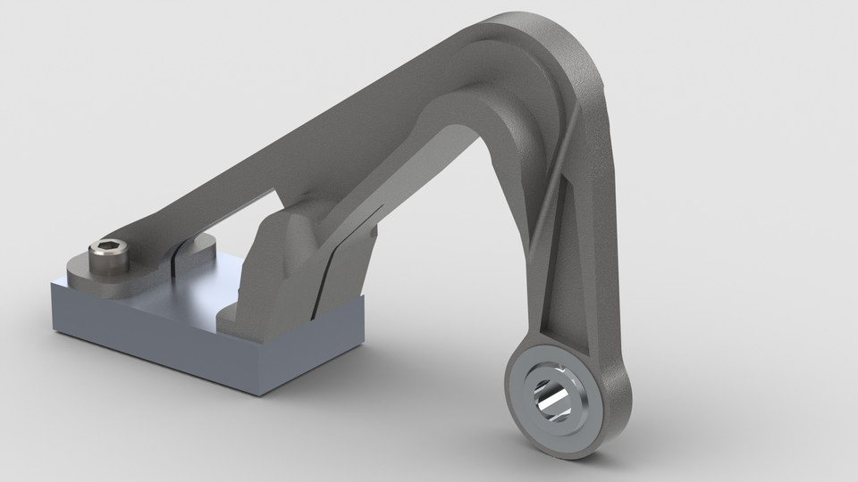
Figure 1 Example of Aircraft Bracket (https://grabcad.com/library/aircraft-bracket-1)

Introduction
The objective of this report is to discuss the functional requirements of the component which is an aircraft access door latch bracket and others brackets. During this section of the report the manufacturing processes of aircraft brackets will be discussed along with the materials used in the processes. The role of aircraft brackets is to enable other components to be fixed in place on the aircraft, it may not be vital to the flight operations of the aircraft but could lead to the aircraft having to land if the latch failed or was compromised in any way.

Functional Requirements
The functional requirements of aircraft brackets are that it needs to be strong and sturdy so that when it is fixed in place it stays where it is and doesn’t change its shape. Another functional requirement is that it needs to be easily accessible and ergonomically efficient. They need to be fitted to certain parts of the aircraft which may be in awkward positions so this also need to be accounted for. The brackets also have to be able to have another component fitted to them after they have been fitted. This means they require the ability to withstand a certain load being put on to the bracket. It also means they require the means for another component to be attached to them, for example a hole for a bolt to go through. The brackets play no role in the operation of the aircraft but the components they are supporting may play vital roles. An example of this would be the engine bracket which hold the aircraft engine in place. If this bracket was to fail it may lead to catastrophic consequences. It is important to consider all of these points when thinking of the functional requirements of the bracket, but the main argument one has to overcome for the aircraft bracket is weight against strength. It is vital the bracket is strong enough to hold components in place and withstand extreme stresses and pressures but it also has to be lightweight.

Manufacturing Process
The current manufacturing process for aircraft brackets on an aircraft is machining. Custompartnet.com states “Machining is a term used to describe a variety of material removal processes in which a cutting tool removes unwanted material from a workpiece to produce the desired shape. The workpiece is typically cut from a larger piece of stock, which is available in a variety of standard shapes, such as flat sheets, solid bars, hollow tubes, and shaped beams. Machining can also be performed on an existing part, such as a casting or forging.” The aircraft brackets used inside the aircraft are manufactured through machining meaning they are cut out from a larger piece of material. This is a traditional form of manufacturing used in many industries and has been used and effective for many years. This technique of manufacturing may be effective but is also outdated as it creates a significant amount of waste once the material has been cut out.
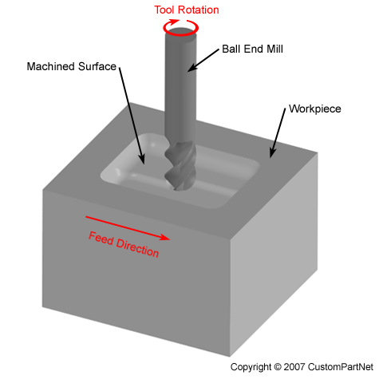
Figure 2 Example of Machining Process

Material used
The material currently used in the manufacturing of most aircraft brackets is Aluminium. Aluminium is used as it is light, which is a priority to all parts in the aircraft. Basystems.co.uk states “Aluminium is the third most common element on our planet after oxygen and silicon, making up over 8% of the Earth’s crust. The material is extremely versatile and is being increasingly used for a variety of applications in the construction industry.” According to Britannica.com “Aluminum (Al), also spelled aluminium, chemical element, a lightweight, silvery-white metal of main Group 13 (IIIa, or boron group) of the periodic table. Aluminium is the most abundant metallic element in Earth’s crust and the most widely used nonferrous metal. Because of its chemical activity, aluminium never occurs in the metallic form in nature, but its compounds are present to a greater or lesser extent in almost all rocks, vegetation, and animals.” Aluminium is an ideal material to use in aircraft construction as it is light yet relatively high in strength. It can withstand a lot of stress when taking in to account its low weight. Its is also a useful material is it is easy to machine. Another factor why Aluminium is a good material to use is because it is relatively easily attainable and cost efficient.
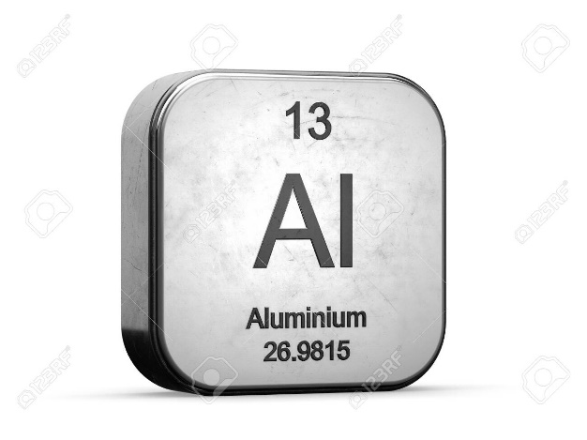
Figure 3 Aluminium element (https://www.123rf.com/photo_120653760_aluminium-element-from-the-periodic-table-metallic-icon-3d-rendered-on-white-background.html)

Task 2

Additive Manufacturing

Introduction
During this section of the report additive manufacturing will be discussed. An additive manufacturing process will be discussed as a possible alternative to the original form of machining the brackets for aircraft. Additive manufacturing is an advancement in the manufacturing industry where they are utilising the technology that is now available. Due to technology rapidly advancing throughout recent times the manufacturing industry has not advanced in the same way. The manufacturing industry has a long industry and therefore has it’s traditional ways of working which has seen it work effectively so far. But with additive manufacturing introduced for the manufacturing of particular parts and components it will be more efficient and effective in many ways. Additive Manufacturing is decribed on https://www.ge.com/additive/additive-manufacturing as “Additive manufacturing uses data computer-aided-design (CAD) software or 3D object scanners to direct hardware to deposit material, layer upon layer, in precise geometric shapes. As its name implies, additive manufacturing adds material to create an object. By contrast, when you create an object by traditional means, it is often necessary to remove material through milling, machining, carving, shaping or other means.
Although the terms "3D printing" and "rapid prototyping" are casually used to discuss additive manufacturing, each process is actually a subset of additive manufacturing.
While additive manufacturing seems new to many, it has actually been around for several decades. In the right applications, additive manufacturing delivers a perfect trifecta of improved performance, complex geometries and simplified fabrication. As a result, opportunities abound for those who actively embrace additive manufacturing.

Additive Manufacturing Process
There are a number of additive manufacturing processes that have a number of beneficial factors to the manufacturing process of aircraft brackets. Some of the main advantages of additive manufacturing according to https://www.ge.com/additive/industry/aerospace are “Lower costs and simplified supply chains
AM allows you to consolidate parts, which may reduce your supply sources and logistical costs.
Improved product performance
It has been shown that additive components and systems can outperform their traditional predecessors due to material and geometry flexibility.
Faster time to market
High flexibility during development can significantly reduce time to market
Faster cycle time
Tooling elimination and manufacturing simplification can reduce cycle time up to 10x.
Flexible logistics
Additive allows distributed manufacturing and on-demand product solutions.”
All of these factors listed would be extremely advantageous to the manufacturing process, especially in the aircraft industry. The lower costs and simplified supply chains would be very useful as it would firstly save the company money during the manufacturing of parts. Secondly the simplified supply chain is extremely useful in the aircraft industry as it eliminates the need to contact suppliers for specific parts that they may not manufacture any longer. The improved product performance is another excellent benefit as in the aircraft industry the performance of a part could result in an efficient flight which leads to monetary profits, or on the other hand could result in a catastrophic failure leading to fatalities. A part failure or underperforming could also be damaging to the companies reputation.
The additive manufacturing process one would suggest to use for the manufacturing of aircraft brackets is Powder Bed Fusion (3D printing). “Powder Bed Fusion (PBF) technology is used in a variety of AM processes, including direct metal laser sintering (DMLS), selective laser sintering (SLS), selective heat sintering (SHS), electron beam melting (EBM) and direct metal laser melting (DMLM). These systems use lasers, electron beams or thermal print heads to melt or partially melt ultra-fine layers of material in a three-dimensional space. As the process concludes, excess powder is blasted away from the object.” (https://www.ge.com/additive/additive-manufacturing). This is the process selected as I believe it is the most suitable for the task in hand. Firstly it is able to work with a number of material most importantly metals. Secondly it has a high level of accuracy through the use of CAD and lasers. This is notable as accuracy is a high priority when considering parts for an aircraft. Next it is able to create 3D parts and does not create as much waste, therefore is more cost efficient.
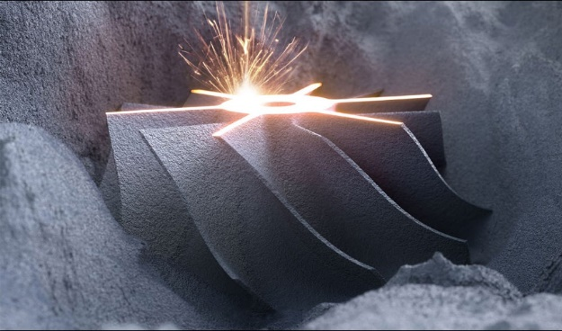
Figure 4 Example of Powder Bed Fusion Printing (https://www.3dnatives.com/en/direct-metal-laser-sintering100420174-2/)

The new Material
The new material that I would suggest to use instead of the original Aluminium would be a Titanium alloy. Britannica.com says “Titanium (Ti), chemical element, a silvery gray metal of Group 4 (IVb) of the periodic table. Titanium is a lightweight, high-strength, low-corrosion structural metal and is used in alloy form for parts in high-speed aircraft”. Titanium would be an improvement to the aluminium as it is also still a lightweight material but it has higher strength. Although the titanium may be more costly for use, it should have a longer life and require less repair or replacement costs.
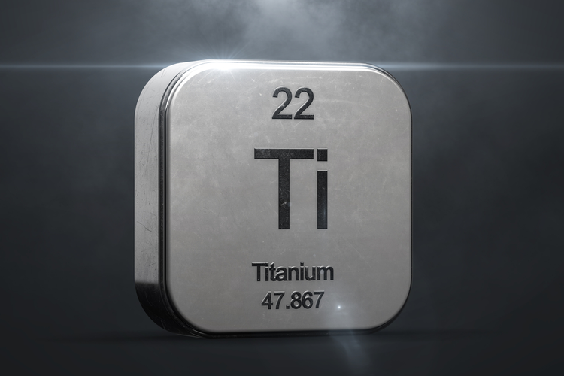
Figure 5 Titanium (https://www.thomasnet.com/insights/why-military-aerospace-industries-rely-heavily-on-titanium/)

Benefits of the new Process
The benefit the new manufacturing process would offer are substantial. Firstly there will be higher level of accuracy with the dimensions and shape of the bracket being produced. This allows the engineers to be as specific as possible when designing the brackets for the aircraft. The next benefit that for the new process is that there would be less time wasted having to wait for parts to be made for the aircraft. Time is a huge factor in the aircraft industry as the more time the aircraft is on the ground means the less money the aircraft is making. Another factor is that parts that may have been stopped being produced could cause major problems for the aircraft, in terms of waiting for parts to be made to fit the needs of the former part. This would no longer be a problem as the new process is easily adjustable and can fit the dimensions as shapes as needed.
The performance of the product would be a lot better also which is another benefit. The new manufacturing process would secure a better performance from the product as it has been proven that the new processes outperform traditional means of manufacturing. This is due to the material and geometry flexibility that comes with additive manufacturing process like powder bed fusion.
Another benefit to the new process would be the elimination of tooling. This is a significant benefit when is comes to aircraft. With the elimination of tooling, the marks often left from tools being in contact with the material are no longer there, this is hugely beneficial when considering aerodynamics of an aircraft. The smooth finishes to the material allows for the air to flow over the material easier. This will be particularly advantageous for brackets on the exterior of the aircraft like the engine bracket mounts. The tooling elimination also saves a lot of wasted time in having to make any adjustments to the parts because the new process should produce parts that are ready to use.
One major benefit that comes as a result of the new additive manufacturing process proposed is the ability to have on demand product solution. This means the process allows the ability to make alterations to the product easily if it is not performing to the required standard. The way in which the change could be made is as easy as changing the computer data that is being input in to the printing machine. It also offers the opportunity to create prototypes easily so you are able to trial a new design which could lead to a better performing product in the longer term.

Bibliography

Dogget, Mark (2005). Root Cause Analysis: A Framework for Tool Selection. Quality Management Journal P.35-44
Juran, J M. (1992) Juran on Quality by Design, The new steps for planning quality into goods and services . New York : Free Press
Womack, J P and Jones, D T (2003) Lean Thinking Banish Waste and Create Wealth in your Corporation 2nd ed. New York: Free Press
Investigation of Fuel Nozzle Technologies to Reduce Gas Turbine Emissions https://tspace.library.utoronto.ca/bitstream/1807/70231/3/Antony_Francis_Roger_N_201511_MAS_thesis.pdf[Accessed 25/01/2020]

Flaps and Slats, https://www.grc.nasa.gov/www/k-12/airplane/flap.html [Accessed 25/01/2020]
Aircraft Manufacturing, https://www.precisionaircraft.com/materials-logistics/manufacturing/ [Accessed 25/01/2020]
Machining, https://www.custompartnet.com/wu/machining [Accessed 1/02/2020]
Aluminium, https://www.britannica.com/science/aluminum [Accessed 1/02/2020]
Additive Manufacturing Aerospace, https://www.ge.com/additive/industry/aerospace [Accessed 1/02/2020]
Why Military, Aerospace Industries Rely Heavily on Titanium, https://www.thomasnet.com/insights/why-military-aerospace-industries-rely-heavily-on-titanium/ [Accessed 1/02/2020]
The Complete Guide to Laser Powder Bed Fusion in 3D Printing, https://www.3dnatives.com/en/direct-metal-laser-sintering100420174-2/ [Accessed 1/02/2020]
What is Additive Manufacturing, https://www.ge.com/additive/additive-manufacturing [Accessed 1/02/2020]
Aircraft Engine Parts, https://www.jamco.co.jp/en/business/jco/engine_partts.html [Accessed 1/02/2020]
Manufacturing Aircraft Components https://www.aerospacemanufacturinganddesign.com/article/amd0214-electro-chemical-machining/ [Accessed 1/02/2020]
5 Places Additive Manufacturing is Unstoppable, https://www.stratasysdirect.com/manufacturing-services/3d-printing/unstoppable-industries-using-additive-manufacturing [Accessed 1/02/2020]
What Is the Role for Additive Manufacturing in Aircraft Structural Components?, https://www.additivemanufacturing.media/articles/what-is-the-role-for-additive-manufacturing-in-aircraft-structural-components [Accessed 1/02/2020]
Aircraft Bracket, https://grabcad.com/library/aircraft-bracket-1 [Accessed 1/02/2020]
Titanium, https://www.britannica.com/science/titanium [Accessed 1/02/2020]

