

HNC/HND/BSc Civil Engineering and
Environmental Management

Integrated Group Project
Module Code : ACBA6003
Assignment 1

Civil Engineering Cohort
Project B

Lecturer: Alun Nantel
Report By:
Thomas Hinder : 1701670



TABLE OF CONTENTS

These page numbers apply to the final group document only.

1.0 Introduction…………………………………………………………………………9
1.3 Constraints (TH) ………………………………………………………………....9
1.3.1 Project Scope (TH) ………………………………………………………………....10
1.3.2 Project Schedule (TH) …………………………………………………………….10
1.3.3 Resources (TH) …………………………………………………………………...10
1.3.4 Time and Cost (TH) …………………………………………………………………10
1.3.5 Time (TH) …………………………………………………………………………..11
1.3.6 Cost (TH) ………………………………………………………………...………...11
1.3.7 Other Resources (TH) …………………………………………………………….11
1.3.8 Design Constraints (TH) ………………………………………………………….11
1.3.9 Environmental Constraints (TH) ………………………………………………....11

3.0 A Schematic to Highlight your Solutions in Draft and Final
Drawings (TH) ………………………………………………………………………………....54

4.0 Construction Materials and Methods (TH) …………………………………..66
4.1 Arch Bridge ……………………………..……………………………………………...66
4.2 Steel Superstructure ……………………………..………………………………….66
4.2.1 Durability ……………………………..……………………………………………..68
4.2.2 Environmental ……………………………..………………………………………..69
4.2.2.1 Recycling and reuse ……………………………………………………………..69
4.2.2.2. Minimum Waste …………………………………………………………………..70
4.2.3 Fabrication, Construction and Erection …………………….…………………...70
4.2.4 Arch tie connection ……………………………..……………………………………71
4.2.5 Hangers ……………………………..……………………………………………...71
4.2.6 Components and Choice of Materials …………………………………………...73
4.3 Substructure ……………………………..…………………………………………...74
4.3.1 Cofferdam ……………………………..……………………………………………74
4.3.2 Pre Cast Concrete Piles ……………………………..…………………………….75
4.3.2.1 Handling and Lifting of the piles ……………………………………………….77
4.3.3 Reinforced Concrete Pile Cap ………………………………………………….....77
4.3.3.1 Connection from concrete pile cap to steel superstructure…………………..78
4.4 Abutments ……………………………..………………………………………………78
4.4.1 Gravity Abutment ……………………………..…………………………………...79
4.4.1.1 Bridge Seat ……………………………..………………………………………..80
4.4.1.2 Wing Walls ……………………………..………………………………………...80
4.4.1.3 Backwall ……………………………..…………………………………………...80
4.4.1.4 Pile ……………………………..………………………………………………….80
4.4.1.5 Footing ……………………………..……………………………………………..81
4.4.2 Drainage ……………………………..……………………………………………...81
4.4.3 Design Loads ……………………………..………………………………………..81
4.5 Deck ……………………………..……………………………………………………...82
4.5.1 Steel Girders ……………………………..…………………………………………82
4.5.2 Factors Effecting a Bridge Deck Service Life …………………………………..82
4.5.4 Cast in Place Concrete Deck ……………………………………………………...83
4.5.4.1 System Dependent Loads ……………………………..……………………….83
4.5.4.1.1 Differential shrinkage ………………………………………………………….83
4.5.4.1.2 Thermal ……………………………..………………………………………….83
4.5.4.2 Natural Considerations ………………………………………………………….83
4.5.4.2.1 Thermal Climate ……………………………..………………………………...84
4.5.4.2.2 Coastal Climate ……………………………..………………………………...84
4.5.4.3 Mix Designs ……………………………..………………………………………..84
4.5.4.3.1 Permeability ……………………………..………………………………………84
4.5.4.3.2 Crack Resistance ……………………………..………………………………....84
4.5.4.3.3 Workability ……………………………..……………………………………….85
4.5.4.4 Drainage ……………………………..……………………………………………85
4.5.4.5 Construction ……………………………..………………………………………..85
4.5.4.5.1 Placement and Curing of Concrete …………………………………………..85
4.5.4.5.2 Formwork ……………………………..………………………………………...86
4.6 Design Loads ……………………………..…………………………………………..86
4.6.1 Vertical loading ……………………………..………………………………………86
4.6.2 Side loading ……………………………..…………………………………………...86
4.6.3 Live loads ……………………………..…………………………………………......86
4.7 Lighting ……………………………..…………………………………………………..87
4.8 Pedestrians ……………………………..……………………………………………..87
4.9 Preventions ……………………………..……………………………………………..87
4.10 Maintenance ……………………………..…………………………………………...87
4.11 Mooring ……………………………..………………………………………………...87
4.11.1 Piles ……………………………..…………………………………………………..87
4.11.2 Pile caps ……………………………..……………………………………………..88
4.11.3 Pontoon System ……………………………..…………………………………….88
4.11.4 Floats ……………………………..………………………………………………...89
4.11.5 Access Bridge ……………………………..……………………………………….89
4.11.6 Safety Gates ……………………………..………………………………………...90
4.11.7 Lighting ……………………………..………………………………………………..90
4.11.8 Aluminium Cleats and Connection ……………………………..………………..90
4.11.9 Life Buoy Stands ……………………………..……………………………………..91
4.11.10 Safety and Access Ladders ……………………………..………………………91

References……………………………………………………………………………………….92

LIST OF FIGURES

Fig 1.0: Picture of the area from above………………………………………………….....9
Fig 1.1: historic map of Swansea………………………………………………………....13
Fig 1.2: Superficial deposit map…………………………………………………………...14
Fig 1.3: Radon map………………………………………………………………………...14
Fig 1.4: Map of coal mining………………………………………………………………..15
Fig 1.5: Trial pits……………………………………………………………………………16
Fig 2.0: Illuminated arch bridge…………………………………………………………...29
Fig 2.1: Picture of Swansea’s arch bridge in SA1………………………………………29
Fig 2.2: Swansea’s simple but aesthetically pleasing sail bridge …………………….30
Fig 2.3: Swansea’s steel deck sail bridge………………………………………………..31
Fig 2.4: copper paint for a steel bridge…………………………………………………...31
Fig 2.5: Overall site plan (preconstruction stage) ………………………………………51
Fig 2.6: Site plan for A14B and A17 (stage one) ……………………………………….52
Fig 2.7: Site plan for B5 and C4 (stage 2) ………………………………………………53
Fig 4.1: Tied arch bridge…………………………………………………………………..66
Fig 4.2: Steel protection……………………………………………………………………68
Fig 4.3: Steel recycling…………………………………………………………………….69
Fig 4.4: Assembling the steel arch section………………………………………….…..70
Fig 4.5:Sheet pile cofferdam………………………………………………………………74
Fig 4.6: Pile driving rig……………………………………………………………………..75
Fig 4.7: Adjustable pile brackets………………………………………………………….88
Fig 4.8: Fiberglass pile caps………………………………………………………………88
Fig 4.9: Steel framed pontoon with wooden deck finish……………………………..…89
Fig 4.10: Floats float………………………………………………………………………..89
Fig 4.11: Steel truss bridge with hardwood deck finish…………………………………90
Fig 4.12: Aluminium Cleats………………………………………………………………..90
Fig 4.13: Life buoy stand…………………………………………………………………..91
Fig 4.14: Fibber glassed safety ladders………………………………………………….91

1.3 Constraints
Project constraints are limitations on the progress towards the projects objective goal. They constrain the choices that you have with the project in designing and executing the project.
There are many different constraints that can have an effect on a construction project. During the beginning of the project it is vital to identify these constraints therefore any possible impact on the project can be managed. This includes being very clear about any possible risks and who might be accountable for them, as well as understanding the dynamics of the project and how the different constraints have different effect.

There are three types of project constraints that define the project boundaries, Scope, Schedule, and Resources.

1.3.1 Project scope

The project scope is the description of all the required work to create the product, service or result. The constraint of the scope typically takes two foams, either its features which means what needs to be developed or what must be created or the quality of the work.

1.3.2 Project schedule

A project is like a temporary endeavour, unlike a process that keeps going on and on continuously. A project has a precise start and finish. Another schedule constraint is the relation of activity’s within the project. Which ones can be done sequentially and which ones can be done in parallel, which ones have special time windows when they must be done because of weather constraints.

1.3.3 Resource

To complete the work of the project resources like money, people or equipment are required. There are also limitations associated with these. One of the limitations are the type of resources that are available to the project. There are also limitation around how many resources will be assigned to the project.

These three categories comprise the projects constraints. All the rest of the project management tools and techniques will be focused on managing and controlling these three categories to achieve the project objective.

1.3.4 Time and Cost

To ensure success with any project, there are many different limitations that need to be addressed. There are a great deal of project constraints. Time, Cost, and Scope are the three constraints that project managers are most familiar with. These three primary constraints are known as the project management triangle, or the triple constraints.

Every constraint is connected to other constraints in some sort of way, for example if we were to increase the projects scope we would most likely need more money and time, while if we were to speed up the timeline it might result in reducing the cost of the project but could diminish the project scope.

1.3.5 Time

The project’s completion schedule is referred as the time constraint. These include the deadline for every phase of the project and also the final rollout date of the deliverable.

A Gantt chart is a good way to visualise the schedule of the project. Having this data can result in more accurate estimates.

1.3.6 Cost

The commitment of the financial side of a project depends on a number of variables.
In any project budget includes a fixed and variable cost that is needed to be calculated. These include not only cost for material but other resources, labour cost, quality control, vendors, and other outside forces.

1.3.7 Other Constraints

1.3.8 Design Constraints
Some of these constraints may be knows at the start of the project while others will become visible as the design progresses.
The design constraints will change depending the site and the building type required or who they might be imposed for. Client or is there a third party involved.
Design constraints are very helpful for developing the design as they lead you to the right solution and they also limit the number of options for the feasibility.

1.3.9 Environmental Constraints

The limiting factors concerning the environmental constraint include:
- The use of hazardous or sustainable materials.
- Carbon emissions and energy consumption.
- Contamination of water, air or ground pollution.
- Water and waste management.
- Vibration, dust and noise.
- Transport and traffic.
- Adapting to climate change.
- Design for disposal and deconstruction.

3.0 Sketches

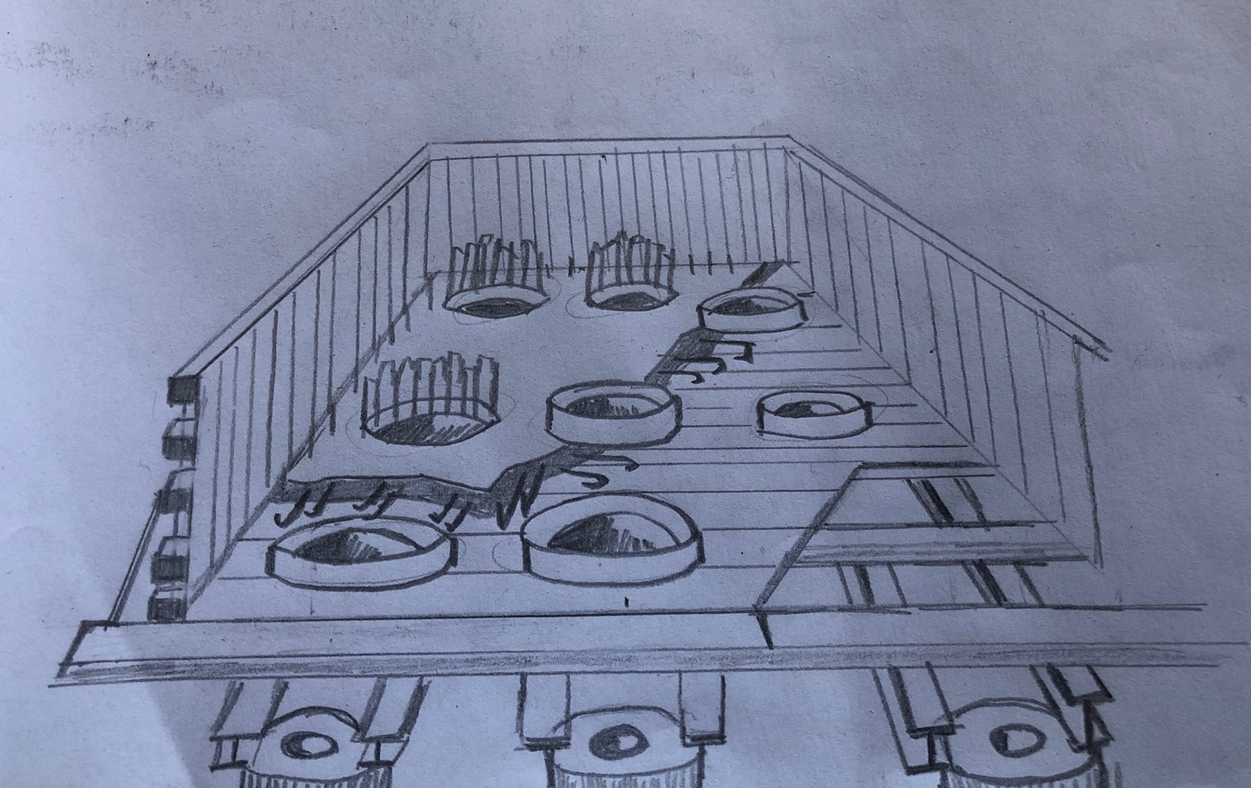

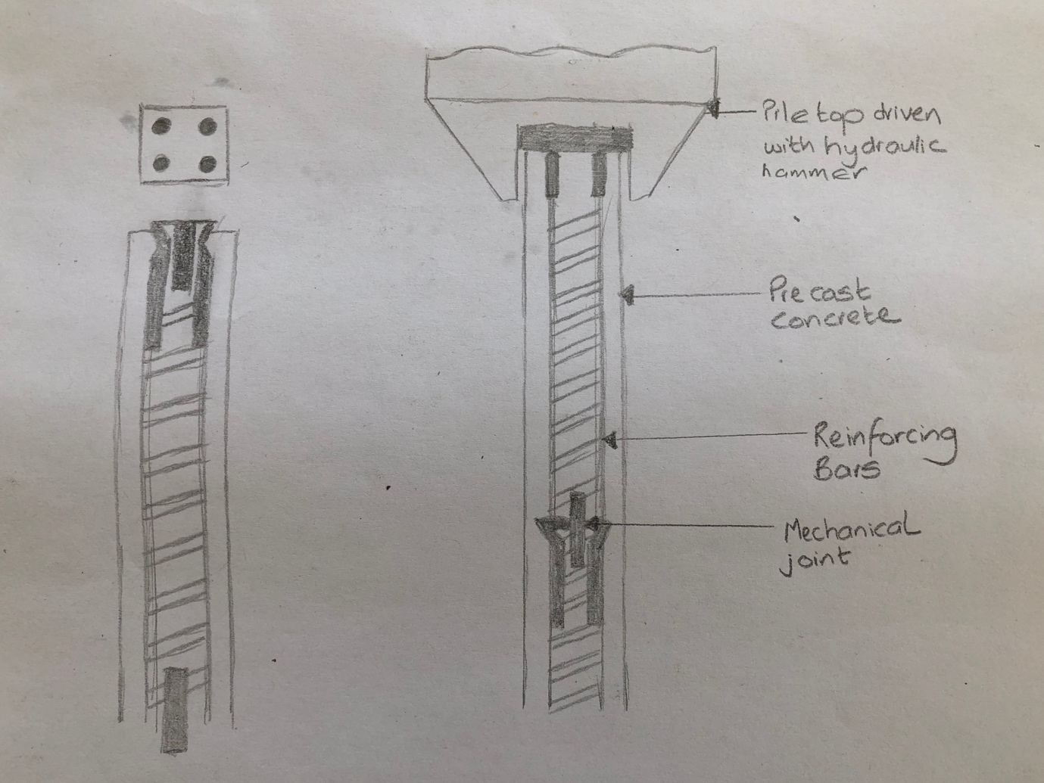
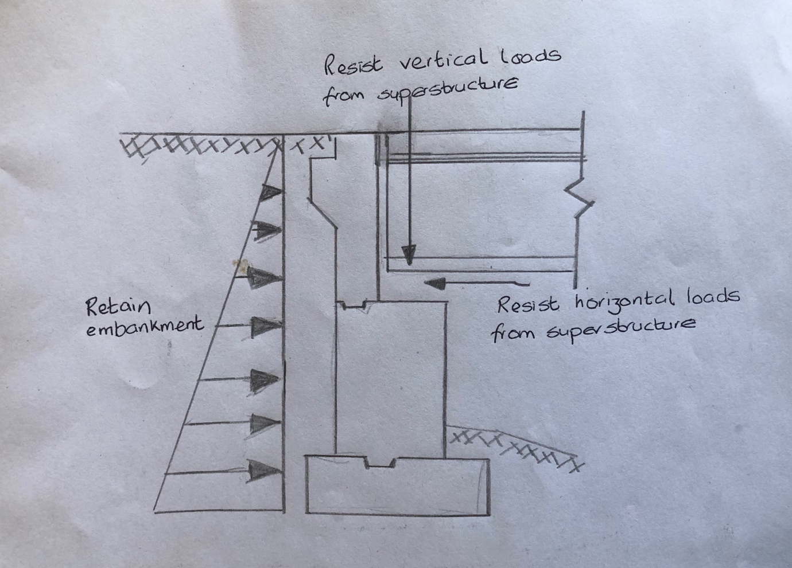
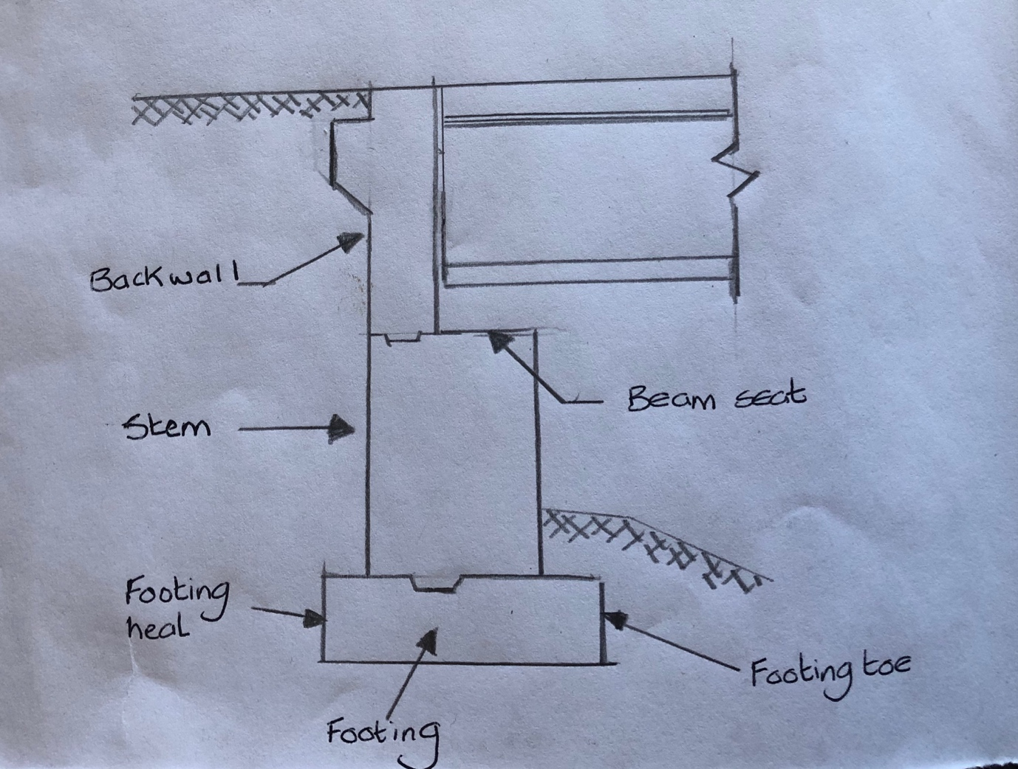
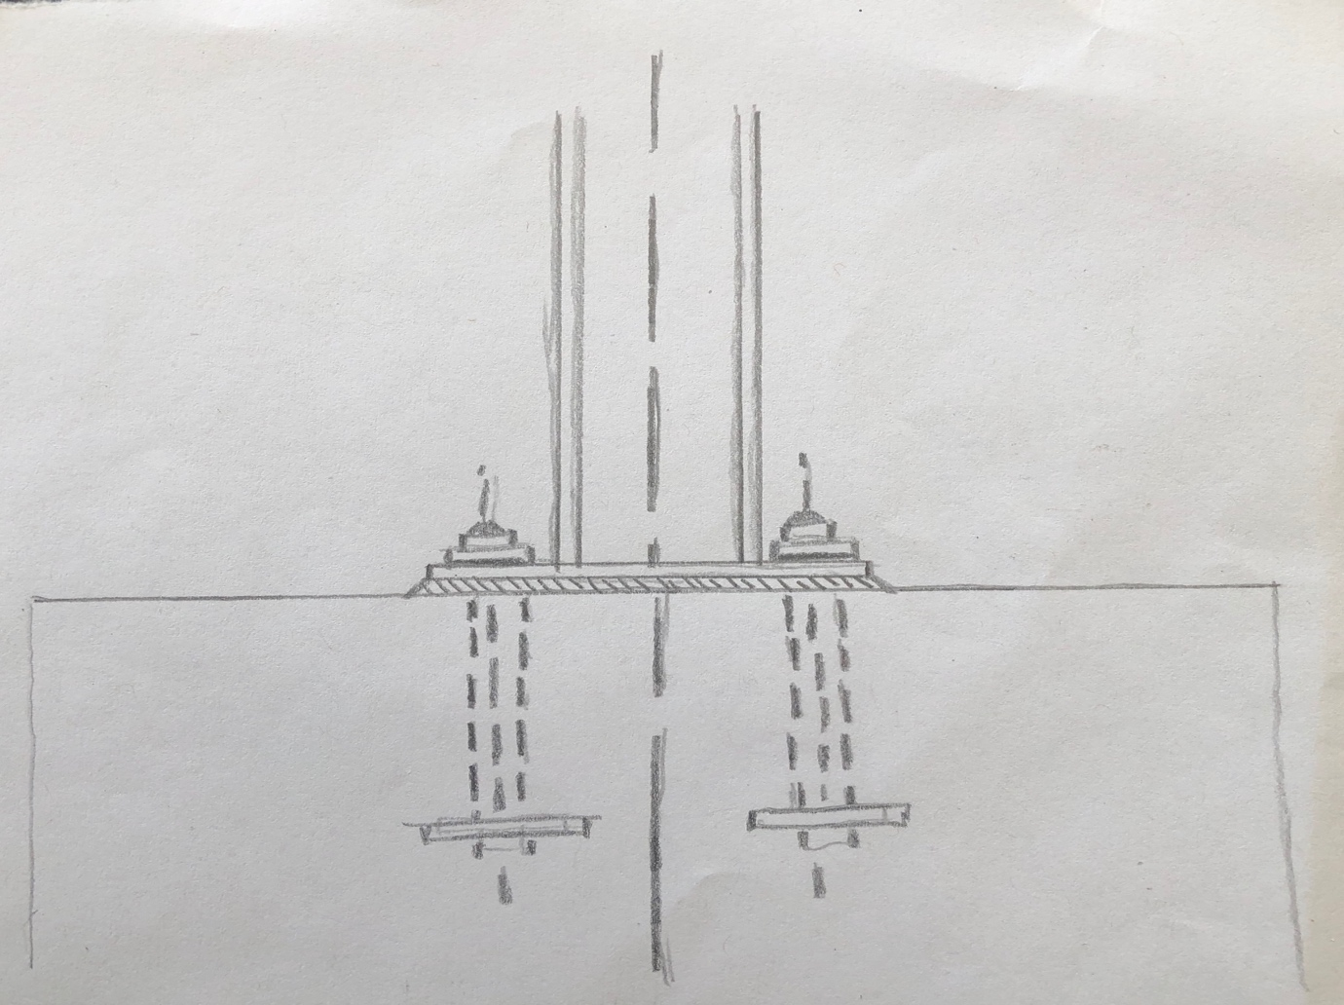
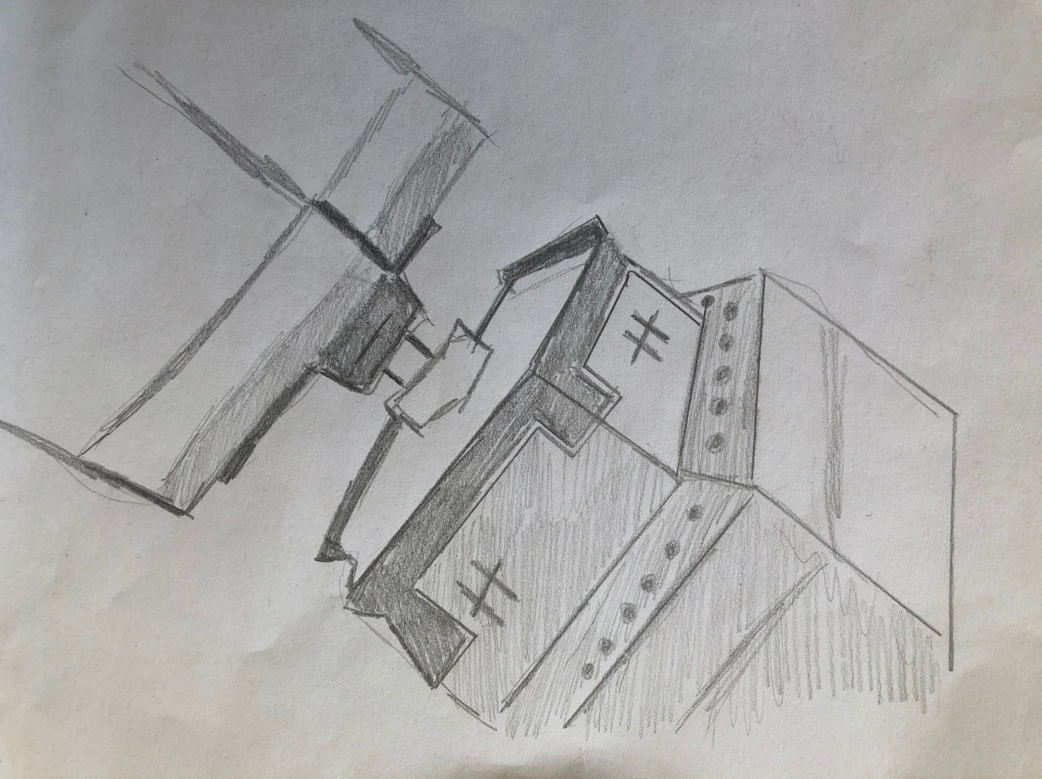
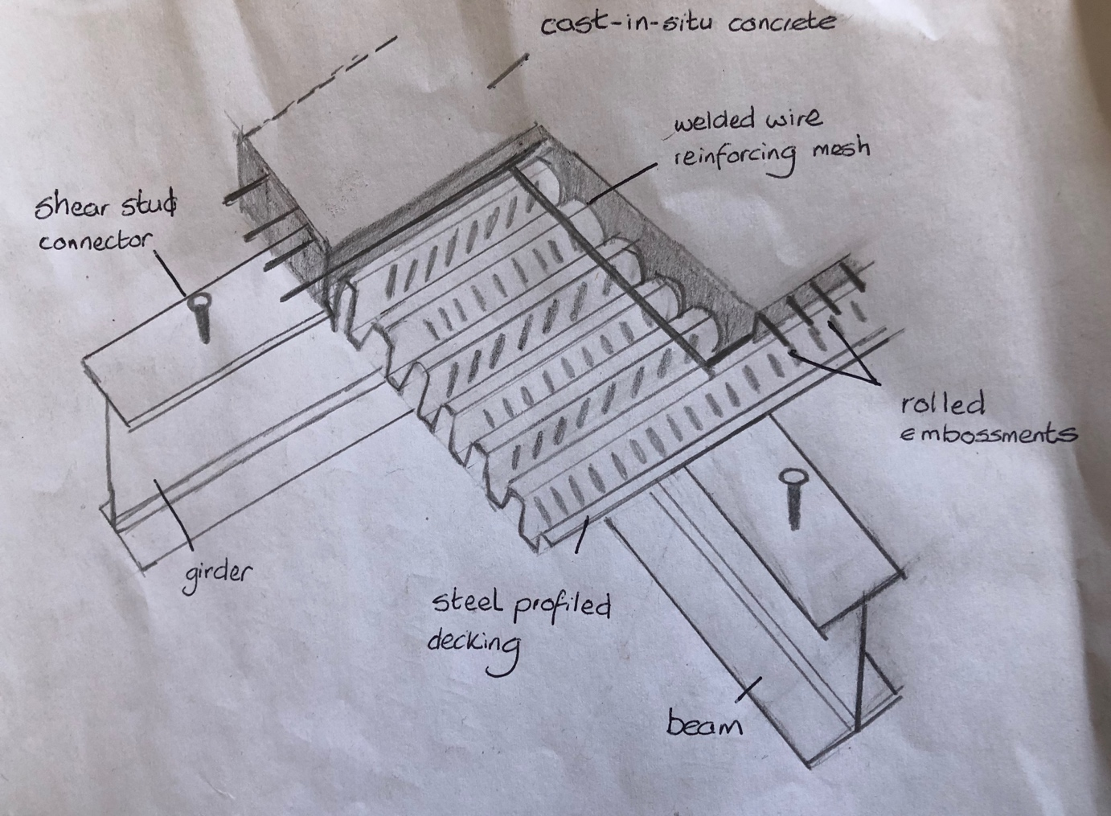
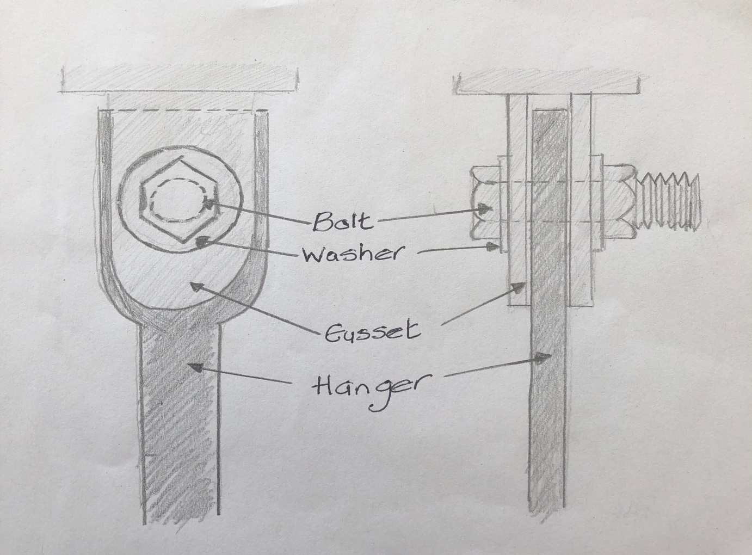

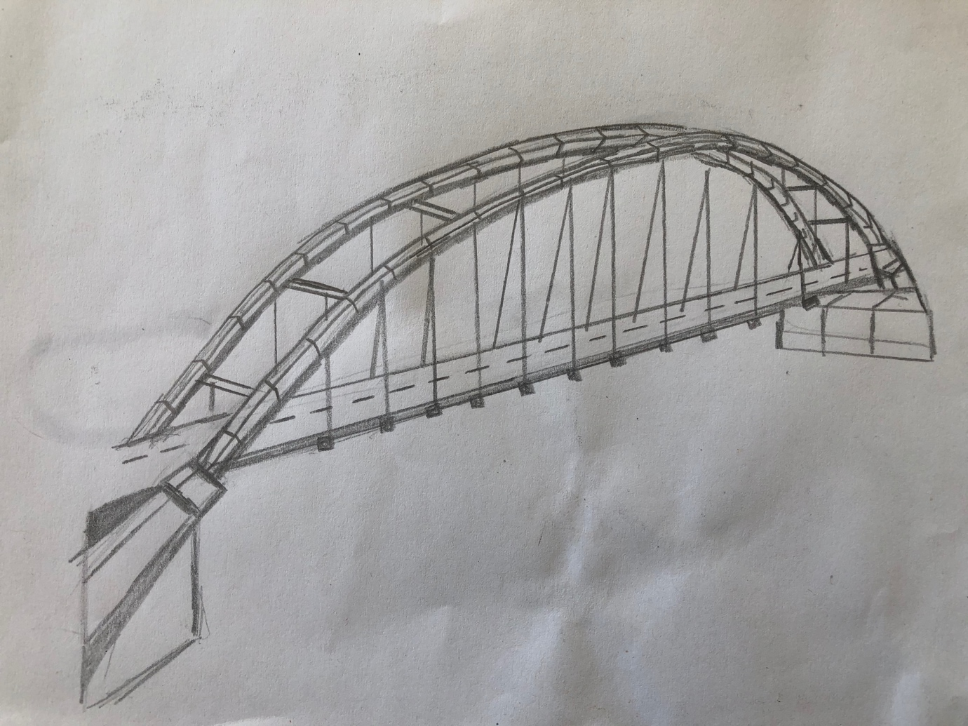
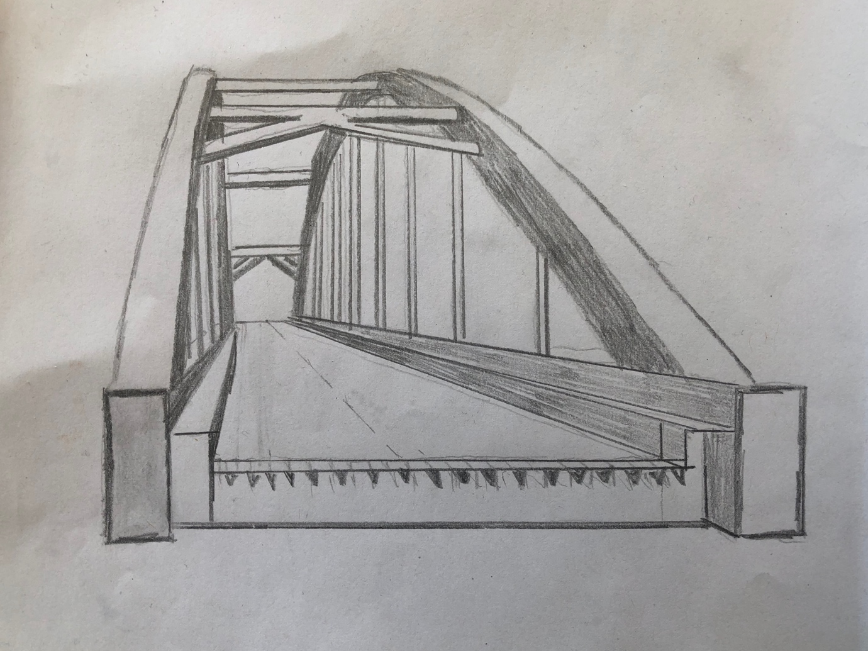

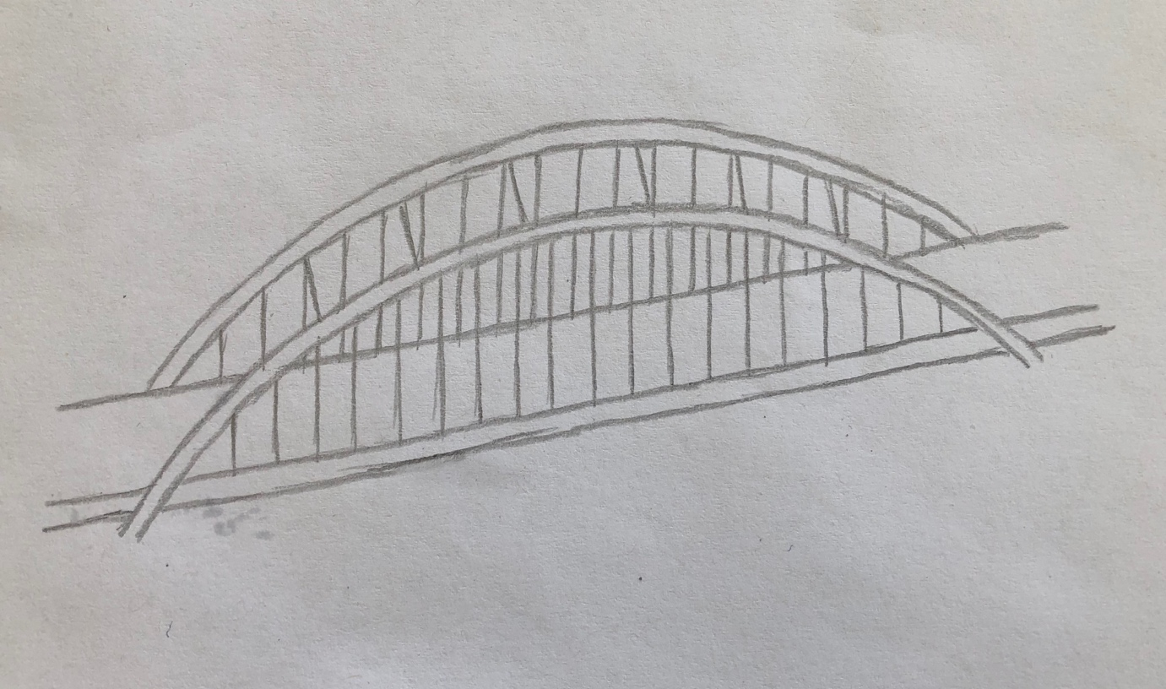

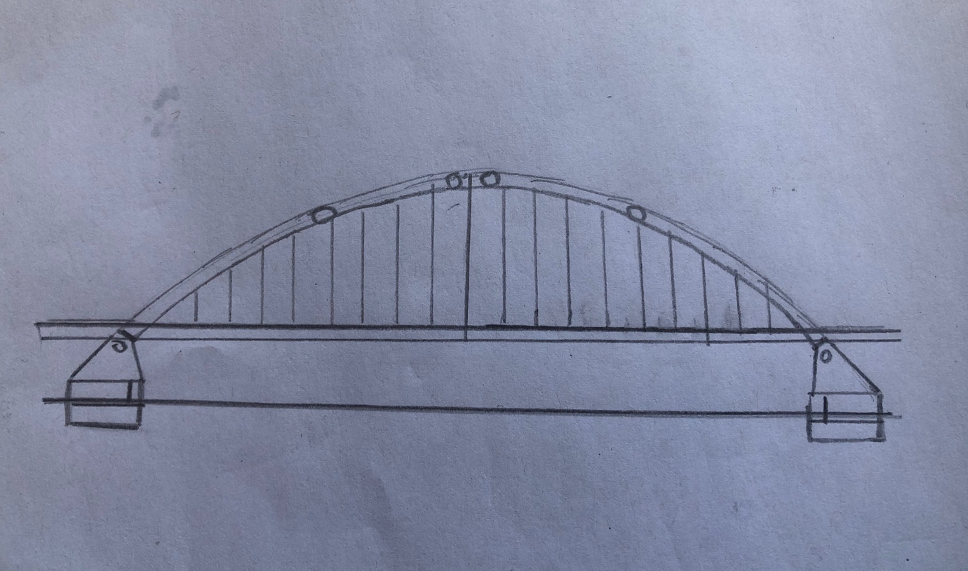
4.0 Construction Materials and Methods

4.1 Arch Bridge

There is a long history with masonry arch bridges. They are thrust arches which means they reply on their foundations as horizontal restraints. In many projects this is not practical and are now replaced by tied-arches. Recent bridges that used the thrust arch were the Tyne Bridge, Newcastle and another is the Harbour Bridge in Sydney.

The traditional Masonry arch and newly steel arch bother share similarities when it comes to its structural design. They rely on the foundations for their horizontal thrusts. In compression the arch acts as the arch above can hold the deck up through the hangers.
To deduce costs for foundations in a tied-arch bridge, the tension members are taken by the deck. This makes bridges with a crossing distance of 70 to 200 meters more suitable. Other bridge designs would require other support systems such as stay cables.
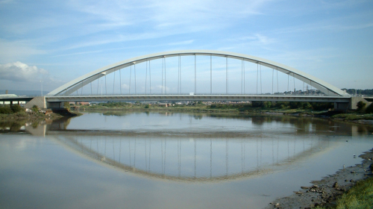

Fig 4.1: Tied arch bridge

4.2 Steel Superstructure

Steel construction used worldwide for the construction of bridges. It is flexible material that provides sustainable and efficient solutions. Long span bridges, highway bridges, railway bridges, footbridges, steel is recognised as the most cost-effective, economical option. As its dominance increases there are also many benefits to the society. These benefits include, landmark structures, good designs, and the speed of construction is quick.
These bridge features are essential of a landscape and infrastructure of a country. The combination of aesthetics and technicality, there is not many structures man-made that has been built in such way.
The structural high quality of steel in various product shapes, sizes and certified grades is available across the world. Factory controlled prefabrication is at minimum cost with high quality. The steel is quality controlled during its fabrication during the processes of cutting and drilling, welding, assembly, and protective treatments. Quality assurance with confidence should be given to engineers and clients who specify the steel for the project.

Steel delivers a material properties capable the job at hand. Its combination of mechanical working, chemical composition as well as precaution heat treatment. The most important property that designers specify is the steels yield strength. The drive behind the making and rolling process of modern construction is its ability to maintain all the different properties while having the suitable yield strength.

In exposed environment all structural steel has similar corrosion resistance and all need a protective coating.

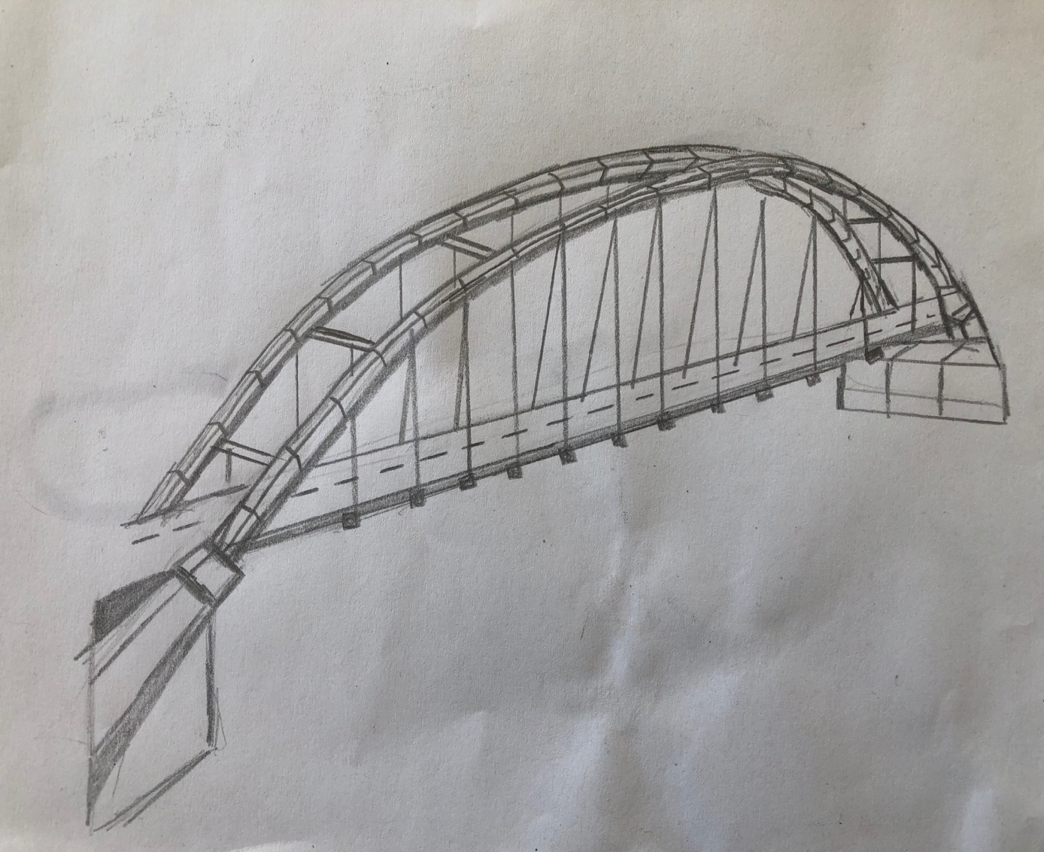

4.2.1 Durability

The predicted lifespan of a steel bridge is up to 100 years. As the steel has a fatigue predictable life with the element accessible and visible. Without major investigation deterioration signs are apparent. The effect of corrosion is an effect to its surface and can be addressed and maintained by repainting. With the newly advanced technology the life span of these protective coatings can have an expected life of up to 30 years. The use of weathering steel increasingly is becoming more popular as they require almost no maintenance meaning maintenance cost reducing.

In the UK because of the weather conditions the majority of bridges have corrosion protection. Specifications comprise of a coating sequence of paints or the application of paints over thermally sprayed metal coatings, a duplex form system is then created. These comprise of a primary coating, intermediate coating and a finish coating. Each of these coatings having a specific function. Primary and intermediate coatings are applied off site. The final coatings then finalised on site.

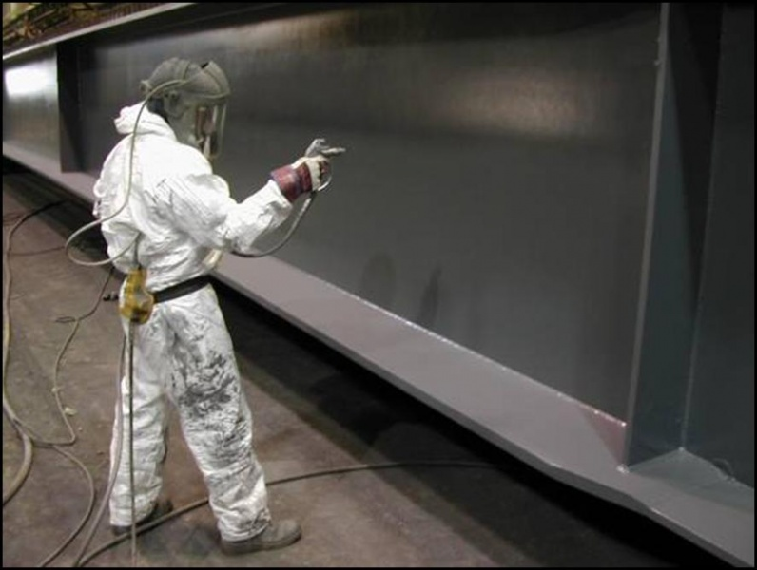

Fig 4.2: Steel protection

4.2.2 Environmental

If we to build our world with steel not much could be more natural and sustainable. The raw material of iron is the most rich element on earth. The polarity of iron is like a magnet that’s why a compass points north. These natural resources without loss of property or performance can be recycled.

4.2.2.1 Recycling and reuse

Steel as a construction material is the most recyclable and represent a sustainable option for bridge construction. As a steel bridge starts to come to the end of its service life the girders can be cut and made into demolition magnets and returned to steelworks to be recycled. Nearly every steel component is returned back to steelmaking to be reused. Recycled steel produces degradation free in its performance. Bridges have entirely been relocated and can be designed to be future relocated.

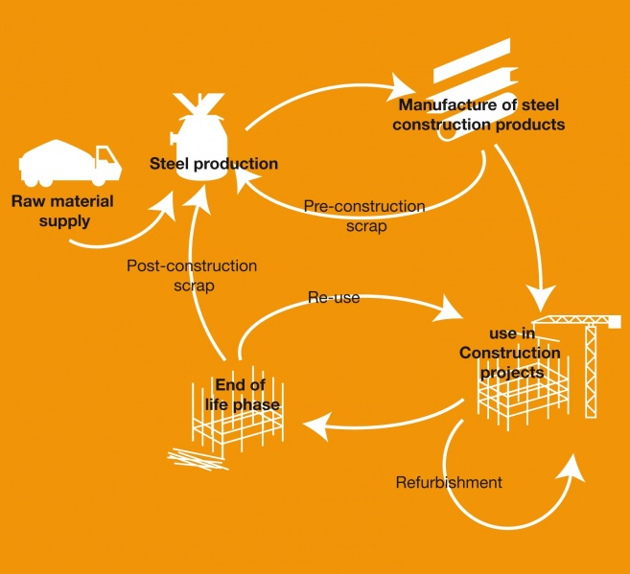

Fig 4.3: Steel recycling

4.2.2.2. Minimum Waste

Modern prefabrication of steel using state of the art CAD software and CNC machinery enables waste to minimised, during manufacture and on site. Good designs can also contribute to minimise waste. The aim of good designs to minimum waste is well promoted.

4.2.3 Fabrication, Construction and Erection

Offsite prefabrication allows the steel components to be assembled in quick duration. By the use of the fabrication it will minimise road disruption and rail users, therefore producing a positive effects for the economy. The structural low weight of steel components allows large sections to be erected and moved, positioned, and completed overnight.

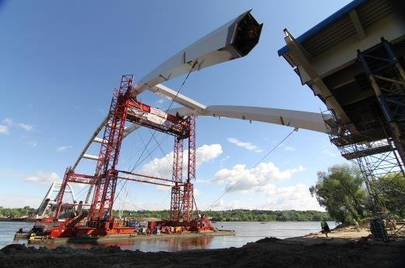

Fig 4.4: Assembling the steel arch section

The process of fabrication starts with 3D modelling. A CADCAM software is used to create a component list of girders, bracing elements, stiffeners required for the bridge. A program for the automated equipment is produced. This model can carry out virtual trial erection and also rectify any conflicts.

There is a large range of methods for construction. Piece by piece they can be crane lifted into position or for the girders to be rolled on from the abutments.

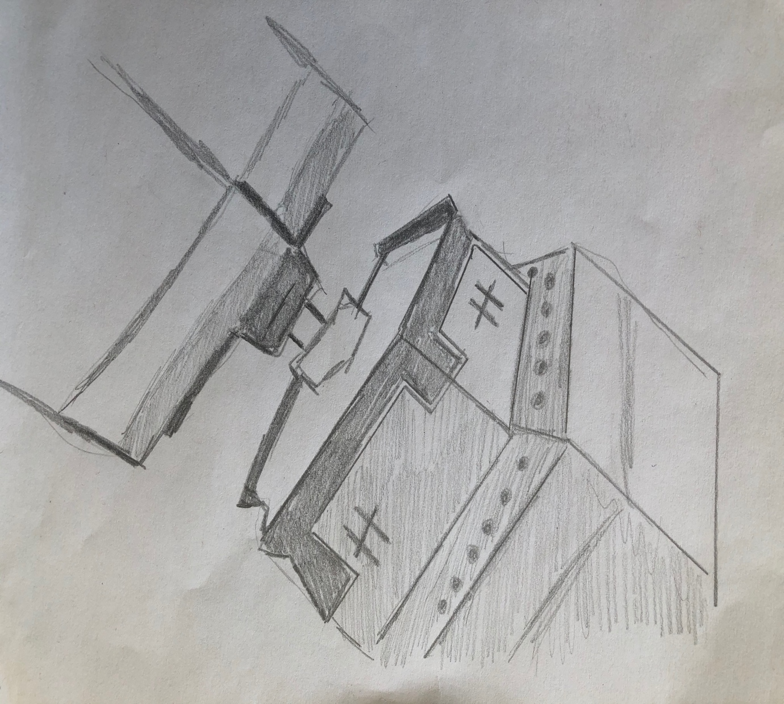

4.2.4 Arch tie connection

For fabrication this is the most complex part of the construction. Although consideration must be given to deal with transfer of forces and moments also how it will be fabricated to achieve a cost effective, efficient solution.

4.2.5 Hangers
As there are different designs of tied arch bridges there are different hanger designs. Through the improvement is computer technology modelling the layout of hangers have been improved. With the development of computer technology the understanding of the behaviour with structure with more than one reaction forces became available.
The langer system is where the deck has a high rigidity. For flexibly arches they are the main function. Vertical hangers suspend the deck.

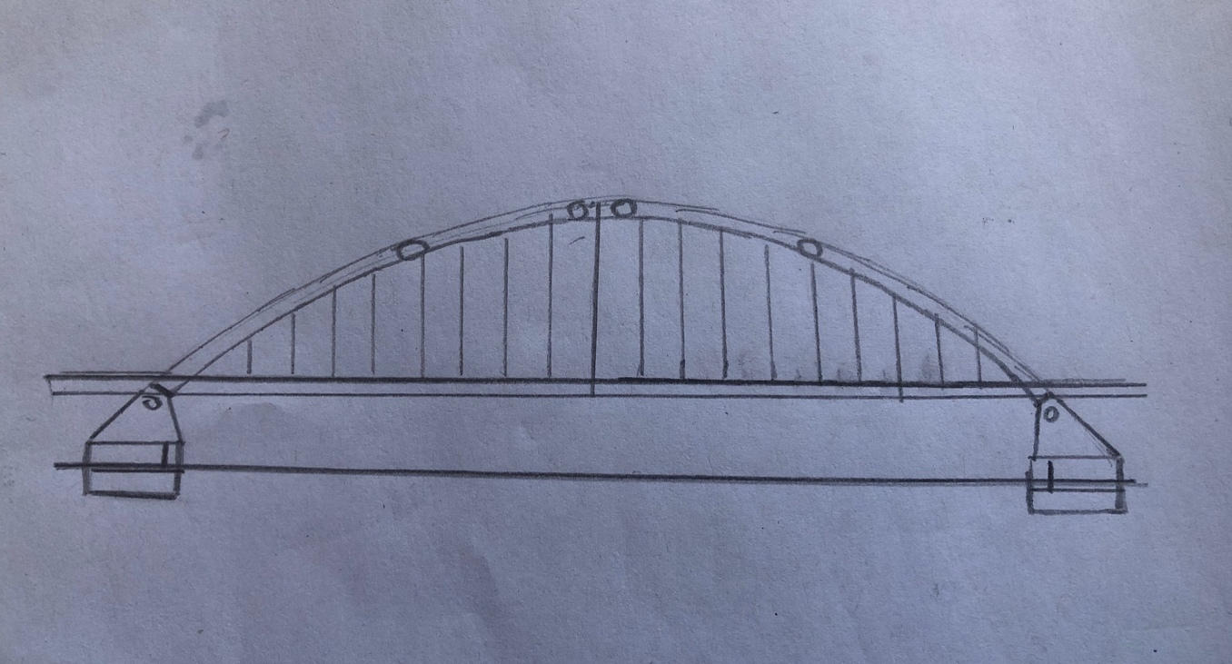

Tension component specifications for design are given in BS EN 1993-1-11. To SLS loading the cable sizes should be used where the tensile stress limit is at 45% of the braking load. Data for various manufactures can be found on the proprietary system. These include strand, rope, and bar.

If there is an incident and a hanger is lost, the remaining adjacent hangers under higher levels of stress should works. The fixings and the anchorages for the cables are designed so that the strength of them exceeds the cables braking load. Robustness should be in mind when designing steelwork.

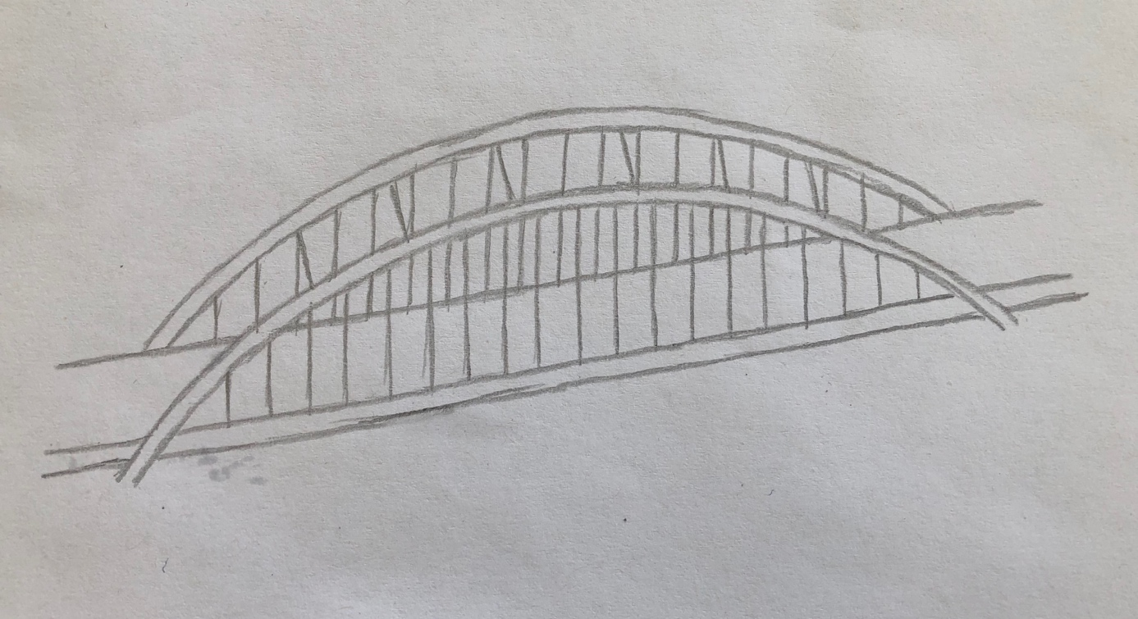
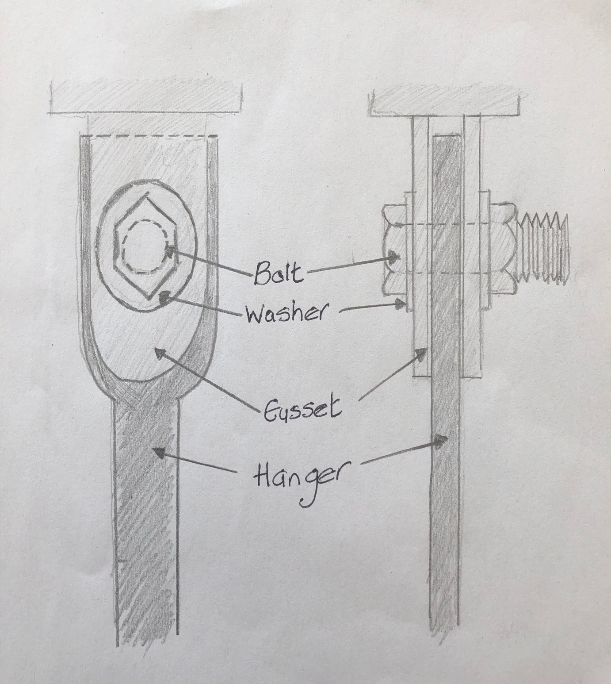

4.2.6 Components and Choice of Materials

The most efficient section is a box section as the primary compression member is the arch. The arch can or cannot be stiffened longitudinally but it depends the efficiency loss by using thing plates or the fabrication cost being more because the panels will need stiffening. The steel of the arch is from weathering steel to minimise the maintenance internally. Painting the exterior is needed but not the interior. There will be a medium span of bracing between the arch and to provide drainage will be vented.

4.3 Substructure

The foundations of a structure is the main form of support to transfer the load from the structure to the suitable soil settlement. The principle of pile foundations is for the load to be transmitted into strong, compact stiffer strata which will increase the effect of the foundation.

4.3.1 Cofferdam

Every cofferdam before construction requires good analysis as each one is unique. Designers have many parameters needed taking into account such as ground conditions, weather conditions and other forces such as wind and wave currents.

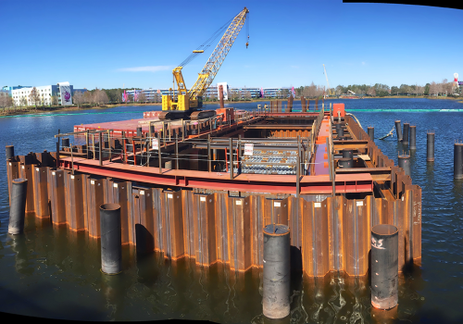

Fig 4.5:Sheet pile cofferdam

The steel sheet piles will be driven into the muddy soil in pairs sufficiently deep to develop lateral and vertical support and are then interlocked to create an air tight seal. Once the air tight box like structure has been constructed the water from inside will need to be removed to create a dry working environment inside.

4.3.2 Pre Cast Concrete Piles

Pre cast concrete piles are suitable for almost all soil conditions and are good for their stability and versatility. Pile foundations are adopted when the soil below the structure is suitable and has the capability to carry the load to the foundations after applying a factor of safety. The foundations will transmit the load into the underlying soil so that there is no settlement of the foundations.
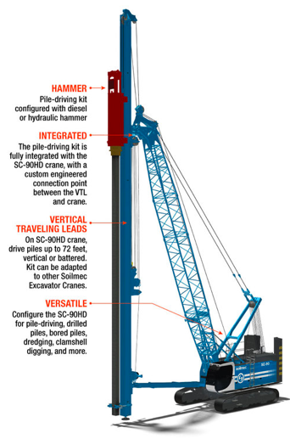

Fig 4.6: Pile driving rig
A pile driving rig is used to drive the precast concrete piles in to the soil. The precast concrete piles will be suitable for our foundation due to the possibility of bending moments as well as horizontal and vertical loads. Manufactured in a factory controlled environment these reinforced concrete sections will be made to the required length. Our piles will be 400mm square reinforced to provide more friction surface. This also allows for potential heavier loading. The piles will be cast and then cured before being transported to site. The concrete mix used for these piles will be a 1: 1 ½: 3, a rich concrete with a richer concrete mix for the pile head of 1: 1: 2. This is because of the driving can cause stresses in the concrete.

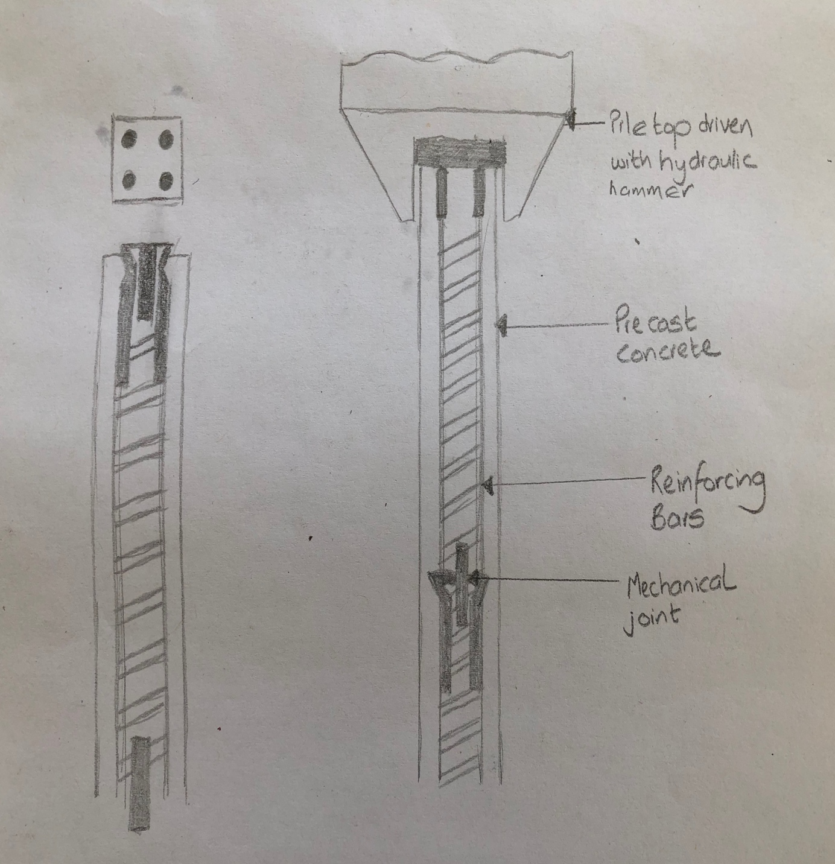

4.3.2.1 Handling and Lifting of the piles

The bending moment is included when the piles are lifted due to its self-weight. The reinforcement inside the piles help to handle these stresses. To minimise to amount of reinforcement needed there should be a significant amount of care given when lifting the piles to minimise any possible bending moment.
4.3.3 Reinforced Concrete Pile Cap

After the piles have been driven down into the required level, the pile cap will be constructed on top of the piles. A pile cap is a thick layer of reinforced concrete that rests on the piles. It is the transition component from the precast piles to the steel arch superstructure.
For the formwork to be constructed an excavation around the piles will be made. The reinforcement cage will then be assembled inside the formwork and fastened to the precast piles. The formwork will be made so that it’s well above the water level as we don’t want our steel arch in the water. The concrete is then poured into the formwork. When the concrete has cured the formwork in removed.

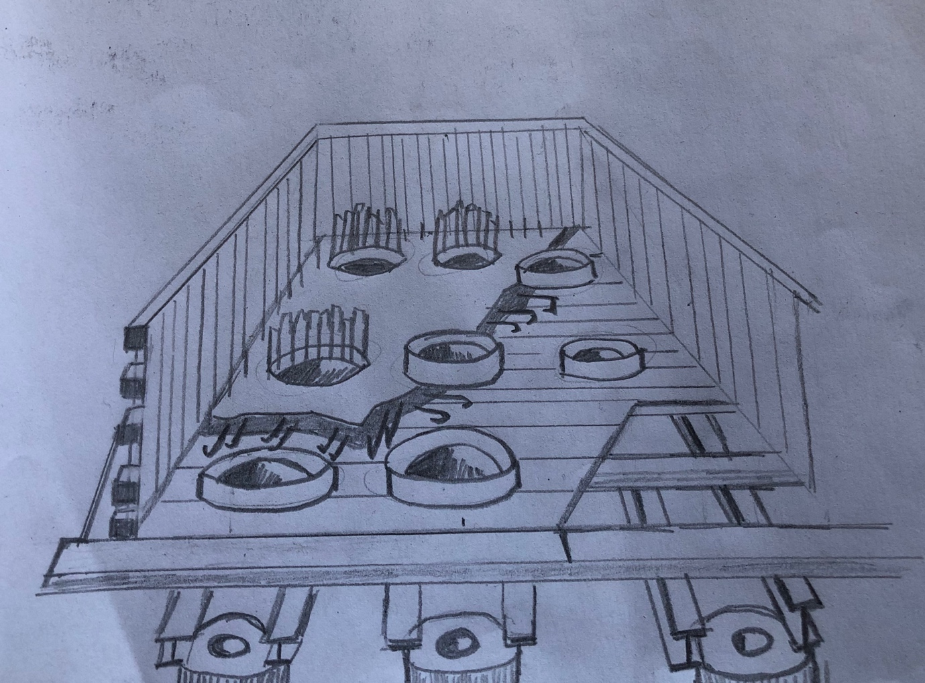

4.3.3.1 Connection from concrete pile cap to steel superstructure

As the reinforced concrete pile cap is above the water and has cured, the transition from concrete substructure to steel arch superstructure is next. A column base plate will be connected to the concrete foundation by using cast in bolts. As there may be spacing between the baste plate, concrete foundation and the bolt pockets a non-shrinkage grout will be used to fill any unnecessary gaps. The enclosed area beneath the base plate is filled using cementitious grout. When filling the bolt pockets care must be taken to make sure they are filled properly.

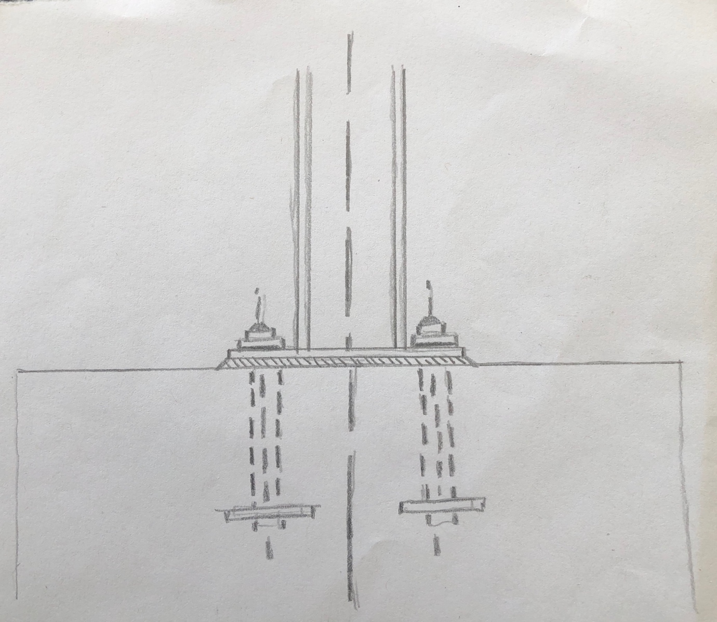

4.4 Abutments
Bridge abutments are to be constructed at each end of the bridge for not only the embankment to be retained but for the horizontal and vertical loads to be carried from superstructure to foundation. Similar to the design requirements of piers and retaining walls, abutments must be able to be stable and to withstand sliding and overturning. They should also prevent any lateral movements and differential settlement.
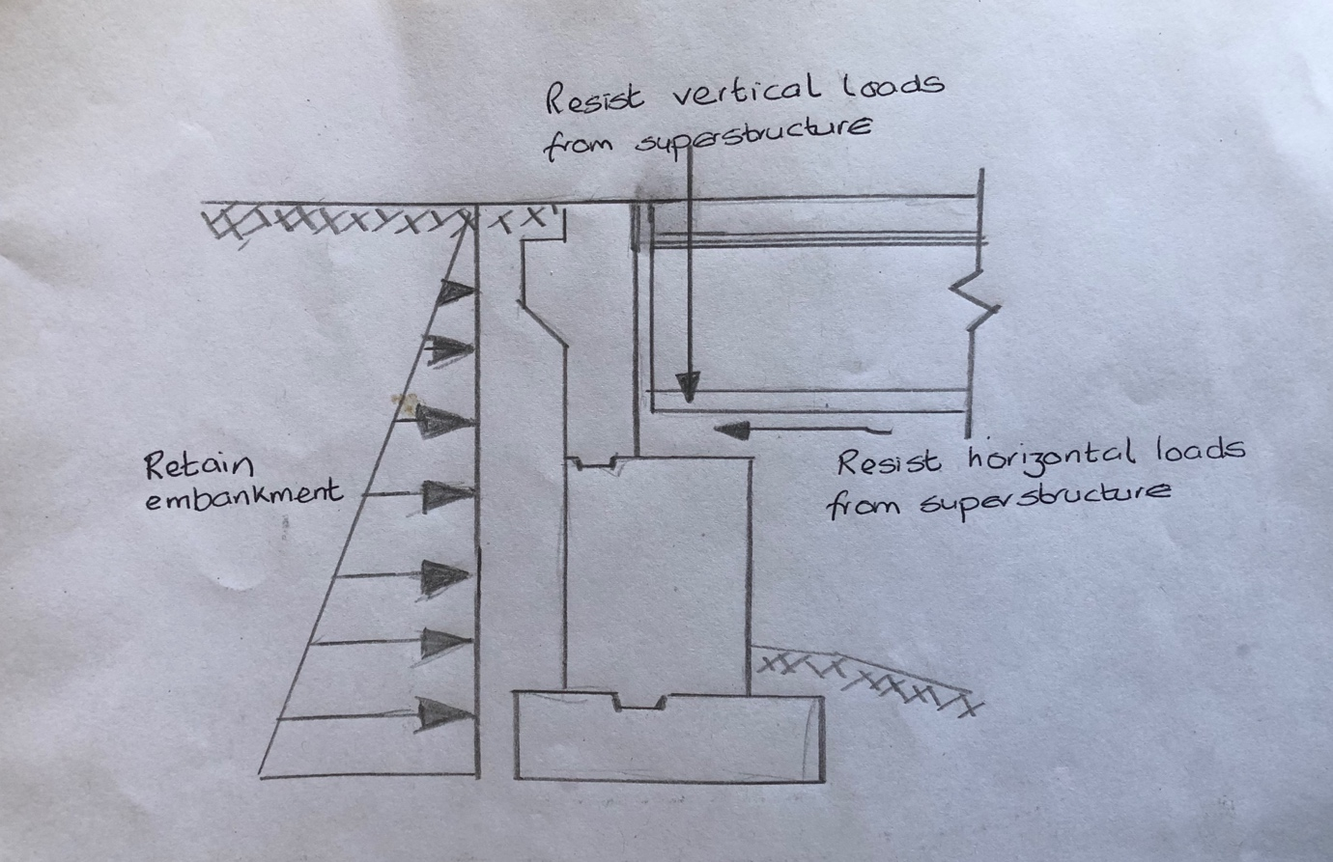

For particular sites for bridge construction can many types of abutments be used. The primary factory usually for abutment selection is usually down to economics. The minimum required section and channel area are considered for water crossings.
There are many aspects that effect a choice of abutment. These include:

- Space available
- Site geologic
- Project funding

4.4.1 Gravity Abutment

The most common and the abutment chosen is the typical gravity abutment. The gravity abutment includes:

- Bridge seat
- Wing walls
- Backwall
- Pile
- Footing

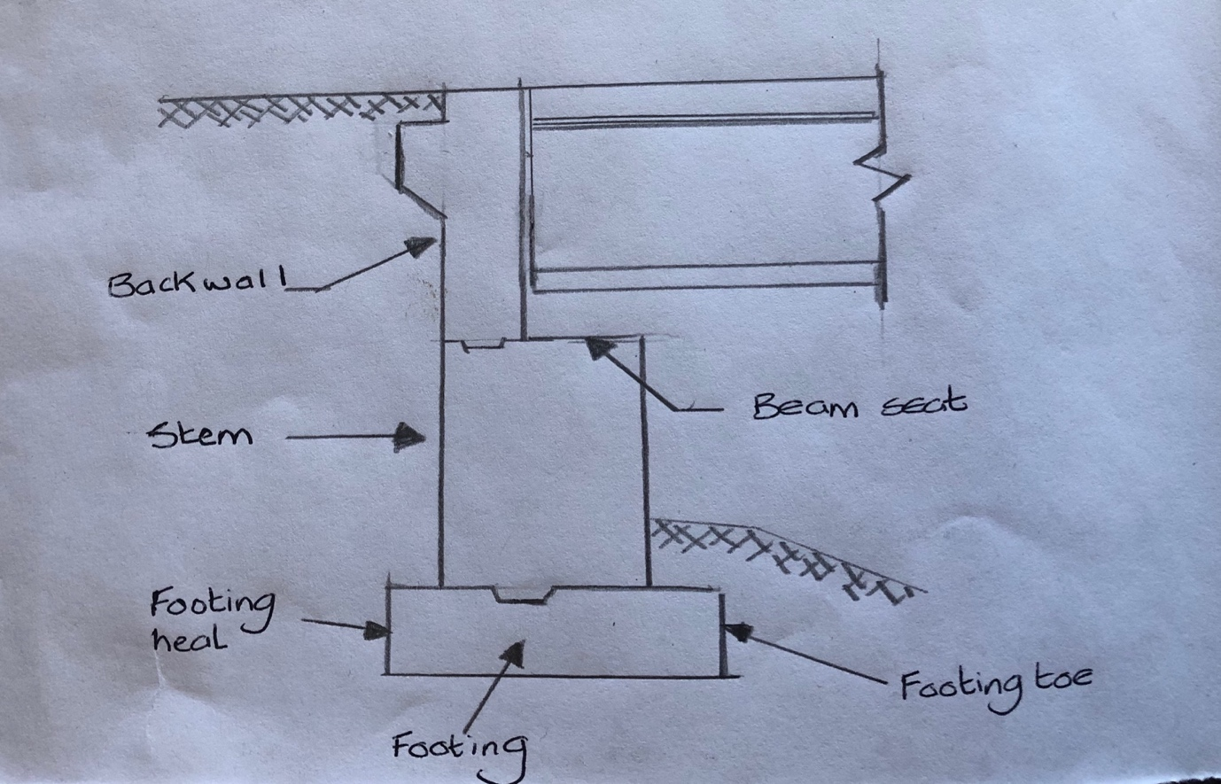

4.4.1.1 Bridge Seat
The bridge seat is a horizontal support that which the deck of the bridge will sit on.

4.4.1.2 Wing Walls
Wing walls are only included the embankment is connected to the abutments. They are short retaining walls for the embankment and deck to add stability and prevent erosion. Parallel to the bridge seat the wing walls will sit.

4.4.1.3 Backwall
As well as the wing wall, backwall are also only included when the abutment is connected to the embankment. To reduce the connection point from getting erosion and for the deck to provide a horizontal brace the backwall in constructed to rise above the seat.

4.4.1.4 Pile
The piles used for the abutment will be a wall that is vertically constructed and that connects seat with the foot. As our abutment is on the embankment, structurally with the wall constructed vertically it provides a retaining wall while abutments mid span use columns which are cost effective.

4.4.1.5 Footing
The footing is the transfer from the ground to the vertical load bearing. The footing is wide horizontal surface constructed beneath the ground. For the weight to be distributed the footing will be wider that the bridge.

4.4.2 Drainage
To prevent any applied loading that unwanted the backfill and drainage of the abutment must be properly detailed and designed.
Drainage of an abutment is very important as we don’t wanted any hydrostatic pressures being applied. This can applied a huge pressure from the water and soil and contribute to a soil unit weight of around 85 pcf. High pressure from frost in cold conditions can lead in silty backfills. If not accounted for when designing it could result in movement in the abutment or structural damage.
To prevent any of these unwanted pressures building up on our abutment it is important that any of the accumulative water that builds up behind the wings and body drains away. This can be achieved by using a previous granular fill. This granular fill will sit on the abutments inside face with a underdrain pipe. This underdrain pipe will be behind winger and body of the abutment and will drain the fill.
A six inch wrapped underdrain pipe will be used will a minimum slope of 0.5% and will drain away from the abutments and discharged into the water.
4.4.3 Design Loads
Vertical and horizontal loads from the superstructure are both applied on the abutments. The location and the amount of resisted reaction from the abutments are dependent on the spacing and amount from the girders of the deck. Loads that also resist the abutment are present water and material used for backfill.
Although the superstructures horizontal and vertical reaction present concentrated loads, they will be distributed over the length of the wall of the abutment.
For use in structural design and stability analysis load per unit weight will need to be obtained. It is calculated as the sum of reactions, either vertical or horizontal, then divided by the wall length.
Concrete reinforced vertical reaction should also be included from designers. This is because they transmit load directly from the approaches to the abutments.

4.5 Deck

4.5.1 Steel Girders

Multi-girder bridge decks for medium span bridges is one of the most common in the UK. As show in the cross section below multi-girder construction comprises of longitudinal girders usually around the same size that are uniformly arranged over the width of the bridge. They are then braced together at some intermediate positions and supports. The deck will then span across the girders and cantilevers. For the composite actions between girders and reinforced deck slab shear connection will be welded.

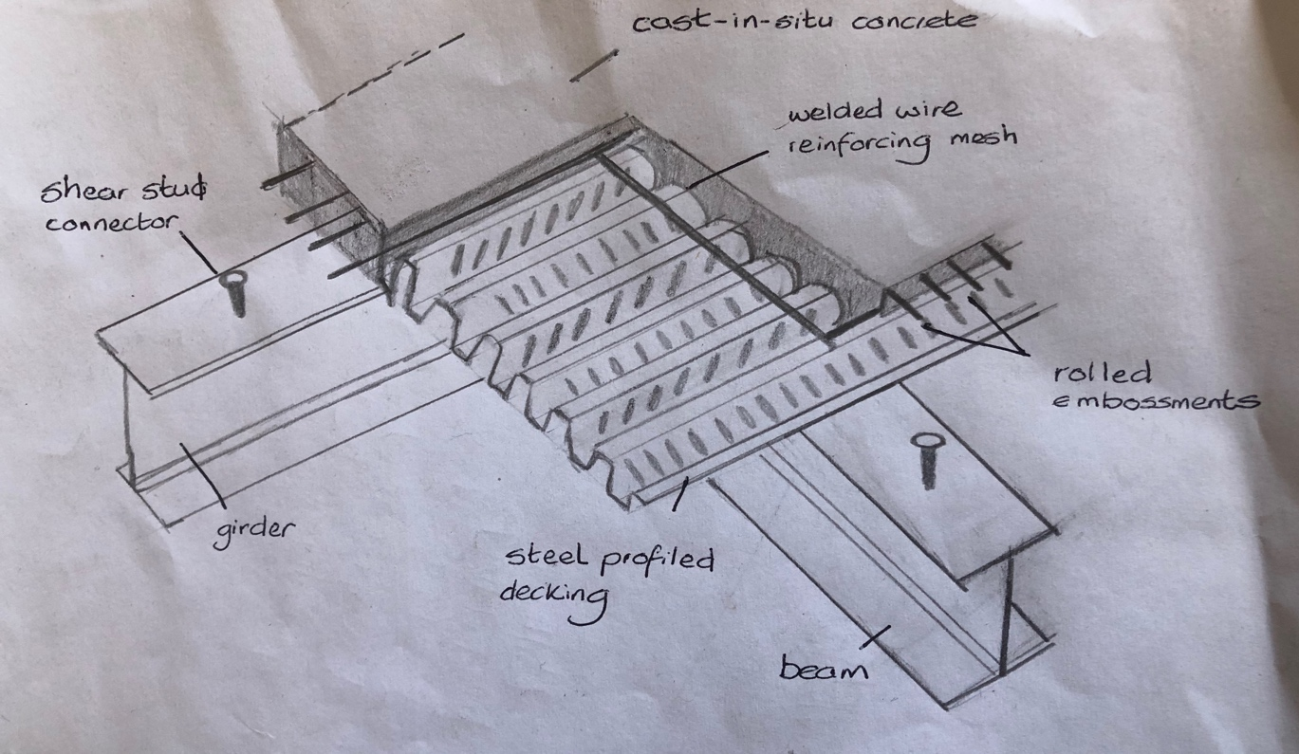

4.5.2 Factors Effecting a Bridge Deck Service Life
Maintenance of a bridge deck is one of the most costly of a bridge. There are two main causes that can affect the life span of a bridge deck;
- Obsolescence
- planning issue and its function

- Deficiencies in its performance because of the material
- Load induced – natural hazard or human activity
- Deflects from production – operational or design

4.5.4 Cast in Place Concrete Deck
As the final integral part of the bridges superstructure the bridge deck will be cast in place. This cast in place concrete deck provides many advantages in the process of casting as it moulds easy. If some elements aren’t located precisely such as lane tapering’s, transitions of elevation, and screws to the original plan the cast in place can still meet the geometric requirements. Although there are advantages there are disadvantages such as quality of concrete. This could be because of workmanship and the process of curing.
Although in compression concrete is a durable material, through various loadings and condition restraints the materials strength in tension can surpass its limit therefore resulting in cracking. When cracking occurs in a bridge deck the surrounding layer around the reinforcement will lose its integrity, therefore losing its resistance to corrosion.
4.5.4.1 System Dependent Loads
Loads that are system-induced are when there is an effect on the configuration behaviour of a bridge deck system.
4.5.4.1.1 Differential shrinkage
When the concrete is cast over steel girders differential shrinkage can occur. The fresh concretes shrinkage when casting gets restrained by the steel. This result in compression in the girders and tension in the deck because of equal and opposite forces. Tensile forces from heat of hydration also has an effect in the fresh concrete.
4.5.4.1.2 Thermal
Axial forces can start to develop in the deck if the temperature changes frequently. Due to temperature gradient and internal uniform changes in temperature there are thermal forces.
4.5.4.2 Natural Considerations
Depending on the environment that the bridge will be can have a big influence on the service life or a bridge deck. Hazards such as naturel hazards, climates, thermal climates, chemical climates and also chemical material properties.

4.5.4.2.1 Thermal Climate
Cold weather is the primary thermal climate influence on bridge decks. With chloride ingress, it can affect the layer supporting the steel and therefore causing corrosion. The process of corrosion to reinforcement causes expansion in the bar. This results in delamination, spalling, and of course cracking. If when building the deck with a cross slope for drainage this will allow the salt water to run away into the adjacent gutter.
If cracking occurs the water can be absorbed into the deck. If this then freezes because of cold weather conditions, there will be stresses inside the concrete because the water rends to expand.

4.5.4.2.2 Coastal Climate
Chlorides from salt spray is the primary coastal climate influence on bridge decks. With a combination of wave and wind action the salty water chlorides can become airborne. A coastal region environment of saltwater is subjected to chloride-laden.
This deposition of spray can also land on the surface of the bridge deck on very windy days. When this deposits the surface it will leave a residual of chloride that will absorb in to the deck and into the steel. This will result in corrosion.

4.5.4.3 Mix Designs
Mix design factors affecting a bridge decks service life such as:
- Permeability
- Crack resistance
- Workability
- Shrinkage
4.5.4.3.1 Permeability
The ability of concrete to resist water infiltration and aggressive solutions will heavily depend on its durability. There will be less resistance to these if the concrete has a high permeability. This could possibly cause the forces to expand because of freeze-thaw which is a physical factor or because of ASR, corrosion, or sulphate attacks which are chemical factors.
4.5.4.3.2 Crack Resistance
For all Cast in place concrete decks the mix design can affect the ability of the concrete to crack.
- Shrinkage cracks that can developed over time can be because there was a high content of water and paste.
- When using large well graded aggregates it can reduce the water and paste content therefore minimising shrinkage.
- If the rate of bleeding is exceeded by the rate of evaporation of fresh concrete plastic shrinkage can occur.
- Concrete with low water/cement ratio, a stiff consistency, and a low bleed water is venerable to cracking from plastic shrinkage. This will depend on the effectiveness of curing.

4.5.4.3.3 Workability
Appropriate admixtures and aggregates of good quality makes a good design for the mix. If there is bad workability when mixing it could result in over vibration or water cement ratio being higher. This can cause segregation of the aggregates. It is vital when mixing to have proper workability to ensure the intended mix design for the project.
4.5.4.4 Drainage
Ponding in bridge deck could be the result of a poor design for drainage. This could affect the life span of the deck as the components will be more exposed moisture. This could result in corrosion and other distresses. With moisture in the concrete it can slightly expand, and will contact or shrink when there moisture loss. As the wet concrete starts to dries the concrete inner portion dries and shrinks slower than the concrete close to the surface. The result of this will be differential moisture where cracks can appear at the surface because of the tensile stresses.
4.5.4.5 Construction
Good practices is crucial during construction and a lot of attention should be given as it could affect the durability of the steel reinforcement long-term in the concrete. To reduce material waste, increase productivity a well-trained work force that’s are well-qualified.
4.5.4.5.1 Placement and Curing of Concrete
Good practices include:
- Correct location of reinforcement
- Curing and consolidation
The correct consolidation can minimise the air voids which can weaken the durability and strength. The correct curing process is required for the blinder and also control both temperature and moisture control though volumetric changes.
4.5.4.5.2 Formwork
If the formwork is not correct the concretes surface finish can be affected. Surface voids because of impermeable forms can result in reduced strength, more surface permeability, and less durability.
4.6 Design Loads
Without any deflection or flexibility, footbridges to withstand the following loading need to be strong and rigid:
4.6.1 Vertical loading
- Dead loads from the self-weight of the bridge
- Dead loading from snow
- Live loading from bridge users
The vertical loading is a combination of the highest possible live load expected on the bridge with the dead load. The decking and the superstructure as a dead load is a distributed weight.

4.6.2 Side loading
- Wind pressure – exposed faces of the bridge members
- Leaning and bumping from users against the safety railings
According to the standard BS EN 1991-1-4 NA Swansea are considered to have wind velocities of around 24m/s and this will have a uniform pressure on the exposed side of the bridge.
4.6.3 Live loads
The two main live loadings to be considered are:
- Point loads from people walking, or biking
- The load transfer from the deck slab, to the superstructure structural members and into the substructure. These different loadings will act as a continuous distributed load that will spread across the decking longitudinal or in short distributed loads.
To provide a margin of safety for all normal footbridges it is considered that the distributed load being 4kn/m ² with a point load of 5kn.

4.7 Lighting
LED lighting will be added to provide discrete and even bridge deck illumination as well as on the entrances and on the arch of the bridge. To identify the faces of other users the light level distribution will be designed.
4.8 Pedestrians
Pedestrian lane for walking and a cycling lane will be provided for less conflict and easy crossing. A shared environment is likely to be clear understood by all users.
4.9 Preventions
Barrier preventions will be located at each entrance of the bridge, this is to stop any motorcycles or any other transport other than bikes across.
4.10 Maintenance
Lack of bridge maintenance can reduce the life of the bridge. Simple maintenance task can easily be delayed which means the problem becoming a safety issue.

4.11 Mooring
4.11.1 Piles
Piles will be constructed to enable stability in the pontoon. An adjustable pile bracket system will be used where they are located at intervals. They piles will be prefabricated and the material used will be galvanised steel. To provide a hard wearing surface blocks with low friction rubbing will be used. These low friction blocks allows pontoons to slide on the piles.
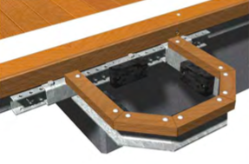
Fig 4.7: Adjustable pile brackets
4.11.2 Pile caps
As the top of our pile caps will be unprotected fiberglass pile caps will be used for protection.
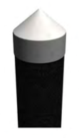
Fig 4.8: Fiberglass pile caps
4.11.3 Pontoon System
Our prefabricated galvanised steel framed pontoon will be a bolted modular system that will be connected to our floats. Steel has been chosen for protection from the elements. They will be 3m wide and 12m long with a joint gap of 15mm between each pontoon. The pontoon will have a wooden deck finish over the steel frames.
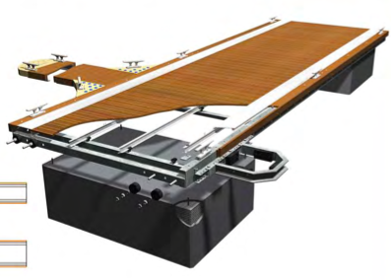
Fig 4.9: Steel framed pontoon with wooden deck finish
4.11.4 Floats
Our float will be encased in reinforced concrete. A Fiberglass grid will be used in the mix with concrete and for reinforcement at the lifting points steel meshing will be used. Galvanized steel with be used for all fixings. When the plastic floats have been formed, polystyrene bead are used to fill. For the float then to become one unit they are steamed.
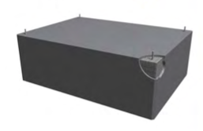
Fig 4.10: Floats float
4.11.5 Access Bridge
Our access bridge will be 5m long down to our first pontoon and will be also be a galvanised steel frame with a hardwood decking finish. The hand rail down will not only be a handrail but it will work as a truss system as it contributes in the stability of the bridge as well as keeping people safe.
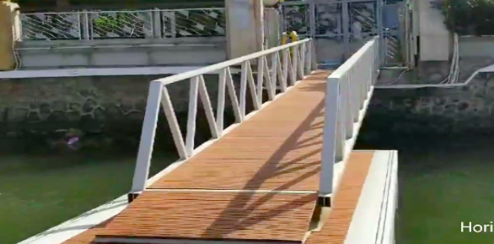
Fig 4.11: Steel truss bridge with hardwood deck finish
4.11.6 Safety Gates
Safety gates will be constructed at the entrance to the platoon to provide safety to the boats. These safety gates will be steel gates with a painted finish.
4.11.7 Lighting
A lighting system will be used for to ensure easier navigation at night from boats as well as safer movement around the pontoon from pedestrians. A Solent marine system will be used in where there will be illumination with the power source being the sun therefore no power supply.
4.11.8 Aluminium Cleats and Connection
Three ton aluminium alloy cleats will be used. They will be cleaned and deburred to leave a neat finish. Washers, lock nuts, bolts, and nuts will be used to connect the cleats to the pontoon.
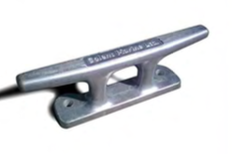
Fig 4.12: Aluminium Cleats
4.11.9 Life Buoy Stands
The life buoy stand will include mountains, throwing line and complete housing. It will be prefabricated and brought to sight ready to be assembled. It will be a bright highly visible moulded plastic with a durable casing. To ensure a support that is sturdy it is finished off with a double post support.
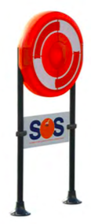
Fig 4.13: Life buoy stand

4.11.10 Safety and Access Ladders

The safety ladders that will used for access from the water will be made out of fibber glass and will be prefabricated offsite.
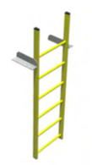

Fig 4.14: Fibber glassed safety ladders
References (TH)

O.Moen. (April 2016). Bridge Design Requirements. Retrieved from: https://assets.publishing.service.gov.uk/government/uploads/system/uploads/attachment_data/file/570574/Bridge_Design_Requirements_Document.pdf

I.T Transport Ltd. (June 2004). Footbridges. Retrieved from: https://assets.publishing.service.gov.uk/media/57a08ccced915d622c0015a9/R8133.pdf

M.Vlad, G.Kollo, V.marusceac. (12 June 2015). A Modern Approach To Tied-Arch Bridge Analysis and Design. Retrieved from: http://www.bipcons.ce.tuiasi.ro/Archive/513.pdf

Aarsleff. (anon). Driven Precast Concrete Pilling. Retrieved from: https://aarsleff.co.uk/solutions/driven-precast-concrete-piling/

A.E.Yates. (anon). Precast Concrete Piling. Retrieved from: https://www.aeyates.co.uk/tritech-ground-engineering/services/precast-concrete-piling

A.Shraddha. (anon). Foundations for Bridges. Retrieved from http://www.yourarticlelibrary.com/bridge-construction/foundations/foundations-for-bridges-with-diagram/94515

Designing Building Wiki. (28 Aug 2019). Pile Cap. Retrieved from: https://www.designingbuildings.co.uk/wiki/Pile_cap

WisDOT. (Jan 2020). Abutments. Retrieved from: https://wisconsindot.gov/dtsdManuals/strct/manuals/bridge/ch12.pdf

Cornwall gov. (2020). Bencoolen Bridge Design Constraints. Retrieved from: https://www.cornwall.gov.uk/transport-and-streets/roads-highways-and-pavements/major-highway-schemes/bencoolen-bridge-bude/bencoolen-bridge-design-constraints/

A.Robb. (anon). Design Constraints in Engineering: Definition & Example. Retrieved from: https://study.com/academy/lesson/design-constraints-in-engineering-definition-example.html

Designing Building Wiki. (19 Feb 2020). Constraints on Construction Projects. Retrieved from: https://www.designingbuildings.co.uk/wiki/Constraints_on_construction_projects

J.Westland. (22 Mar 2018). The Triple Constraints. Retrieved from: https://www.projectmanager.com/blog/triple-constraint-project-management-time-scope-cost

R.Hensley. (anon). Connections Between Steel and Other Materials. Retrieved from: https://www.steelconstruction.info/images/d/d6/SCI_P102.pdf

Figures (TH)

- Fig 4.1: Tied arch bridge
C.R.Hendry. (2015). Tied-arch bridges. Retrieved from: https://www.steelconstruction.info/Tied-arch_bridges

- Fig 4.2: Steel protection
SteelConstruction.info. (26 June 2012). Airless spraying. Retrieved from: https://www.steelconstruction.info/File:Airless_spraying.jpg

- Fig 4.3: Steel recycling
C.Dolling. (4 July 2012). Recycling rout. Retrieved from: https://www.steelconstruction.info/File:Recycling_route_diagram.jpg

- Fig 4.4: Assembling the steel arch section
A.Banas. (Oct 2016). Strain gauges monitoring of arch bridge over the Vistula river in Torun during construction. Retrieved from: https://www.researchgate.net/figure/5-2-Bridges-of-Torun-3-assembly-of-bay-arch-girders-13-15-4-assembly-of-bay-arch_fig1_309681503

- Fig 4.5: Sheet pile cofferdam
Morris-Shea. (2019). Restricted Access Foundation Installation. Retrieved from: https://www.morrisshea.com/portfolio-item/restricted_access/

- Fig 4.6: Pile driving rig
Soilmeco. (2020). Pile Driving. Retrieved from: https://soilmecna.com/technologies/pile-driving/

- Fig 4.7: Adjustable pile brackets
Solent Marine. (2020). Simbro Pontoon Systems. Retrieved from: http://www.solentmarine.com/hres/catalogue.pdf

- Fig 4.8: Fiberglass pile caps
Solent Marine. (2020). Simbro Pontoon Systems. Retrieved from: http://www.solentmarine.com/hres/catalogue.pdf

- Fig 4.9: Steel framed pontoon with wooden deck finish
Solent Marine. (2020). Simbro Pontoon Systems. Retrieved from: http://www.solentmarine.com/hres/catalogue.pdf

- Fig 4.10: Concrete float
Solent Marine. (2020). Simbro Pontoon Systems. Retrieved from: http://www.solentmarine.com/hres/catalogue.pdf

- Fig 4.11: Steel truss bridge with hardwood deck finish
Horizon. (2020). Marine Grade Aluminium Gangway. Retrieved from: https://horizon-marina.en.made-in-china.com/product/CyLJbMNoGqkK/China-Marine-Grade-Aluminum-Gangway-Access-Bridge-to-Floating-Pontoon.html

- Fig 4.12: Aluminium Cleats
Solent Marine. (2020). Simbro Pontoon Systems. Retrieved from: http://www.solentmarine.com/hres/catalogue.pdf

- Fig 4.13: Life buoy stand
Solent Marine. (2020). Simbro Pontoon Systems. Retrieved from: http://www.solentmarine.com/hres/catalogue.pdf

- Fig 4.14: Fibber glassed safety ladders
Solent Marine. (2020). Simbro Pontoon Systems. Retrieved from: http://www.solentmarine.com/hres/catalogue.pdf

