R1(config)#exit
R1#
*Aug 19 11:33:37.864: %SYS-5-CONFIG_I: Configured from console by console
R1#en
R1#conf term
Enter configuration commands, one per line. End with CNTL/Z.
R1(config)#enable secret class
R1(config)#exit
R1#
*Aug 19 11:48:17.337: %SYS-5-CONFIG_I: Configured from console by console
R1#conf term#
^
% Invalid input detected at '^' marker.

R1#conf term
Enter configuration commands, one per line. End with CNTL/Z.
R1(config)#serviceb password-encryption
^
% Invalid input detected at '^' marker.

R1(config)#service password-encryption
R1(config)#excit
^
% Invalid input detected at '^' marker.

R1(config)#exit
R1#
*Aug 19 11:50:14.672: %SYS-5-CONFIG_I: Configured from console by console
R1#conf term
Enter configuration commands, one per line. End with CNTL/Z.
R1(config)#exit
R1#
*Aug 19 11:51:20.848: %SYS-5-CONFIG_I: Configured from console by console
R1#conf term
Enter configuration commands, one per line. End with CNTL/Z.
R1(config)#password cisco
^
% Invalid input detected at '^' marker.

R1(config)#password-cisco
^
% Invalid input detected at '^' marker.

R1(config)#password cisco
^
% Invalid input detected at '^' marker.

R1(config)#password Cisco
^
% Invalid input detected at '^' marker.

R1(config)#line vty 0 15
R1(config-line)#password cisco
R1(config-line)#log in
^
% Invalid input detected at '^' marker.

R1(config-line)#login
R1(config-line)#exit
R1(config)#service password-encryption
R1(config)#exit
R1#
*Aug 19 12:00:03.172: %SYS-5-CONFIG_I: Configured from console by consoleconf
Configuring from terminal, memory, or network [terminal]?
Enter configuration commands, one per line. End with CNTL/Z.
R1(config)#banner moto"Unauthorized acces is prohibited"
Enter TEXT message. End with the character 'm'.
Unauthorized acces is prohibited

exit
R1#exit
m
R1(config)#int G0/0/0
R1(config-if)#ip add
R1(config-if)#ip address 172.16.0.1 255.255.255.0
R1(config-if)#exit
R1(config)#exit
R1#c
*Aug 19 12:06:51.193: %SYS-5-CONFIG_I: Configured from console by consoleonf term
Enter configuration commands, one per line. End with CNTL/Z.
R1(config)#int G0/0/1
R1(config-if)#ip add
% Incomplete command.

R1(config-if)#ip add
R1(config-if)#ip address 172.16.11.1 255.255.255.0
R1(config-if)#exit
R1(config)#exit
R1#
*Aug 19 12:11:30.095: %SYS-5-CONFIG_I: Configured from console by console
R1#show run
Building configuration...

Current configuration : 3585 bytes
!
! Last configuration change at 12:11:30 UTC Mon Aug 19 2019
!
version 16.9
service timestamps debug datetime msec
service timestamps log datetime msec
service password-encryption
platform qfp utilization monitor load 80
no platform punt-keepalive disable-kernel-core
!
hostname R1
!
boot-start-marker
boot-end-marker
!
!
enable secret 5 $1$dJ2f$URKZGJZAQ/9aRnv5SoI9I.
!
no aaa new-model
!
no ip domain lookup
ip admission watch-list expiry-time 0
!
!
!
!
!
!
!
!
!
!
subscriber templating
multilink bundle-name authenticated
!
!
!
crypto pki trustpoint TP-self-signed-1227001095
enrollment selfsigned
subject-name cn=IOS-Self-Signed-Certificate-1227001095
revocation-check none
rsakeypair TP-self-signed-1227001095
!
!
crypto pki certificate chain TP-self-signed-1227001095
certificate self-signed 01
30820330 30820218 A0030201 02020101 300D0609 2A864886 F70D0101 05050030
31312F30 2D060355 04031326 494F532D 53656C66 2D536967 6E65642D 43657274
69666963 6174652D 31323237 30303130 3935301E 170D3139 30383139 31313036
32305A17 0D333030 31303130 30303030 305A3031 312F302D 06035504 03132649
4F532D53 656C662D 5369676E 65642D43 65727469 66696361 74652D31 32323730
30313039 35308201 22300D06 092A8648 86F70D01 01010500 0382010F 00308201
0A028201 0100E13F 41E28DC3 6E79C42A 120AB5AB FB074C04 20030A04 A39FC2D9
97C62680 5561B973 070F8C54 B3350E79 DB58AB9D 08DEEE1C 76311E33 8CAF7A7A
94C17316 B376D1B4 C2D603F7 EDA8045B F871C027 223E24F5 851AECF2 AA07F922
4AD9AD00 9CE179B3 374BF276 65727C0C 90E16252 B23FE634 CFF6F622 2D780D2E
44FFED7B D7FFC5BC DDED4BC4 5A64DAE1 65FD5DF0 4EB881B9 259DB368 1952052A
35EC2DB0 19A90AA0 09E67EE6 CC924AA3 514F3A67 05425409 BD0365B3 1A16BCD2
528576A6 4FB004F6 A6CEB7B4 EA92E213 2D36EE29 54E81BD0 56EABD14 6F35F5A0
5D6EE5CE F1B0887F 5285DB58 3A4B0D87 913AB0EC 4B7E4834 03F53B92 721131E3
CA037077 E82B0203 010001A3 53305130 0F060355 1D130101 FF040530 030101FF
301F0603 551D2304 18301680 1418BCC6 B436D988 C2EB51AE A92ADB93 4F907704
79301D06 03551D0E 04160414 18BCC6B4 36D988C2 EB51AEA9 2ADB934F 90770479
300D0609 2A864886 F70D0101 05050003 82010100 5F8ABD28 22CF544E 57F16D05
25D83362 AAF47DC0 3B9EBFF1 449F9A7D F5C1B955 289FE24B 88B1A1FD A32D694A
81D0D6C7 8CF76426 3DDFECFB 921E0B8B 92D632A3 F8ABA556 843F5EA3 DDAEE5FD
50DBCCB6 3D788DDC 5A3FEE52 DC69281B 842F9265 57A73C6B FD8ED87D 787CAA0E
ACBE27B2 73B681AA E091BB3D E784636E ED342AF3 DEEE7683 283499BB 716CE6F9
2B66724D D6ECD8EB 662FB4E7 33E96AA0 B1B29343 C2978C2D 530652D3 F3C618B6
0EAB7095 36323DB9 BA6C8648 A199F2A0 E7F49613 0D578431 E1D64A97 E9B5D553
662D76C0 EAB393C9 3D4515C4 6626EBEA 81A00C33 081F5713 6E07FF9A 6DF1D98A
63CBDB27 5DA609AA 0474F009 5C80F311 ABA68FFF
quit
!
license udi pid ISR4221/K9 sn FGL224190DV
no license smart enable
diagnostic bootup level minimal
!
spanning-tree extend system-id
!
!
!
!
redundancy
mode none
!
!
!
!
!
!
!
!
interface GigabitEthernet0/0/0
ip address 172.16.0.1 255.255.255.0
shutdown
negotiation auto
!
interface GigabitEthernet0/0/1
ip address 172.16.11.1 255.255.255.0
shutdown
negotiation auto
!
interface Serial0/1/0
no ip address
shutdown
!
interface Serial0/1/1
no ip address
shutdown
!
ip forward-protocol nd
ip http server
ip http authentication local
ip http secure-server
!
!
!
!
!
!
control-plane
!
banner motd ^Coto"Unauthorized acces is prohibited"
Unauthorized acces is prohibited

exit
R1#exit
^C
!
line con 0
transport input none
stopbits 1
line vty 0 4
password 7 14141B180F0B
login
line vty 5 15
password 7 14141B180F0B
login
!
!
!
!
!
!
end

R1#conf term
Enter configuration commands, one per line. End with CNTL/Z.
R1(config)#no shut down
^
% Invalid input detected at '^' marker.

R1(config)#no shutdown
% Incomplete command.

R1(config)#no sh
% Incomplete command.

R1(config)#interface vlan1
^
% Invalid input detected at '^' marker.

R1(config)#interface vlan
^
% Invalid input detected at '^' marker.

R1(config)#interface fast ethernet 0/0
^
% Invalid input detected at '^' marker.

R1(config)#show run
^
% Invalid input detected at '^' marker.

R1(config)#exit
R1#
*Aug 19 12:18:08.068: %SYS-5-CONFIG_I: Configured from console by consoleno shutdown
^
% Invalid input detected at '^' marker.

R1#no shutdown
^
% Invalid input detected at '^' marker.

R1#en
R1#conf term
Enter configuration commands, one per line. End with CNTL/Z.
R1(config)#show run
^
% Invalid input detected at '^' marker.

R1(config)#exit
R1#show
*Aug 19 12:18:50.195: %SYS-5-CONFIG_I: Configured from console by consolerun
Building configuration...

Current configuration : 3585 bytes
!
! Last configuration change at 12:18:50 UTC Mon Aug 19 2019
!
version 16.9
service timestamps debug datetime msec
service timestamps log datetime msec
service password-encryption
platform qfp utilization monitor load 80
no platform punt-keepalive disable-kernel-core
!
hostname R1
!
boot-start-marker
boot-end-marker
!
!
enable secret 5 $1$dJ2f$URKZGJZAQ/9aRnv5SoI9I.
!
no aaa new-model
!
no ip domain lookup
--More—
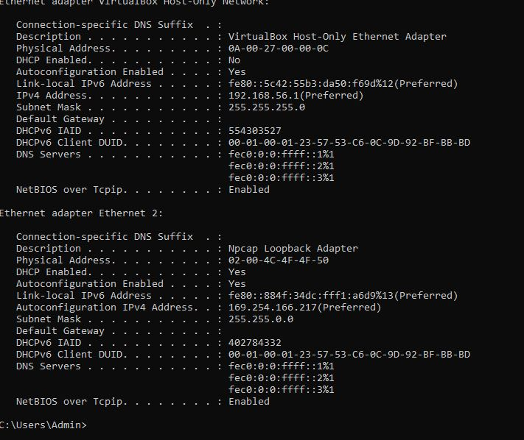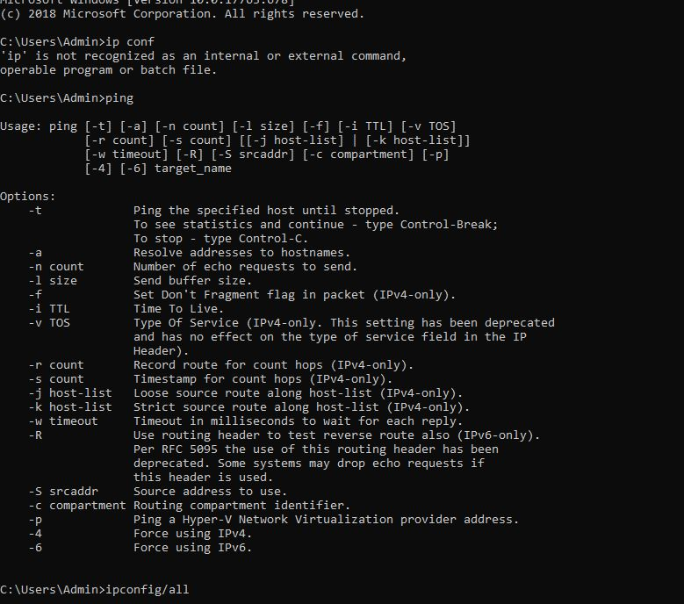

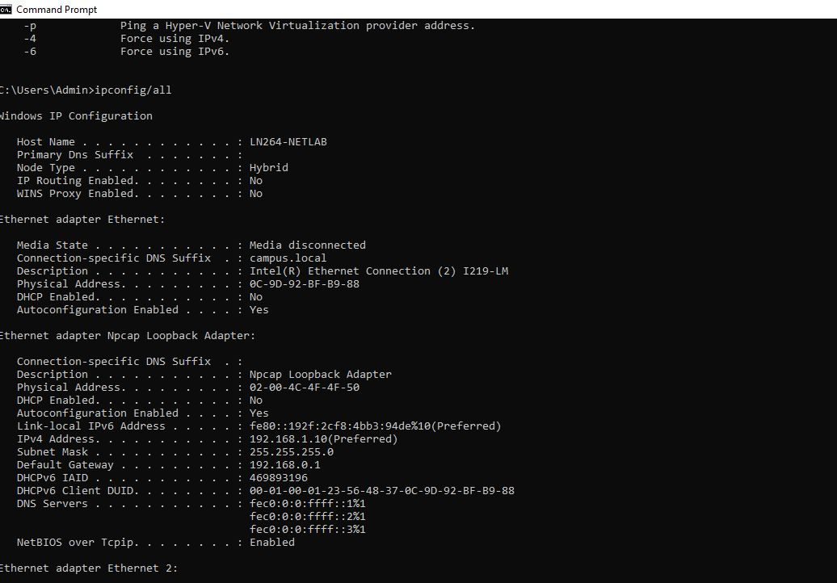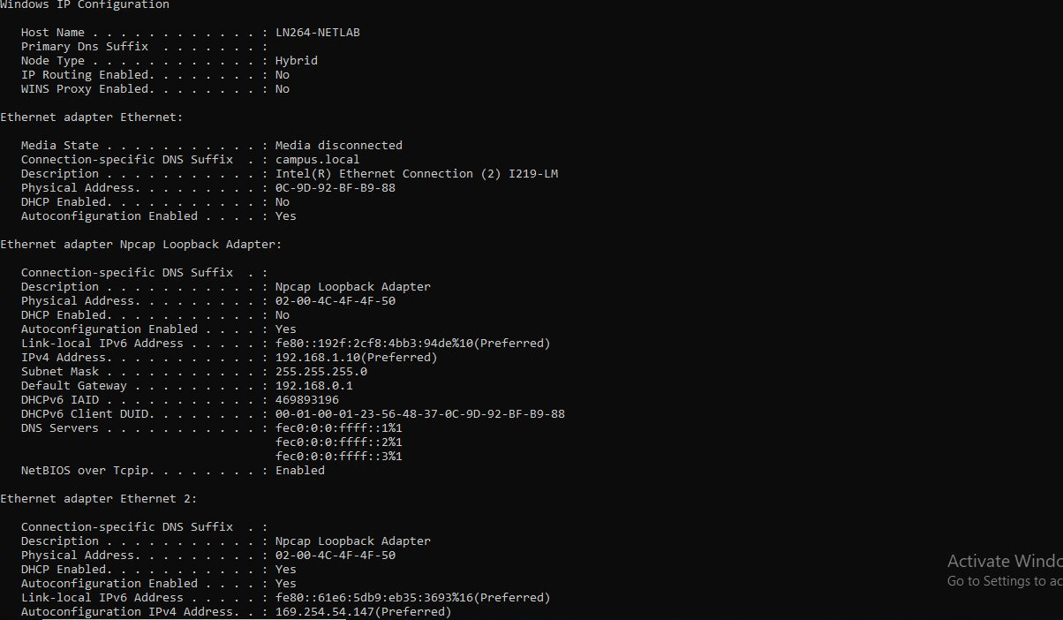
% Unknown command or computer name, or unable to find computer address
S1>
S1>
S1>conf term
^
% Invalid input detected at '^' marker.

S1>configure term
^
% Invalid input detected at '^' marker.

S1>conf term
^
% Invalid input detected at '^' marker.

S1>conf
Translating "conf"...domain server (255.255.255.255)
% Unknown command or computer name, or unable to find computer address
S1>
S1>
S1>conf ter
^
% Invalid input detected at '^' marker.

S1>en
S1#conf term
Enter configuration commands, one per line. End with CNTL/Z.
S1(config)#no ip domain-lookup
S1(config)#

S1 con0 is now available

Press RETURN to get started.

*Mar 1 00:59:52.790: %SYS-5-CONFIG_I: Configured from console by console
S1>conf term
^
% Invalid input detected at '^' marker.

S1>conf term
^
% Invalid input detected at '^' marker.

S1>en
S1#conf term
Enter configuration commands, one per line. End with CNTL/Z.
S1(config)#no ip domain-lookup
S1(config)#exit
S1#
*Mar 1 01:37:32.412: %SYS-5-CONFIG_I: Configured from console by console
S1#conf term
Enter configuration commands, one per line. End with CNTL/Z.
S1(config)#banner motd
% Incomplete command.

S1(config)#banner motd"message-of-the-day"
S1(config)#exit
S1#
*Mar 1 01:39:06.440: %SYS-5-CONFIG_I: Configured from console by console
S1#conf term
Enter configuration commands, one per line. End with CNTL/Z.
S1(config)#interface vlan1
S1(config-if)#ip address 172.16.11.10 255.255.255.0
S1(config-if)#no shutdown
S1(config-if)#exit
S1(config)#exit
S1#
*Mar 1 01:42:45.375: %SYS-5-CONFIG_I: Configured from console by consoleinterface
Translating "interface"
% Unknown command or computer name, or unable to find computer address
S1#
S1#conf term
Enter configuration commands, one per line. End with CNTL/Z.
S1(config)#conf default gateway
^
% Invalid input detected at '^' marker.

S1(config)#default gateway
^
% Invalid input detected at '^' marker.

S1(config)#interface ip
^
% Invalid input detected at '^' marker.

S1(config)#interface
% Incomplete command.

S1(config)#interface VLAN!
^
% Invalid input detected at '^' marker.

S1(config)#interface VLAN1
S1(config-if)#default gateway 172.16.11.1
^
% Invalid input detected at '^' marker.

S1(config-if)#default
% Incomplete command.

S1(config-if)#default 172.16.11.1
^
% Invalid input detected at '^' marker.

S1(config-if)#exit
S1(config)#interface fast ethernet 0/0
^
% Invalid input detected at '^' marker.

S1(config)#line vty0 15
^
% Invalid input detected at '^' marker.

S1(config)#line vty 0 15
S1(config-line)#exit
S1(config)#exit
S1#
*Mar 1 01:48:10.928: %SYS-5-CONFIG_I: Configured from console by consoleshow run
Building configuration...

Current configuration : 1379 bytes
!
! Last configuration change at 01:48:10 UTC Mon Mar 1 1993
!
version 15.2
no service pad
service timestamps debug datetime msec
service timestamps log datetime msec
no service password-encryption
!
hostname S1
!
boot-start-marker
boot-end-marker
!
!
no aaa new-model
system mtu routing 1500
!
!
!
!

S1#show run
Building configuration...

Current configuration : 1379 bytes
!
! Last configuration change at 01:48:10 UTC Mon Mar 1 1993
!
version 15.2
no service pad
service timestamps debug datetime msec
service timestamps log datetime msec
no service password-encryption
!
hostname S1
!
boot-start-marker
boot-end-marker
!
!
no aaa new-model
system mtu routing 1500
!
!
!
!


