

Diabetes Inequalities in Birmingham Adults
Student Name: Solanki Prathamkumar Himmatlal
Student ID: 2430951
Professor Name: Jolly Nwankwo
Module: Social Epidemiology and Public Health Development
Module Code: LCHS7000

Table of Contents
TASK 1 – Social Epidemiological Analysis 3
Title: Ethnic Health Inequalities among South Asian Adults in the United Kingdom 3
1. Introduction 3
2. Contextual Background & Underlying Factors 3
2.1 Higher Prevalence of Type 2 Diabetes 3
2.2 Higher Cardiovascular Disease (CVD) Mortality 4
2.3 Poorer Mental Health Outcomes 5
2.4 Socioeconomic Deprivation 6
2.5 Language and Cultural Barriers 7
2.6 Structural Racism & Healthcare Access Barriers 7
3. National Responses to Reduce Inequalities 8
4. Organisations Supporting South Asian Communities 9
5. Conclusion 9
TASK 2-Epidemiological Analysis 9
Title: Type 2 Diabetes among Adults Aged 40+ in Birmingham, UK 9
1. Introduction 9
2. Global, National & Local Prevalence 10
3. Determinants and Risk Factors 10
4. Public Health Measures — The 3 Ps 11
5. Epidemiological Studies & Health Needs Assessment 12
6. Surveillance & Monitoring Systems 12
7. Public Health Impact 13
8. Intervention Programme & Evaluation 13
9. Strengths & Weaknesses of the Epidemiological Approach 13
References 15
References of Images 19

TASK 1 – Social Epidemiological Analysis

Title: Ethnic Health Inequalities among South Asian Adults in the United Kingdom

1. Introduction
This section describes the key health and social inequalities that impact South Asian adult adults in the UK. South Asians, who predominantly represent Indians, Pakistani and Bangladeshi backgrounds are among the largest minority groups in the country with a population of 9.3 0 -percent of the population in England and Wales amounting to 5.5 million according to the 2021 Census (Office for National Statistics). It has also been found that this population is far more likely to acquire type 2 diabetes (Katangwe-Chigamba et al., 2024). Research indicates that they have two to six times higher chances of developing the disease than the White British. The South Asian adults are also more heart disease-prone. According to UK studies, the issues begin earlier and individuals become dead more frequently. The causal factors contributing to these gaps are primarily social in nature, i.e., the amplified poverty of Pakistani and Bangladeshi communities, the differences in culture and food preferences, language challenges that introduce the challenges of obtaining care, and inequitous treatment in healthcare services (Raleigh, 2023).

2. Contextual Background & Underlying Factors

2.1 Higher Prevalence of Type 2 Diabetes
The probability that south Asian adults in the UK will get type 2 diabetes is significantly more likely. Diabetes UK and NHS data sources reveal that they are 2 and 4 times more susceptible to develop the disease compared to White British adults. They are also prone to developing diabetes 5 to 10 years younger. One reason is genetics. Even when the body weight is not excessive, the South Asians are able to store a lot of fat around the belly area. This is a large risk factor of diabetes in this belly fat. Their diets are also a contributing factor to the danger. Some South Asian societies consume too much of refined carbohydrates, ghee and sweet beverages. The problem is aggravated by these foods (Shyama Reji et al., 2025).
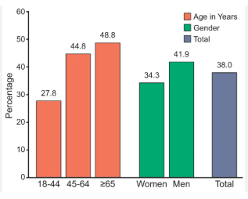
Figure 1:Higher Prevalence of Type 2 Diabetes (www.healio.com, n.d.)

2.2 Higher Cardiovascular Disease (CVD) Mortality
Still, one of the major causes of health disparities among individuals with varying ethnic backgrounds in the UK is cardiovascular disease. Heart disease among adults of Pakistani and Bangladeshi origin kills people at a very high rate compared to that of the general population. According to Public Health England, these populations have an increased number of high blood pressure, high cholesterol, and diabetes, which are the conditions that are directly associated with heart attacks. They also develop heart diseases at a younger age and at a faster rate partly due to a combination of a number of health risk factors that are likely to manifest among South Asian adults. These communities do not have many individuals who attend regular check-ups of their heart health and they are less likely to use statins, a drug which helps to reduce cholesterol. The fact that these issues are accompanied by bad access to timely medical aid, language barriers, and reduced education on the subject of heart health, enlarge the death gap further (Guzik and Touyz, 2018).
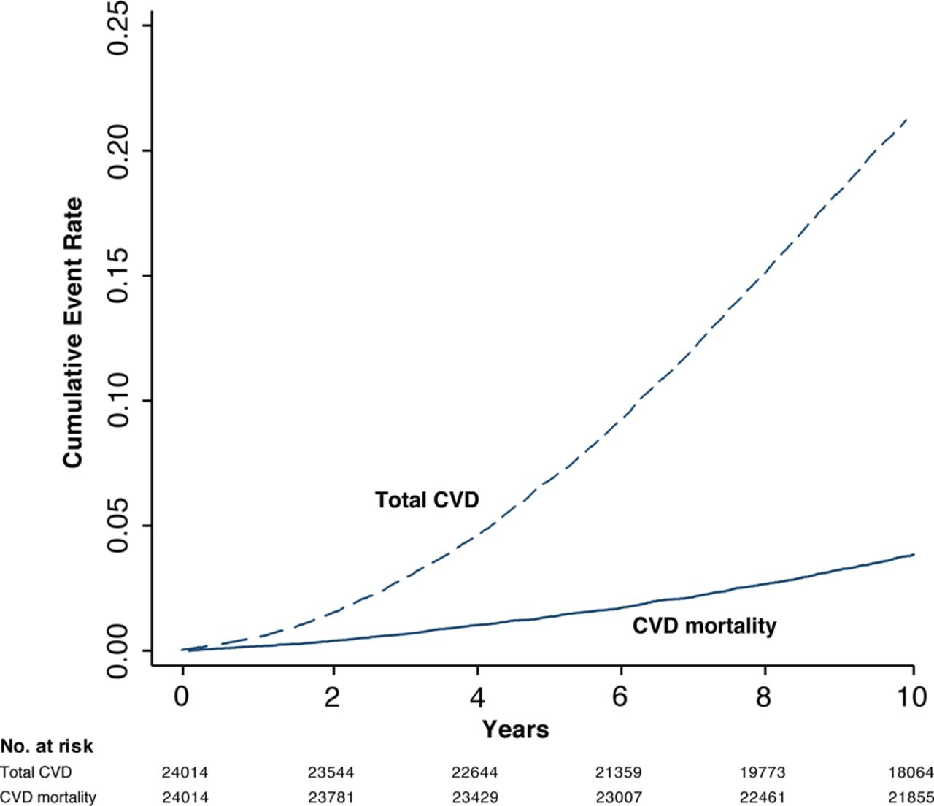
Figure 2: Higher Cardiovascular Disease (CVD) Mortality (Jørstad et al., 2015)

2.3 Poorer Mental Health Outcomes
Although the adults of South Asian origin might report having mental health as high or higher than the rest of the UK population, they are less likely to receive treatment through mental health services, thus, worsening their conditions or failing to treat them altogether. It has been found that individuals with Pakistani and Bangladeshi descent tend to possess increased stress, anxiety and depression. This is linked to the experiences of getting to a new land, financial issues, prejudice, and loneliness. In a 2017 audit of race disparity, ethnic minority groups had many obstacles to using mental health care, including lack of trust in the services, stigma, and belief that providers are not culturally sensitive. The mental distress experienced by South Asian people is also more likely to manifest itself physically hence making it slow to diagnose (Naz et al., 2025).
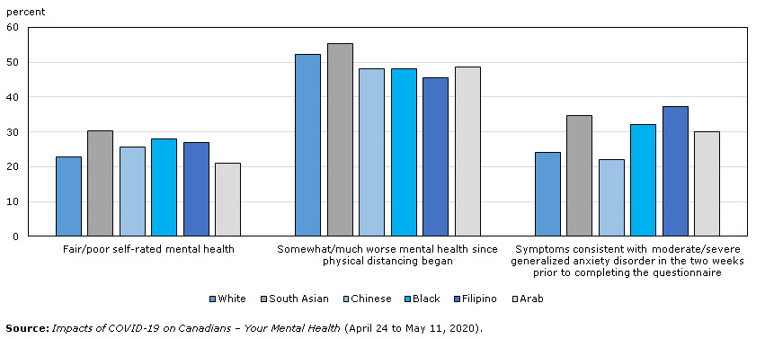
Figure 3:Poorer Mental Health (Government of Canada, 2020)

2.4 Socioeconomic Deprivation
The South Asian groups have a big cause of bad health which is caused by low income and other problems in life. The Bangladeshi and Pakistani families are two of the most impoverished households in the UK. The data provided by ONS shows that over half of the households in Bangladesh and approximately 46 percent of the households in Pakistan reside in poor neighbourhoods. Such families also experience increased unemployment, household congestion and reduced average income. The poor neighbourhoods are associated with higher air pollution, bad houses, and lack of parks, which increases the fear of long-term diseases. Money issues are also a barrier to purchasing healthy food and performing preventative health care (Sathi et al., 2022).
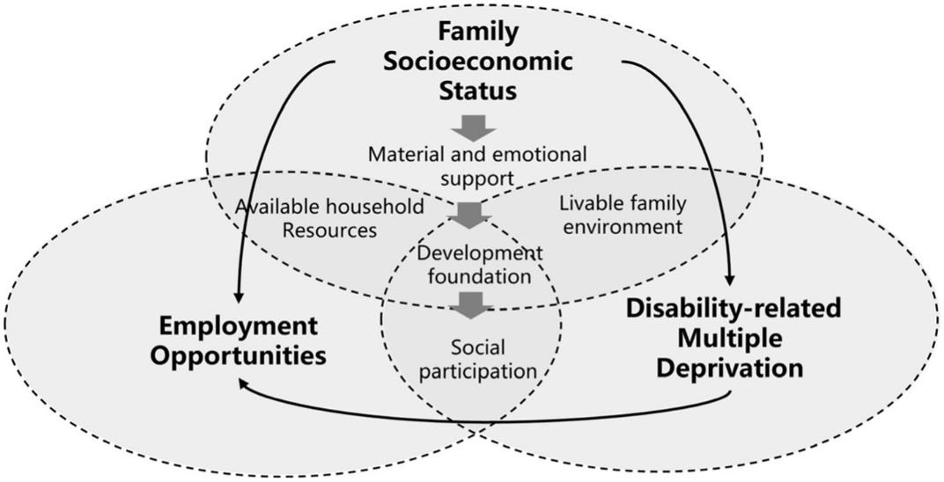
Figure 4: Socioeconomic Deprivation (Qiu et al., 2023)

2.5 Language and Cultural Barriers
The knowledge of languages influences the level of the ease with which individuals can receive medical assistance. According to NHS statistics, most older Pakistani and Bangladeshi adults do not speak fluent English. This causes them to be less self-assured in attempting to access GP services, and grasp the intentions of the doctors or in undergoing screening procedures such as NHS Health Checks and diabetes screening programs (GOV.UK, 2018). The cultural practices also influence the perceptions of the people towards health. The reasons that some families will wait to receive assistance are that they believe that illness is a shame, women are not able to exercise easily due to gender restrictions, and finally, people choose home remedies to see the doctor. Lack of understanding between the patients and clinicians may prevent patients to take medicines well or misunderstand symptoms. All these issues with language and culture postpone a proper diagnosis and good treatment of long-term illnesses and increase health disparities among the South Asian communities (Awal, 2024).
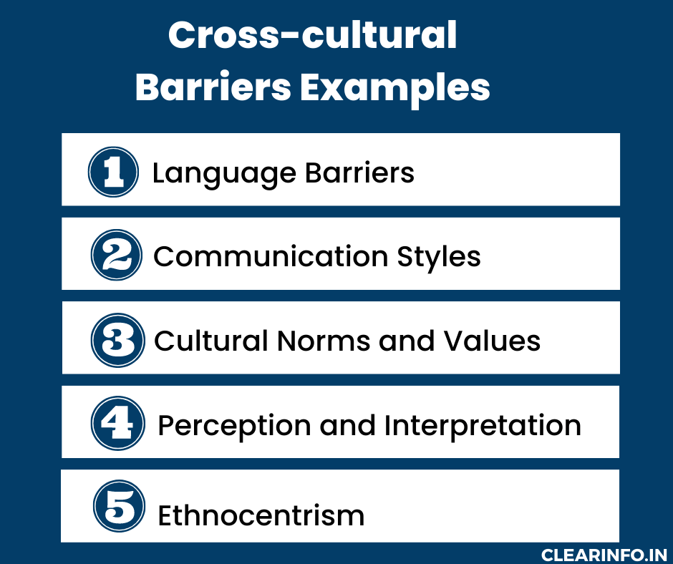
Figure 5:Language and Cultural Barriers (Clearinfo, 2023)

2.6 Structural Racism & Healthcare Access Barriers
The results of the Race Disparity Audit (2017) and subsequent NHS reports have demonstrated that even nowadays, systemic racism continues to influence the health care experiences of South Asian adults. It may become difficult to receive good care due to discrimination. Nurses and doctors are perceived to be indifferent, misinterpreting, and criticizing by many patients. Such negative experiences decrease the level of trust in the health system, and the individuals will be less likely to seek assistance in the future or preventive action. These unequal outcomes are compounded by other structural issues such as the lack of services that would accommodate various cultures, lack of sufficient translation assistance, and the lack of sufficient South Asian voices in the health policy (Costa-Font and Docrat, 2024).
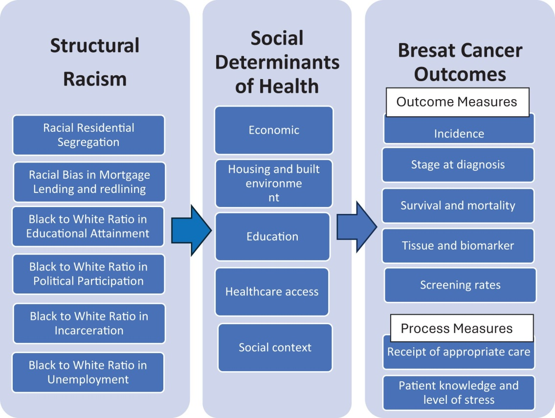
Figure 6: Structural Racism & Healthcare Access Barriers (Abdelhadi, Williams and Yan, 2025)

3. National Responses to Reduce Inequalities
The UK government has implemented a number of national plans to address health disparities that impact the South Asian groups. One such initiative is the NHS Long Term Plan of 2019 that ensures that South Asians are screened against type 2 diabetes earlier and are managed to better cope with the condition since they are more vulnerable. The strategy also expands NHS Diabetes Prevention Programme (NDPP). This has covered over a million individuals and employs methods that resonate with the culture of the high-risk individuals. It is also interested in more people undergoing screening tests and receiving care that is in line with their personal needs, yet it remains difficult to get poorer communities involved (Wadhawan et al., 2023).
The Office of Health Improvement and Disparities (OHID) has made efforts to bridge the ethnic health disparities through community campaigns, provision of information on health in various languages, and collection of more information by ethnicity so as to locate the high-risk areas (Sreya Sanyal Puja et al., 2024).

4. Organisations Supporting South Asian Communities
The South Asian Engagement Programme at diabetes UK makes South Asian people remain healthier. It conducts diabetes classes that are culturally relevant to the community, provides handouts and online resources in Urdu, Punjabi, Bengali and Gujarati and collaborates with mosques, gurdwaras and community centres to ensure people are aware of the early signs and risky behaviours. It also organizes annual Know The Risk events in locations where high concentrations of people acquire diabetes such as Birmingham and Leicester. Such measures are meant to make people discover diabetes earlier, know how to handle it more effectively and learn about health better, the long-term payoff will be the increased money and collaboration with local NHS services (Khunti, Kumar and Brodie, n.d.).

5. Conclusion
The South Asian adults in the UK have large health issues. Their prevalence rates of type 2 diabetes, heart disease and poor mental health are higher. They also encounter social ills such as poverty, language barrier and discrimination. All of these issues increase their health hazard. There have been national plans like the NHS Long Term Plan and the public health projects by OHID which have aided in preventing and early detection, and these still differ by locality. The community organizations like Diabetes UK provide significant assistance that does not compromise culture (Dovjak and Kukec, 2019).

TASK 2-Epidemiological Analysis

Title: Type 2 Diabetes among Adults Aged 40+ in Birmingham, UK

1. Introduction
T2D is a chronic condition that occurs when the organism fails to utilize insulin effectively and the level of sugar cannot be easily regulated, a factor that leads to severe consequences including heart diseases, kidney failure, and nerve loss. It is a very significant social health issue in the UK as an increasing number of individuals are being infected as well as it is preventable. According to NHS and ONS, over 4.3 million individuals in the UK are diabetic, with nearly 90 per cent of them being Type 2. The Type 2 diabetes population has increased over two times during the past 20 years due to the increased age of people, the growing number of overweight people, the very sedentary lifestyle people have, and the growing disparity in health differences (Lu et al., 2024).
The rate of diabetes in Birmingham is very high. Over 10 percent of the adults there have a type 2 diabetes which is more than the national average. The disease occurs in particular prevalence in poor neighbourhoods and in ethnic minorities. Compared to the White British adults, South Asian adults have two to four times more chances of developing type 2 diabetes. These diversities demonstrate that biology, social existence and environment all collaborate to form the local health image. This report will examine the impact of type 2 diabetes among the aged (40 and above) in Birmingham (Au-Yeung et al., 2024).

2. Global, National & Local Prevalence
The global diabetes type 2 (T2D) is increasing more rapidly than ever. According to the WHO, over 460 million people are already diabetic, and the figure is likely to be over 570 million in 2030. Older population, urbanization, unhealthy diets, and exercise are the reasons of this increase. The greatest increase is experienced in countries that have low and middle income due to significant changes in the way people live and eat (Colozza, Wang and Avendano, 2023).
NHS and UKHSA data reveal that over 4.3 million individuals in the UK have Type 2 diabetes and 90 percent of them have Type 2. There is an increased prevalence of diabetes in various ethnic groups, low economic regions as well as overweight individuals. People of South Asia, black African and Caribbean are more affected. There is a two-fold higher chance of adults in the poorest communities to have Type 2 diabetes compared to the richest communities (Johnson et al., n.d.).

3. Determinants and Risk Factors
The occurrence of type 2 diabetes in adults aged 40-and-above in the city of Birmingham is influenced by a combination of biological, behavioral, and social factors. By biological standards, aging is an obvious risk since the bodies are become less responsive to insulin and the pancreas is less effective. There is also a risk due to family history whereby parents, siblings and children of individuals with diabetes are up to three times more likely to acquire it. Birmingham is a place where ethnicity is important. The South Asian communities that are large have two to four times greater risk in that most of them have more belly fat and are more likely to have insulin resistance genes (Hill-Briggs and Fitzpatrick, 2023).
Such risks are exacerbated by behaving in a specific manner. Consumption of high amounts of refined carbs, sweetened beverages, and saturated fats may result in belly fat, a primary cause of type 2 diabetes. The lack of physical activity is massive, and it is one of the issues that are particularly significant in impoverished neighborhoods as there are limited safe areas to exercise or play. Although the overall smoking trend is decreasing, it still aggravates metabolism and makes people insulin resistant (Cohen et al., 2017).
Social and environmental issues contribute to the issue in the city of Birmingham. Poverty in the city is some of the worst in England. Unhealthy food, unsafe parks, and preventive medical care are beyond the reach of poor families. CSA caused by unemployment, financial concerns and congested homesteads cause poor coping mechanisms and hormones that are associated with diabetes (Greenham et al., 2024).
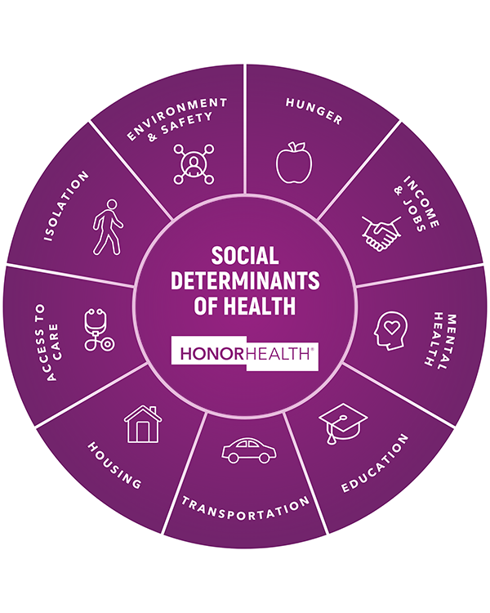
Figure 8: Determinants and Risk Factors (www.honorhealth.com, n.d.)

4. Public Health Measures — The 3 Ps
The type 2 diabetes prevention, the protection of persons at risk and the promotion of healthy behaviors are the priorities of the Birmingham health programs related to diabetes. The NHS Diabetes Prevention Programme includes lifestyle programs which are suitable in various cultures. The programs target high-risk adult adults and particularly South Asians. Protection includes monitoring blood sugar levels with HbA1c and providing NHS Health Check to adults between 40 and 74 years old. Promotion refers to conducting local council, group and place of worship campaigns. These adverts attempt to create awareness and adopt healthy lifestyles. Despite the improvement of things, not all people in poorer regions use the programs, and the resources are not provided in many languages. This demonstrates that they require additional unchanging, culturally modified programmes (NHS England, 2023; NCCH, 2022).
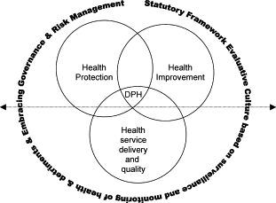
Figure 7: 3 Ps framework(Griffiths, Jewell and Donnelly, 2005)

5. Epidemiological Studies & Health Needs Assessment
According to epidemiological research in the city of Birmingham, South Asian adults develop diabetes type 2 at an earlier age and lower body mass index compared to White British adults (UK Biobank, SABRE). The prevalence rate of the disease is related to poverty, obesity, and ethnicity in cross-sectional studies, and in some neighborhoods the prevalence exceeds 1215. More belly fat and insulin resistance are indicated by case-control studies. According to Birmingham Health Needs Assessment, adults (40 and older), South Asians, and poor neighborhoods (such as Sparkbrook, Small Heath) should receive the most assistance. Lack of screening and late diagnosis can demonstrate why culture-appropriate prevention programs are required (Scott & Hoskin, 2024).

6. Surveillance & Monitoring Systems
The National Diabetes Audit of the NHS Digital, GP practice registers, and UKHSA of hospital admissions and deaths are the resources used to perform surveillance of type 2 diabetes in Birmingham. The tools monitor the prevalence of diabetes, its risk factors, complications, and the high-risk groups such as South Asian adults in poor localities. People have been underdiagnosed, incomplete ethnicity records, and variations in the quality of GP data are some of the limits of the system (Lewis et al., 2025).

7. Public Health Impact
Diabetes type 2 is a severe health, cost, social issue in Birmingham. The complications can involve damage to nerves, eye complications, kidney disease, and heart complications. Death rates are disproportionately high in the South Asian adults and low-income regions. The illness increases the disability days, reduces life quality, and strains the NHS finances (approximately 10-percent of the national budget). There is also the stress and the stigma and reduced work levels of people. Health gaps are further aggravated by the fact that it is prevalent in certain communities indicating that prevention and care should be culturally appropriate (GBD 2021 Diabetes Collaborators, 2023).

8. Intervention Programme & Evaluation
The specific intervention is an adapted diabetes prevention program among the adult population aged 40 years and above in Birmingham particularly those residing in South Asian areas. It provides diet classes, culture-fitting activities, GP check-ups, and two-language classes. The program partners with Diabetes UK, mosques and gurdwaras. Measures of success will be monitored by looking at blood sugar HbA1c and weight, and the number of people present and their level of engagement. The pilot will be sustainable over 12 months with reviews being made after every three months (Lim et al., 2019).

9. Strengths & Weaknesses of the Epidemiological Approach
Strengths: Big datasets of NHS Digital, GP records, and HNA allow them to analyze age or ethnicity and the degree of well-offness of individuals, as such that they can organize certain assistance. Long-term, observational research and cross-sectional research provide strong evidence on what increases risk (England, 2025).
Weaknesses: The data may not be as accurate as relying on the self-reports of people, lack of ethnicity data, misdiagnosis, and inconsistent GP records. The selection of some of the participants may restrict the applicability of the results to all (Walden_, Zozus and Pieper, 2023).
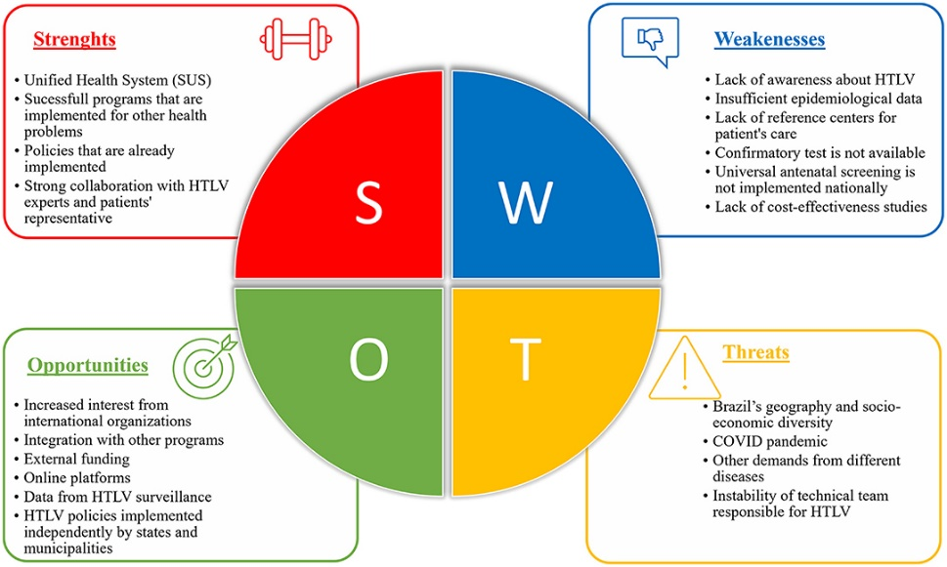
Figure 9: Strengths & Weaknesses of the Epidemiological

References
Au-Yeung, C.H., Ellis, D., Dallaway, A., Riley, J., Varney, J. and Howell-Jones, R. (2024). Socioeconomic and ethnic inequalities increase the risk of type 2 diabetes: an analysis of NHS health check attendees in Birmingham. Frontiers in Public Health, 12. doi:https://doi.org/10.3389/fpubh.2024.1477418.
Awal, A. (2024). Usage of English in Healthcare Settings: A Study on Patients’ Experiences and Language Preference in Bangladesh. [online] 10(1), pp.120–145. Available at: https://www.researchgate.net/publication/381697243_Usage_of_English_in_Healthcare_Settings_A_Study_on_Patients.
Cohen, D.A., Han, B., Derose, K.P., Williamson, S., Marsh, T., Raaen, L. and McKenzie, T.L. (2017). Promoting physical activity in high-poverty neighborhood parks: A cluster randomized controlled trial. Social Science & Medicine, 186, pp.130–138. doi: https://doi.org/10.1016/j.socscimed.2017.06.001.
Colozza, D., Wang, Y.-C. and Avendano, M. (2023). Does urbanisation lead to unhealthy diets? Longitudinal evidence from Indonesia. Health & Place, [online] 83, p.103091. doi:https://doi.org/10.1016/j.healthplace.2023.103091.
Costa-Font, J. and Docrat, F. (2024). Discrimination Backfires? Minority Ethnic Disparities in Vaccine Hesitancy. Economics & Human Biology, [online] p.101441. doi:https://doi.org/10.1016/j.ehb.2024.101441.
Dovjak, D.M. and Kukec, A.P.A. (2019). Identification of Health Risk Factors and Their Parameters. [online] www.ncbi.nlm.nih.gov. Springer. Available at: https://www.ncbi.nlm.nih.gov/books/NBK553923/.
England, N. (2025). NHS England» Ethnicity Recording Improvement Plan. [online] England.nhs.uk. Available at: https://www.england.nhs.uk/long-read/ethnicity-recording-improvement-plan/.
GBD 2021 Diabetes Collaborators (2023). Global, regional, and national burden of diabetes from 1990 to 2021, with projections of prevalence to 2050: a systematic analysis for the Global Burden of Disease Study 2021. The Lancet, [online] 402(10397). doi:https://doi.org/10.1016/s0140-6736(23)01301-6.
GBD 2021 Diabetes Collaborators (2023). Global, regional, and national burden of diabetes from 1990 to 2021, with projections of prevalence to 2050: a systematic analysis for the Global Burden of Disease Study 2021. The Lancet, [online] 402(10397). doi:https://doi.org/10.1016/s0140-6736(23)01301-6.
GOV.UK (2018). English language skills. [online] www.ethnicity-facts-figures.service.gov.uk. Available at: https://www.ethnicity-facts-figures.service.gov.uk/uk-population-by-ethnicity/demographics/english-language-skills/latest.
Greenham, S.V., Ferranti, E.J.S., Jones, S., Zhong, J., Grayson, N., Needle, S., Acton, W.J.F., MacKenzie, A.R. and Bloss, W.J. (2024). An open access approach to mapping climate risk and vulnerability for decision-making: A case study of Birmingham, United Kingdom. Climate Services, 36, p.100521. doi:https://doi.org/10.1016/j.cliser.2024.100521.
Hill-Briggs, F. and Fitzpatrick, S.L. (2023). Overview of Social Determinants of Health in the Development of Diabetes. Diabetes Care, [online] 46(9). doi:https://doi.org/10.2337/dci23-0001.
Johnson, M., Everson-Hock, E., Jones, R., Woods, H., Baxter, S., Goyder, E., Chilcott, J., Payne, N. and Walker, V. (n.d.). Preventing pre-diabetes in adults from black and minority ethnic groups Prevention of type 2 diabetes: Interventions to reduce risk factors for pre- diabetes among UK adults from black and minority ethnic groups. Preventing type 2 diabetes in adults from black and minority ethnic groups. Commissioned by: NICE Centre for Public Health Excellence. [online] Available at: https://www.nice.org.uk/guidance/ph35/evidence/review-2-interventions-to-reduce-risk-factors-for-prediabetes-among-uk-adults-from-black-and-minority-ethnic-groups-pdf-435069757.
Katangwe-Chigamba, T., Kumud Kantilal, Hartley-Palmer, J., Salisu-Olatunji, S.O., Seeley, C., Naughton, F. and Chester, R. (2024). Diet and Physical Activity Interventions for People from Minority Ethnic Backgrounds in the UK: A Scoping Review Exploring Barriers, Enablers and Cultural Adaptations. Journal of Racial and Ethnic Health Disparities. doi: https://doi.org/10.1007/s40615-024-02112-y.
Kattner, A.A. (2022). The best protection is early detection. Biomedical Journal. doi:https://doi.org/10.1016/j.bj.2022.01.010.
Khunti, K., Kumar, S. and Brodie, J. (n.d.). Diabetes UK and South Asian Health Foundation recommendations on diabetes research priorities for British South Asians South Asian Health Foundation. [online] Available at: https://sahf-f4ra.squarespace.com/s/94568c92a5848659bdc21ea518175d30621b.pdf.
Lewis, G.A., Hughes, D.M., Irving, G., Wilding, J. and Hardy, K. (2025). Association between diabetes self-management education attendance, hospital admissions and mortality in type 2 diabetes: A cohort analysis protocol. Diabetes, obesity & metabolism, [online] 27(5), pp.2377–2386. doi:https://doi.org/10.1111/dom.16257.
Lim, S., Wyatt, L., Chauhan, H., Zanowiak, J.M., Kavathe, R., Singh, H., Kwon, S., Trinh-Shevrin, C. and Islam, N.S. (2019). A Culturally Adapted Diabetes Prevention Intervention in the New York City Sikh Asian Indian Community Leads to Improvements in Health Behaviors and Outcomes. Health Behavior Research, 2(1). doi:https://doi.org/10.4148/2572-1836.1027.
Lu, X., Xie, Q., Pan, X., Zhang, R., Zhang, X., Peng, G., Zhang, Y., Shen, S. and Tong, N. (2024). Type 2 diabetes mellitus in adults: Pathogenesis, prevention and therapy. Signal Transduction and Targeted Therapy, [online] 9(1), p.262. doi:https://doi.org/10.1038/s41392-024-01951-9.
Naz, A., Aynalem, Y., Park, T., Lassi, Z. and Meherali, S. (2025). Factors affecting mental health of South Asian international university students studying in high-income countries: A scoping review. International Journal of Intercultural Relations, 108, p.102251. doi:https://doi.org/10.1016/j.ijintrel.2025.102251.
NCCH (2022). National Centre for Creative Health. [online] Ncch.org.uk. Available at: https://ncch.org.uk/case-studies/birmingham-city-council-public-health.
NHS England (2023). NHS Diabetes Prevention Programme (NHS DPP). [online] NHS England. Available at: https://www.england.nhs.uk/diabetes/diabetes-prevention/.
Petrie, J.R., Guzik, T.J. and Touyz, R.M. (2018). Diabetes, Hypertension, and Cardiovascular Disease: Clinical Insights and Vascular Mechanisms. The Canadian journal of cardiology, [online] 34(5), pp.575–584. doi:https://doi.org/10.1016/j.cjca.2017.12.005.
Raleigh, V. (2023). The Health of People from Ethnic Minority Groups in England. [online] The King’s Fund. Available at: https://www.kingsfund.org.uk/insight-and-analysis/long-reads/health-people-ethnic-minority-groups-england.
Sathi, N.J., Ahammed, B., Alam, K., Hashmi, R., Lee, K.Y. and Keramat, S.A. (2022). Socioeconomic inequalities in low birth weight in South Asia: A comparative analysis using Demographic and Health Surveys. SSM - Population Health, 20, p.101248. doi:https://doi.org/10.1016/j.ssmph.2022.101248.
Scott, E.C.S. and Hoskin, P.J. (2024). Health inequalities in cancer care: a literature review of pathways to diagnosis in the United Kingdom. EClinicalMedicine, [online] 76(102864), pp.102864–102864. doi:https://doi.org/10.1016/j.eclinm.2024.102864.
Shyama Reji, Malini Sankaraeswaran, Venkatesan Ulagamathesan, Wesley, H., Ramesh, G., Srinivasan, S., Misra, S., Ranjit Mohan Anjana, Ranjit Unnikrishnan, Mohan, V. and Anandakumar Amutha (2025). Cohort prevalence of young-onset type 2 diabetes in South Asia: A systematic review. Diabetes Research and Clinical Practice, pp.112013–112013. doi:https://doi.org/10.1016/j.diabres.2025.112013.
Sreya Sanyal Puja, Nahian Noor Neha, Ofia Rahman Alif, Tarannaum Jahan Sultan, Md. Golam Zel Asmaul Husna, Jahan, I. and Noor, J. (2024). Exploring the Barriers to Feminine Healthcare Access among Marginalized Women in Bangladesh and Facilitating Access through a Voice Bot. Heliyon, 10(14), pp.e33927–e33927. doi:https://doi.org/10.1016/j.heliyon.2024.e33927.
Wadhawan, M., Nguyen Vu, Z., Linden, B., Barry, C. and Abiola, A. (2023). Digital apps and reducing ethnic health inequalities Driving progress through digital, design, and organisational transformation. Recommendations for national NHS leadership including organisations such as NHS Blood and Transplant, NHS England, and NHS Digital, and beyond. [online] Available at: https://www.nhsrho.org/wp-content/uploads/2023/05/Digital-apps-and-reducing-ethnic-health-inequalities-January-2023-1.pdf.
Walden_, A., Zozus, M. and Pieper, C. (2023). Comparing the Accuracy of Health Record Data and Self-Reported Data. doi: https://doi.org/10.25302/03.2023.me.140922573.

References of Images
Abdelhadi, O., Williams, M. and Yan, A. (2025). Structural racism as a leading cause of racial disparities in breast cancer quality of care outcomes: a systematic review. Frontiers in Oncology, 15. doi:https://doi.org/10.3389/fonc.2025.1562672.
Clearinfo (2023). Cultural Barriers to Communication: Examples & How to Overcome It. [online] Clearinfo. Available at: https://clearinfo.in/blog/cultural-barriers-to-communication/.
Government of Canada (2020). Impacts on Mental Health. [online] www150.statcan.gc.ca. Available at: https://www150.statcan.gc.ca/n1/pub/11-631-x/2020004/s3-eng.htm.
Griffiths, S., Jewell, T. and Donnelly, P. (2005). Public health in practice: the three domains of public health. Public health, 119(10), pp.907–13. doi:https://doi.org/10.1016/j.puhe.2005.01.010.
Jørstad, H.T., Colkesen, E.B., Boekholdt, S.M., Tijssen, J.G., Wareham, N.J., Khaw, K.-T. and Peters, R.J. (2015). Estimated 10-year cardiovascular mortality seriously underestimates overall cardiovascular risk. Heart, [online] 102(1), pp.63–68. doi:https://doi.org/10.1136/heartjnl-2015-307668.
Qiu, N., Jiang, Y., Sun, Z. and Du, M. (2023). The impact of disability-related deprivation on employment opportunity at the neighborhood level: does family socioeconomic status matter? Frontiers in Public Health, [online] 11(1232829). doi:https://doi.org/10.3389/fpubh.2023.1232829.
www.healio.com. (n.d.). Diabetes Statistics. [online] Available at: https://www.healio.com/clinical-guidance/type-2-diabetes/diabetes-statistics-overview.
www.honorhealth.com. (n.d.). The five determinants of health | HonorHealth. [online] Available at: https://www.honorhealth.com/healthy-living/5-determinants-health.

