Student Name: Nidia Rios Ahmed
Student Number: 2511212
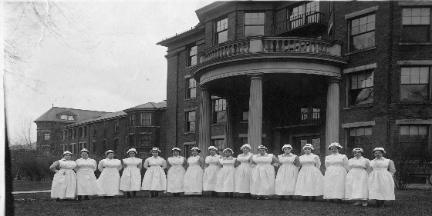
Module: Introduction to Health and Social Care
Module code: LCHS4003
Lecturer: Mumtaz Goolam
Title: Residential care home

Q: what is a residential care home?  A: According to Legislation.gov.uk a care home is any place that can provide suitable accommodation without discrimination of disability, capacity or addiction including some mental health to anyone requiring help, from nursing to assisting with personal care. Allocation to people residing in care homes must be in accordance with the 1984 Act.  Q: How long have care homes been around?    A: In all honesty, the revelations upon research were shocking and extraordinarily long but most definitely extremely interesting. It will be presented factual but briefly as the aim is to also show its continuity and developments over time. | Research from Lambournalmshouse.org shows that for example St Oswald’s Hospital in Worcester was founded in 990. A refuge was created by the bishop “to help the sick, bury the dead, assist the poor and provide shelter to travellers”. This is the oldest and still standing institution established to provide food and shelter to the poor.  Previously called hospitals or “bed-houses” are the Alms houses charitable housing institutions, over a millennium year of changes and adaptations alongside the monarchy, the church and state to continuously keep providing, helping, and assisting to those in need and the vulnerable.  With two objectives and focus that has lasted over a millennium which is to provide “hospitality and shelter” and by “always preserving their dignity.”
“Regulation 12: Safe care and treatment - Care Quality Commission CQC Regulation 12 requires care providers to ensure that all care and treatment is delivered safely, including managing risks, maintaining staff competence, safe premises and equipment, proper medicines management, infection control, and coordinated care planning.”  There are laws and regulations in place to ensure that residents in care homes are protected and that staff are fully compliant. Healthcare has been revolutionised in the las Millenium, and it will keep doing so. The priority has in the past been focusing on the person requiring the care, but laws have changed and not only protect the service user but also the staff. The Equality act 2010 this law protects everyone from discrimination and states that all individuals must be respected and treated fairly. | Following the Code of conduct in health and social ensures that healthcare workers know beforehand what is expected from them, understanding this permits the health care worker to carry out their work correctly, taking pride in maintaining the service user’s, safety, respect, and dignity as of paramount importance. By doing this they are also keeping themselves protected, registering and completing all logs, adhering to manual handling training. Reporting any issues correctly and promptly.  Laws are in place to protect everyone, to keep everyone safe. If unsure always ask for further, help, training, information.
According to a report written by The Health Foundation www.health.org.uk  “The NHS constitutional standard that at least 92% of patients should wait no more than 18 weeks from referral to starting treatment has not been met nationally since 2016.⁴⁷ In cancer care, the 62-day waiting time target – that at least 85% of patients should start treatment within 62 days of an urgent GP referral – was last met in 2015.”  www.necsu.nhs.uk/digital-applications/capacity-tracker/ from the 19 August to 19 September CQC ran a voluntary survey via Capacity Tracker.  From Domiciliary agencies, care homes and hospitals that participated the survey it gave the government a better idea of what issues to tackle and in which order. This came after a big surge of work visas in the healthcare sector were being applied after Brexit. This survey covers several issues that happen daily and constant in the health and sector. | 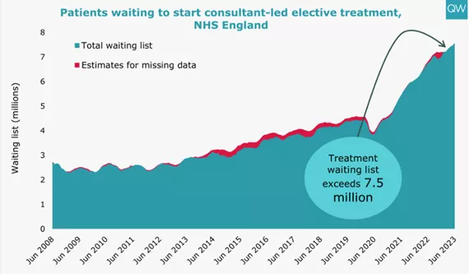
To summarise, there are many issues in the healthcare sector that we are aware of, many that we are not so much aware, this research only demonstrates that with each challenge there are also many solutions and many more possibilities of a more positive outcome.  The trouble is that it is much easier to focus on the problem without realising that it is more productive to be positive and support change, campaign for awareness, encourage fundraising, education, training. There are plenty of independent non-profit organisations other than the most common ones that we are familiar with that provide such services.  www.carecampaignforthevulnerable.com | With optimism in mind, we should want to educate ourselves to support ourselves and others.  It can be time consuming but on the long run it will be worth it if enables a job to be done correctly and efficiently, not to mention rewarding.  There is no price on education or peace of mind. Communication is key.
Reference Care Campaign for the Vulnerable (2026) Care Campaign for the Vulnerable. Available at: http://www.carecampaignforthevulnerable.com (Accessed: 15 February 2026).  Care Learning (2025) Health and social care blog. Updated 25 April 2025. Available at: http://www.carelearning.org.uk (Accessed: 16 February 2026).  Care Quality Commission (2025) Guidance and regulations: Regulations for service providers and managers. Last updated 16 May 2025. Available at: http://www.cqc.org.uk (Accessed: 21 February 2026).  Health Foundation (2023) Nine major challenges facing healthcare and care in England. November. Available at: http://www.health.org.uk (Accessed: 19 February 2026). | Legislation.gov.uk (2026) Legislation.gov.uk. Available at: http://www.legislation.gov.uk (Accessed: February 2026).  Lambourn Alms houses (2026) Lambourn Alms houses. Available at: http://www.lambournalmshouses.org (Accessed: 20 February 2026).  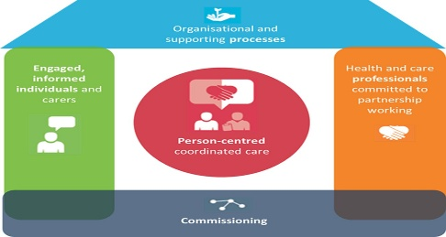  NHS North of England Commissioning Support Unit (2026) Capacity Tracker. Available at: http://www.necsu.nhs.uk/digital-applications/capacity-tracker (Accessed: 16 February 2026).
Name: Nidia Rios Ahmed
Student number: 2511212
Module: Introduction to Health and Social Care
Module number: LCHS4003
Lecturer: Mumtaz Goolam
Title: Pharmacy Services

Introduction: Pharmacy services are an important and crucial part of modern healthcare service systems; it provides safe and effective access to medicines supporting patients with their health and wellbeing.
These services have been developing overtime, from simply preparing drugs to roles that are more person centred with an approach that is focused on improving health outcomes (World Health Organizations, 2019).
Understanding the origins, the current functions and the importance of the pharmacy services highlight their growing role in enhancing quality of life.

The origins of pharmacy services can be traced back to ancient civilisations, where early pharmacists, often called apothecaries, prepared herbal remedies and treatments. In medieval times, pharmacy began to separate from medicine as a distinct profession, with practitioners specialising in the preparation and dispensing of medicines (Royal Pharmaceutical Society, 2020).
The industrial revolution marked a major turning point, as mass production of drugs became possible, improving availability and consistency. In the 20th century, pharmacy evolved further with the introduction of regulations, professional standards, and formal education (Anderson, 2005). This historical development shaped modern pharmacy into a highly regulated and evidence-based healthcare service. Today, pharmacy services have expanded far beyond simply dispensing medication. Pharmacists now play a key role in patient care, offering advice on the safe use of medicines, managing long-term conditions, and promoting public health (National Health Service, 2023).

Community pharmacies are often the first point of contact for patients seeking healthcare advice, making them highly accessible. Services such as medication reviews, vaccinations, smoking cessation support, and minor ailment consultations demonstrate the shift towards a more clinical and preventative role (Bush et al., 2019).
One of the main functions of pharmacy services is ensuring the safe and effective use of medicines. Pharmacists check prescriptions for accuracy, monitor potential drug interactions, and provide guidance on dosage and side effects. This helps reduce medication errors and improves patient safety (Elliott et al., 2021).
Additionally, pharmacists support individuals with chronic conditions such as asthma, diabetes, and hypertension by helping them manage their treatment plans effectively. Pharmacy services also play a significant role in public health. Pharmacists contribute to health promotion by advising patients on healthy lifestyles, disease prevention, and early intervention. For example, services such as blood pressure checks and weight management support help identify health risks early and encourage positive behavioural changes (Public Health England, 2018).
During public health crises, such as pandemics, pharmacies have been vital in delivering vaccinations and providing reliable health information. Critically evaluating pharmacy services today shows both strengths and challenges. One major strength is accessibility. Pharmacies are widely available in communities, often with extended opening hours, making healthcare support more convenient for patients. This reduces pressure on other healthcare services such as general practitioners and emergency departments (National Health Service, 2023).
Furthermore, pharmacists are highly trained professionals who can provide expert advice and personalised care. However, challenges still exist. Increasing demand for services, workforce shortages, and funding limitations can affect the quality and consistency of care (The King’s Fund, 2022). In some areas, patients may not fully utilise pharmacy services due to a lack of awareness about the range of support available. Additionally, the expanding role of pharmacists requires continuous training and adaptation to ensure they can meet complex healthcare needs effectively.
Despite these challenges, the significance of pharmacy services in enhancing quality of life is substantial. By improving access to medicines, supporting disease management, and promoting healthier lifestyles, pharmacists contribute directly to better health outcomes (World Health Organization, 2019).
Their role in preventing illness and reducing hospital admissions further highlights their value within the healthcare system. In conclusion, pharmacy services have evolved from traditional medicine preparation to a vital component of modern healthcare. Their focus on patient-centred care, safety, and public health makes them essential in improving overall wellbeing. As healthcare continues to develop, pharmacy services will remain a key contributor to enhancing the quality of life for individuals and communities.

Harvard Reference
List Anderson, S. (2005) Making Medicines: A Brief History of Pharmacy and Pharmaceuticals. London: Pharmaceutical Press. Bush, J., Langley, C. and Wilson, K. (2019) ‘The corporatization of community pharmacy: implications for service provision’, Health Policy, 123(2), pp. 172–178. Elliott, R.A., Camacho, E., Jankovic, D., Sculpher, M.J. and Faria, R. (2021) ‘Economic analysis of the prevalence and clinical and economic burden of medication error in England’, BMJ Quality & Safety, 30(2), pp. 96–105.
National Health Service (2023) Community pharmacy services. Available at: https://www.nhs.uk⁠ (Accessed: 3 March 2026).

Public Health England (2018) Pharmacy: A Way Forward for Public Health. London: PHE. Royal Pharmaceutical Society (2020) A brief history of pharmacy. Available at: https://www.rpharms.com⁠ (Accessed: 3 March 2026).
The King’s Fund (2022) Community pharmacy explained. Available at: https://www.kingsfund.org.uk⁠ (Accessed: 3 March 2026).

