Student Number: 1700823

Programme of Study: Primary PGCE

Group: 2

Module: School Development and Pupil Progress

Module Code: M7X02153

Module Lead: Helen Lewis

Assignment Title: ‘Supporting pupil progress: a detailed analysis of one child’s holistic development, with justification for the next steps in learning.’

Submission Date: 30/05/2018

Student Self Evaluation Form

This section repeats in brief the common assessment criteria detailed on previous pages. The extent to which these are demonstrated by you determines your mark. Using these criteria, tick the box that best indicates the level of achievement you feel you have achieved with regard to each of them.

Common Assessment Criteria Applied
Common Assessment Criteria Applied | REFER |  | D |  | C | B | A
 | OUTRIGHT FAIL | UNSATISFACTORY | SATISFACTORY |  | GOOD | VERY GOOD | EXCELLENT
1. Subject Knowledge and Understanding (which includes using research-informed literature and knowledge and understanding of the subject) |  |  |  |  | x
2. Intellectual Skills (Analysis) |  |  |  |  | x
3. Pedagogic and Professional Applications  (Practical Application and Deployment) |  |  |  |  | x
4. Key Transferable Skills |  |  |  |  | x
PLEASE COMMENT ON AREAS IN WHICH YOU FEEL THAT YOU HAVE PERFORMED WELL |  |  |  | PLEASE COMMENT ON AREAS you feel that you need TO DEVELOP
- Teaching 100% workload in PTE and gathering data. |  |  |  | - Provide further evidence to back up next steps.
Introduction

This assignment will demonstrate how during my current Professional Teaching Experience (PTE) I have supported a pupil’s progress, as well as conduct a detailed analyse of the child’s holistic development. This assignment with then go further in laying out the next steps in learning for that pupil. When presenting the child’s progress, the data collection will adopt a ‘Mosaic Approach’ (Clark and Moss, 2011). This will promote a pupil voice and allow the child to metacognitively think about themselves as learners. Analysis of the child’s holistic development will be unearthed through guidance of Nottingham’s (2013) ASK model focusing on the attitudes, skills and knowledge of the learner.

The primary school (School X) in which I am currently undertaking a PTE, is situated on the outskirts of Swansea, the area is designated by the local authority as one of the most deprived areas of Swansea. Of the 384 pupils at School X, 33.6% are entitled to Free School Meals (FSM), which is above the Welsh national average of 19%. In addition 22% of pupils are from minority ethnic backgrounds, with 15% speaking English as a second or additional language. Pupils attending the school represent a full range of ability, with 46% of pupils identified as having Additional Learning Needs (ALN). School X is considered as a Green Category supported school by the Welsh Government. The class in which I am currently teaching is a More Able and Talented (MAT) Year 5/6 class. I have chosen to centre this assignment around a pupil (Child A) who throughout his time at School X has always been supported by interventions to improve his Literacy skills. Through a combination of National Tests and Teacher Assessment Child A, a Year 6 pupil, will leave School X attaining a Level 4 in English, Level 5 in Maths and Level 5 in Science.

Data Collection

Within a primary school setting a class teacher will collate a wide range of evidence to assess the progress of a pupil. Mandatory National Tests provide raw data on the attainment of a pupil under test conditions, whereas book moderation focuses on a child’s quality of work when scrutinised against success criteria’s and other Assessment for Learning (AFL) strategies. I have witnessed during my PTE that AFL strategies can help to create more motivated and hard-working learners who are aware of and able to monitor their own personal progress. Other forms of teacher assessment may include observations, diagnostic tests for pupils experiencing difficulties with their learning, learning walks to gather a flavour of teaching and learning at the school.

Estyn expectations require schools to consider how learners are actively involved as stakeholders in the school’s self-evaluation processes. Through empowering pupils, it gives an insight into their views and perspectives, promoting the well-being of the child (Arnot and Reay, 2007). The mosaic approach was developed to include the ‘voice of the child’ in an evaluation of the services educational settings provide for children (Clark, 2005). The approach views children as being ‘experts’ on their own lives (Gallacher and Gallagher, 2008), taking the role of co-researchers in the data collection process, before piecing together the data into a ‘mosaic’. The tools used for gathering data ‘play to young children’s strengths,’ the methods are active, accessible and not reliant on written or spoken word (Clark and Moss 2001). In their most recent book ‘Listening to Young Children: The Mosaic Approach’ Clark and Moss (2011) present their approach in two stages. Stage One involves using the tools to gather and document children’s and adults’ perspectives, while Stage Two pieces together information for reflection and action. Figure 1 below shows the tools used to gather data during Stage One of the mosaic approach.

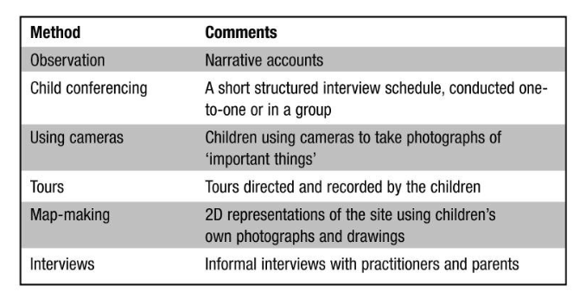

Figure 1: Tools used during the mosaic approach (Clark and Moss, 2011).
My current class teacher acknowledges the importance of classroom observation as the most powerful tool to asses a child’s progress. A popular method used for research classroom interaction (Silverman, 2011), the observations taken were ‘naturalistic,’ as they were carried out in the everyday setting of Child A (Mukherji and Albon, 2018). Observation enables practitioners to know the individual child and highlight their strengths, interests and needs, to identify a plan for the child’s progress (DCELLS, 2015). Throughout my observations I remained objective, recording only what they see and hear as it happens (Jarvis et al., 2014). I chose to record my observation through narrative notes, these are shown in Appendix C.

I carried out interviews with both Child A (Appendix E) and my class teacher (Appendix F). The interview with Child A was not conducted ‘on the move’ but in a relaxed, unpressured environment, I then allowed Child A to guide me to areas of the school which they had described. The interview encouraged Child A to reflect upon their learning, questioning what they enjoy doing or dislike or find hard. Some questions focussed on important people, places and activities in School X (Clark and Moss, 2011). Both the semi-structured interviews allowed me to understand the feelings, attitudes, and behaviours of Child A by probing beneath the surface and encouraging elaborative answers (Denzin and Lincoln, 2005). The interview with my class teacher meant that I was able to build up a more detailed understanding of young children’s experiences, adding an important dimension to discussions of children’s perspectives, as well as raising areas of consensus and perhaps disagreement (Clark and Moss, 2011).

Another method used to collect data within the mosaic approach required Child A to capture photographs of important things and important places, a silent tool that has great potential for use with young children (Entz and Galarza, 2000). A photograph of Child A’s favourite place to learn is shown in Appendix D. Clark and Moss (2011) state that taking photographs and looking at the results provides a platform for talking and listening. Supplementary data collected using the mosaic approach includes Child A’s reading record (Appendix G), and evidence of Child A’s progress in core subjects during my PTE. I also chose to include a quantifiable summary of Child A’s attainment levels (Appendix B) throughout his journey through School X in my data collection, to provide a deeper context to his pupil profile. The data gained through the observations and interview process will be qualitative data, an argument to include qualitative data collection methods in early childhood studies, emphasises how children are able to be competent participants (Albon and Rosen, 2014). A qualitative approach places value on the participant’s involvement, rather than the detached acquisition of numerical data in a quantitative approach (Creswell, 1994).

Throughout this assignment I was especially mindful of the ethical issues surrounding the vulnerability of the participants (Coady, 2010). When considering ethics, it is imperative that I adhere to principles of moral behaviour (Palgrave, 2012). Prior to carrying out the assignment a consent form (Appendix A) was signed by my class mentor, granting permission to collect a wide range of data. Ethical guidance from the BERA (2011) clearly puts the onus on researchers to facilitate children’s informed consent. Adhering to UWTSD’s Research, Ethics and Integrity Code of Practice (2017) and the safeguarding policy of School X, participants will be under no risk as they will remain completely anonymous. These policies will also ensure the researchers do not put their personal safety or professionalism at risk. Ethical guidance from the British Educational Research Association (BERA) (2011) clearly places the onus on myself to facilitate children’s informed assent. This assent was obtained, and Child A was aware that at any point he was able to withdraw his views from this assignment. With School X being a Rights Respecting School, at the forefront of this assignment was The United Nations (UN) (1989) Rights of the Child convention. Particular attention was given to Article 12, which advocates a child’s right to have their own views and to listened to.

Analysis of Learner

I applied the ‘Mosaic’ process (Clark and Moss, 2011), by collecting evidence from pupil centred observations and discussions, and supplemented this with Teacher Assessment data and test results as a way of re-affirming my initial conceptions of the pupils in the class. From the analysis conducted, and the whole school commitment to wellbeing and developing a pupiled approach to growth mindset I selected a pupil who presented as a very capable pupil, but had significant gaps in his learning, which provides an uneven pupil profile.

Child A is pupil who is well respected by staff and peers, he is a School Prefect and popular amongst others in the class. He is a high ability pupil in terms of his mathematical development and science, but has difficulties with most aspects of literacy, and presents as disengaged and lacking confidence in all tasks associated with literacy. Child A also presents as a pupil who experiences elements of social deprivation, in the context of being an FSM pupil in a school with a high percentage of FSM pupils located in socially deprived area of Swansea.

My analysis of Child A will be structured according to James Nottingham’s (2013) ASK model, shown below in Figure 2. The ingredients of the ASK model came from Vinke’s (2002) definition of holistic development as ‘the ability of an individual to select and use the knowledge, skills, and attitudes that are necessary for effective behaviour in a specific professional, social or learning situation.’ Attitudes, skills and knowledge are the three components that comprise Nottingham’s (2013) conceptual framework, these components area shown below in Table 1. Nottingham (2013) believes that practitioners should recognise the value and role that attitudes, skills and knowledge play in the learning process and then ensure that children’s education involves a development of all three, this in turn will aid the holistic development of learners.
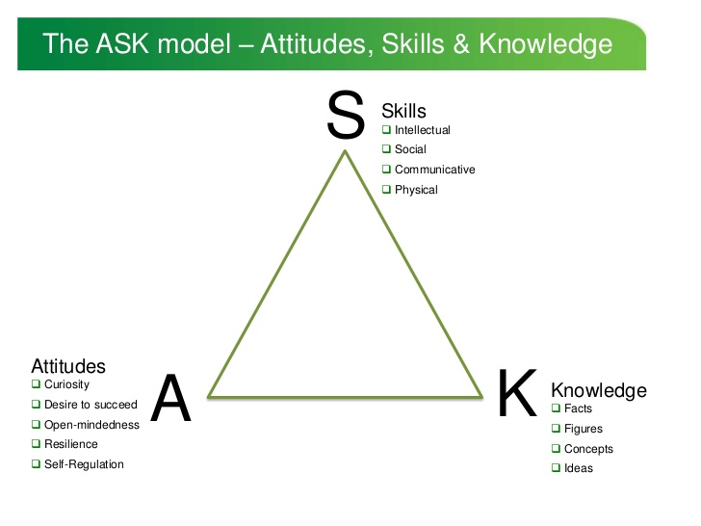

Figure 2. ASK model (Nottingham, 2013: 13)

Attitudes | - positive attitudes towards learning, including curiosity and persistence.
Skills | - abilities to carry out those actions necessary for gaining understanding and achieving excellent performance in any given context.
Knowledge | - familiarity with information, concepts, theories and practice in a given field.

Table 1: Three components of the ASK model (Nottingham, 2013: 14).

In using the ASK model analysis of the learner I am also aware that there needs to be additional evidence used to obtain a complete picture of Child A. Here I will also refer to the school’s pupil profile of Child A which includes data of pupil progress, observation of specific interventions to support aspects of learning, teaching methodologies and the learning environment, and the whole school philosophy to tackling deprivation through growth mindset and supporting pupil wellbeing.

With regards to Child A attitudes to learning he presents as a pupil who loves to come to school. He has 100% attendance in Year 6 to date, and attendance is previous school years was also good. He is able to follow school rules and carry’s out his Prefect duties on a daily basis. However, he does experience difficulties self-regulating, specifically after lunch when he is actively involved in playing games with his peer group. I have observed him (Appendix C) returning to the classroom agitated or engaged in arguments with other pupils over incidents that have taken place during lunch. He does calm down eventually and will readily engage in his learning in the afternoon.

Child A presents as a pupil who enjoys learning, lesson observations show him as being motivated to learn and will engage in all aspects of the curriculum. He particularly enjoys mathematics and scientific studies. Here he has a particular flair for these subjects and can use and apply the skills he has learnt. Child A can recognise he has a talent for mathematics as during an interview with Child A in Appendix E he refers to maths being ‘easy’. Child A regularly transfers calculation skills to other curriculum areas and is always eager to find out new information in these particular Areas of Learning (AOL). This is skill that is integral to the new curriculum of Wales (Donaldson, 2015). He is open minded to all new learning experiences and never ‘opts out’ of tasks set. This is seen in Art and Craft activities where he will always engage despite not enjoying them.

Child A also shows a positive attitude when experiencing difficulties with his learning. He has recognised difficulties with literacy skills. Like many pupils of his gender, he presents as very engaging orally, but has problems applying his thoughts and ideas in the written form. Also, he does not enjoy reading and subsequently his grammar and spelling of new unfamiliar words, evidence of this can be seen in Appendix L where Child A struggles spelling proper nouns in his new topic work. However, during an interview with the class teacher (Appendix F) I learned that Child A has shown resilience and desire to succeed by applying himself to specific literacy interventions. He was previously part of a reading intervention group in Year 5 where he undertook guided reading sessions twice a weak was part of ‘Target L4’ reading group. He is currently part of a ‘Target L4’ writing group for intervention and he has shown a positive approach and desire to do well. He applies himself to all additional writing task and shows grit and determination to complete them to the best of his ability. Child A has a very positive growth mindset which the school invest in heavily as a mechanism to overcome Adverse Childhood Experiences (ACE’s) and social deprivation. Through involvement in school assemblies, display and overall language of staff that challenge pupils. He will always ‘have a go’ and not fear failure. During a recent Mindfulness week, he actively took park and engaged with peer to develop skills in relation to supporting his learning.

Child A has a strong intellectual profile, he has developed many of the skills necessary to become an independent learner who can apply himself to difficult learning experiences. He is particularly strong in terms of his mathematical, scientific and Personal Social Development. Appendix B shows he recently scored full marks in the National Test in both the Numerical Procedural and Reasoning paper, whilst current teacher assessment data places him at Level 5 in both maths and science. He is also at Level 5 in terms of physical and social development (PSD). However, his teacher assessment in Literacy is at Level 4. Although Child A is able to recognise his lack of enjoyment for English in the child interview, it is the interview with the class teacher, and the collection of the pupil’s work that highlights the Child A’s failings which in turn lead to a dissatisfaction on the subject. He experienced some difficulties with his reading and decoding skills of more complete subject specific words and did not undertake reading for pleasure activities. Specific intervention now sees him apply skills of syllabification in decoding new and unfamiliar words. Also, more recently the class teacher (Appendix F) is able to recognise that the move from reading Oxford Reading Tree books to Tom Gates novels, has seen Child A become more engaged with reading. The books are more age appropriate and the content is more interesting meaning the greater expression and fluency highlighted in his reading record (Appendix G) has seen him make significant progress. Currently he is part of a focussed writing group to improve the quality of his written response to learning tasks. He is focussing on planning and structures of his writing, choice of language and audience. At the same time, he is developing strategies to support his spelling of unfamiliar words through use of word bank and word attack.

Child A is a very effective communicator, through observation I have seen him, regularly communicate his thoughts and feelings to staff and person a regular basis. He is confident in new social settings such as visit or trips or when meeting new people. He talks confidently about himself and what he likes to do. He has a good understanding of his difficulties and can explain when he ‘can’t do’ something. He has been observed on occasions to be lacking focus and his written work will only be completed t the minimum level, and he will not go beyond expected levels in tasks set. In other words, he will settle for second best, which he does not do in science or maths tasks.

He has good interpersonal relationships with peers in his class and can take in challenges in group tasks and works well with pupils of different abilities. He can however lose focus and is easily influenced by other less focussed boys in the class. He will often give in to peer pressure to misbehave and not engage in tasks. Physically Child A is very capable, he has excellent fine motor and gross motor skills as observed in practical activities. He takes part in physical education and can be creative with his movement. Child A is a member of the school football team. Through the interview with Child A (Appendix E) it became apparent that he enjoys learning outside, this led to Child A, taking a photograph of his favourite learning place in Appendix D.

Child A has a very strong knowledge base when undertaking a range of tasks. He is able to retain new knowledge and transfer it to different learning experiences. This is especially true in terms of maths and science. Here he can apply the appropriate understanding to use relevant calculation skills or problem solve to find the suitable approach needed. Child A can take in facts and figures related to topic work and include them their work to enhance its quality. Child A is also very creative but lacks confidence in his own ability to voice ideas in group tasks or independently. He does not fear failure, but sometimes lacks confidence. He can however make connections to his learning and uses prior experience to build.

Next Steps

Having identified key areas of development to support the ongoing learning need of Child A it is important to plan, resource and implement the next steps in his learning. These progress steps should take into account the relevant pedagogical methods, classroom management strategies and planned learning activities, with the appropriate context and resources. It is also important to recognise that the progression steps should be prioritised in terms of importance but should be delivered holistically as part of the pupils overall learning experience in the classroom.

One important area of development for Child A is obviously to continue to develop their literacy skills. Child A has made significant progress in terms of his reading and should be encouraged at all times to continue to develop his reading skills. Child A responds to continual rewards, so he should be recognised and praised verbally at every opportunity in lessons. I would look to praise him when reading aloud from unfamiliar texts in lesson. I would also look to develop his ability to attack non-fiction text during guided reading sessions, Appendix I shows the content of previous guided reading tasks as engaging, with Child A providing detailed answers. A strategy that would be useful and engaging would be the use of a KWL grid, to test both his prior knowledge and what new knowledge he has acquired.

I would look to enhance his love of sport by involving him and other pupils in a reading programme linked to sport, for example the Premier League Primary Stars, where soccer players come to the school to listen to reading for meaning. Child A also like the Tom Gates series of fiction, I would build on this by looking for similar authors or content to motivate his opportunities for reading for pleasure. I would provide reading materials of both fiction and non-fiction texts for him to take home and read as there is little support at home to help him read. As well as praising his reading skills in class I would also give him opportunities to help others in the class of a younger age who experience difficulty with their reading. This opportunity to help them would motivate Child A to continue to improve his own reading skills. I would also arrange a visit to the local library to get class cards and encourage the pupils to visit and take out books with the help of the local libraries.

Child A also requires support to develop his writing skills, as he lacks confidence and is not engaged or motivated to do well, when it comes to putting ideas down in written form. On observation of Child A’s English Work (Appendix H) I feel one aspect of this negative attitude is his own handwriting. Child A’s letter formation is too large and at times unacceptable. He requires an opportunity to continue to develop a more cursive style which will allow his writing to be more fluid and easier to express himself. However, if he was guided towards a handwriting programme, he may become de-motivated and it may raise further barriers to developing his writing skills. I would therefore incorporate a cursive handwriting approach, within an exciting scheme that supports spelling development. I would use Charles Cripps ‘A Hand for Spelling’ Level 4 and above and motivate Child A by stressing that this would improve his spelling. I would allow time for ‘A Hand for Spelling’ within literacy sessions and identify areas of weakness in his spelling and provide resources to support development, whilst continuously focussing on rewarding Child A for reducing the size of his letter formation and a more cursive style in his writing.

Jerome Bruner (1960) believes teachers need to scaffold a child’s performance by providing small steps of guidance. This strategy should be applied to enhance Child A’s independent writing skills. By providing word banks, writing frame examples of different sentences structures etc. it would scaffold Child A’s learning so that eventually he would be able to use the prompts given independently. In regard to challenging his mathematical ability, it is my responsibility of a practitioner to continually scaffold extensions that aid the progression of his mathematical development. As Child A is currently working at Year 7 of the National Literacy and Numeracy Framework (LNF) (2013), this could mean scaffolding opportunities to challenge his ability even further within LNF pathway.

Child A also requires support to help him become independent from peers in terms of managing his behaviour. I would look to involve Child A in supporting others during play time by organising games, I would look to give him a task additional to his Prefect duties, as the lunch time bell rings, so that he does not carry on with outside behaviours inside the classroom. By making him responsible for collecting the lunch time equipment, this would help him self-regulate and mean he would enter the classroom ready to learn.

I would also support Child A in terms of following negative peer group behaviour, by regularly reviewing seating plans and ensuring a rotation in grouping in the class. I would also reward independent decision making by encouraging good learning decisions through the class dojo reward scheme. I would also introduce a holistic approach to pupils working together through a PERMA model based on the work of American psychologist Martin Seligman (2011). This dynamic concept of wellbeing identifies key elements that are building blocks for a flourishing life. These are positive emotions, engagement, relationships, meaning, and accomplishments. Through the implementation of strategies discussed in the assignment, evidence of these elements of well-being should be clear to see in Child A’s actions. Taking into account the views of Chid A, in future there should be opportunities to provide greater exposure to outdoor learning environment, as this is an area where he feels he learns best.

When considering his ASK model Nottingham (2013) considers the view point of one of the pioneers of educational psychology, Lev Vygotsky (1978) who emphasised that children pick up mental, as well as physical, habits from their elders. Therefore, Nottingham (2013) holds me as a practitioner responsible for modelling the desired attitudes and values that learners will ultimately adopt and behold. Nottingham (2013: 16) then continues to list the attitudes that he believes make up outstanding learners. These attitudes are listed in Table 2 below. When delivering the new curriculum for Wales I have to scaffold innovative and meaningful learning experiences that encourage learners to apply these attitudes to their learning.

Outstanding learners are: | Curious  Focussed on what is relevant  Full of wonder  Keen to learn from mistakes  Open to new experiences  Persistent  Resilient  Risk takers  Self-regulating  Willing to ask for support and coaching

Table 2: Attitudes of Outstanding Learners (Nottingham, 2013: 16).

Conclusion

On reflecting upon the process of conducting a child centred assessment of an individual pupils learning needs using the Mosaic Approach (Clark and Moss, 2011). I feel this has given me an invaluable insight into the importance of conducting assessments which have the child at the core of the process. The valuable knowledge I have gained into the relevance of listening to learners as the reflect on their learning is something that I will continually look to include in my pedagogy as I develop in the profession. More importantly it is not just the structured pupil interview that has given me the clearest insight into the feelings of Child A in relation to his learning experiences, but the day to day comments he made whilst engaged in these learning activities. Crucial to this is the open, trusting relationships a teacher develops with the pupils in their class that allows them to talk openly about the difficulties they experience. I also recognise the need for these comments not to be lost as in a busy classroom as they can be forgotten, and it is important to keep listening to learner’s log where I would listen to and record pupil comments during my observations. Pupil voice is the key to the process. Listening to pupils is democratic and respects children as individuals in their own right, giving adults access to children’s experiences and perspectives and engaging with their ‘rights’ (Gallacher and Gallagher, 2008).

The ASK model also provides a model to work from which helps in focussing the pupil in terms of attitudes, skills and knowledge. I particularly found this useful in relation to exploring pupil attitudes to learning, as this is a passion of mine, as I feel it is vital we build learners ability to develop resilience, desire and curiosity in the learning behaviours. children are regarded as being competent communicators of their own experiences and opinions, as having something important to say and as being capable of expressing that ‘something’ (Jones and Welch, 2010).

References

Albon, D., & Rosen, R. (2014). Negotiating adult–child relationships in early childhood research. London: Routledge.

Arnot, M. and Reay, D. (2007) A sociology of pedagogic voice: Power, inequality and pupil consultation. Discourse: studies in the cultural politics of education, 28(3), pp.311-325.

British Educational Research Association. (2011) Ethical guidelines for ethical research. Available at: https://www.bera.ac.uk/wp-content/uploads/2014/02/BERA-Ethical-Guidelines-2011.pdf [Accessed: 30th May 2018].

Bruner, J. (1960) The Process of Education. Cambridge, MA: Harvard University Press.

Clark, A. and Moss, P. (2001) Listening to young children: the Mosaic approach (London, National Children’s Bureau and Joseph Rowntree Foundation). European Early Childhood Education Research Journal, p.535.

Clark, A. and Moss, P. (2011) Listening to young children: The mosaic approach. Jessica Kingsley Publishers.

Clark, A. (2005) Ways of seeing: Using the Mosaic approach to listen to young children’s perspectives. Beyond listening: Children’s perspectives on early childhood services, pp.29-49.

Coady, M. (2010) Ethics in early childhood research. Doing early childhood research: International perspectives on theory and practice, pp.73-84.

Creswell, J.W. (1994) Research design: Qualitative & quantitative approaches. Sage Publications, Inc.

DCELLS. (2015) Observing Children. Available at: http://learning.gov.wales/docs/learningwales/publications/140828-observing-children-en.pdf. [Accessed: 30th May 2018].

Denzin, N. K. and Lincoln Y. S. (2005) “The discipline and practice of qualitative research,” In N. K. Denzin & Y. S. Lincoln (Eds.), The Sage Handbook of Qualitative Research (3rd ed.), Sage, Thousand Oaks, CA, pp.1-32.

Donaldson, G. (2015) Successful Futures: Independent Review of Curriculum and Assessment Arrangements in Wales. Crown Copyright. Available at: http://gov.wales/ docs/dcells/publications/150317-successful-futures-en.pdf. [Accessed: 30th May 2018].

Dweck, C.S. (2006) Mindset. New York, NY: Random House.

Entz, S. and Galarza, S.L., 2000. Picture this: Digital and instant photography activities for early childhood learning. Corwin Press.

Gallacher, L.A. and Gallagher, M. (2008) Methodological immaturity in childhood research? Thinking throughparticipatory methods'. Childhood, 15(4), pp.499-516.

Jarvis, P., George, J., Holland, W. and Newman, S. (2014) Research in the Early Years: A Step-by-step Guide. Routledge.

Jones, P. and S. Welch. (2010) Rethinking children’s rights. London: Continuum.

Mukherji, P. and Albon, D. (2018) Research methods in early childhood: An introductory guide. Sage.

Nottingham, J. (2013) Encouraging Learning: How you can help children learn. Routledge.

Palgrave, (2012) Choosing appropriate research methods and methodologies. Available at: http://www.palgrave.com/skills4study/studentlife/postgraduate/choosing.asp [Accessed: 30th May 2018].

Seligman, M. E. P. (2011) Flourish – A new understanding of happiness and well-being – and how to achieve them. London: Nicholas Brealey Publishing.

Silverman, D. (2011) Qualitative Research: Issues of theory, method and practice, 3 rd ed., London, UK: Sage.

Vinke, D. (2002) Industrial design at TU/e: the student as a junior employee, Interim report, Available at: www.industrialdesign.tue.nl/education/ downloadableFiles/theStudentAsAJuniorEmployee.doc [Accessed: 30th May 2018].

Vygotsky, L. S. (1978) Interaction between learning and development. Cambridge, MA: Harvard University Press.

Welsh Government. (2013) National Literacy and Numeracy Framework. Available at: http://learning.gov.wales/docs/learningwales/publications/130415-lnf-guidance-en.pdf. [Accessed: 30th May 2018].

Appendix
Appendix A: Consent Form
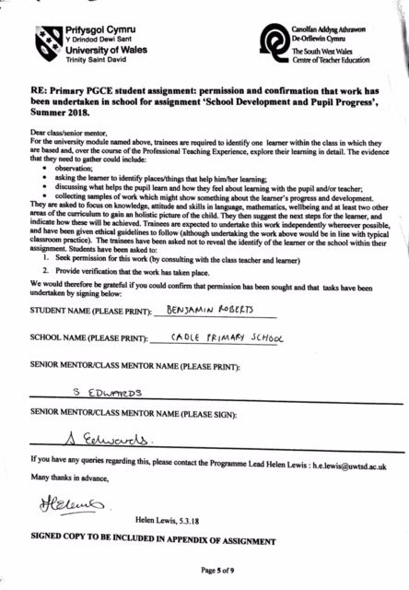

Appendix B: Pupil Data
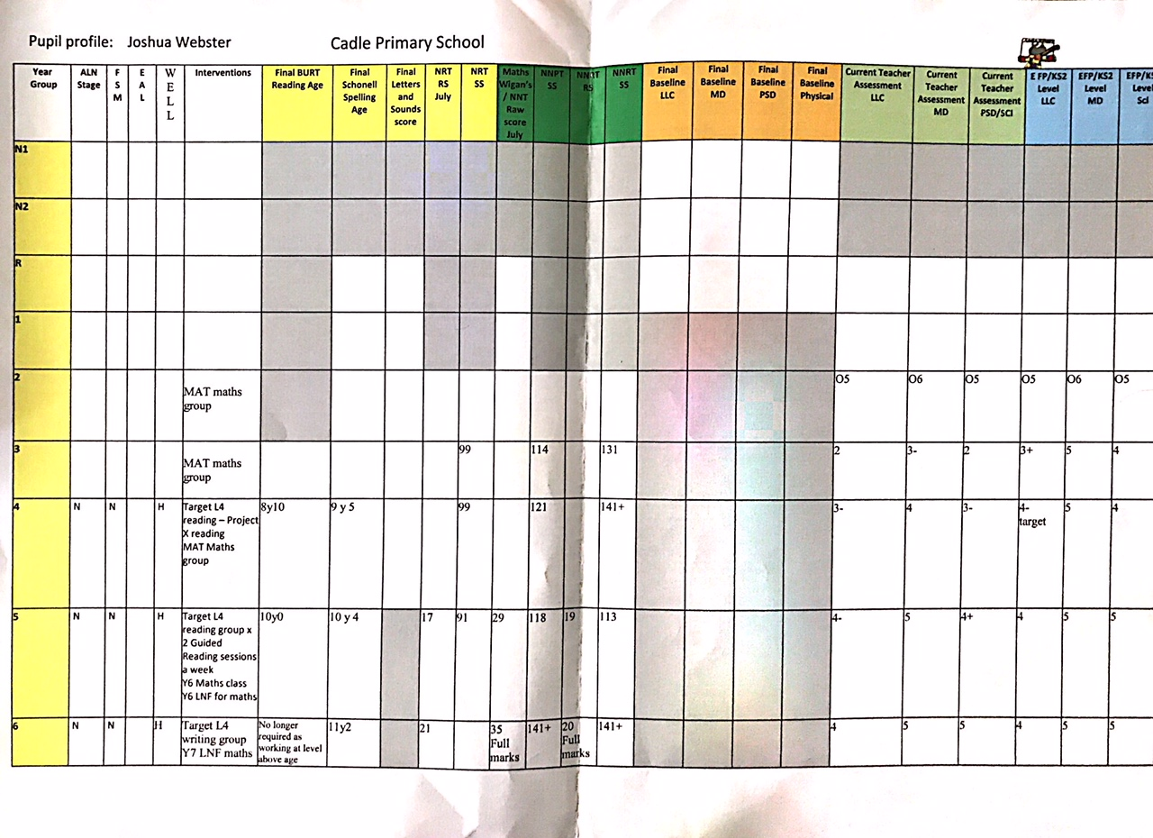

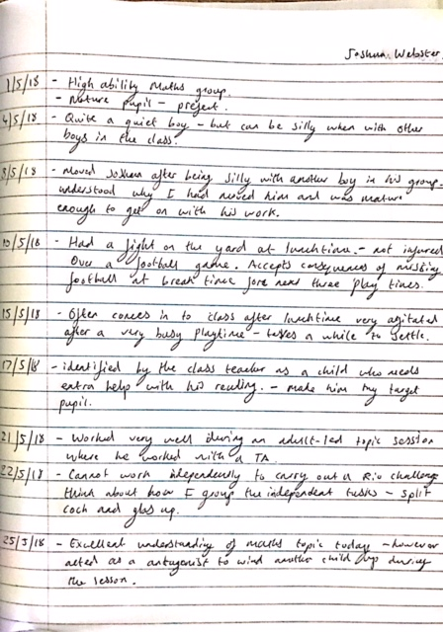
Appendix C: Observational Notes

Appendix D: Child A’s Photograph
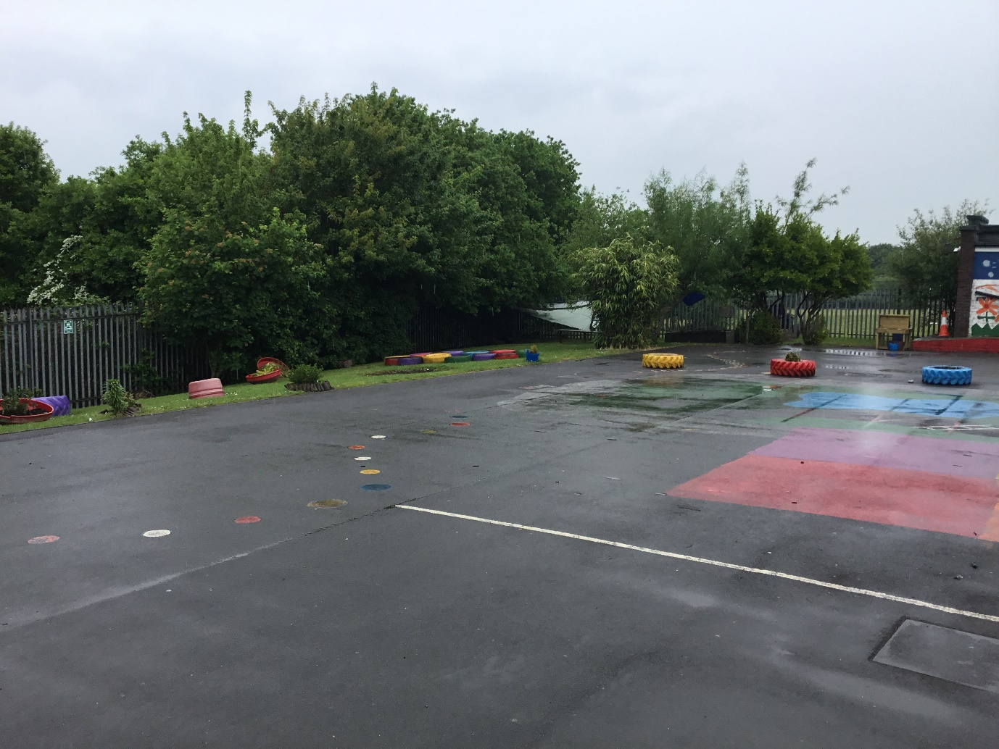

Appendix E: Child A’s Interview
Interview with Child A
Date: 24/5/2018
1. What is your favourite subject in school?
- My favourite subject is PE but we don’t do that much so after that I would have to Maths because I find it easy.
2. What is your least favourite subject?
- I find English really boring, there’s always loads of writing to do.
3. What do you find the hardest in school?
- Probably English as well, the work usually takes me forever to do, and I am always correcting my work.
4. How do you think the school could make reading more enjoyable for you?
- The selection of books has got better recently which has helped. I like reading non-fiction too finding out about real things. We need a chill out area that is really comfy for us to read in the classroom.
5. What area is your favourite place to learn in school?
- Sometimes we go outside to the garden area to read that’s relaxing. PE is the best lesson because it is outside. I like using the enhanced learning area during lessons when I am allowed, it gives me peace and quiet to get on with my work.
6. Who is your favourite teacher and why?
- My year 5 teacher was the best I have had because he used to have lots of fun activities during his lessons and he liked maths like me. We also did lots of PE with him.

Appendix F: Teacher Interview
Teacher Interview
Date: 15/5/2018
1. How does Child A’s perform in Numeracy?
Class Teacher: Chid A recently achieved full mark both their National Numerical Reasoning and National Numerical Reasoning tests. Child A is in the high ability maths group of a MAT class and is currently working to Year 7 LNF strands. The child has been a target MAT pupil for Maths since Year 2 and has excelled in their current National Tests. His combined test results alongside my teacher assessment means Child A will leave us with as a Level 5 Mathematics.
2. How does Child A perform in Literacy?
- Throughout their time in KS2 Child A has always been involved in target reading groups, as this is an area that needs to be improved. Child A often struggles with their spelling although they have a spelling age of 11. During the National Tests Child A scored an adequate 21 marks out of 35, this score alongside my teacher assessment means that Chid A will leave the school with a Level 4 in Literacy.
3. What do you see as Child A’s barriers to learning?
- As mentioned through their school life Child A has been a target reader. They do not read at all in the house. He has always been a target pupil for literacy and over the past year Child A made big improvements in their reading skills and was therefore able to be in my Year 5/6 MAT class. Its testament to the progress Child A has made with their reading that keep up with the high volume of work in this class. Recently he has started reading Tom Gates novels that has seen him read a lot more.
4. How does Chid A transfer key skills across the curriculum?
- Child A performs well across the curriculum, the errors that are made are Literacy based, these usually present as spelling mistakes, grammatical errors and adequate vocabulary. Child A has no problem transferring their numeracy skills across the curriculum.
4. How is Child A’s general wellbeing?
- Child A has had a 100% attendance record so far in Year 6. Their wellbeing is very good as the child is an active member of the class and is well liked amongst their peers.
5. What is Child A’s attitude to learning like?
- Child A is a prefect in the school and is involved in emotion coaching their peers. They have a very mature attitude towards learning most of the time. However, when paired with certain members of the class Chid A can become silly and easily distracted. On occasions Child A gets into conflicts on the playground. Child A shows a sheer commitment to improving their literacy skills while in the school environment.

Appendix G: Reading Record
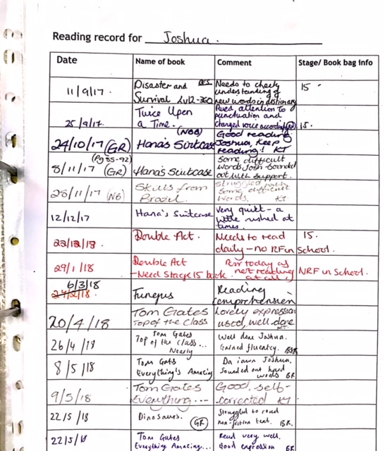

Appendix H: Child A’s English Work
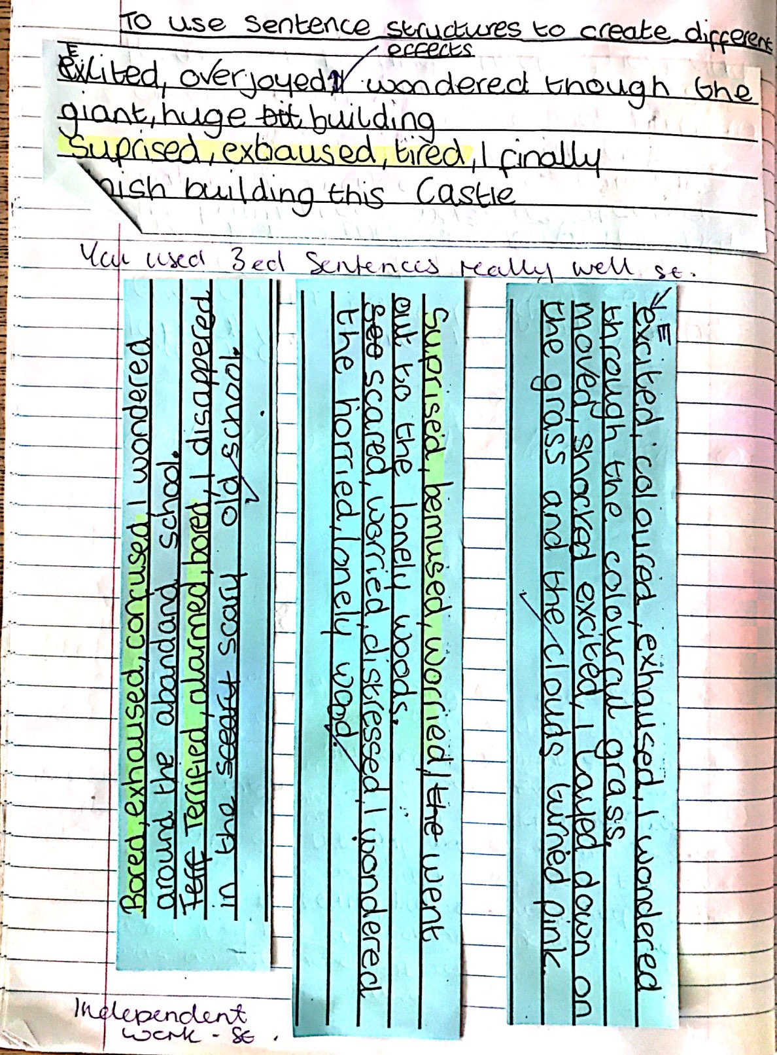

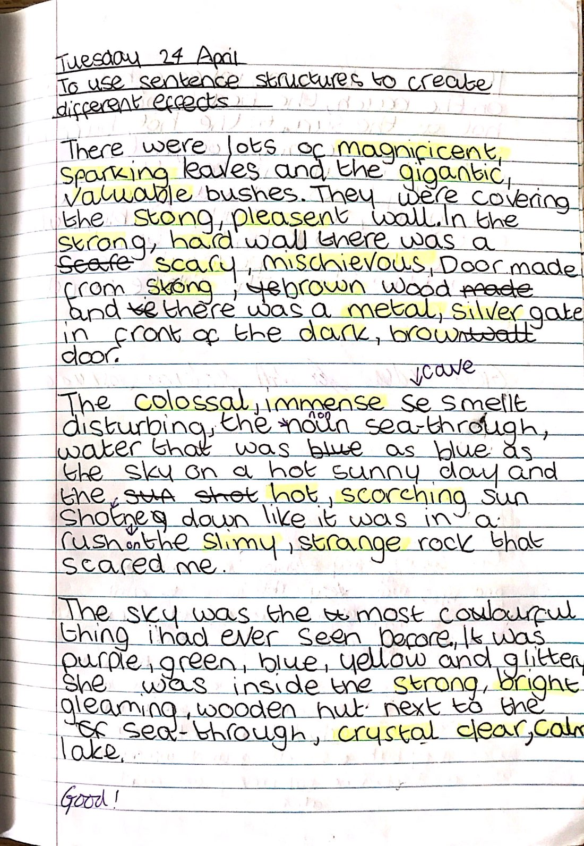
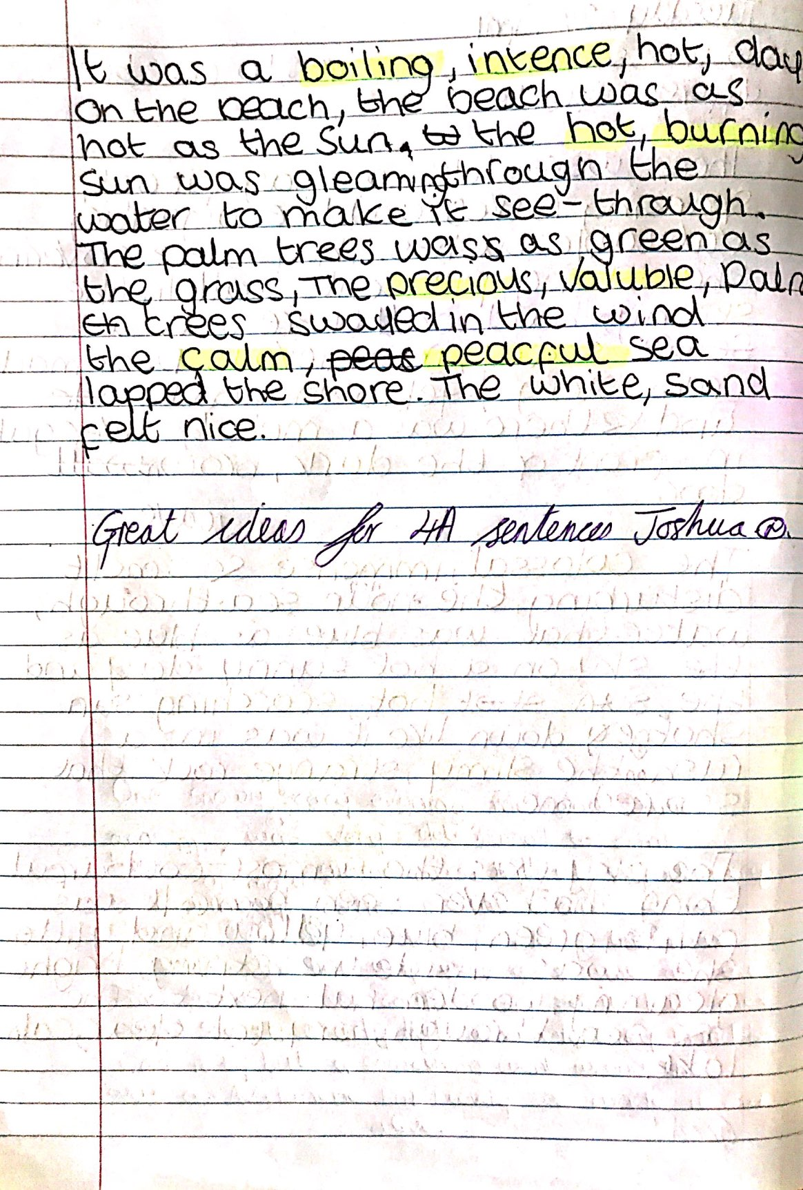
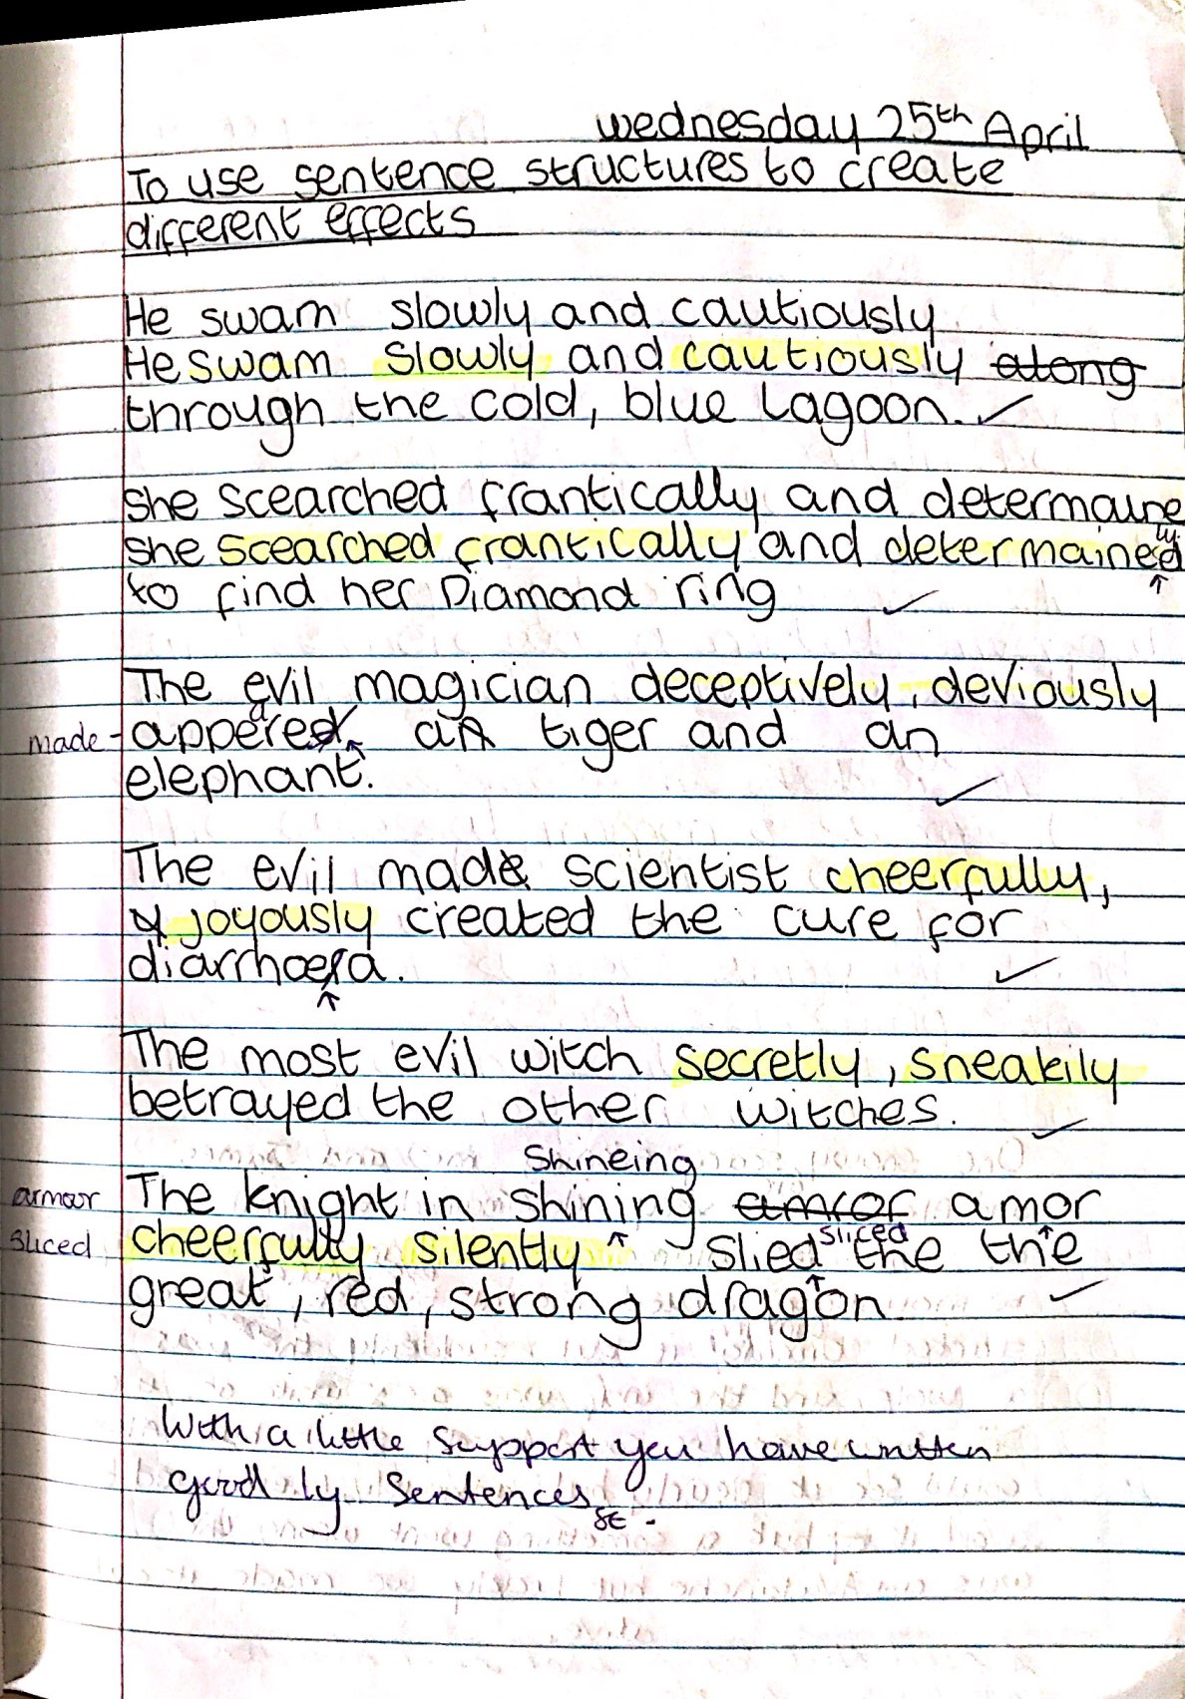

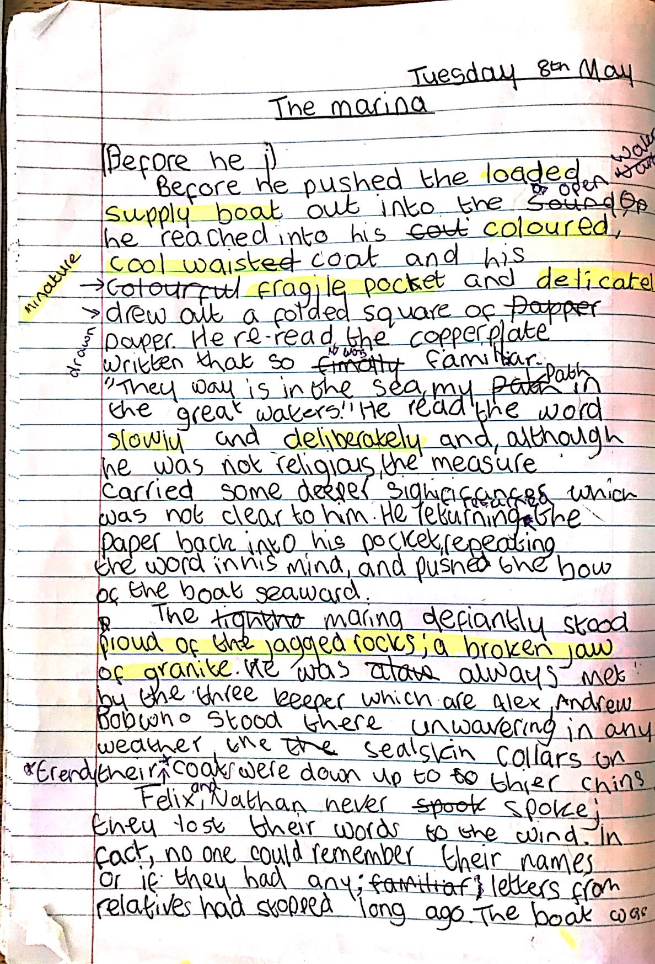
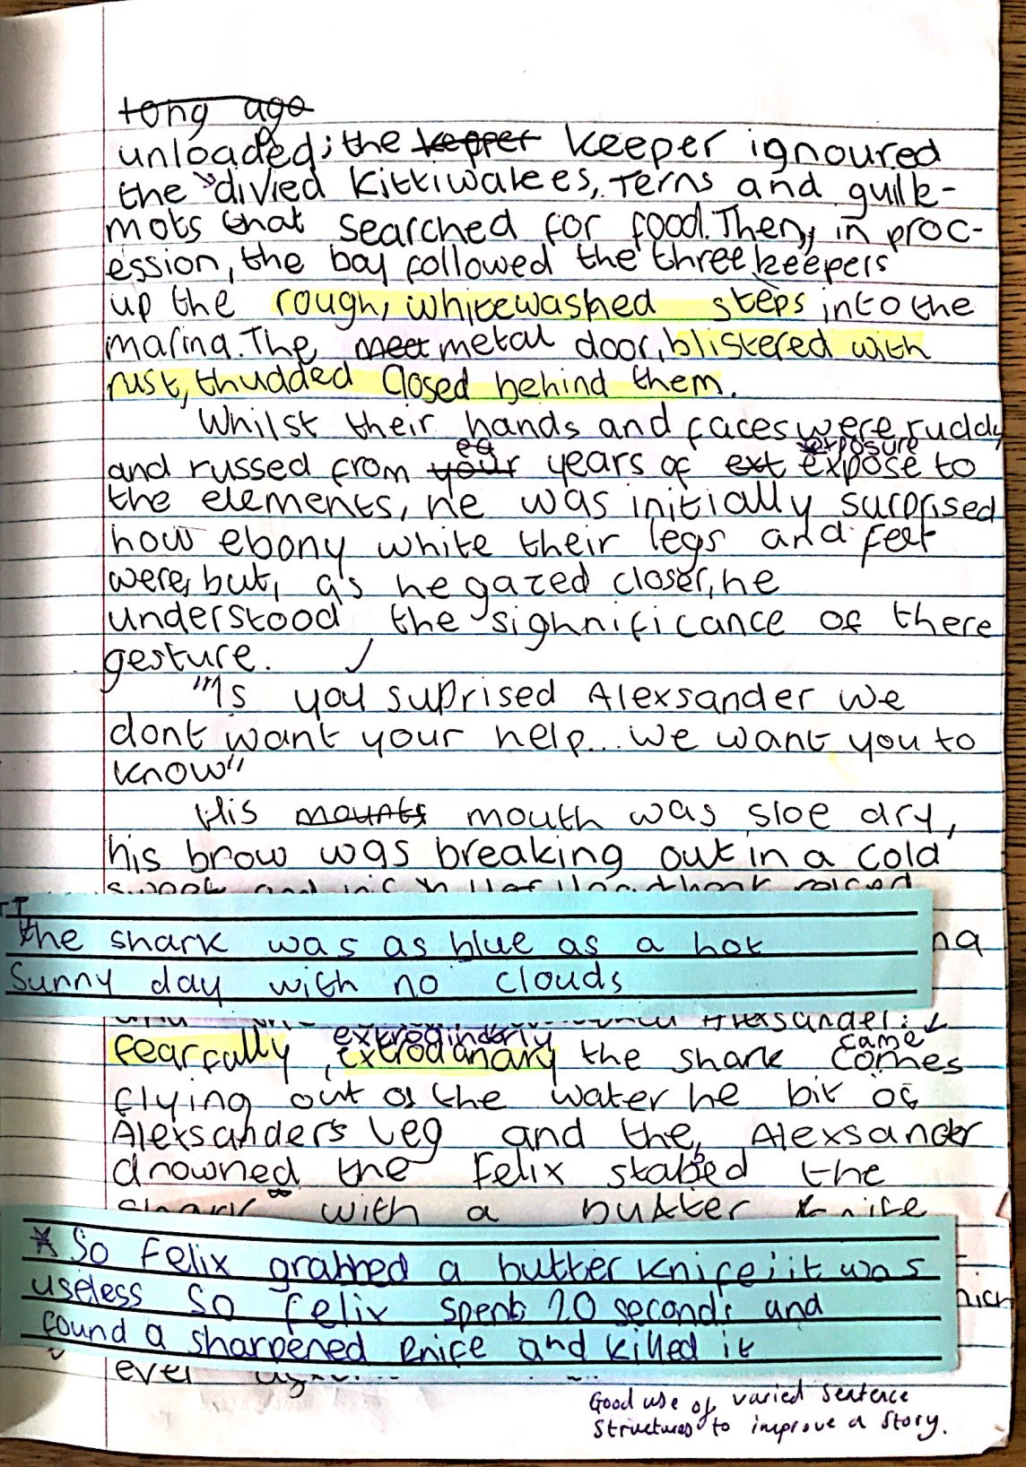



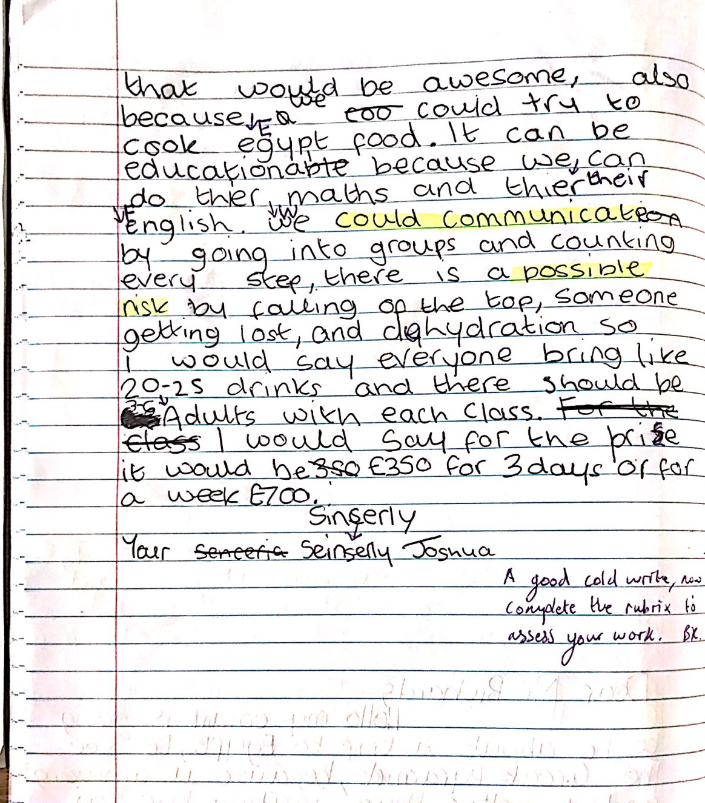

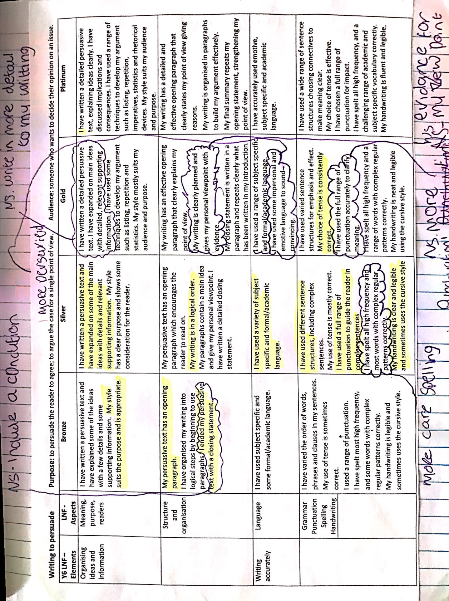

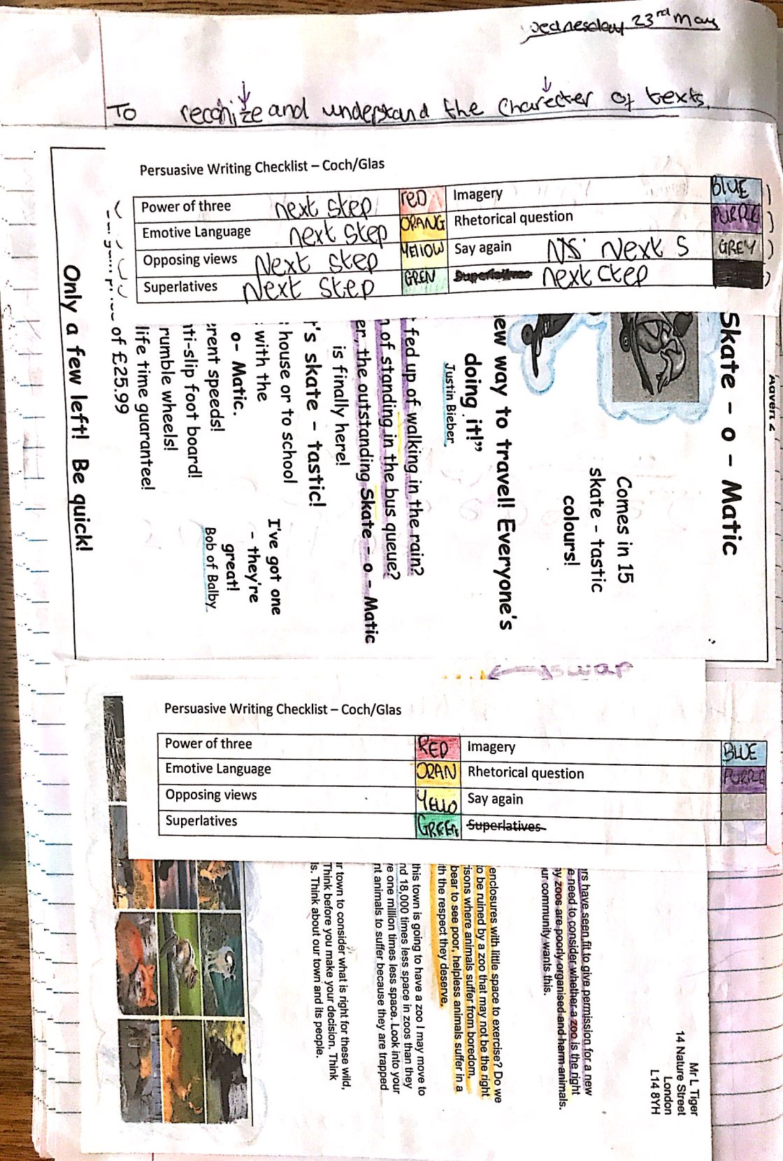
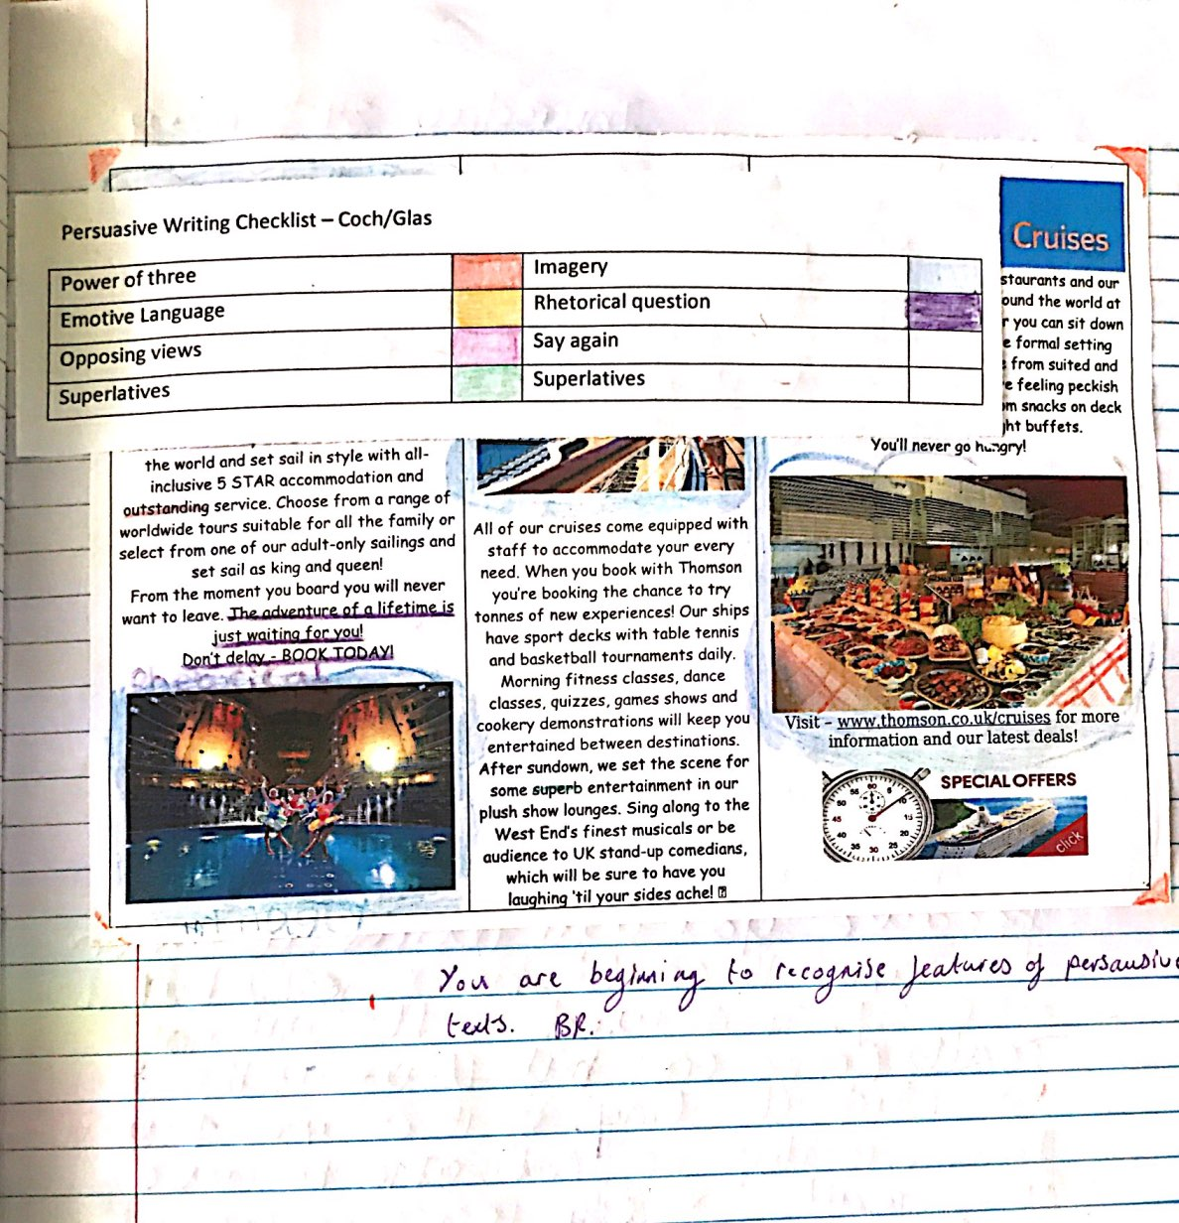

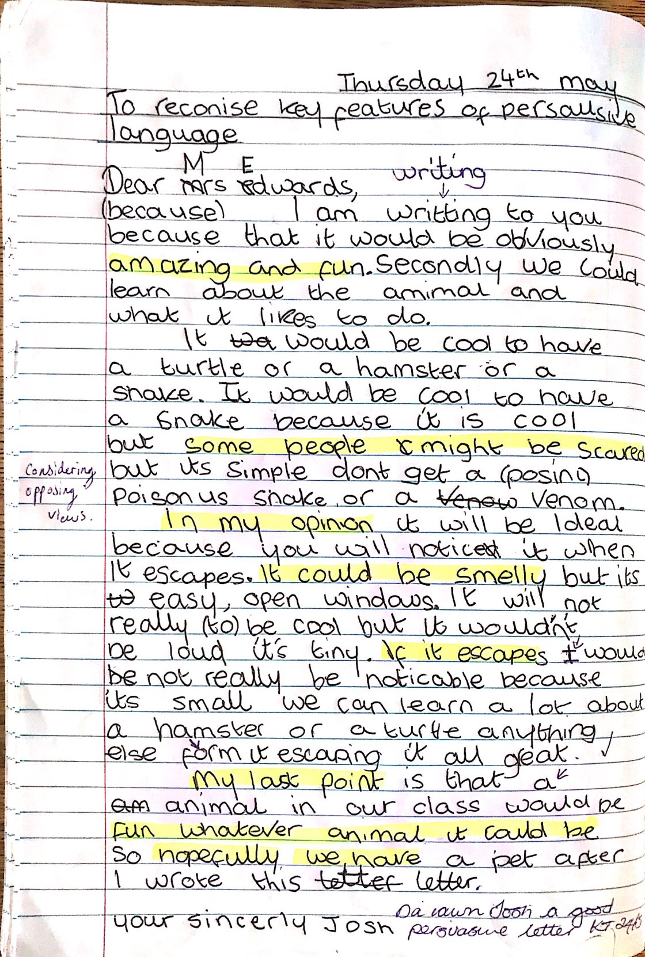
Appendix I: Child A’s Guided Reading Work
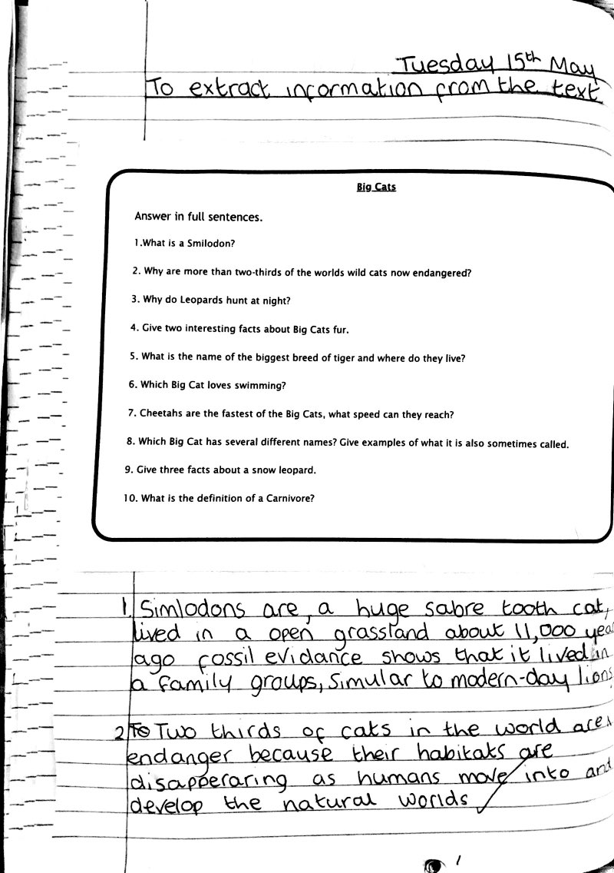

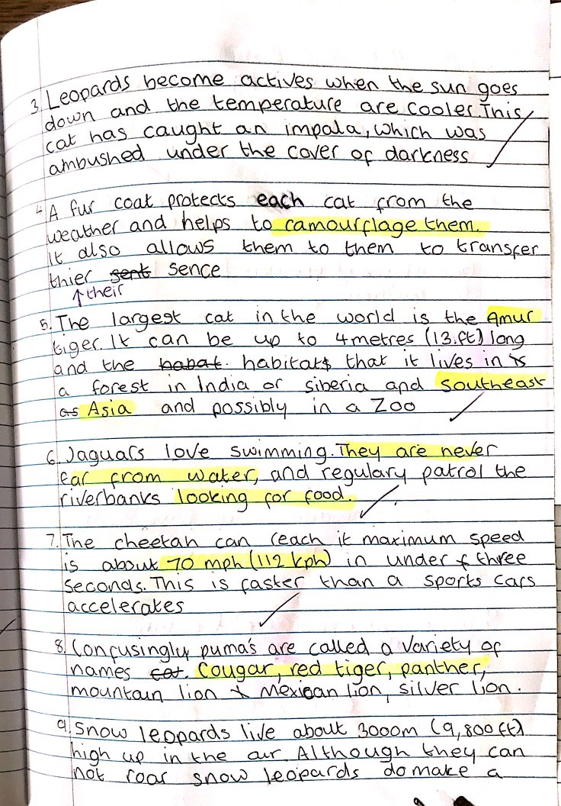
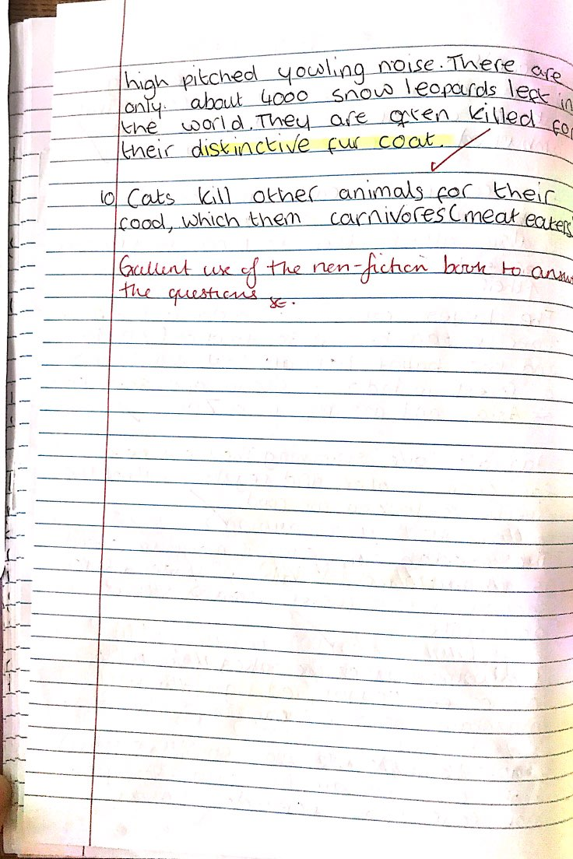
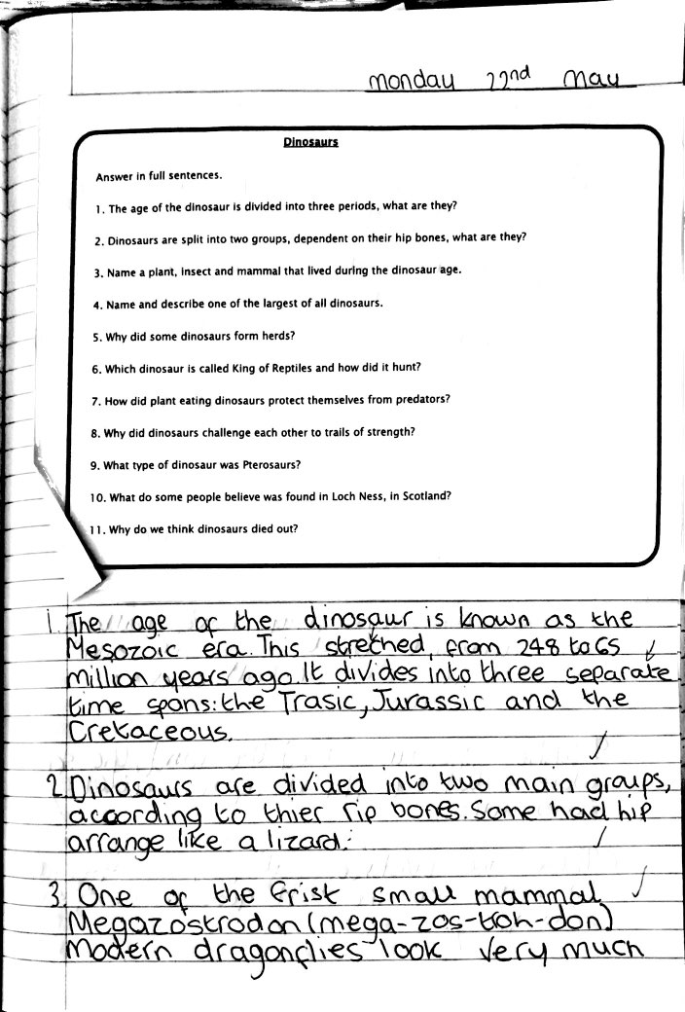
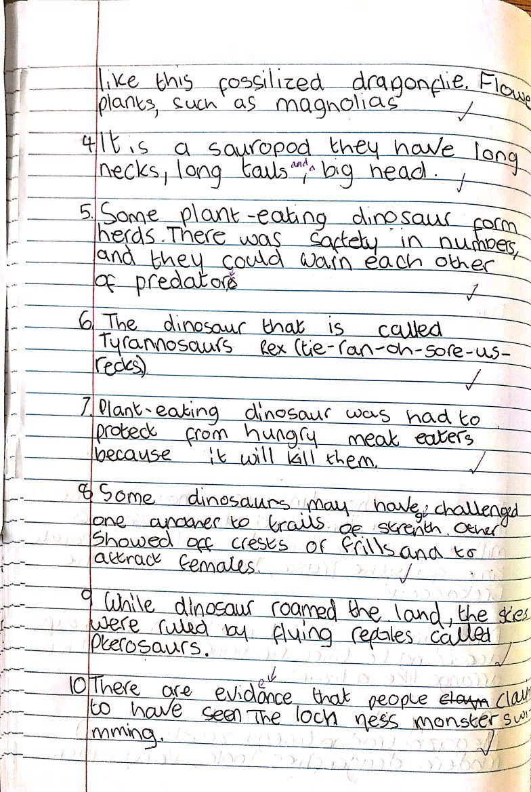
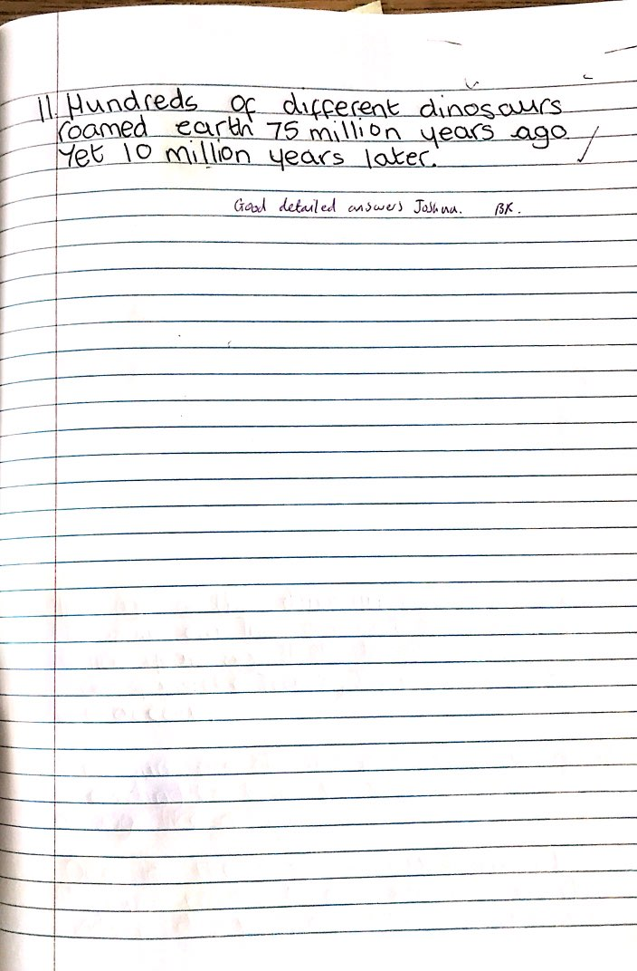
Appendix J: Child A’s Mathematics Work
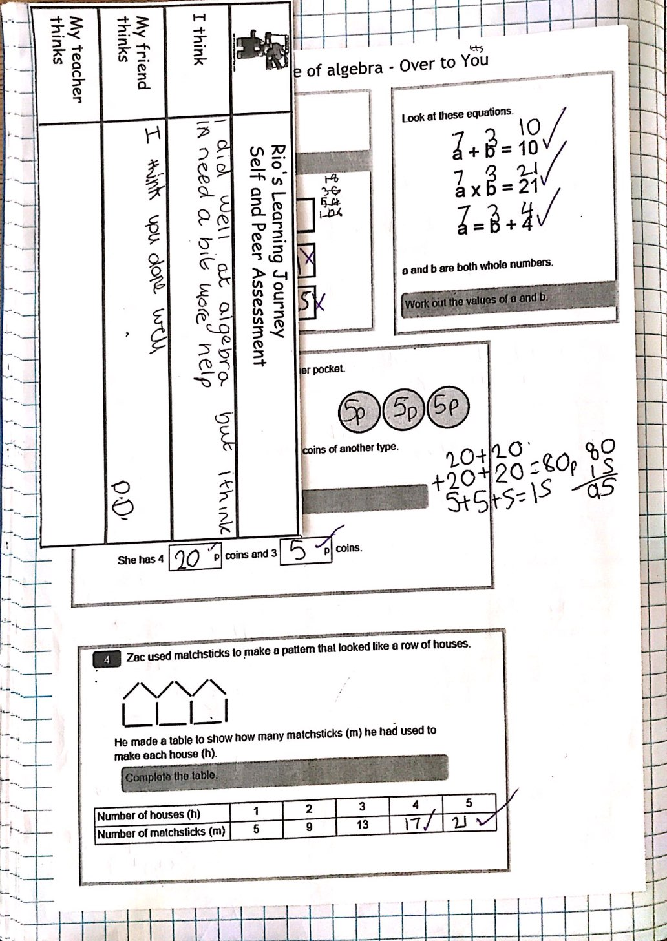

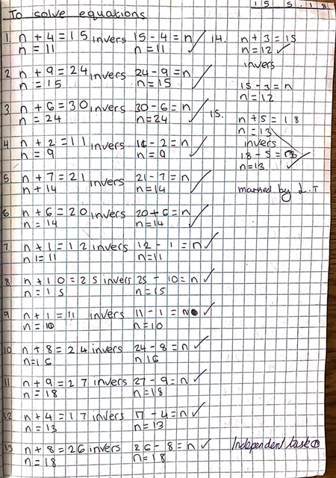

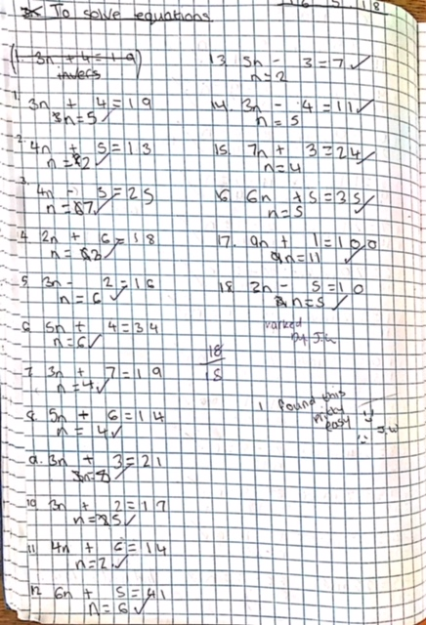

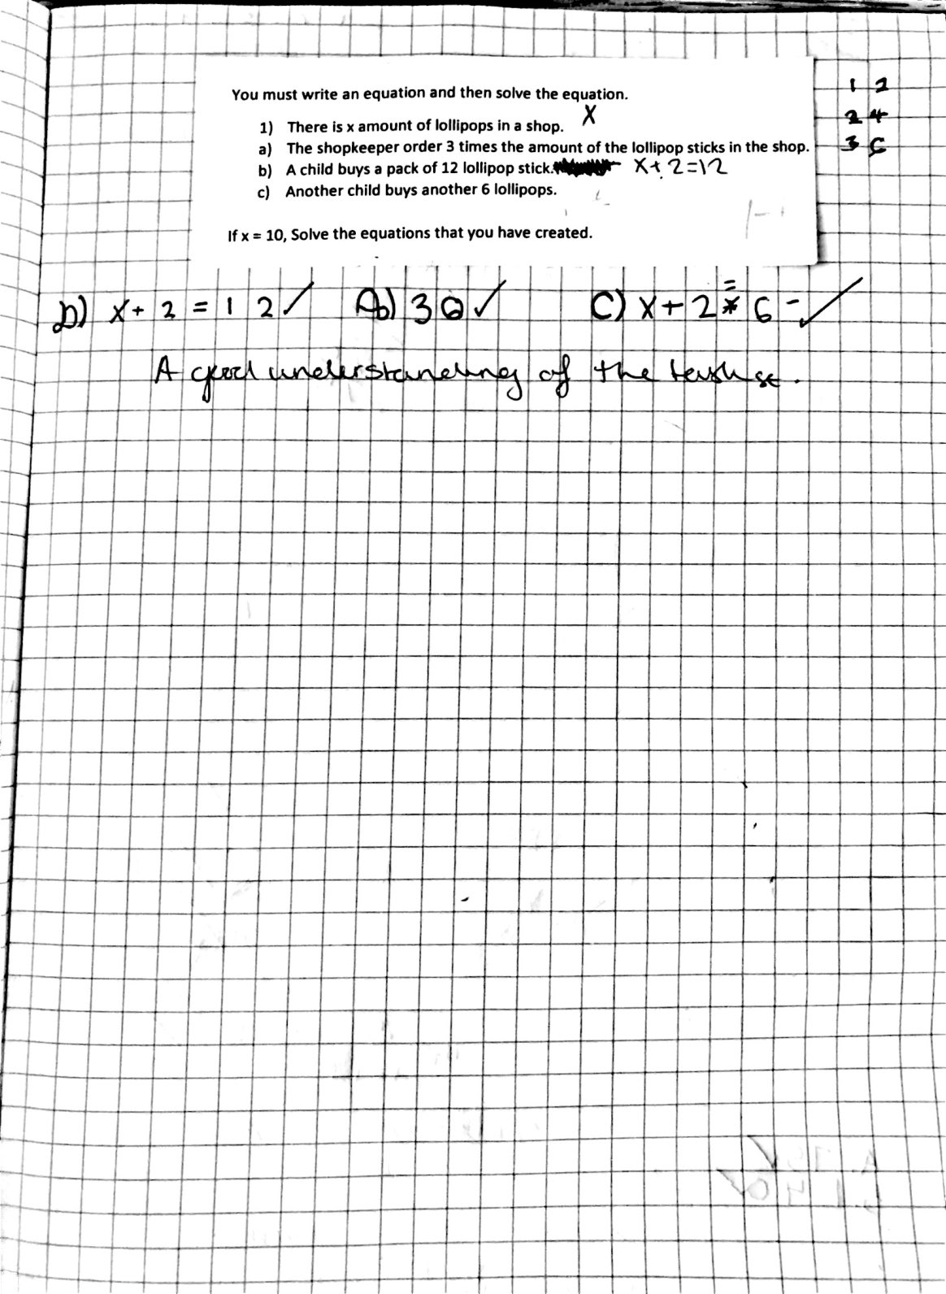

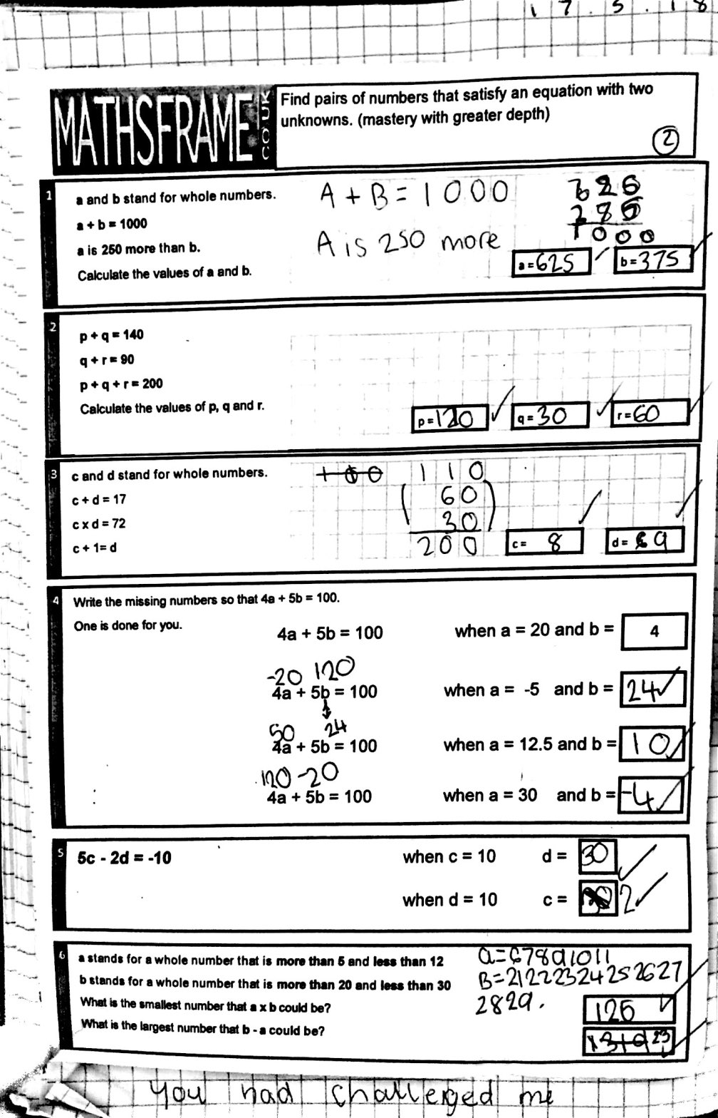

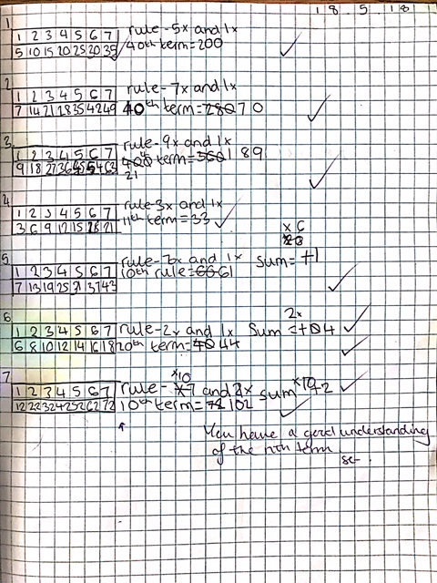

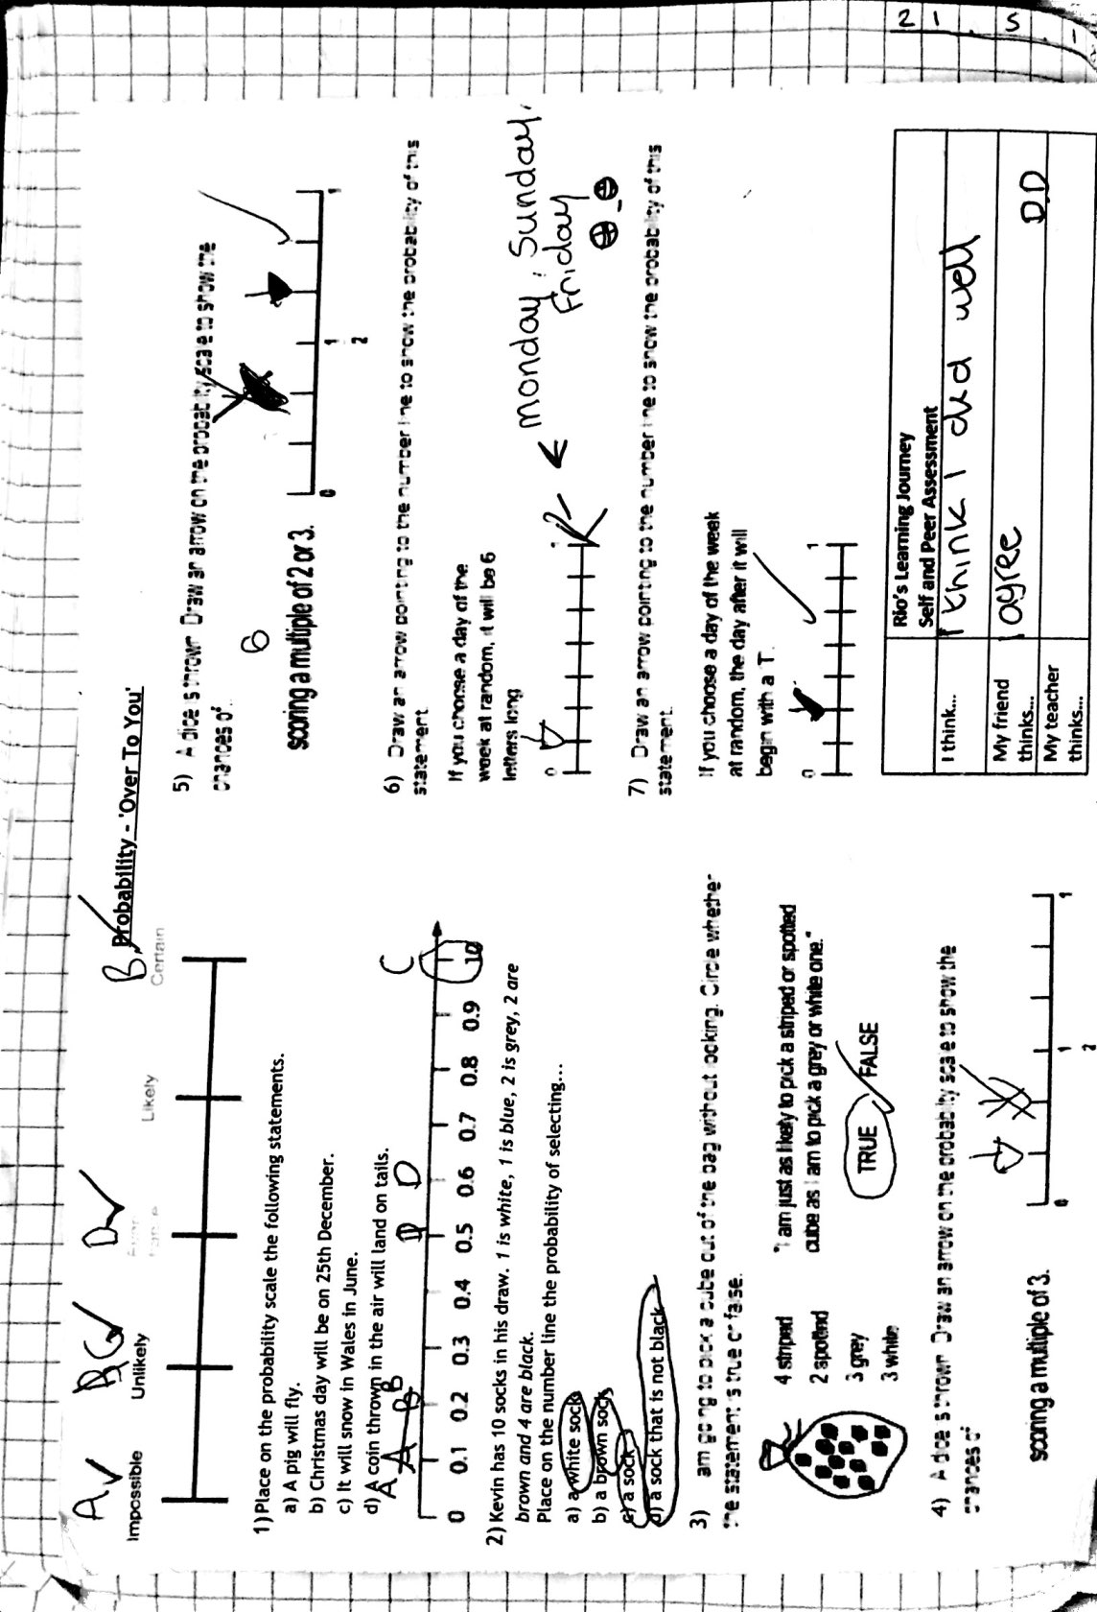

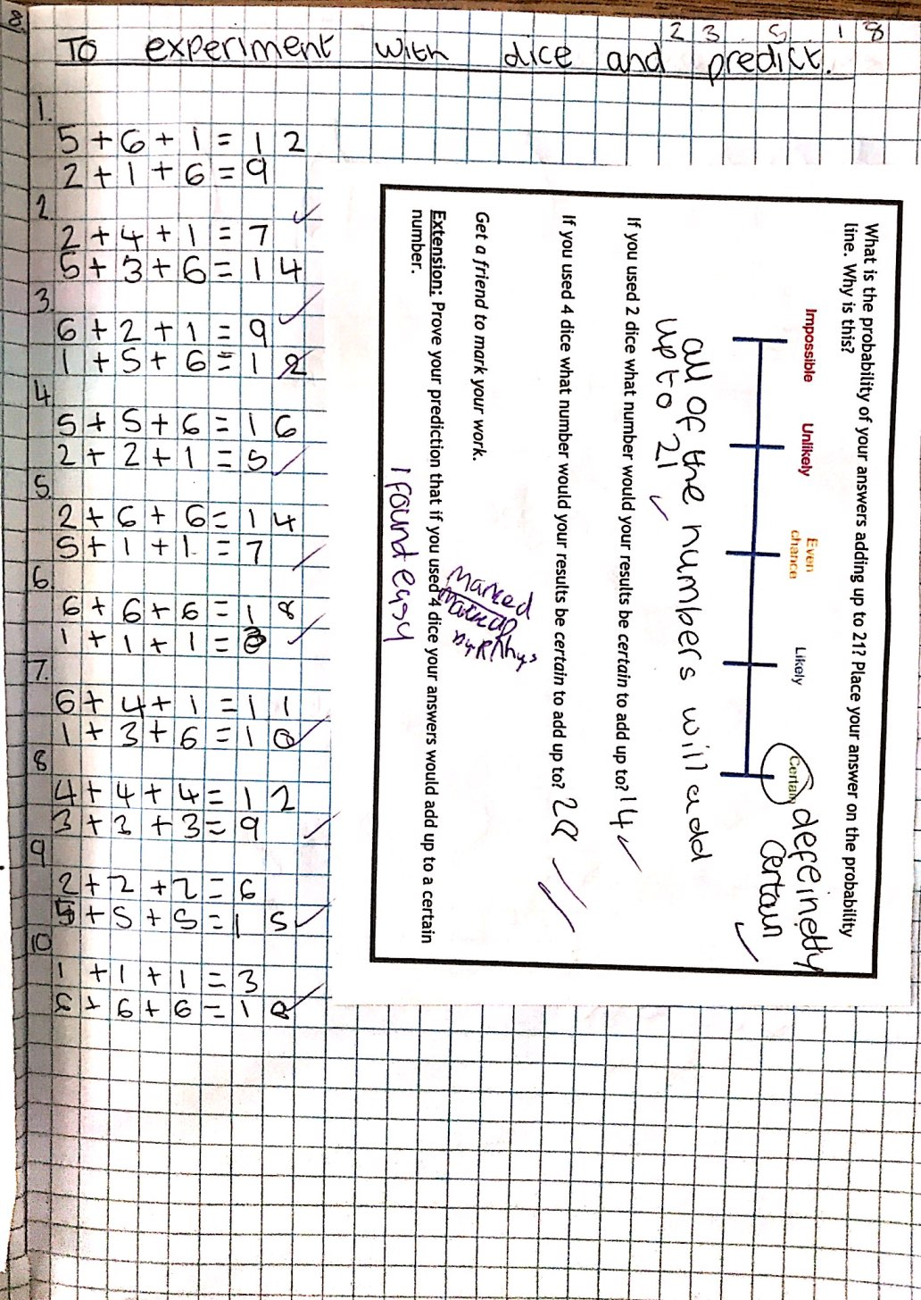

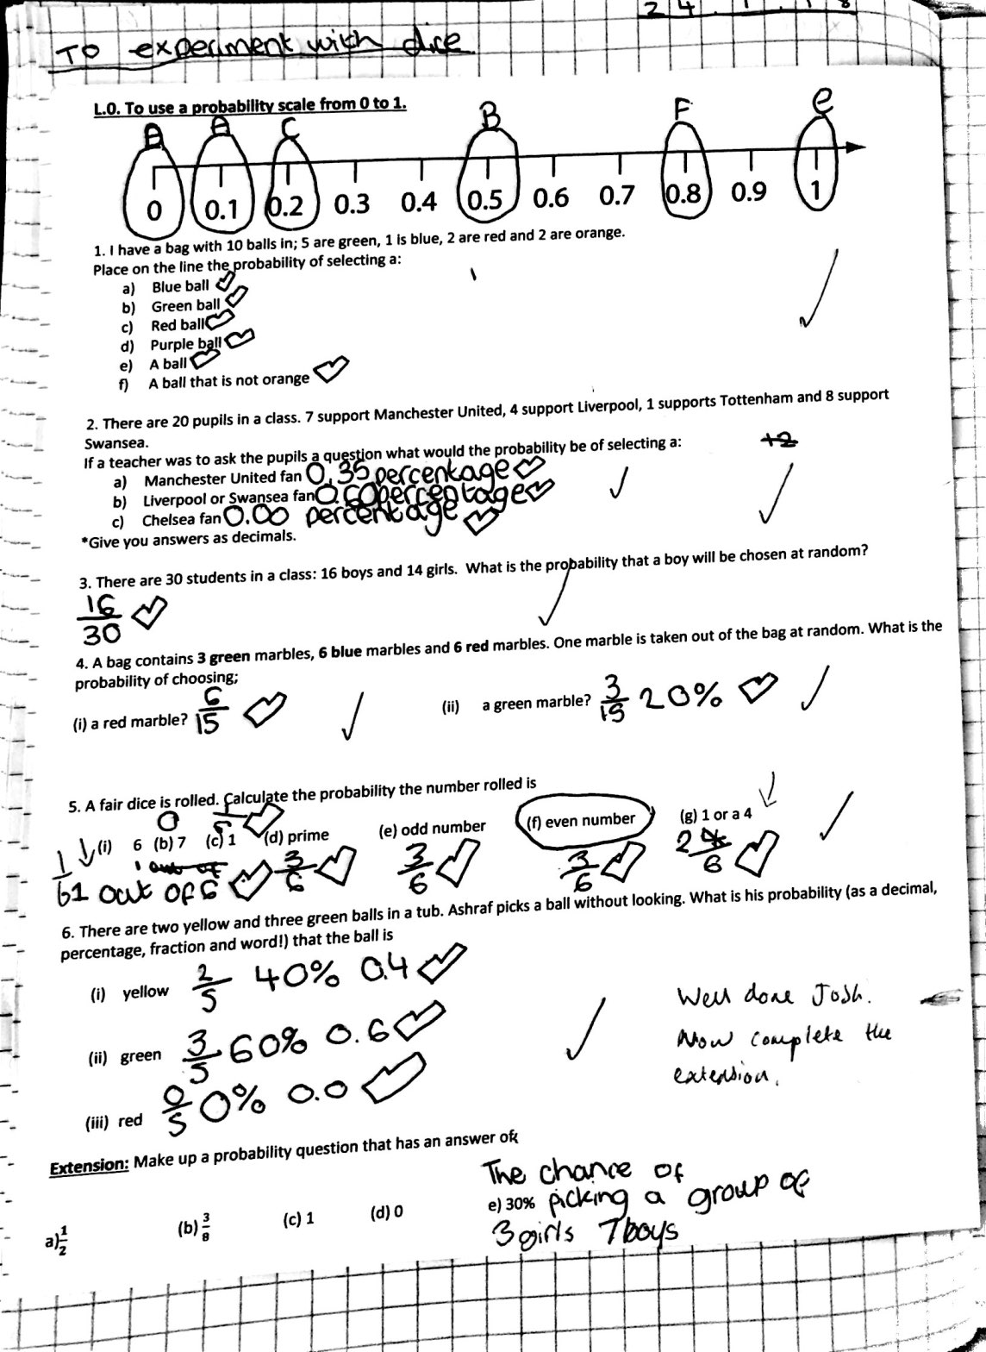

Appendix K: Child A’s Science Work
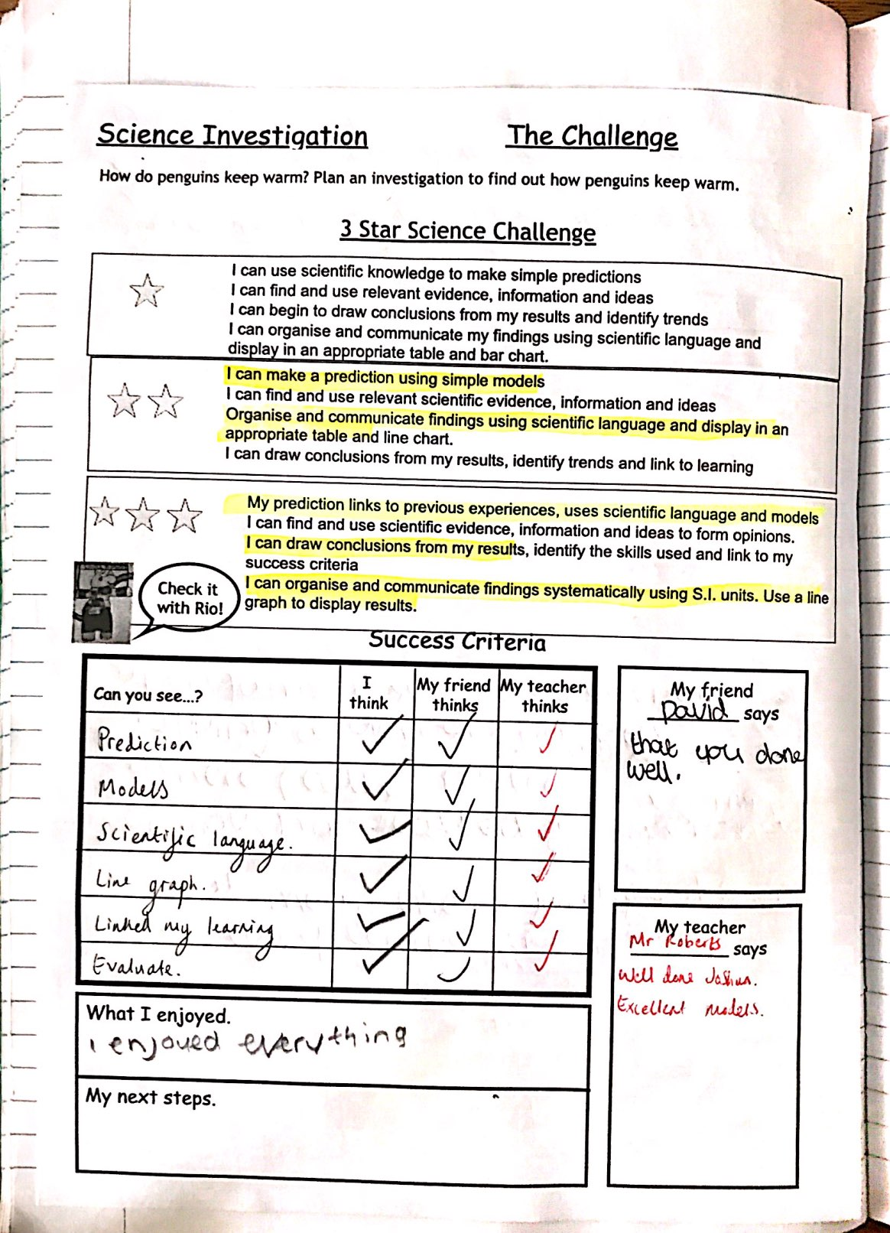

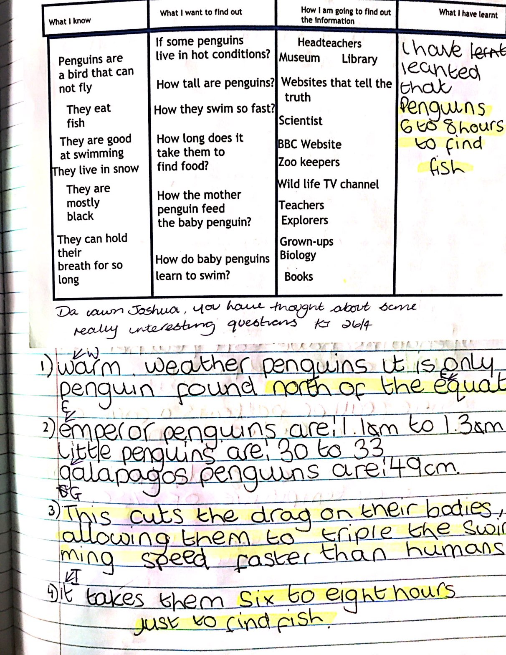

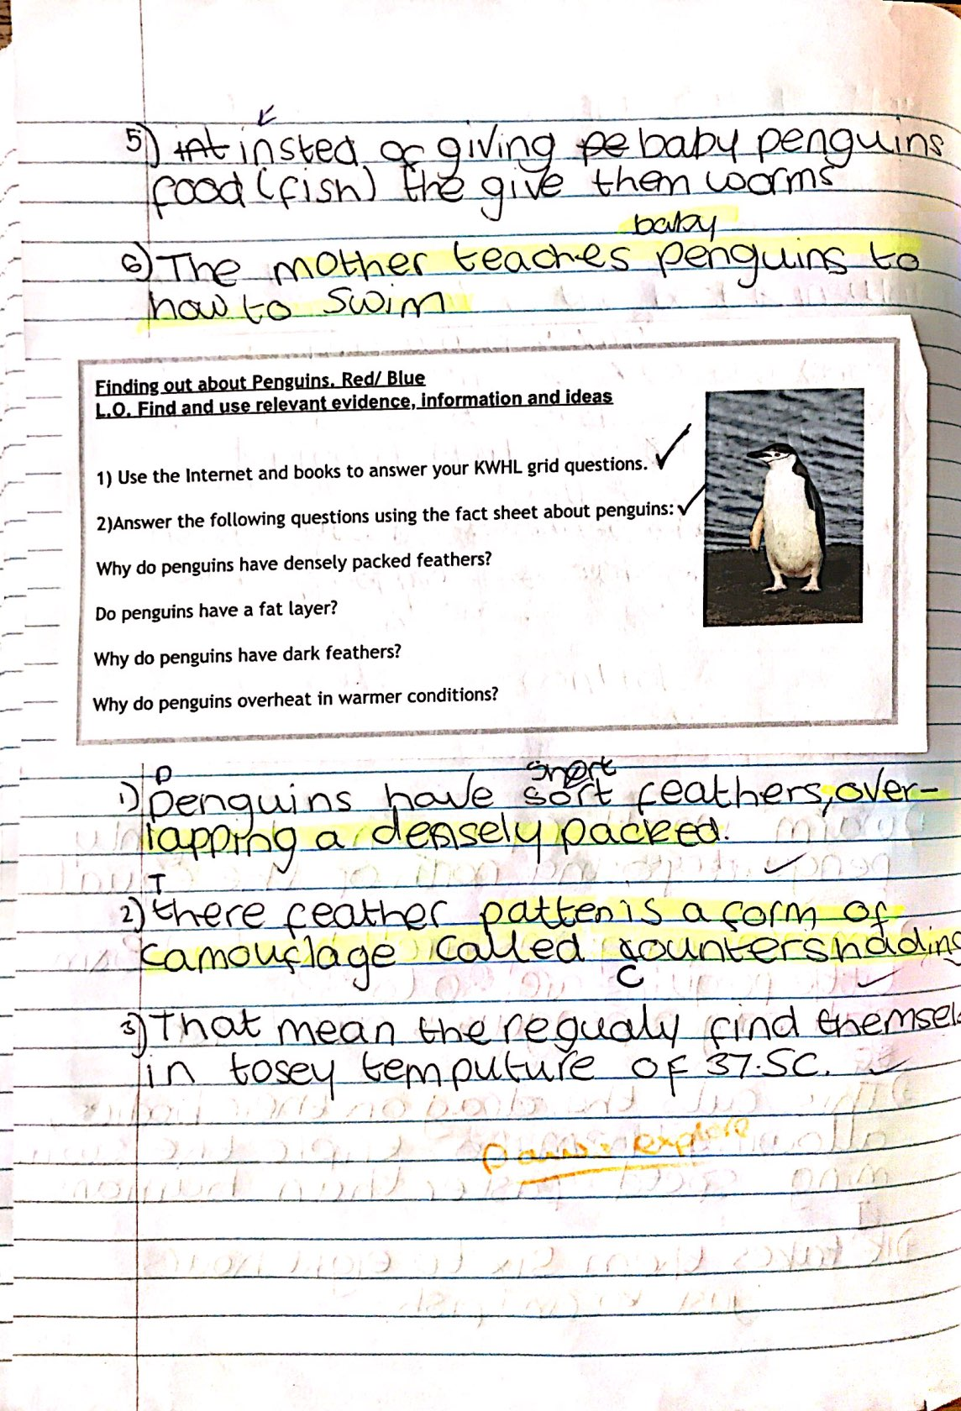
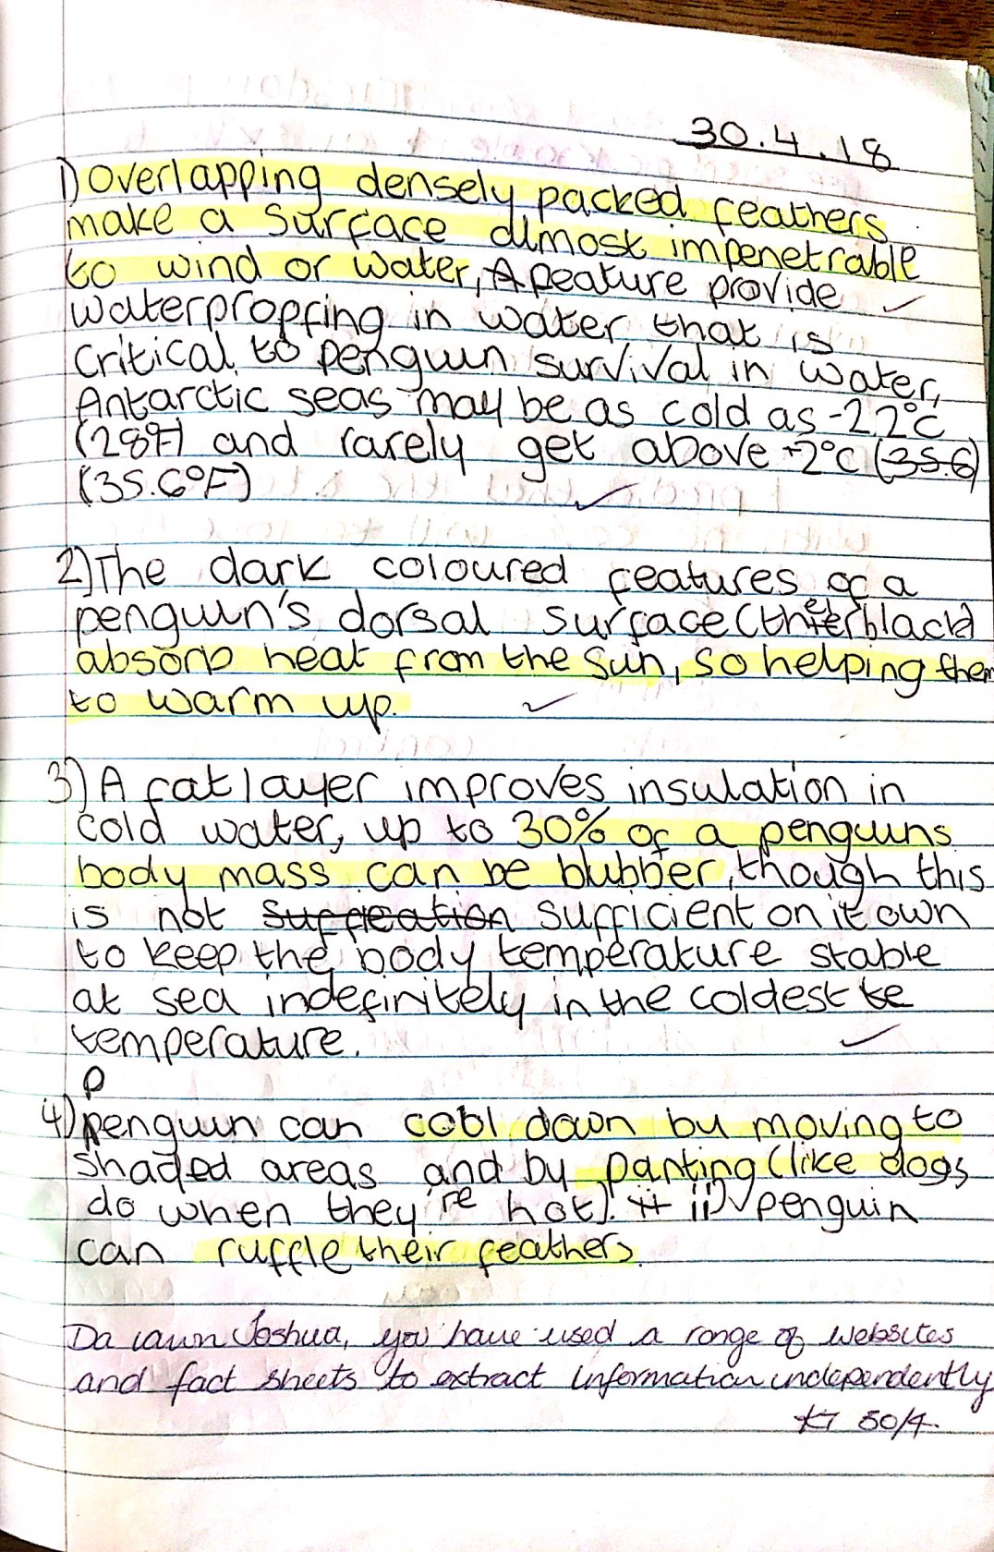
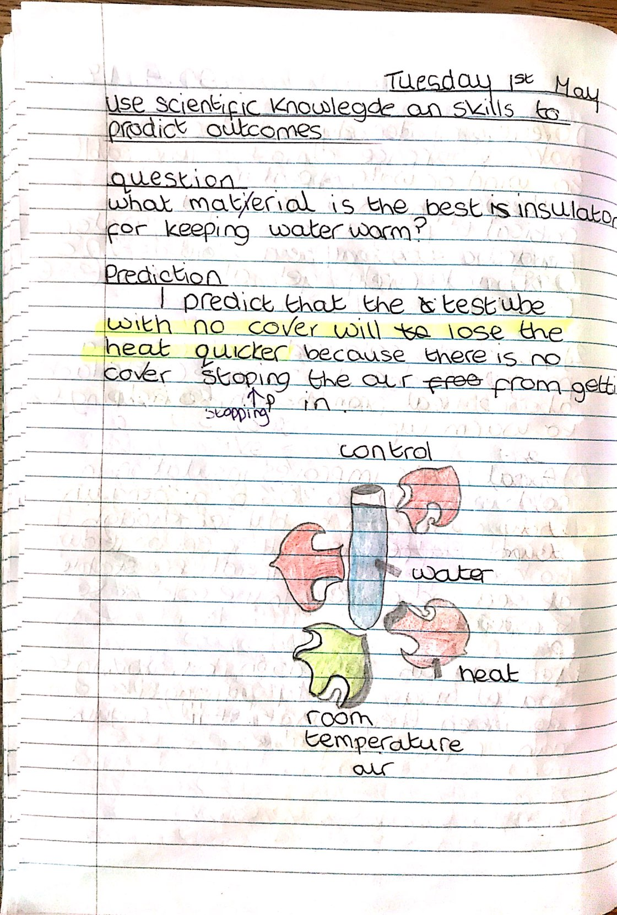
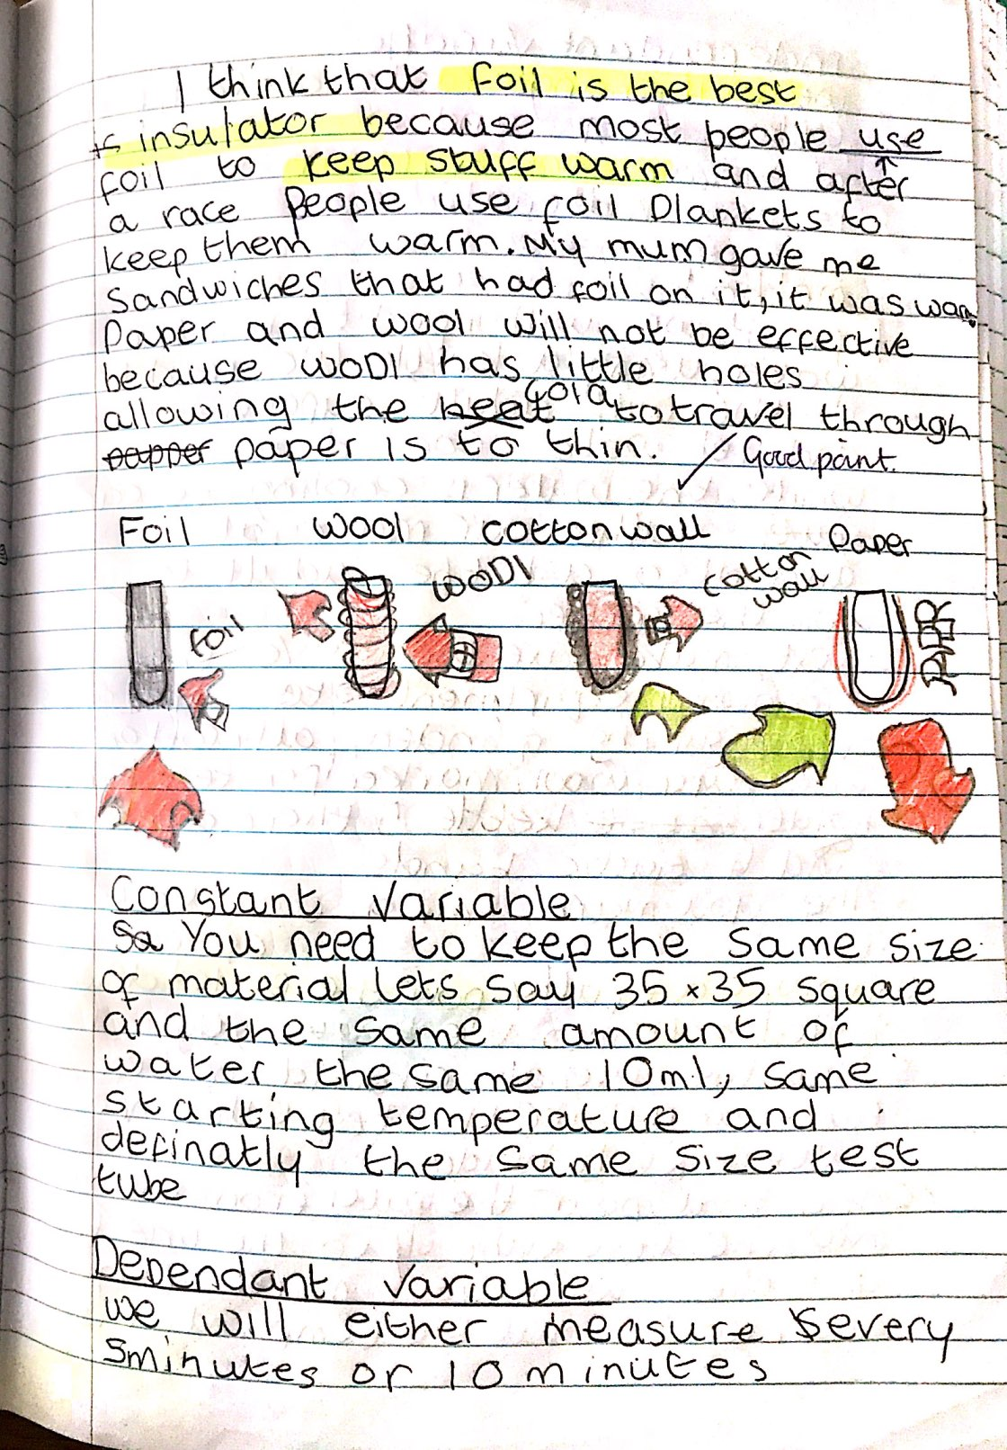

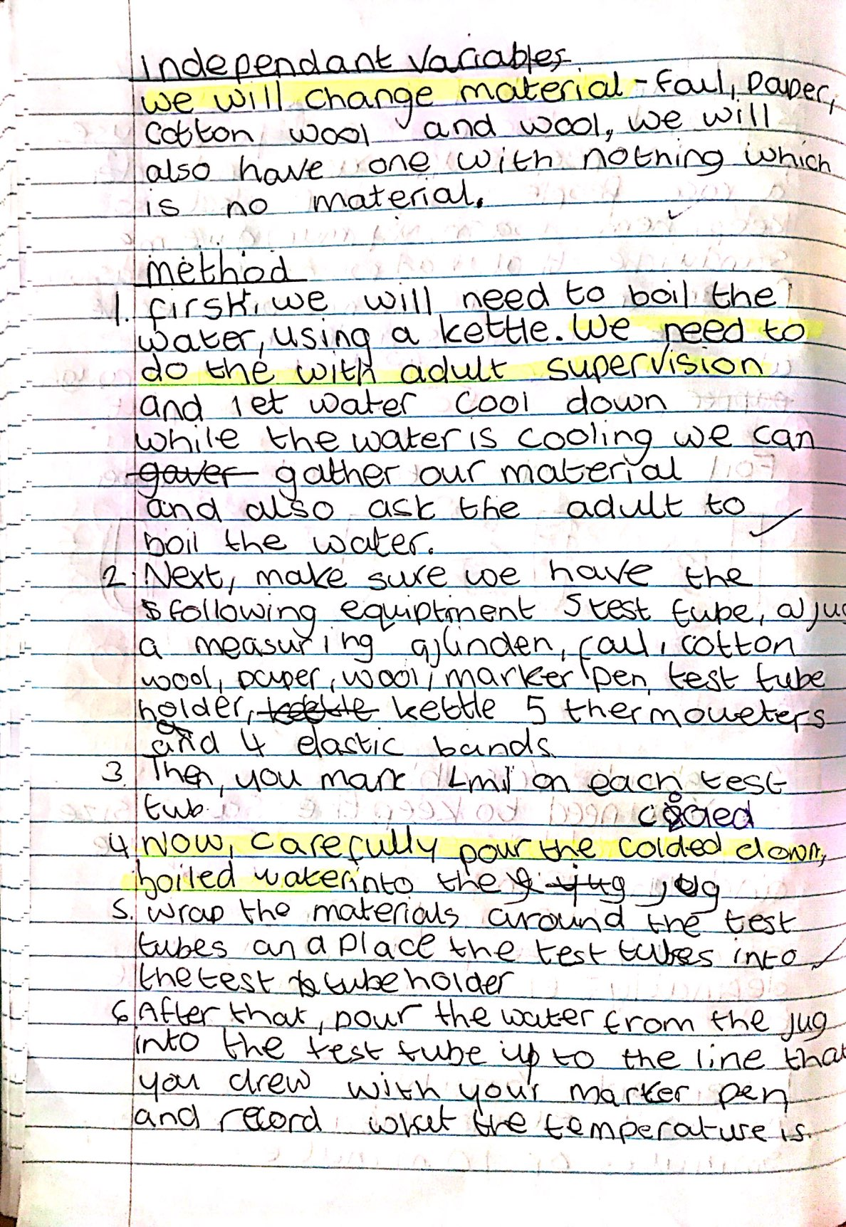

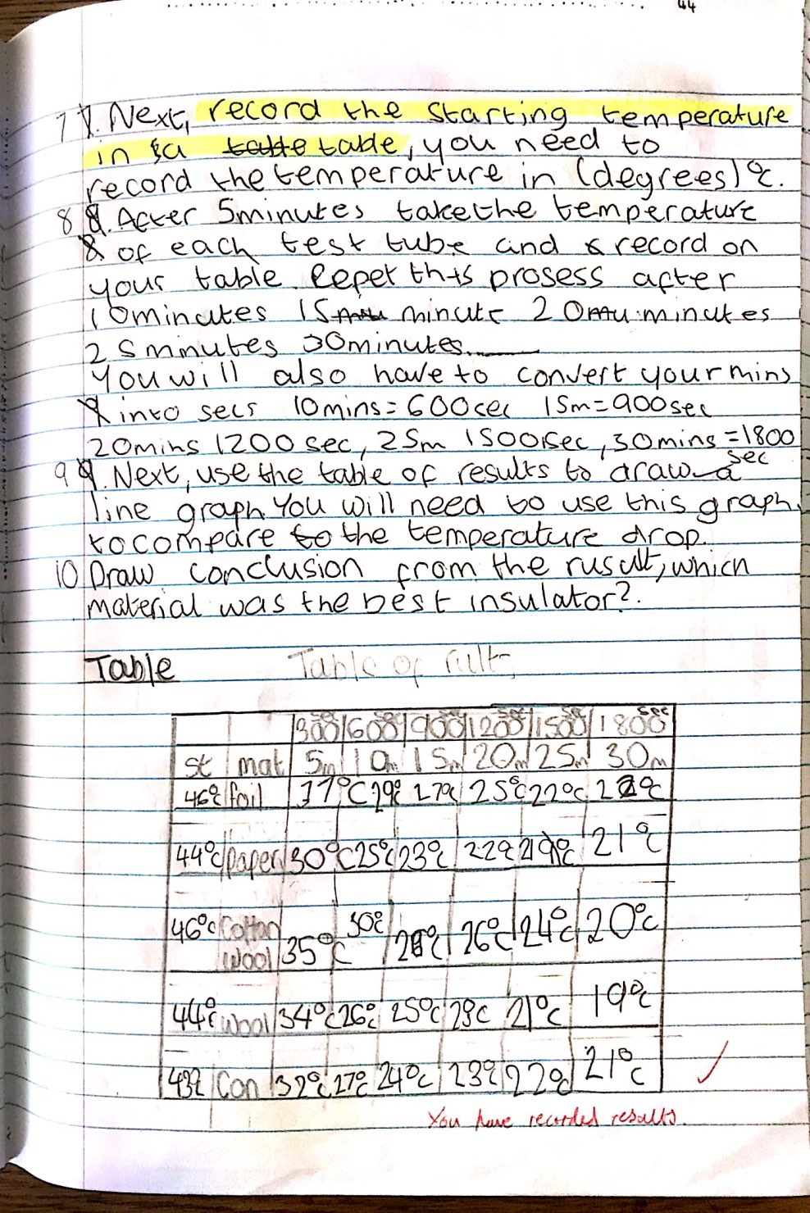
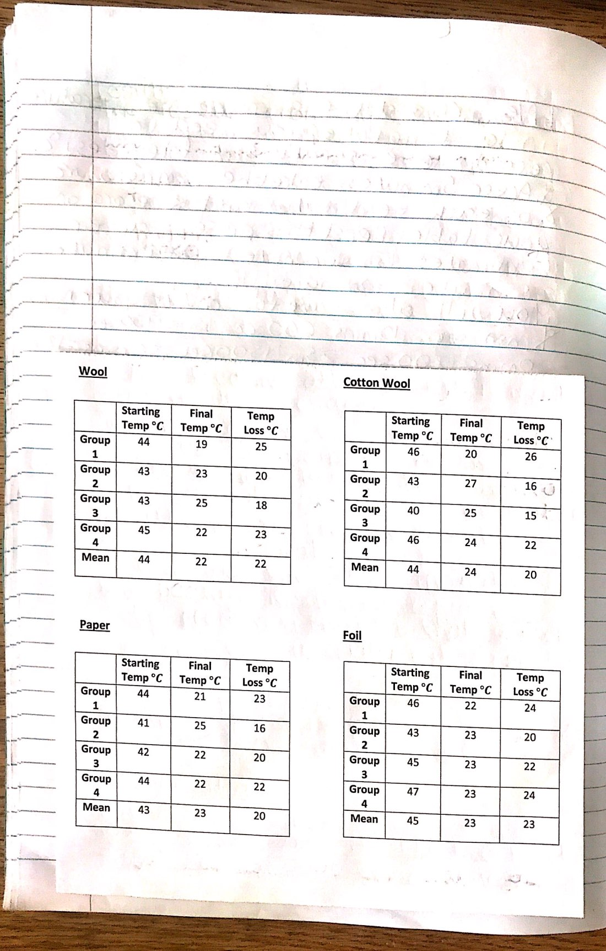
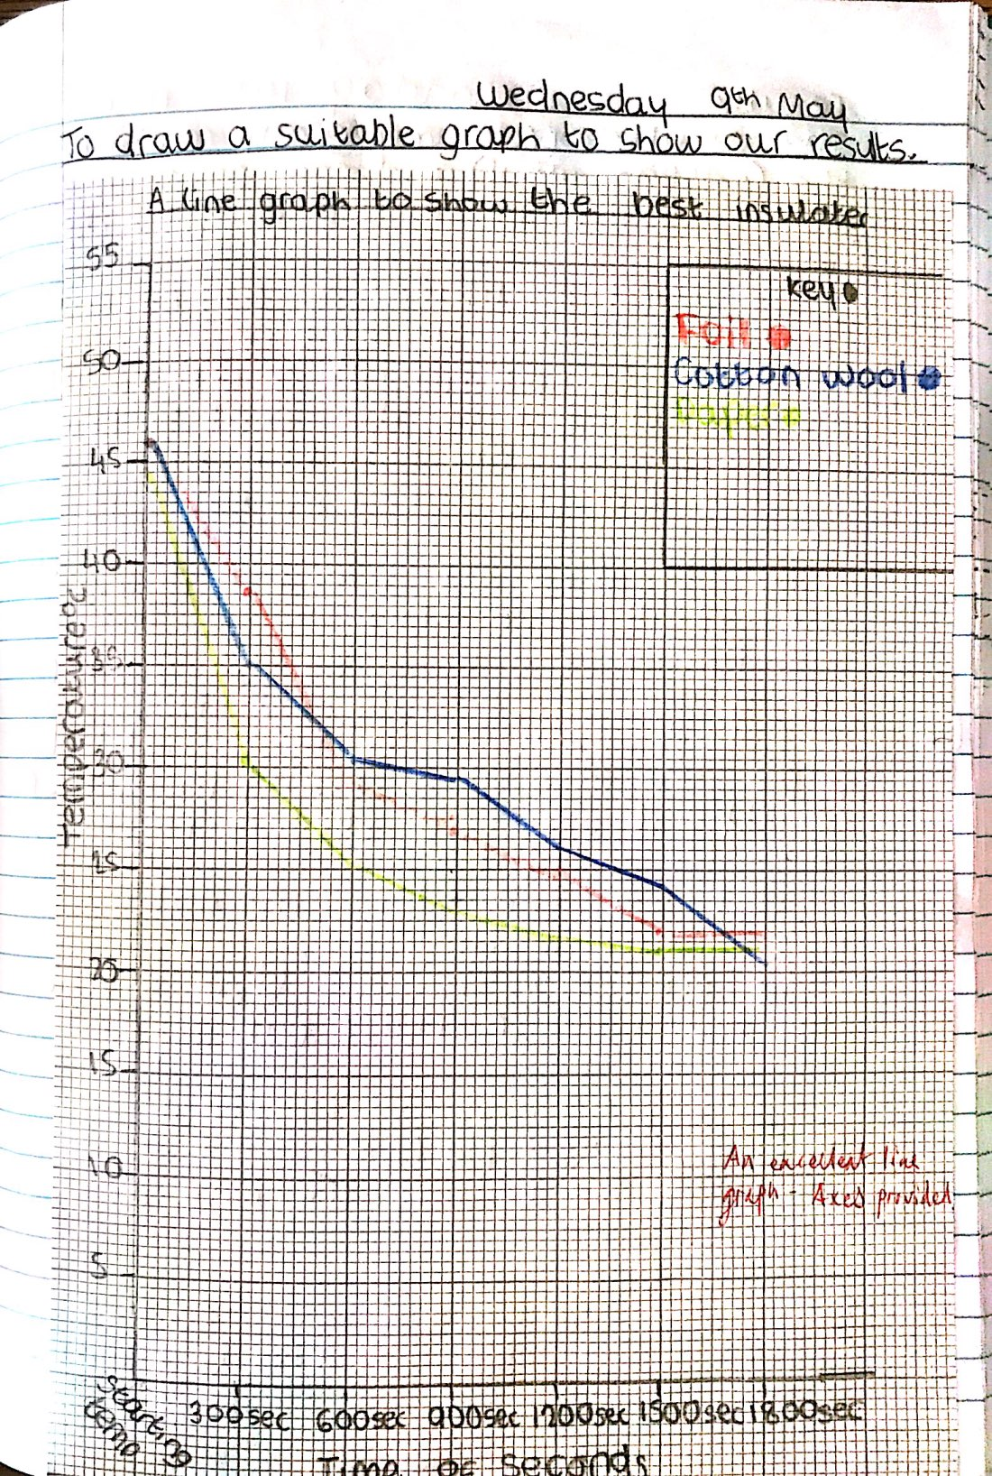
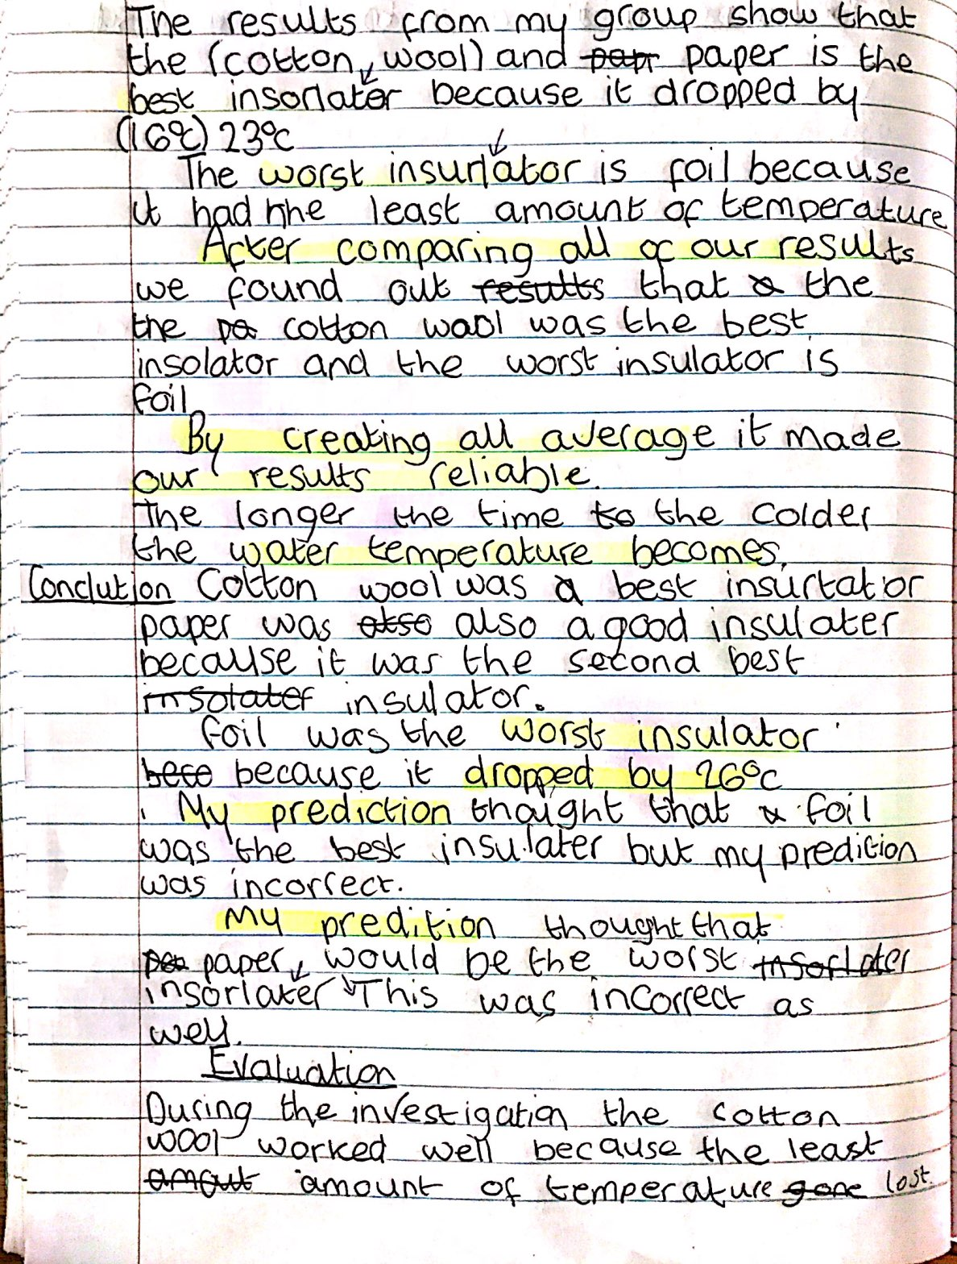
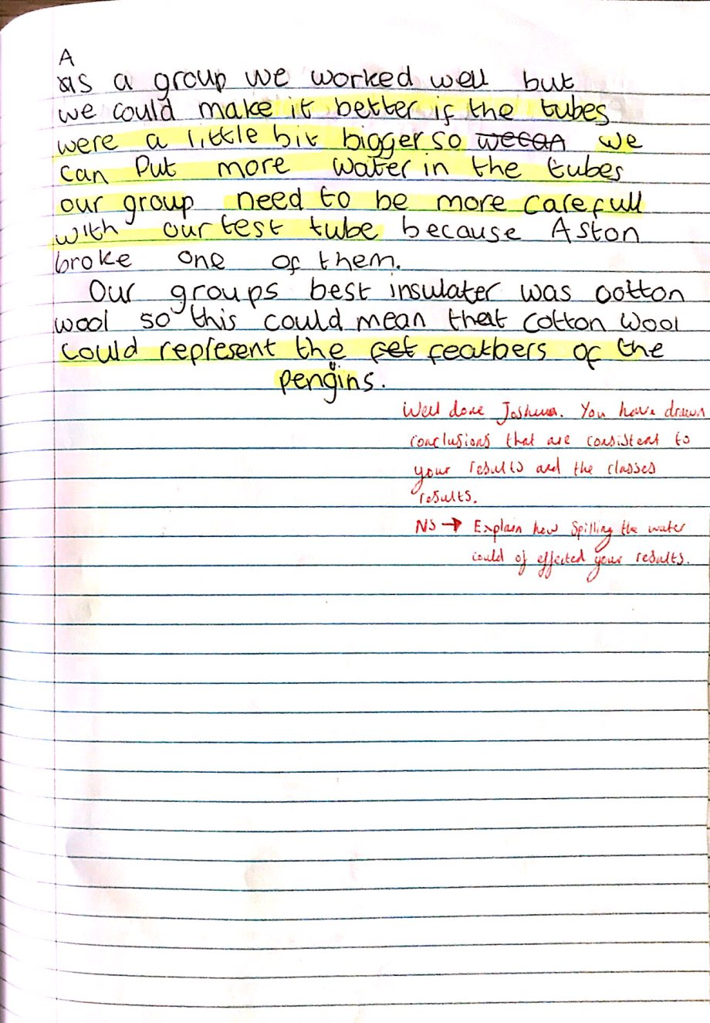

Appendix L: Child A’s Topic Work





