MODULE: CONTEMPORARY THEMES IN THE HOTEL AND HOSPITALITY SECTOR
MODULE CODE: BMIH6001
LECTURER NAME: JESSICA NEWPORT
RESEARCH PAPER THEME: SUSTAINABILITY IN TERMS OF FOOD WASTE AND ITS EFFICACY
STUDENT NAME: ANELIYA KARAMANOVA
STUDENT NUMBER: 2235641

AI Declaration:
I confirm I have used of Grammarly for spelling correction.
I confirm that I have not presented any AI generated text as my own work. I confirm I have copies of my drafts, notes and other resources I used before, and after the use of AI tools which I may be asked to provide in evidence.

Abstract
The study highlights the theme of the impact of food waste on sustainability and its efficacy. The research helps in incorporating a specific area within the chosen theme. The UK hospitality industry is a leading industry within the region and contributes to the economy. However, the company generates about 1.1 million tonnes of food waste annually, which needs to be curbed. In order to combat this, there are initiatives such as composting, deploying technologies such as AI and strategies for partnering with companies that can be considered. Fleming Mayfair is a boutique hotel located in the UK. The hotel can face issues due to a limited budget and maintaining a balance between profitability and eco-friendly initiatives. Developing a partnership with companies such as Greyparrot and Biffa can help Fleming Mayfair in live data streaming the collection process to its existing or new hardware and software. The company can use technology such as automated cameras to track materials passing on conveyor belts and AI-enabled devices that can translate images into real-time insight on a live dashboard.

Table of contents
1. Introduction 4
1.1 Chosen contemporary theme and its importance and relevance 4
1.2 Background information 4
2. Literature Review 5
2.1 Importance of the concept of waste management and recycling 5
2.2 Relationship between sustainability initiatives and guest perception in the UK 6
2.3 Impact of technology on the food waste management of the UK hospitality industry 6
2.4 Theoretical underpinnings 7
3. Method 8
3.1 Research data collection procedures 8
3.2 Analytical techniques 8
3.3 Tools or frameworks used 9
4. Theme impact analysis 9
4.1 PESTLE Analysis 9
4.2 Industry response to the issue 10
4.3 Strengths and limitations 10
4.3.1 Strengths 10
4.3.2 Limitations 11
4.4 Theoretical application 11
5. Conclusion 12
6. Recommendations 12
6.1 Investing in waste composting 12
6.2 Reaching out to companies for partnership 12
6.3 Investing in AI-enabled waste tracking systems 13
7. References 14

Introduction

1.1 Chosen contemporary theme and its importance and relevance
Sustainability within the hospitality industry is an important concept, as it helps maintain property profitability while controlling environmental impact. The application of relevant sustainability practices in the UK hospitality and tourism industry also helps shape consumer perceptions. In the UK hospitality sector, sustainability practices demand reducing food waste. This is important for the industry, as the hotel and hospitality sector in the region has generated more than 1.1 million tonnes of food waste (Ig-groupuk.com, 2026). However, implementing the same in small-scale hotels can be limiting due to the financial strain associated with it. This makes balancing eco-friendly initiatives with profitability challenging.

1.2 Background information
The UK Hospitality industry is a leading contributor to the UK economy. The industry contributed about £93 billion annually towards the economy.
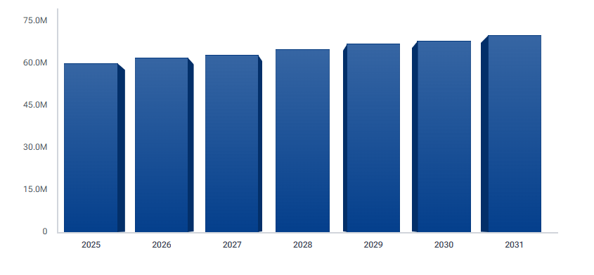
Figure 1.1: Hotel industry growth in the UK
(Source: Datainsightsmarket.com, 2026)
As shown in the graph above, the industry has grown in recent years. The sector has generated approximately £54 billion in tax receipts and approximately £20 billion in exports (Ukhospitality.org.uk, 2026). At the same time, several boutique hotels have been opened in the region. With a rise in boutique properties, it is important to focus on waste reduction and recycling initiatives to mitigate the adverse environmental impacts of their operations.

2. Literature Review

2.1 Importance of the concept of waste management and recycling
Waste management and recycling are important concepts as they can potentially help preserve the environment. According to the studies of Senarathna et al., (2023), recycling materials such as paper, glass and metal can save natural resources. At the same time, it can help in reducing greenhouse gas emissions as well. Contrary to this, as per the findings of Frazer-Williams and Sankoh (2024), proper waste management can help in preventing soil and waste contamination. Overall, this can prevent pollution of natural resources. Hence, companies can prevent pollution of natural resources by implementing effective waste management and recycling practices.
As per the studies of Ivanov and Webster (2019), it has been noted that the presence of automated systems is necessary in speeding up the implementation process. In contrast to this, in the UK, several companies have already implemented waste management and recycling initiatives.
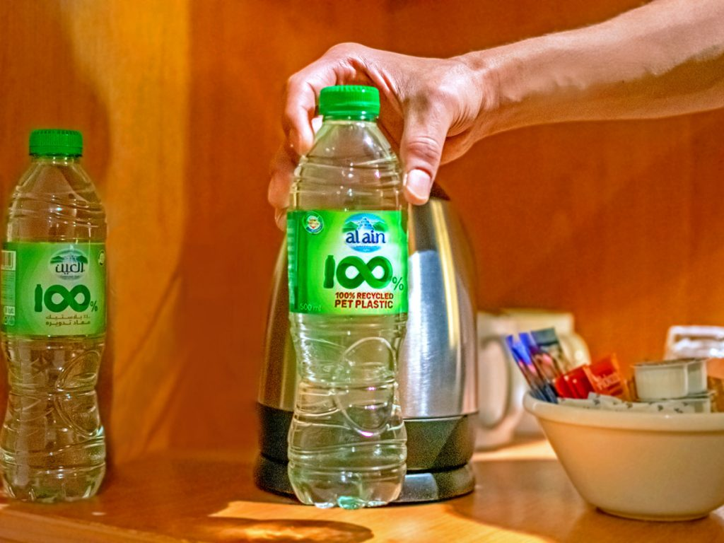
Figure 2.1 Recyclable bottle as used in Premier Inn hotels
(Source: Mansuri, 2023)
Leading hospitality brands such as Whitbread and Premier Inn have adopted recycling initiatives. On the other hand, Chkoniya (2021) finds that automated systems can be coupled with technologies such as Artificial Intelligence (AI) and data analytics to achieve efficient waste handling and alignment with business goals. Hence, it can be stated that waste management and recycling can help in maintaining sustainability and at the same time, could be automated for better results.

2.2 Relationship between sustainability initiatives and guest perception in the UK
The presence of sustainability initiatives within the hotels of the UK has an impact on the guest perception. As per the findings of Rahimi et al., (2022), it has been noted that most of the customers and guests within the UK prefer brands which are associated with sustainability initiatives. Developing an eco-friendly brand image can help service providers ensure a robust brand image. On the other hand, as noted by Ferrer-Estévez and Chalmeta (2023), the presence of sustainability can be added to the Customer Relationship Management (CRM) initiatives. Hence, it can be stated that sustainability can help drive guest satisfaction.
According to Dixit (2020), operational efficiency in hospitals and tourism businesses can be linked with sustainability processes. Efficient handling of food waste through sustainability initiatives can help ensure that the hotel develops positive relationships with its customers and fosters brand loyalty. By contrast, Batabyal and Das (2019) note that most global tourism companies in the UK have not focused on strategic positioning. Implementing sustainability initiatives can help improve the strategic positioning of the brands. At the same time, it can be contrasted with the fact that sustainability helps ensure that the internal management system is effective, a capability that businesses can leverage as well. These have helped establish industry examples of the adoption of sustainability-based initiatives that other brands can follow.

2.3 Impact of technology on the food waste management of the UK hospitality industry
Food waste can be defined as an outcome of choices in the food consumption chain. Additionally, Technology plays a key role in regulating food waste management processes within the hospitality industry (Alexander M. Danzer, 2025). According to Fatorachian, Kazemi, and Pawar (2025), technology such as smart inventory systems could play a significant role in controlling waste management. This can use technologies such as the Internet of Things (IoT) to track stock in real time and automate inventory management. Smart sensors placed in hotel warehouses can help monitor production conditions, export rates, and stock levels. This can be useful in sending automated alerts when inventory levels exceed optimal thresholds. This can ensure that management can make informed decisions, such as redistributing stock, adjusting pricing, and modifying procurement plans to reduce waste.
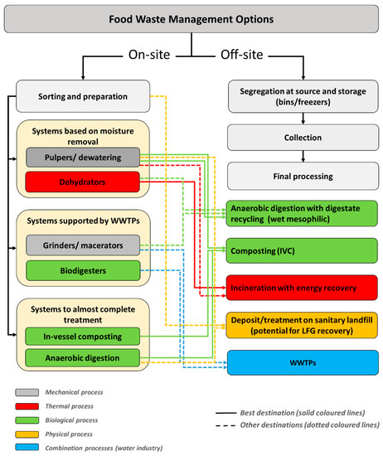
Figure 2.2: Food Waste Management options highlighting in-vessel composting
(Source: Gerassimidou, Dora, and Iacovidou, 2022)
In this case, smart inventory can leverage real-time data that can help in offering timely insights. This can play a leading role in preventing food wastage. On the other hand, as noted by Gerassimidou, Dora, and Iacovidou (2022), techniques such as composting could play a key role in predicting food waste. Hotels can use composting techniques to reduce food waste. According to the findings, food waste can be converted into valuable products through composting. Hotels and hospitality businesses are the most viable for initiating this, as they generate a considerable amount of food waste within the UK.

2.4 Theoretical underpinnings
The circular economy model is a closed-loop production concept that highlights processes associated with prioritising preserving the product value for as long as possible. Under this model, all the resources, materials and products are reused as input elements for other processes.
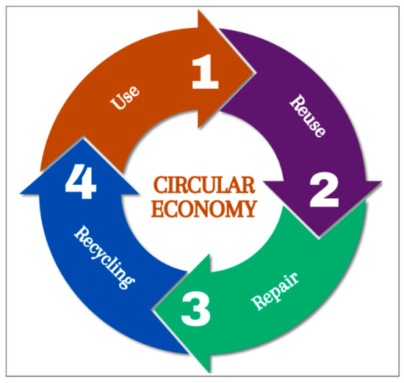
Figure 2.3: Circular economy model
(Source: Santos, Teles and Freires, 2024)
The circular economy model can be described as having four important steps. This includes use, reuse, repair and recycling. This can help hospitality brands and businesses reduce waste generation. In some cases, it could also help in the complete elimination of the waste generated.

3. Method

3.1 Research data collection procedures
The research data collection process will include a secondary step to verify data from existing, published sources. This includes peer-reviewed articles and journals, websites, government publications and news releases by existing organisations. This can help collect data more quickly and be implemented on a low budget. By contrast, secondary data are susceptible to bias, which may lead to erroneous conclusions and irrelevant insights.

3.2 Analytical techniques
In this case, thematic analysis can help in developing insights associated with the behavioural mechanisms of adopting sustainable initiatives as observed in the study of Alexander Danzer (2025). Using thematic analysis, it will be possible to elucidate the motivations for implementing waste management initiatives. Thematic analysis within this study can also help extract and illuminate deep insights from data sources. This can be done by developing subsequent themes to analyse related data and present the findings.

3.3 Tools or frameworks used
In this PEST analysis, which includes four distinct factors associated with the external environment of the business, these factors include political, environmental, social and technological aspects. By considering macroeconomic factors, it will be possible to highlight both the changes the hotel has faced. Additionally, this can be useful for framing recommendations that are valid for the selected hotel.

4. Theme impact analysis

4.1 PESTLE Analysis
Factors | Details
Political | - The political stability index of the UK is 0.26, which is on the lower end and can result in changes in policies (Globaleconomy.com, 2026).  - Changes in policies due to events such as Brexit can affect operational aspects such as the availability of labour.
Economic | - The UK inflation rate is 3.6%, which contributes to financial strain on boutique hotels such as Flemings Mayfair (ONS.gov.uk, 2026).  - The presence of high landfill taxes and excessive costs associated with waste disposal can affect a boutique hotel such as Flemings Mayfair, with limited resources to drive towards recycling (Gov.uk, 2026).
Social | - The UK population, especially millennials and Gen Z, are preferring eco-friendly properties (Toboso-Gómez et al., 2025).  - The eco-friendly kitchen concept of Flemings Mayfair can help align with the eco-friendly image requirements of the guests (Flemings-mayfair.co.uk, 2026).
Technological | - The hotels have been using technologies such as Artificial Intelligence (AI) to track and regulate waste processing within their operations.  - New recycling techniques, supported by smart bins, could help Flemings Mayfair reduce waste and ensure effective waste management.
Legal | - Food safety regulations control by strict rules about hygiene and dating labels.  - Liability protections encourage food donations.
Environmental | - Reducing carbon emissions, water usage and energy consumption improving environmental and operational efficiency.
Table 1: PESTLE analysis
Based on the above table, it can be observed that the Flemings' Mayfair hotel faces threats from the political and economic factors. These can result in reduced profit margins and service disruptions. On the other hand, the social and technological factors can be potential opportunities for business expansion. The manager can leverage its already existing sustainability and community welfare initiatives to drive brand loyalty. By contrast, it can use AI and analytics to track and minimise operational waste.

4.2 Industry response to the issue
UK-based hospitality brands such as have implemented policies aimed towards reducing waste. For example, Travelodge has developed strategic partnerships with companies such as Sedex to enhance supply chain transparency (Travelodge.co.uk, 2026). Private companies such as Waste Research Action Program (WRAP) have issued guidelines that highlight the need to manage waste and promote potential approaches to its control (Wrap.ngo, 2026). On the other hand, the government has included provisions in the Environment Act 2021 that set out guidelines and laws for businesses to minimise waste (Legislation.gov.uk, 2026). This implies that businesses are now legally obligated to manage the waste they generate and mitigate its subsequent environmental impacts.

4.3 Strengths and limitations

4.3.1 Strengths
One of the major strengths associated with the waste management initiatives within the hospitality industry of the UK is the initiatives that have been undertaken by the leading companies. Initiatives taken by companies such as Travelodge can function as a benchmark for small-scale companies and can act as a catalyst for them to adopt effective waste management techniques within their operations. In contrast, the government has developed initiatives, including the net-zero 2050 initiative, which mandates reductions in carbon emissions and focuses on waste reduction and management (Poynting, 2025). This can act as a guideline for the companies to follow, which can lead to effective waste management.

4.3.2 Limitations
While there have been initiatives associated with various properties within the industry, there are no fixed initiatives developed by a common governing body. As a result, the efforts towards waste reduction are divided and are dependent on individual business efforts. While there have been initiatives implemented by the government associated with environmental protection, there are no fixed initiatives in place that are focused on waste recycling. While provisions exist in existing laws, a greater focus on the United Nations Sustainable Development Goals (UN SDGs) is required.

4.4 Theoretical application
Triple Bottom Line theory can be applied in the given case that consists of three major considerations that include people, planet and profit. By aligning with the theory, Fleming Mayfair can ensure that it maintains a balance between profitability and sustainability.
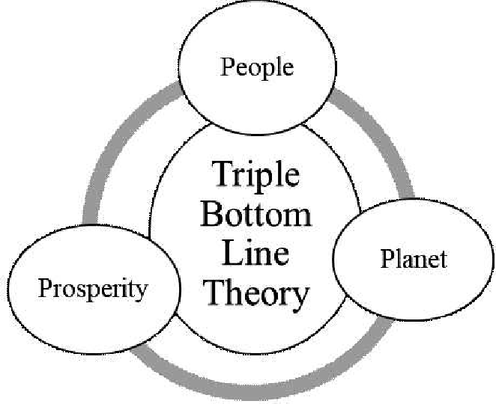
Figure 4.1: Triple Bottom Line Theory
(Source: Firoj and Mohammad, 2024)
The diagram above illustrates the three aspects of sustainability initiatives, as defined by the theory. These can be applied to Fleming Mayfair, helping the hotel balance effective food waste management with initiatives to sustain it. Initiatives developed by official governing bodies can also be evaluated against the theory, thereby highlighting how environmental stewardship can be useful in developing business values (Firoj and Mohammad, 2024). At the same time, this can help in highlighting how value can be developed for the guests through eco-friendly initiatives. These considerations can be useful in developing recommendations for the business as well.

5. Conclusion
Waste management and recycling are important aspects of sustainability in business, as they help guide effective waste reduction and elimination initiatives. The study will use a thematic analysis technique that will include developing themes based on the objectives of the study. This can help in aligning with the needs associated with the topic and can help in deriving the necessary insights. In this case, a PESTLE analysis was conducted to assess the macroeconomic conditions of the Flemings Mayfair hotel, highlighting technology and social factors as opportunities. As identified in the literature review, the company can focus on strategies that include composting, AI deployment, and strategic partnerships to ensure effective waste management.

6. Recommendations

6.1 Investing in waste composting
Fleming Mayfair can invest more in composting organic waste, which can include food scraps and plant matter. This can be diverted from landfills and converted into nutrient-rich compost. The company develops partnerships with organisations such as Trikon that can effectively manage its food waste (Trikon.co.uk, 2026). In contrast, the company can place recycling bins in various locations to make composting more accessible and easier. In addition, the company can develop training initiatives to educate staff on the importance of composting waste and its implementation. With this, it can be possible to implement a culture of focus on waste management within the company.

6.2 Reaching out to companies for partnership
As highlighted by the case of Travelodge partnering up with Sedex, companies can form strategic partnerships with established companies working in the field of waste management. This can include Biffa, which is a waste management company headquartered in High Wycombe. The management and Flemings Mayfair can contact Biffa, which provides customised and cost-effective waste management services based on company size (Biffa.co.uk, 2026). This can mitigate the prohibitive cost and facilitate effective initiation of waste management processes, and can help the management save on additional costs. This can also help in making sure that the companies can share resources and knowledge associated with waste management. In the long run, this can help in pooling the resources and ensure that the companies can work together on common projects aimed towards waste reduction.

6.3 Investing in AI-enabled waste tracking systems
The company can focus on implementing an AI-enabled waste analysis system to support the estimation of waste collection and sorting tasks. As evidenced in the UK, there are companies that provide customised solutions for this purpose, such as Greyparrot and Winnow. Flemings Mayfair may consider collaborating with Greyparrot to enhance waste management. In addition, it can increase transparency at each stage of the global value chain (Greyparrot.ai, 2026). This can help Fleming Mayfair leverage its existing sustainability initiatives. Greyparrot offers easy-to-install units that use cameras to track waste materials on conveyor belts. The company also has a dedicated software that can live-stream the waste collection process to existing hardware. This can help the company in reducing the food waste generated and provide more transparency associated with its processing.

.

7. References
Batabyal, D. and Das, D.K. (eds) (2019) Global trends, practices, and challenges in contemporary tourism and hospitality management. Hershey, Pennsylvania: Business Science Reference, an imprint of IGI Global.

Biffa.co.uk (2026) Business waste management made easy. Available at: https://www.biffa.co.uk/ (Accessed: 28 January 2026).

Chkoniya, V. (ed.) (2021) Handbook of research on applieddata science and artificial intelligence in business and industry. Hershey, Pennsylvania: IGI Global.

Datainsightsmarket.com (2026). Hotel Industry in the UK Strategic Insights: Analysis 2026 and Forecasts 2034. Available at: https://www.datainsightsmarket.com/reports/hotel-industry-in-uk-7486 (Accessed: 28 January 2026)

Dixit, S.K. (2020) Managing hospitality organisations: achieving excellence in the guest experience (second edition): by Robert C. Ford and Michael C. Sturman, Sage Publications Inc., 2019, 544

Fatorachian, H., Kazemi, H. and Pawar, K., (2025). ‘Digital technologies in food supply chain waste management: a case study on sustainable practices in smart cities’. Sustainability, 17(5), p.1996. Available at: https://doi.org/10.3390/su17051996

Ferrer-Estévez, M. and Chalmeta, R., (2023). ‘Sustainable customer relationship management’. Marketing Intelligence & Planning, 41(2), pp.244-262. Available at: https://doi.org/10.1108/MIP-06-2022-0266

Firoj, K. and Mohammad, B.T., (2024). ‘Measuring sustainability in the broadcasting media industry in Bangladesh. I-Manager’s’. Journal of Management, 18(3), p.51. Available at: https://doi.org/10.26634/jmgt.18.3.20234

Flemings-mayfair.co.uk (2026) Sustainability & Giving Back. Available at: https://www.flemings-mayfair.co.uk/information/giving-back (Accessed: 30 January 2026).
Frazer-Williams, R. and Sankoh, A., (2024). ‘Soil contamination resulting from inefficient solid waste management’. In Environmental pollution and public health (pp. 251-264). Elsevier. Available at: https://doi.org/10.1016/B978-0-323-95967-4.00010-6

Gerassimidou, S., Dora, M. and Iacovidou, E., (2022). ‘A tool for the selection of food waste management approaches for the hospitality and food service sector in the UK’. Resources, 11(10), p.80. Available at: https://doi.org/10.3390/resources11100080

Globaleconomy.com (2026) Political stability - Country rankings. Available at: https://www.theglobaleconomy.com/rankings/wb_political_stability/Europe/ (Accessed: 29 January 2026)
Gov.uk (2026) Landfill Tax rates Available at: https://www.gov.uk/government/publications/rates-and-allowances-landfill-tax/landfill-tax-rates-from-1-april-2013(Accessed: 30 January 2026)

Greyparrot.ai/ (2026) Recover more resources with waste intelligence. Available at: https://www.greyparrot.ai/ (Accessed: 30 January 2026)

Ig-groupuk.com (2026) Reducing Environmental Impact in Hospitality: How IG Group Contributes Available at: https://www.ig-groupuk.com/news/reducing-environmental-impact-in-hospitality-how-ig-group-contributes/ (Accessed: 22 January 2026)

Ivanov, S., & Webster, C. (Eds.). (2019). Robots, artificial intelligence, and service automation in travel, tourism and hospitality (1st ed.). Emerald Publishing.

Legislation.gov.uk (2026) Environment Act 2021. Available at: https://www.legislation.gov.uk/ukpga/2021/30 (Accessed 28 January 2026).

Mansuri, M. (2023) Premier Inn launches Force For Good programme in the Middle East. Available at: https://www.hoteliermiddleeast.com/business/premier-inn-launches-force-for-good-programme-in-the-middle-east (Accessed: 22 January 2026)

ONS.gov.uk (2026) Inflation and price indices. Available at: https://www.ons.gov.uk/economy/inflationandpriceindices#:~:text=Consumer%20price%20inflation%2C%20UK%3A%20December%202025&text=On%20a%20monthly%20basis%2C%20CPIH,the%2012%20months%20to%20November. (Accessed: 29 January 2026).

Poynting, M. (2025) What is net zero and is the UK on track to achieve it?.. Available at: https://www.bbc.com/news/articles/cx238yyr40qo (Accessed: 22 January 2026)

Rahimi, R., Thelwall, M., Okumus, F. and Bilgihan, A., (2022). ‘Know your guests’ preferences before they arrive at your hotel: evidence from TripAdvisor’. Consumer Behavior in Tourism and Hospitality, 17(1), pp.89-106. Available at: http://dx.doi.org/10.1108/CBTH-06-2021-0148

Senarathna, W.G.C.M., Sulaksha, L.G.T., Weerarathna, D.M., Jayathma, W.M.V.A., Gamage, D.G.M.L., Thennakoon, T.M.T.N., Hewage, H.T.M., Panagoda, L.P.S.S., Sandunika, D.M.I. and Perera, M.D.V., (2023). ‘Paper recycling for a sustainable future: Global trends’. J. Res. Technol. Eng, 4(3), pp.169-186. Available at: https://www.jrte.org/wp-content/uploads/2023/07/Paper-Recycling-for-a-Sustainable-Future-Global-Trends.pdf

Toboso-Gómez, J.D., Mercadé-Melé, P., Almeida-García, F. and Gorji, A.S., (2025). ‘A Systematic Review and Bibliometric Analysis of Studies on Generation Z and the Hotel Industry: Past, Present and Future Agenda’. Systems, 13(11), p.989. Available at: https://doi.org/10.3390/systems13110989

Travelodge.co.uk (2026) Always caring about the impact of our decisions. Available at: https://www.travelodge.co.uk/our-business/sustainability/conscious/#water-waste-management-recycling (Accessed: 31 January 2026).

Trikon.co.uk (2026) Sustainable Waste Management for Hotels & Restaurants: Reduce, Reuse, Recycle! Available at: https://trikon.co.uk/sustainable-waste-management-for-hotels-restaurants-reduce-reuse-recycle/#:~:text=Many%20hotels%20and%20restaurants%20produce,and%20turned%20into%20nutrient%2Drich%20compost. (Accessed: 30 January 2026)
Ukhospitality.org.uk (2026) Facts and stats. Available at: https://www.ukhospitality.org.uk/media-centre/facts-and-stats/ (Accessed: 22 January 2026)
Wrap.ngo (2026) Reducing food waste. Available at: https://www.wrap.ngo/what-we-do/future-proof-food/reducing-food-waste (Accessed 22 January 2026).

