
University of Wales Trinity Saint David
Motorsport Engineering Beng Hons

Electronic Circuits Testing and Applications
Vehicle Electronics (ACHA4031)

George Campling
2503449

Word Count: 1628
19/04/2026

Contents:

- Introduction…………………………………………………………………………………...1
- Scope Time Division Calculations………………………………………………………….2
- Function Generator Output Square Wave…………………………………………………3
- Capacitor Charge and Discharge Wave Marked…………………………………………5
- Basic Capacitor Calculations………….........................................................................7
- Capacitor Discharge Table………………………………………………………………….8
- Plot log(V) Gradient………………………………………………………………………….9
- Gradient Calculations and Comparison………………………………………………….10
  - Gradient Calculations……………………………………………………………..10
  - Comparison Table………………………………………………………………….11
- Capacitor Uses……………………………………………………………………………..12
- Inaccuracies Question……………………………………………………………………..13
- Risk Question……………………………………………………………………………….14
- Conclusion…………………………………………………………………………………..15
- References………………………………………………………………………………….16

Figures:
- Figure 1, Function Generator Output Square Wave……………………………………..3
- Figure 2, Function Generator Output Measurements……………………………………4
- Figure 3, Oscilloscope Measured Capacitor Charge/Discharge Wave Marked………5
- Figure 4, Capacitor Charge/Discharge Wave Measurements…………………………..6
- Figure 5, Voltage Loss Against Time Graph………………………………………………9

Tables:
- Table 1 - Capacitor Discharge Table……………………………………………………….8
- Table 2 – Comparison Table……………………………………………………………….11

Equations:
- $τ=Number of Horisontal Time Divisions · Current Time Division setting$……….2
- $τ=R∙C$……………………………………………………………………………………….7
- $C= \frac{τ}{R}$………………………………………………………………………………………….7
- $Gradient=\frac{∆y}{∆x}=\frac{y2-y1}{x2-x1}$……………………………………………………………………….9
- $V=V_{0}ⅇ-\frac{t}{RC}$…………………………………………………………………………………10

Abbreviations:
- Nº – Number
- EV – Electric Vehicle
- DC – Direct Current
- AC – Alternating Current
- PC – Personal Computer
- ISO – International Organisation for Standardisation
- SAE – Society of Automotive Engineers

Chapter 1 – Introduction:

This report makes up third and final task of the vehicle electronics module.
Inside the report analysis shall be conducted on the behaviour of a capacitor through information gained from using an oscilloscope. The inaccuracies that may have occurred whilst performing the experiment shall be considered. And some basic calculations shall also be done to find parameters such as capacitance.
Additionally the uses for capacitors in both electrical and automotive settings shall be discussed, and finally the ways in which engineers can go about preventing CANBUS hacking through the regulations set by ISO/SAE 21434 will be debated.

1
Chapter 2 - Scope Time Division Calculations:

To calculate the time division of an oscilloscope use the equation (Wedgwood Tutors. 2014):

$$τ=Number of Horisontal Time Divisions · Current Time Division setting \left(Equasion 1\right)$$

To get a time division for a scope to have one full wave form lasting 40 seconds use the below figures:

- Nº of Horisontal Time Divisions = 4
- Selected Oscilloscope Time Division Setting = 10 Farads

$$τ=4· 10=40 Seconds$$

2
Chapter 3 - Function Generator Output Square Wave:

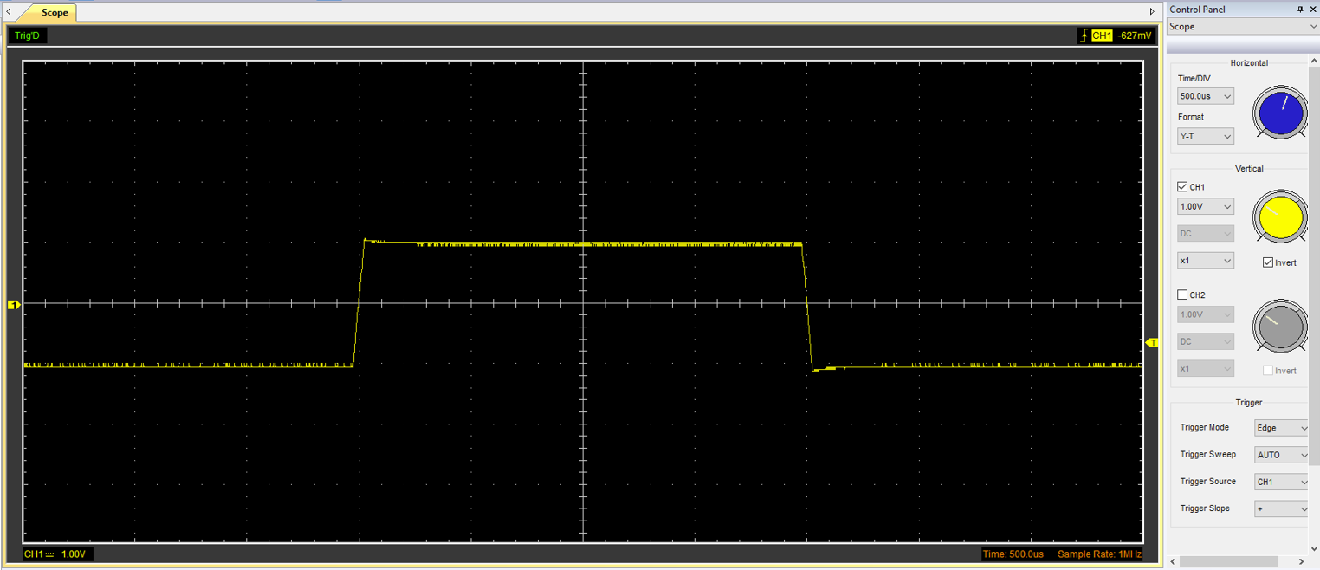
3
Figure 1, Function Generator Output Square Wave
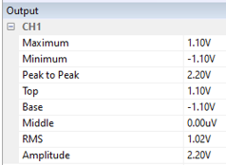
Figure 2, Function Generator Output Measurements

4
Chapter 4 - Capacitor Charge and Discharge Wave Marked:

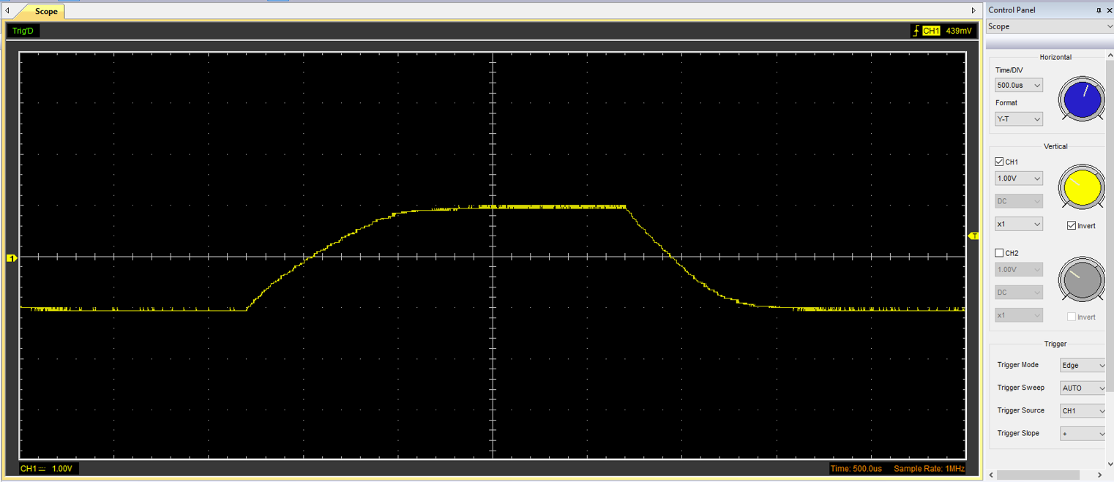
5
Capacitor Discharging Voltage
Transient Period (Capacitor Charging)
Capacitor Fully Charged
Steady State Period (Holding Max Charge)
Capacitor Fully Discharged
Figure 3, Oscilloscope Measured Capacitor Charge/Discharge Wave Marked
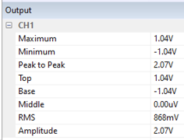
Figure 4, Capacitor Charge/Discharge Wave Measurements

6
Chapter 5 - Basic Capacitor Calculations:

The capacitance can be found both through being measured on the oscilloscope and by using the time constant equation rearranged for capacitance (James, R. 2026).

$$τ=R∙C \left(Equasion 2\right)$$
Rearrange:
$$C= \frac{τ}{R} \left(Equasion 3\right)$$

It is important to remember that one time constant is equal to 63.2% of the charge voltage, and 36.8% of the discharge voltage. The voltage at time constant two is then 63.2% (on charge) of the voltage of time constants one and two together (James, R. 2026). This pattern continues as you add time constants.
The value for $τ$ can be calculated if the capacitance and resistance is already known, or it can be read off of the oscilloscope trace. The resistance of the circuit can be both measured manually using a multimeter, or one could analyse the relationship between voltage and current over time, and calculate through that.

7

Chapter 6 - Capacitor Discharge Table:

Table 1 - Capacitor Discharge Table
Time (s) | Voltage (V) | ln (V) | dy = y2 – y1 | dx = x2- x1 | dy/dx
 |  |  | dy = ln(V)2-ln(V)1 | dx = Time2 – Time1
0.002346 | 2.069 | 0.727 | x | x | x
0.002396 | 1.849 | 0.615 | -0.112 | 5.0E-05 | -2.24E+03
0.002446 | 1.598 | 0.469 | -0.146 | 5.0E-05 | -2.92E+03
0.002496 | 1.441 | 0.365 | -0.103 | 5.0E-05 | -2.07E+03
0.002546 | 1.253 | 0.226 | -0.140 | 5.0E-05 | -2.80E+03
0.002596 | 1.096 | 0.092 | -0.134 | 5.0E-05 | -2.68E+03
0.002646 | 0.877 | -0.132 | -0.224 | 5.0E-05 | -4.47E+03
0.002696 | 0.782 | -0.245 | -0.114 | 5.0E-05 | -2.27E+03
0.002746 | 0.626 | -0.469 | -0.224 | 5.0E-05 | -4.48E+03
0.002796 | 0.5 | -0.693 | -0.224 | 5.0E-05 | -4.48E+03

8
Chapter 7 - Plot log(V) Gradient:

Figure 5, Voltage Loss Against Time Graph

Manual Gradient Calculation:
Point 1 = (0.00235, 0.73)
Point 2 = (0.00275, -0.70)
$Gradient=\frac{∆y}{∆x}=\frac{y2-y1}{x2-x1}$(Equation 4)
- Calculate Delta Y = -0.70 – 0.73 = -1.43
- Calculate Delta X = 0.00275 – 0.00235 = 0.00040
- Divide = -1.43 / 0.00040 = -3575
Gradient = -3.6x10^3

The gradient given by the trendline and the manual calculations are different because when your manually calculating you estimate the values of where the points are located. The more accurate the estimate the closer to the true gradient value you receive.
9
Chapter 8 - Gradient Calculations and Comparison:

8.1. Gradient Calculations:

We know that to get time and voltage in a discharging capacitor: (James, R. 2026)
$$V=V_{0}ⅇ-\frac{t}{RC} \left(Equasion 5\right)$$
When logs are taken of both sides:
$$lnV={lnV}_{0}ⅇ-\frac{t}{RC}$$
From this:
$$lnV=a-bt$$
We can now say:
$$b= -\frac{1}{RC}$$
Therefor we can now find $τ$ from:
$$τ= -\frac{1}{Gradient }$$
From the trendline gradient:
$$τ= -3098.7s$$
To calculate the capacitance:
$$C=\frac{τ}{R} \left(Equasion 3\right)$$
Once the resistance value is found, input the values and the answer for capacitance shall come out in micro farads.

10

8.2. Comparison Table:

Table 2 – Comparison Table
 | Capacitance | Delta | Percentage difference
Actual | 1 µF | X | X
Marker Calculation
Gradient Calculation

11
Chapter 9 - Capacitor Uses:

10 uses for capacitors in electrical and automotive applications:
- In EV vehicles, capacitors help to balance out power demands, in situations such as rapid acceleration and regen braking. Quick bursts of power help to create a smoother driving experience with improved responsiveness, as well as cutting down on energy losses (Amelia. 2025).
- In EV vehicles, capacitors help to improve battery durability. They help to prevent voltage spikes, and control the amount of electrical noise produced protecting the more sensitive components (Amelia. 2025).
- In EV vehicles, capacitors support “efficient power electronics” helping battery cooling and battery health (Amelia. 2025).
- In EV Vehicles, capacitors are used to control multiple systems within a traction inverter, where DC power from the battery is converted to AC for the motor, and vice versa where AC is converted to DC as seen in onboard chargers. (Matthews, P. 2024).
- On vehicles there used to enhance safety systems such as airbags, where deployment power is needed in milliseconds. Also used in stability control and anti-lock brakes where they maintain and operate crucial safety mechanisms (Eurika. 2025).
- On vehicles there used to ensure that advanced driver assistance systems (ADAS) such as cruise control, lane-keeping assist, and automatic emergency braking operate at peak efficiency and safety (Eurika. 2025).
- Capacitors can be used in audio and communication systems, as they can be used for signal coupling and DC blocking between amplifier stages. They can also be fund in filter circuits, where it controls the frequencies that are received (Reed, C. 2025).
- Large capacity capacitors (super/ultra capacitors) are used in uninterruptable power supplies, such as emergency lighting (Microchip USA. 2023).
- Capacitors paired with resistors are key components in oscillators and pulse generators (Microchip USA. 2023).
- Capacitors manage charge and discharge rates to produce signals for microcontrollers and signal generators (Microchip USA. 2023).
12

Chapter 10 - Inaccuracies Question:

The values measured and calculated in this experiment may be different to the specified capacitor values due to a number of parameters.
The most obvious of which is the quality of the measuring equipment used. To gather the data seen in figures 1 to 4 above a Hantek 6022BE compact oscilloscope was used. This oscilloscope was designed to be at the budget end of the market (around £50), and is powered by being plugged into a PC via a USB, a downloadable software is then used to display the live measurements. Despite having most of the features that can be found on higher end oscilloscopes, the accuracy of the equipment can be questioned at this price range.
When collecting the data little was done in the way of minimising error. The oscilloscope probes were not thoroughly inspected and calibrated before use, nor was the signal integrity verified. Some oscilloscopes accuracy can also be effected by environmental conditions, so it is recommended to use them in a stable environment. “By being aware of these common mistakes and implementing strategies to avoid them, you can enhance the accuracy and reliability of your oscilloscope” (Adrian’s Digital Basement. 2022).

13
Chapter 11 - Risk Question:

Most vehicles being manufactured at the time of writing (2026) have an internal system known as a CANBUS (Controller Area Network bus) system (Lee, J. 2025). “This system acts as the vehicle’s brain linking various Electronic Control Units (ECUs) that control various features of the vehicle such as the engine, safety features, and infotainment systems” (Lee, J. 2025). If access is gained inside the CANBUS system, all features of the car can be controlled at will. This does however create a new form of security threat, where if a malicious party was to gain access to the CANBUS system, those inside the vehicle could be vulnerable to multiple forms of vehicle sabotage (Lee, J. 2025).
Due to the fact that CANBUS systems were originally developed in the 1980’s when cybersecurity was less of a concern, there are multiple ways entry can be gained into a CANBUS system (Chain. 2024). Entry is most often gained through an OBD-II port (a standard feature on most vehicles) which is designed to allow mechanics and technicians to use diagnostic tools and software, to gain access to the vehicles operating systems. However this is also an potential entry point for hackers (Chain. 2024). There are multiple different entry points across a vehicle, a more obscure example being the headlights (Lee, J. 2025). Previous vehicle attacks have seen hackers plugging in a device disguised as a speaker, and on inspection of the CANBUS system there isn’t anything immediately suspicious (Lee, J. 2025). Once inside hackers can perform multiple different types of attacks, such as fuzzing, replay and injection attacks (Lee, J. 2025).
As of 2021 due to the rise of concern regarding attacks of this nature, manufacturers have been required to follow ISO/SAE 21434, a standard that lists mandatory requirements regarding cybersecurity risk management (ISO. 2021). By following these regulations the consumer gains added benefits such as earlier risk identification, improved vehicle resilience, and overall risk reduction (ISO. 2021).
Manufacturers main way of improving cybersecurity is to incorporate blockchain technology. A system such as this can provide multiple features that significantly enhance the security of the vehicle (Chain. 2024):
- Data cannot be altered or deleted without detection.
- Intrusion detection on multiple nodes.
- If a node is compromised the rest of the systems continue to operate.
- Each intrusion detection is logged so the time and origin of the event can be tracked.
14
Chapter 12 – Conclusion:

To conclude this report, it aimed to detail how to calculate and analyse a series of data, after performing a test of measuring a capacitor using an oscilloscope. Later a series of uses for capacitors was listed, the majority of which focused on use in EV vehicles, which seems like good knowledge to have today, as automotive engineering is so pressurised to electrify vehicles in this era.
However potentially the most learning came from, discussing what CANBUS hacking is, how it can effect a vehicle, attack entry points, and the ways in which engineers prevent Hacking occurring.

15

Chapter 13 – References:

- Adrian’s Digital Basement (2022) How good can a new $60 oscilloscope actually be? (Hantek 6022BE Review), YouTube. Available at: https://www.youtube.com/watch?v=8ts5J09Y7Gc&t=59s (Accessed: 18 April 2026).

- Amelia (2025) exploring the Future: How Automotive Capacitors Enhance Electric Vehicle Performance, Exploring the future: How automotive capacitors enhance electric vehicle performance. Available at: https://www.crccapacitor.com/blog/automotive-capacitors-enhance-electric-vehicle-performance/ (Accessed: 17 April 2026).

- Chain (2024) Understanding can bus vulnerabilities and how blockchain can amplify security | by Chain | Medium, Medium.com. Available at: https://medium.com/@chaincom/understanding-can-bus-vulnerabilities-and-how-blockchain-can-amplify-security-a58388bf1fb4 (Accessed: 17 April 2026).

- ERM Telematics (2026) Prevent CANbus hacking, ERM Telematics. Available at: https://www.ermtelematics.com/prevent-canbus-hacking (Accessed: 17 April 2026).

- ISO (2021) ISO/SAE 21434:2021, ISO. Available at: https://www.iso.org/standard/70918.html (Accessed: 17 April 2026).

- James, R. (2026) Task 3 Capacitors Handout, Unpublished. (Accessed: 19 April 2026)

- Lee, J. (2025) How to protect your vehicle against can bus theft, Miller CAT Corp. Available at: https://millercat.com/blogs/news/how-to-protect-your-vehicle-against-can-bus-theft?srsltid=AfmBOorOcEzXGlkgLMa6glnQ9_xCLLD7jB1e-f7IgI-9XqN7260BmkjI (Accessed: 17 April 2026).

- Matthews, P. (2024) Exploring the capacitor technologies needed in electric vehicles, Knowles Precision Devices. Available at: https://blog.knowlescapacitors.com/blog/exploring-the-capacitor-technologies-needed-in-electric-vehicles (Accessed: 17 April 2026).
16
- Microchip USA (2023) The ultimate guide to capacitors - microchip USA, Microchip USA - TRANSPARENCY INNOVATION EFFICIENCY. Available at: https://www.microchipusa.com/electrical-components/the-ultimate-guide-to-capacitors-everything-you-need-to-know?srsltid=AfmBOopZIlSbCQxNhiu5nmbwqkZ16dmruQdSHmFuyroR2uRpnIrfZJZf (Accessed: 17 April 2026).

- Reed, C. (2026) Oscilloscope calibration: Your essential guide - used keysight equipment, Keysight . Available at: https://www.keysight.com/used/us/en/knowledge/guides/oscilloscope-calibration-guide (Accessed: 18 April 2026).

- Reed, C. (2025) What is a capacitor? uses & functions explained - used Keysight equipment, Keysight . Available at: https://www.keysight.com/used/rs/en/knowledge/guides/what-is-a-capacitor-used-for (Accessed: 17 April 2026).

- Wedgwood Tutors (2014) Oscilloscope Questions - How to Calculate Time Period and Frequency - GCSE Physics, YouTube. Available at: https://www.youtube.com/watch?v=Hil3d7OF5m4&t=44s (Accessed: 19 April 2026).

- What Makes Capacitors Crucial in Automotive Electronics? (2025) eurika.patsnap.com . Available at: https://eureka.patsnap.com/article/what-makes-capacitors-crucial-in-automotive-electronics (Accessed: 17 April 2026).

17

