

University of Wales Trinity Saint David
GIS and Data visualization
Abdulla Alzahid

Content:

1-Introduction
- Background of the study
- Main objectives
- Brief explanation of Geographical information systems
2-Methodology
- Step by step produce taken to produce the GIS Maps
3-Results
- Figure 1(Full map of economic activity of fulltime employees)
- Figure 2( Zoomed version of figure one including air quality stations)
- Figure 3(Map of van owners per area in Swansea)
- Figure4 (Map of deprivation area 0
- With each map a brief explanation of it
4-Disscussion
- Figure 5(Satellite map of Swansea)
- Brief explanation of some of the results in previous section
- Health effects of the air pollution and correlation to deprivation areas
- Welsh assembly statement on air quality
- Jakarta application in tackling environmental degradation
- Green wall
5- Conclusion

6-Appendices

7-References

Introduction:

Air pollution has been an increasing issue globally. Therefore, many countries have introduced regulations to tackle air quality. The European union has set legislation for annual/hour limits for specific pollutants such as nitrogen dioxide 40ug/m3 a year. The welsh government recently has been taken to court in regard to the illegal limits of nitrogen dioxide emissions as it exceeds the annual bounds which come from mainly vehicles (BBC,2017). A health study reveals that dust from Tata steel located in Port Talbot has been linked to respiratory diseases according to that study the nearby areas have the highest incidences of health issues related to air quality (P.P,2013) . This shows that there is an importance in increasing the monitoring abilities within organizations and governments. Therefore, The sophistication of geographical information system (GIS) which can be used to capture, store, manipulate, analyze, manage and present spatial or geographical data. This allows professionals in the field to demonstrate the possible links that contributes to a certain issue for example in this assignment some of the geographic data are aligned with air quality stations across a Swansea city which is also correlated with data that shows areas of most deprivation. The objectives of the study are to collect air quality data and demonstrate it via the GIS to show any correlations between factors (economically active, deprivation, Van owners) linking to air quality standards on each station and then providing possible amendments to lessen the impacts.

Methodology:

This study was done on GIS MapInfo 16. The first procedure was to collect data from the welsh air quality website as provided in the assignment brief and a specific pollutant (nitrogen dioxide) was chosen upon the knowledge that it was conducted on all of the air quality stations in the Swansea area. On excel each station latitude and longitude was inserted. The data for nitrogen dioxide was done on monthly average of 2017 in each station. The data was then inserted into the workspace provided from previous sessions which included the map of Swansea and specific category from the Townsend index which includes information such as economically active fulltime employees were collected from census data and were extracted as excel for some final mathematical arrangements. then The Swansea maps was originally gathered from UK data services website through the census data then boundary data after that the boundary data selector. In this section wales census outbound area was chosen and then the county of Swansea was selected ,from there the file was changed to suit the MapInfo system and the same process was repeated to receive inbound data mid bound data of Swansea. On the GIS to open a map first step is to click on the home tap and under the open icon and then click on open workspace which most maps on MapInfo are saved then a map will appear accordingly. In order to thematic map must go to map on the software and then click on rangers and choose the specific template then click next and chose the correct filed and then next and after that click on open and a map of rangers will appear with different shades of the colors. In order to change colures, it could be done via theme and color plates. It is critical to note that professional assistance were provided and when the tasks were done individually many resets were done to achieve the final map .

Results:

(Figure 1) Full map of economic activity of fulltime employees
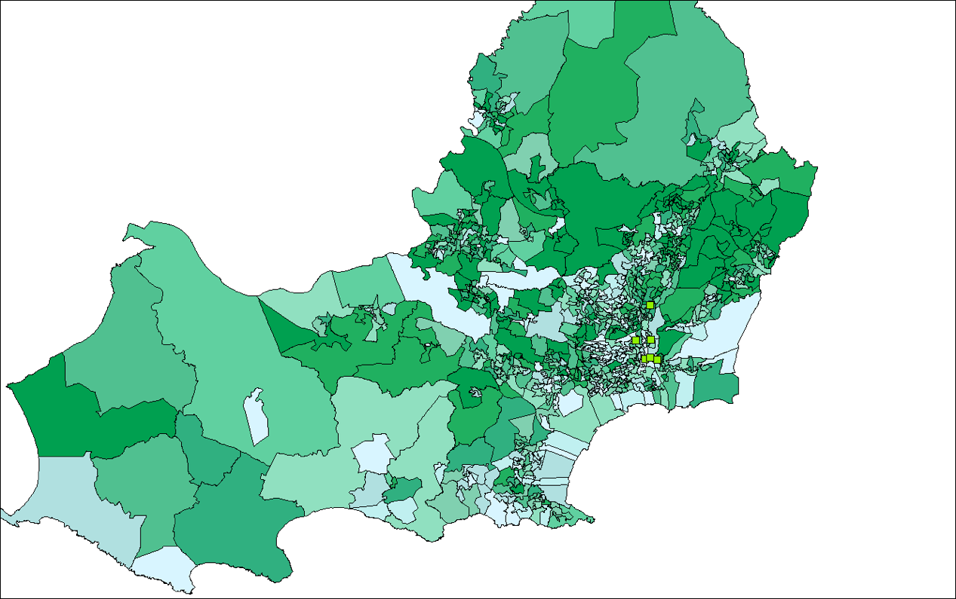
The picture above demonstrates economic activity of fulltime employees in the Swansea area. The darker shade of green determines the higher economic active it is. It is vital to note that many studies have concluded that there is a correlation of environmental degradation caused by the increase of economic activity.

(Figure2) Zoomed version of figure one including air quality stations
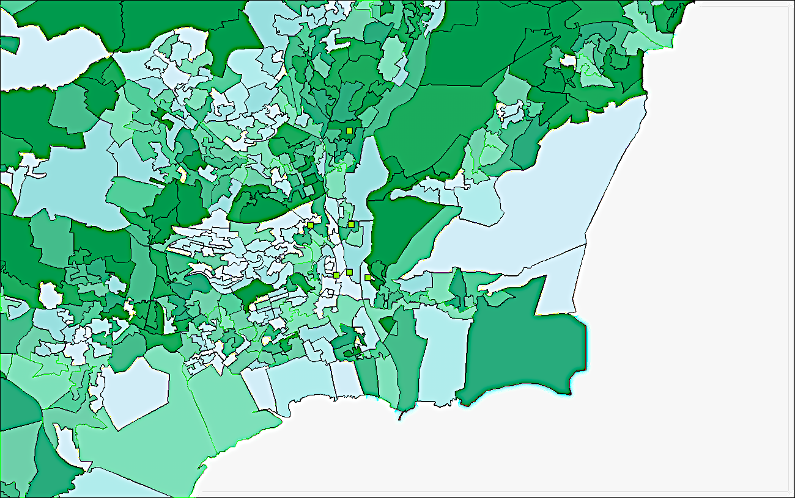

Figure 2 is a zoomed in version of figure one as it also shows the main air quality stations where the arrows were added to highlight the exact locations of the stations

(Figure 3) Map of van owners per area in Swansea
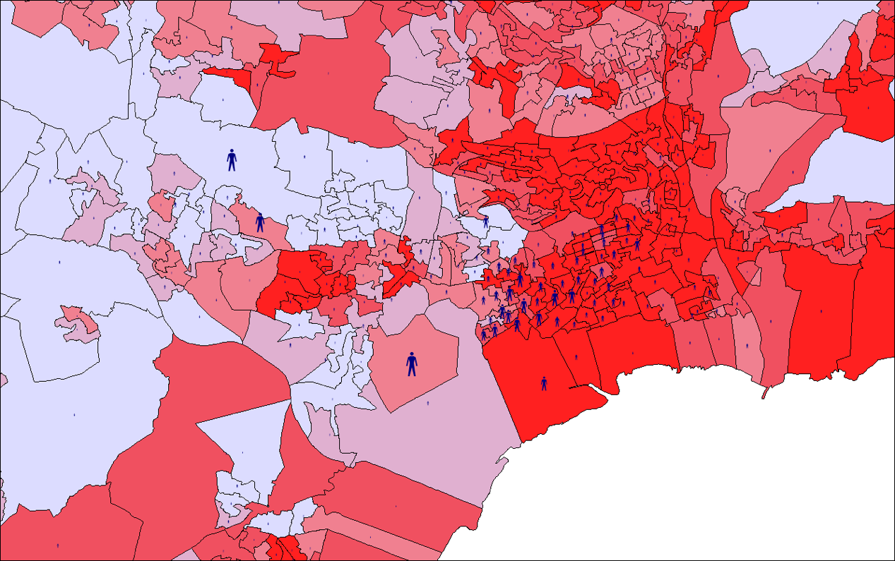
Above map shows the Swansea area according to van ownership per area. The darker red shade the higher number of ownership. This is many respects dose shows a correlation in regard to air quality as most of the vehicles are located in the centre of Swansea which could increase the air pollution in the area.

(Figure4) Map of deprivation area

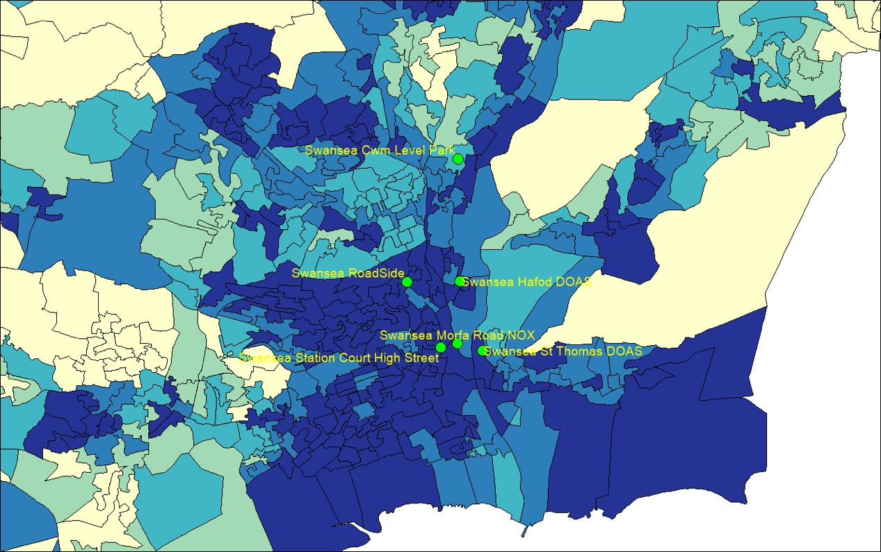
Figure 4 map shows the deprivation area by colour code as the darker the shade the higher aligning it with the labelled air quality stations in place. Which shows that there is a correlation between air quality and deprivation as the most polluted area in Swansea is by the Swansea station court high street as it also exceeds the annual limit for the air quality European law due to the increase of traffic and it is located by the train station and some main bus stops.

Discussion:

The data gathered from the welsh air quality website has concluded that the most polluted station in by the railway station as it is also near by the main highway. Below is a picture that shows a satellite picture of Swansea and the locations of air quality
stations.
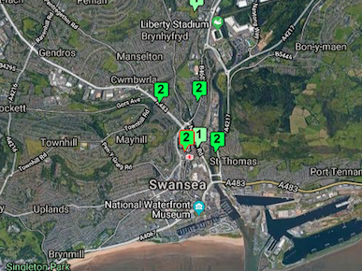
(Figure5) satellite map of Swansea

The station highlighted in red has the highest record of pair pollution and this causes many issues as it also exceeds the European union’s regulations for health standards. It is also important to note that it exceeds the worlds health organizations air quality standards limits which is the world-wide standard of air for healthy living (WHO,2016). Air pollution, deprivation and poor-health status combinations can create increased and disproportionate disease burdens. Problems and solutions are rarely considered in a broad public health context but doing so can add value to air quality management efforts by reducing air pollution risks, impacts and inequalities. Swansea city council are aware of the issue as they confirm to be running continuous air quality management in the area (Swansea.gov,2017). However, little is being done to tackle this specific issue even though the evident area is from one air quality station, but this could raise awareness as there are many other areas that are not under air quality monitoring and is usually difficult for to measure for an everyday citizen in many parts of Swansea. However, the other air quality stations are within the legislative limits. Although, one of the station (Swansea Morfa Road NOX) only monitored for two months in 2017 which could seem that there might have been technical issues The main reasoning for choosing Nitrogen Dioxide is that it is the only pollutant common in all of the stations.

Health effects of the air pollution and correlation to deprivation areas

Figure 4 highlights that Swansea station court high street is concentrated in deprived area compared to most of the other air quality stations which show social equality as the air standards in other stations are healthier and within the legislative limits. It is important to note that according to the wellbeing of future generations act (2015) Environmental (air quality) degradation, social inequality are against the goals and more importantly illegal and the government should be hold accountable. (G.J,2017)). It is essential to high light that the groups that are most likely to be affected by air quality are three main groups in the community (the elderly, Children, patents) as their immune systems are prone to defend itself as it is weak and most likely building itself. This could have an effect on children’s growth patterns as the more exposure to pollution the more likely to be negatively affected. Outdoor air pollution has contributed to about 40,000 deaths in the United Kingdom on an annual basis which is mainly due to traffic congestions (BBC.2016). Nitrogen dioxide according to epidemiological studies have shown that symptoms of bronchitis in asthmatic children increase in association with long term exposure of Nitrogen dioxide. Reduced lung function growth is also linked to the toxic gas at concentrations currently in cities of Europe and North America (WHO.2017). The economic implications of air quality have been a great concern. Especially since the national health system continues to escalate due to poor public health asthma alone costs the NHS an estimate of 1billion pound a year-it is essential that policy makers consider the effects of long term exposure on children and the public (BBC.2016).

Welsh assembly statement on air quality

There are many solutions to consider on a Swansea scale the latest Welsh Government greenhouse gas emission figures show that, in 2014, transport was responsible for 12.77% of total emissions in Wales, second only to emissions from the business sector. There has been little improvement over the years, with transport emissions for 2014 being only slightly lower than the 1990 baseline. 22. There is a strong, proven link between congestion, increased emissions and reduced local air quality. Slower journey speeds are less productive, use more fuel, ultimately resulting in increased emissions. CPT Cymru’s evidence stated that “in nose-to-tail traffic, tailpipe emissions are four times greater than they are in free flow traffic”. Wales has ambitious decarbonisation commitments under the Environment (Wales) Act 2016, and an ambition to achieve a sustainable, low carbon future set out in the Well-being of Future Generations (Wales) Act 2015. Transport has a key role to play in fulfilling Wales’ duties under the Acts. Hitting those targets will require persuading people to swap the private car for public transport, so action to address congestion has the potential to make a real difference. 23. The Greener Journeys report suggests that the “quickest and most cost-effective solution to our air quality epidemic is to put the bus at the centre of the [air quality] strategy”, and that bus priority measures can deliver 75% fewer emissions per bus passenger km than for car passengers (Assembly.wales,2017). This shows that the welsh government is well informed about this issue and is willing to take action.

Jakarta application in tackling environmental degradation

Installation of new technologies is deemed to be a useful tool to combat air quality which a smart city case study Jakarta launched a programme in 2014 which is citizen based by providing an application such as the one in Jakarta (Qlue) which allows people to report issues and upload pictures of potholes and abandoned cars in the city. This approach is more education based many people in the UK are aware of the increasing issue of air quality and there has been several campaigns by environmental organisations such as friends of earth and people and planet are raising awareness on the issue and lobbying the government to force positive change. (BBC,2017)

Green walls against air pollution

A study by Dr Thomas Pugh show that it is estimated that planting vegetation along city streets could limit air pollution by 30% in detail the study suggests that planting trees could improve air quality where pollution is at its highest in cities especially in street canyons of glass and concrete the plants are known to filter Pollutants especially nitrogen dioxide which is one of the main polluters in modern time. However, it suggests that green walls are more beneficial as it is done on an empty space and could tackle the pollutants more efficiently (P.T,2012)

Conclusion:

The air quality issue has been an ongoing issue for several years and the Geographical information systems provides a service that could maximise the efficiency of data collection and visualisation as it was demonstrated in the results section. The government must act upon the issue and provide sustainable solutions for future generations.

Appendices:

1-A flash drive will be provided to show the exact GIS work space and it is important to go back to that for further assessment

References:

Pugh.T (2012) "Green walls" against air pollution, Available at: https://phys.org/news/2012-09-green-walls-air-pollution.html (Accessed: 3/3/2018).
Swansea Council (2017) Air Quality, Available at: https://www.swansea.gov.uk/article/2831/Air-quality (Accessed: 3/3/2018).
Wakefield.J (2017) Tomorrow's Cities: What can be done to improve air quality?, Available at: http://www.bbc.co.uk/news/technology-37372119 (Accessed: 3/3/2018).
The National Assembly for Wales (2017) Taming the traffic: The Impact of Congestion on Bus Services, Available at: http://www.assembly.wales/laid%20documents/cr-ld11145/cr-ld11145-e.pdf (Accessed: 3/3/2018).
World Health Orginasation (2017) Ambient (outdoor) air quality and health, Available at: http://www.who.int/mediacentre/factsheets/fs313/en/ (Accessed: 3/3/2018).
Roberts.M (2016) UK air pollution 'linked to 40,000 early deaths a year', Available at: http://www.bbc.co.uk/news/health-35629034 (Accessed: 3/3/2018).
Griffiths.L (2017) Written Statement - Local air quality management in Wales – policy guidance, Available at: http://gov.wales/about/cabinet/cabinetstatements/2017/localairqualitymanagement/?lang=en (Accessed: 3/3/2018).
Adu.D (2018) 'Kasetsart Journal of Social Sciences', Economic growth and environmental pollution in West Africa: Testing the Environmental Kuznets Curve hypothesis, 1(1), pp. 1 [Online]. Available at: https://www.sciencedirect.com/science/article/pii/S245231511730320X (Accessed: 3/3/2018).
European commission (2017) Air Quality Standards, Available at: http://ec.europa.eu/environment/air/quality/standards.htm (Accessed: 3/3/2018).
Pigott. P (2013) Health study call on dust from Tata Steel, Port Talbot, Available at: http://www.bbc.co.uk/news/uk-wales-south-west-wales-24308823 (Accessed: 3/3/2018).
Vaughan.A (2016) Eastbourne a surprise name among UK's most polluted towns and cities, Available at: https://www.theguardian.com/environment/2016/may/12/eastbourne-a-surprise-name-among-uks-most-polluted-towns-and-cities (Accessed: 3/3/2018).
BBC (2017) Air pollution: Green group takes Welsh Government to court, Available at: http://www.bbc.co.uk/news/uk-wales-42228458 (Accessed: 3/3/2018).

