Modern Technology and Social Media as Tools For Workplace

Diana Czanasz

Student ID: 1808345

Group: 3
Term: 1

Module: BMSK4003

Digital Skills and Research Methods.

Lecturer: Balendran Kandasamy

Date: 08.01.2019.

CONTENTS

Introduction 3

Part 1 Modern Technology Used in the Workplace 3

  - Cloud Storage 4
a) Dropbox 5
b) Google Drive 7
Recommendation 8

1.2 Smartphones 9
Apple iPhone XS vs Samsung Galaxy S9 10

Part 2 Social Media as Tool for Business 12

Part 3 Professional Profiles Online 14

- LinkedIn Profile 14
- Twitter Profile 15
- Facebook Profile 16

Part 4 References 17

Introduction

This report will evaluate the advantageousness of the use of modern technologies, and explore social media as instrument used for communication, marketing and information gathering within the workforce. In order to show the research evidence, personal, professional profile online will be illustrated.

- Modern Technology used in the Workplace.

Technology has big impact on business operations. Regardless the size of the organisation, technology helps in optimising production, it improves the communication between workers, and gives opportunity of minimising the inventory costs. Providing employee with laptop or letting workers use their own device, would increase work productivity, as job could be done even from outside the office. Creating one secure location where all important data would be stored and providing access for employees so that they could find relevant information, would increase engagement and decrease amount of stress of the worker. Therefor modern technology is worth investment. (Veriday, 2017).

There are many advanced technologies, such as:

  - Cloud storage.



In the 1960s, an computer scientist Joseph Carl Robnett Licklider, came up with idea of bringing together people and data remotely.

However, cloud was introduced only nearly 50 years later, in 2006. Firstly, it was launched by Amazon Web Services in order to keep data. safe. Lately, cloud storage was adopted by the Dropbox and followed by Google, Microsoft, Apple and more. (Cloud Pro, 2018).

Cloud computing is known as technological evolution of 21st century. It allows applications to run without premise, individuals and organisations can store big amount of data on their devices, and co-workers can communicate without effort such as traveling or attending the meeting, this includes long distance collaborations, like between the counties or intercontinental. Cloud storage has become very popular. Thus, it might be difficult to choose the right platform (Cloud Pro, 2018).

I let myself compare two different platforms used frequently as information backup.

- Dropbox:
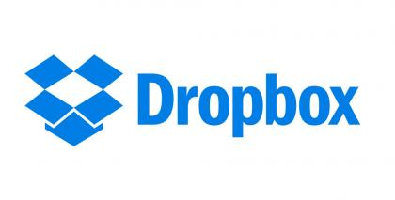

Dropbox was founded in 2007, in San Francisco, California a personalise cloud storage, used for collaboration and file sharing. It is also known as online backup service, and it is available for Windows, Linux and Macintosh desktop operating systems. Dropbox application can be downloaded on to any smartphones that runs Android, iOS and also on Blackberry. (Technopedia, 2018).

Advantages of Dropbox: mentioned by Dominic Acito (2015):

First of all, everyone has free of charge access to Dropbox and receives 2 gigabytes (GB) of storage space, to start with. Dropbox gives opportunity of increasing the amount of memory space without need of paying anything extra, by simply subscribing on social media, inviting others to join the app, and sending fun emails about Dropbox.

Another benefit of the Dropbox is that it’s very easy to operate. Everyone can use this application as soon as device is connected to internet. Thus, it enables one to simply open the app and download, upload or share the file.

Possibility of accessing the latest version of files, as an example: if document was updated on ones, computer same update version can be downloaded using the smartphone.

Dropbox enable users to share files such as: documents, images, music and videos, by placing files in specific folder designed for sharing with private users or with public.
This platform is ideal for backing up the information’s. If device was destroyed, lost or stolen, person can still access the data from his/hers, account.

Disadvantage:

According to Dominic Acito (2015), there have been many cases of servers being hacked and information’s were stolen.

Another disadvantage is connected to the risk of losing files, as administrators and developers maintaining the service have all rights to delete the files. If person that owes the free account, abandons the account for couple of months, it is less likely that the files will be still saved on the server. (TOOLBOX, 2015).

Another example of Cloud storage:

- Google Drive:

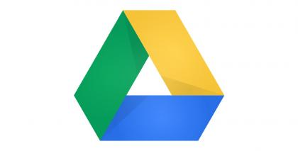

Users of Google Drive are allowed to store and access the files from any place and transfer them at any time. By connecting its service with Gmail and different collaboration tools, Google provides synergies for its customers users. For small amount of money such as £5 users of Google Drive, receive unlimited storage and other useful futures, such as advanced administrative controls for the information technology and email archiving. (Pines, 2018).

Google marketed variety of related products to its customers. In compare with Dropbox, Google achieved higher level of engagement with its users. If customers are using Google Docs spreadsheets, Chrome browser and Google’s search engine, they are most likely to adopt Google Drive as cloud storage suitable for them. “Dropbox offers a solution to one problem, while Google's tools offer a seamless, integrated solution to multiple problems”. (Pines, 2018).

- Recommendation:

Before choosing the platform It is vital to think of the business needs and to assure that it is adaptable enough to deal with the challenges that organisation might face in the future.

Personally, I would choose Dropbox, simply because I am an existing user of this platform, for the long time. Therefore, it would be very inconvenient for me to move all my files onto new storage server. But If, I were a new user, I would probably choose Google Drive, because of its capacity, Google Drive provides 15GB of free memory in compassion with Dropbox it is 13GB more.

  - Smartphones.

Considering the increase of mobility within the workforce, when it comes to business, usage of the smartphones becomes essential. Therefor almost every market is adopting them.

Businesses can benefit using those, modern phones in many ways. In compassion to traditional mobile phones, smartphones have lots more to offer. Those mobile devices, allows employees around the world to communicate in smoother and more efficient way. It is no longer needed to stay at home or office in order to send important emails, make and receive phone calls, etc. Now days smartphones are very compact-pocket size, they are light and easy to carry everywhere. Smartphones also operates all sort of futures such as internet, online banking, organiser, mailbox and other useful apps, for example Bluetooth, with enables sharing of files between co-workers. Another example of advantages involved with smartphone devices is the ability of store large amount of data, with can be accessed and shared at any time. (Chron, 2018).

Every year, biggest brands launches new versions of smartphones. According to Mark Jansen (2018) two top smartphones of year 2018 were announced as Apple iPhone XS and Samsung Galaxy S9.
Apple iPhone XS vs Samsung Galaxy S9
 | Apple iPhone XS | Samsung Galaxy S9
Weight | 177 grams | 163 grams
Size | 143,6 x 7.7 x 7.9mm | 147.6 x 68.7 x 8.4mm
Screen Size | 5-8 inch Super Retina AMOLED display | 5-8 inch Super AMOLED display
Screen Resolution | 2,436 x 1,125 pixels | 2,960 x 1,440 pixels
Operating System | iOS 12 | Android 8.0 Oreo
Processor | A12 Bionic | Qualcomm Snapdragon 845
Storage Space | 64GB, 256GB, 512GB | 64GB, 128GB, 254GB
RAM | TBA | 4GB
Micro SD card slot | None | Yes, up to 512GB
Camera | Dual 12MP rare, 7MP Face Time HD Front | 12MP (with OIS) rear, variable aperture, 8MP Front
Video | 2,160p at 60 fps, 1080p at 240fps | 2,160p at 60 fps, 1,080p at 240fps, 720p at 960fps
Bluetooth | Bluetooth 5.0 | Bluetooth 5.0
Ports | Lighting | 3mm headphone jack, USB-C
Finger Print | None | Yes
Tap to pay | Apple Pay | Google Pay, Samsung Pay
Water resistance | IP68 | IP68
Battery | TBC fast charging ( fast charger not included in box) Qi wireless charging | 3,000mAh, Quick charge 2.0, Qi wireless charging
Colours | Gold, Silver, Space Grey | Midnight Black, Coral Blue, Lilac Purple
Price | 1000£ | 720£
Reviews | Awaiting | 4 out of 5

The table above shows the difference between the Apple iPhone XS and the Samsung Galaxy S9. In the weight category Samsung is lighter than the iPhone XS by around 14 grams. Samsung also seem to have a slight edge in the screen resolution. In term of storage, both phones offer 3 different capacity where the highest storage categorie for the iPhone XS has almost doubling the capacity of Samsung 9S. However, unlike the iPhone XS, Samsung 9S have a Micro SD card slot of a maximum storage of 512 GB.

In features such as water resistance, Bluetooth setup, both the iPhone XS and Samsung 9S share the same features. However overall Apple iPhone XS has the lead with stronger processor and RAM. (Jansen, 2018).

I personally prefer Samsung Galaxy S9, the price for its value is really good, it is almost 300£ cheaper than Apple iPhone XS, and overall the specs are not much worse. Another reason of me choosing Samsung is that I am fun of Android system. Also, when using Bluetooth, I can connect with different devices such as Sony Xperia, iPhone can only pair with Apple operating system via Bluetooth.

- Social Media as Tool for Business.
Social media is a platform that enable people to communicate with each other through applications and website via devices, such as mobile phones or computers. (Lifewire, 2018). Business can benefit from usage of social media in many ways:

- Target market - companies can reach customers, through advertising on the most popular platforms used by the targeted group of people, for example if company wants to gain interest of young professionals, platforms such as Facebook, Twitter and Instagram, could be used.
- Brand loyalty – strong relationship with customer could be also gained by usage of social media. Potential consumers/clients can be easily inspired trough promotion. (As an example, Nike brand, uses strategy of using innovations and emotions in their advertisements). Providing same level of quality and service consistently, encourages loyalty and builds trust. (Forbes, 2018).

- Feedback – customers are keen to interact in such way as giving the feedback. Positive feedback could promote the business and build trust within consumers, negative feedback could be treated as suggestion, with could be used in order to improve the business.

- Cost saving - advertising trough social media is cheaper than other alternatives. Also, if individual sale some item (clothing), using social media, there is no fees that apply and no need of sharing the earning. Accounts on social media platforms are easy to set up, therefore there is no need of third-party. All those aspects help to lower the expenditure.

- Environmental-friendly – reduction of packaging waste. According to Packaging Digest (2018), company called TerraCycle, encouraged people to participate in “Less Waste Challenge”. Thousands of individuals took part in the challenge, by sharing hashtags, posting videos and pictures of them recycling, spreading environmental awareness. In result, about 128,000 pounds of waste were kept away from landfill.
Using platform such as LinkedIn is vital when it comes to marketing, communication and research of information. Members using the site can cooperate with business associates, clients, and work mates.

Linked in is a platform that host nearly 600mln professional users. To majority of this users LinkedIn is an official and reliable source of information about individuals work experiences and background. To some employers LinkedIn is a reliable live CV of future candidates, and to the candidates it is a reliable source for job hunting. LinkedIn have function option with allows individuals to search for the jobs in their area of interest, it also allows employer to advertise available job opportunities. It became a modern way and the alternative method of job recruitment (Zimmerman and Ng, 2018).

In another LinkedIn function known as sale navigator, it allows sales and business developers to approach many businesses easily to promote their product and services. It also helps locating decision makers in large companies for future collaboration or investment proposal. For example, if a company have a product or a service to sell. They only need to select the target industry on LinkedIn sale navigator. Then the search engine will provide them with a list of all the companies within industry and their decision makers to approach them directly. Where before then it would of cause the firm a lot of time and money to achieve those contact(Zimmerman and Ng, 2018).

Professional Profiles Online

- LinkedIn Profile - https://www.linkedin.com/feed/

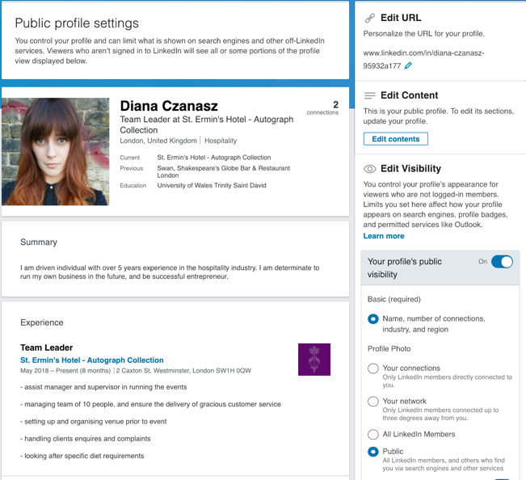

- Twitter Profile - https://twitter.com/czanasz?lang=en

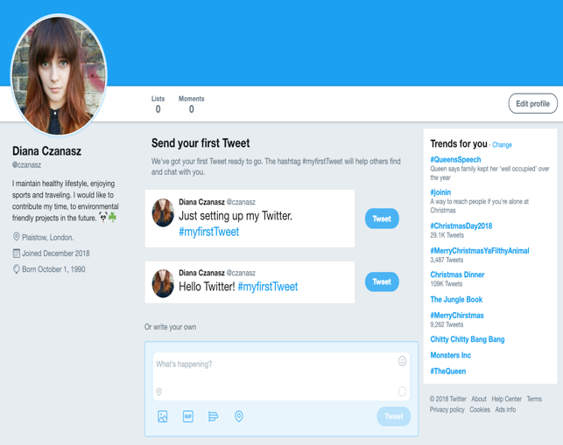

- Facebook Profile - https://www.facebook.com/diana.cz.7

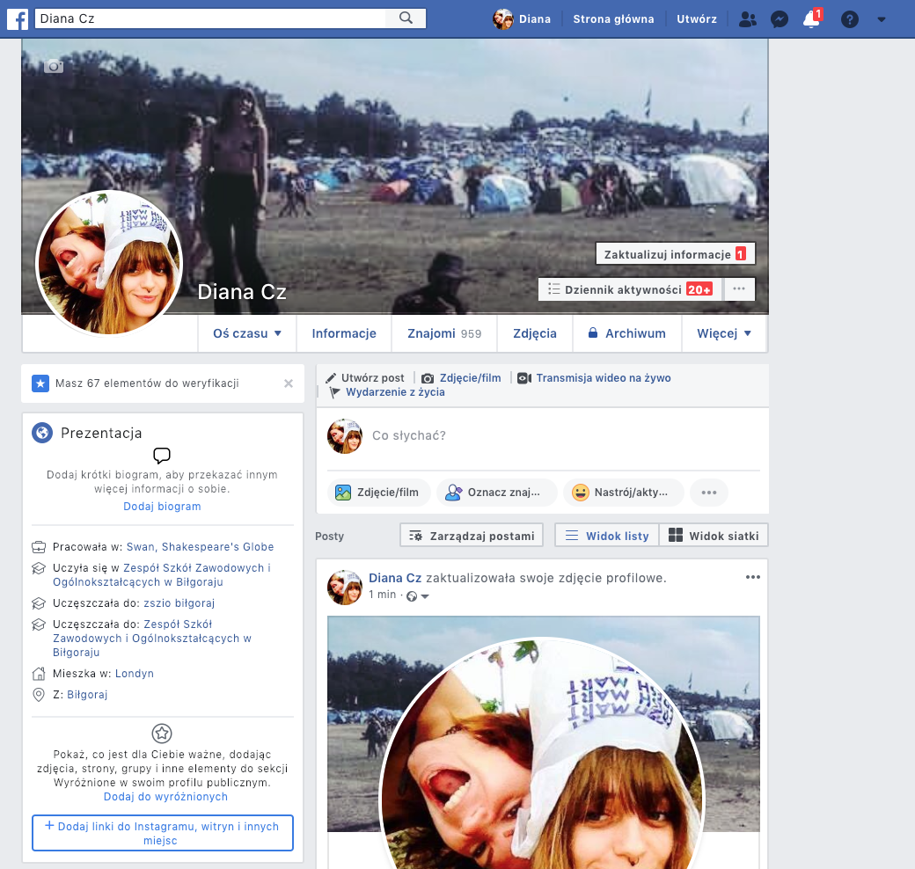

References:

- Acito, D. (2015) ‘Advantages and disadvantages of using Dropbox’. Acito Dominic [blog]. Available at: https://it.toolbox.com/blogs/acitodg/advantages-and-disadvantages-of-using-dropbox-072215 (Accessed: 12th December 2018).

- Cambridge University Press (2018). Social media. Available at: https://dictionary.cambridge.org/dictionary/english/social- media
(Accessed: 18th December 2018)

- Chron (2018) Mobile technology for business. Available at: https://smallbusiness.chron.com/mobile-technology-business-2187.html (Accessed: 18th December 2018).

- Cloud Pro (2018) Best cloud storage of 2018. Available at: https://www.cloudpro.co.uk/it-infrastructure/cloud-storage/5232/best-uk-cloud-storage (Accessed: 18th December 2018).

- Forbes (2018) Three ways to build brand loyalty.
Available at: https://www.forbes.com/sites/ryanwestwood/2015/07/30/three-ways-to-build-brand-loyalty/#7eaf9b5479c3 (Accessed: 18th December 2018).

- Jansen, M. (2018) Apple iPhone XS vs. Samsung Galaxy S9: 2018’s biggest flagships clash. Available at: https://www.digitaltrends.com/mobile/iphone-xs-vs-galaxy-s9/ (Accessed: 18th December 2018).

- Lifewire (2018) What is social media? Available at:https://www.lifewire.com/what-is-social-media-explaining-the-big-trend-3486616
(Accessed: 18th December 2018).

- Mind Tools (2018). How to use LinkedIn effectively. Available at: https://www.mindtools.com/pages/article/linkedin.htm
(Accessed: 18th December 2018).

- Packaging Digest (2018) Using social media to inspire consumers into reducing waste. Available at: https://www.packagingdigest.com/sustainable-packaging/using-social-media-to-inspire-consumers-into-reducing-waste-2016-05-13
(Accessed: 18th December 2018).

- Pines, L. (2018) ’Dropbox’s top competitors’, Investopedia, 9th August.
Available at:https://www.investopedia.com/articles/company-insights/090116/dropboxs-top-3-competitors-box-goog.asp
(Accessed: 16th December 2018).

- Technopedia (2018) Cloud computing. Available at: https://www.techopedia.com/definition/2/cloud-computing
(Accessed: 16th December 2018).

- TOOLBOX (2015) Advantages and disadvantages of using Dropbox. Available at: https://it.toolbox.com/blogs/acitodg/advantages-and-disadvantages-of-using-dropbox-072215
(Accessed: 16th December 2018).

- Veriday (2017) 5 Ways to increase productivity using technology. Available at: https://www.veriday.com/blog/increasing-productivity-technology/
(Accessed: 18th December 2018).

Zimmerman, J; Ng, D. (2018), ‘The benefits of using LinkedIn’. Available at: https://www.dummies.com/business/marketing/social-media-marketing/the-benefits-of-using-linkedin/

(Accessed: 18th December 2018).

