

Student name: Anna Poznanska
Student ID: 2442414

Module name: Introduction to Health and Social Care
Module code: (LCHS4003_LON)
Lecturer name Mark Kane
Content page

Element 1 …………………………………………………………….. page

Conclusion
Dentistry services in the UK are essential for oral and general health. However, access problems, staff shortages and funding pressures still limit quality and availability. Strengthening prevention, fair funding and contract reforms are vital for creating a sustainable, accessible system that supports both patients and professionals (The King’s Fund, 2023; NHS England, 2024).
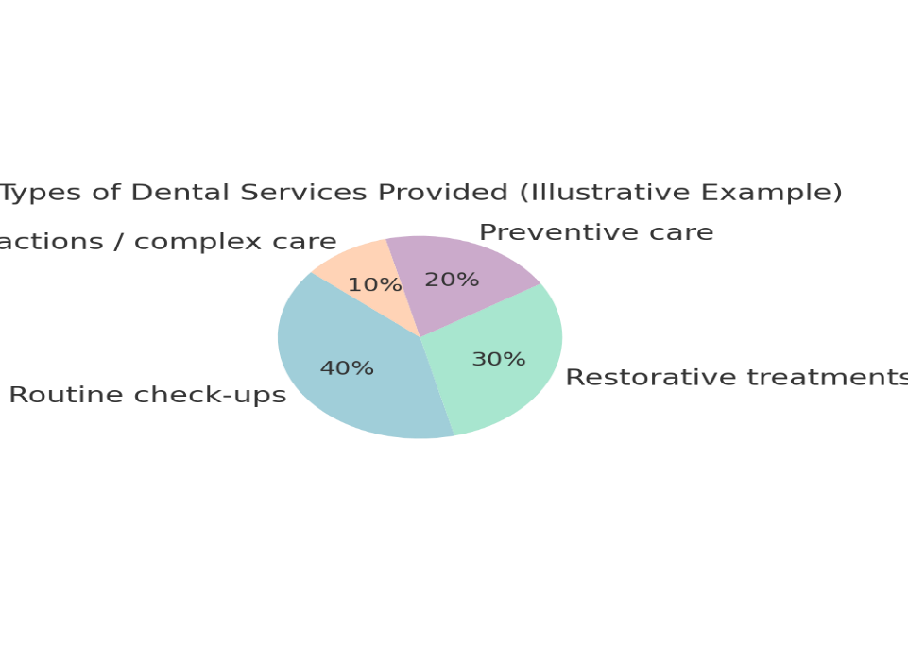
Challenges faced by dentistry services
Access to NHS dental care remains limited, with adult attendance still below pre-pandemic levels and many unable to book appointments (UK Parliament, 2024). “Dental deserts” exist in rural and deprived areas, forcing some people to delay treatment, attempt self-care, or visit A&E, increasing NHS pressure (Policy Connect, 2024). Workforce shortages and funding problems also persist. The Unit of Dental Activity (UDA) system is criticised for not supporting preventive or complex care, while NHS payments often fail to meet costs (House of Commons Library, 2025). As a result, more dentists move to private practice. Although the government introduced recovery plans and contract reforms, experts say deeper systemic changes are required for sustainability (NHS England, 2024; The King’s Fund, 2023).

References
The King’s Fund (2023) Dentistry and oral health in the UK. London: The King’s Fund. Available at: https://www.kingsfund.org.uk (Accessed: 16 November 2025).
House of Commons Library (2025) Dentistry in the UK: Access and policy developments. London: UK Parliament. Available at: https://commonslibrary.parliament.uk (Accessed: 16 November 2025).
NHS Business Services Authority (2024) Annual Dental Statistics for England 2023/24. Newcastle upon Tyne: NHSBSA. Available at: https://www.nhsbsa.nhs.uk/statistical-collections (Accessed: 16 November 2025).
NHS England (2024) NHS Dental Recovery Plan. London: NHS England. Available at: https://www.england.nhs.uk (Accessed: 16 November 2025).
Policy Connect (2024) Rebuilding Trust: Tackling Inequalities in NHS Dentistry. London: Policy Connect. Available at: https://www.policyconnect.org.uk (Accessed: 16 November 2025).
Care Quality Commission (2024) State of Care 2023/24: Dentistry overview. London: CQC. Available at: https://www.cqc.org.uk/publications (Accessed: 16 November 2025).
(Accessed: 16 November 2025).

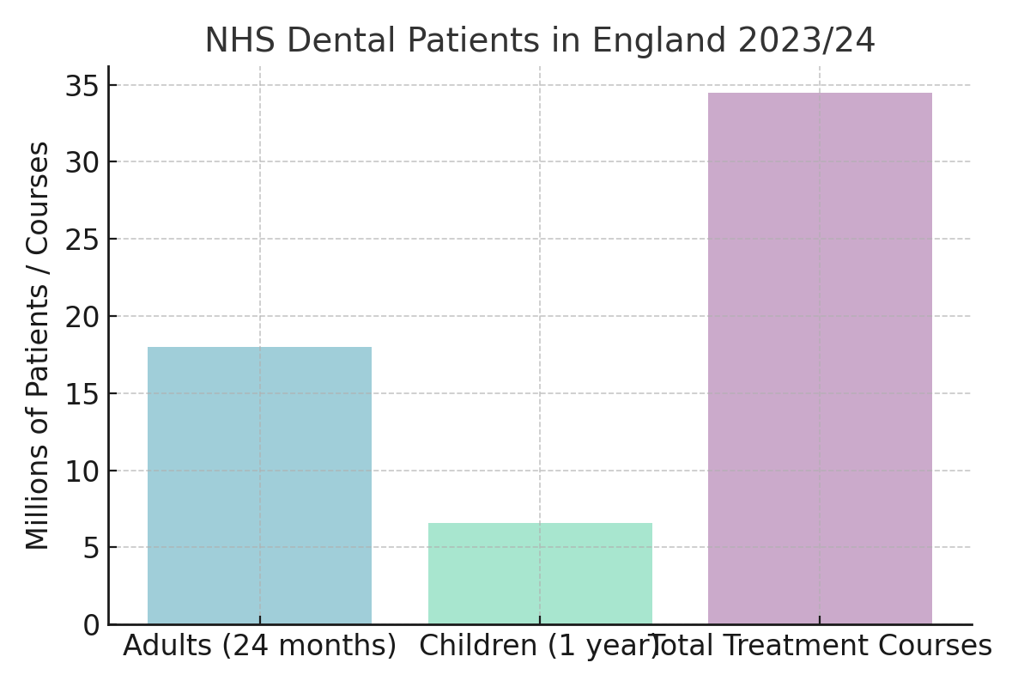
Current functioning of dentistry services
NHS dentistry in the UK is mainly delivered by independent practices contracted by the NHS. Patients register with a practice rather than an individual dentist. Clinically necessary treatments, such as pain relief and infection control, are NHS-funded, while cosmetic procedures are private (The King’s Fund, 2023). In 2023/24, about 34 million NHS treatments were provided to 18 million adults and 6.6 million children, reflecting a gradual recovery after COVID-19 disruptions (NHS Business Services Authority, 2024; Care Quality Commission, 2024). Community dental services support patients with restricted access, and hospitals handle complex cases. Preventive initiatives, including fluoride varnish for children and oral-health guidance for adults, remain central to current dental care (NHS Business Services Authority, 2024).
Explanation of the chosen healthcare service
Dentistry services in the UK focus on prevention and treatment of oral diseases. Within the National Health Service (NHS), dental care aims to maintain oral health, relieve pain and support eating and speaking (The King’s Fund, 2023). NHS dentistry offers check-ups, fillings, extractions, dentures and orthodontics through NHS-contracted practices, with community teams and hospitals caring for people with complex needs (NHS Business Services Authority, 2024). Private dentistry operates alongside the NHS, with similar treatments but waits and higher costs. NHS care is subsidised in bands, while children, pregnant people and low-income groups receive free care (House of Commons Library, 2025). Dentistry contributes to public health by promoting hygiene and identifying early signs of disease.

A brief history of dentistry services
Dental care in the UK began in the early 1900s, when school dental schemes treated children (House of Commons Library, 2025). A major change came in 1948 with the creation of the National Health Service (NHS), which made dental carefree for everyone based on need, not ability to pay (The King’s Fund, 2023). In the 1950s, small charges for adults were added to manage demand, though care remained affordable (House of Commons Library, 2025). Over time, the focus shifted from emergency work to prevention through fluoridated toothpaste, health campaigns and regular check-ups (NHS England, 2024). Since the 2000s, NHS dentistry has evolved, introducing UDA contracts and reforms to promote a fairer and more preventive system (NHS England, 2024).
Dentistry services in the UK
Anna Poznanska, Introduction to Health and Social Care (LCHS4003_LON),
2442414@student.uwtsd.ac.uk
0
Element 2
The National Health Service (NHS) was founded in 1948 to provide healthcare that was free when used, paid for through taxation, and available to everyone in the United Kingdom. Its creation came from the Beveridge Report (1942), which called for action against five “giant evils” — Want, Disease, Ignorance, Squalor and Idleness. These ideas shaped new welfare policies after the Second World War. The Minister of Health, Aneurin Bevan, made this vision real, inspired by the Tredegar Workmen’s Medical Aid Society, a community scheme offering care to local workers (Bevan, 1952). Built on equality and fairness, the NHS turned healthcare from a privilege into a basic right for all citizens.
Before 1948, healthcare in Britain was uncoordinated and unequal. Access depended mainly on people’s income or local support from councils and charities, which meant that poorer families often went without treatment (Ham, 2014). The Second World War revealed the benefits of organised healthcare. Wartime medical services showed that a national, centralised system could deliver care more effectively. After the war, the Labour government under Prime Minister Clement Attlee launched the NHS on 5 July 1948, led by Aneurin Bevan. Its main principles were clear: healthcare should be available to everyone, funded by taxes, and based on need rather than ability to pay (Bevan, 1952).
Running such a large system was never easy. Pettigrew, McKee and Ferlie (1988) observed that change within the NHS has always been shaped by politics, financial limits and professional culture. Reforms in the 1980s introduced management structures and internal markets to improve efficiency. During the 1990s, NHS Trusts and local commissioning bodies were formed to give hospitals and local authorities more control. Later reforms sought to link health and social care, aiming to provide more joined-up support for patients (Ferlie and Ongaro, 2015).
Today, the NHS remains the world’s largest publicly funded health system, employing more than 1.4 million people. It includes the Department of Health and Social Care, NHS England and regional Integrated Care Boards, which plan and deliver local services (NHS England, 2024). In 2025, the government is introducing new reforms to bring NHS England’s management closer to ministers, improving political oversight. The 10-Year Health Plan focuses on moving more care into the community, developing digital health services and preventing illness before it develops.
Despite these efforts, the NHS faces serious challenges. Waiting lists reached 7.8 million people in England by mid-2025 (House of Commons Library, 2025). There are around 120,000 staff vacancies, and an ageing population is creating greater demand for long-term care (The King’s Fund, 2023). Funding pressures and regional inequalities also make it difficult to maintain consistent standards across the country.
Even with these problems, the NHS remains one of the most trusted and valued public institutions in the UK. It continues to represent fairness, compassion and equal access to care — the same values that inspired its creation more than seventy-five years ago.
The NHS was created to fight inequality and disease by providing healthcare for everyone, funded by the public. Guided by Bevan’s principles of fairness and equal access, it changed the way people in Britain think about health and social responsibility. Although the service has evolved through many reforms, its founding values remain strong. Today, staff shortages, long waiting times and limited funding are major challenges, but innovation and prevention offer hope for the future. To protect the NHS for future generations, investment in people, technology and community care will be essential (NHS England, 2024; The King’s Fund, 2023).

References
Bevan, A. (1952) In Place of Fear. London: Heinemann.
Ferlie, E. and Ongaro, E. (2015) Strategic Management in Public Services Organisations. Abingdon: Routledge.
Ham, C. (2014) Health Policy in Britain. 7th ed. London: Palgrave Macmillan.
House of Commons Library (2025) The NHS: Current Structure and Policy Developments. London: UK Parliament. Available at: https://commonslibrary.parliament.uk (Accessed: 16 November 2025).
NHS England (2024) Structure of the NHS. Available at: https://www.england.nhs.uk (Accessed: 16 November 2025).
Pettigrew, A., McKee, L. and Ferlie, E. (1988) Understanding Change in the NHS. Oxford: University of Oxford. Available at: https://ora.ox.ac.uk/objects/uuid:c0ab662b-0580-4950-8419-2d9d8664a9c7 (Accessed: 16 November 2025).
The King’s Fund (2023) The NHS in a Nutshell: How It Works and Who Runs It. Available at: https://www.kingsfund.org.uk (Accessed: 16 November 2025).

