

Master of Business Administration
Dissertation
LCMB7035

Topic: Evaluating the Role of Clubcard Personalisation in Improving Customer Loyalty in the UK Supermarket Industry

Student Name: Harshkumar Manojkumar Patel
Student ID: 2503790
Word Count: 15983
Supervisor: Dr. Jia Miao
DECLARATION
I Harshkumar Manojkumar Patel declare that this dissertation has been composed by myself, that the work contained herein is entirely my own except where explicitly stated otherwise in the text, and that this work has not been submitted for any other degree or qualification, in whole or in part, except as specified.
Signature: H.M.PATEL
Date: 25/09/2026

ACKNOWLEDGEMENT
I would like to express my gratitude to my supervisor and lecturers who have assisted me with a lot of guidance and support during my MBA. My family and friends are also extremely supportive and helpful in encouraging me, being patient, and motivating me. Lastly, I would like to acknowledge all those who directly or indirectly helped me to complete this dissertation.
Abstract
The research focuses on the importance of personalized loyalty programs in improving customer loyalty in the UK supermarket market, especially Tesco Clubcard and Sainsbury's Nectar. This study follows a secondary qualitative design based on a Systematic Literature Review (SLR) to integrate evidence of the existing academic and industry literature on the topic, published within the past five years (2022-2026). Thematic analysis revealed five main themes, which include personalized programs help promote perceived customer value and customer satisfaction; personalization helps to promote customer engagement and behavioural loyalty; customer data and digital technologies help contribute to personalized experiences; trust and privacy impact personalization effectiveness; and personalization can influence behavioural loyalty but is not a guarantee of sustainable customer loyalty. The results indicate that individualized discounts and rewards and data-based suggestions can be used to motivate repeat buying and enrolment in a program. Nevertheless, the cases of price sensitivity, switching behaviour, privacy, and service quality remain to impact long-term loyalty. These relationships can be explained by Relationship Marketing Theory and Social Exchange Theory, which give complementary explanations. The paper suggests enhancing the relevance of the offer, enhancing the transparency of the data, minimizing the effects of promotional fatigue, and integrating personalization with more extensive customer value models. In general, personalization is a significant factor in customer engagement and behavioural loyalty, yet to be sustainable, a relationship-based approach is needed.
Table of Contents
CHAPTER 1: INTRODUCTION 10
1.1 Background & Problem Statement 10
1.2 Research Aim 12
1.3 Research Objectives 12
1.4 Research Questions 12
1.5 Significance / Relevance of Study 13
1.6 Research Methodology 14
1.7 Structure of the rest of the project 14
CHAPTER 2: LITERATURE REVIEW 16
2.1 Introduction 16
2.2 Customer Loyalty in the UK Supermarket Industry 16
2.3 Personalisation in Retail Loyalty Programmes 18
2.4 Clubcard Personalisation within the UK Supermarket Industry 22
2.5 Effectiveness and Challenges of Personalised Loyalty Programmes 24
2.6 Theoretical Framework 26
2.7 Conceptual Framework 29
2.8 Literature Gap 30
2.9 Chapter Summary 31
CHAPTER 3: RESEARCH METHODOLOGY 33
3.1 Introduction 33
3.2 Research Design 33
3.3 Data Collection Methods 36
3.4 Ethical Considerations 40
3.5 Reliability and Validity 41
3.6 Limitations 41
3.7 Conclusion 42
CHAPTER 4: RESULTS, ANALYSIS AND DISCUSSION 43
4.1 Introduction 43
4.2 Presentation of Findings from SLR 44
4.3 Industry and Company Evidence 53
4.4 Analysis of Results 58
4.5 Discussion of Results 69
4.6 Chapter Summary 74
CHAPTER 5: CONCLUSIONS AND RECOMMENDATIONS 75
5.1 Summary of main findings 75
5.2 Conclusion based on the research questions 75
5.3 Recommendation 77
5.4 Limitation of Research 78
5.5 Recommendation for Future Work 79
Reference List 80
Appendices 96
Appendix 1: Quality Appraisal Process by CASP tool 96
Appendix 2: Thematic Coding Framework 98

Contents of Figures
Figure 1: Grocery market share of retail brands in Great Britain 2017-2026 10
Figure 2: Dissertation Structure 15
Figure 3: Factors driving consumers to join loyalty programs in Great Britain 2024 19
Figure 4: Global loyalty programs participation 2024, by industry 22
Figure 5: Factors negatively impacting customer loyalty in the UK 2024 26
Figure 6: Relationship Marketing Theory 28
Figure 7: Social Exchange Theory 29
Figure 8: Conceptual Framework 31
Figure 9: Saunder’s Research Onion framework 35
Figure 10: PRISMA Diagram 41
Figure 11: Supermarket Loyalty Card Usage in Great Britain by Gender, April 2025 54
Figure 12: Supermarket Loyalty Scheme Membership in Great Britain 55
Figure 13: Appeal of Major Loyalty Programmes in Great Britain, 2024 56
Figure 14: Tesco Clubcard Personalisation Scale 57
Figure 15: Sainsbury Nectar Price Scale 58

Contents of Tables
Table 1: Inclusion and Exclusion Criteria 39
Table 2: Findings from SLR 45
Table 4: Theme development 59
Table 5: Theme development 60
Table 6: Theme development 62
Table 7: Theme development 64
Table 8: Theme development 65
Table 9: Theme Objective Mapping Table 67

CHAPTER 1: INTRODUCTION

1.1 Background & Problem Statement
Research Background
The UK supermarket industry is a leading and growing market which is characterised by changing consumer preferences and trends. As the largest and most competitive retail industry in the UK, the supermarket industry has a high level of competition among the leading retailers such as Tesco, Sainsbury, Asda, Aldi, Lidl and Morrisons (Peer et al., 2025). Despite Tesco still dominating the market, discount retailers have still been able to consolidate their competitive positions with lower prices and value-based propositions, forcing the well-established supermarkets to develop new customer retention strategies beyond price competition. As of the report by Watty (2025), the UK grocery retail market has a value of over 220 billion, out of which Tesco holds about a 28% share of the market; next come Sainsbury and Asda, with Aldi and Lidl steadily increasing their market share.
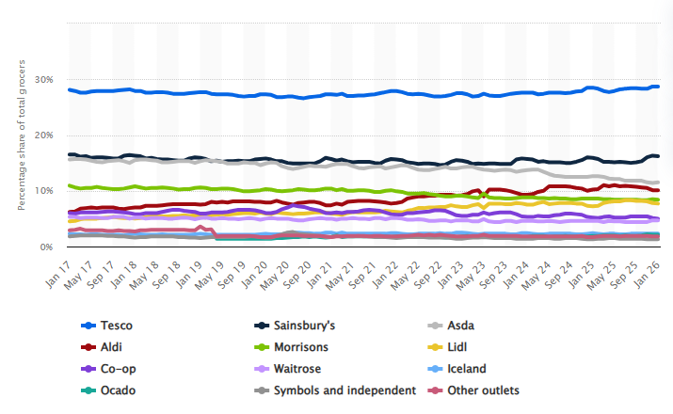
Figure 1: Grocery market share of retail brands in Great Britain 2017-2026
(Source: Watty, 2025)
These changes indicate that customer loyalty over the long term has been of growing importance in ensuring the competitive advantage of the industry in the UK supermarket. Supermarkets have responded to rising competition and shifting consumer demands by developing old-fashioned loyalty programmes into new, data-driven personalisation platforms (Varshney and Grover, 2026). Instead of using rewards based on points only, retailers are now using the data on customers' purchasing behaviours to offer them differentiated discounts, personal product offerings and specific promotions. The programmes are also commercially important, demonstrated by their scale. In 2023/24, Tesco stated that over 22 million households in the UK were utilizing Clubcard and that 82% of total Clubcard sales were penetrated and 289 million personalized coupons were sent to 7.6 million customers (LSE, 2025). On the same note, Sainsbury reported that Nectar Prices had created over 2 billion customer savings in 2024/25, and over 85% of the participants (J Sainsbury plc, 2025).
Problem Statement
Although there is an increasing use of personalised loyalty programmes, current studies have mixed results on the use of these programmes in promoting long-term customer loyalty. Although Nyaboga (2026) believes that individualised rewards enhance customer involvement and repeat buying, Berri and Toma (2023) stated that individuals are still more affected by price, convenience and service quality than by individualised incentives. In addition, much of the literature that exists studies loyalty programmes or personalisation as individual entities. It has been found that little comparative evidence exists regarding how the personalised strategies practised by Tesco Clubcard and Sainsbury Nectar have led to customer loyalty in the UK supermarket market. Thus, this research aims to fill this research gap by assessing the importance of personalisation of Clubcard and taking the example of personalisation of Nectar at Sainsbury as a benchmark in comparison. The study will help to understand the personalised loyalty strategies in the UK grocery retail market in a more holistic manner. Moreover, and although retailers indicate that their programmes are highly subscribed to, customers are saving more and utilising personalised offers in large quantities, publicly available data does not always isolate the degree to which this activity leads to customer retention, repeat buying or turnover. This brings a requirement to differentiate programme engagement and sustainable customer loyalty as well as critically assess the reality of the results of personalisation.

1.2 Research Aim
The research aims to assess the role of Clubcard personalisation in improving customer loyalty in the UK Supermarket Industry, with a focus on the comparison between Tesco Clubcard and Sainsbury's Nectar.

1.3 Research Objectives
- To analyse the role of personalised loyalty programmes in enhancing customer loyalty within the UK supermarket industry.
- To compare the personalised features of Tesco Clubcard and Sainsbury's Nectar and evaluate their contribution to customer loyalty.
- To examine the connection between Customer loyalty and Clubcard personalisation in the UK supermarket industry.
- To propose measures to enhance customer loyalty within the UK supermarket sector with regards to Clubcard personalisation.

1.4 Research Questions
Research Questions
RQ1: How can personalised loyalty programmes improve customer loyalty in the UK supermarket industry?
RQ2: How do the personalised features of Tesco Clubcard and Sainsbury's Nectar contribute to customer loyalty?
RQ3: What is the connection between customer loyalty and Clubcard personalisation in the UK supermarket industry?
RQ4: How can we enhance the personalisation of Clubcard to enhance customer loyalty within the UK supermarket sector?

1.5 Significance / Relevance of Study
The importance of this research is that personalised loyalty programmes have now become a key element of customer relationship management in the UK supermarket sector. With competition rising and consumer expectations constantly changing, supermarkets are increasingly using data-based personalisation to enhance customer interactions and foster long-term customer loyalty (Nurhilalia and Saleh, 2024). Despite the high level of the personalised loyalty programs usage, little is known about the role of the most popular supermarket programmes, especially Tesco Clubcard and Sainsbury Nectar, in maintaining customer loyalty. Consequently, this study provides timely information about the usefulness of personalised loyalty strategies in a very competitive retail setting. Academically, the research paper adds to the literature in the field by summarising the available evidence on customer loyalty, retail personalisation and loyalty programmes. Studies by Zikienė et al. (2024) and Nyaboga (2026) have mainly analysed customer loyalty, loyalty programmes or personalisation as independent variables, whereas there is little comparative evidence on Tesco Clubcard and Sainsbury Nectar. With the combination of these streams of research, the study builds on existing knowledge on the impact of personalised loyalty strategies on customer loyalty in the UK supermarket industry. In addition, the Relationship Marketing Theory and Social Exchange Theory are used, which give a theoretical basis to the explanation of how personalised interactions add customer value and build long-term relationships.
In the practical context, the study will offer valuable knowledge for supermarket managers regarding the ways personalised loyalty strategies can influence customer engagement, retention and repeat purchase. The comparison of Tesco Clubcard and Sainsbury Nectar can inform improvements in loyalty programme design and customer experience. It is also an industry-relevant study because the digital transformation and the use of data analytics are still transforming the marketing approaches of retail. The knowledge of the impact of rewarding customers individually, promotions and insights tailored to customers on loyalty can help supermarkets address the shifting preferences of consumers more adequately without jeopardising sustainable relationships with customers (Moleka, 2024). Lastly, the study is also methodologically relevant, as it uses a systematic literature review and thematic analysis to critically assess academic and industry-based evidence.

1.6 Research Methodology
This paper uses a qualitative research design of secondary research to assess how Tesco Clubcard and Sainsbury Nectar personalisation is important in enhancing customer loyalty in the UK supermarket market. A Systematic Literature Review (SLR) will be used as a source of data collection, and its structure will follow a systematic and transparent data identification, screening and selection of relevant studies. Predefined inclusion and exclusion criteria will ensure the quality, relevance and credibility of the selected literature (Mishra and Alok, 2022).
The gathered data will be analysed with the help of Braun and Clarke's six-phase thematic analysis, which will make it possible to identify and interpret the regular themes in all of the chosen studies (Braun and Clarke, 2022). Such an analytical method will enable a thorough analysis of the efficiency of personalised loyalty strategies and will present evidence-based findings of how Tesco Clubcard and Sainsbury Nectar can lead to customer loyalty in the UK supermarket sector.

1.7 Structure of the rest of the project
The dissertation is divided into five chapters, which is shown in the figure 2 below.
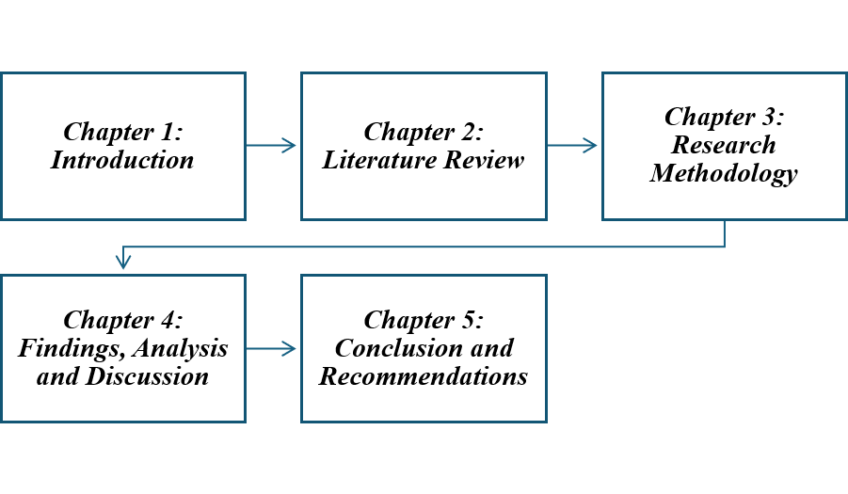
Figure 2: Dissertation Structure
(Source: Self-developed)
The first chapter provides the research settings, focusing on background, problem, aim, objectives, questions and significance of the study. Chapter Two critically reviews the literature on customer loyalty, personalised loyalty programmes, Tesco Clubcard and Sainsbury Nectar. Chapter Three presents the research methodology that incorporates research design, data collection and thematic analysis processes. Chapter Four contains the findings based on the systematic literature review and discusses them. Lastly, Chapter Five is a summary of the main findings, conclusions, practical implications, limitations and recommendations for future research.

CHAPTER 2: LITERATURE REVIEW

2.1 Introduction
This chapter is a critical review of the literature that exists in customer loyalty, personalised loyalty programmes and the application of Tesco Clubcard and Sainsbury Nectar in the UK supermarket industry. The review will proceed to review the concept of customer loyalty and how consumers can be retained in a grocery retail business. It goes on to discuss how individualised loyalty programmes have evolved, and the role of data-driven technologies in changing customer relationship management and shopping experiences. The section also compares the personalisation approaches of Tesco Clubcard and Sainsbury Nectar critically and analyses how they have helped the companies to improve customer loyalty. Relevant empirical studies are synthesised to define areas of agreement, inconsistencies and methodological constraints in the existing literature. In this section, the theoretical framework will be introduced along with the conceptual framework, while highlighting the research gap that gives the rationale of the current study.

2.2 Customer Loyalty in the UK Supermarket Industry
Customer loyalty has become a strategic focus in the UK supermarket industry as it allows shops to retain customers, grow repeat purchases and profitability over the long term in a market which is increasingly competitive. Literature is becoming conceptualised as supermarket loyalty being a multidimensional construct and not as repetitive buying. The transformation of sustainable customer relationships and value is highlighted by Islam and Arif (2022); Samah and Ghazouani (2025) identify behavioural, attitudinal and emotional aspects of loyalty. Yum and Kim (2024) relate loyalty to positive experiences, trust and perceived value. Nevertheless, Damaschi et al. (2025) stated that repeat buying can also be due to convenience, a lack of substitutes or financial motivation. All of these studies show that behavioural loyalty does not necessarily translate into long-term customer commitment.
In a number of empirical studies, the key determinants of supermarket loyalty are service quality, perceived value and customer satisfactionLoyalty programmes are not the only determinants of loyalty to the supermarket. Service quality, satisfaction, trust and positive shopping experiences are identified by Jasin et al. (2023) and Saoula et al. (2023) as key factors of retention. Conversely, Bandi (2025) and Doan and Poirier (2023) focus on the role of the economic situation and sensitivity to prices, whereas CMA evidence and Jessop et al. (2024) report that a significant portion, around 97% of UK buyers are members of a range of loyalty programs and still price-sensitive. Combined, the evidence indicates that both relational and economic factors influence the level of supermarket loyalty and therefore personalisation is not the only driver of loyalty but one of the factors that influence it. Additionally, Tesco Clubcard and Sainsbury Nectar are the two most popular supermarket loyalty programs, which underscores the strategic nature of loyalty programmes in UK grocery retailing.
External evidence also casts doubt on whether or not loyalty-programme participation is a true loyalty. The CMA discovered that the majority of UK grocery customers were members of various supermarket bids, with a significant proportion of their number still scrutinizing the prices of the different retailers irrespective of their loyalty offers (Doan and Poirier, 2023). This indicates that programme membership can be an indicator of consumers seeking value as opposed to commitment by retailers themselves. Thus, customer loyalty in UK supermarkets can and must be measured using more comprehensive measures like repeat buying, retention and low switching as opposed to membership or frequency of transactions.
Overall Summary
On the whole, the literature indicates that UK supermarket loyalty is multifactorial. The long-term relationships can be underpinned by trust, quality of service, experience and perceived value of the customer, whereas price competitiveness, convenience and promotional benefits lead to the choice of the supermarket (Bandi, 2025; Doan and Poirier, 2023). This forms a critical difference between programme involvement, repeat buying and sustainable loyalty, which offers a case to study the possibility of personalisation strengthening true customer loyalty.

2.3 Personalisation in Retail Loyalty Programmes
Traditional loyalty programmes primarily provided standardised points and discounts, but digital technologies, CRM, AI and big-data analytics have helped retailers to offer more personalised offers and recommendations (Pissarra et al., 2025; Uddin, 2026). It has changed loyalty programmes to data-driven personalisation that is aimed at improving customer relationships and engagement. Personalisation seems especially to be of relevance to perceived customer value. Wang et al. (2026) claim that a personalized communication enhances the saliency of marketing messages, whereas Mensouri and Azmani (2022) discover that customised recommendations are more helpful when they consider individual shopping behaviour. According to the report by Statista Research Department (2024), the most valued feature of loyalty programmes is the ability to receive discounts and personalised offers; 69% of British consumers expect this feature of loyalty programmes. Comparatively, free products or partner rewards are valued by 30%, and less than 10% of customers place more emphasis on enhanced services or membership experiences. Taken together, these results indicate that perceived relevance and value can be enhanced by personalisation, through aligning rewards with the needs of the individual customers.
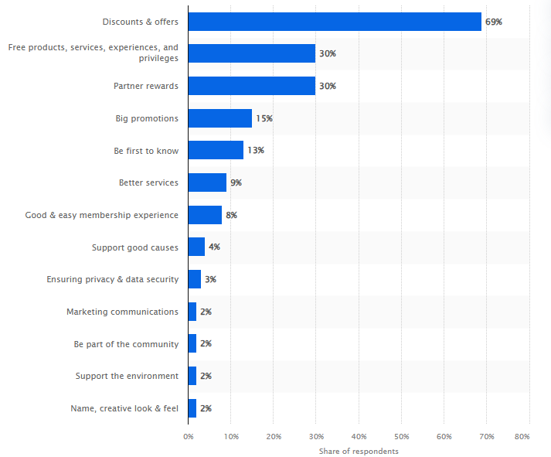
Figure 3: Factors driving consumers to join loyalty programs in Great Britain 2024
(Source: Statista Research Department, 2024)
The significance of discounts and customised offers, however, also brings about the difference between engagement in a programme and actual loyalty. Consumers can engage since individualised prices would give them instant economic benefits and still compare the rival supermarkets (Bhosale, 2025). Thus, membership or the use of the offers should not be evaluated as the effectiveness of personalisation, but the signs of repeat purchases, retention and decreased switching should be observed to conclude whether a short-term promotional involvement can turn into long-term loyalty.
The findings suggest that consumers mostly relate loyalty programmes to short-term economic gains as opposed to relationship benefits. This justifies the increasing trend of retailers using personalised promotions since bespoke discounts will better meet customer expectations compared to generic rewards. Nevertheless, Rodriguez-Ardura et al. (2025) contended that customer participation can be more of a value-seeking behaviour than actual brand commitment, which suggests that personalisation is not necessarily sufficient to build sustainable customer loyalty. Bhosale (2025) also stated that personalisation enhances behavioural loyalty by creating repeat purchases as well as attitudinal loyalty by heightening customer satisfaction and loyalty.
Although these are the benefits, researchers have contradicting views on the effectiveness of personalisation in creating true customer loyalty. Personalisation is related to the literature with customer engagement and behavioural loyalty. Ahmad et al. (2022) discover that personalised recommendations have the potential to increase engagement rates by improving the perceived programme value, whereas Oumaima and Lamari (2024) perceive personalisation as the transformation of promoting activity into customer relationship management. Bhosale (2025) finds impacts on repeat purchase and satisfaction. Nonetheless, Rodriguez-Ardura et al. (2025) and Mukabbir (2023) warn that participation and repeat purchase might be the manifestation of value-seeking or temporary promotional reactions instead of commitment. Magasi (2024) also highlights the broader importance of price, convenience, service quality and product availability. In general, the data demonstrate that there is a positive correlation between personalisation and behavioural engagement, although the impact of the former on sustainable loyalty is contingent. The infrastructure on which personalisation is delivered is through digital technologies. CRM, AI, predictive analytics, mobile apps and digital communication enable retailers to study customer behaviour and offer relevant recommendations and offers in real time (Pissarra et al., 2025; Uddin, 2026; Biswas et al., 2026; Wolniak et al., 2024). All these studies suggest that technology only makes it possible to personalise based on data; the level of technical development is not a guarantee of loyalty; the offers created as a result should be relevant and have value to the customers.
Overall Summary
Nevertheless, personalisation based on data poses a conflict between relevance and privacy. The issues identified by Fox et al. (2022) are the privacy and transparency of data, and Aydin (2022) demonstrates that customers could share personal information to receive personalised rewards but are not sure what will happen with the data and who controls it. Jagadeeswaran et al. (2026) hence stresses on responsible data management and transparency. Collectively, these studies indicate that trust and privacy are key conditions for personalisation to maintain customer participation and loyalty. The increased digitalisation of retailing has also increased the use of personalised loyalty programmes. Mobile apps, digital wallets, location-based and AI-driven recommendation systems allow retailers to provide personalised offers in nearly real-time. Nevertheless, they are especially adopted in the supermarket industry since shopping in grocery stores is typified by a high level of purchases, high competition and comparatively low switching costs. The study by Statista Research Department (2025) showed that supermarkets and food retail note the most consumer involvement in loyalty programmes, with 33% of the surveyed customers expressing their loyalty to the programme, which is significantly higher than airlines (12%), hotels (11%), and restaurants (8%).
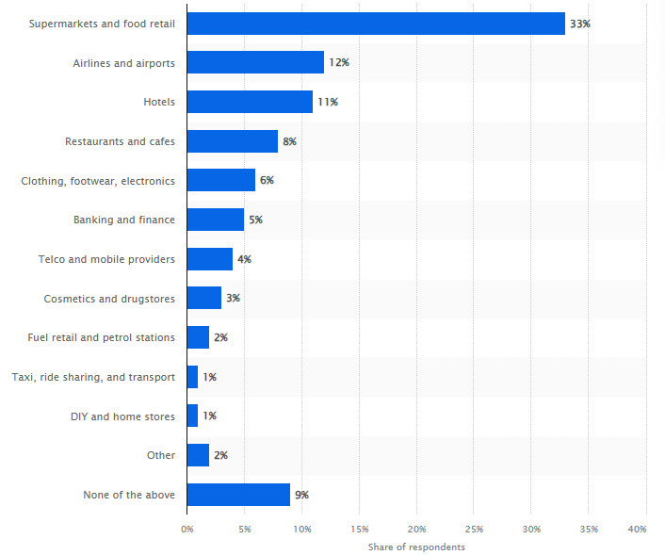
Figure 4: Global loyalty programs participation 2024, by industry
(Source: Statista Research Department, 2025)

2.4 Clubcard Personalisation within the UK Supermarket Industry
Loyalty programme design in the UK supermarket sector has undergone a vast change as the less personalised point-based reward systems are being replaced by more personalised digital platforms, which use customer information to enhance shopping experiences and customer relationships. In accordance with Hallikainen et al. (2022), personalisation has been a strategic focus due to the fact that supermarkets are in a very competitive atmosphere with low switching costs and high frequency of purchase. For this reason, retailers are utilising customer purchase history, mobile apps and digital analytics to provide targeted discounts, recommendations and promotional offers more frequently, as a way of encouraging repeat buying and enhancing customer retention. As opposed to traditional loyalty programmes that offered the same benefits to every member, the current supermarket loyalty programmes are designed to offer value provision, depending on the shopping behaviour of the individual members (Xu and Hu, 2022). Retailers can divide customers by their preferences by examining buying behaviour and give them personalised offers that are more likely to suit their needs.
Evidence of large-scale personalised loyalty activity is seen at Tesco, with 22m+ households with UK Clubcard, 82% sales penetration and 289m personalised coupons to 7.6m customers in 2023/24 (LSE, 2025). Sainsbury also announced customer savings of over £2 billion, a participation of over 85% and above 9,000 Nectar price deals in 2024/25 (J Sainsbury plc, 2025). These numbers indicate a high level of reach and involvement of the programme, yet they do not prove the long-term retention and loyalty of the customers. In relative terms, the two programmes show a transition away from standardised rewards to value propositions that are increasingly personalised, depending on customer information and buying behaviour. Clubcard offered by Tesco offers personalised benefits and specific coupons, whereas Nectar Prices focuses on differentiated prices and offers. Thus, both programmes seem to have the potential to create perceived value and interaction, yet their on-record participation and savings will not be sufficient to show sustainable loyalty. This justifies the necessity to make a distinction between behavioural engagement and customer commitment over the long term.
Although the use of personalised loyalty programmes has been widely practised, the literature has given conflicting views on its efficacy. Khodakarami et al. (2024) opined that customised promotions lead to better customer satisfaction since customers feel that customised offers are more valuable and relevant than generic promotions. Nevertheless, Abi Azhar et al. (2026) claim that the success of personalised loyalty programmes will be conditional on more general determinants like price competitiveness, product quality, service experience and convenience. During economic downturns, there is a high possibility that customers will keep on shopping at different supermarkets to get the most benefits even when they are given personalised rewards. As such, targeted discounts can only stimulate short-term buying behaviour and not necessarily create true long-term loyalty. The other issue is related to consumer attitudes towards data privacy. As stated by Aydin (2022), one-to-one loyalty programmes are highly dependent on customer data gathered on loyalty cards, online shopping and mobile applications. Whereas a large number of consumers readily give their personal information in trade of personalised rewards, others are apprehensive about their data privacy, accountability and ethical transgression of personal information. Therefore, retailers need to make sure that personalisation strategies are underpinned by responsible data management practices to sustain customer trust and programme credibility.
Overall Summary
The effectiveness of loyalty pricing has a more reserve interpretation by independent evidence. Report by CMA examined around 50 000 products in the grocery industry which were provided at loyalty prices and established that 92 of the withdrawn loyalty-priced products were real savings with an average savings of 1725 per cent across five supermarkets (Ziliani and Ieva, 2025). Nonetheless, three-quarters of the surveyed shoppers indicated that there were no changes in loyalty pricing at their shopping locations, with one-fourth indicating that they were more likely to compare prices. The results thus indicate that loyalty pricing has the potential to generate real customer value without necessarily eradicating multi-supermarket shopping behaviour. Nonetheless, Lion and Akpan (2024) keep on arguing whether personalised loyalty programs can create real long-term customer loyalty or whether they are just a way to stimulate repeat purchases by means of financial incentives.

2.5 Effectiveness and Challenges of Personalised Loyalty Programmes
The increased use of personalised loyalty programmes is a testament to the growing focus by retailers on their need to build long-term customer relationships, as opposed to merely inciting short-term sales. It is mentioned by Theodorakopoulos and Theodoropoulou (2024) that, through purchase histories and customer profiles, online platforms and data analytics, retailers aim to provide customers with relevant offers that can improve customer experiences and drive repeat purchases. Nevertheless, Pereira et al. (2025) debate whether such measures can actually make customers more loyal, or whether they are just affecting purchasing behaviour because of the financial rewards. This discrepancy makes it clear that the effectiveness of the personalised loyalty programmes is very complicated to measure. Customised discounts, product suggestions and coupons to specific customers are regarded as more useful than generic promotions, as they cater to the personal needs of customers (Alexandru and Andrei-Dorian, 2024). The engagement of the customers can be evidenced by membership, usage of offers and savings, whereas more definite loyalty would need such signs as repeat purchasing, retention and decrease of switching. Commercial effectiveness would necessitate additional evidence in terms of sales, basket value or revenue attributable to the programme. Nonetheless, Felix and Rembulan (2023) stated that publicly available retailer reporting rarely separates the contribution of personalisation to revenue with other elements such as price, product quality, investments in the store and broader promotional efforts. The value and engagement created by personalised loyalty programmes is, therefore, supported by existing evidence of the value and engagement created by it more than of its independent causal effect on long-term loyalty or revenue.
Overall, the literature provides inconsistent evidence concerning the capacity of personalised loyalty programmes to create true long-term loyalty. point out that customers often subscribe to more than one loyalty programme to get the best discounts and other promotional offers instead of showing loyalty to one retailer. This means that purchasing behaviour may be more driven by economic motivation, rather than emotional attachment or brand loyalty. This is especially noticeable in the context of grocery retailing, as consumers are used to comparing prices in competing supermarkets on a regular basis due to the relatively low switching costs. According to Oualid et al. (2024), personalisation can lead to customers becoming more engaged, but it does not imply that they cannot switch retailers to one that offers them better value. The report by Statista Research Department (2024) highlighted that rising prices (48%), bad customer service (47%) and product quality deterioration (45%) are the most common causes of decreased brand loyalty among UK consumers. Personalisation must, therefore, be used as an addition to competitive pricing, service quality and convenience and not as substitutes.
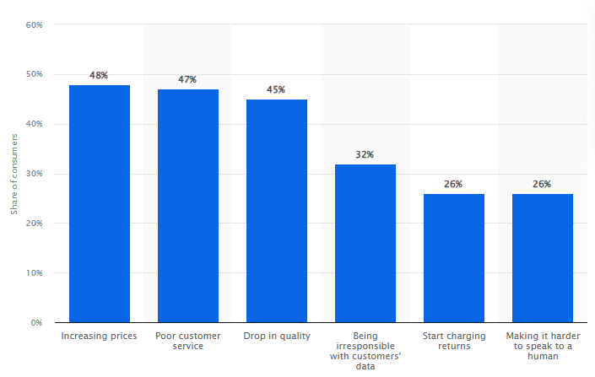
Figure 5: Factors negatively impacting customer loyalty in the UK 2024
(Source: Statista Research Department, 2024)
The other major issue is the privacy of customers and the ethical handling of data. The loyalty programmes that are personalised rely on the gathering of a lot of information about customer buying habits, shopping frequency and demographics. Although consumers like receiving personalised suggestions, some are concerned about the use, storage and collection of personal data by retailers. On the same note, privacy and trust are other vital conditions of personalisation. According to Moric et al. (2024), anxieties regarding data use may decrease the level of trust and programme uptake, and Puneet (2023) suggests balancing personal relevance, promotional value and privacy.
Overall Summary
In general, in the literature reviewed, personalisation is positively but conditional associated with customer loyalty. Perceived value, satisfaction, engagement and repeat purchasing can be enhanced with personalised offers and rewards, and digital technologies can help retailers to provide them at scale. Nonetheless, behavioural engagement is not necessarily sustainable loyalty, as customers are still affected by price, convenience, service quality, trust and competitive offers. The literature thus places personalisation as a significant factor in customer loyalty as opposed to a determinant on its own, which is the foundation of studies to analyse the role of personalisation in Tesco Clubcard and how it compares to that of Sainsbury's Nectar.

2.6 Theoretical Framework
Since personalised loyalty programmes are developed to create a long-term relationship based on personalised customer relationships and value creation, Relationship Marketing Theory and Social Exchange Theory offer a decent basis for interpreting the impact of personalisation on customer loyalty.
Relationship Marketing Theory
The Relationship Marketing Theory as formulated by Morgan and Hunt (1994) holds that effective marketing is achieved by the creation, sustenance and reinforcement of long-term relationships as opposed to focusing on individual transactions. The study by Wang et al. (2020) states that trust and commitment are the two key determinants when it comes to sustainable customer relationships. In the context of retailing, this practice has gained even more topicality as supermarkets rely on loyalty programmes to maintain relationships with customers by providing them with personalised offers, sensitive communications and customised shopping experiences.
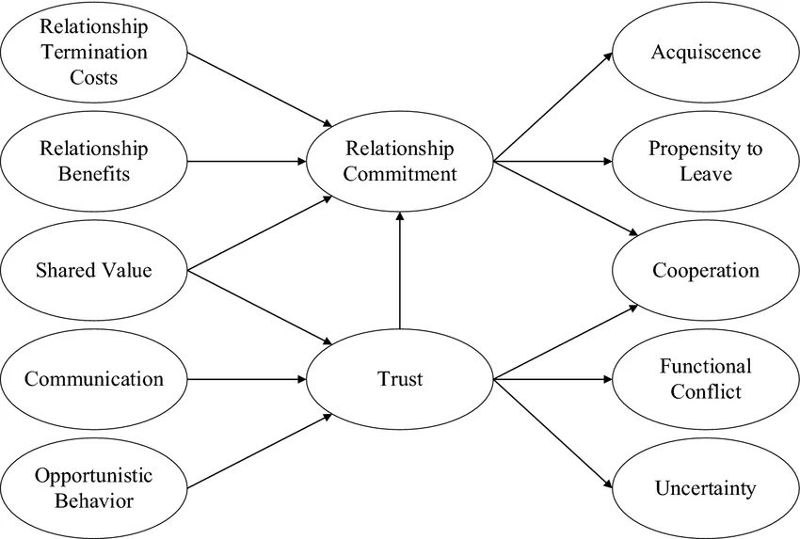
Figure 6: Relationship Marketing Theory
(Source: Wang et al., 2020)
The Relationship Marketing Theory has been used especially in contemporary supermarket loyalty programmes whereby customer buying information is processed to come up with individualised recommendations and rewards. These initiatives will make retailers and customers constantly interact, thus enhancing customer satisfaction and quality of relationships. Pfajfar et al. (2022) indicate that personalised communication increases trust since customers feel that retailers have a better understanding of their personal preferences.
Although it has strong points, Relationship Marketing Theory has a number of weaknesses. The theory presupposes that customers are interested in long-term relations with retailers, but the decision to purchase the product in supermarkets is often dependent on the situational factors of price promotion, convenience, product availability and economic conditions (Dwilianingsih and Indradewa, 2022). The characteristic features of grocery shopping are low switching costs, as consumers can switch across competing retailers regardless of the existence of loyalty programmes. Relationship-building strategies, therefore, might not be sufficient in securing customer loyalty in the presence of rival supermarkets who offer better value to customers. Thus, although the theory does well in expounding on the role personalised loyalty programmes could play in enhancing customer relationships, it could be under-evaluating the role played by external market conditions in consumer behaviour.
Social Exchange Theory
The second theory that is used to support this study is the Social Exchange Theory, which was first proposed by Blau (1964). The theory postulates that people remain loyal with a brand where they feel that the returns to the relationship outweigh the costs incurred (Ahmad et al., 2023). Value, fairness and reciprocity are therefore the rational considerations that affect customer behaviour. Under the retail loyalty programmes, customers will persist in the programme as personalised rewards, discounts and exclusive offers are perceived to have a significant value relative to the effort of being loyal to a retailer.
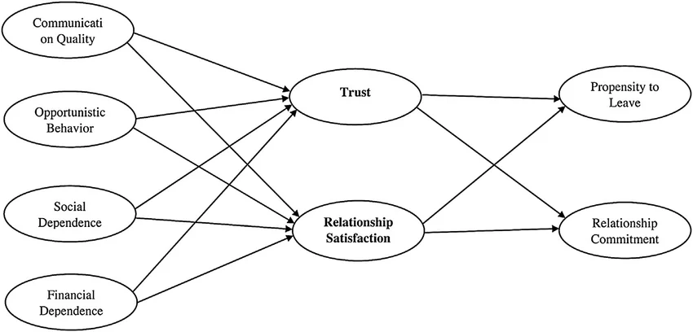
Figure 7: Social Exchange Theory
(Source: Jeong and Oh, 2017)
The effectiveness of personalised loyalty programmes can be well explained using Social Exchange Theory since customers consider whether or not personalised offers can enhance their shopping experience and create economic value. Personalised promotions and other applicable rewards enhance the felt benefits, thereby persuading customers to keep interacting with retailers (Al-Ghanim and Al-Hadrawi, 2026). On the other hand, customers might drop out after the rewards are deemed inadequate, unrelated or too complex. The theory also determines why customers often make comparisons across competing loyalty programmes and can change retailers when there are other programmes which present them with better value. The Social Exchange Theory has, however, been criticised by Cloarec et al. (2022) as taking customer behaviour to be a rational economic transaction. Brand identification, emotional attachment, habit and psychological commitment may also be important determinants of loyalty but have comparatively less focus in terms of the theory. Moreover, the views of customers on value vary significantly based on personal preferences, shopping behaviour and shifting economic conditions, so loyalty is hard to forecast based on economic analysis only.
The combination of Relationship Marketing Theory and Social Exchange Theory offers an all-round perspective of this research. Relationship Marketing Theory describes the role of personalised loyalty programmes in the strength of customer relationships based on the three pillars of trust, commitment and ongoing engagement (Rosário and Casaca, 2023). Whereas Social Exchange Theory describes the response customers would give when they perceive a personalised reward as creating value. Notably, the theories describe the processes by which personalisation can foster trust, perceived value and commitment, but they do not in and of themselves show the strength of the resultant commercial impact (Cloarec et al., 2022). There is therefore a need to find empirical evidence as to whether the benefits of relationships as predicted by theory translate into actual customer loyalty results.

2.7 Conceptual Framework
The conceptual framework shows the hypothesised correlation between the attributes of the personalised loyalty programmes and customer loyalty in the UK supermarket sector. It supposes that customer satisfaction, customer trust, customer repeat purchase behaviour and customer retention are positively affected by personalised rewards, customer data analytics and digital engagement. The theory that supports the framework is Relationship Marketing Theory, which describes the ability of personalised interaction to build long-term customer relationship and Social Exchange Theory, which explains the relationship between customers who will stay loyal when they see that the value of personalised benefits exceeds the costs involved. This framework is used to frame the analysis and interpretation of the findings of the study.
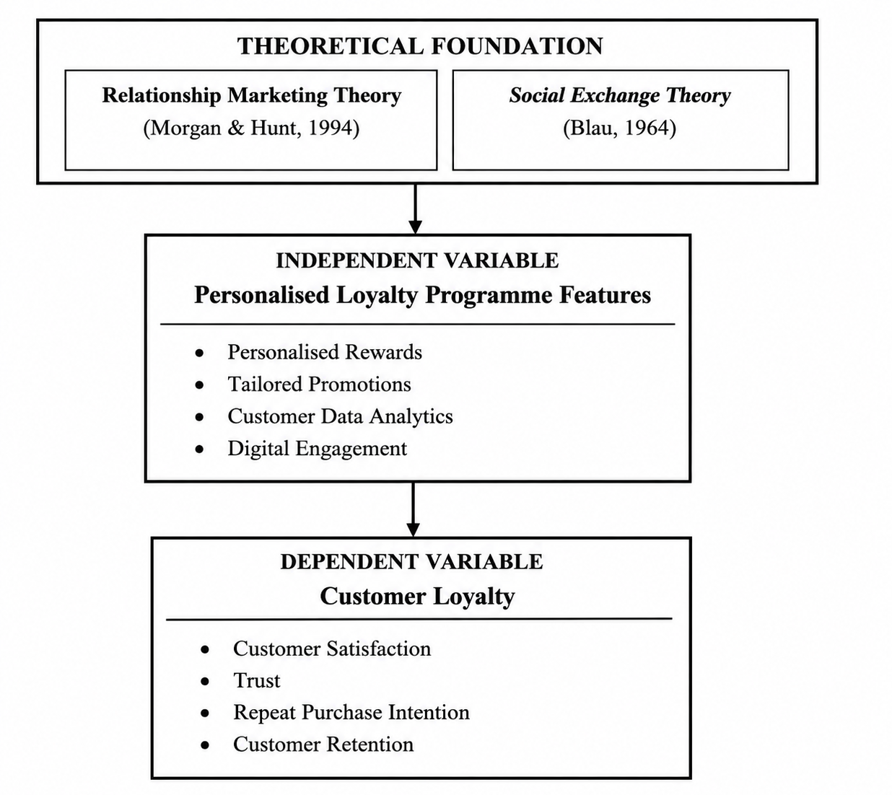
Figure 8: Conceptual Framework
(Source: Self-developed)

2.8 Literature Gap
The literature reviewed shows that customer loyalty and personalised loyalty programmes have received significant scholarly interest, especially as regards customer engagement, satisfaction and repeat purchasing. Nevertheless, the literature by Oualid et al. (2024) and Hallikainen et al. (2022) analyses these concepts separately or in a wider retail environment, which has limited the insight into the functioning of personalised loyalty strategies in the UK supermarket industry. In addition, Theodorakopoulos and Theodoropoulou (2024) and Lion and Akpan (2024) focus on the technological aspects or functioning capabilities of loyalty programmes instead of critically evaluating their role in creating sustainable customer loyalty. In spite of the fact that Tesco Clubcard is often considered to be a prime illustration of retail personalisation, comparatively limited research exists on how personalised features of it compare to those implemented in the UK supermarket industry to evaluate its success.
Moreover, there is an inconsistent body of past studies as to whether or not the use of personalised rewards enhances true long-lasting loyalty or simply promotes short-term buying by generating financial incentives. Less consideration has also been made on synthesising the current evidence on how digital personalisation, customer data analytics and customised promotions all play a role in customer trust and retention. Another weakness has to do with the lack of synthesis of quantifiable results that relate to individualised loyalty programmes. Current literature has tended to associate personalisation and engagement, satisfaction and repeat purchase, yet there is less focus on the difference between these effects and sustainable retention and on whether the effects reported in the commercial literature can be directly related to personalisation (Oualid et al., 2024). Thus, this paper fills these gaps by conducting a systematic review of current literature to assess the role of personalisation of Clubcard in enhancing customer loyalty and creating evidence-based findings for the broader UK supermarket sector.

2.9 Chapter Summary
The literature on the topic of customer loyalty, personalised loyalty programmes and how they are used within the UK supermarket industry was critically reviewed in this chapter. The discussion has analysed the concept and determinants of customer loyalty, the development of retail personalisation and how the major UK supermarkets have implemented the strategy of personalised loyalty. It also assessed the success and issues related to individualised loyalty programmes, with incongruent results on their effects on customer long-term loyalty. The study was based on Relationship Marketing Theory and Social Exchange Theory, and the conceptual framework depicted the proposed relationship between personalisation and customer loyalty. Thus, the literature gap identified defined the research methodology in the following chapter.

CHAPTER 3: RESEARCH METHODOLOGY

3.1 Introduction
This chapter elaborates on the research methodology that was used to assess the effectiveness of personalisation of Clubcard in enhancing their customer loyalty in the UK supermarket industry. It provides the methodological choices, which are justified by the use of Saunders' Research Onion, which encompasses the philosophy of research, approach, strategy, choice and time horizon. Due to the exploratory character of the study, a secondary qualitative design is used, which is a Systematic Literature Review (SLR) to gather and synthesise available evidence. The chapter discusses data collection procedure, study selection, quality appraisal, thematic analysis, ethical issues, and actions taken to achieve research trustworthiness and methodological rigour.

3.2 Research Design
Research Onion
In this research, the choices, including the research philosophy, approach, strategy, choice, time horizon and techniques, are justified using the Research Onion by Saunders et al. (2023) to ensure consistency between the research aim and the methods chosen.
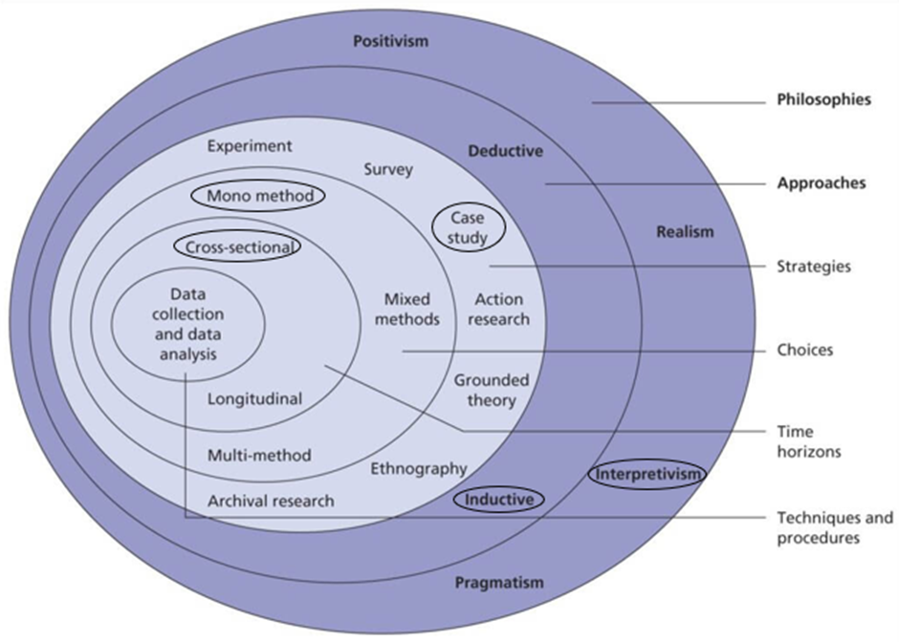
Figure 9: Saunder’s Research Onion framework
(Source: Saunders et al., 2023)
3.2.1 Research Philosophy and Assumptions
The key philosophical approaches are positivism, interpretivism, realism and pragmatism, and the selection should be determined by the nature and the aim of the research (Ikram and Kenayathulla, 2024). The current study followed an interpretivist philosophy to interpret through criticism published data on the topic of Clubcard personalisation and customer loyalty in the UK supermarket market. It presumes that the loyalty of customers is situation-specific and determined by various organisational and consumer variables reported in the literature available. The research thus adopts interpretivism since the objective is to explain how existing scholarly and practice evidence is used to explain the relationship between Clubcard personalisation and customer loyalty, and not to statistically test a predetermined causal relationship.
3.2.2 Research Approach
Research approach mainly has the two major methods: deductive and inductive (Cheng et al., 2024). This study has adopted an inductive approach since it is a methodical analysis and synthesis of published literature to assess the importance of personalisation of Clubcard to enhance customer loyalty. Instead of testing pre-established hypotheses, the study uses existing empirical data to form a broad picture of the impact that personalised loyalty programmes have on customer loyalty in the UK supermarket industry. Inductive approach would be suitable since there are no set hypotheses that are tested in the study (Okoli, 2023). Rather, the selected literature is coded and synthesised to determine recurring patterns with regard to perceived value, engagement, data use, trust and sustainable loyalty. These patterns are then compiled into the themes that are used to respond to the research objectives.
3.2.3 Research Strategy
Amongst various research strategies, such as surveys, case studies, experiments, ethnography, grounded theory and archival research, this research used an archival research strategy as it examined existing information regarding Clubcard personalisation and customer loyalty in the UK supermarket sector, which will yield detailed and reliable information without creating primary data. The choice of archival research allows the systematic analysis of published scholarly materials, trade reports and organisational documents compared to surveys or case studies, where direct data acquisition is necessary through interviews with respondents or organisations (Lim, 2025). Archival research was thus suits the purpose since evidence needed to conduct this study is already available in peer-reviewed studies, company reports, industry reports and published data on supermarket loyalty and personalisation (Cheong et al., 2023). The approach enables these sources to be analysed in a systematic manner without necessarily accessing the proprietary database of customers at Tesco.
3.2.4 Research Choice
As per the Research Onion, various research choices define whether a researcher can choose a particular method of data collection, following a mono-method, multi-method or mixed-method research. The research is a mono-method qualitative research choice as the research used solely secondary qualitative data gathered by published academic sources and industry. The analysis is based on a single method, qualitative analytical approach, and the numerical data provided in the secondary literature are applied as the complementary evidence instead of being tested statistically (Irvine, 2024). In comparison to the mixed-method research that presupposes the combination of different types of data, a mono-method qualitative approach will allow gaining a thorough interpretation and synthesis of available evidence (Kakar et al., 2023). In turn, this research option suits best to critically examine the contribution of Clubcard personalisation to customer loyalty enhancement in the UK supermarket market.
3.2.5 Time Horizon
Saunders' Research Onion suggests that studies can use either cross-sectional or longitudinal time horizons (Nair, 2024). This research followed a cross-sectional time horizon due to its synthesis of the current evidence from the published literature in providing an answer to the question of how Clubcard personalisation enhances customer loyalty in the UK supermarket sector. Instead of analysing the changes in the loyalty programmes over a few years, the research gives a wholesome evaluation of the existing knowledge and evidence available at the time when the systematic literature review was conducted. The cross-sectional time horizon is taken since the SLR will synthesise evidence, which is available at a specific timeframe, which in this case is 20222026 to evaluate the existing role of Clubcard personalisation. The analysis thus offers a modern evaluation as opposed to following the changes in individual customers over time.

3.3 Data Collection Methods
3.3.1 Data Collection
Primary data are data gathered by original means like surveys, observation or interviewing, whereas secondary data are already available in print, in scholarly journals, books, company reports and industrial data banks. In this research, secondary qualitative data collection method was chosen as this research seeks to determine the effectiveness of using Clubcard personalisation to enhance customer loyalty as opposed to directly measuring customer perceptions. The research gathered data in a Systematic Literature Review (SLR), which is a structured and transparent data-identifying, selection and synthesising literature process (Ajayi, 2023). The research employed secondary data since the objective of the research is to critically evaluate the role of Clubcard personalisation based on the existing evidence on the same in the UK supermarket industry, as opposed to quantifying the perceptions of a new sample of customers. Primary data, e.g. a survey or interviews, may give direct customer perceptions, but would largely only give individual perceptions at a single point in time and would not access proprietary Clubcard data or other organisational evidence owned by Tesco. Conversely, secondary evidence allows the research to synthesize the scholarly results with corporate records, industry facts and published records pertaining to the programme enrolment, client savings, customisation and loyalty (Dale et al., 2025). This is especially suitable when the Tesco-Sainsbury comparison is concerned since the two retailers have evidence available on the size and functionality of their loyalty programmes.
Secondary Data Sources
Academic databases were searched to find relevant studies in well-known databases, such as ScienceDirect, Emerald Insight, SpringerLink, Wiley Online Library and Google Scholar. These databases were chosen as they give access to peer-reviewed research of high-quality that relates to retail marketing, customer loyalty, and personalisation of a loyalty programme.
Search Strategy
An extensive search strategy was built based on the keywords that were formulated based on the research topic and objectives. Some of these keywords were "Clubcard personalisation", "Customer loyalty", "Retail loyalty programmes", "UK supermarket industry", "Tesco Clubcard", "personalised marketing", and "consumer behaviour". AND, OR and NOT were used as Boolean operators to further narrow down search results and enhance retrieval.
Study Selection Process
After the search process, predetermined inclusion and exclusion criteria were used to screen out the studies.
Table 1: Inclusion and Exclusion Criteria
Criteria | Inclusion | Exclusion
Article type | Peer-reviewed journal articles | Conference papers, editorials and blogs
Language | English language publications | Non-English publications
Time Period | Published between 2022–2026 | Studies published before 2022
Relevance | Studies relating to retail, supermarkets or loyalty programmes | Studies unrelated to customer loyalty or retail personalisation
Availability | Full-text articles available | Abstract-only publications
Quality Assessment
The Critical Appraisal Skills Programme (CASP) Checklist was used to determine the quality of methodology of the chosen studies to guarantee credibility, relevance and methodological rigour. In that case, only the studies that passed the quality assessment criterion were incorporated into the final review, thus making the evidence synthesised in this study reliable.
PRISMA Diagram
The image below illustrates the searching process that was done in this dissertation.
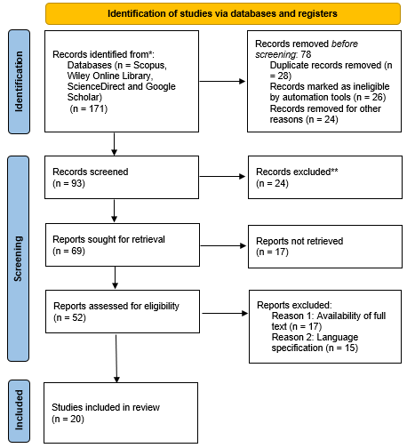
Figure 10: PRISMA Diagram
(Source: Self-developed)
3.3.2 Data Analysis
The study used thematic analysis as it offers a flexible and rigorous method of determining the common patterns and themes in a number of studies. Thematic analysis can be used to better understand meanings and relationships of concepts in qualitative evidence than content analysis, which is mainly used to measure the prevalence of concepts (Braun and Clarke, 2022). Thus, it is more suitable for assessing the contribution of Clubcard personalisation in enhancing customer loyalty.
The analysis was done using the six-phase model by Braun and Clarke (2006). The chosen data sources were re-read to obtain familiarity with the information. After that, the relevant information was then coded systematically as per the research objectives. Similar codes were clustered to give preliminary themes, which were now revised and refined to make sure that they were consistent and relevant. The themes were then characterised and named to represent the underlying meaning and then combined into a coherent narrative (Naeem et al., 2023). This systematic analytical procedure facilitated the identification and synthesis of the main trends in connection with the personalised loyalty programmes and customer loyalty in the UK supermarket sector (Aguinis, 2023).

3.4 Ethical Considerations
Ethical considerations are integral in research work to guarantee the conduct of research in a responsible manner (Taquette and Borges da Matta Souza, 2022). Even though the research does not imply the use of human subjects and the collection of primary data, the principles of ethics still apply since the research utilises published secondary sources. The study only utilised peer-reviewed journal articles, academic books, industrial reports, and reputable databases that are publicly available and suitable for conducting academic research. Before inclusion in the systematic literature review, all sources had to undergo a critical assessment of their credibility, relevance and methodological quality.
In order to ensure academic integrity, any ideas, findings and evidence acquired through published research are properly referenced with the necessary referencing style, which prevents plagiarising and ensures respect for copyright laws (Drolet et al., 2023). Moreover, the search strategies, inclusion and exclusion criteria and quality assessment procedures were applied uniformly to the whole review process in order to reduce researcher bias and provide transparency in the selection of the studies. Interpretation and reporting of findings were done in an objective manner without distortion and misrepresentation of the original evidence. Since no personal data were gathered, no data on informed consent, anonymity and confidentiality issues were relevant (Aguinis et al., 2024). In general, the research adhered to the institutional ethical standards and the norms of honesty, transparency and research integrity during the research process.

3.5 Reliability and Validity
The key to the credibility and reliability of a research study depends on reliability and validity. Reliability was strengthened in this study by applying a systematic and clear literature review process and involved predefined search strategies, inclusion and exclusion criteria, and standard study selection procedures. The validity was enhanced by the fact that only peer-reviewed journal articles and industry reports that were directly relevant to the research objectives were selected. Moreover, the Critical Appraisal Skills Programme (CASP) Checklist was used to evaluate the quality of the methodology, the credibility and relevancy of the chosen studies (Smith et al., 2025). Such practices made sure that the results were informed by strong, credible and quality evidence and thus enhanced the overall rigour and credibility of the study.

3.6 Limitations
Although a systematic and rigorous approach is adopted, this study is limited in a number of ways. To start with, the study uses only secondary data and cannot access any proprietary organisational data like Tesco Clubcard customer databases, the level of sales and revenue directly obtained by the personalised loyalty programmes. Second, the results rely on the quality, breadth and access of available literature, and it can have varying approaches and settings. Third, the review is limited to English-language articles, which may exclude other studies that are relevant but in other languages.
This is a limitation especially in the sense that the study aims at measuring effectiveness. Even though indicators of company reports and industry datasets, including programme participation, customer savings, sales performance and market share, in general do not separate the proportion of these results that can be specifically attributed to personalised loyalty activity. The study is therefore able to find out associations and trends in the existing evidence but not a direct cause effect of Clubcard personalisation on revenue, or retention or purchasing behaviour.

3.7 Conclusion
In this chapter, the research methodology to be used in assessing the importance of Clubcard personalisation in enhancing customer loyalty in the UK supermarket industry has been presented. Inspired by the Research Onion by Saunders, it explained the choice of an interpretivist philosophy, an inductive method, an archival research design, a mono-method qualitative research option and a cross-sectional time frame. The systematic review of the literature procedure, comprising data collection, selection of studies, quality evaluation, and thematic analysis based on a six-phase framework by Braun and Clarke, was also described in the chapter. Reliability, validity and study limitations, as well as ethical considerations, were also addressed, and a clear and stringent methodological basis for the findings and discussion in the next chapter was established.

CHAPTER 4: RESULTS, ANALYSIS AND DISCUSSION

4.1 Introduction
This chapter has provided the findings, discussion and analysis of the systematic literature review that was conducted to determine the role of Clubcard personalisation in enhancing customer loyalty in the UK supermarket industry. The results have been obtained based on the chosen secondary sources and analysed based on themes based on the thematic analysis method provided by Braun and Clarke. The chapter outlines some of the major trends around personalised offers, customer engagement, perceived value, repeat buying, customer retention, data analytics, trust and privacy. The results are critically analysed with respect to the research questions, literature available and the Relationship Marketing Theory and Social Exchange Theory.

4.2 Presentation of Findings from SLR
Table 2: Findings from SLR
Sl no. | Author name and Year of publication | Validity of the research | Research method applied | Geographic region | Key findings | Relevance
1. | Kovalev et al., 2022 | Peer-reviewed journal research; uses established theoretical foundations including relationship marketing and organisational economics. | Quantitative comparative analysis using an index method and comparison of loyalty-programme data from 10 food retailers. | Russia | The online loyalty programmes have the potential to enhance communication and interaction with customers. Programme efficiency can be enhanced by combining loyalty tools in the CRM systems. | Highly relevant because it directly examines digital loyalty programmes in food retail and demonstrates the importance of CRM and digital personalisation.
2. | Krampe et al., 2025 | Peer-reviewed research published in Cleaner and Responsible Consumption. | Conjoint analysis examining consumer preferences for sustainable temporary loyalty-programme attributes. | Europe | Consumers consider temporary loyalty programmes based on the nature of incentives and sustainability. The paper emphasises the need to base loyalty reward designs on consumer preferences instead of considering all incentives to be loyalty-generating. | Applicable to the study of the effects of reward design and customer preferences on the effectiveness of loyalty programmes.
3. | Haji et al., 2025 | High validity; peer-reviewed European Journal of Marketing study with a large sample of 923 retail consumers. | Field study/survey, testing a conceptual model based on Social Exchange Theory. | United Kingdom | The perceived availability of consumer data may affect loyalty in both positive and negative ways: convenience and inspiration, and perceived risk, respectively. | Highly relevant to Clubcard because Tesco's personalisation depends on collecting and analysing customer data.
4. | Smith, 2023 | Published academic research examining CRM and brand loyalty; methodological detail should be interpreted according to the original article. | CRM-focused empirical/secondary analysis. | Global | Good CRM practices can build strong relationships with customers and help retain loyal customers by enhancing customer interaction and relationship management. | Relevant since Clubcard is a significant CRM mechanism by which Tesco can manage relationships with customers.
5. | Motlani et al., 2025 | Peer-reviewed/research-journal systematic review. | Systematic Literature Review (SLR) of customisation and personalisation research. | Global | Customer engagement and commitment can be enhanced through personalisation and customisation. The role of AI and technological development in the provision of personalised experiences is on the rise. | Very topical in terms of the role of digital personalisation in engagement and loyalty and the role of technology in helping Clubcard.
6. | Apergis, 2023 | Peer-reviewed empirical research using a large household dataset. | Logit regression using data from 1,500 households in the Understanding Society Innovation Panel. | United Kingdom | Customers need not utilise loyalty cards as a rewarding tool in the first place. The more insecure households are in terms of their cash flows in their bank accounts, the higher their propensity to have loyalty cards. | Highly relevant because it challenges the assumption that loyalty-card ownership automatically represents genuine loyalty.
7. | Burgess et al., 2025 | Peer-reviewed scoping review in Public Health. Two researchers independently screened and extracted studies, strengthening methodological reliability. | Scoping review of 44 studies using supermarket loyalty-card data. | United Kingdom | Loyalty-card data offer massive and objective purchasing data, but may include missing purchases, connection problems and demographic biases. | Applicable in the context of valuing the usefulness and constraints of the customer data that informs personalised loyalty programmes.
8. | Ahmad et al., 2022 | Peer-reviewed article in Frontiers in Psychology with established theoretical and empirical foundations. | Quantitative empirical study examining relationships between online customer experience, engagement and loyalty. | Global | Customer engagement can result in customer loyalty due to positive online customer experience, whereas the relationship is mediated by value co-creation. | Relevant owing to the fact that Clubcard is becoming more digitalised in terms of application and online customer experiences.
9. | Alexandr and Andrei-Dorian, 2024 | Academic journal research focusing directly on consumer responses to promotional activity. | Conceptual/literature-based analysis of promotional strategies and consumer behaviour. | Global | Perceived value and urgency can be used to make purchase decisions based on promotions, special offers, loyalty campaigns and seasonal promotions and may produce both short and long-term impacts. | Relevant to understanding the role of Clubcard discounts and personalised promotional offers in influencing purchasing behaviour.
10. | Aydin, 2022 | Peer-reviewed journal article; empirical study using an established theoretical framework. | Online survey of users of two leading coalition loyalty programmes; value theory extended with personalisation and information-disclosure constructs. | Turkey | Monetary, hedonic and symbolic benefits have a positive impact on satisfaction. Personalisation has an indirect impact on satisfaction via perceived value, and privacy issues do so earlier. | Very timely since it offers direct Tesco-specific evidence and puts Clubcard in the broader Tesco operating model context.
11. | Meng, 2024 | Academic case-study research focused specifically on Tesco's operations. | Case study/secondary research examining Tesco's grocery operations. | United Kingdom | The success of Tesco's operations is linked with technology, convenience and customer-oriented services. Clubcard is a component of Tesco's greater digital and operational ecosystem. | Applicable to the future of Clubcard since advanced analytics and AI can enhance the quality of the personalised offers.
12. | Bhosale, 2025 | Recent academic research focusing on AI-driven personalisation and loyalty. | Conceptual/secondary research concerning machine-learning-based personalisation. | Global | Machine-learning and AI-based personalisation will be able to detect customer preferences and deliver tailored experiences to convince them to make a purchase again and build brand loyalty. | Very pertinent since it contributes to the relationship-marketing discussion about how tailor-made benefits may be converted to loyalty.
13. | Corbishley et al., 2023 | Peer-reviewed empirical research in the FMCG context. | Quantitative empirical study examining perceived loyalty-programme benefits, relationship quality and loyalty. | South Africa | The benefits of a loyalty-programme affect the quality of relationships in the form of satisfaction, trust and commitment, which are linked to customer loyalty. | Relevant in that Clubcard personalisation is a part of the overall digital transformation of supermarket retail.
14. | Csillik, 2025 | Academic research examining contemporary transformation of food retail. | Review/secondary analysis of automated-commerce developments. | Europe | Special attention is paid to technology and digitally based customer experiences, as automation and digitalisation are transforming both traditional supermarkets and e-commerce. | Applicable to the technological infrastructure underpinning the contemporary loyalty programmes and personalised customer experiences.
15. | Wolniak et al., 2024 | Peer-reviewed review article in Foods; published through an established academic journal. | Literature review of digital transformation in grocery in-store shopping. | Poland and Türkiye | Self-checkouts, scanners, mobile applications, AI, AR and other technologies are becoming more important in grocery retail. More convenient and personalised shopping experiences can be supported by technology. | Moderately relevant as it gives evidence of UK retailing about retention, but it deals with fashion as opposed to supermarket retailing.
16. | Ologunebi, 2023 | Academic Master's thesis; useful contextual evidence but lower evidential weight than peer-reviewed journal research. | Case study using quantitative data and observation, supported by literature, surveys and financial records. | United Kingdom | Marketing, customer experience and technology-driven strategies affect customer retention. Retention can be underpinned by data analytics and digital approaches. | Moderately relevant because it provides UK retail evidence on retention, although it concerns fashion rather than supermarket retail.
17. | Weits, 2025 | Academic postgraduate research focusing specifically on Generation Z and loyalty. | Empirical research examining the relationship between gamification and brand loyalty. | South Africa | Gamification has the potential to facilitate interactions with and brand-loyalty formation of younger consumers who are digitally oriented. | Relevant to the future personalisation of loyalty programmes, particularly digital engagement and younger consumers, although it is less directly related to supermarkets.
18. | Mahlangu, 2025 | Peer-reviewed journal research using a large empirical sample and structural equation modelling. | Survey of 516 digital-loyalty-programme users; SmartPLS 4 and structural equation modelling. | South Africa | There is a positive but weak influence of information benefits on confirmation of digital loyalty programmes. The research highlights the importance of information in the design of digital loyalty programmes. | Relevant because useful information and personalised communication are important components of digitally delivered loyalty programmes.
19. | Belli et al., 2022 | Very high validity due to a comprehensive meta-analysis incorporating evidence from 40 years of research. | Meta-analysis using 429 effect sizes from studies available between 1990 and 2020. | Global | Customer loyalty, especially behavioural loyalty, has a high positive impact on loyalty programmes. Attitudinal loyalty effects are harder to accomplish and are based on programme design and reward attributes. | Very relevant as it gives the best overall evidence that loyalty programmes promote behaviour and shows that behavioural loyalty is not the same as long-term attitudinal loyalty.
20. | Aydin, 2022 | Same peer-reviewed empirical study as Entry 10; therefore should not be treated as a separate study in the final SLR count. | Online survey of two coalition loyalty programmes in Turkey, examining value, personalisation, satisfaction and privacy. | Turkey | Perceived value indirectly enhances satisfaction; monetary, hedonic and symbolic benefits have a positive impact on satisfaction and privacy issues have a less significant negative impact. | Applicable in the context of personalised benefits, customer satisfaction, privacy and loyalty. Duplicate of Entry 10.

4.3 Industry and Company Evidence
Along with the evidence found during the systematic literature review, secondary industry and company data were analysed to give empirical background to the results.
4.3.1 Supermarket Loyalty Card Usage by Gender
The data show that Tesco Clubcard has good, reported usage as compared to Sainsbury's Nectar amongst male and female shoppers. The use of Clubcard is 74% among men and 79% among women, as opposed to 52% of Nectar and 62% of Nectar (Ozbun, 2025). The difference is especially relevant as it implies that Tesco has attained a more extensive behavioural response to its loyalty programme than relying on the availability of the programmes. The increased rate of use must not, however, be automatically taken to be indicative of greater sustainable loyalty since the data measure is programme use and not emotional commitment or retention.
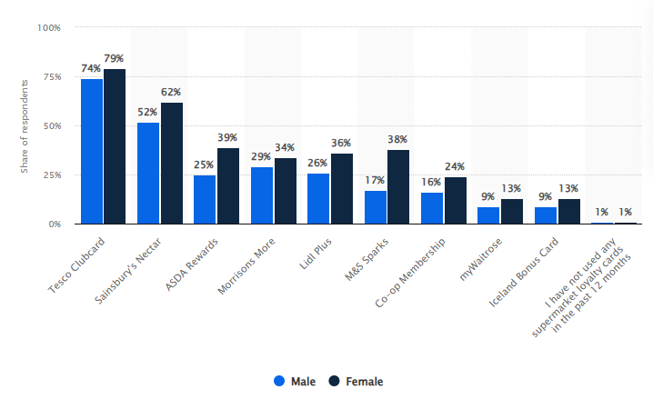
Figure 11: Supermarket Loyalty Card Usage in Great Britain by Gender, April 2025
(Source: Ozbun, 2025)
The gender pattern in the comparison is also similar in both retailers, as women indicated more usage as compared to men. This implies that the personalised loyalty programmes could be affected by the customer characteristics in the process of engagement. The increased usage in the case of Tesco results in an increased behavioural base on which Clubcard can produce personalised offers, but the reduced usage of the Sainsbury's card means that there is less, but still a large pool on which the Nectar-based personalisation can be created. Hence, the evidence favours the topicality of the engagement in loyalty programmes in the context of the research, yet it does not prove that the increased usage at Tesco is due to the personalisation only.
4.3.2 Supermarket Loyalty Scheme Membership
The membership data gives more persuasive data on the penetration of Tesco in the UK loyalty-programme market. Tesco Clubcard has 36.3 million members and a 77% usage rate among frequent grocery shoppers, compared to 26.8 million members of Nectar with a 57% usage rate of Sainsbury (CMA, 2024). The 20-percentage point gap in usage implies that not only is Clubcard subscribed to by a large percentage of shoppers, but that it is also used more often by the target audience of shoppers. This is significant since the repetition of using the programmes will lead to increased purchasing information gathered by Tesco and the provision of a personalised reward.
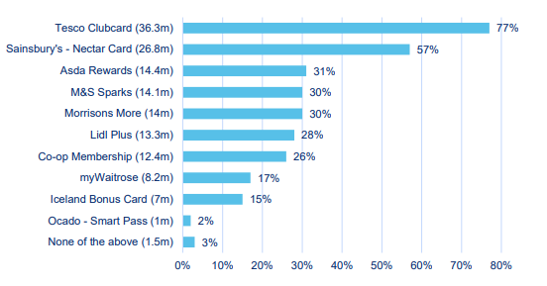
Figure 12: Supermarket Loyalty Scheme Membership in Great Britain
(source: Competition and Markets Authority, 2024)
Membership and usage should, however, be viewed as a measure of programme participation as opposed to customer loyalty. This difference aligns with the existing literature indicating that attitudinal loyalty is less likely to be affected by the loyalty programmes as compared to behavioural loyalty (Belli et al., 2022). The Tesco-Sainsbury comparison thus shows a higher position of engagement by Clubcard but does not show that Clubcard creates higher long-term commitment as compared to Nectar.
4.3.3 Consumer Appeal of Loyalty Programmes
The data on the consumer appeal also enhances the relative position of Tesco. Tesco Clubcard was considered appealing by 69% of the participants, as opposed to 47% of Sainsbury's Nectar (Statista Research Department, 2024). The difference of 22-percentage-points implies that the value proposition of Clubcard can be more attractive to customers compared to Nectar at the measurement point. This can be applied in Theme 1 since perceived value is a significant process by which engagement can be stimulated by personalised rewards.
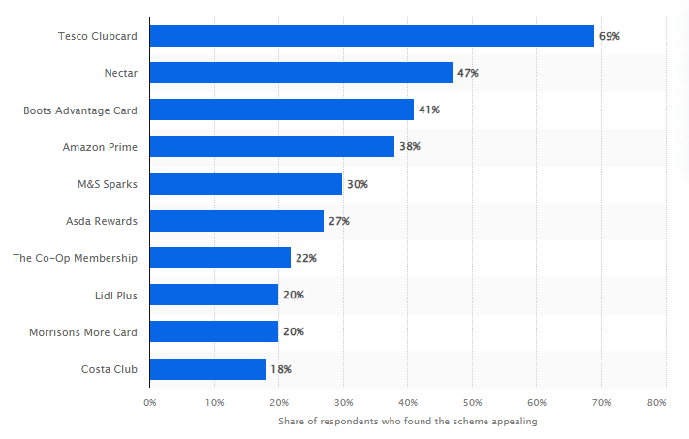
Figure 13: Appeal of Major Loyalty Programmes in Great Britain, 2024
(Source: Statista Research Department, 2024)
However, the attraction cannot be considered as the testimony to allegiance on its own. Clubcard might be appealing to a customer due to the instant savings as he or she uses competing supermarket programmes. As such, the increased attractiveness of Clubcard is indicative of increased perceived programme value but does not determine that personalisation has been generated to higher customer retention or attitudinal loyalty independently.
4.3.4 Tesco Clubcard Personalisation Scale
The Tesco statistics indicate that personalisation is applied at a large scale as opposed to the promotion of a small scale. By 2023/24, over 22 million households in the UK had been using Clubcard; Clubcard sales penetration was at 82% and 289 million personalised coupons were given to 7.6 million customers (LSE, 2025). These numbers are significant as they indicate that Clubcard is integrated into a significant percentage of Tesco customer communications and personalised communication is being delivered consistently, as opposed to infrequently.
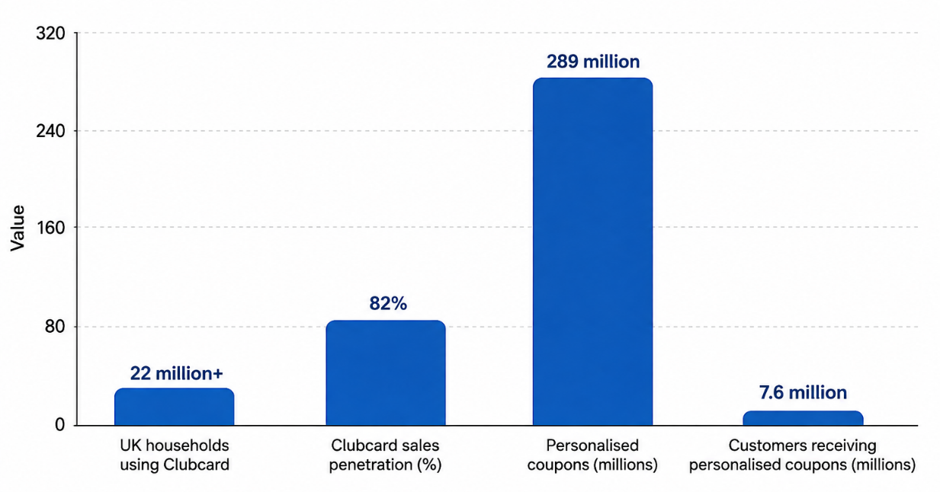
Figure 14: Tesco Clubcard Personalisation Scale
Source: Self-developed using evidence from LSE (2025)
The degree of individualised couponing also demonstrates the degree to which Tesco is using customer buying data to create individualised promotional effort. This favours Theme 1, whereby a huge amount of target offers will create chances to give customers pertinent monetary significance, and Theme 2, since frequent offers can result in further interaction with programmes and buying. The numbers must not, however, be assumed as indications that the 289 million coupons led to higher retention or even revenue. As the methodology acknowledges, publicly accessible company data do not single out the contribution of personalisation to other variables like price, service, convenience of the store and broader marketing action.
Tesco evidence thus shows the magnitude and business significance of personalisation, but not its causal influence alone on the sustainability of loyalty. This difference is the main theme of Objective 3 that relates to the connection between Clubcard personalisation and customer loyalty as opposed to assuming programme activity is a loyalty driver.
4.3.5 Sainsbury’s Nectar Prices Scale
The Nectar used by Sainsbury's offers a valuable point of reference since its personalisation strategy is at a similar level of commercial magnitude. As of 2024/25, Nectar Prices had created over 2 billion in customer savings, over 85% of people are participating, and over 9,000 offers are live (J Sainsbury plc, 2025). These numbers indicate that Sainsbury has also left the traditional points-based loyalty model for a value proposition with a heavy emphasis on personalised and loyalty-based pricing.
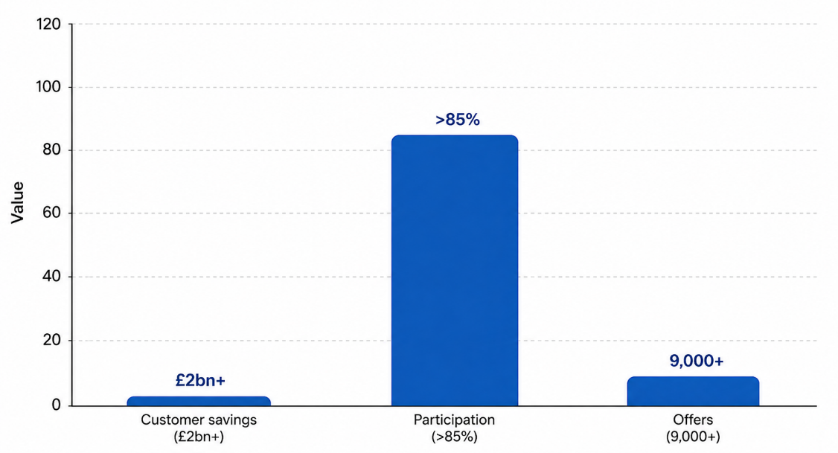
Figure 15: Sainsbury Nectar Price Scale
Source: Self-developed using evidence from J Sainsbury plc (2025)
The comparison between Tesco and the programme is not that of programme size. Tesco has high usage of Clubcard and high usage of personalised coupons; Sainsbury focuses on personalised prices and personalised customer savings with Nectar Prices. Both methods have the advantage of being able to deliver an immediate economic benefit, although they employ slightly different mechanisms to produce engagement. The evidence provided by Tesco indicates the level of focused coupon operation, and the evidence provided by Sainsbury indicates the financial savings achieved by personalised pricing. Notably, neither group of characters do not demonstrate commitment by itself. The high participation and customer savings are signs of engagement with the programme and perceived value, although customers might still use both programmes and alternate between supermarkets where competing prices are more favourable. This supports behavioural engagement and sustainable loyalty found in Theme 5.

4.4 Analysis of Results
The development of themes was done according to the six-phase thematic analysis process suggested by Braun and Clarke. To start with, the chosen literature was read multiple times, which helped to become familiar with the evidence and find out common meanings. Second, systematic coding on pertinent segments was done. Initial codes consisted of personalised offers, customised rewards, personalised discounts, perceived customer value and satisfaction; customer engagement, promotional response, repeat purchasing and behavioural loyalty, customer data, loyalty-card data, data analytics, CRM, AI, machine learning and mobile applications, data privacy, sharing personal information, privacy risk, customer trust, transparency and responsible data use, and attitudinal loyalty, long-term commitment, customer retention, switching, price sensitivity and financial incentives. Third, coded related codes were categorized into larger themes and candidate themes. Fourth, these themes were checked with the coded evidence and research objectives. Fifth, themes underwent refinement and became well defined. This exercise generated five themes that included customer value, engagement and behavioural loyalty, digital technologies, trust and privacy and sustainable loyalty. Lastly, the themes were analysed and documented against the research objectives and literature available.
4.4.1 Theme 1
Table 4: Theme development
Initial code | Category | Theme
Personalised offers | Customer value and personalised benefits | Theme 1: Personalisation enhances perceived customer value and satisfaction
Customised rewards | Customer value and personalised benefits
Personalised discounts | Customer value and personalised benefits
Relevant promotions | Customer value and personalised benefits
Perceived customer value | Customer value and personalised benefits
Customer satisfaction | Customer value and personalised benefits
Monetary benefits | Customer value and personalised benefits
Individual customer preferences | Customer value and personalised benefits
This theme demonstrates that by offering and rewarding customer preferences, personalisation has the potential to increase customer perceived value and customer satisfaction. According to Magasi (2024), the repetition of personalised offers, rewards, customised and personalised discounts, and relevant promotions highlights that customers can gain more value as the loyalty benefits are based on their purchasing behaviour and not offered in a standardised way. Aydin (2022) indicates this result, showing that perceived value is a crucial aspect in determining satisfaction in mobile loyalty programmes. Satisfaction can be boosted with the help of monetary, hedonic and symbolic benefits, and personalisation can be a source of value creation.
The results further highlight that the key to personalisation is the individual customer preferences. By utilising customer data to determine buying habits, retailers will be able to offer more pertinent promotions and can even make the loyalty programme more useful. The same can be said about Motlani et al. (2025), who view customisation and personalisation as mechanisms that can be used to facilitate customer engagement and loyalty. In the case of Tesco, this implies that with personalised discounts based on the needs and preferences of customers in shopping, Clubcard can enable Tesco to generate more customer value.
However, the perceived value can be perceived regarding monetary discounts. The overall customer experience can be enhanced by providing relevant recommendations, convenient offers and personalised communication (de Sousa Pereira et al., 2025). In general, the theme shows that customer value and satisfaction can be enhanced by personalised Clubcard benefits, which provide a valuable platform to engage and consequently bring loyalty. Relative to Tesco, which offers personalised Clubcard discounts and offers, Sainsbury uses Nectar Prices and personalised Nectar offers. The two methods thus sustain the perceived value on the basis of individualised economic gains, though the existing evidence lacks the determination of which programme generates more risk in long-term loyalty.
4.4.2 Theme 2
Table 5: Theme development
Initial code | Category | Theme
Customer engagement | Customer engagement and repeat purchasing | Theme 2: Personalised loyalty programmes enhance customer engagement and behavioural loyalty
Online customer experience | Customer engagement and repeat purchasing
Customer interaction | Customer engagement and repeat purchasing
Repeat purchasing | Customer engagement and repeat purchasing
Promotional response | Customer engagement and repeat purchasing
Continued programme participation | Customer engagement and repeat purchasing
Behavioural loyalty | Customer engagement and repeat purchasing
Customer retention | Customer engagement and repeat purchasing
This theme illustrates that customer engagement and behavioural loyalty can be improved through personalised loyalty programmes by promoting interaction. Customer responses to promotions, repeat purchases and sustained customer involvement. Individualised offers provide customers with pertinent motivation (Ahmad and Hussain, 2025). This theme is evidenced in the industry by both retailers. Clubcard is used by Tesco to provide personalised coupons, discounts and targeted benefits on a large scale, and Nectar by Sainsbury's is a combination of broad Nectar Prices and Your Nectar Prices. Tesco thus seems to focus more on personalised couponing and benefits associated with Clubcard, whilst Sainsbury relies more on personalised pricing and individual offers on a weekly basis. The two methods generate instant financial value, implying that the mechanism behind them is likely to be similar: customers feel more valued when the rewards are applicable to their buying behaviour. Nonetheless, the existing data do not prove that either of the approaches results in more long-term loyalty.
Customer retention is a potentially significant consequence of long-term engagement. Once customers always feel that they get value out of the personalised Clubcard benefits, they might keep on with the programme and sustain their association with Tesco. Another aspect that Corbishley et al. (2023) and Kuppelwieser et al. (2022) focus on is the connection between the benefits of the loyalty programme, the quality of the relationship, and loyalty. Comparatively, Tesco personalised coupons and online Clubcard activities promote return contact, whereas Nectar Prices (personalised products) at Sainsbury's promote customer re-engagement to access the targeted savings. Therefore, there is evidence of behavioural involvement in both programmes, but the reported programme usage is higher in Tesco, which implies that it reaches more people at the moment.
4.4.3 Theme 3
Table 6: Theme development
Initial code | Category | Theme
Customer data collection | Data-driven personalisation and digital transformation | Theme 3: Customer data and digital technologies strengthen personalised loyalty programmes
Loyalty-card data | Data-driven personalisation and digital transformation
Customer data analytics | Data-driven personalisation and digital transformation
CRM systems | Data-driven personalisation and digital transformation
Artificial intelligence | Data-driven personalisation and digital transformation
Machine learning | Data-driven personalisation and digital transformation
Mobile applications | Data-driven personalisation and digital transformation
Digital loyalty programmes | Data-driven personalisation and digital transformation
Personalised recommendations | Data-driven personalisation and digital transformation
Information benefits | Data-driven personalisation and digital transformation
The third theme reveals that customer data and digital technologies are focused on the creation of personalised loyalty programmes. The repetitive codes reveal that loyalty-card information, customer data analytics and CRM systems allow retailers to comprehend the purchasing behaviour and give them more specific benefits. Haji et al. (2025) stress the role of consumer-data availability in retail relationships and Burgess et al. (2025) show the usefulness of supermarket loyalty-card data to gain more detailed information about purchasing behaviour.
The results point to the growing role of artificial intelligence and machine learning and digital technologies. Bhosale (2025) finds AI-based personalisation as one of the methods of gaining insights into customer preferences and facilitating repeat buying. Likewise, Wolniak et al. (2024) demonstrate the impact of technologies such as artificial intelligence and digital shopping systems on grocery retail. Digital loyalty programmes and mobile applications can offer other platforms where personalised offers and suggestions can be delivered to customers (Obiegbu and Larsen, 2025).
The additional benefits of the code information are that the customer would be able to derive value as their information is used by the retailers to send relevant and useful communication. According to Mahlangu (2025), information benefits have a role in digital loyalty programmes, implying that beneficial information can help in keeping customers satisfied with their adopted digital loyalty systems.
In the case of Tesco Clubcard, the results imply that the data on customers can be converted to individualised discounts, suggestions, and digital communication. However, technology failed to ensure loyalty. Its success relies on the perception of customers of the resulting benefits being relevant, useful and valuable (Yum and Kim, 2024). The comparison of Tesco and Sainsbury's reveals that both companies are increasingly becoming dependent on personalisation based on data. Tesco leverages Clubcard data, analytics and AI to assist in personalised offers and customer interactions, and Sainsbury leverages transaction data and machine learning to create personalised Nectar offers and data-driven marketing with Nectar360. Thus, technology is a facilitator of customisation between the two retailers, and not a Tesco special. Nonetheless, technological capability is not the only thing that can prove sustainable loyalty until the customers see the ensuing offers as applicable and useful.
4.4.4 Theme 4
Table 7: Theme development
Initial code | Category | Theme
Customer data privacy | Trust, data privacy and perceived risk | Theme 4: Trust and privacy influence the effectiveness of personalisation
Personal information sharing | Trust, data privacy and perceived risk
Perceived privacy risk | Trust, data privacy and perceived risk
Customer trust | Trust, data privacy and perceived risk
Data transparency | Trust, data privacy and perceived risk
Responsible data use | Trust, data privacy and perceived risk
Perceived convenience | Trust, data privacy and perceived risk
Information disclosure | Trust, data privacy and perceived risk
Relationship quality | Trust, data privacy and perceived risk
Data availability | Trust, data privacy and perceived risk
The fourth theme determines trust, privacy and perceived risk to be critical determinants of the effectiveness of personalised loyalty programmes. Personalisation involves gathering and analysing customer data, such as buying behaviour and preferences to retailers. Haji et al. (2025) demonstrate that convenience and inspiration are the positive effects that may be produced by providing consumer data. However, perceived risks to customers can be generated. Thus, personalisation based on data could have both positive and negative effects in the customer-retailer relationship.
Similarly, Aydin (2022) marks privacy concerns in the case of mobile multi-brand loyalty programmes, showing that customers are concerned with privacy and the benefits they get with the help of loyalty programmes. Therefore, data transparency and responsible use of data are both valued in ensuring customer trust.
The results indicate that the perceived convenience can motivate customers to embrace personalisation in case data sharing leads to relevant offers and useful experiences (Flacandji et al., 2023). The quality of relationships is crucial since trust can assist in longer-term relationships with customers, as Corbishley et al. (2023) argued. In the case of Tesco Clubcard, it implies that increased availability of data can be used to improve the precision of personalised offers, as data gathered or confusing data gathering can affect trust adversely. The results indicate that successful personalisation should be based on the balance between customer value and privacy protection (Dyatmika et al., 2025). Tesco and Sainsbury have the same privacy-personalisation trade-off since both loyalty programmes rely on data about customer transactions. The Clubcard at Tesco and the Nectar at Sainsbury leverage customer data to personalise the offerings and the marketing, so transparency and accountable use of the data are key requirements for the preservation of trust.
4.4.5 Theme 5
Table 8: Theme development
Initial code | Category | Theme
Behavioural loyalty | Short-term engagement versus long-term loyalty | Theme 5: Personalisation encourages behavioural loyalty but does not guarantee sustainable customer loyalty
Attitudinal loyalty | Short-term engagement versus long-term loyalty
Repeat purchasing | Short-term engagement versus long-term loyalty
Long-term commitment | Short-term engagement versus long-term loyalty
Customer retention | Short-term engagement versus long-term loyalty
Customer switching | Short-term engagement versus long-term loyalty
Multiple loyalty-programme membership | Short-term engagement versus long-term loyalty
Price sensitivity | Short-term engagement versus long-term loyalty
Financial incentives | Short-term engagement versus long-term loyalty
Sustainable loyalty | Short-term engagement versus long-term loyalty
Customer commitment | Short-term engagement versus long-term loyalty
The above theme brings out the difference between behavioural and sustainable customer loyalty. The results show that tailored offers and financial rewards can prompt a repeat purchase, sustained participation in the programme and retention. However, these behaviours cannot be a sign of commitment or attitudinal loyalty in the long term. Belli et al. (2022) present valuable data according to which loyalty programmes are more influential on behavioural loyalty than attitudinal loyalty, and customers can buy more and more products in a retail store without becoming emotionally attached.
Apergis (2023) criticises the notion that involvement with the loyalty card is a major sign of loyalty since the economic situation can affect customers' use of loyalty cards. This renders price sensitivity and monetary incentives critical in the UK supermarket industry. Customers can take advantage of individualised Clubcard discounts as they offer instant savings and price comparisons with other competing supermarkets (Pereira et al., 2025). Therefore, customers make repeat purchases at Tesco due to their effective loyalty programs such as Clubcard. This aligns with the literature by Cloarec et al. (2022) that determined supermarket loyalty to be dependent on price, convenience, service quality, and customer experience in addition to the benefits of the loyalty programme.
This is a weakness for both Tesco and Sainsbury. The strong programme engagement is demonstrated by High Clubcard usage and Nectar Prices participation, although they neither create exclusive nor long-term loyalty. Customers can still shop around and move between supermarkets, suggesting that personalisation helps maintain loyalty but works in conjunction with more general values, convenience, and service considerations.
4.4.6 Theme Objective Mapping
The themes that have been formed on the basis of the thematic coding are not discussed as independent findings to the objectives of the research. Instead, they are interrelated aspects of the research problem and altogether, they are the evidence needed to fulfil the four objectives. Theme 1 and Theme 2 elaborate mostly on how personalisation leads to customer value, engagement and behavioural loyalty in order to meet Objective 1. Objective 2 also includes the comparison of Tesco Clubcard and Sainsbury Nectar based on Theme 1 and Theme 2. Themes 1-5 explain together the relationship between Clubcard personalisation and customer loyalty under Objective 3 with Themes 1, 3, 4 and 5 giving the evidence of recommendations under Objective 4. The thematic analysis thus gives the evidence base based on which each of the research objectives is addressed, not a distinct analytical process.
Table 9: Theme Objective Mapping Table
Theme | Core finding | Main objective addressed | Supporting objectives
Theme 1: Personalisation enhances perceived customer value and satisfaction | Personalised offers, rewards and discounts increase perceived value and satisfaction | Objective 1 | Objective 2, Objective 3
Theme 2: Personalised loyalty programmes enhance customer engagement and behavioural loyalty | Personalisation encourages interaction, repeat purchasing and behavioural loyalty | Objective 1 | Objective 3
Theme 3: Customer data and digital technologies strengthen personalised loyalty programmes | Customer data, CRM, AI and digital technologies enable more relevant personalisation | Objective 3 | Objective 4
Theme 4: Trust and privacy influence the effectiveness of personalisation | Data sharing, transparency and privacy affect willingness to engage with personalisation | Objective 3 | Objective 4
Theme 5: Personalisation encourages behavioural loyalty but does not guarantee sustainable customer loyalty | Personalisation can stimulate repeat purchases but wider factors influence sustainable loyalty | Objective 1 | Objective 3, Objective 4

4.5 Discussion of Results
4.5.1 Discussion based on Objective 1 (addressed through Theme 1, 2 and 5)
The findings indicate that the customised loyalty programmes have the potential to lead to customer loyalty based on the perceived value, satisfaction, engagement and repeat purchasing. Theme 1 revealed that loyalty programmes, with personalised offers, tailored rewards and pertinent discounts, are more valuable to individual customers. This confirms findings by Aydin (2022), who discovered that personalisation could increase satisfaction levels with perceived customer value, and Motlani et al. (2025), who discovered that personalisation was a relevant tool to attract customers and keep them loyal. Nonetheless, this discovery must be taken together with the opposing evidence of the fact that personalisation does not always lead to sustainable loyalty. According to Rodriguez-Ardura et al. (2025) or Mukabbir (2023), customer engagement and repurchase behaviour can be the expression of a value-seeking behaviour or a response to a temporary promotion rather than a long-term commitment. Thus, the current results confirm the beneficial contribution of personalisation to behavioural loyalty, along with the fact that the contribution of personalisation to sustainable loyalty is conditional.
Theme 2 showed how the personalised programmes may stimulate customer interaction, response to promotions, purchase reiteration and behavioural loyalty. The result agrees with the literature review that found customer experience, perceived value and satisfaction to be significant predictors of supermarket loyalty. Ahmad et al. (2022) determined that positive customer experiences can be a loyalty contributor, and customer engagement is one of the mechanisms that can facilitate this effect. The support is especially close in Belli et al. (2022) demonstrate that the effects of the loyalty programmes are more significant on behavioural loyalty rather than attitudinal loyalty.
Theme 5, however, suggests that individualised loyalty programmes do not necessarily generate sustainable customer loyalty. Customers might react to individualised discounts due to financial motivations and compare prices or competitive supermarket loyalty programs. This reinforces the argument of the literature review by Li et al. (2024) that the loyalty of supermarkets is multidimensional and price-dependent in terms of convenience, quality of service and customer experience.
Relationship Marketing Theory can be used to explain the findings because, through personalised interactions, the level of satisfaction, trust and quality of relationship can be enhanced, which may support stronger customer relationships over time. Nevertheless, Theme 4 reveals trust and privacy as significant requirements, as personalisation relies on the information about customers. This agrees with the study by Li et al. (2024), which aligns with the Social Exchange Theory, in which customers evaluate the benefits gained out of personalisation against the perceived costs and risks of information sharing.
Generally, Objective 1 is attained by showing that personalised loyalty programmes can contribute to customer loyalty, especially the perceived value, engagement and behavioural loyalty. However, personalisation must work together with competitive prices, convenience, quality of services, trust and positive customer experiences to build sustainable loyalty.
4.5.2 Discussion based on Objective 2 (addressed through Theme 1 and 2)
As the comparison shows, Tesco and Sainsbury employ various yet closely connected personalisation mechanisms. Tesco is integrating Clubcard information with personalised coupons, Clubcard Prices and digital, with Sainsbury focusing on Nectar Prices, personalised Nectar offers and data-driven marketing (Zhou et al., 2024). The increased reported programme use and greater membership by Tesco indicate a greater reported programme reach, whilst the fact that the Customer savings are impressive. Moreover, the percentage of Nectar Prices participation is huge by Sainsbury show that the creation of a perceived value through personalised pricing can also be powerful. The evidence thus indicates that the involvement of both programmes in behavioural involvement is based on the pertinent economic advantages, yet neither the data on the participation of the companies nor data on the data on savings shows sustainability loyalty (Haris, 2025). These results favour the opinion that personalisation is a significant factor of loyalty, though its efficacy is still reliant on other broad aspects, including price, convenience, quality of service and trust.
Belli et al. (2022) meta-analysis of the supportive literature revealed that the impact of loyalty programmes on behavioural loyalty was stronger compared to attitudinal loyalty. It is in line with the differentiation found in the literature review between behavioural engagement and sustainable loyalty. Abi Azhar et al. (2026) and Pereira et al. (2025) indicate that customer behaviour can also be impacted through price competitiveness, service quality, convenience and financial incentives. The Tesco vs Sainsbury comparison, thus, suggests the worth of personalisation, but not that personalisation is a sufficient factor to build long-term loyalty. The involvement and customer savings are therefore to be perceived as a sign of engagement and value as opposed to a conclusive commitment of emotions. This is especially significant in the UK supermarket industry where consumers are allowed to be members of various rival loyalty programs and are price-sensitive (Dahish et al., 2025).
Relationship Marketing Theory would have it that the two programmes would lead to strengthening relationships between retailers and customers through relevant benefits and adding value. Under the Social Exchange Theory, customers will tend to keep on participating when the benefits (economic and convenience) outweigh the costs of data sharing and privacy issues. Generally, the observations imply that Clubcard and Nectar are usually similar in their application of personalisation to generate customer value and customer engagement, and their eventual contribution to sustainable loyalty relies on broader concerns like price, convenience, quality of service, trust and customer experience.
4.5.3 Discussion based on Objective 3 (addressed through Theme 1, 2, 3, 4 and 5)
The results provide a positive yet contingent relationship between personalisation of Clubcard and customer loyalty. Omazić et al. (2026) demonstrated that perceived customer value and satisfaction can be enhanced with personalised offers, discounts and customised rewards. By offering benefits tailored to the personal preferences of purchasing, customers can find them more relevant and useful, and this will reinforce their bond with Tesco. This is in line with the literature review by Rosário and Casaca (2025), which found perceived value, satisfaction and positive customer experiences to be key determinants of supermarket loyalty. However, this observation could not be construed to mean that personalisation is a sole determinant of loyalty. Price, convenience, the quality of services and availability of products turned out to be other factors affecting supermarket loyalty, which were named in the literature review. This helps to confirm that one of the determinants of loyalty is the personalisation of Clubcards and that this is not an independent determinant.
Theme 2 found a connection between personalisation, customer engagement, repeat purchasing and behavioural loyalty. Customised offers would help attract customers to use Clubcard more often and visit Tesco to enjoy the offers. This aligns with the findings by Belli et al. (2022), who in their meta-analysis revealed that behavioural loyalty is more strongly impacted by loyalty programmes as compared to attitudinal loyalty. Thus, Clubcard personalisation can affect the purchase behaviour as behavioural loyalty should not necessarily be perceived as deep customer commitment.
Theme 3 emphasises customer information and digital technologies as significant mechanisms between personalisation of the Clubcard and loyalty. The information provided by loyalty cards, customer analytics, and digital platforms enables Tesco to recognise purchasing trends and offer some benefits to customers. Theme 4, however, shows that this relationship may be undermined by privacy issues and perceived dangers in sharing information.
These results are in line with Relationship Marketing Theory, whereby personalised interactions have the potential to enhance customer satisfaction, relationship quality and possibly long-term commitment (Pfajfar et al., 2022). Social Exchange Theory also provides a useful explanation of this finding, as customers assess the degree to which the benefits that are accrued by using Clubcard outweigh the perceived negative consequences of providing personal information. Therefore, the connection between personalisation and loyalty lies in the perceived exchange of value to the customer.
The Sainsbury analogy offers a valuable qualifier: there are parallel personalised systems in the Nectar that also create programme engagement, implying the relationship is not exclusive to Tesco. The increased reported use by Tesco implies a higher behavioural reach; however, it is not proven that Clubcard personalisation in isolation generates higher long-term loyalty.
4.5.4 Discussion based on Objective 4 (addressed through Theme 1, 3, 4 and 5)
The results give several steps that Tesco could take to enhance customer loyalty by personalising the Clubcard. To begin with, Tesco could enhance the usefulness and precision of individual offers. Theme 1 revealed that customers respond to the discounts and rewards, which are based on their personal preferences and purchasing behaviour. Thus, Tesco ought to focus on quality and relevancy and not merely boosting the quantity of customised promotions (Satpal, 2026). This has the potential to enhance customer satisfaction and perceived value.
In that case, Tesco needs to enhance data-led personalisation and online interactions. Theme 3 showed that customer data analytics, CRM systems, artificial intelligence, machine learning and mobile applications can enhance the effectiveness of loyalty programmes to deliver targeted benefits. Tesco could utilise such technologies to detect shifts in customer preferences and make timely suggestions and personalised rewards. This would enhance the relationship between customer information, interaction and repeat buying (Rahayu, 2024).
It is discovered that Clubcard personalisation should include the protection of trust and privacy. Theme 4 showed that, despite the potential benefits of increased personalisation to customers, more data can cause privacy concerns and perceived risk. Tesco could strengthen communication around how customer data are gathered and utilised and to give more transparency and responsible data practice. This may enhance customer trust and bring more value exchange to the programme. The personalisation of Nectar offers, and data-driven marketing used by Sainsbury, can also serve as a valuable example for Tesco to consider the integration of personalisation with the overall digital and marketing potential, instead of promoting with a greater amount.
Moreover, Tesco could place greater emphasis on long-term loyalty and not short-term promotional behaviour (Nurhilalia and Saleh, 2024). Theme 5 revealed that personalised discounts may promote behavioural loyalty necessarily develop sustained customer commitment. Tesco needs to integrate personalised rewards with more extensive relationship-building approaches such as enhanced convenience, customer experience and quality of service. This is aligned with Relationship Marketing Theory that focuses on trust, satisfaction and commitment in the building of long-term relationships.
Lastly, following the Social Exchange Theory, Tesco could seek to ensure that customers like the advantages of personalisation of the Clubcard more than the cost or risk of providing their information (Khandai et al., 2023). In general, the results indicate that Tesco can increase loyalty by creating pertinent, transparent, technology-based and customer-centric personalisation, instead of merely using discounts.

4.6 Chapter Summary
This chapter compared the results of the SLR with the evidence from industry and companies in the context of Tesco Clubcard and Sainsbury's Nectar. Comparison between the Results of SLR and Industry Evidence on Tesco Clubcard and Sainsbury's Nectar Programs indicate that the use of personalization can help with creating perceived value, customer satisfaction, customer engagement and behavioural loyalty because of relevance of offers and interactions based on data. Participation in the program does not guarantee sustainable loyalty.

CHAPTER 5: CONCLUSIONS AND RECOMMENDATIONS

5.1 Summary of main findings
The research has analysed the impact of personalization via loyalty schemes such as the Tesco Clubcard scheme in customer loyalty in the supermarket industry in the UK. The research indicates that discounts, incentives, and promotions have the potential to provide value, satisfaction, engagement and behavioural loyalty. However, these findings do not always mean attitudinal loyalty that is sustainable. Analytics, data, and technology are tools for personalization, while factors such as trust, transparency, privacy, and relevance of the benefits determine whether the customers will engage or not. Personalization is one of the determinants of loyalty.

5.2 Conclusion based on the research questions
The research findings highlighted that customer loyalty can be enhanced using personalized loyalty programs, with the main effects being the enhancement of perceived customer value, satisfaction, engagement, and repeat purchase. Loyalty programs that are more relevant to individual shopping preferences as compared to standardized rewards include personalized discounts, relevant promotions, and customized rewards. This can prompt customers to engage with retailers more often and promote behavioural loyalty by making repeat purchases and joining the program. Nonetheless, the results also show that behavioural loyalty cannot be automatically referred to as sustainable customer loyalty. Financial incentives might make customers remain price-sensitive and look at competing supermarkets. It has been found that personalisation is valuable with competitive pricing, service quality, convenience, trust and positive customer experiences in Uk super market. Thus, the first research question is addressed, as the results suggest that personalised loyalty programmes can contribute to customer loyalty through perceived value, satisfaction, engagement and repeat purchasing, although their effects on sustainable loyalty are conditional.
The results show that Tesco Clubcard and Sainsbury's Nectar leverage personalized value propositions to enhance customer interaction. The level of customer data usage to facilitate personalized rewards is shown by the wide Tesco Clubcard system, with its personalized coupons and high household involvement. Likewise, Nectar Prices offers personalized deals and discounts to a significant percentage of Sainsbury's customers. These attributes can enhance perceived value and promote program attendance and repeat purchases. However, customer savings and program enrolment show interest and appreciation as opposed to conclusive loyalty in the long run. Subsequently, both programmes demonstrate the ways personalisation shape behavioural loyalty, while wider factors remain crucial to determine sustainable customer commitment. Thus, RQ2 is addressed because the results suggest that the individualised features of Tesco Clubcard and Sainsbury's Nectar are associated with customer value, engagement and behavioural loyalty, but do not, on their own, establish enduring customer loyalty.
The research determines a positive and conditional relationship between customer loyalty and Clubcard personalization. Individualized Clubcard benefits have the potential to generate value and satisfaction, promote engagement and subsequent buying, and assist in customer retention. Customer information, CRM systems, digital technologies and analytics also allow Tesco to make offers based on purchasing behaviour. Nonetheless, the connection is not necessarily causal, and the available evidence does not establish a direct causal effect on sustainable loyalty. The relationship can be undermined by privacy issues, perceived risk, low switching costs, as well as price sensitivity, and customers might use Clubcard solely to gain financial gains and not emotional loyalty. The results thus indicate that behavioural loyalty is strengthened more by personalization of Clubcard as compared to attitudinal and sustainable loyalty. This finding aligns with the theoretical framework containing Relationship Marketing Theory that focuses on trust and continued relationships, whereas the Social Exchange Theory elucidates how customers assess personalized benefits against the perceived costs and risks. Nevertheless, the application of these theories here is as interpretive theories as opposed to theories that are directly tested on primary empirical data. As such, RQ3 is achieved since the research indicates a positive, albeit conditional relationship between the personalization of Clubcard and customer loyalty, with greater support for behavioural loyalty than sustainable attitudinal loyalty. The results are generally in line with the literature review in Chapter 2, which has attributed personalised loyalty programmes to perceived value, satisfaction, engagement and repeat purchasing. Nevertheless, price, convenience, service quality, trust and customer experience were also found to be broadly impacting sustainable loyalty in the literature. The current results thus indicate that the personalisation of the Clubcard could be a contributory factor to behavioural loyalty although it cannot be viewed as a sole factor in the explanation of sustainable customer loyalty.
The results imply that Tesco needs to improve Clubcard personalization by making it more relevant, more valuable to customers, more transparent, and more responsible with data instead of promoting the number of personalized promotions. Customer data and digital technologies must be utilized to deliver actually valuable recommendations and offers without overloading customers with messages or sending too many messages. An increase in transparency in terms of data collection and usage can increase customer confidence and minimize perceived privacy threats. More extensive value propositions such as competitive pricing, convenience, service quality, and product availability should be incorporated with personalization as well. This would allow Tesco to move beyond short-term promotional reactions to better customer relationships and possibly more long-term loyalty. It can be concluded from the research that effective Clubcard personalisation must balance commercial value with customer trust and relationship quality, not only considering discounts alone. Thus, RQ4 is fulfilled, since the results reveal how to improve personalization of the Clubcard by enhancing its relevancy, responsible data usage, transparency, customer value, and integration with the broader service and pricing strategies.

5.3 Recommendation
Practical Recommendations
Enhance the relevance of personalized offers
Tesco could leverage Clubcard buying information by offering more personalized discounts, recommendations, and rewards that are based on the preferences of specific customers as opposed to incorporating many generic promotions.
Enhance transparency and privacy
Tesco could explicitly explain the process of gathering customer data, its analysis, and utilization. Adequate data management and open privacy policies can help build customer trust and perceived lower risks of personalization.
Balance personalisation with broader customer value
Invest in wider value personalization with competitive pricing, product quality, convenience, and service experience should support personalized rewards. This can decrease the switching of customers to different supermarkets just because they offer them better economic gains.
Minimize promotional fatigue
Tesco could be careful of promoting too much or too many personalized communications and focus on fewer, more valuable offers that are more likely to be seen by customers as helpful and relevant.
Theoretical Recommendations
The results are that Relationship Marketing Theory and Social Exchange Theory may offer some valuable frameworks to explain personalised loyalty programmes. The role of trust, commitment and relationship quality can be explained with the help of the Relationship Marketing Theory, whereas the Social Exchange Theory can be used to interpret how customers can balance the personalised benefits with the perceived costs and risks of privacy and effort. Future studies must thus take into account not only relational but also economic aspects instead of quantifying loyalty in terms of repeat buying or program attendance. The extended theoretical framework can give a greater explanation of how personalization can be built on short-term behavioural involvement to long-term customer loyalty.

5.4 Limitation of Research
There are a number of limitations to this study. The main concern is that it was based solely on secondary qualitative data, which made it not possible to directly study primary customer perceptions and experience of Tesco Clubcard and Sainsbury's Nectar. The findings were based on the availability, quality, and methodological consistency of existing literature, which differed across studies, contexts, and research designs. Moreover, only English-language publications published in 20222026 were reviewed, which may have sought out other languages or older publications that could have contained relevant evidence. Apart from that, the publicly accessible company and industry data do not differentiate the particular contribution of personalization to sales, revenues or customer retention. The study, therefore, determines relationships, patterns and themes but does not determine a direct causal impact of personalization of the Clubcard in customer loyalty or business performance.

5.5 Recommendation for Future Work
The research carried out in future needs to conduct primary empirical research to confirm the findings identified using this secondary review of the literature. Customer perceptions, customer satisfaction, customer trust and customer loyalty might be directly evidenced through surveys or interviews with the Tesco Clubcard and Sainsbury's Nectar users. The comparative study may focus on the results of the personalized programs in the context of diverse demographics, customer segments, and supermarket formats. Longitudinal studies would also help in establishing the possibility of personalized promotions resulting in long-term loyalty as opposed to short-term surges in purchasing behaviour. The effect of artificial intelligence, predictive analytics, and mobile applications on the effectiveness of personalization could be further addressed by future researchers. Apart from that, organisational data about retention, purchasing frequency, basket value and revenue might allow one to conduct a stronger assessment of the causality between personalization and commercial performance.

Reference List
Abi Azhar, A., Rizali, R.N., Afiandy, N.A., Nabil, A., Zulfitrie, D. and Markonah, M., (2026, June). Retention Strategy Customer As Superiority Competitive In the Era of Digital Marketing. In Perbanas International Seminar on Economics, Business, Management, Accounting and IT (Vol. 4, pp. 839-847). http://journal.perbanas.id/index.php/Proficient/article/view/1339
Aguinis, H., (2023). Research methodology: Best practices for rigorous, credible, and impactful research. SAGE Publications.
Aguinis, H., Li, Z.A. and Der Foo, M., (2024). The research transparency index. The Leadership Quarterly, 35(4), p.101809. https://www.sciencedirect.com/science/article/pii/S1048984324000389
Ahmad, F., Mustafa, K., Hamid, S.A.R., Khawaja, K.F., Zada, S., Jamil, S., Qaisar, M.N., Vega-Muñoz, A., Contreras-Barraza, N. and Anwer, N., (2022). Online customer experience leads to loyalty via customer engagement: Moderating role of value co-creation. Frontiers in psychology, 13, p.897851. https://www.frontiersin.org/journals/psychology/articles/10.3389/fpsyg.2022.897851/full
Ahmad, M.N. and Hussain, P., (2025). From Production to personalisation: A Strategic Framework for Transitioning Marketing Focus to Customer Satisfaction. Swami Vivekananda University Press, pp.18-39. http://swamivivekanandauniversitypress.com/index.php/svup/article/view/323
Ahmad, R., Nawaz, M.R., Ishaq, M.I., Khan, M.M. and Ashraf, H.A., (2023). Social exchange theory: Systematic review and future directions. Frontiers in psychology, 13, p.1015921. https://www.frontiersin.org/journals/psychology/articles/10.3389/fpsyg.2022.1015921/full
Ajayi, V.O., (2023). A review on primary sources of data and secondary sources of data. Available at SSRN 5378785. https://papers.ssrn.com/sol3/papers.cfm?abstract_id=5378785
Alexandru, S.F. and Andrei-Dorian, P., (2024). The impact of promotions on consumer behavior. Annals-Economy Series, 6, pp.296-300. https://www.researchgate.net/profile/Florin-Alexandru-Stan/publication/401808957_THE_IMPACT_OF_PROMOTIONS_ON_CONSUMER_BEHAVIOR/links/6a01a9b50fc2cb502284bbfa/THE-IMPACT-OF-PROMOTIONS-ON-CONSUMER-BEHAVIOR.pdf
Al-Ghanim, M.A. and Al-Hadrawi, B.K., (2026). VALUE-BASED MARKETING AND CUSTOMER ADVOCACY: A MULTIDIMENSIONAL ANALYSIS BASED ON SOCIAL EXCHANGE THEORY. Veredas do Direito, 23(9), pp.e237018-e237018. https://revista.domhelder.edu.br/index.php/veredas/article/view/7018
Apergis, E., (2023). What can monitoring our bank account cash flows say about our loyalty cards?. Journal of Marketing Theory and Practice, 31(1), pp.18-38. https://www.tandfonline.com/doi/abs/10.1080/10696679.2021.1988646
Aydin, G., (2022). Mobile multi-brand loyalty programs: Elaborating customer value and satisfaction. International Journal of E-Business Research (IJEBR), 18(1), pp.1-25. https://www.igi-global.com/article/mobile-multi-brand-loyalty-programs/309397
Bandi, N., (2025). Behavioral Retail Operations to Incentivize Customers. McGill University (Canada).
Belli, A., O’Rourke, A.M., Carrillat, F.A., Pupovac, L., Melnyk, V. and Napolova, E., (2022). 40 years of loyalty programs: how effective are they? Generalizations from a meta-analysis. Journal of the Academy of Marketing Science, 50(1), pp.147-173. https://link.springer.com/article/10.1007/s11747-021-00804-z
Berri, A. and Toma, L., (2023). Factors influencing consumer use of social supermarkets in the UK: A redistribution model providing low-cost surplus food. Cleaner and Responsible Consumption, 10, p.100133. https://www.sciencedirect.com/science/article/pii/S2666784323000347
Bhosale, H., (2025). AI-Driven Brand Loyalty: How Machine Learning Personalization Strategies Foster Repeat Purchases in Digital Marketplaces. Advances in Consumer Research, 2(4). https://www.researchgate.net/profile/Yogesh-Bhosale-2/publication/395220794_AI-Driven_Brand_Loyalty_How_Machine_Learning_Personalization_Strategies_Foster_Repeat_Purchases_in_Digital_Marketplaces/links/68b7e9843391fb1a7a4cfb74/AI-Driven-Brand-Loyalty-How-Machine-Learning-Personalization-Strategies-Foster-Repeat-Purchases-in-Digital-Marketplaces.pdf
Bhosale, H., (2025). AI-Driven Brand Loyalty: How Machine Learning Personalization Strategies Foster Repeat Purchases in Digital Marketplaces. Advances in Consumer Research, 2(4). https://www.researchgate.net/profile/Yogesh-Bhosale-2/publication/395220794_AI-Driven_Brand_Loyalty_How_Machine_Learning_Personalization_Strategies_Foster_Repeat_Purchases_in_Digital_Marketplaces/links/68b7e9843391fb1a7a4cfb74/AI-Driven-Brand-Loyalty-How-Machine-Learning-Personalization-Strategies-Foster-Repeat-Purchases-in-Digital-Marketplaces.pdf
Biswas, B., Rane, J. and Rane, N.L., (2026). Artificial intelligence for customer relationship management: Impact on customer experience, engagement, value creation, and loyalty. International Journal of Applied Resilience and Sustainability, 2(2), pp.503-536. http://deepscipub.com/ijars/article/view/48
Braun, V. and Clarke, V., (2022). Conceptual and design thinking for thematic analysis. Qualitative psychology, 9(1), p.3. https://psycnet.apa.org/journals/qua/9/1/3/
Burgess, R., Suhag, A. and Skatova, A., (2025). Exploring the use of supermarket loyalty card data in health research: A scoping review. Public Health, 247, p.105848. https://www.sciencedirect.com/science/article/pii/S003335062500294X
Cheng, K., Yang, J., Jiang, H., Wang, Z., Huang, B., Li, R., Li, S., Li, Z., Gao, Y., Li, X. and Yin, B., (2024). Inductive or deductive? rethinking the fundamental reasoning abilities of llms. arXiv preprint arXiv:2408.00114. https://arxiv.org/abs/2408.00114
Cheong, H.I., Lyons, A., Houghton, R. and Majumdar, A., (2023). Secondary qualitative research methodology using online data within the context of social sciences. International Journal of Qualitative Methods, 22, p.16094069231180160. https://journals.sagepub.com/doi/abs/10.1177/16094069231180160
Cloarec, J., Meyer‐Waarden, L. and Munzel, A., (2022). The personalization–privacy paradox at the nexus of social exchange and construal level theories. Psychology & Marketing, 39(3), pp.647-661. https://onlinelibrary.wiley.com/doi/abs/10.1002/mar.21587
Competition and Markets Authority, (2024). Review of loyalty pricing in the groceries sector. [online] GOV.UK. Available at: https://www.gov.uk/government/publications/review-of-loyalty-pricing-in-the-groceries-sector [Accessed 27 Aug. 2026].
Corbishley, K.M., Meintjes, C. and Mason, R.B., (2023). Loyalty program benefits and their effect on relationship quality and loyalty to the retailer. International Journal of Research in Business & Social Science, (2). https://drive.google.com/file/d/1_JKl7WaKHl-Ws-I7v6bpNaVvz6-XOw-5/view
Csillik, F. J. (2025) The transformation of food retail: Analysing the influence of automated commerce on traditional stores, supermarkets, and e-commerce platforms. https://dolgozattar.uni-bge.hu/55026/
Dahish, Z., Miah, S.J., Pandit, A. and Roy, S.K., (2025). Enhancing phygital customer experience through generative AI: a social listening method for strategic retail decision-making. Journal of Strategic Marketing, pp.1-21. https://www.tandfonline.com/doi/abs/10.1080/0965254X.2025.2540267
Dale, A., Arber, S. and Procter, M., (2025). Doing secondary analysis. Taylor & Francis.
Damaschi, G., Aboueldahab, A. and D’Addario, M., (2025). Decomposing brand loyalty: an examination of loyalty subcomponents, product price range, consumer personality, and willingness to pay. Behavioral Sciences, 15(2), p.189. https://www.mdpi.com/2076-328X/15/2/189
de Sousa Pereira, M., Gonçalves, M.C., Castro, B.S., Cordeiro, B.A. and Castro, B.S., (2025). Factors of customer loyalty and retention in the digital environment. https://www.preprints.org/frontend/manuscript/57d7d0d593f134808bac8e828ff9125d/download_pub
Doan, D. and Poirier, A., (2023). Industry Implications of Evolving Consumer Behaviour. https://capi-icpa.ca/wp-content/uploads/2023/06/Industry-Implications-of-Evolving-Consumer-Behaviour.pdf
Drolet, M.J., Rose-Derouin, E., Leblanc, J.C., Ruest, M. and Williams-Jones, B., (2023). Ethical issues in research: Perceptions of researchers, research ethics board members and research ethics experts. Journal of Academic Ethics, 21(2), pp.269-292. https://indianapublications.com/articles/IJHSS_3(1)_14-20_61f38990115064.95135470.pdf
Dwilianingsih, N.A. and Indradewa, R., (2022). The influence of relationship marketing and service quality with customer satisfaction mediation variables on customer loyalty. Quantitative Economics and Management Studies, 3(4), pp.548-554. https://qemsjournal.org/index.php/qems/article/view/963
Dyatmika, S.W., Suyanto, B., Setijaningrum, E., Rizky, A. and Mkhize, T., (2025). Enhancing brand loyalty through customer satisfaction strategies in digital business. Aptisi Transactions on Technopreneurship (ATT), 7(2), pp.556-566. https://att.aptisi.or.id/index.php/att/article/view/558
Felix, A. and Rembulan, G.D., (2023). Analysis of key factors for improved customer experience, engagement, and loyalty in the e-commerce industry in Indonesia. Aptisi Transactions on Technopreneurship (ATT), 5(2sp), pp.196-208. https://att.aptisi.or.id/index.php/att/article/view/350
Flacandji, M., Passebois Ducros, J. and Ieva, M., (2023). Redesigning loyalty marketing for a better world: the impact of green loyalty programs on perceived value. Journal of Service Theory and Practice, 33(4), pp.465-487. https://www.emerald.com/jstp/article/33/4/465/249361
Fox, G., Lynn, T. and Rosati, P., (2022). Enhancing consumer perceptions of privacy and trust: a GDPR label perspective. Information Technology & People, 35(8), pp.181-204. https://www.emerald.com/itp/article/35/8/181/185830
Haji, I.H.A., Temprano-García, V. and Peluso, A.M., (2025). The impact of perceived availability of consumer data on loyalty in retail channels: a relational exchange perspective. European Journal of Marketing, 59(10), pp.2327-2374. https://www.emerald.com/ejm/article-abstract/59/10/2327/1305086
Hallikainen, H., Luongo, M., Dhir, A. and Laukkanen, T., (2022). Consequences of personalized product recommendations and price promotions in online grocery shopping. Journal of Retailing and Consumer Services, 69, p.103088. https://www.sciencedirect.com/science/article/pii/S0969698922001813
Haris, A., (2025). Consumer behavior shifts in digital age: Impact on brand loyalty. Advances: Jurnal Ekonomi & Bisnis, 3(1), pp.38-51. http://advancesinresearch.id/index.php/AJEB/article/view/417
Ikram, M., and Kenayathulla, H. B. (2022). Out of touch: comparing and contrasting positivism and interpretivism in social science. Asian Journal of Research in Education and Social Sciences, 4(2), pp. 39-49. https://www.researchgate.net/profile/Maryam-Ikram/publication/366810045_Out_of_Touch_Comparing_and_Contrasting_Positivism_and_Interpretivism_in_Social_Science/links/63b30f54097c7832ca84ccd3/Out-of-Touch-Comparing-and-Contrasting-Positivism-and-Interpretivism-in-Social-Science.pdf
Irvine, A., (2024). First steps in qualitative secondary analysis: experiences of engaging with the primary research team. International Journal of Social Research Methodology, 27(6), pp.721-733. https://www.tandfonline.com/doi/abs/10.1080/13645579.2023.2267836
Islam, M.S. and Arif, M.Z.U., 2022. Impacts of competitive price reduction policy on consumers’ trust in the supermarket industry. International Journal of Trade and Commerce-IIARTC, 11(2), pp.278-307. https://www.researchgate.net/profile/Md-Zahir-Uddin-Arif/publication/369022442_Impacts_of_Competitive_Price_Reduction_Policy_on_Consumers'_Trust_in_the_Supermarket_Industry/links/6410601e92cfd54f84fd3c61/Impacts-of-Competitive-Price-Reduction-Policy-on-Consumers-Trust-in-the-Supermarket-Industry.pdf#page=31
J Sainsbury plc, (2025). Good food for all of US annual report and financial statements 2025. [online] Available at: https://corporate.sainsburys.co.uk/media/e1lfnybd/sainsbury-annual-report-and-financial-statements-2025.pdf [Accessed 12 Aug. 2026].
Jagadeeswaran, B., Kumaran, V.S. and Jenifer, M.V., (2026). Digital Transformation: Ethical Challenges With Regard To Balancing Personalization And Privacy In Data-Driven Marketing. AIJFR-Advanced International Journal for Research, 7(1). https://www.aijfr.com/papers/2026/1/3554.pdf
Jasin, M., Firmansyah, A., Anisah, H.U., Junaedi, I. and Haris, I., (2023). The effects of customer satisfaction, perceived service quality, perceived value, and brand image on customer loyalty. Uncertain Supply Chain Management. http://repository.undhirabali.ac.id/id/eprint/2828
Jeong, M. and Oh, H., (2017). Business-to-business social exchange relationship beyond trust and commitment. International Journal of Hospitality Management, 65, pp.115-124. https://www.sciencedirect.com/science/article/pii/S0278431916303528
Jessop, C., Mezzanzanica, M., Sivathasan, C. and Morton, G. (2024). Attitudes towards supermarket loyalty pricing | national centre for Social Research. [online] National Centre for Social Research. Available at: https://natcen.ac.uk/publications/attitudes-towards-supermarket-loyalty-pricing [Accessed 4 Aug. 2026].
Kakar, Z.U.H., Rasheed, R., Rashid, A. and Akhter, S., (2023). Criteria for assessing and ensuring the trustworthiness in qualitative research. https://academicworks.cuny.edu/yc_pubs/342/
Khandai, S., Mathew, J., Yadav, R., Kataria, S. and Kohli, H., (2023). Ensuring brand loyalty for firms practising sustainable marketing: a roadmap. Society and Business Review, 18(2), pp.219-243. https://www.emerald.com/sbr/article/18/2/219/455931
Khodakarami, F., Andrew Petersen, J. and Venkatesan, R., (2024). Customer behavior across competitive loyalty programs. Journal of the Academy of Marketing Science, 52(3), pp.892-913. https://link.springer.com/article/10.1007/s11747-023-00965-z
Kovalev, V.E., Novikova, K.S. and Antineskul, E.A., (2022). Efficiency of customer loyalty programmes in the food retail industry. Journal of new economy, 23(4), pp.121-136. https://cyberleninka.ru/article/n/efficiency-of-customer-loyalty-programmes-in-the-food-retail-industry
Krampe, C., de Groot, A.J. and Hurst, W., (2025). Green loyalty? Unveiling consumer preferences in sustainable temporary loyalty programs. Cleaner and Responsible Consumption, 16, p.100253. https://www.sciencedirect.com/science/article/pii/S266678432500004X
Kuppelwieser, V.G., Klaus, P., Manthiou, A. and Hollebeek, L.D., (2022). The role of customer experience in the perceived value–word-of-mouth relationship. Journal of Services Marketing, 36(3), pp.364-378. https://www.emerald.com/jsm/article-abstract/36/3/364/451071
Li, S., Zhou, Q., Huo, B. and Zhao, X., (2024). Environmental uncertainty, relationship commitment, and information sharing: the social exchange theory and transaction cost economics perspectives. International Journal of Logistics Research and Applications, 27(8), pp.1363-1387. https://www.tandfonline.com/doi/abs/10.1080/13675567.2022.2141699
Lim, W.M., (2025). What is qualitative research? An overview and guidelines. Australasian Marketing Journal, 33(2), pp.199-229. https://journals.sagepub.com/doi/abs/10.1177/14413582241264619
Lion, C.J. and Akpan, E.E., (2024). A Loyal Customer: Asssessing the Techniques for Retention and A Continued Patronage. Intercontinental Journal Of Education, Science And Technology, 8(1). https://www.globalacademicstar.com/download/article/a-loyal-customer-asssessing-the-techniques-for-retention-and-a-continued-patronage-90432.pdf
LSE, (2025). London Stock Exchange | London Stock Exchange. [online] Londonstockexchange.com. Available at: https://www.londonstockexchange.com/news-article/TSCO/tesco-plc-preliminary-results/16415646 [Accessed 12 Aug. 2026].
Magasi, M.M.C., (2024). The role of customer perceived value, brand trust and service personalization in shaping customer loyalty. International Journal of Management, Accounting and Economics, 11(9), pp.1197-1219. https://www.researchgate.net/profile/Chacha-Magasi/publication/384766048_The_Role_of_Customer_Perceived_Value_Brand_Trust_and_Service_Personalization_in_Shaping_Customer_Loyalty/links/6706c93656f2ab4a3418ed67/The-Role-of-Customer-Perceived-Value-Brand-Trust-and-Service-Personalization-in-Shaping-Customer-Loyalty.pdf
Mahlangu, E. N. (2025). The Impact of Information Benefits on Confirmation of Digital Loyalty Programmes in a Developing Economy. Acta Universitatis Danubius. Œconomica, 21(6), 312-326. https://dj.univ-danubius.ro/index.php/AUDOE/article/view/3634
Meng, S., (2024). Operation management of grocery retailer in the uk: a case of tesco. Pacific International Journal, 7(2), pp.136-142. http://rclss.com/index.php/pij/article/view/586
Mensouri, D. and Azmani, A., (2022). A new marketing recommendation system using a hybrid approach to generate smart offers. Applied Computer Systems, 27(2), pp.149-158. https://reference-global.com/article/10.2478/acss-2022-0016
Mishra, S.B. and Alok, S., (2022). Handbook of research methodology. Educreation publishing. http://74.208.36.141:8080/jspui/bitstream/123456789/1319/1/BookResearchMethodology.pdf
Moleka, P., (2024). Cultivating Exceptional Customer Engagement and Loyalty: A Strategic Paradigm for Sustainable Retail Success. Algerian Journal of Islamic Finance, 2(02 (2024)). https://hal.science/hal-05109957/
Morić, Z., Dakic, V., Djekic, D. and Regvart, D., (2024). Protection of personal data in the context of e-commerce. Journal of cybersecurity and privacy, 4(3), pp.731-761. https://www.mdpi.com/2624-800X/4/3/34
Motlani, S., Choudhary, S. and Jain, R., (2025). Customization and personalization: Driving engagement and loyalty in the digital marketplace. International Journal of Advances in Business and Management Research (IJABMR), 2(4), pp.42-53. https://ibn.idsi.md/vizualizare_articol/246156
Mukabbir, M.N., (2023). Integrating Generative AI for Personalized Banking: Opportunities, Risks, and Future Directions. Frontiers in Computer Science and Artificial Intelligence, 2(2), pp.15-25. https://alkindipublisher.com/index.php/fcsai/article/view/11524
Naeem, M., Ozuem, W., Howell, K. and Ranfagni, S., (2023). A step-by-step process of thematic analysis to develop a conceptual model in qualitative research. International journal of qualitative methods, 22, p.16094069231205789. https://journals.sagepub.com/doi/abs/10.1177/16094069231205789
Nair, A. (2024). Cross Sectional Study vs Longitudinal Study. [online] Enago Academy. Available at: https://www.enago.com/academy/cross-sectional-and-longitudinal-study/ [Accessed 04 Aug. 2026].
Nurhilalia, N. and Saleh, Y., (2024). The impact of consumer behavior on consumer loyalty. Golden Ratio of Mapping Idea and Literature Format, 4(2), pp.140-153. https://goldenratio.id/index.php/grmilf/article/view/357
Nyaboga, Y.B., (2026). Relationship Marketing: Its Relevancy and Efficacy to Business Organizations: A Focus of Supermarkets in Kisii Township, Kenya. Indiana Journal of Economics and Business Management, 6(3), pp.1-13. https://www.indianapublications.com/articles/IJEBM_6(3)_1-13_6a082c633bf723.47166830.pdf
Obiegbu, C.J. and Larsen, G., (2025). Algorithmic personalization and brand loyalty: An experiential perspective. Marketing Theory, 25(2), pp.199-219. https://journals.sagepub.com/doi/abs/10.1177/14705931241230041
Okoli, C., (2023). Inductive, abductive and deductive theorising. International Journal of Management Concepts and Philosophy, 16(3), pp.302-316. https://www.inderscienceonline.com/doi/abs/10.1504/IJMCP.2023.131769
Ologunebi, J. (2023). An analysis of customer retention strategies in e-commerce fashion business in the UK: A case study of Primark. https://mpra.ub.uni-muenchen.de/id/eprint/119040
Omazić, M.A., Renić, M. and Grilec, A., (2026). The Dynamics of Customisation, Perceived Fairness, and Customer Loyalty within a Corporate Sustainability Framework. Business Systems Research: International journal of the Society for Advancing Innovation and Research in Economy, 17(1), pp.37-56. https://hrcak.srce.hr/346801
Oualid, C., Selma, D. and Soufyane, B., (2024). The impact of content personalization on customer engagement and market risks of e-stores. Financial Markets, Institutions and Risks, 8(3), pp.37-56. https://armgpublishing.com/journals/fmir/volume-8-issue-3/article-3/
Oumaima, J. and Lamari, S., (2024). Customer experience in the digital transformation era: Insights on personalization, digital marketing, and customer relationship management. International Journal of Economics, Management and Finance (IJEMF), 3(2), pp.52-69. https://ijemf.com/index.php/ijemf/article/view/61
Ozbun, , T. (2025). Supermarket loyalty card usage in the past year in GB as of april 2025, by gender. [online] Statista. Available at: https://www.statista.com/statistics/1620321/supermarket-loyalty-card-usage-gender-gb/#google_vignette [Accessed 27 Aug. 2026].
Peer, M.A., Mulla, T. and Gilani, A., (2025). The Impact of the 2008 Economic Recession on the Survival and Growth of UK Supermarkets. https://thecasehq.com/wp-content/uploads/2025/06/The-Impact-of-the-2008-Economic-Recession-on-the-Survival-and-Growth-of-UK-Supermarkets.pdf
Pereira, M.D.S., de Castro, B.S., Cordeiro, B.A., de Castro, B.S., Peixoto, M.G.M., da Silva, E.C.M. and Gonçalves, M.C., (2025). Factors of customer loyalty and retention in the digital environment. Journal of Theoretical and Applied Electronic Commerce Research, 20(2), p.71. https://www.mdpi.com/0718-1876/20/2/71
Pfajfar, G., Shoham, A., Małecka, A. and Zalaznik, M., (2022). Value of corporate social responsibility for multiple stakeholders and social impact–Relationship marketing perspective. Journal of business research, 143, pp.46-61. https://www.sciencedirect.com/science/article/pii/S0148296322000613
Pissarra, C., Gomes, J.V. and Romão, M., (2025). Critical success factors in implementing a CRM solution: a case study. International Journal of Electronic Customer Relationship Management, 15(1-2), pp.40-72. https://www.inderscienceonline.com/doi/abs/10.1504/IJECRM.2025.145715
Puneet, S., (2023). AI-driven personalization in telecom customer support: Enhancing user experience and loyalty. AI-Driven Personalization in Telecom Customer Support: Enhancing User Experience and Loyalty. https://papers.ssrn.com/sol3/papers.cfm?abstract_id=5196189
Rahayu, S., (2024). Digital marketing strategies to build customer loyalty: A systematic review of sustainable financial benefits. Atestasi: Jurnal Ilmiah Akuntansi, 7(1), pp.792-806. https://jurnal.feb-umi.id/index.php/ATESTASI/article/view/951
Rodriguez-Ardura, I., Meseguer-Artola, A., Herzallah, D. and Fu, Q., (2025). Pumping up customer value with convenience and personalisation strategies in e-retailing: an analysis of the engagement connection. Journal of Research in Interactive Marketing, 19(1), pp.35-58. https://www.emerald.com/jrim/article/19/1/35/1240514
Rosário, A. and Casaca, J., (2025). The Impact of Relationship Marketing on Customer Loyalty: A Systematic Literature Review. International Journal of Marketing, Communication and New Media, 13(24). http://u3isjournal.isvouga.pt/index.php/ijmcnm/article/view/920
Rosário, A. and Casaca, J.A., (2023). Relationship marketing and customer retention-a systematic literature review. Studies in Business and Economics, 18(3), pp.44-66. https://reference-global.com/article/10.2478/sbe-2023-0044
Samah, A.D.I.B. and GHAZOUANI, K., (2025). Models and Theoretical Approaches on the Concept of Loyalty: An Analysis of Paradigms and Orientations in the Marketing Literature. International Journal of Accounting Finance Auditing Management and Economics, 6(7), pp.119-136. https://revue.ijafame.com/index.php/home/article/view/1916
Saoula, O., Shamim, A., Mohd Suki, N., Ahmad, M.J., Abid, M.F., Patwary, A.K. and Abbasi, A.Z., (2023). Building e-trust and e-retention in online shopping: the role of website design, reliability and perceived ease of use. Spanish Journal of Marketing-ESIC, 27(2), pp.178-201. https://www.emerald.com/sjme/article/27/2/178/454694
Satpal, M., (2026). AI-Driven Marketing Personalization and Customer Loyalty. Scriptora International Journal of Research and Innovation (SIJRI), pp.75-83. https://scriptora.org/index.php/files/article/view/121
Saunders, M.N., Lewis, P. and Thornhill, A., (2023). Research Methods for Business Students. https://research.birmingham.ac.uk/en/publications/research-methods-for-business-students-3
Smith, H., (2023). Customer relationship management (CRM) strategies and their influence on brand loyalty. Journal of Strategic Marketing Practice, 1(1), pp.40-51. https://forthworthjournals.org/journals/index.php/JSMP/article/view/50
Smith, V., Smith, A. and Carroll, L., (2025). Quality appraisal tools used in qualitative evidence syntheses of maternity care research: A scoping review. Midwifery, p.104479. https://www.sciencedirect.com/science/article/pii/S0266613825001974
Statista Research Department, (2024). Factors driving consumers to join loyalty programs in Great Britain 2024. [online] Statista. Available at: https://www.statista.com/statistics/1399808/consumer-expectations-loyalty-program-uk/?srsltid=AfmBOoqmHj64rB3TmABPvA1e7KBP5KnPcuD4XLSdtEwdHuOEmo7TfFvj [Accessed 4 Aug. 2026].
Statista Research Department, (2024). Most attractive loyalty schemes in Great Britain 2024. [online] Statista. Available at: https://www.statista.com/statistics/1319246/most-appealing-loyalty-programs-great-britain/?srsltid=AfmBOoqK_CiBSXxKx9hIXvoNF5ix0eWfcO2b44sRfO7mka3a2YscRZ_- [Accessed 27 Aug. 2026].
Statista Research Department, (2025). Global loyalty programs participation 2024, by industry. [online] Statista. Available at: https://www.statista.com/statistics/1537011/loyalty-programs-participation-categories-worldwide/?srsltid=AfmBOooJcdh18jYQNLknqrp6WQod3U6dJku_zJDfYLnDYSP6ucmET-yy [Accessed 4 Aug. 2026].
Taquette, S.R. and Borges da Matta Souza, L.M., (2022). Ethical dilemmas in qualitative research: A critical literature review. International Journal of Qualitative Methods, 21, p.16094069221078731. https://journals.sagepub.com/doi/abs/10.1177/16094069221078731
Theodorakopoulos, L. and Theodoropoulou, A., (2024). Leveraging big data analytics for understanding consumer behavior in digital marketing: A systematic review. Human behavior and emerging technologies, 2024(1), p.3641502. https://onlinelibrary.wiley.com/doi/abs/10.1155/2024/3641502
Uddin, H.M., (2026). A systematic review of artificial intelligence-based customer analytics in personalized digital marketing (2019–2026). American Journal of Data Science and Analytics, 7(03), pp.295-339. https://ajdsa-journal.org/index.php/ajdsa/article/view/32
Varshney, D. and Grover, M., (2026). Artificial Intelligence in Marketing: Concepts, Strategies and Applications. Chyren Publication.
Wang, X., Tajvidi, M., Lin, X. and Hajli, N., (2020). Towards an Ethical and Trustworthy Social Commerce Community for Brand Value Co-creation: A trust-Commitment Perspective: X. Wang et al. Journal of business ethics, 167(1), pp.137-152. https://link.springer.com/article/10.1007/s10551-019-04182-z
Wang, Z., Wang, E. and Zhu, G., (2026). From Fragmentation to Integration: Finding the Psychological and Instrumental Common Ground for Algorithmic Management and Marketing. Available at SSRN 6464749. https://papers.ssrn.com/sol3/papers.cfm?abstract_id=6464749
Watty, F. (2025). Leading 10 retailers in the UK 2025| Statista. [online] Statista. Available at: https://www.statista.com/statistics/462863/leading-ten-retailers-by-sales-uk/?srsltid=afmboopdnml58h9am9mvcfmpnn-3_joyjd1sde7rvdce3wvd0yevvksp [Accessed 16 July 2026].
Weits, E. (2025). The role of gamification in shaping the brand loyalty of Generation Z consumers. https://open.uct.ac.za/items/8b6dc530-3d98-4fd6-95ed-f723dc2120d6
Wolniak, R., Stecuła, K. and Aydın, B., (2024). Digital transformation of grocery in-store shopping-scanners, artificial intelligence, augmented reality and beyond: A review. Foods, 13(18), p.2948. https://www.mdpi.com/2304-8158/13/18/2948
Xu, X. and Hu, Z., (2022). Effect of introducing virtual community and community group buying on customer’s perceived value and loyalty behavior: A convenience store-based perspective. Frontiers in Psychology, 13, p.989463. https://www.frontiersin.org/journals/psychology/articles/10.3389/fpsyg.2022.989463/full
Yum, K. and Kim, J., (2024). The influence of perceived value, customer satisfaction, and trust on loyalty in entertainment platforms. Applied Sciences, 14(13), p.5763. https://www.mdpi.com/2076-3417/14/13/5763
Zhou, C., Xia, W. and Feng, T., (2024). Adopting relationship trust and influence strategy to enhance green customer integration: a social exchange theory perspective. Journal of Business & Industrial Marketing, 39(8), pp.1669-1686. https://www.emerald.com/jbim/article/39/8/1669/1227680
Zikienė, K., Kyguolienė, A. and Kisieliauskas, J., (2024). The influence of creative and innovative loyalty programs’ features on customers’ attitudinal, conative, and behavioural loyalty. Creativity Studies, 17(1), pp.254-273. https://journals.vilniustech.lt/index.php/CS/article/view/20130
Ziliani, C. and Ieva, M., (2025). Loyalty Management: Driving Engagement with Loyalty Programs and Customer Experience. Taylor & Francis.

Appendices

Appendix 1: Quality Appraisal Process by CASP tool
Article name | Did the review address a clearly focused question? | Did the authors look for the right type of papers? | Do you think all the important, relevant studies were included? | Did the review’s authors do enough to assess the quality of the included studies? | If the results of the review have been combined, was it reasonable to do so? | What are the overall results of the review? | How precise are the results? | Can the results be applied to the local population? | Were all important outcomes considered? | Are the benefits worth the harms and costs?
Kovalev et al., 2022 | Yes | Yes | Yes | Yes | Yes | Yes | Yes | No | Yes | Yes
Krampe et al., 2025 | No | Yes | Yes | Yes | Yes | Yes | Yes | Yes | Yes | No
Haji et al., 2025 | Yes | No | Yes | Yes | Yes | Yes | Yes | Yes | No | Yes
Smith, 2023 | No | Yes | Yes | Yes | Yes | No | Yes | Yes | Yes | Yes
Motlani et al., 2025 | Yes | No | Yes | Yes | Yes | No | Yes | Yes | Yes | No
Apergis, 2023 | No | No | Yes | Yes | Yes | Yes | Yes | Yes | Yes | No
Burgess et al., 2025 | Yes | Yes | Yes | Yes | Yes | Yes | No | No | Yes | Yes
Ahmad et al., 2022 | Yes | No | Yes | Yes | Yes | Yes | Yes | No | Yes | Yes
Alexandr and Andrei-Dorian, 2024 | No | Yes | Yes | Yes | Yes | Yes | No | Yes | No | Yes
Aydin, 2022 | No | Yes | Yes | Yes | Yes | Yes | Yes | Yes | Yes | No
Meng, 2024 | No | Yes | Yes | Yes | Yes | Yes | No | Yes | No | Yes
Bhosale, 2025 | No | Yes | Yes | Yes | Yes | Yes | No | Yes | No | Yes
Corbishley et al., 2023 | No | Yes | Yes | Yes | Yes | Yes | No | Yes | No | Yes
Csillik, 2025 | No | Yes | Yes | Yes | Yes | Yes | No | Yes | No | Yes
Wolniak et al., 2024 | No | Yes | Yes | Yes | Yes | Yes | No | Yes | No | Yes
Ologunebi, 2023 | No | Yes | Yes | Yes | Yes | Yes | No | Yes | No | Yes
Weits, 2025 | No | Yes | Yes | Yes | Yes | Yes | No | Yes | No | Yes
Mahlangu, 2025 | No | Yes | Yes | Yes | Yes | Yes | No | Yes | No | Yes
Belli et al., 2022 | No | Yes | Yes | Yes | Yes | Yes | No | Yes | No | Yes
Aydin, 2022 | No | Yes | Yes | Yes | Yes | Yes | No | Yes | No | Yes

Appendix 2: Thematic Coding Framework
Theme | Definition | Key Codes Included
Theme 1: Personalisation enhances perceived customer value and satisfaction | Analyses how personalised rewards and offers increase the perceived usefulness and value of loyalty programmes. | Personalised offers, customised rewards, personalised discounts, relevant promotions, perceived customer value, customer satisfaction, monetary benefits
Theme 2: Personalised loyalty programmes enhance customer engagement and behavioural loyalty | Examines how personalisation encourages customer interaction, repeat purchasing and continued programme participation. | Customer engagement, customer interaction, repeat purchasing, promotional response, behavioural loyalty, customer retention
Theme 3: Customer data and digital technologies strengthen personalised loyalty programmes | Evaluates how customer data and digital technologies enable retailers to deliver personalised experiences. | Customer data collection, loyalty-card data, data analytics, CRM, AI, machine learning, mobile applications, personalised recommendations
Theme 4: Trust and privacy influence the effectiveness of personalisation | Explores how customer perceptions of privacy, transparency and responsible data use influence personalisation. | Data privacy, personal information sharing, privacy risk, customer trust, data transparency, responsible data use, information disclosure
Theme 5: Personalisation encourages behavioural loyalty but does not guarantee sustainable customer loyalty | Examines the distinction between short-term behavioural responses and deeper, sustainable loyalty. | Behavioural loyalty, attitudinal loyalty, repeat purchasing, long-term commitment, promotional response, price sensitivity, switching behaviour

